Revisiting the Balassa-Samuelson Effect:
International Tourism and Cultural Proximity

Annie TUBADJI  University of the West of England,  Bristol, UK  atubadji@hotmail.com | Peter NIJKAMP  Tinbergen Institute, Amsterdam, NL  Adam Mickiewicz University, Poznan, PL  pnijkamp@hotmail.com

Abstract
This paper focuses on a neglected part of the well-known Balassa-Samuelson (B-S) effect in international trade, namely: the specific role of tourism in equilibrating the purchasing power parities (PPP) across areas. The paper aims to highlight in particular the cultural bias in destination choice by foreign tourists and its importance as a barrier for eradicating economic inequality between countries. We regard international tourism here as a mixed type of tradable service which leads to – short-time, but potentially massive – cross-border movements of people that can impact income redistribution among countries. Our claim is that this short-time movement is positively biased towards culturally closer localities. The recognition of this role of cultural proximity in the tourist choice destination can help fine-tune empirical models of international goods or services to reality. To test our hypothesis, a unique big dataset for the EU28 and all OECD countries (4031 observations on the shares of outbound tourists per country) is composed for the year 2014. We use data from the UN World Tourism Organization, Centre d’Etudes Prospectives et d’Informations Internationales (CEPII, Paris) (especially on linguistic proximity), and the six well-known Hofstede indices of cultural dimension: individualism, power-distance relationship, masculinity, uncertainty, indulgence and long-term orientation. To fully specify our tourist destination model we include also climate-related explanatory variables, reflecting sun, rain and wind differences between sending and recipient countries. Regression analysis with fixed effects and a hierarchical (multi-level) model both lead to consistent empirical estimates. Our results clearly demonstrate that tourism is a significant counter-balancing factor for the B-S effect that seems to be present and related to non-trade sectors and wages across the countries involved. Moreover, we find that linguistic proximity is statistically and economically the most powerful quantitative proxy for cultural factors, which determine the outbound tourists’ destination choice.

Keywords: Balassa-Samuelson Effect, tradable services, tourism, cultural proximity, linguistic distance, Hofstede’s cultural dimensions
JEL classification: Z10, O11, J60, E31

Introduction
Both Balassa (1964) and Samuelson (1964), in their seminal papers on the purchasing power parity (PPP) and international exchange rates mismatch, note that international tourism, even though a locality-specific service, behaves like a tradable element of the economy, being able to create a clear comparative advantage in a Ricardian sense (see Appendix 1 for the original quotes). Yet, they refrained from analysing this aspect, since in the early 60es the volume of international tourism was still negligible.
The aim of this paper is to address the role of culture in predicting the share of outbound tourists towards certain destinations, and to examine the role of this mechanism for the Balassa-Samuelson (B-S) effect in terms of the redistribution of consumption potentials between localities through tourism. Put differently, we explore the existence of a ‘home-bias’ in tourist destination choice – i.e. the existence of cultural pre-determination of the tourist destination choice for tourists of certain cultural backgrounds. This bias, in a B-S framework, leads to an externally culturally fostered rise in demand in the services sector of only some of the localities. In this setting, we will explore the relationship between a sending country and a tourist destination choice in light of the role of cultural proximity as a source of the ‘home bias’. We hypothesize, that cultural proximity between two countries (see Caragliu and Nijkamp 2014; Nijkamp 2016) is a main determinant of the choice of direction in which the relocation of consumption potential will flow through tourism throughout the world economy.
In recent years, the discussion on tourism-led growth has prompted much empirical research on the significant welfare impacts of tourism and its distributive consequences, not only at regional, but also at national level (see also Lin et al. 2017). Tourism impact assessment has become an important tool to estimate the foreseeable effects of both tourism consumption and investments (see Matias et al. 2016). In addition to input-output studies (using e.g. tourism satellite account (TSA) information), several studies have also addressed the endogeneity of tourism because of its dependence on the local economic potential to invest in tourism. Yet, only a very limited number of studies have paid sufficient attention to tourism as an endogenous source of regional economic growth, and, in particular, on its actual effect on rebalancing wealth between richer and poorer regions or nations. One of the reasons for neglecting this important role of tourism as an endogenous factor for growth and inequality is that tourism is not perceived as an actual type of movement of people. It is noteworthy that another type of movement of people which relates to endogenous growth – viz. work migration – has been widely investigated as a tool for reshuffling human capital across regions or continents, and has become a well-established part of the core of labour economics. Tourism however, and its role as a tool for reshuffling large groups of consumers from e.g. richer to poorer countries, has received insufficient attention as a noteworthy redistributional mechanism between countries.
Next, if tourism is indeed a significant tool for redistributing the consumption potential between economies and thus playing a role in determining local or regional GDP, then it is essential to know the destination towards which this redistribution happens through tourist destination choice. What determines the choice of destination in this short-term movement of people through international tourism? And how important is this choice for the ‘rebalancing’ of the world economy? Finally, last but not least, why can cultural proximity be expected to be essential in this process?
To answer these questions, the current paper revisits the literature on the Balassa-Samuelson (B-S) effect (Balassa 1964; Samuelson 1964) – i.e. the tradable versus non-tradable sectors and their wage levels as an explanation for the differences in PPP between localities with different levels of productivity (see Rogoff (1996) for an extensive summary of the concept). We suggest a shift of focus in reading this important frame of reference in order to point out the neglected international economic dependency on tourism. The original B-S hypothesis relates the difference in productivity to the difference in employment in the tradable and non-tradable sector. Both Balassa and Samuelson discuss the role of over-employment in services as a non-productive sector, which lowers the quality of life in the richer countries, since the same service is priced higher in better-trade-oriented and more productive places. In this context, both authors independently acknowledge explicitly the importance of tourism for the PPP disparities in the service sector. They treat tourism not as simply one more service sector, but as a totally different type of an economic tool. Tourism is related to a completely locally-specific economic offer and causes a movement of people and a relocation of economic consumption potential. Tourism therefore, increases the demand and price for a service and its satellite services and goods in the poor countries, and decreases the demand available for all those in the rich countries. Thus, the main assumption is that tourism basically functions as a specific re-balancing mechanism within the B-S tradable vs. non-tradable setting. The exact functioning of this re-balancing mechanism - in particular, its strong dependence on culture – remains so far under-explored in both a theoretical and empirical sense.
Cultural proximity and the B-S effect have a long tradition in the economic literature, but mainly in the context of trade flows and investment flows. Gravity models of trade have found that cultural proximity affects positively the trading between countries, which immediately relates to the tradable sector consequence in the B-S effect (McCallum 1995; Helliwell 1998). Foreign direct investment flows have often been found to avoid culturally-close localities and to be oriented towards culturally-distant localities for investment, i.e. the opposite to the positive ‘home bias’ effect found for trade (Lucey and Zang 2010). Yet, the home-bias effect is not clearly established as a valid mechanism for all types of financial investments and economic exchange (Wolf 2000; Kalamova and Konrad 2010; Bernstein et al. 2013). Migration, productivity and cultural cost of migration has been evolving towards the modern notion of cultural gravity, where local cultural milieu and individual culture interact and counterbalance the economic pull factor for international emigrants towards a locality (see Tubadji and Nijkamp 2015 for an extensive recent literature review). Therefore, we know that culture is clearly related to the movement of people and their destination choices in different types of economic decisions. Moreover, culture is specifically related to the tourist destination choice, due to the presence of unique new cultural experiences in the destination. And this cultural effect is economically so strong, that tourism is a particular case of international trade in which as a rule the consumer directly covers the transportation costs involved, without a cost burden for the producer. The novel contribution of our paper is that we interpret the above literature on cultural proximity as a strong support for exploring jointly the role of culture in tourism destination choice and the role of this choice as a pre-determinant of the localities towards which the spatial shift of consumption will direct itself.
Given the above observations, the structure of our study is as follows. Section 2 provides an overview of the literature on tourism and the B-S effect. Section 3 presents the role of cultural factors in the movement of people and suggests our culturally augmented endogenous tourism model concerning the B-S effect. We state here our working hypothesis for cultural bias on tourist destination choice, which indirectly causes a cultural bias in the spatial redistribution of the consumption potential and hence ultimately matters for an eradication of the B-S effect between a sending and a receiving country. Section 4 presents our data, the estimation strategy and the results, and provides the interpretation of our findings. Finally, Section 5 offers some concluding remarks and comments on the limitations and potential extensions of the current study.

The Balassa-Samuelson Effect
The B-S effect may be considered to be a ‘disease’ for the richer economy. It signifies that the pricing of services in this locality is inefficient. The local population is basically suffering from local price discrimination, since they have to pay for the same type of input intensiveness of a service a higher price than the customer in the poorer locality. On a micro-level, the equivalent of the B-S effect is Baumol’s disease (Baumol and Bowen 1966; Baumol 1996; Towse 1997). Baumol’s disease is the phenomenon that prices in services increase only ‘artificially’ over time, while their actual level of innovation and productivity remains relatively stagnant. On a macro level, in the domain for which the B-S hypothesis is posed, this anomaly can also be interpreted as a ‘disease’ of the PPP on an aggregate level (see Piton 2016). The difference in prices of services across countries is explained with the difference in labour productivity, and especially with the Ricardian factor for economic success – i.e. the focus of the economy on a tradable sector advantage (see Strauss 1997, 1998; Strauss and Ferris 1996). The different elasticity of the prices of the same service compared between two countries is equalized by the B-S hypothesis to the relationship between the PPPs in these two countries. Put differently, the B-S hypothesis explains the mismatch between exchange rate and PPP ratios of two localities with the fact that local PPP is defined as a function of the share of employment in the tradable sector and the wages in this sector, as contrasted to the size of and wages in the non-tradable sector. This means that the B-S hypothesis defines local PPP as:
PPP_{A} = EmplTrade_{A} * WageTrade_{A} / EmplNon-Trade_{A} * WageNon-Trade_{A} (1)
where PPP_{A} is the purchasing power parities of the country A, EmplTrade_{A} is the share of employment in the tradable sector in country A, WageTrade_{A} is the average wage in this sector in country A, EmplNon-Trade_{A} is the share of employment in the non-tradable sector in country A, and WageNon-Trade_{A} is the average wage in the non-tradable sector in country A. Then according to the B-S effect, generally exchange rates between country A and B are arbitraged in agreement with the law of one price (LOP) over time, and this can be empirically observed if exchange rate ratios are explained by purchasing power ratios between A and B, where PPP is defined as in model (1). However, while improving the initial work on the PPP paradoxical mismatch with exchange rates, this interpretation also does empirically not readily and always find sufficient support in the data as initially expected (see Mihaljek and Klau 2003; Schmillen 2013, Bordo et al 2014).
The B-S effect itself is based not only on the wages, but on the very differentiation between a tradable and non-tradable sector. This differentiation has been treated mostly as a quantitative matter – as a problem of data disintegration and comparability of definitions and statistical indices available across countries (see Rogoff 1996, Schmillen 2013). Thus, a tradable sector might be defined as any sector generating an income higher than a certain percentage. This may even have led to defining tourism as a tradable sector in some modern studies. Yet, this still strongly disregards the nature of the tourist sector in comparison to the nature of all other tradable sectors. What is being exchanged in the tourist trade part is not an indifferent consumption product, but instead people who are units of consumption potential and are being ‘exchanged’ between the localities due to the recipient locality-specific tourist service supply. Moreover, each exchanged unit of consumption potential has a different effect on PPP depending on the country of origin which charges the person with his or her respectively different consumption potential. Thus, not the share of employment in the tourist service sector, but the share of incoming people and their wage differences in destination from wages in the country of origin is what will affect significantly the effect of tourism on the local PPP in the recipient country.

The Balassa-Samuelson Hypothesis Revisited through Culture-Based Development Approach
The Culture-Based Development (CBD) concept (see Tubadji 2012, 2013) assumes that culture shapes the possibilities and outcomes in the real economy. Put differently, we propose here that not only PPP depends on tourism, but this dependence is culturally pre-determined in terms of why and which tourists go to which countries and therefore, cause a redistribution of income to the culturally closer countries rather than elsewhere. Below we elaborate this CBD rationale in two aspects – the link between PPP and tourism, and the link between culture and tourism, which ultimately are assumed to find each other in interdependence. Put differently, this section of the paper will deal with two objectives: (i) to explore the neglected link between tourism and the B-S effect, and (ii) to examine the link between culture and tourism in this context. These two aspects are mutually related. The latter has a great importance for the former. Namely, if we find a cultural dependence of touristic destination choice, then the income redistribution, that tourism contributes to, and the cure for the B-S effect, that it produces, will be culturally biased so that tourism benefits for PPP will be generated only in certain culturally preferred countries rather than others.

The Balassa-Samuelson Effect and the Role of Tourism
The importance of tourism has actually been acknowledged explicitly by the fathers of the B-S hypothesis themselves (See Appendix 1). In short, both pioneering authors agreed that tourism is a tool for a reallocation of consumption potential, but they both view the size of the reallocation from tourism as negligible in their reality, which assumption is no longer true for the modern economy.
In our modern world with increased mobility of people, we observe growing tourism and decreasing transportation costs and this contributes to the recognition of the enormous importance and potential of tourism for counter-balancing the B-S hypothesis. Serious attention is needed for a sector which amounts on average to some 3% of the GDP of most economies (Balaguer and Cantavella-Jorda 2002, Kumar 2014, UNWTO 2015, Aslan 2015; Perez-Rodríguez et al. 2015; Kumar and Stauvermann 2016). Foreign tourism is largely responsible for this economic power of tourism. Foreign (i.e. outbound) tourism can be viewed and hypothesized as a tool for relocation of consumption potentials between countries. Moreover, tourism has recently been shown to influence positively trade between countries (see e.g., Fry et al. 2010) and to impact economic growth as well (see e.g., Cortes et al. 2011). These are strong indications that the link between tourism, the tradable sector and socio-economic development in a country is not to be neglected. Thus, tourism obviously should be expected to influence the recipient country through the consumption of the tourists on the local market. Clearly, there are some serious observations to be made around this statement (see Appendix 2 for an elaboration on these considerations). Yet, the relationship between PPP and tourism is generally very convincingly stated both by Balassa (1964) and Samuelson (1964) and the modern economic significance of tourism cannot be denied given its size. This is how we arrive at our first working hypothesis in this study, as stated below. The variation of the ratio of the PPP between two countries can be expected to be influenced by the income differences, resulting from the inflow of tourists from the one country into the other (see Figure 1).
+++ insert Figure 1 about here +++
This income is actually a transfer of purchasing power from the sending country to the destination (recipient) country. This relocation of purchasing power through localities as a function of increased balance of payment income through an inflow of tourists on a macro level can be presented in the B-S setting as:
PPP_{A}/_{B} = β₁WageNonTr_{A}/_{B} + β₂EmplNonTrade_{A}/_{B} + β₃Tourism_{X} + e, (2)

where PPP_{A}/_{B} is the ratio between the purchasing power parities in countries A and B, WageNonTr_{A}/_{B} is the ratio between the wages in the non-tradable sector in countries A and B, EmplNonTrade_{A}/_{B} is the ratio between the share of employment in the non-tradable sector in the two countries, and Tourism_{X} is the role of tourism in-coming from the main tourist-exporting economies to the countries A and B.
The model naturally accounts for differences in productivity and shares of employment in the tradable sector and labour productivity per capita, which is the classical way to capture the role of labour efficiency in the model. But we account also for the heterogeneous consumption potential of the real inflow of tourists, in addition to the size and operational efficiencies of the two compared tourist service markets. The above model (2) can be used to test our first working hypothesis:
H01: The PPP between two countries has a reverse relationship with the income in the two countries due to tourist inflows from third destinations (when controlled for the share of the non-tradable sector and the local level of productivity in the two countries).
Hypothesis H01 is important to be explored empirically, as the direct amount contributed by every tourist to the overall income (balance of payment in both country A and B) can only be known empirically. Clearly, a part of the choice of the tourist is predictable. And this part of choice is related with the crucial decision about the destination country to which the tourist consumption potential will be directed. The arriving tourists’ different consumption potential depends on both the economy from which they come and the economy where they arrive, and the arriving tourists’ composition per origin and shares of total inflow is different between any two recipient countries compared through PPP and exchange rate, i.e. arrivals inflows are compositionally different across space. Thus, the effect from tourist inflows on PPP will be determined by the outbound tourists’ destination choice internationally. Therefore, the tourist choice acts as the invisible feet of the economy through which consumption potential redistributes itself across space. And the most interesting thing is that the direction of the steps of those invisible feet are predictable, since this tourists’ locality-specific choice is bound to be culturally influenced, as explained below.

Clearly, tourist consumption is always strongly biased by the cultural similarities between the sending and receiving country. Whether the cultural effect on tourist destination choice runs in a positive or negative direction is an empirical question, but the inevitable cultural bias in the destination choice has very strong reasons to be theoretically expected in both directions. We provide an elaboration of these considerations in the next section with a focus on the role of tourism, its place-based (i.e. culturally biased) nature, and its importance for local socio-economic development (in terms of productivity and PPP differences across countries). The role of cultural proximity in this context is our main value added to the debate on the B-S effect and tourism.

Cultural Proximity and Tourism: Implications for the Balassa-Samuelson Hypothesis
The second important working hypothesis in our study relates to the effect of culture (cultural proximity, in particular) on tourism destination choice. Clearly this second hypothesis has a great causal effect explaining the economic impact from H01. We mainly argue here that the choice of tourists about the destination of their travel can be easily understood as a culturally-determined choice. Tourist destinations are specifically intertwined with local culture, since geographically and historically they are rather unique. Even if we include physical distance and weather, this can capture both the geographical uniqueness effect and the transportation costs, but the impact of history and cultural values remains unexplored in the model of touristic choice of destination. Culture has an important role in the development of unique socio-economic places (see Guiso et al. 2006; Fritsch and Storey 2014; Huggins and Thompson 2015; Tubadji et al. 2014). It is well known in the B-S literature that cultural proximity plays a role in trade (as ‘home bias’, see Guo 2004; Tihanyi et al. 2005; Lewer and Van den Berg 2007), FDI (see among others Duru and Reeb 2002; Chan et al. 2005; Lee et al. 2008; Lucey and Zhang 2010), and migration choices made by ‘footloose’ people (Tiebout 1956; Florida 2002a,b; 2005; Rose 2006; Rose and Spiegel 2010; Tubadji and Nijkamp 2015). Our proposed model for foot-loose local demand in the form of outbound tourist flows and its susceptibility to local cultural bias can now be formulated as follows:
Tourism_{AtoB} = β₁PPP_{A}/_{B} + β₂Phys_Distance_{A}/_{B} + β₃Cultural_Distance_{A}/_{B} + e, (3)
where Tourism_{AtoB} is the share of outbound tourists from locality A to locality B, PPP_{A}/_{B} is the ratio between the purchasing power parities in the two countries, Phys_Distance_{A}/_{B} is a vector of the physical distance between the two countries accounting also for transportation costs, as well as the difference between the climate conditions in the two countries: average temperatures, average precipitation of rain and average wind speed differences, and Cultural_Distance_{A}/_{B} is the cultural distance in terms of values, living culture and historically shaped proximity between the two localities. Cultural proximity might create a link between the two countries, but tourists might be in pursuit of different experiences, new information and an encounter with an unknown environment. Which of the two directions of the cultural impact will be at stake is a matter of empirical investigation. Therefore, we formulate the inclusion of culture in the context of tourism as expressed in our second working hypothesis:
H02: The share of outbound tourists from country A to country B is determined by the cultural distance (i.e. the reverse of cultural proximity) between the two countries (when controlled for physical distance (i.e. transport costs and weather) and the ratio between the purchasing power parities in the two countries.
The main implication of our analysis narrows down to the following two conditions:
- if our hypothesis H02 cannot be rejected and if there is an effect from a historically shaped variable such as cultural differences on the number of outgoing tourists from locality C to locality A;
- if our H01 cannot be rejected and the number of outbound tourists to a locality C determines the redistribution of income between localities A and B (and thus the ultimate effect on PPP ratios),
then the elimination of the B-S effect between the two localities will be a process that is both economically endogenous (i.e. dependent on PPP ratios today) and historically dependent (i.e. driven by the historically shaped cultural differences between the two compared localities and the rest of the countries in the world). Thus, the test of these hypotheses can identify whether the B-S effect perpetuates due to persistent cultural preferences in tourist-destination choice. The next section deals with the operationalization of these two hypotheses.

Operationalization of Cultural Bias in the Outbound International Tourism Destination Hypothesis and its Consequences for the B-S Effect

Database
To address and test our two working hypotheses, we have constructed for each hypothesis a unique dataset of respectively 705 and 4031 observations.
For our Hypothesis 1, our first dataset contains the purchasing power parity (PPP) for the year 2014 for all EU28 countries (excluding Croatia). The data is obtained from the Centre d’Etudes Prospectives et d’Informations Internationales (CEPII, Paris) and their EconMap database. This data is complemented with variables for the year 2011 related to the share of the local employment in the non-tradable services sector, and the relative level of the wages in this sector. The latter measures are obtained from the European University Institute (Florence) Regional Dataset for EU28. Finally, we have in our first dataset the number of tourists from Australia, Canada and USA that visited each of the EU28 countries in 2014 – this data comes from the World Tourism Organization (UNWTO) (2016), Data on Outbound Tourism (calculated on basis of arrivals in destination countries).
We use the same PPP data to construct our second dataset for testing Hypothesis 2. Here we use the data for all 34 OECD countries and all 28 EU countries (see Table 1).
+++ insert Table 1 about here +++
This includes the OECD countries: Australia, Austria, Belgium, Canada, Chile, Czech Republic, Denmark, Estonia, Finland, France, Germany, Greece, Hungary, Iceland, Ireland, Israel, Italy, Japan, Korea, Luxembourg, Mexico, the Netherlands, New Zealand, Norway, Poland, Portugal, Slovak Republic, Slovenia, Spain, Sweden, Switzerland, Turkey, the United Kingdom and Unites States of America. Our data includes also the remaining part of the 28 EU countries and some candidate countries, which are not part of the OECD, namely: Bulgaria, Croatia, Cyprus, Malta, Albania, Montenegro, Serbia, the former Yougoslav Republic of Macedonia. Next, we include our measures of physical distance between each two countries; this data is obtained from CEPII, Paris. We include also the number of outbound tourists for each chosen destination, which is available from the United Nations World Tourism Organization (UNWTO), the tourist destinations amounting to a total of 129 countries as a potential direction chosen by outbound tourists (see Table 2).
+++ insert Table 2 about here +++
We will include three climate-related variables in our dataset: the average temperature (available from the World Bank), the average precipitation levels in terms of millimetres per year (source: Food and Agriculture Organization) and the average wind speed, namely GW of Onshore Wind Resource Potential (obtained from the National Renewable Energy Laboratory (NREL) based on the National Center for Atmospheric Research's (NCAR) Climate Four-Dimensional Data Assimilation (CFDDA), USA, mesoscale climate database). These variables are selected as determinants of destination choice in the spirit of the model of tourist choice presented in Ridderstaat et al. (2014). We create a measure of difference between sending and recipient country of the tourists by taking the ratio between the respective levels of the same measure in the two locations.
Finally, the cultural distance can be alternatively approximated in our dataset through either: (i) data from the Linguistic Distance Index of CEPII (in particular, the common spoken languages between two countries – a measure varying from 0 to 1), or (ii) the six online available Hofstede (1983, 1989) cultural dimension indices: Individualism versus Collectivism (IDV), Indulgence versus Restraint (IND), Power Distance Index (PDI), Masculinity versus Femininity (MAS), Uncertainty Avoidance Index (UAI) and Long Term Orientation versus Short Term Normative Orientation (LTO) (see Appendix 3 for a detailed description of the qualitative and quantitative side of each of our cultural measures and Table 3a for descriptive statistics for each cultural index).
+++ insert Table 3a&b about here +++
The descriptive statistics for the rest of the variables used in the model are presented in Table 3b. We have a total of 4031 observations on outbound tourists from a particular country to a particular destination from the UNWTO dataset. From these, we can use only 3391, because of missing data on PPP and climate conditions for some of the destination countries. We use the above described two datasets to inform the measures necessary for testing our hypotheses as follows (see Appendix 4 for a detailed presentation of the quantification of every variable per regression per hypothesis).

Estimation Strategy
We adopt a clear exploratory approach to test our two hypotheses. An ordinary least square (OLS) is first applied for both hypotheses. Robust standard errors are presented in all result tables. The rational for the regressions is, respectively, the following.
For Hypothesis 1, we operationalize model (2) by first checking for the presence of the classical B-S effect and then plugging in the impact from income redistribution from tourists’ inflows from a third sending country. Thus, firstly we address the operational model (5) below:
ratio_ppp = β₀ + β₁ratio_wages_non_tr + β₂ ratio_non_tr + e (5)
where the differences in PPP between two countries are explained in a classical B-S setting through the employment and wages in the non-tradable sector in these countries. This regression aims first to identify whether there is indeed a B-S effect at stake in the EU28 countries and whether this is related to the standard factors for the B-S effect. Next, we augment this model, as explained above, with the income from the inflowing tourists, as follows:
ratio_ppp = β₀ + β₁ratio_wages_non_tr + β₂ ratio_non_tr + β₃ touists_fromX + e (6)
Consequently, we explore if there is an amelioration for the B-S effect in EU28 inflicted by tourist inflows in addition to the classical factors for the B-S effect, after controlling for the share of employment in the non-tradable service sector and the ratio of the wages in this sector between the two countries compared.
For Hypothesis 2, we directly operationalize model (3), first as stated before, and next by adding an interaction term between the physical and cultural distance. Therefore, our first regression model is:
share_outb = β₀ + β₁ratio_ppp + β₂cult_dist+ β₃phys_dist + e (7)
where cultural distance is alternatively quantified with our different cultural indices from the CEPII data and Hofstede’s cultural dimensions. Next, we augment this regression with the interaction term (multiplication term) between physical and cultural distance:
share_outb = β₀ + β₁ratio_ppp + β₂cult_dist + β₃phys_dist + β₄cult_dist*phys_dist + e (8)
Including this interaction term allows us to explore the eventual trade-off between travel costs and home-bias in destination choice. The alternative measurements for cultural distance are experimented also for the specification with the interaction terms.
Since the share of outbound tourists is available for each country in each destination addressed by the local tourists, we have a large number of observations (in total 4031; if we consider only OECD countries, our sample size includes 3411 observations and if we focus only on EU as sending countries, we have a total of 2560 observations). These observations, however, are nested within groups of receiving countries. Therefore, we carry out alternatively the regressions with country fixed effects or by the use of a multi-level (hierarchical) model expressing the same logic about the nestedness of the data. We will have to drop later on some of these observations due to missing information about some destination countries in the quantification available for the remaining explanatory variables in our database.

Empirical Results
As seen from Table 1 above, each country experiences a very diverse set of destination choices for its outbound tourists. While some richer and bigger countries have their outbound tourists going to over 120 different tourist destinations, tourists from other smaller and poorer countries face a smaller choice set of 50 different destinations. In a similar manner, as seen from Table 2, some countries are visited by almost all 40 countries in our dataset, while others can attract visitors from 3 to 5 countries. And this last variation is not necessarily related to the size of the recipient country, as some bigger countries seem to receive less diverse (in terms of sending country) visitors. Therefore, a gravity model capturing the mutual exchange of income between two destinations is less relevant for exploring the exchange of touristic flows. What seems to be at stake is a relationship in which the number of incoming tourists at a particular destination will have the final say for the different PPP per se, not only with regard to a particular sending and destination country (as a gravity model would suggest), but with regard to the overall world economy. That is the rationale expressed in our Hypothesis 1 and which we operationalize with a set of 705 observations for the relationship in a given EU28 country with each of the other EU28 countries (excluding Croatia and Malta which were missing in respectively the EUI and the OECD datasets). The results are presented in Table 4 below and confirm our conceptually important assumption that the inflow of tourists per country is very diverse.
+++ insert Table 4 about here +++
Table 4 presents four alternative operationalizations of our model (2) testing the B-S effect in the EU28 and its relationship to a redistribution of income between localities through tourism. In our first specification in Table 4, we regress the ratio between the PPP in a certain country against another country for comparison, explaining this relationship with the ratios between their share of employment in the non-tradable services and the relative size of the wages in the same sector of the economy. These are both standard factors capturing theoretically the B-S effect, and they both find empirical support as determinants in the ratio between purchasing power parities of two countries. Namely, the ratio between the wages in the non-tradable sector gives a positive effect and the ratio between the overall share of the non-tradable sectors generates a negative effect on the ratio of the purchasing power parities between each pair of the EU28 countries. The obtained R-squared of 28% is a satisfactory reliability of the prediction. Our results show that the higher the difference in wages in the non-tradable sector, the lower the difference between the two countries, but the larger the sector of non-tradables, the worse is the disparity in PPP. This means that PPP disparities between richer countries are less powerful, but the big share of the non-tradable sector, as expected by Ricardian theory of competitiveness, causes the undesirable B-S effect. This finding is in line with the standard expectations for a B-S setting.
Next, in specifications 2 to 4, we include our main explanatory variable – testing our Hypothesis 1 – namely, the share of tourists from a third destination who reshuffled a significant amount of international income to the recipient country. We consider the tourists from the three biggest sending economies: the USA, Australia and Canada, as these can be expected to have a most significant impact on the smaller economies. Indeed, our results show that when a country received more tourists from any of these destinations, the B-S effect in this country decreased. This can be interpreted as a support for the claim that an actual relocation of world income has taken place which counter-balances the B-S effect in the country. The coefficient of the number of tourists from USA, Australia and Canada is always highly statistically significant and negative. The size of the effect is however small. This can be explained by the fact that the number of tourists is only a proxy for the income redistribution. Also, the actual income redistribution from all sending countries received in the destination country under analysis has to be taken into consideration for an appropriate quantification of the tourism effect on the destination country economy. Still, even our relatively weak measure manages to capture a strongly statistically significant effect, which indicates that our Hypothesis 1 – and its further exploration with richer and more refined indicators – is worth endeavouring.
In the next step, since outbound tourists seem to affect the B-S effect in the manner hypothesized in this paper, we proceed with exploring our Hypothesis 2 regarding the main interest in our current analysis, namely, the role of cultural proximity in the process of global redistribution of income through tourism. Table 5 below presents our result.
+++ insert Table 5a, b & c about here +++
Tables 5a, b & c show seven alternative specifications for model (3) of the current paper. We aim to test our Hypothesis 2 regarding the relationship between the share of outbound tourists directing themselves towards a country as a function of the PPP advantages in the destination country, counterbalanced by the transportation expenses and physical distance, and biased by the cultural distance between sending and destination country, when controlled for the relevant climate-related explanatory variables (differences in sun, rain and wind) for destination choice. The seven specifications differ in terms of measurement of the cultural distance. The cultural distance is firstly quantified in terms of linguistic proximity (the percentage of common spoken language between the sending and recipient country). In Specification 2 – 7, each Hofstede cultural dimension index is considered individually as a source of cultural distance between the sending and destination countries. We re-estimated our seven specifications using differences between the same index in the two countries, and the results appeared to be the same.
In addition, we address first the whole set of observations (Table 5a), and then limit the sets to the OECD countries only (Table 5b) or the EU28 countries only (Table 5c). This is in an attempt to clean unwanted heterogeneity in the sample.
Our results show the expected positive effect on attracted outbound tourists from higher PPP possessed by the tourists in comparison to the destination country, where she/he decides to go. The climate variables are most relevant as monthly trend implications in a panel data setting, as explained in detail in Ridderstaat et al. (2014). These variables are however, statistically most relevant to be included on an aggregate average level in our cross-sectional exploration. Even in this aggregate form, they seem to be statistically significant determinants of tourist destination choice. The sun and rain related variables show a high negative significance in the strongest Specification 1, where cultural distance is approximated by linguistic distance. In the other specifications, the significance of all the climate variables is loaded only on the wind-related variable and takes a positive sign. This is a signal that on aggregate level these variables might be a rather general approximation of climate per se and do not have a big statistical difference between each other. Therefore, we performed the same test by keeping alternatively only one of the three variables. In this setting, the climate variable was always consistent sign-wise and always statistically significant, while all remaining results in the model were not influenced significantly by these alterations. So, we interpret this as evidence that there is no significant collinearity created by the inclusion of the three variables simultaneously and that they still represent different self-standing dimensions of the climate. We present here the results for all three variables, as this reflects the full conceptual model that we introduced earlier in the paper. Thus, climate and its seasonality captured by the different aspects of weather do matter, but generally climate plays a role as a composite variable, and acts as a composite determinant of choice on aggregate level.
The main explanatory variable of interest – cultural distance – shows always a significant home bias. Since the direction of the effect is positive in the case of a growing linguistic distance ratio between sending and receiving country as an approximation for cultural distance, this means that people seem inclined to go to countries that are linguistically closer to them i.e. the love for the same (and potentially more symmetric information about the local culture too). This finding means that consumption potentials are directed to culturally closer destinations, which is consistent with previous findings that foreign trade flows are attracted to more culturally close destinations (see McCallum 1995). The effect however, is relatively small in an economic sense (up to 3%). Also, while linguistic proximity and its specification have the largest and most stable results across different country samples, the Hofstede indices seem to perform very differently. The cultural distance in terms of institutional and general attitudinal differences (respectively, cult_power_dist and cult_indulge_dist) seems to have a negative effect on destination choice, while differences in individualism and long-term orientation, i.e. the interpersonal-related differences, show certain evidence for a significant positive effect. The reason for these results may be found in the margins of institutions as a source of security and regulation and freedom, while interpersonal differences in approach to life (such as individualism and long-term orientation) provide an opportunity for an exotic experience (in the sense of experiencing a different approach to living). The differences in masculinity and uncertainty however, do not seem to have a significant effect. This is perhaps due to these cultural dimensions being secondary in importance, more involved with everyday aspects of local culture, which do not play a role in tourist destination choice utility functions.
Moreover, the physical proximity between the countries seems to have a positive effect on the destination choice. The measure of physical distance is intended to capture the cost of transportation. It would be theoretically possible that it captures also part of the cultural effect, as close-by countries often share linguistic proximity as well (Axelrod, 1997). To cross-check for this interdependence between physical and cultural proximity, we re-estimate the same models involving an interaction term between the two variables. The results are presented in Table 6a, b & c below.
+++ insert Table 6a, b & c about here +++
The same seven specifications, including this time a multiplicative term between physical and cultural distance, show that indeed the two dimensions seem to counterbalance each other. Namely, a higher physical distance counterbalances growing linguistic proximity, but this interaction term does not cause collinearity signals to emerge in the results. This means that indeed the physical distance can be viewed as a proxy for the travel expenses as initially intended. Meanwhile, again the linguistic proximity is the specification which yields the most robust results. The Hofstede indices show more significant results, especially within the EU28 sample. This might be due to the best managed unwanted heterogeneity in this sample. The climate variables show the same statistical behavior as reported in Tables 5a, b & c.
We present the estimations with robust standard errors and with a correction for clustering effects. We conduct a within-method triangulation about the nestedness of our data within sending countries. In particular, we carried out the triangulation for the correction for clustering errors with regards to the sending country through estimating a hierarchical model, where the country grouping of outbound share of tourists is taken into consideration. The results obtained appear to remain always consistent, in a statistical and an economic sense, with our OLS findings (tables with these results are available upon request). This means that tourism, and the choice of tourist destination, is indeed sensitive to economic, geographical and cultural factors.

Conclusion
The current study serves a major function to highlight a neglected in the existing literature key element from the original contributions by Balassa and Samuelson on the Balassa-Samuelson (B-S) effect – namely, the link between tourism and PPP. Moreover, our study has offered an original Culture-Based Development (CBD) plug-in to this original stand on tourism, by hypothesizing that cultural proximity (i.e. ‘home bias’) drives the patterns across space through which tourism affects PPP. While the trade literature on B-S effect has paid significant attention to ‘home bias’ the link between home-bias, tourism and PPP, up to our best knowledge, has never been explored before.
In specific, the paper has presented results from a quantitative analysis regarding: (i) the relevance of tourism for fine-tuning the B-S effect in the PPP disparities between countries, and (ii) the role of cultural proximity in this context. We explore two alternative datasets, one with the PPP disparities between the 28 EU countries and the other one with the share of outbound tourists from the same countries (comparing only the OECD countries, or only the EU countries, or the joint pool of both EU and OECD countries).
We find, with regard to our Hypothesis 1, that indeed the B-S effect in each of the EU28 countries is counterbalanced by the size of tourist inflows from three of the biggest world economies (United States, Canada and Australia) towards a given EU28 country. The results in this estimation have a relatively high R-square. Our second Hypothesis regarding the cultural home bias effect on the redistribution of world income through tourism cannot be rejected either, based on our estimations with a large sample of 3391 observations.
Our findings bring to light an interesting statistical and economic strength of the more general quantification of cultural proximity – the linguistic proximity variable. This variable seems to be a generally more statistically powerful measure for the cultural bias effect on tourist destination choice in comparison with the explanatory power of the six Hofstede more-specific cultural dimensions indices. This is in line with a rising number of studies, putting emphasis on linguistics as a reflection of the overall mindset of specific language users, and in support of existing studies on the linguistic effect on economic outcomes (Melitz, 2008; Guiso et al. 2009; Falck et al. 2012; Bauernschuster et al. 2014; Lemali et al. 2015), which demonstrate that language is an economically and statistically powerful quantification of cultural factors. Put differently, linguistic proximity is likely a measure that is best reflecting the full spectrum of cultural proximity, approximating the whole spectrum of culture as a multi-dimensional, latent factor for local development (see Tubadji 2014 on the conceptual and statistical difference in using multi- and mono-dimensional approximations of the cultural factor in empirical research) determining the locally-specific attitudes and thinking outcomes. Instead, the mono-dimensional Hofstede’s cultural indices are differently relevant for certain economic choice dimensions of local culture. Thus, including only one of them might lead to under-specification, and failing to account for the overall important effect from culture on economic output. In this sense, a possible and worthwhile extension of this study is creating a super-construct combining the statistical information from the six Hofstede indices and comparing its significance with the linguistic measure.
The limitations of the current study are that, in spite of the relatively large samples, some of our explanatory variables would need a more accurate measurement (such as the income from tourists generated). Also possible additional economic controls might increase the overall performance of the estimation models regarding Hypothesis 2. Using observations only from one and the same time period and/or use of panel data (which is the best operational environment for exploring the B-S effect; see Rogoff 1996) and including additional controls such as lagged values from several periods of the economic development in the country, can improve significantly the explanatory power of our estimation model. Addressing the economic and cultural endogeneity of physical distance might also imply a useful further amelioration and extension of the results presented.
Overall however, the empirical evidence found in the current paper provides an important and fascinating signal: given its large share of GDP, tourism is nowadays indeed a potential source for redistribution of income between localities, as both Balassa (1964) and Samuelson (1964) noted tentatively in their seminal papers. In other words, tourism seems to be indeed one of the driving forces between the eradication of the PPP disparities between countries. Moreover, this role of tourism in the B-S effect is also demonstrated as being clearly related to cultural proximity and to some relevant key cultural dimensions such as institutional differences, propensity to indulgence, degree of individualism and long-term orientation, which we interpret in line with security and experiential (exotic) opportunities. This finding is especially important in the light of the current case of USA losing significant share of its incoming overseas tourism from other countries after the cultural change in the political life of the country since the 2016 presidential elections (see ITA 2017). Our research helps appreciate the magnitude of significance of this quasi-anecdotal fact. The cultural-home bias is however economically endogenous as well, since it is moderated (decreased or neutralized) by the travel expenses (and physical distance) between the countries concerned. Thus, tourism can also be seen as a mechanism for creating a positive spillover, though mainly from the development of culturally closer localities.
Based on the above, the two main policy implications from our study directly stem from our two working hypotheses and can be summarized as follows: (i) tourism is important for the economy of a country, not only directly through the income from sales, but indirectly through the complex latent impact of the tourist consumption of services on the purchasing power parity (PPP) of the local currency; (ii) tourism as a tool for enhancing one’s currency is strongly sensitive to cultural proximity (‘home-bias’), i.e. a country can naturally attract tourists that are culturally closer; this might not be an optimal situation, if one’s culturally closer localities are poorer and send less tourists than other culturally more distant localities; in such cases, the cultural proximity/’home-bias’ effect needs to be explicitly recognized by policy makers and managers in the field of tourism in order to achieve better outcomes for the local economy.

References
Asea, P. and W. Corden (1994) The Balassa-Samuelson Model: An Overview, Review of International Economics, 2(3): 191–200.
Aslan, A. (2015) The sustainability of tourism income on economic growth: does education matter?, Quality & Quantity, 49(5): 2097–2106.
Axelrod, R. (1997) The dissemination of culture: a model with local convergence and global polarization. The Journal of Conflict Resolution 41(2): 203-226.
Balaguer, L. and M. Cantavella-Jorda (2002) Tourism as a long-run economic growth factor: the Spanish case, Applied Economics 34: 877–884.
Balassa, B. (1964) The Purchasing-Power Parity Doctrine: A Reappraisal, Journal of Political Economy, 72(6): 584-596.
Bauernschuster, S., O. Falck, S. Heblich, A. Lameli, and J. Südekum (2014) Why are Educated and Risk-Loving Persons More Mobile Across Regions?, Journal of Economic Behavior and Organization, 98 (2): 56-69.
Baumol, W. J. (1996) Children of Performing Arts, the Economic Dilemma: The Climbing Costs of Health Care and Education, Journal of Cultural Economics, 20: 183–206.
Baumol, W. and W. Bowen (1966) Performing Arts, The Economic Dilemma: a study of problems common to theater, opera, music, and dance. New York: Twentieth Century Fund.
Barrett, A. and I. Mosca (2011) Social isolation, loneliness and return migration: evidence from older Irish adults, IZA Discussion Paper No. 6331; forthcoming in Journal of Ethnic and Migration Studies.
Bahmani-Skooee, M. (1992) A Time-Series Approach to the Productivity Bias Hypothesis in Purchasing Power Parity, Kyklos, 42(2): 227-236.
Bordo, M., E. Choudhri, G. Fazio and R. MacDonald (2014) The Real Exchange Rate in the Long Run: Balassa-Samuelson Effects Reconsidered, NBER Working Paper No. 20228.
Boschma, R. (2005) Proximity and Innovation. A Critical Survey, Regional Studies, 39(1): 61-74.
Bröcker, J. (1984) How do international trade barriers affect interregional trade, In: Regional and Industrial Development Theories, Models and Empirical Evidence.
(Studies in Regional Science and Urban Economics). Ed. by Ake E. Andersson, Amsterdam: Elsevier Science, 1984, pp. 219–239.
Candela, G., M. Mussoni and R. Patuelli (2015) Centralized vs Decentralized Tourism Policies: a Spatial Interaction Model Framework, Preliminary version for ERSA Congress 2015.
Candela, G. and P. Figini (2012) The Economics of Tourism Destinations, Springer.
Capello R. (2009) Spatial Spillovers and Regional Growth: A Cognitive Approach, European Planning Studies, 17(5): 639-658.
Caragliu, A. and P. Nijkamp (2014) Cognitive capital and islands of innovation, Regional Studies, 48: 624-645.Cassel, G. (1921) The world's money problems, New York: E.P. Dutton and Co.
Chan, K., V. Covrig, and L. Ng (2005) What Determines the Domestic Bias and Foreign Bias? Evi-dence from Mutual Fund Equity Allocations Worldwide, The Journal of Finance 60(3): 1495-1534.
Correia, A., P. Pinto and C. Moço (2007) Why people travel to exotic places, International Journal of Culture Tourism and Hospitality Research 1(1):45-61.
Cortes I., Nowak J-J. and Sahli M (2011) Mass Beach Tourism and economic Growth: Lessons from Tunisia, Tourism Economics, 17 (3): 531-547.
Drinea, I. and C. Raulta (2003) Do panel data permit the rescue of the Balassa-Samuelson hypothesis for Latin American countries?, Applied Economics 35(3): 351-359.
Duru, A. and D. Reeb (2002) International Diversification and Analysts' Forecast Accuracy and Bias, The Accounting Review, 77(2): 415-433.
Egert, B., I. Drine, K. Lommatzsch and C. Rault (2003) The Balassa-Samuelson Effect in Central and Eastern Europe: Myth or Reality? Journal of Comparative Economics 31: 552-572.
Falck, O., S. Heblich, A. Lameli and J. Südekum (2012) Dialects, Cultural Identity, and Economic Exchange, Journal of Urban Economics 72 (2-3): 225-239.
Florida, R. (2002a) The Rise of the Creative Class: And how it’s transforming work, leisure, community, and everyday life, New York: Basic Books.
Florida, R. (2002b) ‘Bohemia and Economic Geography’, Journal of Economic Geography, 2, 55-71.
Florida, R. (2005) The Flight of the Creative Class: The new global competition for talent, London: Harper Collins.
Fritsch M. and D. Storey (2014) Entrepreneurship in a Regional Context: Historical Roots, Recent Developments and Future Challenges, Special Issue: Entrepreneurship in a Regional Context, Regional Studies, 48(6): 939-954.
Fry, D., A. Saayman and M. Saayman (2010) The Relationship Between Tourism And Trade In South Africa, South African Journal of Economics 78(3): 287–306.
Funda, J., G. Lukinić and I. Ljubaj (2007) Assessment of the Balassa-Samuelson Effect in Croatia, Financial Theory and Practice 31 (4): 321-351.
Fourie, J., J. Rossello, M. Santana‐Gallego (2015) Religion, Religious Diversity and Tourism, Kyklos, 68(1): 51-64.
Guiso, L., P. Sapienza, and L. Zingales (2009) Cultural Biases in Economic Exchange?, Quarterly Journal of Economics, 124 (8): 1095-1131.
Guiso, L., P. Sapienza and L. Zingales (2006) Does Culture Affect Economic Outcomes? Journal of Economic Perspectives 20 (2): 23-48.
Guo, R. (2004) How Culture Influences Foreign Trade: Evidence from the US and China, The Journal of Socio-Economics, 33: 785-812.
Helliwell, J. (1998) How Much Do Borders Matter?, Washington: Brookings Institute.
Hofstede, G. (2001) Culture's Consequences: comparing values, behaviors, institutions, and organizations across nations (2nd ed.). Thousand Oaks, CA:SAGE Publications
Hofstede, G. (1989) The Cultural Relativity of the Quality of Life Concept, Academy of Management Review, 9 (3): 389-398.
Hofstede, G. (1984) National Cultures and Corporate Cultures, in: L.A. Samovar and R.E. Porter (eds), Communication Between Cultures, Belmont CA: Wadsworth, pp. 51-63.
Hofstede, G. (1983) National Cultures in Four Dimensions, International Studies in Management and Organization 13(1/2), 46-74.
Huggins, R. and P. Thompson (2015) Culture and place-based development: a socio-economic analysis, Regional Studies, Special Issue on Urban and Regional Horizons, 49(1): 130-159.
Inchausti-Sintes, F. (2015) Tourism: Economic growth, employment and Dutch Disease, Annals of Tourism Research 54 (2015) 172–189.
ITA (2017) I-94 Program: 2016 Monthly Arrivals Data: Non-Resident Arrivals to the United States: Overseas, Canada, Mexico & International, National Travel & Tourism Office, US.
Kalamova, M. and K. Konrad (2010) Nation Brands and Foreign Direct Investment, Kyklos 63(3): 400–431.
Kravis, I., A. Heston and R. Summers (1978) International Comparisons of Real Product and Purchasing Power, Baltimore: Johns Hopkins University Press (for the World Bank).
Krugman, P. (1978) Purchasing Power Parity and Exchange Rates: Another Look at the Evidence, Journal of International Economics, 8(3): 397-407.
Kumar, R. (2014) Exploring the nexus between tourism, remittances and growth in Kenya, Quality and Quantity, 48(3):1573–1588.
Kumar R. and P. Stauvermann (2016) The linear and non-linear relationship between of tourism demand and output per worker: A study of Sri Lanka, Tourism Management Perspectives, 19(A): 109-120.
Lameli, A., V. Nitsch, J. Südekum and N. Wolf (2015) Same Same But Different: Dialects and Trade, German Economic Review 16(3): 290–306.
Lee, S., O. Shenkar and J. Li (2008) Cultural Distance, Investment Flow, and Control in Cross-Border Cooperation, Strategic Management Journal 29: 1117-1125.
Lewer, J. and H. Van den Berg (2007) Estimating the Institutional and Network Effects of Religious Cultures on International Trade, Kyklos, 60(2): 255–277.
Lin, J., Nijkamp, P. and D. Lin (2017) Urban-Rural Imbalance and Tourism-Led Gtowth in China, Annals of Tourism Research, 64: 24-36.
Lucey, B., and Q. Zhang (2010) Does cultural distance matter in international stock market co-movement? Evidence from emerging economies around the world, Emerging Markets Review, 11: 62-78.
Ludsteck, J. and F. Lehmer (2013) Downward-Drifting Sticky Floors? – Evidence on the Development of Wage Inequality Among Foreigners in Germany, Manuscript.
MacDonald, R. and L. Ricci (2001) PPP and the Balassa Samuelson Effect: The Role of the Distribution Sector, CESifo Working Paper Series No. 442.
Matias, A., P. Nijkamp and J. Romao (eds.) (2016) Advances in Tourism Economics, Vol. V, Springer, Berlin.
McCallum, J. (1995) National Borders Matter: Canada-U.S. Regional Trade Patterns, American Economic Review 85: 615-623.
Méjean, I (2008) Can firms' location decisions counteract the Balassa-Samuelson effect?, Journal of International Economics, 76(2): 139-154.
Mélitz, J. (2008) Language and Foreign Trade, European Economic Review 52(5): 667-699.
Mihaljek, D. and M. Klau (2003) The Balassa-Samuelson effect in central Europe: a disaggregated analysis, BIS Working Papers, No 143.
Naudé, W. and A. Saayman (2005) Determinants of tourist arrivals in Africa: a panel data regression analysis, MPRA Paper 16479, University Library of Munich, Germany.
Nijkamp, P. (2016) The ‘Resourceful Region’ – a new conceptualization of regional development strategies, Journal of Regional Research, forthcoming.
Perez-Rodríguez, J., F. Ledesma-Rodríguez and M. Santana-Gallego (2015) Testing dependence between GDP and tourism's growth rates, Tourism Management 48 268-282.
Piton, S. (2016) A European Disease? Non-tradable inflation and real interest rate divergence , CEPII Working Paper N2016-09.
Rallet A. andA. Torre (eds.) (1995): Économie Industrielle et Économie Spatiale, Economica, Paris: 273-293.
Ridderstaat, J., M. Oduber, R. Croes, P. Nijkamp and P. Martens (2014) Impacts of seasonal patterns of climate on recurrent fluctuations in tourism demand: Evidence from Aruba, Tourism Management 41: 245-256.
Rodríguez-Pose, A. (2011) Economists as geographers and geographers as something else: on the changing conception of distance in geography and economics, Journal of Economic Geography, Oxford University Press, 11(2): 347-356.
Rogoff, K. (1996) The Purchasing Power Parity Puzzle, Journal of Economic Literature, 34(2): 647-668.
Rose, A. (2006) Size really doesnt matter: In search of a national scale effect. NBER Working Paper Series, Working Paper 12191.
Rose, A., Spiegel, M. (2010) International Environmental Arrangements and International Commerce. In S. Brakman and P. van Bergeijk (Eds.): Recent Applications of the Gravity Model. Cambridge University Press: 255 - 277.
Rutten R. and F. Boekema (2012) From Learning Region to Learning in a Socio-spatial Context, Regional Studies, 46.8: 981-992.
Samuelson, P. (1994) Facets of Balassa-Samuelson Thirty Years Later , Review of International Economics 2(3): 201-226.
Samuelson, P. (1964) Theoretical Notes on Trade Problems, Review of Economics and Statistics 46: 145–154.
Schank, T., C. Schnabel and J. Wagner (2007) Do Exporters Really Pay Higher Wages? First Evidence from German Linked Employer-Employee Data, Journal of International Economics 72: 52-74.
Schank, T., C. Schnabel and J. Wagner (2010) Higher Wages in Exporting Firms: Self-selection, Export Effect, or Both? First Evidence from German Linked Employer-Employee Data, Review of World Economics 46: 303-322.
Schmillen, A. (2013) Are wages equal across sectors of production? A panel data analysis for tradable and non-tradable goods, Economics of Transition, 21(4): 655–682.
Sen, A. and T. Smith (1995) Gravity Models of Spatial Interaction Behavior, Berlin: Springer.
Strauss, J. (1997) The Influence of Traded and Nontraded Wages on Relative Prices and Real Exchange Rates. Economics Letters 55: 391-395.
Strauss, J. (1998) Relative Price Determination in the Medium Run: The Influence of Wages, Productivity and International Prices. Southern Economic Journal 65: 223-244.
Strauss, J. and M. Ferris (1996) The Role of Nontraded and Traded Wages in the Productivity Differential Model, Southern Economic Journal 63: 327-338.
Strauss, S. and B. Orlove (2003) Weather, Climate, Culture, Berg Publishers: UK.
Tadesse, B. and R. White (2010a) Cultural distance as a determinant of bilateral trade flows: do immigrants counter the effect of cultural differences?, Applied Economics Letters: 17(2): 147-152.
Tadesse, B. and R. White (2010b) Does Cultural Distance Hinder Trade in Goods? A Comparative Study of Nine OECD Member Nations, Open Economies Review, Springer, vol. 21(2): 237-261.
Tihanyi, L., D. Griffith and J. Russell (2005) ‘The Effect of Cultural Distance on Entry Mode Choice, International Diversification, and MNE Performance: A Meta Analysis’, Journal of International Business Studies, 36(3): 270-283.
Torre, A. (2008) On the role played by temporary spatial proximity in knowledge transmission, Regional Studies, 42.6, 868-89.
Towse, R. (ed.) (1997) Baumol’s Cost Disease: The Arts and Other Victims, Cheltenham, UK and Lyme, US: Edward Elgar.
Tubadji, A. (2014) Was Weber Right? The Cultural Capital Roots of Economic Growth, International Journal of Manpower, Special Issue on Culture and Labour, 35(1/2): 56 – 88.
Tubadji, A. (2013) "Culture-Based Development: Culture and Institutions – Economic Development in the Regions of Europe", International Journal of Society Systems Science 5(4): 355-391.
Tubadji, A. (2012)"Culture-Based Development: Empirical Evidence for Germany", International Journal of Social Economics 39(9): 690 – 703.
Tubadji, A. and P. Nijkamp (2015) Cultural Gravity effects among migrants: a comparative analysis of the EU15, Economic Geography, 91(3): 344-380.
Tubadji, A., B. Osoba and P. Nijkamp (2014) Culture-Based Development in the USA: Culture as a Factor for Economic Welfare and Social Wellbeing at a County Level, Journal of Cultural Economics, 38(4): 1-27.
Tubadji, A. (2014) Was Weber Right? The Cultural Capital Roots of Economic Growth, International Journal of Manpower, Special Issue on Culture and Labour 35(1/2): 56-88.
UNWTO (2015) UNWTO tourism highlights, World Tourism Organization, Edition 2015.
Wolf, H. (2000) Intranational Home Bias in Trade, The Review of Economics and Statistics 82(4): 555-563.

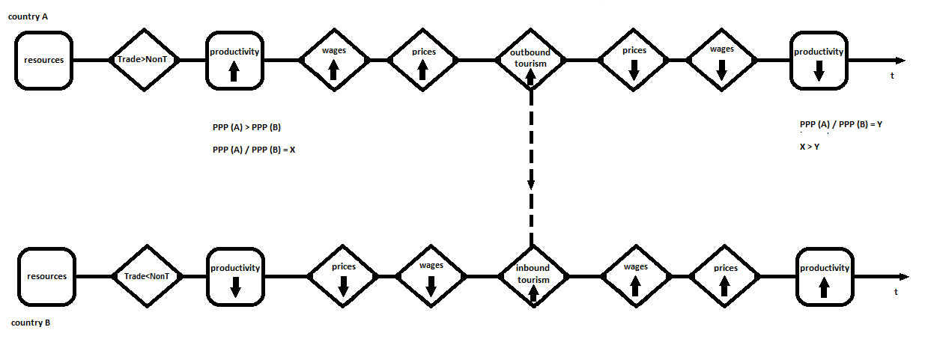

Figure 1: Balassa-Samuelson Effect with an International Tourism Component
Legend: The figure presents the CBD interpretation of the mechanism of B-S effect by accounting the role of international tourism. As suggested by Balassa and Samuelson (1964), the choice of structuring the economy with a prevailing orientation towards tradable (compared to non-tradable) activities determines the rise in local level of productivity, which will lead to a rise in wages in all sectors, including the less productive sectors. This process however, will lead to rising prices in this better developing locality. CBD argues further that: under conditions of international tourism, people from the richer locality can choose to short-term migrate (travel as an international tourist) to poorer localities where the price for the same service or good is lower, following a price discrimination logic of economic behaviour. The outflow of consumers from richer localities to poorer localities will boost demand, and this will respectively increase the price and profit and wages in the poorer locality, which will result ultimately in a boost in local productivity in the poorer locality and will phase out part of the difference in the PPP between the richer and the poorer locality. Our CBD model also suggests that what will determine whether a tourist from the richer locality will go to the poorer locality depends, besides the lower price, on the comparative cultural proximity between the two localities and the cultural proximity of the richer locality with other potential poorer localities. Our CBD hypothesis is that given that the price is equally low at both poorer localities, the outflow of tourists from the richer locality will direct towards the culturally closer poorer locality.

Table 1: Main Set of Countries Sending Outbound-Tourists
Legend: The table presents the whole set of countries available in our dataset, from which one can extrapolate either the 35 OECD countries or the EU28 countries. We later address these different subsets as a search for triangulation of the results with datasets free from unwanted heterogeneity making the cases uncomparable.
Source: Authors’ calculations.

Table 2: Set of All Destinations of the Outbound-Tourists
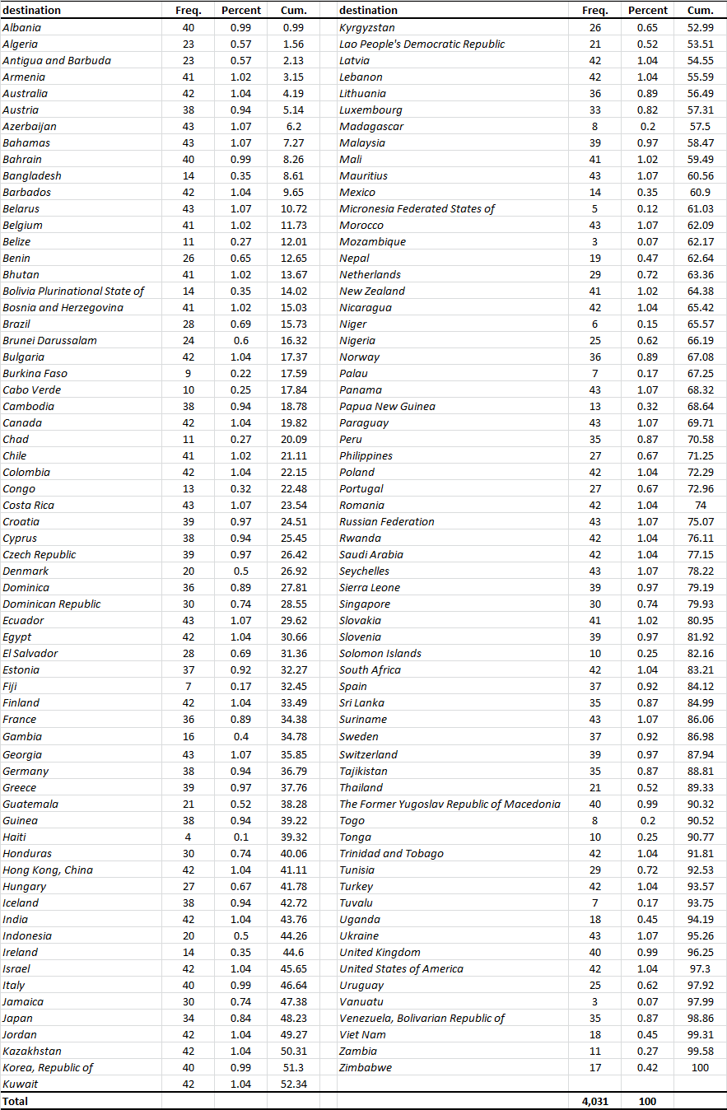
Legend: The table presents the 129 destinations addressed by the outbound tourists from the 45 OECD and EU countries under investigation in our paper.
Source: Authors’ calculations.

Table 3a: Alternative Measures of Cultural Distance b/n Sending and Destination Country
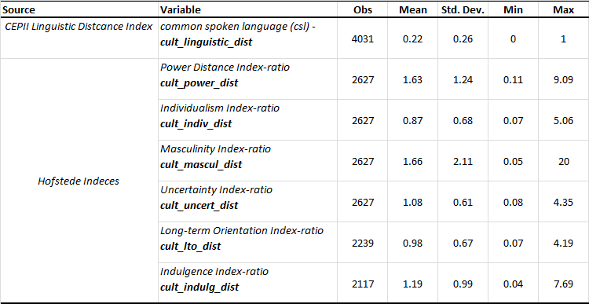
Legend: The table presents descriptive statistics for our seven alternative measures for cultural proximity – the cultural_linguistic_distance which measures the percentage of common spoken languages between to countries on a scale from 0-1; and the six Hofstede cultural dimensions, answering to the indices: Individualism versus Collectivism (IDV), Indulgence versus Restraint (IND), Power Distance Index (PDI), Masculinity versus Femininity (MAS), Uncertainty Avoidance Index (UAI) and Long Term Orientation versus Short Term Normative Orientation (LTO) (see Appendix 3 for a detailed description.
Source: Authors’ calculations.

Table 3b: Descriptive Statistics of main Dependent Variables
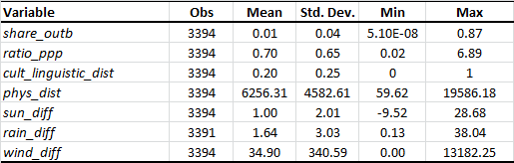
Legend: The table presentsmain descriptive statistics for the variables in our compiled dataset: share of outbound tourists (share_outbound_tourists), ratio of purchasing power parity in sending and destination country (ratio_ppp), cultural proximity measure dwith the common spoken languages between two countries (denoted cult_linguistic_distance) and physical distance (phys_distance).
Source: Authors’ calculations.

Table 4: Purchasing Power Parity Differences as Function of the B-S Effect and Tourism - OLS, robust standard errors

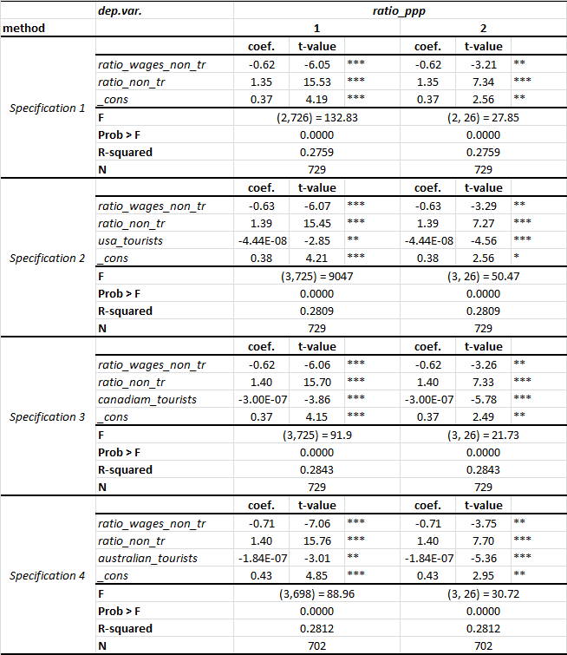

Legend: The table presents an examination for the B-S effect in the EU28 and the role of tourism as a redistributor of income across countries. Three specifications for tourists from USA, Canada and Australia are presented. Column 1 present OLS with robust standard errors, while column 2 has also fixed effects controlling for the clustering by country. Stars denote statistical significance, respectively: * p<0.10, ** p<0.05 and ***p <0.001.

Source: Authors’ calculations.

Table 5a, b & c: Share of Outbound-Tourists as a Function of Purchasing-Power-Parity Differences and Cultural Distance – OLS, robust standard errors
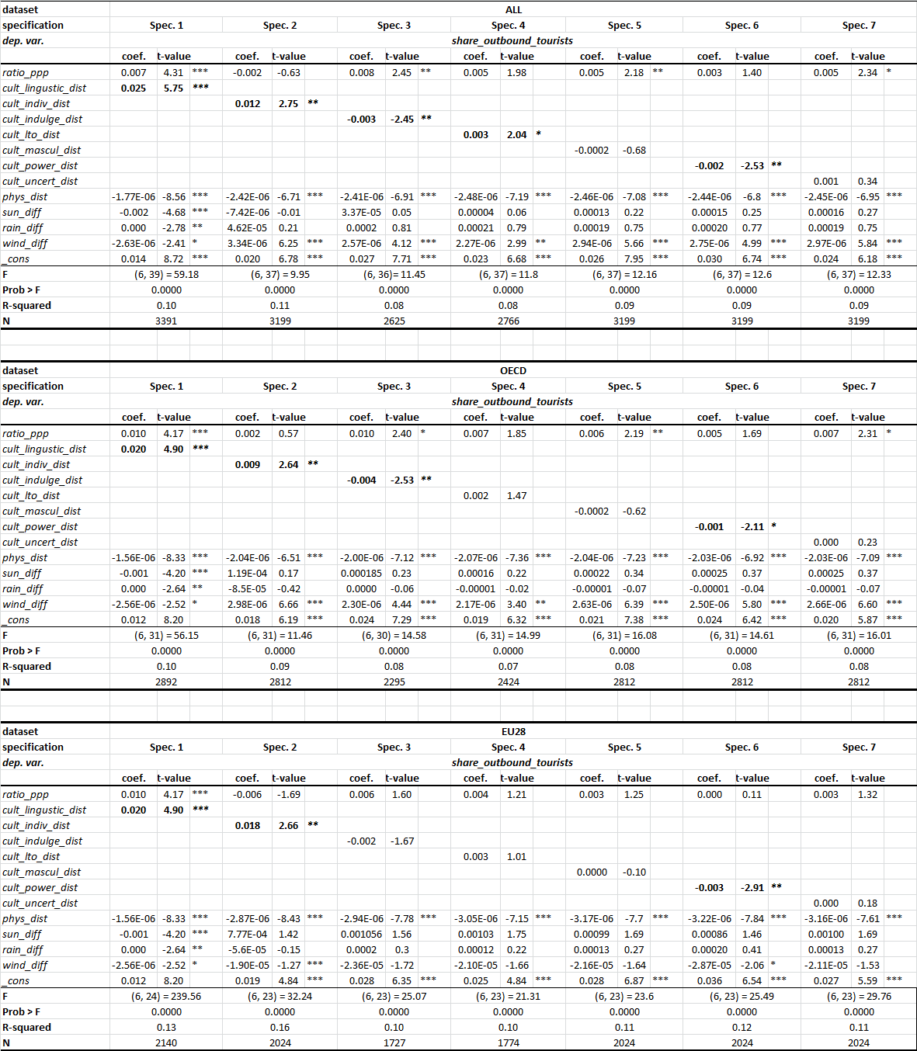
Legend: The table presents estimations with impact from physical and cultural distance for 45 countries, for only the OECD or only the EU28 countries. Seven specifications with alternative measurement of cultural proximity – the Cultural Distance Index of CEPII and the six cultural dimensions according to Hofstede (2002). Estimations include country fixed effects. Stars denote statistical significance, respectively: * p<0.10, ** p<0.05 and ***p <0.001.
Source: Authors’ calculations.
Table 6a, b & c: Share of Outbound-Tourists as a Function of Purchasing-Power-Parity Differences, Cultural Distance, and their interaction – OLS, robust standard errors
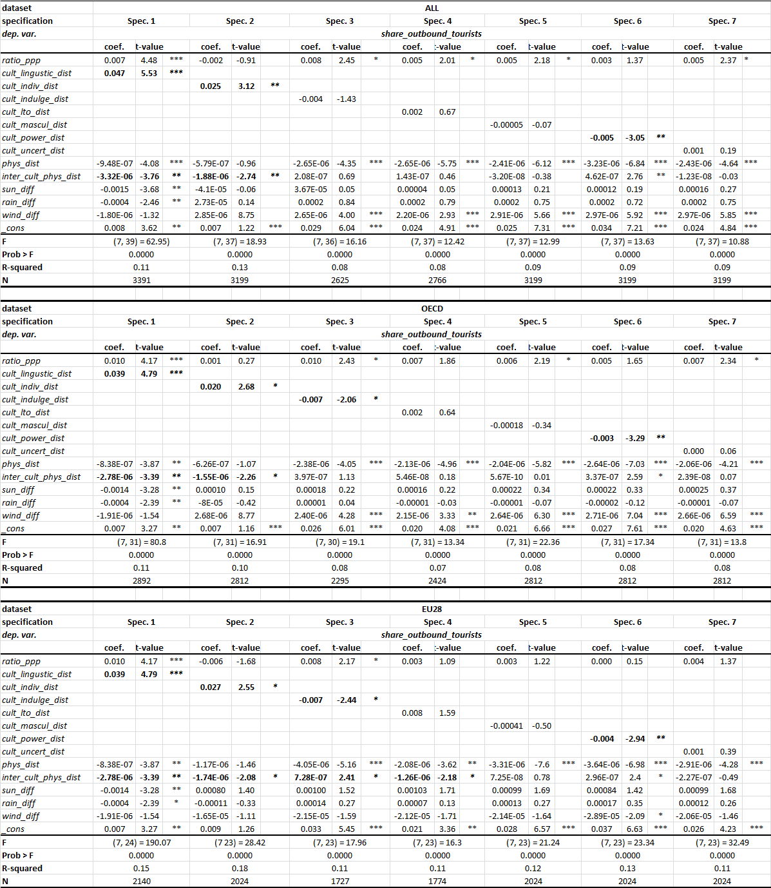
Legend: The table presents estimations with interactions between physical and cultural distance for 45 countries, for only the OECD or only the EU28 countries. Seven specifications with alternative measurement of cultural proximity – the Cultural Distance Index of CEPII and the six cultural dimensions according to Hofstede (2002). Estimations include country fixed effects. Stars denote statistical significance, respectively: * p<0.10, ** p<0.05 and ***p <0.001.

Source: Authors’ calculations.

Appendix 1: Samuelson (1964) and Balassa (1964) on the Role of Tourism for PPP

Tourism, together with labour migration, was noted as a source for the B-S effect by Samuelson (1964) as follows: “Patently, I cannot import cheap Italian haircuts, nor can Niagara-Falls honeymoons be exported. We are left with the minute grain of truth that tourism may move in the direction of cheaper prices, thereby tending to lower in some fractional degree the net price differentials of tourists’ items. It is bizarre to think that there are enough retired rentiers, who will move to Germany to bid up their cheap prices, and who will only cease to move in either direction when COL PPP has been achieved. What is true is that some footloose people and absentee landlords do move. Those with “American taste” tend to move here where the things they like are relatively cheap, and those with “foreign tastes” tend to become expatriates” (Samuelson 1964, p. 148). Besides defining tourism as a special type of service that is locality-specific, Samuelson acknowledges that tourism and labour migration are the two sources for relocation of consumption potential.
The previous message was completed and extended by Balassa (1964) who actually concludes his expose on the B-S hypothesis with the following statement: “Note, however, that, while in the above discussion we have assumed that services cannot be traded, this assumption will have to be modified if account is taken of international tourism that involves international transactions in services. Tourism will affect services prices in the individual countries, and it will tend to reduce international disparities in these prices. But even if the cost of transportation involved in foreign travel is disregarded, tourism will not equalize service prices as long as it is restricted to periods of limited length, for example, those of annual vacations. An international equalization of service prices will, then, require the migration of labour in response to intercountry differences in living costs,” (Balassa, 1964, p. 596).
The above statements show that the B-S effect accounts for differences in PPP that may be assumed to be explained by wages in a closed labour market and under the conditions of a negligible movement of people and resources across countries. Such conditions were adequate as assumptions for the reality of the sixties when the B-S hypothesis was proposed. Yet, this explanation depends on fixed labour and consumers across space, an issue that was already noted by the very promoters of the B-S hypothesis in their original contributions from the year 1964. Clearly, the B-S hypothesis needs to be adjusted to these additional and now relevant explanations in relation to tourism and in particular with regards to the short-term movement of people (tourists) involving a relocation of big slots of consumption potential among countries due to these footloose citizens (see Inchausti-Sintes, 2015).

Appendix 2: Important Considerations about the Link Tourism-PPP

The integrating of tourism in the PPP paradigm can only be adequately achieved, if done with caution based on the following careful considerations. First, given the intensive level at which they operate nowadays in comparison to the 60s, migration and tourism should already have erased the B-S effect, while this does not seem to take place in reality (see, for example, Drinea and Raulta 2003; Mejean 2008), so that there must be some barriers for it to happen. Second, this inefficiency of the tourism explanation in the B-S effect might be due to the international regulations across the EU, for instance – such as forbidden price discrimination towards foreign tourists - make local suppliers unable to follow the otherwise normally expected efficient market elasticity of supply that the richer tourist consumers would evoke in the recipient economy. Put differently, although more and richer customers come to the poorer country, the country cannot increase the prices up to the normal free market reaction to this increased purchasing potential. This institutional barrier for the elimination of the B-S effect can practically be expected to contribute towards the preservation of the conditions for the richer countries to have higher prices of services and poorer countries to have lower prices for their services. But much more importantly, third, obviously, as elaborated above, there are some more intricacies to the tourist sector impact, other than the level of wages in the tourist service sector or its share, which have to be accounted for in the model, such as the third party countries consumption influence on the between PPP relationship between two countries etc. Fourthly, indifferent of how large its volume is today, tourism indeed continues to be mostly seasonal. This means that its effect might be expected to be seasonal and its tendency related to specific weather and geography-fixed effects. Fifth, tourism is also place-based, i.e. culturally locally-specific, as noted by Samuelson, there is only one Niagara Falls in the world and we agree that there is only one authentic Maya culture. So, the cultural value of the tourist attraction turns tourism into an inevitable potential for a Ricardian comparative advantage. And, above all, sixth, last but by far not least, what is essential to be acknowledged is that tourism in general, i.e. every single type of tourism, is strongly susceptible to locally-specific preferences with the tourists. An exported good may create its market through objective direct contact of the customer with its qualities after being exported to a place indifferently of the customers’ initial interest and information about the product. Tourism however, can a-priory reach the customer only indirectly through advertisement, so tourist consumption is much more vulnerable to only the perceptions of the customer about the tourist destination and not the objective tourist services quality.

Appendix 3: Alternative Measures of Cultural Proximity - Definitions
Linguistic Distance Index (Common Spoken Language): The CEPII Institute has elaborated a Linguistic Distance Index. The dataset on the basis of which this index is calculated contains: (i) a measure of Common Official Language (COL) - a binary variable informed from the CIA World Factbook; (ii) measures for Common Native Language (CNL) and Common Spoken Language (CSL), which require all languages to be spoken by at least 4% of the population in 2 countries. The Index is constructed by using two separate measures of Linguistic Proximity, LP1 (based on language trees) (see Fearon, 2003; Laitin 2000) and LP2 (based on lexical similarity between languages) (the latter being based on the data collected under the Automated Similarity Judgment Program (ASJP) project). From this variety of measures, we use in the current paper the Common Spoken Language measure as it is most easily intuitively interpreted in the case of tourist experience and her/his communication with the surrounding environment.
Hofstede’s Individualism versus Collectivism (IDV) Index: The differentiation between individualism and collectivism in this Index is based on the degree of embeddedness of the individuals in their local networks with regard to family and friends. A society that has relatively low level of embeddedness, and individuals care largely for themselves and their own families only, is defined as individualistic. The opposite, societies with care for extended family and friend are collectivistic under the definition of the IDV index.
Hofstede’s Indulgence versus Restraint (IND) Index: Indulgence is defined as the preference to allow relatively free gratification of basic and natural human drives related to enjoying life and having fun. Restraint is defined as the preference for suppresses gratification of needs and regulation of desires by abiding to strict social norms.
Hofstede’s Power Distance Index (PDI): This Hofstede’s cultural dimension measures the degree to which the less powerful members of a society are willing to tolerate inequality in the distribution of power. Countries with high levels of this index tend to accept inequality in a strongly hierarchical institutional setting. Places with low Power Distance Index tend to strive for higher equality and better justification for the distribution of power.
Hofstede’s Masculinity versus Femininity (MAS) Index: This index defines masculinity as a predominant social preference for achievement, heroism, assertiveness and material rewards for success. Thus generally a higher MAS denotes a more competitive society. Meanwhile, femininity, is defined as a preference for cooperation, modesty, caring for the weak and quality of life. Thus low levels of the MAS denote a society that is more consensus-oriented.
Hofstede’s Uncertainty Avoidance Index (UAI) Index: The Uncertainty Avoidance Index relates to the Hofstede cultural dimension concerned with the degree of local population’s unease with uncertainty and ambiguity and the level of attempting to control the events in the future. A high UAI indicates a locality that is culturally rigid, maintains closely its old beliefs and practices and is generally culturally closed and intolerant of new unconventional ideas. Low UAI indicates a society of more relaxed attitude, with more practical orientation.
Hofstede’s Long Term Orientation versus Short Term Normative Orientation (LTO) (also denoted as PRA (pragmatic) dimension): This cultural dimension deals with the persistence of cultural tradition in a locality. If the index is high this means that the local population prefers to maintain old traditions and norms while viewing societal change with suspicion. Low LTO index indicates more pragmatically oriented cultures, which are open to change as a response to the current circumstances.

Appendix 4: Quantification of Variables per Regression

Regarding our Hypothesis 1, our dependent variable is the ratio of the PPP between each two pairs of countries in EU28 (variable ratio_ppp). Our explanatory variables are: the ratio of the shares of people employed in the non-trade service sector in the same two countries under comparison (ratio_non_tr) and a proxy for the impact of income from tourism (alternatively quantified with the number of tourists from the richest sending countries outside Europe – USA (usa_tourists), Canada (canada_tourists) and Australia (australia_tourists)). This last regressor attempts to approximate the share of income that has been redistributed from respectively the USA, Canada and Australia to the country basis for the comparison.
Our Hypothesis 2 is operationalized by quantifying our main dependent variable: share of sending country outbound tourists towards a destination country (share_outb) from the UNWTO source. Our regressors are respectively: (i) the ratio between the PPP in sending and destination countries, expressed in USA dollars (ratio_ppp); (ii) the set of three climate-related ratios – sun_diff, based on average annual temperatures, rain_diff, measuring differences in precipitation on average in the sending and recipient country and wind_diff, accounting for the differences in the speed of onshore wind; (iii) a cultural distance measure (we use alternatively the difference between the same cultural index in sending and destination countries or the ratio between these values – these are respectively the cultural distance measuring variables: cult_ling_dist related to linguistic proximity, cult_indiv_dist – related to levels of individualistic behaviour in the country; cult_indulge_dist – related to the level of self-control against affording indulgence; cult_power_dist – related to the level of power-distance relationship between people and institutions in the countries; cult_mascul_dist – related to the level of masculinity predominance in the country; cult_uncert_dist – level of uncertainty avoidance preferences in the local culture; and finally cult_lto_dist – related to the long-term orientation typical for the countries under comparison); (iv) the distance between the centroids of the capitals of the two countries measured in kilometres is available from CEPII and denoted as the repressor phys_dist, accounting both for the distance effect and approximating the economic cost of the travelling between the sending and destination country (see Appendix 3).

See Cassel (1921), Krugman (1978), Rogoff (1996) and Bordo et al. (2014) for details on the exchange rate and the purchasing power parity mismatch and the development of the literature on this issue in the past decades.
Cultural proximity is defined here as the opposite of cultural distance between two national cultures (see also Nijkamp 2016). We use the definition of Culture Based Development regarding culture as a set of material and immaterial manifestations of a latent variable of predominant and passed-through-generations local attitudes (see Tubadji 2013a,b). Therefore, cultural proximity is the reciprocal of the distance (i.e. the differences) between the latent (and multi-dimensional) factors of culture present in every two localities under study. Clearly, as there are many possible quantifications of culture (see Tubadji, 2014), the distance between two cultures can also be approximated in a variety of quantitative measures. An established stream of literature is dealing with institutional cultural distance (see for example Rallet and Torre 1995; Boschma 2005; Torre, 2008; Capello 2009; Rutten and Boekema 2012). Interesting work on cultural distance as distance in norms and values (Tadesse and White 2010a,b) or as a difference in the degree of social isolation (Barrett and Mosca, 2011) has also taken place. Another approach to defining and measuring cultural proximity can be found in the existing literature on linguistic proximity/distance (see Melitz, 2008; Guiso et al. 2009; Falck et al. 2012; Bauernschuster et al. 2014; Lemali et al. 2015). For in-depth recent literature reviews on defining and measuring proximity, we refer to Rodriguez-Pose (2011) or Tubadji and Nijkamp (2015). In the present study, we adopt the linguistic proximity approach, as language has been identified since Wittgenstein as an important construct related to thinking and is likely to bear a strong connection with and explanatory power to local cultural attitudes and modes of thinking. We also compare in the present study the linguistic measure to other measures for distance in alternative institutional and other cultural frameworks, following Hofstede (1983, 1984, 2001).
See MacDonald and Ricci (2001) on some of the known links between the Balassa-Samuelson effect and the distribution of impacts.
We refrain from adopting here the classical two-directional-flow gravity model. The reason for this is that while trade and foreign direct investment (FDI) are bilateral in nature, the touristic activity is motivated by an idiosyncratic, locality-specific mix of geographical, historical and artistic experiences related to a place as a fixed effect. Thus, cultural proximity has to be accounted for as a factor for the utility function of the tourists, but the attractiveness of the destination as a geographical and historic locus remains unique as an experience in each locality. As stated in Tubadji and Nijkamp (2015): the Bulgarian town of Plovdiv – having also the Greek name Philipopolous – will naturally carry a cultural proximity between Santorini and the historic town center of Plovdiv. Yet, the uniqueness of Santorini island, which is a top-ranked world natural environment, will attract way more Bulgarians than the city of Plovdiv will be ever able to attract Greek tourists with the same cultural proximity. This is of course due to the climatic differences between the two places, but also when climate is accounted for, a difference based on cultural uniqueness remains that cannot be assumed as equalized under any condition. Thus, a bilateral cultural gravity model is not justified, as it cannot capture the nonlinearities from the uniqueness of the cultural and geographical mix of a locality. While entropy and spatial interaction have long been integrated with regard to the physical distance aspects that distort the classical gravity model operations (see Broecker 1984; Sen an Smith 1995), and recent theoretical work demonstrates the significance of centralization and level of management for tourism income optimization (see Candela et l. 2015), virtually no attention has been paid, to the best of our knowledge, to the cultural proximity distortion of the gravitational forces in the movement of people through tourism and the effect of this distortion for the income redistribution between countries. The classical gravity model will assume the same gravitational constant to operate in both directions, while in tourism the common component of culture affects tourist utility, but local culture has also a unique component that attracts all consumers as well. These dual effects from culture cannot be distinguished easily in a bilateral flows model.
The reasons for the unstable empirical support for the B-S hypothesis (see Bahmani-Skooee, 1992) are various. The standard approach has been to swerve the interpretation of the B-S hypothesis into what is called a homogenization of wages. Namely, prices across sectors tend to equalize within a country’s economy (called the internal transmission mechanism by Egert et al. (2003)). Similarly, the prices across countries are also assumed to tend to homogenize based on productivity increase (Schank et al. 2007, 2010). And a kind of sticky wage or sticky prices effect is often seen as an explanation to counterbalance the B-S effect (see Obstfeld and Rogoff 1995, Ludsteck and Lehmer 2013). Next, some authors note the theoretical mismatch with empirics, namely that the original B-S hypothesis suggests a relative internal wages homogenization, not an absolute one. In addition, the wage interpretation is just one hypothetically possible explanation for the B-S effect instability, based on what is known as the Penn effect (dealing with wages differentials, in particular) (see Kravis et al. 1978; Samuelson 1994).
On the one side, cultural proximity might motivate choice through homophily and cognitive ability of the tourist to recognize a destination as interesting (see for example Fourie et al. 2015). On the other side, cultural distance might satisfy the experiential need for adventure and the need of the choosing individual for learning about the world (see Correia et al.2007). And of course, in this process, the information asymmetry and relativity in ranking of preferences between localities about the value of the local cultures across space affect the choice of tourist destination.
Some studies suggest a relationship between local culture (especially work culture) and local climate (see Strauss and Orlove 2003). While this relationship might be valid, there is certain historical path dependence in the formation of local culture, which climate alone cannot explain.
We do not report temperature in the final result tables with the parsimonious version of our models, which contains only the variables which showed significance. Temperature was the only weather-related measure that was turned insignificant by the addition of our wind-measures. Potentially the temperature is causally related to the atmosphere – and from there to the cloudiness, therefore the wind variable outperforms it. Also – temperature is a seasonally varying variable and it will have different meaning for the tourists from different sending countries during the same time of the year. These complex non-linearities of the effect of the variable are likely the reason why the temperature-measure was unable to explain directly the tourism flows.
See Ridderstaat et al. (2014) for an extensive review and motivation of the relevance of such climate factors for modeling touristic destination choice.
And in addition to the PPP difference between A and C and B and C, the local mix of tourist inflow in A may not necessarily contain tourists from country C at all.
We choose on purpose the main sending countries of tourists internationally. If our measure was aggregate (including all incoming tourists in the local economy), we couldn’t be able to distinguish from 1000 tourists if they come from 10 different countries and 1000 tourists from 1 country. While what we want here is to isolate our analysis from the cultural background complexity of who is the sending country and to focus only on volume of inflowing tourists – does it impact the PPP or not.
The UNWTO data might have some limitations with regard to the level of detail that some countries provide from their statistical services in comparison to other countries. Focusing on the OECD countries and the 28 EU countries, we avoid a significant part of this problem, because while smaller sending and receiving countries might not be well-documented, the main sending countries (such as OECD and EU, the developed economies per se) usually are.
Dynamic approaches are always more appealing cross-section analysis. However, our main dependent variable of interest is time-invariant (cultural proximity and the Hofstede’s Indices). Therefore, while ideally a panel analysis would be interesting, given the current data availability on culture this analysis would not be possible. Moreover, culture varies at much bigger intervals than economic factors do. Thus, if we want a dynamic analysis of the cultural impact we will need a much bigger time-period per se. Current data availability restrains this ideally interesting suggestion from implementation.
While the spending made by tourists may be different due to their different income with regard to deciding if they can afford a destination or not, once they have arrived at a destination their spending cannot be dramatically varying outside of the average income of the sending country variation (for which we control in our estimations). So, while ideally data on spending from tourists can improve the analysis as a substitute to average country income of the sending country, the spending by tourists is not supposed to be an alternative measure for the number of tourists, which is justified as core explanatory variable by the fact that we model the cultural bias in the choice made by tourists.
We focus on developed countries only on purpose. If we included both developed and developing countries, this would cause unwanted heterogeneity in our dataset. An unwanted heterogeneity is a heterogeneity that stems from factors other than the main ones relevant for the current analysis. This unwanted heterogeniety is normally treated by either dividing the samples into two (developed and developing) or by including a dummy variable for the type of economy. In both cases however the dataset would be more problematic if it contained countries with vast differences in their economic development, which would need to be explained on its own with factors not available and irrelevant for our investigated mechanisms of tourism and cultural proximity. We want to know what happens after a given country produces at a certain level of development – what happens as redistribution between the economies due to income. Therefore we have to compare the redistribution among countries with relatively comparable initial conditions other than tourism and cultural proximity to the sending countries.
See Candela and Figini (2012) on defining tourism as a quasi-tradable good.

