**A Lean-TOC Approach for Improving Emergency Medical Services (EMS) Transport and Logistics Operations**

***Abstract***

The improvement of transport and logistics performance of Emergency Medical Services (EMSs) systems has been mainly addressed through mathematical modelling, operations research, and simulation methods. This paper proposes an alternative and/or complementary improvement approach based on the adaptation and simultaneous deployment of lean thinking and Theory of Constraint (TOC) methods and tools.The paper briefly reviews key aspects of the application of lean in the logistics and healthcare industries and conceptually develops the proposed lean-TOC approach. The approach is then tested, through an individual detail case study, in the EMS transport and logistic system of the Red Cross operating in the metropolitan area of Monterrey, Mexico.The results obtained from the case study suggest that the proposed systematic lean-TOC approach may be an effective alternative and/or complement to mathematical modelling, operations research, and simulation methods to improve EMS transport and logistics operations.

***Keywords:*** Healthcare, lean, Theory of Constraints, transport and logistics, Emergency Medical Services.

**1. Introduction**

Over the last decades, extensive theoretical and empirical evidence has demonstrated the effectiveness of lean to enhance the competitiveness of organisations (Hines et al., 2004). This has contributed for lean to emerge as a dominant and prevailing managerial paradigm in business environments. Nevertheless, despite the deployment of lean in a vast range of industries including manufacturing, healthcare, telecommunications, education, fast food restaurants, among others (Garza-Reyes et al., 2012), and its wide approval as a ‘best operational practice’ by companies around the world (Forrester et al., 2010), evidence of its application in transport and logistics operations is still limited.

It is only until recently that the empirical application of lean principles, methods and tools has been explored to improve logistics operations. For instance, Villarreal et al. (2017a) combined two lean-based principles and tools, i.e. transportation value stream mapping (TVSM) (Villarreal, 2012) and the seven transportation extended wastes (STEWs) (Sternberg et al., 2013), to enhance the road transport operations of a leading Mexican brewing organisation. Villarreal et al. (2016a) developed and applied a systematic method for improving road transport operations based on the elimination of the STEWs proposed by Sternberg et al. (2013) and Sternberg and Harispuru (2016). Garza-Reyes et al. (2016a) implemented and combined some fundamental principles and tools of the lean and green paradigms to enhance both the environmental and operational performance of the routing operations of a world leader logistics company in Monterrey, Mexico. Villarreal et al. (2016b) proposed and deployed a lean thinking and simulation-based approach to improve the efficiency of warehousing and routing operations. Garza-Reyes et al. (2017) applied lean thinking to measure and drive the improvements of the road transport operations of a world leading provider of paper-based packaging solutions operating in Bogota, Colombia. Other similar empirical works include the studies of Villarreal et al. (2012), Villarreal et al. (2013), Villarreal (2012) and Hines and Taylor (2000).

In theoretically-based terms, Villarreal et al. (2016b) suggest that the employment of lean thinking to address transportation and logistics challenges has been mainly limited to only three research lines, namely; (1) characterisation of lean-based road transportation wastes (e.g. Sternberg et al., 2013; Guan et al., 2003; Sutherland and Bennett, 2007); (2) development of lean-based methods to eliminate road transportation waste (e.g. Villarreal et al., 2016a; Villarreal et al., 2016b; Villarreal et al., 2012; Villarreal, 2012; Hines and Taylor, 2000); and proposal of lean-based performance measures to evaluate road transport operations (e.g. Villarreal, 2012; Taylor and Martichenko, 2006; Simmons et al., 2004; Guan et al., 2003).

On the other hand, although the application of lean in the healthcare sector, traditionally known as lean healthcare, is well documented (e.g. Soriano-Meier et al., 2011; Chalice 2007; Joint Commission on Accreditation of Healthcare Organizations 2006; Brandao 2009), the specific implementation of lean thinking to address some of the transport and logistics challenges of Emergency Medical Services (EMS) is almost non-existent. Transport and logistics EMS operating processes can be considered a specialised transportation activity in which the life of patients is at risk (Zhang et al., 2017), hence their agility capability is of major public concern. The fundamental responsibilities of EMS systems are to provide urgent medical care, such as pre-hospital care, and to transport the patient to the hospital if needed (Fitch et al., 2015). The activities normally involved in this service include:

* Receive emergency calls and assigned and ambulance to serve it;
* Ambulance preparation;
* Transport the ambulance to the emergency scene;
* Serve the injured or sick person until he/she is stabilised;
* Transfer the patient to a health institution;
* Deliver the patient to the health institution;
* Transport back the ambulance to its base.

Recently, various research studies have focused on improving the transport and logistics performance of EMS systems (e.g. Meilinda et al., 2018; Zhang and Cardin, 2017; He and Liu, 2015; Blackwell and Kaufman, 2002; Caunhye et al., 2012). However, like ‘traditional’ transport and logistics problems, these have been mainly addressed through mathematical modelling, operations research, and simulation methods. Even though these methods have successfully contributed to tackle transport and logistics challenges, their effectiveness to actually address real-life transportation problems has been recently criticised (Berhan et al., 2014). Ak and Erera (2007) suggest that this is due to the large majority of these methods overgeneralise solutions by considering various stochastic real-life parameters such as demand, time, distance, and others, as deterministic. In this context, only the works of Villarreal et al. (2017b), Villarreal et al. (2016c), Siller et al. (2013), and Villarreal et al. (2014) have demonstrated the use of alternative/complementary approaches such as lean thinking and/or Theory of Constraints (TOC) (Goldratt et al., 2014) as also potential solutions. Therefore, to advance our knowledge regarding the application of lean thinking to enhance transport and logistics operations in EMSs, this paper proposes an improvement approach, based on the reduction of waste and TOC, for reducing ambulance cycle time. This approach is unique and the first to consider the customisation of the emerging theory of Lean Transportation to enable its use for improving EMS operations. This effort includes the redefinition of new wastes, the adaptation of the Transportation Value Stream Map, and the modification of the improvement scheme to embed it as part of the steps of the Theory of Constraints improvement scheme. The paper also contributes by documenting its application in a Mexican EMS, hence serving as a guiding reference for operations managers in healthcare organisations who may wish to conduct similar improvement projects. Finally, the paper also aims at making a contribution to the field by motivating researchers to undertake further investigations in this relatively under-researched field.

The rest of the paper is organised as follows: Section 2 provides a brief review of the application of lean in the logistics and healthcare industries, paying particular attention to the central elements of this research, i.e. waste and the mapping of the value stream; Section 3 presents the proposed lean-TOC approach for improving EMS transport and logistics operations and its development, whereas its application is shown in Section 4. Finally, Section 5 presents the concluding remarks, limitations and future research derived from this work.

**2. Literature Review – Lean Application in Logistics and Healthcare**

***2.1 Waste***

Elimination of waste is at centre of the lean philosophy (Hines et al., 2004). Under this principle, a process can be divided into value adding and non-value adding activities, i.e. waste, as seen from the customers’ perspective. Lean originally defined seven major ‘internal’ types of wastes in manufacturing and business processes, namely: overproduction, waiting, unnecessary transport, incorrect processing, excess inventory, unnecessary movement and defects (Ohno, 1988). However, since entire value streams include value-adding and non-value adding activities that go from the conception of customers’ requirements and until they receive the product, there was a clear need to extend the internal removal of the seven wastes to the complete supply chain (Wee and Wu, 2009), including logistics operations. In this context, the ‘Seven Deadly Wastes of Logistics’ (i.e. overproduction, delay/wait, excess transport/conveyance, motion, inventory, space and errors) were defined by Sutherland and Bennett (2007). They suggest that these wastes keep the management of supply chains from realizing its full potential. In the same way, Sternberg et al. (2013) advocated that out of the seven lean wastes (Ohno, 1988), excess inventory and conveyance did not apply to motor carrier operations, but they included resource utilisation and uncovered assignments as road transportation wastes. Finally, Guan et al. (2003) defined five transport wastes, i.e. driver breaks, excess load time, fill losses, speed losses and quality delays, based on an extended version of Overall Equipment Effectiveness (OEE) (Nakajima, 1988) designated as Overall Vehicle Effectiveness (OVE) (Simmons et al., 2004).

As it was the case for manufacturing, business, and later road transportation processes, in lean healthcare terms it was also necessary to define what is considered waste or value. In this line, Bentley et al. (2008) suggested three types of waste, i.e. administrative, operational, and clinical. Both administrative and operational wastes derive from inefficient production, whereas clinical waste is a form of allocative waste. Administrative waste is the excess of administrative overhead activities that stem primarily from the complexity of U.S. insurance and provider payment systems. Operational waste refers to other aspects of inefficient production processes. Clinical waste originates from the production of low-value outputs. On the other hand, Graban (2016) proposed an extension of the seven lean wastes for a healthcare environment, including human potential as an additional eighth waste. This waste classification is more suitable for process improvement in a health institution as these are best associated to hospital operations.

***2.2 Mapping of the Value Stream***

Besides the adaptation/extension of the traditional manufacturing/business wastes to make them applicable and relevant to transport and logistics operations, mapping the value stream at a supply chain level was also an important aspect to the identification and subsequent elimination of waste, especially those related to unnecessary inventories and transportation. In this line, VSM is a lean tool that has been widely utilised to quantify, document, comprehend and visualise the flows of material and information (Andreadis et al., 2017) of manufacturing (e.g. Singh and Sharma, 2009) and service (e.g. Barber and Tietje, 2008) value streams. Additionally, some empirical evidence also shows its application in healthcare operations (e.g. Teichgräber and de Bucourt 2012). Nevertheless, only a handful of researchers have considered the use of VSM to support the analysis and improvement of the value stream of transport and logistics operations (e.g. Hines et al., 1999; Jones et al., 1997). Most recently, Villarreal (2012) adapted the traditional VSM, which he labelled as Transportation Value Stream Mapping (TVSM), to support efficiency improvement programmes in transport and logistics operations. TVSM concentrates on transport efficiency by focusing on uncovering waste that may exist through the entire distribution cycle, i.e. from loading the orders of goods to the transportation vehicles to unloading their returns from the market and closing administratively the route or shipment (Villarreal, 2012). TVSM has now been successfully employed by Villarreal et al. (2016a), Villarreal et al. (2016b), Villarreal et al. (2017a) and Garza-Reyes et al. (2017) to drive the improvements of transport and logistics operations. The VSM utilised in this work is a TVSM’s modified version that is denoted as the Ambulance-VSM (A-VSM) hereafter, see Section 4.

**3. Proposed Lean-TOC Approach for Improving EMS Transport and Logistics Operations**

***3.1 Approach Development***

Due to the close similarity and applicability of lean in various industrial sectors, the design approach followed by Garza-Reyes et al. (2016b) to develop a Lean Sigma framework for the reduction of ship loading commercial time in the iron ore pelletising industry was replicated. Thus, the proposed lean-TOC approach for improving EMS transport and logistics operations presented in this paper was developed by following three ‘design phases’.

The first design phase entailed the study of the applicability, characteristics, different frameworks proposed in the literature, and reasons for employing lean and/or TOC to improve both road transport and healthcare operations. This resulted in the amalgamation of the most relevant and current theoretical knowledge into the proposed approach (Chen and Lyu, 2009), which consequently stemmed the identification and detail study of Huang et al.’s (2002) method for the improvement of manufacturing operations. This method is underpinned by the TOC principle which advocates that bottlenecks, or the most constrained capacity resource, determine the productivity of manufacturing systems (Goldratt et al., 2014). Huang et al.’s (2002) method also suggests that bottlenecks are those resources which present the lowest OEE value. Founded on these principles, Huang et al. (2002) developed the improvement method by fitting it into the five-stage improvement cycle proposed by Goldratt et al. (2014). In this method, the first two stages are focused on estimating the OEE values for each production resource. The third stage entails the identification of the bottleneck, or most constrained resource, which is carried out by identifying the resource with the lowest OEE value. In the subsequent stage, wastes, or losses, are identified. These are associated with the availability, performance and quality efficiency factors of the bottleneck resource. The final stage includes the formulation of an improvement agenda with projects and/or actions to eliminate/reduce the identified wastes and hence remove the constraint. The same process is replicated if a new constraint is identified, and to continue improving the productivity of a manufacturing system.

Since Rocha-Lona et al. (2013) indicate that practitioner’s experience plays an essential role in the development of theoretical frameworks that will be deployed in industry, the second design phase consisted in using the wide industrial and theoretical experience of the authors as consultants, practitioners, academics and researchers to support the development of the proposed approach.

Lastly, the third design phase involved the consideration of relevant input from the health institution where the proposed approach would be deployed (Garza-Reyes et al., 2016b; Vinodh et al., 2011). For this reason, discussions with providers of the EMS, e.g. paramedics, doctors, operations managers, administrative staff, etc., and preliminary observations of the EMS transport and logistics process were also conducted to consider, in the design of the proposed approach, key issues and restrictions of the EMS process. Although by following this design stage the proposed method may be considered specifically designed for the case organisation and to address its particular EMS operational challenges, the close similarities and high level of standardisation of EMS operations across hospitals (Sinreich and Marmor, 2005) make the proposed approach also applicable to other healthcare institutions.

***3.2 The Approach***

The proposed approach for improving EMS transport and logistics operations presented in this paper builds on Huang et al.’s (2002) method and the lean’s cornerstone philosophy of waste elimination. Nevertheless, unlike Huang et al.’s (2002) method, the proposed approach does not require the OEE values for each capacity resource to be estimated in order for the bottleneck resource to be identified. Instead, the determination of the bottleneck (B), or most capacity constrained resource (MCCR), is carried out through a load analysis and the elaboration of an A-TVSM. Other studies which have employed similar procedures for the definition of bottlenecks include those of Hussain et al. (2018), Villarreal et al. (2016d), Siller et al. (2013) and Villarreal et al. (2014). For the phase of waste identification and elimination, the lean healthcare waste classification suggested by Graban (2016) was adopted. Figure 1 illustrates the proposed lean-TOC approach for improving EMS transport and logistics operations.

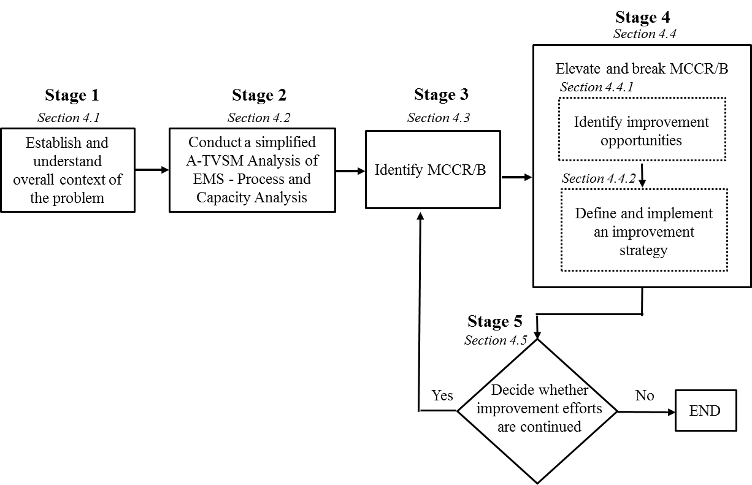

Figure 1. Lean-TOC approach for improving EMS transport and logistics operations

The initial stage of the proposed approach consists in establishing and understanding the overall context of the problem of concern. This is essential as it provides the foundation to take managerial decisions to effectively carry out the subsequent stages of the proposed approach (Rocha-Lona et al., 2013). The overall context of the problem may include establishing and understanding the strategic intent of the company, description of the services provided, its competitive environment and demand as well as the infrastructure utilised to satisfy its mission and market demand, among other general aspects. In relation to understanding the company’s demand, it corresponds to obtaining data regarding and studying the volume and location of emergency service demand. This is a fundamental aspect of the TOC approach to understand the overall context of the system under study (Goldratt et al., 2014), and in this particular case, to determine the quantity of ambulances and its base location required to cover the demand to satisfy certain criteria of performance.

The second stage requires the elaboration of a simplified version of the A-TVSM, as suggested by Villarreal et al. (2017b), of the EMS under improvement. The A-TVSM is developed by following the ambulance from the reception of the emergency call until the ambulance is liberated after handing over the patient to a health institution. This map is used to identify the MCCR or B resource of the process and the status of various performance parameters, e.g. ambulance response time, turnaround and cycle times, patient’s stabilisation time. Ambulance cycle time determines ambulance turnover and ambulance capacity of the EMS process.

The third stage has the objective of defining the MCCR/B of the EMS process, which in this case corresponds to the operation with the highest cycle time. Based on TOC principles, this is the resource that sets the rhythm, or in this case the patients’ throughput, of the process (Goldratt et al., 2014). Hence, all the improvement efforts must be focused on reducing the cycle time of such resource.

The fourth stage consists in identifying, formulating and deploying a waste elimination strategy, or agenda, to elevate and break the MCCR/B identified in the previous stage. Similarly as the traditional VSM tool, the A-TVSM will contribute in identifying the most significant and important wastes, from which improvement initiatives can then be generated for their elimination (Andreadis et al., 2017). These should be implemented until the MCCR/B is broken. Once the cycle time of the MCCR/B has been reduced, the A-TVSM should be updated with the new and improved process parameters. Similarly, the new process capacity is estimated and observed from the results gathered after the implementation of the improvement strategies. This will allow the organisation not only to understand the new operational performance of the EMS transport and logistics operations but to also obtain a view of the magnitude of the improvement achieved. After the fourth stage, the organisation deploying the proposed lean-TOC approach may consider the improvement project terminated. However, if the organisation wishes to seek further improvements to develop a higher potential of its EMS transport and logistics operations, a new MCCR/B can be identified and improved. This can be an ongoing process until no further improvements can be made or the organisation determines that no further improvements should be pursued due to the lack of capability, willingness or cost-benefit.

**4. Lean-TOC Improvement Approach Application**

This section documents, through an exploratory case study, the empirical application of the lean-TOC approach proposed in this work, see Figure 1, to improve the transport and logistics operations of EMSs. Besides serving as a validation method for the proposed approach, the documentation of the case study also contributed in enriching the almost non-existent evidence, as previously established in Section 1, of the application of lean/TOC to address some of the current transport and logistics challenges of EMSs. This is in line with Voss et al. (2002), who suggest that cases study support the development and testing of new theory, e.g. in this case the proposed approach, particularly in the field of operations management (McCutcheon and Meredith, 1993). In the same manner, field case research has been recognised as a valid research method to study and understand specific phenomenon within specific contexts, for example, in this respect the application of lean and TOC for the improvement of EMS transport and logistics operations (Zander et al., 2015; Cameron and Price, 2009). Finally, while conducting the application of the proposed approach, the case study research method proved to be a valuable strategy to document and report the experiences that the authors gained through such deployment (Voss et al., 2002). Therefore, and despite relying in a single and deep observation of a specific phenomenon that does not enable the generalisation of results (Garza-Reyes et al., 2016a), in this study the field case method was an ideal research strategy that effectively supported the enrichment of the limited body of knowledge in this under researched area.

***4.1 Stage 1 - Establishing and Understanding the Overall Context of the Problem of Concern***

The initial stage of the proposed approach involves gaining an understanding of the environment and organisation were the approach would be deployed. In this case, the empirical application of the lean-TOC approach proposed in this work had as its primary objective to improve, i.e. reduce, the EMS’ ambulance cycle time of the Mexican Red Cross branch operating in the Monterrey metropolitan area of the Nuevo Leon state. This particular EMS institution operated in a total of ten locations, seven fixed and three mobile, from which ambulances were dispatched to servicing pre-hospital events. The organisation had 34 ambulance vehicles, but limited financial resources constraint the operation of these to only 50% of the fleet at any given time.

The period of study considered in this work comprised 8 months, i.e. November 2016-June 2017, during which 30,600 emergency calls were recorded. Ninety three percent (93%) of the total emergency calls were related to three main causes, namely: 40% were due to people sickness, 31% due to vehicular accidents, and 22% due to other types of accidents. The rest of the calls, i.e. 7%, were made to address various other causes. The Monterrey Red Cross branch considered that the turnaround time of its EMS needed to be significantly reduced to meet both international standards and a 16% upsurge in demand due to the recent centralisation of emergency calls implemented by the government of the state of Nuevo Leon. This new situation subjected the Monterrey Red Cross branch to a strong pressure on the level of operational cost and the requirements for more capital investment.

***4.2 Stage 2 – Simplified A-TVSM – Process and Capacity Analysis***

The second stage of the proposed lean-TOC approach consists of conducting a simplified A-TVSM to map the EMS operation. The current simplified A-TVSM of the Monterrey Red Cross branch is illustrated in Figure 2. The information required to construct the A-TVSM was gathered from an administrative information system and the GPS and ambulances’ tracking devices. In addition, a team of researchers empirically collected field data by accompanying some of the ambulance vehicles when dispatched to attend some of the emergency calls.

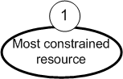

Figure 2. Current A-TVSM of the Monterrey Red Cross branch

The A-TVSM study indicated that the average ambulance response time was 24.7 minutes. In terms of a patient’s stabilisation time, international guidelines recommend a response time for EMSs of a maximum of between 8 to 10 minutes to ensure a successful cardiac and cerebral resuscitation (Blackwell et al., 2009). Thus, a standard time below 10 minutes by paramedics to stabilise the patient at the scene is called Platinum Ten (Watson, 2001). Achieving this time is essential for offering a high standard service. In this case, the average time recorded to stabilise a patient’s health was 64% over the Platinum Ten. Similarly, the A-TVSM revealed that the average time from which the emergency call was placed until the time at which the patient was delivered to a hospital was 77% above the Golden Hour. This is an EMS performance indicator related to the first 60 minutes after a traumatic injury (Rogers et al., 2014). It indicates that injury treatment outcomes improve if definite trauma care is provided within an hour of its occurrence (Newgard et al., 2010). Furthermore, the EMS turnaround time was estimated in 49.1 minutes and total ambulance cycle time averaged 124.9 minutes, with a standard deviation of 117.8 minutes, see Figure 2. The ambulance’s average cycle time indicated a patient throughput per ambulance of 0.48 per hour. Overall, the A-TVSM indicated that transport and logistics operations of case Red Cross did not comply with any of the international standards, establishing a significant gap for improvement.

***4.3 Stage 3 – Identifying MCCR/B***

This stage has the purpose of identifying the MCCR/B of the EMS operation. In the present study, ambulance turnaround had the greatest cycle time with 49.1 minutes, i.e. 39.3% of the total ambulance cycle time, see Figure 2. The second greatest component of the cycle time was determined to be the ambulance response time, which accounted for 19.8% of the total ambulance cycle time. For this reason, the most capacity constrained resource was determined to be the ambulance turnaround time. According to the proposed lean-TOC approach, all improvement efforts must be assigned to the involved resource. This stage may be repeated in a continuous cycle of improvement, see Figure 1, if the management of the health institution desires further operational enhancements after the MCCR/B is elevated and broken in the following stage of the proposed approach.

***4.4 Stage 4 – Elevate and Break MCCR/B - Ambulance Turnaround***

This stage is devoted to the formulation of initiatives for elevating and breaking the identifiedMCCR/B. For this study, this corresponded to activities involved with the arrival of the ambulance to the emergency scene, treatment of the patient and handing it over to the corresponding health institution. The time required for executing these activities corresponded to the MCCR/B, i.e. ambulance turnaround time. Patients were entrusted to various health institutions. From these, five institutions accounted for about 77% of the emergency arrivals of the Red Cross ambulances. These were Hospital de Zona 21 (HZ) with 26%, Hospital Metropolitano (HM) with 23%, Hospital Universitario (HU) with 18%, Clinica 6 del IMSS (IMSS 6) with 6% and Clinica 17 del IMSS (IMSS 17) with 4%.

Emergency calls where serviced by the fleet of ambulances available. However, not all of emergency calls required the transportation of the patient to a health institution. On average, the hourly level of calls that were needed to transfer the patient to a health institution decreased significantly. The daily behaviour of average arrivals to the health institutions is presented in Figure 3. As indicated by this figure, three health institutions received most of these patients; Hospital de Zona (HZ), Hospital Universitario (HU) and Hospital Metropolitano (HM). Two general patterns were identified; a high level of emergency arrivals occurring from 7 to 22 hrs and a low level load pattern during the rest of the day (at night), see Figure 3.

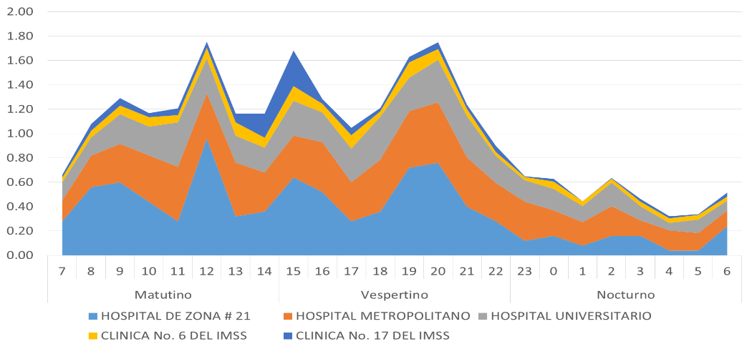

Figure 3. Behaviour of the emergency arrivals to each health institution

***4.4.1 Identification of Improvement Opportunities***

In order to identify the most important causes for long ambulance turnaround times, a sample of 850 observations were taken during the period of August 15th to September 10th, 2017. The observations were gathered from the five health institutions mentioned previously, i.e. HU, HM, HZ, IMSS 6 and IMSS 17. As indicated by Figure 4, the total average turnaround time of the sample was estimated in 59.36 minutes. The highest element of the ambulance turnaround corresponded to stretch liberation with 55.9%. This value was significantly higher than the recommended standard range of 15–30 minutes. HU and IMSS 17 presented the highest turnaround times with 90.4 and 83.5 minutes respectively.



Figure 4. VSM for the EMS operations of the Monterrey Red Cross branch

The New South Wales Ministry of Health (2012) suggests that EMS operations should terminate after the triage, when the patient’s responsibility is transferred to the health institution. Nevertheless, paramedics in the Monterrey Red Cross branch rarely finished their participation at the ideal suggested stage. Due to the lack of stretches available in the health institutions, they were forced to continue “their participation” in the process until there was a way to release the patient safely. For this reason, the ambulance turnaround time increased from an average of 17.7minutes to an average of 59.4 minutes. Thus, the main sources of wastes were waiting for doctors and stretches, excess of movement, and over-processing. Figure 4 illustrates the location of occurrence of these wastes. In summary, the study indicated that paramedics took an average of 41.8 minutes working for the health institution performing tasks that did not correspond to their duty. Additionally, it was observed that the rest of the activities contained a 70% of waste time due to over-processing information, waiting for doctors, nurses and medical students, and excess movements of the patients.

***4.4.2 Defining and Implementing an Improvement Strategy***

Different practical strategies to improve transport and logistics operations have been proposed by Villarreal et al. (2016a; 2016b) and Villarreal et al. (2017a). Taken into consideration these, a brainstorming session was set up and run to generate suitable improvement strategies applicable to this project (Garza-Reyes et al., 2016b). As recommended by Fortune (1992), key stakeholders and experts of the EMS process were involved in the formulation of the improvement strategies, these included paramedics, doctors, operations managers and administrative staff. Three main improvement initiatives generated from the brainstorming session were considered the most appropriate to tackle the excessive ambulance turnaround time, namely: (1) incorporating an ambulance decoupling team; (2) defining and implementing internet based tools to communicate patients information during their transfer to the hospital and the status of stretches in the hospital; and (3) negotiating with the hospitals the Red Cross responsibility in the patient handover process. If the last initiative were to be implemented, it would automatically imply the liberation of the ambulance immediately after the patient triage.

***Incorporating an ambulance decoupling team***

The initiative of the ambulance decoupling team consisted in putting together a crew formed by a paramedic and an assistant per shift and hospital. This team would be responsible for booking the patient from the ambulance crew and proceed with the rest of the activities. The potential decoupling points (Canca and Barena, 2018) could be located right after the arrival of the ambulance to the hospital, or after the execution of the patient triage. The impact of implementing this initiative may be significant if implemented. For instance, total average turnaround time could be reduced to a range of 2 to 18 minutes approximately. Before making a full implementation of this initiative and as suggested by Villarreal et al. (2016b), a simulation model was elaborated to determine the number of stretches and paramedics required to form the ambulance decoupling team. Additionally, a pilot project was carried out to ensure the feasibility of the modification in practice. Similarly, the determination of the crew size and the stretch inventory level at each hospital was facilitated by the use of simulation. Simulation models for the handover processes in HU and HM were developed using the ProModel software suite considering a decoupling point located after the patient triage. The sample of emergency calls taken during the period of August 15th to September 10th, 2017 was used to obtain the probability distribution functions for each activity of the handover processes with the StatFit tool provided by ProModel. The statistical robustness of the models was enhanced with the determination of the warming-up and total simulation periods of the models and the definition of the number of runs. According to the simulation, the minimum turnaround time was achieved with a crew size of two paramedics and a stock of two stretches in both hospitals. The average turnaround time obtained from the simulation models was 12.9 minutes for HM and 17.3 minutes for HU.

The initiative of concern was tested in a two-stage pilot project at HU. This had the objective of making the necessary adjustments for a successful implementation and building confidence (Villarreal et al. 2016a; 2016b). The initial stage considered the location of the decoupling point immediately after executing the patient triage. Then, the team would be responsible to continue performing the rest of the activities, including the stretch recuperation. The second stage of the project was implemented simultaneously with an internet based tool that would enable to transfer patient information from the ambulance to the team while transporting the patient. This information made it possible for the team to receive the patient immediately after arriving to the hospital. The team was then in charge of taking the patient through the triage and the rest of the activities of the handover process.

The implementation of the pilot project, in its first stage, of the ambulance decoupling point was undertaken from October 15th and at the HU. Thus, the results described hereafter are based on the information gathered during 15 days. The total number of observations was 108. The real average turnaround time for HU, during the pilot project period, was estimated in 19 minutes, a 79% reduction from the original.

***Negotiating with the hospitals the Red Cross responsibility in the patient handover process***

This initiative considered the definition of the responsibility boundaries of the Monterrey Red Cross, and the associated hospital, with respect to their participation in the patient handover process. Ideally, the collaboration of the Red Cross should end once that patients pass the triage activity, leaving the patient under the hospital’s responsibility. If the process is conducted in this manner, the ambulance turnaround time would result in a significant reduction. The implementation of this initiative was undertaken for HU and HM with different results. The negotiation with HM was successfully completed, whereas that for HU was dependent on the results obtained from the implementation of the ambulance liberation team. After 13 days and 67 observations, the ambulance turnaround time for HM was estimated in 23.6 minutes during the pilot project period. This achieved level represented a 54% decrease in relation to the original turnaround time.

***Implementing internet based tools***

The internet based tools considered had the objective of achieving a better integration between the ambulance vehicles and the hospital by improving communication and to enhance the control of stretches in the hospital. The impact of the first tool was expected to be at the triage activity, reducing the time taken by about four minutes. The tools identified to monitor the stretches’ status would improve their recovery on time. However, the implementation of this initiative was postponed until the second semester of 2018, until the operating budget for the institution receives approval.

The following steps of the implementation of the first two initiatives in the following two months will be to consider; the implementation of the ambulance decoupling team after the arrival of the ambulance at each hospital HU and HM and; to finish the negotiations to reconsider the responsibility of the Red Cross in the patient handover process in the HU.

***4.5 Stage 4 – Deciding whether improvement efforts are continued***

At this point in the proposed lean-TOC approach, the initial breakpoint would have already been elevated and broken. In this case, and as indicated by the A-TVSM presented in Figure 5, the projected value for the ambulance turnaround time was 3.9 minutes on average. This time would allow the ambulance cycle time to be decreased to 75.8 minutes, increasing its capacity to 5-6 services per shift. Based on this, the Monterrey Red Cross branch decided to continue a new round of improvement to identify the impact of this new ambulance capacity on ambulance response time and the demand coverage within the benchmark standard.

Figure 5. A-TVSM - illustration of the new bottleneck resource

***4.5.1 - Stage 3 – second improvement cycle - Identifying MCCR/B***

As indicated in Figure 5, the new bottleneck activity was associated with the ambulance response to emergency calls. This included (1) receiving the call, (2) assigning and dispatching the ambulance, and (3) transportation to the emergency site. In this case, the total average response time was estimated in 24.7 minutes, with a standard deviation of 12.5 minutes. About 31.5% of this time was associated with the execution of the activities required to prepare the trip of the ambulance to the emergency site. Thirty seven percent (37%) of the emergency calls were responded in less than ten minutes.

***4.5.2 – Stage 4 – second improvement cycle - Elevate and Break MCCR/B –Identification of Improvement Opportunities***

In order to identify improvement opportunities, the daily pattern of emergency calls received by the Monterrey Red Cross branch was analysed. This showed a similar pattern to the daily configuration of emergency arrivals to the health institutions, see Figure 6. In the same way as before, two patterns were recognised, i.e. a low emergency call level per hour at night from 22 to 7 hrs and a high emergency call level per hour during the rest of the day.

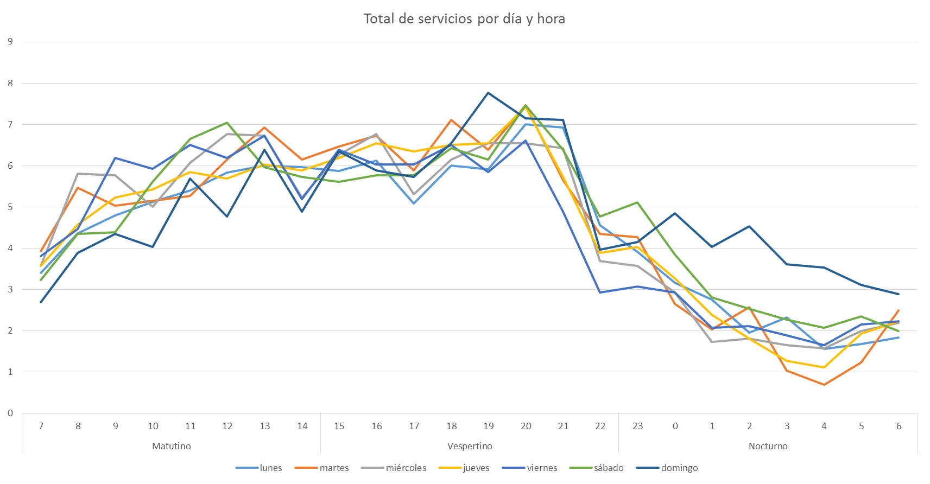

Mon

Tue

Wed

Thu

Fri

Sat

Sun

Figure 6. Behavioural pattern of emergency calls to the Monterrey Red Cross branch

Furthermore, Figure 7 illustrates the (kernel) density map of the emergency calls. The areas with the highest call density corresponded to Monterrey downtown, followed by General Escobedo downtown. The rest of the metropolitan Monterrey region had the same density of emergency calls. Ambulance response time included the ambulance assigning and dispatching times and the time required to get to the scene of the emergency call. From Figure 5, the average time observed before the ambulance departed to service an emergency call was 7.8 minutes. Therefore, the required international standard of 10 minutes was reached without the ambulance being used at all. In addition, the average time taken by the ambulance to reach the call scene was 16.9 minutes.

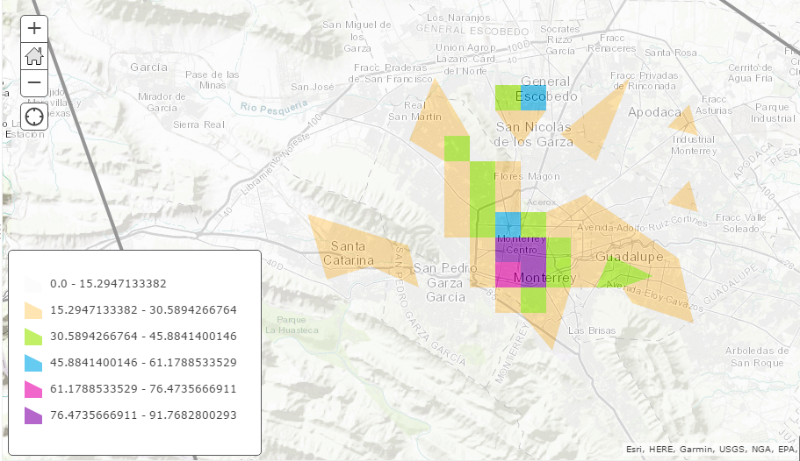

Figure 7. (Kernel) Density map of emergency calls

***4.5.3 – Stage 4 – second improvement cycle - Elevate and Break MCCR/B – Defining and Implementing an Improvement Strategy***

The location of ambulance depots depended upon the behaviour of service density and its dynamics throughout the day and the ambulance desired response time. Considering the daily service demand requirements behaviour illustrated in Figures 6 and 7, two different patterns were identified, a low demand level in the range of two to three services per hour occurring from the 23:01 hrs of a day to 7: 59 A.M. of the following day, and a high demand level with a range of four to five services per hour occurring the rest of the following day. Therefore, two daily ambulance deployment strategies were developed for each day, i.e. a high-demand and a low-demand strategy for all days of the week.

The previously described information set the general context required to guide the determination of ambulance capacity and location. The ambulance location problem has been exhaustively treated in the Operations Research area. For example, Brotcorne et al. (2003) conducted a review of ambulance location and relocation models. Leigh et al. (2016) illustrated a scheme in which a variation of the double standard model used for ambulance dispatching by Gendreau et al. (1997). Maghfiroh et al. (2018) applied a two-stage modelling approach for locating-allocating ambulances in a case study developed in Dhaka, Bangladesh. However, in this work, a similar scheme to the ones suggested by Ong et al. (2010) and Peleg et al. (2004) was employed to derive such strategies. In this line, an ambulance deployment scheme with the support of geospatial analyses and the use of the ESRI Software System was performed in this study.

Its application was carried out in two stages; the first stage consisted on defining the optimal location for the current ambulance fleet in operations. The second stage included the determination of the optimal fleet size required to meet the international standard for ambulance response time. The current location of the ambulances satisfied 37% of the emergency calls with a response time of less than or equal to 10 minutes. Therefore, the first stage involved the definition of the optimal location of the 21 ambulances operating from the 23:01 hrs of a day to 7: 59 A.M. of the following day and the eleven ambulances operating at night. The optimal new locations were determined by using the ESRI Software System considering an ambulance capacity of four services per shift. The expected percentage of emergency calls covered with a response time less than or equal to ten minutes was 87% for the high-demand period. For the low-demand emergency call period, the expected percentage of demand with a response time less than or equal to ten minutes was 75%. Figure 8 illustrates the high-demand recommendation as an example. The expected average response time estimated for this scenario was 5.34 minutes. This increased to 6.63 minutes for the case of low-demand case.

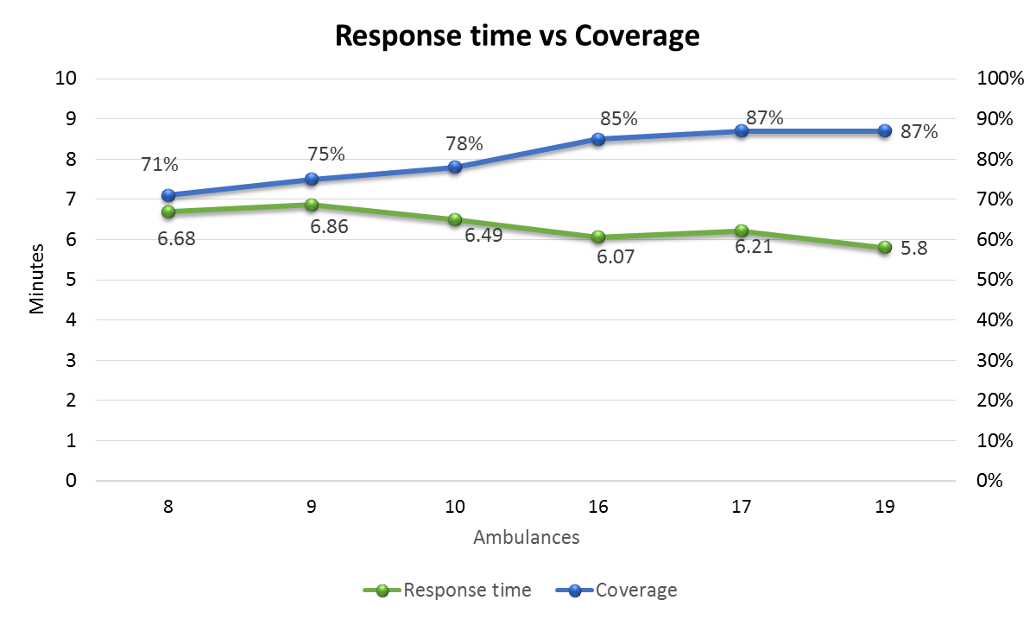

Low Demand Options

High Demand Options

Figure 8. Illustration of the optimal new ambulance location during the high-demand emergency call period

The reduction of the ambulance turnaround time resulted in an increase on ambulance capacity. Figure 9 illustrates the behaviour of the ambulance transport time, from its dispatching at the base until the arrival to the patient scene, and the percentage of calls with service time less than ten minutes in respect to the number of ambulances in operation. Considering an increase in ambulance capacity from 4 to 5 services per day per ambulance, the number of ambulances operating could be reduced to 9 during the night shift without impacting the service level. Similarly, for 19 ambulances operating the rest of the day, the percentage of calls with time of less than 10 minutes was maintained. However, the response time increased by about half a minute. Decreasing two ambulances per day from operations had an impact on cost. Savings on labour cost equivalent to six ambulance crew shifts per day were obtained. Additionally, cost reductions on fuel and maintenance associated to these changes would also be achieved.

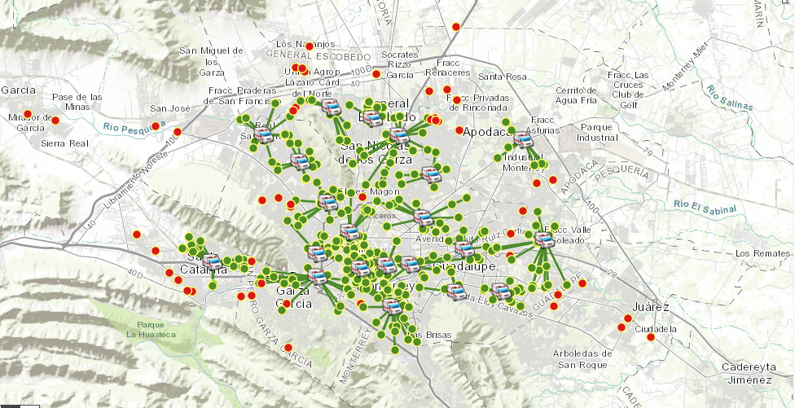

Figure 9. Behaviour of response time and coverage percentage with respect to the number of ambulances.

 In summary, the improvement in ambulance capacity due to the potential reduction in turnaround time had also the potential to positively impact on the service level and operating costs of the Monterrey Red Cross EMS operations. As illustrated in Figure 9, a better location of the ambulances with respect to the emergency call demand can decrease ambulance response time, on average, by about ten minutes. This can improve ambulance cycle time and furthermore its capacity. The expected new cycle time was 65.8 minutes as illustrated in Figure 10.

Figure 10. New improved A-VSM for the Monterrey Red Cross EMS operations

***4.5.4 Stage 5 – second improvement cycle - Deciding whether improvement efforts are continued***

The ambulance re-location improvement initiative broke the second MCCR/B, shifting the focus to a new most constrained activity (Goldratt et al., 2014), i.e. the patient stabilisation activity. In this case, the institution decided to pursue the application of the proposed lean-TOC approach on this activity only until all the modifications suggested so far had been fully implemented and become mature and stable. Thus, the application of the proposed lean-TOC approach and the improvement project it enable in the operations of the Monterrey Red Cross were considered be completed in this stage.

**5. Concluding remarks, limitations and future research**

The improvement of transport and logistics performance of EMSs systems has been mainly addressed through mathematical modelling, operations research, and simulation methods. This paper proposes an alternative and/or complementary improvement approach based on the simultaneous utilisation and adaptation of lean thinking and Theory of Constraint (TOC) methods and tools. Thus, the present research is among the very first studies that have focused on the simultaneous utilisation of the theory of Lean Transportation and TOC principles and tools to drive improvements in EMS transport and logistics operations. For this reason, this study makes significant theoretical and practical contributions to the transport, logistics and process improvement fields by:

* Advancing our knowledge regarding the development of a new improvement approach that considers the adaptation of the emerging theory of Lean Transportation to enable its use for improving EMS operations. This effort includes the redefinition of waste concepts, tools and methodologies, and the modification of the improvement scheme to incorporate it as part of the steps of the Theory of Constraints improvement scheme.
* Documenting the combined application of lean and TOC principles and tools in a real industrial context;
* Serving as a guiding reference for operations managers in healthcare organisations who may wish to conduct similar improvement projects;
* Motivating researchers to undertake further investigations in this relatively under-researched field.

These contributions are beneficial for operations managers in healthcare institutions who aim at improving the operations of their emergency medical services. Due to the broad applicationof lean thinking and TOC as well as the nature of the proposed lean-TOC approach, other non-healthcare based transport and logistics operations are also likely to benefit from this study and the approach proposed. This will occur if operations managers are able to adapt the lean tools used in the proposed approach, e.g. A-TVSM, to the specific contexts of their operations. The entire transport and logistics sector is under constant pressure to operate competitively, and the effective implementation of lean and TOC principles and tools, e.g. through the proposed approach, may provide them with this opportunity. For instance, it would be of great interest to explore the possibility of adapting and applying the proposed approach to other type (sea, air, rail or multimodal) of transport operations. Another possible application of the approach would be the post and parcel industry (Fedex, UPS and others).

In terms of the empirical deployment of the proposed approach, the paper documented its application in the transport and logistics activities of the Red Cross operating in the metropolitan area of Monterrey, Mexico. In particular, the application of the proposed approach aimed at improving the ambulance fleet capacity of the Monterrey Red Cross. Following the proposed approach, the identification of the most constrained capacity resource (MCCR)/bottleneck (B) was facilitated by the elaboration of an A-TVSM. As indicated in Table 1, the first MCCR/B was the patient handover process.This restriction was broken through the definition of three initiatives, namely: (1) the creation of ambulance release teams, (2) the re-negotiation of the responsibility of the Monterrey Red Cross and each hospital in the handover process, and (3) the use of internet-based technology to facilitate communication between the Monterrey Red Cross ambulances and the Emergency departments of the hospitals. Pilot projects were undertaken for the first two initiatives in the HU and HM healthcare institutions. The expected improvements with these initiatives relate to the reduction of ambulance cycle and turnaround times by about 50 minutes, increasing ambulance capacity from 4 to a maximum of 6 services per shift.

The second bottleneck identified corresponded to the response time of the ambulances. The improvement initiative undertaken to address this was the application of mathematical modelling for re-locating ambulances. The benefits expected with this initiative was the enhancement of the emergency call coverage from 37% to 85% within 10 minutes. It was also expected that response time could be decreased by 10 minutes on average, and hence the maximum number of services per ambulance per shift could increase to 7. The analysis conducted on this bottleneck supported the idea that decreasing the number of ambulances would not impact negatively the level of covering service. At the same time, it would enable management to achieve a reduction in the operating cost.

Table 1. Summary of improvement sequence

|  |  |  |  |  |  |
| --- | --- | --- | --- | --- | --- |
| **MCCR/Bnumber** | **Most restricted activity** | **Improvement initiatives** | **Cycle time**  **(minutes)** | **Maximum number of services per shift per ambulance** | **Average response time (minutes)** |
| 1 | Patient handover | * Ambulance decoupling * Negotiation of responsibility in handover process * Use of internet-based technology | 75.8 | 6 | 24.2 |
| 2 | Ambulance transport from base to patient | * Relocation of ambulance bases | 65.8 | 7 | 14.2 |
| 3 | Patient stabilisation | * To be defined | To be defined | To be defined | To be defined |

Finally, although the proposed lean-TOC approach yielded positive results for the Monterrey Red Cross, the use of a single detail case study research method employed in this paper suggests that further research must be carried out to test the method in different industrial settings. This will contribute to the further validation of the applicability and effectiveness of the approach in different industrial situations as previously suggested. For this reason, the collection of further evidence through a multiple case study research method is part of the future research agenda proposed from this work. The limited use of lean thinking and TOC principles and tools highlighted in this paper to improve transport and logistics operations in EMSs may indicate that there is no clear understanding of the benefits that their combination may bring to enhance this type of operations. This article has provided some evidence of this, and can hence serve as a driver to undertake further research in this area.

**References**

Ak, A., Erera, A.L. (2007), “A Paired-Vehicle Recursive Strategy for the Vehicle Routing Problem with Stochastic Demands”, *Transportation Science*, 41(2), 222–237.

Andreadis, L., Garza-Reyes, J.A., Kumar, V. (2017), “Towards a conceptual framework for Value Stream Mapping (VSM) implementation: An investigation of managerial factors”, *International Journal of Production Research*, 55(23), 7073-7095.

Barber, S., Tietje, B.C. (2008), “A Research Agenda for Value Stream Mapping the Sales Process”, *Journal of Personal Selling & Sales Management*, 28(2), 155–165.

Bentley, T.G.K., Effros, R.M., Palar, K., Keeler, E.B., (2008), “Waste in the U.S. Health Care System: A Conceptual Framework”, *The Milbank Quarterly*, 86(4), 629–659.

Berhan, E., Beshah, B., Kitaw, D., Abraham, A. (2014), “Stochastic Vehicle Routing Problem: A Literature Survey”, *Journal of Information & Knowledge Management*, 13(3), 1450022 (12 pages).

Blackwell, T.H., Kaufman, J.S. (2002), “Response Time Effectiveness: Comparison of Response Time and Survival in an Urban Emergency Medical Services System”, *Academic Emergency Medicine*, 9(4), 288-295.

Blackwell, T.H., Kline, J.A., Willis, J.J., Hicks, G.M. (2009), “Lack of Association between Prehospital Response Times and Patient Outcomes”, *Prehospital Emergency Care*, 13(4), 444 – 450.

Brandao, D.S.L. (2009), Trends and approaches in lean healthcare, *Leadership in Health Services*, 22(2), 121–139.

Brotcorne, L., Laporte, G., Semet, F. (2003), “Ambulance location and relocation models”, *European Journal of Operational Research*, 147(3), 451–463.

Cameron, S., Price, D. (2009), *Business Research Methods: A Practical Approach*, Chartered Institute of Personal and Development, London.

Canca, D., Barrena, E. (2018), “The integrated rolling stock circulation and depot location problem in railway rapid transit systems”, *Transportation Research Part E: Logistics and Transportation Review*, 109, 115-138.

Caunhye, A.M., Nie, X., Pokharel, S. (2012), “Optimization models in emergency logistics: A literature review”, *Socio-Economic Planning Sciences*, 46(1), 4-13.

Chalice, R. (2007), *Improving Healthcare Quality using Toyota lean Production Methods: 46 Steps for Improvement*, 2nd ed., Quality Press, Milwaukee, WI.

Chen, M.N., Lyu, J.J. (2009), “A Lean Six-Sigma Approach to Touch Panel Quality Improvement”, *Production, Planning & Control*,20(5), 445–454.

Fitch, J.J., Knight, S., Griffiths, K., Gerber, M. (2015), *The new EMS imperative: Demonstrating value*, Infocus, *ICMA Publishing*, 47(1), 1–19.

Forrester, P.L., Shimizu, U.K., Soriano-Meier, H., Garza-Reyes, J.A., Cruz Basso, L.F. (2010), “Lean Production, Market Share and Value Creation in the Agricultural Machinery Sector in Brazil”, *Journal of Manufacturing* *Technology Management*,21(7), 853–871.

Fortune, J. (1992), “Idea Generation Techniques for Quality Improvement”, *International Journal of Quality and Reliability Management*, 9(6), 32–38.

Garza-Reyes, J.A., Parkar, H.S., Oraifige, I., Soriano-Meier, H., Harmanto, D. (2012), “An empirical-exploratory study of the status of lean manufacturing in India”, *International Journal of Business Excellence*, 4(5), 395-412.

Garza-Reyes, J.A., Villarreal, B., Kumar, V., Molina Ruiz, P. (2016a), “Lean and Green in the Transport and Logistics Sector – A Case Study of Simultaneous Deployment”,*Production Planning & Control*, 27(15), 1221-1232.

Garza-Reyes, J.A., Al-Balushi, M., Antony, J., Kumar, V. (2016b), “A Lean Six Sigma framework for the reduction of ship loading commercial time in the Iron Ore Pelletising industry”, *Production Planning & Control*, 27(13), 1092-1111.

Garza-Reyes, J.A., Beltran Forero, J.S., Kumar, V., Villarreal, B., Cedillo-Campos, G., Rocha-Lona, L. (2017), “Improving road transport operations using lean thinking”, *Procedia Manufacturing,* 11, 1900-1907*, 27th International Conference on Flexible Automation and Intelligent Manufacturing (FAIM)*, Modena, Italy, 27-30 June.

Gendreau, M., Laporte, G., Semet, F. (1997), “Solving an ambulance location model by tabu search”, *Location Science*, 5(2), 75–88.

Goldratt, E.M., Cox, J., Whitford, D. (2014) *The Goal: A Process of Ongoing Improvement*, 3rd revised, 30th anniversary edition, North River Press, Great Barrington, MA.

Graban, M., (2016), *Lean Hospitals: Improving Quality, Patient Safety and Employee Engagement*, 3rd edition, CRC Press, Boca Raton, FL.

Guan, T.S., Mason, K., Disney, S. (2003), “MOVE: Modified Overall Vehicle Effectiveness”, *8th International Symposium on Logistics*, Seville, Spain, July 2003.

He, Y., Liu, N. (2015), “Methodology of emergency medical logistics for public health emergencies”, *Transportation Research Part E: Logistics and Transportation Review*, 79, 178-200.

Hines, P., Holweg, M., Rich, N., (2004), “Learning to Evolve.” *International* *Journal of Operations and Production Management,* 24(10), 994–1011.

Hines, P., Taylor, D. (2000), *Going Lean*, Cardiff: Lean Enterprise Research Centre, Cardiff Business School.

Hines, P., Rich, N., Esain, A. (1999), “Value Stream Mapping: A Distribution Industry Application”, *Benchmarking: An International Journal*, 6(1), 60–77.

Hussain, M., Khan, m. and Sabir, H., (2016), “Analysis of Capacity Constraints on the Backlog Bullwhip Effect in the Two-tier Supply Chain: A Taguchi Approach”, *International Journal of Logistics Research and Applications*, 19(1), 41-61.

Joint Commission on Accreditation of Healthcare Organizations (2006), *Doing more with less: lean thinking and patient safety in healthcare*, Joint Commission Resources, Oak Brook, IL.

Jones, D. T.,Hines, P., Rich, N. (1997), “Lean Logistics”, *International Journal of Physical Distribution & Logistics Management*, 27 (3/4), 153–173.

Leigh, J.M., Dunnett, S.J., Jackson, L.M. (2016), “Predictive policing using hotspot analysis”, *Proceedings of the International Multiconference of Engineers and Computer Scientists*, Vol. II, IMECS 2016, Hong Kong, March 16–18.

Maghfiroh, M.F.N., Hossain, M., Hanaoka, S., (2018), “Minimising Emergency Response Time of Ambulances Through Pre-positioning in Dhaka City, Bangladesh”, *International Journal of Logistics Research and Applications*, 21, (1), 53-71.

McCutcheon, D., Meredith, J. (1993), “Conducting Case Study Research in Operations Management”, *Journal of Operations Management*,11(3), 239–256.

Meilinda, F.M.N., Hossain, M., Hanaoka, S. (2018), “Minimising emergency response time of ambulances through pre-positioning in Dhaka city, Bangladesh”, *International Journal of Logistics Research and Applications*, 21(1), 53-71.

Newgard, C.D., Schmicker, R.H., Hedges, J.R., Trickett, J.P., Davis, D.P., Bulger, E.M., Aufderheide, T.P., Minei, J.P., Hata, J.S., Gubler, K.D., Brown, T.B., Yelle, J., Bardarson, B., Nichol, G. (2010), “Emergency Medical Services Intervals and Survival in Trauma: Assessment of the “Golden Hour” in a North American Prospective Cohort”, *Annals of Emergency Medicine*, 55(3), 235–244.

Ohno, T. (1988), *Toyota Production System: Beyond Large-Scale Production*, Productivity Press, Portland, OR.

Ong, M.E., Chiam, T.F., Ng, F.S., Sultana, P., Lim, S.H., Leong, B.S., Ong, V.Y., Tan, E.C., Tham, L.P., Yap, S., Anantharaman, V. (2010), “Reducing ambulance response times using geospatial-time analysis of ambulance deployment”, *Academic Emergency Medicine*, 17(9), 951–957.

Peleg, K., Pliskin, J.S. (2004), “A geographic information system simulation model of EMS: Reducing ambulance response time”, *American Journal of Emergency Medicine,* 22(3), 164–170.

Rocha-Lona, L., Garza-Reyes J.A., Kumar, V. (2013), *Building quality management systems: selecting the right methods and tools*, Productivity Press, CRC Press, Taylor & Francis, Boca Raton, FL.

Rogers, F.B, Rittenhouse, K. (2014), “The Golden Hour in Trauma: Dogma or Medical Folklore?”, *The Journal of Lancaster General Hospital*, 9(1), 11–13.

Siller, M, Villarreal, B., Melissa Rosselly, M. (2013), “A Theory of Constraints Approach to Achieve Agility: An Application”, *The 2nd Industrial and Systems Engineering World Conference*, Las Vegas, NV, USA, November 5-7.

Simmons, D., Mason, R., Gardner, B. (2004), “Overall Vehicle Effectiveness”, *International Journal of Logistics Research and Applications*, 7(2), 119–134.

Singh, B., Sharma, S.K. (2009), “Value Stream Mapping as a Versatile Tool for Lean Implementation: An Indian Case Study of a Manufacturing Firm”, *Measuring Business Excellence*, 13(3), 58–68.

Sinreich, D., Marmor, Y. (2005), “Emergency department operations: The basis for developing a simulation tool”, *IIE Transactions*, 35(3), 233-245.

Soriano-Meier, H., Forrester, P., Markose, S., Garza-Reyes, J.A. (2011), *“*The role of the physical layout in the implementation of lean management initiatives”, *International Journal of Lean Six Sigma*,2(3), 254-269.

Sternberg, H. and Harispuru, L., (2016), “Identifying Root Causes of Inefficiencies in Road Haulage: Case Studies From Sweden, Switzerland and Germany, *International Journal of Logistics Research and Applications*, 20(1), 73-83.

Sternberg, H., Stefansson, G., Westernberg, E., Boije af Gennas, R., Allenstrom, E., Nauska, M.L. (2013), “Applying a Lean Approach to Identify Waste in Motor Carrier Operations”, *International Journal of Productivity and Performance Management*, 62(1), 47–65.

Sutherland, J.L., Bennett, B. (2007), *The Seven Deadly Wastes of Logistics: Applying Toyota Production System Principles to Create Logistics Value*, White Paper No. 701, Center for Value Chain Research, Lehigh University, August.

Taylor, L., Martichenko, R. (2006), “Lean Transportation-Fact or Fiction?”, Executive White Paper, [www.fedex.com](http://www.fedex.com), September.

Teichgräber, U.K., de Bucourt, M., (2012), “Applying Value Stream Mapping Techniques to Eliminate Non-Value-Added Waste for the Procurement of Endovascular Stents”, *European Journal of Radiology*, 81(1), e47–e52.

Villarreal, B. (2012), “The Transportation Value Stream Map (TVSM)”, *European Journal of Industrial Engineering*, 6(2), 216–233.

Villarreal, B., Sañudo, M., Vega, A., Macias, S., Garza, E. (2012), “A Lean Scheme for Improving Vehicle Routing Operations”, *Proceedings of the 2012 International Conference on Industrial and Operations Management*, Istanbul, Turkey, July 3–6.

Villarreal, B., Macias-Sauza, S., Garza-Varela, E., (2013) “An Efficiency Improvement Approach to Reduce Transportation Cost: An Application”, *Industrial and Systems Engineering Review*, 1(2), 153–161.

Villarreal, B., López, N. (2014), “A TOC-OEE Based Scheme to Improve Productivity”, *Proceedings of the 2014 International Conference on Industrial Engineering and Operations Management* *(IEOM)*, Bali, Indonesia, January 7-9.

Villarreal, B., Garza-Reyes, J.A., Kumar, V. (2016a), “Lean road transportation – a systematic method for the improvement of road transport operations”, *Production Planning & Control*, 27(1), 865-877.

Villarreal, B., Garza-Reyes, J.A., Kumar, V. (2016b), “A lean thinking and simulation-based approach for the improvement of routing operations”, *Industrial Management & Data Systems,* 116(5), 903-925.

Villarreal, B., Elizondo, M.M., Morales, B., Turrubiates, M. (2016c), “A TOC-OEE Driven Approach to Increase Order On-Time Delivery”, *Proceedings of the 2016 Industrial and Systems Engineering Research Conference*, H. Yang, Z. Kong & M.D. Sarder, eds, Anaheim, CA, May 21-28.

Villarreal, B., Elizondo, M.M., Morales, B., Turrubiates, M. (2016d), “A toc-oee driven approach to increase order on-time delivery”, *Proceedings of the 2016 Industrial and Systems Engineering Research Conference*, Anaheim, CA, May 21-28, 2016.

Villarreal, B., Garza-Reyes, J.A., Kumar, V., Lim, M.K. (2017a), “Improving road transport operations through lean thinking: A case study”, *International Journal of Logistics Research and Applications*, 20(2), 163-180.

Villarreal, B., Granda-Gutierrez, E.A., Lankenau, S., Bastidas, A.C., Montalvo, A. (2017b), “Decreasing Ambulance Response Time Through an Optimal Base Location”, *Proceedings of the 2017 International Symposium on Industrial Engineering and Operations Management (IEOM)*,Bristol, UK, July 24-25.

Vinodh, S., Gautham, S.G., Ramiya, A. (2011), “Implementing Lean Sigma Framework in an Indian Automotive Valves Manufacturing Organisation: A Case Study”, *Production Planning & Control*, 22(7), 708–722.

Voss, C., Tsikriktsis, N., Frohlich, M. (2002), “Case Research in Operations Management”, *International Journal of Operations and Production Management*, 22(2), 195–219.

Watson, L., (2001), *The Platinum Ten*, ResQMed, Halstead, available at: <http://www.resqmed.com/GoldenHourPlatinum10.pdf> (accessed 8 January 2018).

Wee, H.W., Wu, S. (2009), Lean supply chain and its effect on product cost and quality: a case study on Ford Motor Company”, *Supply Chain Management: An International Journal*, 14(5), 335-341.

Zander, S., Trang, S., Kolbe, L.M. (2015), “Drivers of Network Governance: A Multitheoretic Perspective with Insights from Case Studies in the German Wood Industry”, *Journal of Cleaner Production*, 110, 109-120.

Zhang, S., Cardin, M.A. (2017), “Flexibility and real options analysis in emergency medical services systems using decision rules and multi-stage stochastic programming”, *Transportation Research Part E: Logistics and Transportation Review*, 107, 120-140.