ELS

Climate Change and Insectivore Ecology

A28030

Jim Vafidis^{1,3}
Jeremy Smith^{2,3}
Robert Thomas^{2,3}

¹ Faculty of Applied Sciences, University of the West of England, Bristol, UK
² School of Biosciences, Cardiff University, Cardiff, UK
³ Eco-explore Community Interest Company www.eco-explore.co.uk

Abstract

The impacts of climate change on natural populations are only beginning to be understood. Although some important changes are already occurring, in the future these are predicted to be more substantial and of greater ecological significance. Insects are a key taxonomic group for understanding the ecological impacts of climate change, due to their responsiveness to environmental change and importance as food for other organisms. Insects are highly sensitive to rising temperatures, changes in rainfall patterns and erratic weather conditions, driving rapid short-term variations in their abundance, mobility, distribution and phenology. Such variations represent changes in their availability as prey to insectivores, a diverse range of insect-eating animals that include mammals, fish, amphibians, reptiles, and birds. The impacts of these changes on the ecology of insectivores are complex and include population increases or decreases, broad-scale shifts in distribution, and changes in behavioural traits such as foraging strategy, investment in parental care, and the timing of breeding and migration. Although some insectivorous species are able to respond to- and even benefit from- climate change, those that fail to respond appropriately may struggle to reproduce, disperse and survive, leading to population decline and ultimately, to extinction.

Key words

Insectivore ecology, climate change, phenology, trophic cascade, trophic mismatch.

Key Concepts

- Insects are a key taxonomic group in most terrestrial and freshwater ecosystems, providing an important trophic resource for insectivores.

- Climate change is already causing major shifts in the distribution, phenology, behaviour, abundance and diversity of insect populations, with complex consequences for insectivores.

- Climate change may benefit some insectivores by increasing food availability and providing more suitable conditions for reproduction.

- Specific benefits to insectivores include earlier parturition, faster development of juveniles and range expansion.

- Warmer temperatures may also cause negative impacts on insectivores, through more frequent and intense heat waves and reduced water availability in arid environments.

- The negative impacts are expected to be more severe for taxa that are less able to disperse or migrate to escape unfavourable conditions, and thus less able to shift range to track the changing conditions.

- The timing of biological events (phenology), will be affected –primarily by advancing the dates at which insects become active in spring, and extending the length of the active season of insects in temperate and boreal regions.

- Important gaps in our knowledge remain; for example, despite the large biomass and species richness of insects in the tropics the impacts of climate change on tropical insectivores remain largely unknown.

Introduction

Climate change is typically described in terms of long-term increases (across multiple years or decades) in average global temperatures, but the overall warming of the planet is highly variable across local and regional scales. Although climate change has been well documented over the last century, the most significant changes have mainly occurred over the last 40 years (Walther et al., 2002). As well as rising temperatures, climate change includes disruptions in the patterns of other meteorological variables including rainfall, humidity, solar radiation and wind, in which the changes are less predictable. Weather is the short-term manifestation of climate on a scale of days to weeks; extreme weather events such as heat-waves, droughts, storms and floods are also becoming more frequent and more intense.

Inevitably, by varying abiotic conditions, climate change can have substantial direct effects on the biotic components of ecosystems. Insects are one such biotic component that, by being small and having relatively rapid life-cycles, are strongly affected by changes in temperature, rainfall and wind. Physiologically, their development, metabolism, activity, and phenology are all strongly influenced by their local conditions. Increases in temperature are linked with higher rates of insect activity, higher survival, increases in fecundity, accelerated life-cycles, and greater rates of dispersal (Bale et al., 2002; Wilf, 2008).

Insects are the most abundant and diverse animal group on Earth, and are present in practically all freshwater and terrestrial ecosystems. As such, changes in their abundance, activity, distribution and phenology will have important ramifications for their roles as herbivores, detritivores, predators, and parasitoids, but also as prey to a carnivorous guild of mammals, amphibians, reptiles, birds, fish, other invertebrates, and even plants. These are the insectivores, which rely on insects and other invertebrates as food, either as their primary diet across the annual cycle, or as a protein supplement during the breeding season. Although climate change biology is an active area of research, the majority of the research on insectivores so far has focused on terrestrial vertebrates including birds, mammals, and reptiles. Rather than attempt to describe the reported impacts on all insectivorous taxa, we have focused this review upon these groups.

Insectivores play an important regulatory role in their ecosystems by suppressing arthropod populations of ecto-parasites, herbivores and predators. For example, the little brown bat Myotis lucifugus can consume up to 1,200 mosquitos (Culicidae) in one hour (Ducummon 2000), and a colony of 150 big brown bats Eptesicus fuscus are capable of consuming 50,000 leafhoppers (Cicadellidae), 38,000 cucumber beetles (Diabrotica and Acalymma), 16,000 June bugs (Phyllophaga) and 19,000 stink bugs (Pentatomidae), over the course of one breeding season (Whitaker 1995). Climate-driven changes in the spatial and temporal availability of prey as well as other resources including water and suitable foraging habitat, can have important implications for insectivore populations. The reported impacts include changes in abundance, geographical shifts towards the poles and towards higher elevations, and the timing of seasonal events. In this review, we assess the evidence for such impacts, examine the mechanisms by which these impacts may be mediated, and discuss the future conservation of insectivores in a rapidly changing world.

Changes in abundance of insectivores

There are several reported instances of changes in insectivore abundance observed at the local and regional scales that have been attributed to the effects of climate change, particularly increases in temperature, changes in rainfall patterns and higher frequency of extreme climatic events. Changes in these parameters can both directly and indirectly affect rates of insect survival and fecundity, which together lead to changes in insect population size. The direct physiological effects of rising temperatures are more significant for ectothermic species such as reptiles and amphibians, which are less able to thermoregulate effectively compared to endotherms such as mammals and birds. Reptiles in particular are susceptible to very high temperatures, which force them to spend more time sheltering in the shade, rather than foraging for insects. For example, energetic shortfalls during hot spring weather prevent Mexican populations of Sceloporus lizards from breeding, leading to decreases in lizard population size and local extinction of several local populations (Sinervo et al., 2010).

In some circumstances, the dynamics of insectivore populations seem to be more strongly affected by minimum temperatures rather than average temperatures. Bats, as small endotherms occupying temperate regions, have to expend large amounts of energy on thermal regulation when ambient temperatures are low. During unfavourable conditions such as low temperatures, or prolonged wet and stormy conditions, bats can also use brief periods of torpor or protracted hibernation, to reduce energy expenditure (Geiser and Turbill 2009). Minimum roost temperatures are rising with climate change, which lowers the cost of thermoregulation and enables bats to invest more energy in breeding activities and embryonic development (McNab and O’Donnell 2018).

The lesser and greater horseshoe bats (Rhinolophus hipposideros and Rhinolophus ferrumequinum respectively) are two species that suffered steep population declines in the UK during the second half of the 20th Century, due to prolonged periods of freezing temperatures (Ransome and McOwat 1994). Although milder winter temperatures reduce mortality rates among hibernating bats, warmer spring temperatures cause bats to emerge from hibernation earlier in the year. Such periods of emergence are energetically costly if there is insufficient prey for the bats to feed on. Starvation and dehydration are major causes of mortality among early-emerging bats (Jones et al., 2009). Most temperate bat species mate in autumn or winter, and females delay fertilization by storing spermatozoa in their reproductive tract until conditions are suitable for reproduction in late spring (Racey and Entwistle 2000). Stored sperm can quickly die in active individuals if the conditions are not yet suitable to initiate ovulation and pregnancy, compromising reproductive success during the breeding season (Sherwin et al., 2013).

Even during spring, summer and autumn, flying insects in temperate regions are less active when night temperatures drop below 10ºC (Jones et al., 2009). For many temperate-zone insects, this temperature is a thermal threshold for flight, below which, aerial hawking bats struggle to find prey. Warmer and drier night temperatures improve foraging conditions for aerial hawking species of bat, by increasing the activity of flying insect prey (Sherwin et al., 2013). Consequently, warmer foraging conditions are associated with higher rates of pregnancy and lactation, faster juvenile development, and population growth (Ransome and McOwat 1994; Linton and Macdonald 2018).

In high temperatures, bats are highly susceptible to evaporative water loss due to the large surface-to-volume ratio of their wing membranes. Increasing frequency of drought conditions in arid regions increases energetic costs for bats, which must make regular trips to drink at nearby water sources. This is particularly problematic for lactating females, which require large volumes of water (Webb et al., 1995). The reproductive success of Myotis bat species in arid regions is predicted to decline by 84% with an increase in temperature of 5°C and a reduction in water availability (Figure 1, Adams and Hayes 2008).

The effects of changes in food availability are especially evident in species with high metabolic rates. Shrews (Sorex spp.) breeding in temperate regions must spend a large proportion of their waking hours hunting for ground invertebrates such as beetles (Coleoptera). Climate warming, at least in the short term, is predicted to improve rates of survival, growth and reproduction of shrews (Newman and Macdonald 2013) by increasing the abundance and activity of invertebrate prey (Graham and Grimm 1990; Berthe et al., 2015).

There is much evidence for the positive effect of warmer spring temperatures on breeding success, productivity and survival of birds, through greater prey availability. Instances of very high temperatures can, however, have a negative effect on breeding success and survival of aerial insectivorous birds, by reducing the abundance of flying insects. This is particularly problematic for aerial insectivores such as crag martins Ptyonoprogne rupestris breeding in southern Europe. Drought conditions in the Alpine rivers and streams can lead to shortages of flying insect populations, which can result in nestling starvation (Acquarone et al., 2003).

Survival and population size in white-throated dippers Cinclus cinclus in temperate regions are strongly influenced by winter temperatures. In particular, carrying capacity and winter mortality are dependent on the extent of ice formation over the streams in which dippers hunt for aquatic invertebrates. Milder winter temperatures increase the availability and accessibility of prey, leading to lower mortality rates among dippers, and consequent population growth (Loison et al., 2002; Nilsson et al., 2011).

Changes in distribution of insectivores

The geographical and altitudinal distribution of a species represents the spatial extent of suitable conditions represented by available habitat, environmental tolerances, and sufficient food resources. The distribution of a species is not static but expands, contracts and shifts dynamically in response to natural variation in conditions within and between years. For example, the European breeding distribution of golden plovers Pluvialis apricaria depends on the synchronised emergence of their cranefly (Tipulidae) prey when their chicks hatch. The abundance of emerging craneflies at this time is higher following a period of low temperatures (15°C) during the previous August (Pearce-Higgins 2010). Warmer late summer temperatures reduce the emergence rates of craneflies at lower altitudes, which drives golden plovers to breed at higher altitudes where the temperatures are low enough to maintain high cranefly emergence rates (Pearce-Higgins et al., 2005; 2010). Temperature variation between years drives altitudinal shifts in suitable breeding conditions, but the long-term trend of increasing temperatures is gradually pushing golden plovers to breed at ever-higher altitudes, where higher altitude terrain is available.

There are numerous studies describing long-term range shifts of insectivorous species associated with climate change, although it is unknown whether these are directly mediated by changes in insect prey resources. Many of these shifts are of mid-to high latitude species shifting toward the poles or towards higher altitudes. Northward range expansions have been observed among populations of insectivorous bats, including Nathusius’ pipistrelle Pipistrellus nathusii and insectivorous birds such as Cetti’s warbler Cettia cetti. These expansions have been driven by increasing minimum temperatures and increasing availability of suitable habitats (Robinson et al., 2007; Sherwin et al., 2013). Bioclimatic modelling predicts that there will be twice as much suitable habitat for Nathusius’ pipistrelle in the UK by 2050, under projected climate conditions (Lundy et al., 2010; Figure 2). The Cetti’s warbler is a non-migratory insectivorous wetland songbird that has advanced its northern range limit northwards from central and southern Europe to northern France and the UK (Birdlife International 2017), in association with warmer overwinter temperatures. It is unclear whether warmer winter temperatures increase survival due to fewer and less protracted freezing events, or because of the resulting increase in food availability; indeed it is likely that both mechanisms act in concert (Robinson et al., 2007).

It is predicted that isotherms in temperate latitudes will shift 300-400 km polewards and 500 m in elevation, with each 3°C increase in the average global temperature (Hughes 2000). Insects and their insectivorous predators are expected to track these conditions polewards and to higher elevations. The ability to physically move in response to changing resources or environmental conditions depends upon the dispersal capability of the species and the availability of unoccupied habitat where the new resources or conditions exist. This may be more feasible for aerial species of birds and bats, but may be more difficult for less mobile, ground-based taxa such as amphibians, reptiles and small mammals. These taxa may face obstacles to movement, including natural barriers such as mountain ranges and oceans, and fragmentation of suitable habitat to disperse through, in an increasingly agricultural and urbanized landscape (Levinsky et al., 2007). Furthermore, any poleward and altitudinal shifts in suitable thermal conditions can only be matched by insects and their predators if there is higher altitude terrain or higher latitude land available for the organisms to move into, which may not always be the case.

Changes in the phenology of insectivores and their insect prey

Phenology, the timing of periodic life cycle events such as reproduction and migration, is strongly associated with climate (Walther et al., 2002; Linton and Macdonald 2018). There is compelling evidence for long-term impacts of rising temperatures on the phenology of insects, representing both fitness benefits and costs for insectivores.

Reproduction is energetically expensive and requires a lot of food to support the production, parturition and provisioning of offspring. It is no coincidence that the timing of breeding in insectivorous taxa is generally timed to coincide with the period of greatest insect abundance. In temperate ecosystems, the seasonal timing of this peak in insect prey availability is advancing with warmer spring temperatures, and some insectivore populations are failing to adjust their timing sufficiently to maintain synchrony with the availability of their food supply. Both et al. (2006) have shown this trophic mismatch effect among pied flycatchers Ficedula hypoleuca breeding in oak woodlands, which have advanced their laying date at a slower rate than that of their caterpillar prey. There are, however, examples of successful phenological adaptation in response to shifts in the timing of prey abundance in insectivorous birds, bats and reptiles (Urban et al., 2014; Linton and Macdonald 2018) such as Brazilian free tailed bats Tadarida brasiliensis, in Texas advancing migration initiation by two weeks over 22 years, to match shifts in prey availability (Stepanian and Wainwright 2018).

Beyond obtaining a sufficient supply of food for breeding activities, an advancement in the timing of reproduction can have important fitness benefits for breeding adult insectivores and their offspring. For example, in bats, earlier breeding provides a longer period leading up to winter in order to store fat reserves, which increases over-winter survival (Sherwin et al., 2013). Little brown bat pups born earlier in the summer have higher survival and greater breeding probabilities than those born later (Frick et al., 2009). In birds, earlier breeding is associated with larger clutch sizes (Von Haartman 1982), increased offspring survival (Figure 3, Naef-Daenzer et al., 2001) and a greater opportunity to complete multiple broods within a single breeding season (Halupka et al., 2008).

Climate change may influence the phenology of organisms unequally across trophic levels, commonly advancing the phenology of invertebrate populations at a faster rate to that of the insectivores. This can result in a “trophic mismatch” between the timing of reproduction by insectivores and the timing of peak abundance of their invertebrate prey (Ovaskainen et al., 2013). Such trophic mismatches can have large impacts on reproductive success among birds, particularly by impairing offspring growth and reducing survival (Daan et al., 1989; Rodenhouse and Holmes 1992). Trophic mismatch is a particular problem for insectivores breeding in highly seasonal habitats, in which the opportunity to breed is constrained to a short time-window, whereas across many less seasonal habitats, trophic mismatch may be a relatively rare phenomenon and of much less importance in driving changes in insectivore populations.

A particularly well-studied example of a trophic mismatch in terrestrial ecosystems is between birds and their invertebrate prey in temperate oak (Quercus) woodlands. Oak woodlands exhibit a brief period of productivity in spring, when oak leaf burst prompts the mass emergence of geometrid moth caterpillars, which feed on the young leaves before they contain too much tannin and phenolic compounds to be edible. This feeding period occurs within a brief period of around three weeks (Burger et al., 2012) in which the caterpillars provide the main prey for songbirds such as migratory pied flycatchers Ficedula hypoleuca and resident great tits Parus major provisioning their nestlings, after which spiders become the primary prey as the nestlings grow larger (Pagani-Núùñez et al., 2011). Increasing spring temperatures advance the timing of oak leaf burst and caterpillar emergence. Although birds are advancing their laying date to synchronise the period of nestling provisioning with changes to food availability, if they cannot match the rate of change in caterpillar phenology, the nestlings will be increasingly prone to starvation (Figure 4, Both et al., 2009). See also: DOI: 10.1002/9780470015902.a0020484.pub2.

Resident insectivore species that remain on the breeding grounds (e.g. great tits), appear better able to avoid trophic mismatches than long-distance migrants (e.g. pied flycatchers), whose timing of arrival on the breeding grounds is strongly constrained by factors operating far away on the wintering grounds. Substantial mismatches tend to occur for long-distance migrants, which fail to adjust the onset of breeding to match the changes in timing of insect abundance. For example, in one study, caterpillar peak abundance advanced by 7.5 days per decade between 1988 and 2005, while pied flycatcher hatching only advanced by 5 days per decade over the same period (Both et al., 2009). In contrast, resident insectivores are able to adjust the timing of their breeding in order to avoid shortages during the nestling period.

Migratory insectivorous wading birds breeding in Arctic wetlands rely on seasonal peaks of emergent invertebrate taxa (particularly mosquitoes and chironomids), to feed their young (Schekkerman et al., 2003). The effects of climate change include dramatic changes in spring temperatures and water levels (Gilg et al., 2009), which can cause large shifts in the timing of invertebrate availability. The environmental cues used by migrant species to initiate departure from the wintering grounds include changes in daylength or availability of food, neither of which are closely linked to conditions on the breeding grounds. The potential for trophic mismatch is increasing and such mismatches are implicated in the decline of migratory insectivores breeding in highly seasonal habitats.

For some species, the timing of food peaks is not the most important selective pressure for the optimal timing of reproduction. For example, sanderling Calidris alba breeding in Greenland have not advanced their hatching dates despite the median date of invertebrate emergence shifting forward by 12.7 days per decade, between 1996 and 2013 (Reneerkens et al., 2016). For sanderling, avoiding the high rates of nest predation by Arctic foxes Vulpes lagopus early in the breeding season is more important than matching the nestling phase with high food peaks.

There is no evidence of phenological mismatch affecting insectivorous bird populations breeding in less seasonal habitats such as temperate wetlands. In this habitat, macro-benthic insects emerge continuously throughout the summer months, providing a protracted period of abundant prey supply for insectivores (Dunn et al., 2011). Warmer spring temperatures are predicted to lengthen the period of high invertebrate availability in wetlands, allowing insectivorous birds, such as Eurasian reed warblers Acrocephalus scirpaceus to nest earlier and to fit additional broods into the breeding season, increasing the birds’ overall breeding productivity (Halupka et al., 2008).

Although most studies of climate impacts on insect and insectivore phenology have focused on temperature, other aspects of climate variation can also have dramatic effects on breeding phenology, mediated by trophic processes. Delay in laying dates has been recorded in in tree swallows Tachycineta bicolor (Irons et al., 2017) and great tits and blue tits Cyanistes caeruleus (Whitehouse et al., 2013) in response to harsh spring conditions, including persistent wet and windy weather which reduces the availability of insect prey.

Conclusions
This review identifies some of the potential mechanisms by which climate change is mediating impacts on insectivores. Although our understanding of these mechanisms is still limited, we are beginning to understand why some species are declining as a result of climate change, while others are benefitting. Warmer temperatures are causing negative impacts on many insectivores, through more frequent extreme weather events, and reduced water availability in arid environments, leading to impacts such as disruption of hibernation or migration, and energetic shortfalls during the breeding season. Climate-driven changes in insect abundance is mediating changes in insectivore population growth rates that result in increases in some species and decreases in others, and in some cases causing local population extinction. Although there are population declines and localised extinctions of insectivores that are likely to be mediated by climate-driven changes in insect prey availability, there are not yet any definitive examples of global extinctions of insectivores being caused primarily by food limitation. Climate-mediated shifts in invertebrate prey resources have been implicated in distributional changes in insectivore populations, which can be manifested as latitudinal or altitudinal shifts. Negative impacts of climate on insectivores are expected to be more severe for taxa that are less able to disperse or migrate to escape unfavourable conditions, and thus less able to shift range to track the changing conditions. Species particularly susceptible to climate warming are those that are sedentary, with low dispersal ability, or in high latitudinal or altitudinal ranges, where more suitable habitat is in short supply.

Climate change may benefit some insectivores by increasing food availability and providing more suitable conditions for reproduction. However, climate impacts on insect phenology are often more substantial than the corresponding impacts on vertebrate phenology, leading to substantial trophic mismatches between the timing of high insect availability and the timing of reproduction in vertebrate insectivores which rely on such resources to provision their offspring. There are substantial differences between habitats in the magnitude of such phenological mismatches, depending on the behaviour and ecology of the predator and the phenology of the prey. Oak woodlands and Arctic tundra are highlighted as habitats where mismatches are relatively large, whereas in temperate wetlands, such mismatches are minimal.

Phenology is affected by increasing temperatures, primarily by advancing the dates at which insects in temperate and boreal regions become active in spring, and extending the length of the active season of insects. Specific benefits to insectivores of this greater and more prolonged food availability include earlier parturition, faster development of juveniles and range expansion.

Although this review highlights the primary ways in which we are beginning to understand the ecological impacts of climate change on insectivores, there is much that we still understand very poorly. For example, information is sparse on the effects of climate change on non-avian and non-mammalian insectivore taxa. Likewise, the impacts of climate change on insects in the tropics, and the consequences for tropical insectivores, remain largely unknown. Given the large biomass and species diversity of insects in the tropics, this area of research requires urgent and extensive study.

The climatic changes over the last 100 years have been relatively small compared to the projections for the next 100 years, which will likely include increases in average global temperatures of between 1.5 and 6°C, as well as disruptions to wind and rain patterns, as well as more frequent extreme weather events. The long-term impacts of these changes will likely endanger many of the Earth’s species (Thomas et al., 2004), and lead to further local, and –eventually- global extinctions as the conditions move rapidly beyond the current tolerances of insects, and the insectivores that rely upon them.

References
Acquarone C, Cucco M, Malacarne G (2003) Reproduction of the Crag Martin (Ptyonoprogne rupestris) in relation to weather and colony size. Ornis Fennica 80(2):79-85.
Adams RA, Hayes MA (2008) Water availability and successful lactation by bats as related to climate change in arid regions of western North America. Journal of Animal Ecology 77(6):1115-1121.
Bale JS, Masters GJ, Hodkinson ID, Awmack C, Bezemer TM, Brown VK, et al. (2002) Herbivory in global climate change research: direct effects of rising temperature on insect herbivores. Global Change Biology 8(1):1-16.
Berthe SC, Derocles SA, Lunt DH, Kimball BA, Evans DM (2015) Simulated climate-warming increases Coleoptera activity-densities and reduces community diversity in a cereal crop. Agriculture, Ecosystems and Environment 210:11-14.
BirdLife International (2017) Cettia cetti (amended version of 2016 assessment). The IUCN Red List of Threatened Species 2017: e.T22714445A111073290.
http://dx.doi.org/10.2305/IUCN.UK.2017-1.RLTS.T22714445A111073290.en
Both C, Bouwhuis S, Lessells CM and Visser ME (2006) Climate change and population declines in a long-distance migratory bird Nature Letters 414:81-83
Both C, Van Ash M, Bijlsma RG, Van Den Burg AB, Visser ME (2009) Climate change and unequal phenological changes across four trophic levels: constraints or adaptations? Journal of Animal Ecology 78:73–83.
Burger C, Belskii E, Eeva T, Laaksonen T, Mägi M, Mänd R, et al. (2012) Climate change, breeding date and nestling diet: how temperature differentially affects seasonal changes in pied flycatcher diet depending on habitat variation. Journal of Animal Ecology 81(4):926-936.
Daan S, Dijkstra C, Drent R, Meijer T (1989) Food supply and the annual timing of avian reproduction. Acta Congressus Internationalis Ornithologici 19:392-407.
Ducummon SL (2000) Ecological and economic importance of bats. Bat Conservation International: Austin, TX.
Dunn PO, Winkler DW, Whittingham LA, Hannon SJ, Robertson RJ (2011) A test of the mismatch hypothesis: How is timing of reproduction related to food abundance in an aerial insectivore? Ecology 92(2):450-461.
Frick WF, Reynolds DS, Kunz TH (2010) Influence of climate and reproductive timing on demography of little brown myotis Myotis lucifugus. Journal of Animal Ecology 79(1):128-136.
Geiser F, Turbill C (2009) Hibernation and daily torpor minimize mammalian extinctions. Naturwissenschaften 96(10):1235-1240.
Gilg O, Sittler B, Hanski I (2009) Climate change and cyclic predator–prey population dynamics in the high Arctic. Global Change Biology 15(11):2634-2652.
Graham RW, Grimm EC (1990) Effects of global climate change on the patterns of terrestrial biological communities. Trends in Ecology & Evolution 5(9):289-292.
Grossman, D. (2004) Spring forward. Scientific American, 290, 85–91.
Halupka L, Dyrcz A, Borowiec M (2008) Climate change affects breeding of reed warblers Acrocephalus scirpaceus. Journal of Avian Biology 39(1):95-100.
Hughes L (2000) Biological consequences of global warming: is the signal already apparent? Trends in Ecology & Evolution 15(2):56-61.
Irons RD, Harding Scurr A, Rose AP, Hagelin JC, Blake T, Doak DF (2017) Wind and rain are the primary climate factors driving changing phenology of an aerial insectivore. Proceedings of the Royal Society B Biological Sciences 284(1853):10.1098/rspb.2017.0412.
Jones G, Jacobs DS, Kunz TH, Willig MR, Racey PA (2009) Carpe noctem: the importance of bats as bioindicators. Endangered species research 8(1-2):93-115.
Levinsky I, Skov F, Svenning J, Rahbek C (2007) Potential impacts of climate change on the distributions and diversity patterns of European mammals. Biodiversity Conservation 16(13):3803-3816.
Linton DM, Macdonald DW (2018) Spring weather conditions influence breeding phenology and reproductive success in sympatric bat populations. Journal of Animal Ecology 87:1080–1090.
Loison A, Sæther B, Jerstad K, Røstad OW (2002) Disentangling the sources of variation in the survival of the European dipper. Journal of Applied Statistics 29(1-4):289-304.
Lundy M, Montgomery I, Russ J (2010) Climate change‐linked range expansion of Nathusius’ pipistrelle bat, Pipistrellus nathusii (Keyserling & Blasius, 1839). Journal of Biogeography 37(12):2232-2242.
McNab BK and O’Donnell C (2018) The behavioural energetics of New Zealand’s bats: Daily torpor and hibernation, a continuum. Comparative Biochemistry and Physiology Part A: Molecular & Integrative Physiology 223:18-22
Naef‐Daenzer B, Widmer F, Nuber M (2001) Differential post‐fledging survival of great and coal tits in relation to their condition and fledging date. Journal of Animal Ecology 70(5):730-8.
Newman C, Macdonald D (2013) The Implications of climate change for terrestrial UK Mammals. Terrestrial biodiversity Climate change impacts report card Technical paper.
Nilsson AL, Knudsen E, Jerstad K, Røstad OW, Walseng B, Slagsvold T, et al. (2011) Climate effects on population fluctuations of the white‐throated dipper Cinclus cinclus. Journal of Animal Ecology 80(1):235-243.
Ovaskainen O, Skorokhodova S, Yakovleva M, Sukhov A, Kutenkov A, Kutenkova N, et al. (2013) Community-level phenological response to climate change. Proceedings of National Acadamy of Sciences 110(33):13434-13439.
Pagani–Núñez E, Ruiz I, Quesada J, Negro JJ, Senar JC (2011) The diet of Great Tit Parus major nestlings in a Mediterranean Iberian forest: the important role of spiders. Animal Biodiversity and Conservation 34(2):355-361.
Pearce-Higgins JW, Yalden D, Whittingham M (2005) Warmer springs advance the breeding phenology of golden plovers Pluvialis apricaria and their prey (Tipulidae). Oecologia 143(3):470-476.
Pearce-Higgins JW, Dennis P, Whittingham MJ, Yalden DW (2010) Impacts of climate on prey abundance account for fluctuations in a population of a northern wader at the southern edge of its range. Global Change Biology 16(1):12-23.
Racey PA, Entwistle AC (2000) Life-history and reproductive strategies of bats. In: Crichton EG, Krutzsch PH (Eds) Reproductive biology of bats pp363-414. Academic Press.
Ransome R, McOwat T (1994) Birth timing and population changes in greater horseshoe bat colonies (Rhinolophus ferrumequinum) are synchronized by climatic temperature. Zoological Journal of the Linnean Society 112(3):337-351.
Reneerkens J, Schmidt NM, Gilg O, Hansen J, Hansen LH, Moreau J, et al. (2016) Effects of food abundance and early clutch predation on reproductive timing in a high Arctic shorebird exposed to advancements in arthropod abundance. Ecology and evolution 6(20):7375-7386.
Robinson RA, Freeman SN, Balmer DE, Grantham MJ (2007) Cetti's Warbler Cettia cetti: analysis of an expanding population. Bird Study 54(2):230-235.
Rodenhouse NL, Holmes RT (1992) Results of experimental and natural food reductions for breeding black‐throated blue warblers. Ecology 73(1):357-372.
Schekkerman H, Tulp I, Piersma T, Visser GH (2003) Mechanisms promoting higher growth rate in arctic than in temperate shorebirds. Oecologia 134(3):332-342.
Sherwin HA, Montgomery WI, Lundy MG (2013) The impact and implications of climate change for bats. Mammal Review 43(3):171-182.
Sinervo B, Mendez-de-la-Cruz F, Miles DB, Heulin B, Bastiaans E, Villagran-Santa Cruz M, et al. (2010) Erosion of lizard diversity by climate change and altered thermal niches. Science 328(5980):894-899.
Stepanian PM and Wainwright CE (2018) Ongoing changes in migration phenology and winterresidency in Bracken Bat Cave. Global Change Biology, 24:3266-3275
Thomas CD, Cameron A, Green RE, Bakkenes M, Beaumont LJ, Collingham YC, Erasmus BF, De Siqueira MF, Grainger A, Hannah L, Hughes L (2004) Extinction risk from climate change. Nature 427(6970):145.
Urban MC, Richardson JL, Freidenfelds NA (2014) Plasticity and genetic adaptation mediate amphibian and reptile responses to climate change. Evolutionary Applications 7(1):88-103.
von Haartman L (1982) Two modes of clutch size determination in passerine birds. Journal of the Yamashina Institute for Ornithology 14(2-3):214-219.
Walther G, Post E, Convey P, Menzel A, Parmesan C, Beebee TJ, et al. (2002) Ecological responses to recent climate change. Nature 416(6879):389.
Webb P, Speakman J, Racey P (1995) Evaporative water loss in two sympatric species of vespertilionid bat, Plecotus auritus and Myotis daubentoni: relation to foraging mode and implications for roost site selection. Journal of Zoology 235(2):269-278.
Whitaker Jr JO (1995) Food of the big brown bat Eptesicus fuscus from maternity colonies in Indiana and Illinois. American Midland Naturalist 134(2):346-360.
Whitehouse MJ, Harrison NM, Mackenzie J, Hinsley SA. (2013) Preferred habitat of breeding birds may be compromised by climate change: unexpected effects of an exceptionally cold, wet spring. PLoS One 8(9):e75536.
Wilf P. (2008) Insect‐damaged fossil leaves record food web response to ancient climate change and extinction. New Phytologist 178(3):486-502.

Further Reading List

Both C (2010) Food Availability, Mistiming, and Climatic Change. In: Møller AP, Fiedler W, Berthold P (Eds) Effects of Climate Change on Birds pp129-147. Oxford University Press, Oxford.

Brenchley PJ (2002) Biotic Response to Climatic Change. In: eLS. John Wiley & Sons Ltd, Chichester. http://www.els.net [doi: 10.1038/npg.els.0001651]

Pearce-Higgins JW, Green RE (2014) Birds and climate change: impacts and conservation responses, Cambridge University Press.

Schoenly K (1990) The predators of insects. Ecol Entomol 15(3):333-345.

Stange EE, Ayres MP (2010) Climate Change Impacts: Insects. In: eLS. John Wiley & Sons Ltd, Chichester. http://www.els.net [doi: 10.1002/9780470015902.a0022555]

Thomas RJ, Vafidis JO, Medeiros RJ (2017) Climatic Impacts on Invertebrates as Food for Vertebrates. In: Johnson SN, Jones TH (Eds) Global Climate Change and Terrestrial Invertebrates pp295-316. John Wiley & Sons, Ltd. Chichester.

Tomotani BM, Ramakers JJC, Gienapp P (2016) Climate Change Impacts: Birds. In: eLS. John Wiley & Sons Ltd, Chichester. http://www.els.net [doi: 10.1002/9780470015902.a0020484.pub2]

Figure 1. Myotis bat species are predicted to suffer from significant declines in breeding success under increases in climate warming and reduced water availability. Reproduced from Adams and Hayes, 2008. Reproduced by permission of John Wiley & Sons Inc.
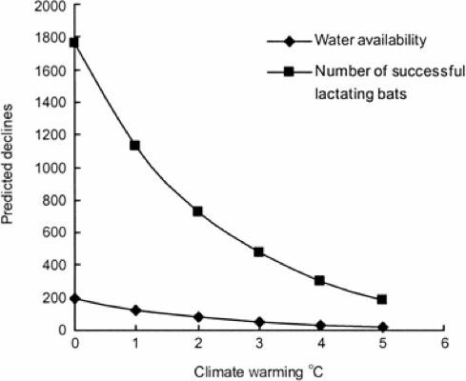

Figure 2. Mapped habitat suitability change of Pipistrellus nathusii across the UK from 1980 to 2080. Change is based on actual climatic change from 1980 to 2000 based on UK Meteorological Office climate data (http://www.metoffice.gov.uk). The projected suitability change from 2020 to 2080 is based on the CGCM3 climate model (http://www.cccma.ec.gc.ca). Shaded areas have a suitability greater than 0.65. The records prior to each date are represented in black on the corresponding map (1980, 1990, 2000), with records prior to 2010 shown on the habitat suitability map for 2020. Reproduced from Lundy et al., 2010. Journal of Biogeography. Reproduced by permission of John Wiley & Sons Inc.
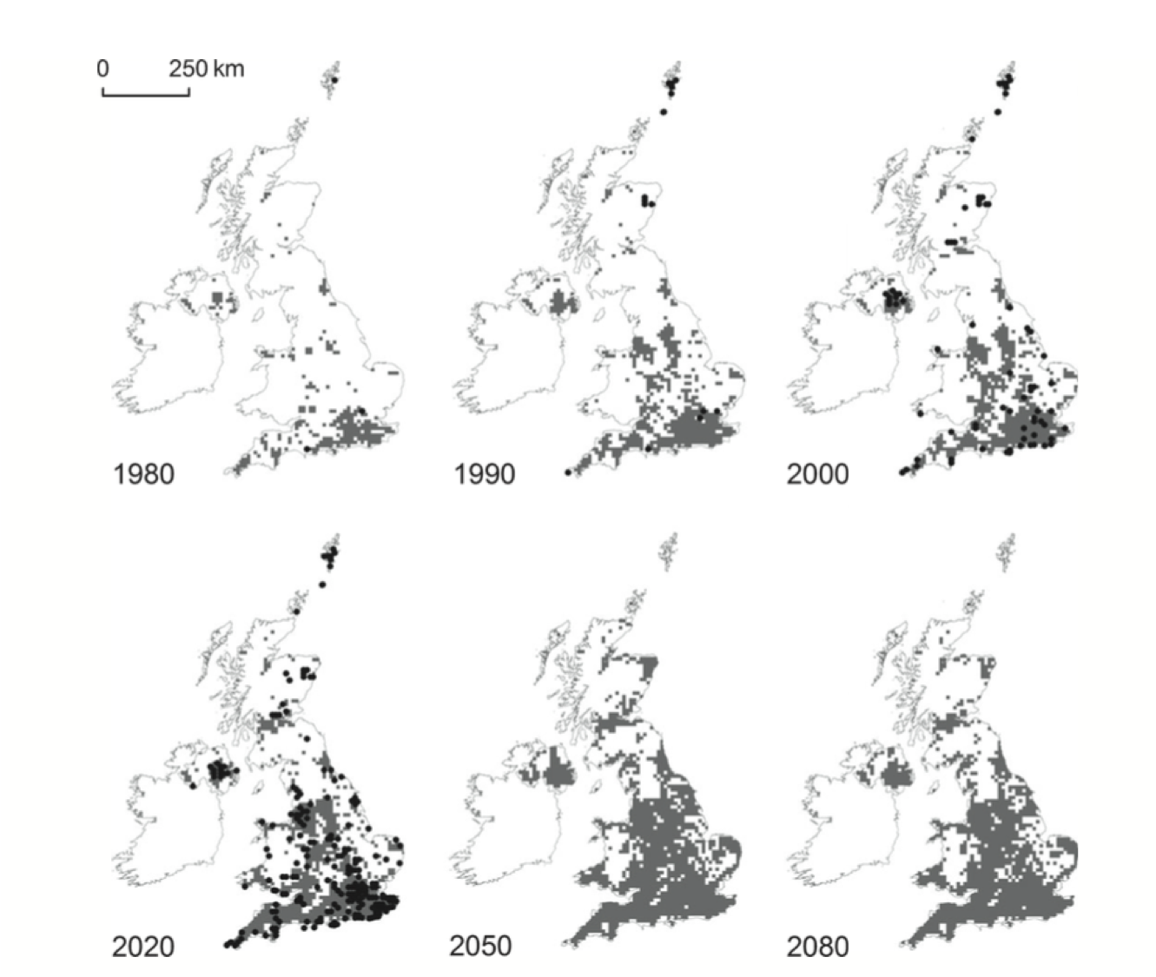

Figure 3. Relative mortality in great tit (Parus major L.) and coal tits (Parus ater L.) is lower in earlier fledging individuals. Data from 1995 (circles), 1996 (squares) and 1997 (triangles). Reproduced from Figure 4a in Naef-Daenzer et al., 2001. Reproduced by permission of John Wiley & Sons Inc.
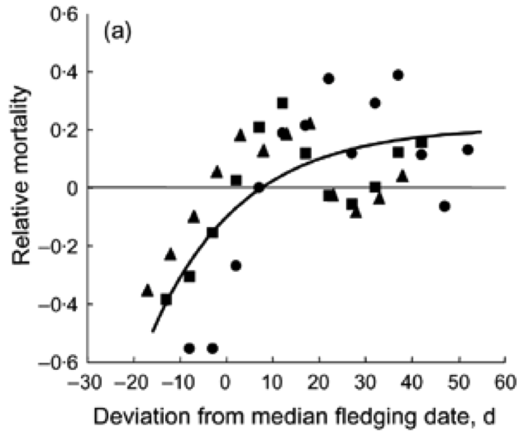

Figure 4. Phenological mismatches between vertebrate predators and their invertebrate trophic resources can arise when predators and prey alter their phenology at different rates. Figure adapted from Grossman, 2004.
