An evidence-based approach to specifying survey effort in ecological assessments of bat activity

Suzanne M. Richardson^{1*}, Paul R. Lintott^{1*,} David J. Hosken², Fiona Mathews^{1^}
¹Hatherly Laboratories, Biosciences, College of Life and Environmental Sciences, University of Exeter, Prince of Wales Road, Exeter, EX4 4PS
²College of List and Environmental Sciences, University of Exeter, Cornwall Campus, Treliever Road, Penryn, Cornwall, TR10 9EZ, UK
*Co-first authors
^ Corresponding author: Fiona Mathews, Email: F.Mathews@exeter.ac.uk

Abstract
Robust ecological assessments are fundamental for effective wildlife conservation. Owing to the high legal protection of bats, surveys are frequently required as part of ecological assessments. Yet there is uncertainty about the amount of survey effort that should be deployed to facilitate bat protection. Bat activity can be extremely variable, and capturing periods of high activity can be as important as estimating parameters such as the median activity level. However the frequency and intensity of surveys required to capture the required information is unknown. Here we assessed the probability that acoustic surveys of differing durations would detect periods of high activity within a focal site and the importance of a site relative to others in a regional or national context. We randomly subsampled from 660 nights of activity data collected from 33 wind farm sites across Britain. The minimum surveying effort required to classify bat activity accurately varied between species and was dependent on weather conditions. We found that the survey periods required to give reasonable certainty in assessing risk exceeded those currently recommended in Europe. The approach of using bat activity accumulation curves, as described here, is transferrable to other situations where determining surveying effort and risk is necessary to ensure that ecological assessments provide a robust evidence base, whilst minimising the time and expense of surveys.
Keywords: accumulation curves; bat activity; chiroptera; ecological assessment; risk assessment; survey design; survey period

1. Introduction
Reliable ecological surveys to assess animal abundance and diversity are fundamental to wildlife management (Spellerberg 1994). Frequency of occurrence or relative abundance estimates are often primary outcome measures, being of critical importance for prioritising areas for conservation status or highlighting those at greatest risk from development (Araujo and Williams 2000). Given the pressure on ecological consultants to balance the need for efficient surveying which minimises the expense to their clients whilst ensuring that effective surveying is conducted, there is a growing reliance on survey guidelines to impose minimum standards. The need for an evidence-based approach when developing survey guidelines has been well acknowledged (e.g. Sutherland et al. 2004), yet for many taxa there is a scarcity of knowledge.
Surveys for bats as part of ecological assessments are frequently conducted, due to their high legal protection (e.g. Europe, Eurobats 2014; North America, Endangered Species Act 1973) and their importance in providing ecosystem services (Boyles et al. 2011). However, it is not known if current recommendations about survey duration are adequate, and there is no established methodology for determining the extent of surveying effort required.
Acoustic surveys to measure bat activity are widely used by commercial ecological consultants to determine species presence and to quantify the level of bat activity within a site (e.g. Roche et al. 2011). However, bat activity can show considerable inter-night variability, being strongly dependent on multiple factors including insect availability, seasonality, temperature, and wind (Fischer et al. 2009). The statistical power of the survey to capture, with reasonable precision, periods of high activity (critical when assessing the risks from developments such as roads or wind turbines), or to allow a robust assessment of whether activity at a site is significant in a regional or national context, is rarely considered.
The rapid global increase in wind farms has led to extensive pre-construction ecological assessments in efforts to assess risk to wildlife, yet they are relatively ineffective at identifying collision threat to bats (Lintott et al. 2016a). It may be that pre-construction acoustic surveys are not of sufficient duration to capture inter-night variability in bat activity, and therefore miss periods of high bat activity. Peak numbers of bat fatalities are strongly associated with periods of low wind speeds (e.g. Arnett et al. 2008), highlighting the importance of surveying for a sufficient length of time to account for such variance. Behr et al. (2017) and Slack and Tinsley (2015) found that bat activity at wind farms varies greatly depending on wind speed, temperature, and precipitation. Although minimum surveying standards are adhered to (e.g., in Britain, conducting surveys at sunset temperatures of 10˚C or above, no rain or strong wind; Collins 2016), it does not necessarily follow that surveys are conducted during optimal conditions. In addition, bat activity varies spatially. For example, in a study of 42 windfarm sites, Mathews et al. (2016) found relatively low levels of bat activity at certain sites, and high levels at others, regardless of weather conditions. Establishing survey protocols that permit relative activity to be compared across sites, correctly categorising those with high and low activity indices, is therefore important. Given that field surveys are costly and time-consuming, establishing the minimum effort required to provide a robust assessment is a pragmatic approach.
The aim of pre-construction surveys at proposed wind farms is to collect robust data to allow an assessment of the potential impact of the development on bat species using the area (Hundt 2012). Acoustic monitoring is used to determine i) the species assemblage, and ii) relative frequency of use by different species (Hundt 2012). This information is used to assess if permission should be granted to install the development and/or what level of mitigation is required. The extent and type of mitigation required is species-specific and is based on vulnerability to mortality and its conservation status. For example, the presence of a rare and threatened species within a site may be sufficient to require mitigation whereas for a common species (e.g. Pipistrellus pipistrellus) high bat activity (see Lintott et al. 2018) is required to trigger any action (Hundt 2012). A sufficient level of acoustic monitoring is therefore required to detect the presence of rarer species and to quantify the level of activity of commoner species.
Data from acoustic bat detectors have been used to create species accumulation curves for an area (e.g. Milne et al. 2004; Skalak et al. 2012). Here, we demonstrate that a similar method can be used to determine survey effort levels required for robust ecological assessments. Using bat activity recorded at wind farm sites across Britain, we outline how accumulation curves can be used to determine the minimum surveying effort required that can contribute to assessing risk at a site. We demonstrate how to i) capture with reasonable certainty periods of high activity within a site, and ii) establish whether bat activity at a site is significant in a regional or national context.
2. Methods
2.1 Acoustic monitoring
Acoustic monitoring was conducted at 48 wind farm sites across Britain (23 in England, 16 in Scotland, and 9 in Wales). The mean numbers of turbines at the study sites was 13 (SD-7; range 6-45). Surveys were conducted in 2011 (14 sites), 2012 (14 sites) and 2013 (20 sites) between July and October each year to coincide with periods of peak bat activity (e.g. Swift 1980; Mathews et al. 2016; Rydell et al. 2010). Acoustic surveys were conducted for a mean of 29 consecutive nights (SD 6) per site. Bat detectors (SM2BAT and SM2BAT+, Wildlife Acoustics, Massachusetts, USA), in combination with omni-directional SMX-II microphones were placed at ground level (~2 m) at the base of three randomly selected turbines at each site. In the UK, all wind turbines are placed such that there is a minimum distance of 50 m between the rotor-swept area and the nearest part of a hedgerow or tree. Given that the effective range of the microphone was approximately 30 m (less for some species), this means that activity at these features would not be recorded, ensuring that valid comparisons could be made between turbines within and across sites. Bat detectors were programmed to record from 30 minutes before sunset until 30 minutes after sunrise.
2.2. Bat identification
Bat calls were manually assessed using Kaleidoscope Pro (v.1.1.20, Wildlife Acoustics, Massachusetts, USA) and classified to species, genus or unknown (as detailed in Mathews et al. 2016). The call parameters used to identify species were based on Russ (2012). A bat pass was defined as a continuous run of pulses not separated by a time gap of more than one second (Fenton, Jacobson & Stone 1973).
2.3. Environmental indicators
At each site, weather data [rainfall (mm), wind speed (ms⁻¹), temperature (°C)] were sampled using an automated weather monitor (Wireless Weather Station N25FR, Maplins, UK), located central to the site in an open location at ~2 m high. Recordings were taken every 10 minutes and average, minimum and maximum values were calculated for the same period that acoustic monitoring occurred (30 before sunset until 30 minutes after sunrise).
2.4 Statistical analysis
Statistical analyses were undertaken in R Studio using R version 2.14.1 (R Core Team 2012) and the ggplot2 (Wickham 2009) package for graphics. Analysis was conducted at the species level for three species (Pipistrellus pipistrellus, P. pygmaeus, and Nyctalus noctula) as these species were recorded in sufficient quantity to support robust analysis. The analysis included only wind farm sites that contained a minimum of 20 nights of static detector recordings and where at least one pass was recorded for each species. Only nights where static detector recording occurred at all three turbines were selected; this eliminated nights where at least one detector failed due to technical issues. Surveying effort was assessed for i) all nights of static detector deployment, and ii) those which were classified as meeting minimal weather conditions as specified in best practice guidelines (Collins et al. 2016; sunset temperature ≥ 10°C, ground level wind speed ≤ 8m s⁻¹ and average rainfall ≤ 2.5mm hr⁻¹).
2.4.1 Surveying effort required to capture peaks of high activity within a focal site
For each wind farm site and species, the nightly activity was ordered and the value at the 70th percentile was taken to represent the threshold between moderate and high activity (i.e. top 30% of activity; following Lintott et al. (2018). The choice of cut-off point is, to some extent, arbitrary and another value such as 25% may be appropriate in other cases. Here it was based on discussions with practitioners and policy-makers about values they considered suitable to define ‘high’, ‘medium’ and ‘low’ activity). The maximum activity recorded at any one of the three turbines was taken to represent the highest level of normal activity at the site. For each site, one night was randomly selected and assessed to determine whether it was classified as having ‘high’ activity or not, depending on whether it crossed the 70th percentile threshold. A 2nd night was then selected from the remaining dataset. Both the 1st and 2nd nights of activity were then assessed to determine if at least one night of activity would be classified as containing high activity. This sequence was continued for 20 nights of sampling. This sequence of sampling (1 to 20 nights) was run for 100 iterations to ensure that stochastic variability was accounted for. For each night and site, the number of occasions where high activity was detected out of the 100 iterations was calculated. We based our recommendations for surveying effort on a minimum of 80% of occasions where high activity was detected (a common threshold used in power analyses, Cohen 1992).
2.4.2 Surveying effort required to determine the importance of a site relative to others in a regional or national context
In this analysis we ordered the nightly activity for all wind farm sites together and calculated the bat activity level at the 70th percentile, in order to define ‘high’ activity in the context of all locations. We then excluded any sites which did not have at least one night of high activity where high activity was defined as the top 30% of activity across all sites (i.e. >70th percentile). We then assessed the level of surveying effort required at each individual site for it to have been correctly classified as containing high activity following the same method as described in 2.4.1.
3. Results
A total of nine bat species were recorded across the 48 sites, with P. pipistrellus, P. pygmaeus and Myotis spp. being present at most sites within their range (Table 1).
3.1. Surveying effort required to capture periods of high activity within a focal site
The surveying effort required to provide a reasonable probability of detecting nights of high activity varied by species. There were 33 wind farms that contained a minimum of 20 nights of activity data for P. pipistrellus (660 nights of activity data in total) and 10 sites which had at least 20 nights of ‘good’ weather. A minimum of five nights of surveying was required to reach a 0.80 probability of correctly detecting nights of high activity within a site; and this decreased to four nights for sites which had good weather (Figure 1A).
For P. pygmaeus there were 31 wind farm sites which contained a minimum of 20 nights of bat activity data, and 10 sites where sufficient acoustic monitoring could be conducting during periods of suitable weather. A minimum of seven nights of surveying was required to reach a 0.80 probability of correctly detecting nights of high activity within a site, this decreased to five nights for sites which had good weather (Figure 2A).
For N. noctula there were 22 wind farm sites which contained a minimum of 20 nights of bat activity data, and eight sites where sufficient acoustic monitoring could be conducted during periods of suitable weather. A minimum of 12 nights of surveying was required to reach a 0.80 probability of correctly identifying nights of high activity across all sites and for sites which had a sufficient number of nights of good weather (Figure 3A).
3.2 Surveying effort required to determine the importance of a site relative to others in a regional or national context
For P. pipistrellus, eight nights of data were required to classify a site as containing ‘high activity’ correctly, this decreased to four nights for sites which had good weather (Figure 1B). For P. pygmaeus, eight nights of surveying were necessary decreasing to six nights during surveying periods containing sufficient good weather (Figure 2B). For N. noctula, 12 nights were required. For this species, the results were very similar (although much larger confidence intervals) when only assessing nights of good weather (Figure 3B).
4. Discussion
Evidence-based approaches to develop survey guidelines are required to ensure that ecological practitioners can survey both efficiently and effectively. Acoustic monitoring is widely used as the evidence base for determining whether a development poses a risk to bat populations (Hundt et al. 2012). Although the extent of survey effort to determine species composition has previously been investigated (e.g. Skalak et al. 2012), here we demonstrate that accumulation curves can be used to determine the minimum surveying effort required to classify bat activity in a meaningful way.
Current British guidance for undertaking bat surveys recommends that data should be collected on five consecutive nights per season in appropriate weather conditions (Collins et al. 2016). However, we found it may take up to 12 nights of surveying to estimate N. noctula activity reliably. Given that N. noctula is perceived to be at high collision risk at wind farms (Mathews et al. 2016), present recommended surveying effort is probably insufficient to capture periods of peaks of activity.
The surveying effort to classify a site correctly was generally reduced when surveying under good weather conditions. Higher bat activity occurs during warmer, dry nights, with low wind speed (e.g. Wolbert et al. 2014) meaning that accurate impressions of maximum foraging activity are likely to be derived more quickly. Additionally, for N. noctule the surveying effort to capture periods of high activity did not vary with weather conditions. This may be explained by its foraging activity: during warm nights foraging activity is spread out throughout the night whereas at low temperatures foraging activity is intensified shortly after sunset (Rachwald 1992). In both these scenarios, similar levels of bat activity would have been recorded but over different time frames.
Bat activity at a study site can be contextualised against other records of nightly bat activity detected in the surrounding landscape to provide a quantitative assessment of whether a site contains ‘high’ levels of bat activity. We show that the surveying effort required to correctly classify sites containing high activity is greater than that for capturing periods of high activity within a site, particularly for P. pipistrellus with an additional three nights of surveying required to accurately classify a site as containing ‘high activity’ (relative to comparable sites). Given that P. pipistrellus appears to be a habitat generalist (Davidson-Watts et al. 2006), is influenced at both local and landscape scales by anthropogenic pressure (Lintott et al. 2016b), and is responsive to environmental variables (e.g. temperature; Maier 1992) it is very difficult to predict their activity levels at a site accurately. Our results illustrate that a precautionary approach to the extent of surveying effort required. Given that up to five nights of surveying effort are needed to detect the presence of ‘common’ species (Skalak et al. 2012), it is unsurprising that additional surveying effort is necessary to capture the temporal variation in bat activity.
In this study we only analysed the three most frequently recorded bat species as there were insufficient records available for other taxa. For these under recorded species additional survey effort would be required, for example, Mathews et al. (2016) found that it took ten nights to confirm Barbastella barbastellus presence at wind farm sites. Therefore assessing risk to bat populations using bat activity is only practically possible with common species where sufficient passes are recorded between sites to allow for accumulation curves to be constructed. When assessing risk to bats from proposed wind farm sites it is important that seasonality is accounted for to ensure that surveys are conducted at periods of peak bat activity (generally July to September in Europe; Mathews et al. 2016). If surveying is conducted outside of peak periods than potential risk can not be fully determined, regardless of surveying effort. It is also worth noting that a variety of methods, including walked transects and vantage point surveys, can be used to complement the information gained from static detectors to assess risk.
Nonetheless, bat activity accumulation curves can be used to provide evidence for determining minimum surveying effort within guidance document for common bat species. We based our recommendations for surveying effort on a minimum of 80% occasions where high activity was detected as this is a threshold commonly used in power analyses (Cohen 1992). However, altering this threshold will adjust minimum survey effort levels. We therefore welcome the input of practitioners in suggesting an appropriate cut-off level to form accumulation curves. There is a delicate balance between recommending sufficient surveying effort to assess risk with sufficient accuracy, and the time and expense of undertaking additional nights of surveying. Bat activity accumulation curves can inform where this threshold is placed for common bat species, and therefore eliminate the subjective nature of recommending minimum levels of surveying effort. The approach described here is transferrable to other situations where determining surveying effort to assess risk is necessary, for example road (Abbott et al. 2015) and housing developments. The usefulness of accumulation curves, however, is dependent on there being a suitable database of bat activity available from which accumulation plots can be compiled. Data is more likely to be readily available for common bat species rather than rarer species which are recorded infrequently. The creation of centralised data repositories in some areas (e.g. Adams et al. 2015, North America; Lintott et al. 2018 www.ecobat.org.uk UK; www.vleermuiskasten.nl, Europe) might provide sufficient information to allow this to occur for a wider range of bat species. The useful of accumulation curves is therefore dependent on ecological practitioners and policymakers supporting the progression to an open data society where shared data can be used to make effective conservation decisions whilst minimising the risk to wildlife.
5. Acknowledgements
The research was funded by the Department for Environment, Food and Rural Affairs, Department of Energy & Climate Change, Natural England, Natural Resources Wales, Scottish Natural Heritage, and Renewable UK. We would like to thank the site owners and operators who allowed access to the wind farm sites. We also thank Jan Collins (Bat Conservation Trust), Simon Pickering (Ecotricity), and all of the field workers who helped with the project. We thank Patrick Wright for his comments on the manuscript, and the referees for suggestions that helped impove the manuscript.
6. References
Abbott, I.M., Berthinussen, A., Stone, E., Boonman, M., Melber, M., Altringham, J., 2015. Bats and Roads, in Handbook of Road Ecology (eds R. van der Ree, D. J. Smith and C. Grilo), John Wiley & Sons, Ltd, Chichester, UK.
Adams, A.M., McGuire, L.P., Hooton, L.A., Fenton, M.B., 2015. How high is high? Using percentile thresholds to identify peak bat activity. Canadian Journal of Zoology, 93, 307-313.
Araujo, M.B., Williams, P.H., 2000. Selecting areas for species persistence using occurrence data. Biological Conservation, 96, 331-345
Arnett, E.B., Brown, W.K., Erickson, W.P., Fiedler, J.K., Hamilton, B.L., Henry, T.H., Jain, A., Johnson, G.D., Kerns, J., Koford, R.R., Nicholson, C.P., 2008. Patterns of bat fatalities at wind energy facilities in North America. Journal of Wildlife Management, 72, 61-78.
Behr, O., Brinkmann, R., Hochradel, K., Mages, J., Korner-Nievergelt, F., Niermann, I., Reich, M., Simon, R., Weber, N., Nagy, M., 2017. Mitigating bat mortality with turbine-specific curtailment algorithms: A model based approach. In Wind Energy and Wildlife Interactions (pp. 135-160). Springer, Cham.
Boyles, J.G., Cryan, P.M., McCracken, G.F., Kunz, T.H., 2011. Economic Importance of Bats in Agriculture. Science, 332, 41-42.
Cohen, J., 1992. Statistical power analysis. Current Directions in Psychological Science, 1, 98-101.
Collins, J. (ed.)., 2016. Bat Surveys for Professional Ecologists. Good Practice Guidelines (3rd edn). The Bat Conservation Trust. London. ISBN-13 978 1-872745-96-1
Davidson-Watts, I., Walls, S., Jones, G., 2006. Differential habitat selection by Pipistrellus pipistrellus and Pipistrellus pygmaeus identifies distinct conservation needs for cryptic species of echolocating bats. Biological Conservation, 133, 118–127.
Fenton, M., Jacobson, S., Stone, R., 1973. An automatic ultrasonic sensing system for monitoring the activity of some bats. Canadian Journal of Zoology, 51, 291-299.
Fischer, J., Stott, J., Law, B.S., Adams, M.D., Forrester, R.I., 2009. Designing Effective Habitat Studies: Quantifying Multiple Sources of Variability in Bat Activity. Acta Chiropterologica, 11, 127-137.
Hundt, L., Barlow, K., Crompton, R., Graves, R., Markham, S., Matthews, J., Sowler, S., 2012. Bat surveys – good practice guidelines 2nd edition. Surveying for onshore wind farms. Bat Conservation Trust, London.
Lintott, P.R., Richardson, S., Hosken, D., Fensome, S., Mathews F., 2016a. Ecological impact assessments fail to reduce risk of bat casualties at wind farms. Current Biology, 26, 1135-1136.
Lintott, P.R., Barlow, K., Bunnefeld, N., Briggs, P., Gajas Roig, C., Park, K.J., 2016b. Differential responses of cryptic bat species to the urban landscape. Ecology and Evolution, 6, 2044-2052.
Lintott, P.R., Davison, S., Breda, J., Kubasiewicz, L., Dowse, D., Daisley, J., Haddy, E., Mathews, F., 2018. Ecobat: An online resource to facilitate transparent, evidence‐based interpretation of bat activity data. Ecology and Evolution, 8, 935-941.
Maier, C., 1992. Activity patterns of pipistrelle bats (Pipistrellus pipistrellus) in Oxfordshire. Journal of Zoology, 228, 69-80.
Mathews, F., Richardson, S., Lintott, P.R., Hosken, D., 2016. Understanding the Risk to European Protected Species (bats) at Onshore Wind Turbine Sites to inform Risk Management. Department for Environment Food and Rural Affairs Science and Research Projects. WCO0753 Final Report (Phase 2)
Milne, D.J., Armstrong, M., Fisher, A., Flores, T., Pavey, C.R., 2004. A comparison of three survey methods for collecting bat echolocation calls and species-accumulation rates from nightly Anabat recordings. Wildlife Research, 31, 57-63.
R Core Team., 2012. R: A language and environment for statistical computing. R Foundation for Statistical Computing, Vienna, Austria. URL http://www.R-project.org/.
Rachwald, A., 1992. Habitat preference and activity of the noctule bat Nyctalus noctula in the Białowieża Primeval Forest. Acta Theriologica, 37, 413-422.
Roche, N., Langton, S., Aughney, T., Russ, J., Marnell, F., Lynn, D. & Catto, C., 2011. A car‐based monitoring method reveals new information on bat populations and distributions in Ireland. Animal Conservation, 14, 642-651.
Russ J. 2012. British bat calls: a guide to species identification. Exeter, UK: Pelagic Publishing Ltd.
Rydell, J., Bach, L., Dubourg-Savage, M.J., Green, M., Rodrigues, L. and Hedenström, A., 2010. Mortality of bats at wind turbines links to nocturnal insect migration?. European Journal of Wildlife Research, 56, 823-827.
Skalak, S.L., Sherwin, R.E., Brigham, R.M., 2012. Sampling period, size and duration influence measures of bat species richness from acoustic surveys. Methods in Ecology and Evolution, 3, 490–502.
Slack, G., Tinsley, E., 2015. Linking bat surveys with meterological data: a way to target operational wind farm mitigation. In Practice, 87, 34-38
Spellerberg, I.F., 1994. Evaluation and assessment for conservation: ecological guidelines for determining priorities for nature conservation. Springer Science & Business Media.
Sutherland, W.J., Pullin, A.S., Dolman, P.M., Knight, T.M., 2004. The need for evidence-based conservation. Trends in Ecology & Evolution, 19, 305-308.
Swift, S.M., 1980. Activity patterns of pipistrelle bats (Pipistrellus pipistrellus) in north‐east Scotland. Journal of Zoology, 190, 285-295
Wickham, H., 2009. ggplot2: elegant graphics for data analysis. Springer Science & Business Media.
Wolbert, S.J., Zellner, A.S., Whidden, H.P., 2014. Bat activity, insect biomass, and temperature along an elevational gradient. Northeastern Naturalist, 21, 72-85.

Table 1. The number of sites surveyed within each species’ range and a summary of the number of bat passes recorded. Turbine nights is the sum of all nights of survey effort at each site.

Species | No. sites in range (% sites spp. detected within range) | Total Passes | Count of turbine nights | Max passes per night | Mean number of passes per night
Barbastella barbastellus | 25 (36) | 95 | 2,156 | 6 | 0.06
Myotis spp. | 48 (88) | 3,527 | 3,897 | 88 | 0.93
Nyctalus noctula | 37 (89) | 6,783 | 3,073 | 272 | 2.30
Pipistrellus nathusii | 42 (88) | 1,156 | 3,453 | 91 | 0.36
Pipistrellus pipistrellus | 48 (98) | 138,033 | 3,897 | 3,324 | 36.60
Pipistrellus pygmaeus | 46 (96) | 28,515 | 3,771 | 813 | 7.86
Plecotus spp. | 48 (79) | 736 | 3,897 | 27 | 0.20
Rhinolophus ferrumequinum | 11 (55) | 6 | 966 | 2 | 0.01
Rhinolophus hipposideros | 13 (8) | 11 | 1,140 | 2 | 0.01

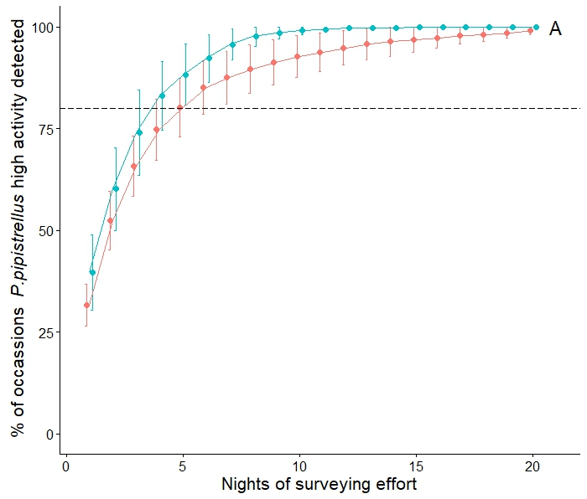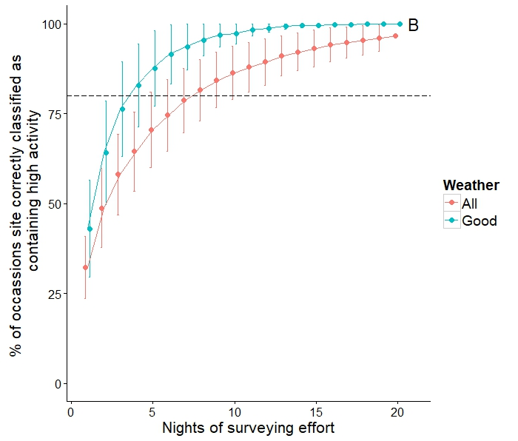
Figure 1. Surveying effort required to A) capture periods of high activity within a site, and B) correctly classify whether a site contains at least one night of high activity relative to comparable sites for P. pipistrellus. Datapoints have been offset for clarity.
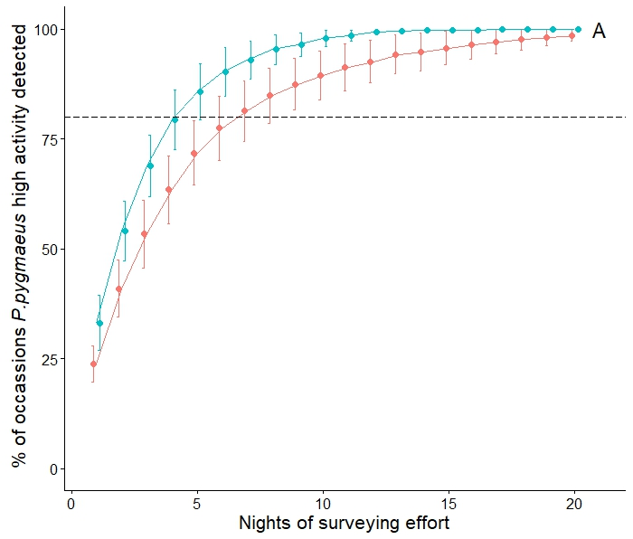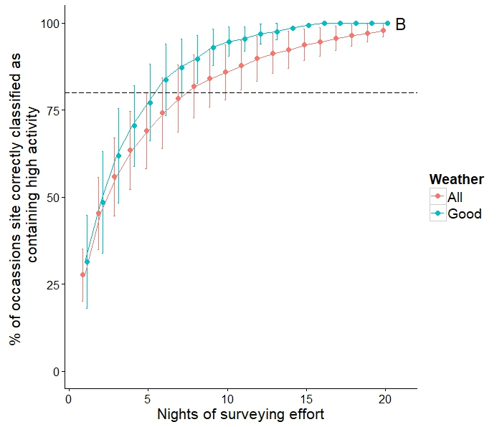
Figure 2. Surveying effort required to A) detect periods of high activity within a site, and B) correctly classify whether a site contains at least one night of high activity relative to comparable sites for P. pygmaeus. Datapoints have been offset for clarity.

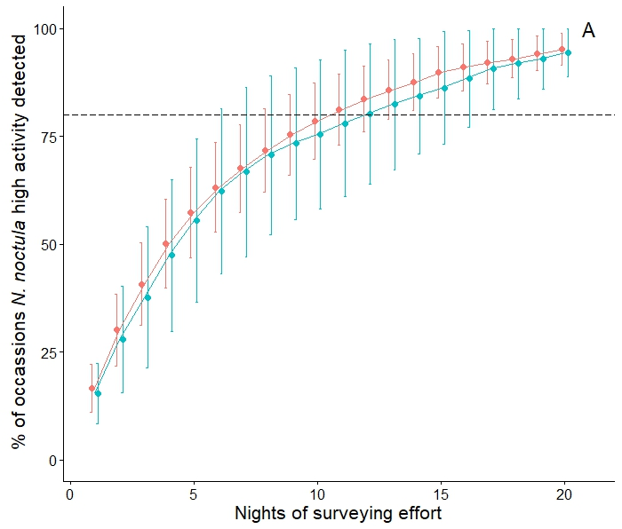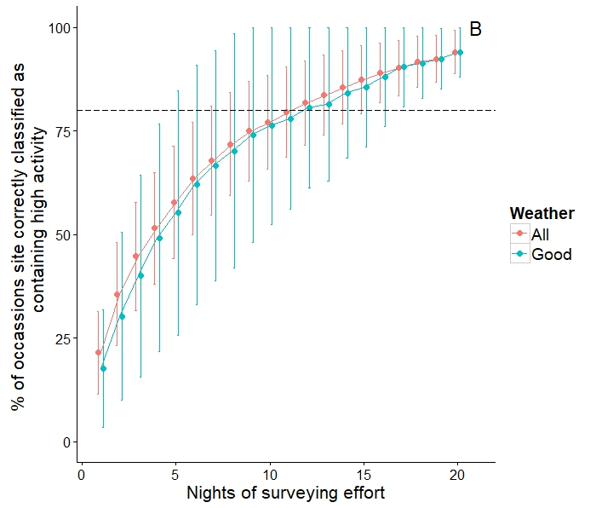
Figure 3. Surveying effort required to A) detect periods of high activity within a site, and B) correctly classify whether a site contains at least one night of high activity relative to comparable sites for N. noctula. Datapoints have been offset for clarity.

