Fantasy, pragmatism and journalistic socialisation: UK journalism students’ aspirations and motivations

Daniel Jackson, Einar Thorsen, and Sally Reardon
Journalism Practice (2019).
https://doi.org/10.1080/17512786.2019.1591929

*To cite this article:
Jackson, D., Thorsen, E. and Reardon (2019). Fantasy, pragmatism and journalistic socialisation: UK journalism students’ aspirations and motivations. Journalism Practice (2019). DOI: 10.1080/17512786.2019.1591929

Corresponding author: jacksond@bournemouth.ac.uk

Abstract

Despite the sustained growth in journalism as a choice of degree path for young people, our understanding of students’ aspirations and motivations remains relatively underdeveloped. At the same time, journalism careers appear increasingly uncertain, as the industry responds to digitalization and convergence. In this mixed-methods study - employing 35 interviews and a survey of 837 UK journalism students - we ask what areas of journalism do students aspire towards, how do they feel about their future career prospects, and what is motivating them to study journalism in the first place? We find that intrinsic motivations (calling and talent, dynamic job) prevail over public service ones, with students drawn to soft news beats over hard news. Aspirations are also strikingly gendered, opening up questions of journalism education in this process. We also find that while students articulate an aspirational career in respected media outlets, they are pragmatic about their immediate career prospects. Here, journalism education appears to play a significant role in socialising students towards careers beyond journalism. Findings are discussed in the light of ongoing debates around journalistic socialisation and the future of journalism.

Keywords: journalism education; journalistic socialisation; motivations; aspirations; gender roles; journalism careers

Introduction

The economics of news organisations continue to undergo fundamental transformation, with closures and job losses in the print newspaper industry, alongside cutbacks in broadcasting newsrooms (Ramsay et al., 2017; Lewis, Williams and Franklin, 2008). Connected to this, the industry is also undergoing a casualization of the journalistic workforce, with 59% of UK journalists in full time employment in 2016 compared to 72% in 2001 (Office for National Statistics, 2016). At the same time, technological and cultural convergence offer new employment opportunities for journalists; from digital news startups, to the YouTube vlogging entrepreneur, to ‘content creation’ in the growing spaces that exist in between journalism and the promotional industries.

Journalism students are therefore faced with a career path that is increasingly precarious, fluid and unpredictable. With the number of graduates outstripping supply of journalism jobs in some countries, many students will inevitably not go into the journalism profession upon graduation. A question, then, is how do journalism students feel about their future career prospects, what is motivating them to study journalism in the first place, and what can their answers tell us about the future of the news industry?

Despite the sustained growth in journalism as a choice of degree path for young people, our understanding of students’ aspirations and motivations remains relatively underdeveloped, both theoretically and empirically. Yet it remains important to know why students are choosing journalism degrees, and how they view their future place in the industry (if they do at all). Firstly, because university study can form a key part of the socialisation of journalists (Hanusch et al., 2015; Hovden, 2008), capturing journalists’ ideals and aspirations at the ‘becoming’ stage, while certain dominating ideals and aspirations are being internalised (Hartley and Olsen 2016). Secondly, as the evidence supporting the “graduatization” of the profession (Splichal and Sparks, 1994) mounts, the views of journalism students hold increasing value in understanding the future direction of the news industry and journalistic ideals within it. And thirdly, such research can feed into reflections on the nature of journalism education itself.

In this mixed-methods study, employing 35 interviews and a survey of 837 UK students, our ambition is to advance understanding of the motivations and aspirations of contemporary journalism students. We draw particular attention to the role of journalism education as a socialising agent, and the ways in which aspirations are shaped by gender.

Motivations for studying journalism

Whilst still in its relative infancy, research into students’ motivations for studying journalism has grown in scholarly attention across a range of European (e.g. Bjørnsen, Hovden and Ottosen, 2007; Hanna and Sanders, 2007, 2012; Hopmann et al., 2010; Nygren and Stigbrand, 2014), Asian (e.g. Wu and Weaver, 1998) and North American contexts (e.g. Carpenter, Grant and Hoag, 2016; Coleman et al., 2016). Existing research finds motivations are diverse and varied, but generally fall under three categories: intrinsic motivations related to personal creativity, motivations related to journalism as an exciting and diverse profession, and motivations related to the importance of journalism in society (Carpenter et al., 2015). Wherever in the world the question has been asked, intrinsic motivations tend to prevail, with findings emphasizing the appeal of journalism as an outlet for young people's’ passions (e.g. sport, travel, entertainment) and talents (e.g. writing, photography); as well as the exciting, non-routine, non-conventional, and sociable nature of journalism.

In the UK, for example, as far back as 1970, Boyd-Barrett found only 1% of students were motivated by a public service ideal. More recently, Hanna and Sanders (2007) found only a combined 16% were motivated by a desire to reform or change society, campaign or investigate. Country context does matter here though. In Nordic countries – perhaps related to their strong public service tradition – more students are motivated by idealistic reasons related to the normative functions of the press (Bjornsen, Hovden and Ottosen, 2007; Hovden et al., 2009). Furthermore, countries that have recently experienced democratic transitions also seem to cultivate budding journalists motivated more by the opportunity to change society (Hanusch et al., 2015).

A recent study of Austrian journalism students found, using a factor analysis, that motivations were linked to aspirations, with those motivated by a sense of political and social agency or a journalistic calling / talent more likely to want to work in the field than those who were motivated by pragmatic, employment-driven motives (Prandner and Moosbrugger, 2018). With this in mind, we now turn to examining the dynamics of journalism students’ aspirations.

Aspirations of journalism students

The skills learned in a journalism degree are transferable to a number of fields, and thus provide students with options to pursue careers in a range of different industries (Berger and Foot, 2017). Indeed, existing research consistently finds a strong minority of students who do not want to work in journalism. In the UK for example, Hanna and Sanders (2007) found that only 75% of students at the beginning of their course were sure they wanted to work in journalism, with 1% sure they did not (23% responded ‘maybe’). Moreover, journalism education would appear to influence aspiration negatively, with final year students far less likely to be sure of entering journalism (53%) and those unsure rising to 38%. Hanusch et al.’s (2015) comparative study of eight countries found a similar trend. With the exception of one country (Switzerland), there was a universal shift away from aspiring to work in journalism from the beginning (8 country average of 17.6%) to the end of journalism education (average of 31.9%), though this still means that over 2 in 3 journalism graduates intend to pursue a career in the industry. Exactly why journalism students become less intent on pursuing a career in the industry at the end of their studies is a pressing question, and one that has yet to be examined empirically.

Of those who do intend on becoming a journalist, what areas of journalism do they aspire towards? Despite the preoccupation of much of journalism’s scholarship and educational curriculum with hard news and the exercise of societal power, students retain a strong interest in ‘soft news’ as a career choice (Splichal and Sparks, 1994; Hanna and Sanders, 2007). In their study of eight countries, Hanusch et al. (2015) found just under half of students aspired to working in hard news fields, with around one third ‘soft news’. However, there were some stark differences between countries – with South African students the least likely to aspire towards hard news (29%) and Spanish the most (69%) – telling us that distinct cultural, societal and educational contexts are important for the socialization of journalists. In the UK, whilst the question of subject areas has not been directly explored, one survey found that around one third of final year students were interested in becoming a news reporter, with more than half aspiring towards feature writing or sports journalism (Hanna and Sanders, 2007).

Beyond the question of hard and soft news preferences, research examining the specific areas of the news industry that students aspire towards (print, television, magazines etc) is relatively sparse. Yet Hartley and Olsen (2016, p. 113) argue that such questions are closely tied to broader normative discourses of what journalism is. Here, “journalism students navigate among these contrasting forms of interest and means of self-perception, trying to position themselves as what they themselves regard as ‘proper journalists’”. Drawing from the concepts of ‘journalistic capital’ and ‘editorial capital’ they find that in Denmark, there are clear hierarchies between production platforms, with students constructing an aspirational journalistic career to be one working at a national newspaper or in public service TV performing watchdog functions. Further research should examine such dynamics in other settings.

One final – and crucial – dimension is that a number of studies have identified a strong gendering of the hierarchy of aspirations within the journalistic field (e.g. Bjørnsen et al 2007; Hovden, 2008; Splichal and Sparks 1994). Previous research suggests female students are seemingly drawn towards ‘soft news’ subjects such as lifestyle, health, relationships and consumer news; with males more interested in politics, news journalism, business and sport (e.g. Djerff-Pierre, 2007; Hovden, 2008). As Bromley (2013) points out, such phenomena raise questions about socialization both within and beyond journalism education. It has been suggested, for example, that university curricula, mentoring and advice services, role models and classroom cultures socialise male and female students towards certain aspirations (see Dorer 2003; North 2010). The broader context, of course, is an industry with historically gendered roles that while under challenge, still retain some socialising power (Bromley 2009).

Journalism education in the UK

In the UK, journalism was historically considered a trade rather than a profession (see Barrera, 2012), with newspapermen (and it was historically men) typically brought into the local news fold at the age of 16 and trained in the workplace. Journalism training in the UK was only formalised in the 1950s with the establishment of The National Council for the Training of Journalists (NCTJ) to provide and assess primarily entry-level technical skills - courses taken either prior to or alongside employment (Aldridge and Evetts, 2003). Journalism training was almost entirely absent from Universities until the 1970s, with a small number of postgraduate degrees emerging between in this period until the early 1990s. Typically these were postgraduate certificates or diplomas, with courses also recognised and later accredited by the NCTJ, with undergraduate courses starting to emerge in the 1990s and flourishing from the 2000s onwards. Other industry-led accreditation bodies also emerged to facilitate more structured training for different industries - the Broadcast Journalism Training Council (BJTC) and the Periodicals Training Council specialising in magazine industry.

Whilst journalism education in the UK took longer to gain a firm foothold in the university sector than in say the United States and parts of Western Europe (Barrera, 2012), it is now firmly established as a popular path to a career in journalism. In the past twenty years, the number of full-time, first-year journalism undergraduates enrolled at British universities has increased by 773% (from 415 in 1994/95 to 3625 in 2015/16. Source: HESA) and the number of higher education institutions offering journalism education in the UK stands at 98 (UCAS, 2016). Now, consistent with many parts of the world (Weaver and Willnat, 2012), UK journalism is done by graduates: 86% of professional journalists are university educated, and for early career journalists (those with three or fewer years in employment) the figure is 98% (Thurman, Cornia and Kunert, 2016). This is one signifier of a broader, global trend, what some have termed the “graduatization of journalism” (Splichal and Sparks, 1994, p.114).

Research focus and questions

Hanna and Sanders (2007; 2008; 2012) have led important work on UK journalism students’ role conceptions, motivations and aspirations. But their surveys were conducted between 2002-2006. Since then, the UK higher education system has seen significant change (tuition fees were introduced at £1000 in 1998, rising to £3000 in 2006, and then £9000 per annum from 2012, heralding an accelerated marketisation of the sector) and the news and journalism industry has undergone considerable disruption through the move to digital. Both phenomena are sufficiently disruptive to potentially shape the outlook of journalism students. What is more, existing knowledge of the field is largely shaped by surveys rather than qualitative methods. Resultantly, existing literature has been unable to fully a) unpack the meanings behind certain survey responses, b) explain some of the contradictions in student survey responses and c) understand the related student discourses that emerge with respect to their education and professional aspirations.

Through a mixed-methods approach, we address some of these shortcomings. Our first research question asks:

RQ1: What are students’ motivations for studying journalism at university?

When it comes to aspirations, we believe that there are two dimensions to this. First, given that existing research consistently finds a significant minority of students who do not intend to pursue journalism careers, we ask:

RQ2a: What proportion of journalism students intend to go into the news industry, and if not journalism, what careers do they aspire towards?

Second, responding to perceived hierarchies of news platforms and beats (e.g. Hartley and Olsen, 2016), we ask:

RQ2b: Do journalism students prefer to work in hard news or in soft news beats?

Related to aspirations are expectations towards job prospects. Whilst this question has not been examined before, given the increasingly uncertain context of journalism careers, we believe there is a pressing need for further research. A recent survey of over 500 journalists across the Western world found that there were concerns that in the future, journalists will have to work harder, be more entrepreneurial, and that they cannot count on stable employment, full time jobs, or indeed lifelong journalistic careers (Picard, 2015). However, journalists were found to be remarkably “clear eyed about how their profession is changing, and not stuck in the past as some commentators assume” (1). Our question is whether aspiring journalists feel the same:

RQ3: How optimistic are journalism students about their future job prospects?

Our final RQ concerns the role of university education as a socialising agent in shaping students aspirations. Interestingly, the existing evidence is mixed on this matter, with a number of studies finding education to play an important socialising role (e.g. Nygren, Degtereva and Pavlikova, 2010; Splichal and Sparks, 1994; Wu and Weaver, 1998) and others suggesting that pre-arrival socialisation prevails (e.g. Bjørnsen et al., 2007; Hovden et al., 2009), including in the UK (Hanna and Sanders, 2007). We therefore ask:

RQ4: What role does university education play in shaping the aspirations of journalism students?

Method

Our data is drawn from two sources: a survey and interviews. The survey is the UK dataset of the global project, Journalism Students Across the Globe, led by Folker Hanusch and Claudia Mellado. The survey was conducted in early 2016 based on a purposive sampling strategy: 14 institutions that had established journalism courses were chosen to represent old and new universities, different vocational and theoretical mixes of journalism courses featuring different levels of industry accreditations, and a geographical spread. As Table 1 shows, most of the chosen institutions run both postgraduate and undergraduate courses and more than half have one or more industry accreditations. Most of our sample run dedicated journalism courses, though some are combined with other subjects such as media or English. To be included in the sample, students had to be on journalism majors.

Table 1: Institutional overview
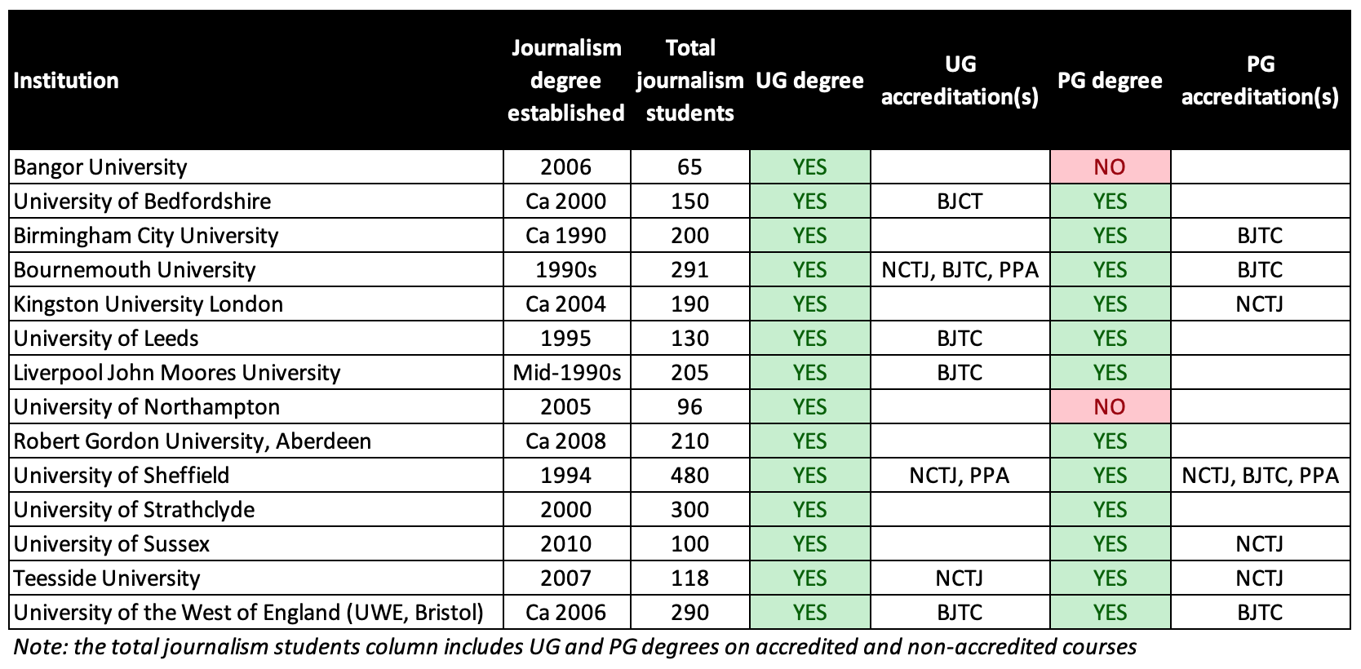

Academic staff at each institution distributed the survey in hard copy format to their students, to be completed at the start / end of class. Our sample consists of 837 students from 14 institutions (see Table 1), giving an overall response rate of approximately 30%. Our respondents were 83% undergraduate students and 17% postgraduates, which is broadly reflective of the balance of journalism students in the UK. 45% were in their first year, 31% second year, and 22% third year; so our sample is weighted towards the early stages of journalistic identity formation. 63% of respondents were female, which compares to the 57% nationally for journalism degrees (HESA, 2015).

Survey variables
RQ1 was answered through the question, “Please rate the following aspects in terms of the extent to which they motivated you to study your degree”. Students could choose one of 19 options, which were based on past studies (Splichal and Sparks, 1994), and directly responded to calls for more nuanced measures of student motivations (Hanusch et al., 2015).

To measure aspirations (RQ2) - again, drawing from previous measures (Hanusch et al., 2015; Splichal and Sparks, 1994) - we firstly asked whether students wanted to pursue a career as a journalist (which also acted as a filter question). We then asked respondents: “If you could choose, which communication area would you like to work in for the rest of your professional career?” Respondents could choose one from four options: 1) journalism, 2) advertising, (3) teaching and research, or (4) PR/corporate communications or (5) “other”. Questions then became narrower, exploring particular specialisations: “In which area specifically would you like to work?”, where students were presented with a list of 14 areas ranging from politics to travel, where each participant indicated their interest on a 5 point scale.

RQ3 measured students’ future job expectations by asking two questions: “Do you think you will be able to get a job as a journalist after finishing your university education?”, and “Do you think you will be able to make a living from being a journalist alone?”. Both were measured on a 5 point scale.

In-depth interviews
Between February and May 2017, 35 face-to-face interviews with journalism students were carried out by the authors at two of the universities from the survey sample. This included participants from all three undergraduate awards at university [anonymous for peer review] (Journalism; Journalism and PR; and Media and Journalism) and one undergraduate award at university [anonymous for peer review] (Multimedia Journalism). 21 of our participants were third years and 13 first years; 19 were female.

The interviews took place on university campus, in a setting familiar to the participants.
Interviews were semi-structured, lasting between 30 and 90 minutes. The interview guide broadly responded to the RQs, though was flexible and allowed for subjects to be brought up by the participant.

Interviews were audio recorded, transcribed and then coded through a thematic analysis framework (Braun and Clarke 2006), meaning the analysis was influenced by the research questions (and indeed the literature review), but there was also an inductive element allowing for themes to evolve during the analysis process. We analysed each interview separately, identifying codes that developed into overarching themes that were subsequently checked across the whole sample for validation.

Findings

Motivations

To answer RQ1, students were asked to indicate the extent to which they regarded each of 19 motivations as important. To determine whether there are underlying dimensions of motivations, an Exploratory Factor Analysis (EFA) with Varimax rotation and Kaiser Normalisation was conducted. One item was excluded from the final model due to low communalities ("the amount of autonomy one has"). Based on the final 18 items, a four-dimensional solution emerged from students’ motivations (Table 2) based on robust between-item correlations and convergence with existing theory.

Table 2: Exploratory factor analysis of motivations for studying journalism (pattern matrix)
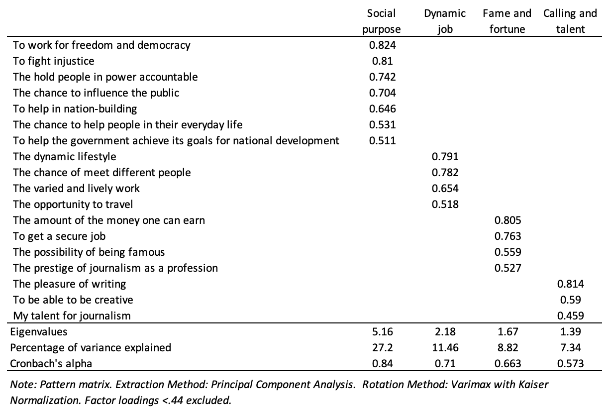

Component one - what we call social purpose - converges with what Prandner and Moosbrugger (2018) call "political and social agency". It captures some normative roles of the press, such as fighting injustice and holding power to account. Dynamic job (component two) again corresponds with previous research (Sanders et al., 2008) and is characterised by the social benefits of journalism as well as the varied and dynamic work environment. We term component three fame and fortune, which is an employment-driven motivation towards the financial rewards and social prestige that journalism potentially holds. Component four (calling and talent) can be described as how journalism is an outlet for one’s creative talents, particularly in writing - again, well established in the literature (e.g. Carpenter et al., 2015; Hanna and Sanders, 2007; Sanders et al., 2008). There were no significant differences for motivations based on gender or year in programme.

Table 3: Motivations for studying journalism
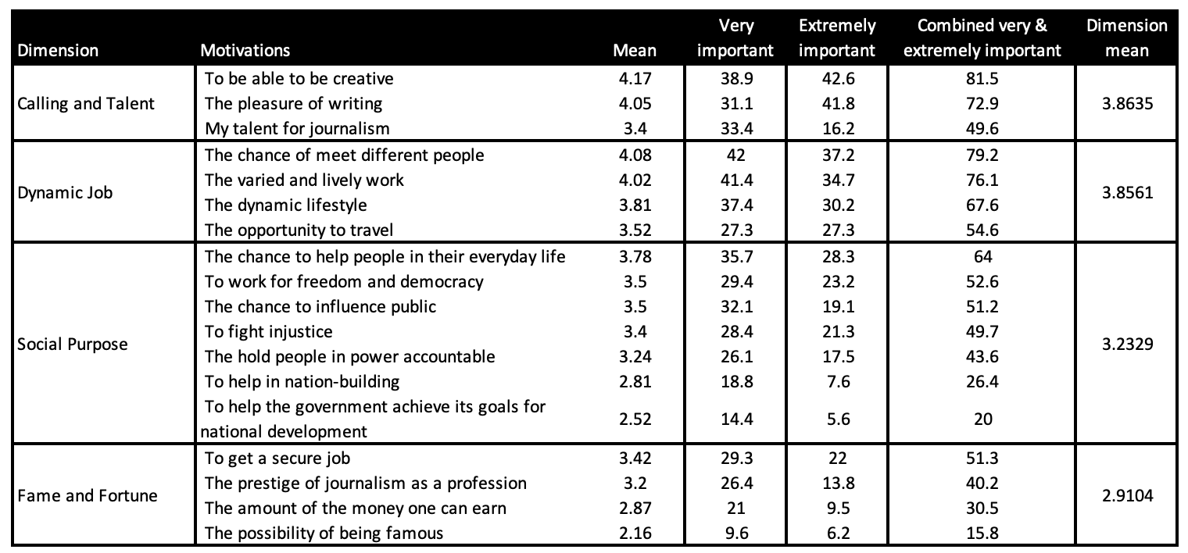

Having established four dimensions of motivations, Table 3 shows the means for each of the motivation variables we measured for (on a 5 point scale, with higher means indicating greater importance). The first observation to be made from this table is that there were few motivations that were not seen as relevant by participants. Interestingly, we could conclude that fame and to an extent fortune, are not primary motivations for UK journalism students. This would be consistent with those studies that have found material success to be of little interest to journalism students (Bowers, 1974; Endres and Wearden, 1990), though in the end, poor salary is one of the main reasons why journalists leave their profession (Weaver et al., 2007). While a recent US study identified "fame seekers" (Coleman et al., 2016) as a growing motivation for journalism students in an increasing celebrity culture, this does not appear to be the case in amongst UK students.

The primary motivations – in line with previous research - primarily consist of intrinsic motivations related to calling and talent and to journalism as an exciting, dynamic and diverse profession. Turning to the qualitative data, these were also the overwhelming discourses that emerged when discussing motivations. For instance, we saw journalism as the creative outlet for people’s passions:

I was thinking, "What can I do music related that will nourish my writing ability?" I feel like I've got certain social skills that also lend myself towards journalism, so I
guess those are the two most predominant ones (male third year student).

It probably stems from creativity to be honest. I've always been quite creative. When I was 14 or 15 I quit playing football, which I used to channel my creative energies. I don't know, I need a creative outlet I think. I found it through writing and journalism (male third year student).

Others described the excitement of the career as an appealing factor:

I just like the fact that it’s a job where … basically, I saw my dad coming home every day from work when I was younger, and he just hated his job. I thought, I don’t want to go and do any old job just to earn money. I’ve always thought, you know, you only get one life. You don't want to spend every single day hating your job. I want to be able to travel, I want to meet loads of people, meet interesting people. I like the fact that every day there’s something different happening, so every day is not the same. I don't know, I just like the fact of talking to loads of people, and I’ve always loved writing (female first year student).

Interestingly, when the normative role of journalism was brought up, students employed distancing strategies, with personal self-fulfillment prevailing:

Sometimes there are issues that I think, "Oh I'd really like..." I do have that
feeling, but I'm not going to lie, it's not ... Maybe it's because I've lived, always, quite a relatively easy life, the things that motivate me are just my own interests ... I'm just, at this stage in my first year, like, "Right, how am I going to transition this degree into something that I want to do, that I'm going to really enjoy?" (male first year student).

I don’t want to change the world. I don’t think I can change the world. As a journalist, what I want to do is - I just quite enjoy reporting the news and informing people what is going on, whether that be across multi-media … I don’t do it because I’m angry, I do it because I feel a sense of pride when I complete something (male third year student).

Though if we return to the Table 3, participants did assign more importance to the social purpose of journalism than some previous studies. This is likely due to the way the question is asked, with our study inviting participants to rate the importance of each motivation, rather than asking a zero-sum question. Here, we found that 43% of participants rated “to hold people in power accountable” as very important or extremely important, with the corresponding number for “to fight injustice” at 49%. We might conclude, then, that the societal role of journalism is a motivating factor for many students, but that personal, intrinsic motivations prevail.

Aspirations

RQ2a was concerned with what proportion of journalism students intend to go into the industry, and if not journalism, what careers they aspire towards. Overall, nearly 70% of students were either likely or absolutely intending to pursue a journalism career. But as Figure 1 demonstrates, the year in programme is a determining factor (RQ4). In their first year, 75% of students are either "absolutely" or "likely" to pursue careers in journalism, a figure which falls to less than 60% by the third year. At the same time, "unsure" grows from 19% in the first year to over 30% by year three.

Figure 1: Intention to pursue a career as a journalist by year of study
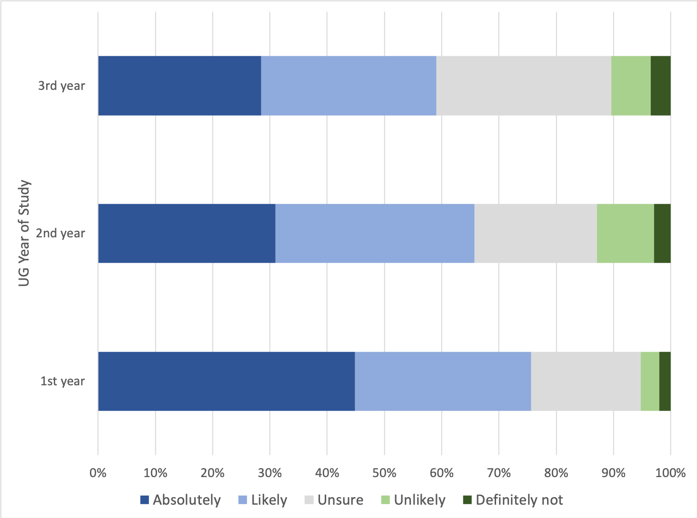

A Jonckheere-Terpstra test for ordered alternatives demonstrates that the trend of lower (median) intention to pursue a career as a journalist as students move through their degree is statistically significant (TJT = 79705, z = 4.42, p <.001). This finding would be consistent with previous research (e.g. Hanusch et al., 2015), but no study has yet examined what might be driving such a shift. Based on the analysis of our qualitative interviews, two general explanations emerge, both of which are united through the learning of more about journalism.

The first - seemingly learned through the study of journalism in the classroom - is a greater understanding of the political economy of news. This is expressed through a distaste for the dynamics of political and commercial agendas in journalism, as the following quotes illustrate:

Do you know what? Recently, I’ve realised how messed up journalism is and how political it is. I didn’t realise it was this bad. From all the lectures that you’ve been talking about, the gender and the racism and stuff like that ... I didn’t realise that there is this much in it. I didn’t realise that we’re actually ... I’m not saying that we’re screwed. There is always hope. I didn’t realise … how censored it can be (male first year student).

It’s just a lot more complicated. And especially, in terms of funding and things like that. which is why I’m more focused on the more documentary side of it. Because it’s more stable, and personally I don’t want to write sponsored content (female first year student).

At one time in my life I did think that I wanted to be a journalist, but I don't think I knew what a journalist did and then I think, “yes” and then when I kind of found out what a journalist does I was like, “I don't want to be a journalist” (female third year student).

The second explanation comes from industry experience, usually through a work placement or internship, which are often compulsory in UK journalism degrees. Many students told us stories of how the reality of journalism (in its lower echelons) did not match their expectations:

I remember my first day [on local radio]. We'd get in, and I was really excited, because I was like, "We're going to go out. We're going to find some original stories. We're right in the town. The town centre is just down the road. We can do something here." The guy running it, he basically just told us to get local newspaper website up, and take their stories and reword them, and then go and read them on air (male third year student).

For example at [national newspaper], I was on the sports desk for transfer deadline day. I specifically wanted to be on the sports desk for transfer deadline day. I thought that would be amazing. I love transfer deadline day. I thought they would be on the phone getting inside sources about what’s going on. No, that doesn’t happen. They’re literally just on Twitter like me. I could do it. They’re on Twitter just rehashing rubbish (male third year student).

So I thought, “Let me go and experience it first.” So I went and when I went there – okay I am going to be really honest – newspaper journalism is seriously the most boring job, literally everyone looks so depressed (female third year student).

Others described failed work experiences, which have prompted them to rethink their career plans.

I just did not like it, not a good experience. That threw me, because that had been, like, "I'd love to work there, that'd be amazing." Then I actually did it and was like, "I don't like it. What do I do now?" I think, as well, that brought on self-doubt. I was kind of like, "Well, if I'm not getting anything published, maybe I just shouldn't be a journalist" (female third year student).

Figure 2: Preferred area of work by gender
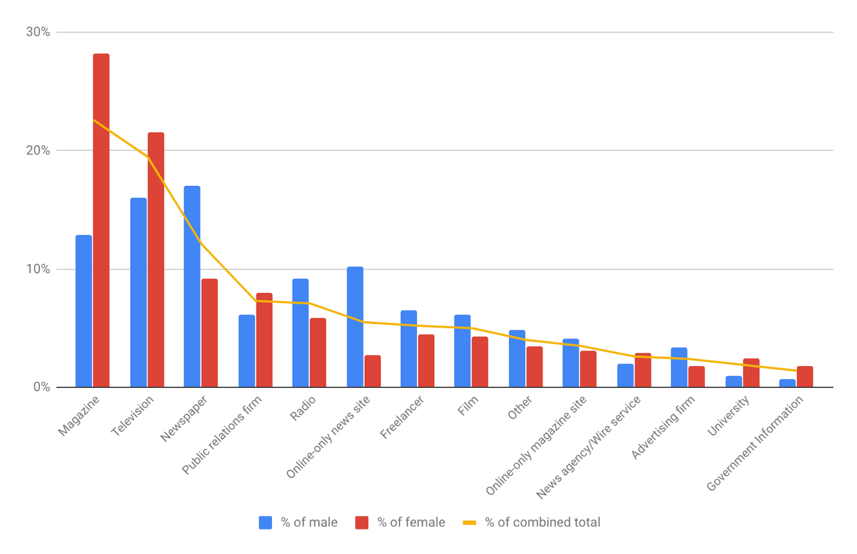

RQ2a also examines what parts of the news industry and related professions journalism students would aspire to work in. As figure 2 shows, students are still largely drawn towards careers in established media such as TV, magazines, radio and newspapers. However, there are some important gender differences, with male students far more likely to choose careers in newspapers (17% male vs 9.2% female) and online-only news sites (10.2% vs 2.7%); with females preferring careers in magazines (28.2% female vs 12.9% male) and television (21.6% female vs 16% male).

Comparing these findings to a similar study by Sanders et al (2008) conducted in 2002-3 showed the aspirations of UK journalism students have changed very little in the last 13 years. There are two exceptions to this: online news, which has gone from zero in 2003 to 10% in 2016; and – perhaps more significantly – the promotional industries such as advertising, PR and government information, which were 3% in 2002, and now nearly 10%. Notable also is the finding that only 5% of students aspire towards freelance careers. According to the 2015 Labour Force Survey, 28% of UK journalists are freelance, a figure that is on the rise, with women in particular more likely to be freelance.

Nevertheless, it is interesting - and perhaps surprising - that despite seismic changes to the news industry in the last decade and a half, journalism students are still drawn towards careers in traditional legacy news media. Our qualitative data help expand this finding. Here, normative discourses of ‘proper’ journalism were tied to traditional news outlets, with the BBC typically cited as the pinnacle of career aspirations:

Well, I’ve always thought, I would love to have a placement at the BBC … Well, I’d be grateful to go to any of the well-known broadcasters or anything. You’d still feel a bit like, “Oh, yes, this is so cool. This is what I want to do” (female first year student).

Obviously I have aspirations to be the editor at the BBC. Everyone has that (male third year student).

You look at the BBC as the pinnacle of journalism, the ultimate ... I do anyway, I’ve always grown up with it like that (male third year student).

In contrast, digital native news organisations (typically associated with Buzzfeed) are positioned as “more media than journalism. I don’t think that’s proper journalism” (male third year student) and therefore not something to aspire towards:

I think clickbait, fake news, and sites like BuzzFeed. I've always said BuzzFeed, I don't really think, ever really claim to be a news source. For me, personally, I'm very black and white about that. I just stick to BBC, to Sky News, Sky Sports News; just places that I trust (male third year student).

RQ2b asked whether students aspired towards certain subject specialisms over others. Our survey invited students to indicate the extent to which they regarded each of 14 specialisations as desirable. We then performed an EFA on this data, with three components emerging, each containing four variables, and all with theoretical grounding. These factor loadings within the underlying construct explained 57.85% of the total variance. As Table 4 shows, component one can be characterised as hard news, component two, soft news, and component three specialist news.

Table 4: Exploratory factor analysis of students’ preferred specialisations (pattern matrix)
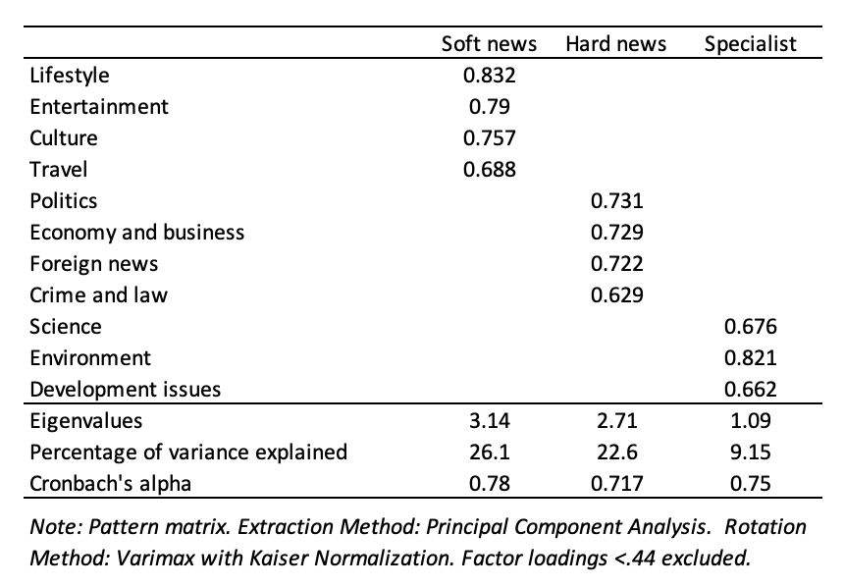

We then explored components (and individual items within) for differences in desirability, and whether gender was a significant factor. As Table 5 shows, soft news specialisms are comfortably the most popular, confirming the findings of previous studies (Splichal and Sparks, 1994; Hanna and Sanders, 2007; Hanusch et al., 2015), but even still, the scale of soft news’ appeal is notable. The other key story of Table 5 is what it tells us about gender differences.

Table 5: Students’ preferred specialisations by gender
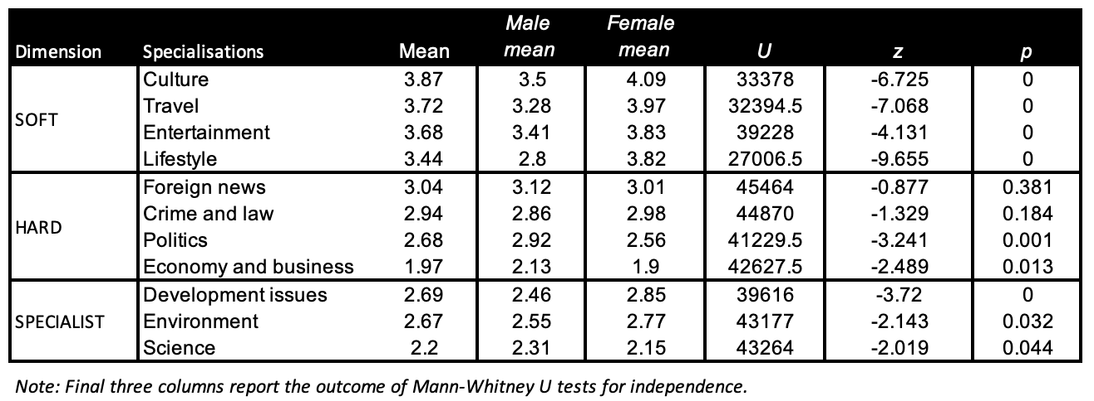

As Table 5 shows, Mann-Whitney U tests demonstrate significant gender differences in 12 out of 14 (85.7%) specialisations, with crime and foreign news reporting the only exceptions. Here, male students were significantly more attracted to specialising in politics, economics/ business, science and sport - all traditionally male domains. Whilst males were on the whole more interested in soft than hard news specialisms, they were still significantly more likely to favour hard news compared to female students. Sport was clearly the most gendered specialisation, where 44% of males were extremely interested compared to 6% of females, with 54% not interested at all. This also reflects in the EFA (Table 4), where sport had insufficient communality with other items to be included within other components.

The final set of findings concern students’ perceptions of their future employment prospects (RQ3). Whilst earlier we found that 70% of students would like to pursue a career in journalism, Figure 3 suggests there is a degree of realism about the likelihood of this. Just under half (48%) think they will definitely or likely get a job as a journalist after finishing university; with only 37% thinking they can definitely or likely make a living from being a journalist alone. The fact that "unsure" was the most popular response adds to the sense that many students seem uncertain about the future.

Figure 3: Perceptions of future employment prospects by year of study and course accreditation
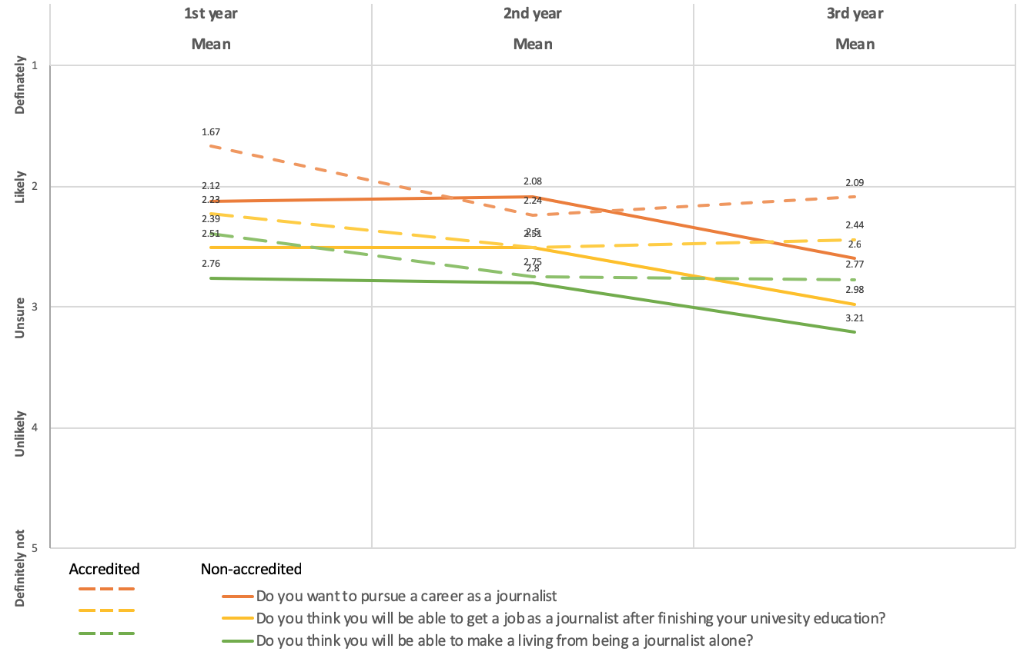

Again, education plays a significant role in shaping students’ expectations (RQ4). A Jonckheere-Terpstra test for ordered alternatives showed that there was a statistically significant trend of lower (median) expectations of getting a job as a journalist after finishing their education (TJT = 71429.5, z = 3.15, p <.01) and making a living from journalism alone (TJT = 73453.5, z = 4.2, p <.001) as students move through their degree. As Figure 3 illustrates, there is another layer to the impact of education when as it relates to employment prospects. Students on industry accredited courses (n = 413) start and end their degrees more likely wanting to go into journalism than those on non-accredited courses (n = 255). Furthermore, Mann-Whitney U tests for independence find that these relationships are statistically significant for wanting to pursue a journalism career (U = 46539, z = -2.65, p = <.01), expectations of getting a job as a journalist after finishing their education (U = 41378, z = -3.49, p = <.01), and making a living from journalism alone (U = 40477, z = -3.8, p = <.01).

When we turn to the qualitative data, two pragmatic discourses give some context to this picture of employment uncertainty: "I'll take anything I can get at the moment" and "I’m actually completely unfazed by it". A recurring theme in the interviews was that getting into journalism was going to be difficult. Whilst many responses constructed an optimistic outlook for the long term, in the short term they were prepared to compromise their ambitions, even if it meant working in journalistic sectors that they were highly critical of.

I think short-term it’s more of a concern. Like I keep an eye on the jobs that open up, and for however many, I know roughly how many students there are that are probably going to graduate with a journalism degree this summer, and that is a minor concern (male third year student).

I'll take anything I can get at the moment. Straight out of uni, you'll take anything you can get (female third year student).

I can say I want to be bigger than clickbait. Still, at the end of the day, if I get offered a job and I don’t have any other options, what am I going to do? I’m going to take the job wherever it is. I can talk all day about being on my moral high ground, but at the same time, it’s a difficult situation for a lot of journalists to be in, when they’re coming out of university especially. We’re not going to get a job at the BBC first round. Some people do, but not many ... Some of us will have to do the dirty work at these sorts of organisations. I would be lying to say I wouldn’t do it ....But then that flies in the face of everything I’ve said about a journalist’s pure responsibility (male third year student).

Evident in this final quote are the tensions between normative and aspirational conceptions of "pure" journalism set against the reality of post-graduate employment. Here, doing the "dirty" work was justified on pragmatic grounds as a way to getting to the "proper" BBC type of journalism.

This discourse of pragmatism was developed further in responses to our questions around how they felt about working in a profession increasingly characterised by job mobility, short-term contracts and freelancing. Here, the talk was of acceptance:

Am I prepared for the precarity of it? I suppose I am, I've already come to terms with the fact I'm not going to walk into a job, I've already come to terms with the fact it's going to take me a long time to get a position that's really going to hit on the knuckles of what I really want to do long term (female third year student).

Yet this was combined with a gloss of optimism:

I'm actually completely unfazed by it. I feel like I have a very good understanding of how all that sort of thing works. I could be completely wrong. I might have no idea how it works. But I'm not massively fazed (male third year student).

What we find here, in other words, are students who are critical about the news industry, realistic about their personal prospects, and therefore adopt pragmatic outlook on their future.

Discussion and conclusion

Whilst we do not wish to overstate the short-term influence journalism students will have on their profession, they do represent the future of the news industry. To this end their personal ambitions provide an insight into the future challenges of the journalism profession and indeed how these journalists of the future will respond to the challenges facing the news industry. The purpose of this study was therefore to document and interrogate the motivations and aspirations of contemporary UK journalism students through a multi-method design. This is particularly important given the context of rapid changes in the profession (and its employment landscape) and the persistent popularity of university journalism education in the UK. Whilst our study was derived from a UK specific dataset, we identify four key findings that further our understanding of journalism students motivations and aspirations, and their relationship with journalism education.

The first is that UK students are not primarily motivated by a desire to change the world. Our exploratory factor analysis demonstrated that there are clearly identifiable components of motivations that correspond with existing literature. We find that UK journalism students are primarily motivated by an intrinsic sense of calling or perceived personal talent, and the dynamic working environment that journalism offers. In this sense, our findings suggest that little has changed since the last major studies of UK journalism students (Hanna and Sanders, 2007; Sanders et al., 2008), and that UK students fall in line with students from most other advanced Western democracies. Hanna and Sanders (2008, p. 344) argue that “Journalism educators in democracies aim to produce journalists motivated to scrutinize the powerful”; a discourse which pervades the journalism profession. However, there is little evidence that in the UK - as with other countries - this has ever been the major motivation for journalism students.

This point is further reinforced when we examine student aspirations. Here, we find - again consistent with previous literature from the UK and beyond (Splichal and Sparks, 1994; Hanna and Sanders, 2007) - that more students are drawn towards careers in soft news topics such as culture, entertainment and travel journalism than they are hard news topics. A question for journalism educators is the extent to which they encourage such aspirations or challenge them. Existing research on journalistic role perceptions and identities suggests that university education does not significantly cultivate greater watchdog ideals (Bjørnsen, Hovden and Ottosen, 2007; Hanna and Sanders, 2008; Schultz, 2002), thus implying that such aspirations and motivations are established through pre-university socialisation. Here, we might then turn to the broader advance of consumer culture and its blunting effect on civic activism and political participation (Scullion, 2010), which was evident in some of our interviews. Such outlooks might safely align with the direction in which journalism employment is moving (see below), but still raise the potentially troubling prospect of future journalists being "increasingly disengaged from the democratic process" (see Reese and Cohen, 2000, p. 213).

Previous research had found mixed evidence for the influence of education on students’ aspirations but in this study, students were less likely want to pursue a journalism career towards the end of their studies, and more uncertain about their career prospects. Commenting on this phenomenon at a global level, Hanusch et al (2015, p.155) suggest this is an issue that “deserves further investigation as to its root causes and how these can be addressed.” A second key finding of our study is to highlight how critical dimensions of the curriculum alongside placement work experience provide two crucial moments at which journalistic socialisation occurs. With critical journalism studies, students are confronted with the ethical compromises journalists make, and their (often troubled) relationship to societal power structures. With the placement, student perceptions of journalism meet the reality - often to the student’s disappointment. But in the context of a diversifying career path where boundaries between platforms and forms of public communication (journalism, commercial, promotional) are increasingly blurring (Carlson and Lewis, 2016), alongside concerns about an oversupply of journalism graduates, we might perhaps welcome the fact that university education broadens a student’s horizons beyond journalism alone.

Another layer to this finding is offered by the fact that students on accredited courses both start and end their degrees more likely to pursue journalism as a career. It is not clear if this is a consequence of the curriculum design of accredited versus non-accredited courses, or if simply reflecting the type of student (and their predisposition for pursuing journalism as a career) of those seeking out accredited courses. Nevertheless, whilst we did not find significant differences in motivations or other dimensions of aspirations based on accreditation, this finding still opens up the possibility that accreditation could be an important influence on the development of journalistic role perceptions and identities; a direction future research could pursue.

A third - and consequential - key finding was the persistence of strikingly gendered aspirations amongst journalism students. Here, our findings are congruous with existing literature that finds males more likely to pursue careers in hard news topics such as politics, economics and business; and females to favour soft news beats (Bjørnsen et al 2007; Hovden, 2008). Furthermore, male students were more likely choose careers in newspaper and online news sites than females, with the latter more likely to prefer magazine and television careers. Taken together, these findings are perhaps predictable and reflect historic cultural expectations of gender roles, preferences, and career paths. However, news sectors and beats come with status, with men historically dominating the high-status, hard news sectors of the industry (Djerf-Pierre, 2007); a pattern that looks set to continue based on our findings. This is echoed in the news industry more broadly, which still struggles to make significant progress on gender equality - for example on women as sources in the news, and women as media professionals (Ross et al., 2018). We might ask, then, to what extent are journalism educators perpetuating or challenging such gender preferences? Historically, journalism education has been accused of perpetuating the gender roles and disparities present in the news industry (Bromley, 2013). Future research might turn again to the contemporary gender profile of journalism departments, as well as the (often subtle) ways in which gender preferences are moulded through the curriculum.

Another notable element of students’ aspirations was their preference for careers in traditional news sectors, with qualitative findings suggesting this is associated with conceptions of "proper journalism" and associated journalistic capital (Hartley and Olsen 2016). Here, students at least aspire towards a career in the familiar, respected and universally-recognised sectors of journalism. On the face of it, such career aspirations might set them on a collision course with the increasingly fragmented and casualised contemporary jobs market in journalism. However, such careers were a fantasy. When it came to the realities of their immediate career, our fourth key finding was that aspirations were to be compromised, with participants articulating realistic appraisals of their career prospects. Here, we also note the growing willingness (in historical perspective) of students to work in the promotional industries that while clearly in tension with normative journalistic ideals, do offer a realistic career path for the pragmatic graduate.

These findings have important implications for journalism scholars, educators, and practitioners. At the heart of our study lies the ongoing and unresolved tension between the focus of journalism curricula in the West (often highly normative), student aspirations (pragmatic, instrumental, employability-driven) and the needs of the industry. These are battles about the future of journalism itself, as it comes to terms with rapid changes in the business of making news and its implications for journalistic work. These forces pull journalism in different, conflicting directions with respect to its societal functions; functions which themselves are undergoing challenge and revision (Carlson, 2016; Zelizer 2013). While our findings do not show the way forward, they do help map out the priorities of future journalists. And with the mission of journalism becoming increasingly unclear, they leave journalism educators with much to consider.

References

Aldridge, Meryl and Julia Evetts. 2003. “Rethinking the concept of professionalism: the case of journalism.” British Journal of Sociology 54 (4): 547–564, DOI: 10.1080/0007131032000143582
Alysen, Barbara. 1998. “From the Hopeful to Hardened: How Three Years’ Study Changes Journalism Students.” Australian Journalism Review 20 (1): 133–48.
Barrera, Carlos. 2012. “Transatlantic Views On Journalism Education Before And After World War II.” Journalism Studies 13 (4): 534-549, DOI: 10.1080/1461670X.2011.637722
Guy Berger and Joe Foot. 2017. “Taking Stock of Contemporary Journalism Education.” In Global Journalism Education In the 21st Century: Challenges and Innovations. Edited by Robyn S. Goodman and Elanie Steyn. Knight Center for Journalism in the Americas, University of Texas at Austin.
Gunn Bjørnsen, Jan Fredrik Hovden, and Rune Ottosen. 2007. “Journalists in the Making,” Journalism Practice 1(3): 383–403, DOI: 10.1080/17512780701505085
Bowers Thomas A. 1974. “Student attitudes toward journalism as a major and a career”. Journalism Quarterly 51(2): 265–270.
Boyd-Barrett, Oliver. 1970. ‘‘Journalism Recruitment and Training: problems in professionalization.’’ In Media Sociology: a reader, edited by Jeremy Tunstall, 181-201. London: Constable.
Braun, Virginia, and Victoria Clarke. 2006. “Using Thematic Analysis in Psychology.” Qualitative Research in Psychology 3 (2): 77–101. DOI: 10.1191/1478088706qp063oa.
Bromley, Michael S. 2013. “The 'new majority' and the academization of journalism.” Journalism, 14(5): 569-586. DOI: 10.1177/1464884912453285
Bromley, Michael S. 2009. ”The United Kingdom journalism education landscape.” In European Journalism Education, edited by Georgios Terzis, 49-66. Bristol, UK: Intellect.
Carlson, Matt. 2016. “Establishing the boundaries of journalism’s public mandate”. In Rethinking journalism Again, edited by Chris Peters and Marcel Broersma, 49-63. London: Routledge.
Carlson, Matt and Seth C. Lewis, eds. 2015. Boundaries of journalism: Professionalism, practices, and participation. New York: Routledge.
Carpenter, Serena, August E. Grant, and Anne Hoag. 2016. “Journalism Degree Motivations: The Development of a Scale.” Journalism & Mass Communication Educator 71(1) 5–27. DOI: 10.1177/1077695814551835.
Carpenter, Serena, Anne Hoag, August E. Grant, and Brian J. Bowe. 2015. “An Examination of How Academic Advancement of U.S. Journalism Students Relates to Their Degree Motivations, Values, and Technology Use.” Journalism & Mass Communication Educator. 70(1): 58–74. DOI: 10.1177/1077695814551834
Coleman, Renita., Joon Yea Lee, Carolyn Yaschur, Aimee Pavia Meader and Kathleen McElroy. 2016. “Why be a journalist? US students’ motivations and role conceptions in the new age of journalism.” Journalism: Theory, Practice, Criticism. 19(6): 800-819. DOI: 10.1177/1464884916683554.
Djerf-Pierre, Monika. 2007. “The Gender of Journalism”. Nordicom Review, 28: 81-104.
Dorer, J. 2003. “The historic development and present state of journalism education and training in Austria.” In Journalism education in Europe and North America: an international comparison, edited by Romy Fröhlich and Christina Holtz-Bacha, 237-253. Cresskill, NJ: Hampton.
Endres, Fred F., and Stanley T. Wearden. 1990. "Career choices, perceptions of work by undergrads." The Journalism Educator. 45(1): 28-35. DOI: 10.1177/107769589004500104
Hanna, Mark, and Karen Sanders. 2007. “Journalism Education in Britain: Who are the Students and What Do They Want?.” Journalism Practice. 1(3): 404–420. DOI: 10.1080/17512780701505093
Hanna, Mark and Karen Sanders. 2008. “Did Graduate Journalism Education Make a Difference? A Study of British Journalism Students’ Views on News Media Roles”, Journalism and Mass Communication Educator, 62(4): 344-359. DOI: 10.1177/107769580806200402
Hanna, Mark, and Karen Sanders. 2012. “Perceptions of the News Media’s Societal Roles: How the Views of U.K. Journalism Students Changed during Their Education”. Journalism & Mass Communication Educator. 67(2) 145–163. DOI: 10.1177/1077695812441905
Hanusch, Folker, Claudia Mellado, Priscilla Boshoff, María Luisa Humanes, Salvador de León, Fabio Pereira, Mireya Márquez Ramírez, et al. 2015. “Journalism Students’ Motivations and Expectations of Their Work in Comparative Perspective”. Journalism & Mass Communication Educator. 70(2): 141–160. DOI: 10.1177/1077695814554295
Hartley, Jannie Møller and Maria Bendix Olsen. 2016. “From Politics on Print to Online Entertainment? Ideals and Aspirations of Danish Journalism Students 2005–2012”. In Becoming a Journalist Journalism Education in the Nordic Countries, edited by Jan Fredrik Hovden, Gunnar Nygren and Henrika Zilliacus-Tikkanen, 111-126. Gothenburg: Nordicom.
HESA. 2015. Students in Higher Education Institutions (reference volumes for academic years 1994/5 to 2015/16). London: Higher Education Statistics Agency.
Hovden, Jan Fredrik. 2008. Profane and Scared - a Study of the Norwegian Journalistic Field. Doctoral Thesis. University of Bergen. Available from: http://bora.uib.no/bitstream/handle/1956/2724/Jan?sequence=1
Jan Fredrik Hovden, Gunn Bjørnsen, Runn Ottosen, Ida Willig, and Henrika Zilliacus-Tikkanen. 2009. “The Nordic Journalists of Tomorrow: An Exploration of First Year Journalism Students in Denmark, Finland, Norway, and Sweden,” Nordicom Review. 30(1): 149–65. DOI: https://doi.org/10.1515/nor-2017-0144
Lewis, Justin, Andrew Williams, and Bob Franklin. 2008. "Four rumours and an explanation: A political economic account of journalists’ changing newsgathering and reporting practices." Journalism Practice. 2(1): 27-45. DOI: 10.1080/17512780701768493
North, Louise. 2010. ‘The gender “problem” in Australian journalism education’, Australian Journalism Review. 32(2): 103-115. DOI; 10.2139/ssrn.2015844
Nygren, Gunnar, Elena Degtereva, and Marina Pavlikova. 2010. “Tomorrow’s Journalists: Trends in the Development of the Journalistic Profession as Seen by Swedish and Russian Students,” Nordicom Review 31(2): 113–133. DOI: https://doi.org/10.1515/nor-2017-0133
Office for National Statistics (2016). Employment by occupation dataset. Available from: https://www.ons.gov.uk/employmentandlabourmarket/peopleinwork/employmentandemployeetypes/datasets/employmentbyoccupationemp04.
Picard, Robert. 2015. Journalists’ Perceptions of the Future of Journalistic Work. Oxford: Reuters Institute for the Study of Journalism. Available from: https://reutersinstitute.politics.ox.ac.uk/our-research/journalists-perceptions-future-journalistic-work
Prandner, Dimitri and Robert Moosbrugger. 2018. “Who is even studying journalism to become a journalist?”. Proceedings of the 4th International Conference on Higher Education Advances. Universitat Politecnica de Valencia, Valencia, 2018 DOI: 10.4995/HEAd18.2018.8047
Ramsay, Gordon, Des Freedman, Daniel Jackson, and Einar Thorsen. 2017. Mapping changes in local news 2015-17: More bad news for democracy?. Centre for the Study of Journalism, Culture and Community. Available from: http://bit.ly/LocalNewsMatters-Report_v1
Reese, Stephen D. and Jeremy Cohen. 2000. ‘‘Educating for Journalism: the professionalism of scholarship’’, Journalism Studies 1(2):213-27. DOI: 10.1080/14616700050028217
Ross, Karen, Karen Boyle, Cynthia Carter and Debbie Ging. 2018. “Women, Men and News”, Journalism Studies, 19:6,824-845, DOI: 10.1080/1461670X.2016.1222884
Sanders, Karen, Mark Hanna, Maria Rosa Berganza, and José Javier Sánchez Aranda. 2008. "Becoming journalists: A comparison of the professional attitudes and values of British and Spanish journalism students." European Journal of Communication 23(2): 133-152. DOI: 10.1177/0267323108089219
Scullion, Richard. 2010. “The emergence of the “accidental citizen”: Implications for political marketing”. Journal of Political Marketing, 9(4): 276-293. DOI: 10.1080/15377857.2010.518062
Schultz, Tanjev. 2002. “Does Education Matter? Characteristics of Journalists Who Went to Graduate School,” Journalism. 3(2): 223-38. DOI: 10.1177/146488490200300204
Splichal, Slavko and Colin Sparks. 1994. Journalists for the 21st Century: tendencies of professionalization among first-year students in 22 countries. Norwood, NJ: Ablex Publishing.
Thurman, Neil, Alessio Cornia and Jessica Kunert. 2016. Journalists in the UK. UK: Reuters Institute for the Study of Journalism. Available from: http://openaccess.city.ac.uk/14664/
Weaver, David H. and Lars Willnat. 2012. The Global Journalist in the 21st Century. New York: Routledge
Weaver David H, Randall A Beam, Bonnie J Brownlee, Paul S Voakes and G. Cleveland Wilhoit. 2007. The American Journalist in the 21st Century: U.S. News People at the Dawn of a New Millennium. Mahwah, NJ: Lawrence Erlbaum Associates, Inc.
Wu, Wei and David H. Weaver. 1998. “Making Chinese Journalists for the Next Millennium: The Professionalization of Chinese Journalism Students,” Gazette 60(6): 513-529. DOI: 10.1177/0016549298060006004.
Zelizer, Barbie. 2013. “On the Shelf Life of Democracy in Journalism Scholarship”, Journalism. 14(4), 459-473. DOI: 10.1177/1464884912464179.

Acknowledgements

The authors wish to thank all of the students who took part in this study, particularly those who gave their time to be interviewed. We thank Folker Hanusch and Claudia Mellado for their leadership of the wider project and for designing the global survey. Finally, we thank all of the UK university colleagues who participated in the project and collected the survey data from their respective institutions: Vian Bakir (Bangor University), Paul Rowinski (University of Bedfordshire), Paul Bradshaw (Birmingham City University), Mary Braid and Sara McConnell (Kingston University), Julie Firmstone (University of Leeds), Jackie Newton (Liverpool John Moores University), Matt Walsh (University of Northampton), James Morrison (Robert Gordon University, Aberdeen), Scott Eldridge (University of Sheffield), Michael Higgins (University of Strathclyde), Lee Salter and Ivor Gaber (University of Sussex), Bethany Usher (Teesside University).

Whilst this is a high response rate for a survey, it is relatively low for an in-class distribution method. This reflects class attendance rather than unwillingness to complete the survey.
Bartlett’s test (χ2 = 4537.96, df = 171, p < .001) and the KMO statistic of .842 suggested that the correlation matrix was appropriate for factor analysis.
Students who did not intend on pursuing a career in journalism were excluded from this question, resulting in 659 remaining participants.
Bartlett’s test (χ2 = 2278.32, df = 66, p < .001) and the KMO statistic of .754 suggested that the correlation matrix was appropriate for factor analysis. Loadings were set at .44 or above.

