Abstract
INVESTIGATION OF THE HYBRID EFFECT IN HIGH PERFORMANCE QUASI-ISOTROPIC THIN-PLY CARBON/GLASS COMPOSITES UNDER TENSION

G. Idarraga^{1*}, M. Fotouhi², M. Jalalvand^{3,4}, J. Meza¹, MR. Wisnom⁴
1 National University of Colombia, Tribology and Surfaces Group, 75th Street 79A-5, Building M17, Medellín, Colombia
2 Department of Design and Mathematics, University of the West of England, Bristol BS16 1QY, UK
3 Department of Mechanical and Aerospace Engineering, The University of Strathclyde, 75 Montrose Street, Glasgow G1 1XJ, UK
4 Bristol Composites Institute (ACCIS), University of Bristol, Bristol BS8 1TR, UK
* Corresponding author (gaidarra@unal.edu.co)

Keywords: Thin-ply hybrid composites, quasi-isotropic, pseudo-ductility, hybrid effect, numerical modelling, tensile tests.
This work studies the hybrid effect in high performance Quasi-Isotropic (QI) composite plates under tensile loading. The hybrid effect is the enhancement in strain at failure of the carbon fibre layers in the hybrid composite compared with a pure carbon fibre composite. Different types of QI lay-ups were tested and analysed to understand the interaction between the layers and the effect of the stiffness of the adjacent sub-laminates. A numerical model using finite element method was proposed to evaluate the strain distribution through the thickness considering a premature failure of one of the 0° carbon plies, the strain gradient was calculated as well as the average strain concentration in the undamaged 0° carbon ply. Correlations between pseudo-yield strain, strain concentration in the undamaged 0° carbon ply and stiffness of the sub-laminates were identified. Additionally, microscopic observations of specimens interrupted before the final failure were studied to recognise the damage mechanisms and measure the fragmentation distance.

- General Introduction

Achieving a gradual failure can help composite structures to maintain functionality even when they are overloaded, improving the reliability and reducing the applied safety factors and therefore weight. One of the successful approaches for introducing pseudo-ductility into composite materials and avoiding catastrophic failure is ply-by-ply hybridisation. By combining different types of Low Strain (LS) and High Strain (HS) plies and selecting an appropriate configuration, it is possible to obtain a gradual failure and a nonlinear stress–strain response [1, 2]. As reported by M. Jalalvand et.al, in UD thin-ply hybrid composites the hybrid effect depends directly on absolute and relative carbon thickness [3]. However, a recent work conducted by M. Fotouhi on QI thin-ply hybrid composites indicated that the hybrid effect varies depending on the direction of the traction force, despite keeping the material and the absolute/relative carbon thicknesses constant. Those results led to the hypothesis that the position and the interaction of the plies play an important role in the hybrid effect. This work further analyses the interaction of the plies and the effect of the stiffness of the adjacent sub-laminates in the hybrid effect in the QI thin-ply hybrid composites.

- Method
2.1 Tensile test
Different configurations of QI lay-ups with 45° and 60° intervals were proposed and evaluated under tensile conditions just variating the position of the plies. SkyFlex USN020 thin carbon prepreg and standard thickness S-glass/913 Epoxy prepreg were used as the constituent materials.

2.2 Numerical modelling
To analyse the interaction between the carbon layers and the effect of the stiffness of the adjacent sub-laminates, a 2-D finite element model has been proposed using 8-node biquadratic plane strain quadrilateral elements with linear elastic material properties. The model evaluates the strain concentration of the undamaged 0° carbon layer considering a premature failure of the fibres of the upper 0° carbon ply, see Figure 1. Cohesive elements are used for modelling the interlaminar damage modes which follow the failure of the fibres in the 0° carbon ply.

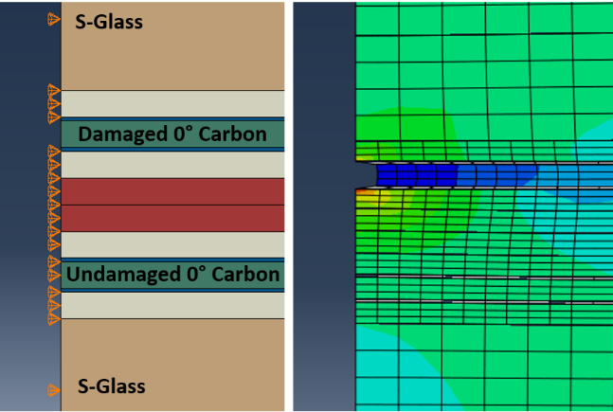
Figure 1. FE model of ±45/-45° layup.

2.4 Microscopic observations
The samples interrupted during the tensile tests were cut and analysed by light microscopy. The microscopic images revealed the failure mechanisms of the layups and shown fragmentation distance.

- Results
3.1 Experimental and numerical results
Using the experimentally measured stress-strain curves, pseudo-yield strains were calculated, and as it was expected, different strain values were found for the investigated configurations. The pseudo-yield strain is the strain level at which the tensile response deviates significantly from the initial linear elastic behaviour and is considered as the strain level at which the carbon layer starts to suffer fragmentation.
Using the finite element analysis, the strain concentration in the undamaged carbon ply and the strain gradient through the thickness were calculated. Figure 1 shows the correlation between the strain concentration on the undamaged carbon ply and the yield strain measured during the experiments. It can be seen that when the strain concentration and the strain gradients are lower the pseudo-yield strain increases. This effect is produced mainly due to the stiffness of the adjacent layers close to the 0° carbon plies, which are failing by fragmentation. Figure 2 shows the correlation between stiffness and pseudo-yield strain.

3.2 Microscopic observations
The micrographs show that the position of the plies play an important role in the failure mechanisms and fragmentation density of the 0° carbon plies. The laminates with stiffer layers close to 0° carbon plies have lower fragmentation density and lower damage levels. On the other hand, the 0° Glass ply controls the damage propagation of the matrix impeding cracking grow. The ±45 QI/+0 and ±60 QI/+0 laminates show the best performance, as in their configuration the 0° Glass plies are located close to the 0° Carbon plies.

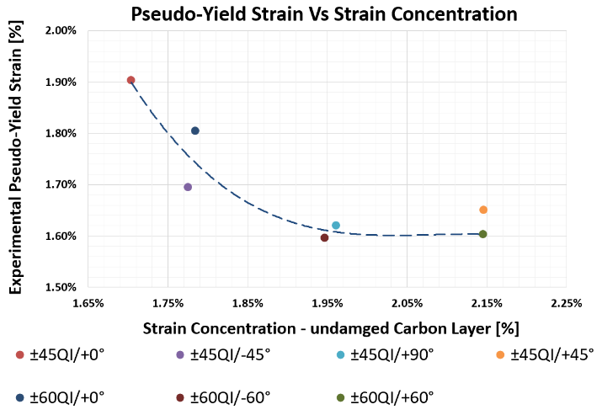
Figure 2. Correlation between the pseudo-yield strain and the average strain concentration.

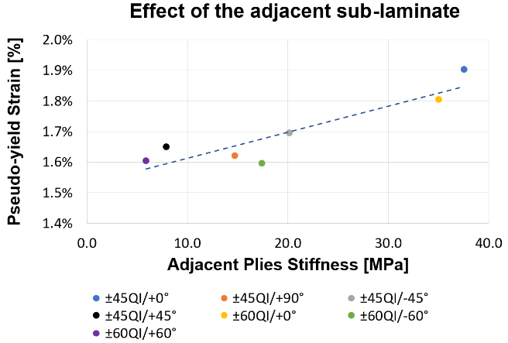
Figure 3. Correlation between pseudo-yield strain and stiffness of the adjacent sub-laminates.

- References
- G. Czel, MR. Wisnom, “Demonstration of pseudo-ductility in high performance glass-epoxy composites by hybridisation with thin-ply carbon prepreg”, Compos Part A Appl. Sci. Manuf. 52 (2013) 23-30.
- Fuller JD, Wisnom MR. “Pseudo-ductility and damage suppression in thin ply CFRP angle-ply laminates”. Compos Part A Appl Sci Manuf 2014;69:64–71.
- M. Jalalvand, G. Czel, MR. Wisnom, “Numerical modelling of the damage modes in UD thin carbon/glass hybrid laminates”, Compos Sci. Technol. 94 (2014) 39-47.
- M. Fotouhi, M. Jalalvand, MR. Wisnom. “High performance quasi-isotropic thin ply carbon/glass hybrid composites with pseudo-ductile behaviour in all fibre orientations”. Compos Sci Technol 2017;152: 101–10.

