Aerospace industry in México and biofuels: a sustainability approach

Rocha-Lona L. a , Muñoz-Sánchez C. a, Garza-Reyes J. A. b, Kumar Vc., and López-Torres G.Cd.

*a ESCA Santo Tomás, Instituto Politécnico Nacional, Mexico City, 07738, Mexico.*

*b Centre for Supply Chain Improvement, The University of Derby, DE22, UK.*

*C Bristol Business School, University of the West of England, Bristol, BS16 1QY, UK*

*d Centro de Ciencias Económicas y Administrativas, Universidad Autónoma de Aguascalientes, Ciudad Universitaria*

*Aguascalientes, 20131, Mexico*

Abstract

The development of the aerospace industry in Mexico shows potential growth measured through the levels of state investment and the arrival of several international manufacturers to set up manufacturing production because of advantages offered by the country’s proximity to North America and its international trade agreements with the European Union and some Asian countries, which are considered to be the biggest markets in this sector. Very high demand is expected for jet fuels in the coming decades due to intense global economic activity. Under this context, the Mexican government has developed infrastructure and several programs aimed at developing sustainable long-term biofuels for the industry. The objective of this research is to provide a literature review of the aerospace industry and the main biofuel crops currently deployed for this industry (mainly transportation). The main results show a promising and innovative industry fostered by public and private investments motivated by Mexico’s recent regulatory changes in the energy sector. The main raw material crops for the production of biofuel in Mexico are Jatropha, sunflower, canola, and palm oils, all of which present significant advantages with production in Mexican soils. Important challenges remain, however, for continued development of capabilities in R&D, manufacturing production, supply chain optimization, and market development for biofuels.

*Keywords: Sustainable energy, aerospace industry, biofuels, business sustainability*

1. Introduction

The aerospace industry is currently facing major challenges, and the entire industry is looking for opportunities to reduce operational costs, gain energy efficiency, and become a sustainable industry in the long-term. It has been argued that activities derived from transportation [1] are the second major source of CO2 emissions, just after the industrial sector. According to the US Energy Information Administration (EIA) [1], it is estimated that transportation accounts for around 116 quadrillion Btus in 2016, and the consumption of jet fuel, for instance, will double from 2015 to 2040 because of the global rise in air travel. This will represent an increase of 4.7 quadrillion Btus between 2015 and 2040 [1, pp. 120-124]. In this regard, the industry faces major challenges in its attempts to improve energy efficiency and diminish its dependence on fossil fuels.

Jet fuel consumption for OECD countries, including Mexico, is projected to grow in the coming years and to more than double by 2040, passing from 5 quadrillion Btus in 2015 to 12 quadrillion Btus. The global increase is also fostered by China and India, with a 70% increase by 2040 for non-OECD countries in Asia [1, p. 16]. In fact, growing populations around the world, the need for personal transportation, and economic and business development are the main factors that will motivate jet fuel consumption in the coming decades. For this reason, international and industry efforts, including the aerospace industry in Mexico, have been aimed at searching for sustainable strategies that help to push economic growth while using alternative fuels, mainly non-fossil fuels. This will not only diminish negative environmental impacts but also help significantly in reaching the UN’s Sustainable Development Goals by 2030 [2]. The advances Mexico presents focus on the design and strengthening of a public policy that encourages the production and use of bio-jet fuels. This strategy has focused particularly on the production of commodities such as Jatropha, sunflower, canola, and palm oils. This paper focuses on reviewing the feasibility of these biofuel crops considering current government involvement, investments from public and private sectors, production strategy, and the growing market forecast for bio-jet fuel production.

1. The Aerospace Industry: A Perspective

The aerospace industry can be defined as all productive activities dedicated to the construction and design of airplanes, helicopters, launchers, missiles, satellites, and equipment used onboard [3]. The industry is one of the largest manufacturing industries in the world in terms of jobs generated and value added. It can be said that just as the locomotive was the symbol of progress in the 19th century, during the 20th century, aircrafts were the most striking symbol of progress and industrial development.

The aerospace industry has motivated the development of other sectors, including tourism and travel, logistics and transportation, telecommunications, electronics and computing, advanced materials development, fuels, engines, civil engineering, capital goods, defense supplies, salvage, and public safety.

Aerospace companies are governed not only by profitability resulting from research and development, production strategies, and quick commercialization of products and services but also by strong demand and governmental policies. The demand of governments and policy issues influence the processes of strategic planning, development of an industry-wide vision, industry agreements, and the setup of key suppliers. Most clusters and supply chain providers are located in North America and Europe, with some in a few Asian countries. However, further development of the industry is expected to cause an expansion to other locations that are becoming manufacturing centers for production and end-consumers (e.g., the emerging economies). Along with the development of the aerospace industry in Western Europe and the United States, countries on other continents have joined in becoming manufacturers and consumers of aerospace equipment [4].

The manufacturing production of aircrafts has increased since 2004–2005. Fig. 1 shows the sales order and production history of commercial aircrafts from 1981 through 2016, during which there was a 220% increase. Using a seven-year moving average, production levels over the last 20 years have increased 120.5% since 1996 [5]. Over the next decade, annual production levels of commercial aircraft are anticipated to increase by an estimated 29.3% [6]. These figures are congruent and correlated with jet fuel consumption figures provided by the EIA [1]. In other words, the entire industry and all the supply chain providers have grown significantly in the last two decades, and they are expected to keep growing for at least another two.



Fig. 1. Aerospace industry growth rate (demand forecasting) (1981–2020) [7].

* 1. The Aerospace Industry in Latin America

Latin America is considered to have good prospects for development of the aerospace sector. The industry is led by Brazil, Mexico, Panama, Chile, Colombia, and Peru, who have all shown good performance in economic indicators and are expanding, generating new routes, increasing aircraft demand, and boosting internal markets. The region’s commercial fleet is projected to double between 2015 and 2035, from nearly 1,550 airplanes to more than 3,600 (see Fig. 2). Latin America will need 2,960 new deliveries over the next 20 years to meet the combined demands of growth and replacement. The majority of these deliveries are expected to be in the single-class segment, reflecting the continued growth of low-cost carriers and further expansion of networks within Latin America and the Caribbean [8].

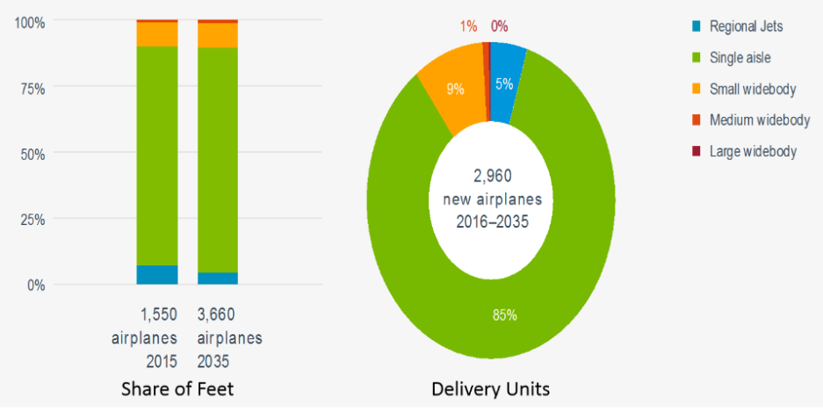

Fig. 2. Latin American market value [8].

In addition, the region is considered to be strategic for the development of the aerospace industry because of investments in the sector, the growing demand, and the developments in infrastructure, which include new airports and facilities across the region. In this regard, the clusters and companies involved in the industry, whether in transportation, infrastructure, communications, tourism, governmental policy regulations, or a number of others, are responding efficiently to these challenges to foster economic growth.

* 1. The Evolution of the Mexican Aerospace Industry

In 2002, only 20 aerospace companies in Mexico exported products to the United States worth $150 million. After the Mexican economic crisis in 1998, Mexico was urged to develop industries and to export more goods, which led to good economic performance from the automotive and electronic industries. The development of the aerospace industry took place after 2000, taking advantage of already developed human resources in the automotive, telecommunications, transportation, and electronics industries. This soon resulted in value added products and reduction of operational costs due to the proximity of the main markets, cheap labor, and financial incentives [9]. It can be said that the aerospace industry in Mexico is relatively new and offers significant competitive advantages that have attracted foreign and local investment, leading to settlement in production centers for a wide range of aerospace parts and equipment.

Most of Mexico’s aerospace industry is located in the states of Baja California, Chihuahua, Nuevo León, Querétaro, and Sonora, in primarily the central and northern states (Fig. 3). This makes sense because these states are some of the most industrialized, they are close to the US market, and, on average, they possess good communications infrastructures. These states have also managed to get their public, private, and educational sectors working together to form specialized clusters that, in turn, have fostered the development of the industry. This led to 330 aerospace companies operating in Mexico in 2016, greatly surpassing the pioneering 20 established in 2000.



Fig. 3. The number of aerospace industry companies in each Mexican state in 2014 [10].

According to Euromonitor International [11, p. 4], the market value of the industry soared 24% in 2015 to reach MXN 55.1 billion due to spending on commercial aircraft. The industry’s production growth was much the same, around 23%, in 2015, reaching MXN 48.6 billion, which is congruent with the growing air travel market reported from these sources [12, 13]. Production is expected to continue growing, making this industry the second largest in Latin America after Brazil [11, p. 2]. The Mexican producers play a key role in the supply chain of some of the major global producers such as Boeing, Airbus, Bombardier, Embraer, and Honeywell. For instance, Boeing alone has claimed to have $1 billion worth of aircraft components made by Mexican producers each year, and the company has commented that it was evaluating having its own production facilities in Mexico [11]. The increase of the industry’s production can be traced in Fig. 4, which shows that the level of exports were at the same level until 2012, and then, up to 2014, the exports significantly increased, leaving a positive trade balance of $640.6 million.



Fig. 4. Mexican aerospace trade balance (million USD) in 2010–2014 [14, 15].

This way, Mexico has initiated an explicit campaign to attract aerospace companies, and the positive experiences of the first firms paved the way for increases in industry production on a wider range of products and services with the quality and safety standards demanded by the global industry. In addition, the natural resources that foster the metal-mechanic industry were considered a key issue for development of a wide range of suppliers [10], and today, the aerospace industry is one of the fastest-growing industries in Mexico [13, p. 4]. However, the increasing economic activity of the industry has posed several challenges for industry regulations, environmental impacts, technological developments, financial investments, and long-term industry sustainability. As a result, there is a need to develop alternative fuels not only to keep efficient production running but also to provide products and services that consume less energy and are friendly to the ecosystems in which we live.

1. The Biofuels Industry for Aerospace in Mexico
   1. The Transportation–Aerospace Sector

The transportation sector is the largest of all the end-use energy sectors in Mexico, well above industry (28%) and building (20%) (Fig. 5). The energy demand for the transportation sector has been rising rapidly at an average annual growth rate of 2.6% since 2000; light-duty cars and trucks, followed by aircraft, consume most of the energy in the sector [16].

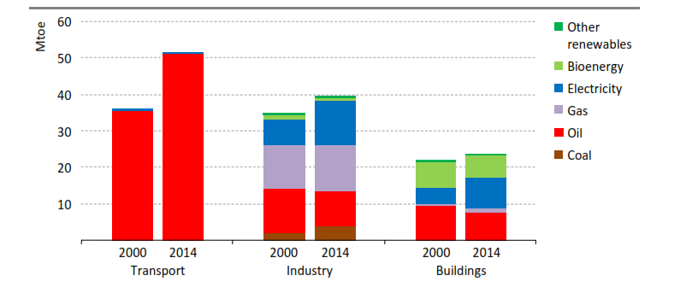

Fig. 5. Energy demand by fuel in selected end-use sectors in Mexico. Mtoe = million tons of oil equivalent [16].

Fig. 5 shows that fossil-based fuels are the main (and nearly the total) source for the transportation sector, pointing to a net dependency for these kinds of fuels. With the combined impact of increasing oil prices and concerns about environmental deterioration and high CO2 emissions, the aerospace industry is focusing on biofuels as an alternative to traditional fossil-based fuels. The International Energy Agency (IEA) estimates that by 2050, biofuels will account for 27% of all fuels in the transportation sector, particularly as a replacement for diesel and jet fuel [17]. Bio-jet fuel has recently started to attract interest, and it has been identified by the International Air Transport Association (IATA) as the most promising strategy to reduce CO2 emissions in the aviation sector. In this context, IATA aims to reduce by 50% the industry’s carbon emissions by 50% by 2050, relative to a 2005 baseline [18]. Fossil jet fuel is composed of approximately 20% paraffins, 40% isoparaffins, 20% naphthenes, and 20% aromatics. This combination gives fossil jet fuel its physical properties [19]. When jet fuel is burned, other emissions, including sulfur oxides, nitrogen oxides, unburned hydrocarbons, and particulates (soot) are formed [20]. Biomass-derived jet fuel can provide a short-term and even long-term solution to the aerospace industry in the form of a lower environmental impact than fossil jet fuels [21].

Accordingly, bio-jet fuel has been identiﬁed by the IATA as the most viable alternative for the replacement of fossil fuels in the aerospace industry [22, 23]. Sustainable biofuels for aviation could reduce CO2 emissions by 80% on a full carbon life cycle basis. IATA’s focus is on biofuels sourced from second or new generation biomass (e.g., algae, Jatropha, and camelina). These fuels can be produced sustainably to minimize their impacts on food crops and fresh water usage [23]. The International Standard ASTM D7566, which guides the use of mixed biofuels with conventional turbosina, was introduced in 2012, allowing commercial airlines to carry out flights using biofuels. Interjet, a Mexican airline, was the first to deploy commercial flights with biofuel in the Americas. The flight took place using an Airbus A320-300 aircraft, and the fuel mix was 27% bioturbosina and 73% conventional turbosina [24].

* 1. Bioenergy: Mexico’s Capacity and Resources

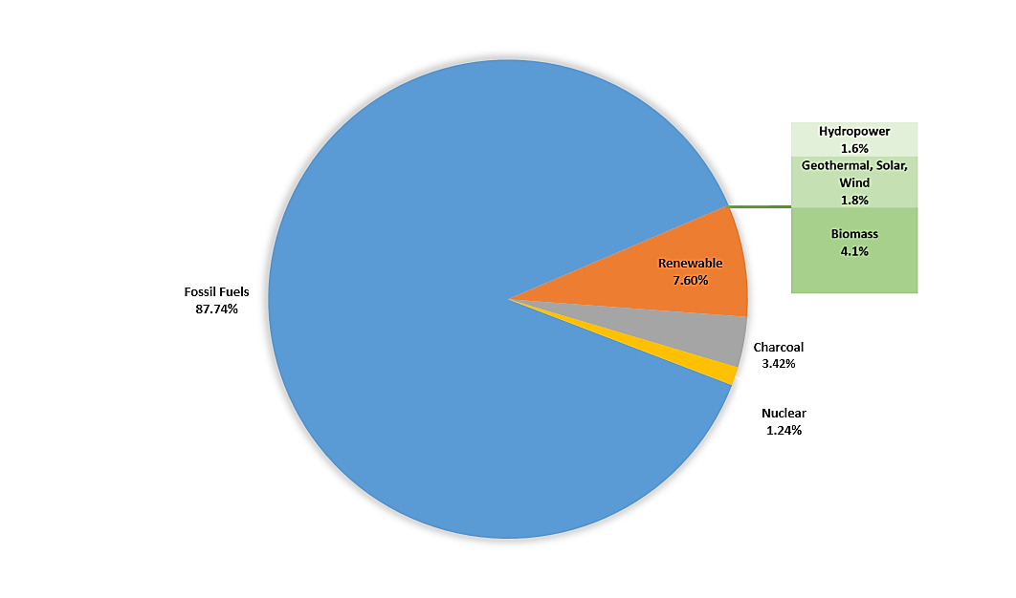Mexico is the third largest country in Latin America and the Caribbean in terms of cropland area, following Brazil and Argentina [25]. In 2014, the cultivated area was 22.4 million hectares, with agricultural production of 200 million tons [26]. Six crops represent 58% of the cultivated area: corn, sorghum, beans, coffee, sugarcane, and wheat [27]. The residual biomass generated from these crops currently has diverse uses, including animal feed and bedding, mulch, burning to produce energy, and composting. Biomass utilization for obtaining energy is an attractive option for the rural sector due to its multiple potential social benefits [28]. In 2016, modern biomass use included around 68 projects for power self-supply through combustion process using biogas and waste lignocellulosic biomass (e.g., sugarcane bagasse). Power installed capacity is 647 MW, of which 586 MW come from sugarcane bagasse and 61 MW from biogas [29]. Mexico produced 210.8 million tons of oil equivalent energy during 2014. According to Fig. 6, an estimated 87.74% came from fossil-based fuels, 7.60% from renewable sources, 3.42% from charcoal, and the remaining 1.24% from nuclear energy [30, 31].

Fig. 6. Mexico’s total energy production (Mtoe) in 2014 [30, 31].

Out of the global production of renewable energy sources (7.60%), biomass contributes 4.1%; geothermal, solar, and wind together contribute 1.8%; and hydropower contributes 1.6%. The potential to produce biomass in Mexico is high and is under development, with recent public policies put in place for its growth. Biomass energy use and production in Mexico are considered in the recent general regulatory framework for renewable energy sources. The National Development Plan (NDP) (2013–2018) and National Energy Strategy (NES) (2014–2028) recognize and promote the following specific guidelines [32, 33]:

* Prepare a national program for sustainable use of renewable energy that contains a methodology for the accounting of environmental and social externalities.
* Promote the development of and investment in technologies for the use of renewable energy in the generation of energy. Establish economic incentives and incremental goals that allow reaching 2030 with a renewable energy share of at least 20% of the total energy portfolio.
* Create robust support mechanisms for the development and manufacture of materials, equipment, and subcomponents for all renewable energy technologies in which Mexico would have competitive advantages with the exterior.
* Promote the efficient use of energy in domestic, industrial, agricultural, and transportation sectors through regulations on energy consumption.

Through the Secretary of Energy (SENER) and the commission for regulating energy, Mexico has deployed initiatives to promote the use of biofuels for the aerospace sector that aim to ensure the sector evolves toward safe, efficient, and sustainable operation. In this effort, and with the support of the National Council of Science and Technology of Mexico (CONACyT), the Mexican Network of Bioenergy (RMB) was created. This project aims to establish and consolidate a bioenergy network that is focused on aspects of science, technology, and innovation to promote the sustainable use of bioenergy on a large scale [34].

The group has managed to bring together higher education institutions, research centers, and companies operating in the sector such as Boeing and Aeromexico (the largest commercial airline in Mexico). Marc Allen, President of Boeing International, said, “With the objective to support customers and the growth of the aerospace industry in the long-term, Boeing is proud to work together with Aeromexico and other important partners to develop sustainable biofuels for the industry in Mexico.” [35] In the same line of action, the Secretary of Energy launched the Mexican Center for Innovation in Bioenergy (CEMIE-Bio) with the aim of developing technologies for the sustainable use of energy of forests, terrestrial–aquatic plants, agricultural waste, livestock, and urban and industrial sub-products [36]. The center has a cluster dedicated specifically to the development of the aerospace industry in the area of biofuels that integrates the capabilities and resources of research institutes and the private sector. The center also carries out other research activities in the mentioned fields and develops the human resources for the design, implementation, and operation of the generated technologies [36, 37].

* 1. Commodities for the Production of Biofuels

Some of the main commodities that have been of interest in the development of biofuels are Jatropha oil, sunflower oil, canola oil, and palm oil. There are currently more than 6 million hectares of Jatropha plantations with the potential for establishment of approximately 2.6 million hectares with high potential. The Mexican states that have the best conditions for growing these shrubs are Sinaloa, Tamaulipas, Guerrero, Chiapas, and Michoacán [38]. One of the main advantages is that Jatropha can grow in semi-arid conditions or in sandy soils with a low nutrient content and need almost no extra supplies or special nutritional regimes [39]. Fig. 5 shows the production of Jatropha between 2008 and 2014. The graph shows a slight increase every year, starting with 2,185 tons in 2008 and reaching 15,825 tons in 2013, followed by a drastic drop of 6,749 tons in 2014. Production of Jatropha is, however, expected to increase in the coming years as a result of the projects currently implemented by the biomass industry in Mexico [40].

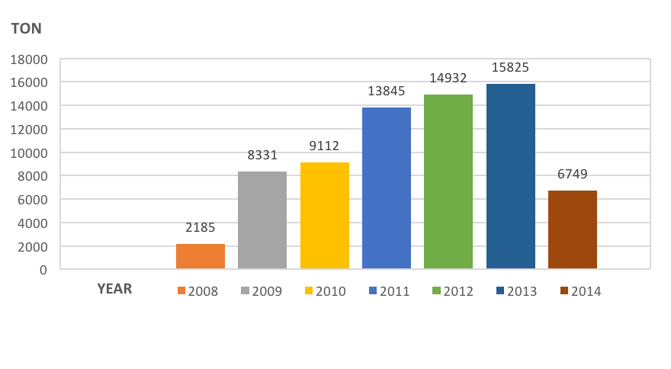

Fig. 5 National production of Jatropha oil in 2008–2014 [38, 41].

Sunflower oil is used in several parts of the world for its ability to generate biofuels, and although the chemical properties of the oil show good results for its manufacture, its profitability is still analyzed to be an important raw material in the production of biofuels [42]. Fig. 6 shows the ups and downs of sunflowers in national production in recent years, starting from 320 tons in 2008 to a production of 3,797 tons in 2010, with no great variation between 2010 and 2011; however, recent years have shown upward growth, and in 2014, production increased to reach 16,559 tons.

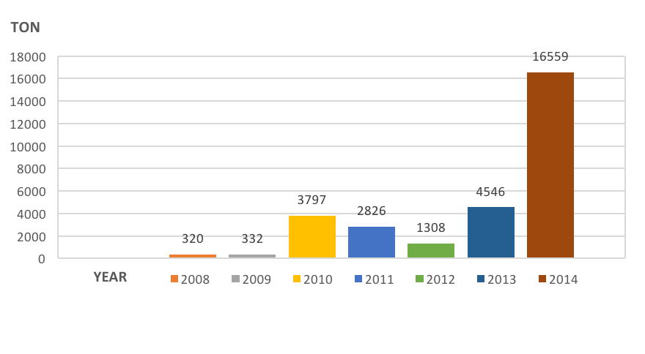

Fig. 6. National production of sunflower oil in 2008–2014 [30, 41].

Canola oil is a good source for production of biofuels because it contains approximately 40–45% oil that is also much better than other oil crops. For example, soybeans only contain one oil at 18–20% [43]. Fig. 7 shows a decrease in the production of canola from 3,849 tons in 2008 to 3,221 tons in 2009 and an increase to 7,544 tons late in 2010. In the following three years, it remained relatively constant—3,531 tons in 2011, 3,348 tons in 2012, and 2,871 tons in 2013. In 2014, the production dropped to 1,946 tons.

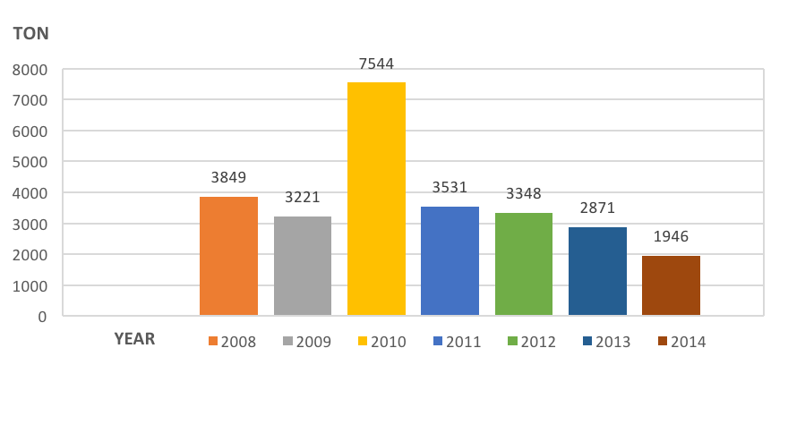

Fig. 7. National production of canola oil in 2008–2014 [30, 41].

The palm oil based biofuel stands out among the other oils because it has a high octane number and high oxidation stability, which makes the product stable for more than six months. Additionally, the physicochemical properties meet the requirements of diesel engine combustion and are comparable with other biodiesels such as soybean and rapeseed oils [44]. As shown in Fig. 8, Mexico has been increasing its production of palm oil. In 2008, 307,757 tons were reported, followed by 367,048 tons in 2009. 2010 and 2011 were at 438,172 tons and 507,011 tons, respectively, with a decrease to 462,662 tons in 2012. Production recovered in 2013, with 567,554 tons, and in 2014, it improved to 678,935 tons. Production continues to increase, given the recent crops in the country.

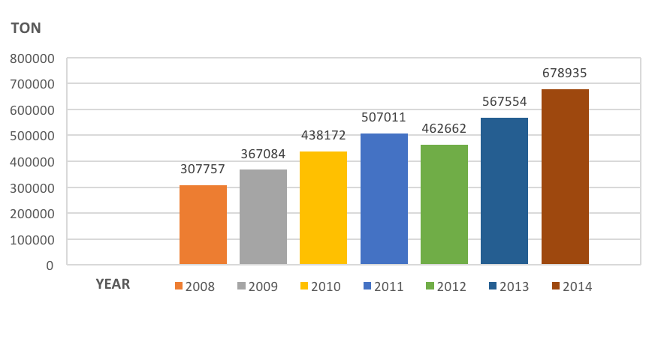

Fig. 8.  National production of palm oil in 2008–2014 [41], [30].

Taking into account the national strategy to develop jet biofuels, Table 1 shows the potential of the commodities that are currently being produced, starting with Jatropha, which is inedible and grows in semi-arid or sandy soils with a low nutrient content. Its production costs are relatively low, between $0.37 and $0.85 per liter [45], [46]. Its production in the country has decreased in recent years; however, there are new plans to increase its production and/or for the government to create specific projects to examine its technical feasibility in bio-jet fuel. Sunflower is being used as a biofuel in different parts of the world with good results. It has a good percentage of oil that runs between 35% and 38% [45], and its national production has increased in recent years. However, its production cost is still high at between $0.93 and $1.30 per liter [45, 46].

TABLE 1

Biofuel Crop to Produce Bio-Jet Fuel

|  |  |  |  |  |
| --- | --- | --- | --- | --- |
| BIOFUEL  CROP | AGRICULTURAL PERFORMANCE  (T/HA) [45] | CONTENT OF  OIL (%) | PRODUCTION COST (US$/L) [45, 46] | OPPORTUNITIES AND OBSTACLES |
| Jatropha | 2.0 | 32–40 (%) [47] | 0.37–0.78 | Easy to cultivate, not edible |
| Sunflower | 1.7 | 35–38% [45] | 0.93–1.30 | High production cost, edible |
| Canola | 1.5 | 40–45% [43] | 0.3–0.45 | High oil content, low production cost |
| Palm oil | 14.8 | 20–24% [45] | 0.3–0.4 | Good national production, low production cost |

As an input for biofuels, canola has an advantage since it has an oil content between 40-45% [43] and a lower production cost that ranges from $0.30 to $0.50 per liter [45], [46]. However, national production has declined in recent years (2012–2014). Finally, palm oil shows a better agricultural performance with respect to the other commodities at 14.8 T/Ha [45], and it has a low production cost of around $0.30 to $0.50 per liter [45, 46]. Its national production is growing steadily (2013–2014).

1. Conclusion

Forecasts indicate strong economic activity for the transportation sectors not only in Mexico but for most developed and emerging economies. As a consequence, the demand for jet fuel will inevitably increase. However, there is a strong need to diminish CO2 emissions and to meet the UN’s sustainability goals and national and international commitments such as the agreements of the Paris and Kyoto protocols. Since the production of fossil fuels is still growing to cope with the demand, the need for developing alternative non-fossil fuels such as biomass to be used for jet fuels has increased. This article argued that Mexico has challenges with developing biofuels for the aerospace sector, but that there is significant potential to produce biofuels considering Mexico’s natural resources, current levels of investment, and research capabilities. Additionally, recent changes in the regulations (Mexico’s Energy Reform) have promoted the production and use of biofuels. In line with these efforts, the renewable sources law has included economic instruments to finance the energy transition through renewables [40], thus ensuring that more projects will be created. Added to climate change efforts and Mexico’s energy reforms [48], this amounts to having a more competitive energy sector. In this regard, the recent creation of research centers by the Mexican government (through the Secretary of Energy) and active participation of companies in the industry bode well for the development and increase of biofuel production.

The article also argues that crops such as Jatropha, sunflower, canola, and palm are promising raw materials for producing jet biofuels. The Jatropha plant has great potential because of its ability to grow in difficult climate conditions and with very little nutrients from the soil. Some Mexican states possess the conditions to efficiently grow this crop. Sunflower also has potential for increasing production. However, production costs are still high although efforts are currently underway to cut down those costs. By contrast, canola has a high oil content for biofuels and better production costs, which make it a very attractive raw material for biofuel production. Finally, palm oil shows better agricultural performance than the previous crops, resulting in good national production and low production costs; thus, it is an attractive raw material option for biofuel production. Mexico is expected to increase production of all of these crops in the coming years, but there are still important challenges to be overcome in the production, supply chain, and regulation issues with the use of land and other social implications.

Acknowledgements

This work was financially supported by the British Academy and Instituto Politécnico Nacional de México under the grants numbers AF160218 and SIP 20171247. The authors would like to thank these institutions for their support and commitments to this research project. May thanks also to the referees for their valuable comments and suggestions to improve this manuscript.

References

|  |  |
| --- | --- |
| [1] | EIA. International Energy Outlook 2017. US Enery Information Administration, Washington DC, 2017. |
| [2] | UNDP, "Sustainable Development Goals ,The United Nations Development Programme," [Online]. Available: http://www.undp.org/content/dam/undp/library/corporate/brochure/SDGs_Booklet_Web_En.pdf. [Accessed November 2017]. |
| [3] | Carrincazeaux C, Frigant V. The Internationalisation of the French Aerospace Industry: To What Extent Were the 1990s a Break with the Past?. *Competition and Change,* 2007; 11(3):260-284. |
| [4] | Frigant V, Talbot D, Kechidi M. Les territoires de l'aéronautique : EADS, entre mondialisation et ancrage, Bordeaux: L'Harmattan, 2006. |
| [5] | Boeing. Order and Deliveries. [Online]. Available: http://www.boeing.com/commercial/#/orders-deliveries. [Accessed November 2017]. |
| [6] | Airbus. Order and Deliveries. [Online]. Available: www.aircraft.airbus.com/market/global-market-forecast-2017-2036/. [Accessed November 2017]. |
| [7] | Deloitte. Analysis Global aerospace and defense sector Outlook 2017. [Online]. Available: https://www2.deloitte.com/global/en/pages/manufacturing/articles/global-a-and-d-outlook.html. [Accessed November 2017]. |
| [8] | Boeing. Boeing Current Market Outlook 2017-2036. [Online]. Available: http://www.boeing.com/resources/boeingdotcom/commercial/market/current-market-outlook-017/assets/. [Accessed November 2017]. |
| [9] | Martinez-Romero J. Towards an Aerospace System of Production in Mexico?. *Int. J. Technology and Globalisation,* 2013; 7(12):141-158. |
| [10] | FEMIA. Federación Mexicana de la Industria Aeroespacial, Pro-Aéreo 2012 - 2020. [Online]. Available: www.2006-2012.economia.gob.mx/files/comunidad_negocios/industria_comercio/PROAEREO-12-03-2012.pdf. [Accessed November 2017]. |
| [11] | Euromonitor. Aircraft and Spacecraft in Mexico: ISIC 353. Eurominor International, London, 2017. |
| [12] | Euromonitor. Air Transport in Mexico: ISIC 62. Euromonitor International, London, 2107. |
| [13] | Euromonitor. Mexico: Counyry Profile. Euromonitor International, London, 2018. |
| [14] | SE. Secretaría de Economía de México, Aeroespacial. [Online]. Available: www.2006-2012.economia.gob.mx/comunidad-negocios/industria-y-comercio/informacion-sectorial/automotriz/110-comunidad-de-negocios/informacion-sectorial/aeroespacial.. [Accessed November 2017]. |
| [15] | PwC. Knowledge Center Mexico, Aerospace Industry in Mexico. [Online]. Available: www.pwc.com/mx/es/knowledge-center/archivo/20150604-gx-publication-aerospace-industry.pdf. [Accessed November 2017]. |
| [16] | IEA. Mexico Energy Outlook 2016. International Energy Agency, Paris, 2016. |
| [17] | IEA. Technology roadmap biofuels for transport: International Energy Agency, 2011. [Online]. Available: www.iea.org/publications/freepublications/publication/biofuels_roadmap_web.pdf. [Accessed November 2017]. |
| [18] | IATA. International Air Transport Association (IATA), Sustainable Aviation Fuel Roadmap 2015. [Online]. Available: https://www.iata.org/whatwedo/environment/Documents/safr-1-2015.pdf. [Accessed November 2017]. |
| [19] | Bernabei M, Reda R, Galiero R, Bocchinfuso G. Determination of total and polycyclic aromatic hydrocarbons in aviation jet fuel. *Journal of Chromatography A,* 2003; 985(1-2):197-203. |
| [20] | Chevron., "Aviation fuels technical review," Chevron Products Company, [Online]. Available: https://www.cgabusinessdesk.com/document/aviation_tech_review.pdf. [Accessed November 2017]. |
| [21] | Wang, W., Tao, L., Markham, J., Zhang, Y., Batan, L., Warner, E., Biddy, M. Review of Biojet Fuel Conversion Technologies. National Renewable Energy Laboratory (NREL)., Denver, West Parkway Golden, 2016. |
| [22] | Bakley, S., Rye, L. Willam-Wilson, C. Aviation gas turbine alternative fuels: A review. *Proceedings of the Combustion Institute,* 2011; 33(2):2863-2885. |
| [23] | IATA. A Global Approach to Reducing Aviation Emissions. The International Air Transport Association, Switzerland, 2009. |
| [24] | Biofuels International. Interjet and Airbus test first Biofuel flight in Mexico. [Online]. Available: https://biofuels-news.com/display_news/3433/Interjet_and_Airbus_test_first_biofuel_flight_in_Mexico/. [Accessed November 2017]. |
| [25] | ECLAC. Statistical Yearbook for Latin America and the Caribbean. Economic Commission for Latin America and the Caribbean (ECLAC). Santiago, Chile, 2016. |
| [26] | SAGARPA. Secretaría de Agricultura, Ganadería, Desarrollo Rural, Pesca y Alimentación, 4to. Informe de Labores (2015-2016). [Online]. Available: www.sagarpa.gob.mx/Transparencia/POT_2016/Informe/CuartoInformeDeLabores_SAGARPA.pdf. [Accessed November 2017]. |
| [27] | INEGI. Instituto Nacional de Estadística y Geografía, Encuesta Nacional Agropecuaria 2014. [Online]. Available: www.inegi.org.mx/saladeprensa/boletines/2015/especiales/especiales2015_08_8.pdf. [Accessed November 2017]. |
| [28] | Demirbas, A. Biofuels Sources, Biofuel Policy, Biofuel Economy and Global Biofuel Projections. *Energy Conversion and Management,* 2008; 9(8):2106-2116. |
| [29] | PROMEXICO. Diagnóstico Sectorial de Energías Renovables. [Online]. Available: www.promexico.gob.mx/documentos/diagnosticos-sectoriales/energias-renovables.pdf. [Accessed November 2017]. |
| [30] | SENER. Inventario Nacional de Energías Renovables. [Online]. Available: https://dgel.energia.gob.mx/inere/. [Accessed November 2017]. |
| [31] | SENER. Sistema de Información Energetica, Secretaría de Energía de México. [Online]. Available: sie.energia.gob.m. [Accessed January 2018]. |
| [32] | Presidencia de la República, México. National Strategic Plan for Development 2013-2018, 20 May 2013. [Online]. Available: http://pnd.gob.mx/. [Accessed November 2018]. |
| [33] | SENER. National Energy Strategy 2014-2018. February 2014. [Online]. Available: https://www.gob.mx/cms/uploads/attachment/file/214/ENE.pdf. [Accessed January 2018]. |
| [34] | RTB. Red Temática de Bioenergía. [Online]. Available: http://rtbioenergia.org.mx/. [Accessed November 2017]. |
| [35] | SKYTEAM. Group SKYTEAM Cargo, 2015. [Online]. Available: https://www.skyteam.com/es/cargo/about/press-releases/2015/boeing-aeromexico-mexican-government-collaborate-on-sustainable-aviation-biofuel-research-and-development/. [Accessed 1 2018 ENERO]. |
| [36] | CEMIE-Bio. Centro Mexicano de Innovación en Bioenergía. November 2017. [Online]. Available: www.gob.mx/sener/articulos/centro-mexicano-de-innovacion-en-bioenergia. |
| [37] | SENER. CEMIE-BIO Clúster de Bioturbosina: misión y objetivos estratégicos," 15 July 2015. [Online]. Available: https://www.gob.mx/sener/ [Accessed November 2017]. |
| [38] | T. C. L., E. Bautista R., A. Zamarripa C., J. Rivera L. and A. Pérez V., Diagnosis and Strategic Plan Jatropha SPP. in Mexico. Ciudad de México: SNICS, SINAREFI., 2015. |
| [39] | A. Lang and F. Abdelraheem Elhaj. Jatropha oil production for biodiesel and other products : A study of issues involved in production," World Bioenergy Association (WBA) , 2013. |
| [40] | Alemán-Nava G. *et al*. Renewable energy research progress in Mexico: A review. *Renewable and Sustainable Energy Reviews,* 2014; 32:725-736 |
| [41] | SIAP. Servicio de Información Agroalimentaría y Pesquera. [Online]. Available: https://www.gob.mx/siap. [Accessed November 2017]. |
| [42] | Boumesbah I., Hachaïchi-Sadouk Z., Ahmia A.C. Biofuel Production from Sunflower Oil and Determination of Fuel Properties. *Progress in Clean Energy*, Springer, 2015, pp. 105-111. |
| [43] | D. Yadava, S. Vasudev, N. Singh, T. Mohapatra and K. Prabhu. Breeding Major Oil Crops: Present Status and Future Research Needs.*Technological Innovations in Major World Oil Crops*, New York, NY, USA, , Springer, 2012. |
| [44] | Kalam, M.A., Masjuki H. H. Biodiesel from palm oil–an analysis of its properties and potential. *Biomass and Bioenergy,* 2002; 23(6):471-479. |
| [45] | Vega, O. Atlas de la agroenergía y los biocombustibles en las Américas.,» IICA, Programa Hemisférico en Agroenergía y Biocombustibkes, San José, Costa Rica., 2010. |
| [46] | SENER, "Perspectiva de Energías Renovables 2016-2030," [Online]. Available: www.gob.mx/sener. [Accessed November 2017]. |
| [47] | Axelsson, L., Franzen M., Ostwald, M., Berndes, G., Ravindranath. Performance of jatropha biodiesel production and its enviromental and socio-economic impacts - a case study in Southern India. *World Renewable Energy Congress*, Linkoping, Sweden, 2011. |
| [48] | Alpizar–Castro I., Rodríguez–Monroy, C. Review of Mexico׳s energy reform in 2013: Background, analysis of the reform and reactions. *Renewable and Sustainable Energy Reviews,* 2016; 58:725-736. |