Offsite Construction: Developing a BIM-Based Optimizer for Assembly
ABSTRACT
The lack of adequate consideration of the underlying factors affecting the methods of building assembly often results in inefficiencies in the uses of building materials, equipment and manpower. These inefficiencies are further compounded by the nature of the construction industry, which traditionally involves complex processes that result in wastages during production. To address this problem, this study integrates the principles of Design for Manufacture and Assembly (DFMA) and Lean Construction to develop a design assessment and optimization system to assist designers in the selection of alternative building design elements and materials in a building information model. This assessment and optimization system rely on metrics derived from production data associated with the ease of assembling, ease of handling, the speed of assembling and the wastage during assembly or construction of a building element or material. This paper presents the development of BIM-OfA assessment logic and its application for assessment and optimal selection of building envelop through the extension of Building Information Modelling (BIM). The system demonstrates its adequacy as an indicator of construction and material efficiency, its integration with BIM further enhances the practicality of using production data such weight of components, number of on-site workers and number of parts, for buildability assessment to improve efficiency and reduce waste.
Keywords: Assembly; Efficiency; DFMA; Lean Construction; Building

INTRODUCTION
During the early stages of design conception, it is important to make guided decisions to enhance production efficiency (Boothroyd, et al., 2004). Design for manufacture and assembly (DFMA) is a design procedure and guideline that supports product simplification, integration of economic materials and processes into the design with the goal of achieving optimal manufacturing and assembly (Boothroyd, et al., 2004). DFMA has been successfully applied for various optimisation processes such as; enhancing early stage design specification (Vliet & Luttervelt, 2004), evaluating the ease of sourcing materials and manufacturing components (Marion, et al., 2007), recommending manufacturing options for concurrent engineering to designs (Howard & Lewis, 2003), developing assessment system for automatic assembly and developing guidelines for designs for on-site assembly of building components (Lassl & Löfgren, 2006). Although the manufacturing industry is far more efficient than the construction industry, there are some attempts to optimize construction through design assessment for constructability (Zolfagharian & Irizarry, 2017). Concepts such as standardization of parts, preassembly engineering, transportation, installation, and review specification have been proposed to improve constructability of building designs (O'Connor, et al., 1987). These concepts have a positive influence on improvement of construction efficiency, however, the overall application of DFMA has more potential to significantly improve the design process for more efficient fabrication and assembly of buildings (Yuan, et al., 2018). Furthermore, DFMA has a synergistic relationship with the lean construction concept through the promotion of efficiency and waste reduction especially in terms of the process of construction.
The application of lean principles in construction has great potential for design optimization and efficient construction. Lean construction has been applied to optimize work schedules, manage the allocation of materials and equipment to production just-in-time, and to plan congestion free work environment (Zhang, et al., 2016). Despite the potential benefits of DFMA and lean construction, there is a lack of design assessment tools that integrate both concepts to assist designers in appraising the implications of design on efficient assembly. Construction processes can be continuously improved and standardized through the concept of lean construction (Zhang, et al., 2016). Similarly, the adoption of principles from the concept of DFMA can enhance the consideration of production knowledge at the design stages for the purposes of optimization of design (JÜrisoo & Staaf, 2007; BCA, 2016). With the current trend of digital technologies in the construction sector, these concepts can be leveraged for continuous improvement (BCA, 2016; Zhang, et al., 2016).
Data-driven technologies such as Building Information Modelling (BIM) has enhanced early-stage decision making through advanced data visualization, clash detection, material quantity take-off and so on (Akinade, et al., 2015; Mahamadu, et al., 2017). However, there remains no example of incorporation of production economics data within BIM for the purposes of design appraisal or optimization (Zhang, et al., 2016). This is due to the complexity of construction operations which results from the uniqueness of construction processes, and the fragmentation within the industry which results in a wide variety of data formats (Gbadamosi, et al., 2018). The applicability of BIM to various stages enables the use of information from lean-based assembly principles such as DFMA for continuous improvement of design assessment and optimization systems (Das & Kanchanapiboon, 2011; Akinade, et al., 2015; Tauriainen, et al., 2016). BIM functionalities also present the opportunity to enhance the benefits of concepts such as; concurrent engineering, just-in-time delivery, supply chain management, waste minimization, deconstructability and reusability (Akinade, et al., 2015). Gbadamosi et al., (2018) affirmed that the adoption of successful practices in the manufacturing industry such as DFMA and lean principles can improve the efficiency in the construction industry. An extension of early-stage design capabilities to include principles of DFMA and lean construction will enhance the overall efficiency of the construction industry through the consideration of the critical factors that affect efficiency.
Based on the need to enhance design optimization through BIM, DFMA and lean construction, this study aims to explore the relevant principles in order to develop a BIM-based optimizer (BIM-OfA) for assembly of building design components. The following objectives have been addressed in this article.
- To identify factors for design assessment and optimization from DFMA and lean principles
- To develop an assessment logic of BIM-OfA for design optimization using the assessment attributes derived from DFMA and lean principles
- To enable the use of digital data for the assessment metric through the integration of building information model
The proposed framework resulted in indices which allowed appraisal of design options in relation to (i) ease of assembly; (ii) ease of handling; (iii) waste greeted from the assembly; and (iv) Speed of assembly. Based on these factors, a multi-criterion assessment metric was developed with factors priority weightings developed based on Voting Analytical Hierarchy Process (VAHP) of construction experts. The assessment metric is important to enhance the systematic consideration of DFMA and lean concepts at the early stage of the building design. Furthermore, the assessment system will enhance the increased adoption of DFMA and the use of BIM components for early-stage design with a view of the easy onsite assembly through lean construction principles. The BIM-OfA assessment system will also enhance the efficient assessment of building components for digital fabrication, efficient handling, and optimal on-site assembly.

BUILDING DESIGN OPTIMISATION AND BIM
The fundamental purpose of BIM adoption in building construction, design, and management (CDM) process is to enhance optimization through effective communication, coordination, collaboration and information management throughout the lifecycle (Grilo & Jardim-Gonvalves, 2010). At the early stage of design, BIM can enhance various aspects of the CDM process such as waste minimisation (Akinade, et al., 2015), supply chain assessment (Mahamadu, et al., 2017), whole-life performance estimation (Akanbi, et al., 2018), off-site manufacturing (Abanda, et al., 2017) and so on. The capability of BIM to capture and deliver quality information has enhanced the potentials of design optimization. However, the efficiency of design optimization depends on the quality of information on which the design decisions are made (Boothroyd, et al., 2004). In the manufacturing industry, concepts such as DFMA and lean manufacturing have been used to improve production efficiency (Boothroyd, et al., 2004). Recently, the construction industry has adopted concepts from the manufacturing industry to improve productivity (Aziz & Hafez, 2013). With the capability of BIM to capture and deliver information and the impacts of DFMA and lean principles on design optimization in the manufacturing industry, it is imperative to consider the integration of these concepts viz BIM, DFMA, and lean construction, for design optimization in the construction industry.
The essence of lean construction is waste elimination from the construction process and simplification of construction procedure and processes (Aziz & Hafez, 2013). In order to implement lean construction, reliable production data can be developed during construction operations and used for design decision making, where production characteristics of design elements and materials selected are considered in order to choose those that offer the cleanest approach to construction. Some examples of BIM use to support lean concepts includes detection of work sequence conflicts, analysis of workspace congestion, enhancement of on-site communication, improvement of material sourcing efficiency and development of efficient workflows (Mallasi, 2006; Aziz & Hafez, 2013). Since lean principles are beneficial for design optimization, there is an opportunity to align these principles with DFMA principles which are focused on early-stage consideration of the efficiency of manufacturing and assembly. Furthermore, the potentials of the integrated principles can be maximized through virtual prototyping with the aid of technologies such as BIM (BCA, 2016).
Table 1 shows the synergies and interrelationship between DFMA and lean construction based on their principal underlying concepts. Some principles of DFMA and lean construction have common optimisation factors such assembly duration and waste minimization. Although, some optimisation factors such as the types of assembly fasteners and secondary finishes are only considered within DFMA principles. However, these optimisation factors contribute to some other principles of lean construction such as waste minimisation. Furthermore, the principles of DFMA and lean construction and complementary on many aspects and can be combined to improve the overall efficiency of construction.
Table 1: The relevant assembly optimisation factors from DFMA and Lean construction concepts
Concepts |  | Geometric complexity | Parts Standardization | Quality of parts |  | Workforce/Expertise | Equipment required | Handling difficulty | Type of material | Type of fasteners | Secondary finishes | Number of parts | Size of parts | Weight of parts | Accessibility of joint | Waste minimization | Stability of parts | Workspace conflict | Sequence conflict | Assembly duration
DFMA | DFMA® (Boothroyd, et al., 2004) | ☐ | ☒ |  | ☐ | ☐ | ☐ | ☒ | ☒ | ☒ | ☒ | ☒ | ☒ | ☒ | ☒ | ☒ | ☐ | ☐ | ☐ | ☒
 | DFA- Bralla method (Bralla, 1999) | ☐ | ☐ | ☒ |  | ☐ | ☐ | ☒ | ☐ | ☒ | ☒ | ☒ | ☒ | ☒ | ☐ | ☐ | ☐ | ☐ | ☐ | ☐
 | DFA- Lucas method (Redford & Chal, 1994) | ☐ | ☒ | ☐ |  | ☐ | ☐ | ☒ | ☐ | ☐ | ☒ | ☐ | ☒ | ☒ | ☐ | ☐ | ☐ | ☐ | ☒ | ☐
 | DFA(OS)-On-site (Lassl & Löfgren, 2006) | ☐ | ☐ | ☐ |  | ☐ | ☒ | ☒ | ☐ | ☐ | ☒ | ☐ | ☒ | ☒ | ☐ | ☐ | ☒ | ☐ | ☐ | ☒
 | DFA 2 (Rapp & von Axelson, 2003) | ☐ | ☐ | ☐ |  | ☐ | ☐ | ☒ | ☐ | ☒ | ☒ | ☒ | ☒ | ☒ | ☒ | ☐ | ☒ | ☐ | ☐ | ☒
LEAN | LPS- Last planner system (Paez, et al., 2005) | ☐ | ☐ | ☐ |  | ☒ | ☐ | ☐ | ☐ | ☐ | ☐ | ☐ | ☐ | ☐ | ☒ | ☒ | ☐ | ☒ | ☒ | ☒
 | Kanban System (Just-in-time) (Paez, et al., 2005) | ☒ | ☐ | ☐ |  | ☐ | ☒ | ☒ | ☐ | ☐ | ☐ | ☐ | ☐ | ☒ | ☐ | ☒ | ☐ | ☒ | ☐ | ☒
 | Concurrent Engineering (Aziz & Hafez, 2013) | ☐ | ☒ | ☐ |  | ☐ | ☐ | ☐ | ☐ | ☐ | ☐ | ☐ | ☐ | ☐ | ☐ | ☒ | ☐ | ☒ | ☒ | ☒
 | PCMAT-work environment (Aziz & Hafez, 2013) | ☐ | ☐ | ☐ |  | ☐ | ☒ | ☐ | ☐ | ☐ | ☐ | ☒ | ☒ | ☐ | ☒ | ☒ | ☒ | ☒ | ☐ | ☐
 | QMT- Quality management (Paez, et al., 2005) | ☐ | ☐ | ☒ |  | ☐ | ☐ | ☒ | ☒ | ☐ | ☐ | ☐ | ☐ | ☐ | ☒ | ☐ | ☐ | ☐ | ☐ | ☐
 | Visual Inspection (Paez, et al., 2005) | ☐ | ☐ | ☐ |  | ☐ | ☐ | ☐ | ☒ | ☐ | ☐ | ☐ | ☐ | ☐ | ☒ | ☒ | ☐ | ☒ | ☒ | ☐

Although the concept of DFMA is yet to be embraced in the construction industry (BCA, 2016), assessment of design constructability is a common practice in construction planning. Some studies developed constructability evaluation models using the multi-objective approach due to the complex nature of construction (Lam, et al., 2007; Zhang, et al., 2016; Zolfagharian & Irizarry, 2017). Some constructability assessment criteria identified from these studies include standardization, part minimization, preassembly engineering, installation, and specifications review. (Kannan & Santhi, 2013) also used constructability assessment criteria such as sustainability, safety, and quality indexes. Although the focus of these attributes is mainly on traditional construction methods, the basis of constructability assessment is to enhance the consideration of the method of construction at during design (Lam, et al., 2007). The multi-objective approach to design assessment is very useful for integrating the concepts of DFMA and lean principles for design optimization for building assembly.
Despite the synergy and availability of metrics for assessing these concepts, no examples exist of their application in assessing building design, especially through BIM. The next section outlines the methodology adopted in this paper to achieve the development of a novel approach to assessing building design in relation to its contribution to efficient and lean construction based on DFMA assessment principles.

METHODOLOGY
The following recommendations were adopted in developing this assessment approach based on DFMA and lean principles for design optimisation through virtual prototyping: (i) Assessment models should enhance flexibility through user-based evaluation (Das & Kanchanapiboon, 2011). The user-based evaluation allows the flexible application of the system by various users for their unique projects. (ii) Assessment tools should be based on a multi-objective approach for scaled evaluation (Akinade, et al., 2015; JÜrisoo & Staaf, 2007; Das & Kanchanapiboon, 2011), because construction operations are complex, and many factors affect the efficiency, assessment tools should incorporate multiple objectives affecting construction. (iii) Assessment principles should be integrated as an additional knowledge base attached to parametric design authoring software such as BIM design tools to ensure applicability (Akinade, et al., 2015; BCA, 2016). These recommendations were adopted because they will enhance the interoperability of the assessment system with BIM design tools and ensure the flexibility for users.
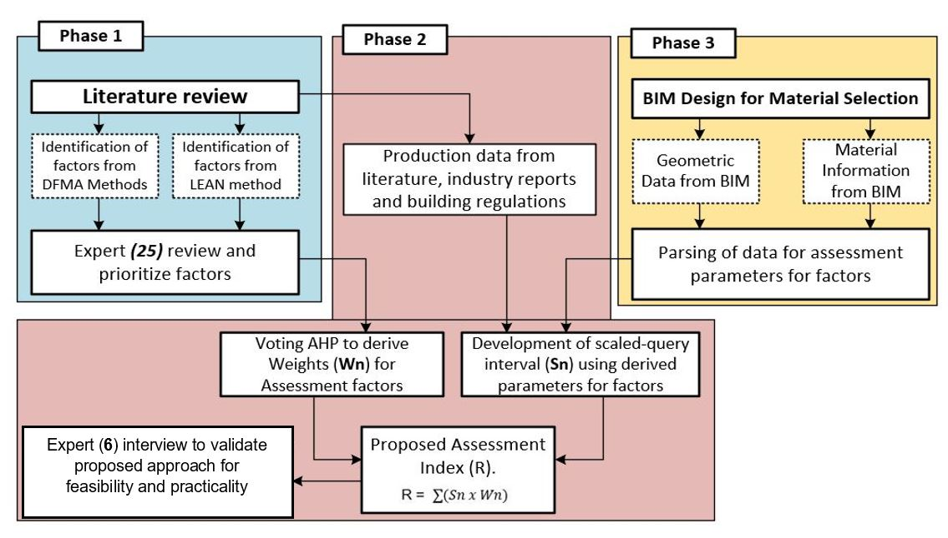
Figure1: Framework for developing BIM-OfA assessment metric
The implementation of the proposed framework entailed three phases. In the first phase, factors that are critical to the efficiency of assembly processes were identified from an in-depth review of the literature on the concepts of DFMA and lean construction. Table 1 shows the occurrence of these preliminary factors as identified from various methods and principles of DFMA and lean construction. A panel of experts in the construction industry reviewed and prioritized these factors using priority voting survey. The experts were defined based on their knowledge of BIM, offsite construction, lean construction and DFMA, the focus of the expert survey was on the level of knowledge of the participants rather than the quantity of participants. Therefore, 40 experts were involved in the expert engagements. Phase-two of the study entailed the analysis of results from the priority voting to derive the weighted importance of each factor to the assessment of optimized assembly design. A scaled-query interval was also developed from literature, industry reports, building regulations and in consultation with the experts to enable the development of assessment metric. The scaled-query interval was reviewed by the experts during expert engagements and the outcome was revised and validated.
The assessment interval was developed on a scale of (0-5) from the literature review and expert discussions using quantitative and qualitative parameters that affect the efficiency of assembly processes. The third phase of the proposed framework was conducted in parallel with phase one. In the third phase of the framework in Figure 1, a case study model was designed to test the applicability of the assessment system for alternative wall materials with BIM environment. The four materials considered for the application were (a) precast concrete; (b) brick; (c) prefabricated exterior insulation finish systems (EIFS) on a metal frame and; (d) concrete blockwork.

Identification of Assessment Criteria
As shown in Table 1, five methods of DFMA concept were integrated with six lean techniques were used for the identification of important factors for design optimization for assembly. Aside from the pioneering concept of design for manufacture and assembly (DFMA) according to Boothroyd, four other methods of DFMA concept were used. These methods include: (a) Design for assembly (DFA) according to Bralla (1999): This method has similar guidelines to DFMA; however, this method specifically focusses on design simplification, part minimization and enhancing easy handling during assembly; (b) Design for assembly (DFA) according to Lucas: This method mainly focusses on assemblability and assembly sequence optimisation. It also includes a functional analysis of parts to identify opportunities for standardization (Redford & Chal, 1994); (c) Design for assembly on-site (DFA-OS): The focus of this method is assembly performance on site, it seeks to minimize the reliance of the assembly process on large equipment, temporary structures and mobile equipment on-site (Lassl & Löfgren, 2006); (d) Design for assembly 2 (DFA2): This method was developed for automatic assembly by IVF (Rapp & von Axelson, 2003).
On the other hand, the six techniques of lean construction that were considered are: (a) Last planner system (LPS): The focus of this technique is to optimize assembly through assessment of workflow, production rate, assembly methods and assembly requirements for each production unit. This assessment is done collaboratively by a group of leaders from various production units and the manager (Paez, et al., 2005); (b) The Kanban system: This technique is based on the just-in-time principle, it is used to manage the allocation of materials and tools for various assembly (Paez, et al., 2005); (c) Concurrent engineering: This method is used to improve assembly schedule and sequence efficiency by overlapping activities, splitting activities and improving transition time between activities (Aziz & Hafez, 2013); (d) Plan conditions and work environment (PCMAT): This technique helps to ensure proper layout of assembly site to avoid congestion, workspace conflict and enhance safety (Aziz & Hafez, 2013); (e) Quality management tools: The essence of this method is to ensure that quality management tools are integrated into lean construction to enhance the quality of parts, connectors, tools, and work. It often involves a point system of evaluating quality controls (Paez, et al., 2005); (f) Visual Inspection: This method of lean construction is used for managing materials, components, activities, and information through visual prototyping tools. The purpose of this method is aligned with the capabilities of BIM (Paez, et al., 2005).
The following guidelines were identified to be applicable in developing an assessment system from the DFMA and lean methods discussed: (i) Fasteners and joints should be durable, reusable and multifunctional. Preference should be given to non-permanent joints such as bolts & nuts and the processing or wet operation of assembly joints on-site should be minimized or eliminated; (ii) Designer should limit the use of materials that require secondary finishes on-site for aesthetics, durability or fire protection. It is preferable for all components to arrive onsite without further processing required aside from assembly and fastening; (iii) Designer should make use of opportunity to standardize parts and components to enhance mass production and repeatability; (iv) Parts with composite materials should be avoided and material variation in general design should be limited to enhance smooth workflow; (v) Regular and symmetrical shape with adequate tolerance is desirable for parts and component design to enhance easy assembly; (vi) The number of building parts should be minimized as much as possible to allow for easy storage onsite and easy delivery to production units;
Table 2: Categories of Identified assessment Factors
Categories | Factors | References
Ease of assembling parts | Connection between parts | (Akinade, et al., 2015; Crowther, 2005; Webster & Costello, 2005; Guy, et al., 2006)
 | Connection to main building elements | (Akinade, et al., 2015; JÜrisoo & Staaf, 2007; Crowther, 2005; Webster & Costello, 2005; Guy, et al., 2006)
 | Post-assembly secondary finishes | (Akinade, et al., 2015; JÜrisoo & Staaf, 2007; Crowther, 2005; Webster & Costello, 2005; Guy, et al., 2006)
 | Standardization of parts | (JÜrisoo & Staaf, 2007; Crowther, 2005; Webster & Costello, 2005; Guy, et al., 2006)
 | Multiple material usage in production | (Akinade, et al., 2015; Crowther, 2005; Webster & Costello, 2005; Guy, et al., 2006)
 | Geometric complexity of parts | (Akinade, et al., 2015; Crowther, 2005; Webster & Costello, 2005; Guy, et al., 2006)
Ease of handling parts | Number of parts | (Boothroyd, et al., 2004, Akinade, et al., 2015; JÜrisoo & Staaf, 2007, BCA, 2016; Webster & Costello, 2005, Guy, et al., 2006)
 | Weight of parts | (Akinade, et al., 2015; JÜrisoo & Staaf, 2007; Guy, et al., 2006; Lassl & Löfgren, 2006)
 | Tools and equipment requirement | (Lam, et al., 2007; Das & Kanchanapiboon, 2011)
 | Fragility of parts | (Lassl & Löfgren, 2006; Rapp & von Axelson, 2003; Redford & Chal, 1994)
 | Quality control requirement | (Tauriainen, et al., 2016; Das & Kanchanapiboon, 2011)
 | Number of workers required | (Tauriainen, et al., 2016); Das & Kanchanapiboon, 2011)
Speed of assembling the whole system | Speed of assembly in relation to labor and equipment cost | (Tauriainen, et al., 2016; Crowther, 2005; Guy, et al., 2006; Chini & Bruening, 2003)
Waste produced during operations | Waste index of parts and applied finishes | (Akinade, et al., 2015; Tauriainen, et al., 2016; Crowther, 2005 Guy, et al., 2006; Chini & Bruening, 2003; Ekanayake & Ofori, 2004)

(vii) The weight of parts should be within the efficient handling capacity of workers and machines to avoid fatigue, accident, damages and assembly errors. Therefore, the density of materials should be considered during design; (viii) Assembly operations that require the use of too many tools and equipment should be avoided, tools should be minimized, and multipurpose equipment is preferable; (ix) Fragile parts that require special damage protection and handling should be avoided, parts should be compact and not loose; (x) Complex parts that require expert quality assurance should be avoided unless necessary, design should enable easy quality control and less sampling; (xi) The number of assembly workers should be minimized as much as possible through the design of efficient assembly system; (xii) The efficiency of the assembly process is determined by the amount of work done with available resources. Efficiency should be as high as possible to minimize resource used and maximize work done; (xiii) Assembly choices with minimum material waste are preferable. Important factors such as components and fastener standardization, minimization of on-site equipment and workforce, and so on were identified from the guidelines and principles. A consolidated list of assessment criteria was derived resulting in a list of 14 presented in Table 2.

Design of Case Study
A BIM model was developed to demonstrate the practicality of design assessment for assembly. The plan is a simple commercial building, the layout floor has an area of 347m² and unconnected height of 3m. The perimeter of the building envelop is 88m and the area of the wall is 220m². Using these characteristics case study prototype, four building envelope materials were used to experiment the assessment approach, viz; (a) precast concrete; (b) brick; (c) prefabricated exterior insulation, finish systems (EIFS) on a metal frame and; (d) concrete blockwork
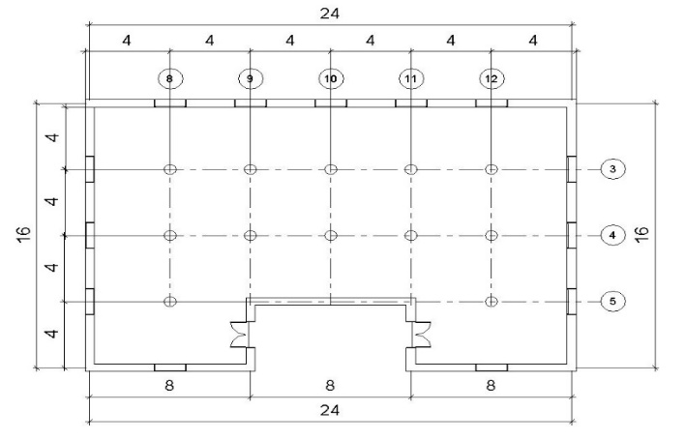
Figure 2: Layout of the design case study (Dimension in meters)

DEVELOPMENT OF BIM-BASED OPTIMIZER FOR ASSEMBLY (BIM-OfA)
The functionality of the assessment system relies on information exchange throughout the assessment and prototyping process. As a means of integrating the geometric and functional data of different material options within a BIM (Autodesk Revit) environment with computational data of assessment conditions stored in an external database (Microsoft Excel), visual programming language (VPL-Dynamo) is used to query basic information (i.e. material/element type and attributes such as geometry or quantities) from the Revit BIM model into the external database as demonstrated in Figure 4. The VPL tool selection was based on its interoperable capability to create bi-directional information exchange with the assessment tool and main parametric modeling tool. Also, the VPL tool can develop visualized prototypes of design alternatives. For the experimental prototype developed in this study, four building envelope materials were used (a) precast concrete; (b) brick; (c) prefabricated exterior insulation, finish systems (EIFS) on a metal frame and; (d) concrete blockwork. Comparisons of the performance of these materials in relation to the 14 assessment criteria were executed in the excel spreadsheets to calculate the composite optimum assembly (COA) index for the materials. The excel database contains all the relevant pre-polluted indices for each material based on 14 assessment criteria which are normalized based on the interval scales proposed (Table 4).

Development of BIM-OfA Logic
Based on the multi-criteria decision modeling (MCDM) principles, the grading system is used in normalizing the performances in each of the 14 areas for easy aggregation and comparison. As shown in Table 2, the 14 assessment attributes are classified into four categories viz; ease of assembly, ease of handling, the speed of assembly and assembly waste.
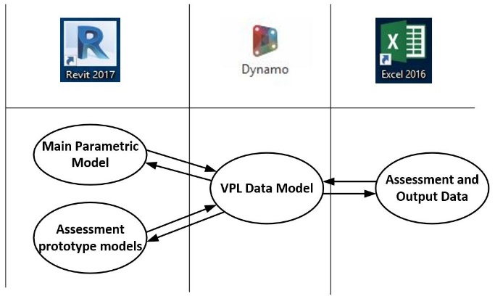
Figure 3: Schema for integrating dynamic model with the assessment system
Given a 3D digital prototype of a building in a BIM environment, the composite optimised assembly (COA) index for each building element (External Wall in this case) is expressed as the summation of the product of the optimised assembly factors “F_{i}” for the building element and the derived weighted importance “W_{i}” of the factors as shown in equation 1;
$COA=\sum_{i=1}^{n}{(W_{i}×F_{i})}$ (1)
It is worth noting that the optimized assembly function F_{i} for a number of assembly factors “i” represents a function of the optimized assembly score of the four categories of assembly factors, i.e. “OA_{EA}”, “OA_{AH}”, “OA_{SA}” and “OA_{AW}”. These categories are (i) ease of assembly; (ii) ease of handling; (iii) speed of handling and (iv) waste produced respectively. This relationship is expressed as;
Table 3: Description of assessment variables
Notation | Description
W_{n} | The weight of categories from VAHP
F_{i} | Set of optimised assembly factors i.e F_{i} = {F₁, F₂,…, F_{n}}
E_{H} | Ease of handling parts, components, and connectors
A_{w} | Waste index of materials & finishes $\left\{0≤Aw≤1\right\}$
S_{A} | The efficient speed of assembly
$$∁bp$$ | Type of connection between parts
$$∁tm$$ | Type of connection to other building elements
R_{i} | Set of connection properties i.e R_{i} = {R₁, R₂,…, R_{n}}
nS_{f} | The need of on-site secondary finishes
N_{j} | Set of properties for on-site secondary finishes
fp | The fragility of parts and components
$$∂s$$ | Degree of standardization
$$np$$ | Total number of parts of building element
$$ns$$ | Total number of standardised parts
$$β$$ | Part minimization factor
P | Production rate
$$A$$ | Area of walls
$$ρ$$ | The density of wall material
$$cl$$ | Cost of assembly labour/craftsmen
$$cpe$$ | Cost of plant/equipment
Gf | Geometry factor
$$mt$$ | Total man-hours
$$nM$$ | Total number of composite material of parts
$$nℇ$$ | Number of equipment required for assembly
nW | Number of on-site assembly workers
$$ωp$$ | The weight of loose parts
V | The volume of loose parts
Qp | The degree of on-site sampling of parts for quality
$F_{i}=f({OA}_{{EA}_{i}}, {OA}_{{AH}_{i}}, {OA}_{{SA}_{i}},{OA}_{{AW}_{i}})$ (2)
Thus, we establish the relation of the optimized assembly index “OA_{i}” for each assessment category to the composite optimized assembly $"COA"$ index by aggregating the value of the optimized assembly index for the categories “OA_{EA}”, “OA_{AH}”, “OA_{SA}” and “OA_{AW}”.
$C{OA}_{i}=\sum_{i=0}^{n}{\left(f({OA}_{{EA}_{i}}, {OA}_{{AH}_{i}}, {OA}_{{SA}_{i}}, {OA}_{{AW}_{i}}) \right)}$ (3)
From Equation 3, the value of the optimized assembly index for the first category (ease of assembly) “${OA}_{{EA}_{i}}"$ is expressed as the product of the optimised assembly score for ease of assembly “$C_{{EA}_{i}}"$ and the weighted importance of the category “$W_{{EA}_{i}}"$ that was determined through VAHP procedure (see table 6).
${OA}_{EAi}=W_{EAi}×C_{{EA}_{i}}$ (4)
As shown in table 4, $C_{EAi}$ is determined by calculating the summation of the product of factors $F_{i}$ and the factors weightings$W_{Fi}$ within the category. The equivalent value $F_{i}$ is determined using the grading scale in table 4. The factors depend on independent parameters as explained below.
$C_{EAi}=$ $\sum_{i=1}^{6}{(W_{Fi}×F_{i})}$ (5)
The first six factors are used to determine the optimized assembly score for ease of assembly $C_{EAi}$. The methods of determining the factors and subsequently, the grading equivalent $F_{i}$ are explained below.
The first factor i.e connection between parts $"∁bp"$ of the same element and the second factor i.e connection to other elements $"∁tm"$are used to derive $F_{1}$ and $F_{2}$ respectively. The parameters for calculating $"∁bp"$ and $"∁tm"$are the same and the factors are taken as the mean of the conditional values of a set of properties R_{i} {R₁, R₂, R_{3,} R_{4,} R₅} for the connections as defined in equation 6.
$∁bp=\frac{R1 + R2 +... + R5}{n}$ (6)
Where n = 5 for the set of properties defined as follows; R₁ = 1 If connector is removable without damage to parts Else R₁ = 0; R₂ = 1 If connector is reusable after removal Else R₂ =0; R₃ = 1 If connector does not require temporary support after fixing Else R₃ = 0; R₄ = 1 If connectors are standardised Else R₄ = 0, and R₅ = 1 If connectors does not involve wet operation on site Else R₅ = 0. This enables the assessment of building connectors based on the conditions above, a preferred connector will have the value of 1 with (0 ≤ $∁bp or ∁tm ≤1)$.
Similarly, the third factor i.e need for on-site secondary finishes “nS_{f}” is used to derive the grading equivalent $F_{3}.$ The factor is obtained by finding the mean of the values of the conditional set of properties N_{i} {N₁, N₂,…, N_{n}} as defined in the equation.
$nSf=\frac{N1 + N2 +... + Nn}{n}$ (7)
Where n = 5 for the set of properties defined as follows; N₁ = 1 If secondary finish is not required for aesthetics Else N₁ = 0; N₂ = 1 If secondary finish is not required for thermal insulation Else N₂ =0; N₃ = 1
If secondary finish is not required for moisture control Else N₃ = 0; N₄ = 1 If secondary finish is not required for fire protection Else N₄ = 0, and N₅ = 1 If secondary finish is not required for durability enhancement Else N₅ = 0. This enables the assessment of building parts based on their requirement for on-site post-assembly finishing, a preferred material will have the value of 1 with (0 ≤ $nSf ≤1)$.
The equivalent $F_{4}$, $F_{5}$, and $F_{6}$are determined by the fourth factor i.e degree of standardisation $"∂s"$, the fifth factor i.e multiple material usage $"nM$”, and the sixth factor i.e geometry $"Gf$” respectively. The degree of standardisation $"∂s"$ is given as the percentage of the number of standard parts $"ns"$ to the total number of parts $"np".$
$∂s= \frac{ns}{np} ×100\%$ (8)
The ‘multiple material usage’ factor $"nM$” is simply the number of composite building material of the parts $"γ"$.
$nM= γ$ (9)
While the geometry factor $"Gf$” is expressed as the length of the longest side of loose parts “lp” for assembly of the building element.
$Gf$ = lp (metres) (10)
From Equation 4, the optimized assembly index for the first category (ease of assembly) “${OA}_{{EA}_{i}}"$ is expressed using the derived equivalent value of the optimised assembly score “$C_{{EA}_{i}}"$ from the equations above and the interval grading scale (Table 4). Where $"W_{EAi}"$ is the weighted importance of the category and ${“W}_{Fi}$” is the weighted importance of the factors respectively.
${OA}_{EAi}$ = $W_{EAi}×\sum_{i=1}^{6}{(W_{Fi}×F_{i})}$ (11)
The optimized assembly score for ease of handling $C_{EHi}$ is determined by six factors $F_{7}$ - $F_{12}$ and the respective weighted importance of the factors $W_{Fi}$. The expression in equation 12 is used to calculate the optimised assembly score for ease of handling:
$C_{EHi}=$ $\sum_{i=7}^{12}{(W_{Fi}×F_{i})}$ (12)
The equivalent value of the seventh factor $F_{7}$ is determined on the grading scale by the part minimisation factor $"β"$. The part minimisation factor is expressed as the ratio of the number of parts $"np"$ to the total area of the wall $"A"$.
$β$ $= \frac{np}{A}$ (13)
The equivalent value of the eighth factor $F_{8}$ is determined on the terval grading scale by the weight of loose parts $"ωp$”. $ωp$ is expressed as a ratio of the density of wall material $"ρ"$ to the volume of parts $"v".$
$ωp= \frac{ρ}{v}$ (14)
The equivalent value of factors $F_{8}$ - $F_{12}$ are determined by for the number of equipment $"nℇ",$the fragility of parts $"fp"$, quality control requirement $"Qp"$, and the number of workers required $"nW"$ respectively. These factors are determined through a user-based evaluation using the interval grading scale.
Table 4: Interval assessment scales (F_{i}) for grading individual building elements and material
 | Factors (F_{i}) |  | Grading Scale Equivalent (0-5)
 |  |  | 0 | 1 | 2 | 3 | 4 | 5
C_{EA} | F₁ | Connection between parts | 0 | 0.2 | 0.4 | 0.6 | 0.8 | 1
 | F₂ | Connection to other elements | 0 | 0.2 | 0.4 | 0.6 | 0.8 | 1
 | F₃ | Need for secondary finishes | 1 | 0.8 | 0.6 | 0.4 | 0.2 | 0
 | F₄ | Degree of standardization | ≤ 10% | 11% - 25% | 26% - 44% | 45% - 65% | 66% - 84% | ≥ 85%
 | F₅ | Multiple material usages | ≥7 material types | 6 material types | 5 material types | 4 material types | 3 material types | ≤ 2 materials types
 | F₆ | Geometry | ≥ 0.81m | 0.6m -0.8m | 0.45m – 0.59m | 0.31m– 0.45m | 0.16m– 0.30m | 0.02m– 0.15m
C_{EH} | F₇ | Number of parts | ≥13.1 | 10.1 – 13.0 | 7.1- 10.0 | 4.1- 7.0 | 1.1- 4.0 | ≤1.0
 | F₈ | Weight of parts | ≥ 15.1 kg | 12.1 -15.0 kg | 9.1- 12.0 kg | 6.1- 9.0 kg | 3.1- 6.0 kg | ≤ 3 kg
 | F₉ | Tools/Equipment requirement | 4 Plants + Tools | 3 Plants + Tools | 2 Plants + Tools | 1 plant + Tools | 3 - 5 Tools | ≤ 2 Tools
 | F₁₀ | Fragility of parts | Require specialized or expert handling | Require individual part packaging | Require packaging and special movement tools | Require protective bulk packaging | Require non- protective bulk packaging | Require no packaging or damage protection
 | F₁₁ | Quality control requirement | ≥ 86% | 66% - 85% | 31% - 65% | 16% - 30% | 4% - 15% | 1% - 3%
 | F₁₂ | Assembly workers requirement | 6 workers or more | 5 workers | 4 workers | 3 workers | 2 workers | 1 worker
C_{SA} | F₁₃ | Production rate | ≤ 0.5 m²/man-hour | 0.51 - 1.0 m2/man-hour | 1.1 - 2.0 m2/man-hour | 2.1 - 4.0 m2/man-hour | 4.1 - 6.0 m2/man-hour | ≥ 6.1 m2/man-hour
C_{AW} | F₁₄ | Waste | 0.96 - 1.0 | 0.8 – 0.95 | 0.6 – 0.79 | 0.4 – 0.59 | 0.2 – 0.39 | 0 – 0.19

Therefore, the optimized assembly index for the second category (ease of handling) “${OA}_{{EH}_{i}}"$ is expressed as the product the derived optimised assembly score “$C_{{EA}_{i}}"$ and its weighted importance $“W_{EHi}$”.
${OA}_{EHi}$ = $W_{EHi}×\sum_{i=7}^{12}{(W_{Fi}×F_{i})}$ (15)
To derive the value of the optimized assembly score for the speed of assembly “$C_{{SA}_{i}}"$, the equivalent value of the thirteenth factor “$F_{13}"$ is multiplied by the weighted importance of the factor $"W_{F13}".$
$C_{{SA}_{i}}=W_{F13}×F_{13}$ (16)
The equivalent value ${"F}_{13}"$ is taken from the interval grading scale based of the production rate “$P$”, which is a ratio of total work area “$A"$ to the average man-hour “$mt".$ To convert the equivalent man-hour $mt$* for on-site equipment, the ratio of the average cost of equipment $"cpe"$ per hour to the average cost of craftsmen $"cl"$ per hour is used.
$mt$* = $\frac{cpe/hr}{cl/hr}$ (17)
$P$ = $\frac{A}{(mt + mt*)}$ (18)
Therefore, the optimized assembly index for the third category (speed of assembly) “${OA}_{{SA}_{i}}"$ is expressed as the product the derived optimised assembly score “$C_{{SA}_{i}}"$ and its weighted importance $“W_{SAi}$”.
${OA}_{SAi}$ = $W_{SAi}×(W_{F13}×F_{13})$ (19)
The equivalent value of the fourteenth factor ${"F}_{14}"$ is determined from the interval grading scale based on the waste index of the materials. A similar expression for calculating the optimised assembly index for the fourth category (assembly waste) ${"OA}_{{AW}_{i}}"$ is given in equation 20.
${OA}_{AWi}$ = $W_{AWi}×(W_{F14}×F_{14})$ (20)
From equation 3, the composite optimised assembly index ${“COA}_{i}"$ is given as the summation of the optimised assembly index of the four categories viz $"{OA}_{EAi}",$ ${"OA}_{EHi}",$ ${“OA}_{SAi}"$ and ${"OA}_{AWi}".$ Taking the expressions for the optimised assembly indexes from equation 11, 15, 19 and 20, ${“COA}_{i}"$ is given as:
$C{OA}_{i}$ = $[W_{EAi}×\sum_{i=1}^{6}{(W_{Fi}×F_{i})]}$ + ${[W}_{EHi}×\sum_{i=7}^{12}{(W_{Fi}×F_{i})}]$ + ${[W}_{SAi}×(W_{F13}×F_{13})]$ + $[W_{AWi}×\left(W_{F14}×F_{14}\right)]$ (21)
To simplify the equation, the weighted importance of each category and the weighted importance of factors within the category are multiplied to derive the global weights $"W_{i}"$. The resultant expression is given in equation 1.

RESULTS
The section presents the results of the engagement of participants with expert knowledge in offsite construction and BIM. Experts were engaged based on their experience in BIM design and assessment. To develop the weighted importance of assessment factors through priority voting, a total of 40 experts were invited for the questionnaire survey, 27 responses were received. The focus of the survey was the depth of knowledge of participants about the relatively news concepts of BIM-based optimisation in the construction industry. After examining the 27 responses, 25 responses were valid, and 2 responses were removed due to incomplete information. This represented a response rate of 62.5%. The participants were from various backgrounds and worked in the construction industry, many of whom had at least a master’s degree and significant experience.
Table 5: Background of Expert Respondents
 |  | Frequency (n) |  | Percentage (%)
Job Description | Architect |  | 5 | 20.0
 | BIM Manager |  | 2 | 8.0
 | Civil/Structural Engineer |  | 6 | 24.0
 | Construction Manager |  | 6 | 24.0
 | Mechanical/Electrical |  | 1 | 4.0
 | Project Manager |  | 3 | 12.0
 | Site Waste Manager |  | 1 | 4.0
 | Others (Lecturer) |  | 1 | 4.0
Qualification | HND |  | 2 | 8.0
 | Bachelor’s Degree |  | 8 | 32.0
 | Master’s Degree |  | 10 | 40.0
 | Doctorate Degree |  | 4 | 16.0
 | Other |  | 1 | 4.0
Years of Experience | 1 – 4 years |  | 6 | 24.0
 | 5 – 9 years |  | 5 | 20.0
 | 10 – 14 years |  | 7 | 28.0
 | Over 15 years |  | 7 | 28.0

Voting analytical hierarchy process
The analytic hierarchy process (AHP) developed by Saaty, 1987 is a multi-criteria decision method used to evaluate the relative importance of factors that affect decision making (Saaty, 1987). It quantifies the relative priorities/weights of a given set of criteria based on the evaluation by a group of experts through a scaled comparison which indicates the extent to which one criterion dominates another criterion. The scaling process is then translated into priority weights for the criteria or alternatives. AHP has been widely applied in several fields of research including construction engineering and management (CEM) (Ameyaw, et al., 2016)thus indicating its usefulness as a multi-criteria decision method. Despite its utility, AHP has some limitations that led to the advent of the voting analytic hierarchy process (VAHP) by Liu and Hai (2005). Prominent amongst the limitations of AHP is the difficulty in applying the paired comparison (Liu & Hai, 2005), particularly where the criteria are many (Hadi-Vencheh & Niazi-Motlagh, 2011). For example, 10 criteria yield 40 paired comparisons that can be very laborious, if not infeasible, for decision-makers. VAHP, instead of using paired-comparison, adopts a vote ranking approach whereby a set of criteria and sub-criteria in a hierarchical structure is ranked to determine their weights (Liu and Hai, 2005). Given a large number of attributes identified in this study, the VAHP approach was deemed more appropriate. Additionally, the categorization of the attributes constituted a hierarchical structure, which lends itself to the use of VAHP for assessment of alternative designs for assembly as shown in figure 2.
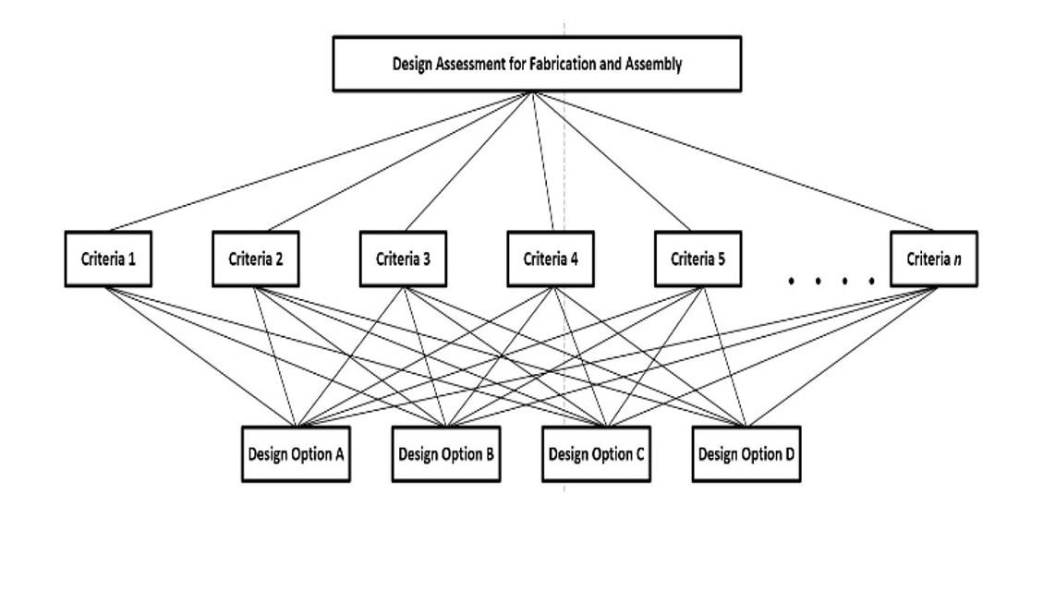
Figure 4: Hierarchy of assessment levels using VAHP
Table 6: Weighted Importance of assessment factors
Table 6: Weighted Importance of assessment factors  Categories (C_{i}) |  | Categories Weighting (W_{ci}) | Factors (F_{i}) |  | Factors Weighting (W_{Fi}) | Global Weighting (W_{i})
C1 | Ease of assembling parts | 0.3184 | F1 | Connection between parts | 0.2898 | 0.0923
 |  |  | F2 | Connection to main building elements | 0.2057 | 0.0655
 |  |  | F3 | Post-assembly secondary finishes | 0.1165 | 0.0371
 |  |  | F4 | Standardization of parts | 0.1510 | 0.0481
 |  |  | F5 | Multiple material usages in production | 0.1088 | 0.0347
 |  |  | F6 | Geometric complexity of parts | 0.1282 | 0.0408
C2 | Ease of handling parts | 0.2096 | F7 | Number of parts | 0.2101 | 0.0440
 |  |  | F8 | Weight of parts | 0.2882 | 0.0604
 |  |  | F9 | Tools and equipment requirement | 0.1426 | 0.0299
 |  |  | F10 | Fragility of parts | 0.1475 | 0.0309
 |  |  | F11 | Quality control requirement | 0.1069 | 0.0224
 |  |  | F12 | Number of workers required | 0.1048 | 0.0220
C3 | Speed of assembling systems | 0.3216 | F13 | Efficiency of operations | 1.000 | 0.3216
C4 | Waste produced in process | 0.1504 | F14 | Waste Index | 1.000 | 0.1504

The Proposed Model
The four design options described in section 3.6.2 of the case study was assessed using the assessment criteria interval (Table 4.1). The case study design options were limited building envelope design in order to test the applicability of the proposed assessment system. The elements considered were: (i) a precast concrete wall; (ii) a brick wall; (iii) an exterior insulation wall and a block wall. The digital prototype was developed in Autodesk Revit. The geometric and material information including the identification of specific materials was achieved through Dynamo studio. A script was developed to allow the extraction of basic parameters into an external database. Microsoft Excel was relied on as the external database as a result of its simplicity. The proposed computational methods were then implemented within the spreadsheet with conditional formatting that highlighted the best alternative in a specific color. i.e. traffic light signaling was adopted. A script was further developed through dynamo to override material properties such that it reflects the color coding from the results of the analysis. Thus, the system provided a design support that highlights where materials with poor and non-efficient construction and assembly credentials are selected in the design process. 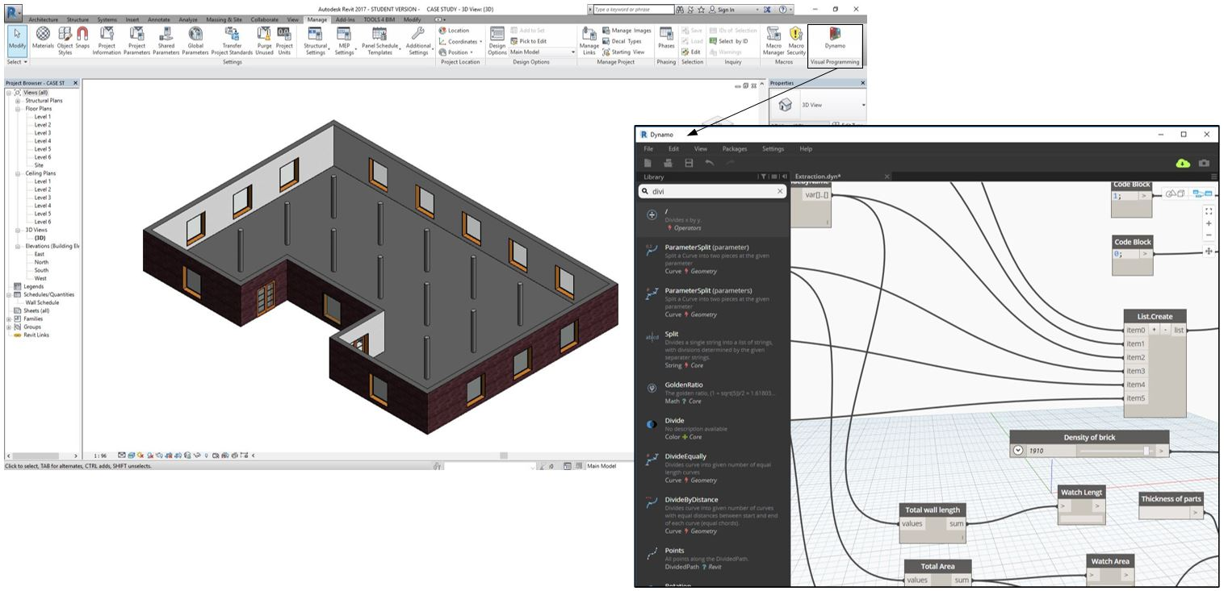
Figure 5: Extraction of information from digital prototype
The VPL tool within the spreadsheet was used to identify and derive some parameters such as the area of the wall, number of parts, the weight of loose parts and so on (Tauriainen, et al., 2016). Other process-based and user-based parameters such number of workers, number of equipment, the fragility of parts and so on (Guy, et al., 2006). The result of the case study assessment is presented in Table 7. The EFIS wall has the highest efficiency of assembly, this is due to the reduced man-hours and machine-hours on-site, the could be because of the ease handling and fastening components (Webster & Costello, 2005). However, the brick wall also has high ease of handling on-site, but it has the lowest speed/efficiency of assembling.
Table 7: COA Score for Case Studies
Case Study | EA | EH | SA | AW | COA
Concrete Wall | 0.1805 | 0.0965 | 0.1930 | 0.0602 | 0.5301
Brick Wall | 0.1723 | 0.1430 | 0.1286 | 0.0902 | 0.5341
EIFS Wall | 0.1893 | 0.1346 | 0.2573 | 0.0602 | 0.6413
Blockwork | 0.1649 | 0.1035 | 0.1930 | 0.0301 | 0.4914
(EFIS- Exterior Insulation Finish Systems, EA-Ease of assembling, EH- Ease of handling, SA- Speed of assembling, AW-Assembly waste)
This means that ease of assembling and ease of handling influences the efficiency positively. The composite optimized assembly (COA) score was highest for the EFIS material which recorded the highest ease of assembling and highest efficiency of assembling. In terms of lean efficiency, the use of EFIS wall material will minimize the duration of onsite operations and the resources used during onsite operations. The brick wall has second highest COA score due to the high ease of handling which is influenced by the characteristics of the parts such as size, weight, and fragility. The blockwork material has the lowest COA score, although the efficiency of assembly is high relative to block work, it has lower ease of assembly, one of the reasons is because it requires post-assembly secondary finishes when compared to brick. This scoring system assists designers in knowing the strength and weaknesses of design choices. Also, the scores reflect DFMA principles and lean principles such as weight minimization, types of connection and so on, and can be used to assess the degree to which each material aligns with DFMA and lean principles.
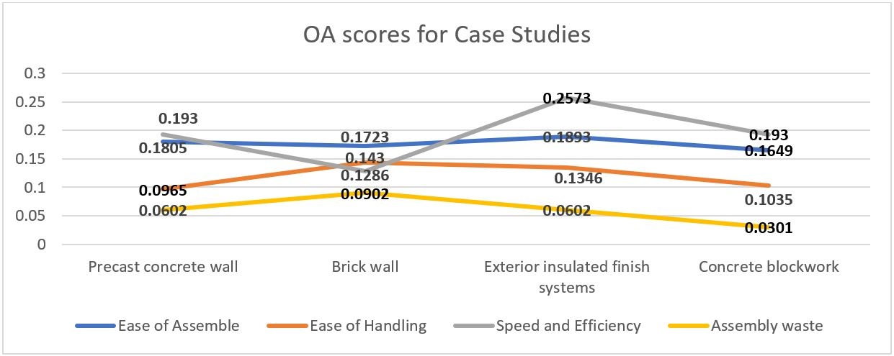
Figure 6: Optimised assembly scores for case studies
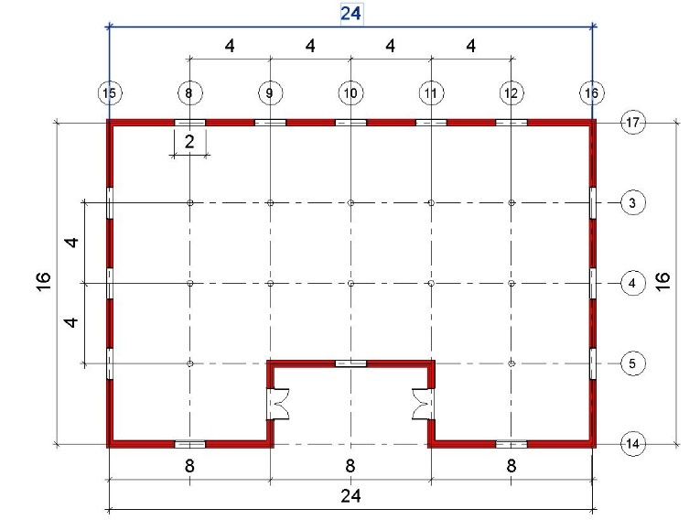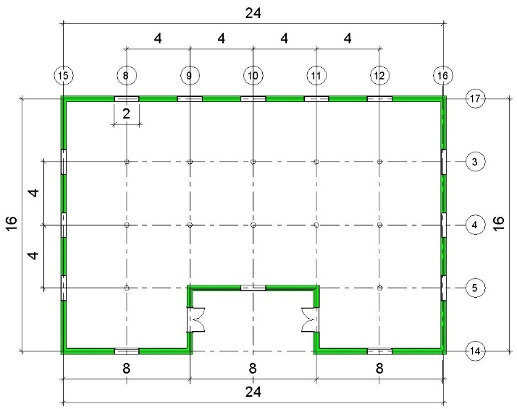
- Block Wall (b) Exterior Insulation Finish System (EIFS) Wall
Colour grading scheme for BIM visualization:
Worst:
Intermediate:
Best:
Figure 7: Visualisation of Optimal Material in BIM Environment through Colour Coding

Validation
This assessment system was evaluated by a panel of six experts with an average industry experience of 15 years and advanced to expert experience in building information modeling and design optimization. A demo of the assessment system was shown to the experts for evaluation based on the following criteria: (i) Relevance to practice; (ii) Usefulness for industry needs; (iii) Insights for design optimization; (iv) Ease of application; (V) Ability to enhance continuous improvement, and; (vi) Reflectiveness of assessment results. Participants were asked to evaluate the system using a Likert scale of (1-5) based on the criteria. The evaluation results indicate the general acceptance of the design optimization tool, all participants agree or strongly agree that the tool is relevant to best practice, easy to use and can enhance continuous improvement in the design optimization. Participants also agree that the tool provides insights for optimizing designs and that the assessment results reflect the degree of optimization. Table 7 shows the mean score and standard deviation for the BIM-OfA assessment system from the Likert scale evaluation based on each criterion.
Table 8: Average score of the assessment system based on validation criteria
 | Question | Average Score (5) | Standard deviation
1 | Relevance to practice | 4.50 | 0.50
2 | Usefulness for industry needs | 4.30 | 0.56
3 | Insightfulness for design optimization | 3.83 | 0.36
4 | Ease of application | 4.50 | 0.58
5 | Ability to enhance continuous improvement | 3.83 | 0.90
6 | Reflectiveness of results | 4.50 | 0.50

DISCUSSION
The global construction market is expanding, and forecasts show that it will grow by over 70% by 2025, the UK Government construction strategy is also keen on achieving ₤1.7 billion savings on construction efficiency from 2016 to 2020 (IPA, 2016). This shows the importance of efficiency and productivity in the construction industry. When compared to the manufacturing industry, the construction industry is very inefficient (Aziz & Hafez, 2013). This is due to the complexity of construction operations and the inability to standardize the construction process to enhance repeatability and continuous improvement (BCA, 2016).
The adoption of successful practices in the manufacturing industry has shown to have a great influence on construction processes (Paez, et al., 2005). Lean construction is specifically aimed at reducing inefficiency in construction operations through process improvement and waste minimization (Aziz & Hafez, 2013). On the other hand, DFMA is aimed at designing building parts and components in a way that will enhance easy fabrication and assembling on site (Boothroyd, et al., 2004). This study explored these manufacturing-based concepts to identify important factors that can enhance design assessment for optimization during design.
This assessment system explored the capabilities of virtual prototyping to assist designers to focus on detailed elements of design optimization such as connections, geometry, weight and so on. The assessment system also incorporates the importance of parts minimization, standardization, waste reduction, efficiency improvement, and reduction of on-site operations, machines, and workers. The integration of these assessment parameters with BIM also enhances the easy application by designers using visual programming languages for computational design, prototyping, and optimization. From the result, the most significant category is the “ease of assembly” and the most significant attribute within this category if the “connection between parts”. This confirms the use of the “type of connection” in similar frameworks such as Akanbi, et al., (2018) and Akinade, et al., (2015). Also, within the “ease of handling category”, the “weight of parts” was the most significant. This shows the importance of DFMA and lean principles for design decision support by using factors that affect manufacturing and assembly.
In view of this, the BIM-OfA assessment system has great potential for improving construction efficiency and minimizing wastage by evaluating design decision using factors that have proven to be useful in the manufacturing context of design optimization (Ekanayake & Ofori, 2004). This will assist designers in understanding the implications that designs have on the manufacturing and assembly process. By improving efficiency through design optimization, designers can contribute to the strategic targets to improve productivity in the construction industry. Future research will develop the system for overall assessment of building designs by computing the composite scores for other building elements such as roofing, slabs, column, beams, and foundations. Also, studies will investigate the overall process of offsite construction and assembly to identify factors of optimization and embed in design optimization tools.

CONCLUSION
This study integrates the principles of lean construction and DFMA to develop a design assessment system for design optimization, factors were identified and prioritized to obtain their weighted importance to the overall assessment system. The study categorized the assessment factors into (i) ease of assembling (ii) ease of handling (iii) speed of assembling; and (iv) assembly waste. The results from the priority voting survey show that the speed of onsite assembly process is the most important category for the construction industry experts. Within the ease of assembling category, the properties of parts connectors such as reusability, removability, standardization and so on, is the most important attribute. Also, the weight of parts and number of parts topped the important attributes in assessing ease of handling category.
The assessment system was tested within a BIM environment to assess the COA score for four BIM materials for building envelopes. Building envelops was chosen because of the large proportion it covers compared to other building elements, it is also a building element with many varieties of materials for alternative design selection. The case study was used to evaluate the system performance and the outcome was presented to a panel of six industry experts for validation. The validation results show that the assessment system is relevant to practice and has the potential to enhance the ability of the construction industry in meeting productivity targets.
Based on the results of the case study, the construction industry can benefit from the assessment system for efficient material selection, waste minimization during assembly and fast project delivery. The BIM-OfA assessment system will help users to understand and choose design options based on the optimization objectives. Also, BIM-OfA will help users in selecting construction methods and materials based on their unique peculiarities and competencies. Generally, the capability of BIM to create efficient information input and output has made it a good platform for design optimization. Through BIM, process-based information can be used to enhance decision making at early while relying on BIM-based information for the overall improvement of the construction process. This study took advantage of this BIM capability to develop an assessment system for building envelopes. A major limitation of the assessment system is that it is limited to building envelops and cannot be applied to other building elements. To enable the overall assessment of building systems, a full-scale development of the system is required. Further study is recommended to improve the system and extend its applicability to the real-life overall assessment of all building elements and alternative designs for building element..

REFERENCES
Abanda, F. H., Tah, J. H. M. & Cheung, F. K. T., 2017. BIM in off-site manufacturing for buildings. Journal of building engineering, Volume 14, pp. 89-102.
Akanbi, L. O. et al., 2018. Salvaging building materials in a circular economy: A BIM-based whole-life performance estimator. Resources, Conservation and Recycling, Volume 129, pp. 175-186.
Akinade, O. O. et al., 2015. Waste minimisation through deconstruction: A BIM-based Deconstructability Assessment Score (BIM-DAS). Resources, Conservation and Recycling, Volume 105, pp. 167-176.
Ameyaw, E. E. et al., 2016. Application of Delphi method in construction engineering and management research: A quantitative perspective. Journal of Civil Engineering and Management, 22(8), pp. 991-1000.
Aziz, R. F. & Hafez, S. M., 2013. Applying lean thinking in construction and performance improvement. Alexandria engineering journal , 52(4), pp. 679-695.
BCA, 2016. BIM design for design for manufacturing and assembly essential essential guide, Singapore: Building and Construction Authority.
Boothroyd, G., Dewhurst, P. & Knight , W., 2004. Product design for manufacture and assembly. Second ed. New York: Marcel Dekker.
Bralla, 1999. Design-for-manufacture handbook. Second ed. s.l.:McGraw Hill Professionals.
Das, S. & Kanchanapiboon, A., 2011. A multi-criteria model for evaluation design for manufacturability. International Journal of Production Research, 49(4), pp. 1197-1217.
Ekanayake, L. L. & Ofori, G., 2004. Building waste assessment score: design-based tool. Built Environment, 39(7), pp. 851-861.
Gbadamosi, A. et al., 2018. A BIM Based Approach for Optimization of Construction and Assembly through Material Selection. Ljubljana, Slovenia, Diamond Congress Ltd.
Grilo & Jardim-Gonvalves, 2010. Value Proposition on the Interoperability of BIM and Collaborative Working Environment. Automation in Construction, 19(5), pp. 522-530.
Guy, B., Shell, S. & Esherick, H., 2006. Design for deconstruction and materials reuse. Proc CITB Task Group, Volume 39, pp. 189-209.
Hadi-Vencheh, A. & Niazi-Motlagh, M., 2011. An improved voting analytic hierarchy process-data envelopment analysis methodology for suppliers selection. International Journal of Computer Integrated Manufacturing, 24(3), pp. 189-197.
Howard, L. & Lewis, H., 2003. The development of a database system to optimize manufacturing processes during design. Journal of Material Processing Technology Management, 134(3), pp. 374-382.
Kannan, M. R. & Santhi, M. H., 2013. Constructability assessment of climbing formwork systems using building information modeling. Procedia engineering, Volume 64, pp. 1129-1138.
Lam, P., Chan, A. P., Wong, F. K. & Wong, F. W., 2007. constructability rankings of construction systems based on the analytical hierarchy process. Journal Architecture and Engineering , 13:1(36), pp. 36-47.
Lassl, V. & Löfgren, P., 2006. Smart connection development for industrial construction. master's Thesis. Department of Engineering, Chalmers University of Technology Sweden, p. 72.
Liu, F.-H. F. & Hai, H. L., 2005. The voting analytic hierarchy process method for selecting supplier. International Journal of Production Economics, Volume 97, pp. 308-317.
Mahamadu, A.-M.et al., 2017. Addressing challenges to building information modeling implementation in UK: Designers' perspectives. Journal of construction project management , 7(1), pp. 1908-1932.
Marion, T. J., Thevenot, H. J. & Simson, T. W., 2007. A cost-based methodology for evaluating product platform commonality sourcing decisions with two examples. International Journal of Production Research, 45(22), pp. 5285-5308.
O'Connor, J. T., Rusch, S. E. & Schulz, M. J., 1987. Constructability concepts for engineering and procurement. Journal of engineering management (ASCE), 113(2), pp. 389-397.
Paez, O., Solomon, J., Salem, S. & Genaidy, A., 2005. Moving from lean manufacturing to lean construction: towards a common sociotechnological framework. Wileyperiodicals, Human factors and Ergonomics, Manufacturing Journal, 15(2), pp. 233-245.
Rapp, K. & von Axelson, J., 2003. DFA2-en method för att utveckla monteringsvänliga produkter, s.l.: IVF-rapport.
Redford , A. & Chal, J., 1994. Design for assembly, principles and practice. Berkshire, England: McGrawhill Book Company Europe.
Saaty, R., 1987. The Analytic Hierarchy Process - What It Is and How It Is Used. Mathematical Modelling, 9(3-5), pp. 161-176.
Tauriainen, M., Marttinen, P., Dave, B. & Koskela, L., 2016. The effects of BIM and Lean Construction on Design Management Practices. Procedia Engineering, Volume 164, pp. 567-574.
Treasury, H. & Cabinet Office, 2016. Government Construction Strategy 2016-2020, s.l.: Infrastructure and Project Authority.
Vliet, H. & Luttervelt, K. V., 2004. Development and application of a mixed product/process-based DFM methodology. International Journal of Computer Integrated Manufacturing, 17(3), pp. 224-234.
Webster, M. D. & Costello, D., 2005. Designing structural systems for deconstruction: How to extend a new building’s useful life and prevent it from going to when the end finally comes. Atlanta, Greenbuild Conference.
Yuan, Z., Sun, C. & Wang, Y., 2018. Design for Manufacture and Assembly-oriented parametric design for prefabriocated buildings. Automation inb construction, Volume 88, pp. 13-22.
Zhang, C., Zayed, T., Hijazi, W. & Alkass, S., 2016. Quantitative assessment of building constructability using BIM and 4D simulation. Open journal of civil engineering, Volume 6, pp. 442-461.
Zolfagharian, S. & Irizarry, J., 2017. Constructability assessment model for commercial building design in the United States. Journal of construction enginnering and management , 143(8), pp. 389-397.

