Governing Urban Regeneration: Planning and Regulatory Tools in the UK
  - Rob Atkinson, Andrew Tallon and David Williams

Abstract
The article focuses on the redevelopment of Previously Developed Land by public-private sector partnerships in three cities/towns in South-West England, two of which can be described as medium-sized towns with little previous experience of such developments. In each case we situated the redevelopment process in its wider multi-level and horizontal relationships using Social Network Analysis to produce network and centrality maps to reveal the complex network of relationships the process was embedded within and shaped by. These developments took place in what is termed the ‘roll-out’ phase of neoliberalism and we illustrate how the overarching planning and regulatory regimes (including contracts), along with wider economic conditions, shaped the development process, with the proviso that in each case these factors were mediated and themselves shaped by the assortment and interaction of local organisational, political, economic and civic forces. These included local planning committees and their interpretation of planning regulations and the developers involved but also opposition to the developments from local sources. Much, however, depended on the ‘capacity to act’ of the relevant partnerships, in the sense of mobilising deploying available resources to realise the proposed developments.

KEYWORDS: Public-private partnerships, urban development, Previously Developed Land, regulation, planning

Introduction

This article draws on research carried out as part of the [name removed] project to investigate the forms of governance that were established in three UK case studies (Bristol, Gloucester and Taunton), and the various planning and regulatory instruments deployed as part of the public-private urban development partnerships created to carry out regeneration projects of previously developed land (PDL), often known as brownfield sites. As part of this research we considered how the governance forms created when contractual arrangements were made between the public and private sector parties, structured and influenced the aims and delivery of urban regeneration. This relates to what van der Veen and Korthals Altes (2011) have termed as ‘government by contract’ and Raco (2012; 2013) has described as ‘planning by contract’ and ‘governance through detail’.
One of our aims was to understand how contractual relationships, particularly between the public and private sectors, affected and influenced public accountability (in terms of transparency of decision-making). The risk we perceive is that contractual relationships are shrouded in ‘secrecy’ under the guise of commercial confidentiality which obscures the ‘public gaze’ and run the risk of effectively undermining both accountability and transparency, thereby creating a form of ‘subterranean governance’ that structures the way in which these partnerships operate without being subject to any rigorous public scrutiny and accountability. More specifically we aim to disentangle the complex web of relationships in which these partnerships are embedded, the various forms of regulation (including that exercised by contracts and the planning system) and their relationship. This is a key focus of what follows if we are to understand how governing and planning by contract operate.
The article is structured in seven sections. Section two sets out the underlying approach to the research, section three provides a summary of each UK case study and the public/private partnership arrangements that were put in place. Section four provides a summary of the UK national planning policy through the last 20 years. Section five outlines the research methodology and Section six presents the findings from the research. Section seven discusses and concludes what the findings mean in the context of urban regeneration.

Urban Development and Governance
Whilst it is widely argued that the overarching context for contemporary urban development is structured and shaped by neoliberalism (cf. Brenner and Theodore, 2002) it has increasingly been recognised that neoliberalism is by no means a uniform phenomenon. It has both ‘mutated’ over time and taken different national forms related to institutional, organisational and political cultures as well as adapting and being adapted to sub-national contexts. This is perhaps best captured by Allmendinger and Haughton’s (2013) notion of ‘variegated neoliberalism’. As they note (ibid, p.10):
“The growing body of critical work on neoliberalization provides a useful, broad framework for interrogating both the evolving market orientation of planning and the variety of its manifestations. The high levels of experimentation, continuous re-interpretation and consequent evolution of neoliberal tenets at different scales mean that it is more accurate to talk of multiple plannings which, to varying degrees may be influenced by what Castree (2006) refers to as the dogmas and doxas of neoliberalism” (emphasis added).
This approach, particularly that of experimentation and continuous re-interpretation, has implications for the nature of (urban) governance and related urban development in terms of what they refer to as ‘variegated neoliberal spatial governance’ (ibid, p.11). This reflects the changing nature of the wider reorganisation, restructuring and fragmentation of the British state and sub-national government over both time and space (see Le Galés and Scott, 2010); a process further accentuated by the response to the 2007-08 Crash which as Omstedt (2016) argues has intensified established patterns of uneven development. Given these developments and the recognition that neoliberalism mutates over time and space it is not possible to simply ‘read off’ the implications for urban governance and development at local level. Thus, we must consider a range of approaches, recalling the dictum of experimentation and continuous re-interpretation, in order to understand the forms of urban governance and development that may exist.
Governance, for us, refers to changes in the institutional arrangements that have developed to coordinate the activities of a range of organisations/actors involved in governing a society (Newman, 2001, p.26) and in relation to specific policies and programmes. Moreover, we recognise that the role of government in the process of governance has become ‘contingent’ compared to the situation prior to the 1980s. In addition, these changes have occurred in a context where cities and towns have become increasingly subject to processes of differentiation and fragmentation, and that the effects of deindustrialisation and economic restructuring along with globalisation have had fundamental implications for the nature and role of urban areas.
These developments have made it increasingly difficult for cities to thrive and for city governments to ‘get things done’. As in the wider society city governments appear to lack both the resources and authority/legitimacy to govern effectively (see Lefèvre, 1998). In this environment attention has focused on the need for cities to achieve economic growth (e.g. Peterson, 1981) and downgrade social expenditures and to engage in what Harvey (1989) terms ‘urban entrepreneurialism’ or what Taşan-Kok (2009) refers to as entrepreneurial forms of governance.
One can understand these developments in a variety of ways. Both Harvey (1989) and Tasan-Kok (2009) stress the entrepreneurial aspect. Clearly entrepreneurialism can take different forms in different places. For instance, in relation to Helsinki, Hyötyläinen and Haila (2018) refer to entrepreneurial public real estate policy in a context where local government owns large quantities of land and seeks to realise the value of that land by selling it to private developers and relinquishing the direct control they previously had over the development of land and the outcomes of any development. The implication is that they are treating the land they own purely as a financial asset and either downgrading or ignoring the social implications of their actions. Similarly, Christophers (2017), albeit in more general terms, argues that in the UK the state is increasingly treating the land that it owns as a financial asset as part of a wider process of privatisation. However, Christophers concludes: “…the state’s role in financializing public land has been largely indirect, it being left to other actors to treat that land first and foremost as a financial asset…” (ibid, p.79). Here land is first of all deemed to be surplus in the sense of being of no value to the public sector, or more specifically, in terms of our concern with PDL, that the public sector cannot realise the value of the land because it lacks the means and resources to do. Secondly, one can argue that this approach reflects a particular politico-ideological consensus that the private sector should be allowed to develop the sites because it has the means and resources to do so and will achieve this more efficiently and effectively than the public sector, including local government. The question that follows in the English context is what (planning) controls local government should and can continue to exercise over any development. Increasingly this control has been exercised through the construction of various forms of local public-private partnership and it is these we focus on in our case studies.
The above provide stimulating and instructive approaches to understanding the general context within which urban development takes place and public-private partnerships are created. However, whilst not wishing to reject the importance of a political economy approach it does seem that these approaches are rather narrowly focused and that we need an approach better able to capture the diversity and complexity of urban governance. For this reason, it is useful to consider the urban regime theory associated with the work of Stone as an approach to urban governance (Stone, 1989, 1993; Stone et al., 1991). Stone acknowledges the role of the wider politico-economic situation in structuring the context within which a regime operates and influences its actions. However, he does not see these wider forces acting in a simple deterministic manner, each local regime mediates these forces and develops strategies, alliances and policies in relation to both its own need for continued existence and the politics of the locality. Nor does he argue that regimes are neutral mechanisms and recognises that private capital (or sections of it) are accorded a privileged position and access. Moreover, it is the ability of a leadership based within government and the private sector to develop a strategic vision and coordinate the actions and capacities of others that lies at the heart of a regime and its stability. A key aspect of this process is the ability of a regime to achieve its objectives (i.e. effectiveness), but at the same time a regime needs to be aware of the implications of its actions for the whole community (i.e. the issue of equity).
While Stone’s approach is helpful in understanding the more concrete creation and operation of public-private urban development partnerships it needs to be treated with caution in the European context. DiGaetano (1997) makes the point that regimes may be the exception rather than the rule; indeed, cooperation may not be the norm and the type of coalitions identified by Stone may be inherently unstable and short-term (if they exist at all). Barlow (1995) in his case-studies of urban planning in France, Britain and Sweden found some support for Stone's argument that “urban regimes perform an empowering and coordinating role for their members.” (Barlow, 1995, p52), however, he found it “...hard to distinguish any coherent groupings of business interests.” (ibid, p51). Thus if ‘urban regimes’ of some form are created in the UK context it is likely that they will be unstable and relatively short-term, organised around specific development projects, change over time, even during the life of a project (i.e. as it moves from planning to implementation and reacts to changes in the local and wider context), and represent a form of ‘entrepreneurial governance’ (Tasan-Kok, 2009). If we accept this caveat, then Stone’s work can provide a valuable supplement to that outlined earlier.
In addition, we need to consider to what extent public-private urban development partnerships involve complex legal and regulatory activities that may involve forms of privatisation that are, potentially, subject to ‘governance through detail’ (Raco, 2012; 2013) articulated through ‘government by contract’ (van der Veen and Korthals Altes, 2011) or ‘planning by contract’ (Raco, 2012; 2013). Untangling the intricate web of relationships in which such partnerships are embedded, the forms of regulation (e.g. by contracts and the planning system) and their interaction is a central focus of what follows. Understanding these relationships is essential to develop an understanding of how governing and planning by contract function in the case studies.

UK Case studies
In what follows we explore the different ways in which ‘variegated neoliberalism’ and financialization of land emerges in our cases as local authorities engage in forms of entrepreneurial governance to create public-private partnerships to bring about the reactivation of surplus land they are unable to redevelop themselves. The resulting ‘urban regimes’ have a particular temporal and spatial specificity as they are not designed to be permanent or to apply more generally to the governance of the locality, they represent ‘temporary entrepreneurial urban regimes’ – put simply they are one-off experiments which are consistent with Haughton and Allmendiger’s (2013) notion of ‘variegated neoliberalism’. In a sense it may be argued ‘all that is solid melts into air’.
The case study sites were selected as they each provide a different type of public-private partnership approach to delivering urban regeneration of PDL. Bristol offers a case of a larger city while Gloucester and Taunton provide insights into regeneration in two small-to-medium cities/towns, a type of area that is currently under researched. Each provides insights into the challenges faced by all parties in ensuring that public-private partnerships deliver schemes that are profitable and provide benefits to the location and the wider city. An overview of each case study is shown in Table 1.

Table 1. Case Studies Overview
Timeframe | 1993-2015 | 2002 – Ongoing | 2004 - Ongoing
Case Study | Bristol Harbourside | Gloucester Quays | Taunton Firepool
Location | Bristol, UK | Gloucester, Gloucestershire, UK | Taunton, Somerset, UK
Background | Derelict site following the closure of the docks between late 1960s and 1980s. | Gloucester Docks closed to freight in the late 1980s and the site had many derelict listed buildings. | As part of a Vision for Taunton in 2004 the former cattle-market and several railway goods yards are identified for regeneration.
Primary Public Sector Parties | Bristol City Council, Harbourside Sponsors Group, Bristol 2000, Concert Hall/ Harbourside Centre Limited Company, South West Regional Development Agency and British Rail Property Board. | British Waterways, Gloucester City Council, Gloucestershire County Council, Gloucester Heritage Urban Regeneration Company, South West Regional Development Agency, English Partnerships | Taunton Deane Borough Council, Somerset County Council, South West Regional Development Agency, Network Rail, Homes and Communities Agency, Environment Agency and the Heart of the South West Local Enterprise Partnership (LEP)
Private Sector Party(ies) | British Gas, JT Group, Lloyds Banking Group, Drivers Jonas, Secondsite Property Holdings Limited (National Grid) and Crest Nicholson | Peel Holdings | Great Western Railway (GWR), St Modwens and Crest Nicholson

All cases studies were engaged in redeveloping PDL and all three developed forms of public-private partnerships to carry out the redevelopment process. However, as will be discussed below each developed a rather different form of partnership, which reflects past experiences (or lack of) with such activities and decisions taken by the relevant council in response to local conditions as they perceived them. What these case studies highlight is that the term public-private regeneration partnership can cover a range of different organisational forms.

Overarching planning context
English planning policy provides the context within which our cases studies are situated leaving considerable discretion in the hands of local authorities in terms of their use of relevant legislation and guidance. It creates both limitations on and possibilities for local authorities in terms of their engagement with the private sector and the construction of public-private regeneration partnerships..
The system can be broken into three distinctive levels: national, regional and local, as shown in Table 2. The following section provides a summary of the regulatory instruments that exist at each level as a context for the research.
Table 2. Key UK Planning Policy 1993-2018
Planning Policy in England
Town and Country Planning Act 1990 | Set out ‘planning gain’ for local authorities, known as Section 106 (S106) to improve the area adjecent to development.
Planning Policy Statements (PPS) (1993-2012) | Technical guidance notes including protecting heritage and the environment.
Planning and Compulsory Purchase Act 2004 | PPSs should be considered before planning would be granted.
Planning Act 2008 | Introduced the Community Infrastructure Levy (CIL) which stipulated that ‘planning gain’ from development could be used anywhere within local authority’s area.
Community Infrastructure Levy Regulations 2010 | Brought CIL into use on 6 April 2010.
National Planning Policy Framework (NPPF) (2012- ) | a 65-page document that replaced all existing detailed PPSs in 2012.
Regional Governance/Guidance
Regional Spatial Strategy (RSS) 2004  (2004-2010) | Produced by South West Regional Assembly setting out development plan for next 30 years.
Regional Economic Strategy (RES) 2006-2016  (2006-2010) | Produced by South West Regional Development Agency (SWRDA) setting out growth for next 30 years.
Regional Documents/Laws
Local Development Frameworks/Plans (LDF) (2004-2012) | Produced by local municipalities in support of the (RSS) setting out where development would be planned.
Core Strategy (2012- ) | Replacement for LDF setting out where development would be planned.
By-laws | Outline what activities and development are permitted within the site and surrounding area

The Town and Country Planning Act, 1990 provides a list of regulations supplemented by legislation related to specific areas while Planning Policy Statements (PPS) provide more detailed technical guidance to ensure that things such as the local heritage and environment were protected. PPSs were not legally binding; The Planning and Compulsory Purchase Act 2004 did state that PPSs should be considered before planning would be granted. In 2012 the government introduced the National Planning Policy Framework (NPPF), a 65 page document that replaced all existing PPSs (CLG, 2012), and is being reviewed in 2018.
Regional Development Agencies (RDAs) played an important role in the regeneration of all three sites; the relevant RDA was SWRDA. Following the abolition of the RDAs government created a sub-regional organisation – Local Enterprise Partnerships (LEPs). LEPs lack the spatial range, scope, funding and land holdings of the RDAs; they are voluntary partnerships between local authorities and businesses at a sub-regional level. As such they form a different type of public-private partnership (see Pugalis, 2015). They have been described by an interviewee as “bidding vehicles” for central government funding, rather than a facilitator of urban regeneration in a similar way to RDAs.
In the 2000s local authorities were required to create Local Development Frameworks or Plans setting out where planning and development would be supported. In 2012 they were replaced with Core Strategies that set out planning expectations to 2028. Local authorities can also create supplementary planning guidance, specific to their locale that outlines what is likely to be permitted for development in the area. Other key documents that need to be considered include conservation plans and local by-laws that outline what activities and development are permitted within the site and surrounding area.
Planning legislation allows local authorities, as part of any planning agreement, to request financial contributions by the developer to pay for infrastructure works that enable the development to go ahead. S106 funding is designed to offset the impact of the development and in our case studies has been used to fund highway infrastructure improvements, public transport infrastructure and flood alleviation works. S106 was replaced by the Community Infrastructure Levy (CIL) in 2011; in all three of our case studies CIL agreements were entered into, although it should be noted that private developers often sought to renegotiate these agreements after contracts had been signed (see Burgess et al., 2011).

methodology
The [name removed] project developed an overarching theoretical and methodological approach to structure the research, particularly the comparative dimension, (see Atkinson et al., 2015). In terms of the case studies the research used an inductive grounded theory approach to generate data from interviews with the key people involved in the regeneration process. Based on initial desk-based documentary research, key informants were identified and interviews conducted; utilising a ‘snowballing approach’ each interview then led to the identification of both key people and documentation related to the development.
The data gathered was analysed using NVIVO software to identify key themes and issues in each case study. The data was then coded into primary categories, the data in each of these codes being broken down into further sub-codes to highlight how each development unfolded. In all 30 face-to-face interviews took place, as this has allowed interpretation of both verbal and non-verbal language used within the interview (Denzin, 2009). Each interview was semi-structured to allow the interviewer to retain control of the discussion. This approach also allowed the interviewee to bring forward new information that had not been found in the desktop study or in prior interviews.
At the outset of the project we decided to restrict the cases studies to South-West England both to allow for some degree of contextual comparability and ease of access. More specifically our three case studies were selected because each had a significant area of PDL close to the city centre that offered significant development opportunities, were potentially attractive to private developers and the relevant local authorities were keen to see them brought back into use – in essence they were all ‘dead spaces’ and had been so for a number of years. Bristol represents the type of place where studies of urban regeneration are frequently carried out; it is at the heart of 10th largest metropolitan region in England and widely regarded as one of the more economically successful regions in the country. On the other hand the other two cases, Gloucester and Taunton, are both much smaller and while they are affluent places are much less economically successful than Bristol. Moreover, these smaller places tend to attract less attention and by studying them we will be able to cast new light on how regeneration partnerships in such places are also embedded in a complex web of relationships. In essence what we show below is that being ‘small’ does not mean being less complex.
The interviews were used to support the development of SNA maps for each of the case studies using Social Network Analysis (SNA). SNA is a well-established approach widely used by political scientists and sociologists although much less by planners (see Dempwolf and Lyles, 2012). Dempwolf and Lyles (2012, p.40) suggest that SNA offers “…a useful tool for visualizing, analyzing, understanding, and remembering complex networks of actors in support of the judgment and relationship building they advocate”. SNA provided a useful tool for ‘mapping’ the governance relationships and processes within our individual case studies by highlighting the specific configuration of actors involved, resource interdependencies, channels of communication for the exchange of resources, and information and knowledge. It also has the potential to provide us with indications of who and where ‘key’ decisions were taken.
The initial SNA maps were constructed on the basis of desk-based research, and then at the end of each interview, interviewees were shown the relevant map and asked to comment on its accuracy and to identify any absences. Thus, this was an iterative process over eighteen months that allowed us to highlight how the characteristics of the network changed over time which in turn allowed us to specify who was involved in the different phases of policy development such as issue definition, agenda building, policy formation and implementation. After an initial round of interviews we decided to produce two SNA maps for each case study based on a distinction between a first phase of policy development/planning and a second phase of implementation, which allowed us to identify which actors/organisations were involved in each phase of the development. However, while first phase maps are best described as a ‘bowl of spaghetti’ and the second phase maps as a ‘bowl of macaroni’ they did not allow for easy identification of which actors/organisations were more central to the process and which were more peripheral. Thus, we constructed centrality maps to clarify the situation. These were based on the institutional maps, but made it easier to identify who was central to the development process and the key decision-making organisations.

Case study findings
In the case studies the interpretation of national legislation and guidance, regional guidance and local documents sit with the planning authority. How this is interpreted and developed varies depending on each site. This section will discuss how this system worked and the issues this created in terms of governance and delivery of the schemes.

Bristol Harbourside – Collective Delivery
In the 1980s the City of Bristol had a poor reputation within the property industry, as the planning department were seen by many as being obstructive to regeneration and new development. Both Interviewees BH6 and BH7 remarked the city was viewed as somewhere “good ideas come to die”. To combat this perception Bristol City Council set up the Harbourside Sponsors Group (HSG) in 1993 to develop the Harbourside. As Figure 1 shows, and Interviewee BH6 confirmed the members were:
“the Council [Bristol City Council], British Gas, British Rail Property Board, Lloyds Bank who were on the site by that time and they were wanting it to start.” [Local business JT Group were also a member.]

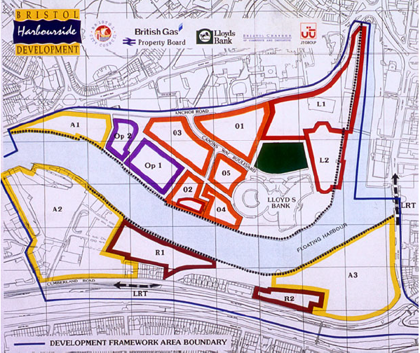
Figure 1 – Harbourside Sponsors Group Site (©Richard Holden, © Bristol City Council)

The HSG was an informal agreement to work collectively to deliver the large-scale regeneration of the site. Lloyds Banking Group were already in situ having built their offices in 1990, but this had not as hoped kick-started started the wider regeneration process. The SNA and centrality maps, shown in Figures 2 and 3, demonstrate that from 1993 to 2002, the HSG were one of the most influential bodies involved in the regeneration process, with many of the processes flowing through them to enable the regeneration process. Two other bodies were central to the regeneration, shown in the centre of Figures 2 and 3, Bristol 2000 and the Performing Arts Centre Company. These companies were set up to deliver the ‘public goods’ on the site. The delivery mechanism for these was a new concept in urban regeneration as noted by Interviewee BH4:
“We got councillors to sit as directors of a company, which was…all Labour and it was alien to them.”
This was a first clear step into urban entrepreneurialism for the council, along with senior business leaders, of being involved in new delivery vehicles designed to bring forward government funding and deliver projects in the public interest.
The HSG signed a non-legally binding agreement in 1994 called the Harbourside Accord. This was as Interviewee BH6 explained:
“a sort of 'gentleman's agreement' which agreed to share the cost of development and share the profits on a per-acre basis. It also agreed to a proportion in the uplift in value of the land to be put towards public infrastructure and in particular towards key leisure facilities that wouldn't otherwise have been fundable”.
The Harbourside Accord therefore acted as a ‘contract’ between the parties to work together, to decontaminate the site, access government funding and ensure the scheme was delivered. The HSG appointed Crest Nicholson in 1998 as the developer who made three attempts before they were granted planning permission to redevelop the Harbourside site. The first two applications were rejected over the quality of the outline planning applications; objections came from both the public and the Church of England, due to the proximity of the development to Bristol Cathedral (Combe, 1999). In March 1999 Crest Nicholson were asked by the council to withdraw their application and find a ‘different solution’ (Onions, 1999). The second application was rejected in January 2000, with the city’s Planning, Transport and Development Committee stating:
“The development would fail to provide sufficiently a coherent network of well-defined streets and spaces ‘appropriate to Bristol city centre and this prominent historic urban context’” (BCC, 2000).
Interviewee BH2 explained that the scheme was rejected because: “there was no imagination, nor thought or any detail of urban design”. In this case the planning committee were making their decision based on the PPS 15 (Planning and the Historic Environment), by stating that the development did not fit within the historic context of Bristol. This also links back to Bristol City Council’s own 1998 Planning Brief for the site, which Crest Nicholson did not adhere to.
As part of HSG’s agreement with Crest Nicholson, the company had until March 2002 to secure outline planning permission. Bristol City Council were advised that allowing Crest Nicholson to submit a third application was: “in the best interests of Bristol City Council as the land owner in terms of time and money” (Lynch, 2000). This meant that if Crest Nicholson were successful Bristol City Council would receive £19.8m (plus overage), plus a further £6m for infrastructure improvements (S106 contributions) (Ibid, 2000).
The HSG were very supportive of Crest’s application; one of the reasons highlighted for this was that the development would bring forward £18.5m of funding from SWRDA for the site to be decontaminated and for infrastructure. This provides an example of how regional governance provided a powerful ally to, and catalyst for, local authorities wishing to bring regeneration forward. However, SWRDA were not the only non-local body to be involved in creating the framework for the initial process of preparing the site for development. As the SNA map for the period 1993-2002 illustrates, a wide range of organisations/bodies were involved from various levels and sectors. What this demonstrates is the complexity of the overarching ‘governance landscape’ within which the project was framed, finance assembled and influence exercised. However, while on one level illuminating this ‘bowl of spaghetti’, it masks who the key players were in this stage. The centrality map (Figure 3) makes it easier to understand who the ‘key players’ were: Bristol City Council and the Bristol Initiative.
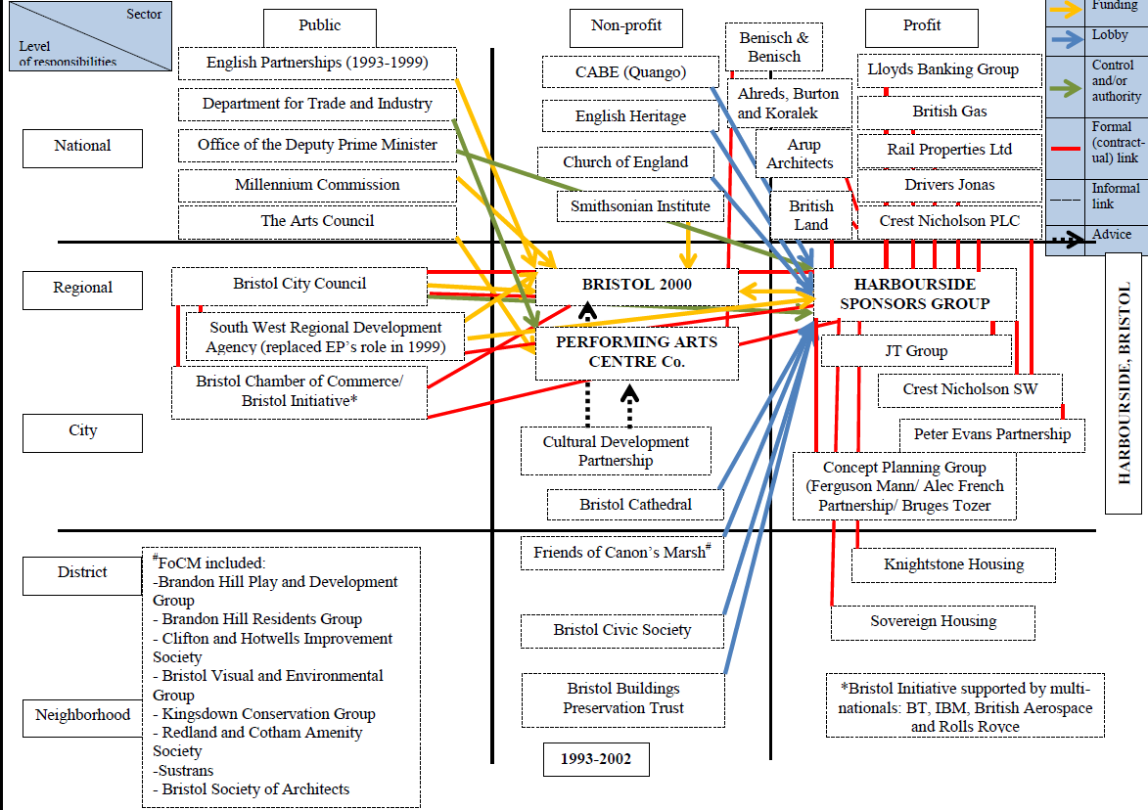
Figure 2 – SNA Map Bristol Harbourside 1993-2002
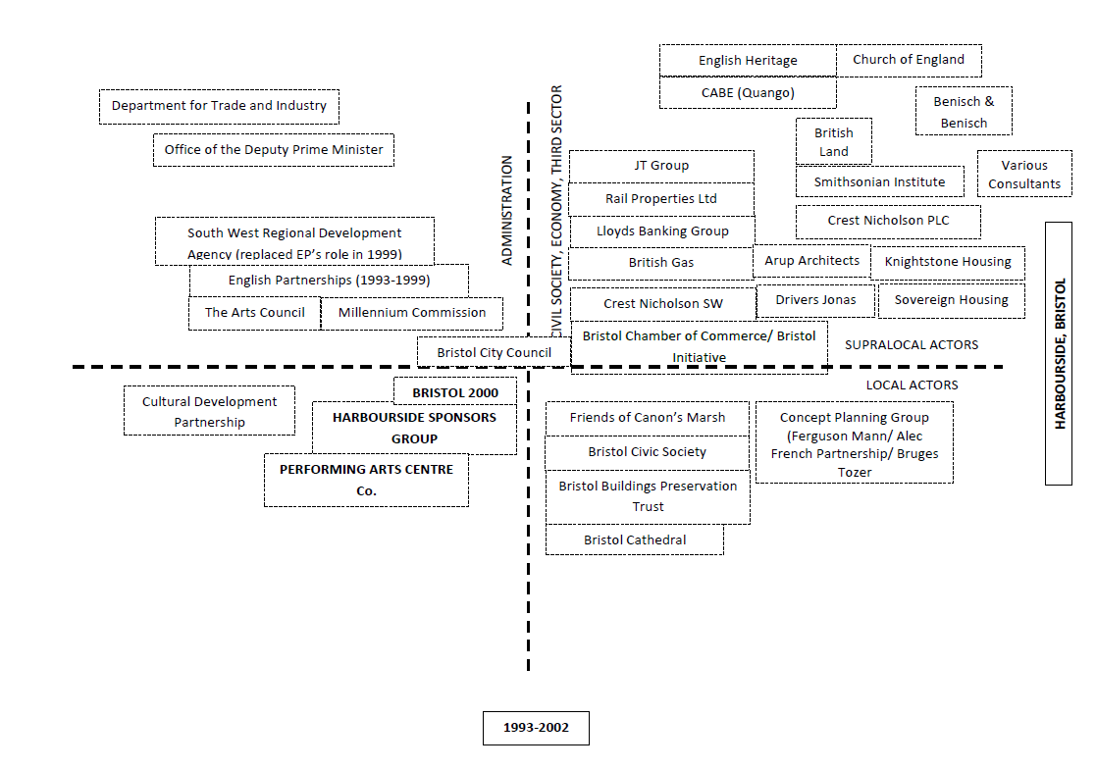
Figure 3 – Centrality Map Bristol Harbourside 1993-2002

The next two maps, Figures 4 and 5 depict the situation during the implementation process (i.e. when the site was being developed). Here we go from a ‘bowl of spaghetti’ to a ‘bowl of macaroni’ – somewhat more streamlined but still complex. The HSG as the ‘glue’ holding the key players together disappeared, as British Rail sold their land in a separate deal, thereby breaking the Accord. What is interesting is that Bristol City Council retained a key role throughout the period along with Crest Nicholson; the two worked closely to bring the development to fruition and ensure its success. In a sense this may be construed as constituting a temporary entrepreneurial ‘urban regime’ bound together by a mutual self-interest in developing the site, a relationship further cemented by the contract signed in 2003 between the city council and Crest Nicholson that included various S106 clauses to provide investment in infrastructure, the public realm and affordable/social housing. However, this was twice subsequently renegotiated to reflect changes in the wider economic context.
However, there were questions as to whether the scheme delivered a ‘public good’. In general all interviewees agreed that the site was an improvement on the derelict site and car park that was there before, but many felt that it could have been “so much better” (see Shaftoe and Tallon, 2010). Despite being approved for outline planning permission, several of the buildings constructed during the development have been criticised for their quality in terms of their construction and design. The Civic Society also continued to challenge each building through the planning process to ensure that they were delivered to a higher standard than was proposed by the developer. With the completion of the last building in 2014, the final public space was opened providing a path through the site. In this sense the area has provided a public good in terms of creating a space for people to use and access the whole of Bristol Harbourside. Since the completion of the project Crest Nicolson has sought to divest itself of any remaining holdings it retained on the site. Thus the ‘urban regime’ has disappeared.

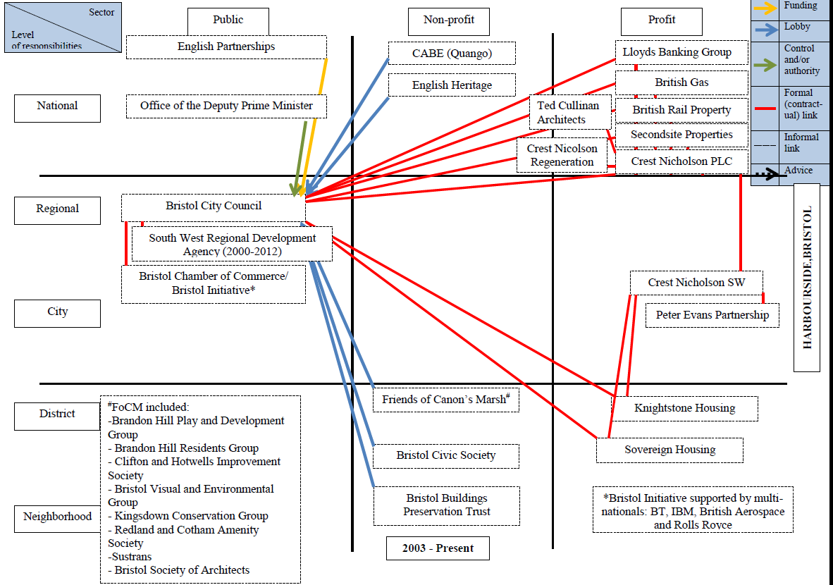
Figure 4 – SNA Map Bristol Harbourside 2003-Present

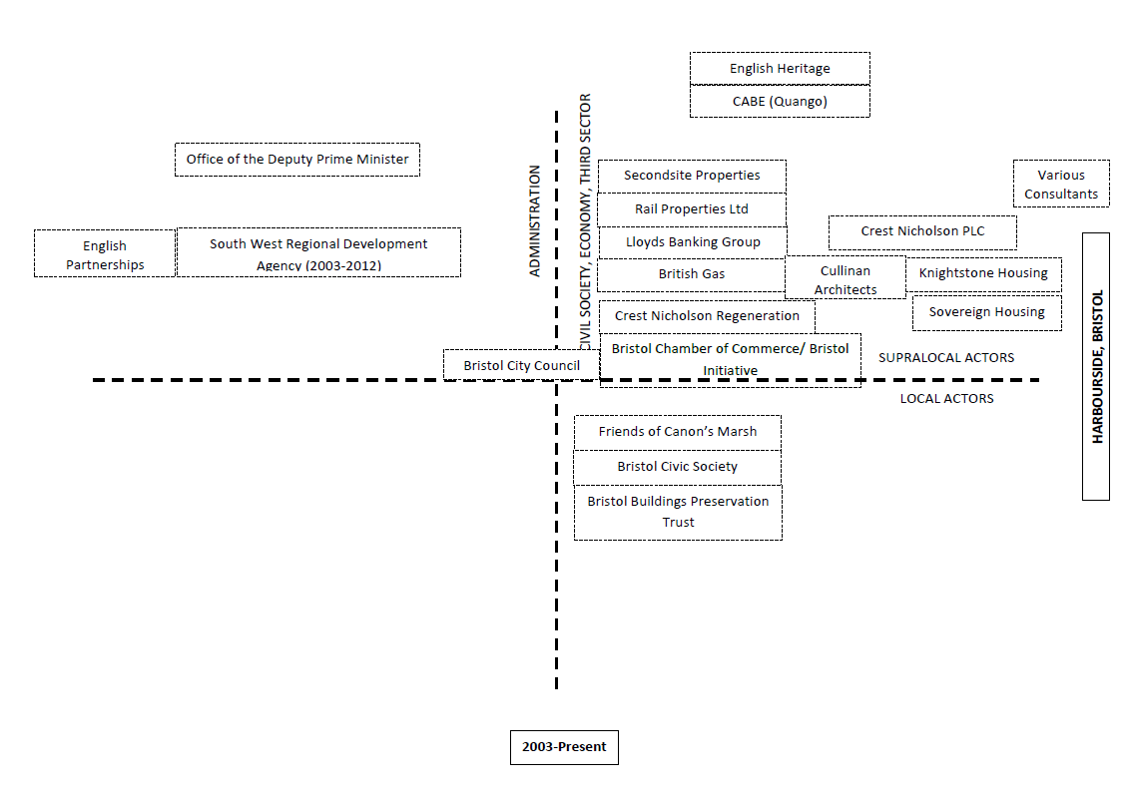

Figure 5 – Centrality Map Bristol Harbourside 2003-Present

Gloucester Quays – Joint Venture Partnership

A public-private partnership was created between a non-departmental government organisation (NGO) British Waterways and the developers, Peel Holdings to develop the Gloucester Quays area. They came to a formal agreement to develop their land together in 2002 which stayed in place until 2012 when the UK government abolished British Waterways and they became a charitable trust called the Canal and Rivers Trust. The Gloucester Quays development plan (Figure 6) included a shopping centre, a new campus for Gloucester College, housing, a supermarket and a new 4* hotel.
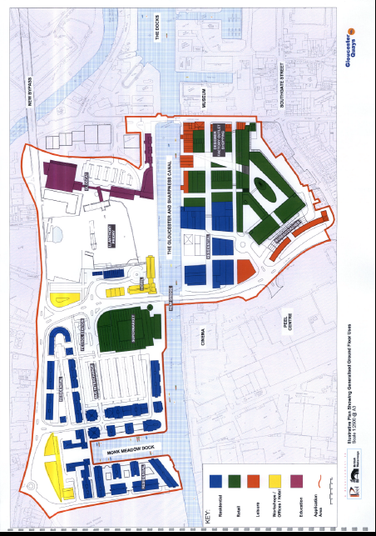
Figure 6, Gloucester Quays Proposal 2002 (© Gloucestershire County Council).

In the early 2000s the planning system in Gloucester was in what Interviewee GQ8 described as a “log jam”, with little activity taking place. Gloucestershire College had identified a site within the Peel/British Waterways site to relocate to, but British Waterways were not willing to release the land unless they received planning consent for a shopping centre. Interviewee GQ8 explained that the college had been awarded £30m towards the costs of relocation by the Department for Education and they had secured the sale of their existing site in the city centre to SWRDA, but were at risk of losing both if an agreement was not reached over how the development was to proceed.
In 2003 all the key parties were summoned to Westminster to agree to clear the ‘blockages’ and allow the development to go ahead. Interviewee GQ8 explained that the decision went right to the wire: “40 or 50 years or whatever of nothing happening and it all came down to the last few minutes of the meeting”. At the meeting it was agreed that British Waterways would release the land and that Gloucester City Council would take the Peel/British Waterways planning application to the full council, instead of the planning committee, to ensure that the decision was given the highest priority. Planning was granted, and the shopping centre opened in 2008.
Due to the issues associated with the redevelopment of their own land, Gloucester City Council, along with partnering organisations set up the Gloucester Heritage Urban Regeneration Company (GHURC) in 2004 comprising four main government bodies: Gloucester City Council, Gloucestershire County Council, SWRDA and English Partnerships. Each of these provided funding giving it a budget of £750,000 per annum to facilitate regeneration. GHURC proved to be a useful vehicle in enabling funding from both SWRDA and English Partnerships, as well as Section 106 funding, to be invested in new transport infrastructure, including a bridge providing a link to the shopping centre car parks; it also invested £7m in enhancing the links between Gloucester Quays shopping centre and Gloucester city centre.
GHURC sought to be inclusive in terms of engagement with the business community and local community groups with interviewee GH6 stating “All of them had sight of the projects before they went to the board, so they've been able to comment.” This enabled a dialogue to be opened between the community and decision makers. GHURC was able to overcome any local opposition (particularly from shop owners in the city centre) and to break the previously existing ‘log-jam’ that had surrounded the redevelopment of the area and the city more generally. The SNA map (Figure 7), shows GHURC as being at the centre of the regeneration process, but this masks the key relationship within the regeneration process between Peel Holdings and British Waterways shown at the top of the map. The centrality map (Figure 8), places these two parties at the centre of the regeneration process. Although not directly involved in the PPP joint venture, the GHURC played an important role in the regeneration process as they developed the planning vision for the city and promoted the regeneration process and in their Chief Executive they had a figure head who was respected by both the planners and developers within the city. Figures 9 and 10 once again show how the governance landscape was ‘simplified’ during the implementation phase of the project.
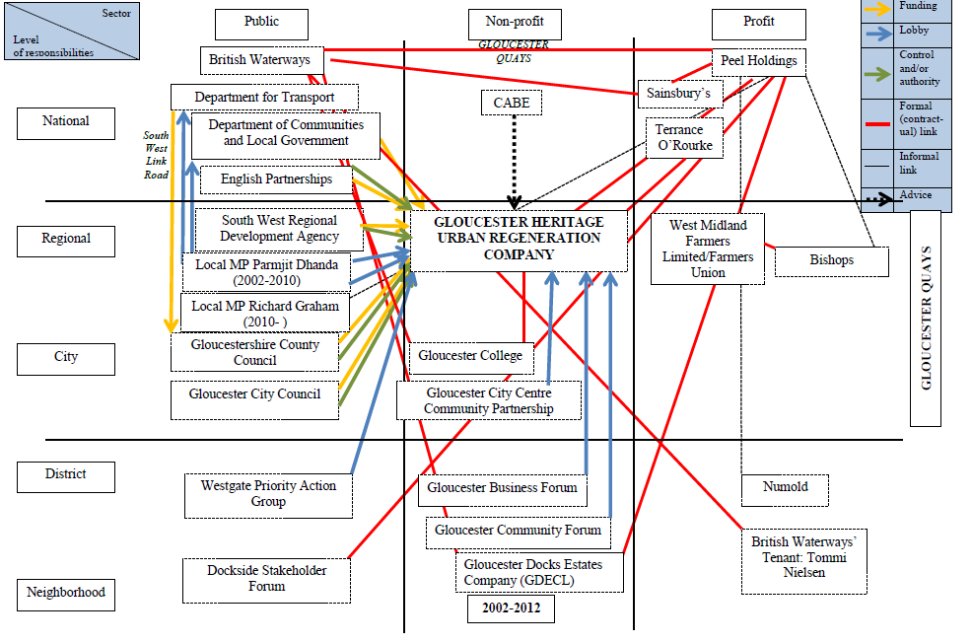
Figure 7 – SNA Map Gloucester Quays 2002-2012
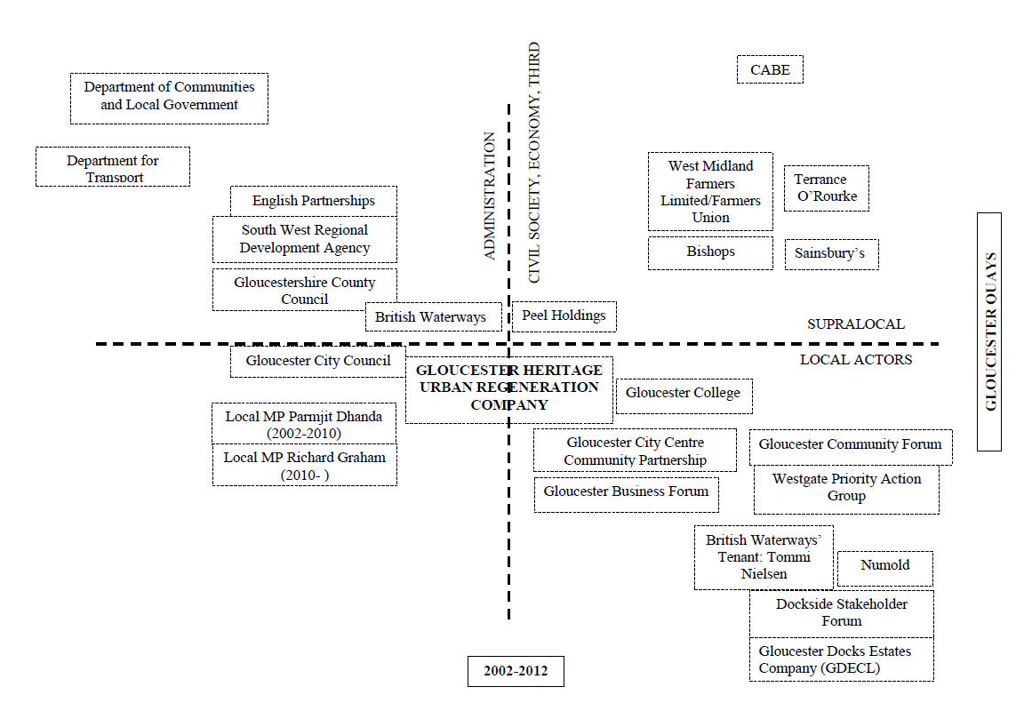
Figure 8 – Centrality Map Gloucester Quays 2002-2012

What these maps demonstrate is that the ‘governance landscape’ during the planning/preparation stage was complex, albeit not as complex as in Bristol, and that GHURC and Peel Holdings were the key players throughout. Indeed, these two appear to have created a ‘temporary urban regime’ resembling that created in Bristol but specific to the situation in Gloucester and the greater prominence of the private sector partner and its long term interest in developing and managing the development . Thus while GHURC was dissolved in 2014, Peel Holdings has continued its involvement in the site (shown by SNA and centrality maps post 2013). Unlike Crest Nicholson in Bristol it envisages being involved for the long term, perhaps 25 years, in the management and further development of the site. This reflects the fact that it is a different type of developer with funds being largely generated in-house and being prepared to take the long-view when it comes to developing a site and realising the value embodied in the site. This would suggest the ‘the developer matters’ and that we cannot treat developers as an undifferentiated category, in other words getting the ‘right developer’ matters.

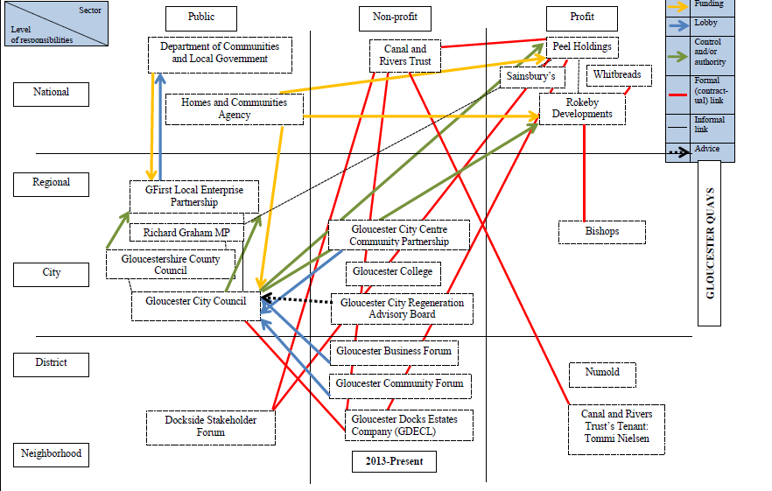
Figure 9 – SNA Map Gloucester Quays 2013-Present

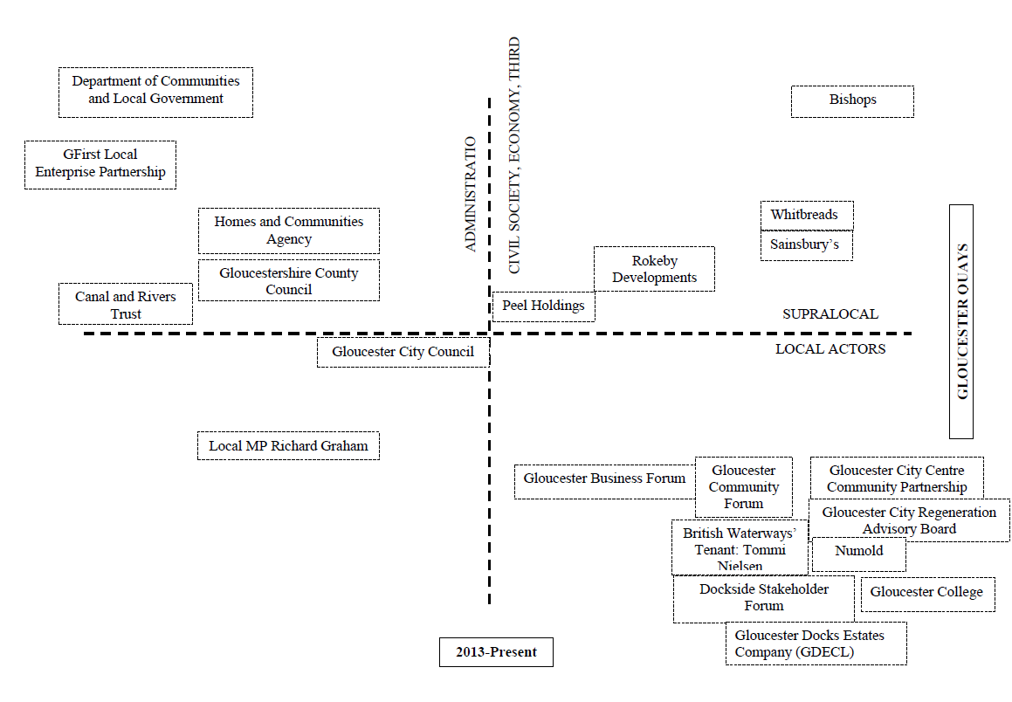
Figure 10 – Centrality Map Gloucester Quays 2013-Present

Peel Holdings and British Waterways delivered the regeneration process via a joint venture board that comprised three people from each organisation. The joint venture meant that each organisation put their land holdings into the agreement with “a very small cost payment into the venture to equalise the respective values” (Interviewee GQ3). The joint venture held until 2012 when British Waterways converted to a charity and sold their stake to Peel Holdings.

Taunton Firepool – Fragmented Development
Taunton Firepool is more complex than the other two cases as it covers several different sites, albeit in the same area but not physically connected. To date it has been less successful than the other two sites, as the primary site is still to be developed, although other aspects of Firepool have been delivered. The land was in mixed ownership between Network Rail, who owned the land now known as Firepool Lock, and Taunton Deane Borough Council (TDBC), who own the former cattle market site. At present Crest Nicholson are in the process of finishing the Firepool Lock site, whilst St Modwen’s proposal for the cattle market site was initially rejected but subsequently granted in 2018.
Network Rail sold their former goods yards (Firepool Lock) to Abbey Manor Developments, who subsequently sold the land to Crest Nicholson. This was described by Interviewee TF8 as “a straight land sale”, rather than a public private partnership. In addition, due to the S106 agreement that was a condition of the planning approval, social housing developers Knightstone Housing developed 200 affordable homes on the site. This was supplemented with a £3.5m grant from the Homes and Communities Agency (formerly English Partnerships) in 2012. This provides a public good in terms of the quality and availability of social housing in Taunton.
The second site has been more problematic to deliver. The cattle market closed in 2001 and TDBC sought to redevelop it. The initial plans were to use the site to construct offices, but this plan was unsuccessful as TDBC were unable to get an ‘anchor’ organisation to agree to locate on the site. This meant that St Modwen’s second application was based on providing retail on the site, but again this application was rejected. Similar to both Bristol and Gloucester, the aesthetic quality of the design was considered to be poor, with Interviewee TF6 describing it as a: “wriggly tin roof development”, and there was a fear that it would take business away from the town centre. Further, there was the potential for flooding, despite extensive flood alleviation work being delivered by Project Taunton.
Project Taunton was set up as an arms-length organisation by TDBC, SWRDA and the Environment Agency in 2004; it was described by Interviewee TF5 as a “URC lite”, as the organisation was designed to facilitate development, but without the bureaucratic structure or funding levels of the GHURC. Project Taunton was successful in delivering flood alleviation through the development of Long View Meadow, an area that was designed to capture flood water and prevent the town centre from flooding. However, it failed to deliver the redevelopment of the cattle market site, primarily due to the global economic downturn reducing the demand for office space in the town. The SNA map (Figure 11) shows Project Taunton at the centre of the regeneration process for the town and this is supported in the centrality map (Figure 12). The reason for Project Taunton’s importance was the link to TDBC, one of the primary land owners at Firepool, which meant they could have a greater influence than the GHURC. Crucially however, Interviewee TF1 stated that as an arms-length organisation Project Taunton never had total control over the former cattle-market site as this was retained by TDBC.
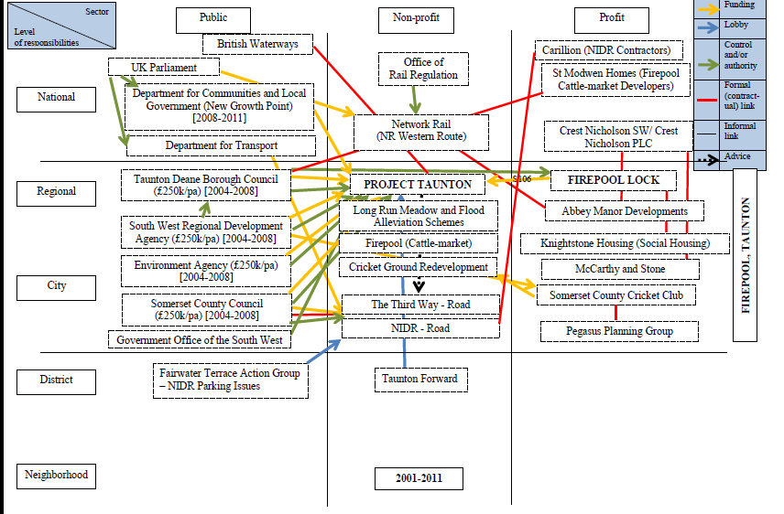
Figure 11 – SNA Map Taunton Firepool 2001-2011
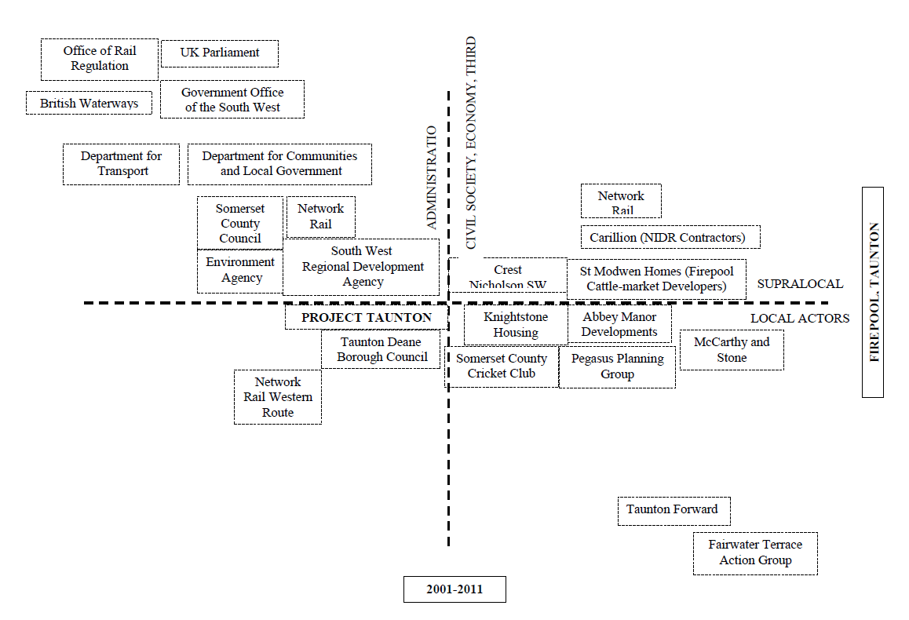
Figure 12 – Centrality Map Taunton Firepool 2001-2011

The first SNA map for Taunton again provides a complex picture of the range of organisations involved in the initial preparation and planning phase of Firepool and the centrality map shows Project Taunton, the TDBC and the developer at its core. However, unlike the other two case studies, SWRDA, Somerset County Council and the Environment Agency occupy much more central positions. This in part reflects TDBCs lack of regeneration experience – they needed greater external inputs and advice to get things going. Project Taunton was set up to try and address this issue. It also reflects the greater complexity of the site and the fact that the area was flood prone, thus the Environment Agency had a prominent role as TDBC needed to work closely with the Agency to put in place the necessary flood prevention arrangements, without these Firepool could not have been developed. Thus we have the complexity of the initial governance arrangements being in part determined by environmental factors. Post 2011, during the ‘implementation phase’, the situation is simplified with Project Taunton being disbanded and the staff taken in-house by TDBC. The close relationship with both Somerset County Council and the Environment Agency remained as both continued to have important inputs into the provision of infrastructure necessary to implement the development, and the developers remained central.
The delivery of the flood alleviation project constitutes a public good, as the land forms a public park, when it is not flooded, and allows the redevelopment to take place. It is clear from this application that the planning department at TDBC have acted in accordance with planning guidance, both on a national level, and locally in respect to ensuring that the cattle market site delivers a scheme that will provide a benefit to the town and community.
In terms of governance there is a shifting ‘governance architecture’, in part determined by the relative inexperience of TDBC in regeneration and the complexity of the Firepool site requiring significant and ongoing inputs in terms of knowledge and resources from Somerset County Council and the Environment Agency and the resources of developers to make the development viable. Even in the post 2011 ‘action phase’ (Figures 13 and 14) there were significant problems to be overcome and the overall development remains incomplete. One might suggest that what was created was a rather unstable and fragmented form of ‘entrepreneurial project based governance’ reflecting the fragmented nature of the Firepool site, TDBCs lack of knowledge and resources, and the ongoing need for external inputs. Nevertheless there were some interesting aspects to the site most notably the role of Network Rail and the Environment Agency which both developed innovative new models (for them) of engagement with local authorities that they are deploying elsewhere. So here we have an interesting example of experimentation and learning. The ‘temporary entrepreneurial urban regime’ created in Taunton was more unstable than in Bristol and Gloucester, with Project Taunton being taken back in house part way through the regeneration process. In part this reflected the more complex nature of the development process caused by the number of sites but also by the need to engage with a wider range of public and private partners. As a result it lacked the ‘coherence’ of the regimes created in the other two cases studies and thus was more unstable.
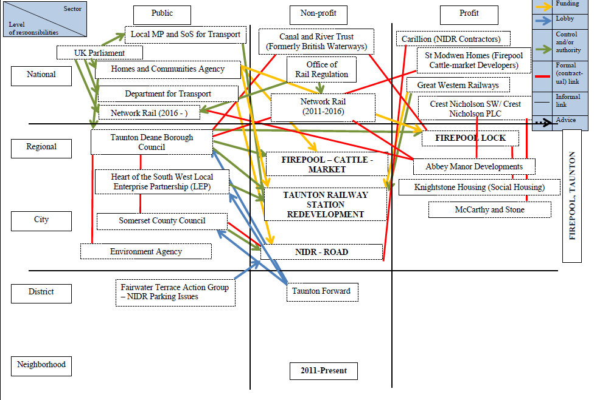
Figure 13 – SNA Map Taunton Firepool 2011-Present

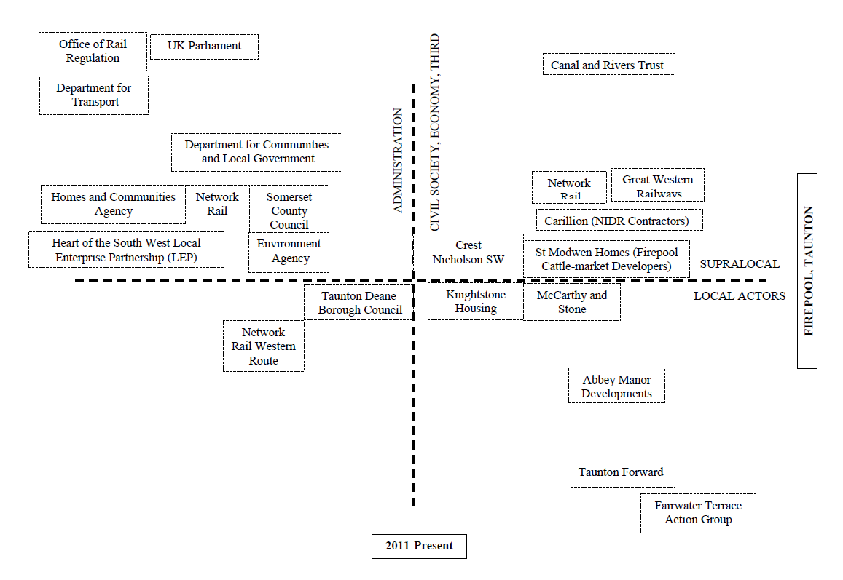
Figure 14 – Centrality Map Taunton Firepool 201-Present

Discussion and Conclusion
Each local authority addressed the regeneration of PDL in their area in somewhat different ways; they utilised different approaches and partnership arrangements. In Gloucester a formal body, the GHURC was set up, in Taunton an ad hoc arms-length body, Project Taunton, was created. In Bristol, which took place over a more extended time period, a range of bodies played a role, some an ‘informal’ role (the HSG) alongside formal bodies, including councillors and business leaders, to deliver the ‘public good’ schemes.
In part these different ‘governance arrangements’ reflected past experiences (or lack of) with regeneration and the local politics of each location/council. In the cases of Bristol and Taunton they also had to contend with the fact that the local authorities were significant land-owners and there was a potential conflict of interest to be addressed. Although interestingly it was Gloucester City Council, which owned none of the relevant land, that decided to go for the most formal arrangement by setting up a URC. Bristol did not do this, even though the option was available post-2000, perhaps due to the fact that a developer had been selected before the option to set up a URC was available. In Taunton it appears in part that the decision to set up Project Taunton reflected that, in terms of regeneration, the Firepool site was a ‘one-off’ while in Gloucester GHURC was concerned with the wider regeneration of the city and the protection of the city’s rich heritage.
The governance arrangements also reflected what the relevant planning committees, councils and stakeholders hoped to achieve through the development process and how they chose to interpret relevant national legislation. This refers not simply to planning legislation but also other environmental and heritage legislation. In the case of these two issues it became clear that in all three cases they set certain ‘limits’ (i.e. acted as a form of regulation) on the developments and what could (and could not) be done. In particular the legislation related to flood risk was a major limitation on developments in Taunton, and this required significant public sector investment to ensure the sites met relevant standards, but this applied, albeit to a lesser degree, to the other two sites as they were around water areas.
What is clear from our research is that national bodies, notably English Partnerships, played an important role in terms of providing resources for important infrastructure work (e.g. site remediation) essential to the development of sites. Similarly at the regional level, SWRDA, was significant in being able to focus significant resources on the sites, bring people together and where necessary ‘knock heads’ together. The abolition of the regional level appears to be a serious loss in terms of current and future developments as LEPs lack the resources and powers to fill the gap left by the abolition of the RDAs. In addition key individuals (or small groups) also played a significant role in bringing key actors together, mediating disagreements and addressing uncertainties at critical points in the development process. What this points to is the complex web of relationships that the projects were embedded in, which spanned local, regional and national levels – something clearly demonstrated by our SNA maps. This suggests that while there were ‘key local actors’ throughout the process, as illustrated by the centrality maps, even relatively small-scale developments in ‘smaller places’ are inserted into a wider set of multi-level governance relationships and flows of (public and private) resources which have to be combined and focussed at local level through the relevant partnerships. Moreover, this complex web of relationships did, at times, make it difficult to identify where decisions were being made and by whom. In this sense they did impact upon public accountability (in terms of transparency of decision-making), although in terms of the actual approval of developers’ planning applications this remained in the hands of the relevant planning committees in Bristol and Taunton while in Gloucester the decision was made by the full council.
In all three areas there were either no, or relatively, small numbers of people living there, so this removed many obstacles to the developments. However, there were often significant ‘spill overs’ from the proposed developments that did elicit, often strong, objections from within the wider city/town or adjacent areas affected by the developments. In the Bristol case much of the debate was around the impacts on sight lines across the city and the design quality/impacts of the proposed development. In Gloucester the main concern was the impact on existing city centre businesses. While in Taunton similar objections were present along with concerns about the design quality of what was (is being) proposed and the impacts of infrastructure provision (e.g. a road associated with the development). In each case addressing these concerns was necessary to establish the legitimacy of the ‘temporary project-based entrepreneurial urban regimes’ established by assuaging local concerns. In each case this regime took on forms specific to the local context and the partners involved, reflecting their interests, experience/knowledge and ‘capacity to act’ (Taşan-Kok and Korthals Altes 2012). However, in none of the cases did the regime become permanent, each was dissolved once the desired outcome had been achieved.
In terms of contracts and their effects on the governance and outputs of the projects, without wishing to downplay their significance, they were only one of a number of factors that structured the governance of these projects. Clearly their impact was greatest during the ‘implementation phase’ of the projects, although governance structures had already been established by then. The contracts established mutual relationships and obligations between the partners that did to a degree shape the governance of projects and what was delivered during this phase. However, they did not prevent local planning committees from rejecting developer planning applications they deemed inappropriate. The contracts also contained commitments by the developers to provide certain S106 outcomes. Nevertheless, ‘renegotiations’ took place over exactly what the developers were to provide in terms of agreements linked to S106; this is in line with the literature (see Burgess et al., 2011). Contracts clearly exercised a ‘degree of control’, although ironically the most interesting ‘contract’ in our cases was perhaps the Harbourside Accord. An ‘informal contract’ between the landowners was based on enlightened self-interest that the best way to maximise their individual returns was by working together. Moreover, the complex web of relationships each development was embedded in seems to have played a more significant role in shaping developments, along with changes in macro-economic circumstances, and the nature of the developers involved and their attitude to the development (e.g. whether they viewed it as a ‘short-term investment process’ or took a longer-term view).
It also has to be kept in mind that the redevelopment of Bristol site took place over an extended period of time and that there were considerable external changes (e.g. within the national economy post-2008) and internal changes within the city that affected the nature and pace of the development. The Taunton case is rather different, partly because of its fragmented nature and also because it is an on-going and unresolved process. Nevertheless, there is a general agreement that these sites needed to be brought back into use, the debates were/are about ‘what type(s)’ of use, the design quality of what is being proposed and the impacts on the existing town centre.
More generally we need to situate our case studies within debates over the wider planning system and forms of governance. It is widely acknowledged the UK operates with a ‘neo-liberal regime’ which has had significant impacts on both planning and governance at a variety of different scales; however, this overarching notion of neo-liberalism has increasing been recognised as too general and lacks a recognition that there are varieties of neo-liberalism. Moreover, it has been argued that even within a particular country there have been ‘phases of neo-liberalism’. For instance, Allmendinger and Haughton (2014) have sought to distinguish between the ‘roll-back’ version of the 1980s, and the ‘roll-out’ variety of the 1990s and 2000s. Our case studies largely fall in what they term the ‘roll-out’ phase which is characterized by “…a variety of market supportive state forms and modes of governance.” (ibid, p11). Arguably the case studies we have considered exhibit examples of how local, regional and national bodies sought to support and facilitate market-based developments in different ways related to local contexts. In addition, they go on to point out that:
This approach also placed a growing emphasis on partnerships as a means of promoting public and private sector coordination and improved policy integration. In this new accommodation, the state’s reworked role was not simply to de-regulate, divest, and open up markets. The role of government was also to reregulate and where necessary invest in ways that reconcile a continuing pro-growth agenda with wider societal issues, not least growing concern about environment and citizenship. (ibid, p12).
We can also detect concerns with these elements in our case studies as each of them has, in different ways, sought to address these wider issues. Part of the problem, however, is that we also need to consider what Taşan-Kok and Korthals Altes (2012) have referred to as the ‘capacity to act’ and Servillo et al. (2012) have termed the ‘mobilization process’. In both cases the authors are referring to the ability of (local) governance arrangements or ‘systems’ to get things done. As Servillo et al. (2012, p.359) point out:
This requires the existence of links, often articulated through organizational arrangements (for example, partnerships) between stakeholders, local authorities, agencies and citizens, in order to identify, create and mobilize assets and develop policies to achieve specific…strategies.
In each of the case studies, local authorities and the associated partnerships they have developed displayed differential capacities to act by mobilizing assets, developing relevant strategies and putting them into practice. Indeed, it is clear that without ‘external support’ from regional and national bodies they were unlikely to have been able to push the development process along and achieve the sustainable regeneration of PDL.

Acknowledgement
This research has been funded through the FAPESP-NWO-ESRC funded [name removed] Project no. 485-14-010.

References
Allmendinger, P. & Haughton, G. (2014) The Evolution and Trajectories of English Spatial Governance: ‘Neoliberal’ Episodes in Planning, Planning Practice & Research, Vol.28(1), pp.6-26.
Atkinson, R., Tallon, A., Tasan-Kok, T. van den Hurk, M. Korthals Altes, W. and Refinetti Rodrigues Martins, M.L. (2015), Guidelines for Research Procedures and Conceptual Framework. Bristol: UWE.
Barlow, J. (1995) Public Participation in Urban Development: The European Experience (Policy Studies Institute: London).
Brenner, N. and Theodore, N, (Eds) (2002) Spaces of Neoliberalism. Urban Restructuring in North America and Western Europe, (Blackwell: Oxford)
Burgess, G., Monk, S. and Whitehead, C. (2011) Delivering local infrastructure and affordable housing through the planning system: the future of planning obligations through Section 106, People, Place & Policy Online, Vol. 5(1), pp.1-11.
Christophers, B. (2017) The State and Financialization of Public Land in the United Kingdom, Antipode, 49(1), pp62-85.
Dempwolf, C.S. and Lyles, L.W. (2012) The Uses of Social Network Analysis in Planning: A Review of the Literature, Journal of Planning Literature, 27(1), pp.3-21.
DiGaetano, A. (1997) Urban governing alignments and realignments in comparative perspective, Urban Affairs Review, 32(6), pp. 844-870.
Le Galès, P. and Scott, A. (2010) A British Bureaucratic Revolution? Autonomy Without Control, or “Freer Markets, More Rules”, Revue Française de Sociologie, 51(1), p. 117-143.
Lynch, S. (2000) Susan Lynch’s (Drivers Jonas) letter to Richard Bunce, Corporate Resources, Bristol City Council, 28 February.
Harvey, D. (1989) From Managerialism to Entrepreneurialism: The Transformation in Urban Governance in Late Capitalism, Geografiska Annaler, 71B, pp3-17
Hyötyläinen, M. and Haila, A. (2018) Entrepreneurial public real estate policy: The case of Eiranranta, Helsinki, Geoforum, 51(1), pp 137-144.
Lefèvre, C. (1998) Metropolitan Government and Governance in Western Countries: A Critical Review, International Journal of Urban and Regional Research, 22, pp9-25.
Newman, J. (2001) Modernising Governance (Sage: London).
Omstedt, M. (2016) Reinforcing unevenness: post-crisis geography and the spatial selectivity of the state, Regional Studies, Regional Science, 3(1), pp.99-113.
Peterson, P. E. (1981) City Limits (University of Chicago Press: Chicago).
Raco, M. (2012) The privatisation of urban development and the London Olympics 2012. City, 16(4), pp452-460.
Pugalis, L. (2015) The English urban policy debate: An urban policy for all, Town Planning Review 86 (2), pp. 125-131
Raco, M. (2013) State-Led Privatisation and the Demise of the Democratic State: Welfare Reform and Localism in an Era of Regulatory Capitalism. Ashgate: Surrey.
Servillo, L., Atkinson, R. and Russo, A. (2012) Territorial attractiveness in EU urban and spatial policy: A critical review and future research agenda, European Urban and Regional Studies, 19(4), pp349-365.
Shaftoe, H. and Tallon, A. (2010) Bristol: not a design-led urban renaissance, in J. Punter (ed.) Urban Design and the British Urban Renaissance, London: Routledge, 115-131.
Stone, C. (1989) Regime Politics. Governing Atlanta, 1946-1988. (Lawrence: University Press of Kansas)
Stone, C. (1993) Urban Regimes and the capacity to govern, Journal of Urban Affairs, 15(1), pp1-28.
Stone, C., Orr, M. and Imbroscio, D. (1991) The reshaping of Urban Leadership in US cities. in M. Gottdiener, and C. Pickvance, (Eds) Urban Life in Transition, pp. 222-239 (Sage: London)..
Taşan-Kok, T. (2009) Entrepreneurial governance: Challenges of large-scale property-led urban regeneration projects, Journal of Economic and Social Geography (TESG), 101(2), pp. 126–149.
Taşan-Kok, T. and Korthals Altes, W.K. (2012) Rescaling Europe: Effects of the Single European Market on localized networks of governance in land development, International Journal of Urban and Regional Research, 36(6), pp.1268-1287.
Van der Veen, M. and Korthals Altes, W. (2011) Urban development agreements. Do they meet guiding principles for a better deal?, Cities, 28, pp.310-319.

(Public Accountability to Residents in Contractual Urban Redevelopment). For more detail see the introduction to the Special Issue.
Uplift on the value of the land.
The Town and Country Planning Act 1990 (as amended) created the Section 106 agreement. This a legally binding document which is part of the granting of planning permission, making a development proposal acceptable that would not otherwise be acceptable. In our cases these were contained in the contracts signed by local authorities with developers.

