**Circular Economy in the Manufacturing Sector: Benefits, Opportunities and Barriers**

###### Abstract

**Purpose:** In recent years, Circular Economy (CE) has come to prominence as an alternative to the classic approach of “make-use-dispose”. How companies can exploit the opportunities of CE to position themselves better are not well articulated in literature. This paper therefore aims to identify the barriers and opportunities of CE in the manufacturing sector through a socio-political, economic, legal and environmental perspective.

**Design/methodology/approach:** The study adopts a positivist approach, which is deductive in nature. A survey questionnaire was designed and distributed to manufacturing companies operating in the UK and EU. The study used FAME database and social networking platform LinkedIn to identify manufacturing companies. More than 200+ companies were approached for this study and data collection lasted over two months.

**Findings:** The study provides a comprehensive review of the CE literature and identifies a number of barriers and opportunities to CE implementation from socio-political, economic, legal and environmental perspective. The findings highlight key barriers, opportunities and benefits of CE for the manufacturing industries operating in the UK and EU.

**Research limitations/implications:** The findings are limited to 63 responses from the survey questionnaire distributed to manufacturing companies in the UK and EU. The present study aims to equip manufacturers with necessary understanding of the key opportunities and barriers to address the challenges encountered during the implementation of CE.

**Originality/value:** This study adds to the limited empirical literature on CE barriers and opportunities to manufacturing organisations operating in the UK and EU. The paper also identifies barriers and opportunities of CE from socio-political, economic, legal and environmental lens.

**Keywords:** Circular Economy, Barriers, Opportunities, Benefits, Manufacturing, UK

1. **Introduction**

Growing environmental awareness, environmental legislation and the need for social responsibility has led manufacturing companies to look for new ways to do their business. There is a growing consensus that the only way forward with sustainable production and development is to switch from our current industrial “linear” model to a circular economy (CE), contributing to a more environmentally-responsible and socially-equal society. Gregson et al. (2015) confirms the assertion that CE has come to prominence as an alternative to the classic approach of “make-use-dispose” which is based on the circular flow of materials and energy. CE has the potential to pave the way for eliminating environmental waste in manufacturing and regaining used materials into the material flow by encouraging the use of renewable energy sources and new manufacturing methods to achieve sustainability (Ciani, Gambardella, and Pociovalisteanu, 2016; Yuan, Bi, & Moriguichi, 2006).

Although CE is considered as a new concept on economic development, its roots date back to 1960s. Firstly, in 1965, Kenneth Boulding (1965) suggested that earth is a unique system similar to the space and to have a constant reproduction in the earth, there should be a cyclical ecological system. After that, two more concepts emerged in parallel to CE, which are Industrial Ecology (IE) and extended product life (Gregson et al., 2015). To visualise, IE was revealed as a concept which was based on the formation of new analogies by taking material and energy flows into account. By this system, it is aimed to recycle residual wastes and by-products to create an industrial symbiosis and reach sustainable development. As a result, IE offers to minimise the use of virgin resources and promotes cleaner production technologies. On the other hand, extending product life refers to the prevention of waste generation and embedding sustainable production and consumption techniques (Andersen, 2007; Gregson et al., 2015). These ideas and concepts paved the way for the emergence of the term, CE.

Later in 1990s, two British environmental economics Pearce and Turner (1990) presented the term CE for the first time in their book ‘economics of natural resources and the environment’. They suggested that the traditional linear economy does not contribute to the recovery of materials and energy and turns the environment to a waste reservoir. They pointed out that matter and energy can only be preserved in a circular system. In this context, they proposed a closed-loop system which contains the circular flow of materials and energy and named the concept as CE (Su et al., 2103). Rizos (2015) further note CE as an industrial economy that relies on the “restorative capacity of natural resources” (Bastein et al., 2013) and aims to minimise – if not eliminate – waste, utilise renewable sources of energy and phase out the use of harmful substances (Butterworth et al., 2013).

CE aims to protect the environment by using and reusing natural resources however, the successful uptake of CE among businesses and policy makers requires the identification of potential barriers, opportunities and benefits that could yield for businesses and economies. In the EU an estimated 6–12 % of all material consumption, including fossil fuels, is currently being avoided as a result of recycling, waste prevention and eco-design policies (EEA Report, 2016). The report further highlights that the implementation of CE approaches in the manufacture of complex durable goods with medium lifespans is estimated to result in net material cost savings of USD 340–630 billion per year in the EU alone, roughly 12–23 % of current material input costs in these sectors (EMF, 2012). For certain consumer goods (food, beverages, textiles and packaging) a global potential of USD 700 billion per year in material savings is estimated, that is, about 20 % of the material input costs in these sectors (EMF, 2013). These statistics show the potential benefits of the CE implementation. CE also has the potential to create job opportunities. The European Commission estimates that CE activities will result in 178,000 new direct jobs by 2030 (EEA Report, 2016).

It is evident from the previous discussions that although CE has been in existence for a while and poses numerous benefits, there is still a huge gap between its theory and implementation process. There are also many companies that have started to implement CE or that have intended to do so, however, they face several barriers in the implementation process of CE and often struggle to mitigate their effects. Many companies are also not well aware of the potential opportunities that CE presents (MacArthur, 2013). A handful of researchers have attempted to identify the barriers, enablers, opportunities and benefits of CE (e.g. Geng and Doberstein, 2008; Bastein et al., 2013; Rizos et al. 2015; Rizos et al. 2016; Wijkman and Skånberg, 2017; Govindan & Hasanagic, 2018). However, there is still a lack of literature presenting existing barriers and potential opportunities of CE, which can help companies to position themselves better (Masi et al. 2018). This paper, therefore, aims to fill this gap by identifying the barriers and opportunities of CE in the manufacturing sector from a socio-political, economic and environmental perspectives (Winans, Kendall, & Deng, 2017; Benton, Hazell, and Hill, 2015; Li & Yu, 2011). Moreover, most studies are qualitative and case study based, thus limiting the generalisation beyond these studies. This presents an opportunity to fill the research gap by conducting an empirical study.

This paper therefore aims to investigate the barriers and opportunities of CE in the manufacturing sector. Rest of the paper is organised as follows. Next section (section 2) presents a brief summary of the definitions of CE. This is followed by CE implementation levels in Section 3. Section 4 presents the opportunities of CE whereas section 5 presents the barriers to CE. Section 6 discusses the research methodology followed. The findings of the study are presented in Section 7 whereas Section 8 concludes this study by highlighting the limitations, implications and future research directions. This study adds to the limited empirical literature on CE and looks at the barriers and opportunities from socio-political, economic, environmental and legal lens, thus adding valuable contribution to the CE literature from the theoretical perspective.

1. **Circular economy definitions**

Over the years, a number of definitions of CE have been proposed. CE is based on the circular flow of material and energy and turns traditional linear take-make-dispose model to circular resource-product-regenerated resource model (Li et al., 2010). In this way, CE aims to reduce the consumption of virgin resources, wastes and pollution generated and paves the way for resource recovery and efficiency (Hu et al., 2011). Although CE has these benefits to the nature, it is an economic strategy instead of an environmental strategy. As the main objective, CE targets to ensure the sustainability and continuous development of the economy (Yuan, Bi, & Moriguichi, 2006). To do this, it introduces more advance technologies, improves equipment and machinery, organises the structures of industries, strengthens managements and correspondingly formulates a sustainable eco-industrial system. In other words, whilst supporting the development of economies as the base of the concept, CE also takes into account the environment and contributes its sustainability. Recenly Kirchherr, Reike, & Hekkert (2017) after reviewing 114 CE definitions defined CE as *“an economic system that is based on business models which replace the ‘end-of-life’ concept with reducing, alternatively reusing, recycling and recovering materials in production/distribution and consumption processes, thus operating at the micro level (products, companies, consumers), meso level (eco-industrial parks) and macro level (city, region, nation and beyond), with the aim to accomplish sustainable development, which implies creating environmental quality, economic prosperity and social equity, to the benefit of current and future generations.”* Table 1 presents a summary of key definitions and a careful examination of the definitions shows that there are many similarities. While all of the definitions hold their respective merit –some more than others- and provide a good understanding of most of the basic principles that comprise CE, each of them seems to lack a few of the elements that would render them complete. Based on the review of definitions (See Table 1)**,** CE can be defined as *"an economic growth and development system which unifies economy with natural resources and environment”*.

|  |  |
| --- | --- |
| **Table 1: Some CE definitions** | |
| **Definitions to the CE** | **Reference** |
| A CE approach encourages the organisation of economic activities with feedback processes which mimic natural ecosystems through a process of ‘natural resources → transformation’ into manufactured products → by-products of manufacturing used as resources for other industries. | Geng, Y., & Doberstein, B. (2008). |
| The CE, which is a mode of economic development based on ecological circulation of natural materials, requires compliance with ecological laws and sound utilization of natural resources to achieve economic development. | Zhijun, F., & Nailing, Y. (2007) |
| CE represents a new economic growth model that operates in the way of resource extraction, production, consumption and regenerated resources. | Ness, D. (2008) |
| CE is a strategy for decoupling economic growth from resource consumption, and hence secure continued economic growth without destroying the environment | Dajian, Z. (2008) |
| A CE is a mode of economic development that aims to protect the environment and prevent pollution, thereby facilitating sustainable economic development. | Ma et al. (2014) |
| The CE concept aims for circular flows of resources in the economy as opposed to the currently dominant linear flows from extraction through use to landfill disposal. | Giurco, et al. (2014) |
| CE is an industrial system that replaces the end-of-life concept with restoration, shifts towards the use of renewable energy, eliminates the use of toxic chemicals, which impair reuse and return to the biosphere, and aims for the elimination of waste though the superior design of materials, products, systems and business models. | MacArthur, E. (2013a) |
| CE advocates that economy system should be constructed on base of material and energy flow and changes linear throughput flow to round put flow of matter and energy. | Hu et al. (2011) |
| The concept of CE broadly accepts that an economic growth and development system to integrate economy with resources and environmental factors is based on the material metabolism mode of ‘‘resource-product-regenerated resource’’, which incorporates a mechanism of efficient resource use and waste stream feedback, while its metabolism is compatible with the whole ecosystem. | Li et al. (2010) |
| CE advocates that economic systems can and should operate according to the materials and energy cycling principles that sustain natural systems, | Zhu, Geng, & Lai (2011). |
| CE is an important way to protect the environment and resources, and to achieve sustainable development; it can transform a traditional linear growing economy, which depends on resource consumption into an economy, which relies on the development of ecological resources circulation. | Wang et al. (2014) |
| In a CE the value of products and materials is maintained for as long as possible; waste and resource use are minimised, and resources are kept within the economy when a product has reached the end of its life, to be used again and again to create further value. | European Commission, (2015) |
| The CE represents an attempt to conceptualise the integration of economic activity and environmental wellbeing in a sustainable way. | Murray, Skene, & Haynes (2017) |
| The CE is an economy designed for "self-regenerating": the bio-based materials are intended to fall into the biosphere, and the "technical" source materials are designed to operate within a flow that provides the minimum loss quality. | Ciani, Gambardella, & Pociovalisteanu, (2016) |
| CE is defined as an economic paradigm where resources are kept in use as long as possible, with maximum value extracted from them. | Nasir et al. (2017) |
| CE aims to decouple prosperity from resource consumption, i.e., how can we consume goods and services and yet not depend on extraction of virgin resources and thus ensure closed loops that will prevent the eventual disposal of consumed goods in landfill sites. | Sauvé, Bernard, & Sloan (2016) |
| CE is designed to eliminate waste through cycles of assembly, use, disassembly and re-use, with virtually no leakages from the system in terms of disposal or even recycling, and replaces the habitual notion of a consumer, who owns things and destroys value, with that of a user. | Spring & Araujo (2017) |
| CE is an economic strategy that suggests innovative ways to transform the current predominantly linear system of consumption into a circular one, while achieving economic sustainability with much needed material savings. | Stahel (2016) |
| The central theme of the CE concept is the valuation of materials within a closed-looped system with the aim to allow for natural resource use while reducing pollution or avoiding resource constraints and sustaining economic growth. | Winans, Kendall, & Deng (2017) |
| CE is one where the resources coming into the economy are not allowed to become waste or lose their value. Instead, this economy would recover those resources and keep them in productive use for as long as possible. | Benton, Hazell, & Hill (2015). |

1. **Circular economy implementation**

Unarguably, the implementation of CE holds various benefits for the environmental strategy of the implementer (McKinsey & Company, Inc., 2017), while also promising a sound economic strategy to go along with it (Yuan, Bi and Moriguichi, 2006). The implementation of CE has several practical aspects. Yun Bi and Moriguichi (2006) and Zhijun & Nailing (2007), citing the Chinese governments adoption towards a successful and effective implementation of a CE, highlight that horizontally CE includes industries, urban infrastructure, cultural environment and social consumption systems. When it comes to vertical implementation, CE consists of enterprises (micro), industrial parks (meso) as well as cities and regions (macro) levels.

To be able to successfully implement CE, the process should start from micro level with enterprises. Then, macro level should be embedded and then the process is concluded with implementation of macro level, since each level forms a basis for the following level and makes it possible to develop a sustainable economic growth and development. At the micro level, companies are promoted to adopt cleaner production (CP) and eco-design. CP is a concept which studies how pollution is generated and refers to the significance of efficient use of resources throughout the production processes (Su et al., 2013). On the other hand, eco-design aims to create awareness against environment and its protection during the design stage of production and formation of the final product. It supports companies to build more efficient, sustainable and integrated production processes to minimise the pollution generated (Negny et al., 2012). By benefiting from CP and eco-design, companies form ecological industrial chains which consist of circular flows of materials and energy within themselves. Thus, they can restrict pollution, waste and toxic substance emission whilst boosting resource efficiency (Zhijun & Nailing, 2007). Furthermore, the application of green labelling in public disclosure systems should be provided. To do this, local organisations should be established which monitors companies according to their levels of environmental protection. All businesses should be classified as green, blue, yellow, red and black from good to bad, in response to their performance. As a result of this classification, it becomes easier to identify and eliminate outdated technologies and decrease resource consumption and pollution generation. This is a crucial procedure since it enables to make companies to more environmentally friendly (Yuan, Bi and Moriguichi, 2006).

CE provides a circular flow of materials and energy and gives importance to higher utilisation of resources. To do this, it serves 3R (reduce-reuse-recycle) principles to set a course of action for companies. By starting its implementation from enterprise level and moving on industrial park and regional levels, CE offers a better future for companies, industries and societies. The next section discusses potential opportunities that CE creates.

1. **Opportunities of Circular Economy**

CE offers a variety of social and political opportunities. Basically, it strengthens the connection between the society and industry. By closing the loop, all participants within supply chains, included the public and companies, are required to have an extended collaboration (Geng et al., 2012; MacArthur, 2013b). At the end-of-life of a product, it should be regained since the value chain does not end up with consumers anymore. This positioning results with a better alignment between businesses and customers (MacArthur, 2013b). Thereby, companies can understand the needs and expectations of the public in a better way and manufacture products accordingly. In turn, they can satisfy their customers and attract many others.

Moreover, the implementation of CE has the potential to create many employment opportunities to local communities (Park et al., 2010; Geng et al., 2012; MacArthur, 2013b; Yuan, Bi, & Moriguichi, 2006). The development of recovery firms also bring investments and create many job opportunities to local people. CE also paves the way for the improvement of public health and environmental awareness (Geng et al., 2012; Park et al., 2010). People become more conscious about hazardous materials and prefer more environmentally friendly and safe products. In addition, CE promotes rental models in all sectors (MacArthur, 2013b), which help companies to collect insight information about customers, provide more customised and personalised products according to customers’ requirements with cheaper prices. Thus, the social value is advanced and the quality of life is improved.

Politically, CE enables companies to operate in accordance with regulations (Park et al., 2010). CE helps to create an organisational legitimacy and improve companies’ environmental consciousness. Therefore, they are able to obey the requirements of laws and decrease the social pressure. CE helps also companies to save money and enhance their profitability. It enables to reduce the costs through sustainable supply chain and end-of-life managements, lower input prices and minimising environmental penalties and waste generation (Park et al., 2010; Geng et al., 2012; MacArthur, 2013b). By the help of the closed loop model of supply chains, companies can sell their wastes instead of disposing them and make additional profits. Therefore, wastes can be turned to raw materials for other companies, reducing their material costs and eliminating their price volatility. Besides, CE opens new markets for recycling and re-manufacturing. These new markets and new revenue channels boost the profits of existing firms and provide competitive advantage to them among their rivals (MacArthur, 2013b; Park et al., 2010; Geng et al., 2012). In addition to companies, local governments and public can cut down their costs (MacArthur, 2013b). Municipalities can make additional profits from the amount that they collect and sell them to recycling businesses. The public can benefit from CE as the amount that they are required to pay for waste disposal is minimised. As a result, a financially mutualist relationship can be formulated.

|  |  |  |  |
| --- | --- | --- | --- |
| **Table 2: Opportunities of CE** | | | |
| **Opportunities of Circular Economy** | **Socio-Political Opportunities** | **Economic Opportunities** | **Environmental Opportunities** |
| CE strengthens the communication between the society and industry (Geng et al. 2012; MacArthur, 2013b, Young, 2015) | Reduction of the costs through sustainable supply chain and end-of-life management, lower input prices and minimizes environmental penalties and waste generation (Park et al.. 2010; Geng et al. 2012; MacArthur, 2013b) | Environmentally friendly and green products save energy and natural resources and reduce the pollution generation (Zhu & Tian, 2016) |
| Better alignment between businesses and customers (MacArthur, 2013b) | Opening of new markets for recycling and remanufacturing (Young, 2015; MacArthur, 2013b; Park et al., 2010; Geng et al., 2012) | Environmentally sound management practices provide organisational and supply chain resiliency (Park et al. 2010) |
| Creation of new employment opportunities to local communities (Park et al., 2010; Geng et al. 2012; MacArthur, 2013b; Yuan et al. 2006; Commission, 2017) | New Markets and new revenue channels boost the profits of existing firms and provide competitive advantage to then among their rivals (Young, 2015; MacArthur, 2013b; Park et al., 2010; Geng et al., 2012) | Avoidance of chemical fertilizers and soil amendments (Young, 2015; MacArthur, 2013b; Commission, 2017; Geng et al., 2012) |
| Improvement of public health and environmental awareness (Geng et al. 2012; Park et al. 2010) | Local governments make additional profits from the amount of waste collected by selling them to recycling businesses (MacArthur, 2013b) | Reduction in the consumption of fossil fuel, the emission of greenhouse gases and toxic substances (Young, 2015; MacArthur, 2013b; Commission, 2017; Geng et al., 2012) |
| CE enables companies to operate in accordance with regulations (Park et al. 2010) |  | Developments in environmental sciences and technologies and emergence of new concepts such as eco-deign, eco-label, cleaner production (Geng & Doberstein, 2008; Liu & Bai, 2014) |
| Promotion of rental models in all sectors which help companies to collect insight information about customers (MacArthur, 2013b) |  |  |

By the developments in environmental sciences and technologies, new concepts that aim at protecting nature have emerged, namely: eco-design, eco-label, cleaner production and life cycle assessment (Geng & Doberstein, 2008; Liu & Bai, 2014). As a result, the amounts of environmentally friendly and green products, which have minimum negative effects on environment, have become more common and preferred. Those products save energy and natural resources and reduce pollution generation (Zhu & Tian, 2016). Such environmentally sound management practices offer organisational and supply chain resilience and make it easier to penetrate into new markets and grow the business operations (Park et al., 2010). CE also improves the utilisation of waste and waste streams advance the availability of materials enabling protection of natural resources, water, energy and minerals. Correspondingly, the productivity of materials is increased by rework and recycling, their life cycles are extended and the need for landfill sites are reduced (Geng et al., 2012; Park et al., 2010; MacArthur, 2013b). Moreover, by the help of CE applications, the need for energy, chemical fertilisers and soil amendments are reduced. It results in a reduction of consumption of fossil fuels, the emission of greenhouse gases and toxic substances (MacArthur, 2013b; Geng et al., 2012). Therefore, the effects of climate change can be mitigated through CE practices. Table 2 summarises key opportunities of CE identified from literature.

1. **Barriers to Circular Economy**

CE offers many opportunities, yet, the level of awareness of the public against CE is quite poor (Su et al., 2013; Naustdalslid, 2014; Benton et al., 2015; Winans et al., 2017). Although in recent years governments and business around the globe have started CE activities, there still exists a lack of awareness of the term CE and its principles (Benton et al., 2015). For these reasons, an extensive public education needs to be provided via different channels. This could be potential achieved through advertisements on TVs, magazines, newspapers and billboards; government policies; development of new business models, etc. to present the opportunities of CE and encourage the society to take part as the public involvement is the key for the success of CE (Geng & Doberstein, 2008). The human and institutional capabilities are generally poor, which limits the availability of public education. Because of the lack of qualified personnel on CE, institutions and governments cannot become successful enough to promote it to the society (Benton et al., 2015; Su et al., 2013; Li & Yu, 2011).

Research indicates that most people care more about the appearance of products whilst purchasing. They do not pay attention to their sustainability and environmental effects and prefer the one with a better look, instead of manufactured from scrap (Pomponi & Moncaster, 2017; Naustdalslid, 2014). This reduces the demand of remanufactured products and low customer acceptance makes it difficult to maintain CE strategies. Moreover, to circulate the loops continuously, there should be a regular flow of materials so that old products and parts can be utilised in remanufacturing operations. To do this, companies make contracts with customers to limit their usage and ensure the return. However, studies indicate that many people want to use their products beyond the contracts and are often reluctant to replace their old products (Park et al., 2010). These circumstances result in the interruption of the smooth flow of materials and increase the waste creation, thus hindering CE activities.

On the other hand, government policies play significant roles for companies to shape their future steps. In most regions, there are fragmented regulatory systems. Governments and local authorities’ responsibilities are not clear on the implementation of CE. This complex structure results on poor accountability of local governments and leads to the creation of an inadequate legal system, a fact supported in many studies (Benton et al., 2015; Geng & Doberstein, 2008; Su et al., 2013; Li & Yu, 2011; Naustdalslid, 2014; Winans et al., 2017). Therefore, necessary systematic laws and regulations on CE cannot be created. Poor enforcement ability of legislations due to fragmented system and correspondingly, lack of policy support make it difficult to apply CE by businesses. As a result, companies prefer to go for their existing strategies rather than taking risks, restricting the spread of CE. Besides, many governments lack of a sophisticated understanding of CE practices (Geng & Doberstein, 2008; Benton et al., 2015; Naustdalslid, 2014). Since they are not completely aware of the benefits of CE, they remain incapable to take the lead, guide companies and make appropriate laws. Correspondingly, they cannot specify a clear vision, goals, objectives, targets and indicators (Pan et al., 2015). Lack of sophisticated knowledge of policy makers on CE further prevents the formulation of standard systems for performance assessment, data collection, calculation and submission and punishment (Su et al., 2013). Furthermore, taxes and charges specified by governments act as another barrier. Current tax regulations does not promote the implementation of CE in most regions, instead, they discourage companies due to its financial burden (Geng & Doberstein, 2008; Benton et al., 2015; Naustdalslid, 2014).

There are many economic barriers to CE in the manufacturing sector. CE is a costly process and it requires a considerable amount of upfront investment (Liu & Bai, 2014). However, it does not pay back instantly, instead, it has a long-term economic return. Having term limits imposed on managers leads to hesitation over investing on CE activities and results in investment in other business operations (Liu & Bai, 2014; Benton et al., 2015; Park et al., 2010). The lack of financial support mechanisms and tax incentives built into the budgetary systems from banks and governments further cause companies to avoid the implementation of CE although they are willing to do (Geng & Doberstein, 2008; Liu & Bai, 2014; Su et al., 2013). It is an expensive process and except from large companies, it is not possible to cope with it financially. Government support is a must to convert the existing linear economy model to the closed loop and it is governments’ responsibility to create a convenient environment for the implementation of CE. CE also requires collaborative business models to have a regular flow of materials and satisfy customers. Yet, because of lack of reliable information (Su et al., 2013; Pomponi & Moncaster, 2017; Winans et al., 2017; Pan et al., 2015) and high cost of establishing eco-industrial chains (Liu & Bai, 2014), companies cannot formulate a quicker feedback mechanism to adjust themselves. On the contrary, they take unsuitable actions which decline their profitability. Furthermore, high costs and uncertainties are embodied within CE can impact on companies financial conditions. These uncertainties cause companies to avoid remanufacturing processes due to the questions on its future sustainability and profitability.

CE also faces several environmental barriers as there are not enough environmental management programs and facilities available both under government bodies and at academic institutions whereas the existing ones are rather dysfunctional (Govindan, and Hasanagic, 2018; Su et al., 2013; Geng & Doberstein, 2008). The available incentives to promote greener activities and save water, energy and materials cannot measure up to the desired level (Geng et al., 2009; Su et al., 2013). Many companies use old technology machinery and equipment since they are not financial strong enough to replace them with higher technology ones on their own. Hence, the level of energy consumption and pollution generation is much higher in those machinery and equipment which treats the environment wastes (Geng & Doberstein, 2008; Naustdalslid, 2014). The landfilling and incineration activities lack adequate technologies (Gregson et al., 2015). As a consequence, these activities cause huge environmental losses which cannot be reverted back. Additionally, scavenger and decomposer companies lack capacity to create new fields due to existing policies (Geng & Doberstein, 2008). Many governments do not provide adequate subsidies and tax reductions to promote waste recovery. Ultimately, the amount of materials recovered remains incapable to meet the demand of companies in remanufacturing business and lead them to use virgin materials. These evidences show that there are many barriers to the successful CE implementation. Table 3 summarises key barriers identified from literature.

|  |  |  |  |
| --- | --- | --- | --- |
| **Table 3: Barriers to CE** | | | |
| **Barriers of Circular Economy** | **Socio-Political Barriers** | **Economic Barriers** | **Environmental Barriers** |
| Low level of awareness on public against CE (Xue et al., 2010; Benton et al. 2015; Yap, 2005; Su et al., 2013; Naustdalslid, 2014; Winans et al. 2017; Geng et al. 2009; Geng et al., 2012) | The need for a considerable amount of upfront investment which has a long-term economic return (Liu & Bai, 2014) | Lack of availability of environmental management programs and facilities both under governmental bodies and at academic institutions (Su et al., 2013; Geng & Doberstein, 2008; Yap, 2005) |
| Lack of understanding of CE’s principles (Benton et al. 2015) | Lack of financial support mechanisms and tax incentives (Geng & Doberstein, 2008; Liu & Bai, 2014; Xue et al., 2010; Su et al., 2013; Geng et al., 2009; Matthews et al., 2011) | Lack of available incentives to promote greener activities and save water, energy, and materials (Geng et al., 2009; Su et al. 2013) |
| Lack of Qualified personnel on CE (Xue et al., 2010; Benton et al. 2015; Yap, 2005; Su et al., 2013; Li & Yu, 2011) | Lack of appropriate partners in supply chains (Benton et al., 2015; Pomponi & Moncaster, 2017) | Many of the areas performing landfilling and incineration activities are lack of adequate technologies (Pringle et al., 2016; Gregson et al., 2015) |
| Low level of demand and acceptance of remanufactured products from public due to their appearance (Pomponi & Moncaster, 2017; Naustdalslid, 2014; Singh & Ordoñez, 2016; Zhu & Tian, 2016) | High cost of establishing eco-industrial chains (Liu & Bai, 2014) | Scavenger and decomposer companies are lack of capacity to create new fields (Geng & Doberstien, 2008) |
| Reluctance to replace end-of-life products (Park et al., 2010) | Informal sector recycling processes (Velis, 2015; Singh & Ordoñez, 2016; Winans et al., 2017) | Waste resource management systems are generally low-tech and they limit the maximum utilisation of recovered materials (Li & Yu, 2011) |
| Poor accountability of local governments and inadequate legal system (Benton et al., 2015; Geng & Doberstien, 2008; Su et al., 2013; Li & Yu, 2011; Naustdalslid, 2014; Winans et al. 2017; Matthews et al., 2011) | The need for a remarkable investment for advanced technology and the updating o facilities and equipment (Su et al., 2013) | Lack of adequate technologies used in landfilling and incineration activities cause huge irrevocable environment losses (Pringle et al., 2016; Gregson et al., 2015) |
| Lack of a standard system for performance assessment, data collection, calculation and submission and punishment (Su et al., 2013; Geng et al., 2012) | High cost of material scrap directs firms to use cheaper virgin materials (Wübbeke & Heroth, 2014; Pomponi & Moncaster, 2017) |  |
| Lack of a sophisticated understanding of CE practices from governments (Geng & Doberstien, 2008; Benton et al., 2015; Naustdalslid, 2014) |  |  |

There is a growing interest in CE in the UK and EU. The Biffaward programme, which was practiced between 1999 and 2008, can be considered as one of the starting points of CE in the UK (Hill, 2015). Later the Waste and Resource Action Programme (WRAP) featured in 2013 as a CE strategy with similar targets with Biffaward programme (Skene & Murray, 2015). The Ellen MacArthur Foundation was established with a sole aim to promote CE in 2009 (Hobson, 2016). Since then a number of organisations across the UK, EU and rest of the world have successfully implemented CE strategy or are in process of CE implementation. In EU, European Commission has started to take actions to ensure the sustainability of the economy. The commission revealed the Sustainable Consumption and Production, and Sustainable Industrial Policy (SCP/SIP) Action Plan in 2008 with the purpose of advancing the environmental performance of products and promoting sustainable production technologies (Commission, 2012). After that, in 2010, the Cradle-to-cradle (C2C) network, which provides sustainable solutions, economic development opportunities and social well-being was created (McDonough & Braungart, 2002). In 2015, European Commission prepared a CE package to encourage the change towards CE. These evidences show that CE has been at the focal point in the UK and EU.

1. **Methodology**

The study follows the positivism philosophical paradigm and adopts a deductive approach. A survey questionnaire was created for the collection of data. The first step involved a comprehensive review of the literature to identify barriers and opportunities among different industries and sizes of companies, and classifying them from socio-political, economic and environmental perspectives. An online survey questionnaire was designed based on the review of literature.

The questionnaire involved four sections (See Table 4). The first part of the survey involved demographic questions; second part of the survey was aimed to identify the basic knowledge and awareness of CE; third part was focused on seeking views on benefits and opportunities of CE; final section aimed to identify the barriers to CE. The survey was distributed using the Qualtrics platform to more than 200+ manufacturing companies identified through FAME database (*Fame is a database of companies in the UK and Ireland*) as well as the social networking platform ‘LinkedIn’. Although the questionnaire reached to sufficient number of potential participants, only 80 people responded to the questionnaire over the period of two weeks, representing a response rate of around 40%. After carefully screening the survey responses, only 63 usable responses formed the final sample size for this study as some users did not complete all questions, thus representing an effective response rate of 32%. The re**s**ponse rate of the study was between 30 to 35 percent, which is perceived by Cohen et al. (2007) and Watt et al. (2002) as acceptable. They survey response rate is higher than various studies (Bhasin, 2012; Belekoukias, Garza-Reyes, & Kumar, 2014), which have reported less than 25% response rate. The survey was mainly directed to companies in manufacturing sector. The participants mainly comprised supply chain managers or senior executives, since they are the ones who have the most critical roles in the implementation of CE in their organisations. The data was then analysed using SPSS. Due to the exploratory nature of the research findings, these were presented using descriptive analysis.

|  |  |
| --- | --- |
| **Table 4: Survey Questionnaire** | |
| 1. **Demography** | |
| Q1 | Which of the following best describe your position in your company? |
| Q2 | In which industry is your company is operating? |
| Q3 | How many employees are there in your company? |
| Q4 | Where is your company located? |
| 1. **Basics of Circular Economy** | |
| Q1 | Have you heard of the circular economy? |
| Q2 | What do you think that the circular economy is about? |
| Q3 | What are the 3Rs of the circular economy? |
| Q4 | Which of the followings do your company do as a practice of the circular economy? |
| 1. **Benefits of the Circular Economy** | |
| Q1 | What is the level of awareness about the benefits of the circular economy within your organisation? |
| Q2 | Which of the following benefits you are expected to achieve by the circular economy? |
| Q3 | What factors promote your intention to implement the circular economy? |
| Q4 | By the implementation of the circular economy, which social benefits do you wait for? |
| Q5 | By the implementation of the circular economy, which economic benefits do you wait for? |
| Q6 | By the implementation of the circular economy, which environmental benefits do you wait for? |
| Q7 | By the implementation of the circular economy, which technological benefits do you wait for? |
| Q8 | Which of the legislative benefits you are expected to achieve by the circular economy? |
| Q9 | What drivers attract you to implement the circular economy? |
| 1. **Barriers to the Circular Economy** | |
| Q1 | What are the external barriers that your organisation has faced or would potentially face while implementing the circular economy? |
| Q2 | What prevents you to implement the circular economy? |
| Q3 | What is the main social barriers for you against the implementation of the circular economy? |
| Q4 | Which is the main economic barrier inhibiting the implementation of the circular economy? |
| Q5 | Which is the main environmental barrier inhibiting the implementation of the circular economy? |
| Q6 | What is the main technological barrier inhibiting the implementation of the circular economy? |
| Q7 | What is the main institutional barrier inhibiting the implementation of the circular economy? |

1. **Findings and Discussion**

The survey resulted in 63 valid responses from manufacturing organisations operating in the UK or EU. The first set of questions was focused on demography of the survey participants. The survey resulted in response from 50% respondents who were supply chain managers and executive, 22% were engineers, 20% sales or human resources and whereas 8% respondents did not reveal their position in the organisation. Around 60% respondents were from the UK manufacturing organisation (41% England, 9.5% Scotland, 6.5% Northern Ireland, and 3% Wales) whereas 16% respondents were from the European Union and 24% respondents decided not to reveal the location of their organisations. Majority of the respondents from the automotive industry (22%), followed by metal processing (20%), paper & paper products (19%), electronics and electrical products (14%), textile& leather products (11%), rubber & plastic products (9%) and rest 5% from other industries. Around 65% organisations were SMEs whereas rest 35% were large businesses.

The next set of questions was aimed to identify the level of awareness towards the CE concept. When asked whether they have heard this term before, around 35.9% of participants have chosen the alternative ‘No, I have not heard of it’ while the remaining 64.1% have stated that they have some basic knowledge on CE. This is in line with the same low level of awareness shown by the general public in Tianjin, China (Liu et al., 2009), showing that there is generally still a lack of sufficient awareness around the CE. However, the low awareness level shown in the private sector in the UK and UE as well as that shown in Tiajin, China, opposes that high level of awareness by municipal and country Chinese level officials (Xue et al., 2010). This suggests that awareness programmes formulated and deployed by the Chinese government can be studied and may be adapted to be implemented in UK and EU manufacturing organisations. The other question further probed their understanding of the CE concept, 3Rs (Reduce – Reuse – Recycle) and their current implementation status. The responses show the low level of awareness among the respondents (only 29% knew about 3Rs).

The next set of questions was focused on the opportunities of CE. When asked about the benefits and opportunities the results were very surprising as many respondents noted the limited awareness (35%) about the benefits of the CE whereas very few (19%) acknowledged that their staff members were aware of the potential benefits. To make use of these knowledge and skills, appropriate education should be provided to those businesses to create awareness on the opportunities that CE is able to provide. With regard to the benefits of CE (See Fig. 1), reducing waste generation was ranked first among the participants followed by sustainability strategy, competitive advantage, improved public relations, and new market opportunities. This finding suggests that companies expect to improve their efficiency and robustness of their manufacturing operations.

On the other hand, they generally refrain from penetrating into new markets, and prefer to focus on their main operations and show risk-averse attitude. Energy savings and environmental protection opportunities appeared to be the top factors promoting intention to implement CE in most organisations, which was followed by financial incentives and tax reduction. This is aligned with the findings of Xue et al. (2010) who suggested the same factor as the main driving forces behind developing CE. Interestingly, growing consumer awareness and pressure from public appeared as least important factor. Constantly increasing energy prices put companies in a tight spot. Additionally, the need for energy to turn natural resources into usable products is enormous. For these reasons, companies are becoming more intended to use renewable energy sources. Moreover, increasing regulations and legislations for environmental protections and public pressure complicate for companies to operate their businesses. CE application makes it easier to obey the rules and avoid from penalties and therefore, companies are becoming more willing to implement CE. When asked about the drivers that attract CE implementation waste reduction, sustainability, environmental protection and new ideas related to production emerged as key drivers (See Fig. 1).

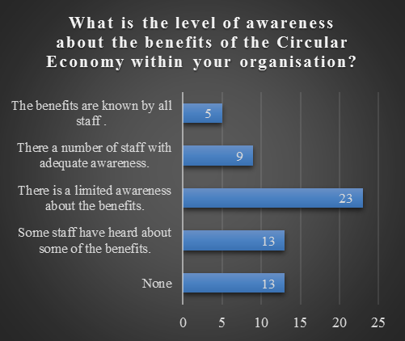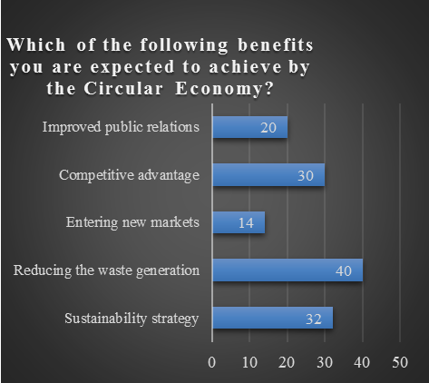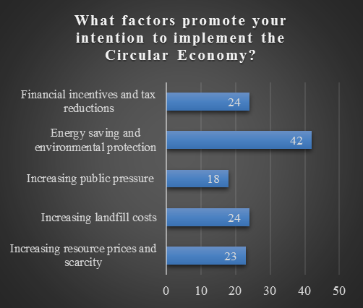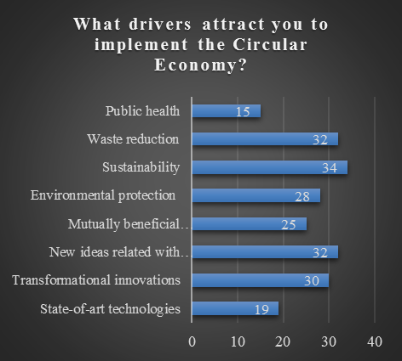

Figure 1: CE Awareness and Benefits

Furthermore, questions on the social, economic, environmental, technological and legislative opportunities/benefits of CE were directed to the participants. The findings show that improved public environmental awareness is the main social expectation linked to CE, which was also supported by Geng et al. (2012) and Park et al. (2010). CE requires the involvement of the public in the supply chains as well since it encourages the reuse of all products, even the ones which are at their end-of-life. For this reason, the contribution of conscious societies to CE is critical. Additionally, increased employment opportunities and better relationships between industry and public emerged as other major social benefits that CE provides. Economically, the main expectation arises as reduction on costs through sustainable supply chain and end-of-life managements. By the implementation of CE and its sustainable management practices, it is possible to reduce input prices, avoid from environmental penalties and minimise waste generation as suggested by Park et al. (2010), Geng et al. (2012) and MacArthur (2013b). From the environmental perspective, the increase in availability of green and environmentally friendly products and reduction in environmental pollution emerged as the main opportunities that CE as also found by Zhu & Tian (2016). Increase in efficiency and productivity emerged as the main technological benefits of CE which is also supported by Young (2015), Park et al. (2010), Geng et al. (2012) and MacArthur (2013b). By reuse and recycling applications in parallel to CE, efficiency and productivity can be improved which, in turn can enhance the profitability of businesses. From legislative point of view, having adequate laws to protect environment and health emerged as key benefits of CE implementation. Thereby, all businesses need to operate in accordance with the regulations to avoid paying penalties. Table 5 summaries the key findings by ranking the responses from the survey.

|  |  |  |  |  |
| --- | --- | --- | --- | --- |
| **Table 5: Ranked CE benefits Responses** | | | | |
| **Social** | **Ranking** |  | **Economic** | **Ranking** |
| Improved public environmental awareness | 1 |  | Reduction of costs through sustainable supply chain management | 1 |
| More employment opportunities from new recycling businesses | 2 |  | Generation of new revenue streams through a more effective life cycle management | 2 |
| Improved social relations between industrial sector and local societies | 3 |  | Revenues from the sale of wastes | 3 |
| Improved public health level | 4 |  | Creation of new markets | 4 |
|  |  |  |  |  |
| **Environmental** | **Ranking** |  | **Technological** | **Ranking** |
| Increasing availability of green or environmental products | 1 |  | Increase in efficiency and productivity | 1 |
| Reduction in environmental pollution | 1 |  | Advance equipment and high-tech facilities | 2 |
| Avoidance of toxic materials | 2 |  | Better designs | 3 |
| Organisational and supply chain resiliency | 3 |  | Technical expertise | 4 |
|  |  |  |  |  |
| **Legislative** | **Ranking** |  | **Legislative** | **Ranking** |
| Making adequate laws to protect environment and health | 1 |  | Tax deductions | 4 |
| Standardisation on data collection, calculation and submission | 2 |  | Formation of award / punishment system | 5 |
| Standardisation on waste collection | 3 |  |  |  |

Next section of the questionnaire aimed to find out what prevents companies to implement CE and how they differ according to their social, economic, environmental, technological and legislative characteristics. Analysis reveals that governments remain incapable to promote CE. They have failed to incentivise companies properly and provide adequate support as Geng & Doberstein (2008), Liu & Bai (2014), etc. have also pointed out in their studies. Besides, the required up-front investment for advanced machinery, risk-averse profiles of management and lack of availability of experts on CE put barriers against the implementation of CE (See Fig. 2).

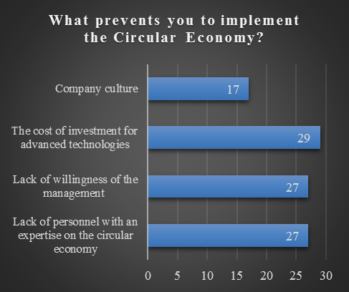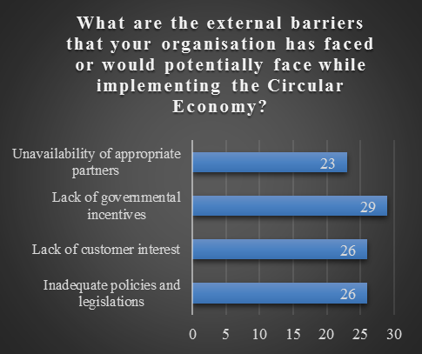

Figure 2: Barriers to CE

Participants were then asked about the CE barriers from the socio-economic, environmental, technological and legislative perspectives (See Fig. 3). The findings suggested that 41.4% of the participants stated the lack of public awareness and understanding of its principles as the main social barrier to CE. Literature also supports this as various researchers such as Benton et al. (2015), Su et al. (2013), Naustdalslid (2014), Winans et al. (2017) and Geng et al. (2009) align to this finding. From the economic barriers perspective, the unavailability of appropriate partners in supply chains emerged as key barrier followed by lack of financial support mechanism as noted in the study of CE as Benton et al. (2015). From environmental barriers perspective, inadequate waste resource system emerged as key barrier which was followed by limited incentive to save energy, water and materials. As Li & Yu (2011) have mentioned, the existing systems are appropriate for linear economies and unable to satisfy the expectations of CE. Lack of advance technology and equipment and inadequate technical capabilities emerged as technical barriers. Finally, with regard to legal barriers, poor enforcement ability of legislations and lack of policy support emerged as a key barrier, which was followed by ineffective recycling policies and current tax regulations (See Fig. 3).

1. **Conclusions**

In conclusion, this study has managed to identify the key barriers and opportunities of CE in the manufacturing sector. In summary, the major socio-political barriers revealed to be low level of public awareness on CE and lack of understanding of its principles. The main economic barrier was seen as lack of appropriate partners in supply chains which restricts the collaboration between companies. From the environment point of view, inadequate waste resource system arose as the biggest challenge in front companies which limits the utilisation of recovered materials. On the other hand, the study also shows the opportunities of CE in terms of the same characteristics. Socio-politically, the main expectations are opening up new employment opportunities and strengthened relations between the society and industry. When it comes to economic opportunities, companies are fundamentally looking for reduction of costs through sustainable supply chains and end-of-life management. Eventually, the participants have shown their interest for environmental friendly green products and reduction in environmental pollution.

Our study thus adds to the limited empirical literature on CE by providing a comprehensive review of CE barriers and opportunities in the manufacturing sector. The study looks at these barriers and opportunities from socio-political, economic, environmental and legal lens, thus adding valuable contribution to the CE literature from the theoretical perspective.

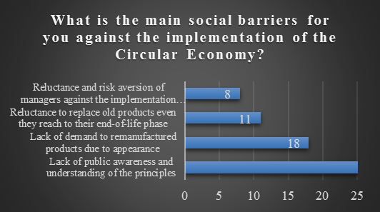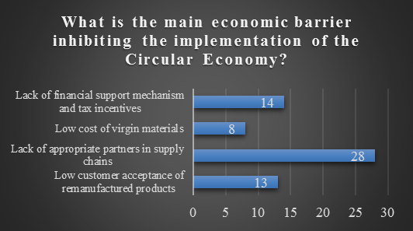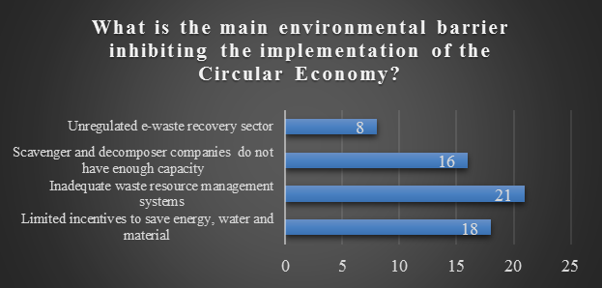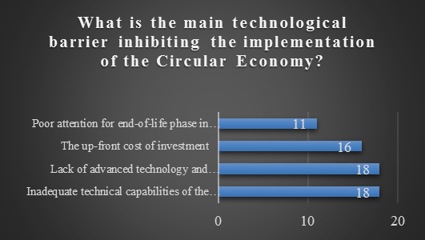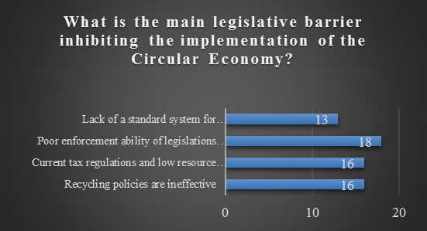

Figure 3: Socio-economic, environmental, technological and legislative barriers

The findings of the study also have managerial implications. It provides top managers, policy makers and researchers with better decision-making insights and a benchmarking base to increase the performance of their manufacturing companies. It acknowledges the degree to which UK and EU manufacturing companies have already adopted CE models; articulates some of the barriers that are preventing wider deployment of CE in manufacturing sector, and tries to find ways to address them. Furthermore, this paper highlights the role of the reuse of waste materials in manufacturing new products, which leads to minimising the resource consumption and reduction of negative environmental impacts. Our findings suggest that CE avoids hazardous and risky goods and materials ending up in landfills or in the oceans, seriously threatening life in the ecosystem. In addition, reuse of waste goods and materials enable the development of local business networks that generate new job opportunities and improve economic performance. The findings of this study will hence equip manufacturers with necessary understanding of the key barriers to address the challenges encountered during the implementation of CE. Findings show how they differ among different industries, sizes of companies and locations. The study highlights the opportunities they can utilise according to their specific strengths and barriers that they can mitigate saving their resources, reducing their costs and improving their profitability. In other words, the results of this research have the potential to add value to the implementation process of CE in every single company.

Like every research, this study has certain limitations. Our findings are based on a limited 63 responses from the survey. Hence future research studies should aim at large data samples to improve the generalisability of the findings. Moreover, quantitative data could be supported with expert opinions by conducting in-depth or semi-structured interviews. The findings of this study also just rely on descriptive analysis. Future research studies can hence use more complex statistical techniques to explore the relationship between barriers, opportunities and performance of manufacturing companies. Another limitation is related to data collection from the FAME database. The database only lists UK and Irish companies and study had to rely on ‘LinkedIn’ for other contacts in the EU region. This was partially limited due to the time constraints. Future research should therefore use other database to increase the sample size and have better representation of the EU region.

Finally, from a thematic perspective, the present study, and its findings leads to the following research questions that researchers may consider to guide future research streams: What role does local, regional and national environmental government policies and culture play in the realisation of CE benefits and creation of barriers for its effective implementation? How does the level of awareness, realisation of benefits and barriers to the implementation of CE in the manufacturing sector compare to those of other sectors? These research questions will guide the future research agenda derived from the present study.

**References**

Andersen, M. S. (2007), “*An introductory note on the environmental economics of the circular economy*”, Sustainability Science, Vol. 2, No. 1, pp. 133-140.

Bastein, T., Roelofs, E., Rietveld, E., & Hoogendoorn, A. (2013), *“Opportunities for a Circular Economy in the Netherlands”*, TNO, Report commissioned by the Netherlands Ministry of Infrastructure and Environment, pp. 1-13, <https://www.dakofa.dk/fileadmin/user_upload/documents/Arrangementer/2014/140616_17/DAG1_1120__Ton_Bastein_REV.pdf>

Belekoukias, I., Garza-Reyes, J. A., & Kumar, V. (2014), *“The impact of lean methods and tools on the operational performance of manufacturing organisations*”, International Journal of Production Research, Vol. 52, No. 18, pp.5346-5366.

Benton, D., Hazell, J., & Hill, J. (2015), “The guide to the circular economy: capturing value and managing material risk”, *Do Sustainability*, Routledge, London.

Benton, D., Hazell, J., & Hill, J. (2015), “*The guide to the circular economy: capturing value and managing material risk*”, Do Sustainability, pp. 15-86.

Bhasin, S. (2012), *“Performance of Lean in large organisations”,* Journal of Manufacturing systems, Vol. 31, No. 3, pp. 349-357

Boulding, K. E. (1966), “The economics of the coming spaceship earth. Environmental Quality Issues in a Growing Economy”, Lippit, V (Eds), *Radical Political Economy: Explorations in Alternative Economic Analysis*, Routledge. London, 357-365.

Boulding, Kenneth E. (1965), The Meaning of the Twentieth Century. The Great Transition, New York: Harper & Row.

Butterworth, J., Morlet, A., Nguyen, H. P., Oppenheim, J., & Stuchtey, M. (2013), *“Towards the Circular Economy: Economic and Business Rationale for an Accelerated Transition*”, Ellen MacArthur Foundation, Vol. 1, No. 1, pp. 98.

Ciani, A., Gambardella, A., & Pociovalisteanu, D. M. (2016), “Circular Economy and Sustainable Rural Development. Theory and Best Practice: A Challenge for Romania*”, Annals- Economy Series*, Vol. 1, pp. 52-56.

Cohen, L., Manion, L., & Morrison, K. (2002), Research methods in education, 6th edition, Routledge, New York.

Commission, E. (2012), Sustainable Development: European Sustainable Consumption and Production Policies. Retrieved on 06.06.2017. Available at: <http://ec.europa.eu/environment/eussd/escp_en.htm>

Commission, E. (2017), Report from the commission to the European Parliament, the Council, the European Economic and Social Committee and the Committee of the Regions on the implementation of the Circular Economy Action Plan. European Commission. Brussels. Retrieved on 02.06.2017. Available at: <http://ec.europa.eu/environment/circular-economy/implementation_report.pdf>

EEA Report (2016), Circular economy in Europe: Developing the knowledge base, Luxembourg, <https://www.socialistsanddemocrats.eu/sites/default/files/Circular%20economy%20in%20Europe.pdf> [Accessed on 30/9/2018]

EMF, (2012), Towards the circular economy — Economic and business rationale for an accelerated transition, Vol. 1, Ellen MacArthur Foundation, Isle of Wight.

EMF, (2013), Towards the circular economy: Opportunities for the consumer goods sector, Ellen MacArthur Foundation, Isle of Wight.

Eurostat, (2015b), “Material flow accounts” (env_ac_mfa)'([http://ec.europa.eu/eurostat/data/database#](http://ec.europa.eu/eurostat/data/database)) accessed 28 September 2018.

Geng, Y., & Doberstein, B. (2008), *“Developing the circular economy in China: Challenges and opportunities for achieving'leapfrog development'”,* The International Journal of Sustainable Development & World Ecology, Vol. 15, No. 3, pp. 231-239.

Geng, Y., Fu, J., Sarkis, J., & Xue, B. (2012), *“Towards a national circular economy indicator system in China: an evaluation and critical analysis”*. Journal of Cleaner Production, Vol. 23, No. 1, pp. 216-224.

Geng, Y., Zhu, Q., Doberstein, B., & Fujita, T. (2009), “*Implementing China’s circular economy concept at the regional level: A review of progress in Dalian, China*”, Waste Management, Vol. 29, No. 2, pp. 996-1002.

Ghisellini, P., Cialani, C., & Ulgiati, S. (2016), “*A review on circular economy: the expected transition to a balanced interplay of environmental and economic systems*”, Journal of Cleaner Production, Vol. 114, pp. 11-32.

Govindan, K., & Hasanagic, M. (2018), *“A systematic review on drivers, barriers, and practices towards circular economy: a supply chain perspective”,* International Journal of Production Research, Vol. 56, No. 1-2, pp. 278-311

Gregson, N., Crang, M., Fuller, S., & Holmes, H. (2015), “Interrogating the circular economy: the moral economy of resource recovery in the EU”, *Economy and Society*, Vol. 44, No. 2, pp. 218-243.

Giurco, D., Littleboy, A., Boyle, T., Fyfe, J., & White, S. (2014), *“Circular economy: Questions for responsible minerals, additive manufacturing and recycling of metals”*, Resources, Vol. 3, No. 2, pp. 432-453.

Hill, J.E. (2015), *“The circular economy: from waste to resource stewardship”*, Part I. Waste and Resource Management, Vol. 168, No. 1, pp. 4-14.

Hobson, K. (2016), *“Closing the loop or squaring the circle? Locating generative spaces for the circular economy”,* Progress in Human Geography, Vol. 40, No. 1, pp. 88-104.

Hu, J., Xiao, Z., Zhou, R., Deng, W., Wang, M., & Ma, S. (2011), “*Ecological utilization of leather tannery waste with circular economy model*”, Journal of Cleaner Production, Vol. 19, No. 2), pp. 221-228.

Kirchherr, J., Reike, D., & Hekkert, M. (2017). “*Conceptualizing the circular economy: An analysis of 114 definitions. Resources*,” Conservation and Recycling, Vol. 127, pp. 221-232.

Li, H., Bao, W., Xiu, C., Zhang, Y., & Xu, H. (2010), “*Energy conservation and circular economy in China's process industries*”, Energy, Vol. 35, No. 11, pp. 4273-4281.

Li, J., & Yu, K. (2011), “A study on legislative and policy tools for promoting the circular economic model for waste management in China”, *Journal of Material Cycles and Waste Management*, Vol. 13, No. 2, pp. 103.

Liu, Q., Li, H.M., Zuo, X.L., Wang, L. (2009), “A survey and analysis on public awareness and performance for promoting circular economy in China: A case study from Tianjin”, Journal of Cleaner Production, Vol. 17, No. 2, pp. 265-270.

Liu, Y., & Bai, Y. (2014), “*An exploration of firms’ awareness and behavior of developing circular economy: An empirical research in China*”, Resources, Conservation and Recycling, Vol. 87, pp. 145-152.

MacArthur, E. (2013a,b), “Towards a Circular Economy – Opportunities for the consumer goods sector”, *Ellen MacArthur Foundation*. Retrieved on 22.01.2018. Available at: <https://www.ellenmacarthurfoundation.org/assets/downloads/publications/TCE_Report-2013.pdf>

McDonough, W. & Braungart, M. (2002). Remaking the way we make things: cradle to cradle. North Point Press, London, pp. 1-208.

Masi, D., Kumar, V., Garza-Reyes, J., & Godsell, J. (2018), *“Towards a more circular economy: Exploring the awareness, practices, and barriers from a focal firm perspective”,* Production Planning & Control, Vol. 29, No. 6, pp. 539-550

Murray, A., Skene, K., & Haynes, K. (2017), “*The circular economy: an interdisciplinary exploration of the concept and application in a global context*”, Journal of Business Ethics, Vol. 140, No. 3, pp. 369-380.

Naustdalslid, J. (2014), “*Circular economy in China–the environmental dimension of the harmonious society*”, International Journal of Sustainable Development & World Ecology, Vol. 21, No. 4, pp. 303-313.

Negny, S., Belaud, J. P., Robles, G. C., Reyes, E. R., & Ferrer, J. B. (2012), “*Toward an eco-innovative method based on a better use of resources: application to chemical process preliminary design*”, Journal of Cleaner Production, Vol. 32, pp. 101-113.

Pan, S. Y., Du, M. A., Huang, I. T., Liu, I. H., Chang, E. E., & Chiang, P. C. (2015), “*Strategies on implementation of waste-to-energy (WTE) supply chain for circular economy system: a review*”, Journal of Cleaner Production, Vol. 108, pp. 409-421.

Park, J., Sarkis, J., & Wu, Z. (2010), “*Creating integrated business and environmental value within the context of China’s circular economy and ecological modernization*”, Journal of Cleaner Production, Vol. 18, No. 15, pp.1494-1501.

Pearce, D. W., & Turner, R. K. (1990), Economics of natural resources and the environment, JHU Press.

Pomponi, F., & Moncaster, A. (2017), “*Circular economy for the built environment: A research framework*”, Journal of Cleaner Production, Vol. 143, pp. 710-718.

Pringle, T., Barwood, M., & Rahimifard, S. (2016), *“The Challenges in Achieving a Circular Economy within Leather Recycling”,* Procedia CIRP, Vol. 48, pp. 544-549.

Rizos, V., Behrens, A., Kafyeke, T., Hirschnitz-Garbers, M., & Ioannou, A. (2015), *“The circular economy: Barriers and opportunities for SMEs”*, CEPS Working Documents (ISBN 978-94-6138-479-9), No. 412. pp. 1-19

Rizos, V., Behrens, A., Wytze V.D.G., Hofman, E., Ioannou, A., Kafyeke, T., Flamos A., Rinaldi, R., Papadelis, S., Hirschnitz-Garbers, M., and Topi, C., (2016*), "Implementation of circular economy business models by small and medium-sized enterprises (SMEs): Barriers and enablers."* Sustainability Vol. 8, No. 11, pp. 1212.

Singh, J., & Ordoñez, I. (2016), “*Resource recovery from post-consumer waste: important lessons for the upcoming circular economy*”, Journal of Cleaner Production, Vol. 134, pp. 342-353.

Skene, K., & Murray, A. (2015), *“Sustainable Economics: Context, Challenges and Opportunities for the 21st-century Practitioner”*, Greenleaf Publishing, pp. 172-278.

Spring, M., & Araujo, L. (2017), *“Product biographies in servitization and the circular economy”,* Industrial Marketing Management, Vol. 60, pp. 126-137.

Stahel, W. R. (2016), *“The circular economy”,* Nature News, Vol. 531, No. 7595, pp. 435.

Su, B., Heshmati, A., Geng, Y., & Yu, X. (2013), “*A review of the circular economy in China: moving from rhetoric to implementation*”, Journal of Cleaner Production, Vol. 42, pp. 215-227.

Velis, C. A. (2015), *“Circular economy and global secondary material supply chains”*, Waste Management and Research, Vol. 33, No. 5, pp.389-391.

Watt, S., Simpson, C., McKillop, C., & Nunn, V. (2002), “*Electronic course surveys: does automating feedback and reporting give better results?*” Assessment & Evaluation in Higher Education, Vol. 27, No. 4, pp. 325-337.

Wijkman, A., and Skånberg, K. (2017), *"The circular economy and benefits for society: jobs and climate clear winners in an economy based on renewable energy and resource efficiency"*, UN Environment Document Repository

Winans, K., Kendall, A., & Deng, H. (2017), “The history and current applications of the circular economy concept”, *Renewable and Sustainable Energy Reviews*, Vol. 68, pp. 825-833.

Wübbeke, J., & Heroth, T. (2014), *“Challenges and political solutions for steel recycling in China”,* Resources, Conservation and Recycling, 87, 1-7

Xue, B., Chen, X.P., Geng, Y., Guo, X.J., Lu, C.P., Zhang, I., Lu, C.Y. (2010), “Survey of officials’ awareness on circular economy development in China: Based on municipal and county level”, *Resources, Conservation and Recycling*, Vol. 54, No. 12, pp. 1296-1302.

Young, E. (2015), *“Are you ready for the circular economy? – The necessity of an integrated approach”*, Ernst and Young Global Limited. Retrieved on 02.06.2017. Available at: <http://www.ey.com/Publication/vwLUAssets/EY-brochure-cas-are-you-ready-for-the-circular-economy/$FILE/EY-brochure-cas-are-you-ready-for-the-circular-economy.pdf>

Yuan, Z., Bi, J. & Moriguichi, Y., (2006), *“The Circular Economy: A New Development Strategy in China”,* Journal of Industrial Ecology, Vol. 10, No. 1-2, pp. 4-8.

Yuan, Z., Bi, J., & Moriguichi, Y. (2006), “The circular economy: A new development strategy in China”, *Journal of Industrial Ecology*, Vol. 10, No. 1‐2, pp. 4-8

Zhijun, F., & Nailing, Y. (2007), “*Putting a circular economy into practice in China*”, Sustainability Science, Vol. 2, No. 1, pp. 95-101.

Zhu, Q., & Tian, Y. (2016), “*Developing a remanufacturing supply chain management system: a case of a successful truck engine remanufacturer in China*”, Production Planning & Control, Vol. 27, No. 9, pp. 708-716.

Sauvé, S., Bernard, S., & Sloan, P. (2016), *“Environmental sciences, sustainable development and circular economy: Alternative concepts for trans-disciplinary research”,* Environmental Development, Vol. 17, pp. 48-56.

Nasir, M. H. A., Genovese, A., Acquaye, A. A., Koh, S. C. L., & Yamoah, F. (2017), “*Comparing linear and circular supply chains: A case study from the construction industry*”, International Journal of Production Economics, Vol. 183, pp. 443-457.