Integrating construction supply chains within a circular economy: An ANFIS-based waste analytics system (A-WAS)

Abstract
The circular economy agenda makes it paramount for construction supply chains to reduce material waste. Although a collaborative platform called Building Information Modelling (BIM) offers a means of supply chains integration, it has not been efficiently upscaled for delivering waste efficient building designs. This study, therefore, develops a BIM-based computational tool for building waste analytics and reporting in the construction supply chains. A Construction Waste (CW) prediction model using Adaptive Neuro-Fuzzy Inference System (ANFIS) was developed and integrated into Autodesk Revit BIM platform. The model development process reveals that “Gross Floor Area” and “Construction type” are the two key predictors for CW. The results of the study show that the tool offers useful insights into CW minimisation opportunities. The study makes a huge contribution to CW management practices by developing a computational approach to CW measurement. The contribution of the study is fundamental because achieving accurate waste prediction is crucial to waste prevention through adequate design principles and BIM.
Keywords: Construction supply chains, circular economy, construction waste analytics, Building Information Modelling (BIM), predictive modelling.

Introduction
Several definitions of supply chains exist in the literature; however, a widely acknowledged definition is given by Christopher (1998) as “the network of organisations that are involved, through upstream and downstream linkages, in the different processes and activities that produce value in the form of products and services in the hands of the ultimate customer”. This definition rightly captures the necessary integration between the upstream and downstream for enhanced value delivery that is required in the Architecture, Engineering, and Construction (AEC) industries through supply chains improvement. The AEC supply chains are: (i) upstream (suppliers, subcontractors and specialist contractors) and downstream (contractors and material manufacturer) (Akintoye et al., 2000). The rethinking construction report (Egan, 1998) reveals that the inefficient linkage among stakeholders in the two supply chains streams contributes to the failure of the fragmented construction industry to meet client demand and the expected efficiency. The report emphasises reduced cost and enhanced value delivery through supply chains improvement. Thunberg (2017) argues that the major challenges of supply chains management are: (i) achieving efficiency in material flow, (ii) achieving efficiency in communication, and (iii) project complexity. However, reducing waste in the supply chains material flow is expedient considering the increasing stringency of waste legislation and regulations (Hicks et al., 2004) and the global circular economy agenda (Pan et al., 2015).
The circular economy agenda is a sustainable development model that offers an alternative to the traditional “take-make-waste” model (Despeisse et al., 2017). Ghisellini et al. (2016) point out that the concept of circular economy is to eliminate waste by adopting appropriate resource-efficient methods from a sustainability viewpoint. Waste is a global problem facing different industries, which include construction (Ajayi et al., 2015), Wastewater (Sepehri and Sarrafzadeh, 2018), transportation (Villarreal et al., 2009), manufacturing (Mirabella et al., 2014), agriculture (Sud et al., 2008), electronics (Cui and Zhang, 2008), biomedical (Hegde et al., 2007), etc. Waste in the construction supply chains is a major concern because of the huge amount of Construction Waste (CW) generated annually across the globe (Anderson and Thornback, 2012; Oyedele et al., 2013). This challenge seems insurmountable despite the various research and development in CW management strategies (Ajayi et al., 2016; Oyedele et al., 2014). The construction industry still generates about 30% of the total waste stream and over 33% of the global CO₂ (Baek et al., 2013; Solís-Guzmán et al., 2009). This level of waste generation has an adverse effect on the environment and it puts a pressure on the depleting landfills. As such, effective CW management practices are imperative to reduce the wider impacts of CW disposal. Also, stakeholders in the construction supply chains must work in an integrated way to tackle waste and project inefficiencies. These requirements reveal that early supply chains involvement and the adoption of component reuse and material recycling are needed to divert waste from landfills (Ajayi et al., 2017; Bilal et al., 2017). Evidence also suggests that any promising innovation on CW prediction and reduction in the construction supply chains requires BIM compliance (Ajayi et al., 2015; Akinade et al., 2016).
The recent wide adoption of BIM has revolutionised the way building projects are designed, constructed, delivered and operated across the world (Eastman et al., 2011). There is no doubt that the upshot in BIM adoption across the AEC industries (Azhar, 2011) has improved system interoperability (Steel et al., 2012), collaboration among project stakeholders (Grilo and Jardim-Goncalves, 2010), visualisation and simulation of building models, and decision-making processes (Eastman et al., 2011). Accordingly, the expectations of stakeholders on BIM cut across various fields (architecture, engineering, construction, project management, information technology, sustainability, knowledge management, and policies.) (Singh et al., 2011), and the needs of all the stakeholders in these fields must be met. Although BIM adoption offers several benefits, using BIM for CW management is not a common practice in the construction supply chains (Akinade et al., 2015). Evidence from several studies highlight BIM potentials for CW management (Liu et al., 2011; Won et al., 2016); however, no study provides a clear direction on BIM implementation for waste management. Existing studies provide only frameworks and guidelines for design-based CW management (Liu et al., 2011; Osmani et al., 2008; Won et al., 2016). The frameworks and guidelines only spell out CW management and minimisation practices, but they do not provide means of integrating the practices into design tools. The frameworks and guidelines also lack a measure of performance for the CW minimisation practices. As such, the frameworks and guidelines are too cumbersome to be used during the design stage. Although BIM capabilities for transforming construction processes is common knowledge in the industry, Design-out-Waste (DoW) principles have not been integrated into BIM platforms because of the lack of computational methodology for measuring CW from building 3D models. Thus, two gaps exist: (i) there is a lack of a methodological mechanism for integrating Design-out-Waste (DoW) principles into BIM platforms, and (ii) there is no BIM-based measure of performance for DoW principles. The lack of BIM-based measure of DoW performance exists because of the limited knowledge on how to translate existing CW minimisation knowledge to computational models that can be incorporated into existing BIM software. The gap in knowledge raises serious concerns and it calls for action on BIM implementation for CW management in the construction supply chains. As such, there is a need to improve the current BIM systems to integrate the construction supply chains fully and to ensure that material waste minimisation is achieved.
Based on the preceding discussion and the identified gap in knowledge, the overall aim of the study is to development of a BIM platform for the construction supply chains to predict CW from building designs. Achieving accurate CW prediction is critical to improving current CW management practices because a phenomenon cannot be improved if it cannot be measured. The specific research objectives of the study are:
- To investigate CW management principles empirically and to structure the required BIM principles to enhance CW management
- To develop a predictive model for estimating CW from building BIM designs.
- To develop a BIM platform that will enable the integration and collaboration of the supply chains towards CW minimisation.
The study adopts experimental and case study research methodologies to achieve the specific objectives. A review of the extant literature was carried out to understand the state of the art in CW management in the construction supply chains and to understand the BIM requirements for CW management. The model developed for CW prediction is underpinned by an Adaptive Neuro-Fuzzy Inference System (ANFIS), which is a combination of artificial neural networks and fuzzy logic. The model was then integrated into Autodesk Revit software as an add-in. The final BIM tool was tested using a case study design.
The remaining sections of the paper are structured as follows: Section 2 contains a review of the literature on construction supply chains integration, BIM requirements for CW management, and ANFIS. Section 3 discusses the system design, specification, and the schematic illustration of the methodological approach for the study. Section 4 contains a discussion on the process of ANFIS model development and BIM tool development for DoW. The section also covers the discussion on the programming environment, i.e., C# programming language, the Autodesk Revit Application Programming Interface (API), and User Interface (UI) frameworks. Section 5 contains a discussion of the results and Section 6 provides the implications of the study. Section 7 concludes the paper with a discussion of areas of further studies.

Supply chains integration and construction waste minimisation
Supply chains integration is a well-researched area, and it has been explored from different perspectives (Alfalla-Luque et al., 2015; Ataseven and Nair, 2017; Dainty et al., 2001; Gimenez and McIvor, 2016; Huang et al., 2014). Evidence from the literature shows that integrating the supply chains have a direct relationship on the operational and business performances (Flynn et al., 2010; Narasimhan and Kim, 2002). However, the inability of the AEC industries to achieve the integration of the supply chain streams has resulted in the failure of the industry to deliver the expected operational efficiency and value delivery to clients (Egan, 1998). Key concerns in the industries still include economic concerns (epidemic profit margin erosion and cost overruns), project control and delivery concerns (project management, procurement, plant and equipment, quality) and waste (material, resources, and process).
Although the economic and project control concerns have been given more attention for several decades, waste management in construction projects is becoming prominent because of the increasing stringency of waste legislation and regulations. Despite the increasing stringency of waste legislation and policies, the construction supply chains are still inefficient in terms of CW minimisation because of the lack of a computational waste measurement mechanism. A major reason for the non-existence of computational approaches for CW measurement is the lack of sufficient waste data (Akinade et al., 2016). Waste data record from most construction site are recorded as mixed waste and transferred to third-party segregation and treatment companies because it is not economically viable to segregate waste onsite. Lord Kelvin rightly argued that “To measure is to know. If you cannot measure it you cannot improve it.” This argument points out that the development of a computational Waste Prediction Model (WPM) is crucial to improving waste-related value delivery in an integrated construction supply chains.
WPMs estimate the potential waste of building models at the design stage. Estimation of CW at the design stage is essential because it is cheaper to make design changes to buildings when its construction has not commenced (Ekanayake and Ofori, 2004; Faniran and Caban, 1998; Osmani et al., 2008). The review of literature reveals that existing WPMs are based on four concepts, which are: (i) waste generation rates (Li et al., 2013; Masudi et al., 2011; Poon et al., 2004); (ii) construction activities (Ekanayake and Ofori, 2004; Fatta et al., 2003; Wang et al., 2004); (iii) building elements and materials (Bergsdal et al., 2007; Cochran et al., 2007; Jalali, 2007; Shen et al., 2005; Solís-Guzmán et al., 2009); and (iv) computer simulation (Salem et al., 2008; Wu et al., 2013; Zaman and Lehmann, 2013). A major limitation of these WPMs is that most of them rely on the national waste generation rates and they can be used only after the completion of the building design.
However, a more practical approach to guaranteeing the effectiveness of the WPMs in supporting CW management decision-making is to ensure that they are accessible during the design process. As such, it is important to establish the relationships between building parameters and CW generation. Another limitation that affects the usability of the WPMs is that they are external to existing 3D BIM visualisation and design software despite the common knowledge that BIM could improve building process performances. The foregoing discussion shows that the development of a BIM-based WPM is timely.

Collaborative strategies for construction waste analytics
It is established in the literature that design decisions have multiple ripple effects throughout the building lifecycle (Ekanayake and Ofori, 2004; Faniran and Caban, 1998; Osmani et al., 2008). This fact means that design decisions could influence project performance indicators such as cost, time, air quality, daylight visibility, etc. (Lopez and Love, 2012). MacLeamy (2004) highlights that design-based philosophy offers a flexible and cost-effective approach to influencing the project performance indicators than in subsequent building lifecycle stages. This possibility highlights the potentials for CW prevention and minimisation through appropriate design decisions (Faniran and Caban, 1998; Osmani et al., 2008). Therefore, adequate effort must be made to integrate the construction supply chains so that all stakeholders can contribute to CW-related design decisions. However, a major impediment to fulfilling this responsibility is that existing CW management tools cannot support the supply chains adequately (Akinade et al., 2017; Bilal et al., 2015). Although BIM for improving the efficiency of processes has been emphasised as a key competitive and operational differentiator in the construction supply chains; most of the existing CW management tools are not BIM compatible.
While assessing the industry stakeholders’ expectations on using BIM technology for designing out CW, Akinade et al. (2018) highlight five BIM strategies that must be considered for CW Analytics (CWA), which are summarised in Figure 1. A key requirement for effective BIM strategies for CW analytics is the development of a collaborative platform. This is because the AEC industries are highly fragmented because the body of knowledge within the industries cuts across various fields. Each stakeholder makes decisions in isolation to maximise personal gains in a traditional construction methodology, which leads to several problems. The major problems are clashes, cost and time uncertainty, waste, and risks (Lichtig, 2010). These problems arise because of lack of communication and collaboration. BIM practice and technology, therefore, provide a collaborative process to the delivery of built assets through efficient stakeholders integration throughout the building lifecycle to mitigate these problems (AIA, 2014). As such, the adoption of BIM strategies enables early informed decision-making with the involvement of all stakeholder, a higher project cost and time certainty, reduction in waste (material, time, and human resources), improved project quality (Azhar et al., 2007) among other benefits. Hence the need to adopt BIM for efficient coordination of participating project teams.

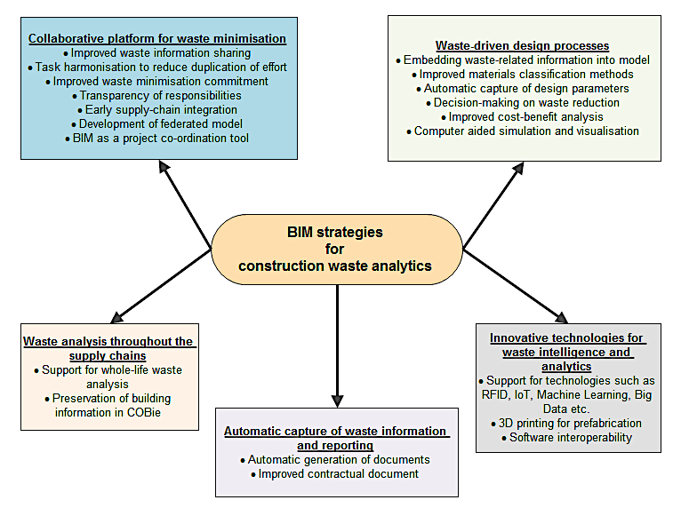
Figure 1: BIM strategies for construction waste analytics

Adaptive Neuro-Fuzzy Inference System (ANFIS)
Hybrid systems are becoming the next generation of AI systems because of their ability to proffer solutions to complex real-life problems (Abraham, 2005). AI techniques such as artificial neural networks, fuzzy logic, support vector machines, genetic algorithm, and expert systems can be applied to varieties of problems; but combining them into a single hybrid system offers a way to address their limitations and to combine their strengths. Examples of hybrid systems include neuro-fuzzy systems (Jang, 1993), Genetic Fuzzy Systems (Gordon et al., 2001), Fuzzy Expert Systems (Otto, 1990), and Evolutionary Neural Networks (Abraham, 2004; Yao, 1993). Despite the various combination possibilities that hybrid systems offer, neuro-fuzzy systems are the most widely used because of their ability to achieve interoperability and accuracy at the same time (Lin et al., 1996). This unique feature contributes to the wide adoption of neuro-fuzzy systems for addressing several real-life problems. This study adopts a neuro-fuzzy system called Adaptive Neuro-Fuzzy Inference System (ANFIS) for CW prediction. ANFIS integrates the strengths of fuzzy logic and Artificial Neural Network (ANN). Hybridization of fuzzy logic and ANN overcomes the weaknesses of the individual systems (Jang, 1996). The major weakness of fuzzy logic is that considerable time and effort is required to compute membership functions and rules in a complex system. Chief among the weaknesses of ANN is the effort required to determining the optimal structure of the network. As such, combining fuzzy logic and ANN to produce ANFIS provides a more superior predictive capability that significantly aid model transparency and validation.
An system with two inputs (we assume that each input has three membership functions) and one output is chosen to explain the concept and operations of an ANFIS model as shown in Figure 2. The network is made up of nine if-else rules and a typical ruleset in a first order Sugeno-Fuzzy model, which can be expressed as:
$$if x is Ai then y is Bi, then f_{1}=p_{1}x+q_{1}y+r_{1}$$ | (1)
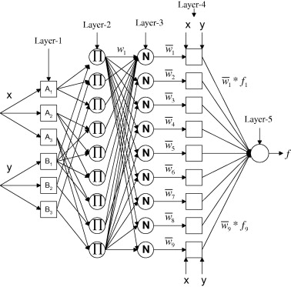
Figure 2: A two inputs (x and y) and one output (f) ANFIS network
Where p, r and q are the output parameters. The layers of the ANFIS network are described below:
Layer 1 (Fuzzification layer): The node function of the fuzzification layer is given as:
$O_{i}^{1}= μ_{Ai}(x)$ (2)
Where $O_{i}^{1}$ is the membership grade of the fuzzy set $A_{i}$, and it specifies the degree to which $x$ satisfies the quantifier $A$. $μ_{Ai}$ is the membership function of the linguistic variable $A$. The membership function is a real interval [0, 1], where a value of 1 means that $x$ is a full member of set and a value of 0 means that $x$ is not a member of the set. For example, a Gaussian membership function is given as:
$μ_{Ai}\left(x\right)=exp\left[-{\left(\frac{x-c_{i}}{a_{i}}\right)}^{2}\right]$ (3)
Where $a_{i}$ and $c_{i}$ are the premise parameters.
Layer 2 (Multiplication layer):
The output of each node of the multiplication later is the product of all incoming nodes, i.e.:
$O_{i}^{2}=w_{i}=μ_{Ai}\left(x\right)×μ_{Bi}\left(x\right), for i=1,2,3,…, 9$ (4)
The nodes of the multiplication layer are the antecedent connectives. The output of each node is called the firing strength of a rule.
Layer 3 (Normalization layer):
The nodes on the normalisation layer compute the ratio of the corresponding firing strength to the sum of all firing strength, i.e.:
$O_{i}^{3}=\overline{w_{i}}= \frac{w_{i}}{w_{1}+w_{2}+w_{3}+…+w_{9}}, for i=1,2,3,…, 9$ (5)
The output of each node is called the normalised firing strengths.
Layer 4 (Defuzzification layer):
The fourth layer produces the consequent parameters and the node function is:
$O_{i}^{4}=\overline{w_{i}}f_{i}=\overline{w_{i}}\left(p_{i}+q_{i}+r_{i}\right), for i=1,2,3,…,9$ (6)
Where the parameters $p_{i}, q_{i}, and r_{i}$ are the adjusted consequent parameters.
Layer 5 (Summation Layer):
The summation layer is made up of a single fixed node and it computes the overall output by using:
${Output(f)= O}_{i}^{5}= \sum_{i}{\overline{w_{i}}}f_{i}=\frac{\sum_{i}{w_{i}f_{i}}}{\sum_{i}{w_{i}}}$ (7)
According to Jang (1993), the learning process of ANFIS is done in two independent stages: (i) adaptation of learning weights and (ii) adaptation of non-linear membership functions. This unique feature allows the learning complexity in ANFIS (Singh et al., 2005) and the uniqueness of this learning process enables ANFIS to be well-suited for modelling complex problems.

System design and specification
The process flow diagram for the ANFIS-based Waste Analytics System (A-WAS) tool is shown in Figure 3. The use of BIM as a technological tool to facilitate decision-making gives the designers the flexibility to choose the building design that will generate the minimum CW. This approach enables the designers to consider CW performance of building design vis-à-vis other performance metrics such as cost, time, buildability, quality standard, health and safety, sustainability, etc. The entire system is designed into four modules, which are: (i) access BIM design document, (ii) extract and compute design parameters, (iii) engage predictive models for CWA, and (iv) CW report generation.
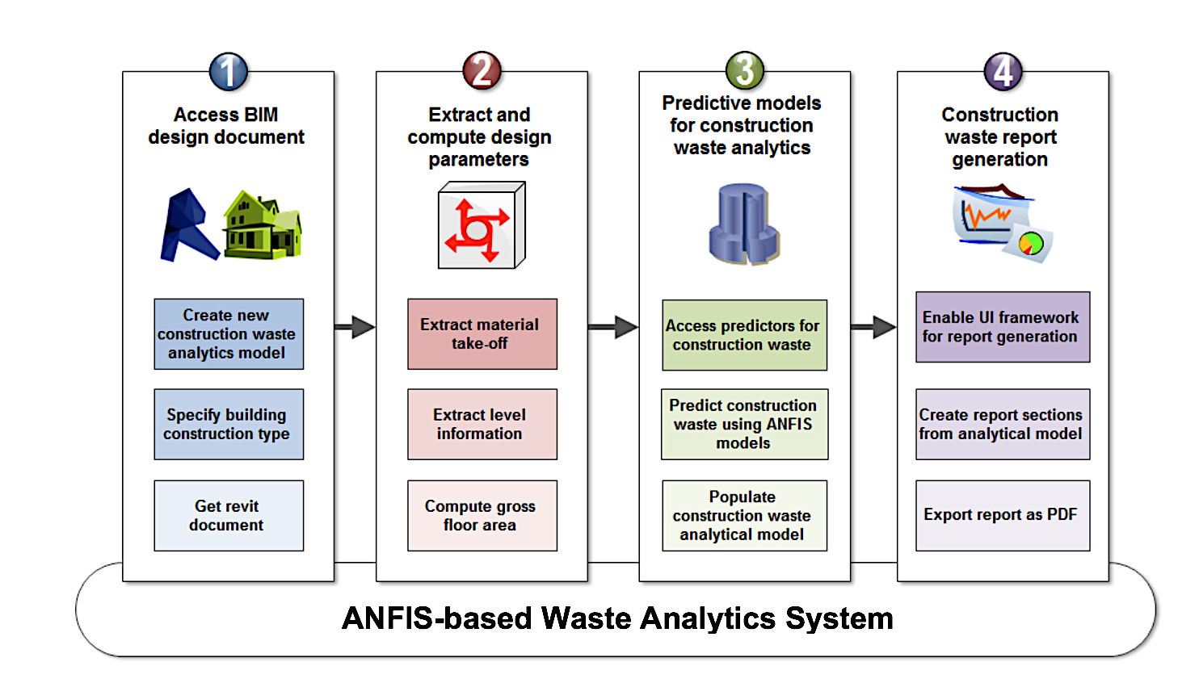
Figure 3: Process flow for the ANFIS-based Waste Analytics System (A-WAS)
The first module allows the user to give a name to the new CW analytical model and to select the construction type of the building. The Revit document is then extracted for analyses, and a new CW analytical model is created. The second module takes the Revit document as input, and it creates a material take-off. This module also extracts and compute some parameters, which include the number of levels, number of floors and, gross floor area (GFA). Building elements are then collected according to floors and levels using filter benchmarks. An assumption that was made here is that all levels are explicitly specified correctly in the BIM model. The third module is where the predictive models are used to estimate the CW from the building designs. The outputs of the predictive models are used to populate the CW analytical model that was created by the first module. The last part of the process is where an interactive CWA report is generated. The UI frameworks and analytical models are enabled to populate and prepare the CWA report. The report contains necessary project information, the overall waste generation, waste management routes, and floor level waste distribution. The fourth module also enables the users to export the CWA report as a PDF document.

A-WAS tool for CW prediction in the construction supply chains
The A-WAS tool developed in this study runs as an add-in to Autodesk Revit Architecture. Although several BIM software exists from companies such as Autodesk, Graphisoft, Nemetschek, Bentley, etc, Autodesk Revit remains the most widely used BIM software. Apart from its common use, Revit comes with a robust API to extend its core functionalities and this has enabled the development of several add-ins to enhance the modelling, visualisation, and simulation capabilities of Revit. Three types of add-in entry point exist in Revit API, which are: (i) IExternalCommand for External Commands, which is added to the “external tools” menu of Revit; (ii) IExternalApplication for external applications, which provide better add-in UI customisation by adding controls to ribbons; and (iii) IExternalDBApplication for database-level external applications, which is used to assign events/updaters to Revit session. The A-WAS tool developed in this study is an external application because it provides better UI customisation and programming flexibility. Revit API uses .NET programming languages (Visual Basic, C#, and F#) but C# remains the most popular programming language because of its easy learning curve and implementation. The development of the BIM software was done in Visual Studio Express IDE using C#. The remainder of this section details the predictive model development and the A-WAS tool development.

Predictive model development for construction waste prediction
The methodological process adopted for the predictive model development is illustrated in Figure 4. The stages of the methodological process are explained in this section.
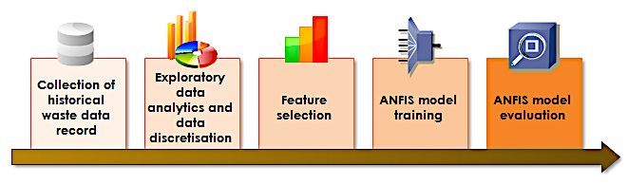
Figure 4: Methodological process of predictive model development

Data preparation and exploratory data analytics
The first task is the collection of historical Waste Data Records (WDR) of 117 building construction projects from waste contractors. Exploratory data analysis and data discretisation were done to understand the data distribution and interpretation. CW distribution according to waste types, construction type, project usage, GFA classification, and cost classification is shown in Table 1, Table 2, Table 3, Table 4, and Table 5 respectively. Figure 5 shows the Waste data record by waste type and waste management routes. After that, the pre-processed data was split into two, i.e., training and testing data, for predictive model development.
Table 1: Construction waste distribution by waste types
Waste type | Total (tonnes)
Binders | 110.48
Bricks | 764.90
Concrete | 2359.48
Gypsum | 355.00
Hazardous | 27.42
Inert | 9288.79
Insulation | 14.38
Metals | 92.24
Mixed | 11083.02
Packaging | 25.22
Plastics | 28.03
Timber | 426.89
Total | 24,575.85

Table 2: Waste data record by construction types
Construction type | Total (tonnes)
Concrete frame | 3,403.72
Load bearing masonry | 17,302.49
Steel frame | 2,407.32
Timber frame | 1,462.32
Total | 24,575.85

Table 3: Waste data record by project usage
Project usage |  | Total (tonnes)
Civil engineering |  | 79.76
Commercial offices |  | 1,987.92
Education |  | 2,086.04
Healthcare |  | 247.83
Industrial buildings |  | 391.27
Leisure |  | 90.66
Mixed-use development |  | 2,450.14
Public buildings |  | 86.29
Residential |  | 17,155.94
Total |  | 24,575.85

Table 4: Waste data record by gross floor area classification
GFA classification | Range | Total (tonnes)
Small | < 536.0m² | 1,488.88
Medium | 537.0m² – 837.5m² | 4,137.61
Large | 837.6m² – 1,713.0m² | 3,791.22
Mega | > 1,713.0m² | 15,158.14
Total |  | 24,575.85

Table 5: Waste data record by cost classification
Cost Classification | Range | Total (tonnes)
Minor | <= £500,000 | 967.50
Medium | £500,001 - £1,000,000 | 4,553.32
Major | £1,000,001 - £10,000,000 | 13,998.33
Mega | > £10,000,000 | 5,056.70
Total |  | 24,575.85

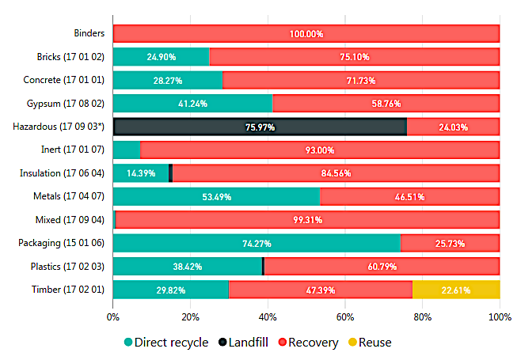
Figure 5: Waste data record by waste type and waste management routes

Feature selection and model training
The complexity associated with the modelling of real-life problems with a large number of predictors brings to the fore the need to find more efficient way to isolate the most relevant predictors. While addressing this challenge, Jang (1996) proposed an efficient approach to feature selection in ANFIS. The approach employs a two-way pass system, which include: (i) the forward pass using the least-square method to quickly calculate the consequent parameters, (ii) the backward pass where the premise parameters are updated using gradient descent. Adopting this approach allows ANFIS to converge to a result with few training epochs. The target of the feature selection process is to select the two best predictors for CW from four predictors (Project cost, GFA, Construction type, and Building usage). The selection process involves the creation of six (6) 2-input ANFIS models. The six models are then passed through the two-way hybrid algorithm to select the model with the least Root Mean Square Error (RMSE). RMSE measures the differences between actual values and the values estimated by a predictive model. This measurement is done by calculating the residual between the actual and estimated values using Equation 8.
$RMSE=\sqrt{\frac{1}{n}\sum_{i=0}^{n}{{\left(y_{i}-{\hat{y}}_{i}\right)}^{2}}}$ (8)
Where $y_{i}$ is the actual value, ${\hat{y}}_{i}$ is predicted values, and n is the sample size. RMSE is a positive value and the least value depicts the best fit. The results of the input selection for the ANFIS model are shown in Table 6, and it reveals that model 2 (“GFA” and “Construction Type”) produces the least RMSE.
Table 6: Input selection for the A-WAS model
Model no | Inputs | RMSE
Model 1 | GFA-Project cost | 0.121984
Model 2 | GFA-Construction type | *0.071806
Model 3 | GFA-Building usage | 0.092198
Model 4 | Project cost-Construction type | 0.098120
Model 5 | Project cost-Building usage | 0.079349
Model 6 | Construction type-Building usage | 0.079349
*Model 2 has the least RMSE
Grid partitioning was used to create the structure of the ANFIS model. Grid partitioning creates more rules than other methods such as subtractive clustering; however, it was selected because the dimension of the search space is already minimised through feature selection. Figure 6 shows the block diagram of the final A-WAS model. After that, the Membership Functions (MFs) of the input variables were created. Several input MFs exist, which are trimf, trapmf, gbellmf, gaussmf, gauss2mf, pimf, dsigmg, and psigmf. However, only two output MFs exist for ANFIS-based systems, which are constant and linear. The ANFIS model was trained using all the eight input MFs and two output MFs. The performance of the different configuration was evaluated using the RMSE.
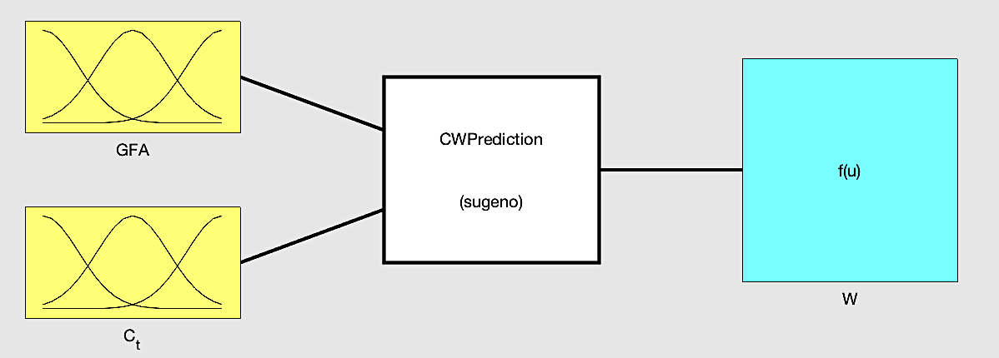
Figure 6: Block diagram of the final ANFIS model
Using a combination of possible eight input MFs and two output MFs, the ANFIS model was trained and the RMSE of each iteration is noted to select the best performing model. The results reveal that “gaussmf” MF produces the best predictions. The next task is the integration of the ANFIS predictive model with a BIM platform.

BIM tool development on the Autodesk Revit
The software development environment comprises the C# programming environment, Autodesk Revit API, and UI frameworks. The development of the A-WAS tool was divided into three active modules to capture its essential functionalities, which include (i) UI module, (ii) material take-off and parameter computation module, and (iii) CWA report generation module. The UI of the BIM tool was integrated into Revit as an external application add-in using ribbon panel as presented in Figure 7. A new CWA project is initiated when the “Create CWA Model” is clicked. The button activated a dialogbox to enter the name of the new project and the construction type of the building. The completed dislogbox will initiate the creation of the CWA report, and the “Reports” button displays previous CWA reports.
Figure 7: BIM tool ribbon as a Revit add-in
A material database was created to facilitate efficient CWA. The classes of materials in the database include: (a) All_Material_Class (A) contains all materials from Revit database; (b) Unknown_Material (K) contains the materials that are unknown; i.e. "Generic", "Miscellaneous", "Unassigned"; (c) Exception_Material_Class (X) contains the materials that are excluded from the CWA. The material take-off was then computed for all valid material ‘x’ using the set calculation in Equation 9.
$$x∈\left(A∪K\right)∩X^{'}$$ | (9)
The material take-off was extracted from the building design to automate the CW quantification process. The material take-off provides a list of building components, and their properties (dimensions, area, volume) were aggregated. In addition to this, floor levels and the GFA were also computed. Given a set of floor levels $L=\{L_{1}, L_{2}, L_{3}, …, L_{n}\}$, the GFA is computed using Equation 10. Accordingly, the building materials and elements in the material take-off are aggregated using the floor level filter benchmark to enable CWA by building levels.
$$GFA= \sum_{i=1}^{n}{Area(L_{i})}$$ | (10)
The UI of the CWA report uses Bootstrap and ChartJS to generate the interactive charts. The report view panel contains the following: (a) building information, (b) dashboard that shows the total waste, CW management route, and disposal costs, (c) building levels information, (d) CW by element type, (e) CW by material type; CW distribution charts by element and material types, (g) building element-material CW distribution; and (h) CW distribution by levels. Figure 8 to Figure 10 show sections from a sample CWA report.
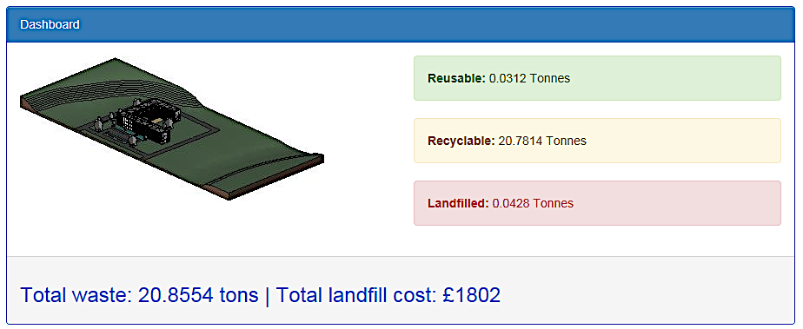
Figure 8: Dashboard of a A-WAS report
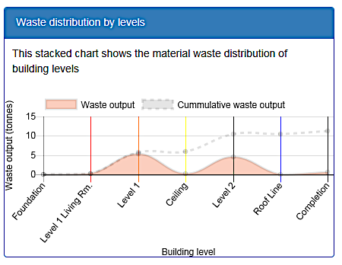
Figure 9: Construction waste distribution by levels

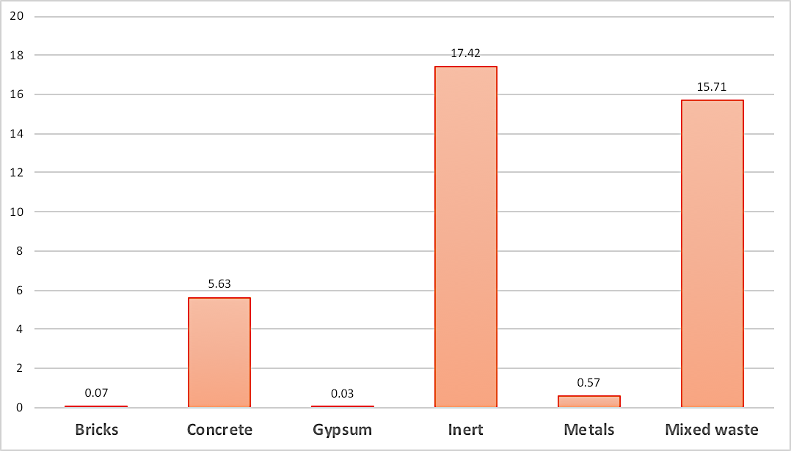
Figure 10: Construction waste distribution by material types

Results and discussion
This study tackles CW prediction by adopting the five BIM strategies proposed by Akinade et al. (2018). After a careful consideration of the BIM strategies, the A-WAS tool aligns with these strategies as follows: (i) improved collaboration for waste management is achieved by enabling the ability to share CW information among stakeholders and the adoption of BIM as a coordination tool for designing out CW; (ii) waste-driven design process and solutions was achieved through automatic waste performance analysis of building models; (iii) lifecycle waste analytics was achieved in BIM by supporting CWA at various lifecycle stages and whole-life preservation of CW information; (iv) innovative technologies for waste intelligence and analytics was achieve using a hybrid machine learning technique (ANFIS) and BIM for building CW performance monitoring and analyses; and (iv) improved documentation for waste management was achieved through extraction of the CW-related documents from the building designs.
A case study was used to test the A-WAS tool for prediction ability and usability. The test case study is a commercial building, and its description is presented in Table 7. The CWA report shows that 39.44 tonnes of waste would be generated from the case study, i.e., 0.0673 tonnes of reusable arisings, 39.3048 tonnes of recyclable arisings, and 0.0693 tonnes that would be sent to landfills. The breakdown of the results according to material types is as follows: 0.07 tonnes of brick, 5.63 tonnes of concrete, 0.03 tonnes of gypsum, 17.42 tonnes of inert, 0.57 tonnes of metal, and 15.71 tonnes of mixed waste.

Table 7: Test case study for the BIM tool
Test case | Description of test case study
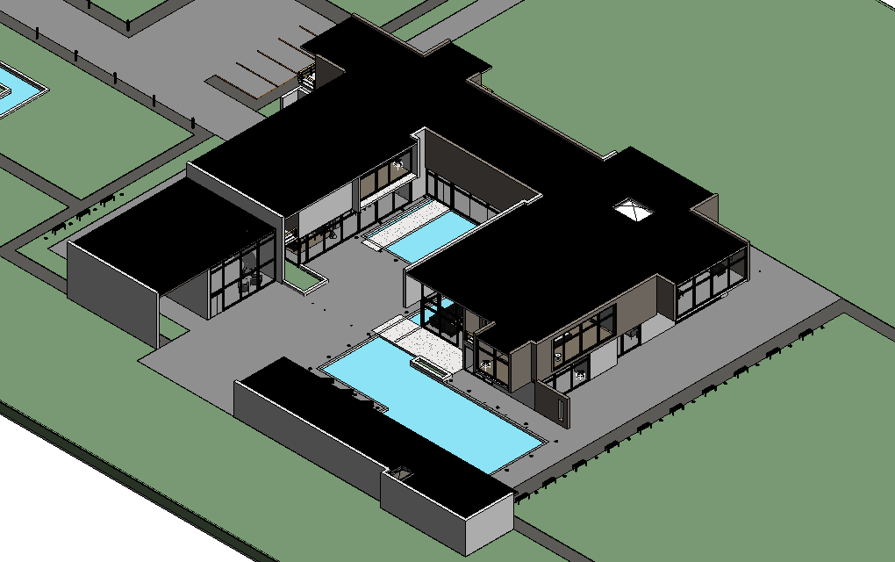 | Building type: Commercial  No of levels: 5 Levels  No of floors: 2 Floors  GFA: 33,952.41m²

Although the adoption of BIM for improved processes in AEC industries is a key competitive and operational differentiator in the construction supply chains; most of the existing CW management tools are not BIM compatible. The A-WAS tool’s offering in integrating CW management into BIM shows that the tool is relevant to the stakeholders of the construction supply chains. With the increasing adoption of BIM in the AEC industries and the development of improved laser scanning techniques, the number of buildings that have BIM model is rapidly increasing. This evidence and the results of this study shows that the relevance and usefulness of the A-WAS tool. The A-WAS tool can perform the following functions: (i) extraction of material take-off (list of all element according to category, materials, and volume), (ii) calculation of the GFA and floor levels, (iii) estimation of the CW arisings by building material type, component type, and level, and (iv) generation of CW analytical report. The BIM tool enables users to interact and export the report.
The major limitation of existing WPMs is that they rely on the national waste generation rates and they can be used only after the completion of the building design. However, the AWAS tool provides a computational mechanism to continuously estimate the waste arisings during the design stage. Besides, the ability of A-WAS tool to isolate the sources of CW by building material type, component type and levels have huge implications for CW management. The development of the tool also broadens the understanding of how DoW factor could be integrated into BIM software. The BIM tool is therefore useful to several industry stakeholders, and the implications for practice on the construction supply chains are discussed in details in the next section.

Implications of findings
This study shows that supply chains integration and the adoption of principles in a BIM environment are critical for CW management. This study, therefore, offers huge implications for construction supply chains integration and collaboration, the circular economy agenda, and future tool development.

Implications for supply chains integration and collaboration
Dainty and Brooke (2004) argue that supply chains solutions are central to CW minimisation and waste diversion from landfills. Early supply chains integration and alliance with suppliers, sub-contractors, recycling companies, and secondary users of waste offer mutual benefits for stakeholders. These relationships are essential for effective information sharing, dynamism, competitive synergy, and superior operating performance within the entire supply chains (Cao and Zhang, 2011; Prajogo and Olhager, 2012; Zhou and Benton, 2007). However, a major gap in the leverage of supply chain integration for CW management is the lack of a tool that is relevant to the operations of the key stakeholders. The A-WAS tool developed as part of this study fills this gap. The study and the A-WAS tool are, therefore, relevant to the practices of building material manufacturers and suppliers. It is important for material manufacturers and suppliers to ensure that their products have minimal impact on the environment. The A-WAS tool will assist material manufacturers and suppliers to estimate and minimise the potential impact of their products on CW generation. In the same way, a client such as the government with huge commitment on the sustainability agenda could use the A-WAS tool to assess various building designs with regards to their CW generation potentials. As such, the A-WAS tool could serve as a selection tool for delivering low-waste buildings.

Implications for the circular economy agenda
The circular economy agenda proposes a shift from the traditional “take-make-waste” model of considering waste as a norm to an integrated system that emulates the nature’s sustainable cycle (Despeisse et al., 2017; Ghisellini et al., 2016). Adopting this approach promotes closed material cycle through recycling economy and reuse. As such, it is imperative that all work stages of production minimise waste and reduce the demand for resources to achieve sustainable development. While CW management tools exist for the construction stage of buildings (BRE, 2008; WRAP, 2011), little effort has been given to the design stages. This study, therefore, has significant implications for low-waste building design practices. The study has huge implications for architectural and design practices by broadening the understanding of how CW reduction could be achieved through appropriate design decisions. The A-WAS tool provides architects and design engineers with insights into potential sources of waste during building design. Achieving this provides an objective comparative mechanism for selecting the building design with the least CW generation potential. In addition, the study has huge implications for the circular economy agenda because it provides the management routes for the predicted CW, i.e. the portion of the CW that could be recycled or reused. This offering is important to ensure that the value of building materials is sustained within the economic circle.

Implications for BIM and future tool development
This study could also influence the BIM practices in the built environment. Although several studies suggest that BIM capability is critical to efficient CW management, BIM-based CW management practices are often ignored. The increasing rate of BIM adoption and the governments’ sustainability goals have compelled more industry practitioners to become interested in the integration of sustainable practices into BIM software. This study provides a clear direction on how to achieve this integration by streamlining the estimation of CW in a BIM environment. This study also shows that adequate CW management requires early supply chains involvement using BIM as a coordination and collaboration tool. This study also has huge implications for BIM software developers. The recent advancement in Information and Communication Technology (ICT) and BIM technologies show that innovation within the AEC industrial practices requires BIM compliance. Besides, complex, and repetitive AEC tasks need to be automated to achieve the required reliability, and efficiency. As such, the framework employed in this study and the A-WAS tool development process serves as a blueprint for developing BIM-enabled software for CW management and related tasks.

Conclusion
This study aims to develop a BIM tool for building CWA. The waste prediction capability of the BIM tool was achieved using a hybrid system known as ANFIS, which combines the strengths of fuzzy systems and ANN. The model development process reveals that the two key predictors for CW are “GFA” and “Construction type”. The hybrid model was integrated into the BIM platform and packaged as an add-in for Autodesk Revit. The development of the A-WAS tool fills two main gaps in knowledge, i.e., the detachment of existing CW tools from the design process, and lack BIM interoperability capabilities in existing CW management tools. Test results of the BIM tool show that the tool predicted CW according to waste types, element types, and building levels. The outputs of this study, therefore, offers huge implications for industry practice of several stakeholders, which include architects, design engineers, building material suppliers, BIM professionals, sustainability experts, software developers, and academics.
This study has some limitations despite its contribution to existing knowledge. A major limitation is that the study was carried out within the UK construction industry context, so the findings have a UK bias. Another limitation of the study is the nature of the data used for model development. An exploration of the collected historical WDR reveals that 45% of CW arising are recorded as mixed waste. This figure supports the general industry practice of recording most arising under mixed or general waste because it is not cost-effective to segregate CW on-site. This challenge constitutes a significant hindrance to CW prediction because the waste data from building projects are not adequately recorded. Overcoming this challenge requires the adoption of an integrated approach to CW data collection. Future research should also consider the development of BIM-enabled CW collection tools, which will integrate WDR into BIM models.

Acknowledgement
The authors would like to acknowledge and express their sincere gratitude to the Engineering and Physical Sciences Research Council (EPSRC) and Innovate UK (Grant Reference No. EP/N509012/1; Grant Application No. 54832–413479/File No. 102473) for providing the financial support for this study.

References
Abraham, a, 2005. Hybrid intelligent systems: evolving intelligence in hierarchical layers. Do Smart Adapt. Syst. Exist. 179, 159–179.
Abraham, A., 2004. Meta learning evolutionary artificial neural networks. Neurocomputing. doi:10.1016/S0925-2312(03)00369-2
AIA, 2014. Integrated Project Delivery: An Updated Working Definition, AIA California Council, Sacramento, CA.
Ajayi, S.O., Oyedele, L.O., Akinade, O.O., Bilal, M., Alaka, H.A., Owolabi, H.A., 2017. Optimising material procurement for construction waste minimization: An exploration of success factors. Sustain. Mater. Technol. 11, 38–46. doi:10.1016/j.susmat.2017.01.001
Ajayi, S.O., Oyedele, L.O., Akinade, O.O., Bilal, M., Owolabi, H.A., Alaka, H.A., Kadiri, K.O., 2016. Reducing waste to landfill: A need for cultural change in the UK construction industry. J. Build. Eng. 5, 185–193. doi:10.1016/j.jobe.2015.12.007
Ajayi, S.O., Oyedele, L.O., Bilal, M., Akinade, O.O., Alaka, H.A., Owolabi, H.A., Kadiri, K.O., 2015. Waste effectiveness of the construction industry: Understanding the impediments and requisites for improvements. Resour. Conserv. Recycl. 102, 101–112. doi:10.1016/j.resconrec.2015.06.001
Akinade, O.O., Oyedele, L.O., Ajayi, S.O., Bilal, M., Alaka, H.A., Owolabi, H.A., Arawomo, O.O., 2018. Designing out construction waste using BIM technology: Stakeholders’ expectations for industry deployment. J. Clean. Prod. 180, 375–385. doi:10.1016/J.JCLEPRO.2018.01.022
Akinade, O.O., Oyedele, L.O., Ajayi, S.O., Bilal, M., Alaka, H.A., Owolabi, H.A., Bello, S.A., Jaiyeoba, B.E., Kadiri, K.O., 2017. Design for Deconstruction (DfD): Critical success factors for diverting end-of-life waste from landfills. Waste Manag. 60, 3–13. doi:10.1016/j.wasman.2016.08.017
Akinade, O.O., Oyedele, L.O., Bilal, M., Ajayi, S.O., Owolabi, H.A., Alaka, H.A., Bello, S.A., 2015. Waste minimisation through deconstruction: A BIM based Deconstructability Assessment Score (BIM-DAS). Resour. Conserv. Recycl. 105, 167–176. doi:10.1016/j.resconrec.2015.10.018
Akinade, O.O., Oyedele, L.O., Munir, K., Bilal, M., Ajayi, S.O., Owolabi, H.A., Alaka, H.A., Bello, S.A., 2016. Evaluation criteria for construction waste management tools: Towards a holistic BIM framework. Int. J. Sustain. Build. Technol. Urban Dev. 7, 3–21. doi:10.1080/2093761X.2016.1152203
Akintoye, A., McIntosh, G., Fitzgerald, E., 2000. A survey of supply chain collaboration and management in the UK construction industry. Eur. J. Purch. Supply Manag. 6, 159–168. doi:10.1016/S0969-7012(00)00012-5
Alfalla-Luque, R., Marin-Garcia, J.A., Medina-Lopez, C., 2015. An analysis of the direct and mediated effects of employee commitment and supply chain integration on organisational performance. Int. J. Prod. Econ. 162, 242–257. doi:10.1016/J.IJPE.2014.07.004
Anderson, J., Thornback, J., 2012. A guide to understanding the embodied impacts of construction products. Constr. Prod. Assoc. 1–53.
Andi, Minato, T., 2003. Design documents quality in the Japanese construction industry: factors influencing and impacts on construction process. Int. J. Proj. Manag. 21, 537–546. doi:10.1016/S0263-7863(02)00083-2
Ataseven, C., Nair, A., 2017. Assessment of supply chain integration and performance relationships: A meta-analytic investigation of the literature. Int. J. Prod. Econ. 185, 252–265. doi:10.1016/J.IJPE.2017.01.007
Azhar, S., 2011. Building information modeling (BIM): Trends, benefits, risks, and challenges for the AEC industry. Leadersh. Manag. Eng. 11, 241–252.
Azhar, S., Hein, M., Sketo, B., 2007. Building Information Modeling ( BIM ): Benefits , Risks and Challenges. Leadersh. Manag. Eng. 11, 241–252.
Baek, C., Park, S.H., Suzuki, M., Lee, S.H., 2013. Life cycle carbon dioxide assessment tool for buildings in the schematic design phase. Energy Build. 61, 275–287. doi:10.1016/j.enbuild.2013.01.025
Bergsdal, H., Bohne, R.A., Brattebø, H., 2007. Projection of construction and demolition waste in Norway. J. Ind. Ecol. 11, 27–39.
Bilal, M., Oyedele, L.O., Munir, K., Ajayi, S.O., Akinade, O.O., Owolabi, H.A., Alaka, H.A., 2017. The application of web of data technologies in building materials information modelling for construction waste analytics. Sustain. Mater. Technol. 11, 28–37. doi:10.1016/J.SUSMAT.2016.12.004
Bilal, M., Oyedele, L.O., Qadir, J., Munir, K., Ajayi, S.O., Akinade, O.O., Owolabi, H.A., Alaka, H.A., Pasha, M., 2016. Big Data in the construction industry: A review of present status, opportunities, and future trends. Adv. Eng. Informatics 30, 500–521. doi:10.1016/j.aei.2016.07.001
Bilal, M., Oyedele, L.O., Qadir, J., Munir, K., Akinade, O.O., Ajayi, S.O., Alaka, H.A., Owolabi, H.A., 2015. Analysis of critical features and evaluation of BIM software: towards a plug-in for construction waste minimization using big data. Int. J. Sustain. Build. Technol. Urban Dev. 6, 211–228. doi:10.1080/2093761X.2015.1116415
BRE, 2008. SMARTWASTE [WWW Document]. URL http://www.smartwaste.co.uk/index.jsp (accessed 4.25.16).
Cao, M., Zhang, Q., 2011. Supply chain collaboration: Impact on collaborative advantage and firm performance. J. Oper. Manag. 29, 163–180. doi:10.1016/j.jom.2010.12.008
Christopher, M., 1998. Logistics and Supply Chain Management: Strategies for reducing cost and improving services. Financ. Times/prentice Hall, London.
Cochran, K., Townsend, T., Reinhart, D., Heck, H., 2007. Estimation of regional building-related C&D debris generation and composition: case study for Florida, US. Waste Manag. 27, 921–31. doi:10.1016/j.wasman.2006.03.023
Cui, J., Zhang, L., 2008. Metallurgical recovery of metals from electronic waste: A review. J. Hazard. Mater. 158, 228–256. doi:10.1016/J.JHAZMAT.2008.02.001
Dainty, A.R.J., Brooke, R.J., 2004. Towards improved construction waste minimisation: a need for improved supply chain integration? Struct. Surv. 22, 20–29. doi:10.1108/02630800410533285
Dainty, A.R.J., Millett, S.J., Briscoe, G.H., 2001. New perspectives on construction supply chain integration. Supply Chain Manag. An Int. J. 6, 163–173. doi:10.1108/13598540110402700
Despeisse, M., Baumers, M., Brown, P., Charnley, F., Ford, S.J., Garmulewicz, A., Knowles, S., Minshall, T.H.W., Mortara, L., Reed-Tsochas, F.P., Rowley, J., 2017. Unlocking value for a circular economy through 3D printing: A research agenda. Technol. Forecast. Soc. Change 115, 75–84. doi:10.1016/J.TECHFORE.2016.09.021
Eadie, R., Browne, M., Odeyinka, H., McKeown, C., McNiff, S., 2013. BIM implementation throughout the UK construction project lifecycle: An analysis. Autom. Constr. 36, 145–151. doi:10.1016/j.autcon.2013.09.001
Eastman, C., Teicholz, P., Sacks, R., Liston, K., 2011. BIM handbook: A guide to building information modeling for owners, managers, designers, engineers and contractors. John Wiley & Sons.
Egan, J., 1998. Rethinking construction, Department of the Environment, Transport and the Regions, London.
Ekanayake, L.L., Ofori, G., 2004. Building waste assessment score: design-based tool. Build. Environ. 39, 851–861.
Faniran, O., Caban, G., 1998. Minimizing waste on construction project sites. Eng. Constr. … 5, 182–188.
Fatta, D., Papadopoulos, A., Avramikos, E., Sgourou, E., Moustakas, K., Kourmoussis, F., Mentzis, A., Loizidou, M., 2003. Generation and management of construction and demolition waste in Greece—an existing challenge. Resour. Conserv. Recycl. 40, 81–91. doi:10.1016/S0921-3449(03)00035-1
Flynn, B.B., Huo, B., Zhao, X., 2010. The impact of supply chain integration on performance: A contingency and configuration approach. J. Oper. Manag. 28, 58–71. doi:10.1016/J.JOM.2009.06.001
Ghisellini, P., Cialani, C., Ulgiati, S., 2016. A review on circular economy: the expected transition to a balanced interplay of environmental and economic systems. J. Clean. Prod. 114, 11–32. doi:10.1016/J.JCLEPRO.2015.09.007
Gimenez, C., McIvor, R., 2016. Risk, risk management practices, and the success of supply chain integration. Int. J. Prod. Econ. 171, 361–370. doi:10.1016/J.IJPE.2015.03.020
Goedert, J.D., Meadati, P., 2008. Integrating construction process documentation into building information modeling. J. Constr. Eng. Manag. 134, 509–516.
Gordon, O., Herrera, F., Hoffmann, F., Luis, M., 2001. Genetic fuzzy systems: Fuzzy Knowledge Extraction by Evolutionary Algorithms. Sci. Publ. Co. Pte. Ltd, UK. doi:10.1142/4177
Grilo, A., Jardim-Goncalves, R., 2010. Value proposition on interoperability of BIM and collaborative working environments. Autom. Constr. 19, 522–530. doi:10.1016/j.autcon.2009.11.003
Hegde, V., Kulkarni, R.D., Ajantha, G.S., 2007. Biomedical waste management. J. Oral Maxillofac. Pathol. 11, 5.
Hicks, C., Heidrich, O., McGovern, T., Donnelly, T., 2004. A functional model of supply chains and waste. Int. J. Prod. Econ. 89, 165–174. doi:10.1016/S0925-5273(03)00045-8
Huang, M.-C., Yen, G.-F., Liu, T.-C., 2014. Reexamining supply chain integration and the supplier’s performance relationships under uncertainty. Supply Chain Manag. An Int. J. 19, 64–78. doi:10.1108/SCM-04-2013-0114
Jalali, S., 2007. Quantification of Construction Waste Amount, in: 6th International Technical Conference of Waste.
Jang, J.-S.R., 1993. ANFIS : Adap tive-Ne twork-Based Fuzzy Inference System. IEEE Trans. Syst. Man. Cybern. 23.
Lavy, S., Jawadekar, S., 2014. A Case Study of Using BIM and COBie for Facility Management. Int. J. Facil. Manag. 5, 13–27.
Li, J., Ding, Z., Mi, X., Wang, J., 2013. A model for estimating construction waste generation index for building project in China. Resour. Conserv. Recycl. 74, 20–26. doi:10.1016/j.resconrec.2013.02.015
Lichtig, W.A., 2010. The Integrated Agreement for Lean Project Delivery, in: Improving Healthcare through Built Environment Infrastructure. pp. 85–101. doi:10.1002/9781444319675.ch6
Lin, C.-T., Lee, C.S.G., Lin, C.-T., Lin, C.T., 1996. Neural fuzzy systems: a neuro-fuzzy synergism to intelligent systems. Prentice hall PTR Upper Saddle River NJ.
Liu, Z., Osmani, M., Demian, P., Baldwin, A., 2011. The potential use of BIM to aid construction waste minimalisation, in: Proceedings of the CIB W78-W102 2011: International Conference. Sophia Antipolis, France.
Lopez, R., Love, P.E.D., 2012. Design Error Costs in Construction Projects. J. Constr. Eng. Manag. doi:10.1061/(ASCE)CO.1943-7862.0000454
MacLeamy, P., 2004. MacLeamy Curve. Collab. Integr. Information, Proj. Lifecycle Build. Des. Constr. Oper.
Manning, R., Messner, J., 2008. Case studies in BIM implementation for programming of healthcare facilities, in: ITcon - IT in Construction, 13 (Special Issue - Case Studies of BIM Use). ITcon.
Masudi, A.F., Rosmani, C., Hassan, C., Mahmood, N.Z., Mokhtar, S.N., 2011. Construction Waste Quantification and Benchmarking : A Study in Klang Valley , Malaysia 5, 909–916.
Mirabella, N., Castellani, V., Sala, S., 2014. Current options for the valorization of food manufacturing waste: a review. J. Clean. Prod. 65, 28–41. doi:10.1016/J.JCLEPRO.2013.10.051
Narasimhan, R., Kim, S.W., 2002. Effect of supply chain integration on the relationship between diversification and performance: evidence from Japanese and Korean firms. J. Oper. Manag. 20, 303–323. doi:10.1016/S0272-6963(02)00008-6
Osmani, M., Glass, J., Price, A.D.F., 2008. Architects’ perspectives on construction waste reduction by design. Waste Manag. 28, 1147–1158.
Otto, M., 1990. Fuzzy expert systems, TrAC Trends in Analytical Chemistry. doi:10.1016/0165-9936(90)85030-B
Oyedele, L.O., Ajayi, S.O., Kadiri, K.O., 2014. Use of recycled products in UK construction industry: An empirical investigation into critical impediments and strategies for improvement. Resour. Conserv. Recycl. 93, 23–31. doi:10.1016/j.resconrec.2014.09.011
Oyedele, L.O., Regan, M., von Meding, J., Ahmed, A., Ebohon, O.J., Elnokaly, A., 2013. Reducing waste to landfill in the UK: identifying impediments and critical solutions. World J. Sci. Technol. Sustain. Dev. 10, 131–142. doi:10.1108/20425941311323136
Pan, S.-Y., Du, M.A., Huang, I.-T., Liu, I.-H., Chang, E.-E., Chiang, P.-C., 2015. Strategies on implementation of waste-to-energy (WTE) supply chain for circular economy system: a review. J. Clean. Prod. 108, 409–421. doi:10.1016/J.JCLEPRO.2015.06.124
Poon, C.S., Yu, A.T.W., Jaillon, L., 2004. Reducing building waste at construction sites in Hong Kong. Constr. Manag. Econ. 22, 461–470. doi:10.1080/0144619042000202816
Prajogo, D., Olhager, J., 2012. Supply chain integration and performance: The effects of long-term relationships, information technology and sharing, and logistics integration. Int. J. Prod. Econ. 135, 514–522. doi:10.1016/J.IJPE.2011.09.001
Salem, O., Asce, M., Shahin, A., Khalifa, Y., 2008. Minimizing Cutting Wastes of Reinforcement Steel Bars Using Genetic Algorithms and Integer Programming Models 133, 982–992.
Sepehri, A., Sarrafzadeh, M.-H., 2018. Effect of nitrifiers community on fouling mitigation and nitrification efficiency in a membrane bioreactor. Chem. Eng. Process. - Process Intensif. 128, 10–18. doi:10.1016/J.CEP.2018.04.006
Shen, L.-Y., Lu, W.-S., Yao, H., Wu, D.-H., 2005. A computer-based scoring method for measuring the environmental performance of construction activities. Autom. Constr. 14, 297–309. doi:10.1016/j.autcon.2004.08.017
Singh, T.N., Kanchan, R., Verma, A.K., Saigal, K., 2005. A comparative study of ANN and Neuro-fuzzy for the prediction of dynamic constant of rockmass. J. Earth Syst. Sci., 114, 75–86.
Singh, V., Gu, N., Wang, X., 2011. A theoretical framework of a BIM-based multi-disciplinary collaboration platform. Autom. Constr. 20, 134–144. doi:10.1016/j.autcon.2010.09.011
Solís-Guzmán, J., Marrero, M., Montes-Delgado, M.V., Ramírez-de-Arellano, A., 2009. A Spanish model for quantification and management of construction waste. Waste Manag. 29, 2542–2548. doi:http://dx.doi.org/10.1016/j.wasman.2009.05.009
Steel, J., Drogemuller, R., Toth, B., 2012. Model interoperability in building information modelling. Softw. Syst. Model. 11, 99–109. doi:10.1007/s10270-010-0178-4
Sud, D., Mahajan, G., Kaur, M.P., 2008. Agricultural waste material as potential adsorbent for sequestering heavy metal ions from aqueous solutions – A review. Bioresour. Technol. 99, 6017–6027. doi:10.1016/J.BIORTECH.2007.11.064
Thunberg, M., Rudberg, M., Karrbom Gustavsson, T., 2017. Categorising on-site problems: A supply chain management perspective on construction projects. Constr. Innov. 17, 90–111. doi:10.1108/CI-10-2015-0059
Villarreal, B., Garcia, D., Rosas, I., 2009. Eliminating transportation waste in food distribution: a case study. Transp. J. 48, 72–77.
Wang, J.Y., Touran, A., Christoforou, C., Fadlalla, H., 2004. A systems analysis tool for construction and demolition wastes management. Waste Manag. 24, 989–97. doi:10.1016/j.wasman.2004.07.010
Won, J., Cheng, J.C.P., Lee, G., 2016. Quantification of construction waste prevented by BIM-based design validation: Case studies in South Korea. Waste Manag. doi:10.1016/j.wasman.2015.12.026
WRAP, 2011. Designing-out Waste Tool for Buildings. Available from http//dowtb.wrap.org.uk/.
Wu, Z., Fan, H., Liu, G., 2013. Forecasting Construction and Demolition Waste Using Gene Expression Programming. J. Comput. Civ. Eng. 04014059. doi:10.1061/(ASCE)CP.1943-5487.0000362
Yao, X., 1993. A review of evolutionary artificial neural networks. Int. J. Intell. Syst. 8, 539–567. doi:10.1002/int.4550080406
Zaman, A.U., Lehmann, S., 2013. The zero waste index: a performance measurement tool for waste management systems in a ‘zero waste city.’ J. Clean. Prod. 50, 123–132. doi:10.1016/j.jclepro.2012.11.041
Zhou, H., Benton, W.C., 2007. Supply chain practice and information sharing. J. Oper. Manag. 25, 1348–1365. doi:10.1016/J.JOM.2007.01.009

