Ways of Making, A collaboration with Sir Peter Blake and Worton Hall Studios, London Original Print Fair, April 2019
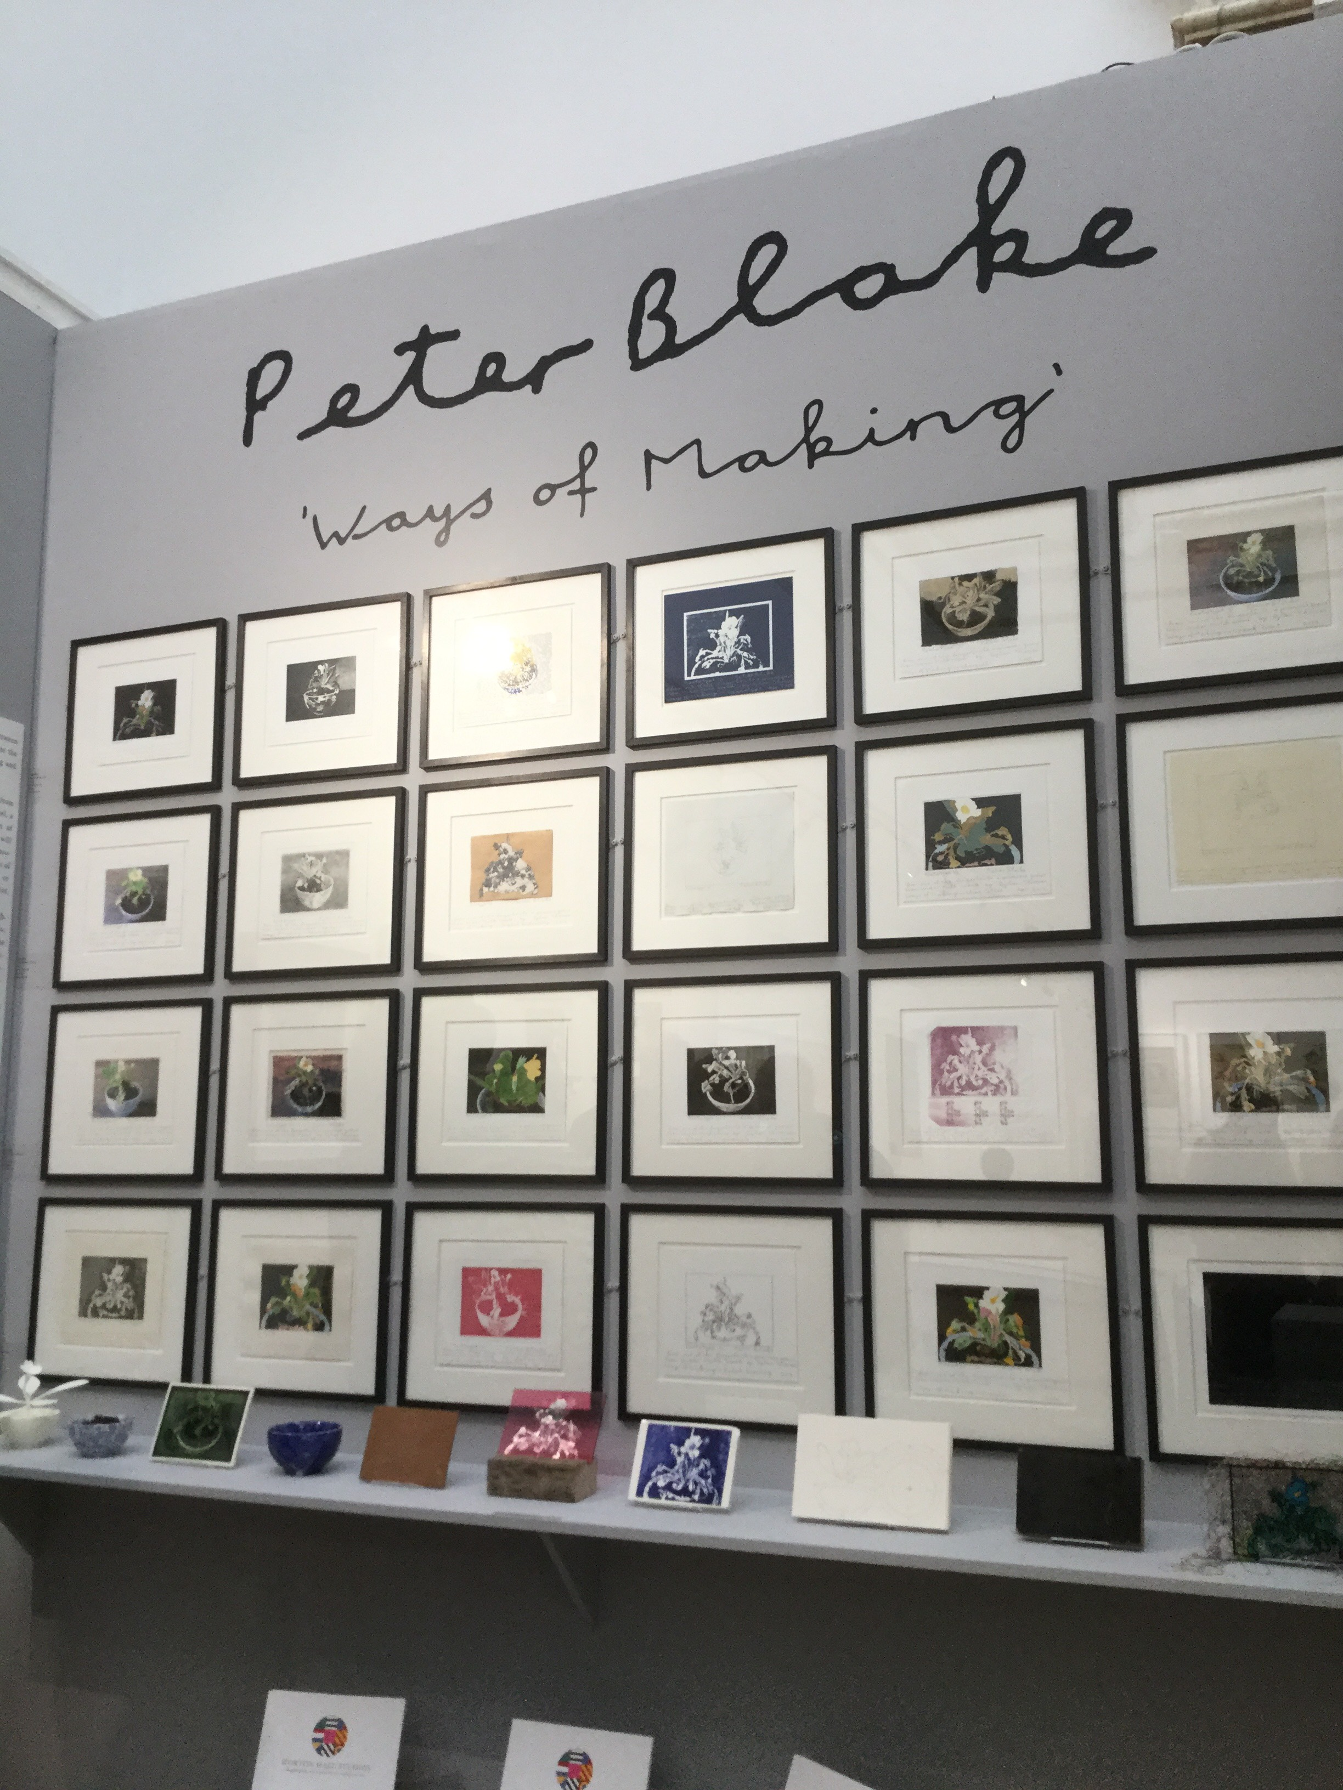
Academics, researchers and practicing artists from the Centre for Fine Print Research at the University of the West of England (UWE Bristol) have been using their expertise in the latest print techniques to collaborate on an ongoing project with veteran of the British art scene, Sir Peter Blake.
Blake’s project, Ways of Making, seeks to explore the range of processes at the disposal of an artist, traditional and contemporary. Taking as a theme the image of a primrose growing from a ceramic bowl – inspired by a line from Dylan Thomas – the project is working towards a comprehensive survey of image reproduction in the field of printmaking.
Working at the cutting edge of contemporary printmaking, experts at the Centre for Fine Print Research were able to introduce Sir Peter Blake to new technologies including robotic-arm painting, digital embroidery, 3D printing and laser etching.
Professor in Design, Colour and Print and Director of the Centre for Fine Print Research, Dr Carinna Parraman said; “Many of the technologies explored in this project have never been used in a fine art context before. It has been fascinating to see the variety of interpretations each technique lends, contrasting with the continuity of subject.”
Lending their own print publishing expertise and bringing the project together, Worton Hall Studios have been working with Blake to produce images using well-established printmaking methods.
Ways of Making is an ongoing project, which Sir Peter Blake intends to continue to explore. It will premiere at the London Original Print Fair 25th-28th April 2019, at the Royal Academy of Arts, and Professor Carinna Parraman will be in conversation with Sir Peter Blake and Director of the London Original Print Fair, Helen Rosslyn on Friday 26 April 2019.

