**Supply Chain 4.0: Concepts, Maturity and Research Agenda**

**Abstract**

**Purpose** – Industry 4.0 is one of the most emergent research topics attracting significant interest by researchers as well as practitioners. Many articles have been published with regards Industry 4.0 however there is no research that clearly conceptualizes Industry 4.0 in the context of supply chain. In this paper, the term “Supply Chain 4.0” is proposed together with a novel conceptual framework that captures the essence of Industry 4.0 within the supply chain context. As Industry 4.0 is inherently a revolution, and as revolutions are evolutionary, this research also aims to capture the evolution of Supply Chain 4.0 from maturity levels perspective to facilitate the formulation and development of Supply Chain 4.0 strategy.

**Design, Methodology/ Approach** – Following a deductive research approach and a qualitative strategy, a Systematic Literature Review (SLR) was adopted as the research method seeking to understand the relationships amongst supply chain, industry 4.0 and maturity levels research. The three phases of the SLR process utilized are: planning, conducting and reporting. A concept-oriented technique was applied to the outputs of the SLR to obtain the key constructs that would facilitate the development of the conceptual Supply Chain 4.0 framework.

**Findings –** The SLR showed that there is limited research linking Industry 4.0 to supply chain. Nevertheless, it was possible to extract a set of thematic categories from the analysis of the articles which are referred to as constructs as they form the core of the conceptual Supply Chain 4.0 framework. These constructs are Managerial & Capabilities Supporters, Technology Levers, Processes Performance Requirements and Strategic Outcomes. Each of these constructs consist of a number of elements which are referred to as ‘dimensions’ in this research and a total of twenty one (21) dimensions were identified during the SLR. The SLR also demonstrated that maturity propositions for Industry 4.0 are still embrionary and entirely missing in the context of Supply Chain. Hence, this research develops and proposes a maturity levels framework that is underpinned by the core constructs of Supply Chain 4.0 and the corresponding dimensions. As these proposed frameworks are conceptual, this research also identifies and proposes several research directions to help fortify the Supply Chain 4.0 concept.

**Originality/value –** The SLR demonstrated a clear gap in literature with regards to Industry 4.0 in the context of Supply Chain, and also in the context of Industry 4.0 maturity levels for Supply Chain. This research is unique as it formulates and introduces novel frameworks that close these gaps in literature. The value of this research lies in the fact that it makes significant contribution in terms of understanding of Supply Chain 4.0 with a clear set of constructs and dimensions that form Supply Chain 4.0, which provides the foundation for further work in this area.

**Research Implications/ limitations –** This research argues that the frameworks are robust since the constructs and dimensions are grounded in literature thus demonstrating both theoretical and practical relevance and value. As Supply Chain 4.0 research is still in infancy, there are a range of open research questions suggested based on the frameworks that could serve as guides for researchers to further develop the Supply Chain 4.0 concept. Also, practitioners can use this framework in order to develop better understanding of Supply Chain 4.0 and be able to evaluate the maturity of their organizations. As the proposed frameworks are conceptual, they require further empirical research in other to validate them and obtain new insights.

**Keywords** Supply Chain 4.0, Concept, Maturity, Framework, Systematic Literature Review

**Paper Type** Literature Review

## 1 Introduction

Currently, Industry 4.0 is one of the most emergent topics of interest by researchers and practitioners. A wide range of research and conferences have been conducted in order to foster more discussion around this subject around the world (Oztemel and Gursev, 2018). According to Liao et al. (2017), in the period between 2013 and 2015, there has been a significant increase in the number of publications in this topical area.

Industry 4.0, also known as the fourth industrial revolution (or 4IR), was launched in 2011 in Germany during an event called Hannover Fair (Ghobakhloo, 2018). In the same year, it became part of the German government’s agenda for trade and industrial development (Ghobakhloo, 2018; Lu, 2017; Hofmann and Rüch, 2017; Pereira and Romero, 2017). From that moment, the subject became a highly interesting topic in industry and academia. Currently, the topic has gained global significance as it has become part of the World Economic Forum’s agenda since 2016 (Hofmann and Rüch, 2017; Lu, 2017). Furthermore, it is being explored and integrated into various countries’ development agenda such as United States, France, Japan, Singapore, United Kingdom and China (Liao et al., 2017).

The reason for this high interest is that Industry 4.0 has the potential to transform how value is created and delivered, and how companies compete (Porter and Heppelmann, 2014). The phrase “the fourth industrial revolution” is meant to highlight the significance of this transformation in comparison to the previous industrial revolutions where: the first industrial revolution of 1760-1860 (Clarke 2005) introduced the steam engine that facilitated the mechanisation of production; the second industrial revolution of 1870-1914 was characterized by huge economies of scale in manufacturing i.e. mass production which was supported by developments around electric power, railways etc. (Mokyr and Strotz 1998); and the third industrial revolution of 1984 is characterized by the growth of electronics and ICT that facilitated automation (Gray, 1984; Fitzsimmons, 1994). At a high level, Industry 4.0 encompasses of a range of cutting-edge and disruptive technologies such as Cyber Physical Systems (CPS), Internet of Things (IoT) and Cloud Computing (Bunse, 2013). As a result, only nations with the foresight to develop Industry 4.0 initiatives and capabilities will remain strong in a global competitive market (Kagermann, Wahlster and Helbig, 2013) – hence the high interest by nations.

In academia, a range of studies have recently been conducted to explore the relationships and impacts of Industry 4.0 on other topical areas such as Sustainability (Kamble, Gunasekaran and Gawankar, 2018; Branger and Pang, 2015; Stock and Seliger, 2016, Jabbour et al., 2018), Organizational Structure (Wilkesmann and Wildesmann, 2018; Schuh et al., 2015), Lean Manufacturing (Sanders, Elangeswaran and Wulfsberg, 2016; Rüttimann and Stöckli, 2016; Kolberg and Zühlke, 2015; Mrugalska and Wyrwicka, 2017), Product Development (Santos et al., 2017), Small and Medium Enterprises - SMEs (Moeuf, 2017), Production Planning and Control (Rossit, Tohmé and Frutos, 2018; Dolgui, et al., 2018) and Strategic Management ( Lin et al., 2018). Despite the extensive work in these areas, it appears that research exploring the relationships, impacts and applicability of Industry 4.0 in the context of Supply Chain is very limited.

In this paper, the term “Supply Chain 4.0” is introduced: to emphasise the relationships between Industry 4.0 and Supply Chain; to facilitate the exploration and clarification of the applicability and impacts of Industry 4.0 in the context of Supply Chain; and to identify the key elements that would form the foundation for Industry 4.0 in the context of Supply Chain. These culminated in the development of a conceptual Supply Chain 4.0 concept, and a Supply Chain 4.0 maturity framework. These are the main objectives of this paper and, in the remainder of this paper, Supply Chain 4.0 will be used to discuss research works that are around Industry 4.0 and Supply Chain.

This paper is structured as follows: this introductory section contextualized the research and introduced the term “Supply Chain 4.0”. The second section demonstrates the research gap that this paper is aiming to fill while the third section presents the research methodology. The theoretical frameworks for Supply Chain 4.0 Concept and Supply Chain 4.0 Maturity are developed in the fourth section. Finally, in the fifth section, conclusions with future research directions, theoretical and practical implications and limitations are discussed.

## 2 Research Gap

Büyüközkan and Göçer (2018) comments that Supply Chain 4.0 approach is still embrionary in academia being more extensively explored by practitioners. As Supply Chain 4.0 has the potential to disruptively transform traditional supply chains (Tjabjono et al., 2017; Mathusami and Srinivsan, 2017, Stevens and Johnson, 2016) and how they are developed and managed, there is an opportunity for significant academic research and original contribution in this area. At a more detailed level, the disruptive technologies related to Industry 4.0 include: Virtual Reality, Simulation, 3D-printing, Big Data Analytics – BDA, Cloud Technologies, Cyber Security, Internet of Things – IoT, Radio Frequency Identification – RFID, Machine to Machine Communication – M2M, Automatic Identification and Data Collection – AIDC, Robotics, Drones, Nanotechnology and Business Intelligence – BI (Tjabjono, Esplugues and Pelaez, 2017; Oztemel and Gursev, 2018).

These new technologies would have implications for a range of business areas including the development of new products and services, operations, work environment, people and organizational management, business models etc. which will lead to significant changes to supply chains (Pereira and Romero, 2017; Bienhaus and Haddud, 2018). Swanson (2017) states that Supply Chain 4.0 can create competitive advantage from products offering and availability, cost reduction and increase of market share. This is supported by Rexbausen and Seyfert (2016) who report that there is an opportunity for 30% overall cost reduction, as well as 75% reduction in inventories and lost sales.

However, Iddris (2018) cautions that although these new technologies will radically change supply chain operations, they need to be aligned with customer requirements. This is supported by some other authors with Schrauf and Berttram (2016) arguing that the understanding of the evolution of traditional supply chains in a Supply Chain 4.0 era will be critical to the success of its implementation. In the same vein, Bukova et al. (2018) suggest that traditional schemes of supply chain management will have to be gradually changed as Supply Chain 4.0 initiatives are implemented. Some other researchers focus on the potential challenges with Strange and Zucchella (2017) calling attention to potential cyber security issues in a Supply Chain 4.0 adoption. For Lu (2017), interoperability is one of the key elements to be taken into account in Supply Chain 4.0 implementation to ensure that various systems can understand one each other and share functionalities (Chen, Doumeingts and Vernadat, 2008).

One important aspect of Industry 4.0 technologies is the amount of data that could be generated which will need to be well managed and harnessed. According to Tan et al. (2015), managing and harnessing Big Data is set become a key factor in generating new capabilities and innovation in supply chains including the capabilities to optimize whole supply chains as emphasized by Wamba et al. (2015). Although some studies have been carried out with regards to Big Data in supply chains, Nguyen et al. (2018) point out that research approaching the entire supply chain holistically is still rare. For this reason Big Data applications is seen as one of the most important areas of study in Supply Chain 4.0 (Addo-Tenkorang and Helo, 2016; Queiroz and Telles, 2018) as they have the potential to cause significant impacts on supply chains (Gunasekaran et al., 2017; Schoenherr and Speier-Pero, 2015).

Another important technology for Supply Chain 4.0 is IoT which potentially has significant implications for global supply chains design, operations and performance (Gunasekaran, Subramanian and Tiwari, 2016). According to Ben-Daya, Hassini and Baroun (2017) IoT is one of the founding technologies of Industry 4.0. Misrha et al. (2016) argue that most current research on IoT are focused on the technical aspects rather than managerial. This is supported by Ben-Daya, Hassini and Baroun (2017) who call for more research into IoT frameworks and models that could provide managerial guidance in supply chains. The focus on technical research is not limited to IoT or Big Data but to the whole Supply Chain 4.0 research as Wu (2016) argues that besides technical challenges, managerial challenges and obstacles will have to be overcome in a Supply Chain 4.0 context. This is further supported by Haddud et al. (2017) who point out the importance in understanding the impacts and challenges linked to IoT implementation.

On the managerial standpoint, Wang et al. (2016) and Ghobakhloo (2018) call for research in the maturity evaluation of Supply Chain 4.0 as a way to understand the progression of supply chain 4.0 implementation. However, there are a range of potential areas of research within the Supply Chain 4.0 context and in order to explore these, it is necessary to clarify the meaning of Supply Chain 4.0, and also develop a thorough understanding of existing pockets of work in this area.

This level of understanding and research is currently lacking in the literature. Therefore, this research aims to fill the gap by identifying the core elements of Supply Chain 4.0 in order to develop a Supply Chain 4.0 framework. These core elements are referred to as constructs in this research. This research also aims to understand and clarify Supply Chain 4.0 from an evolutionary perspective via maturity levels and by clarifying the gaps in the literature, to facilitate the identification of future research directions. These are illustrated in the Figure 1.

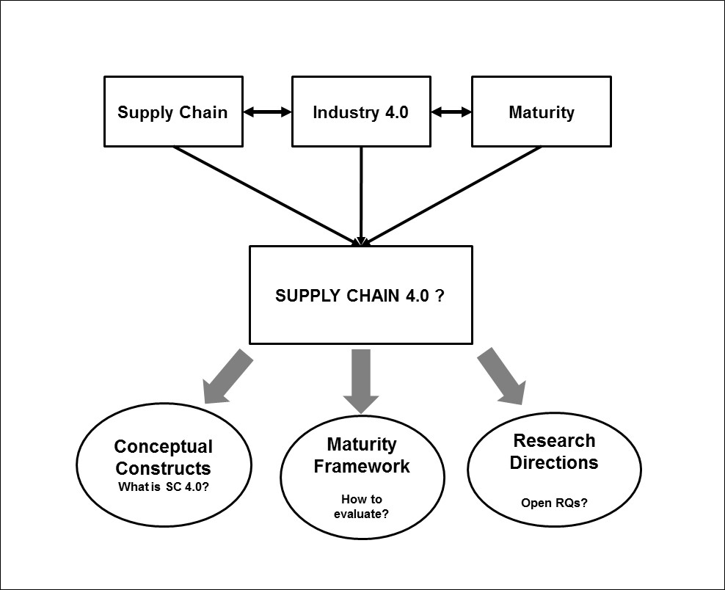  
Figure 1 – Research Framework

From the foregoing, three research questions have been distilled as represented in the framework of figure 1 and itemized below. The sections that follow are focused on addressing the research questions:

1. ***What are the constructs that shape the Supply Chain 4.0 concept? (RQ1)***
2. ***How can the evolution of Supply Chain 4.0 be understood and evaluated? (RQ2)***
3. ***What are the open research questions and research gaps related to Supply Chain 4.0 and its maturity? (RQ3)***

## 3 Research Method

To address research questions 1 and 2, systematic literature reviews were carried out. According to Wilding and Wagner (2014), systematic literature review is a robust and auditable method that facilitates the development of theories and reaching conclusions. The reviews where carried out from two perspectives that align with research questions 1 and 2 respectively:

1) Systematic Literature Review for Supply Chain and Industry 4.0 (sub-section 3.1);

2) Systematic Literature Review for Industry 4.0 Maturity (sub-section 3.2).

The reason for carrying out two systematic literature reviews is to facilitate thorough and in-depth exploration and analysis focused on each research question to ensure that each research question is comprehensively addressed. Each of these systematic literature reviews was structured in three phases following the process developed by Tranfield, Denyer and Smart (2003): planning, conducting and, reporting. The planning phase establishes the search keywords and identifies the search databases and the search period. In the conducting phase, the search is carried out followed by screening of the search results, which is followed by extraction, data analysis and synthesis. The reporting phase, presents the outcome of the analysis in a structured manner.

**3.1 SLR for Supply Chain and Industry 4.0**

Figure 2 diagrammatically presents the three phases of the SLR and the relevant outputs for each phase as described below.

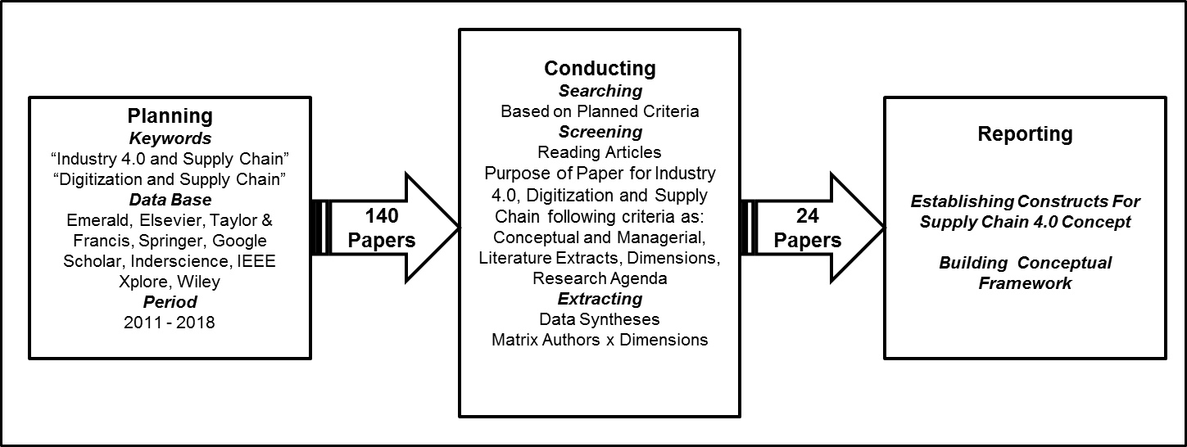  
Figure 2 – Systematic Literature Review Method

*3.1.1 Planning*

In the planning phase, keywords for the search was determined and include: ‘Supply Chain 4.0`, ‘Supply Chain and Industry 4.0’ and, ‘Supply Chain and Digitization’. The databases utilized for the search were: Emerald, Elsevier, Taylor & Francis, Wiley, Inderscience, IEEE Xplore, Springer and, Google Scholar. Google Scholar has been utilized to help capture non-refereed but relevant practitioner oriented articles and reports that could provide further insight into this area particularly as this area is in its infancy. The search period was for articles published between 2011 and 2018 as Industry 4.0 was launched in 2011.

*3.1.2 Conducting*

During the conducting phase, the search step identified 140 papers. This was followed by the screening step which consisted of the reading of the title and abstract of each paper, and if necessary the entire manuscript. The selection criterion was alignment with the research purpose i.e. papers that are focused on managerial aspects of Supply Chain 4.0 are selected whereas heavily technical papers are disregarded. For the non-refereed papers, the structure and contribution were first verified in order to ensure the robustness of the content and analysis. The screening process resulted in the selection of 24 papers.

In order to get reliable results, the data analysis in the extraction step followed a concept matrix technique as suggested by Webster and Watson (2002). This matrix is the most effective way to make the transition from author-centric to concept-centric approach. These authors also argue that using tables and figures to present findings from literature reviews improves communication of the findings and such approach will be used in this article.

The analysis shows that the majority of the papers in this area are very recent despite the search period starting from 2011. Growth in this area started from 2016 with the highest number of articles published in 2018 (11 articles), followed by 2017 (9 articles) and, 2016 (4 articles). This demonstrates that activity in this area has grown in recent times and that there is a great potential for more research. One may expect greater number of publications in this area becoming available in the next couple of years.

While Figure 3 presents the number of articles found for each publication source, Figure 4 shows number of articles from each database. Both figures show that the number of research that relates Industry 4.0 and Supply Chain is still limited. Also, although a range of database were utilised for the searching process, it seems that the articles are still concentrated in a few databases such as Emerald (10 articles), Elsevier (6 articles) and, Google Scholar (8 articles) as shown in Figure 4.

Figure 3 – Articles per Journal/Conference/Publishing Company

Figure 4 – Number of articles per database

Table 1 shows the complete list of the twenty four (24) articles with authors, title, database and journal/conference/publishing Institution.

|  |  |  |  |  |
| --- | --- | --- | --- | --- |
| Table 1 – List of articles found in the literature | | | | |
| ***Article Number*** | ***Author*** | ***Title*** | ***Database*** | ***Journal/Conference/ Publishing Institution*** |
| 1 | Barreto, Amaral & Pereira (2017) | Industry 4.0 implications in logistics: an overview | Elsevier | Procedia Manufacturing |
| 2 | Tjahjono et al ( 2017) | What does industry 4.0 mean to Supply Chain? | Elsevier | Procedia Manufacturing |
| 3 | Pfohl, Burak & Kurnaz (2017) | The Impact of Industry 4.0 on the Supply Chain | Google Scholar | Hamburg International Conference of Logistics (HICL) , 2017 |
| 4 | Swanson (2017) | The Impact of Digitization on Product Offerings: Using Direct Digital Manufacturing in the Supply Chain | Google Scholar | 50th Hawaii International Conference on System Sciences, 2017 |
| 5 | Hofmann & Ruch (2017) | Industry 4.0 and the current status as well as future prospects on logistics | Elsevier | Computers in Industry |
| 6 | Dallasega, Rauch & Linder (2018) | Industry 4.0 as an enabler of proximity for construction supply chains: A systematic literature review | Elsevier | Computers in Industry |
| 7 | Wang et al (2016) | Big data analytics in logistics and supply chain management: Certain investigations for research and applications | Elsevier | Int. J.Production Economics |
| 8 | Muthusami & Srinivsan (2017) | Supply Chain 4.0: Digital Transformations Disruption and Strategy | Google Scholar | Review of Business and Technology Research |
| 9 | Alicke, Rexhausen & Seyfert (2016) | Supply Chain 4.0 in consumer goods | Google Scholar | McKinsey & Company |
| 10 | Ardito et al (2018) | Towards Industry 4.0: Mapping digital technologies for supply chain management marketing integration | Emerald | Business Process Management Journal |
| 11 | Bienhaus & Haddud (2018) | Procurement 4.0: factors influencing the digitisation of procurement and supply chains | Emerald | Business Process Management Journal |
| 12 | Iddris (2018) | Digital Supply Chain: Survey of the Literature | Google Scholar | International Journal of Business Research and Management |
| 13 | Wu et al (2016) | Smart supply chain management: a review and implications for future research | Emerald | The International Journal of Logistics Management |
| 14 | Queiroz & Telles (2018) | Big data analytics in supply chain and logistics: an empirical approach | Emerald | The International Journal of Logistics Management |
| 15 | Tu (2018) | An exploratory study of Internet of Things (IoT) adoption intention in logistics and supply chain management: A mixed research approach | Emerald | The International Journal of Logistics Management |
| 16 | Kache & Seuring (2017) | Challenges and opportunities of digital information at the intersection of Big Data Analytics and supply chain management | Emerald | International Journal of Operations & Production Management |
| 17 | Brinch (2018) | Understanding the value of big data in supply chain management and its business processes: Towards a conceptual framework | Emerald | International Journal of Operations & Production Management |
| 18 | Schrauf & Berttram (2016) | How digitization makes the supply chain more efficient, agile, and customer-focused | Google Scholar | PWC |
| 19 | Barata, Da Cunha & Stal (2018) | Mobile supply chain management in the Industry 4.0 era: An annotated bibliography and guide for future research | Emerald | Journal of Enterprise Information Management |
| 20 | Ghobakhloo (2018) | The future of manufacturing industry: a strategic roadmap toward Industry 4.0 | Emerald | Journal of Manufacturing Technology Management |
| 21 | Haddud et al (2017) | Examining potential benefits and challenges associated with the Internet of Things integration in supply chains | Emerald | Journal of Manufacturing Technology Management |
| 22 | Büyüközkan & Göçer (2018) | Digital Supply Chain: Literature review and a proposed framework for future research | Elsevier | Computers in Industry |
| 23 | Gottge & Menzel (2017) | Purchasing 4.0: An Exploratory Multiple Case Study on the Purchasing Process Reshaped by Industry 4.0 in the Automotive Industry | Google Scholar | Linnaeus University |
| 24 | Bukova et al (2018) | The Position of Industry 4.0 in the Worldwide Logistics Chains | Google Scholar | LOGI – Scientific Journal on Transport and Logistics |

*3.1.3 Reporting Findings SLR*

From the analysis of each article listed in Table 1, the application/focus areas (or themes) of each research work were extracted. In this paper, these application/focus areas are referred to as ‘dimensions’ and these dimensions were extracted following the author-centric to the concept-centric approach which was proposed by Webster and Watson (2002). With this technique it was possible to develop Table 2 which shows the dimensions identified from each article analyzed. Each dimension was extracted by the complete reading and analysis of the papers with the dimensions identified from the various sections of the papers such as proposal, results, conclusions and implications.

As shown in Table 2, twenty one (21) dimensions were extracted from the literature review. With regards concept-centric perspective, there are ten (10) dimensions which are most cited in the articles such as *Disruptive Technologies, Integration, Collaboration, HR- Human Resources and Organizational Skills and Efficiency*. They were cited in more than 5 (five) articles. Some other dimensions identified were: *IT – Information Technology Infrastructure, Transparency, Strategic Vision, Responsiveness, Coordination, Leadership Support, and Flexibility*. These dimensions were cited between five (5) and nine (9) articles. Dimensions with four (4) or less citations are *Cost Reduction and Profitability, Awareness, Compliance, SC – Supply Chain Leaner, Performance Measurement and Supplier Focus.*

From the author-centric perspective, it is possible to demonstrate that only a few authors account for the majority of the twenty one (21) dimensions identified. Twenty four (24) authors were found out from literature review, however only three (3) authors account for more than ten (10) dimensions. They are: Tjahjono et al. (2017), Alicke, Rexhausen and Seyfert (2016), Kache and Seuring (2017) and, Büyüközkan ans Göçer (2018). Figure 5 presents the graph with the quantity of dimensions considered by authors.

  
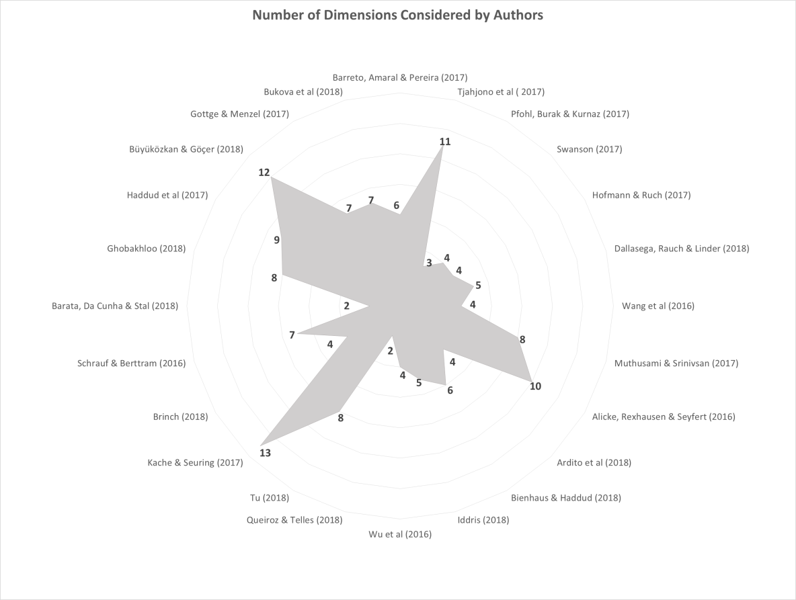 Figure 5 – Number of dimensions per publication

Table 2 – Concept dimensions extracted from literature review

According to the analysis of these data, it is evident that there is no total consensus between all authors on the whole twenty one (21) dimensions obtained. Moreover, there is not a clear and aligned categorization of these dimensions by the authors. Perhaps, this can be explained by the lack of a holistic view regarding the requirements of supply chain in Industry 4.0 context. This demonstrates a gap that this research is aiming to fill and justifies the purpose of this paper in facilitating the understanding of the Supply Chain 4.0 concept including the clarification and categorization of the dimensions.

It is also evident that there is some consensus amongst the authors regarding the dimension of *Disruptive Technologies*. Almost all the authors have considered this dimension which seems to demonstrate that it is a key dimension in Supply Chain 4.0. Also, some authors identified specific technologies considered as disruptive as presented in Table 3.

Figure 6 shows a chart of the number of articles that have considered each technology. According to the data obtained it is possible to demonstrate that the technology most considered by authors are *IoT, Cyber-Security, Automation, Big Data Analytics, Cloud Technologies, RFID, Smart Machines and Artificial Intelligence*. At least five (5) articles considered these eight (8) technologies. The remaining thirteen (13) technologies were cited in less than five (5) articles. These technologies are: *Nanotechnology, Omni Channel, Augmented Reality, ERP, Mobile-Apps, 3D-Printing, Business Intelligence, Optimization Systems, Robotics, Digitization, Sensors Technologies, Smart Products and, M2M.*



Table 3 – Disruptive Technologies sub-dimensions extracted from literature review

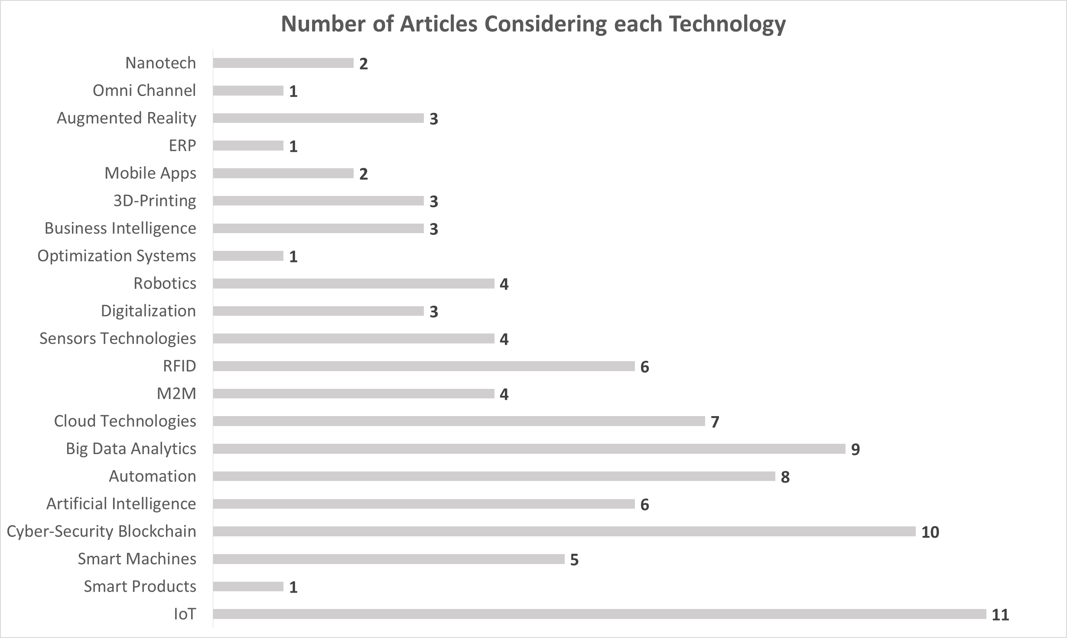

Figure 6 – Number of articles which considered each technology

By analysing the content of Table 2, a number of categories of dimensions were identified. The first category includes a set of dimensions that focus on capabilities and management issues that support Supply Chain 4.0. In this paper, this category is referred to as **Managerial & Capabilities Supporters** and consists of seven (7) dimensions: *IT infrastructure, HR and Organizational Skills, Coordination, Leadership Support, Awareness, Strategic Vision and, Compliance.* These dimensions represent the scaffolding structure for the Supply Chain 4.0 development, implementation and maintenance. This research argues that without these, it would not be possible to successfully implement Supply Chain 4.0.

The second group, which consist of only the *Disruptive Technologies* dimension, is referred to as **Technology Levers** as it consists of a set of disruptive technologies demonstrated by Table 3 that deliver the cutting-edge performance transformation of Supply Chain 4.0. This group has only one (1) dimension i.e. *Disruptive Technologies* which consist of twenty one (21) technologies as shown in Table 3.

A third category of nine (9) dimensions is related to processes. Dimensions such as *Interoperability, Collaboration, Transparency, Integration, Flexibility, Responsiveness, Efficiency, SC Leaner and Performance Measurement* are key process requirements. These elements represent the enablers of Supply Chain 4.0 performance and are referred to as **Process Performance Requirements**.

Lastly, the remaining four (4) dimensions are related to the expected outcomes from the Supply Chain 4.0 strategy. They are: *Cost Reduction and Profitability, Supplier Focus, Customer Focus and Strategic Impacts*. The argument is that meeting the Process Performance Requirements will most likely bring about improvement in terms of cost reduction which can a directly impact on the overall profitability. Process Performance Requirements imply, for example, responsiveness on delivery, transparency of information about the order and quality of products – which would normally lead to increased customer satisfaction. On supply side, this imply, for example, better collaboration and transparency in terms of inventory visibility, collaboration in planning, product and solutions development and other joint initiatives. All these have the potential to lead to an overall strategic impact for a business in terms of its competitive advantage, innovation and financial. For this reason, this last group of dimensions is called **Strategic Outcomes.**

In this paper, these four main groups are referred to as the constructs that facilitate clearer understanding of Supply Chain 4.0. It can be also discerned that there is an explicit cause-and-effect relation between the constructs. This can be demonstrated by the fact that elements of Managerial and Capabilities Support group are necessary to support the Technology Levers. In other words, to implement the set of these disruptive technologies, it is crucial that a foundation be firstly established. Without this foundation, it is unlikely that the technologies will be well implemented and executed in a way that meets the Process Performance Requirements. Consequently, strategic outcomes will not occur making supply chain 4.0 strategy partially or totally unsuccessful. Overall, the identification of these constructs and their relationships as discussed in the foregoing contributes substantially to addressing research question 1 of this paper.

**3.2 SLR for Industry 4.0 and Maturity**

This research argues that as Industry 4.0 is inherently a revolution, and as revolutions are evolutionary, it is necessary to develop a clear understanding of the evolution of Supply Chain 4.0. Maturity evaluation have been used in a range of disciplines to capture the evolutionary nature of various phenomenon or concepts. Hence this research explores Industry 4.0 from maturity levels perspective via a Systematic Literature Review in bid to answer the second research question: ***How can the evolution of Supply Chain 4.0 be understood and evaluated?*** The same SLR process used in sub-section 2.1 is also utilised here consisting of Planning, Conducting and Reporting as presented below.

*3.2.1 Planning and Conducting*

An SLR was carried with the keywords “Maturity and Industry 4.0”. The, search databases and period are the same as the previous SLR in sub section 2.1. The search resulted in 53 articles however after the screening process only 12 were selected. The screening consisted of reading of abstract and if necessary the entire paper, and the objective was to identify articles that proposed or discussed the development of Industry 4.0 from maturity levels perspective. Table 4 presents the selected twelve (12) papers.



Table 4 – Publications about Industry 4.0 and Maturity

*3.2.2 Reporting Findings*

Although a number of maturity models and frameworks were found through the SLR as presented in the Table 4, this research considers them inadequate in the context of Supply Chain 4.0 particularly as they are focused on various narrow aspects of businesses like IT (Leyh et al, 2016), Big Data (Wang et al, 2016), Manufacturing (Klotzer and Pfaum, 2017) etc. This is the overarching limitation of these research works but in addition to this limitation, this research argues that the analysis of a maturity framework should be based on certain criteria as follows. Firstly, the core elements, components, building blocks etc. of the framework should be clearly explained or defined including how they relate to the subject area. As already explained these elements are referred to as constructs in this research. Secondly, there should be clear understanding of the characteristics of each construct for each maturity stage. Lastly, relationships between constructs should be explained to facilitate understanding of how the constructs affect one another. Based on these, findings of the analysis of these papers are:

1. In general, there is no a clear definitions of the constructs presented in the maturity frameworks, and there is no clarification how the constructs were established.
2. In some frameworks, the characteristics of the constructs for each level of maturity are not clear.
3. The relationships between the constructs are not clear and therefore it is difficult to determine how the construct may impact each other.
4. A common consensus cannot be realized regarding the dimensions considered. Each proposal considers different aspects from one each other.

The understanding of current work in this area and their weaknesses contributes substantially to addressing research question 2 of this paper. The weaknesses of these research works may also be demonstrated through the fact that only 1 out of the 12 articles is a journal publication with the remainder being conference papers and practitioner reports. Therefore this paper aims to not only propose a conceptual framework for Supply Chain 4.0 but also to propose a maturity framework for said Supply Chain 4.0 that is robust enough to address the weaknesses identified in existing maturing frameworks. The contribution and robustness of the framework lies in the fact that the core constructs and corresponding dimensions are grounded in literature and the constructs also have clear relationships that demonstrate impact between them. The Supply Chain 4.0 framework and the corresponding Maturity Framework are presented in the next section (section 3).

## 4 Theoretical Framework for Supply Chain 4.0 Concept and Maturity

In this section, two inter-related frameworks are proposed: the Supply Chain 4.0 conceptual framework (sub-section 4.1), and Supply Chain 4.0 Maturity Framework (sub-section 4.2).

**4.1 Supply Chain 4.0 Concept**

In sub-section 3.1.1, the findings from the SLR were presented including the twenty one (21) application areas or dimensions of Supply Chain 4.0 (Table 2). The section also discussed how these dimensions were categorized into four groups that are referred to as constructs in this research: **Managerial & Capability Supporters**, **Technology Levers**, **Processes Performance Requirements and Strategic Outcomes.** These four constructs form the core or foundation of the proposed Supply Chain 4.0 Framework along with their corresponding dimensions (Figure 7).

  
 Figure 7 – Theoretical Framework for Supply Chain 4.0 Concept

The proposition is that at the base of this framework (Figure 7), seven (7) Managerial & Capability Supporters dimensions provide support for the development, implementation and maintenance of Supply Chain 4.0 technologies (Technology Levers). These twenty one (21) technologies will catalyze the nine (9) supply chain Process Performance Requirements to facilitate the achievement of the expected performance levels in terms of the four (4) Strategic Outcomes. This approach shows a clear cause-and-effect relationship between the four main constructs in bottom-up manner as shown in Figure 7.

Due to the importance of this framework, it is prudent to provide further clarity in terms of each of these constructs. These are presented in the following sub-sections.

*4.1.1 Managerial & Capability Supporters*

This construct is the foundation for the Supply Chain 4.0 Strategy as it plays a significant role in supporting the successful implementation of the *Technology Levers*. This construct requires special attention as it contains seven (7) dimensions that are the key determinants of the success of any Supply Chain 4.0 initiative as follows.

* IT infrastructure: as nearly all the technology levers are require IT capabilities, appropriate IT infrastructure and resources should be made available not just for the initial development and implementation but also for the ongoing management and evolution of these technologies.
* HR and Organizational Skills: this dimension includes management structure, HR strategy, work environment and skill development for Supply Chain 4.0. This is particularly important as most of the Technology Levers are essentially new technologies that require new skill sets and on-going skills development. To effectively manage these and embed them within the organization requires foresight, vision and clear understanding of technology trends and the corresponding skills requirements.
* Coordination: effective communication and collaboration across the various tiers of the supply chain is necessary in order to understand the technology requirements and impacts on the entire supply chain. This can be challenging as it requires a holistic approach to supply chain coordination with full consideration of the evolutionary implications of Supply Chain 4.0.
* Leadership Support: higher management is expected to have a clear understanding of the strategic implications of Supply Chain 4.0 to enable them make the right decisions with regards to budget and resource allocations. This may require visionary leadership capabilities that understand not just current supply chain requirements but the evolutionary nature of Supply Chain 4.0.
* Awareness: it is essential that there is awareness amongst all entities in the supply chain regarding the benefits and also requirements of the Supply Chain 4.0. This requires the Leadership Support dimension as leadership has a significant role to play in creating such awareness through appropriate engagement with relevant stakeholders.
* Strategic Vision: As Supply Chain 4.0 evolutionary and requires resources and reconfiguration of supply chains, a clear understanding of where a supply chain is, and where it could potentially be in the future is essential. This also implies an understanding of the competitive advantages of Supply Chain 4.0, potential challenges and potential pathways to realise Supply Chain 4.0.
* Compliance: this refers to the understanding and consideration of relevant legal, ethical, social, environmental and other necessary compliance requirements related to the Supply Chain 4.0. In this way, various aspects of sustainability and compliance are embedded at the core of the Supply Chain 4.0 concept.

*4.1.2 Technology Levers*

Findings from the systematic literature review show the twenty one (21) disruptive technologies that make up the Technology Levers construct would have implications for a range of business areas including the development of new products and services, operations, work environment, people and organizational management, and business models. The technologies in this dimension include:

IoT-Internet of Things, SP-Smart Products, SM-Smart Machines, CSB-Cyber-Security&Blockchain, AI-Artificial Intelligence, At-Automation, BDA-Big Data Analytics, CT-Cloud Technologies, M2M-Machine to Machine communication, RFID – Radio Frequency Identification, ST-Sensors Technologies, Dt-Digitalization, Rb-Robotics, OS-Optimization Systems, BI-Business Intelligence, 3Dp-3D-Printing, MA-Mobile Apps, ERP-Enterprise Resources Planning, AR-Augmented Reality, OC-Omni Channel and Nt-Nanotechnology.

In terms of supply chain operations, these technologies will allow more transparency and collaboration between partners and also facilitate human/machine collaboration. Product flexibility can also be significantly improved enabling increase in product offering and product mix which can be seamlessly managed. There is also potential to minimize lead times due to automation and enhanced visibilities facilitated by technologies like IoT, RFID, Artificial Intelligence etc. leading reduction in costs and increases in efficiencies.

*4.1.3 Process Performance Requirements*

In Supply Chain 4.0, it is expected that Technology Levers above will lead to a range of improvements in a number of dimensions such as interoperability, collaboration, transparency, integration, flexibility, responsiveness, efficiency, SC leaner, and performance measurement. These represent the nine (9) dimensions that make up the Process Performance Requirements construct. To meet any of these requirements from any of the technologies in the Technology Levers, these technologies need to be properly developed, implemented and managed, and ‘processes’ are key to accomplish these.

In literature, there are number of supply chain models that are relevant in the development and implementation of supply chain processes. Some of the key ones include SCOM model (Supply Chain and Operations Management) (Ivanov et al, 2017), SCOR model (Supply Chain Operations Reference) (Jonsson, 2008) and GSCF model (Global Supply Chain Forum) (Jonsson, 2008). The key elements of the SCOM model are Sourcing, Production, Distribution and After Sales, all of which are aligned to planning horizons of Strategy, Planning and Execution. The SCOR model, which was developed by the Supply Chain Council at APICS, consists of five (5) processes: Planning, Acquisition, Make, Delivery and, Return (APICS, 2019). GSCF consists of three components: Supply Chain Network Structure; Supply Chain Business Processes and Supply Chain Management Components. These three models are similar as they are process oriented with the incorporation of various planning horizons. However, SCOR appears superior as it provides the ability for the SCOR elements to be devolved into various hierarchical levels to facilitate detailed analysis in a structured manner. This makes its use in various areas intuitive which could explain its widespread use and in both academia and industry, and APICS argues that it is the most recognized supply chain framework (APICS, 2019). As a result, this research adopts the SCOR processes to act as enablers of the Technology Levers to facilitate the realization of the Process Performance Requirements which are further explained as follows:

* Interoperability: the list of technologies above demonstrates that there is a wide range of technologies that can be harnessed to develop and implement Supply Chain 4.0. This brings up the issue of interoperability amongst these technologies which will have significant impact on the efficiency and effectiveness of the SCOR processes.
* Integration: integration allows members of the supply chain work closely and is facilitated by Interoperability. In vertical integration functions inside companies work more effectively with technologies such as ERP being key to such integration. Horizontal integration can be achieved across the supply chain with cloud technologies, IoT and digitalization.
* Collaboration: Integration is an enabler of collaboration as it is the basis for information sharing among technologies and systems, and the level of collaboration will have significant impact on the efficiency and effectiveness of each of the SCOR processes.
* Transparency: with appropriate Integration and Collaboration, visibility of an end to end supply chain becomes possible. Performance of machines working in factories in different countries can be captured by IoT and RFID technologies and viewed in real-time through cloud technology making the supply chain more transparent.
* Responsiveness: responsiveness and flexibility go hand-in-hand and both are enabled by transparency as transparency induces proactive behavior in the supply chain members by enabling them to identify and respond to various changes and potential disruptions.
* Flexibility: implies the capability to create and deliver different mixes of products and also the capability to create and deliver various quantities of products. Disruptive technologies such as 3D-printing, AI, smart machines and robotics are key to achieving more responsiveness and flexibility.
* Efficiency: Smart machines, artificial intelligence, Automation, M2M technology, RFI, Augmented Reality, 3D-printing and Robotics are technologies that can significantly improve the efficiency of the SCOR processes.
* SC leaner: Lead times can be minimized as manual process are eliminated coupled with waste elimination via SC Leaner and process optimization. As the efficiency increases productivity is enhanced which directly impact on operational costs and profitability.
* Performance Measurement: the amount of data generated by these technologies can facilitate performance measurement. With Big Data Analytics and Business Intelligence applications, data collected from cloud platforms can generate on time performance indicators, allowing effective performance measurement. This has direct impact on how quickly changes and problems can be identified and resolved.

*4.1.4 Strategic Outcomes*

Strategic Outcomes refers to the effects resulting from the process performance as follows.

* Customer Focus: Supply chain 4.0 would have significant impact on customers as customer requirements can be responded to faster due to improved flexibility and efficiency.
* Supplier Focus: Improvements in collaboration and transparency would positively impact suppliers. Suppliers’ production planning processes will benefit from having higher visibility about demand. Potential disruptions can be avoided with high transparency in the supply chain and supplier can manage inventories more effectively eliminating non desirable operational costs.
* Cost Reduction and Profitability: with cost reduction arising from supplier focused operational improvements as well as flexibility and responsiveness to customer requirements; profitability would be increased thus improving the competitiveness of the organization.
* Strategic Impacts: Improvements in competitiveness of the business as well as brand image and business valuation are some of the strategic impacts that is expected from the development and implementation of Supply Chain 4.0 initiatives. And these would be realized through the other three outcomes i.e. Customer Focus, Supplier Focus and Cost Reduction/Profitability.

Having explained the various constructs that make up the Supply Chain 4.0 conceptual framework, it is now possible to propose a definition for the concept of Supply Chain 4.0 as follows:

*“Supply Chain 4.0 is a transformational and holistic approach for supply chain management that utilizes Industry 4.0 disruptive technologies to streamline supply chain processes, activities and relationships in order to generate significant strategic benefits for all supply chain stakeholders”*

In this paper, it is argued that such a definition is highly important in facilitating a common understanding of this novel subject area. Having a common understanding in any area of study enables everyone involved in both theoretical and practical aspects to use terms that are commonly understood. This means that when a practitioner is talking about Supply Chain 4.0, it would be fully understood by all including academics. Furthermore, such definition can be a catalyst for generating interest in the subject area as it creates a point of focus for further investigation, critique and interesting discussions both in academia and in practice. Thus, this sub-section, together with sub-section 3.1, fully addresses research question 1.

**4.2 Supply Chain 4.0 Maturity Framework**

In this section, the conceptual Supply Chain 4.0 Maturity framework is proposed. The framework, presented in figure 8, consists of four maturity levels: Initial, Intermediate, Advanced and Cutting-Edge. Each maturity level of the framework is underpinned by the four constructs of the Supply Chain 4.0 framework i.e. **Managerial & Capability** **Supporters**, **Technology Levers, Process Performance Requirements and Strategic Outcomes**.

For each construct in each maturity level, this research has developed some characteristics that are based on the dimensions of the corresponding construct. For instance, the dimensions of **“Managerial & Capability Supporters”** construct include: IT Infrastructure; HR and Organizational Skills; Coordination; Leadership Support; Awareness; Strategic Vision; and Compliance. So at the ‘Initial’ maturity level, these dimensions are nearly non-existent which implies that the **“Technology Levers**” construct is lacking leading to poor understanding of **“Process Performance Requirements”** and poorly implemented processes. The overall result of these being, low **“Strategic Outcomes”** in terms of: Customer Focus; Supplier Focus; Cost Reduction and Profitability; and Strategic Impacts like brand image, valuation etc. In this way, the bottom-up cause-and-effect relationship between the constructs becomes apparent and can be seen clearly in Figure 8.

Comparing the characteristics of the ‘Initial’ maturity level to the ‘Cutting-Edge’ maturity level and one can begin to see that there’s a vast difference. At the ‘Cutting-Edge’ level, the **“Managerial & Capability Supporters”** dimensions are fully utilized to support and develop the **“Technology Levers”,** with full understanding of **“Process Performance Requirements”** where there is highly integrated and transparent processes that enable collaboration. These, in turn, maximize the flexibility, efficiency and responsiveness of the supply chain bringing about strong **“Strategic Outcomes”** with regards to Customer Focus; Supplier Focus; Cost Reduction and Profitability; and Strategic Impacts.

The foregoing was focused on the two extreme maturity levels, the ‘Initial’ and ‘Cutting-Edge’. In between these, there are two other maturity levels representing two levels of improvements in the constructs as you move from the ‘Initial’ level to the ‘Cutting-Edge’. These two middle maturity levels are also based on the constructs: **Managerial & Capability Supporters, Technology Levers, Process Performance Requirements and Strategic Outcomes.** In this way, it becomes possible to characterize each maturity level with the constructs as key components and the dimensions as descriptors.

Obviously this framework is a conceptual proposition, and although it was developed based on robust constructs obtained from systematic literature review, further empirical studies are required in order to validate the framework. However, this framework is original in comparison with other frameworks found in literature and presented in Table 4 such as the works of Lockamy and McCormack (2004), Lahti, Shamsuzzoha and Helo (2009), Reyes and Giaghetti (2010), Söderberg and Bengtsson (2010), Netland and Alfnes (2011) and, Frederico (2017). Firstly, the maturity framework proposed here is focused on Supply Chain 4.0 and suitable for holistic end to end supply chain, whereas these works are focused on narrow aspects of businesses like IT, Big Data, Manufacturing etc.

The framework proposed herein also has clear definitions of the underlying constructs and clarity and robustness as to how the constructs were developed. The characteristics of the constructs are also clear with clear bottom-up cause-and-effect relationship which facilitates understanding of how construct affect each other. This, in turn, makes it possible for managers to understand how Supply Chain 4.0 maturity strategy could be developed. The discussions of this sub-section, together with sub-section 3.2, fully addresses research question 2. Research question 3 is addressed in the next section (sub-section 5.2).

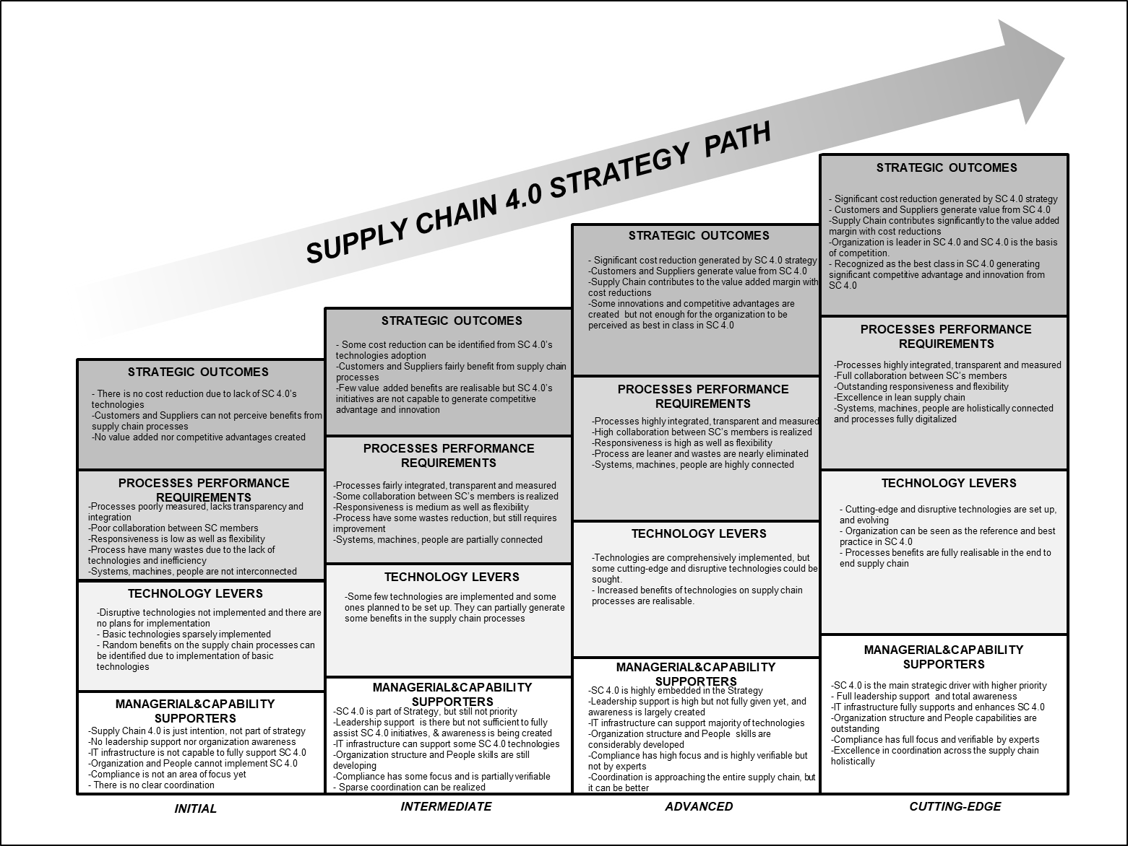

Figure 8 – Supply Chain 4.0 Maturity Framework

## 5 Conclusions and Further Research Directions

This section presents the conclusions reached by this research including some theoretical and practical implications and the limitations of this research (sub-section 5.1). Some potential research opportunities and further research direction are also presented (sub-section 5.2).

**5.1 Conclusions**

In addition to introducing the term Supply Chain 4.0 and proposing a definition for it, this article also aims at proposing a novel conceptual Supply Chain 4.0 framework as well as its evolutionary perspective in the form of a conceptual Supply Chain 4.0 Maturity framework. These fill the gaps identified in literature through a systematic literature review method where three research questions were established in order to properly guide this study. The answer to the first research question RQ1 (What are the constructs that shape the Supply Chain 4.0 framework?) was developed through analysis of findings of the systematic literature review and resulted in the identification of twenty one (21) dimensions of Supply Chain 4.0 which were thematically grouped in four (4) main constructs: **Managerial & Capability Supporters**, **Technology Levers**, **Process Performance Requirements** and **Strategic Outcomes**. Based on these constructs and their corresponding dimensions, a conceptual Supply Chain 4.0 framework was proposed.

To address the second research question RQ2 (How can the evolution of Supply Chain 4.0 be understood and evaluated?), a conceptual Supply Chain 4.0 maturity framework was developed with the four constructs as the core of the each of the four maturity levels and with the corresponding dimensions as descriptors that characterize each construct for each level (figure 8). These together provide the requisite characteristics that will facilitate understand and evaluation of supply chains with regards to Supply Chain 4.0.

This research has both theoretical and practical implications. In terms of practical implications, the two conceptual frameworks can effectively support practitioners who are involved in Supply Chain 4.0 implementation programs. Firstly, the Supply Chain 4.0 framework provides a complete view of all dimensions that must be taken into consideration in order to achieve a successful implementation and management. The clarity regarding the bottom-up cause-and-effect relationships between the constructs would be invaluable. Secondly, the Supply Chain 4.0 Maturity Framework offers a clear progression levels that are underpinned by the constructs developed which would guide practitioners aiming to achieve excellence in Supply Chain 4.0.

Based on these, this research provides a platform for further improvements with regards to Supply Chain 4.0. First, as Industry 4.0 is still seen as a new area, the Supply Chain 4.0 frameworks presented in this paper would facilitate engagement with relevant stakeholders to acquaint them with the concepts and tools leading to increase in interest and adoption of Supply Chain 4.0. Secondly, for businesses that are interested in exploring the concept further, the frameworks would provide assistance in the formulation and deployment of Supply Chain 4.0 policies and strategies. As more and more businesses continue to engage with the approach, more research and interest will be triggered leading to improvements in the tools and techniques.

In terms of theoretical implications this research makes relevant and significant contribution to the academic community as the frameworks are novel. However, as systematic literature reviews may be considered a limited research method (Banomyong, Varadejsatiwong and Oloruntoba, 2017), further studies are still required in order to validate the frameworks. Empirical studies like case studies and surveys can be fruitful in order to identify develop a more exhaustive set of dimensions particularly as Supply Chain 4.0 is still in its infancy. Also, the correlations between the four constructs need to be tested in order to validate the hypothesis of bottom-up cause-and-effect proposition. Moreover, these frameworks are generic which means that empirical studies for specific segments of supply chain management could be helpful to better understand the peculiarities of specific areas being studied.

Furthermore, the conceptual frameworks proposed can strongly support future studies and aid deeper understanding of the various aspects of Supply Chain 4.0. This aligns with the third research question RQ3 (What are the open research questions and research gaps related to Supply Chain 4.0 and its evolution?) and is addressed in the next sub-section.

**5.2 Further Research Directions**

Utilising the four constructs which form the foundation of the Supply Chain 4.0 Framework and the Maturity Framework, a number of further research questions were identified to address research question 3 of this paper. These are essentially suggestions for researchers who are interested in Supply Chain 4.0. The questions are not exhaustive but are generic enough to enable them to be applied in various supply chain operations.

* *Managerial & Capability Supporters*

1. What are the barriers in terms of HR Skills to implement and maintain the disruptive technologies of Supply Chain 4.0?
2. What are the barriers in terms of Organizational Structure to achieve and maintain a successful Supply Chain 4.0 program?
3. What are the barriers in terms of Coordination across the supply chain to successfully implement a Supply Chain 4.0 program?
4. How can Coordination influence on Supply Chain 4.0 implementation path?
5. How can Leadership Support influence on Supply Chain 4.0 implementation path?
6. How the level of Awareness of Supply Chain 4.0 impacts on its implementation?
7. How the Strategic Vision influences on the Supply Chain 4.0 programs?
8. What are the IT infrastructure requirements for the implementation of disruptive technologies of Supply Chain 4.0?
9. What is the relationship between Organizational Maturity and Supply Chain 4.0 Maturity?

* *Technology Levers*

1. Which technologies should be first prioritized in order to achieve a determined level of a Supply Chain 4.0 Maturity?
2. What are the most impacting technologies in the Supply Chain 4.0 processes?
3. What are the most cost benefit technologies in Supply Chain 4.0?
4. Which technologies should be aligned with each stage of Supply Chain 4.0 maturity?

* *Process Performance Requirements*

1. What are the impacts of disruptive technologies of Supply Chain 4.0 on the integration and interoperability along the supply chain and on its members?
2. What are the impacts of disruptive technologies of Supply Chain 4.0 on flexibility and efficiency of supply chain processes?
3. How can disruptive technologies make supply chain processes leaner?
4. What is the role of lean management in a Supply Chain 4.0 context?
5. What is the relationship between maturity of Lean and maturity of Supply Chain 4.0?
6. What are the impacts of disruptive technologies of Supply Chain 4.0 on the collaboration and transparency along the supply chain?
7. What are the benefits of disruptive technologies to the performance measurement of supply chain processes?
8. How to measure performance in Supply Chain 4.0 context?

* *Strategic Outcomes*

1. What is the impact of Supply Chain 4.0 initiatives on the profitability?
2. What are the benefits of Supply Chain 4.0 programs to the customers?
3. What levels of competitive advantages and innovation can Supply Chain 4.0 program generate?
4. What are the benefits of Supply Chain 4.0 programs to the suppliers?

These research questions could be prioritized according to the relevance of each subject. For the Managerial & Capability Supporters, the understanding of barriers related to HR Skills and Organizational Structure would be an important contribution to the subject as they are the basis for the implementation program. With regards the Technology Levers, the first questions is essential. The view of which technologies should be prioritized and implemented is crucial for the success of Supply Chain 4.0 program. On the Process perspective, the understanding of the impacts on integration and interoperability is the key to the supply chain performance. Lastly, in relation to the Strategic Outcomes, the impacts on profitability is highly significant in order to provide the view of real benefits for the organisations in putting its strategic focus on Supply Chain 4.0 initiatives. Thus, this sub-section fully addresses research question 3.

Finally, the present study contributes in proving guidance on Industry/Supply Chain 4.0, uncovers gaps and inconsistencies in the literature and identifies/proposes new paths for further research. However, to empirically validate its findings and the framework proposed as well as shedding light on emerging trends in the subject field, future research may consider the conduction of a Delphi study or a large scale survey. This is considered to be part of the future research agenda derived from the present work.

## References

Addo-Tenkorang, R. and Helo, P. T. (2016) “Big data applications in operations/supply-chain management: A literature review”, *Computers and Industrial Engineering*, Vol.101, pp. 528-543. http://dx.doi.org/10.1016/j.cie.2016.09.023

Alike, K., Rexbausen, D and Seyfert, A. (2016) “*Supply Chain 4.0 in consumer good”*’, Berlim, Germany, Mckinsey&Compant, available at: https://www.mckinsey.com/industries/consumer-packaged-goods/our-insights/supply-chain-4-0-in-consumer-goods

APICS, (2019) Supply Chain Operations Reference model, APICS Supply Chain Council available at: http://www.apics.org/apics-for-business/frameworks/scor

Ardito, L., Petruzzelli, A. M., Panniello, U. and Garavelli, A. C. (2016) “Towards Industry 4.0: Mapping digital technologies for supply chain management marketing-integration”, *Business Process Management Journal*. Vol.25 No.2, pp.173-192. https://doi.org/10.1108/BPMJ-04-2017-0088

Banomyong, R., Varadejsatiwong, P. and Oloruntoba, R. (2017) “A systematic review of humanitarian operations, humanitarian logistics and humanitarian supply chain performance literature 2005 to 2016”, *Annals of Operations Research*, pp.1-16. https://doi.org/10.1007/s10479-017-2549-5

Barata, J., Da Cunha, P. R. and Stal, J. (2018) “Mobile supply chain management in the Industry 4.0 era: An annotated bibliography and guide for future research”, *Journal of Enterprise Information Management*, Vol.31 No.1, pp.173-192. https://doi.org/10.1108/JEIM-09-2016-0156

Barreto, L., Amaral, A. and Pereira, T. (2017) “Industry 4.0 implications in logistics: an overview”, *Procedia Manufacturing*, Vol.13, pp.1245-1252. https://doi.org/ 10.1016/j.promfg.2017.09.045

Ben-Daya, M., Hassini, E. and Bahroun, Z. (2017) “Internet of things and supply chain management: a literature review”, *International Journal of Production Research*. In press,1-24. https://doi.org/10.1080/00207543.2017.1402140

Bienhaus, F. and Haddud, A. (2018) 2Procurement 4.0: factors influencing the digitisation of procurement and supply chains”, *Business Process Management Journal,* Vol.24 No.4, pp. 965-984. https://doi.org/10.1108/BPMJ-06-2017-0139

Branger, J. and Pang, Z. (2015) “From automated home to sustainable, healthy and manufacturing home: a new story enabled by the Internet-of-Things and Industry 4.0”, *Journal of Management Analytics*, Vol.2 No.4, pp.314-332. http://dx.doi.org/10.1080/23270012.2015.1115379

Brinch, M. (2018) “Understanding the value of big data in supply chain management and its business processes: Towards a conceptual framework”, *International Journal of Operations & Production Management*, Vol.38 No.7, pp.1589-1614. https://doi.org/10.1108/IJOPM-05-2017-0268

Büyüközkan, G. and Göçer, F. (2018) “Digital Supply Chain: Literature review and a proposed framework for future research”, *Computers in Industry*, Vol.97, pp. 157-177. https://doi.org/10.1016/j.compind.2018.02.010

Bukova, B., Brumercikova, E., Cerna, L. and Drozdziel, P. (2018) “The Position of Industry 4.0 in the Worldwide Logistics Chains”, *Scientific Journal on Transport and Logistic*, Vol.9 No.1. pp.18-23. https://doi.org/ 10.2478/logi-2018-0003

Chen, D., Doumeingts, G. and Vernadat, F. (2008) “Architectures for enterprise integration and interoperability: Past, present and future”, *Computers in Industry*, Vol.59, pp.647-659. https://doi.org/ 10.1016/j.compind.2007.12.016

Clark, G. (2005) ‘*The British Industrial Revolution, 1760-1780*’, World Economic History,

ECN 110B.

Dallasega, P., Raucha, E. and Linderb, C. (2018) “Industry 4.0 as an enabler of proximity for construction supply chains: A systematic literature review”, *Computers in Industry*, Vol.99, pp.205-225. https://doi.org/10.1016/j.compind.2018.03.039

Dolgui, A., Ivanov, D., Sethi, S. P. and Sokolov, B. (2018) “Architectures for enterprise integration and interoperability: Past, present and future”, *International Journal of Production Research*, In press. 1-22. https://doi.org/10.1080/00207543.2018.1442948

Fitzsimmons, J. (1994) “Information technology and the third industrial revolution”, *The Electronic Library*, Vol. 12 No.5, pp.295-29.

Frederico, G. F. (2017) “Supply Chain Management Maturity: A Comprehensive Framework Proposal from Literature Review and Case Studies”, *International Business Research*, Vol.10 No.1, pp. 68–76. http://dx.doi.org/ 10.5539/ibr.v10n1p68

Geissbauer, R., Vedso, J. and Scrauf, S. (2016) “*Industry 4.0: Building the digital enterpriseow digitization makes the supply chain more efficient, agile, and, customer-focuse”*’. Germany, PWC, available at: https://www.pwc.com/gx/en/industries/industries-4.0/landing-page/industry-4.0-building-your-digital-enterprise-april-2016.pdf

Ghobakhloo, M. (2018) “The future of manufacturing industry: a strategic roadmap toward Industry 4.0”, *Journal of Manufacturing Technology Management*, Vol.29 No.6, pp. 910-936. https://doi.org/10.1108/JMTM-02-2018-0057

Gottge, S. and Menzel, T. (2017) “*An Exploratory Multiple Case Study on the Purchasing Process Reshaped by Industry 4.0 in the Automotive Industry*”, Master Thesis, Linnaeus University. Retrieved from: http://www.diva-portal.org/smash/get/diva2:1109682/ FULLTEXT02.pdf

Gracel, J. and Lebkowski, P. (2017) “The concept of Industry 4.0 related manufacturing technology maturity model (ManuTech Maturity Model, MTMM)”. *Proceedings* *International Conference on Decision Making Manufacturing and Services (DMMS).* Krakow*,* Poland, 2017. Available at: https://www.researchgate.net/publication/ 320830841_The_concept_of_Industry_40_related_manufacturing_technology_maturity_model_ManuTech_Maturity_Model_MTMM

Gray, H. J. (1984) ‘The New Technologies: An Industrial Revolution’, *Journal of Business Strategy*, Vol. 5 No.2, pp.83-85.

Gunasekaran, A., Subramanian, N. and Tiwari, M. K. (2016) “Information technology governance in Internet of Things supply chain networks”, *Industrial Management & Data Systems,* Vol.116 No.7. https://doi.org/10.1108/IMDS-06-2016-0244

Gunasekaran, A., Papadopoulos, T., Dubey, R., Wamba, S. F., Childe, S. J., Hazen, B. and Akter, S. (2017) “Big data and predictive analytics for supply chain and organizational Performance”, *Journal of Business Research,* Vol.70, pp. 308-317. http://dx.doi.org/10.1016/j.jbusres.2016.08.004

Gökalp, E., Sener, U. and Erhan Eren, P. (2017) “Development of an Assessment Model for Industry 4.0: Industry 4.0-MM”. *Proceedings of 7th International Conference on Industrial Engineering and Systems Management (IESM).* Saarbrücken, Germany, 2017. https://doi.org/ https://doi.org/ 10.1007/978-3-319-67383-7_10

Häberer, S., Lau, L K.and Behrendt, F. (2017) “Development of an Industrie 4.0 Maturity Index for Small and Medium-Sized Enterprises”. *Proceedings of Software Process Improvement and Capability Determination (SPICE).* Košice*,* Slovakia, 2018, available at: https://www.researchgate.net/publication/320415942_Development_of_an_Industrie_ 40_Maturity_Index_for_Small_and_Medium-Sized_Enterprises

Haddud, A., DeSouza, A., Khare, A. and Lee, H. (2017) “Examining potential benefits and challenges associated with the Internet of Things integration in supply chains”, *Journal of Manufacturing Technology Management,* Vol.29 No.1. https://doi.org/10.1108/JMTM-05-2017-0094

Hazen, B. T., Skipper, J. B., Ezell, J. D. and Boone, C. A. (2016) “Big data and predictive analytics for supply chain sustainability: A theory-driven research agenda”, *Journal of Computers & Industrial Engineering,* Vol.101, pp.592-598. http://dx.doi.org/10.1016/j.cie.2016.06.030

Hofmann, E. and Rüch, M. (2017) “Industry 4.0 and the current status as well as future prospects on logistics”, *Computers in Industry*, Vol.89, pp.23-34. https://doi.org/10.1016/j.compind.2017.04.002

Iddris, F. (2018) “Digital Supply Chain: Survey of the Literature”, *International Journal of Business Research and Management*, Vol.9 No.1, pp.47-61, available at: http://www.cscjournals.org/manuscript/Journals/IJBRM/Volume9/Issue1/IJBRM-257.pdf

Ivanov, D., Tsipoulanidis, A., and Schonberger, J. (2017) *‘Global Supply Chain and Operations Management: A Decision Oriented Introduction to the Creation of Value’*, Springer, Switzerland.

Jabbour, A. B. L S., Jabbour, C.J.C., Godinho Filho, M. and Roubaud, D. (2018) “Industry 4.0 and the circular economy: a proposed research agenda and original roadmap for sustainable operations” , *Annals of Operations Research..* In press. 1-14. https://doi.org/10.1007/s10479-018-2772-8

Jonsson, P. (2008) *‘Logistics and Supply Chain Management’*, McGraw-Hill, London.

Lahti, M., Shamsuzzoha, A.H.M. and Helo, P. (2009) “Developing a maturity model for supply chain management”, *International Jounal of Logistics Systems and Management*. Vol.5 No.6, pp. 654–678. https://doi.org/10.1504/IJLSM.2009.024796

Kache, F. and Seuring, S. (2017) “Challenges and opportunities of digital information at the intersection of Big Data Analytics and supply chain management”, *International Journal of Operations & Production Management*, Vol.37 No.1, pp.10-36. https://doi.org/10.1108/IJOPM-02-2015-0078

Kagermann, H., Wahlster, W. and Helbig, J. (2013) “*Recommendations for implementing the strategic initiative INDUSTRIE 4.0”*, Frankfurt, Germany, Acatech, available at: https://www.acatech.de/Publikation/recommendations-for-implementing-the-strategic-initiative-industrie-4-0-final-report-of-the-industrie-4-0-working-group/

Kamble, S. S., Gunasekaran, A. and Gawankar, S. A. (2018) “Sustainable Industry 4.0 framework: A systematic literature reviewidentifying the current trends and future perspectives”, *Process Safety and Environmental Protection*, Vol.117, pp.408-425. https://doi.org/10.1016/j.psep.2018.05.009

Klötzer, C. and Pflaum, A. (2017) “Toward the Development of a Maturity Model for Digitalization within the Manufacturing Industry’s Supply Chain”. *Proceedings of the 50th Hawaii International Conference on System Sciences.* Haway, USA, 2017. https://doi.org/ 10.24251/HICSS.2017.509

Kolberg, D. and Zühlke, D. (2015) “Lean Automation enabled by Industry 4.0 Technologies”, *IFAC-PapersOnLine*, Vol.48 No.3, pp. 1870-1875. https://doi.org/10.1016/j.ifacol.2015.06.359

Leyh, C., Schäffer, T., Bley, K. and Forstenhäusler, S. (2016) “SIMMI 4.0 – A Maturity Model for Classifying the Enterprise-wide IT and Software Landscape Focusing on Industry 4.0”. *Proceedings of the Federated Conference on Computer Science and Information Systems.* Gdansk, Poland, 2016. https://doi.org/ 10.15439/2016F478

Liao, Y, L, Deschamps, F, Rocha Loures, E. F. and Ramos Pereira, F. P. (2017) “Past, present and future of Industry 4.0 - a systematic literature review and research agenda proposal”, *International Journal of Production Research*, Vol.55 No.12, pp.3609-3629. http://dx.doi.org/10.1080/00207543.2017.1308576

Lin, D., Lee, C.K.M., Lau, H. and Yang, Y. (2018) “Strategic response to Industry 4.0: an empirical investigation on the Chinese automotive industry”, *Industrial Management & Data Systems*, Vol.118 No.3, pp. 589-605. https://doi.org/10.1108/IMDS-09-2017-0403

Lockamy, A. and McCormak, K. (2004) “The development of a supply chain management process maturity model using the concepts of business process orientation”, *Supply Chain Management: An International Journal*, Vol.9 No.4, pp.272–278, http://dx.doi.org/ 10.1108/13598540410550019.

Lu, Y. (2017) “Industry 4.0: A survey on technologies, applications and open research issues”, *Journal of Industrial Information Integration*, Vol.6, pp.1-10. https://doi.org/10.1016/j.jii.2017.04.005

Mishra, D., Gunasekaran, A., Childe, S. J., Papadopoulos, T., Dubey, R. and Wamba, S. (2016) “Vision, applications and future challenges of Internet of Things: A bibliometric study of the recent literature”, *Industrial Management & Data Systems*, Vol.116 No.7, pp. 1331-1355. https://doi.org/10.1108/IMDS-11-2015-0478.

Mokyr, J and Strotz, R. (1998) ‘The Second Industrial Revolution, 1870-1914’, Northwestern University Web site, available at: http://faculty.wcas.northwestern.edu/~jmokyr/castronovo.pdf. Accessed September 7, 2018.

Muthusami, S. and Srinivsan, M. (2018) “Supply chain 4.0: digital tranformation, disruptions and strategies”, *Review of Business and Technology Research*, Vol.14 No.2, pp. 32-35, available at: http://mtmi.us/rbtr/dec/dec2017/06-Senthil-Srinivsan-pp32-35.pdf

Mrugalska, B. and Wyrwicka, M.K. (2017) “Towards Lean Production in Industry 4.0”, *Procedia Manufacturing*, Vol.182, pp.466-473. https://doi.org/10.1016/j.proeng.2017.03.135

Moeuf, A., Pellerin, R., Lamouri, S., Tamayo-Giraldo, S. and Barbaray, R. (2017) “The industrial management of SMEs in the era of Industry 4.0”, I*nternational Journal of Production Research*, Vol.56 No.3) 1118-1136. https://doi.org/10.1080/00207543.2017.1372647

Netland, T.H. and Alfnes, E. (2011) “Proposing a quick best practice maturity test for supply chain operations”, *Measuring Business Excellence*, Vol.15 No.1, pp.66–76, https://doi.org/ 10.1108/13683041111113259.

Nguyen, T., ZHOU, L., Spiegler, V., Ieromonachou, P. and Lin, Y. (2018) “Big data analytics in supply chain management: A state-of-the-art literature review”, *Computers and Operations Research*, Vol.98, pp.254-264. http://dx.doi.org/10.1016/j.cor.2017.07.004

Oztemel, E. and Gursev, S. (2018) “Literature review of Industry 4.0 and related technologies”, *Journal of Intelligent Manufacturing*. In press, pp.1-56. https://doi.org/10.1007/s10845-018-1433-8

Queiroz, M. M. and Telles, R. (2018) “Big data analytics in supply chain and logistics: an empirical approach”, *The International Journal of Logistics Management,* Vol.29 No.2, pp.767-783. https://doi.org/10.1108/IJLM-05-2017-0116

Pessl, E., Sorko, S. R. and Mayer, B. (2017) “Roadmap Industry 4.0 – Implementation Guideline for Enterprises”*, International Journal of Science, Technology and Society*, Vol.5 No.6, pp.193-2002. https://doi.org/10.11648/j.ijsts.20170506.14

Pereira, A.C. and Romero, F. (2017) “A review of the meanings and the implications of the industry 4.0 concept”*, Procedia Manufacturing*, Vol.13, pp.1206-1214. https://doi.org/10.1016/j.promfg.2017.09.032

Pfohl, H., Yahsi, B. and Kurnaz, T. (2015) “The Impact of Industry 4.0 on Supply Chain”. *Proceedings of the Hamburg International Conference of Logistics.* Hamburg, Germany, 2015, available at: https://hicl.org/publications/2015/20/31.pdf

Porter, M. E. and Heppelmann, J. E. (2014) “How Smart, Connected Products Are Transforming Competition”*, Harvard Business Review*, Vol.92, No.11, pp. 64-88, available at: https://hbr.org/2014/11/how-smart-connected-products-are-transforming-competition

Rajnai, Z. and Kocsis, I. (2018) “Assessing Industry 4.0 Readiness of Enterprises”. *Proceedings of 16th World Symposium on Applied Machine Intelligence and Informatics (SAMI).* Košice*,* Slovakia, 2018. https://doi.org/ https://doi.org/10.1109/SAMI.2018.8324844

Reyes, H.G. and Giachetti, R. (2010) “Using experts to develop a supply chain maturity model in Mexico”, *Supply Chain Management: An International Journal*, Vol.15 No.6, pp. 415–424 https://doi.org/10.1108/13598541011080400

Rossit, D. A., Tohmé, F. and Frutos, M. (2018) “Industry 4.0: Smart Scheduling”, *International Journal of Production Research*, In press, pp.1-12. https://doi.org/10.1080/00207543.2018.1504248

Rübel, S., Emrich, A., Klein, S. and Loos, P. (2018) “A Maturity Model for Business Model Management in Industry 4.0”. *Proceedings* *of Multikonferenz Wirtschaftsinformatik.* Lüneburg, Germany, available at: http://mkwi2018.leuphana.de/wp-content/uploads/MKWI_340.pdf

Rüttimann, B. G. and Stöckli, M. T. (2016) “Lean and Industry 4.0—Twins, Partners, or Contenders? A Due Clarification Regarding the Supposed Clash of Two Production Systems”, *Journal of Service Science and Management*, Vol.9, pp.485-500. http://dx.doi.org/10.4236/jssm.2016.96051

Sanders, A., Elangeswaran, C. and Wulfsberg, J. (2016) “Industry 4.0 Implies Lean Manufacturing: Research Activities in Industry 4.0 Function as Enablers for Lean Manufacturing”, *Journal of Industrial Engineering and Management*, Vol.9 No.3, pp. 811-833. http://dx.doi.org/10.3926/jiem.1940

Santos, K., Loures, E., Piechnicki, F. and Canciglieri, O. (2017) “Opportunities Assessment of Product Development Process in Industry 4.0”, *Procedia Manufacturing*, Vol.11, pp.1358-1365. https://doi.org/10.1016/j.promfg.2017.07.265

Schrauf, S. and Berttram, P. (2016) “*How digitization makes the supply chain more efficient, agile, and, customer-focused”*’, Germany, PWC, available at: https://www.strategyand.pwc.com/reports/digitization-more-efficient

Schoenherr, T. and Speier-Pero, C. (2015) “Data Science, Predictive Analytics, and Big Data in Supply Chain Management: Current State and Future Potential”, *Journal of Business Logistics*, Vol.36 No.1, pp. 120-132. https://doi.org/ 10.1111/jbl.12082

Schuh, G., Gartzen, T., Rodenhauser, T. and Marks, A. (2015) “Promoting working-based learning through Industry 4.0”, *Procedia CIRP*, Vol.32, pp.82-87. https://doi.org/10.1016/j.procir.2015.02.213

Schumacher, A., Erol, S. and Sihn, W. (2016) “A maturity model for assessing Industry 4.0 readiness and maturity of manufacturing enterprises”, *Procedia CIRP*, Vol.52, pp.161-166. https://doi.org/10.1016/j.procir.2016.07.040

Sirotek, S. and Firlus, B. (2016) “*Does organizational learning pay off? A case study of Norwegian and German firms regarding the link between organizational learning and the maturity of Industry 4.0 implementation*”, Master Thesis, NTNU - Norwegian University of Science and Technology, available at: https://brage.bibsys.no/xmlui/handle/11250/ 2417967

Söderberg, L. and Bengtsson, L. (2010) “Supply chain management maturity and performance

in SMEs”, Operations Management Research, Vol.3, pp.90-97. http://dx.doi.org/ 10.1007/s12063-010-0030-6

Stevens, G. and Johnson, M. (2016) “Integrating the Supply Chain … 25 years on”, *International Journal of Physical Distribution & Logistics Management*, Vol.46 No.1, pp. 19-42. https://doi.org/10.1108/IJPDLM-07-2015-0175

Stock, T. and Seliger, G. (2016) “Opportunities of Sustainable Manufacturing in Industry 4.0”, *Procedia CIRP*, Vol.40, pp.536-541. https://doi.org/10.1016/j.procir.2016.01.129

Strange, R. and Zuchella, A. (2017) “Industry 4.0, global value chains and international business”, *Multinational Business Review,* Vol.25 No.3, pp.174-184. https://doi.org/10.1108/MBR-05-2017-0028

Swanson, D. (2017) “The Impact of Digitization on Product Offerings: Using Direct Digital

Manufacturing in the Supply Chain”. *Proceedings of the 50th Hawaii International Conference on System Sciences.* Haway, USA, 2017, available at: https://doi.org/ 10.24251/HICSS.2017.508

Tan, K. H., YuanZhu, Z., Guojun, J., Ye, F. and Chang, C. (2015), “Harvesting big data to enhance supply chain innovation capabilities: An analytic infrastructure based on deduction graph”, *International Journal of Production Economics*, Vol.165, pp.223-233. http://dx.doi.org/10.1016/j.ijpe.2014.12.031

Tjahjono, B., Esplugues, C., Ares, E. and Pelaez, G. (2017) “What does Industry 4.0 mean to supply chain”, *Procedia Manufacturing*, Vol.13, pp.1175-1182. https://doi.org/10.1016/j.promfg.2017.09.191

Tranfield, D., Denyer, D. and Smart, P.(2003) “Towards a Methodology for Developing Evidence-Informed Management Knowledge by Means of Systematic Literature Review”, *British Journal of Management*, Vol.14, pp.207-222. https://doi.org/10.1111/1467-8551.00375

Tu, M. (2018) “An exploratory study of Internet of Things (IoT) adoption intention in logistics and supply chain management: A mixed research approach’, *The International Journal of Logistics Management*, Vol.29 No.1, pp.131-151. https://doi.org/10.1108/IJLM-11-2016-0274

Wamba, S. F., Akter, S., Edwards, A., Chopin, G. and Gnanzou, D. (2015),”How ‘big data’ can make big impact: Findings from a systematic review and a longitudinal case study”, *International Journal of Production Economics*, Vol.165, pp.234-246. http://dx.doi.org/10.1016/j.ijpe.2014.12.031

Wang, G., Gunasekaran, A., Ngai, E. W. T. and Papadoulos, T. (2016),”Big data analytics in logistics and supply chain management: Certain investigations for research and applications”, *International Journal of Production Economics*, Vol.176, pp.98-110. http://dx.doi.org/10.1016/j.ijpe.2016.03.014

Webster, J. and Watson, R. T. (2002), “Analysing the past to prepare for the future”, *MIS Quartely*, Vol.26 No.2, pp.8-23. http://dx.doi.org/ 10.2307/4132319

Wilkesmann, M. and Wilkesmann, U. (2018) “Industry 4.0 – organizing routines or innovations?”, *VINE Journal of Information and Knowledge Management System*, Vol.48 No.2, pp. 238-254. https://doi.org/10.1108/VJIKMS-04-2017-0019

Wilding, R and Wagner, B. (2014), “Special Issue: building theory in supply chain chain management through “systematic reviews” of the literature”, *Supply Chain Management: an International Journal*, Vol.19 No.5/6. https://doi.org/10.1108/SCM-08-2014-0275

Wu, L., Yue, X., Jin, A. and Yen, D. C. (2016) “Smart supply chain management: a review and implications for future research”, *The International Journal of Logistics Management*, Vol.27 No.2, pp. 395-417. https://doi.org/10.1108/IJLM-02-2014-0035