|  |  |
| --- | --- |
|  | |
| news & views |  |

Water use

**Meeting global drinking water needs**

The Millennium Development Goal Target 7c, to halve the proportion of the global population without access to safe drinking water by 2015, is the first international drinking water target ever met. Understanding how this was achieved is critical to replicating success.

**Dr Mark Everard**

Access to safe drinking water is essential for health, economic and social development, and recognised as a basic human right [2]. Successive international targets relating to access to drinking water have been set since 1959, veering from the practically achievable to aspirations for 100% global coverage. The 2012 report of the WHO/UNICEF Joint Monitoring Programme for Water Supply and Sanitation announced that Target 7C-Water (drinking water) of the Millennium Development Goals (MDGs) was achieved in 2010 [3]. In this issue, Fukuda et al. [1] report that this was the first time an international drinking water target had been met. Unlike predecessor targets, Target 7C-Water was proportional, halving the number of people globally lacking sustainable access to safe drinking water and basic sanitation, rather than addressing universal provision. Its attainment was largely due to significant progress in China and India.

Fukuda et al. [1] selected 139 countries for which data were available for both 1990 and 2015 addressing Gross Domestic Product (World Bank) as well as population and water services coverage (Joint Monitoring Programme [4]). Relationships between these parameters suggested that China and India, together accounting for a third of global population, were the major contributors to achievement of MDG Target 7C-Water.

Globally, rising coverage of public services generally correlates with increasing national income and economic growth [5]. Fukuda et al. [1] found an approximate logarithmic relationship between economic growth and water coverage amongst almost all developing countries experiencing growth in real Gross Domestic Product per capita, with close correlations in both China and India. As correlation does not prove causality, further research exploring other contributory factors is necessary.

The findings also highlight that achievement of MDG Target 7C-Water was significantly overestimated, as monitoring did not account for water safety. 41.5% and 60% respectively of sampled households in poor urban districts and a rural area of India were found to be using contaminated water despite high reported national compliance [6]. This observation is consistent with another modelled estimate that the population using faecally contaminated drinking water had not halved from 1990 levels [7]. Definitions of “access” and “improved water source” have varied over time, confounding comparison, with data collection also changing from administrative units to households.

The new research took account of the population growth in developing countries of 1.89 billion between 1990 and 2015 [4]. Approximately 1.5 billion of this occurred in urban areas where access to improved water sources increased by 1.48 billion people, and 376 million in rural areas where access to improved water sources rose by 979 million people. Large and growing numbers of people amongst China’s urban and India’s rural population made substantial contributions to attainment of MDG Target 7C-Water (see breakdown in the Fig 1).

*Fig 1: Summary of data from Fukuda et al. [1] for changes in population (solid boxes) and access to improved water services (patterned boxes) from 1990 to 2015 in both urban (grey) and rural (green) situations in the developing world, China and India*

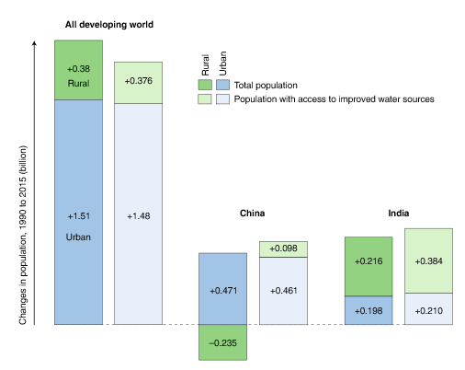

Despite some criticism in the literature of MDG Target 7C-Water for neglecting the most vulnerable, Fukuda et al. [1] record that developing countries and donors made significant efforts towards the drinking water coverage target. Their findings are particularly significant for the Sustainable Development Goals (SDGs), succeeding the MDGs as a global agenda from 2015 to 2030 and applicable to both developing and developed countries [8]. SDG Target 6.1 succeeds MDG 7C-Water, aiming at “universal and equitable access to safe and affordable drinking water for all”.

SDG Target 6.1 is challenging, seeking access to safe drinking water for the entire global population within the over-riding SDG concept of “leaving no one behind”. Monitoring indicators for SDG Target 6.1 are more specific, addressing accessibility, availability and safety of drinking water including the 2 billion people currently lacking access [9]. Updated Joint Monitoring Programme indicators also attempt to measure inequalities in drinking water affordability by disaggregating data by wealth and subnational region [9].

Findings by Fukuda et al. [1] are significant not only for physical and economic access to safe drinking water, but also linkages with all SDGs including the intention to “leave no one behind”. Universal goals stimulate motivation and investments irrespective of their practical achievability, and such ‘hard’ outcomes targets are the important for reasserting the primacy of addressing human needs in sustainable development [10]. Fukuda et al. [1] anticipate that synergies between drinking water access and economic development will remain consistent in making further progress. Given the observed close relationship between drinking water access and economic development, progress with this renewed drinking water goal is a key test of global commitment.

**Dr Mark Everard**, University of the West of England (UWE), Coldharbour Lane, Frenchay Campus, Bristol BS16 1QY, UK ([mark.everard@uwe.ac.uk](mailto:mark.everard@uwe.ac.uk)).

**References:**

[1] Fukuda, S., Noda, K. and Oki, T. *Nature Sustainability*, DOI: <https://doi.org/10.1038/s41893-019-0269-3> (2019).

[2] UN. The human right to water and sanitation, in *Resolution adopted by the General Assembly on 28 July 2010*, A/RES/64/292. (2010).

[3] WHO/UNICEF Joint Monitoring Programme. *Progress on Drinking Water and Sanitation: 2012 Update*. (2012).

[4] WHO/UNICEF Joint Monitoring Programme (JMP). <https://washdata.org/>.

[5] World Bank. *World Development Report 1992, Development and Environment*, 10–11 (Oxford University Press, New York, NY, USA, 1992).

[6] Johri, M., Chandra, D., Subramanian, S.V., Sylvestre, M. & Pahwa, S. *The Lancet* **383**, 1379 (2014).

[7] Onda, K., LoBuglio, J. & Bartram, J. *Int. J. Environ. Res. Public Health* **9**, 880–894 (2012).

[8] United Nations. *Transforming our world: the 2030 Agenda for Sustainable Development*. <https://sustainabledevelopment.un.org/post2015/transformingourworld>.

[9] WHO/UNICEF Joint Monitoring Programme. *Progress on Drinking Water, Sanitation and Hygiene 2017, Update and SDG Baselines*.

[10] Everard, M. & Longhurst, J.W.S. *Science of the Total Environment* 621, 1243-1254 (2018).