Network theory and the resilience of redox signaling

John T. Hancock^{1*}, David Veal¹, Annabel Laura Hancock²

- Department of Applied Sciences, University of the West of England, Bristol, UK.
- Centre for Medieval Studies, King’s Manor, University of York, York, UK.

*Correspondence:
Prof. John T. Hancock
Faculty of Health and Applied Sciences,
University of the West of England, Bristol, BS16 1QY, UK.
john.hancock@uwe.ac.uk

SHORT TITLE | Redox Network Theory

ABSTRACT

The redox status inside and around cells is critically important to control, being used to maintain reduced compounds in the correct state and for cell signaling mechanisms. A myriad of compounds and proteins are involved in a vast network system to regulate the redox state of biological systems. These include reactive molecules such reactive oxygen species (ROS), nitric oxide (NO·) and hydrogen sulfide (H₂S) along with systems for their removal, such as antioxidants. Redox buffering involves molecules such as glutathione, low molecular weight thiols and ascorbate. Network Theory attempts to give the mechanisms underlying complex networks a mathematical and model-based underpinning and it has been suggested that metabolic systems can be described as scale-free networks, having a power law degree distribution. Such networks are said to be both robust but vulnerable, suggesting a level of resilience. Redox metabolism also has to be robust, being maintained in what has been described as the Goldilocks Zone, while it is also vulnerable to outside influence, often leading to the phenomenon referred to as oxidative stress. Therefore, it is suggested here that a holistic approach to understand redox networks should embrace Network Theory, which may be able to predict characteristics of the redox network that can be targeted for new therapeutics or agricultural treatments.

KEYWORDS | Hydrogen sulfide; Nernst equation; Network Theory, Nitric oxide; Reactive oxygen species; Redox; Resilience, Signaling; Stress.

ABBREVIATIONS | APX, Ascorbate peroxidase; Arg, arginine; CAT, catalase; cGMP, Cyclic guanosine monophosphate; Cys, cysteine; Cys-Gly, cysteinyl-glycine; cySS, cystine; DHA, dehydroascorbate; EDRF, endothelial-derived relaxing factor; FA, fatty acid; FA-NO, nitro-fatty acid; Glu, glutamate; γ-Glu-Cys, γ-glutamyl-cysteine; GPx, glutathione peroxidase; GR, glutathione reductase; GSH, reduced form of glutathione; GSSG, oxidized form of glutathione; LMW, low-molecular weight; MPO, myeloperoxidase; NADH, reduced form of nicotinamide adenine dinucleotide; NADPH, reduced form of nicotinamide adenine dinucleotide phosphate; NO, nitric oxide; NOS, nitric oxide synthase; RNS, reactive nitrogen species; ROS, reactive oxygen species; SOD, superoxide dismutase; α-TCP, α-tocopherol; TRX, thioredoxin; TRX-red, thioredoxin reductase; X/HX, xanthine/hypoxanthine; XO, Xanthine oxidase.

CONTENTS
- Introduction
- Redox Biology and the Control of Cellular Function
- The Basics of Network Theory
- Can Network Theory be Useful to Explain Redox Biology?
- Conclusion and Perspectives

Competing Interests Statement

Acknowledgements

References

- INTRODUCTION

The redox status of the cell is extremely important and well controlled [1]. It is vital to be maintained in a relatively reduced state so the cell may maintain the reduced versions of cofactors such as NAD(P)H [2], is important to allow chemical interactions, and is allowed to fluctuate to facilitate its role in cell signaling [3,4]. The redox of a cell will be influenced by a range of factors including the arrival of redox active compounds from the outside [5], the production of intracellular redox compounds such as glutathione [6] or the activity of a range of antioxidant mechanisms [7].

Life evolved in an environment very different to that which most organisms are exposed to today [8]. Early life was influenced by sulfur chemistry [9] and later organisms had to manage the increase in atmospheric and dissolved oxygen [10]. Many of the compounds influencing evolution exist as redox couples and therefore have the ability to impact on the redox state of the solution in which they exist. Cells had to develop strategies to manage the presence of such redox couples, some of which would be oxidizing to the cellular environment. Interestingly, cells not only tolerated the presence of such redox couples but also adopted many of these redox compounds to be regulators of cellular activity [8,11-13]. This included compounds such as hydrogen peroxide (H₂O₂), hydrogen sulfide (H₂S) and nitric oxide (NO·). Therefore, one constant during evolution, and in present day, is that redox chemistry is vital to the survival of cells, tissues and organisms.

It is important, therefore, that the way redox chemistry influences cell activity is more fully understood, especially on the arrival of redox active compounds from the environment or other cells [14]. Here, it is suggested that network theory can be used as an aid in the understanding of how the redox status of the cell may alter when impacted upon by external factors or by cellular dysfunction. Hence, as a results it will help the understanding of cellular adaptation and resilience, which will be key to healthier crops and disease management in animals, including humans.

- REDOX BIOLOGY AND THE CONTROL OF CELLULAR FUNCTION

Early work on redox active signaling molecules focused mainly on those centered around oxygen-based chemistry. Molecules such as the superoxide anion (O₂^{·-}) and hydrogen peroxide were found to be produced by cells and important for pathogen resistance [15] but more recently it has been found that such molecules have a positive role in controlling cell function. Enzymes such as the NADPH oxidase family [recently reviewed in 16] and peroxidases [17] are involved.

However, ROS are not the only redox active compounds that can influence cellular function. In 1987 it was realized that nitric oxide (NO) has a major role [18], being previously dubbed as endothelial-derived relaxing factor (EDRF), and later found to be produced by nitric oxide synthases (NOS) [19]. This opened the door to much research into how reactive compounds can be involved in cell signaling processes. This included NO [20] and ROS [21], but also hydrogen sulfide (H₂S) [22] and hydrogen gas (H₂) [23,24]. However, the generation of this suite of compounds can be initiated by common triggers and they may temporally and spatially accumulate together, suggesting numerous interactions between them [25,26]. The notion of a Reactive Species Interactome has been mooted, suggesting that the redox components in a cell form a regulatory system that can overcome environmental challenge and stresses, and may lead to novel approaches to personalized medicine [27].

Compounds such as ROS exist as redox couples and therefore can have an influence on the redox poise of the cell. The intracellular redox status is kept at a very reducing level. This is partly to enable critical compounds such as NAD(P)H to be maintained in a reduced state [2], but also to enable redox signaling [3]. Several groups have attempted to measure the extracellular [28-30] and intracellular redox states [31-35] while it is well recognized that the redox of the cell is heavily buffered, partly by glutathione [36]. Using the glutathione couple (ie GSH/GSSG) as a model with the aid of the Nernst equation it is possible to calculate the cell’s redox state once the concentrations of GSH and GSSG have been determined [36-38] (the mid-point potential for the GSH/GSSG couple has be reported [39]). However, as it requires two GSH to create one GSSG the Nernst equation becomes a squared relationship – the corollary of this is that the intracellular redox also depends on the total GSH+GSSG content, which can change [40]. In plasma, a diurnal pattern has been seen [28], while it has also be suggested that redox status may follow the circadian clock [1]. However, using such measurements the intracellular redox has been estimated to be around -242mV (relative to hydrogen), although more negative numbers have also be reported [37,41]. Significantly, it has also be suggested that it can become significantly more oxidizing leading to the onset of cell differentiation or apoptosis [36], while plasma redox has been found to become more oxidizing with age [1,33], and is therefore less adaptable. However, several other redox buffers also exist in cells, including other low molecular weight (LMW) thiols, such as cysteine (Cys), cyteinyl-glycine (Cys-Gly) and γ-glutamyl-cysteine (γ-Glu-Cys) [42]. Another major redox buffer is ascorbate, while cells rely on a range of other antioxidant compounds (some soured from diet) and antioxidant enzymes, such as superoxide dismutase (SOD) and catalase (CAT).

Therefore there is a network of reactions between a range of reactive compounds in cells which may impinge on the overall redox state of the cell. On top of this many such compounds may arrive at a cell from the environment and it is thought that the arrival of oxidizing compounds can lead to oxidative stress [43] and the harmful downstream effects that causes disease [44].

The background redox status and numerous redox couples feeds into the signaling network of the cell. NO, for example, can activate soluble guanylyl cyclase and so increase intracellular cGMP levels [45], leading to downstream effects. Of particular importance is the post-translational alteration of protein thiols. ROS, NO, H₂S and glutathione can all lead to modifications of thiols, perhaps in a competitive manner [25,46]. However, the capacity to undertake such reactions will also be influenced by the redox environment of the thiol group and therefore the cellular redox status is important. Proteins which can be influenced by thiol modification includes those involved in metabolism, such as glyceraldehyde 3-phosphate dehydrogenase [47], transcription factors [48], and phosphatases [49], the latter impinging on overall phosphorylation levels in cells. For a more comprehensive review on redox signaling see [50,51].

What is clear from the literature is that controlling the redox status in a cell within limits is important [36] and the redox status of the cell needs to be resilient to influences from outside, such as the arrival of redox active compounds (eg ROS, NO, H₂S etc). Here, it is mooted that network theory may in the future be able to model how redox poise might change in cells.

- THE BASICS OF NETWORK THEORY

Network Theory is an attempt to place a mathematical underpinning to complex systems. One of the most influential papers in this field was published in 1999, when Barabasi and Albert introduced the concept of scaling in random networks [52]. The idea of the use of Network Theory was popularized by the publication of Linked [53], with a more recent book, Network Science, published by the same author [54].

Many of the networks which have been used to describe a variety of systems, from social, technological to biological are what are described as scale-free networks. Li et al. [55] recently has suggested that the term is not defined rigorously enough but there are some features which are useful for redox metabolism. Firstly, such networks are described as having a series of nodes which are connected. This could be visualized as shown in Figure 1. Secondly, such networks follow a power law degree of distribution (Figure 2). That is, it would be predicted that most of the nodes have only a few links to other nodes, but there are fewer which are highly connected and can be thought of as hubs. Such hubs would have a major influence on the whole. In biological systems the nodes and hubs are determined by the presence of certain chemicals, while the interconnections (edges) are the processes which convert one chemical to another (enzyme activities, for example) [56]. In this way, metabolic processes can be re-drawn in the ball and stick manner seen in Figure 1, and as discussed for redox biology below.

Of particular relevance to the discussion below on redox resilience, scale-free networks are said to be “robust yet fragile” and have “error tolerance but attack vulnerability” [55,57]. This means that there is a built in resilience to change, especially if a node is altered, but there is less resilience if a major hub is modulated. Therefore, if this is going to be used to help in our understanding of redox mechanisms the nodes and hubs need to be determined (see below).

Scale-free networks have not been short of criticism. It has been argued that elements of biochemistry have been misinterpreted when scale-free Network Theory has been applied [58] and therefore scale-free networks do not provide a good model. In their paper, Li et al. [55] argued that in biology the influence of evolution, design, functionality and other constraints should not be ignored, but are not readily taken into account in a scale-free network. One of the constraints is that biological systems have a structure: cells are not uniform but are compartmentalized, often in ways which are not obvious. Even the cytoplasm is not uniform and compartmentalization has been reported and discussed for many signaling mechanisms [59], including those involving cAMP [60,61], Ca²⁺ [62,63], ROS [64,65] and redox poise [14,66]. Therefore, any model needs to take such structures into account, but scale-free network models may not do this. Although not concerned directly with the physical structures of cells, Itzkovitz et al. [67] suggested how to incorporate local structures of networks in what was referred to as course-graining, which was an attempt to understand the microscopic features of networks and their structures, referred to as motifs. They looked at signal transduction in cells, in particular the MAP-kinase pathways. Further work by others was carried out, taking the idea of structural patterns to understand complex networks such as found in biological systems [68]. Their models were based on complexity signatures, a suggested biological example is species density in a rain forest.

Scale-free networks are not the only mathematical underpinning which need to be considered, and in fact their use has been criticized in recent papers [55, 69,70]. Another approach, discussed by Li et al. [55], is referred to by the acronym HOT, which stands for Highly Optimized Tolerance [71,72] or Heuristically Organized Tradeoffs [73]. Introduced from systems in physics, it concentrates on defining organised complexity. As it has a focus on constraints, including function and organisation it may be considered better for the modelling of biological systems, and in fact has been used to model cell-cell architectures [74]. Interestingly, HOT networks have been considered to give opposite results from scale-free networks [55]. Furthermore, HOT is a predictive model which can model how external factors may change the network. Therefore, it may be useful for modelling oxidative stress which can be initiated by the arrival of oxidant molecules from outside of the cell.

Other models for modelling metabolism have also been used, for example by Pearcy et al. [75] looking at bacterial metabolism and Toubiana et al. studying plant metabolism [76].

- CAN NETWORK THEORY BE USEFUL TO EXPLAIN REDOX BIOLOGY?

The idea of using Network Theory to get a better understanding of biological systems is certainly not a new idea. In 1925, Yule [77] developed models to study species within genera of plants. To study mutants in bacterial populations models were developed by Luria and Delbrück in 1943 [78]. Some of the early work is further discussed by Mandelbrot [79] and Li et al. [55]. More recently several papers have used Network Theory to explain metabolic, genetic and biochemical processes [56,80-82] while mathematical models have been used to determine the energy cost of cells sensing their environment [83].

Barabasi [39] suggests that metabolism can be drawn as a network, where the nodes are the chemicals involved and the links are the biochemical reactions which connect them. He goes on to suggest that there is a ‘cellular network’ where all cellular components are connected by links, either reactions or physically. Having examined the metabolic maps of forty-three organisms the cellular network appeared to have a scale-free topology. Hubs of the metabolism could be seen where a few molecules were involved in the majority of reactions while most molecules only participated in one or two interactions [53]. It was suggested that despite differences in constituents and pathways, metabolic networks had many similarities to non-biological systems [84]. It was further suggested that the organization of metabolism had a design which conformed to that of an error tolerant and robust scale-free network. Furthermore, Barabasi [53] suggests that if molecules are separated by many nodes the perturbation of one will decay before effects on the other are seen, suggesting resilience of the system. But he goes on to say that cellular molecules only have three degrees of separation in general. Such a network is described as scale-free with small world properties [85]. Interestingly, they also predicted that the molecules forming the largest hubs were found earlier in evolutionary history.

However, very recently there has been doubt cast on the validity of using a Network Theory approach. Firstly the actual definition of a scale-free network [55] has been questioned (there are at least six characteristics which may be used as a definition). Secondly, their use for a variety of systems has been robustly explored [69]. This work looked at a variety of possible networks including social and technological as well as those involving, transportation and information, but of relevance here biological networks were also considered. While social networks were found to be largely weakly scale-free, some of the most strongly scale-free were found to be biological, particularly metabolic systems [69,70]. Therefore, here, we suggest, even though there are other models [71,73,75,76] that using Network Theory based on a scale-free model to look at the metabolic processes which control redox homeostasis would be a valid approach.

To use a scale-free network with a node and hub model the components of the network needs to be known, along with the mechanisms which allow their interconversion, such as chemical or enzymatic processes [39]. With respective to redox it has been suggested that there is a Redox Code [1]. Four principles were given: 1, a core feature is the metabolism of NAD(P)/NAD(P)H operating at near equilibrium; 2, activities can be controlled through protein-based sulfur switching; 3, activation of ROS production in a cyclic manner supports differentiation and the life cycle; 4, redox networks form an adaptive system to allow responses to the environment. These principles highlight two things. Firstly, the redox environment has to be maintained at a certain level to allow NAD(P)H metabolism to work efficiently and to allow protein thiol modification – it is known to be relatively reducing [36] which would facilitate the metabolism needed [2]. Secondly, the redox status of the cell has to be able to cope with change, either from endogenous metabolism or from external factors.

With a focus on striated muscle, it has been suggested that the redox environment is maintained in what has been dubbed the Goldilocks Zone [86], and as depicted in Figure 3A. It was suggested that the redox environment fluctuates, in this case because of exercise and aerobic metabolism. However, despite the variation of the redox if never falls outside a defined region, neither becoming too oxidizing nor too reducing, and hence cell function and integrity is maintained. For other cells this could also be a good model, as the redox may fluctuate (Figure 3A), for example with the movement of glutathione [40], or as a diurnal pattern [28] or with age [1] (see Figure 3B), but the redox environment will not be modulated enough to cause oxidative or reductive stress, as schematically shown in Figure 3. This shows some resilience of the redox status, as it can be altered but will stay within safe limits, although it has been suggested that with age redox may become more oxidizing with a loss of adaptability [1]. However, if the network of redox components is altered too much redox stress will result. Network theory would be a useful tool to determine which nodes are vulnerable to attack and therefore may influence the overall redox environment.

To use the ideas of a scale-free network as proposed by Barabasi and Albert [52] and recently suggested for metabolic pathways by Briodo and Clauset [69], a node and stick model needs to be drawn. Taking elements of the possible redox components in a cell, a network such as Figure 4 can be created. However, there are several caveats here. Firstly, this would not be the same for all organisms or indeed tissues or cells. For example, there is considerable controversy over the enzymes which generate NO in higher plants which are probably not the same as those seen in animals [87], so drawing a network in this area of redox biology would not be easy. This also means that the network drawn for one system would need to be tailored for another system. Secondly, many of the components of the redox network exist in interchangeable couples, with the interchange involving the addition or removal of electrons and perhaps protons, for example, the 2GSH/GSSG couple. If the redox mid-point potential for a couple is relatively negative and near the redox status of the biological fluid it is in, then fluctuations of the redox of that fluid, as discussed by Alleman [86], has the potential to alter the concentration ratio of the components of that couple, and this can potentially alter the biological activity of that redox component. An assessment of the impact of the redox environment on some relevant redox couples has been previously reviewed [14]. Thirdly, there is a considerable amount of structure in biological systems that needs to be taken into account. For example, ROS can be generated by soluble enzymes (eg xanthine oxidoreductase), membrane-bound enzymes (NAPDH oxidases) or from organelles (eg mitochondria). It would not be unusual for redox components to move between cellular compartments, for example glutathione out of the cell [40] or ROS from organelles, and therefore have profound effects [88].

Despite the chemical and biological caveats above, all which may be overcome with time, Network Theory has the potential to assess the resilience of networks such as those redox components. The redox status of the cell is not static [40,86] and will be influenced by external factors, possibly leading to oxidative stress [43]. Many interacting redox compounds may arrive from the outside, including ROS, NO, H₂S and H₂ [25,26] – the latter which has been shown to interfere with ROS and antioxidant metabolism [24,89]. Therefore, to keep the redox status within the Goldilocks Zone [86] an element of resilience is needed. Network Theory can assess such resilience.

It has been found that scale-free networks have a high, unexpected, degree of robustness [57]. Even with high node failure rates they are able to function, but this means that they are vulnerable to attack if certain nodes are upset. Therefore, if this is extrapolated to redox networks it suggests that some nodes are not as important as others, that there is a redundancy in some and not others. Redundancy of metabolic networks has recently been the subject of review [90]. This extrapolation also suggests that there are important nodes, referred to in scale-free networks as hubs, which are important and vulnerable. Therefore, within redox networks such robust nodes and vulnerable hubs need to be identified. Owing to its high concentration in cells and therefore high buffering capacity the glutathione couple [36] may be regarded as a key redox hub.

Network theory can in principle take the field further. By developing analytical tools and mathematical frameworks to scale-free networks, using examples from biological sciences, such as ecological and gene regulatory networks, Gao et al. [91] suggest that it is possible to define the characteristics of a network which can be used to either enhance or reduce resilience. Such characteristics could then be used to enhance redox resilience through pharmacological intervention or agricultural treatments. Perhaps glutathione metabolism is one such characteristic [92].

5. CONCLUSIONS AND PERSPECTIVES

The redox status of biological fluids is critically important, used in cell signaling mechanisms [8,11,12,13] and known to be vital for the health of the cell [93-95]. However, although the maintenance of a reducing redox state in cells seems to be a universal feature it must be remembered that the constituent players in different organisms may be different. For example, NO is almost certainly not produced by a nitric oxide synthase in higher plants, the NO being derived through a nitrate reductase-mediated route [87].

Although there are several network models and mathematical treatise [55], it has recently been suggested that metabolic systems resemble a scale-free network [69,70] and as such can be schematically represented as an interconnected node system as depicted in Figures 1 and 4. Therefore, it is mooted here that such a treatise of the redox network can be used to determine what would constitute the hubs of the system and therefore which parts are vulnerable to external influence. Within such a network it has been suggested that some nodes can be modulated with little effect to the whole system [53] and therefore these would not make good drug targets if redox status is to be maintained. It would be the hubs of the system that would need to be the focus of future work and effects of such hubs could be determined using a scale-free network model. However, to do this, the spatial and temporal concentrations of the constituents of such nodes and hubs would need to be determined. Future therapies, making sure that redox does not have any delirious effects, would need to make sure that the redox status of cell and biological fluids remained in the Goldilocks Zone [86], and network theory may be a way to test any future potential redox-based pharmaceuticals [27] or agricultural useful treatments.

In conclusion, there is little doubt that a vast network of redox components (couples) and interacting partners coordinate to maintain the over redox environment of biological systems, and even if there are variations of redox the status is kept within a Goldilocks Zone [86]. Network Theory [69] could be used to determine the resilience and vulnerability of redox metabolism but temporal and spatial concentrations (of both sides of a redox couple) would need to be known and such detail needs to be the future focus of research which can then benefit from the mathematics being developed in the field of Network Theory.

COMPETING INTERESTS STATEMENT
The authors declare that they have no competing financial interests.

ACKNOWLEDGEMENTS
This work was funded by the University of the West of England, Bristol, who financed the authors’ time and literature sourcing for the preparation of this manuscript.

REFERENCES
[1] Jones DP, Sies H. The redox code. Antiox Redox Signal 2015; 23:734–746. doi: 10.1089/ars.2015.6247.
[2] Bücher T, Brauser B, Conze A, Klein F, Langguth O, Sies H. State of oxidation-reduction and state of binding in the cytosolic NADH-system as disclosed by equilibration with extracellular lactate-pyruvate in hemoglobin-free perfused rat liver. Eur J Biochem 1972; 27(2):301–17.

[3] Forman HJ, Ursini F, Maiorino M. An overview of mechanisms of redox signaling. J Mol Cell Cardiol 2014; 73:2–9. doi: 10.1016/j.yjmcc.2014.01.018.
[4] Hancock JT. The role of redox mechanisms in cell signalling. Mol Biotechnol 2009; 43(2):162–6. doi: 10.1007/s12033-009-9189-1.
[5] Farah C, Michel LYM, Balligand JL. Nitric oxide signalling in cardiovascular health and disease. Nat Rev Cardiol. 2018; 5(5):292-316. doi: 10.1038/nrcardio.2017.224.
[6] Lu SC. Glutathione synthesis. Biochim Biophys Acta. 2013;1830(5):3143-53. doi: 10.1016/j.bbagen.2012.09.008.
[7] Pisoschi AM, Pop A. The role of antioxidants in the chemistry of oxidative stress: A review. Eur J Med Chem. 2015; 97:55-74. doi: 10.1016/j.ejmech.2015.04.040.
[8] Hancock JT. Harnessing evolutionary toxins for signaling: Reactive oxygen species, nitric oxide and hydrogen sulfide in plant cell regulation. Frontiers in Plant Science 2017; 8:189. doi: 10.3389/fpls.2017.00189.
[9] Olson KR, Straub KD. The role of hydrogen sulfide in evolution and the evolution of hydrogen sulfide in metabolism and signaling. Physiology 2016; 31:60–72. doi: 10.1152/physiol.00024.2015.
[10] Reinhard CT, Planavsky NJ, Olson SL, Lyons TW, Erwin DH. Earth's oxygen cycle and the evolution of animal life. Proc Natl Acad Sci USA. 2016; 113(32):8933-8. doi: 10.1073/pnas.1521544113.
[11] Mittler R. Ros are good. Trends Plant Sci 2017; 22(1):11-19. doi: 10.1016/j.tplants.2016.08.002.
[12] Basudhar D, Ridnour LA, Cheng R, Kesarwala AH, Heinecke J, Wink DA. Biological signaling by small inorganic molecules. Coord. Chem. Rev. 2016; 306:708–723. doi:10.1016/j.ccr.2015.06.001.
[13] Fukuto JM, Carrington SJ, Tantillo DJ, Harrison JG, Ignarro LJ, Freeman BA, Chen A, Wink DA. Small molecule signaling agents: the integrated chemistry and biochemistry of nitrogen oxides, oxides of carbon, dioxygen, hydrogen sulfide, and their derived species. Chem Res Toxicol 2012; 25:769–793.
[14] Hancock, J. T. and Whiteman, M. (2018) Cellular redox environment and its influence on redox signalling molecules. Reactive Oxygen Species, 5 (14).
[15] Nguyen GT, Green ER, Mecsas J. Neutrophils to the ROScue: Mechanisms of NADPH oxidase activation and bacterial resistance. Front Cell Infect Microbiol. 2017; 7:373. doi: 10.3389/fcimb.2017.00373.
[16] Ewald CY. Redox signaling of NADPH oxidases regulates oxidative stress responses, immunity and aging. Antioxidants 2018; 7:130. doi.org/10.3390/antiox7100130.
[17] Camejo D, Guzmán-Cedeño Á, Moreno A. Reactive oxygen species, essential molecules, during plant-pathogen interactions. Plant Physiol Biochem. 2016; 103:10-23. doi: 10.1016/j.plaphy.2016.02.035.
[18] Palmer RM, Ferrige AG, Moncada S. Nitric oxide release accounts for the biological activity of endothelium-derived relaxing factor. Nature 1987; 327:524-6.
[19] Lind M, Hayes A, Caprnda M, Petrovic D, Rodrigo L, Kruzliak P, Zulli A. Inducible nitric oxide synthase: Good or bad? Biomed Pharmacother. 2017; 93:370-375. doi: 10.1016/j.biopha.2017.06.036.
[20] Astuti RI, Nasuno R, Takagi H. Nitric oxide signaling in yeast. Appl Microbiol Biotechnol. 2016; 100:9483-9497. doi:10.1007/s00253-016-7827-7.
[21] Schieber M, Chandel NS. ROS function in redox signaling and oxidative stress. Curr Biol. 2014; 24:R453-62. doi: 10.1016/j.cub.2014.03.034.
[22] Kimura H. Hydrogen sulfide and polysulfide signaling. Antioxid Redox Signal. 2017; 27:619-621. doi: 10.1089/ars.2017.7076.
[23] Iida A, Nosaka N, Yumoto T, Knaup E, Naito H, Nishiyama C, Yamakawa Y, Tsukahara K, Terado M, Sato K, Ugawa T, Nakao A. The clinical application of hydrogen as a medical treatment. Acta Med Okayama 2016; 70:331-337. doi: 10.18926/AMO/54590.

[24] Ohta S. Molecular hydrogen as a novel antioxidant: Overview of the advantages of hydrogen for medical applications. Methods in Enzymology 2015; 555:289-317. doi: 10.1016/bs.mie.2014.11.038.
[25] Hancock JT, Whiteman M. Hydrogen sulfide and cell signaling: Team player or referee? Plant Physiology and Biochemistry 2014; 78: 37-42. doi: 10.1016/j.plaphy.2014.02.012.
[26] Hancock JT, Whiteman M. Hydrogen sulfide signaling: Interactions with nitric oxide and reactive oxygen species. Annals of the New York Academy of Sciences 2016; 1365:5-14. doi: 10.1111/nyas.12733.
[27] Cortese-Krott MM, Koning A, Kuhnle GGC, Nagy P, Bianco CL, Pasch A, Wink DA, Fukuto JM, Jackson AA, van Goor H, Olson KR, Feelisch M. The reactive species interactome: Evolutionary emergence, biological significance, and opportunities for redox metabolomics and personalized medicine. Antioxid Redox Signal 2017; 27: 684-712. doi: 10.1089/ars.2017.7083.
[28] Blanco RA, Ziegler TR, Carlson BA, Cheng PY, Park Y, Cotsonis GA, Accardi CJ, Jones DP. Diurnal variation in glutathione and cysteine redox states in human plasma. Am J Clin Nutr 2007; 86:1016–1023.
[29] Ueland PM. Homocysteine species as components of plasma redox thiol status. Clin Chem 1995; 41:340–342.

[30] Jones DP, Carlson JL, Mody VC, Cai J, Lynn MJ, Sternberg P. Redox state of glutathione in human plasma. Free Radic Biol Med 2000; 28(4):625–35.

[31] Hutter DE, Till BG, Greene JJ. Redox state changes in density-dependent regulation of proliferation. Exp Cell Res 1997; 232(2):435–8. doi: 10.1006/excr.1997.3527.

[32] Kirlin WG, Cai J, Thompson SA, Diaz D, Kavanagh TJ, Jones DP. Glutathione redox potential in response to differentiation and enzyme inducers. Free Radic Biol Med 1999; 27(11–12):1208–18.
[33] Jones DP, Mody VC Jr, Carlson JL, Lynn MJ, Sternberg P Jr. Redox analysis of human plasma allows separation of pro-oxidant events of aging from decline in antioxidant defenses. Free Radic Biol Med 2002; 33:1290–1300.

[34] Cai J, Wallace DC, Zhivotovsky B, Jones DP. Separation of cytochrome c-dependent caspase activation from thiol -disulfide redox change in cells lacking mitochondrial DNA. Free Radic Biol Med 2000; 29(3–4):334–42.

[35] Hwang C, Sinskey AJ, Lodish HF. Oxidized redox state of glutathione in the endoplasmic reticulum. Science 1992; 257(5076):1496–502.
[36] Schafer FQ, Buettner GR. Redox environment of the cell as viewed through the redox state of the glutathione disulfide/glutathione couple. Free Radic Biol Med 2001; 30(11):1191–212.
[37] Aller I, Rouhier N, Meyer AJ. Development of roGFP2-derived redox probes for measurement of the glutathione redox potential in the cytosol of severely glutathione-deficient rml1 seedlings. Front Plant Sci 2013; 4:506. doi: 10.3389/fpls.2013.00506.

[38] Hwang C, Lodish HF, Sinskey AJ. Measurement of glutathione redox state in cytosol and secretory pathway of cultured cells. Methods Enzymol 1995; 251:212–21.

[39] Rost J, Rapoport S. Reduction-potential of glutathione. Nature 1964; 201:185.

[40] Ghibelli L, Coppola S, Rotilio G, Lafavia E, Maresca V, Ciriolo MR. Non-oxidative loss of glutathione in apoptosis via GSH extrusion. Biochem Biophys Res Commun 1995; 216(1):313–20. doi: 10.1006/bbrc.1995.2626.

[41] Bücher T, Sies H. Metabolic interaction of mitochondrial and cytosolic systems in rat liver. In: Cell Compartmentation and Metabolic Channeling (L Nover, F Lynen, K Mothes) Fischer Verlag, Jena, Germany. 1980, pp.279-302.

[42] Birtić S, Colville L, Pritchard HW, Pearce SR, Kranner I. Mathematically combined half-cell reduction potentials of low-molecular-weight thiols as markers of seed ageing. Free Radic Res. 2011; 45:1093-102. doi: 10.3109/10715762.2011.595409.

[43] Schrieber M, Chandel NS. ROS function in redox signaling and oxidative stress. Curr Biol 2014; 24(10):R463-62. doi: 10.1016/j.cub.2014.03.034.
[44] Pizzino G, Irrera N, Cucinotta M, Pallio G, Mannino F, Arcoraci V, Squadrito F, Altavilla D, Bitto A. Oxidative stress: harms and benefits for human health. Oxid Med Cell Longev. 2017; 2017:8416763. doi: 10.1155/2017/8416763.

[45] Mónica FZ, Bian K, Murad F. The endothelium-dependent nitric oxide-cGMP pathway. Adv Pharmacol. 2016; 77:1-27. doi: 10.1016/bs.apha.2016.05.001.

[46] Forman HJ. Glutathione: from antioxidant to post-translational modifier. Arch Biochem Biophys 2016; 595:64–7. doi: 10.1016/j.abb.2015.11.019.

[47] Sirover MA. Subcellular dynamics of multifunctional protein regulation: mechanisms of GAPDH intracellular translocation. J. Cell Biochem. 2012; 113:2193-2200. doi.org/10.1002/jcb.24113.

[48] Klotz LO, Sánchez-Ramos C, Prieto-Arroyo I, Urbánek P, Steinbrenner H, Monsalve M. Redox regulation of FoxO transcription factors. Redox Biol. 2015; 6:51-72. doi: 10.1016/j.redox.2015.06.019.

[49] Rahikainen M, Pascual J, Alegre S, Durian G, Kangasjärvi S. PP2A Phosphatase as a Regulator of ROS Signaling in Plants. Antioxidants (Basel). 2016; 5(1):pii: E8. doi: 10.3390/antiox5010008.

[50] Gào X, Schöttker B. Reduction-oxidation pathways involved in cancer development: a systematic review of literature reviews. Oncotarget. 2017; 8(31):51888- 51906. doi: 10.18632/oncotarget.17128.

[51] Ferguson GD, Bridge WJ. The glutathione system and the related thiol network in Caenorhabditis elegans. Redox Biol. 2019; 24:101171. doi: 10.1016/j.redox.2019.101171.
[52] Barabasi, A-L., Albert R. Emergence of scaling in random networks. Science 1999; 286:509-512.
[53] Barabasi A-L. Linked: The new science of networks. 2002, Perseus Publishing, Cambridge USA.
[54] Barabasi A-L. Network Science. 2016, Cambridge University Press, Cambridge, UK.
[55] Li L, Alderson D, Doyle JC, Willinger W. Towards a theory of Scale-Free Graphs: Definition, properties, and implications. Internet Mathematics 2005; 2:431-523. doi: 10.1080/15427951.2005.10129111.
[56] Barabási AL, Oltvai ZN. Network biology: understanding the cell's functional organization. Nat Rev Genet 2004; 5:101-113.
[57] Albert R, Jeong H, Barabasi A-L Error and attack tolerance of complex networks. Nature 2000; 406:378–382.
[58] Tanaka R. Scale-rich metabolic networks. Physical Review Letters 2005; 94:168101.
[59] McCormick K, Baillie GS. Compartmentalisation of second messenger signalling pathways. Current Opinion in Genetics & Development 2014; 27:20–25. doi: 10.1016/j.gde.2014.02.001.
[60] Zaccolo M, Magalhães P, Pozzan T. Compartmentalisation of cAMP and Ca²⁺ signals. Current Opinion in Cell Biology 2002; 14:160–166.
[61] Baillie GS, Scott JD, Houslay MD. Compartmentalisation of phosphodiesterases and protein kinase A: opposites attract. FEBS Letters 2005; 579:3264–3270.
[62] Nunes P, Cornut D, Bochet V, Hasler U, Oh-Hora M, Waldburger JM, Demaurex N. STIM1 juxtaposes ER to phagosomes, generating Ca²⁺ hotspots that boost phagocytosis. Current Biology 2012; 22:1990–1997. doi: 10.1016/j.cub.2012.08.049.
[63] Bononi A, Missiroli S, Poletti F, Suski JM, Agnoletto C, Bonora M, De Marchi E, Giorgi C, Marchi S, Patergnani S, Rimessi A, Wieckowski MR, Pinton P. Mitochondria-associated membranes (MAMs) as hotspot Ca²⁺ signaling units. Advances in Experimental Medicine and Biology 2012; 740: 411–437. doi: 10.1007/978-94-007-2888-2_17.
[64] de Rezende FF, Martins Lima A, Niland S, Wittig I, Heide H, Schröder K, Eble JA. Integrin α7β1 is a redox-regulated target of hydrogen peroxide in vascular smooth muscle cell adhesion. Free Radical Biology & Medicine 2012; 53:521–531. doi: 10.1016/j.freeradbiomed.2012.05.032.

[65] Noctor G, Foyer CH. Intracellular redox compartmentation and ros-related communication in regulation and signaling. Plant Physiol 2016; 171(3):1581–92. doi: 10.1104/pp.16.00346.

[66] Go YM, Jones DP. Redox compartmentalization in eukaryotic cells. Biochim Biophys Acta 2008; 1780(11):1273–90. doi: 10.1016/j.bbagen.2008.01.011.
[67] Itzkovitz S, Levitt R, Kashtan N, Milo R, Itzkovitz M, Alon U. Coarse-graining and self-dissimilarity of complex networks. Phy. Rev. E 2005; 71:016127.
[68] Wolpert DH, Macready W. Self-dissimilarity: An empirically observable complexity measure. In Unifying Themes in Complex Systems, edited by Y. Bar-Yang, pp. 626–643. Cambridge, MA: New England Complex Systems Institute, 2000.
[69] Broido AD, Clauset A. Scale-free networks are rare. Nature Communications 2019; 10:1017. doi: 10.1038/s41467-019-08746-5.
[70] Holme P. Rare and everywhere: perspectives on scale-free networks. Nature Communications 2019; 10:1016. doi: 10.1038/s41467-019-09038-8.
[71] Carlson JM, Doyle JC. Highly Optimized Tolerance: A mechanism for power laws in designed systems. Physics Review E 1999; 60:1412–1428.
[72] Carlson JM, Doyle J. Complexity and robustness. Proc Natl Acad Sci USA 2002; 99:2358–2545.
[73] Fabrikant A, Koutsoupias E, Papadimitriou C. Heuristically Optimized Trade-Offs: A new paradigm for power-laws in the internet.” In Automata, Language, and Programming: 29th International Colloquium, ICALP 2002, Malaga, Spain, Proceedings, pp. 110–122,
[74] Nayak S, Salim S, Luan D, Zai M, Varner JD. A test of highly optimized tolerance reveals fragile cell-cycle mechanisms are molecular targets in clinical cancer trials. PLoS One 2008; 3:e2016. doi: 10.1371/journal.pone.0002016.
[75] Pearcy N, Chuzhanova N, Crofts JJ. Complexity and robustness in hypernetwork models of metabolism. J Theor Biol. 2016; 406:99-104. doi: 10.1016/j.jtbi.2016.06.032.
[76] Toubiana D, Fernie AR, Nikoloski Z, Fait A. Network analysis: tackling complex data to study plant metabolism. Trends Biotechnol. 2013; 31:29-36. doi: 10.1016/j.tibtech.2012.10.011.
[77] Yule G. A mathematical theory of evolution based on the conclusions of Dr. J.C. Willis. F. R. S. Philosophical Transactions of the Royal Society of London (Series B) 1925; 213:21–87.
[78] Luria SE, Delbrück M. Mutations of bacteria from virus sensitivity to virus resistance. Genetics 1943; 28:491–511.
[79] Mandelbrot BB. Fractals and Scaling in Finance: Discontinuity, Concentration, Risk. New York: Springer-Verlag, 1997.
[80] Qian H, Beard DA, Liang SD. Stoichiometric network theory for nonequilibrium biochemical systems. Eur J Biochem 2003; 270:415-421.
[81] Lee DS, Park J, Kay KA, Christakis NA, Oltvai ZN, Barabási AL. The implications of human metabolic network topology for disease comorbidity. Proc Natl Acad Sci USA 2008; 205:9880-9885. doi: 10.1073/pnas.0802208105.
[82] Lee DS, Burd H, Liu J, Almaas E, Wiest O, Barabási AL, Oltvai ZN, Kapatral V. Comparative genome-scale metabolic reconstruction and flux balance analysis of multiple Staphylococcus aureus genomes identify novel antimicrobial drug targets. J Bacteriol 2009; 191: 4015-4024. doi: 10.1128/JB.01743-08.
[83] Sartori P, Granger L, Lee CF, Horowitz JM. Thermodynamic costs of information processing in sensory adaptation. PLoS Comput Biol 2014; 10: e1003974.
[84] Jeong H, Tombor B, Albert R, Oltvai ZN, Barabási AL. The large-scale organization of metabolic networks. Nature 2000; 407:651-654.
[85] Wagner A, Fell DA. The small world inside large metabolic networks. Proc Biol Sci. 2001; 268(1478):1803-1810.
[86] Alleman RJ, Katunga LA, Nelson MA, Brown DA, Anderson EJ. The "Goldilocks Zone" from a redox perspective-Adaptive vs. deleterious responses to oxidative stress in striated muscle. Front Physiol 2014: 5; 358. doi: 10.3389/fphys.2014.00358.
[87] Astier J, Jeandroz S, Wendehenne D. Nitric oxide synthase in plants: The surprise from algae. Plant Sci. 2018; 268:64-66. doi: 10.1016/j.plantsci.2017.12.008.
[88] Pinegin B, Vorobjeva N, Pashenkov M, Chernyak B. The role of mitochondrial ROS in antibacterial immunity. J Cell Physiol 2018; 233(5):3745-3754. doi: 10.1002/jcp.26117.
[89] Yu J, Yu Q, Liu Y, Zhang R, Xue L. Hydrogen gas alleviates oxygen toxicity by reducing hydroxyl radical levels in PC12 cells. PLoS One. 2017; 12(3):e0173645. doi: 10.1371/journal.pone.0173645.
[90] Sambamoorthy G, Raman K. Understanding the evolution of functional redundancy in metabolic networks. Bioinformatics. 2018; 34(17):i981-i987. doi: 10.1093/bioinformatics/bty604.
[91] Gao J, Barzel B, Barabási AL. Universal resilience patterns in complex networks. Nature 2016; 530:307-312. doi: 10.1038/nature16948.

[92] Wu G, Fang YZ, Yang S, Lupton JR, Turner ND. Glutathione metabolism and its implications for health. J Nutr 2004; 134(3):489–92.
[93] Trachootham D, Lu W, Ogasawara MA, Nilsa RD, Huang P. Redox regulation of cell survival. Antioxid Redox Signal 2008; 10:1343–1374. doi: 10.1089/ars.2007.1957.
[94] Zhang Y, Du Y, Le W, Wang K, Kieffer N, Zhang J. Redox control of the survival of healthy and diseased cells. Antioxid Redox Signal 2011; 15:2867–2908. doi: 10.1089/ars.2010.3685.
[95] Go YM, Jones DP. Redox theory of aging: implications for health and disease. Clin Sci (Lond) 2017; 131:1669-1688. doi: 10.1042/CS20160897.

FIGURES

Figure 1: A theoretical network. Here the size of the nodes and the width of the lines are scaled to show importance for their effect on the network as a whole.

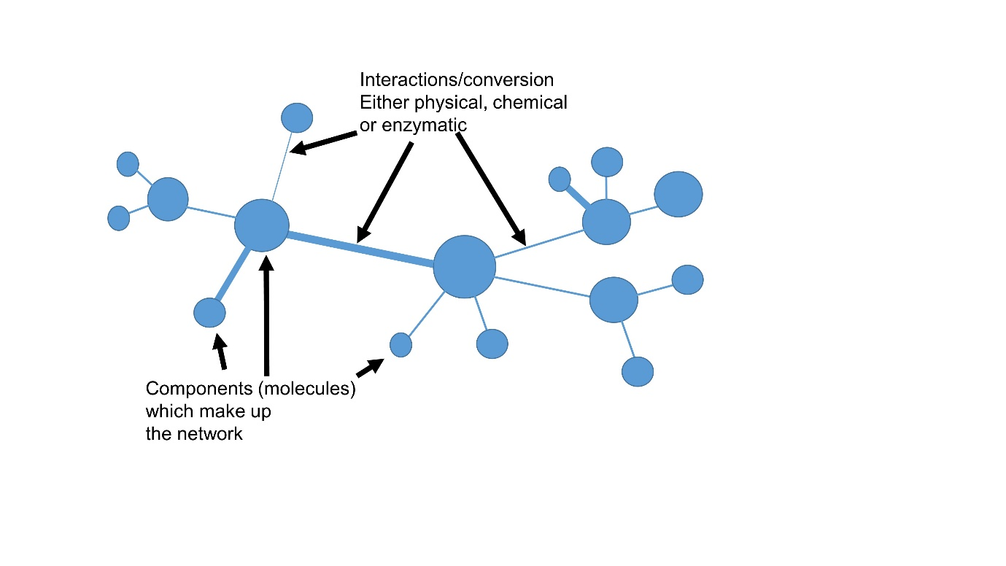

Figure 2: The power law degree distribution of a scale-free network. This predicts that most of the nodes have only a few links, where some are highly connected and can be thought of as hubs, having a major influence on the whole.

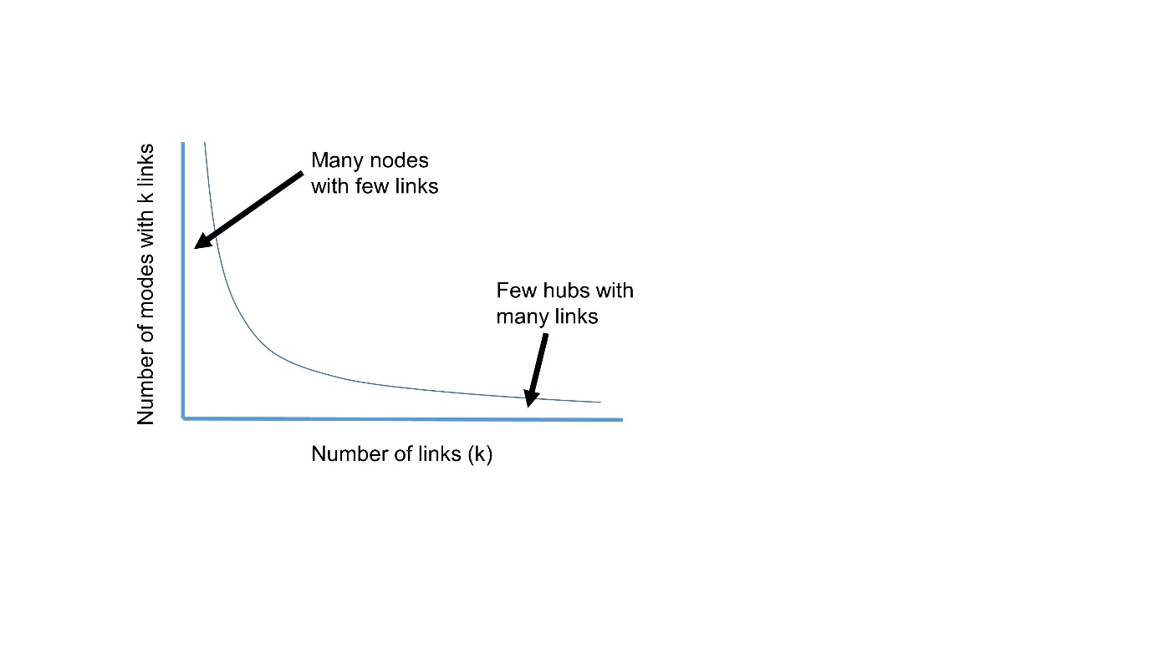

Figure 3: The redox environment of cells. A: the redox environment may fluctuate but is held in what has been dubbed the Goldilocks Zone. If the redox state moves outside this variable then cellular stress may result. Figure adapted from [86]. B: The average redox environment tends to drift towards being more oxidized with time [1,33].

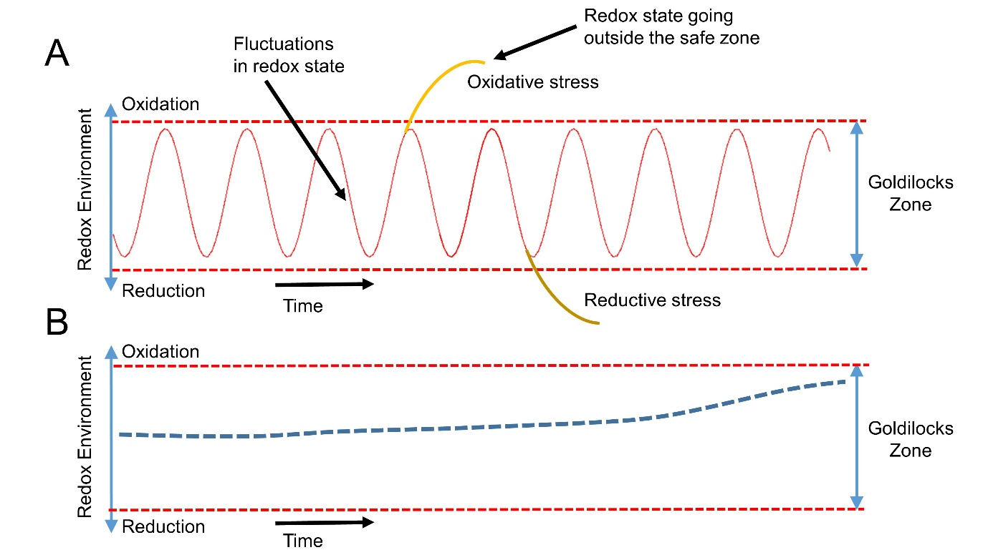

Figure 4: A node and edge approach to representing a redox scale-free network. The size of the node represents the sphere of influence that molecule may have on the overall network (not to scale). * denotes redox couple. Names in red can be considered end points for signaling. NAD or NADP in yellow indicates the involvement of NAD(P)⁺/NAD(P)H couples. Orange solid lines denotes cellular membranes. Although the cytoplasm, mitochondria (details not shown) and the exterior of the cell are represented, the endoplasmic reticulum and nucleus is not shown even though they would have influential redox environments. Also missing are plant-specific redox components such as chloroplast and nitrate reductase. Cytoplasmic redox will be under the influence from external factors, such as ROS, RNS, H₂S and antioxidants. A holistic understanding would need a comprehensive and cell specific network, with scaling to represent measured concentrations and potential influence.

