1 Introduction
Achieving gradual failure in hybrid composite laminates- progressing from tension to beding

M. Jalalvand^{1*}, G. Idarraga², M. Fotouhi³, J. Meza², MR. Wisnom⁴
¹ Department of Mechanical & Aerospace Engineering, University of Strathclyde, Glasgow, UK
² National University of Colombia, Tribology and Surfaces Group, Medellín, Colombia
³ Department of Design and Mathematics, University of the West of England, Bristol, UK
⁴ Bristol Composites Institute (ACCIS), University of Bristol, Bristol BS8 1TR, UK
* Corresponding author (m.jalalvand@strath.ac.uk)

Keywords: Pseudo-ductile composites, Fibre failure, Delamination, Damage mode map
Conventional composites usually exhibit a catastrophic failure with no prior warning. This has led to conservative design and large reserve factors in the design of composite structures and also frequent expensive health-monitoring checks during operation. Pseudo-ductility is a relatively new concept proposed to address such difficulties. In this approach, the possible failure processes are divided into two categories of favourable gradual and unfavourable catastrophic damage modes. By designing a composite to exhibit the desirable failure modes and avoiding the fatal ones, it is possible to achieve gradual deterioration and stiffness reduction while keeping the integrity and load carrying capacity of the laminate.
Hybridisation with thin plies is one of the successful methods to achieve gradual failure or pseudo-ductility [1]. In this method, two types of plies with different fibres and failure strains are co-cured to achieve fragmentation of the lower strain material and a gradual stiffness reduction during this process[2]. So far, gradual failure in several hybrid combinations have been successfully demonstrated [3] using Damage Mope Map technique [4]. To achieve pseudo-ductility in several orientation of a laminate, two different method of hybridisation were proposed and assessed to avoid other undesirable failure modes such as free edge delamination [5].
Most of the progress to-date about achieving gradual failure have been mainly focused on in-plane loading and particularly tension.
In many real structural applications, the load is not pure in-plane and is a mix of in-plane and transverse. One of the most common more complicated load cases is bending, happens in many structural elements from sport equipment to wind-turbine blades. This paper is the authors’ original work to take the lessons learned in in-plane loading and implement it into cases dominated with out-of-plane bending loads. The aim is to achieve gradual failure and pseudo-ductility from composite beam under bending.
2 Specimen design
2.1 Fragmentation of the low strain material
The main failure mechanism for gradual failure in tensile loading has been fibre fragmentation of the low strain material. To achieve a high stiffness beam, two carbon fibres of M55 and T1000 with distinct failure strains of 0.8% and 2.2% respectively were selected to build a hybrid. Damage mode map [4] of this hybrid combination was produced to find the optimal thickness and ratio as shown in Fig. 1. The following hybrid configurations, are highlighted on the map Fig. 1:
- [T1000₂/M55/T1000₂]
- [T1000₄/M55₂/T1000₄]
- [T1000₄/M55₃/T1000₄]
- [T1000/M55/T1000]
The thickness of the layup B and C are about 0.32 and 0.47 mm which is fairly thick to use as the building block to be repeated through the thickness of the beam. To achieve fibre fragmentation of the low strain material (M55) on the tensile side, layup A seems a good choice. It was also decided to reduce the amount of T1000 in the building block layup A to make the building block thinner. The idea was to promote a gradual brush-like failure and achieve a gradual failure of high strain material, T1000. This led to selection of layup D as well. To avoid catastrophic compressive failure, seven layers of S-glass layers were also added to the carbon/carbon hybrid. The final layups then are as
- Layup A: [S-Glass₇/T1000/(M55/T1000₄)₁₀ /M55/T1000₂]
- Layup D [S-Glass₇/(M55/T1000₂)₁₈].
The details of the design of the layups will be provided in the full paper.

3 Test results
Fig. 2 indicates the obtained load-displacement graphs of the 5 different specimens with layup A which shows a considerable change of initial slope due to fragmentation of the outer M55 layers followed by gradual failure of T1000.
Fig. 3 indicates one of these specimens under 3 point bending test, after many of the surface building block T1000/M55 hybrid combinations have gradually broken. This photo shows the specimen stays intact, even after a significant failure of the surface layers and it is still capable of bearing a proportion of the applied load. Compared to convensional composites, this is a significant achievement and is a proof of gradual failure for beams under bending.

4 Figures
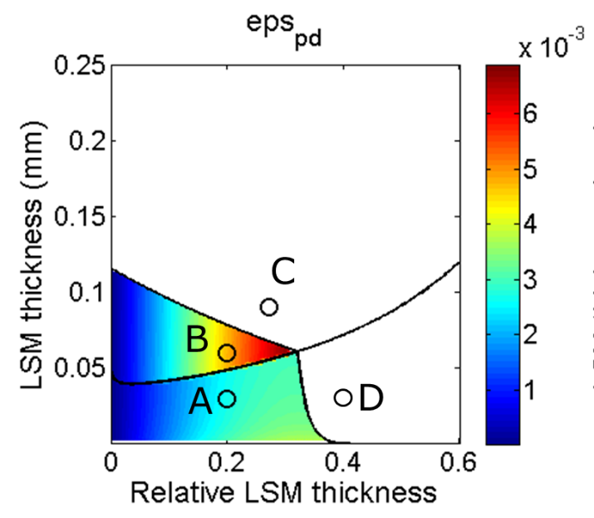
Fig. 1. Damage mode map of M55/T1000 carbon hybrid
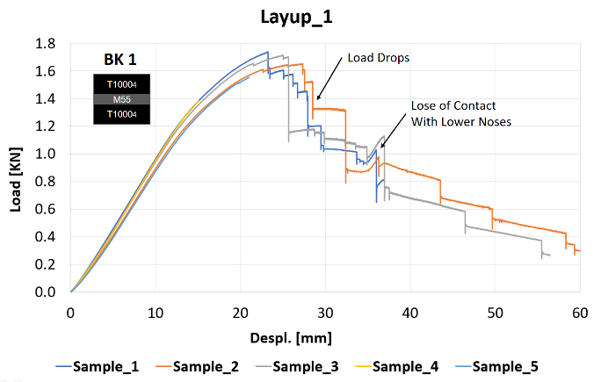
Fig. 2. Load-displacement curves of bending tests of layup A
Fig. 3. The specimen under 3-point bending load
5 References
[1] Y. Swolfs , L. Gorbatikh, I. Verpoest “Fibre hybridisation in polymer composites: A review”. Compos Part A Appl Sci Manuf 2014;67:181–200.
[2]M. Jalalvand, G. Czél , M. Wisnom “Damage analysis of pseudo-ductile thin-ply UD hybrid composites - a new analytical method” Compos Part A Appl Sci Manuf 2015;69:83–93.
[3] G. Czél, M. Jalalvand, M. Wisnom. “Design and characterisation of advanced pseudo-ductile unidirectional thin-ply carbon/epoxy–glass/epoxy hybrid composites” Compos Struct 2016;143:362–70.
[4]M. Jalalvand, G. Czél, M Wisnom. “Parametric study of failure mechanisms and optimal configurations of pseudo-ductile thin-ply UD hybrid composites” Compos Part A Appl Sci Manuf 2015;74.
[5]M. Jalalvand M, Fotouhi M, Wisnom MR. “Orientation-dispersed pseudo-ductile hybrid composite laminates – A new lay-up concept to avoid free-edge delamination” Compos Sci Technol 2017;153.

