Self sufficient wireless transmitter powered by foot-pumped urine operating wearable MFC

Majid Taghavi,1,2 Andrew Stinchcombe1, John Greenman3, Virgilio Mattoli2, Lucia Beccai2, Barbara Mazzolai2, Chris Melhuish1 and Ioannis A. Ieropoulos1*

1Bristol BioEnergy Centre, Bristol Robotics Laboratory, University of the West of England, Bristol, BS16 1QY, UK. Fax: +44 117 3283960; Tel: +44 117 3286318

2Center for Micro-BioRobotics, Istituto Italiano di Tecnologia, Viale Rinaldo Piaggio 34, 56025 Pontedera (PI), Italy.

3Centre for Research in Biosciences, Faculty of Health & Applied Sciences, University of the West of England, Bristol, UK

KEYWORDS

Microbial fuel cell, wearable, urine, foot pump, wireless transmitter

ABSTRACT

The first self-sufficient system, powered by a wearable energy generator based on Microbial Fuel Cell (MFC) technology is introduced. MFCs made from compliant material were developed in the frame of a pair of socks, which was fed by urine via a manual gaiting pump. The simple and single loop cardiovascular fish circulatory system was used as the inspiration for the design of the manual pump. A wireless programmable communication module, engineered to operate within the range of the generated electricity, was employed, which opens a new avenue for research in the utilisation of waste products for powering portable as well as wearable electronics.

Introduction

Portable and wearable devices are progressing at an accelerated pace and are thus becoming more available on the mainstream market. Despite the advances in ultra-low power electronics, powering those systems still poses a significant challenge. In addressing this issue, attention has been given to alternative energy sources such as electromagnetic 1, solar 2, thermal 3, and mechanical 4. Using unwanted waste products, as a source of chemical energy, can be considered as an alternative method for such systems, particularly taking into account that it can be available for humans in a variety of environments. Human urine has been used for powering Microbial Fuel Cells (MFC), producing sufficient power to run real electronic devices 5. Furthermore, a highly efficient, flexible and light-weight MFC, has already been reported, which can be used in such wearable/portable energy harvesting applications 6. However, a mains powered pump is required in order to continually feeding the fuel, which is necessary to increase the performance and biofilm community survival. That kind of MFCs has been already implemented in a self-sustainable manner on-board the EcoBot robots, and in particular EcoBot-III 7. Therefore, a wearable MFC self sustainable system with the ability of being completely powered by human, which can be used in specific outdoor conditions, would require a manual pumping system.

Nature has long been a source of inspiration for engineers looking to solve problems, and in the context of low energy fluid circulation, the circulatory system of animals have been explored. Amongst all, fish have the simplest closed circulatory system, known as single cycle circulation8. These animals have a single circuit for blood, where the heart pumps the blood to the gills for re-oxygenation, then to the rest of the body, and back to the heart. The heart is consisting of one atrium to receive blood and one ventricle, a thick-walled chamber with a large number of cardiac muscles, to pump it9. Ostial valves, consisting of flap-like connective tissues, prevent blood from flowing backward through the compartments10. In fact, the pressure and suction created by cardiac muscles drive blood through the vessels, and the check valves keep the fluid moving only in one direction. The muscles surrounding the chambers and vessels help contract and expand the heart and vessels, which is the key factor for the function of the circulation system.

In this paper, we present the first self sustainable system which is directly powered by wearable MFCs. It indirectly uses the human gaiting energy, where is used to circulate urine, as the fuel, through the fuel cells. The structure and material of foot pumping part were designed by the inspiration of the fish circulatory system. The whole system consists of 24 individual flexible MFCs installed on the fabric of a pair of socks, foot pumping made of soft tubing and check valves, and a programmable transmitting board.

Materials and Methods

The microbial fuel cells were fabricated following the procedure explained in the reference 6 as carbon fibre sleeve- cation exchange membrane- carbon fibre sleeve method. Totally, 24 single-chamber MFCs were built and prepared as following.

The inoculation was performed by activated anaerobic sludge, collected from the Cam Valley wastewater treatment works, Wessex Water. 1% (w/v) tryptone and 0.5 % (w/v) yeast extract (Fisher scientific) were added into 200 mL of sludge. Firstly for one week, the sludge was fed in continuous flow at a slow flow rate (l/min), using a Watson Marlow 205U peristaltic pump (Watson Marlow, UK). It was performed for the purpose of inoculation, but assisted by slow flowing in order to prevent MFCs from blocking. Afterwards, a new catholyte composed of 200 mL of deionized water, 1% (w/v) tryptone and 0.5 % (w/v) yeast extract were driven into the MFCs with the flow rate of 45 l/min for another week. Urine, collected from individuals and pooled together, was used to feed the bacteria in MFCs with the same flow rate. It was replaced by a fresh one every day.

At first that the MFCs were left for inoculating, they all were connected to 5K resistors. Then polarization experiments were performed every week by means of the Resistorstat device11. In detail, the cells were left under open-circuit conditions for at least 5 minutes. Then  electrical resistors separately were connected to the cathodes and anodes of each MFC. Subsequently, the values of the resistances were reduced to reach the short circuit condition. 38 different values were set to the loads, where the time constant of each was 5 min with the purpose of establishing quasi steady-state values. Data were collected using a multi-channel Agilent 34972A, LXI Data Acquisition/Switch Unit (Farnell, UK). All loads connected to the MFCs were then replaced by the value which shows the maximum power in the obtained data.

After 10 days that the MFCs had matured, they were connected together electrically as below. Each two MFCs were connected to a tube, fed by the same common anolyte, and connected in parallel electrically using external wiring. 6 lines of such tube were implemented in each sock (foot). Firstly, the polarisation experiments were accomplished on each of the MFC pairs. After 3 days, however, the 12 pairs (6 pairs per sock) were connected in series, and in order to investigate the entire output of the stack, a polarisation experiment was carried out. It was done by manual connection of 32 different resistors to the stack, starting from 1M as an overload down to 50 as a short circuit. They were left connected for a period of 4 minutes in the purpose of obtaining the steady state condition.

As described above, after that the MFCs were prepared and matured within more than 2 weeks, they were disconnected from the apparatus in order to be integrated on the wearable sock support. A manual pumping system was designed and developed in order to circulate the anolyte through the MFCs, as shown in the schematic of figure 1a.

This manual pumping system, inspired by fish circulatory system, consists of a silicone tube (pumping-tube) with 1mm inner diameter and two check valves (SCV21053, The West Group Ltd, UK). A series of one directional valves were connected between pumping-tube and two other silicone tubes with the inner diameter of 2mm (reservoir-tube and carrier-tube). The latter ones play the role of vessels, carrying urine to the pairs of tubular MFCs with the inner diameter of 1.8mm and pumping-tube, respectively. These tubes have the ability of being distended and compressed like the vessels. Therefore, in each sole, 6 separate pumps were considered for feeding 6 pairs of MFCs by means of 12 pieces of check valves. All the pairs were connected to each other in series to increase the generated voltage. The output energy of the system was stored in two super-capacitors (330mF and 6.8mF) connected in parallel together and to the system. The image of the developed wearable system is illustrated in figure 1b

For demonstrating the real potential of the wearable MFC generator for powering a self sustainable system, a radio communication is established by the use of a RF transceiver (Easy-Radio type, ER400TRS), which operates at a frequency of 433-434MHz. A PIC microcontroller (PIC24F16KA102) installed on the Microchip development board was used to manage the transmission process. The function of the communication circuit was initially tested using an external power supply. The flowchart of the program ran by the microcontroller is shown in figure 2a, which was checking the level of the power supply voltage every 10 seconds. Provided that the voltage was above 3.1V, an exemplar message, i.e. “*World’s First Wearable MFC*”, was sent by the transmitter module. The microcontroller was left in sleep mode in order to reduce the power consumption during the rest time. This was interrupted every 10 seconds and the aforementioned function was performed. A receiver also was connected to a PC for detecting the transmitted message and displaying it on the screen of a PC. The block diagram of all the described components, emphasizing the electrical connections, is shown in figure2b.

Results and Discussion

The power curves of the 12 MFC pairs, when fed with fresh urine at the flow rate of l/min are shown in the reference 12, where the variations in the performance of the MFCs are also discussed. The power and polarization curves of the entire stack are also shown in figure 10. It shows the output signals when the presented 12 pairs are connected to each other in series. In fact, a series of external resistors were wired to the system, and the generated voltage and power is plotted versus the current. The maximum achievable power is about W, occurring when a load of 30K is connected. The fuel was replaced with fresh one and fed with a flow rate of 45l/min for recording these results. The flow rate could not be increased so much owing to destroying some connections and making leakage. It brings about the creation of short circuit between the MFC opposite electrodes, and decreases the performance. In this way, to provide the same flow rate through all the MFC pairs, the manual pumping system was designed. In detail, a soft tube with 1mm inner diameter between a pair of the check valves were used, passing through the insole of footwear. It was evaluated under a walking speed of 45steps/min by each foot, and the average flow was measured as 100l/min. This number was considered as a normal gaiting for each leg, supposing the value of 90steps/min as an average walking speed for a person. Each pair of MFC was fed by pumping the fuel from a single foot, i.e. half of the entire steps, so each leg pumps the fuel into the tubular MFC at the speed of 45 steps/min or 100l/min.

Foot pumping occurs while gaiting during the two phases of heel STRIKE and heel OFF. The design of the foot pump follows the existing single circuit circulatory system in fish. Unlike the cardiac muscles, working involuntary, the frequent compression of the pumping chamber in the generator is provided by gaiting. Therefore, a soft material with the ability of stretching is required to mimic the heart chambers and the function of vessels or capillaries (Figure 4a). In this way, tubes made of silicone rubber were chosen as the main pumping chamber and reservoirs and carriers. One piece with 1mm inner diameter was placed directly under the heels, mimicking the role of a ventricle in the fish heart. We refer to this part here as pumping-tube. It is connected to other pieces of silicone tubes using two check valves. These tubes play the role of reservoirs and feeding path. Similarly, we call these units as reservoir-tube and carrier-tube for the purpose of carrying fresh and used urine respectively. In fact, fish heart consists of other chambers connected to the main muscular part of the heart ([ventricle](http://en.wikipedia.org/wiki/Ventricle_(heart))). For example, atrium and conus arteriosus are working as two accumulators for the entrance and exit of blood from a ventricle, respectively. The muscular structure of these chambers besides check valves assist the ventricles with circulating the fluid 13. In other words, contraction of the ventricle moves the blood into the conus arteriosus and then to the aorta. In contrary, expansion of the ventricle in addition to contraction of the atrium allow blood to flow into the ventricle. In our system, for the sake of simplicity, and since a high speed fluid circulation was not necessary, we used only the pressure and suction created by the main part (pumping-tube) for driving urine out of/into the MFCs.

The two steps required for driving urine were performed by sequential squeezing and releasing the pumping-tube, leading to pump urine into the carrier-tube and to create suction from the reservoir-tube, respectively. Figure 4b shows the first step that all the connections were made when the heart tube was subject to a foot pressure. Therefore, as shown in figure 4c, heel OFF, i.e. the first phase of gaiting, drive the fluid from the reservoir-tube down to the pumping-tube. Check valves leads the fluid flowing only through the reservoir-tube due to the differential potential generated by the released pumping-tube from sustaining the foot pressure. The compensation of the differential pressure in the closed tubing system, consequently, leads to move urine through the MFCs from carrier-tube to the reservoir-tube (figure 4d). In contrary, as shown in figure 4e, heel STRIKE, i.e. the second phase, compressed the tubes, and thus the fluid flow into the carrier-tube, through the check valve on the opposite side. By continuing the flowing of urine in the MFCs, the reservoir-tube is refilled and come back to the first situation (figure 4f). As the toe OFF phase of one foot and heel-ground contact of another one happen at the same time, the identical cycle repeats for the second foot until the time that the first heel strikes the ground again.

Although the average flow rates of the manual and automatic pumps have been compared, the fluid driving mechanism of the two systems are different. Firstly, unlike the former, the electric pump creates a flow with constant velocity, and thus it can be supposed as steady flow. Secondly, it is connected to the tube’s input, and so operates only by pushing the fluid through the tubes. However, the heart-inspired pump benefit from both pushing and pulling mechanisms at the two contraction and expansion phases. Therefore, it not only drives urine inside carrier-tube and MFCs, but also it provides suction to the reservoir-tube and MFCs. This process brings about fluid flow within a lower pressure. Consequently, during the foot pump experiments, this pumping process decrease urine leakage chances, the small quantity of which was observed sometimes around connections during bench experiments under similar conditions. As discussed above, it can affect on the performance of the system, which could be a justification to the fact that the circuit output voltage of the worn system grows up to 4V, but it was 3.66V for the stack in similar condition.

Two super capacitors (6.8F and 0.33F) have been connected in parallel for storing the generated energy of the MFCs stack (Andrew may write some words here as the reason of using the two capacitors). The capacitors were charged up to 4.1V and connected to the Microchip® board with the transmission components. We found that they were discharged by 1V (down to 3.1v) within 465 seconds. After this time, as explained above, since the level of the powering source for the electronic board had decreased down to 3.1V, the transmission stopped sending a message every 10 seconds. This time can be considered as a start point for evaluating the MFC generator function. At that time, the MFCs were generating sufficient energy to reach the threshold voltage and meeting the minimum requirement for charging the capacitors and transmitting the data. During this period, the microcontroller was woken up every 10 seconds and was checking the input power. If it was less than 3.1V, the microcontroller would go back to sleep mode without trying to send any wireless data. This experiment was performed with gaiting by the speed of 88steps/min for 30 minutes, and the results are shown in figure 5. It is illustrated that, the communication module is able to send a meaningful message every 2 minutes on average, whilst fresh urine is pumped into the MFCs by a typical stepping speed (see the video in the supplementary information). In fact, neglecting capacitor’s leakage, the board consumes three different amount of energy within three phases as following: the first is during the time that the processor goes to the sleep mode. The second is while it wakes up and checks the capacitor voltage level and goes back to the sleep mode without trying to send any message. The last occurs when the processor confirm the voltage level, and allow the transition unit to send the message. Therefore, 2 minutes of operation of the wearable power generation system is enough to meet all these requirements within that 2 minutes period.

The heart, in fish, pumps blood first to the gills where the gas exchange takes places, and then blood continues to the rest of the body. However, in our system, in order to simply show the possibility of the presented concept, no unit is considered for replacing urine with fresh fuel. In detail, it is calculated that the entire capacity of the fresh urine stored in each tube for a pair of MFC is about 1.8 ml. Supposing the flow rate of the normal gaiting produces as 45µl/min, as explained above, the single circulation of all the reserved fresh urine occurs within 40 minutes. This part, indeed, can be modified to bridge the gap for transferring this technology into a real long term applications. As an instance, the function of the gills in fish circulatory system can be replaced by a reservoirs containing fresh urine, where equipped with a manual subsystem or integrated with the gaiting pump system in order to replace the fuel.

Conclusions

A wearable electric energy generator, powered entirely by human, successfully run a wireless transmission board. It was shown that is able to send a message every 2 minutes to the pc receiver station. The soft MFCs were worn as a pair of socks and provided by fresh urine using a manual pumping. The pump was designed by the inspiration of a single loop fish circulatory system. The involuntary heart muscles were substituted by soft tubes, placing under heel, which produce the frequent fluid push-pull mechanisms by gaiting. Each two MFCs, positioned in series and wired in parallel, were separately connected to a single pump. 12 couples of those MFCs were wired in series and used as the power supply for the electronics. 90 steps/min as a normal gaiting of human provides urine circulation with the flow rate of 45l/min in each leg for each MFC couples, where the whole open circuit output voltage of the system reaches 4V.

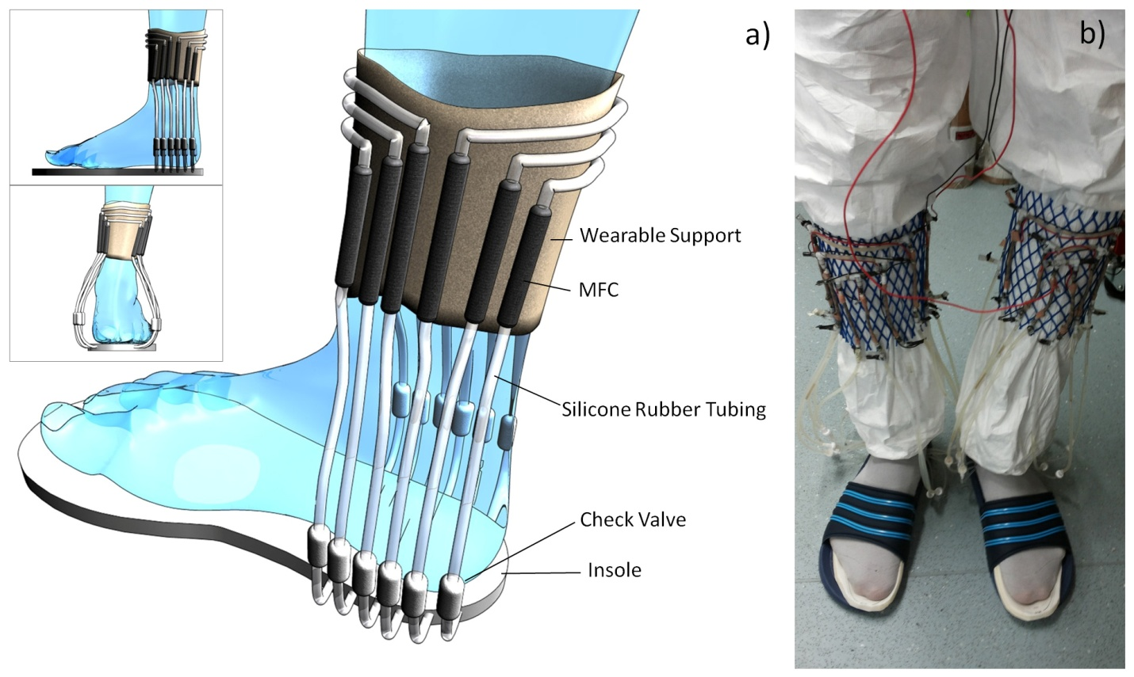

**Figure 1.** a) Schematic drawing; b) image of the developed wearable generator

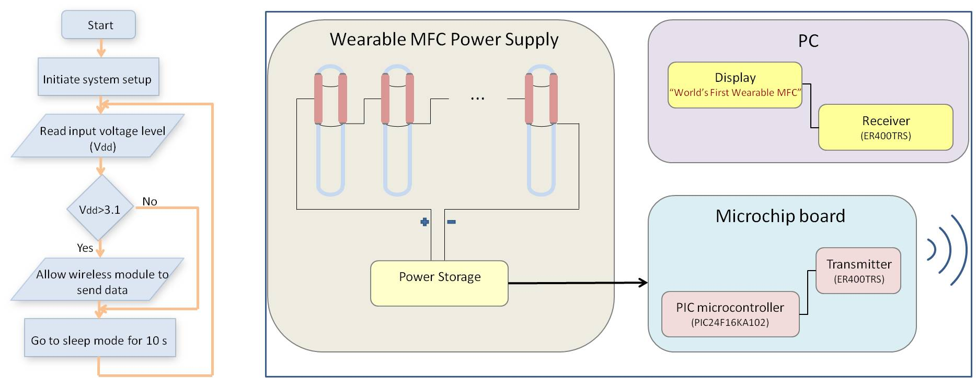

**Figure 2.** a) Flowchart of the program run by micro controller; b) Block diagrams of the wearable MFC power supply and electronic setup

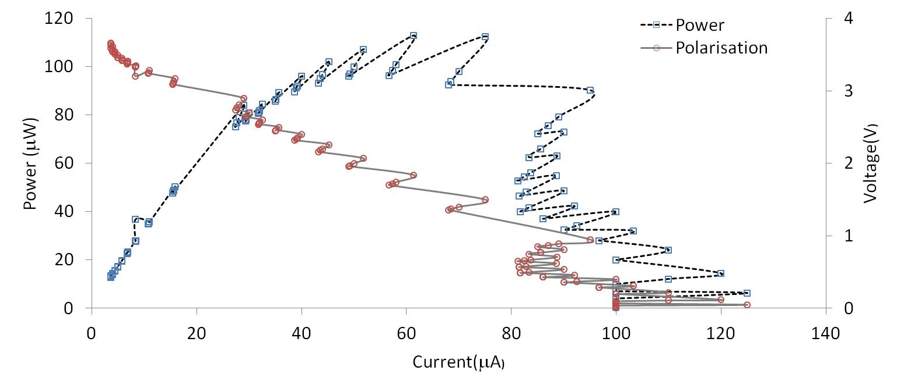

**Figure 3.** Power and polarisation curves of all the 12 pairs of MFCs where are connected in series

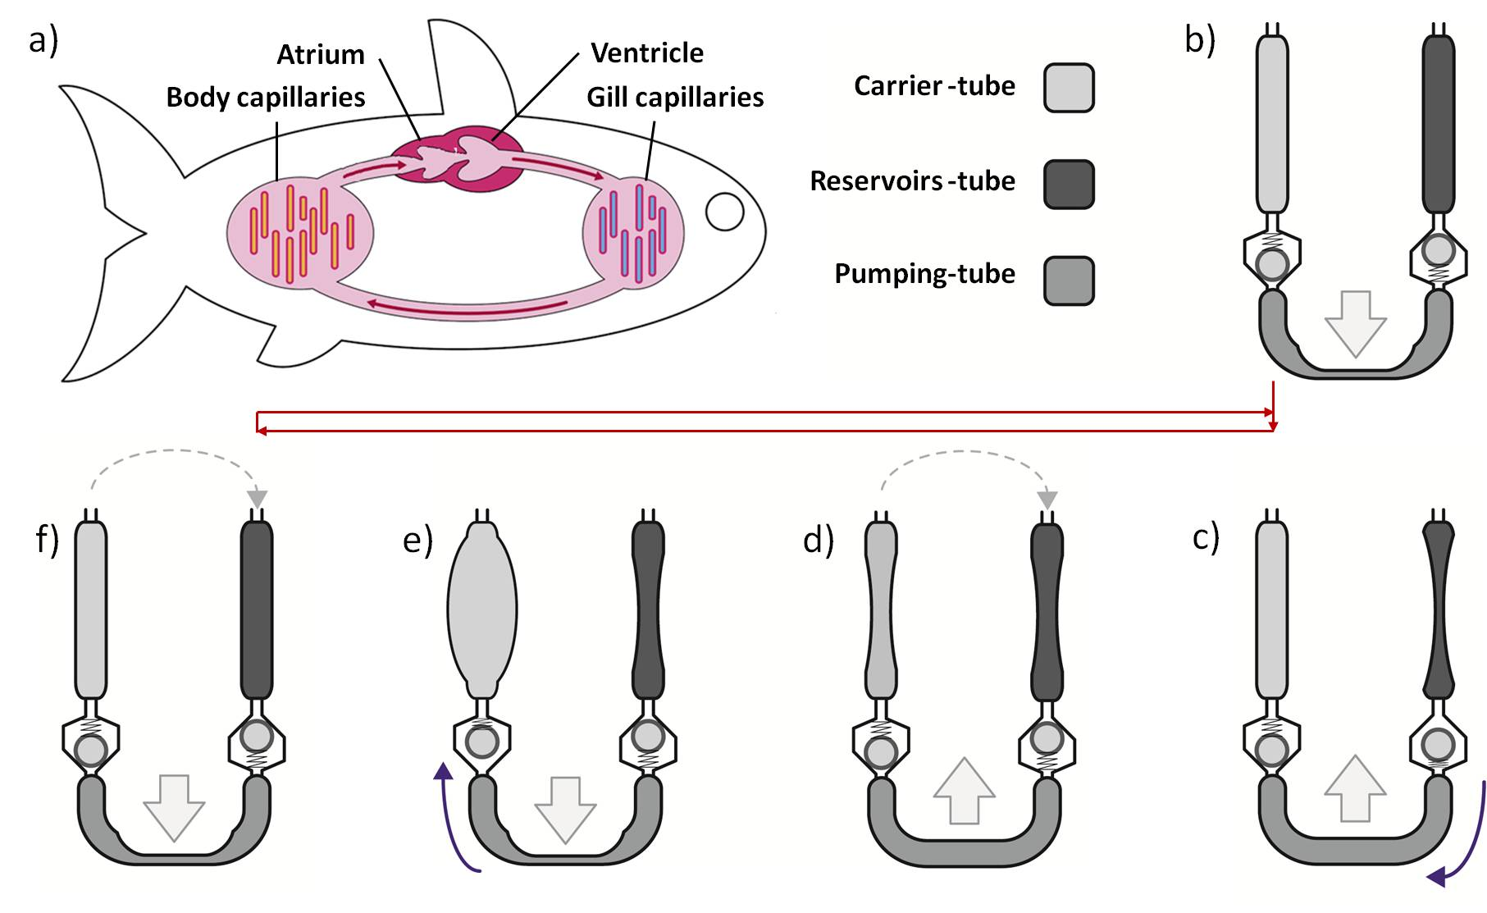

**Figure 4.** Schematics of the bio inspired pumping system; a) the tubes were filled when the heart-tube was left under the foot pressure; b) urine flows from vein-tube to heart-tube as the pressure is released; c) urine flows through MFCs for compensating the differential pressure between vein-tube and aorta-tube; d) squeezing heart-tube flows urine to the aorta-tube; e) The system comes back to the first condition by flowing urine from aorta-tube to the veil-tube trough the MFCs

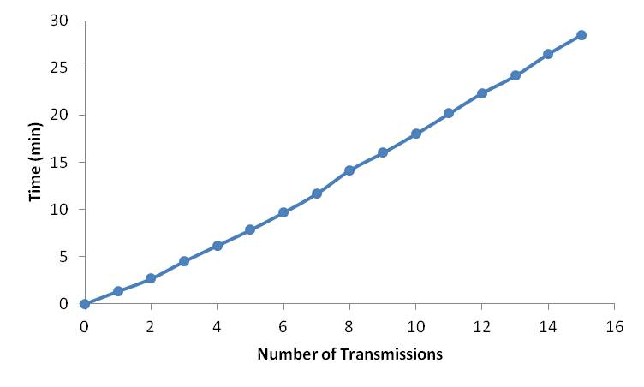

**Figure 5.** Time graph of the transmitted data

**Supporting Information**.

A video showing the operation of the system “This material is available free of charge via the Internet at http://pubs.acs.org.”

**Corresponding Author**

* E-mail: ioannis.ieropoulos@brl.ac.uk

Funding Sources

Any funds used to support the research of the manuscript should be placed here (per journal style).

ACKNOWLEDGMENT

Parts of this work were funded by the UK Engineering & Physical Sciences Research Council (EPSRC) grant numbers EP/I004653/1 and EP/L002132/1, and the Bill & Melinda Gates Foundation grant no. OPP1094890.

ABBREVIATIONS

MFC, microbial fuel cell

REFERENCES

1. (a) Simons, R. N.; Miranda, F. A.; Wilson, J. D.; Simons, R. E. In *Wearable wireless telemetry system for implantable bio-MEMS sensors*, Engineering in Medicine and Biology Society, 2006. EMBS'06. 28th Annual International Conference of the IEEE, IEEE: 2006; pp 6245-6248; (b) Amendola, S.; Moradi, E.; Koski, K.; Bjorninen, T.; Sydanheimo, L.; Ukkonen, L.; Rabaey, J. M.; Rahmat-Samii, Y. In *Design and optimization of mm-size implantable and wearable on-body antennas for biomedical systems*, Antennas and Propagation (EuCAP), 2014 8th European Conference on, IEEE: 2014; pp 520-524.

2. (a) Toivola, M.; Ferenets, M.; Lund, P.; Harlin, A., Photovoltaic fiber. *Thin Solid Films* **2009,** *517* (8), 2799-2802; (b) Leonov, V.; Torfs, T.; Vullers, R. J.; Van Hoof, C., Hybrid thermoelectric–photovoltaic generators in wireless electroencephalography diadem and electrocardiography shirt. *Journal of electronic materials* **2010,** *39* (9), 1674-1680.

3. (a) Leonov, V.; Torfs, T.; Kukhar, N.; Van Hoof, C.; Vullers, R. In *Small-size BiTe thermopiles and a thermoelectric generator for wearable sensor nodes*, Proc 6th Eur Conf Thermoelectrics (ECT 2007), Odessa, Ukraine, 2007; pp 10-12; (b) Leonov, V., Thermoelectric energy harvesting of human body heat for wearable sensors. *Sensors Journal, IEEE* **2013,** *13* (6), 2284-2291.

4. (a) Taghavi, M.; Mattoli, V.; Sadeghi, A.; Mazzolai, B.; Beccai, L., A Novel Soft Metal‐Polymer Composite for Multidirectional Pressure Energy Harvesting. *Advanced Energy Materials* **2014,** *4* (12); (b) Khaligh, A.; Zeng, P.; Wu, X.; Xu, Y. In *A hybrid energy scavenging topology for human-powered mobile electronics*, Industrial Electronics, 2008. IECON 2008. 34th Annual Conference of IEEE, IEEE: 2008; pp 448-453.

5. Ieropoulos, I. a. G., John and Melhuish, Chris, Urine utilisation by microbial fuel cells; energy fuel for the future. *Physical Chemistry Chemical Physics* **2012,** *14*, 94--98.

6. Taghavi, M.; Greenman, J.; Beccai, L.; Mattoli, V.; Mazzolai, B.; Melhuish, C.; Ieropoulos, I. A., High‐Performance, Totally Flexible, Tubular Microbial Fuel Cell. *ChemElectroChem* **2014,** *1* (11), 1994-1999.

7. Ieropoulos, I.; Greenman, J.; Melhuish, C.; Horsfield, I. In *EcoBot-III-A Robot with Guts*, ALIFE, 2010; pp 733-740.

8. Gilbert, S. F., *Developmental Biology*. Sinauer Associates: Sunderland, Massachusetts, 1994.

9. Ostrander, G. K., The Laboratory Fish. Elsevier: 2000.

10. Farrell, A. P., *Encyclopedia of fish physiology: from genome to environment*. Academic Press: 2011.

11. Degrenne, N. a. B., Franois and Allard, Bruno and Bevilacqua, Pascal, Electrical energy generation from a large number of microbial fuel cells operating at maximum power point electrical load. *Journal of Power Sources* **2012,** *205*, 188--193.

12. Taghavi, M.; Stinchcombe, A.; Greenman, J.; Mattoli, V.; Beccai, L.; Mazzolai, B.; Melhuish, C.; Ieropoulos, I. A., Wearable Self Sufficient MFC Communication System Powered by Urine. In *Advances in Autonomous Robotics Systems*, Springer: 2014; pp 131-138.

13. Satchell, G. H., *Circulation in fishes*. CUP Archive: 1971; Vol. 18.