From Hiscore to High Marks: Empirical Study of Teaching Programming Through Gamification
Panagiotis Fotaris¹, Theodoros Mastoras², Richard Leinfellner³ and Yasmine Rosunally⁴
^{1,3} University of East London, London, UK
² University of Macedonia, Thessaloniki, Greece
⁴ University of West London, London, UK
p.fotaris@uel.ac.uk
mastoras@uom.gr
r.leinfellner@uel.ac.uk
yasmine.rosunally@uwl.ac.uk

Abstract: Unlike conventional taught learning, video games are very successful at keeping players constantly motivated and engaged on a set of tasks for many hours without apparent loss of focus. Additionally, when playing, gamers solve complex problems without experiencing the fatigue or frustration, which would normally accompany a comparable learning task. Any methods able to deliver deep learner engagement are naturally of interest to the academic community, thus resulting in an increasing interest in adopting gamification – the integration of gaming elements, mechanics, and frameworks into non-game situations and scenarios – as a means to drive student engagement and improve information retention. However, its application to education has been a challenging task, as attempts have generally been restricted to a one-dimensional approach, such as transposing a trivial reward system onto existing teaching material. The empirical evidence presented in this paper suggests that a gamified, multi-dimensional, problem-based learning approach may yield improved outcomes even when applied to a very complex and traditionally dry task like the teaching of computer programming. This quasi-experimental study employed a real time sequence of scored quizzes, instructor feedback, and live coding to deliver a fully interactive learning experience. By using a combination of the classroom version of the TV game show “Who Wants To Be A Millionaire?”, the “Kahoot!” Classroom Response System (CRS), and Codecademy’s online interactive platform on a Python programming course, students were allowed to experience multiple interlocking methods similar to what would be found in a top quality game experience. Empirical data on learning outcomes from the gamified group were compared with a control group that followed a traditional learning path, which had been used during previous cohorts. Whilst this was a relatively small study, the results were quite interesting in a number of key metrics, including attendance, downloading of course material, and final grades.

Keywords: Gamification, Game-Based Learning, Learning and Teaching, Technology Enhanced Learning, Virtual Learning Environment, Classroom Response System.

Introduction
According to research on the dynamics of attention spans during lectures, the typical learner’s attention increases during the first ten minutes of lecture and diminishes after that point (Hartley and Davies, 1978). One way to address this issue and recapture the attention of learners is by changing the environment during a lecture, e.g., via a short break (McKeachie, 1999). This is almost the opposite of the dynamic experienced by video gamers. The latter are kept at high levels of attention, which in some cases can last for many hours (Green and Bavelier, 2006). They also have a distinct characteristic where they strive to be on the verge of what Jane McGonical (2010) mentions as an “epic win”. Gamers also share common factors such as urgent optimism, social fabric, blissful productivity, and epic meaning, which in turn make them super empowered hopeful individuals (Huang and Soman, 2013).

Gamification for learning would add game mechanics, dynamics, and frameworks to non-game processes in an effort to combine intrinsic with extrinsic motivation so as to raise student engagement and motivation (Deterding et al., 2011). Intrinsic motivation (e.g., altruism, competition, cooperation, sense of belonging, love or aggression) is driven by an interest or enjoyment in the task itself and inspires people to initiate an activity for its own sake; it exists within the individual instead of relying on external pressures or a desire for reward (Ryan and Deci, 2000). Students who are intrinsically motivated are more likely to engage in a task willingly, as well as work to improve their skills, which will increase their capabilities (Wigfield et al., 2004).

However, despite the fact that gamification of education is gaining support among an increasing number of academics who recognise that effectively designed games can stimulate large gains in productivity and creativity among learners (NMC Horizon Report, 2014), opponents argue that what is lacking is concrete empirical data to support of refute these theoretical claims (Annetta et al., 2009; Barata et al., 2013). Some of the negative experiences include disappearance of collaboration among students and overstimulation of competitiveness. The balance between learning, social collaboration, creativity, and competitiveness which is apparent in mainstream commercial games seems to be hard to achieve in tools specifically designed for education (Zaha et al., 2014). As a result, gamification is often reduced into a behaviour model leveraging human need for positive reward system and instant gratification, which is applied to a traditional teacher-centred classroom. The present paper aspires to make a contribution to the empirical evidence in the gamification field by designing, implementing and evaluating a gamified learning experience in a higher education setting in an effort to bridge the gap between theory and practice.

Related works
The new millennium saw the introduction of the terms “ludic engagement”, “ludic design”, and “ludic activities” to describe “activities motivated by curiosity, exploration, and reflection”, as well as the emergence of a new field called “’funology’ – the science of enjoyable technology” (Blythe et al., 2004) which was inspired by game design and studied “hedonic attributes” (Hassenzahl, 2003) or “motivational affordances” (Zhang, 2008) of “pleasurable products” (Jordan, 2002).

The use of video games for educational purposes was also emphasized by the works of Prensky (2001) and Gee (2003). Although these studies were related to game-based learning rather than gamification, their findings form the core of gamification in education: they described the influence of game play on cognitive development, identified 36 learning principles found in video games, and recognised potential advantages of video games in learning such as the value of immediate feedback, self-regulated learning, information on demand, team collaboration, and motivating cycles of expertise (Borys and Laskowski, 2013). However, due to the wide range of course types, learning preferences, student backgrounds, and socio-economical environments, more systematic studies of the influence of different gamification techniques are required in order to assess their efficiency (Barata et al., 2013).

Methodology

Study design and sample
Teaching and assessment of computer programming is considered to be difficult and frequently ineffective, which often results in undesirable outcomes such as disengagement, cheating, learned helplessness, and dropping out (Robins et al., 2003). Based on the concepts of the increasingly popular gamification, game-based learning and serious games movements, the present paper evaluates how gamification affected students of a 12-week university course named Fundamentals of Software Development (FSD) via the use of the Kahoot! CRS, a classroom version of the TV game show “Who Wants To Be A Millionaire?” (WWTBAM), and Codecademy’s online interactive platform.

To reach this objective, faculty staff composed of three lecturers conducted a quasi-experimental study over two consecutive academic years at the University of West London. The sample included a control class (CC) of N_{con} = 54 students (43 males, 11 females) who attended the FSD course in the first year of the study, and an experimental class (EC) of N_{exp} = 52 students (44 males, 8 females) who attended FSD in the second year.

During the first year, FSD followed a non-gamified approach that was similar to the ones used in previous years. The syllabus included 12 regular one-hour lectures, 12 two-hour laboratory classes, and 12 one-hour seminars. The theoretical lectures covered Python programming concepts ranging from loops, functions, and object-oriented programming, to GUI applications and videogame development. In laboratory classes students were presented with a series of programming tasks that they had to complete individually during the session, with the tutors offering occasional help. Finally, seminars were used for revision purposes and were delivered via a combination of Q+A and typical lectures. All course materials were uploaded to the institutional Virtual Learning Environment (Blackboard) on a weekly basis. The course evaluation consisted of 6 theoretical quizzes (30% of total grade), and 2 mandatory assessments: a final exam (35%) and a programming project (35%).

An analysis of the student performance data at the end of the first year showed low attendance rates, numerous late arrivals to classes, and lack of interest in the reference material (low number of downloads that increased only before the exams period). In order to address these issues and to make FSD more fun and engaging, teaching methods changed in the second year to incorporate gamification. Literature indicates that educational gameplay fosters engagement in critical thinking, creative problem solving, and teamwork (NMC Horizon Report, 2014). When students are actively engaged in the content that they are learning, there is increased motivation, transfer of new information and retention (Premkumar and Coupal, 2008). Additionally, the attention span of students diminishes after the first 15-20 minutes into a lecture (Middendorf & and Kalish, 1996). Based on these facts, while the course evaluation remained the same, the delivery of the course was gamified as follows.

Gamification of the course

Formative assessment using Kahoot!
The initial one-hour theoretical lectures were replaced by three 20-minute cycles comprised of a micro-lecture, a formative assessment in the form of a game of Kahoot! and a brief discussion. Kahoot! is a game-based CRS that uses colourful graphics and audio to temporarily transform a classroom into a game show, with the lecturer acting as the show host and the students being the competitors. Once everyone had joined the game, the lecturer’s computer, which was connected to a large screen, displayed a set of 5 multiple-choice (MC) questions related to the preceding micro-lecture. The students then input their answers on their digital devices and earned points based on how fast they answered correctly (Figure 1). Between each question Kahoot! showed a distribution chart of the students’ answers, thus allowing the lecturer to receive immediate feedback on whether concepts had been understood by the whole class or required further elaboration; consequently, a scoreboard displayed the nicknames and scores of the top five students, and at the end of the game a winner was announced and received some candy as a reward.
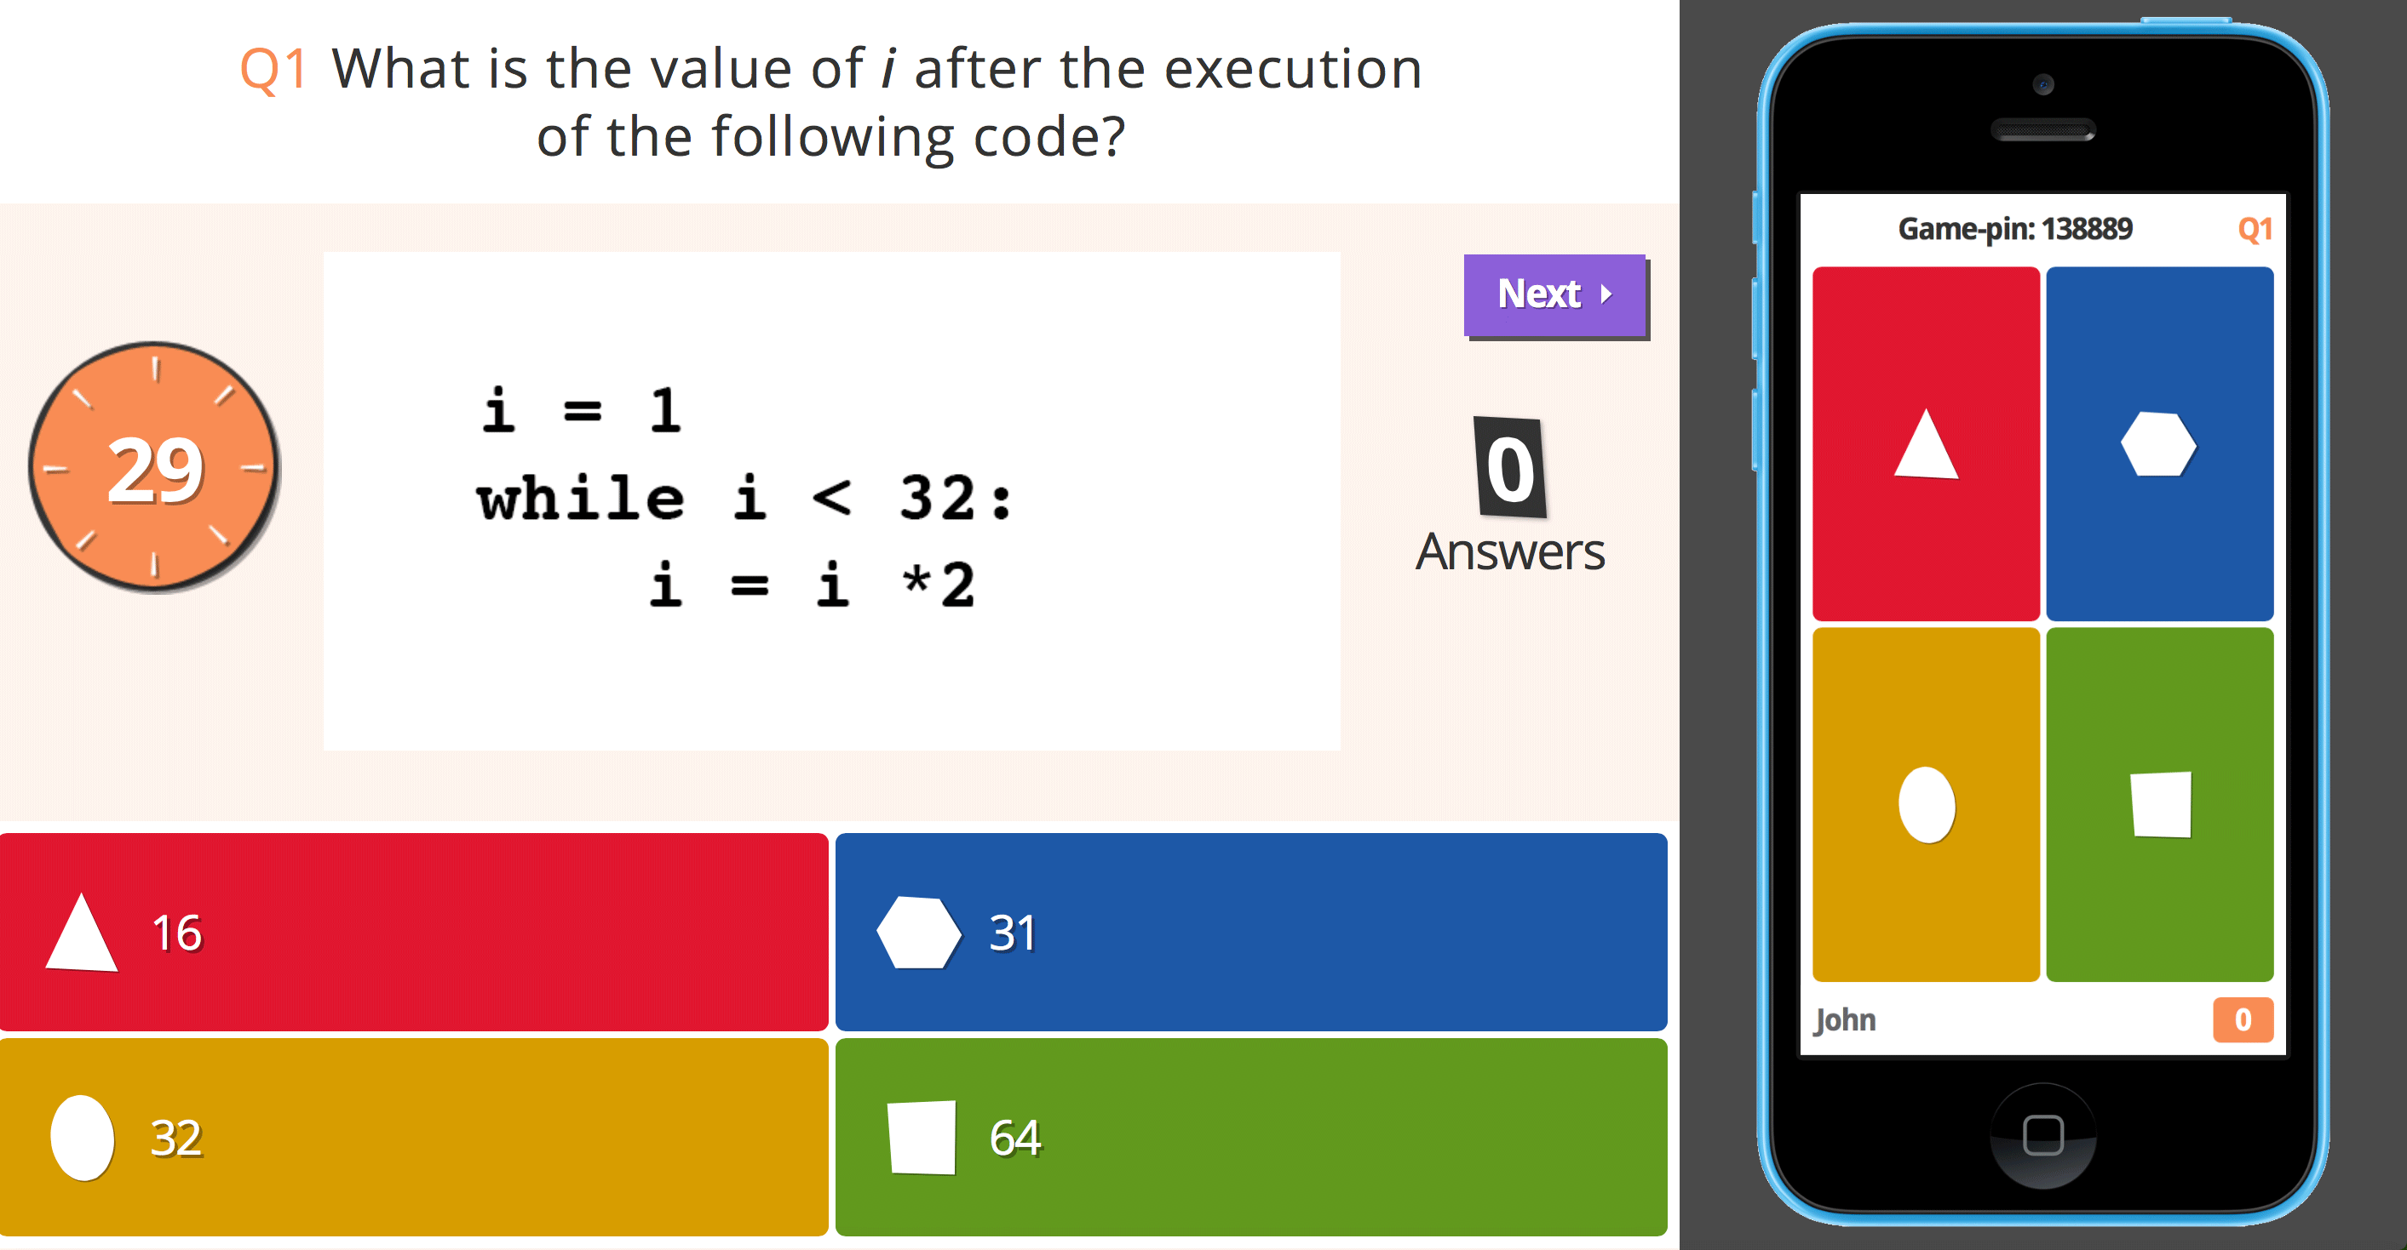
Figure 1: “Kahoot!” in-game screenshot
Following the game’s completion, the lecturer discussed briefly all answers to each question and downloaded a spreadsheet of the results in order to get an overview of the individual student and overall class performance. Each student’s score was updated every week and was entered to a leaderboard webpage, which was publically accessible through Blackboard and displayed enrolled students in descending order according to their total points. This visual display of progress and ranking provided students with direct feedback on their performance against both their own goals and the performance of their peers, while also serving as instant gratification.

Collaborative problem solving with “Who Wants To Be A Millionaire?”
The one-hour revision seminar was also changed; the combination of Q+A and lectures that took place during the first year was replaced by an open-source implementation of WWTBAM, a television quiz show that offers a top prize of $1 million for answering correctly successive MC questions of increasing difficulty (Figure 2). The version of the game used in the classroom featured 540 Python-related MC questions (3 sets of 15 questions per week), which were created by the lecturers through a straightforward process that required the editing of a simple text file. For logistic purposes, the class was randomly divided into four groups of 13 students (11 male, 2 female) who attended a separate seminar every week for a total of 12 weeks. During the first seminar, each group was randomly split into three teams of 4-5 contestants that remained the same for the duration of the course, and then the gaming activity started as outlined below.

Each team was seated in front of the class facing the screen with their backs to the audience so that they could not receive any unsolicited assistance. Students were then asked 15 increasingly difficult questions on Python programming which covered a different topic every week. Since some of these questions were also scheduled to appear in the 6 theoretical quizzes, in fairness to the team of student contestants all other students in the class were instructed to put away their note-taking materials for the duration of the game. This also enhanced the perception that the class was taking a break. Although there was no official time limit to answer a question, each game’s duration was limited to 20 minutes in order to give all teams the opportunity to play once during the seminar. Questions were multiple-choice: 4 possible answers were given and the team had to collaborate, reach a consensus, and give a single response. Additionally, at the beginning of each game contestants were presented with an aid of three lifelines:
- Poll The Class: All students provided their answers for a particular question by raising their hands and the percentage of each specific option as chosen by the class was displayed to the contestants.
- 50/50: The game eliminated two incorrect answers, thus leaving contestants with one incorrect and the correct answer to choose from.
- Ask A Friend: Contestants had 30 seconds to read the question and answer choices to a non-team classmate, who in turn had the remaining time to offer input.

After viewing a question, the team could respond in one of three ways:
- Refuse to answer the question, quit the game, and retain all points earned up to that point.
- Answer the question and, if their answer was correct, earn points and continue to play, or lose all points earned to that point and end the game if incorrect. However, the £5,000 and £100,000 prizes were guaranteed: if a team got a question wrong above these levels, then the prize dropped to the previous guaranteed prize.
- Use a lifeline (Ask A Friend, Poll The Class, or 50/50).

The game ended when the contestants answered a question incorrectly, decided not to answer a question, or answered all questions correctly. All answers to each question were conscientiously reviewed for the entire class as the game proceeded. This discussion of the relative merits of the various provided answers was an integral part of the learning process that took place during the execution of the game.

At the end of every seminar, newly earned points were added to the points carried from previous weeks. The whole scoring process was done manually, with points being collected by faculty and then added to a leaderboard webpage on Blackboard, which showed the team rankings for every group and provided an entry point to the gamified experience. After all 12 seminars were completed, the leading team won the title of “Pythonista of the year” and received chocolate bars as an award. Finally, in order to promote self-assessment and allow students who missed the seminar sessions to experience this alternative form of learning, the game and its latest set of questions became available for downloading at the end of every week.

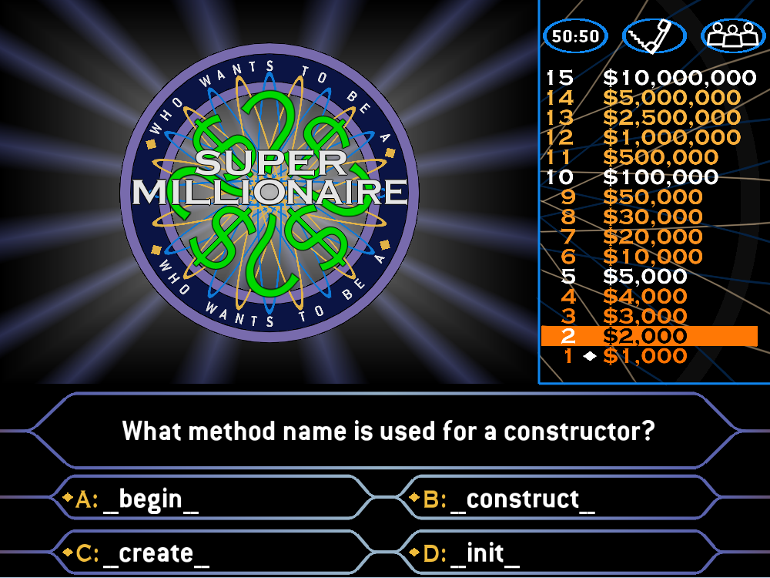
Figure 2: “Who Wants To Be A Millionaire?” in-game screenshot

Practicing programming skills with Codecademy
To make the laboratory classes more interactive and engaging, Codecademy was selected as the delivery platform for the programming exercises. Founded in 2011, Codecademy is one of the most popular online education providers with over 24 million users to date (Richard Ruth, 2015). It offers free coding courses tailored for the new computing syllabus in the UK in a number of programming languages, including Python. Additionally, it serves as a competitive virtual classroom that allows students to track their peers’ achievements and work to match or outdo them.

In the first laboratory session, lecturers created an “FSD Class” containing 36 lessons of Codecademy’s Python track that were mapped to the syllabus of FSD. Students were then asked to sign up and create a pupil account, which was used to enrol them to the FSD class. From that point lab sessions proceeded as follows: every weekly session began with a five-minute introduction to the exercises for the day, and then students were required to complete a certain number of Codecademy lessons based on the topics that had been covered until then. Each lesson was broken down into bite-sized chunks and comprised of practical exercises accompanied by notes that explained the programming techniques and terms used. After reading the exercise instructions, students would type in their Python code to the code window, submit their code for execution, and see its output in a separate window. If the code were erroneous, they would receive an error message and would have to try again. Once they managed to solve the exercise, they would earn points and proceed to the next lesson. Students who were not able to finish on time could continue the lessons independently and at their own pace at home, while students who finished early and wished to further their programming skills were provided with additional exercises.

The Codecademy platform provided students with direct feedback on their progression via graphical representations such as completion indicators for each lesson and for the overall course, badges and points for various achievements etc. This served as instant gratification and offered an added dimension to learning, as students could track their peers’ scores and try to surpass them. In an effort to motivate students to complete the exercises as quickly as possible, the lecturers set a number of different challenges, e.g., highest score achieved in 1 and in 4 weeks, fastest student to reach 50, 100, and 200 points etc. However, no actual physical rewards were given to the winners. The rationale for this decision was to allow faculty staff to evaluate whether the aim of winning a challenge was in itself enough as intrinsic motivation for students to complete their tasks. Each challenge had its own leaderboard, which was made accessible to the students through Blackboard.

Results
To ensure that the gamified approach encouraged students’ active participation in the educational process, formative and summative assessments of student engagement were performed using the following methods (Jennings and Angelo, 2006):
- Observation of student behaviour.
- Online survey exploring the effects of gamification in the classroom.
- Students’ self-report of activity through focus groups and semi-structured interviews.
- Collection of administrative data such as student attendance, late arrivals to class, number of reference material downloads, lab exercises’ completion rate, and academic performance.

Observation of student behaviour
In regards to classroom observation of student behaviour, the majority of the EC students demonstrated the following characteristics during all seminar, lectures, and laboratory sessions, which are considered immediate indicators of engagement (Franklin, 2005; Mandernach et al., 2011):
- Actively listened, focused attention and made eye contact;
- Responded to the lecturer’s prompts;
- Actively participated in the WWTBAM and Kahoot! games, and in the Codecademy challenges;
- Questioned, explored, brainstormed or discussed the WWTBAM and Kahoot! question topics with their peers and lecturers;
- Utilised decision-making or problem solving skills in questioning and responding;
- Demonstrated body language that was open and relaxed with appropriate smiles or laughter.

Online survey exploring the effects of gamification in the classroom
To gather quantitative feedback about the effectiveness of the gamified experience, all EC students (N_{exp} = 52) completed a 15-question online survey at the end of the semester. Every question had 5 possible answers measured on a Likert scale of 1 (Strongly Disagree) to 5 (Strongly Agree).

Figure 3: Online survey results
According to the weighted Likert scale average shown in Figure 3, students mostly agree that the classroom games made learning fun and would like to see them introduced to other modules as well. Students were also generally motivated to attend classes and arrive on time, a finding that was also supported by the administrative data collected at the end of the course. Most students communicated with their peers while playing and believed that performing well in the games increased their self-confidence. Additionally, they were not intimidated by the use of leaderboards and some of them even studied the course material on a weekly basis in order to appear high in the leaderboard rankings. The discussions about the correct and incorrect answers after every Kahoot! and WWTBAM question were deemed satisfying and improved the students’ understanding of the cover topics. Surprisingly enough, there were mixed opinions about getting some tangible rewards, such as translation of game points into actual marks for module assessments. Finally, most students considered gaming a valuable use of instructional time as they felt it helped them improve their analytical and problem-solving skills.

Semi-structured interviews for in-depth student feedback
To get extra insight into the survey results, qualitative research was conducted in the form of focus groups and semi-structured interviews with a small number of students, featuring questions on collaborative learning, cognitive development, and personal skills development. As demonstrated by the following sample of responses, the overall reaction by interviewees was extremely positive:
- “I know that I have learned from watching other people play WWTBAM, as well as through playing myself.”
- “It makes you feel like you’ve learned something when you complete a lesson in Codecademy.”
- “Seeing my name at the top of the leaderboard made me feel smart and proud.”
- “Although I am rather shy and quiet as a person, playing WWTBAM boosted my confidence and made it easier for me to collaborate with my classmates.”
- “I enjoy Kahoot! because it’s always fun to beat your classmates.”
- “Lectures don’t feel boring anymore.”

Analysis of the administrative data
As a means of gauging student persistence, interest, and effort in the gamified classes, there was a comparison of the attendance and the late arrivals (students arriving to class with at least a 10-minute delay) among the control and the experimental classes (Figure 4). Average class attendance for CC was 65% (≈35 students), while EC had an average class attendance of 78% (≈42 students). Additionally, an average of 4 to 5 CC students and 1 to 2 EC students arrived to class late every week, respectively. Both findings suggest that gamification motivated EC students to be more punctual and attend classes more often than their CC peers.

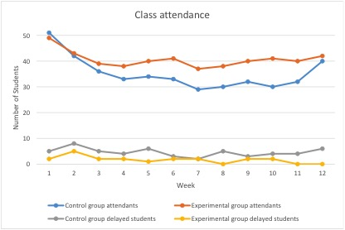
Figure 4: Weekly class attendance
In regards to the number of the reference material’s weekly downloads, CC students demonstrated a lack of interest with an average of 1.2 weekly file downloads per student, which spiked only during the week preceding the final exams; in comparison, every EC student downloaded 1.7 files every week. When combined with the survey’s results, this could suggest that EC students were motivated to download and study the course material every week in order to perform well in the classroom games.

While the CC completion rate of the practical exercises remained roughly around the 50% mark for every laboratory class, EC students showed a small but steady weekly increase in their completion rate, which might indicate that the weekly challenges motivated them to try harder so as to complete their exercises and improve their programming skills. Finally, EC had the best overall academic performance with an average final grade of 61% compared to CG’s 53%. However, due to the relatively low number of participants, additional studies are needed to identify possible correlations between gamification and academic performance.
5 Conclusion and future work
The aforementioned findings suggest that using a multi-dimensional gamified learning approach has successfully achieved the pedagogical goals outlined in the introduction. Based on the concepts of the increasingly popular gamification, game-based learning and serious games movements, it gives teachers and students the opportunity to experience first-hand how game mechanics can be used to make learning fun and addictive. Coupled with effective pedagogy, games can offer more effective and less intrusive measurement of learning than traditional assessments.
Both Kahoot! and WWTBAM serve as an opportunity for instant application of knowledge and allow common programming language misconceptions to be revealed and explored. They also use similar game mechanisms to make students feel good about their accomplishments and overcome their personal records. Kahoot! provides students with the opportunity for self-assessment through a fun and engaging atmosphere, which allows them to master new programming concepts relatively quickly. As for WWTBAM, it requires students to compare and discuss their answers with their teammates in order to come to a consensus regarding the answer, thus honing important employability skills such as collaboration, problem solving, critical thinking, and communication.
This mix of individual and group competition in the classroom catered to the needs of diverse students, some of which preferred to initially develop their coding skills alone while others performed better in groups. As the semester progressed though, it was noticed that the students’ engagement decreased slowly in the Kahoot! sessions; on the other hand, the engagement for WWTBAM remained unchanged. This could be attributed to the fact that students competing at individual level in Kahoot! began to lose interest once they trailed behind in the leaderboard. Another concern from the teaching staff’s point of view was the limited length of the multiple-choice questions and answers in both games, which made their authoring quite challenging.
The use of Codecademy’s points and badges as the sole motivator for completing the practical exercises also provided some interesting insights. Although students were intrinsically motivated to complete their exercises and generally performed better than their CC peers, they expressed some concerns about the lesson contents, saying that some lessons were not always a good fit to the FSD syllabus, lacked clear instructions, and had ambiguous explanations and vague error messages. As a result, students who struggled on a particular aspect of programming due to the poor quality of that particular set of lessons tended to associate that aspect with being difficult to grasp and master, when it was not necessarily so. A possible yet rather demanding solution to this problem would be to provide students with a more personalised experience by developing lessons specifically for the FSD syllabus. Additionally, data analytics could be used to identify which programming concepts are more challenging for students, so as to give the latter opportunities for more practice.
Whilst the results are encouraging, the authors acknowledge that the limited nature of this study does not preclude the possibility that the improvements in student engagement are simply the result of the short-term “novelty” factors generally associated with the introduction of new technology / techniques. Further study is needed to assess whether the increased student engagement suggested by these methods is sustainable and applicable to other subjects.

References

Annetta, L.A., Minogue, J., Holmes, S.Y. and Cheng, M.T. (2009) Investigating the impact of video games on high school students’ engagement and learning about genetics, Computers & Education, Vol. 53, pp 74-85.
Barata, G., Gama, S., Jorge, J. and Goncalves, D. (2013) Engaging Engineering Students with Gamification, In 5th International Conference on Games and Virtual Worlds for Serious Applications (VS-GAMES), Bournemouth, UK, Sep 11-13 2013, pp 1-8.
Blythe, M., Hassenzahl, M. and Wright, P. (2004) Introduction: Beyond fun, Interactions, Vol. 11, No. 5, pp 36–37.
Borys, M. and Laskowski, M. (2013) Implementing game elements into didactic process: A case study, In Management, Knowledge and Learning International Conference, Croatia, 19-21 Jun 2013, pp 819–824.
Deterding, S., Dixon, D., Khaled, R. and Nacke, L. (2011) From game design elements to gamefulness: defining “gamification”, In Proceedings of the 15th International Academic MindTrek Conference: Envisioning Future Media Environments (MindTrek ’11), Tampere, Finland, Sep 28-30 2011, ACM Press, pp 9-15.
Franklin, E.E. (2005) Assessing teaching artists through classroom observation, Teaching Artist Journal, Vol. 3, pp 148-157.
Gee, J.P. (2008) Learning and games, in Katie Salen (ed.). The ecology of games: Connecting youth, games, and learning (John D. and Catherine T. MacArthur Foundation series on digital media and learning), The MIT Press, Cambridge, USA.
Green, C.S. and Bavelier, D. (2006) Effect of action video games on the spatial distribution of visuospatial attention, Journal of Experimental Psychology: Human Perception and Performance, Vol. 32, No. 6, pp 1465-1478.
Hartley, J. and Davies, K. (1978) Note Taking: A Critical Review, Programmed Learning and Educational Technology, Vol. 15, pp 207-224.
Hassenzahl, M. (2003) The Thing and I: Understanding the Relationship Between User and Product, in M.A. Blythe, K. Overbeeke, A.F. Monk and P.C. Wright (eds.), Funology: From Usability to Enjoyment, Kluwer, New York, USA, pp 31-41.
Huang, W.H-Y. and Soman, D. (2013) A Practitioner’s Guide To Gamification Of Education [online] http://inside.rotman.utoronto.ca/behaviouraleconomicsinaction/files/2013/09/GuideGamificationEducationDec2013.pdf
Jennings, J. M. and Angelo, T. (Eds.) (2006) Student engagement: Measuring and enhancing engagement with learning, Proceedings of a symposium, Universities Academic Audit Unit, New Zealand.
Jordan, P.W. (2002) Designing Pleasurable Products. An introduction to the new human factors, Taylor & Francis, London, UK.
Mandernach, B.J., Donnelli-Sallee, E. and Dailey-Hebert, A. (2011) Assessing course student engagement, Promoting Student Engagement, Vol. 1.
McGonical, J. (2010) Gaming can make a better world. [online] http://www.youtube.com/watch?v=dE1DuBesGYM
McKeachie, W.J. (1999) McKeachie’s Teaching Tips: Strategies, Research, And Theory For College And University Teachers, Houghton-Mifflin , Boston, USA.
Middendorf, J. and Kalish, A. (1996) The ‘‘change-up’’ in lectures, Natl Teach Learn Forum, Vol. 5, No. 2.
NMC Horizon Report > Higher Education Edition (2014) [online] http://www.nmc.org/pdf/2014-nmc-horizon-report-he-EN.pdf
Prensky, M. (2001) Digital Game-Based Learning, McGraw-Hill.
Premkumar, K., and Coupal, C. (2008) Rules of engagement-12 tips for successful use of “clickers” in the classroom, Medical Teacher, Vol. 30, No. 2, pp 146-149.
Robins, A., Rountree, J. and Rountree, N. (2003) Learning and Teaching Programming: A Review and Discussion, Computer Science Education, Vol. 13, No. 2, pp 137-172.
Ruth, R. (2015) “Codecademy is teaching the world programming, for free”, Startup Hook [online] http://startuphook.com/employment-2/codecademy-teaching-world-programming-free/498/
Ryan, R. and Deci, E.L. (2000) Intrinsic and Extrinsic Motivations: Classic Definitions and New Directions, Contemporary Educational Psychology, Vol. 25, No. 1, pp 54-67.
Wigfield, A., Guthrie, J.T., Tonks, S. and Perencevich, K.C. (2004) Children’s motivation for reading: Domain specificity and instructional influences, Journal of Educational Research, Vol. 97, pp 299-309.
Zaha, A., Nichols, J. and Deichman, A. (2014) Gaming and Gamification in Education (K-12), Emerging Technologies for Education Change (EDPE640) – Gaming Newsletter. [online] https://edpe640.wikispaces.com/file/view/EDPE640%20-%20Gaming%20Newsletter.pdf/530585356/EDPE640%20-%20Gaming%20Newsletter.pdf
Zhang, P. (2008) Motivational Affordances: Reasons for ICT Design and Use, Communications of the ACM, Vol. 51, No. 11, pp 145-147.

