Influence of metals in the column or instrument on performance in hydrophilic interaction liquid chromatography.

David V. McCalley*

* Corresponding author.

Centre for Research in Biosciences, University of the West of England, Frenchay, Bristol BS16 1QY, UK

Tel. 0044 1173287353

Email [David.Mccalley@uwe.ac.uk](mailto:David.Mccalley@uwe.ac.uk)

Keywords:

HPLC: HILIC: metal interactions.

**Abstract**

A method is proposed for measuring the relative contribution of extracolumn and column effects to the detrimental interactions which occur between metal-sensitive solutes and the complete HPLC system. The method involves the substitution of a length of narrow bore silica tubing for the column and measuring the extracolumn contribution, which is subtracted from the total bandspreading measured with a column in place to yield the column contribution. The investigation focussed on HILIC separations, which have been relatively little studied compared with similar effects in RPLC. Metal-solute interactions can lead to tailing peaks and reduced sensitivity or even irreversible adsorption of particularly challenging solutes such as mono-, di- and triphosphorylated nucleotides, which show strong interactions between their phosphate groups and metals. A deactivated HILIC column, treated by a vapour deposition procedure gave generally good results when using high pH (pH 9.0) mobile phases, which suppress the effects of metals. The addition of metal complexing agents such as citrate at low millimolar concentration gave further improvements in peak shape at high pH, and even micromolar concentrations of citrate or medronic acid showed good results. These lower concentrations are more favourable for LC-MS. Addition of the higher concentration of citrate gave acceptable results for the nucleotides even at low pH (pH 3.0). With the standard UHPLC instrument used, loss of efficiency due to metal solute interactions was 25 % or less, with most losses due to interactions with the column, although this result will depend on the condition and design of the instrument, which is easily assessed by the proposed procedure.

**1. Introduction.**

Hydrophilic interaction chromatography is now a valuable technique for the separation of polar and ionised compounds, which are poorly retained by RPLC. It has many applications in the analysis of compounds of pharmaceutical, biomedical and clinical relevance; its mechanism is increasingly understood [1-3]. It has long been known that interaction of metals from the column hardware/packing or the HPLC instrumentation with the solute can be seriously detrimental to separations in HPLC. Whereas most of the earlier studies have concerned RP separations [4,5], problems also occur in HILIC [6]. Solutes containing vicinal hydroxyl groups (e.g. trihydroxybenzoic acid or catecholamines) can interact with metals leading to tailing peaks and sometimes irreversible solute adsorption [7]. Particularly strong interactions can take place between metals and compounds with a phosphate functionality such as the nucleotides adenosine monophosphate (AMP), adenosine diphosphate (ADP) and adenosine triphosphate (ATP). Severely tailed peaks can result both in RP and HILIC separations [6,8-10]. Problems of peak shape and irreversible adsorption in HILIC [6] were found to increase for nucleotides with multiple phosphate groups. The phosphate functionality of phosphoproteins is known to have an affinity for Fe3+ as exploited in iron-metal affinity chromatography enrichment strategies [11] .

A number of alternatives to stainless steel used to manufacture column hardware or instrument components have been explored, including titanium, which has been regarded as being more inert compared with stainless steel HPLC systems. However, titanium based systems can still cause problems, such as corrosion when using anhydrous mixtures of acetonitrile and methanol, or with pure short chain alcohols [12]. It was proposed that titanium cations, immobilised in the stationary phase, can form complexes with chelating solutes such as fluoroquinones. In an earlier study, a column with titanium frits showed significant epimerisation and elimination of the S-epimer of the ethylsulphoxide of tipredane, a sensitive indicator of metal interactions in RP separations [5]. These authors also proposed the ratio of the efficiency of 2,7-dihydroxynaphthalene divided by that of 2,3-dihydroxynaphthalene (DERT value) as a routine test for metal activity. The latter can chelate metals but the former cannot; however, these solutes are too hydrophobic to be useful in tests of HILIC systems.

Mobile phase additives have been employed to reduce metal-ion adsorption, some recent studies have also used the nucleotides as test compounds [13]. Ethylenediamine has been employed as additive, but can be strongly retained on the column and can cause ion suppression effects in LC-MS. Furthermore, slow or incomplete removal of adsorbed EDTA may generate changes in column selectivity and performance with time (see below). The use of low concentrations of medronic acid, which contains two phosphate groups flanking a central carbon atom, was investigated in HILIC mode [13]. Gradient elution separations were used with solvent A 10 mM ammonium acetate pH 9.0 in water and solvent B 10 mM ammonium acetate in ACN. Medronic acid was spiked into each solvent to generate a concentration typically of 5 M. Unlike EDTA, the additive was found not to produce ion suppression, nor to be difficult to remove from the column or HPLC system. An Agilent Poroshell HILIC -Z column was used. Similar good results were obtained with phosphorylated pesticides or peptides. The authors reported that performance of the separation with the mobile phase additive was inferior at low pH..

The performance of medronic acid and citrate as mobile phase additives has also been studied in the RP-LC analysis of peptides that possess negative charge bearing groups (such as aspartic acid or glutamic acid) [14]. It was found that in gradient analysis using 0.1 % formic acid in water-acetonitrile in conjunction with a Waters CSH C18 column, citric acid at a concentration of 1 ppm or medronic acid at a concentration of 5 M produced reduction in the US Pharmacopeia tailing factor of as much as 40% for these peptides. Care was taken to prevent irreproducible results in these studies by e.g monitoring performance of sequential injections over a period of in some cases 67 hours. Repeated injections of solute over a short time period may deactivate metal sites by strong adsorption of part of the sample, rendering a more inert surface for subsequent injections.

A further alternative procedure is to create a so-called “bio inert” metal free fluidic pathway by treating stainless steel with a non-interacting material. Waters have introduced a hybrid organic-inorganic surface technology to limit analyte-metal interactions, applied using vapour deposition on column and instrument components. This technology is based on the ethylene bridged siloxane polymer of composition [O1.5SiCH2CH2SiO1.5] n , similar to that which the company has used as the base material for the preparation of inert column packings [15]. The performance of the treatment was evaluated in RP separations. The surface was reported to be more hydrophilic than PEEK (an alternative inert coating material), making it less prone to hydrophobic adsorption. Titanium frits gave rise to considerable loss of ATP (used as a test solute) by adsorption. However, adsorption was almost completely prevented on surfaces treated by the vapour deposition method. Frits were stated to account for about half the metal surface area accessible to the analyte in a typical UHPLC system. Using a BEH C18 column in conjunction with a mobile phase of aqueous ammonium acetate (10 mM, pH 6.8) it was demonstrated that ATP was completely adsorbed when using a standard UHPLC system and standard column, partially adsorbed with severe peak tailing on a standard UHPLC system with treated column, and eluted with reasonable peak shape on a treated UHPLC system with treated column. The authors investigated the effect of pH on peak shape using a treated UHPLC system and either a standard or a treated column. It was found that raising of the pH from 4.5 to 6.8 to 8.5 of the 20 mM ammonium acetate mobile phase caused improvements in performance for this RP separation. A rationale for this behaviour is that the oxide layer on 316 stainless steel has been estimated to have an isoelectric point of ~ 7 [16] . Thus at pH 9.0, surface charge is reduced and metal adsorption of phosphorylated peptides/ phophorothioated oligonucleotides was reduced. Rather similar results were obtained for all metal complexing solutes studied, indicating that a simple nucleotides test may give results representative of a wide range of compounds.

Sandra and co-workers [17] evaluated a new zwitterionic HILIC stationary phase (Poroshell 120 with 2.7 m particles) which has a PEEK lined column option with PEEK frits for particularly challenging compounds. This is a different approach to vapour deposition procedures. Columns were evaluated on both conventional and “bioinert” systems. Nucleotides were separated by gradient analysis using decreasing concentrations of acetonitrile in 10 mM ammonium acetate pH 9.0. The authors showed poor results for AMP, ADP and ATP on a conventional column format using either a conventional or a bioinert HPLC system but improved results using the PEEK lined column, especially with the bioinert system. Results were very similar for equivalent nucleotides of guanosine, cytidine and uridine. Different mobile phase conditions were not investigated in this study, nor the use of complexing additives. PEEK systems may however be unsuitable for use with certain solvents e.g. tetrahydrofuran. The contribution of the instrument to poor peak shape was not formally assessed.

Estimation of the instrumental contribution to band broadening of these sensitive solutes is important as this contribution is likely to vary from instrument to instrument and even on the same instrument dependent on the history of its use. Few, if any studies have used a quantitative approach to estimate this contribution, especially in HILIC separations. Such an estimation might assist a decision on whether the purchase of a new treated or bioinert HPLC system is justified, or whether the replacement of the column alone with a more inert version would suffice.

The aims of the present study can be summarised as:

-to focus on detrimental metal interactions in HILIC as this mechanism may present greater or at least different challenges than RP chromatography. Most previous studies have used RP conditions.

-to measure separately and quantitatively the instrumental contribution to band broadening of these sensitive solutes to determine the relative contribution of the instrument and column.

-to use isocratic elution for evaluation rather than gradient analysis as the latter may show optimistic results due to gradient compression of sample bands (the rear of a peak experiences a stronger eluent than the front of the peak [18] ).

-to present quantitative column efficiency data for various mobile phase conditions.

-to investigate the performance of a new deactivated HILIC column.

**2. Experimental**

Experiments were performed using a 1290 ultra-high performance liquid chromatograph (UHPLC, Agilent, Waldbronn, Germany) comprising a binary pump, autosampler and photodiode array UV detector (0.6 L flow cell) set at 260 nm with data collection rate 160 Hz. The instrument was fitted with the ultra-low dispersion needle seat and flow-through needle options. A few experiments were conducted on an Agilent 1100 system using a variable wavelength detector (1.0 L flow cell) and data collection rate 14 Hz. Columns (all 10 cm x 0.21 cm i.d.) were: BEH amide (totally porous, Waters, Milford USA) treated (Premier) and non-treated, particle diameter 1.7 m, pore diameter 130 Å, surface area 185 m 2/g. For measurement of instrumental contribution to band broadening, the column was replaced with a 10 cm x 50 m ID PEEKSIL tube of PEEK coated fused silica (Trajan Scientific, Milton Keynes, U.K.). The temperature of the oven was set at 30 oC. The mobile phase was ACN-water (70:30 v/v), containing various additives, at a flow of 0.40 mL/ min. ww pH was measured before addition of the organic solvent. Solutes were obtained from Sigma-Aldrich (Poole, U.K.). Mobile phase solvents and additives ACN (gradient UV grade), ammonium formate (AF), ammonium acetate (AA) diammonium citrate (AC) formic acid (FA) and ammonia solution (all MS grade) were from Fisher (Loughborough, U.K.).

The HPLC systems were initially washed using the PEEK tubing in place of the column for 10 hours with 0.1 % orthophosphoric acid in 70-30 ACN-water (v/v), 10 hours with 5 mM ammonium formate pH 3.0 in 70-30 ACN-water, and 10 hours with 90-10 ACN-water (v/v). Mobile phase solvents were made up in a single reservoir by weight rather than directly by volume. After each set of results was obtained using a particular mobile phase, the column was washed for 1 hour with 90-10 ACN-water (v/v) and left to stand in this solution for at least 12 hours. The new mobile phase was pumped through the PEEK tubing or column (dependent on the experiment) for 2 hours at 0.4 mL/min. prior to solute introduction [19,20]. Solutes were injected in duplicate or triplicate at 10 minute intervals and further repeat injections were performed after a period of 2 hours of purging the column with mobile phase to check the reproducibility of the results. Under the specified conditions, no evidence was seen for “loading effects” as observed previously for peptides or oligonucleotides in RP separations [14,21]. Injection volume was 1.0 L for the UHPLC system. tM was determined by injection of a solution of toluene. All solutes were injected at a concentration of 20 mg/L dissolved in the mobile phase.

Log Dow (the ratio at equilibrium of the concentration of charged plus neutral solute in octanol devided by their concentration in water) and solute charge were estimated as the average of the values given from the programs Marvin (ChemAxon, Budapest, Hungary) and I-Lab (ACD, Toronto, Canada).

**3. Results and Discussion**

*3.1 Determination of instrumental contribution to peak broadening-principles of the method.*

The UHPLC system was first cleaned as outlined above. Passivation with concentrated solutions of strong acids or complexing agents (EDTA) was not carried out because these reagents may only slowly be removed from the systems, which return to their initial state after a period of time, leading to irreproducible results. The UHPLC system used for these experiments had been employed mostly for the analysis of simple pharmaceutical standard solutions; a new injection needle and needle seat were fitted prior to the experiments but the instrument was composed of standard components that were not treated other than as described above.

The peak broadening caused by the instrument was measured by substituting the column with a fused silica lined PEEK tube which generated sufficient pressure under the conditions used to ensure a reproducible flow from the pump. The total band spreading can be expressed as the variance in volume units 2tot,v where

2tot,v = 2col,v + 2extra col,v [1]

where the subscript col refers to the band spreading of the column itself and the subscript extra col. refers to the band spreading produced by the injector, the connecting tubes and the detector of the 1290 instrument. v can be obtained from t (measurement in time units) from the 5 t peak width measured at 4.4 % of peak height using the relationship:

v = t. F [2]

where F is the volumetric flow rate.

Fig.1a shows the plots obtained by injection of 20 ppm solutions of adenosine, AMP, ADP, and ATP into the PEEK tube using a mobile phase of 2.5 mM AF, 1.25 mM dibasic AC adjusted to pH 9.0 with ammonia in 70: 30 ACN-water, v/v. This mobile phase was subsequently found to give the best peak shapes with a column in place. It is clear that the peak profiles are reasonably symmetrical with relatively little tailing of the injection band. Fig. 1b shows similar plots using 5 mM AF adjusted to pH 3.0 with FA in 70:30 ACN-water, v/v. This mobile phase was subsequently found to be the one that generated the worst peak shapes with a column in place. While the peak shape for adenosine was similar to that in Fig 1a, the profiles for AMP, and especially ADP and ATP, showed increased peak broadening and tailing. Thus, the results mirror the findings for detrimental *column* performance (see below). Table 1 gives a quantitative view of the broadening that occurs for the instrument for toluene, adenosine, AMP, ADP and ATP in 4 different mobile phases. For the pH 5 mM AF pH 3.0 buffer as used in Fig. 1b, the values of 2extra col, v for these 5 solutes were 2.4, 3.5, 6.0, 130 and 520 L2 respectively confirming the increase in peak broadening for solutes with multiple phosphate groups observed visually in Fig. 1b. For the pH 9.0 AF buffer, the results were considerably improved especially for ADP and ATP with results for the 5 solutes of 2.4, 3.5, 7.0, 28 and 40 L2 respectively. These results are in line with the hypothesis that the charge on metal ions decreases as mobile phase pH increases [16]. This effect should thus decrease metal interactions with negatively charged solutes as pH increases. However, Table 2 shows that the negative charge on the nucleotides increases somewhat with increasing pH over the range pH 3.0 to pH 9.0; for instance the charge on ATP increases from -1.8 to -3.4. This effect should conversely somewhat increase metal solute interactions as pH increases. For the 1.25 mM citrate mobile phase at pH 9.0 in Fig.1a the equivalent values of 2extra col, v were 2.5, 3.5, 5.8, 15 and 20 L2 for the 5 solutes respectively, which are clearly smaller still than with the same mobile phase but without the complexing agent. Note however that the values for the non-polar compound toluene (2.3- 2.5  L2 ) and for adenosine (no phosphate groups, 3.5  L2 ) were very similar in all mobile phases (Table 1). Of course, instrumental contribution to peak broadening may take place merely due to the system variance of the instrument and connectors rather than adverse adsorption, which is reflected in the small but appreciable 2extra col, v value for toluene. Clearly however, the peak variance for toluene is much smaller than that for ADP and ATP in any of the mobile phases in Table 1 (see discussion below).

Fig. 1c shows the bandspreading produced by the same solutions on an Agilent 1100 system, cleaned as for the 1290 instrument; note the x-axis is 10 times the scale of Fig. 1a and 1b. The peaks are much broader on this older instrument which is not optimised for use with small internal diameter columns. The bandspreading for toluene, adenosine, AMP, ADP and ATP was 64, 66, 112, 1665, and 1126 L2 respectively using 5mM AF buffer pH 3.0 in 70 % aqueous ACN. These values are much higher than those for the 1290 instrument, reflecting particularly for toluene and adenosine, the normal effects of instrumental band broadening. Nevertheless the still higher values for ADP and ATP follow a similar pattern to those on the 1290 instrument, and are indicative of metal interactions. We have previously shown that the effects of instrumental band spreading of conventional instruments with 4.6 mm ID columns can be less severe than those of UHPLC instruments with 2.1 mm columns [22]. Thus the method can also be used to determine the total effects of metals and general band broadening also on conventional HPLC instruments with wider columns. If a suitable column diameter and conditions leading to appropriate *k* values are used, the contribution of metal effects alone to bandspreading can again be estimated on such instruments.

*3.2 Determination of column contribution to band broadening*.

With the column in place, the experimental protocol for changing the mobile phase was strictly followed (see Experimental) in order to achieve reproducible results and counteract any memory effects of use of the previous mobile phase. Some data obtained using a particular mobile phase were repeated on a different day e.g. to determine whether use of higher concentrations of citrate persist on the column, but none was found. This is in agreement with results in a detailed RP study [15] which claimed that multivalent acid washes improved the recovery and peak shape of acid analytes but that the effect was only temporary. This result contrasts with the use of EDTA, which we have found in preliminary studies to persist on the column. Using the injection protocol (see above) there was little evidence of “sample conditioning effects” where peak shape improves on rapid re-injection of the same sample with a given mobile phase, as found for a RP separation of oligonucleotides [21] . These effects are likely to depend also on the separation mechanism, the particular mobile phase and column used, and the solutes. They may be caused by injection of a new sample on the still tailing peak of solute from the previous sample, which temporarily blocks active sites. They are likely to be less significant on a deactivated column as mostly used in the present experiments, which gave much improved results in the nucleotide test of the present study than a standard column of the same stationary phase (see below). Leaving a period of time between each injection (10 minutes) also minimises such effects.

Fig. 2a shows a chromatogram of the 4 test compounds using a deactivated amide column (Waters Premier BEH amide) and a high pH mobile phase (as Fig. 1a) containing a relatively high concentration of complexing agent (1.25 mM citrate). This column along with some others produced by Waters is based on a bridged ethyl hybrid inorganic/organic substrate which confers high pH stability, in this case over the claimed pH range of 2-12. Columns based on a conventional silica matrix are likely to be much less stable with an upper pH limit of 6-7. The Agilent HILIC Z column studied by others [13,17] also has a high pH limit of 12 and may be based on similar hybrid technology. No detrimental effect of the use of pH 9.0 on the Waters hybrid materials (retention or efficiency changes) were observed in the course of this study. The solutes are eluted in order of increasing numbers of phosphate groups. Table 2 indicates increasing hydrophilicity for adenosine, AMP, ADP, ATP with log Dow values -1.7 to -12.7 along the series at pH 9.0. (Note that large negative log Dow values indicate high hydrophilicity). Ionic interactions, which increases with the number of phosphate groups in the solute, clearly contribute to retention: these interactions increase as the charge on a solute increases at a given pH. For instance, the charge on adenosine, AMP, ADP, ATP is 0, -2.0, -2.4, and -3.4 at pH 9.0. Ionic interactions are however, likely to be suppressed at high pH by the reduced ionisation of metal oxides such as chromium, nickel, cadmium and iron. They are also reduced by the presence of complexing agents such as citrate or medronic acid. These reagents are highly hydrophilic and remain negatively charged at pH 9.0 (see Table 2). Caution must be exercised in use of Table 2 as data are based on the properties of compounds in pure water, rather than 70 % ACN for which data is not available.

Having calculated the contribution of the instrument to peak broadening it is now possible to determine the contribution of the column alone. This is done by measuring the total variance 2 and subtracting the extracolumn variance. Table 1 shows data for 4 different mobile phases using the deactivated column. For ATP using the pH 9.0 high citrate concentration mobile phase, the total variance is ~ 100 L2 and the extracolumn variance 20 L2 suggesting the column variance is ~ 80 L2 . This indicates a true column efficiency using the 5  peak width method of 12900 plates (see the penultimate column on the right hand side of Table 1, N true col.). The uncorrected efficiency is 10,400 plates representing a 20 % loss of efficiency due to metal effects (and extra column dispersion). Note this mobile phase gave the best performance for ADP and ATP. For the same mobile phase (1.25 mM citrate) at pH 3.0, the extracolumn variance was larger at 98 L2 for ATP. However, this value is counterbalanced by a proportionally much higher value of 2400 L2 for the total variance for the deactivated column and instrument at pH 3.0, leading to a loss in efficiency of only 3.7 %. These results suggest that the interaction of nucleotides with column metals replicates their interaction with extracolumn metals. Clearly, the proposed method also takes into account peak broadening due to instrumental dead volume (in addition to metal interactions), which is large only at low *k* values. Thus the % loss in efficiency for toluene is ~ 50 % in each mobile phase; however toluene has a retention factor of effectively zero, as it is often used as a void volume marker in HILIC [23]. The effect of instrumental band spreading as measured by toluene (no solute-metal interactions, variance ~2.5 L2 ) is small compared with the peak variance of retained solutes such as ATP (k ~4 in AF/AC pH 9.0) and smaller still in the other mobile phases shown in Table 1, which give greater retention and thus broader chromatographic peaks. Therefore the measurement of peak broadening using ATP is almost entirely due to metal-solute interactions.

While it appears that most of the band broadening of metal-interactive solutes takes place due to the column, and in some cases particularly on frits, which have a large surface area [21], the relative contribution of column and instrument will also vary with the condition of the instrument used. However, the proposed method provides a simple way of assessing these contributions. The most detrimental influence of extracolumn interaction with metals would be obtained in the situation where the column generates sharp symmetrical peaks but the instrument itself contributes considerable broadening and tailing to the injected profile. This might be possible for a contaminated or corroded instrument; however the methodology suggested above can easily identify such a situation. This situation may also be less common, in that instrument and column have been shown to suffer from similar effects i.e. metal interactions would tend to lead to a broad extracolumn injection profile and also strong adsorptive column interactions.

Clearly, it would be possible to substitute different solutes for the nucleotides which were of particular interest, allowing the determination of the instrumental and column contributions for those particular solutes. Of course, a reasonable value of *k* for such solutes is required to minimise the normal effects of instrumental dead volume on column efficiency.

Finally, the use of the 5-sigma method to characterise losses in column efficiency is debatable in that it assumes peaks are Gaussian which is clearly not the case. However, we found the measurements reproducible and straightforward to make. More sophisticated methods have been proposed, but these also may not be accessible to the average practitioner [24].

*3.3 Effect of mobile phase pH and complexing additives on column performance*.

3.3.1 Column efficiency effects.

Fig. 3a shows column efficiencies (uncorrected for instrumental band spreading) in a variety of mobile phases at pH 3.0. The performance of the conventional BEH amide column is poor using a simple 5 mM AF buffer, with very low efficiency even for AMP. Fig. 2b shows a chromatogram of the deactivated column with the test mixture in this mobile phase, which shows some improvement, however, the peak of AMP is still noticeably tailing, while ADP and ATP were irreversibly adsorbed even on this deactivated column at pH 3.0 in the absence of complexing agents. Addition of 10 M citrate to the mobile phase at pH 3.0 hardly improved the efficiency with the deactivated column, although there is a slight improvement for AMP and the marginal appearance of a peak for ADP (Fig. 3a). A larger concentration of citrate additive (1.25 mM) produced a marked increase in the efficiency for AMP and ADP, and the appearance of a peak for ATP (Fig. 3a and 3b). Thus at pH 3.0, it seems that relatively high concentrations of metal complexing additives are necessary to mediate metal-solute interactions even when using the deactivated column.

Using pH 9.0 conditions the conventional BEH amide column continued to give poor performance. However, the deactivated column produced marked improvement in efficiency over that for the same column at pH 3.0 (Fig. 4a). Performance of the deactivated column was clearly better than that of the standard column at pH 9.0, giving measurable efficiency also for ADP and ATP. Addition of micromolar concentrations of citrate (10 M) or medronic acid, however produced marked increases in efficiency on the deactivated column compared with the simple AF buffer, resulting in these mobile phases being suitable for use in LC-MS. While performance with medronic acid and citrate was similar at this concentration, we noted longer stabilisation times (several hours) required to produce consistent retention times with the former additive; this result may be connected with the low concentration used compared with some other studies [2]. Fig. 4a shows that further small improvements in efficiency were revealed with 1.25 mM citrate on calculation of the 5 sigma plate counts, although these are hardly apparent from visual comparison of the chromatograms Fig. 2c and Fig. 2a.

These results show that addition of complexing agents at pH 9.0 produces further increases in efficiency, despite metal-solute interactions being reduced at this higher pH. Metal-solute interactions appear to be still significant even this high pH. Fig. 4a shows that use of 1.25 mM citrate produces acceptable effiency even for the conventional BEH column, although this mobile phase may not be as suitable for LC-MS applications. The difference is again hardly apparent by mere inspection of chromatograms 2a and 2d.

The contribution of extracolumn adsorption to peak shape remains low at pH 9.0, with a maximum loss of efficiency due to the instrument of 20-25 % for the retained peaks of ADP and ATP when using the 1.25 mM citrate buffer. The consistent loss in efficiency of about 25 % for adenosine in all 4 mobile phases in Table 1 is due to the normal bandspreading effect of the instrument on a peak of low k (~0.7) and not due to adsorptive metal interactions. Peaks were consistently symmetrical for adenosine with USP tailing factors <1.25 in all cases.

Finally, the advantage of the use of high pH in conjunction with pH-stable columns is confirmed in Fig. 2e. Column efficiency using 5 mM AA at pH 6.5 was for adenosine, AMP, ADP and ATP 9580, 4500, 220 and 430 theoretical plates, compared with at pH 9 (Table 1) 9390, 7650, 2420 and 887 respectively. Irreversible adsorption of ADP and ATP at pH 6.5 is clearly shown by the small peak areas for these solutes, which is not shown at pH 9 (Fig. 4b).

3.3.2 Peak area and “recovery”.

The plots in Fig. 3a and 3b have a similar appearance showing that the effects of metal interactions on peak shape or detection sensitivity (peak area) are similar at pH 3.0. Clearly ADP and ATP are the most challenging solutes that are only detected at pH 3.0 when using 1.25 mM citrate as additive (Fig. 3b). The equivalent graphs at pH 9.0 show greater differences between the peak area plots (Fig. 4b) and the efficiency plots (Fig. 4a). Thus the conventional BEH amide column at pH 9.0 with 5mM AF gave reasonable peak area for AMP, ADP and ATP but very low efficiencies. This result can be explained by reversible strong adsorption of some solutes, giving extensive peak tailing but nevertheless (eventual) release of much of the solute. Accordingly, the peak area plots at pH 9.0 are rather similar to each other, whereas the efficiency plots are not and demonstrate the added benefit of using complexing additives, even at pH 9.0. Clearly the use of peak area alone is insufficient and inadequate to monitor metal interaction effects.

It is interesting to note that the (acceptable) performance in terms of peak area and efficiency on the deactivated column are roughly similar for pH 3.0 with1.25 mM citrate and pH 9.0 with ammonium formate (no citrate). This shows that use of low pH is still practical e.g. to improve selectivity, although this higher concentration of complexing agent may be detrimental to MS use. However, no detrimental effects of low mM concentrations of citrate were noted in the present LC-UV study. It seems however, that complexing reagents may still be required to obtain the best results, even at pH 9.0.

**4. Conclusions**

A method is proposed for separate estimation of the contribution of extracolumn and column interactions to peak shape with metal sensitive solutes. The method involves measuring the instrumental bandspreading by substitution of the column with a short piece of 50 m PEEK coated fused silica tubing (to generate some back pressure in the system) and measuring the peak widths at 4.4 % of peak height (5 method). The extracolumn effects can then be subtracted from the total bandspreading of instrument and column to leave the column effects. The contribution of normal instrumental dead volume bandspreading, which does not involve metal interactions, can be minimised if desired by avoiding solutes or mobile phase conditions (e.g. in HILIC, higher % water concentrations) that generate low *k*.

A deactivated amide HILIC column gave generally good peak shape for the searching nucleotide test compounds used at pH 9.0; results were considerably improved compared with a standard column of the same stationary phase. Results on the deactivated column were much improved over those at low pH (3.0) or at intermediate pH (6.5). Micromolar concentrations of metal complexing agents (citrate or medronic acid) added to the pH 9.0 mobile phase gave further improvements in peak shape. The best results at pH 9.0 were obtained with low mM concentrations of citrate, which also allowed reasonable analysis of the nucleotides even at pH 3.0. Isocratic elution was used throughout as a more demanding test; gradient elution can give peak focussing effects that partially conceal the influence of metal interactions

Lack of any loss in peak area due to metal-solute interaction cannot be taken as meaning these detrimental effects are absent. Deterioration in column efficiency is a much more sensitive indicator of metal effects. Absence of peak area loss may be explained by the presence of strong but reversible interactions.

With the instrument used (a standard UHPLC system) extracolumn metal interactions were found to mirror column interactions; column interactions were found to cause the most deleterious effects on efficiency. However, this result depends on the condition of the instrument, which can be easily assessed by the proposed method. Furthermore, whereas the chosen nucleotides may be representative of solutes that give strong metal interactions, substitution of any chosen solutes can be used to probe the extent of these interactions in a particular separation.

**Funding**

This research did not receive any specific grant from funding agencies in the public, commercial, or not-for-profit sectors.

**Author contribution**

David McCalley: conception, investigation and experimental work, technical aspects, data analysis, writing.

**Declaration of competing interest**

The authors declare that they have no known competing financial interests or personal relationships that could have appeared to influence the work reported in this paper.

**5 Acknowledgements**

The authors thank Agilent Technologies (Waldbronn, Germany) for the loan of the 1290 instrument, and thank Waters (Milford, USA) for the gift of columns used in this work.

**6. Legend to Figures**

Fig. 1. Injection profiles on Agilent 1290 of 1 L solutions of 20 ppm adenosine (blue), AMP (red), ADP (green), ATP (pink) dissolved in mobile phase. Flow rate 0.4mL/min. Detection UV at 260 nm. Oven temperature 30 o C. Mobile phase a) 2.5 mM AF, 1.25 mM dibasic AC adjusted to pH 9.0 with ammonia in 70: 30 ACN-water, v/v; b) 5 mM AF adjusted to pH 3.0 with FA in 70: 30 ACN-water, v/v; c) injection profiles of 5 L solutions of the same solutes on Agilent 1100, mobile phase as for 1 b). Note the x-axis scale is 10 x greater in c) than in a) and b).

Fig. 2 Chromatograms on Premier amide column of 1 = adenosine; 2 = AMP; 3 = ADP; 4= ATP using mobile phases 70:30 ACN-water containing: a) 5 mM AF +1.25 mM citrate pH 9.0; b) 5 mM AF pH 3.0:. c) 5mM AF + 10 M citrate pH 9.0; d) as in a) with BEH amide column; e) 5 mM AA pH 6.5 with Premier amide column. Other conditions as in Fig. 1.

Fig. 3. a) Column efficiency (5 sigma method) for adenosine (orange); AMP (grey); ADP (yellow); AP (blue) using 70:30 ACN-water (v/v) containing various buffers at pH 3.0. Column BEH amide standard or Premier BEH amide as indicated. b) Peak area for the same columns and mobile phase conditions as in Fig. 3 a). Other conditions as Fig.1.

Fig. 4. a) Column efficiency data (5 sigma method) for same solutes (see Fig. 3) using 70:30 ACN-water (v/v) containing various buffers/additives at pH 9.0. Columns BEH standard or Premier BEH amide as indicated. b) Peak area for the same columns and mobile phase conditions as in Fig. 4 a). Other conditions as Fig.1.

**7. References**

1 Y. Guo. Recent progress in the fundamental understanding of hydrophilic interaction chromatography (HILIC), Analyst 140 (2015) 6452-6466, doi:10.1039/c5an00670h.

2 L. Fical, M. Khalikova, H.K. Vlčkova, I. Lhotská, Z. Hadysová , I. Vokřál ,- L. Červený , F. Švec, L. Nováková. Determination of Antiviral Drugs and Their Metabolites Using Micro-Solid Phase Extraction and UHPLC-MS/MS in Reversed-Phase and Hydrophilic Interaction Chromatography Modes. Molecules 26 (2021) 2123, doi:10.3390/molecules26082123.

3 D. V. McCalley. Understanding and manipulating the separation in hydrophilic interaction liquid chromatography. J Chromatogr. A 1523 (2017) 49-71, doi:10.1016/j.chroma.2017.06.026 ).

4 M. R. Euerby, C. M. Johnson, I. Rushin, D. A. Sakunthala Tennekoon. Investigations into the epimerisation of tipredane ethylsulphoxide diastereomers druing chromatographic analysis on RP silica. I Investigations into the reaction mechanism. J. Chromatogr. A 705 (1995) 219-227, doi.org/10.1016/0021-9673(95)00272-O

5 M. R. Euerby, C. M. Johnson, I. Rushin, D. A. Sakunthala Tennekoon. Investigations into the epimerisation of tipredane ethylsulphoxide diastereomers during chromatographic analysis on RP silica. II. The involvement of metals in commercially available C18 silicas. J. Chromatogr. A 705 (1995) 229-245. doi.org/10.1016/0021-9673(95)00273-P.

6 J. C. Heaton , D. V. McCalley. Some factors that can lead to poor peak shape in hydrophilic interaction chromatography, and possibilities for their remediation. J. Chromatogr. A 1427 (2016) 37-44, doi:10.1016/j.chroma.2015.10.056.

7 J. C. Heaton, J. J. Russell, T. Underwood, R. Boughtflower, D. V. McCalley. Comparison of peak shape in hydrophilic interaction chromatography using acidic salt buffers and simple acid solutions. J. Chromatogr A 1347 (2014) 39-48, doi:10.1016/j.chroma.2014.04.026.

8 A. Wakamatsu, K. Morimoto, M. Shimizu, S. Kudoh. A severe peak tailing of phosphate compounds caused by interaction with stainless steel used for liquid chromatography and electrospray mass spectrometry. J. Sep. Sci. 28 (2005) 1823-1830, doi:10.1002/jssc.200400027.

9 R.Tuytten, F.Lemière, E.Witters, W. VanDongen, H.Slegers, R.P.Newton, H. VanOnckelen, E.L.Esmans. Stainless steel electrospray probe: a dead end for phosphorylated organic compounds? J .Chromatogr. A 1104 (2006) 209-221, doi:10.1016/j.chroma.2005.12.004.

10 [Y. Asakawa](https://www.sciencedirect.com/science/article/abs/pii/S0021967308008194#!), [N.Tokida](https://www.sciencedirect.com/science/article/abs/pii/S0021967308008194#!), [C.Ozawa,](https://www.sciencedirect.com/science/article/abs/pii/S0021967308008194#!) [M. Ishiba, O. Tagaya, N. Asakawa](https://www.sciencedirect.com/science/article/abs/pii/S0021967308008194#!). Suppression effects of carbonate on the interaction between stainless steel and phosphate groups of phosphate compounds in high-performance liquid chromatography and electrospray ionization mass spectrometry. J. Chromatogr. A 1198-1199 (2008) 80-86, doi:10.1016/j.chroma.2008.05.015 .

11 L. Andersson , J. Porath. Isolation of phosphoproteins by immobilized metal (Fe3+) affinity chromatography. Anal. Biochem. 154 (1986) 250-254, doi:10.1016/0003-2697(86)90523-3.

12 M.De Praa, G.Greco, M.P.Krajewskia, M.M. Martin, E. George, N.Bartsch, F.Steiner. Effects of titanium contamination caused by iron-free high-performance liquid chromatography systems on peak shape and retention of drugs with chelating properties. J .Chromatogr. A 1611 (2020) 460619, doi:10.1016/j.chroma.2019.460619.

13 J. J. Hsiao, O. G. Potter, T. W. Chu, H. Yin. Improved LC/MS Methods for the Analysis of Metal-Sensitive Analytes Using Medronic Acid as a Mobile Phase Additive. Anal. Chem. 90 (2018) 9457-9464, doi:10.1021/acs.analchem.8b02100.

14 R. E. Birdsall, J. Kellett, Y. Q. Yu, W. Chen. Application of mobile phase additives to reduce metal-ion mediated adsorption of non-phosphorylated peptides in RPLC/MS-based assays. J. Chromatogr. B Analyt. Technol. Biomed Life Sci 1126-1127 (2019) 121773, doi:10.1016/j.jchromb.2019.121773.

15 M. DeLano, T.H. Walter, M.A. Lauber, M. Gilar, M.C. Jung, J.M. Nguyen,C. Buissel, A.V. Patel, R. Bates-Harrison, K.D. Wyndham . Using Hybrid Organic-Inorganic Surface Technology to Mitigate Analyte Interactions with Metal Surfaces in UHPLC. Anal. Chem. 93 (2021) 5773-5781, doi:10.1021/acs.analchem.0c05203.

16 T. Nagayasu, C. Yoshioka, K. Imamura, K. Nakanishi. Effects of carboxyl groups on the adsorption behavior of low-molecular-weight substances on a stainless steel surface. J .Colloid Interface Sci .279 (2014) 296-306, doi:10.1016/j.jcis.2004.06.081.

17 K. Sandra, J. Vandenbussche, G. Vanhoenacker, R. t'Kindt, P. Sandra. HPLC-DAD analysis of nucleotides using a fully ineert flowpath. Agilent application note pharma and biopharma 5994-0680EN (2019).

18 L. R. Snyder, J. J. Kirkland, J. W. Dolan. Introduction to Modern Liquid Chromatography 3rd ed., Wiley, 2010, doi:10.1002/9780470508183.

19 D. V. McCalley. Managing the column equilibration time in hydrophilic interaction chromatography. J. Chromatogr. A 1612 (2020) 460655, doi:10.1016/j.chroma.2019.460655.

20 D. V. McCalley. A study of column equilibration time in hydrophilic interaction chromatography. J Chromatogr. A 1554 (2018) 61-70, doi:10.1016/j.chroma.2018.04.016.

21 M. Gilar, M. DeLano, F. Gritti. Mitigation of analyte loss on metal surfaces in liquid chromatography. J. Chromatogr. A 1650 (2021) 462247, doi:10.1016/j.chroma.2021.462247.

22 D. V. McCalley. Instrumental considerations for the effective operation of short, highly efficient fused-core columns. Investigation of performance at high flow rates and elevated temperatures. J Chromatogr. A 1217 (2010) 4561-4567, doi:10.1016/j.chroma.2010.04.070.

23 D. V. McCalley. Evaluation of a linear free energy relationship for the determination of the column void volume in hydrophilic interaction chromatography. J. Chromatogr. A 1638 (2021) 461849, doi:10.1016/j.chroma.2020.461849.

24 F. Gritti, F. Wahab. Extraction of intrinsic column peak profiles of narrow bore and microbore columns by peak deconvolution methods. Anal. Chim. Acta 1180 (2021) 33885, doi.org/10.1016/j.aca.2021 338851.

Fig 1a

250

200

150

100

50

mAU

0

0.07

0.0

Fig. 1b

mAU

250

0

200

150

100

50

0 0.07 min.

Fig. 1c

mAU

0

0 0.7 min.

50

100

150

200

`

mAU

120

2

1

3

4

0

mAU

120

1

2

0

Fig. 2

a)

b)

0 6 min.

80

80

40

40

0 6 min

0

40

80

120

mAU

1

2

3

4

(c)

120

80

40

0

mAU

1

2

3

4

(d)

1

2

3

4

0 6 min

40

80

120

mAU

(e)

0

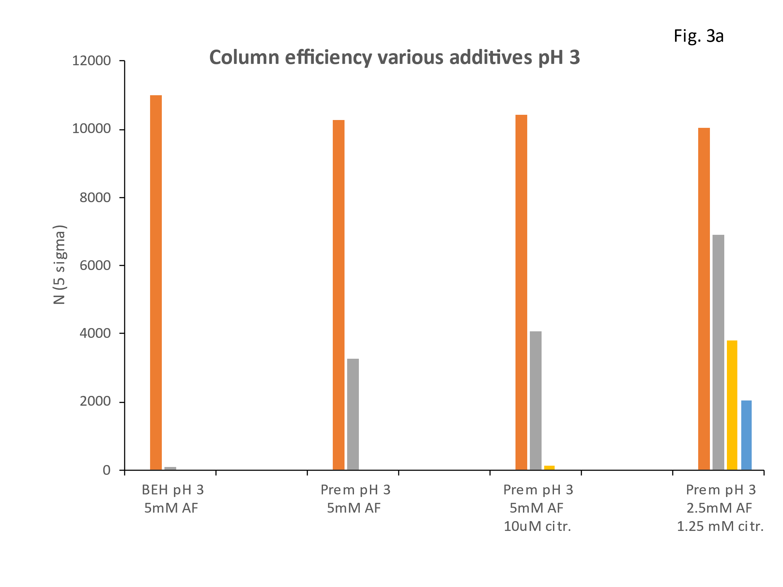

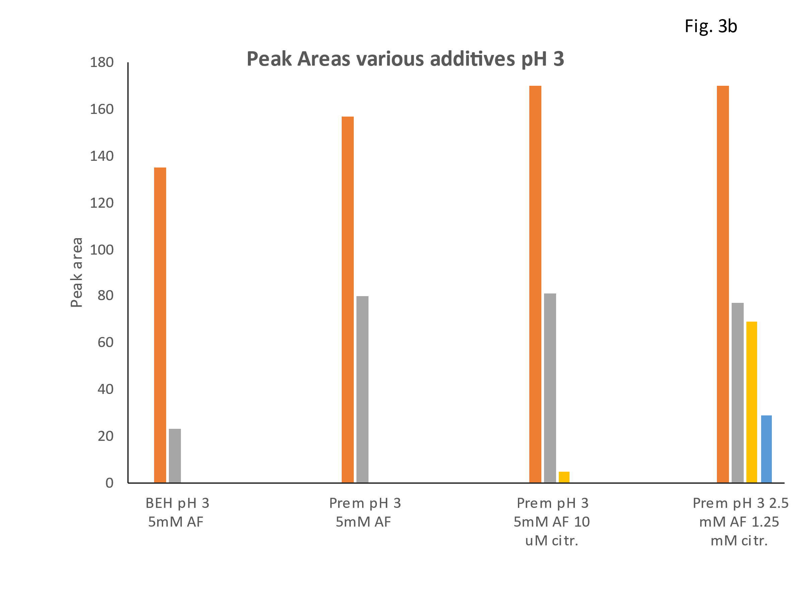

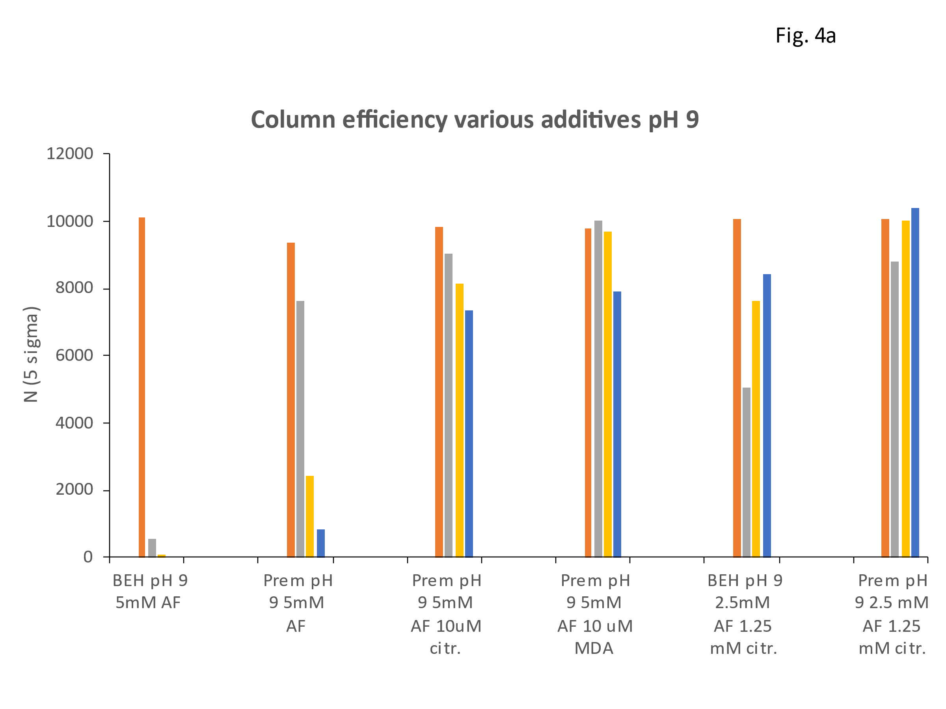

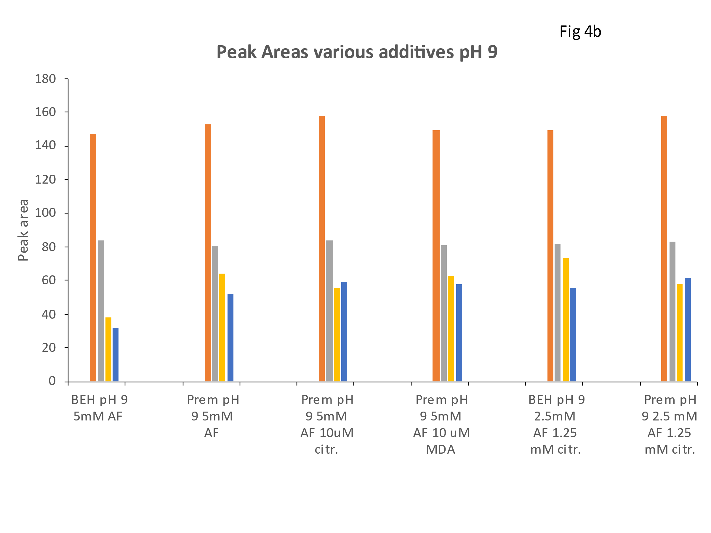

887

|  |  |  |  |  |  |  |  |  |  |  |
| --- | --- | --- | --- | --- | --- | --- | --- | --- | --- | --- |
|  |  |  |  |  |  |  |  |  |  |  |



