Barriers to the uptake of Combined Heat and Power technology in the UK Higher Education sector
K. P. Amber*, J. Parkin

Faculty of Engineering, Science and the Built Environment, , London South Bank University, London, SE1 0AA, UK

amberk@lsbu.ac.uk , j.parkin@lsbu.ac.uk

Abstract:
Keywords: Combined Heat and Power, Higher Education, energy management, facilities management
To achieve the carbon reduction targets set by the United Kingdom Higher Education Funding Council (HEFCE), universities in the UK are investigating a number of energy efficient technologies including Combined Heat and Power (CHP). However, the growth of CHP technology in the Higher Education (HE) sector is slow and this may be because of barriers to implementation. Towards the end of 2011-12, 59 of the 161 UK universities had installed CHP.
The main objective of this study is to identify barriers which may be preventing the growth of CHP technology in the UK’s HE sector. An online questionnaire was sent to energy managers at all UK universities.
The results reveal a range of barriers, with the most important being the following: lack of funds; site constraints; lack of incentives; and lack of support from the higher management.

Introduction
In 2006 the Higher Education (HE) sector in England emitted 3.2 million tonnes of carbon dioxide (t/CO₂) [1]. The Higher Education Funding Council for England (HEFCE) requires all institutions to set a carbon reduction target of 34% for 2020 from a 2005/6 baseline for Scope 1 and 2 carbon emissions (direct fuel and electricity consumption) [2]. These actions aim to ensure that the HE sector meets, and if possible exceeds, the UK Government's general targets to reduce carbon emissions by 34% by 2020 and 80% by 2050 against 1990 levels. One of the most important technologies universities are investigating to achieve their carbon reduction targets is Combined Heat and Power (CHP).
CHP is the simultaneous generation of usable heat and power (usually electricity) in a single process. The electricity is generated on or close to the end user’s site, allowing the capture and use of the resulting waste heat for site applications [3]. By contrast, CHP plants generate useful energy, at the point of use, in the form of both electricity and heat, with an overall efficiency of typically up to 80% [4]. Figure 1 presents a comparison between a CHP system and a conventional separate heat and power system. It is apparent that the overall efficiency of a combined heat and power system is 35% higher than the conventional separate heat and power system.
When compared with other technologies, CHP offers higher carbon savings and a lower payback period as shown in Table 2 [5].

2 Penetration of CHP into the energy market
Use of CHP technology is growing at a consistent rate. Recognising the potential for financial and environmental benefits of this technology, with its ability to improve the security of supply, the European Commission (EC) developed in 2004 a directive on the promotion of CHP in the European energy market. The purpose of this Directive is to increase energy efficiency and improve security of supply by creating a framework for promotion and development of high efficiency cogeneration of heat and power based on useful heat demand and primary energy savings in the internal energy market, taking into account the specific national circumstances especially concerning climatic and economic conditions. The directive entered into force in February 2004 and member states are obliged to begin its implementation since 2006 [6]. Figure 2 which has been developed by analyzing the data downloaded from Eurostat’s website [7] shows CHP’s contribution in meeting the electricity demand of all European Union countries.
In the United States of America (USA), there is approximately 82 GWe of CHP capacity installed [8]. In China, almost 13 % of the nation's electricity (28,153 MW) and 60 % of urban central heating is generated by CHP [9].
The UK lags behind other countries in the uptake of CHP technology. Based on 2010 data, the UK has 6% of the total installed capacity of CHP in the Europe. CHP plants generated 6.2% of the country’s total energy produced in 2010. In 2011, CHP’s share of electricity generation increased to 7.4% of total electricity production and saved 9.1Mt/CO₂ emissions. Total installed capacity of CHP in the UK was 6.11GWe at the end of 2011-12, of which 89% is installed in the industry sector, with 11% installed in agricultural, commercial, public, administration, residential and transport sectors. Gas is the dominating fuel used for CHP schemes in the UK and accounts for 70% of the total fuel used in CHP plants. Figure 3 shows the growth of CHP installed capacity in the UK since 1993 [10].
Figure 4 shows the variation in the installed capacity of CHP plants for different sectors in the UK over the period 2007 to 2011. It is evident that the highest share of installed CHP capacity is in the Chemical industry, petroleum refineries and in the other industries. Since 2009, CHP installed capacity in the petroleum refinery industry has increased. Growth in CHP installed capacity in other sectors, including the public sector, has increased by 29% in 2011 compared to 2007. This is a healthy sign indicating that non-industrial sectors are installing CHP technology.
The HE sector offers strong potential for renewable and clean technologies. Realising the need to improve energy and carbon performance, a number of universities have installed renewable and clean technologies in the last decade. Towards the end of 2011-12, 59 out of 161 universities have had CHP systems installed [11]. Figure 5 shows the percentage of universities in the UK where CHP systems are installed.
As shown in Figure 6, energy generation from CHP systems during 2011-12 increased by 29% compared to 2008-09. In 2011-12, CHP systems supplied 12% of the total energy demand of the UK’s HE sector [11].
Table 1 shows CHP energy generation from the ten universities with the highest percentage of energy from CHP as a percentage of the total sector’s annual energy generation from CHP systems.
The top ten universities generated 81% of the sector’s total CHP energy generated in 2011-12. The University of Leeds is the leader and delivered 21.75% of the sector’s total CHP energy generated. The University of Edinburgh and Imperial College were at second and third position in this list, delivering 11.45% and 9.07% respectively of the sector’s CHP energy generated in 2011-12 [11].
Since 1996 the University of Leeds achieved 75% of its energy demand from a combined heat and power plant (CHP) operated by a third party supplier, Dalkia. This plant is known as the Generating Station Complex. The university aims to replace the old CHP plant with a new 3MW CHP by 2017 [12].
The University of Edinburgh is committed to reduce absolute CO₂ emissions by 40% by 2010, based on 1990 levels and to invest 5-10% of annual utilities spend on energy efficiency improvements. A high proportion of this is achieved through a £12m investment in three large CHPs of total capacity 4.9MWe which have been implemented with significant grant support from the Energy Savings Trust’s Community Energy programme [13].
Loughborough University installed three CHP plants during 2007 and 2011. The total capacity of three CHP plants is 3.1MWe [14]. The University of Warwick installed a 4.71MWe CHP plant in 2001 [15].
Overall, towards the end of 2011, out of 161 universities in the UK, only 49 have installed CHP. This shows a clear potential for this technology to be further implemented in the university sector.The growth rate of CHP technology in the UK, an increase of 10% from 2005 to 2011, has not been as great as it might have been owing to a number of potential barriers. Hinnells [16] found that the level of skills (both in terms of installing current technologies and developing new ones) in the UK is low, following a difficult market for CHP over the last few years.
The absence of suitable incentives for CHP, procurement policies and complex regulations are major barriers to CHP technology in the UK [17]. Toke and Fragaki [18] studied the influence of the liberalised electricity market on the take up of CHP technology in the UK. They found that CHP will not affect the current liberalised electricity market in the UK. A feed-in tariff for CHP could be an instrument that could ensure a major take-up in this technology, provided it is combined with planning policies that oblige the spread of CHP into new and old buildings.
3 Methodology
Towards the end of 2012, there were 59 of the 161 universities which have installed Combined Heat and Power (CHP) at their respective campus buildings. Energy generation from the CHP systems installed at HE sector increased by 12% during the 2010-11period compared to 2008-09. These data show that growth of CHP technology in the HE sector is increasing, however its growth rate has been slow.
In order to understand the barriers to uptake of CHP technology in the HE sector, a questionnaire was developed and distributed via the Survey Monkey website [19] in December 2012. In order to develop as great a response as possible from recipients, the questionnaire was kept as brief as possible, with only five questions being posed broadly as follows: 1) Do you have CHP?; 2) If you have considered CHP and it seemed viable, but you did not managed to install it, what prevented you?; 3) What is your opinion on the main barriers?; 4) What are the main drivers towards CHP?; 5) If you have considered CHP, and it was not viable, why was this the case? Appendix A provides the questions in their full form. The questionnaire was sent to the Energy Managers of universities via email.
Unfortunately, despite the survey design, only nineteen managers returned the completed questionnaires. All those who did not return the questionnaire were reminded on a bi-weekly basis via email but with no success. It is therefore assumed that those who returned the completed questionnaire are proactive in energy efficiency whereas those who did not returned the questionnaire may have different reasons (may be organisational policies) for not completing the questionnaire. This lack of response is also potentially a lack of interest in CHP. Clearly, there could be an issue of bias in the results, with only managers more interested in CHP taking the time to respond, and this issue is discussed more fully in the next section.
5 Results and Discussion
Although the number of responses is low, the responses do contain some very interesting findings which may help to tackle the problem of slow CHP take up. As noted, we are likely to be seeing responses only from energy managers with some level of interest in CHP, and we can estimate this level of general interested based on the proportion of responses (12%). We should recognize, therefore, that the responses we have received are likely to come from more informed and interested individuals who are likely to have already undertaken some level of thinking about CHP, whatever the stage the university is at in promoting such technology.
.
Replying to the first question “Do you have a Combined Heat and Power (CHP) plant installed at your University?” 50% of respondents confirmed that they have already installed CHP in their university with the remaining confirming that they are investigating the potential of this technology in their campus buildings. Only one respondent confirmed that they have no intention to install CHP due to low thermal demands in their campus buildings. Hence, the respondents are confirming an interest and understanding in CHP and the results will be valuable of the issues that these managers have faced during installation, or are facing.
Answering the second question “If you have had a CHP feasibility study showing positive results but have not managed to install CHP, what is your opinion on the barriers that have delayed the installation of CHP plant at your University?”, 26% said it was due to lack of funds. 21% of the respondents said it was due to the fact that the university has changed its financial priorities over time. 10% of respondents confirmed the delay happened due to the fact that their buildings can be shutdown for specific periods only. 5% of respondents noted that the delay happened due to a late engagement of the financial and procurement team. These responses are interesting as they do not point solely to money being a barrier, but they do point to other internal organisational barriers in the uptake of the CHP technology.
In response to the third question “Although CHP has a strong potential in the HE sector, what are the three main barriers resulting in a slow growth rate of this technology” 74% of the respondents rated lack of funds and site constraints as the main barriers. 63% were of the view that lack of incentive and support from Government is a major barrier. 47% rated the lack of support from higher management as a major barrier. 36% said it was due to lack of awareness. 15% were of a view that lack of staff members who work on energy issues is also a barrier.
Replying to the fourth question “What are/were the main drivers behind the investigation/installation of CHP technology at your University”, 47% of the respondents ranked the rising energy costs as the major driver. 42% ranked the university’s carbon reduction targets, pressure from stake holders and obligation as the second major driver. 36% of respondents ranked the improvement in the university’s green league rating as the third major driver behind the installation of the CHP technology. Overall, we can see deduce that rising energy costs, the main driver, is not a more powerful force than the lack of funds identified in previous questions. Depending on the funding model, CHP may require some level of capital investment, and this may be problematic.
In response to question number five“What could be the possible reasons for the negative results of your CHP feasibility study”, 79% of respondents ranked low energy demand as the major reason. 69% of respondents ranked the following as the second major reason for the negative results of their CHP feasibility study.
- Use of ambiguous energy data;
- Use of energy benchmarks instead of real energy data;
- Low spark gap and;
- Building’s sensitivity
63% of the respondents ranked the following as the third major reason for the negative results of their CHP feasibility study.
- High capital cost and;
- Lower competency level of the consultants

Conclusions
In this study, the current status of Combined Heat and Power (CHP) technology in the UK and its Higher Education sector has been reviewed. 30% of the UK universities have had CHP installed . Through an online questionnaire, barriers to the uptake of CHP technology in the Higher Education sector of the UK have been identified.
The responses from nineteen of the UK universities, although a limited number of responses, is representative of universities which have seriously considered CHP and the results are do provide some interesting insights on the important barriers to the uptake of CHP technology in the HE sector of the UK. Major barriers include lack of funds, site constraints, lack of incentive and support from Government, and lack of support from higher management.
Barriers like lack of support from higher management and late engagement of university’s finance and procurement teams must be addressed in order to avoid a delay in the CHP installation process. It would appear that there is a gap between incentives for greater uptake in CHP, such as fuel prices and targets, and the capabilities to procure CHP by energy professionals and their counterparts in finance. Issues like building sensitivity must also be addressed in an appropriate way and its effects must be addressed while designing and building a new facility in the campus. Financial barriers like higher capital cost or lack of funds could be addressed through external funding bodies and advice on different procurement methodologies, many of which do not require up-front capital expenditure by the university. The UK Government might also consider increasing incentives for CHP technology in order to accelerate its uptake. There is also a skill gap with most consultants not being highly rated in CHP design and installation by the respondents.

Acknowledgement

We would like to thank the University of Engineering and Technology Mirpur, Pakistan for providing PhD sponsorship for the main author. We would like to thank the energy managers of the UK universities for completing and returning the online questionnaire.

Abbreviations
CHP Combined Heat and Power
DECC Department of energy and climate change
HE Higher Education
HEFCE Higher Education Funding Council for England
HESA Higher Education Statistics Agency
UK United Kingdom

References
- HEFCE, Higher Education Funding Council for England (2010) Sustainable development. [Online]. Available at: http://www.hefce.ac.uk/lgm/sustain/carbon/. [Accessed: 20 December 2012].

HEFCE, Higher Education Funding Council for England (2010) Carbon reduction target and strategy for higher education in England [Online]. Available at: http://www.hefce.ac.uk/pubs/hefce/2010/10_01/10_01a.pdf. [Accessed: 20 December 2012].
- EC, European Commission (2004) Directive 2004/8/EC of the European Parliament and of the Council of 11 February 2004 on the promotion of cogeneration based on a useful heat demand in the internal energy market and amending Directive 92/42/EEC, pp. 50–60. [Online]. Available at: http://eur-lex.europa.eu/LexUriServ/LexUriServ.do?uri=OJ:L:2004:052:0050:0050:EN:PDF [Accessed: 19 November 2012].

Carbon Trust (2010) Introducing combined heat and power. [Online]. Available at: http://www.carbontrust.com/media/19529/ctv044_introducing_combined_heat_and_power.pdf [Accessed: 25 January 2013].
- CIBSE, Chartered Institute of Building Services Engineers (2006) Renewable energy sources for buildings, TM38. [Online]. Available at: http://www.ihs.com/info/st/e/info4education.aspx [Accessed: 7 January 2011].

- CIBSE, Charter Institute of Building Services Engineers (2012) Introducing CHP. [Online]. Available at: http://www.cibse.org/content/documents/Groups/CHP/Datasheet%201%20-%20Introducing%20CHP.pdf [Accessed: 25 January 2013].
- Eurostat, (2012), CHP in Europe. [Online]. Available at: http://epp.eurostat.ec.europa.eu/portal/page/portal/eurostat/home/ [Accessed: 29 January 2013]
- USCHPA, United States Clean Heat and Power Association (2012) About CHP. [Online]. Available at: http://www.uschpa.org/i4a/pages/index.cfm?pageid=1 [Accessed: 20 January 2013].

- WCI, World Watch Institute (2012) One Twelfth of Global Electricity Comes from Combined Heat and Power Systems. [Online]. Available at: http://www.worldwatch.org/node/5924 [Accessed: 21 January 2013].

- DECC, Department of Energy and Climate Change (2012) Digest of the UK Energy Statistics. Combined Heat and Power (CHP) statistics. [Online] Available at: http://www.decc.gov.uk/en/content/cms/statistics/publications/dukes/dukes.aspx [Accessed: 20 January 2013].

- HESA, Higher Education Statistics Agency (2011-12) Estates Management Statistics Tables. [Online]. Available at: http://www.hesa.ac.uk/index.php?option=com_datatables&Itemid=121&task=show_category&catdex=4 [Accessed: 18 November 2012].
- University of Leeds (2011) Carbon Management Plan. [Online]. Available at: http://www.leeds.ac.uk/estate_services/downloads/CMP%20Full%20Document-June2011.pdf [Accessed: 22 November 2012].
- University of Edinburgh (2010) Decentralised Energy innovation at the University of Edinburgh. [Online]. Available at: http://www.cibse.org/pdfs/Edinburgh_Case_Study.pdf [Accessed: 22 November 2012].
- Loughborough University (2012) Combined Heat and Power at Loughborough University. [Online]. Available at: http://www.lboro.ac.uk/sustainability/carbon/chp.html [Accessed: 22November 2012].
- University of Warwick (2012) CHP at Warwick. [Online]. Available at: http://www2.warwick.ac.uk/about/environment/energy/chp/ [Accessed: 24 November 2012].
- Hinnells, M. (2008) Combined heat and power in industry and buildings. Energy Policy, 36, pp.4522–4526.
- CHPA, Combined Heat and Power Association (2010) The role of CHP and district heating in our energy future. [Online] Available at: http://www.chpa.co.uk/medialibrary/2011/04/07/8de0aeaf/integrated_energy_low_res.pdf [Accessed: 21 November 2012].
- Toke, D. and Fragaki, A. (2008) Do liberalised electricity markets help or hinder CHP and district heating? The case of the UK, Energy Policy, 36 (4), pp. 1448-1456.
- Survey Monkey (2012) Barriers to the CHP technology in the HE sector. [Online]. Available at: https://www.surveymonkey.com/ [Accessed: 25 October 2012].

Figure 1 A comparison of Combined Heat and Power and Separate Heat and Power systems
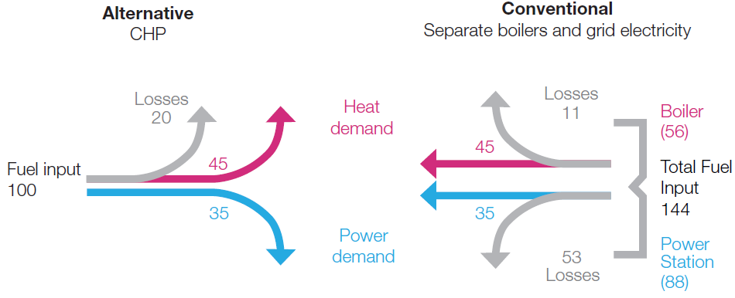
(Source: CHPA, 2010, [17])

Figure 2 CHP electricity generation as percentage of the country's gross electricity generation
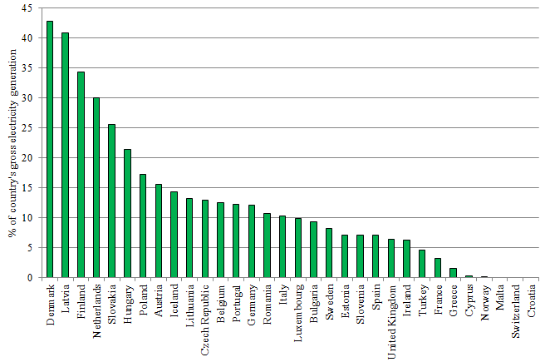
(Source: Eurostat, 2012, [7])
Figure 3 CHP installed capacity in the UK
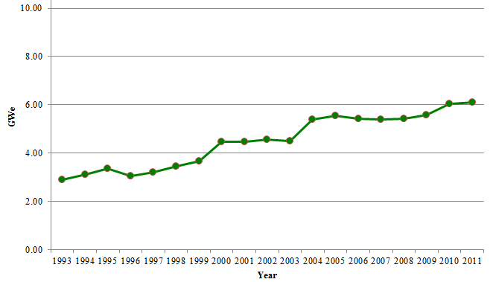
(Source: DECC, 2012, [10])

Figure 4 Installed capacity of CHP in different sectors in the UK
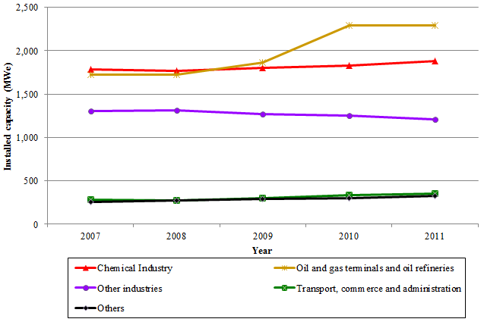
(Source: DECC, 2012, [10])
Figure 5 Percentage of the UK universities which have CHP 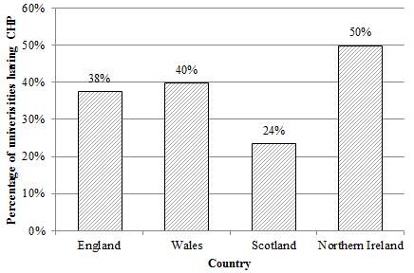
(Source: HESA, 2011-12, [11])

Figure 6 CHP energy generation in the UK Higher Education sector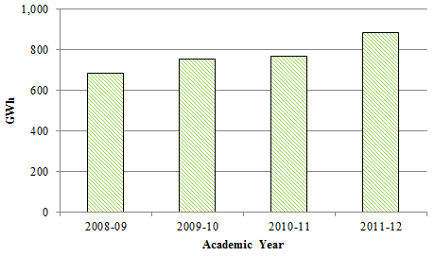
(Source: HESA, 2011-12, [11])

- Table 1 CHP energy contribution in the UK universities
University | Contribution to the sector’s annual energy generation from CHP
The University of Leeds | 21.75%
The University of Edinburgh | 11.45%
Imperial College of Science, Technology and Medicine | 9.07%
The University of Birmingham | 8.95%
The University of Warwick | 8.73%
The University of East Anglia | 8.04%
The University of Southampton | 4.21%
The University of Dundee | 3.92%
University College London | 3.03%
The University of Liverpool | 2.21%
(Source: HESA, 2011-12, [11])

- Table 2 Comparison of different renewable and clean technologies
Technology | CO2 saving potential | Cost effectiveness | Influencing factors | Typical payback period
Solar thermal system | Low | Low | The building or site should have good access to solar radiation. Rural and suburban sites are more likely to have access to more sunlight for longer periods of the day than urban locations where other buildings can cast shadows. | >10 years
Photovoltaic | Low | Low | The building or site should have good access to solar radiation. Rural and suburban sites are more likely to have access to more sunlight for longer periods of the day than urban locations where other buildings can cast shadows. | 12 - 20 years
Wind Turbine | Low | Medium | Wind speed of 5m/s or higher is required. It is ideal for rural or exposed locations. | 15 - 20 years
Ground Source Heat Pumps (GSHP) | Medium | Medium | More suitable in buildings with high levels of occupancy and large, mixed use developments. Its viability depends on the availability of land and the availability of aquifer. | 15 - 20 years
Combined Heat and Power (CHP) | High | Medium | The technology is not dependent on geographic location although this may influence the fuel options available, which, in turn, will affect carbon emissions. Cost effectiveness is very sensitive to the variation in a building's energy demands and the relative price of electricity and fossil fuel. | 5 - 10 years
(Source: CIBSE, 2006, [5])

Appendix A Results obtained from returned questionnaires
- Do you have a Combined Heat and Power (CHP) plant installed at your University?
 |  |  |  |  |  |  |  |  |  |  | Response percent |  | Response Count
Yes, we have single CHP installation |  |  |  |  |  |  |  |  |  |  | 26.30% |  | 5
Yes, we have multiple CHP installations |  |  |  |  |  |  |  |  |  |  | 26.30% |  | 5
No, but we are investigating/installing |  |  |  |  |  |  |  |  |  |  | 26.30% |  | 5
No, but this is something we shall be looking in future |  |  |  |  |  |  |  |  |  |  | 15.80% |  | 3
No, we have no intention to install this technology |  |  |  |  |  |  |  |  |  |  | 5.30% |  | 1
2. If you have had a feasibility study showing the positive results but haven't managed to install the technology, what is your opinion on the barriers that have delayed the installation of CHP plant at your University? If this doesn't apply to you, simply tick N/A. |  |  |  |  | 3. There is a strong potential of CHP technology in the higher education sector in the UK, but yet CHP technology hasn't been recognised/installed in the majority of universities. In your opinion, what are the main three barriers behind this issue?
 | Response percent |  | Response Count |  |  |  |  |  |  |  | Response percent |  | Response Count
Lack of funds | 26.30% |  | 5 |  | Lack of awareness |  |  |  |  |  | 36.80% |  | 7
University's financial priorities have changed over time | 21.10% |  | 4 |  | Lack of interest/support from the higher management |  |  |  |  |  | 47.40% |  | 9
Late engagement of the finance and procurement teams | 5.30% |  | 1 |  | Lack of energy staff |  |  |  |  |  | 15.80% |  | 3
Buildings can only be shut down during a specific period of the year | 10.50% |  | 2 |  | Lack of funds |  |  |  |  |  | 73.70% |  | 14
Changes in the internal staff structure | 0.00% |  | 0 |  | Due to site constraints |  |  |  |  |  | 73.70% |  | 14
Difference of opinion among the internal staff | 0.00% |  | 0 |  | Lack of incentives/support from the Government for this technology |  |  |  |  |  | 63.20% |  | 12
Planning permission process | 0.00% |  | 0
site constraints e.g. Limited access to the plant room, less space in the plant room, asbestos in the building, critical electrical or thermal connection of CHP | 15.80% |  | 3
Delay on part of the designers/installers | 0.00% |  | 0
N/A | 63.20% |  | 12
4. What are/were the main drivers behind the investigation/installation of CHP technology at your University? Please rank the drivers. If this doesn't apply to you, simply rank N/A as 1 and leave the other options.
 | 1 | 2 | 3 | 4 | 5 |  | 6 | 7 | 8 | Rating Average |  | Rating Count
Carbon Reduction Target | 42.1% (8) | 36.8% (7) | 10.5% (2) | 5.3% (1) | 0.0% (0) |  | 5.3% (1) | 0.0% (0) | 0.0% (0) | 2 |  | 19
Rising Energy Prices | 21.1% (4) | 47.4% (9) | 21.1% (4) | 5.3% (1) | 0.0% (0) |  | 0.0% (0) | 0.0% (0) | 5.3% (1) | 2.42 |  | 19
For Research Purpose | 0.0% (0) | 5.3% (1) | 26.3% (5) | 36.8% (7) | 10.5% (2) |  | 5.3% (1) | 10.5% (2) | 5.3% (1) | 4.37 |  | 19
Pressure from stake holders | 0.0% (0) | 10.5% (2) | 5.3% (1) | 36.8% (7) | 42.1% (8) |  | 0.0% (0) | 5.3% (1) | 0.0% (0) | 4.32 |  | 19
To improve University's ranking in Green League | 0.0% (0) | 0.0% (0) | 21.1% (4) | 5.3% (1) | 36.8% (7) |  | 36.8% (7) | 0.0% (0) | 0.0% (0) | 4.89 |  | 19
Obligatory | 5.3% (1) | 0.0% (0) | 10.5% (2) | 5.3% (1) | 10.5% (2) |  | 42.1% (8) | 26.3% (5) | 0.0% (0) | 5.47 |  | 19
Don't know | 5.3% (1) | 0.0% (0) | 0.0% (0) | 5.3% (1) | 0.0% (0) |  | 5.3% (1) | 57.9% (11) | 26.3% (5) | 6.74 |  | 19
N/A | 26.3% (5) | 0.0% (0) | 5.3% (1) | 0.0% (0) | 0.0% (0) |  | 5.3% (1) | 0.0% (0) | 63.2% (12) | 5.79 |  | 19
5. If the results of CHP feasibility were negative showing that CHP is not a viable option for your University, what is your opinion on the main factors behind these negative results? Please rank your answers. If this doesn't apply to you, simply rank N/A as 1 and leave the other options.
 | 1 | 2 | 3 | 4 |  | 5 | 6 | 7 | 8 | Rating Average |  | Rating Count
Low load demand | 5.3% (1) | 78.9% (15) | 10.5% (2) | 5.3% (1) |  | 0.0% (0) | 0.0% (0) | 0.0% (0) | 0.0% (0) | 2.16 |  | 19
Ambiguous energy data | 5.3% (1) | 5.3% (1) | 68.4% (13) | 21.1% (4) |  | 0.0% (0) | 0.0% (0) | 0.0% (0) | 0.0% (0) | 3.05 |  | 19
Use of energy bench marks instead of the actual energy consumption data | 0.0% (0) | 5.3% (1) | 5.3% (1) | 68.4% (13) |  | 15.8% (3) | 0.0% (0) | 5.3% (1) | 0.0% (0) | 4.16 |  | 19
Low spark gap | 0.0% (0) | 10.5% (2) | 5.3% (1) | 5.3% (1) |  | 68.4% (13) | 10.5% (2) | 0.0% (0) | 0.0% (0) | 4.63 |  | 19
High capital cost | 21.1% (4) | 0.0% (0) | 5.3% (1) | 0.0% (0) |  | 10.5% (2) | 63.2% (12) | 0.0% (0) | 0.0% (0) | 4.68 |  | 19
Building's sensitivity | 5.3% (1) | 0.0% (0) | 5.3% (1) | 0.0% (0) |  | 0.0% (0) | 21.1% (4) | 68.4% (13) | 0.0% (0) | 6.26 |  | 19
Lower competency level of the consultants who carried out the feasibility study | 0.0% (0) | 0.0% (0) | 0.0% (0) | 0.0% (0) |  | 5.3% (1) | 5.3% (1) | 26.3% (5) | 63.2% (12) | 7.47 |  | 19
N/A | 63.2% (12) | 0.0% (0) | 0.0% (0) | 0.0% (0) |  | 0.0% (0) | 0.0% (0) | 0.0% (0) | 36.8% (7) | 3.58 |  | 19

Spark gap is the difference between electricity and fuel price
Building sensitivity means how sensitive a building is in terms of its activities and electrical infrastructure.
spark gap is the difference between electricity and gas price
few buildings cannot be shut down due to highly sensitive operation/activities taking place in the buildings

