Luis Rocha
Business School
National Polytechnic Institute
Mexico City, 11340, Mexico
E-mail: lrocha@ipn.mx
*corresponding author

Silvia Edith Alvarez-Reyes
Hospira S. de R.L. de C.V
Mexico City, 01376, Mexico
E-mail: silvia.alvarez@hospira.com

Jose Arturo Garza-Reyes
Centre for Supply Chain Improvement,
The University of Derby,
Kedleston Road Campus,
Derby, DE22 1GB, UK
E-mail: J.Reyes@derby.ac.uk

Vikas Kumar
Bristol Business School
The University of the West England
E-mail: Vikas.Kumar@uwe.ac.uk

Dr. Luis Rocha-Lona has over 10 years of working experience in the public and private sectors. He has lead several research projects sponsored by private companies and the Mexican Government through the National Council of Science and Technology (CONACYT) and is actively involved in consulting activities to manufacturing and service organisations.
Luis joined the Business School at National Polytechnic Institute of Mexico in 2007, where he is a Senior Lecturer in Operations Management and Quality Management Systems. His research interest include business process improvement, operations management, manufacturing sustainability, business performance, and quality management systems.

MSc Silvia Edith Alvarez Reyes. At the beginning of her professional carrier she became a researcher in Pharmacology at Center for Research and Advanced Studies of the National Polytechnic Institute of Mexico. Silvia has been working by several leading pharmaceutical companies and has more than seven years of working experience in the pharmaceutical industry. She holds a Master in Science degree from Business School of National Polytechnic Institute of Mexico. As a certified Six Sigma Green Belt, Silvia has leading improvement projects in both manufacturing and administrative processes. Her areas of knowledge and expertise are in Business Process Improvement, Auditing, and Quality Management Systems.

Dr Jose Arturo Garza-Reyes is a senior lecturer in Operations and Supply Chain Management at the Centre for Supply Chain Improvement, Derby Business School, the University of Derby, UK. He has published a number of articles in leading international journals and conferences and two books in the areas of quality management systems and manufacturing performance measurement systems. Jose Arturo is co-founder and editor of the Int. J. of Supply Chain and Operations Resilience (IJSCOR), and has participated as guest editor for special issues in various international journals. His research interests include general aspects of operations and manufacturing management, operations and quality improvement, and supply chain improvement.

Vikas Kumar is an Associate Professor in Enterprise Operations Management at Bristol Business School, University of the West of England, UK. He holds a PhD degree in Management Studies from Exeter Business School, UK. He has published more than 90 articles in leading international journals and international conferences. He has also co-edited a book on quality management and published 8 book chapters. He serves on the editorial board of six international journals. His current research interests include green supply chain management, supply chain coordination, lean and six sigma, process modelling, operations strategy, and service operations management
.

An integrated approach of Six Sigma and QSAM methodologies for a pharmaceutical company: a Shipment Improvement Process

Abstract
This paper presents a shipment improvement project in a pharmaceutical company to reduce distribution costs of a set of products shipped to Germany. The project consisted in the diagnosis and improvement of the shipment process through the deployment of Quick Scan Audit Methodology (QSAM) as a precursor to Six Sigma implementation. The original sample-shipments process was analysed to improve it and achieve the targets based on optimised sub-processes. The results showed a set of non-value added activities in transportation, motion, waiting, defects and the sub-utilisation of people. Based on the application of quality tools such as VSM, CFD, VOC, CTQ-Three under the Six-Sigma approach, the improvements achieved a 26% reduction in cycle time, and no complaints from customers were reported since the implementation. A control plan was deployed to track shipments and maintain open and close communication with the customer. The resulting benefits had a significant impact on reducing distribution costs.

Key Words: VSM, QSAM, Six Sigma, Pharmaceutical, shipment, distribution costs

- 'This article is a revised and expanded version of a paper entitled ‘Lean Six Sigma supply chain case study: aircraft shipment improvement in a pharmaceutical company presented at the 23rd International Conference on Flexible Automation and Intelligent Manufacturing (FAIM), Porto, Portugal, 26-28 June, 2013.

- Introduction

There is a need to improve strategic processes at all levels to keep companies competitive. Supply Chain (SC) is a set of key processes that involve delivering goods from suppliers to final consumers. The objective when optimising the SC is to increase operational efficiency and reduce costs. This is not a simple job, as it requires processes to be well designed and supported by information technology, plus highly trained and talented personnel at several levels of the organisation. Thus, it is essential to integrate efficiently and effectively the SC and managing the key strategic processes: from suppliers to customers(Jayant et al., 2009).

In manufacturing and service processes, an effective and efficient Supply Chain Management (SCM) is crucial to achieving high levels of efficiency and competitiveness(Jayant et al., 2009). Evidence shows that organisations have reduced cycle times and costs by improving the management of their SCs, see for instance (Shang et al., 2009, Rossetti et al., 2011, Huehn-Brown and Murray, 2010). According to Balachandran (2012) , over the past 30 years, in the US, the percentage of the Gross Domestic Product (GDP) devoted to logistics costs has dropped from 17.9% in 1980 to 8.3% in 2011. This suggests that companies have been investing and refining their SCs to optimise processes and reduce cost significantly. There is also evidence that shows many companies are making an effort to improve their supply chain process, see for example (DHL, 2013b, DHL, 2013c, DHL, 2013a, Anonymous, 2009, Balachandran, 2012, Lewis, 2001). The counterfeiting of products, which is a real threat to public health and safety, represents one of the main concerns in the SCM of the Pharmaceutical Industry. According to the U.S Food and Drug Administration (FDA, 2012), a counterfeit drug is that which, without authorization, bears the identifying mark of the manufacturer and which thereby falsely purports to be the product. Consequently, it is essential to protect the manufacturers against penetration of such products as well as illegal imported products, stolen, and those that lack the quality standards to be distributed and consumed(WHO, 2010). In this way, worldwide certifications such as those from the International Organization Standardization (ISO), Customs-Trade Partnership Against Terrorism (C-TPAT) and the Customs Watch programmes address the counterfeiting problem (USP, 2014). These programs establish specific supply chain security criteria to meet, and in return, they provide incentives and benefits like expedited processing. For instance, a study issued by The University of Virginia (CBP, 2011) identified tangible and intangible benefits associated with the C-TPAT programme. These included the reduction of waiting times for carries at borders, the increase in number of customers and revenues, and the greater ability to predict lead times, among others.

- Project Background

In this context, this paper presents an empirical study of a leading pharmaceutical company that applied the integrated approach of Quick Scan Audit Methodology (QSAM), and the Define Measure Analyse Improve and Control (DMAIC) phases of the Six Sigma methodology in order to improve a shipment process. The study focuses on the company’s goal of reducing the cost of sample-shipments. To achieve this aim, the paper reviews some of the relevant literature related to QSAM, Six Sigma, plus the assessment of suitability of some lean-manufacturing tools. The paper also describes the sample-shipment process associated with the SC problem. It then describes the integration of QSAM and the DMAIC process, and presents the different situations that the company went through during each stage of the improvement process (See Figure 3). Finally, it discusses the results that were achieved after the QSAM-plan was implemented and draws conclusions about the use of the Six Sigma method as it was applied to the SC.

The study was conducted on a leading pharmaceutical company Headquartered in Germany. The group consists of 140 affiliated companies with 40,000 employees dedicated to the manufacture of human and animal pharmaceuticals. Those goods are manufactured in 20 production plants in 13 countries. This project belongs to the manufacturing site located in Mexico City, which exports 60% of its production to the European market.

The company is required to satisfy international regulations. For example, some EudraLex regulations state the following:

- Samples from each batch manufactured outside the European Economic Area (EEA) should be tested in the EEA before a certification of the finished product batch is issued.
- For samples taken in the manufacturing site, it should be demonstrated that they are still representative of the batch.

Since the company ships samples from Mexico City to Germany, it has reported damaged samples, which have resulted in several complaints. This process has reported high operational costs due the manufacturer needs to re-send samples if the first shipment is damaged. Then this paper focuses on the problem of improving the sample-shipment process, which is briefly described below.

In essence, the stages for the sample-shipment process of each batch are defined by 1) sampling, 2) testing, 3) packaging and 4) document fulfillment. The stages are strictly dependent upon each other and each stage involves minor activities that are performed by different areas. (See Figure 1)

Insert Figure 1 here

The sampling stage is carried out by the In Process Control (IPC) team. This team takes some samples during processing and labels each of them in order to identify which will be analyzed at the manufacturing site and segregates those which will be sent for analysis to Germany. Once the samples are tested in site, the results are registered in a Certificate of Analysis, which is then signed by the IPC supervisor. When the results are within specifications, the segregated bottles are packaged into small groups according to the quantities required for the tests to be performed in the EU. The packages are then delivered to the Quality Designee (QD), who is responsible for verifying that the number of bottles is according to the batch size. A second review and signature of the Certificate of Analysis are required for this verification.

In this way, the QD generates the Certificate of Conformance and send all the information by e-mail to the Foreign Trade Area so that documentation for delivering the shipment to customs can be prepared. The next step is to pack the samples in a corrugated box, attaching the proper identification. . The QD also takes the corrugated box to the Foreign Trade office to weight it, and places the exact value of the box’s contents into the shipping format. Finally, the courier service picks up the box to ship it to Europe.

The sample shipment process described above usually takes from seven to nine days after the manufacturing process is completed. This shipment process is usually performed twice a week, depending on the product demand. If all the documentation is in order and no further information is required by customs, the courier service delivers the box to Europe within three days. Historical data shows that in Europe it usually takes seven days to analyse the samples and provide the test results. Considering these activities, the cycle time for the sample shipment process takes a total of 19 days to complete. Due to the length of this cycle time, when one or more of the shipped batches is part of an urgent order, ‘urgent analysis’ is also required, which increases the cost of the analysis by 12.5% per batch.

The complaints related to long delivery shipment times as well as issues with the quality and consistency of the samples, have a direct impact on the distribution costs of the product. The pharmaceutical company has established its standards for distribution costs to be less than 0.16 euros per unit, where sample shipments should represent no more than 15% of that total cost. Nevertheless, those issues have increased the estimated cost, which can reach as high as 30%. Consequently, the quality assurance team set an objective of reducing their costs.

- Literature Review
3.1 Six Sigma

According to Jayant et al. (2009), one convenient way for a single company to view the SC is to divide the company’s logistics system into inbound logistics (material management and procurement) and outbound logistics (customer service and channels of distribution). As such, Jayant et al. (2009) suggests that inbound logistics is a matter of perspective; that is, if someone is the receiver of a shipment, the shipment is categorized as inbound. On the other hand, if someone sends a shipment— e.g., as a raw materials supplier, manufacturer or vendors—then the shipment is considered to be outbound. From this point of view, the process under study (sample shipments) belongs to the category of outbound logistics. Companies typically have reduced their manufacturing costs by implementing improvements in activities related to operational logistics, but inbound and outbound logistics seems to be effective ways to further reduce cycle times and costs and they can also improve customer service and satisfaction (Jayant et al., 2009).

In this way, several works have already simultaneously addressed Six Sigma and SC process improvement, see (Bandyopadhyay and Jenicke, 2007, Blanchard, 2012, Shang et al., 2009). Six Sigma, was developed by Motorola in the 1980s and popularized by General Electric and other multinationals in the 1990s (Lescault et al., 2002). Six Sigma uses metrics that determine how well a process performs against a standard of excellence at only 3.4 defects per million opportunities (Sheehy et al., 2011). A defect occurs when a measured attribute is outside the tolerance limits, which typically results in customer dissatisfaction. (Huehn-Brown and Murray, 2010, Narahari et al., 2000) argue that Six Sigma recognizes that variations or defects are inevitable due to insufficient design margins, inadequate process controls, imperfect parts, fluctuations in environmental conditions and operator variations, among other variables. As products and processes’ defects are driven out, the company captures market share by providing higher quality at a lower price, while maximizing profits and company stakeholder value (McCarthy and Stauffer, 2001). In addition to the financial benefits of cost reduction and revenue growth, Six Sigma also helps to improve what it may be considered one of the most value metrics of performance for any organisation: customer satisfaction (Lescault et al., 2002).

Six Sigma can be supported by several quality methods and tools that enable an organisation to make correct decisions based on scientific facts through data collection and analysis. According to Jacobsen (2007), some quality tools that support Six Sigma projects are : statistical process control (SPC); the Define Measure Analyze Improve Control (DMAIC) process, the eight disciplines problem-solving process (8D); the Shainin System; Poka-yoke; Failure Mode & Effects Analysis (FMEA); and process capability . The decision to select the improvement techniques and methods is based on a variety of factors, such as cost, time, training and suitability. See for example (Rocha-Lona et al., 2013) where the authors describe how to select the most appropriate methods and tools to implement a Quality Management Systems at strategic and operational levels.

Other initiatives are also helpful for process improvements, and for the purpose of this paper, some lean-tools were also selected to support the Six Sigma approach. Lean manufacturing is derived from the Toyota Production System (TPS) introduced by Toyota's Taiichi Ohno in the 1950s as a response to competition from larger car manufacturers (Womack et al., 2007). Lean is focussed on the reduction of waste and different types of non-value added activities (Lummus et al., 2006). The Toyota Production System emphasizes the common wastes in production system which are: overproduction, waiting, transport, inappropriate processing, unnecessary inventory, waste of motion and defects (Ohno, 1998). Lean programs and tools help to eliminate waste, reduce variability, reduce inventory and, thereby, reduce operational costs. Lean manufacturing has been defined as an ‘integrated manufacturing system intended to maximize capacity, reutilization and minimize buffer inventories through the minimization of system variability’ (Narasimhan et al., 2006). The essence of leanness is focused on the efficient use of resources through the minimisation of waste. Some of lean manufacturing tools and techniques include value stream mapping (VSM), Cross Functional Diagram (CFD), 5S, Kanban, Kaizen, Total Quality Management (TQM), total productive maintenance (TPM) and Quality Function Deployment (QFD) (Abdulmalek and Rajgopal, 2007, Doolen and Hacker, 2005, Vinodh and Kumar Chintha, 2011).

Several large pharmaceutical organisations, such as AstraZeneca, Johnson and Johnson, Pfizer, among others, have simplified operations and processes, and have reduced costs via Lean and Six Sigma. As a consequence of these good practices, other pharmaceutical companies and suppliers within the industry have also apply them. When lean manufacturing practices are properly deployed; several benefits pay off including cost savings, better quality-products, lower impact on the environment, and higher customer satisfaction. On the other hand, some disadvantages and risks may include lack of stock when products are needed, the possibility of distribution problems due to natural or other disasters and the potential for ineffectiveness, unless suppliers are also practicing lean strategies. Despite the drawbacks lean manufacturing outweigh the disadvantages (Houborg and Lundbeck, 2010).

3.2 Quick Scan Audit Methodology (QSAM)

For this project QSAM was deployed. QSAM is a diagnostic approach designed to perform a health check of a SC (Childerhouse and Towill, 2011). The methodology involves the fully audit of a SC. The time to complete the task depends on the size of the organisation and the areas and processes that need to be audited. QSAM involves the following stages: 1) Preliminary presentation, 2) Evaluation of the supply chain status, 3) Brainstorm supply chain inhibitors, 4) Hypotheses investigation, 5) Analysis of findings, and 6) Feedback presentation.

The details of this procedure are well presented by Naim et al. (2002). The QSAM approach was originally developed for the automotive sector, but it has also been successfully implemented in different industrial sectors across countries in large, medium, and family businesses (Childerhouse and Towill, 2011). Thomas and Barton (2011) suggest to deploy QSAM prior to a Lean Six Sigma (LSS) projects as they argue that QSAM provides a starting point for process improvement projects. According toThomas and Barton (2011), rich contextual data can be developed and processes characterized in order to serve as key inputs to the LSS methodology. The QSAM outputs will help to describe the requirements for process improvements and to determine the level that the processes need to be improved. In a general way, QSAM monitors the symptoms and the degree of improvement needed.

In this paper, the authors developed a hybrid implementation strategy which allowed the integration of the QSAM and Six Sigma methodologies (Figure 2). The QSAM stages were aligned to DMAIC and supported by key lean tools . In order to achieve this, the QSAM plan for the Pharmaceutical company is illustrated in Figure 3.It describes in detail how the integrated approach was developed and which lean tools were used to support it.

Insert Figure 2 here

- Methodology

4.1 Action Research

Action Research (AR) is a type of applied research designed to help researchers to solve practical problems by being immerse on them (Collis and Hussey, 2003). The assumptions in which AR is based, categorized AR in the phenomenological approach rather than the positivistic one. AR assumes that business environments change constantly, and the researcher or practitioner along with the elements in the environment is part of it. Coughlan and Coghlan (2002) argue that AR is about research in action not research about action. This implies that AR helps organisations to sort out problems in a scientific way with those that experience the issues directly. Gummerson (1991) suggests the following relevant characteristics for AR:

- Actions research goals are to solve a problem and to contribute to science by generating knowledge or new theories.
- Researchers and practitioners should learn from each other and develop their skills.
- The researcher is in charge of investigating the whole problem and has to make it simple enough to be understood by everyone.
- Action research was primary developed for social sciences in the planning of change, and thus it is a suitable research method for consulting strategies and business organisations.
- The business environments and the conditions must be understood before the project starts.
- Finally, this methodology should not be assessed only by the criteria in the positivist paradigm, but by the criteria in the phenomenological paradigm or criteria for appropriate for the particular methodology.
AR is therefore one of the most suitable approaches to deploy process improvement projects as practitioners and researchers can work on solving practical problems. It is however recommended that researchers take precautions when deploying observations (Maylor and Blackmon, 2005). Observation and participation on a project in AR involve risks, as some activities may take longer than expected (Maylor and Blackmon, 2005). Full commitment is also needed by employees. However, this may be difficult to achieve in real time since employees may not feel comfortable with the investigations or may not be well trained to fully participate in a process improvement project. Perhaps, the most significant issue when deploying AR and observation techniques is that the researchers and practitioners must retain critical subjectivity as it becomes easy to get too involved. This means that there is a risk of depicting subjective data and information that may not necessarily be true for the organisation. In this project, these issues were considered and all the necessary precautions were taken by the Quality Team as well as the senior managers.

Thus, for the purpose of this article, AR was taken as a general methodological approach to support the project-background from a phenomenological perspective. Then, a practical approach using Six Sigma-QSAM was deployed as shown in Figure 3.

4.2 Process Improvement Deployment

This research aims to determine the root causes related to the three main customer complaints and to propose an improvement strategy. Towards that end, a team was created that included two QDs, a Foreign Trade specialist, a supervisor from the IPC area, a supervisor from the warehouse area, a supervisor from the logistics area and two technicians. This project was developed under the company’s wide quality approach introduced in October 2009. This approach has enabled the company to implement the Six Sigma methodology. Lewis et al. (1998) suggest the Quick Scan diagnostic procedure to enable a ‘health check’ of a business’ supply chain. They argue that the methodology can effectively improve quality, cost, service quality, and cycle times of key processes in the SC.

The standard QSAM intervention requires only few weeks. However, due to the large operations carried out for this project, it was agreed that this would be conducted over a period of six months. The specific QSAM plan developed for the Pharmaceutical Company is shown in Figure 3.

The first step of QSAM process entails defining the customers’ needs and the project’s scope. To achieve this, complaints reported during 2012 were used as the Voice of the Customer (VOC). Bearing in mind that a good project is one that will have a measurable impact on Critical to Quality characteristics (CTQ) (Lai and Wu, 2011), special attention was paid to set the right CTQ characteristics. In the second step, the data collection started by analysing complaints, deploying a brain-storm session, and applying semi-structured interviews to team members, which indicated the potential root causes of variations in the process. In addition, for the analysis phase, the activities conducted during the sample shipment process were identified in order to describe the process ‘as is’ into a Value Stream Map (VSM) and a Cross Functional Diagram (CFD). Some authors, such as Doolen and Hacker (2005) and Lummus et al.(2006) have reported that only the use of VSM allows a process to achieve significant efficiency. Furthermore, a fish-bone diagram and an FMEA were useful to understand the causes of failure.

Insert Figure 3 here

Kaizen blitz was conducted for each area in the sample shipment process and during the implementation stage each group was focused on improving their own work. In this way, all aspects of the process were streamlined by implementing roles and responsibilities, establishing parallel operations between the technicians and the Foreign Trade specialist to write guidelines to standardize the process. Furthermore, some job procedures were officially implemented to clarify job-profiles, and to identify allowable materials for the samples’ packaging. In addition, manufacturing site’s Customs Application Forms were developed for all product ranges in order to avoid holding times. Feedback from the QP in Germany, and the Manager’s Committee agreed to construct and share a shipment database in order to follow up shipments status in real time.

Finally, shipment pictures were shared before and after deliveries as well as a tracking process to ensure deliveries to be on time and within specifications.

- Results and Discussion

The results and discussion were structured according to the proposed stages shown in Figure 3. These are presented in the following sections.:

5.1 QSAM, Stage 1: Agreements with Manager’s Committee

At this Pharmaceutical Company, considerable emphasis was given to communicating the purpose of the project, and then the customer complaints reported on April 2012 were informed to the Manager’s team. The purpose of the project was clearly identified: ‘no more sample shipments complaints’. The QSAM methodology for the project development was also presented. Six months were agreed for the implementation of improvements.

5.2 QSAM, stage 2: Data collection

Once agreements and objectives were settled, the second stage of QSAM involved the collection of data through complaints sheets using the Voice of the Customer (VOC). In addition, a survey was sent to those customers in order to obtain more information about their unstated needs and requirements. Due to customer satisfaction requirements, these attributes had a linear impact on the level of sufficiency (Lai and Wu, 2011), and a critical-to-quality tree (CTQ-Tree) was designed to convert the customer needs into CTQs requirements. These were defined as follows:

1) Ensure 100% of the samples arrive at the customer site in optimal condition and on time so that they can be analysed.
2) Reduce cycle time of sample shipment process by 20%.
3) Eliminate urgent analysis orders due to holding times at customs.

Based on the historical data from sample shipments in 1Q, 2012, the Cost of Poor Quality (COPQ) was estimated to be high. Crosby (1979) argues that those ‘visible’ internal costs are the result of failing to meet requirements before the product or service is delivered to the external customer, and he strongly suggests to tackle the problem before failure occurs.
COPQ deficiencies are caused by errors in products and inefficiencies in manufacturing and shipping processes, long cycle time was placed into this category.
On the other hand, external ‘visible’ costs caused by deficiencies after delivery to external customer involved the reshipment and replacement of samples, incurring in losses due to urgent analysis. Additional costs such as those related to the loss of confidence by corporate governance, handling complaints, and time spent with customers to sort out problems were also identified. Finally, a SIPOC diagram was designed, focusing on the sample packaging and fulfillment documentation for customs, to clarify the process.

Figure 4 shows the analysis of 48 sample shipments during 1Q 2012 and revealed the main reasons for customer complaints: disorder in samples, which involved bottles out of individual boxes, and boxes without leaflets or syringes. These issues appeared because of loss of traceability and due to the lack of monitoring packages in transit. The second most common complaint was due to the placement of the bottles, which were frequently found in an upside down position. This is considered a severe issue since exported medicines to Europe is in oral suspensions, and inappropriate handling of these bottles impacts the product’s performed tests. When this complaint is reported, the company replaces damaged samples, increasing the cost of rework and decreasing the size of the original batch.

Insert Figure 4 here

The third most common issue for complaints was due to the length of time shipments spend in customs when there was a need to provide more information about the origin of the material or packaging.

Thus, complaints not only had a negative impact on cost, but also on productivity, which resulted on a lack of ability to process urgent demands. This generated losses of potential customers, management loss of confidence, and had a direct impact on the satisfaction of current customers.

5.3 QSAM, Stage 3: Analysis

An important tool is the Value Stream Map (VSM), which is a visual representation of information and material flow to document processes (Tapping et al., 2002). For Keyte and Locher (2004) it is a common and powerful tool to identify value and non-value added activities. The VSM in Figure 5 was created to identify improvement opportunities and address future stage of the process. The VSM was developed by the team and it captured the significant information and detail for the shipment process, then, it was validated to be sure it represented the real process. The VSM in Figure 5 revealed that 22 minor activities were required in the cycle, but only two activities were Value Added (VAA) while five were Non-Value Added (NVA), so they could be eliminated. Two other activities were inappropriately processed because the work of the responsible specialist was unnecessary. In addition, five activities that could be improved in order to meet the CTQs were also identified.

Insert Figure 5 here

To identify more issues in the process that could have a broad impact on timeframes, the process was determined through a Cross Functional Diagram (CFD). The CFD revealed deficiencies such as frequent downtimes and inequitable workload. The decision point analysis demonstrated that the sample shipment was mainly a push system. After developing the CFD, all people involved in the stages participated in a brainstorming session. They were asked to identify the root causes of the three most common complaints reported in Figure 4. Then, ideas were transferred to an Ishikawa’s diagram, where potential causes were identified. When the diagrams were put together, it surprisingly noted that four reasons were similar.

The first issue was an inappropriate way to handle samples during their inspection at customs. This issue was related to the lack of information of the origin and content of bottles. In addition, instructions and warnings in corrugated boxes were not “visible” and the language on labels was in English instead of Spanish and German. A Cause & Effect Matrix was developed based on impact on customers’ expectations to prioritize the root causes.

Then, an FMEA was conducted to include an appropriate depth of information on the causes of failures based on experience with similar products and processes. For example, the potential failure of disorder in samples was attributed to different sizes and materials of corrugated boxes that could contribute to complicated configuration of bottles. The upside down position of the bottles was attributed to wrong packaging, in that moment the control performed was to use bags fixed to the bottles with adhesive and any dividers to limit each package into the box were used. Finally, the holding time in customs were difficult to analyze since the unknown content of bottles and a slow communication flow between customs-courier-office-customer delayed deliveries.

5.4 QSAM, Stage 4: Improvements implementation

At this stage, team members worked separately according to the area to which they belonged. This approach was necessary in order to suggest viable and quick improvements in their own workload. Highlights from the Kaizen results were the following:

The QD implemented the packaging of small groups of bottles using wrapping material instead of bags to prevent the shifting of the product arrangement during transportation. The challenge was to standardize the configuration of those small groups and avoiding empty spaces by using a corrugated divider, and a top pad to ensure the easy manipulation when the samples were required by customs. The team placed the shipping label—written in English and German—on top of the box to avoid any confusion. At the same time, the team used better quality corrugated boxes as a unique material for the sample shipments. To avoid lengthy customs holding times, a letter was addressed to the personnel at the manufacturing site’s customs area. This letter included relevant information about the product’s composition, packaging materials, and dosage per unit forms. This allowed an easy identification of the box content in the event that a customs inspection was required.

Since, shipments with a unique box were more frequently inspected than those placed into an exportation pallet; it was decided to place them all in the pallet. In addition, the courier service allowed to ship packages of up to 200 kg at a discounted rate, which had no significant impact on the distribution cost.

Hence, a warehouse technician was required to put the corrugated box onto a pallet. As a result, elimination of inappropriate processing waste was accomplished when the responsibility for bringing the box to Foreign Trade office was transferred from the QD to a technician. The time the technicians spent in unnecessary motion was avoided by creating a specific schedule and designating a place to pick up the box. Since the new process involves the pallet shipment, the activity related to weighing the boxes was eliminated from the Foreign Trade specialist’s task load. Now, that person only waits for the information shared by the QD and a warehouse technician to prepare the export bill and the documents required in customs.

Finally, the courier service is now responsible for picking the pallet up at the warehouse, which resulted in conveyor waste reduction because the warehouse is closer to the courier service station than the Foreign Trade office . The improved shipment process and documentation flow is showed in Figure 6. All those improvements were well executed at the end of 2Q 2012 and they contributed to the reduction of the sample shipment time from 19 to 14 days, which represents a 26% reduction in the cycle time.

Insert Figure 6 here

5.5 QSAM, Stage 5: Feedback

In order to specify the roles and responsibilities in the improved process, job profiles and procedures were updated. The manufacturing site’s Customs Application Forms are now always attached to all shipments to avoid holding times. A database was generated at the beginning of 3Q 2012 in order to track all shipments in real time. That file included pictures of the boxes before they are shipped and after they have arrived to Germany to maintain a detailed track of every batch. Until now, no urgent analysis orders due holding times at customs have been reported, and 100% of the shipments have arrived at the customer’s site within specifications. Furthermore, a cost-benefit analysis of the project, based on the investment of human resources and new equipment (like a hand wrapper packaging machine), revealed that distribution costs during 3Q 2012 were reduced from 30% to 17%, which represents a reduction of 26%. Until the QA managers achieve those results, it is suggested that the target established by the company (15%) has not yet been completely fulfilled. Nevertheless, there are more opportunities for improvements, like decreasing the bottleneck in the warehouse, since the warehouse workers spend 1.5 working days preparing the pallet. Further studies could provide improvements at this stage of the process.

- Conclusions and Summary

The aim of this paper was to propose and implement a process strategy in order to improve productivity in a leading pharmaceutical company. It seems that the application of QSAM provide a much more robust front-end analysis mechanism, which was used by the Pharmaceutical company to focus on more strategic opportunity areas of this project. The Six Sigma methodology allowed the researchers and practitioners to determine the root causes of customer complaints. Using lean manufacturing tools, the project implemented optimal standard procedures for a sample shipment process. The improvements obtained were significant, allowing for a decrease in the company’s distribution costs (from 30% to 17%) and reducing the company’s process cycle from 19 to 14 days. This was an achievement since the process under investigation had previously reported low efficiency, resulting in waste and high distribution costs.

Results derived from this research project cannot be generalized since working and environmental conditions, among other factors vary for every organisation and processes. However, they may help other supply chain and quality assurance managers and directors replicate good practices and avoid pitfalls. For the case of this pharmaceutical company, further research and projects may include the implementation of the DMAIC phases into other stages involved in the SC process, which may include challenges in reducing time for the analysis stage. In addition, further projects can include studies related to the Theory of Constraints to decrease bottlenecks detected in the warehouse. Similarly, careful registration and tracking of key variables of shipments through trend analysis could improve the shipment process. Finally, it can be stated that Six Sigma methodology and lean manufacturing tools were useful and provided positive results for reducing this company’s distribution costs. To accomplish these objectives, it is also recommended to carefully select improvement methods and techniques, based on organisation’s needs, resources, experience, and the regulations enforced within the pharmaceutical industry.

- References

Abdulmalek, F. A. & Rajgopal, J. (2007). Analyzing the benefits of lean manufacturing and value stream mapping via simulation: A process sector case study. International Journal of Production Economics, 107, 223-236.
Anonymous (2009). SUpply Chain Standard: Protect the future, invest in excellence. Logistics Manager, 22.
Balachandran, M. (2012). DHL Supply Chain to invest Rs 680 crore for India expansion [Shipping / Transport]. The Economic Times (Online), 2012 Oct 18.
Bandyopadhyay, J. K. & Jenicke, L. O. (2007). Six Sigma Approach to Quality Assurance in Global Supply Chains: A Study of United States Automakers. International Journal of Management, 24, 101-107.
Blanchard, D. (2012). Lean Six Sigma Keeps Cardinal's Supply Chain Healthy. Industry Week/IW, 261, 54-54.
Cbp 2011. C-TPAT Cost and Savings Survey. US: US Customs and Border Protection.
Collis, J. & Hussey, R. (2003). Business Research: a practical guide for undergraduate and postgraduate students, New York, Palgrave macmillan.
Coughlan, P. & Coghlan, D. (2002). Action research for operations management. International Journal of Operations & Production Management, 22, 220-240.
Crosby, P. B. (1979). Quality is Free: The Art of Making Quality Certain, Florida, McGraw-Hill Companies.
Childerhouse, P. & Towill, D. R. (2011). Effective supply chain research via the quick scan audit methodology. Supply Chain Management, 16, 5-10.
Dhl. (2013a). DHL Supply Chain to Invest $52.5 Million in Indonesia. Journal of Commerce, 2013 Feb 27.
Dhl. (2013b). DHL Supply Chain to Invest in Southeast Asia. Journal of Commerce, 2013 May 28.
Dhl. (2013c). DHL to Invest Euro 140 million to Enhance its Supply Chain Business in Southeast Asia. PR Newswire Asia, 2013 May 27.
Doolen, T. L. & Hacker, M. E. (2005). A Review of Lean Assessment in Organizations: An Exploratory Study of Lean Practices by Electronics Manufacturers. Journal of Manufacturing Systems, 24, 55-67.
Fda 2012. Food, Drug, and Cosmetic Act. Chapter 2 Section 201. In: ADMINISTRATION, F. A. D. (ed.). US: FDA.
Gummerson, E. (1991). Qualitative Methods in Management Research, Newbury, Sage.
Houborg, C. & Lundbeck, H. (2010). Implementing a successful Lean programme: where do you begin? 22, 52-57.
Huehn-Brown, W. J. & Murray, S. L. (2010). Are Companies Continuously Improving Their Supply Chain? Engineering Management Journal, 22, 3-10.
Jacobsen, J. 2007. Siemens VDO Optimizes Processes Using Six Sigma. American Society for Quality.
Jayant, A., Kumar, S., Gupta, P. & Garg, S. K. (2009). An Integrated Approach for Performance Improvement in Supply Chain -A Case of Manufacturing Unit. International Journal of Business Insights & Transformation, 3, 62-73.
Keyte, B. & Locher, D. (2004). The Complete Lean Enterprise: Value Stream Mapping for Administrative and Office Processes, New York, Productivity Press.
Lai, H.-J. & Wu, H.-H. (2011). A Case Study of Applying Kano's Model and ANOVA Technique in Evaluating Service Quality. Information Technology Journal, 10, 89-97.
Lescault, N. J., Neuman, R. P., Cavanagh, R. R. & Pande, P. S. (2002). The Six Sigma Way: How GE, Motorola, and Other Top Companies are Honing Their Performance, McGraw-Hill
Lewis, J., Naim, M., Wardle, S. & Williams, E. (1998). Quick Scan your way to supply chain improvement. IOM Control, 24, 14-16.
Lummus, R. R., Vokurka, R. J. & Rodeghiero, B. (2006). Improving Quality through Value Stream Mapping: A Case Study of a Physician's Clinic. Total Quality Management & Business Excellence, 17, 1063-1075.
Maylor, H. & Blackmon, K. (2005). Researching Business and Management, London, Palgrave.
Mccarthy, B. M. & Stauffer, R. Enhancing Six Sigma through simulation with iGrafx Process for Six Sigma. Simulation Conference, 2001. Proceedings of the Winter, 2001 2001. 1241-1247 vol.2.
Naim, M. M., Childerhouse, P., Disney, S. M. & Towill, D. R. (2002). A supply chain diagnostic methodology: determining the vector of change. Computers & Industrial Engineering, 43, 135.
Narahari, Y., Viswanadham, N. & Bhattacharya, R. Design of synchronized supply chains: a six sigma tolerancing approach. Robotics and Automation, 2000. Proceedings. ICRA '00. IEEE International Conference on, 2000 2000. 1151-1156 vol.2.
Narasimhan, R., Swink, M. & Kim, S. W. (2006). Disentangling leanness and agility: An empirical investigation. Journal of Operations Management, 24, 440-457.
Ohno, T. (1998). Toyota Production System, Cambridge, MA, Productivity Press.
Rocha-Lona, L., Garza-Reyes, J. A. & Kumar, V. (2013). Building quality management systems; selecting the right methods and tools, FL, USA, CRC Press, Taylor and Francis Group.
Rossetti, C. L., Handfield, R. & Dooley, K. J. (2011). Forces, trends, and decisions in pharmaceutical supply chain management. International Journal of Physical Distribution & Logistics Management, 41, 601-622.
Shang, J., Yildirim, T. P., Tadikamalla, P., Mittal, V. & Brown, L. H. (2009). Distribution Network Redesign for Marketing Competitiveness. Journal of Marketing, 73, 146-163.
Sheehy, P., Navarro, D., Silvers, R. & Keyes, V. (2011). The Black Belt Memory Jogger: A Pocket Guide for Six Sigma Success, Salem, NH, Six Sigma Academy.
Tapping, D., Luyster, T. & Shuker, T. (2002). Value Stream Management: eight step to planning, mapping and sustaining lean improvements, New York, Productivity Press.
Thomas, A. & Barton, R. (2011). Using the Quick Scan Audit Methodology (QSAM) as a precursor towards successful Lean Six Sigma implementation. International Journal of Lean Six Sigma, 2, 41-54.
Usp 2014. General Chapter. Good Distribution Practices-Supply Chain Integrity. . In: USP (ed.).
Vinodh, S. & Kumar Chintha, S. (2011). Application of fuzzy QFD for enabling leanness in a manufacturing organisation. International Journal of Production Research, 49, 1627-1644.
Who, W. H. O. 2010. Good Distribution Practices for Pharmaceutical Products. In: SERIES, T. R. (ed.) Technical Report Series. World Health Organization, Annex 5, No.957.
Womack, J. P., Jones, D. T. & Roos, D. (2007). Machine That Changed the World. Bloomsbury Business Library - Management Library, 51-53.

Figure 1. The sampling shipment process.

Figure 2. Alignment of QSAM and LSS processes. Source: Based on (Thomas and Barton, 2011) and (Childerhouse and Towill, 2011).

CTQ
and CFD
Figure 3. QSAM Process for the Pharmaceutical Company.

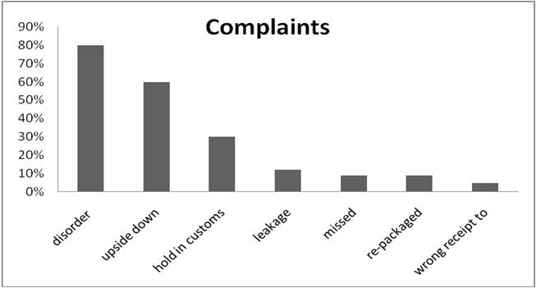
Figure 4. Sample shipments complaints from company’s manufacturing site (1Q, 2012).

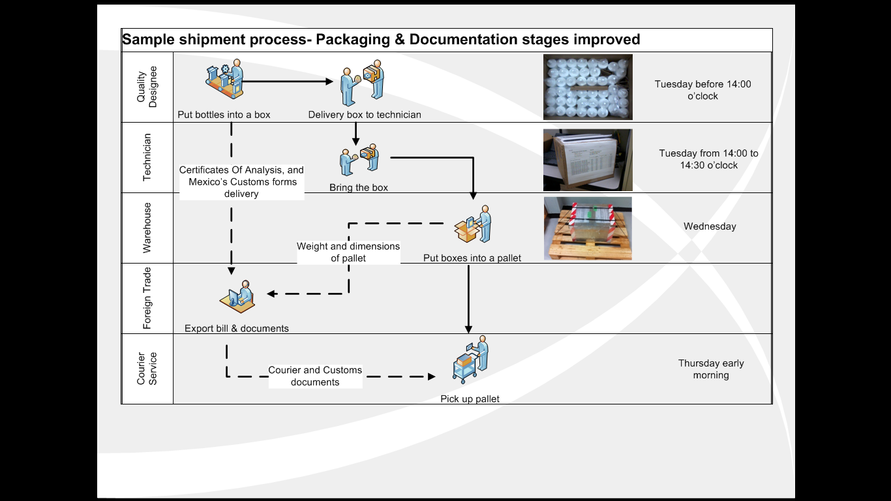
Figure 6. Cross Functional Diagram for the packaging and documentation stages.

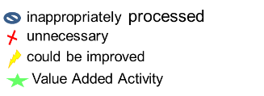
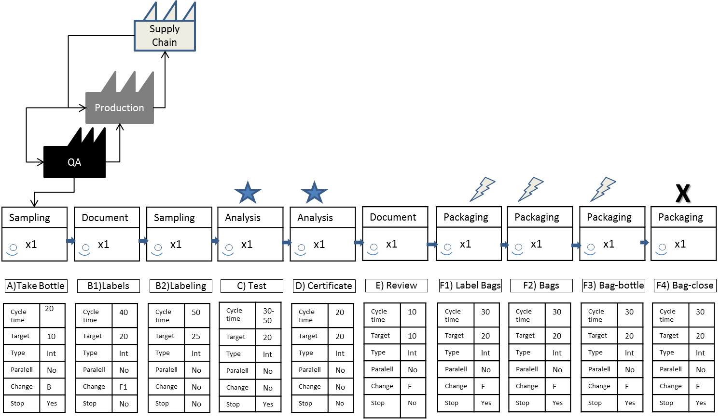
Figure 5. Value Steam Map for the Sample Shipment Process.

Corresponding author. E-mail: lrocha@ipn.mx
EudraLex: The rules governing the medicinal products in European Union.

