Learning spaces in Virtual Worlds: Bringing our Distance Students Home

Mari Carmen Gil Ortega and Liz Falconer

Abstract
Distance learning (DL) programmes are becoming increasingly popular in higher education (HE). Overcoming feelings of isolation that may occur due to the reduced support available, the few possibilities of social interaction and the non-existent campus atmosphere in online courses, have become one of the major challenges of designers and instructors of DL programmes.

This paper provides an example of how we can create and use virtual world (VW) learning spaces that not only match the face-to-face learning experience, but also enhance it. Innovation@UWE Island in Second Life, home of the MA Education in Virtual Worlds (MA EVW), is an example of pedagogical innovation that capitalises on what VWs have to offer to social aspects of teaching and learning. In this programme we use a three-dimensional virtual space to provide postgraduate students –physically located in diverse geographical areas of the world- with a sense of community and connectedness that matches the sense of belonging that often accompanies the on-campus learning experience. This paper introduces the rationale behind the choice of architecture of the learning environment as well as the instructional design of the programme to enhance co-presence and place presence, to build a true community of practice, and to foster collaboration for reflective learning. The paper also provides examples of students engaging in an environment where traditional conceptions of both ‘teaching’ and ‘learning’ do not apply, where the four-walled classroom is not the only setting where learning happens, where everyone in the group can potentially be an instructor or a peer, an expert or a novice, and learn from each other in a meaningful way.

Keywords: 3D virtual learning spaces, Second Life (SL), design in VWs, community of practice, collaborative learning, role plays, simulations
- Introduction
The distance learning (DL) MA Education in Virtual Worlds (MA EVW) was successfully launched in September 2012 with a cohort of seven students. It tripled its number the following academic year 2013-14 with 21 student registrations. The broad aim of the MA is to facilitate the study of virtual worlds (VWs) and gaming environments as places where learning can take place. The course offers highly flexible opportunities for study to everyone wherever they are based in the world. Although we operate from Bristol (United Kingdom), our current students are located dispersedly geographically: Argentina, Canada, Germany, Greece, New Zealand, Saudi Arabia, United Kingdom, and the United States. During term time they all join for synchronous tutorials and learning sessions twice a week for three hours each time in the three-dimensional VW Second Life (SL).
The typical student of the MA EVW will complete it in two years on a part time mode, although this is not the only path, as modules can also be studied separately, with or without assessment for continuing professional development (CPD). Students are in their majority educators at any level, developers, or counsellors/psychotherapists. Their familiarity with VWs varies; some are already experienced users while others are “newbies”. This can be challenging to manage during the first few weeks of term, but soon it becomes irrelevant. Mechanisms are being implemented, such as pre term induction courses, and MOOCs, to narrow this initial skills gap.
Students interact with each other and with the world through avatars, that can be customised in many ways, but most students choose to use a human-shaped one. They converse in real time using the voice tools so that it appears visually as thought the avatars are speaking or the text-based system both privately to the tutor, or one class mate at a time, using Instant Messaging (IM) or publicly to the whole group, using the chat room facility. This multiple way of communicating, and the architectural visualisation, make it possible for students to experience others as being present in the same environment, or ‘being there together’ even though they are geographically dispersed.
The course activities students carry out for the different modules during the SL sessions include:
- travelling to, and critiquing, a wide range of virtual environments,
- discussing and reflecting upon their own practice as educators and/or developers,
- carrying out role plays and simulations,
- building and scripting learning environments,
- working with artificial agents and bots and
- attending conferences and similar gatherings.

Interactions among students make up the students voice of this article, which is key to the development of the design guidelines proposed. Quotes from these interactions, together with pictures of our virtual campus, illustrate the design and functionality of the environment.

- Learning in SL
Apart from the many available communicative modes in 3D virtual learning space, and consequently greater potential for collaboration, as mentioned above, another advantage of using SL in education is the high degree of customisability offered. This plasticity, enables educators to tailor a learning space to fit a learning activity or a certain pedagogical approach (Sköld, 2012). As Minocha and Reeves (2010) point out, learning spaces in SL are being utilised to foster creativity among students, aid socialisation, facilitate informal learning and enable exploratory and experiential learning rather than traditional instructional ones. There is, therefore, a transition from the traditional ‘directional’ mode of teaching to a more social constructivist pedagogy, based on communities of practice, in which the tutor facilitates and guides. Furthermore, through role play and simulations, students are getting opportunities to practise work-based skills.
We could indeed argue that learning in SL is, by its very nature, collaborative and social. The MA EVW is a clear example. People come together from many countries and learn together. The fact that we can meet synchronously online in a VW regardless of our location in the world, and communicate without barriers in a vivid visual and auditory manner demonstrates the immense opportunities for education. We believe these fluid interactions stimulate the learning process. As Savin-Baden (2011) points out, opportunities for interactive discourse facilitate opportunities for experimentation ... in ways that are not possible in real life. SL allows for student centred learning to take place. This is a constructivist view of learning with the importance being placed on activity, discovery and independent learning (Carlile and Jordan, 2005).
The active nature of the learning that takes place in this environment as we can observe from our students in the MA EVW can be categorized as follows:
- Learning by doing
- Learning through role playing
- Learning by playing games
- Learning through simulations.
Different ways of learning match different spaces. Traditional learning environments such as classrooms and lecture theatres, while they suit passive ways of learning and can, in cases, accommodate large numbers of students, they often prove to be limited to stimulate active ways of learning. The sort of activities pointed out above and carried out by students in the MA EVW, would be difficult to replicate in a traditional environment.
- Data sources and analysis
As tutors in the course we have been observing students’ reactions in and interactions with the virtual world environment; particularly at Innovation@UWE Island, for the two years the course has been running. The main sources of data captured are:
- Online journals in which both tutors and students record their reflections on a regular basis. Students know that although their peers don’t have access to their personal journal, their tutors do, and frequently make comments on their entries.
- Video and sound captures of examples of the weekly tutorials and other events such as social gatherings within the course and joint parties with students and tutors from other universities using VWs as places of study and exploration. We use screen-capture software and have approximately 150 hours of video capture and the archive will continue to grow in subsequent years.
- Chat transcripts from the text communication that takes place alongside the voice communication on our SL tutorials or social events. Text chat is used continuously and non-sequentially, and covers a more diverse range of subjects than voice communication. We have over 2,000 pages of text chat that contain approximately 400,000 words. Again this archive will continue to grow.
- One to one semi structured interviews about the course with students from the first cohort. These took place right after they finish the first year module assessments. Similar interviews are already scheduled to take place with students in the second cohort during July 2014.
- Asynchronous discussion boards where students interact on a regular basis not only about academic aspects related to the course, but also social matters.
- Students artefacts which they create during the course and form the basis for a couple of modules’ assessments. This archive will grow as new cohorts of students go through the programme. The creativity shown in students’ artefacts, emphasised by the possibilities for this creativity to be expressed offered by the environment, is one of the big assets of the course. It is also one of the most rewarding aspects for us as tutors, and for students who get themselves amazed by the artistic nature and detail of their own creations.
Analysis of all the data sets described above is a large project planned to begin in July 2014. However, for developing the design guidelines, we carried out a preliminary analysis of the data to identify some of the factors that relate to the design of the spaces and of the learning experiences at Innovation@UWE Island. Because these data are rich in their exploration of opinions, feelings, experiences and knowledge, we found that they tell us a lot about what was really going on in the MA and about how students perceive the environment in which they learn and socialise. These data, together with analysis of architecture of the environment, and insights from the literature in the field, provide the basis for the design guidelines described in the section below. These design guidelines should be incorporated to provide the optimum environment for enhancing students learning through a perceived increased satisfaction, participation and enjoyment of the course.
- Guidelines for the design of a virtual campus for DL students
We experience because we as avatars are human beings and therefore we are acting out real world scenarios within a virtual world context. We are contextualising what we see with how we as humans know how to feel and believe. The avatar is playing us as humans. They are part of us as humans and that is why we are able to empathise and create an identity for the avatar. VW are a continuum of what we perceive as real/believe is real (Student A)
The affordances of VWs to provide immersive simulations of this kind have, in recent years, been a subject of research for scholars such as Aldrich (2005), Cram and colleagues (2011), Dawley and Dede (2013), de Freitas and colleagues (2010), de Freitas and Neumann (2009) and Falconer (2013). As argued by Savin-Badem (2011), many universities have already chosen to use SL for some of their educational activities as it provides a platform to create, customise and build learning spaces and activities that relate to the particular courses. Hence, there may be expectation that teachers and researchers need to develop the skills to design effective virtual world learning environments. For example, Wang and Chen (2011) discuss the importance of educators becoming architects of learning spaces to fulfil their instructional aspirations; however, Minocha and Reeves (2010) point out, there is hardly any guidance or research in this area. This section outlines the rationale behind the design of Innovation@UWE Island, backed up with illustrations that include both, pictures of the SL campus and students’ reflections and interactions with each other. They can be a direction or advice to future designers of instructional experiences in VW, for researchers, and for tutors in these environments.
  - Designing to facilitate immersion
According to Farley (2013), in order to promote student engagement with a program, course or activity in a virtual environment, it is necessary to generate immersion. Immersion has been defined as the subjective impression that one is participating in a comprehensive, realistic experience (Witmer & Singer, 1998), and is seen as a necessary condition for presence. The successful cultivation of immersion is characterised by the impression of actually ‘being there’ in the virtual world. The representation of place, space and self contributes to the feelings of immersion so characteristic of virtual worlds. This refers to a decreased awareness of one’s existence in the actual physical space at the computer in a room and an increased experience of being in the VW (Witmer & Singer, 1998). The sense of immersion can be enhanced by a number of factors in the environment, leading to a sense of flow and presence resulting in an enhanced involvement and commitment to learning (McKerlich & Anderson, 2007). According to Lakshmi and colleagues (2013) one factor is the persistent focused social interaction that maintains immersion and returns users to SL. This is certainly one of the key affordances for learning and for learner satisfaction (Delgarno and Lee 2010; Dickey 2003; Edirisingha et al 2009; Mennecke et al 2011; Pfeil et al 2009; Warburton 2009).
Innovation@UWE Island hosts familiar and well understood visual cues for learning and social exchanges that give students ‘clues’ about how to make sense of the environment and how to interact with it (presence) and with each other in it (co-presence). These cues provide familiarity and support students’ existing mental models of what to expect. These visual cues facilitate rapid understanding of, and immersion in, the space. Warburton (2009: 419) describes how the visual and physical realism that SL adds to the virtual space combine to produce a profoundly immersive experience. This is perhaps a valuable lesson for the teacher/designer in virtual worlds - to remember both the real and the familiar to ensure maximum immersion and participation. It should be noticed that this environment has less restrictions than the physical world so familiar elements can be arranged in a way that would be not possible in RL (Real Life), thus we can play with this aspect and have, for example, seating arrangements in the bottom of the ocean to carry out a discussion there (see picture 1 below).

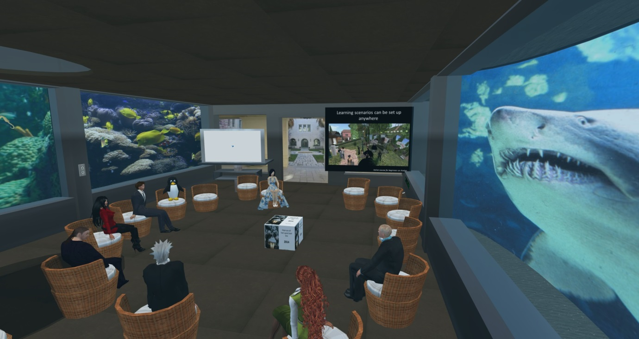Picture 1 - An immersive experience at the bottom of the ocean
One interesting quote taken from a student journal during the third week of the course refers to the design of the space and the activities to take place in it. It is an inquisitive view, but already reflects on the different paradigms that we would need to be considering when designing inworld.
Virtual worlds may provide us with spaces and places to be and think differently. How do these spaces and places need to be arranged, put together and with what ideas that resist the everyday structures and patterns? How do we structure and facilitate this for every learner at each stage of their learning process? (Student B)

  - Designing to provide a ‘sense of place’
‘Sense of place’ is a term defined and used in different ways by different people; it is associated to the concept of ‘place attachment’ defined by Plunkett (2011) as the emotional bond between person and place. Low (1992) sees ‘place attachment’ as not only an emotional and cognitive experience, but also encompasses cultural beliefs and practices that link people to place. She goes on to say that, place attachment is the symbolic relationship formed by people giving culturally shared emotional/affective meanings to a particular space or piece of land that provides the basis for the individual’s and group’s understanding of and relation to the environment (1992: 165). Harrison and Dourish (1996) describe sense of place as sets of mutually-held and mutually available, cultural understanding about behaviour and action. The design of Innovation@UWE Island in SL encompasses these definitions. We aimed to create an environment that would feel and be perceived as unique and special and that would contribute to create a strong connection for students to the virtual campus. This ‘sense of place’ has an important influence of how social interactions originate, how avatars move around (flying, walking, teleporting, running), how the different scenarios support learning and particular social activities; and importantly, it has a profound impact on the total academic experience.
Acknowledging identity and historic context as important attributes of place, our campus aims to engender on a ‘global sense of place’ in which, as Bilandzic and colleagues (2011) argue, cultural diversity, multiple identities, backgrounds, skills and experiences of people traversing a place are regarded as social assets of that place. The inclusion of a port, which conveys the idea of a place where different cultures come together, is the landing point at Innovation@UWE Island.
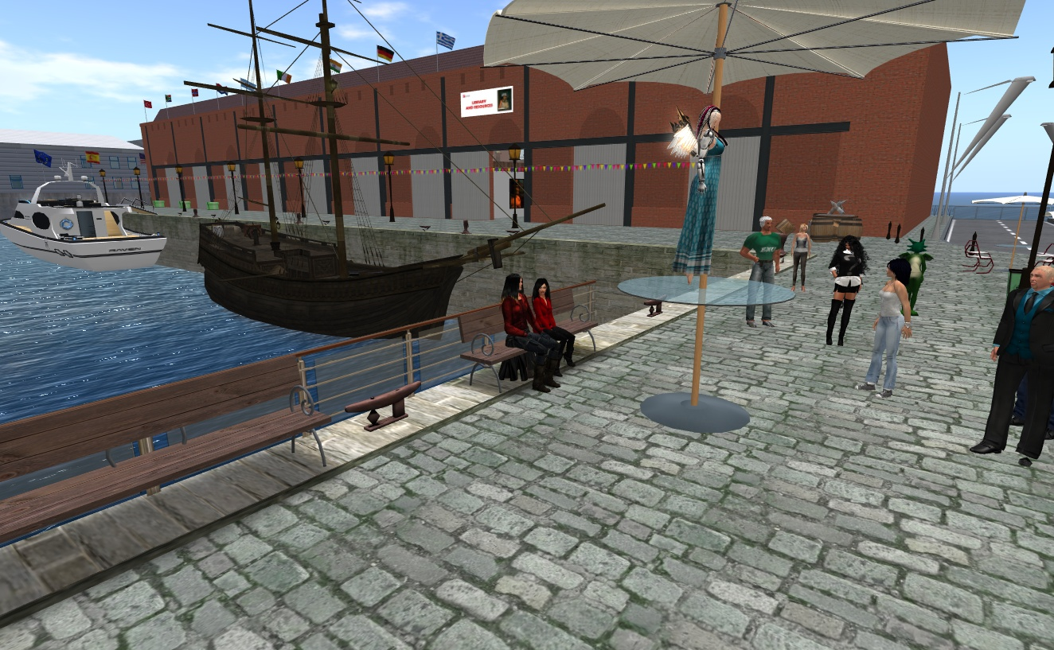Picture 2 -Landing at the port of Innovation@UWE Island

Quotes below from students’ blogs not only illustrate the importance of designing to provide a ‘sense of place’, but also point out that, as in RL, attachment to a place is not something that happens immediately, but develops over some time. The longer one spends inworld, the more chances for virtual spaces to become part of one’s internal schema.
When I first encountered SL I had a limited notion of place in as much as I did not feel a ‘sense of ‘being there’ in a virtual world. The physical/virtual nature of the environment produced tension for me and feeling that I was on the outside looking in. Over time, with patience, a growing connection began to take shape. Not as yet a fully socially embodied connection or perception but a sense of being somewhere in a virtual world. With this growing sense of place, I began to call my home in Second Life, ‘my home’ rather than just a rental. (Student B)
My satisfaction with SL as a place for learning was limited initially as barriers to full participation and sense of others took time to work round and eventually something similar to what Hassell et al. (2011) found with their study of the links between presence/copresence and learning outcomes and satisfaction. (Student C)

  - Designing to promote social encounters
As we are trying to create a community of people that study and work together, it was impossible to give social environments a miss in our virtual campus. There is the pub, where students can chat informally and have a virtual drink. One of the students posted in this blog:
I have noticed that when engaged in replicating traditional face to face conversation/lecture style sessions my engagement and attention is limited. My attention and engagement feels different when in a social environment in SL. It feels more like an active session. Collaboration with peers is more likely to occur in that context (Student B).

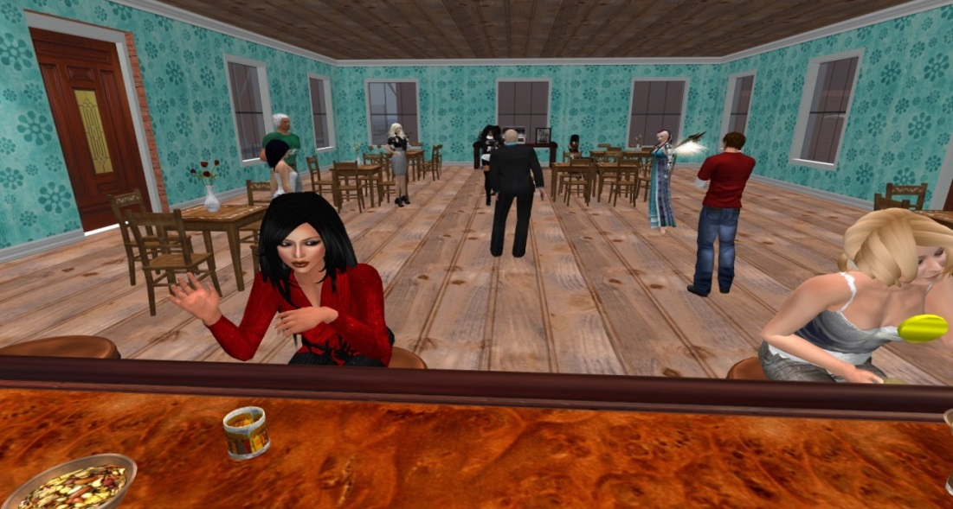
Picture 3 - Having a drink at the pub with friends

Also at Innovation@UWE Island there is a beach where students can come to relax and meditate to a nice sunset. They can also listen to the waves while admiring the rainbow. This is a special place for thinking and reflecting. Students have commented on how this environment supports creative thinking after they have come up with some brilliant idea for their projects.

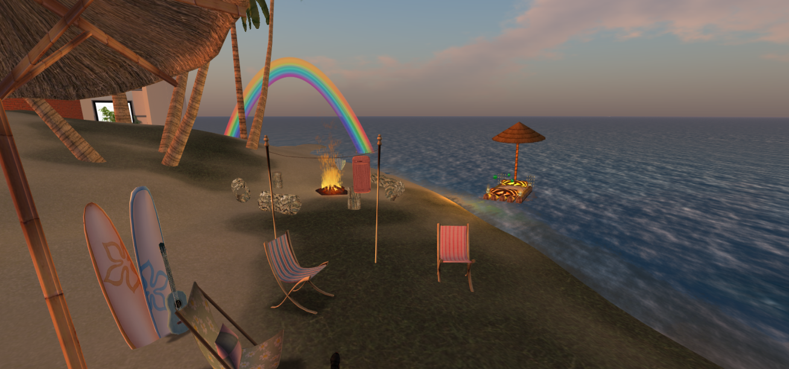
Picture 4 - Lovely sunset at the beach

Additionally, the beach has been reported as a great place to have big parties and dance to the music. In picture 5 below our students in the MA EVW invited students from the University of Arkansas and exchange a few ideas and some choreographic moves.

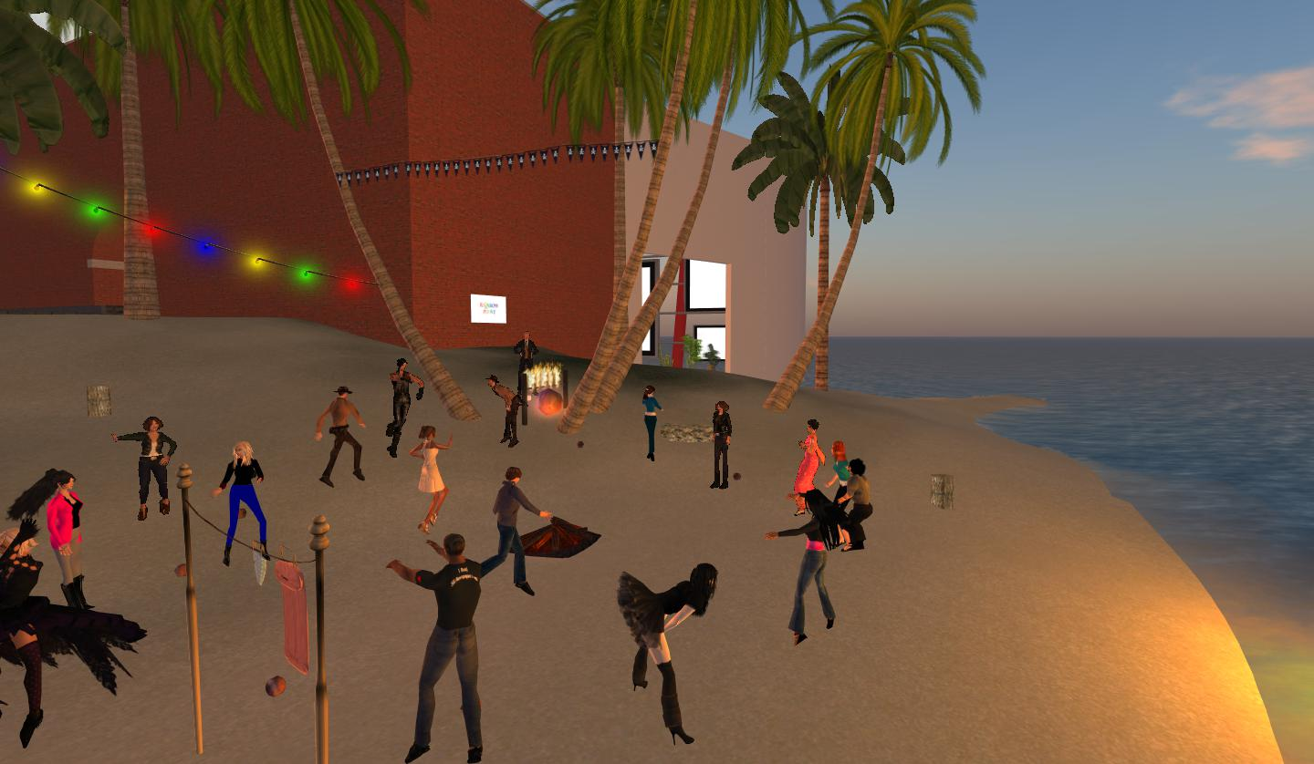
Picture 5 - Students party at the beach
One of the second cohort students commented in her journal:
I danced around with Student Z and that was great as we had some great opportunity to chat about our impressions on the course and how we could help each other. Student Y has so many things to share so I am happy to learn from her. I offered my skills in machinimatography which Student Z said he will certainly come back to. I love this kind of socializing and I think it is necessary in virtual worlds as much as in RL - although it is taking a lot of extra time. However, you learn a lot. (Student D)

Other spaces provided are aimed at students carrying out social activities. There is a football pitch, and a circle of drums and horns perfect for jamming. These spaces have proven very successful to increase interaction among students and provoke a laugh. Students report on having a smile on their faces when in front of their computer they are playing music or trying to hit the ball in a football match.

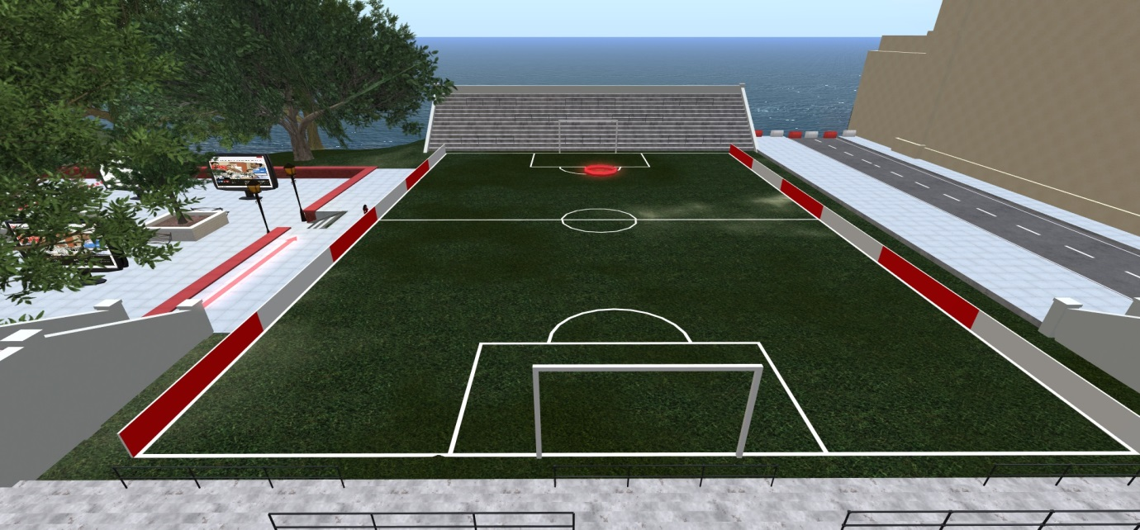
Picture 6 - Fancy a game?

4.4. Designing to stimulate learning
At Innovation @UWE campus learning is not limited to classrooms, and curriculum attainment is only one indication of learning. Wenger (1998) popularised the idea that learning is a social achievement and is evidenced through competent activity within a community.
Carr et al (2010) give an account of their teaching in SL and conclude that it is a less structured space and often causes difficulties for teachers to predict learning, compared with the control exerted in a physical space in the real world, such as a university classroom or lecture theatre. One of the characteristics of traditional university classrooms is that students and tutors are physically present within the place of learning. In this type of setting conversation among students either one to one or in groups would be discouraged as they would disrupt the dynamics established for this context. This is not particularly beneficial for group identity and group formation. Dörnyei and Murphey (2004), emphasise six characteristics that define a group, the first one of them being interaction among group members, which seems rather weak in traditional learning contexts. However, although they are weak, these interactions exist. In the physical classroom where tutors and students are physically present, students tend to show their engagement (or lack of) with the learning activities by the use of speech and body language.

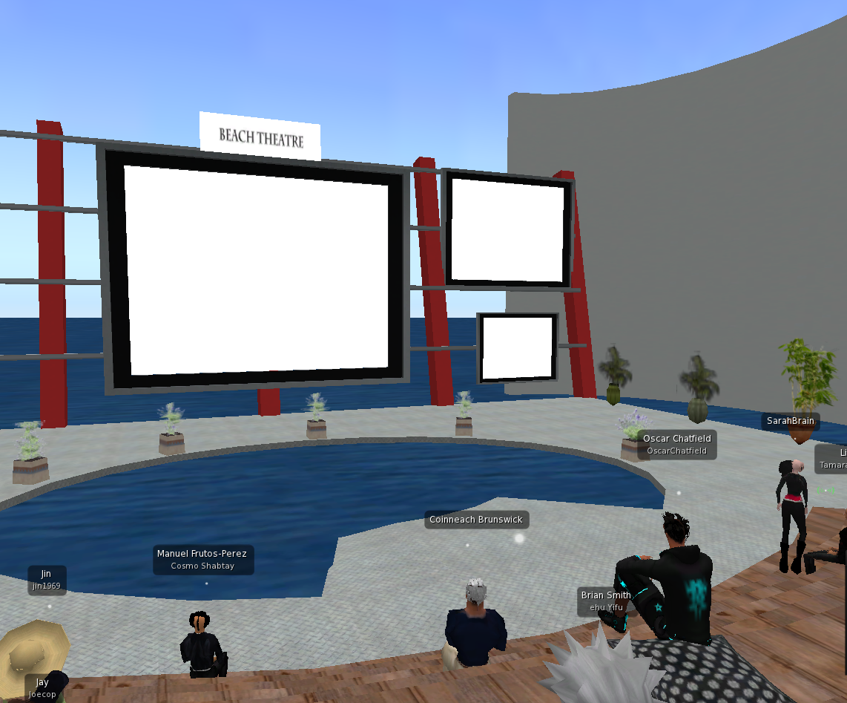
Picture 7- Beach theatre – reflecting on whether the design exerted power and control on the learning experience.
In VWs body language is missing, but instead there are many other visual cues and ways of interacting. In these environments the roles are not clearly defined and, as suggested by Carr et al. (2010) each individual in the group has a way of negotiating their community involvement. If we look at picture 8 below portraying one of our ‘classrooms’ we can see that seating arrangements can be quite informal. Although we could infer that there is a class going on as indicated by the screen with a Powerpoint presentation at the back of the room, it would be difficult to point out who the tutor is in this environment.
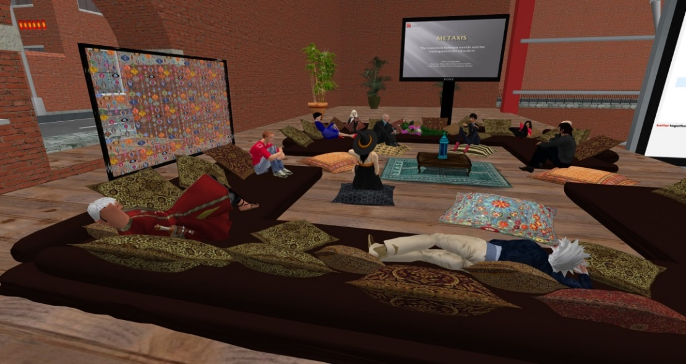
Picture 8 - A tutorial on metaxi
The following subsections will use students’ voices to illustrate to illustrate how the design of the Innovation@UWE campus has facilitated the students to learn by doing, through role play, by playing games and through simulations.
4.4.1. Learning by doing
Much of the students’ activity on the MA programme is concerned with the design and development of learning environments in a range of subject areas. In particular, the Scripting and Building module assessment requires the students to design and build a learning environment of their choice in a 20mx20mx20m cube in the virtual world. These assessments have resulted in some wonderfully creative work from the students, including law courts, hospitals and simulations of computer firewalls. An excellent example of the creativity students demonstrate on the programme is a learning environment that supports students of English literature studying “Night” by Elie Wiesel. Here the student created an evocative synagogue environment, which later drops the participants into cattle carts travelling to Auschwitz. The student’s blog entry includes the following comment.
In many virtual spaces I have experienced a sense of immersion purely because of what surrounded me; the artefacts, the atmosphere, the soundscape, the lighting; all combining to provide a sense of being there that was beyond that of a spectator; I was emotionally there. It is my view that this level of immersion would facilitate students connecting with a literary work such that discussions would provide far more meaningful and emergent learning than those conducted solely from a classroom environment. As Thomas states (2010, p.503) “engaged learning is an emergent property of learning spaces that are designed to provide affordances that actively encourage such engagement”. I want to investigate how a build can actively engage students in literature at an emotional level and move their discussions beyond the abstract .(Student F).

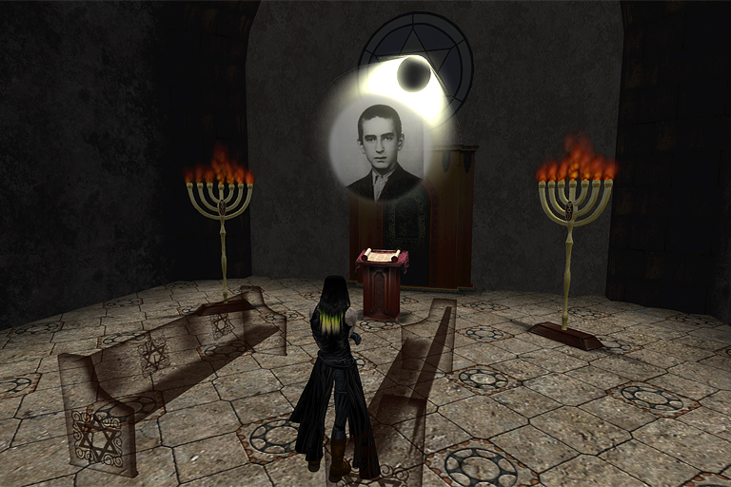
Picture 9 – Night, a mystical learning experience designed by one of the students of the MA EVW

4.4.2. Learning through role playing
Learning through role play is a particular affordance of VW environments. In the Simulations and Role Play module the students undertake a role play as part of their studies. They choose roles in a scenario that relates to an ethical decision that has to be made by a small company, and the scenario is played out over two consecutive weeks in the virtual world tutorials. The students enter into the spirit of the play, and change their avatars and clothes to fit the scenario. The excerpt below is an example of the students’ feedback on their experiences.
Very enjoyable though exhausting opportunity to experience how this technique can help organize ideas and think of strategies for problem-solving situations. Realistic enough to parallel and transfer RL events. Very creative and fun. Liked the climate that was created by the participants (us!) and this is surely the beginning of further analysis. Felt very comfortable and strongly believe this is a genuine way to train and elicit valuable resources. Thank you all for a joyful instance of learning.(Student G)

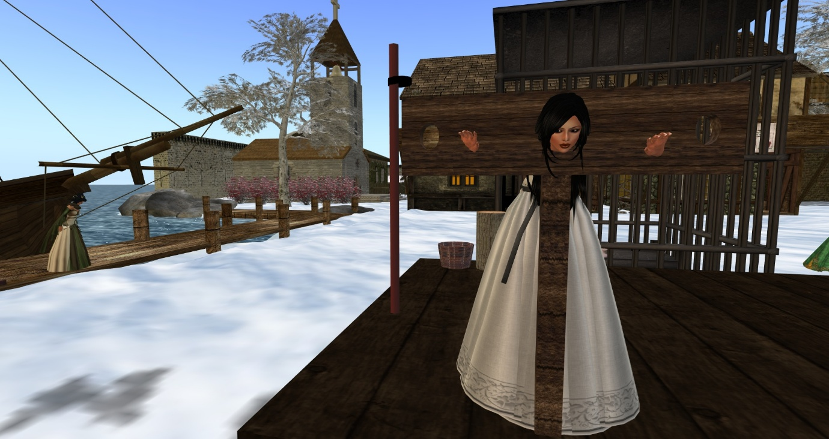
Picture 10 – Role Play at Medieval Usk Castle

    - Learning by playing games
Learning through games and play is a method that is well-suited to the adaptable, flexible and potentially fantastic environments that can be created in virtual worlds. As an example, the virtual world tutorial on 31st October 2013 (Hallowe’en) was a group treasure-hunt game in a haunted house. Again, the students changed their avatar appearances to enter into the spirit of the game. A sample of the text discussion that took place during the game is shown below, to illustrate the dynamics of learning in virtual world games.

Player 1: Where are you?
Player 2: Near a telephone ringing
Player 1: I’m with the scary monk by the coffins, warning me not to get trapped here
Player 2: I’ve got clue 3
Player 3: There's an awful lot of blood in here.
Player 1: how do you get clue 3?
Player 2: If you click on the skulls you get clue 3Player 3: And far too many spiders.
Player 1: Oh yeah got it!!
Player 1: think we need to get the clues in order
Player 2: ok lets look for one and two
Player 2: found clue 2
Player 4: just found it too
Player 1: Arggh Player 4, you're in a cage with a skeleton!
Player 4: not sure how to get out either lol
Player 1: how did you get in?
Player 4: clicked on something to put me in. the face on the wall I think
Player 2: answer the question and the gate will open. been there.
Player 1: yay you’re out!

4.4.3. Learning through simulations
Learning through simulations has proved to be a powerful tool in a number of subject areas at UWE, especially as the university has a focus on education for the professions and case-based learning. One example is a simulation we have developed of a liquefied petroleum gas explosion accident, which the students on the MA witnessed as part of an ideas workshop. A small sample of the text chat discussion that took place during this workshop is shown below.
Student 1: ideas ideas ideas!
Student 2: perfect for nursing schools
Student 1: awesome, how would that be done with a bot could you put real people to animate the crash test dummies
Student 3: you mean role play the bot?
Student 1: the reason I ask is I would like to look at a first aid introduction and was wondering how to take vitals etc.
Student 2: how long would this simulation take?
Student 3: so the simulation is the behaviour...the RP is the content
Student 1: the blood patterns etc would be good for the emergency services to help assess and triage
Student 4: could the participants wear a particular tag?
Student 5: they could have name tags
Student 1: arm bands
Student 2: it is worth trying.

The opportunities to use simulations like this generated a good discussion on the potential of their use in education, and one student is now further developing this as part of his assessment for the programme.
- Conclusions and Implications
The possibilities inherent in 3D VWs are exciting for education. The fact that students from very diverse parts of the world, with different backgrounds can get together to discuss educational topics and work on things collaboratively and cooperatively, makes any efforts in designing effective spaces to facilitate this worthwhile. Students are able to meet and interact with tutors and classmates in a manner that creates a special connection among them for they play, discuss, and work towards a common learning goal. This special connection is also evident between students and the environment since it is the design of this space that makes possible such multimodal interactions. As Saven-Baden (2011) suggests, the advantage of using Second Life in higher education is that it is a space in which experimentation can occur in ways that are not possible in real life.
The ways in which a space is designed shape the learning that happens in that space. We fail sometimes to notice the ways in which space constrains or enhances what we intend to accomplish. Traditionally, space arrangements have been taken for granted and they have been replicated in ways that are not always appropriate. Chism and Bickford (2003) list a number of typical assumptions such as:
- Learning only happens in classrooms.
- Learning is an individual activity.
- What happens in classrooms is pretty much the same from class to class and day to day.
- A classroom always has a front.
- Learning demands privacy and the removal of distractions.
- Flexibility can be enhanced by filling rooms with as many chairs as will fit.

As we show in this article and from examples from the MA EVW, these assumptions can easily be challenged. Education in the 21st Century ought to be focusing on aspects such as communication, autonomy, flexibility, accessibility, increased innovation and creativity. Learning spaces need to be able to supply this. If the 3D world is used effectively there is strong potential to create a constructivist approach to learning. A good design of the space can provide for opportunities to learn in ways not possible before the existence of these technologies. We can create rich and dynamic DL experiences in which students have a chance to take ownership of their learning and create multiple possibilities to interact with tutors and peers, not in classrooms, but in a social context where every activity that takes place becomes a learning opportunity.

The goal of education space is to improve the learning of the students in it, and the results from initial analysis obtained suggest that the design guidelines we have applied to the MA EVW have helped to achieve this goal. The set of guidelines presented here are clearly not complete, but they present a step in defining principles that can guide the design process, with the particular strength of being informed through the student voice. As future work, we would like to explore in more detail how these guidelines (and possibly additional ones) can be best used.

- References

Aldrich, C. (2005). Learning by doing: A comprehensive guide to simulations, computer games, and pedagogy in e-learning and other educational experiences. San Francisco: Pfeiffer.
Bilandzic, M., Jones, M., & Foth, M. (2011). The embodied hybrid space: designing for digital encounters in physical environments. In Lugmayr, Artur (Ed.) Proceedings of the 4th International Workshop on Semantic Ambient Media Experience (SAME 2011), Ambient Media Association, Brisbane.

Carlile, O., & Jordan, A. (2005). It works in practice but will it work in theory? The theoretical underpinnings of pedagogy. Emerging Issues in the Practice of University Learning and Teaching, 11-26. Dublin: AISHE.

Carr, D., Oliver, M. & Burn, A. (2010). Learning, teaching and ambiguity in virtual worlds. In A. Peachey, J. Gillen, D. Livingstone & S. Smith-Robbins (Eds), Researching Learning in Virtual Worlds, 17-30. London: Springer. Retrieved from: http://dx.doi.org/10.1007/978-1-84996-047-2_2

Cram A., Hedberg J.G., Gosper M. & Dick G. (2011) Situated, embodied and social problem-solving in virtual worlds. Research in Learning Technology, 19(3), 259-271.
Dawley, L., & Dede. C. (2013). Situated learning in virtual worlds and immersive simulations. In J.M. Spector, M.D Merrill, J. Elen, & M.J. Bishop (Eds.), The Handbook of Research for Educational Communications and Technology (4th ed.). New York: Springer.
de Freitas S. & Nuemann T. (2009). The use of ‘exploratory learning’ for supporting immersive learning in virtual environments. Computers and Education, 52 (2) 343-352.
de Freitas, S., Rebolledo-Mendez, G., Liarokapis, F., Majoulas, G., & Poulovassilis, A. (2010). Learning as immersive experiences: Using the four-dimensional framework for designing and evaluating immersive learning experiences in a virtual world. British Journal of Educational Technology, 41 (1), 69-85.
Delgarno, B. and Lee, M. J. W. (2010) What are the learning affordances of 3-D virtual environments? British Journal of Educational Technology, 41(1), 10-32.
Dickey, M. D. (2003) Teaching in 3D: Pedagogical Affordances and Constraints of 3D Virtual Worlds for Synchronous Distance Learning. Distance Education, 24 (1), 105-121.
Dörnyei, Z., & Murphey, T. (2003). Group Dynamics in the Language Classroom. Cambridge: Cambridge University Press.
Edirisingha, P., Nie, M., Pluciennik, M. and Young, R. (2009) Socialisation for learning at a distance in a 3-D multi-user virtual environment, British Journal of Educational Technology, 40 (3), 458-479.
Falconer, L. (2013). Situated learning in virtual simulations: Researching the authentic dimension in virtual worlds. Journal of Interactive Learning Research, 24 (3), 285-300.
Farley, H. (2013) Facilitating immersion in virtual worlds: an examination of the physical, virtual, social, and pedagogical factors leading to engagement and flow. In: Outlooks and Opportunities in Blended and Distance Learning. Advances in Mobile and Distance Learning, 189-203. IGI Publishing (IGI Global), Hershey, PA. United States.

Harrison, S.; Dourish, P. (1996). Re-place-ing space: the roles of place and space in collaborative systems. Proceedings of the 1996 ACM Conference on Computer Supported Cooperative Work, 67-76. ACM Press New York, NY, USA.

Lakshmi, G., Johnson, N., Junglas, I. and Ives, B. (2013) Predicting users’ return to virtual worlds: a social perspective, Info Systems, 23, 35-63.

Low, S. (1992). Symbolic ties that bind: place attachment in the plaza In Altman, I. and Low, S. (Eds.), Place Attachment, 165-186. New York: Plenum Press.

McKerlich, R., & Anderson, T. (2007). Community of enquiry and learning in immersive environments. Journal of Asynchronous Learning Networks, 11(4), 35-52.

Mennecke, B. E., Triplett, J. L., Hassall, L. M., Jordan-Conde, Z. and Heer, R. (2011) An Examination of a Theory of Embodied Social Presence in Virtual Worlds. Decision Sciences, 42 (2), 413-449.

Minocha, S. & Reeves, A. J. (2010). Design of learning spaces in 3D virtual worlds: an empirical investigation of Second Life Learning. Media and Technology, 35 (2), 111–137.
Pfeil, U., Ang, C. S. and Zaphiris, P. (2009) Issues and challenges of teaching and learning in 3D virtual worlds: real life case studies, Educational Media International, 46 (3), 223-238.
Plunkett, D. (2011) On place attachments in virtual worlds. World Leisure Journal 53 (3), 168-178

Savin-Baden, M. (2011) A Practical Guide to Using Second Life in Higher Education. Maidenhead: McGraw-Hill.

Sköld, O. (2012) The effects of virtual space on learning: a literature review

Wang, Y.M. & Chen, D.V. (2011). Instructors as architects-designing learning spaces for discussion-based online courses. Journal of Educational Technology Systems, 39(3), 281-294. Retrieved from http://www.editlib.org/p/51729.

Warburton, S. (2009) Second Life in higher education: Assessing the potential for and the barriers to deploying virtual worlds in learning and teaching, British Journal of Educational Technology, 40 (3), 414-426.

Wenger (1998). Communities of Practice: Learning, Meaning and Identity. Cambridge: Cambridge University Press.

Witmer, B. G., & Singer, M. J. (1998). Measuring presence in virtual environments: a presence questionnaire. Presence, 7(3), 225-240.

