Simultaneous Electricity Generation and Microbially-Assisted Electrosynthesis in ceramic MFCs

Iwona Gajdaª, John Greenman^{a,b}, Chris Melhuishª, Ioannis Ieropoulos^{a,b}
ªBristol Robotics Laboratory, Block T , UWE, Bristol, Coldharbour Lane, Bristol BS16 1QY, UK
^{b}School of Life Sciences, UWE, Bristol, Coldharbour Lane, Bristol BS16 1QY,UK
*ioannis.ieropoulos@brl.ac.uk

*Corresponding author: Tel.: +44 117 32 86318, 86322; Fax: +44 117 32 83960 E-mail address: ioannis.ieropoulos@brl.ac.uk (I. Ieropoulos)
Bristol Robotics Laboratory, T-Building, Frenchay Campus, Bristol, BS16 1QY, UK

Abstract
To date, the development of microbially assisted synthesis in Bioelectrochemical Systems (BES) has focused on mechanisms that consume energy in order to drive the electrosynthesis process. This work reports - for the first time - novel ceramic MFC systems that generate electricity whilst simultaneously driving the electrosynthesis of useful chemical products. A novel, inexpensive and low maintenance MFC demonstrated electrical power production and implementation into a practical application. Terracotta based tubular MFCs were able to produce sufficient power to operate an LED continuously over a 7 day period with a concomitant 92% COD reduction. Whilst the MFCs were generating energy, an alkaline solution was produced on the cathode that was directly related to the amount of power generated. The alkaline catholyte was able to fix CO2 into carbonate/bicarbonate salts. This approach implies carbon capture and storage (CCS), effectively capturing CO2 through wet caustic ‘scrubbing’ on the cathode, which ultimately locks carbon dioxide.

Key words: terracotta MFC, wet scrubbing, catholyte generation, water recovery, microbially assisted electrosynthesis

Highlights
- MFCs synthesise alkali as a direct product of electricity generation - not consumption
- Electric current and up to 68mL of alkaline solution was produced from the breakdown of wastewater
- The maximum power performance of a single MFC obtained by polarization curve was 2.58 mW
- Cost effective ceramic MFCs with internal cathode achieved 92% COD reduction
- Energy generated from ceramic MFCs operated LED light for 7 days

- Introduction
The cost of energy generation and wastewater treatment is expected to increase in the near future, in order to meet the growing global population and the resultant demand on resources. The treatment of wastewater is typically viewed as an energy intensive burden rather than a resource. The energy value of domestic wastewater can be up to 7.6 kJ per litre (kJ/L) and that of mixed industrial and domestic wastewater as much as 16.8 kJ/L [1]. By harnessing the energy in wastewater, the water industries can become more efficient both financially and environmentally. In addition, wastewater could become a source of energy in parts of the world, which currently lack the essential infrastructure for reliable and affordable energy generation and distribution. Globally, there is an urgent need for low-cost water treatment technologies both in developed and developing countries.
Research in the field of Bioelectrochemical Systems (BES) has focused on converting compounds in wastewater to bioelectricity via Microbial Fuel Cell (MFC) or other energetically valuable products [2]. Properties of the proton selective membrane and its configuration in dual-chamber MFC offer the opportunity to transfer cations from the anolyte over to the cathode [3]. In this way the cathode can be exploited as a mechanism for removing specific contaminants e.g. heavy metals [4]. This can be taken a step further by supplying an external energy into the BES system, where valuable products such as hydrogen gas [5], hydrogen peroxide [6], methane [7] or caustic soda [5,8] can be recovered.
The formation of caustic soda for example, is driven by the alkalinisation on the cathode side due to the continuous consumption of protons by the oxygen reduction reaction (ORR) and cationic flux [3]. In general, ORR on the carbon based cathodes proceeds either via the two- or four- electron pathway. The 4-electron pathway appears to be predominant on noble metal catalysts, whilst the 2-electron pathway, known as peroxide pathway is more common on carbon based electrodes. In acidic conditions, it will result in formation of hydrogen peroxide which is further reduced to water. In alkaline environment it will result in generation of OH- [9] that leads to a further increase in pH. MFC operation causes not only transport of ions (protons and cations) but also flow of liquid through the membrane, which leads to the so called electroosmotic transport of water [10]. This has resulted in many recent studies moving away from electricity generation and instead focussing on electricity consumption via Microbial Electrolysis Cells, where microbially assisted electrosynthesis can effectively be used for the production of oxidants or disinfectants [11] or even water dissociation via electrodialysis for separating the ionic species. However, it has recently been reported that the same process of microbially driven electrosynthesis can be achieved with both energy production and simultaneous elemental recovery in a simple MFC design [12]. This process generated a highly saline catholyte that additionally acted as a dragging mechanism, similar to the Osmotic MFC. The Osmotic Microbial Fuel Cell (OsMFC), incorporates forward osmosis membranes, NaCl as the catholyte solution and usually, platinum electrodes. OsMFC represents a water extraction technology, which can recover water molecules from the anolyte through the membrane via osmotic pressure [13]. This relies on Forward Osmosis (FO), where the osmotic pressure gradient that exists between solutions of two different concentrations is driving the transport of water across the membrane. The driving force is created by high solute concentration solution and water transport occurs naturally via electro passive transport. In OsMFC, externally supplied salt solution is used as catholyte and has been shown to increase current generation [14], however the disadvantage of FO reactors is the salt leakage across the membrane [15].
Wastewater, as an abundant biological resource has the enormous potential for clean energy, and its treatment is an important benefit of this process. In order for the MFC technology to be feasible and implemented in real world conditions, the performance needs to be improved and its design has to be simplified to become cost effective for practical use. To explore this path further it is important to look into cost effective materials, design and methodology to showcase the technology as a serious contender for practical implementation in wastewater treatment plants. For example, ceramic material have been recognised as a low cost alternative to PEM and used as septum/separator [16] or as a whole MFC reactor [17–20]. In addition, the electrode material is another critical factor of the MFC architecture that plays an important role in performance, cost of production and preparation, as well as longevity and maintenance. In this respect, activated carbon based cathodes are inexpensive and useful alternatives to Pt-catalyzed electrodes in MFCs [21–24].
The aims of this work were therefore to: i) develop a simple, ceramic based MFC design as an immersed anode in a wastewater tank for both energy recovery and microbially driven electrosynthesis of catholyte; ii) explore simple and cost effective designs based only on carbon electrodes and ceramic materials, iii) demonstrate the catholyte generation in situ within the catholyte chamber as a means of water recovery and carbon capture.
- Materials and methods
  - MFC design and operation
MFCs were built using terracotta caves (Orwell Aquatics, UK) of 10 cm length, 4.2 cm outside diameter, 3.6 cm inside diameter and the wall thickness of 3mm. They were assembled with carbon veil anode and activated carbon cathode. The anode electrode was made of carbon veil 20 g/m² (PRF Composite Materials, Dorset, UK), size 2430cm². The electrode was folded down, wrapped around the terracotta cave, and it was held in place with nickel chromium wire (0.45cm diameter) as shown in Figure 1. The MFCs were placed inside a container filled with 200 mL of activated sludge provided by Wessex Water Scientific Laboratory (Cam Valley, Saltford, UK) and supplemented with 0.1M sodium acetate at pH 6.6, which was periodically (7 days) supplied as feedstock.
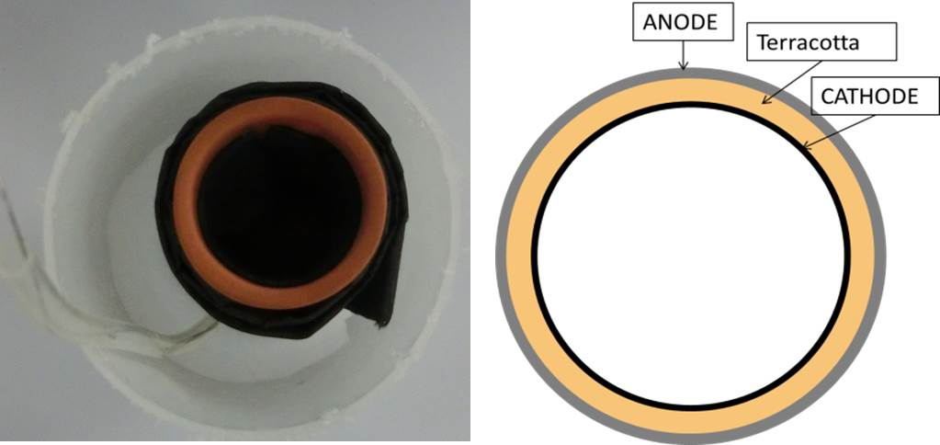
Figure 1. The ceramic MFC assembled and its schematic description.

  - Cathode preparation
To optimise the cost and performance of the cathode electrode, carbon veil was used as gas diffusion layer (GDL) replacing the more expensive carbon cloth. Carbon veil sheet was pre-treated by coating with 30% PTFE (Sigma Aldrich) solution and left to dry. This material was used as the current collector and GDL. Afterwards, it was coated with activated carbon and 20% PTFE mixture on one side only. The mixture was prepared by combining 80g of activated carbon powder (G. Baldwin and Co., London, UK) and 20 % wt PTFE (60% PTFE dispersion in water -Sigma Aldrich, UK) in deionised water. The prepared mixture was applied onto the pre-treated carbon veil and distributed with a spatula. The obtained loading of activated carbon was ~60 mg/cm². The AC/PTFE mixture and carbon veil were hot pressed at 150-200 ˚C using a household iron until the coated material was completely dry (Figure 2).
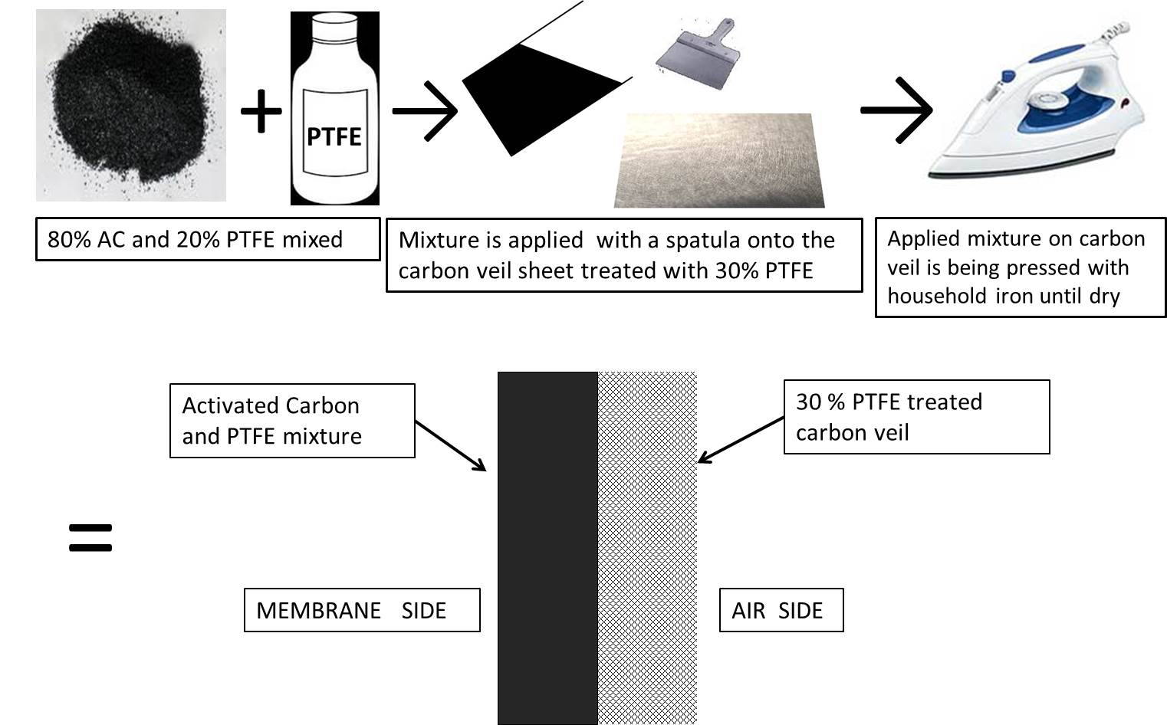
Figure 2. Cathode electrode preparation procedure
The cathodes were then cut in 90cm² pieces and placed inside the MFC cylinders so the activated carbon layer faced the inside of the terracotta wall. Electrodes were connected to the data logging equipment via nickel chromium wires and stainless steel crocodile clips.
  - Data capture
Polarisation experiments were performed using a Resistorstat tool [25] in the range of 30kΩ to 10Ω and the time constant for each resistance value was 3 minutes. Data were logged using a multi-channel Agilent 34972A, LXI Data Acquisition/Switch Unit (Farnell, UK) and processed using the Microsoft Excel and GraphPad Prism software packages. Current and power were calculated as previously described [26].
For the purposes of demonstrating the feasibility of the tested MFCs as the sole power source for applications, a single red LED (RS, UK) was connected directly to the MFC without the use of any energy harvesting system.
  - Analysis
The pH was measured with Hanna 8424 pH meter (Hanna, UK) and the conductivity with 470 Jenway conductivity meter (Camlab, UK). Dry weight of precipitated salts was determined by drying 0.5 mL of catholyte over 48 h and weighing the dry mass. Energy dispersive X-ray (EDX) analysis was performed (Philips XL30 SEM) and was used to determine elements present in crystallised cathodic salts. Detection limits are typically 0.1–100% wt. X-ray diffraction (XRD) analysis on precipitated salts from the catholyte was determined using powder measurements, performed on a Bruker D8 Advance Diffractometer with the results analysed using EVA software package (Bruker, UK).
COD was determined using the potassium dichromate oxidation method (COD HR test vials, Camlab, UK) and analysed with a MD 200 photometer (Lovibond, UK) where 0.2mL samples were taken before and during MFC treatment and filter-sterilised prior to analysis.

- Results
  - Power performance
A triplicate of MFCs were continuously operated under external load conditions from the beginning (T1, T2, T3), whereas the second triplicate set (T4, T5, T6) was left under open circuit conditions. In order to evaluate the electricity generation of this system, the polarisation experiments were performed only on the working MFCs and are shown in Figure 3. The best performance 2.58mW (286mW/m²) was achieved by T1, whereas T2 generated 2.12mW (235mW/m²) and T3 gave 1.16 mW (128mW/m²). The MFCs under open circuit conditions were used to assess the passive dialysis effects, i.e. the passive diffusion of anolyte through the porous structure of the terracotta chassis.
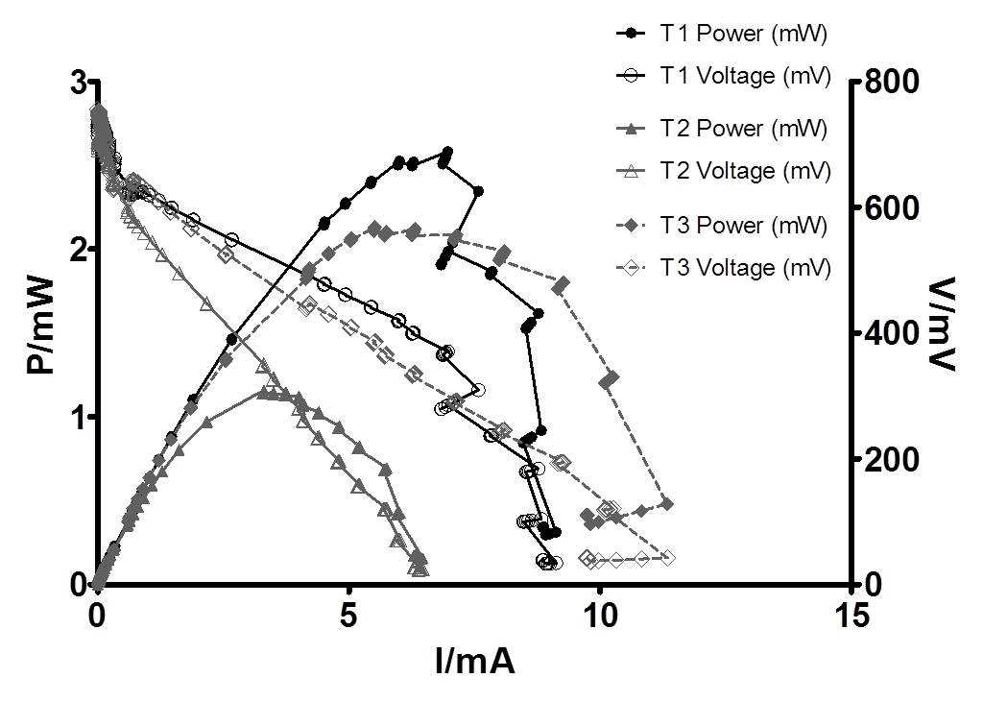
Figure 3. Polarisation curves performed during MFCs were operated using sodium acetate and wastewater mixture.

The performance under fixed external load conditions (53Ω) demonstrated that all MFCs exhibited stable performance over a 7 day period, during which, catholyte formed on the surface of the cathode (Fig. 5A). The current generated during this time was T1 7.12 mA, T2 4.50 mA and T3 6.09 mA, which was proportional to the amount of catholyte generated (Fig. 4A); T1 produced 68 mL, T2 45 mL and T3 produced 55 mL of clear catholyte. The MFCs in open circuit mode showed some catholyte accumulation, however in significantly smaller volumes (Fig. 4B); T4 produced 15mL, T5 17 mL and T6 generated 10 mL of catholyte. This is most likely due to passive diffusion, since no charge transfer was occurring under open circuit conditions. During this time the amount of anolyte lost was proportional to the accumulated catholyte, and thus the MFC performance. This is in agreement with the previously published work that reported on catholyte generation [12].
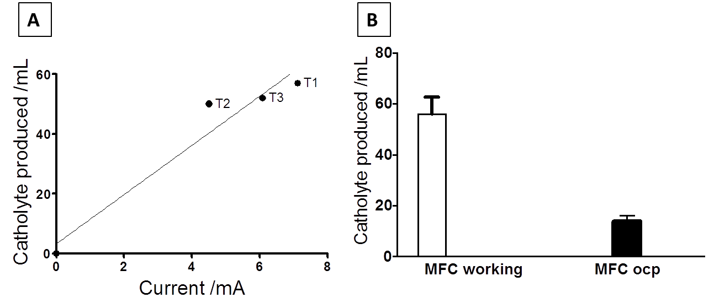
Figure 4. A) Amount of water produced under working (53Ω) conditions in relation to current; B) comparison of the amount of catholyte produced in closed and open circuit conditions

  - Catholyte analysis
Only the cathode electrodes in the working MFCs showed clear production of droplets directly on the surface of the electrode material, which resulted in further accumulation of liquid. The catholyte generated was transparent in colour and odourless, whilst the catholyte generated under open-circuit, was similar to the anolyte (Figure 5B). The level of pH and conductivity was a function of the presence or absence of the external load. Figure 6 shows that both pH and conductivity of the catholyte in the working MFCs (T1, T2 and T3) was significantly higher than that of the catholyte of the open-circuit MFCs. Moreover, the difference in pH between the anolyte and catholyte was more marked for the working MFCs rather than the MFCs under open-circuit, which showed no significant changes indicating anion and pH splitting mechanism in working MFCs (T- working).
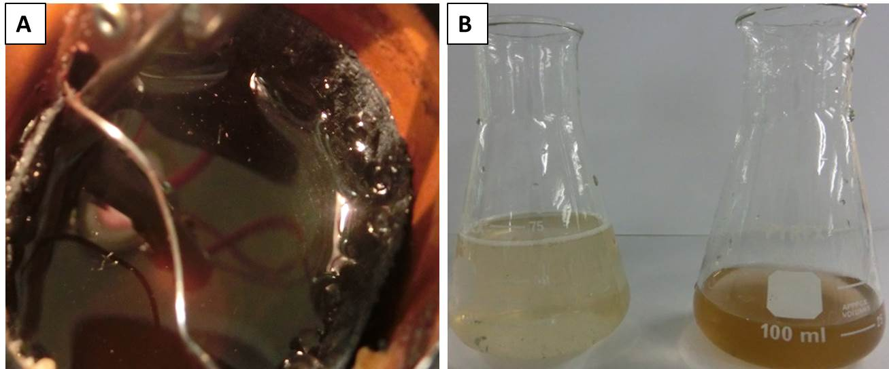
Fig 5. A) Catholyte formation, B) the amount of catholyte produced under closed circuit (left) and open circuit conditions (right).

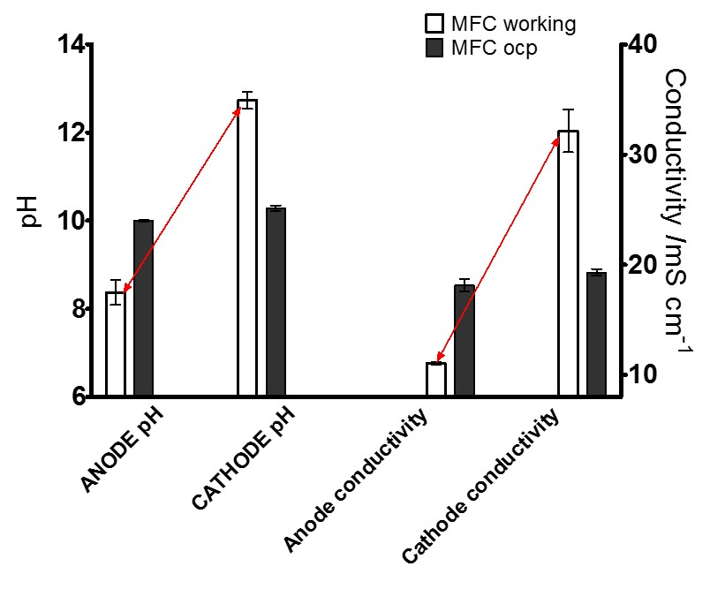
Figure 6. Conductivity and pH of MFC catholyte, with respect to the anolyte, in working and open circuit conditions. Arrows highlight the difference in these two conditions.

During the 7 days of continuous operation under load, for the working MFCs, it was clearly shown that the COD was significantly reduced, as illustrated in Figure 7 below.
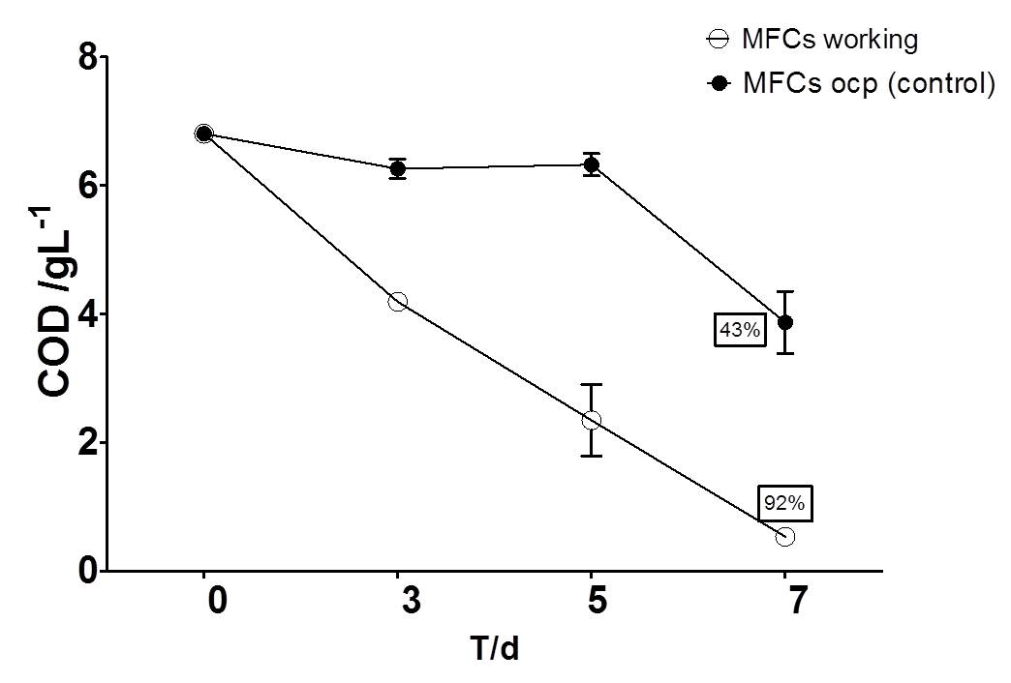
Figure 7. Temporal COD reduction from the working MFCs against MFCs in open circuit.

As can be seen in Figure 7, the level of COD reduction achieved by the ceramic MFCs was of the order of 92%, and this was also true for the underperforming T2 MFC. It may be assumed that other antagonistic reactions were taking place in this unit in particular, and this should form part of a separate investigation.
  - Powering the LED
To show the potential of the cylindrical MFCs to power real world applications, the working MFCs were used to successfully operate a red LED directly, at a constant voltage of ~1.7V. The LED was shown to be operated continuously as long as the substrate (0.1M sodium acetate) was fed to the MFCs. This substrate was fed at the beginning of the week and was not replenished until the end of the test as shown in figure 8. During the anolyte exchange for feeding, the LED would stop working for a short period of time, until the MFC performance recovered to the previous levels, at which point the LED would turn ON once again.
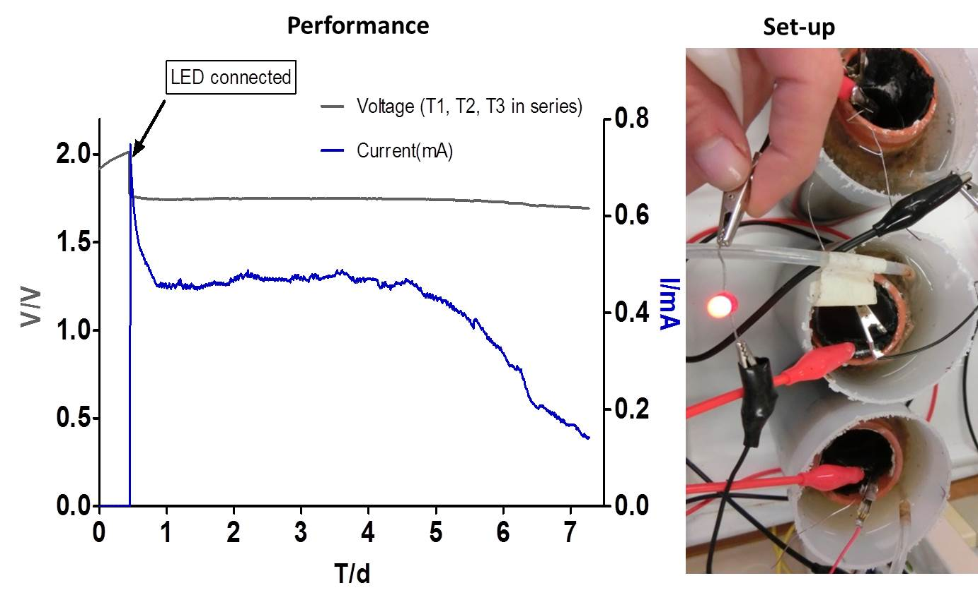
Figure 8. Voltage of the LED and current generated from the 3 working MFCs connected in series, and directly powering the single LED.

  - Carbon Capture via electrodialysis
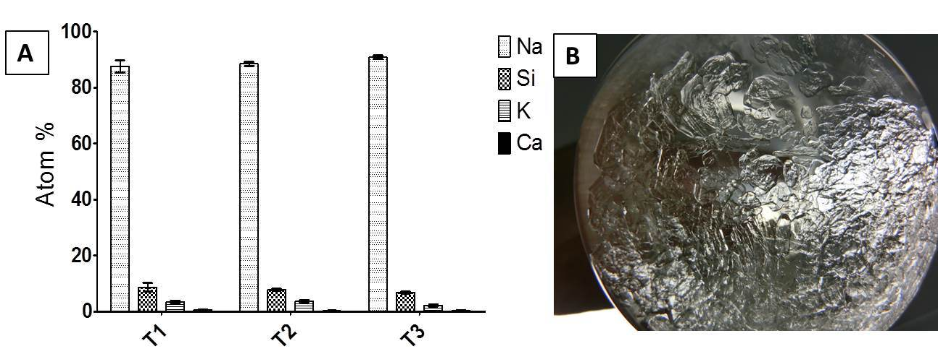
Figure 9.A) EDX profile representing % of detected elements in crystallised salts from the evaporated liquid sample, B) crystalline structure of catholyte formed on the bottom of the glass container (right).

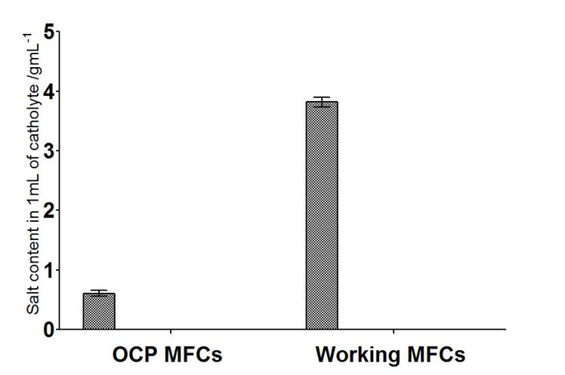

Figure 10. Comparison between the amounts of salts generated in the collected catholyte, for the open circuit and loaded MFCs.

Further analysis of the accumulated salts shows that apart from high pH and high concentration of the solution, the salts formed following the evaporation of samples, showed on average 88% content as sodium salt. As can be seen in Figure 10, a significantly higher amount of salts migrated from the anode to the cathode in the loaded MFCs is far higher than the solid mass measured from the open circuit units; this is also proportional to the amount of liquid catholyte formed. If the amount of salts generated under open circuit (no charge transfer) is deducted from the amount of salts generated by the loaded MFCs, then a net weight of 3.3g/mL can be directly attributed to electro-osmotic drag and ORR. In addition, the chemical properties of the catholyte generated under load conditions, such as high pH, high conductivity and high salinity, may be suitable as a disinfection agent, which is forming part of our continuing research. Initial findings suggest that the chemical composition of the catholyte is consistent with mineral phases such as trona, (Na₃(CO₃)(HCO₃) 2H₂O) and Na₂ CO₃ 2H₂O.Trona is a mixture of two phases of sodium carbonate/bicarbonate (data not shown).

- Discussion
The key issue for the implementation of Carbon Capture and Storage (CCS) is the high cost of sorbents. The current practice for CCS is effectively capturing CO₂ in the flue gas by an alkaline hydroxide absorbing solution, in order to react and form an alkaline carbonate solution with a normal gas-liquid absorption tower; for example, CO₂ + MOH → MHCO₃ where M represents a metal such as sodium . The use of alkaline sorbents have been shown as a method for carbon capture [27] and the MFC could be a method for a sorbent production that produces electrical energy [28].
Electro-dialysis is a process that depends on the principle that most dissolved salts are positively or negatively charged and they will migrate to electrodes with opposing charges. Electro-dialysis systems do this by using expensive membranes [29]. In the MFC presented here, wastewater was supplemented with sodium acetate and utilised as the carbon energy source for the microorganisms, which break it down for consumption. This dissociates the sodium ions, which migrate over to the cathode through the ceramic material, as a direct consequence of the electricity being generated, thus effecting electrodialysis and ion separation. This method is truly cost effective because inexpensive materials and simplified methods of preparation were employed. For example, carbon veil used as a gas diffusion matrix is 100 times cheaper than 30% PTFE pre-treated, commercially available carbon cloth (e.g. as supplied by fuelcellearth). The calculated cost of in house prepared activated carbon cathodes is 120 £/m² which is 7 times cheaper to using the same coating on carbon cloth.
With an electric field in the system, the process of anolyte dissociation takes place with the use of membrane systems. Electrical potential applied to the ion exchange separators will involve the ion movement within the reactor. This has been the basis for electrodialysis studies where the potential is set externally to drive the dialytic process or desalination. Recently, it was proposed that alkali production in a cathodic chamber of a microbial electrolysis cell is possible, when a high electrical potential is applied and additional catholyte is externally supplied at high salt concentrations [8]. This exploration has been showing the potential of alkali production in situ in electrodialysis systems [30] resulting in rather complicated designs [31]. This study is aiming to demonstrate the advantages of simple designs to make the MFC technology even more attractive.
The novelty of the use of ceramic material to (i) perform the co-generation of electricity and electro-dialytic functions and (ii) extract water and (iii) produce alkaline catholyte, is bringing this closer to implementation in real domestic environments as well as wastewater treatment plants. It is shown here that water desalination can be accomplished without electrical energy input as a result of electricity generation. The fact that the power does not decrease during this operation, whilst the cathode electrode has been flooded, might be attributed to the high salt concentration and increased conductivity. Electrical resistance of ion exchange membranes strongly increases with the decrease of solution concentration especially in low strength solutions [32,33]. Moreover the electrical power produced from mixing saline solutions is rooted in the membrane-based energy conversion mechanisms such as reversed electrodialysis [34,35]. The salinity gradient energy is a very promising avenue for electricity generation and in this design, it might be an additional driving element.
Ceramic based MFC cylinders have been previously shown in standard anode-cathode configurations [20] to remove ammonium [36] and energise practical applications [37]. The submerged MFC design described in the present study represents a true integration of two BES systems (MFC and MEC) into one simple design that could be used in a real environment. Scaled-up versions of the MFCs presented here have already been demonstrated as (i) a stack of 40 MFC reactors set up to treat urine and charge a mobile phone in real-time [38] and (ii) a stack of 288 MFC reactors operating directly from urinals to power indoor lighting [39]. Open to air cathode coupled with ceramic membranes could be used both for electricity generation and filtration of wastewater to regenerate water. Real life implementation of microbial fuel cells presented herein that does not require strictly controlled conditions or high maintenance, has the potential to play a major role in developing sustainable urban wastewater systems. Considering the amount of wastewater produced globally and the potential energy stored within it, it is important that MFC technology development should perhaps be pursued with real word applications in mind. This work is aiming at efficient industrial-scale development that would recover energy from wastewater using a terracotta tubular design, enhancing functionality of the MFC.

- Conclusions
This work has shown a novel, ceramic based MFC with an internal cathode that can perform the function of the co-generation of electricity and linked formation of catholyte from wastewater. MFC electrical performance is directly related to the amount of accumulated catholyte in the internal cathode chamber. The formation of catholyte is solely due to the MFC operation that drives the electro-dialytic transport of ions from the anode to the cathode and results in active electroosmotic extraction of water. The properties of formed catholyte include high pH and high salt concentration, which demonstrates the potential of in situ production of alkaline sorbent from wastewater. Pt-free MFC produced caustic sorbents that can fix carbon dioxide into carbonates and bicarbonates through wet scrubbing showing cost effective microbially assisted electrosynthesis.
This work reports simultaneous extraction of clean water from wastewater, elemental recovery and power production using a low maintenance, simple to make Microbial Fuel Cell system encouraging further scale-up into real world applications.

- Acknowledgement
The work was funded by the Engineering and Physical Sciences Research Council EPSRC CAF EP-I004653/1 and EP/L002132/1. The scale-up part of the work for the Re-Invent the Toilet Fair in India has been supported by the Bill & Melinda Gates Foundation, grant no. OPP1094890. The authors would like to thank Dr David Patton, from the University of the West of England and Dr Hazel Sparkes from the University of Bristol for the valuable expertise and analysis of the catholyte samples, and also Dr Jonathan Winfield for his general advice.

References
[1] E.S. Heidrich, T.P. Curtis, J. Dolfing, Determination of the internal chemical energy of wastewater., Environ. Sci. Technol. 45 (2011) 827–32. doi:10.1021/es103058w.
[2] D.R. Lovley, K.P. Nevin, A shift in the current: new applications and concepts for microbe-electrode electron exchange., Curr. Opin. Biotechnol. 22 (2011) 441–8. doi:10.1016/j.copbio.2011.01.009.
[3] R. Rozendal, Effects of membrane cation transport on pH and microbial fuel cell performance, Environ. Sci. Technol. 40 (2006) 5206–5211. http://pubs.acs.org/doi/abs/10.1021/es060387r (accessed May 08, 2014).
[4] K. Rabaey, J. Keller, Microbial fuel cell cathodes: from bottleneck to prime opportunity?, Water Sci. Technol. 57 (2008) 655–9. doi:10.2166/wst.2008.103.
[5] D. Call, B.E. Logan, Hydrogen production in a single chamber microbial electrolysis cell lacking a membrane., Environ. Sci. Technol. 42 (2008) 3401–6. http://www.ncbi.nlm.nih.gov/pubmed/18522125.
[6] R.A. Rozendal, E. Leone, J. Keller, K. Rabaey, Efficient hydrogen peroxide generation from organic matter in a bioelectrochemical system, Electrochem. Commun. 11 (2009) 1752–1755. doi:10.1016/j.elecom.2009.07.008.
[7] P. Clauwaert, W. Verstraete, Methanogenesis in membraneless microbial electrolysis cells., Appl. Microbiol. Biotechnol. 82 (2009) 829–36. doi:10.1007/s00253-008-1796-4.
[8] K. Rabaey, S. Bützer, S. Brown, J. Keller, R. a Rozendal, High current generation coupled to caustic production using a lamellar bioelectrochemical system., Environ. Sci. Technol. 44 (2010) 4315–21. doi:10.1021/es9037963.
[9] K. Kinoshita, Carbon Electrochemical and Physicochemical Properties, John Wiley & Sons, Ltd,., 1988.
[10] J.R. Kim, G.C. Premier, F.R. Hawkes, R.M. Dinsdale, A.J. Guwy, Development of a tubular microbial fuel cell (MFC) employing a membrane electrode assembly cathode, J. Power Sources. 187 (2009) 393–399. doi:10.1016/j.jpowsour.2008.11.020.
[11] K. Rabaey, R. a Rozendal, Microbial electrosynthesis - revisiting the electrical route for microbial production., Nat. Rev. Microbiol. 8 (2010) 706–16. doi:10.1038/nrmicro2422.
[12] I. Gajda, J. Greenman, C. Melhuish, C. Santoro, B. Li, P. Cristiani, et al., Water formation at the cathode and sodium recovery using Microbial Fuel Cells (MFCs), Sustain. Energy Technol. Assessments. 7 (2014) 187–194. doi:10.1016/j.seta.2014.05.001.
[13] Z. Ge, Q. Ping, L. Xiao, Z. He, Reducing effluent discharge and recovering bioenergy in an osmotic microbial fuel cell treating domestic wastewater, Desalination. 312 (2013) 52–59. doi:10.1016/j.desal.2012.08.036.
[14] F. Zhang, K.S. Brastad, Z. He, Integrating forward osmosis into microbial fuel cells for wastewater treatment, water extraction and bioelectricity generation., Environ. Sci. Technol. 45 (2011) 6690–6. doi:10.1021/es201505t.
[15] N.T. Hancock, T.Y. Cath, Solute coupled diffusion in osmotically driven membrane processes., Environ. Sci. Technol. 43 (2009) 6769–75. http://www.ncbi.nlm.nih.gov/pubmed/19764248.
[16] D.H. Park, J.G. Zeikus, Improved fuel cell and electrode designs for producing electricity from microbial degradation., Biotechnol. Bioeng. 81 (2003) 348–55. doi:10.1002/bit.10501.
[17] M. Behera, P.S. Jana, M.M. Ghangrekar, Performance evaluation of low cost microbial fuel cell fabricated using earthen pot with biotic and abiotic cathode., Bioresour. Technol. 101 (2010) 1183–9. doi:10.1016/j.biortech.2009.07.089.
[18] F.F. Ajayi, P.R. Weigele, A terracotta bio-battery., Bioresour. Technol. 116 (2012) 86–91. doi:10.1016/j.biortech.2012.04.019.
[19] M. Behera, P.S. Jana, T.T. More, M.M. Ghangrekar, Rice mill wastewater treatment in microbial fuel cells fabricated using proton exchange membrane and earthen pot at different pH., Bioelectrochemistry. 79 (2010) 228–33. doi:10.1016/j.bioelechem.2010.06.002.
[20] J. Winfield, J. Greenman, D. Huson, I. Ieropoulos, Comparing terracotta and earthenware for multiple functionalities in microbial fuel cells., Bioprocess Biosyst. Eng. 36 (2013) 1913–21. doi:10.1007/s00449-013-0967-6.
[21] X. Zhang, X. Xia, I. Ivanov, X. Huang, B.E. Logan, Enhanced activated carbon cathode performance for microbial fuel cell by blending carbon black., Environ. Sci. Technol. 48 (2014) 2075–81. doi:10.1021/es405029y.
[22] M. Ghasemi, S. Shahgaldi, M. Ismail, B.H. Kim, Z. Yaakob, W.R. Wan Daud, Activated carbon nanofibers as an alternative cathode catalyst to platinum in a two-chamber microbial fuel cell, Int. J. Hydrogen Energy. 36 (2011) 13746–13752. doi:10.1016/j.ijhydene.2011.07.118.
[23] C. Santoro, K. Artyushkova, S. Babanova, P. Atanassov, I. Ieropoulos, M. Grattieri, et al., Parameters characterization and optimization of activated carbon (AC) cathodes for microbial fuel cell application., Bioresour. Technol. 163C (2014) 54–63. doi:10.1016/j.biortech.2014.03.091.
[24] X. Li, X. Wang, Y. Zhang, N. Ding, Q. Zhou, Opening size optimization of metal matrix in rolling-pressed activated carbon air–cathode for microbial fuel cells, Appl. Energy. 123 (2014) 13–18. doi:10.1016/j.apenergy.2014.02.048.
[25] N. Degrenne, F. Buret, B. Allard, P. Bevilacqua, Electrical energy generation from a large number of microbial fuel cells operating at maximum power point electrical load, J. Power Sources. 205 (2012) 188–193. doi:10.1016/j.jpowsour.2012.01.082.
[26] I. Ieropoulos, J. Greenman, C. Melhuish, Microbial fuel cells based on carbon veil electrodes: Stack configuration and scalability, Int. J. Energy Res. 32 (2008) 1228–1240. doi:10.1002/er.1419.
[27] K.S. Lackner, The thermodynamics of direct air capture of carbon dioxide, Energy. 50 (2013) 38–46. doi:10.1016/j.energy.2012.09.012.
[28] Gajda, I., J. Greenman, C. Melhuish, I. Ieropoulos, Artificial photosynthesis coupled with electricity generation – microbial fuel cells as artificial plants, in: ALIFE 14 Fourteenth Int. Conf. Synth. Simul. Living Syst. ALIFE Work. Exploit. Synerg. between Biol. Artif. Life Technol. Tools, Possibilities, Examples, 30 July-2 August 2014, NY, USA., 2014.
[29] C. Huang, T. Xu, Electrodialysis with Bipolar Membranes for Sustainable Development, Environ. Sci. Technol. 40 (2006) 5233–5243. doi:10.1021/es060039p.
[30] M. Chen, F. Zhang, Y. Zhang, R.J. Zeng, Alkali production from bipolar membrane electrodialysis powered by microbial fuel cell and application for biogas upgrading, Appl. Energy. 103 (2013) 428–434. doi:10.1016/j.apenergy.2012.10.005.
[31] X. Zhu, M.C. Hatzell, R.D. Cusick, B.E. Logan, Microbial reverse-electrodialysis chemical-production cell for acid and alkali production, Electrochem. Commun. 31 (2013) 52–55. doi:10.1016/j.elecom.2013.03.010.
[32] P. Długołęcki, B. Anet, S.J. Metz, K. Nijmeijer, M. Wessling, Transport limitations in ion exchange membranes at low salt concentrations, J. Memb. Sci. 346 (2010) 163–171. doi:10.1016/j.memsci.2009.09.033.
[33] F. Harnisch, U. Schröder, F. Scholz, The suitability of monopolar and bipolar ion exchange membranes as separators for biological fuel cells., Environ. Sci. Technol. 42 (2008) 1740–6. http://www.ncbi.nlm.nih.gov/pubmed/18441829.
[34] J.W. Post, J. Veerman, H.V.M. Hamelers, G.J.W. Euverink, S.J. Metz, K. Nymeijer, et al., Salinity-gradient power: Evaluation of pressure-retarded osmosis and reverse electrodialysis, J. Memb. Sci. 288 (2007) 218–230. doi:10.1016/j.memsci.2006.11.018.
[35] R.E. Pattle, Production of Electric Power by mixing Fresh and Salt Water in the Hydroelectric Pile, Nature. 174 (1954) 660–660. doi:10.1038/174660a0.
[36] D.A. Jadhav, M.M. Ghangrekar, Effective ammonium removal by anaerobic oxidation in microbial fuel cells., Environ. Technol. (2014) 1–23. doi:10.1080/09593330.2014.960481.
[37] I. Ieropoulos, P. Ledezma, A. Stinchcombe, G. Papaharalabos, C. Melhuish, J. Greenman, Waste to real energy: the first MFC powered mobile phone., Phys. Chem. Chem. Phys. 15 (2013) 15312–15316. doi:10.1039/c3cp52889h.
[38] Gatesfoundation.org, Urine-tricity, Reinvent-the-Toilet-Fair-India-2014-Program. (2014) Page 13. http://www.gatesfoundation.org/~/media/GFO/Documents/What-We-Do/Reinvent-the-Toilet-Fair-India-2014-Program.pdf.
[39] University of the West of England, “Pee-power” to light camps in disaster zones, (2015). http://info.uwe.ac.uk/news/UWENews/news.aspx?id=3050.

