POSTED ON [31ST AUGUST 2015](http://www.theheroinecollective.com/andrea-dworkin-behind-the-myth/) BY [FINN MACKAY](http://www.theheroinecollective.com/author/finn-mackay/)

**INSPIRE: ANDREA DWORKIN – BEHIND THE MYTH**

Andrea Dworkin was, and remains, a Feminist legend. It is too bad that what most people know about her is nothing more than anti-feminist myth.

I first met Andrea in Brighton in 1996, at the International Conference on Violence, Abuse and Women’s Citizenship. I was then lucky enough to meet her on two other occasions, including several conversations that I will treasure. I will never forget listening to her keynote speech in that hall in Brighton, amongst rows and rows of over one thousand women, all mesmerised by the honesty and strength of Andrea’s testimony. I will never forget the passion with which she spoke and the clear, steely determination behind her low, slow, measured and husky tones. She did not mince those words; a lot of her speeches are visceral, they reference the physical suffering of abused women and children, they reference the legacy that scars the bodies of those in prostitution and pornography.

Andrea was no stranger to violence herself of course, and nor do her words shy away from naming men’s violence against women or falter in mapping such crimes. A scholar, literary critic, political theorist, poet, novelist and activist she put male violence on the map, and she spent her adult life putting herself on the line for victimised peoples. Although we all know her for the tireless work she did for women, it is lesser known that she had also long been active in anti-racism and anti-war movements. In fact it was following an arrest at a demonstration against the war on Vietnam in the early 1960s that Andrea was detained by the state and subjected to a brutal sexual assault under the guise of standard medical examination; a violation she spoke out about bravely, with the result that the brutal House of Detention and its bloody practices were eventually closed down. This is just one of many examples of how Andrea always turned her experiences into action, and into positive change.

**[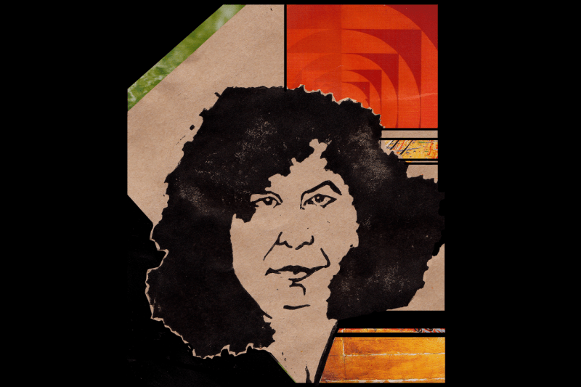](http://i1.wp.com/www.theheroinecollective.com/wp-content/uploads/2015/02/AD2.png)**Andrea Dworkin by Carrie Love, feminist artist and maker.

Andrea knew violence intimately, she used that knowledge to work towards freeing others; she never let that violence hinder her or stop her. Andrea Dworkin was no passive victim, so to speak, although she had experienced the victimisation so common to so many women, the victimisation that is both the foundation and endpoint of male supremacy. But Andrea did not do feminism because she had been victimised; she did feminism because all women are victimised and because feminism is our resistance movement. Having survived sexual violence as a child, domestic abuse from a partner and a period in prostitution, Andrea was well qualified to investigate and dissect the workings of patriarchy, with an intellect and scholarship that was sharp as a blade.

Yet, in an an ongoing disrespectful travesty, none of this is what we hear, receive or know of Dworkin’s life and work. What we do hear about Andrea, ad infinitum, is that she was a man-hater, that she was an ignorant privileged woman, that she did not care about racism or poverty, that she was anti-sex, that she was a prude. These are common refrains used against many feminists, particularly those on the front line, particularly those who push the boundaries like Andrea did. Such inflammatory narratives are used to silence and dismiss Andrea’s work, and to stop others from reading her or finding out for themselves what she stood for and against.

It should be clear that Andrea had certainly not led a charmed life, and she was certainly not ignorant of the daily struggles that people faced in her own America and around the world, as her rigorous political writing demonstrates. It should be clear from her activism that she cared deeply about struggles for social justice. It should also be clear from her writing, if people would actually read it, that she was certainly no man-hater. To side-line for a moment however, it is important to note of course, that the charge of “man-hater” is so powerful in our culture in the first place, turning attention yet again to the sensitivities of men and women’s acquiescence to those, or lack thereof; all this in a society so saturated with blatant and vulgar woman-hating that we barely notice it any more. In her own words, here is what Andrea had to say about man-hating:

*We are not feminists because we hate men; we are feminists because we believe in men’s humanity, against all evidence to the contrary*

These words also hint at the great compassion and love that Andrea exuded, and this aura surrounded her when you met her in person. For such a great orator, she was always more of a listener when not on the stage. She wanted to hear what other women thought of her ideas, she wanted to hear about their own feminist thought and action. Meeting her as a young, excitable feminist I was thrilled to find her questioning, curious and obviously so delighting in hearing the views and experiences of younger feminists and of those new to the movement. This was a feminist celebrity who was almost mobbed by people wanting to speak to her, who within our own small world and outside it was a giant figure, yet who in person possessed a disarming, quiet and grounded delicacy.

What you think you know about Andrea Dworkin is likely half-truth, or outright lies. There can and should be no greater motivation for discovering her work, no greater reason to explore it than all the myriad of voices telling you not to. You may find her language shocking, you may not agree with all of her thesis, but what you will find are the words of a true and rare visionary. More often than not you will find logic behind her arguments, even if you falter or balk at some of her conclusions. Her analysis calls us to confront the outrage of male supremacy, and her perfectly penned rage gives us permission to question the daily injustices we witness, and to take our resistance that little bit further.

Without Amazons like her moving those barriers forward, the field of debate is sorely narrowed. Her death in 2005 is a tragic loss that continues to send shockwaves through our movement, reverberating in the growing liberalism and individualised mircopolitics that stare inwards while our world burns. Andrea’s writing is not only relevant for today, it is necessary and it resonates and provokes in equal measure.

Don’t believe what you hear about the Radical Feminism of Dworkin, find out for yourself; you might even agree with it.

As an introduction to Dworkin, I recommend her collection of speeches *On Life And Death: Unapologetic Writings on the Continuing War Against Women* (1997) or another collection Letters*From a War Zone* (1988).

THIS ENTRY WAS POSTED IN:[**21ST CENTURY**](http://www.theheroinecollective.com/category/era/21st-century/), [**INSPIRE**](http://www.theheroinecollective.com/category/article-type/inspire/), [**NORTH AMERICA**](http://www.theheroinecollective.com/category/location/north-america/), [**POLITICS**](http://www.theheroinecollective.com/category/specialism/politics/)

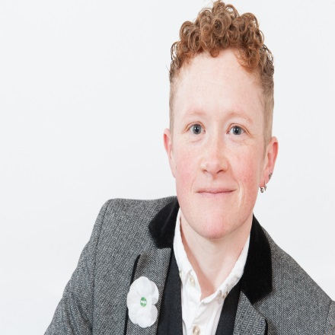

**WRITTEN BY FINN MACKAY**

Cutting her teeth in the Women's Peace Movement, Finn Mackay has been involved in feminist activism in the UK for twenty years. After a career beginning in Youth Work and then Local Government policy on domestic abuse prevention education and anti-bullying, Finn returned to academia to complete her PhD studying the British feminist movement from the 1960s to the present day. She is currently a Senior Lecturer in Sociology at the University of the West of England in Bristol where she lives. Finn is an Ambassador for the Worker's Educational Association, a Trustee of the Feminist Archive and an Executive of the Feminist & Women's Studies Association. Her book "Radical Feminism: Feminist Activism in Movement" is published by Palgrave.

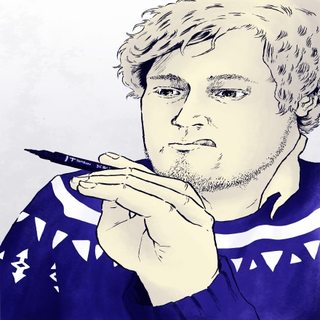

**IMAGE BY WILL ELLIOTT**

Will Elliott is a comic-artist and illustrator hailing from rural Buckinghamshire. He's currently writing and drawing a regular comic series, "Opera Strip" for Sinfini Music (amongst other things).