Project Title: ‘Orbit’ series of glass Bowls

Name: Tavs Jorgensen
Affiliation: Falmouth University
Contact email: tavs.jorgensen@falmouth.ac.uk
Key Words: Tool Making, Reconfigurable Pin Tooling, Glass Slumping.
Conference activity: Exhibit (a series of 2 to 3 glass bowls, sizes 58 – 62 cm)
Question arising from research: How to make objects balance?

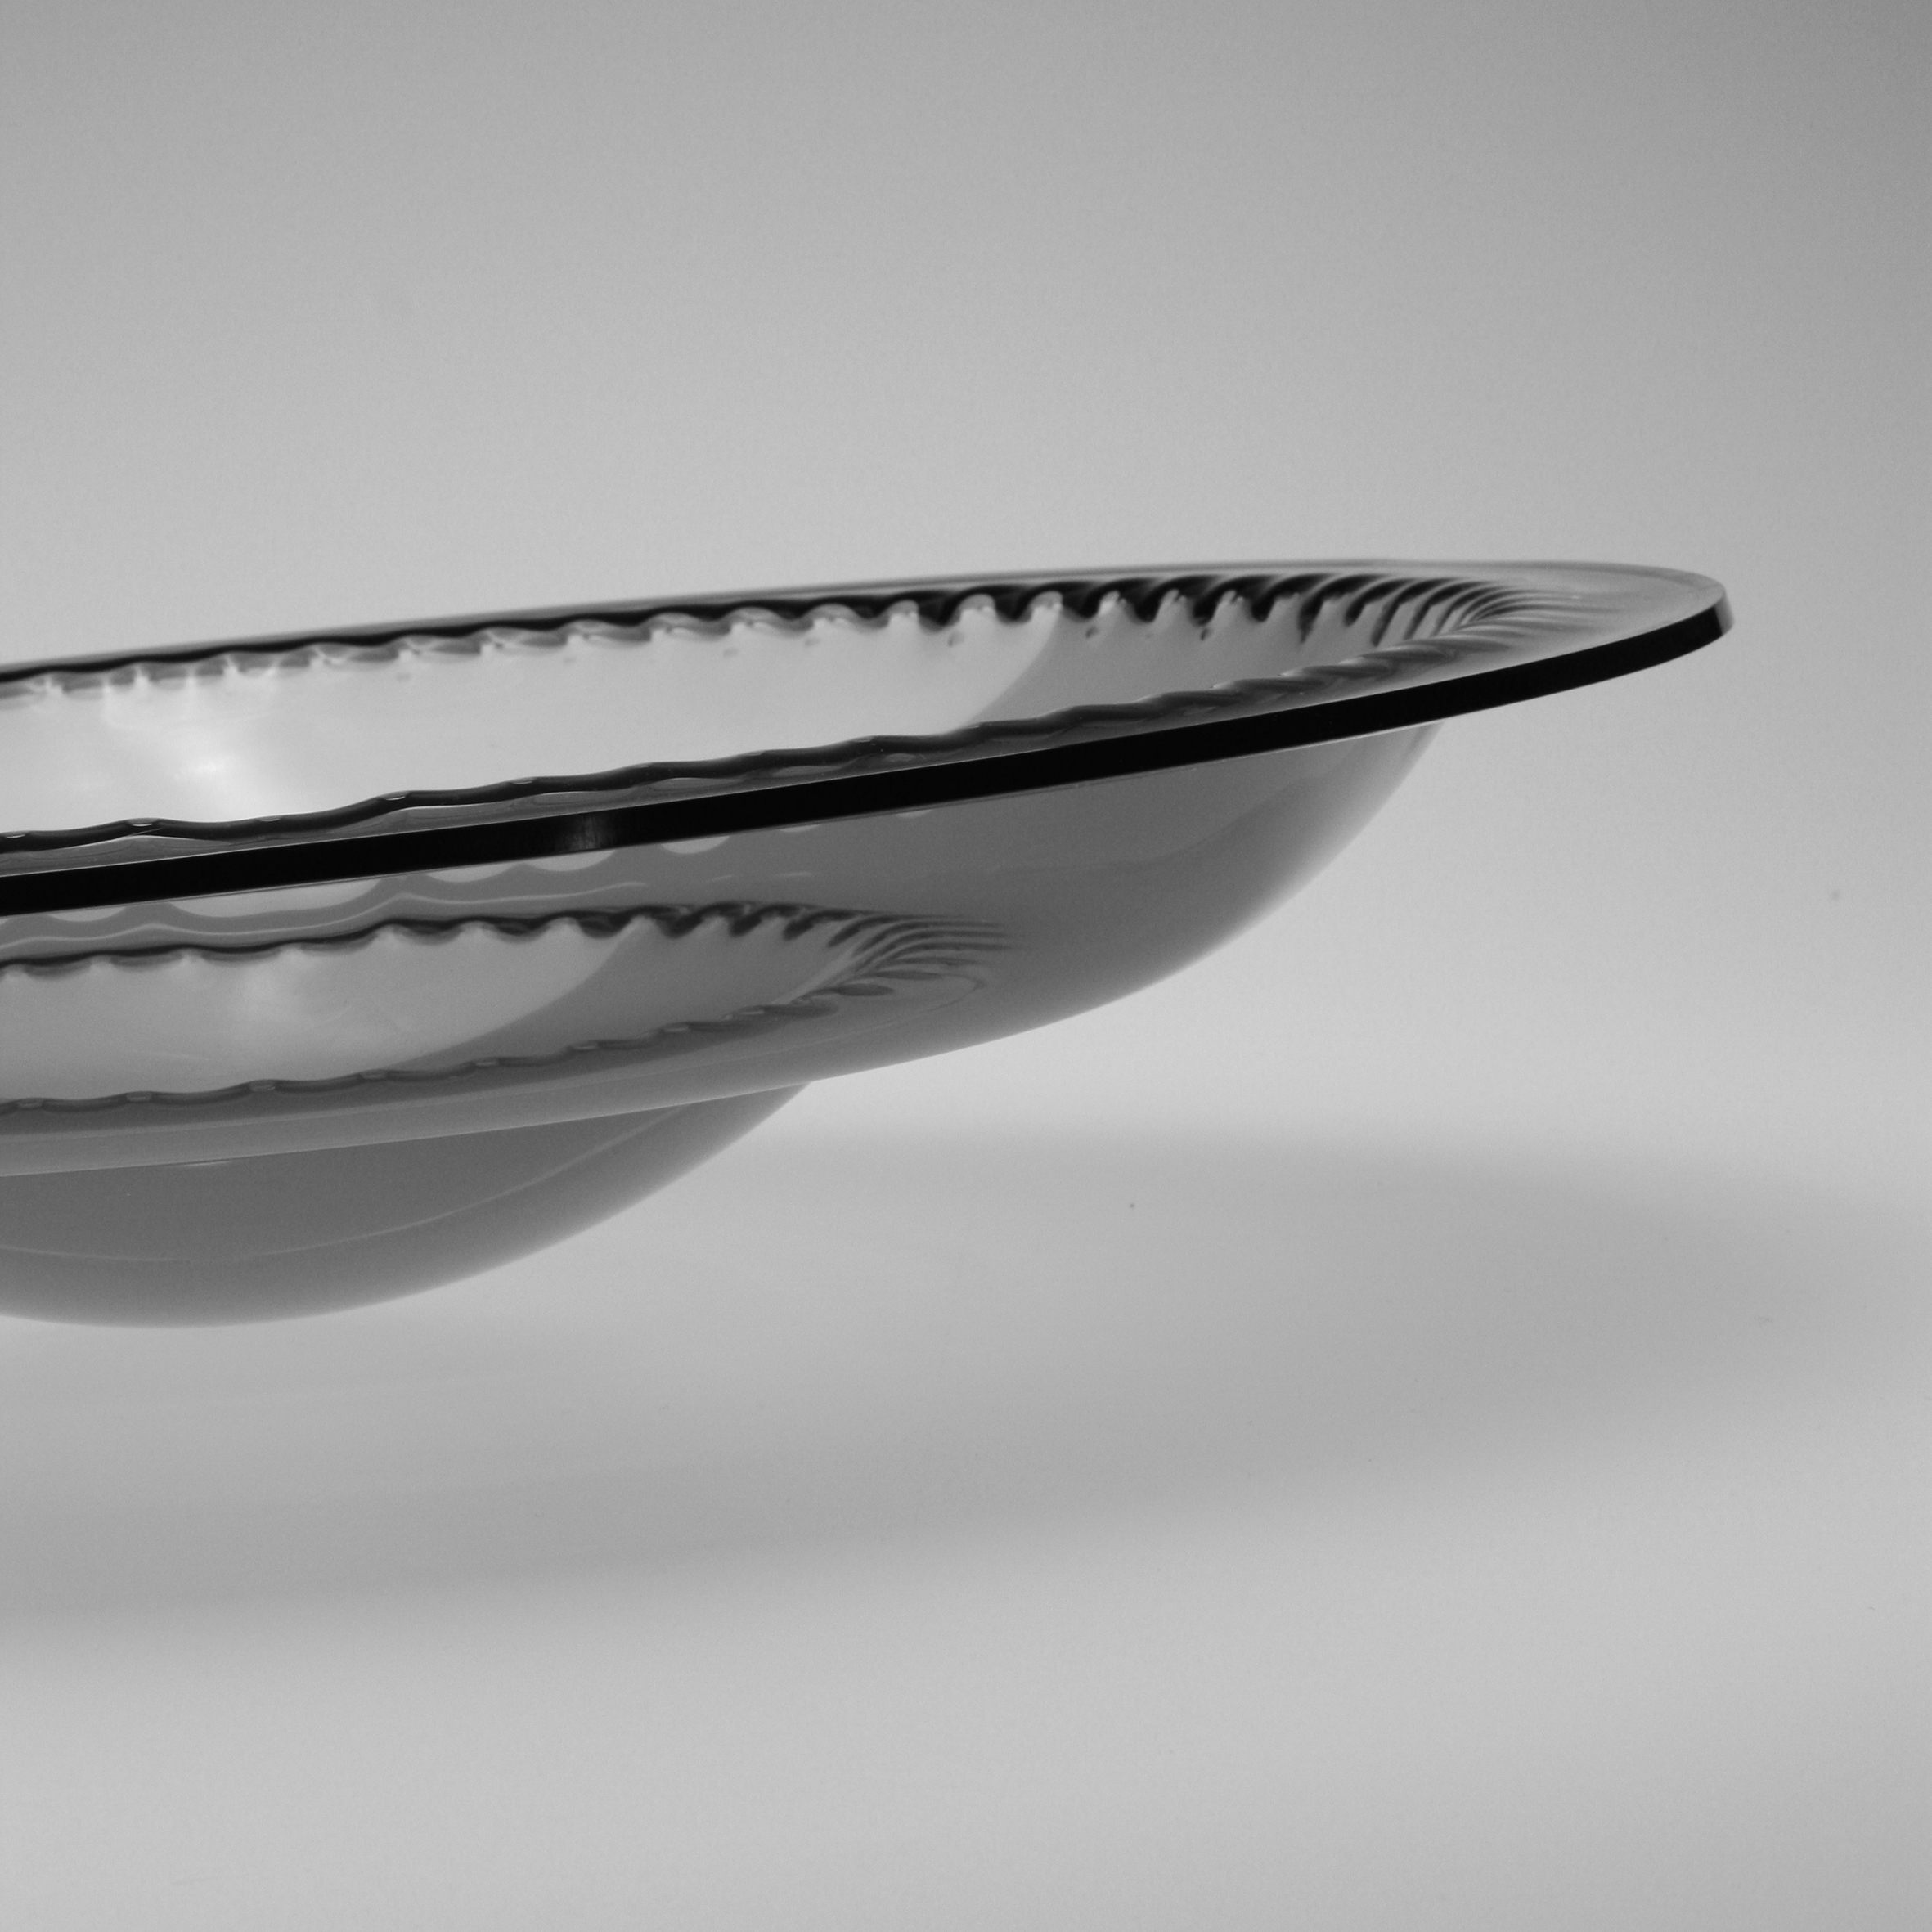

Abstract:

This conference contribution is an exhibition of a series of glass bowls. These bowls are part of the output from the author’s investigation into a flexible tooling concepts known as Reconfigurable Pin Tooling (RPT) and the ‘Orbit’ series is the result from a new phase in the author’s creative exploration of RPT. Pervious investigations have explored ‘free-form’ aesthetics in the glass pieces produced via this tooling concept. This new cycle of investigation is intended to provide evidence for the versatility of the RPT concept by the creation of pieces with a contrasting aesthetic based on more formal geometries.

The author’s interest in the RPT concept has resulted in the development of several bespoke systems for various application and materials. The particular RPT system used for creating glass bowls is circular in shape and through the Orbit series the author seeks to explore this underlying geometry as an integral part of the aesthetics of the pieces.
The bowls are created by using a ‘free fall slumping’ technique (Cummings, 2001), with the pieces being produced by heating glass disks and letting gravity force the glass through a series of apertures, which have been created by positioning pins in concentric circles in a RPT device.
The Bowls have been designed to balance at an angle to further highlight the evidence of the circular orbits of pins.

The wider context for this research concerns notions of tool making and technology driven innovation. More specifically it relates to the diffusion of digital fabrication technologies and the increased access to knowledge resources which are currently perceived to create an environment in which the independent innovator have increased opportunities to operate. These are notions, which authors such as Von Hippel (2005), summarize as: ‘Democratising Innovation’.

References:

Cummings, K., 2001. Techniques of kiln-formed glass. A & C Black, London.
Smith, D., 2005. Exploring Innovation. McGraw-Hill Higher Education, Maidenhead.
Von Hippel, E., 2005. Democratizing innovation. The MIT Press, Cambridge MA

