The Decomposition of Autonomy: or, Drones and Global Technicity

SLIDE: Epigraph
In this automatic transformation of the world that is industrialization, technics is therefore and always the instrument of a struggle, of which war is the extreme version, but that also proceeds more stealthily and silently during peacetime, when nihilism tends, as becoming-herdish, to stifle its counter-tendency, that is, to decompose becoming.
The Decadence of Industrial Democracies, 54

Introduction
SLIDE: Epigraph

SLIDE THEORIE DU DRONE
What Gregoire Chamayou calls the “tendency inscribed in the material development of the [drone] weapon-system” is a tendency toward the disappearance of warfare and its replacement by the more “sombre machinations” of “crime and punishment” regulated by an increasingly automated apparatus. The relative “sombreness” of war versus crime and punishment might be debateable, but what Chamayou means here is that the automation and remote control of tracking and targeting and killing the enemy (currently termed in US military parlance as “going kinetic”—signalling an ultimately mechanistic animating of the chains of processes, communication links, software, hardware and distributed military operators, legal advisors and decision-makers, in regional, domestic and global command centres, etc), the automation of all this involved in the drone weapon-system removes the citizen-warriors from the scene and the risk of combat, and this is what is more sombre. For it tends to close off not only the application of rules of combat, the conventions and “laws of warfare” (LoW) that attempt to limit the killing of the enemy to the combat situation, to protect non-combatants, and to circumscribe the territory (in time and space) defined as “battlespace”
SLIDE OF BATTLESPACE
(what used to be known as the theatre of war).
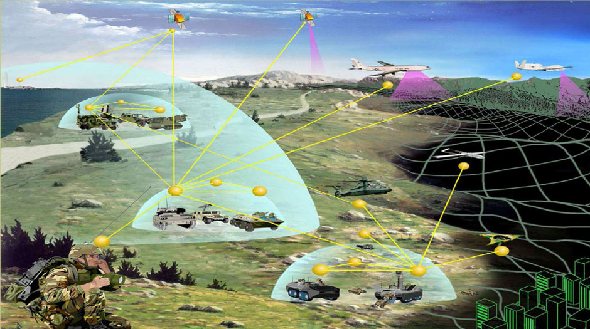

Note: Battlespace was a key concept emerging from the so-called RMA in the wake of the Vietnam war, redefining the field of conflict for the digital age, and an early instantiation of our milieu of realtime always on communications, ubiquitous computing and reformulated spatial and temporal orientations.

Not only this then, but for Chamayou this closing off of warfare is also, paradoxically, the inflation of battlespace as a space of existing and potential conflict, now a pervasive field of insecurity rather than war, one which is to be controlled rather than contested, where regulation and sanction replace the commitment (and risking) of forces, and the contestation of space by armies is replaced by with the “manhunt” for individual targets, along with the monitoring of collectives for emergent challenges to the imposition of control. And this inflation is also a rezoning that necessarily implies a deterritorializing of territories understood as ethnocultural, national, or even regional and a reterritorializing as scalable elements in a global zone, a zone of control in realtime, one whose “sombre machinations” target control of the future—realizing the dream that Philip Lawrence identified as the “watchword” of modernity. And it does this via the inscription of a tendency toward the automation of this regulation and sanctioning of an increasingly globalized security-space.

I will explore dimensions of the onset of this tendency, approaching them through Bernard Stiegler’s thematizing of automation and autonomy and of the tendency and the counter tendency. From this perspective, I understand the threat of the increasing automation of military violence as part of a much broader unbalancing of the technocultural dynamics composing tendencies toward automation and tendencies toward a greater autonomy for human individual and social-political development. But this is to move a bit too quickly to my main argument, and I acknowledge I have been firing propositions at you at a rather alarming rate already. This was in part to perform or dramatize perhaps “our” situation today.

(in the spirit of Paul Virilio’s work which always sought--and at its best--attained a kind of critical speed in response to technological, political and military developments that were for him constantly challenging us to be in a position to adequately account for and question them). “To dramatize our situation”, that is, “we” of the “advanced democracies” of the “west”, inasmuch as we are part of the globalized world we share with the others, here, there and everywhere, a world globalized through a process of colonization and exploitation, inflected with elements of the enlightenment project, and extending a technological becoming beyond ethnocultural boundaries in an unprecedented manner.)

So, to slow down a little, let me introduce Stiegler’s thought (still all too briefly) in order to explain further the significance of Chamayou’s statement about the tendency inscribed in the “material development” of the drone weapon system. Chamayou does not expand on this notion of the tendency in his book but it seems to me something that Stiegler’s thinking illuminates in a way that is decisive for appraising drones as part of “our” challenges and our possibilities today.

For Stiegler human life is a constitutively technical form of life. “We” humans have no permanent essence, neither innate, transcendental nor achieved once and for all historically or in evolutionary terms. In an unavoidably paradoxical formulation Stiegler says it thus: what is essential to human being is its default of essence; the human names a “being-in-default”, and this means the human is a (mis)naming of a process of becoming in the absence of a being. This is very hard to grasp and to maintain a grasp on, but for Stiegler it means the key questions of philosophy, politics, ethics, strategy, etc, must always be thought of with technics in mind, with our “technicity” in mind. For our becoming is technically conditioned and co-constituted.

Some “history”: We were other, and then we became homo sapiens (surpassing and incorporating the Neanderthals, and other competitors). Technics was crucial to this becoming and remains so. Technical invention conditions and dominates human becoming which is techno-cultural more than it is evolutionary, is history more than it is biology.

(up to now at least—we are approaching an era of biotechnologies where the distinction is making less and less sense; And also, for many our ongoing becoming will soon trigger catastrophic “natural” processes which will occasion the collapse of current tendencies and a mass extinction of homo sapiens who will go the way of the neanderthals...) .

SLIDES OF THE CUTTING MACHINES STORY BOOK;
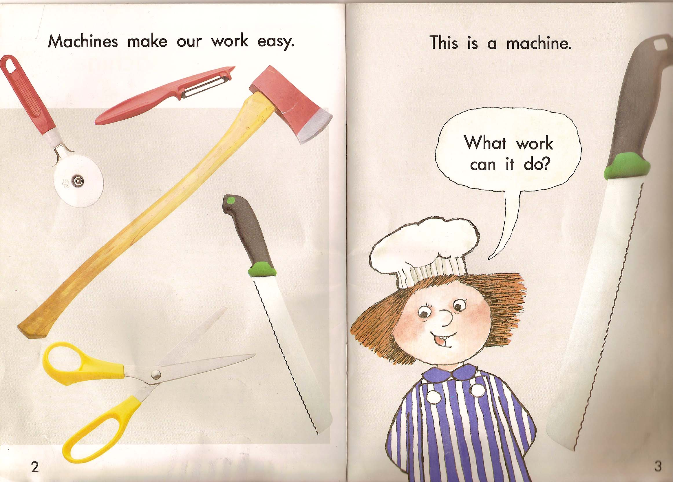
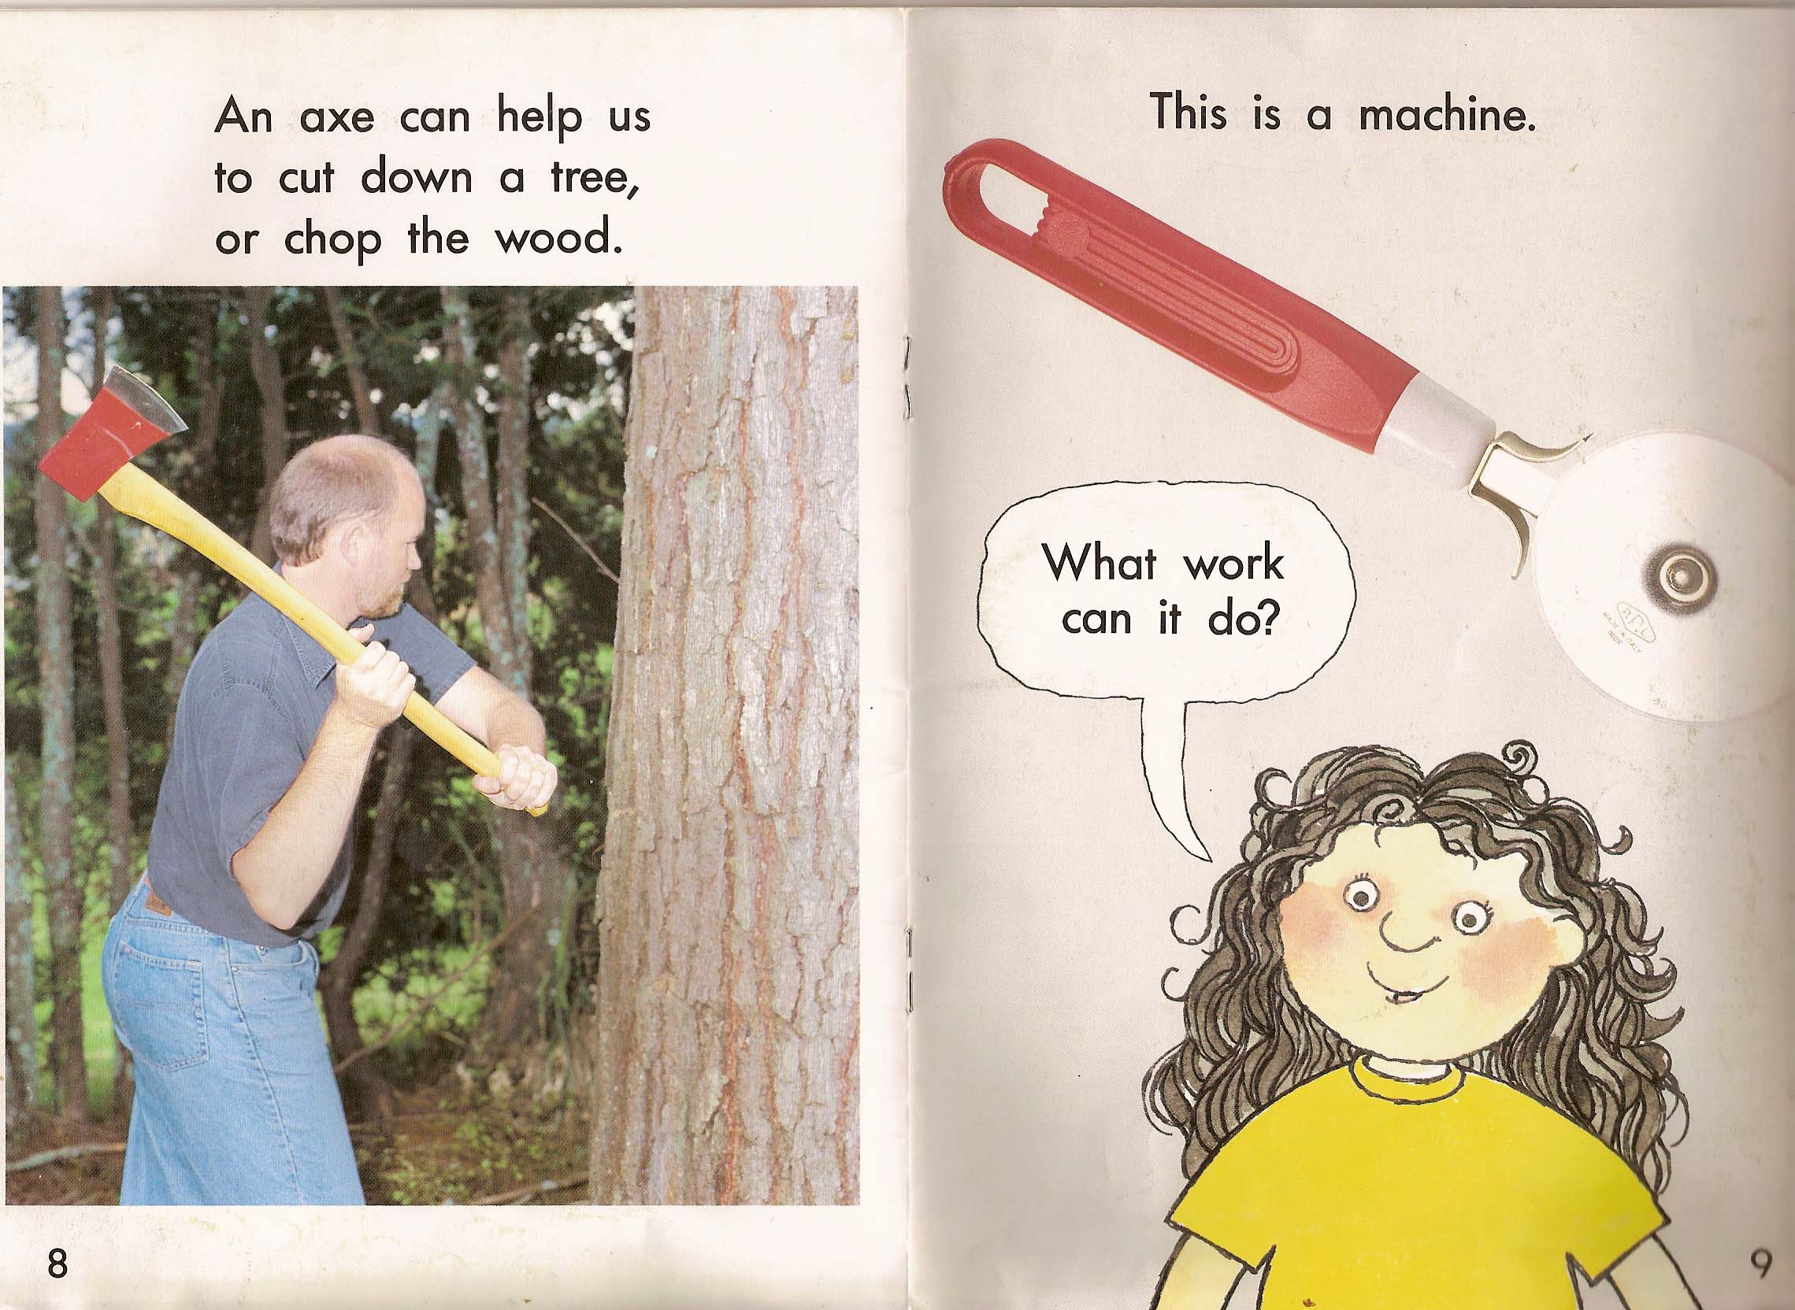

The tool is not just an aid to the human, a means of realizing her intention. The tool is a memory-form, an exterior form of memory, and indeed a substrate and condition of interior, organic memory. It preserves the gestures of its maker, “remembers” her invention, and enables its reproduction. And what it enables opens up new fields of activity, new modes of surviving. And these become ethnoculturally specific ways of living, exchangeable inasmuch as they are materialised in objects, routines and rituals. And later specific technics develop on the basis of this memorious or “retentional” capacity, as people move from mere survival to existing, living as mortals in relation to their dead and their children to come, as a negotiation with the environment full of threats and possibilities:

SLIDES OF CHAUVET AND INDIGENOUS AUSTRALIAN ART

Stiegler calls these mnemotechnics, and they run from such ancient forms and traditions as these to our digital gps-enabled, realtime online devices.

But this is evidence of a long lineage, a series of technical tendencies that cross ethnocultures differently, that has a history and a becoming, and not of a universal humanness always the same beneath its diverse manifestations. For Stiegler, human being names a becoming, an historical process composed with a technical becoming which is co-constitutive of the human but is not identical with it, not a subset or “accidental” attribute of it. And today, as my epigraph indicates, today in our industrial or “post-industrial” age—which Stiegler prefers to call hyper-industrial for it is more and more industrial rather than leaving the industrial behind—today the sense of the different trajectory of technical becoming is far more apparent than it has ever been perhaps. The perception of an estrangement from the dynamics of technical innovation is marked in all spheres of existence and interests—economic, scientific, environmental etc.

The question posed by “our” default condition of technicity is simultaneously what to become, and how to become. “What?” inasmuch as we humans are in default of an essence which is always and necessarily technically conditioned by our necessary prostheses and realised (conditionally) through our technical artifactuality. And “how?” inasmuch as technics is the medium of human individuation. Human individuation is a dynamic of psychic and collective elements or identities. Technics is what is between individuals, between an individual and their collective(s): language, gestures, decoration, dress, images, videos, writings, texts, instragrams, etc., but also tools, weapons, infrastructure, institutions: All this Stiegler (influenced by Gilbert Simondon) names the “transindividual”.

What? and how? questions and answers are not only simultaneous but composed in an ongoing relation—the how of technics conditions the possible answers to what or who we could or should be, and the who inflects the becoming of technics in adopting its possibilities, both realising it in the service of ethnocultural and other collective programs, and in idiosyncratically iterating their reproduction and opening up new paths from past potentials toward future innovations.

And this is to also say that human life is always a process and a question of composing autonomy and the automatic. Because cultural forms and ways of living are so many automatisms, learnt ways of speaking, thinking, expressing, making. These have conditioned the individual from before they could reflect on what it was they had learnt, and individuation is always a process of becoming individual as a modification of the automatic forms of living and thinking. The goal of education, of “upbringing” is to entrain this process of becoming independent, but always in relation to cultural norms, or automatisms.

The what and how questions are ethical and political as much as they are philosophical on the one side or “merely technical” on the other. In the light of our topic today of the tendency toward an increasing automation of war, they can be reposed together as “How to become (more) human as opposed to (more) “inhuman,” (inasmuch as this might be taken as the name for the best of what “we” can do, in the sense of humanitarian, “humane”, etc). Today these questions concern how to adopt the extraordinary innovations in technologies for altering and extending “our” capacity to act, to think, and program “our” future. This ethico-political and philosophico-technical question concerning the balancing of autonomy and automation can nowhere be more urgently and pertinently posed today than in regard to the deployment of remote and automated weapon-systems by the “advanced Western powers”. For in pursuing the trajectory toward the automation of warfighting, from reconnaissance, intelligence and mission planning and coordination, to automated execution, all with a minimisation of “risk” to the system and its human operators, we of the globalized digital technocultures tend to lose the very possibility of modifying what Stiegler calls the “automatic transformation of the world”; we lose the capacity to understand and conduct warfare as a strategic-political negotiation, as “a continuation of politics by other means” in the Clausewitzean formula. We succumb to a further decisive “proletarianization”—a deskilling not only in war fighting but in the composing of military power with the political, cultural and economic spheres.

[[[[[This is where I would mark out a difference from Commodore Osinga’s position; whereas I completely agree that it is important to identify and distinguish particular uses and developments of unmanned systems, and so to indicate the potentials for other adoptions of the technical innovations of automation, robotics, realtime surveillance and communications etc.; indeed this is a crucial point of agreement with Stiegler’s philosophy which takes technics to be composed with human becoming and not a force determining human uses of it as it emerges in its first or predominant forms—Stiegler talks about a complex series of doublings and redoublings to describe the emergence and crystallization of technical developments as they first appear, are adopted in “default” modes according to existing conceptions and uses, and then often evolve as specific instantiations of them tend to realise some or other of their innovative potentials. But on the other hand, these crystallizations and predominant forms have an impact on the subsequent course of the human-technical dynamic. Because technicity is our constitutive condition and our milieu of becoming, the constituted, realised technical forms tend to “fix” but not to determine (that is, to ensure the endpoint or goal) the course of technical becoming. I would argue that the predominant tendency toward the automation of war is such a fixing of the course, powerfully invested in by the US and other states, and seeding massive commercial investment in R&D, as part of a larger tendency toward automation rapidly becoming evident in all domains.]]]]]

I have already said that the material tendency Chamayou identifies envisages a perfecting of the modern project of control, and particularly of controlling the future. My thesis, then, is that advanced Western powers follow this project of the development of automated warfare beyond its measure. They drive out of balance the ensemble of forces balancing tendencies and counter-tendencies emerging from the interaction of these dynamics, between the pursuit of technological, strategic-political, economic and cultural programs, between the speedrace of research, development, implementation and commercialization and the reflective movements of reappraisal and “redoubling” where goals and programs are redrafted and designs are respecified or adopted differently.

The “Western powers” follow this drive in following each other—The U.S, following and now outstripping the Isrealis, with the other advanced powers such as China, Japan, South Korea, India, powers both Western and now global. They push it out of balance within the military-strategic, economic and geopolitical project that seeks a preserving of the peace, a metastabilization of global geo-politics, fostering political institutions able to sustain a representational function for their populations, establishing the rule of law, economic recovery and reform, socio-cultural normalisation (of trade, education, peaceful negotiation of difference), and so forth.

Now, one could certainly debate whether the actions of the U.S and its ISAF allies in Afghanistan, or the coalition operating in Iraq, or the Isrealis in Palestine, Syria and Lebanon, or of other recent military adventures by France, Russia, Australia, and others live up to or only cynically or conditionally subscribe to the rhetorics espousing these kinds of geopolitical and developmental goals. One could make (as several have) a compelling case that these military operations are better understood as part of post-colonial exploitation of the global south. My proposal here is that howsoever that debate goeth, something beyond the (post-)colonial is going on here; or perhaps that the post-colonial project’s inherent contradictions are exacerbated, accelerating toward its demise as a coherent project, however subject it is to critique, condemnation, and therefore still to be called to account and subject to review, and reform.

The drive to develop increasingly automated weapon systems, powered by massive state and private investment in a boosting of the military-industrial-education complex:

SLIDES: drones article at imperial college London, at Bristol robotics lab, Penn State etc

and which has in more recent times formalised its longstanding relations with commercial media in the terms military-entertainment complex:

SLIDE Inst Creative technologies, Recent Pentagon and COD article; ref to Lenoir and Lowood, and to Stahl, militainment

This drive is producing multiple symptoms of a destabilizing of the West’s historical/ideological project and global projection. Perhaps this is good news from a certain perspective, but I am not an accelerationist, and I would argue there are less nihilist stances to adopt toward this our present technocultural situation, and that the globalizing project that “came from the West” has to be transformed and “rehabilitated” for a post-western “world” to emerge....

Two symptoms, two stupidities

In the time remaining I will sketch out two interrelated signs or symptoms of this going out of balance of human and technical individuation in the current and projected developments in the conduct of military operations by the “advanced powers”.

1. Automation of the Identification of the enemy.
Drones supply multi-spectral image data and the persistent flow of data-feeds from these various sensors are treated by video analysis software designed to selectively identify key information required for intelligence analysis and targeting processes. These softwares perform statistical, algorithmic procedures for making usable an overwhelmingly enormous database of pixels—set out to “distinguish ‘normal’ from ‘abnormal’ activity” in what Derek Gregory calls “a sort of militarized rhythmanalysis that is increasingly automated” (Gregory 2011a, 10).
This cutting edge “big data” software development includes the NVS system (National System for Geo-Intelligence Video Services) being produced under the direction of arms manufacturer giant, Lockheed-Martin.

SLIDE NVS Lockheed-Martin, Geotime

NVS will filter, sort and produce video-on-demand reports through software agent functions comparable to Netflix’s user profiling of preferences and related searches (Richfield 2011). Reports combine various statistics concerning the full motion video playback and resemble financial reporting on MSNBC or watching a football game on ESPN (Richfield 2011). Like all database processing software, the generation of useful reports depends on the quality of the metadata produced through the indexing of video data according to relevant categories. The allusion to ESPN is more than illustrative: Chamayou notes that the U.S. Army had licensed a version of the video analysis software ESPN uses in its football coverage to aid research and development of its drone-supported counter-insurgent targeting (Chamayou 2013, 61). The software is especially good for collecting and cataloguing videos associated with a particular player from a massive archive of game coverage, and this dovetails with the desire to map and characterize the past actions of individuals identified as insurgent or terrorist.
This software processing of the pattern of the enemy-as-player is becoming increasingly automated. Projects such as the Defense Advanced Research Projects Agency’s (DARPA) “Mind’s Eye” are working on Artificial Intelligence to analyse and annotate video automatically. The envisaged “visual intelligence” would be able to “learn generally applicable and generative representations of action between objects in a scene directly from visual inputs, and then reason over those learned inputs” (DARPA Information Innovation Office, 2011). Beyond machine vision developments in pattern recognition and object identification, the ambition of this project is to automate a cataloguing of actions and relations between objects. The ever-growing flows of multi-spectrum video scans from battlespace will necessitate the implementation of such programs able to “automatically translate the aggregations of pixels into nouns, verbs and propositions” (Chamayou 2013, 62).
Systems and software such as NVS and Mind’s Eye will supplement the suite of statistical and analytical software already in use. These include Geotime which gathers together and visualizes various forms of location surveillance data such as satellite monitoring and mobile phone signal tracking. Mobile phone tracking has become a significant contributor in the intelligence analysis supporting the targeting of individual “insurgents” in the deployment of drones to support or to execute targeted assassinations. It has also been at the centre of some of the more infamous mistaken strikes such as the alleged killing of an election campaign team in northern Afghanistan by a joint operation relying on cell phone tracking to (mis)identify the target (Gregory 2011a, 13).

The phone tracks are an important part of what is known as “pattern of life” analysis used across the drone operations of both the U.S Air Force and the Joint Special Force operations they are involved in and by the C.I.A’s targeted assassinations in northern Pakistan and elsewhere. A person’s activities, associations and electronic communications with others can be compared against a “normal” civilian set of routines and social exchanges for people in the surveilled territory in order to identify unusual “patterns” or associations. Such abnormal patterns indicate potential targets for further monitoring or possible assassination. The individual identified with such a pattern may find themselves graduating from the database of potential targets—the “Disposition Matrix”—to becoming a “nomination” on the “kill-list” under consideration in the Pentagon and ultimately by the U.S. President (Becker and Shane 2012).

It has been claimed that strikes based on pattern of life analysis represent a significant component of drone-based hunter-killer attacks on individuals who are only known as potential threats through a process reliant on software-based analysis (Becker and Shane 2012, 16). These targeted individuals no longer need to be identified except as a certain kind of deviation from a norm established through the statistical modelling of sets of data drawn from full-spectrum monitoring of the battlespace. Their names and lived reality are less relevant than this conceptualization of them as potential threat known as a “signature target” (as opposed to a “personality”)—the signature refers to the particularity of their abnormal data pattern of movements, habits and web of associations that marks them as threat (Becker and Shane 2012, 18).

In their anonymity and abstraction the “signature targets” are the output of the programmatic generation of a pattern from data processing of various intelligence feeds that is used to produce the targets in advance of their threatening movement or action. As Chamayou notes this technical procedure instantiates a promise to “predict the future and be able to modify its course through preemptive action” (Chamayou 2013, 66).

2. Rezoning of battlespace as zone of preclusion
I'm starting from a specific technical procedure now to discuss the expansion and transformation of battlespace. This procedure—termed “joint fire area” today after a more colourful history as the “killbox”

SLIDES of JFA and Killbox

This procedure exemplifies the tendency toward the global extension of battlespace as much as its becoming-perpetual, always on, 24/7 as Jonathan Crary would say. It is in precisely such technics of implementation that values, propositions and projects are found in their most concrete, automatic form as systems of procedures, computational devices, communications networks, learnt and implemented as part of the conduct of military operations. In such automatic and semi-automated procedurality is materialized the disappearance of the distinction between war and peace, battlespace and sovereign territory, and tendentially today, the time of living and the time of “living under drones”—which is no longer living but surviving, subsistence not existence—and which is fertile milieu for a corresponding extremism of military-political action.

SLIDE Living under drones report

“Joint fire areas” or “kill-boxes” are names for a procedural designation of physical space enabling the coordination of elements engaging targets within a specified area that is both temporary and scalable according to the nature of the target and the conditions and constraints of the operation.

SLIDE OF PROCEDURE TIMELINE

As Chamayou explains, the killbox describes a process as much as a space: “one opens, activates, freezes and then closes a killbox” (Chamayou 2013, 83). The killbox is a zone of temporarily and flexibly realized virtual space: virtual inasmuch as it comes into existence digitally thanks to the realtime technologies of modelling, monitoring, measurement and transmission. It puts into practice the redefinition of traditional geographical and strategic-political territory begun with the theory of battlespace.

SLIDE OF SCALABILITY
Killboxes can in principle (and in their virtuality as digital diagrams) be opened anywhere in the world, and be as small or as large as required, rendering irrelevant traditional geopolitical limitations such as national borders, city walls, and geophysical boundaries such as mountain ranges, rivers and so forth. Chamayou speaks about the killbox’s combination of precision measurement and flexible delineation enacting a dual principle of the “globalization and homogenization” of space (Chamayou 2013, 86).
It is in the technological implementation of such procedures that the redefinition of the theater of war as “battlespace” is concretized in the manner of the technical object: that is, as the ongoing materialization of a tendency that demands critical-theoretical as well as legal-humanitarian attention. This is made clear in the history of the “killbox” concept that Chamayou dates to a 1996 U.S.A.F report envisaging the future use of unmanned aerial vehicles in zones of “autonomous operation” (Chamayou 2013, 326). [[Gregory’s history goes back rather to the Vietnam war ‘target boxes’ ]]

The human rights and legal challenges to the expansion of targeted assasinations by drones and U.S. special forces has focussed on the way they abandon the legal and conventional delimitation of the theatre of war as they identify and pursue targets in the “global battlefield”. War becomes a “manhunt” in Chamayou’s thesis, conducted by the hunter on the basis of a unilateral claim to the right to pursue a suspected threat to the homeland anywhere it can be found (Chamayou 2013, 107-108).

At the same time, the inhabitants of the now everywhere battlespace become subject to a permanent regime of realtime surveillance, evaluating their movements, liaisons, communications, etc. in relation to the “patterns of life” ascertained (that is, modelled) to be normal, that is, non-threatening to the monitoring organization. They have first hand experience of the capacity of this generalized battlespace to instantiate a well delineated zone in which the battlespace is intermittently actualised by the semi-automated coordination of strike capabilities permanently on call in the global borderlands as Gregory calls them.

Gregory proposes that the military adventures in remote counter-insurgency at the borders of the West’s zones of control in Afghanistan and Pakistan will produce a “vortex”: “If the battle space is now global, and if the United States claims the right to use lethal force against its enemies wherever it finds them, then what happens when other states claim the same right? And when non-state actors possess their own remotely piloted aircraft?” (Gregory 2011a, 15).

Chamayou captures best, perhaps, the systemic dimension of this contradictory production of the very opposite of the secured geo-political world future projected with and through the current deployments of drones. He criticizes the remote conduct of counterinsurgent operations, citing military strategist David Kilcullen’s condemnation of these as the misuse of an effective tactic that threatens the very strategy of counterinsurgency inasmuch as this depends on the building up of relationships and sympathies between armed forces and local inhabitants on the ground (Chamayou 2013, 100-103). I would add here that this diagnosis of a tactic usurping the place of strategy is best understood in relation to this decoupling of a technical development from its strategic-political reconsideration and adoption. Chamayou sees here the victory of an anti-terror doctrine over a counterinsurgent one.

Moreover “dronified anti-terror” can be understood as employing a perversely strategic logic whose pursuit implies its own failure as strategy. The fact that drone operations tend to produce the conditions for the recruitment of more radicalized extremists—the core of the counterinsurgent strategists’ critique of their use—becomes the rationale for their expansion and technological “improvement.” The system incorporates its inherent contradiction in what Chamayou characterizes as an “endless spiral” that is unable to “decapitate the Hydra that it itself permanently regenerates by the productive effects of its own negativity” (Chamayou 2013, 108).

SLIDE: Whack a mole

To conclude, I would note that this endless spiral is not endless, and perhaps vortex is a better figure in this regard. For a vortex can suck in diverse elements and then disappear itself in a kind of self-destructive self absorption. The extension of the battlesapce globally is a tendency toward a zone of pre-emption of threat, a zone of preclusion of the anomalous that fosters its growth. Like Tinguely’s

SLIDE self-destructing machine

It is an automatism without future, at least without a viable future as a machine component of a human future, one in which a politically and strategically worked out composition of autonomy with the extraordinary powers of digital automatisms manages to maintain a space for living not permanently contaminated by wartime.

3. The projection of the future of LARs
to be done.

[[[[[Automation of war-fighting (having identified the enemy combatants) to comply with rules of engagement, ‘laws of war’, etc. ]]]]]]]]]]

Conclusion: Stiegler: the challenge is always how to adopt, manage new automatisms. Autonomy is composed with automatisms.

Thiery duve; Foucault tactics from military to police.
Other kinds of experience at stake.

Post-colonial or other
Tinguely

Final , last , latest. Problem of technical individuation: global process, no psychi c

Chamayou, Theorie du drone, 2013, 230.
Philip Lawrence, Modernity and War.
Stiegler makes this distinction between fixing and determining in Technics and Time 1, pp.?? in commenting on Heidegger’s account of the destiny of modern technology. To fix here refers to the clamp or bolts or screws (“fixers” in English) that holds a piece of wood in place so that work can be done on it, whereeas determine has the sense of securing the endpoint of a process, or guaranteeing a particular intended result. The fixing of a technical tendency does not do this, on the contrary.
And not for the first time, and perhaps as a further “after-shock” of the passage to the limits of total war and onto the threshold of absolute, thermonuclear war—which is “automatic” by default. It never ceases to amaze me how the nuclear character of our era is invisible in so much of the discussion and debate as to the merits and future course of unmanned weapons. For this aftershock is also a fore-shock of its further ramifications which continue to impact tendentially the course of events.
See for example, Human Rights Watch (2010) and Stanford International Human Rights & Conflict Clinic and the Global Justice Clinic of New York University (2012).

