Prioritisation of Operations Improvement Projects in the European Manufacturing Industry

1st Author
Mr. Louis Kirkham
School of Technology, The University of Derby
Markeaton Street Campus, Derby, UK, DE22 3AW
louis.kirkham@hotmail.co.uk

2nd Author and Corresponding
Dr. Jose Arturo Garza-Reyes*
Centre for Supply Chain Improvement
The University of Derby
Kedleston Road Campus, Derby, UK, DE22 1GB
E-mail: J.Reyes@derby.ac.uk
Tel. +44(0)1332593281

3rd Author
Dr. Vikas Kumar
Bristol Business School
University of the West of England
Coldharbour Ln, Bristol, UK, BS16 1QY
Vikas.Kumar@uwe.ac.uk
Tel: +44-(0)117-32-83452

4th Author
Prof. Jiju Antony
School of Management and Languages
Heriot-Watt University
Edinburgh, Scotland, UK

* Corresponding Author

Prioritisation of Operations Improvement Projects in the European Manufacturing Industry

Author 1
Affiliation

Author 2
Affiliation

Author 3
Affiliation

Author 4
Affiliation

To improve their competitive ability, organisations are turning towards implementing improvements into their operations and processes. Whilst operations improvement projects are often identified with relative ease, resource constraints limit the ability of organisations to conduct them simultaneously. This paper supports the limited empirical research on prioritisation of improvement initiatives by investigating how European manufacturing organisations conduct this activity. To do this, four hypotheses and two research questions were formulated and tested using a combination of descriptive statistics and two proportion t-tests, while data was collected through a survey questionnaire responded by 203 organisations. The results highlight the importance of objectively prioritising improvement projects and establish that the adoption of this method increases through the implementation of improvement methodologies, especially those that stipulate the use of objective methods towards project prioritisation. In this way, Six Sigma is defined as the most influential improvement methodology for supporting the use of objective prioritisation approaches. The paper also identifies the reasons as to why organisations adopt subjective over objective prioritisation methods, and the most common approaches used by large organisations and small and medium enterprises (SMEs). This research provides organisations, and their managers, with a better understanding of the different factors that affect this key aspect of operations improvement projects.

Keywords: Improvements prioritisation, lean, operations, Six Sigma, objective methods, subjective methods.

1. Introduction

The success, profitability and overall competitiveness of a manufacturing organisation are closely attributed to the effectiveness of its operations (Emiliani, 2006). With the endless pursuit for operational excellence, many companies strive to pursue a strategy of continuous improvement to reduce costs and improve productivity, ultimately improving the overall performance of the organisation (Garza-Reyes, 2010). To gain and sustain a competitive advantage, it is becoming more common amongst manufacturing organisations to identify and carry out improvement initiatives to enhance their operations. According to Pyzdek (2003), organisations searching for improvement opportunities will often identify a significant number of potential improvements. However, Marriott et al. (2013) highlight that it is not feasible to conduct all identified improvement projects simultaneously due to organisations often facing resource constraints in terms of time, capital, and personnel. These constraints and the disruptions caused by the implementation of operations improvement projects make their prioritisation a key factor for their success. In this context, effective prioritisation would ensure that resources are allocated to the projects most beneficial to the organisation. It also ensures that associated problems like multiple conflicting objectives, insufficient project details, inappropriate equal allocation of resources, conflicts amongst those wishing to gain resource allocation, etc. (Phillips and Bana e Costa, 2007) are avoided. In addition, Davis (2003) states that failure to prioritise could not only affect the success of improvement activities but also the competitiveness of an organisation due to inefficient allocation of resources.
Marriott et al. (2013) comment that different authors have developed and proposed a wide range of objective methods to help practitioners deal with the complexity of the selection and prioritisation of improvement projects. However, evidence suggests that in practice, companies also use subjective approaches as an aid for the prioritisation of such improvement initiatives. Subjective prioritisation methods are mainly based on personal beliefs, feelings, experiences, and common sense whilst objective methods may be considered a more ‘scientific’ alternative as they are based on proven methodologies and real facts. Objective methods and tools include Pareto analysis (Larson, 2003); Project ranking matrix (Adams et al., 2003); project selection matrix (Kelly, 2002); quality function deployment (QFD) (Pande et al., 2000); project assessment matrix (Breyfogle et al., 2001); Pareto priority index (PPI) (Pyzdek, 2003); cost benefit analysis (CBA) (Hira and Parffit, 2004); analytical hierarchy process (AHP), theory of constraints (TOC) (Pyzdek, 2003); and reviewing data on potential projects against specific criteria for project selection (De Feo and Barnard, 2004; Thawesaengskulthai and Tannock, 2008). Marriot et al. (2013) provide a review of some of these objective prioritisation methods. Conversely, subjective approaches may involve brainstorming, focus groups, interviews, and customer visits.
Most of the academic literature on the prioritisation of operations improvement projects has been focused on proposing novel and more effective objective methodologies. For example, Padhy and Sahu (2011) proposed a two-stage methodology for selecting and scheduling an optimal project portfolio. It considers an organisation’s objectives and constraints and is based on a real option analysis and a zero-one integer linear programming model. Saghaei and Didehkhani (2011) designed a comprehensive methodology for the evaluation and selection of Six Sigma improvement projects. The methodology uses an adaptive neuro fuzzy inference system capable of considering interrelations among criteria for deriving the overall utility projects and a fuzzy weighted additive goal programming model to obtain the optimal portfolio of projects that should be implemented. Kornfeld and Kara (2013a) presented a framework to assist programme managers to develop portfolios of improvement projects targeted to fulfil their company’s needs and also align them to the organisations’ measures and objectives. Su and Chou (2008) proposed an approach to create critical Six Sigma projects and identify the priority of these by combining the AHP and the hierarchical failure mode effects analysis (FMEA) methods. Kornfeld and Kara (2011) also proposed a normative framework to prioritise and select improvement projects based on their potential to realise the desired future state. Finally, Marriot et al. (2013) presented a methodology that integrates process activity mapping (PAM) and FMEA to prioritise improvement projects or initiatives based on two key performance objectives, cost and quality, specifically important for low volume-high integrity product manufacturers.
Although these methodologies indicate that there is a considerable body of literature dedicated on how to objectively select projects to improve an organisation’s operations; limited empirical research has been conducted to understand the specific details involved with this activity in industry. In this sense, Banuelas et al. (2006) carried out a study to identify the criteria followed by UK organisations to prioritise Six Sigma improvement projects. The study found the most widely used tools by UK companies and the most common criteria they follow to prioritise improvement projects. Gošnik and Hohnjec (2009) conducted a similar study but within the context of Slovenian manufacturing organisations. This study found that companies in this country tend to select Six Sigma projects based on criteria that include: customer satisfaction, connection with the business strategy, financial benefits and growth of the organisation. It also identified the most popular tools for improvement projects prioritisation in Slovenia. Kornfeld and Kara (2013b) also carried out a study of this type, but it mainly included Australian and some few global companies. The study results showed, among other things, that practitioners were dissatisfied with the prioritisation methods used, there is a gap between portfolio generation and strategy formulation, and that companies generally use subjective or unstructured approaches. To complement these studies and support the empirical body of knowledge on the prioritisation of operations improvement initiatives, this paper explores how SMEs and large European manufacturers prioritise improvement projects (i.e. objectively or subjectively), the specific methods they adopt to undertake this critical activity, and their relative success in relation to the results obtained from the operations improvement projects undertaken. It also investigates the correlation between the deployment of improvement approaches and the use of objective/subjective prioritisation methods, as well as identifies the motives and rationale for the adoption of prioritisation methods to better comprehend the complex nature of prioritising improvement initiatives.

2. Literature review – definition of hypotheses and research questions

2.1 Adoption of improvement approaches and prioritisation of improvement projects

IAEA (2006) suggests that the deployment of an improvement approach that strongly emphasises project prioritisation is likely to increase the chance of success of operations improvement projects. One of these improvement approaches is Six Sigma. The fundamentals of Six Sigma are to create a well-structured, methodical and project-based approach towards process improvement (Van Iwaarden et al., 2008). Thus, since Six Sigma is a project driven methodology, it emphasises the prioritisation of improvement projects to maximise financial benefits (Ingle and Roe, 2001; Coronado and Antony, 2002). Antony (2006) states that the correct selection and prioritisation of projects is a key critical success factor in a Six Sigma programme, which suggests that organisations adopting this improvement approach are likely to use objective project prioritisation methods. This is supported by the results of a survey carried out by Banuelas et al. (2006), which targeted large UK organisations implementing Six Sigma. The study found that almost all Six Sigma organisations in the study use at least one objective method for project prioritisation, with the most common being CBA and Pareto analysis, both of which are tools of Six Sigma (Sharma and Chetiya, 2010).
Bertels and Patterson (2003) discuss the high quality approach towards project-based improvement that Six Sigma offers compared to other popular improvement campaigns. Bertels and Patterson (2003) fail to disclose which improvement campaigns they refer to, although due to their popularity, it may be assumed that these include improvement approaches such as theory of constraints, total quality management (TQM) and the lean enterprise theory (LET). There is a high volume of research suggesting that Six Sigma puts a strong emphasis on being a project driven methodology with a high regard for objective driven approaches towards project prioritisation. However, with regards to other improvement initiatives, Antony (2004) discusses that there are limited approaches and tools used in the manufacturing industry towards the prioritisation of improvement projects.
According to Pyzdek (2003), TOC improvement approach has been proposed as a suitable methodology for the selection of improvement projects. This is supported by Steyn (2002) and Breyfogle (2008). TOC is based on the concept that all systems (i.e. production, process or service-based) have resource constraints that prevent operations meeting market demands (Goldratt, 1990). For this reason, Goldratt (1990) suggests that improvement projects should be prioritised based on priority constraints and by using a five rule system. In contrast, Elton and Roe (1998) advocate that TOC has yet to be applied adequately enough to consider it as an effective method for this purpose, with Nave (2002) suggesting that it is more suitable for improving throughput volume.
Research carried out by Walsh et al. (2002) surrounding TQM revealed the high focus of this approach on continuous improvement. There is however, limited evidence suggesting that TQM is a framework that encompasses and/or encourages project prioritisation. However, research carried out by Mann and Voss (2000) describes how a particular company developed its ISO 9000 system in accordance with the TQM framework using the Baldridge criteria. In this case, TQM was combined with ISO 9000 and objective techniques to prioritise improvement projects, but there is a lack of supporting evidence suggesting a similar use by other organisations. In the case of ISO 9000, this quality management system aims to provide a high focus on assuring process conformance (Zeng et al., 2007; McTeer and Dale, 1996). However, although ISO 9000 principles include using a factual approach towards decision-making, there is no evidence to suggest that it can be effectively used or promote the objective prioritisation of improvement activities.
The improvement initiative LET has a high focus on waste reduction through process and value analysis (Bendell, 2006; Hoss and ten Caten, 2013). Due to a number of benefits including an established structure to project prioritisation, some organisations have combined LET with Six Sigma to provide a comprehensive improvement approach. This incorporates variation reduction, waste removal and supplementary tools to ameliorate organisational performance. However, Bendell (2006) highlights the lack of prioritisation approach of LET, stating that when combined with Six Sigma, the project-based nature of the latter would contradict, for example, the “waste walks” of LET, which are aimed at identifying and removing all sources of waste with no real sense of prioritisation. By analysing LET, it is easy to observe that there are various tools used to define, analyse and eliminate sources of waste (Wong et al., 2009), but none to aid in the prioritisation of improvement projects.

A further improvement approach is the European Foundation for Quality Management (EFQM) model, which was proposed using the principles of TQM (Gomez et al., 2011). EFQM is a tool that aids in the structuring of the management of an organisation through the self-assessment of a framework criterion (Gomez et al., 2011). Due to the nature of EFQM and its assessment criteria, this method does not encourage organisations to objectively prioritise improvement activities. However, the adoption of this initiative may cause an organisation to question its methods when reviewing the organisational performance in the self-assessment stage. Whilst a host of alternative improvement methodologies such as statistical process control (SPC), kaizen and quick response manufacturing (QRM) exist, it is evident that limited research is available in relation to their ability to influence an organisation to use factual and structured methods towards the prioritisation of improvement projects.
The lack of available evidence regarding the prioritisation of improvement initiatives in methodologies other than Six Sigma advocates that organisations adopting Six Sigma are more likely to prioritise objectively. However, based on the structured and systematic approach towards operations that improvement initiatives bring to an organisation, it may be suggested that organisations adopting any improvement methodology are more likely to prioritise objectively than those not implementing any improvement initiative. This is supported by Marriott et al. (2013), who suggest that objective prioritisation methods for process improvement are often determined by improvement initiatives, which may suggest that when no improvement approaches are deployed, a subjective approach is favoured. This led to the formulation of the following hypotheses:

H1: Organisations that have implemented improvement approaches and methodologies are more likely to use objective approaches towards the prioritisation of operations improvement projects than organisations that have not adopted any improvement methodologies.

H2: Six Sigma facilitates the use of objective methods towards project prioritisation more than any other improvement initiative.

To complement the empirical investigation of how SMEs and large European organisations prioritise improvement projects and H1 and H2, the following research question was posed.

RQ1. What are the most common improvement project prioritisation methods adopted by SMEs and large European manufacturing organisations?

2.2 Organisation’s size, objective and subjective prioritisation methods

The use of objective prioritisation methods by large organisations is well documented, especially considering that all of the American Fortune 500 companies have Six Sigma programmes built into their management structure (Gershon, 2010). However, although Antony (2004) states that in the majority of the UK’s SMEs manufacturing organisations operations improvement projects are prioritised based on subjective judgements, there is less documented evidence regarding smaller organisations (Antony et al., 2005); identifying this as an area for further analysis. The theory surrounding the use of subjective and objective approaches in relation to the company’s size advocates the third hypothesis:

H3: SMEs mainly use subjective approaches for the prioritisation of operations improvement projects, whilst large organisations mainly use objective approaches.

The more likely use of objective methods for the prioritisation of improvement initiatives by large manufacturing organisations raises the question ‘are objective methods more successful than subjective methods?’ A recent case study carried out by Kumar et al. (2009) on an SME revealed that with no improvement methodologies in place, the organisation was struggling to prioritise improvement projects that were aligned with the organisational objectives. The authors documented that no formal established decision-making procedure was in place for evaluating the importance of various projects and as a consequence, projects were prioritised subjectively. This resulted in a high failure rate and projects often being terminated before completion due to loss of focus and management change. The Six Sigma business strategy was chosen to provide an objective approach towards project prioritisation. Although the success of the organisation’s project prioritisation approach has not been evaluated post implementation, Kumar et al. (2009) suggest that objective project prioritisation methods are more robust, suggesting they are likely to provide a better success rate than the subjective methods previously used. Breyfogle et al. (2001) reinforce this, stating that for projects to be successfully implemented, the organisation must have a “truly effective and strategic process for selecting, sizing, and executing projects”.
Sharma and Chetiya (2010) and Ray et al. (2012) believe that prioritising projects according to some rational criteria to narrow down the potential list of projects is likely to increase the chance of a project being successful; an example suggested by these authors is the objective method of creating a prioritisation matrix. According to Bondale (2007), when looking to prioritise projects, the initial approach taken by many organisations is to prioritise subjectively into low, medium or critical priorities. The projects classed as critical will undoubtedly be prioritised, which leads to an increase in the subjective labelling of projects as critical. This makes it difficult to truly identify critical projects, decisions following this, are often made through political or emotional influences. Newton (2010) believes that subjective approaches towards project prioritisation are likely to be unsuccessful due to a lack of project awareness regarding on-going projects. Considering this, a fourth hypothesis was formulated:

H4: Operations improvement projects are more successful when using objective prioritisation methods than subjective methods.

Similarly as before, to complement the investigation regarding the use of objective and subjective prioritisation methods and H3 and H4, the following research question was also posed:

RQ2: What are the most common reasons for organisations to use subjective over objective project prioritisation methods?

3. Research methodology

3.1 Survey questionnaire

Houser (2008) suggests that the selection of an appropriate and effective data collection method is vital to support any research, and thus to produce reliable evidence. In this case, since the subject focus was SMEs and large European manufacturing organisations with geographical dispersion, a survey questionnaire was selected as the most appropriate primary data source. This decision is supported by Bryman and Bell (2007) and Phipps et al. (1995), who state that the most effective means of gathering data over geographical dispersed areas is through questionnaires, especially when large data samples are required. Questionnaires offer numerous benefits in that they can be distributed on a large scale simultaneously with standardised questions and rapid data collection that is easily quantified, enabling statistical analysis of results (Peterson, 2000; Fowler, 2002; Saunders et al., 2003).
Questions were devised based upon past studies from Banuelas et al. (2006), Kornfeld and Kara (2013b), Marriott et al. (2013), Antony et al. (2005) and Antony et al. (2007), and were designed to test the hypotheses and answer the research questions of the study. The questionnaire consisted of two main sections with a maximum of thirteen questions (see Appendix 1 for details), this was dependent upon the responses. The first section comprised of a set of general questions related to the organisation’s size and the respondent’s profile (i.e. position in the company, age, education and experience). Section two was aimed at identifying methods of project prioritisation and the relative success of them, as well as the reasons why organisations may prioritise subjectively. Additionally, this section explored the influence that improvement approaches such as Six Sigma, TOC, LET, TQM, etc. have on the use of objective prioritisation methods. The questionnaire was designed in such a way that the generic and simple questions preceded the more specific questions. Previous studies suggest that this relaxes the respondent, creating ownership and commitment, which is likely to increase the response rate (Black et al., 1998).
The Financial Analysis Made Easy (FAME) database was used to obtain information on public and private UK and Irish companies. Contacts of non-UK European organisations were sourced using Internet search engines and by consulting professional associates. Organisations were randomly selected; however some were excluded if no suitable contact details were accessible. To reinforce the survey’s validity, the questionnaire was aimed at those in a position likely to have relevant knowledge of the company’s operations and improvement approaches implemented, such as managers, engineers, supervisors and those with higher authority.

3.2 Questionnaire validity and reliability

Validity testing
According to Hinkin (1998), validity and reliability assessments should proceed the questionnaire construction to test the extent to which the instrument captures the various facets of the construct (Rungtusanatham, 1998; Vinodh et al. 2012). Validity testing for the purposes of quantifying the survey instrument encompasses content validity, face validity and construct validity. Content validity ensures that the questionnaire is representative, appropriate and relevant to the subject being examined (Beanland et al., 1999). Content validity was established through carrying out a content review with a field of three experts, which is the minimum amount to provide adequate validation (Polit and Hungler, 1999). This consisted of two Doctors of Engineering and a highly qualified statistician specialising in improvement methodologies. Face validity relates to the appearance of the questionnaire, including readability, clarity and ease of use (Beanland et al., 1999). Haladyna (1999) identifies the Fog index method as a suitable method for establishing readability, whilst a pilot test was used to establish the remaining elements of face validity. Construct validity relates to the extent to which the questionnaire measures the theoretical attribute, for example, do the survey questions measure the knowledge of the area to be examined? (Beanland et al., 1999; Polit and Hungler, 1999). To ensure construct validity of this study, the hypotheses, research questions and survey instrument were developed based on an extensive literature analysis.

Reliability testing
Reliability refers to the accuracy of the data gathering instrument. Robson (2002) and Considine et al. (2005) state that as with validity, reliability can be established through carrying out a small scale pilot study. For this, Robson (2002) highlights the importance of using participants representative of the eventual target population in terms of ability and range. Thus, reliability of the instrument was ascertained by administering the questionnaire to the same group of respondents on two separate occasions. The survey results were then converted into two groups of dichotomous variables and analysed using the Phi coefficient 2x2 tables, a variation of Pearson’s definition of ‘r’ (Kotz, 2005). According to Beanland et al. (1999), the scores of the Phi coefficient need to be at least +0.70 to depict significance.

Pilot study
A target of 20-30 subjects was used for the pilot study in accordance with recommendations from Radhakrishna (2007). Following the questionnaire construction, copies were sent to managers and engineers within the lead author’s organisation and local manufacturing companies. The pilot study was devised with a number of objectives in mind:
- Eradicate irrelevant questions and find out if any further relevant questions were required;
- Receive feedback on the presentation of the questionnaire in order to improve language, layout, and sequence of questions, and to ensure it is comprehendible;
- Ensure that the survey was reliable.

Results of pilot study
Results of the pilot study and content review indicated the need for some small changes to the questionnaire in terms of content and face validity. This included the addition of two more questions to understand the full dimension of the construct in question. Additionally, the Likert scale was reversed in some sections of the questionnaire as it proved to be counter intuitive.
The Fog index provided a result of 21.4, which represents the number of years of formal education a respondent may need to understand the document. This score indicated that the respondent had to be a Masters level university graduate as a minimum. Due to the unlikeliness of all the respondents meeting this level of education, the questionnaire was edited, this gave a Fog index of 18.6 (university graduate level). Although this remained high, a person who is already familiar with a particular subject and vocabulary associated with it may read above their grade level with relative ease (Downey, 2009). As the survey was targeted at those likely to have an understanding of the subject and have a reading score of 16+, it was determined that the readability of the document level was acceptable.
With regards to the validity test, the following null and alternative hypotheses were set:
H₀: Null hypothesis: There is a correlation between the test and re-test.
H₁: Alterative hypothesis: There is no correlation between the test and re-test.

The results of the Phi coefficient test gave a mean significance value of 0.86. According to Yount (2006), results above +0.80 to +1.00 represent a strong positive association, therefore the test re-test of the pilot study gave a high level of validity. Based on this, the null hypothesis was accepted. Thus, through the completion of the pilot study it was statistically established that that the questionnaire measures what it is intended to, is expansive enough to address the objectives of the study, is appropriate for the sample, looks like a questionnaire, and is representative of the content.

3.3 Questionnaire distribution and response rate

The chosen method of distribution for the survey questionnaire consisted of a combination of postal delivery (6 percent), e-mail (92 percent) and completion following direct dissemination (2 percent). It was considered that handing out surveys personally gives a higher response rate (Han et al., 2009). However, due to the infeasibility of personally delivering all questionnaires, the vast majority of them were sent via e-mail. Kaplowitz et al. (2004) discuss how a web-based survey has a comparable response rate to a hard copy. Szwarc (2005) and Kaplowitz et al. (2004) identify a number of advantages of electronic based surveys, including; quicker distribution, cost advantages and the questionnaire can be designed to have a more professional appearance which creates appeal and ultimately increases the response rate. Although postal distribution was also utilised, availability of direct contact details was a confounding factor. A cover letter accompanied each questionnaire to introduce the research and briefly explain its objectives, including instructions for completion.
Cook et al. (2000) acknowledge a response rate of between 27 and 56 percent as acceptable, whilst Cohen et al. (2007) state that a response rate of 30-35 percent provides statistical significance. According to Watt et al. (2002), the overall response rate for an online survey averages 32.6 percent, whilst a paper based survey has a response rate of 33 percent. Of the 1403 questionnaires distributed, 212 were returned, of which 203 were useable, giving an overall response rate of 14.4 percent. The response rate obtained did not reach the minimum required by Cook et al. (2000) and Cohen et al. (2007). However, based on comparable researches from similar fields (i.e. Banuelas et al. 2006; Antony et al. 2007), this response rate was still considered acceptable.

4. Survey questionnaire results

4.1 Organisations and subjects’ profile

The questionnaire responses consisted of 32 percent from large organisations and 68 percent from SMEs, with the majority of SMEs having between 10 and 250 employees (66 percent of overall respondents), only 2 percent of the companies that responded had less than 10 employees. Of the 203 responses obtained, 63 percent came from organisations in the UK whilst the remaining 37 percent came from organisations based in other European countries.
In terms of their job role, more than 50 percent of the respondents were engineers (30 percent) and managers (22 percent), whilst 32 percent of the responses were received from employees with a credible level of confidence (i.e. process improvement members and directors). The remaining responses (16 percent) contained analyst and human resources consultants, apprentices and operators. In total, 57 percent of the respondents held a minimum of university degree, of which 18 percent of them had a postgraduate qualification. The results showed that 100 percent of the respondents held some form of academic qualification, which included City and Guilds, National Vocational Qualifications (NVQs) and other international qualifications. 53 percent of the respondents had more than 10 years of experience in the manufacturing industry, with 24 percent of these having more than 25 years of experience. 4 percent of the respondents had less than 2 years’ experience, but in total, 80 percent of the respondents had a minimum of 5 years of experience in the manufacturing industry. The credibility of the study is supported by the overall subjects’ profile, combination of high profile job roles, manufacturing industry experience and high level of education.

4.2 Hypotheses and research questions - results

H1: Organisations that have implemented improvement approaches and methodologies are more likely to use objective approaches towards the prioritisation of operations improvement projects than organisations that have not adopted any improvement methodologies.

Of the 203 respondent organisations, 143 had adopted improvement approaches, of these, 45 percent had adopted both objective and subjective methods to prioritise improvement projects. Moreover, 37 percent solely adopted objective methods and 18 percent solely adopted subjective prioritisation methods. Of the 60 organisations that had not adopted any improvement approach, 13 had adopted both objective and subjective improvement methods, whilst no organisations solely adopted objective methods, and a staggering 87 percent solely adopted subjective methods. This is illustrated in Figure 1.

Insert Figure 1 in here

To test H1, null (H0) and alternative (H1) hypotheses were formulated, see Table 1. The P-values for each data comparison gave a result of 0.001 (see Table 1), suggesting a set of statistically significant results as Brook (2010) comments that P < 0.001 indicate “very strong evidence against the null hypothesis in favour of the alternative hypothesis”. H1 can therefore be accepted. The acceptance of H1 indicates that organisations that have implemented improvement approaches are more likely to employ objective methods for the prioritisation of improvement initiatives than those organisations that have not implemented any improvement approach.

Table 1. Two-proportion T-tests results showing the effect of improvement approaches on the use of project prioritisation methods
H0: There is no statistically significant difference between organisations that have adopted improvement methodologies and those that have not adopted any improvement methodology in relation to the use of objective project prioritisation methods.
H1: There is a statistically significant difference between organisations that have adopted improvement methodologies and those that have not adopted any improvement methodology in relation to the use of objective project prioritisation methods.
Two proportion T-tests | P-value | Evidence against  Null hypothesis
Objective comparison | <0.001 | Very Strong
Subjective comparison | <0.001 | Very Strong
Comparison of those that adopt both | <0.001 | Very Strong

H2: Six Sigma facilitates the use of objective methods towards project prioritisation more than any other improvement initiative.

The results of the survey revealed that 118 (58 percent) of the organisations surveyed had deployed some type of operations or quality improvement programme. In this case, the respondents were asked their perception regarding whether the approach/approaches implemented had contributed or encouraged their organisations to prioritise improvement projects objectively. As seen in Figure 2, Six Sigma was perceived as the improvement approach with the strongest encouragement towards the objective prioritisation of improvement initiatives.

Insert Figure 2 in here

A series of two-proportion T-tests were also performed, by formulating H0 and H1 from H2, to determine data significance levels, see Table 2. As the P-values for each test were less than 0.05 (Brook, 2010), the alternative (H1) hypothesis can therefore be accepted. This shows statistical confidence that Six Sigma supports the use of objective methods for prioritising improvement projects more than any other improvement methodology.

Table 2. Facilitation of Six Sigma’s objective approach vs. other improvement methods
H0: There is no statistically significant difference in the use of objective approaches towards project prioritisation when Six Sigma is adopted over the adoption of any other type of improvement methodology.
H1: There is a statistically significant difference in the use of objective approaches towards project prioritisation when Six Sigma is adopted over the adoption of any other type of improvement methodology.
Two-proportion T-tests | P-value | Evidence against  Null hypothesis
Six Sigma vs. Lean Sigma | 0.004 | Strong
Six Sigma vs. Lean Manufacturing | <0.001 | Very Strong
Six Sigma vs. ISO 9000 | <0.001 | Very Strong
Six Sigma vs. TQM | <0.001 | Very Strong
Six Sigma vs. EFQM | <0.001 | Very Strong
Six Sigma vs. Kaizen | <0.001 | Very Strong
Six Sigma vs. SPC | <0.001 | Very Strong
Six Sigma vs. QRM | 0.037 | Moderate

RQ1. What are the most common improvement project prioritisation methods adopted by SMEs and large European manufacturing organisations?

Small and medium size enterprises
As illustrated in Figure 3, experience, judgement or feeling are the most commonly employed prioritisation methods by SMEs, with 63 percent of the 139 SMEs surveyed using them as a common practice. The study showed that for SMEs, the most popular objective prioritisation method was CBA. Table 3 shows other prioritisation approaches also adopted by SMEs.
Insert Figure 3 in here

Table 3. Other prioritisation methods adopted by SMEs
Objective (number (N)/%) | Subjective (n/%)
Project selection matrix (10/7%) | Interviews (12/9%)
QFD (7/5%) | Customer demand (2/1%)
Un-weighted scoring (7/5%) | Cost saving potential (1/<1%)
Non-numeric models (7/5%) | Resource availability (1/<1%)
Project ranking matrix (6/4%) | Benefit scoring (1/<1%)
Project assessment matrix (4/3%)
PPI (4/3%)
AHP (1/<1%)

Large organisations
The study identified that 53 percent of the 64 large organisations that participated in the study prioritise their projects primarily based on the objective use of CBA (see Figure 4). This was closely followed by Pareto analysis, which was embraced by 48 percent of large organisations. The most frequently used subjective prioritisation method was the use of experience, judgement or feeling, with a 42 percent adoption rate. Table 4 highlights other adopted approaches by large organisations.

Insert Figure 4 in here

Table 4. Other prioritisation methods adopted by large organisations
Objective (n/%) | Subjective (n/%)
Project ranking matrix (12/19%) | Brainstorming (20/31%)
PPI (11/17%) | Focus groups (20/31%)
QFD (11/17%) | Customer visits (15/23%)
Un-weighted scoring (10/15%) | Interviews (2/3%)
Project selection matrix (9/14%) | Quality and business improvement board (1/2%)
Non-numeric models (5/8%)
Project assessment (4/6%)
AHP (2/3%)
FMEA (1/2%)

H3: SMEs mainly use subjective approaches for the prioritisation of operations improvement projects, whilst large organisations mainly use objective approaches.

The survey results identified that SMEs primarily use subjective methods to prioritise improvement projects whilst large organisations mainly use a combination of subjective and objective methodologies or solely objective approaches for project prioritisation. This is illustrated in Figure 5.
A series of two-proportion T-tests were completed to determine any significance in the data, as shown in Table 5. The P-values for each test were less than 0.05 (Brook, 2010), the alternative (H1) hypothesis can therefore be accepted, showing that SMEs mainly use subjective methods to prioritise projects whilst large organisations use objective approaches.

Insert Figure 5 in here

Table 5. SMEs and large organisations adoption of subjective and objective prioritisation approaches
H0: There is no statistically significant difference between SMEs and large organisations’ use of subjective and objective approaches for prioritising improvement projects.
H1: There is a statistically significant difference between SMEs and large organisations’ use of subjective and objective approaches for prioritising improvement projects.
Two-proportion T-tests | P-value | Evidence against null hypothesis
Objective comparison | 0.002 | Strong
Subjective comparison | <0.001 | Very Strong
Comparison of those that adopt both | 0.04 | Moderate

Of the respondents representing SMEs it can be seen in Table 6 that in total 81 percent of respondents adopt some form of subjective project prioritisation methods, whilst only 50 percent adopted some form of objective prioritisation method, and only 19 percent of these solely adopt objective methods. In comparison, respondents representing large organisations identify that 59 percent adopt subjective methods whilst 88 percent adopt some form of objective prioritisation methods, of which 41 percent solely adopt objective methods.
Table 6. Frequency of adoption of subjective and Objective prioritisation methods for SME’s and Large organisations.
SME’s | Frequency of adoption | Percentage of adoption | Large organisations | Frequency of adoption | Percentage of adoption
Subjective | 69 | 50% | Subjective | 8 | 12%
Objective | 27 | 19% | Objective | 26 | 41%
Combination of subjective and objective | 43 | 31% | Combination of subjective and objective | 30 | 47%

H4: Operations improvement projects are more successful when using objective prioritisation methods than subjective methods.

Respondents were asked to rate the relative success of their methods for project prioritisation using a five point Likert scale. This was done by considering the success of the improvement projects carried out after they were prioritised by either using an objective or a subjective method, as perceived by the respondents. Although some other factors will certainly contribute to the success of improvement projects, their effective selection through appropriate prioritisation will play a major role in this (Davis, 2003; IAEA, 2006; Sharma and Chetiya, 2010; Ray et al., 2012). The results are shown in Figure 6, with the associated significance values shown in Table 7. To further identify which operations improvement project has higher success rate within objective prioritisation, a bar chart (Figure 7) was plotted against ths success rate of each methods which shows that success of projects by means of Six Sigma improvement methodology are much higher as compared to other methods.

Insert Figure 6 in here
Insert Figure 7 here

With only a small sample of organisations perceiving their prioritisation approaches as never failing, the normal approximation may be inaccurate. However, the alternative (H1) hypothesis can be accepted (P-values <0.05) (Brook, 2010), see Table 7, demonstrating statistical confidence. As it is evident from Figures 8(a) and 8(b), only 1 percent of organisations reported project’s failure favouring objective prioritisation methods as compared to organisations that used subjective prioritisation methods, where project’s failure rate was around 6 percent. Such finding highlights how the success rate is higher when employing objective prioritisation methods, this is portrayed in Figure 6, where it can be seen that over 75 percent of respondents feel the adoption of objective project prioritisation methods results in projects being mostly or always successful. When contrasted with the same analysis for organisations using subjective methods, the results identify a significant difference, with only 36 percent of respondents that prioritise subjectively believing projects are always or mostly successful. It is regarded that a larger sample is required to validate this claim before the findings can be generalised. This issue is considered as part of the future research agenda.

Table 7. Success of objective and subjective improvement methods
H0: There is no statistically significant difference in terms of success when objective and subjective methods of project prioritisation are used.
H1: There is a statistically significant difference in terms of success when objective and subjective methods of project prioritisation are used.
Two-proportion T-tests | P-value | Evidence against null hypothesis
Always successful | <0.001 | Very Strong
Mostly successful | 0.035 | Moderate
Sometimes successful | 0.002 | Strong
Note very often successful | <0.001 | Very Strong
Never successful | 0.024 | Moderate

Insert Figure 8(a) and 8(b) in here

RQ2: What are the most common reasons for organisations to use subjective over objective project prioritisation methods?

The survey revealed that 77 of the 203 organisations solely adopted subjective project prioritisation methods, of these, 43 percent believed that the use of subjective methods over objective methods was down to a ‘lack of awareness and/or knowledge’. Figure 9 identifies additional key reasons for the use of subjective methods over objective methods. A marginal number of organisations felt that ‘results are difficult to analyse’, ‘extensive education efforts needed’ and/or ‘there is a lack of support from upper management’, making the use of subjective project prioritisation methods more feasible than objective methods. Results of the study also showed that 48 percent of the organisations highlighted more than one reason as to why their organisation uses subjective over objective prioritisation methods. Table 8 presents a breakdown of the reasons SMEs and large organisations adopt subjective methods over objective methods. The most frequently occurring reason for SMEs to adopt subjective over objective methods was down to a lack of awareness (42 percent of 69 respondents) followed by a lack of resources (23 percent) and feeling subjective methods are more effective (23 percent). Of the 8 large organisations that solely adopted subjective approaches, the most common occurring reason for adopting such methods was due to a lack of resources (50 percent of 8 respondents) and feeling subjective methods are more effective (50 percent). This analysis highlights a clear distinction between SMEs and large organisations, suggesting that larger organisations are more aware of objective improvement methodologies than SMEs.

Table 8. Reasons for adopting subjective over objective project prioritisation methods
Reasons for adopting subjective methods over objective methods | SMEs (n=69) | Percentage (%) of SMEs | Large (n=8) | Percentage (%) of Large organisations
Lack of awareness | 29 | 42 | 1 | 12.5
Lack of resources | 16 | 23 | 4 | 50
Feel subjective methods are more effective | 16 | 23 | 4 | 50
No perceived benefits | 14 | 20 | 3 | 37.5
Difficult theory | 13 | 19 | 3 | 37.5
Extensive education efforts needed | 9 | 13 | 1 | 12.5
Difficult to analyse | 7 | 10 | 2 | 25

Insert Figure 9 in here

5. Discussion of results

Marriott et al. (2013) and Lo and Humphreys (2000) suggest that organisations adopting improvement initiatives are more likely to use objective methods to prioritise operations improvement projects. The results of this study corroborate this theory by accepting H1, showing that out of the 60 organisations that had not adopted any improvement methodology, only 13 percent of them were using objective prioritisation methods. Conversely, out of the 143 companies that had adopted improvement initiatives, 83 percent were employing objective prioritisation techniques. It can therefore be concluded that without the adoption of an improvement initiative, organisations are inclined to prioritise subjectively, often with less successful results. Whilst successfully implementing objective methods without the support of an improvement initiative may be true for a small minority, it does not deter from the fact that those who adopt improvement initiatives are more likely to use objective prioritisation methods.
In accordance with Antony (2006), Banuelas et al. (2006) and Bertels and Patterson (2003), 32 percent of the 118 organisations that had adopted operations or quality improvement programmes and used objective methods towards project prioritisation believed that Six Sigma plays a significant role in ensuring that objective prioritisation methods are used. Thus, Six Sigma is becoming synonymous with having a reputation for supporting and facilitating project prioritisation, placing prominence on the use of objective tools. Although other popular improvement methodologies such as TQM, lean Six Sigma, LET, SPC, ISO 9000, etc. have a high adoption rate in industry, a limited number (14, 12, 12, 10 and 8 percent respectively) of organisations believed they play a significant role in facilitating objective prioritisation. All of these approaches intend to help organisations achieve operational excellence, however, it can be considered an important limitation based on the fact that their approach to improvement neither considers nor facilitates a systematic and objective method to indicate to an organisation where to focus their improvement resources.
In terms of the most commonly used prioritisation methods in the European manufacturing industry, 63 percent of SMEs adopted subjective approaches that include experience, judgement and/or feeling. On the other hand, the study found that large organisations tend to use the objective method of CBA, with 53 percent of large companies concurring. This was closely preceded by Pareto analysis with 48 percent of the responding organisations adopting it. The high percentage of SMEs using experience, judgement or feeling seems a primitive concept when compared to the objective methods often suggested by improvement initiatives. The study highlights that the primary reason for SMEs adopting subjective approaches is due to a lack of awareness and promotion of the effectiveness of objective approaches as well as resource constraints. With limited knowledge on objective prioritisation methods, the majority of SMEs based decisions on experience and intuition. Moreover, organisations need to become educated on and aware of the benefits of using objective methods for project prioritisation. Only then will resource justification be appreciated, presenting the opportunity for organisations to reap the benefits and move forward with their approach towards continuous improvement. In addition, although subjective methods are considered viable to some organisational aims, they are likely to yield issues that have been identified by Phillips and Bana e Costa (2007). These include failure of decision makers to sufficiently know all the details of all projects and questioning the basis of an informed decision. With a systematic objective approach in place, decision makers can make informed decisions based on facts and figures as opposed to personal interpretation.
In relation to large manufacturing organisations, the study showed that 42 percent used experience, judgement or feeling as well as a selection of other subjective methods to prioritise improvement projects. This may be attributed to the notion that not all improvement initiatives put extensive emphasis on solely using objective prioritisation methods. For example, QRM is concerned with reducing lead times and although it may bring about the use of objective techniques, it does not stipulate the exclusive use of objective methods for improvement project prioritisation. Additionally, as the literature suggests, individuals may be sceptical towards objective methods, creating resistance through active application of subjectivity. This may be due to such individuals believing they already know what projects require prioritising. Human nature tends to influence individuals decisions based on previous experience or exposure and as a result, subjective methods continue to be endorsed alongside objective approaches. This means that organisations failing to exclusively employ objective project prioritisation tools are unlikely to benefit from what such methods offer. This is made apparent by the study results highlighting that out of the 53 large organisations that solely use objective approaches, 89 percent believe that their projects are always or mostly successful, whereas with those that adopted both objective and subjective methods, only 68 percent believed that their objectively defined projects were successful.
Whilst CBA and Pareto analysis are commonly associated with Six Sigma, they were independently developed in the 1800s/early 1900s with no direct association with any improvement methodology (OECD, 2006). Such well documented use and benefits warrants their occurrence in many of the improvement methodologies, and as such have a high adoption rate. The overall benefit of these tools in relation to the success of improvement projects, as perceived by the respondents, further supports the reason for their high adoption rate. A total of 81 percent of the 86 respondents utilising the CBA, Pareto analysis and/or cause-effect matrix tools felt their improvement projects were always or mostly successful. On the other hand, the limited adoption of other objective prioritisation tools such as AHP could be attributed to its immaturity, as the AHP method was developed and refined in the 1970/80s this may be reason for the methodology having limited exposure to organisations. Kumar et al. (2009) comments that although AHP is a well documented decision-making initiative, it is still at its inception. The study conducted by Kornfeld and Kara (2013b) further supports this, showing that only 4 percent of the respondents had adopted AHP for decision-making in Six Sigma organisations.
Kumar et al. (2009) and Breyfogle et al. (2001) suggest that the use of objective project prioritisation methods would likely result in higher success rates of improvement initiatives than when employing subjective methods. The results of this study support this statement and signify the importance of using objective methods as well as the underlying benefits of adopting objective prioritisation approaches as perceived by the organisations studied. Of the 60 companies that had not adopted any improvement methodology, only 30 percent believed that their improvement projects were always or mostly successful when using subjective approaches. Conversely, six out of eight organisations that had not adopted any improvement methodology but used objective project prioritisation methods, felt projects were mostly successful. This reinforces the views of Sharma and Chetiya (2010) and Breyfogle et al. (2001), suggesting that objective methods towards prioritising improvement projects are more likely to result in project success.
Similarly, Newton (2010) suggests that the use of subjective approaches towards project prioritisation is likely to be unsuccessful. This study corroborates that this is true for 32 percent of subjective organisations, whilst 32 percent believe results are sometimes successful and 36 percent believe results are always or mostly successful. Although evidence suggests that objective prioritisation methods are more effective, the results of this study highlight that effective results can still be made apparent from the use of subjective methods. This may be rationalised due to some organisations being limited in size, making it relatively simple to implement and manage improvement projects. This is reinforced by the study results, showing that 40 of the 54 respondents that successfully implemented subjective improvement methods were SMEs.

6. Managerial implications

This paper offers organisations and their managers a refined understanding of the different factors that affect one of the key aspects of operations improvement projects, this being their prioritisation. Even the largest and most profitable organisations will face some type of resource constraint, which will restrict their ability to simultaneously carry out all the improvement activities identified and required by their operations. In this context, the paper can therefore help organisations in identifying, understanding, and in this way, developing the factors that will aid them in assuring that an effective prioritisation of improvement activities is carried out, resulting in a better opportunity for their improvement initiatives to be successful.
Nowadays operations improvement initiatives have become an integral aspect of routine organisational procedures to cultivate a competitive environment with maximum productivity and a refined level of operation. As organisations themselves become more refined, a change in focus has become apparent with a paradigm shift from the mere inclusion of continuous improvement in an organisation to a more meticulous approach involving the careful selection of specific improvement initiatives. In particular, the study presented in this paper has established that in order to prioritise operations improvement projects with successful results, organisations should employ objective forms of decision-making. To ensure that such methods of prioritisation are supported and sustained within an organisation, the study indicates that an improvement approach should be incorporated into an organisation’s managerial structure. Whilst the study shows that organisations adopting Six Sigma are more likely to prioritise improvement projects using objective techniques, the adoption of any improvement initiative is more likely to support the use of objective prioritisation methods than using no improvement initiatives at all. Thus, this paper provides a valuable insight to business practitioners involved in process improvement initiatives.

7. Conclusions, limitations and future research

This paper presents the prevalence of continuous improvement in relation to the prioritisation of improvement activities of European manufacturing organisations. It also reveals the trends, hindrances and supporting factors of this practice. In addition, the paper also examines the links between organisational size, improvement methodologies, prioritisation tools and their success. The results signify the idyllic environment that best facilitates successful and refined project prioritisation to help practitioners and support the existing academic research on the subject. For organisations adopting improvement initiatives and prioritising improvement projects objectively, this study highlights the importance of sustaining these initiatives and continuing to ensure that they prioritise objectively to produce more effective results. Additionally, as the results of this study identify that Six Sigma supports the use of objective methods towards project prioritisation more than any other improvement approach, those organisation seeking to further improve the success of their efforts should consider the implementation of Six Sigma and application of its associated tools into their operations.
In terms of the study limitations, various constraints were encountered, with complex confounding factors that are important to highlight in order for similar future studies to consider. Due to the focus being on European organisations, a broad variety of respondents was desired; however the number of responses from non-UK countries was limited. Therefore, the profile of differing country manufacturing industries presented in this study is limited as the majority of the respondents were from the UK. The geographical dispersion of the survey incorporated many non-English speaking countries, which limited the response rate in such instances. To gain a deeper understanding of the European profile, it would therefore be beneficial to translate the data collection instrument into a variety of languages and gain access to a broader base of non-UK based organisation contact details. As the FAME database only holds information regarding UK organisations, difficulty was encountered in acquiring contact details from non-UK organisations, further restricting non-UK sources. A similar problem may arise if non-European manufacturing companies are also considered.
The survey questionnaire software had access restrictions from a number of organisations’ internet browsers. It is unknown how many organisations were affected, but one can assume corporate restrictions within a number of organisations, particularly large ones that impose stricter access to external websites. Recipients of the survey could have been restricted through firewalls, security and fraud-prevention measures resulting in a failure to respond. These limitations may be linked to the response rate of the various survey dissemination methods. A higher response rate was obtained from those surveys sent out by post (21 percent) than those sent out by email (12.7 percent), this effect was also seen by Banuelas et al. (2006). Due to the problems encountered with Internet restriction, it may prove beneficial to send out a higher number of questionnaires by post in future studies. Alternatively, carrying out interviews would increase response rates, these methods however are constrained by resources such as time and capital.
An inherent confounding factor of any questionnaire is that an essence of subjectivity is likely to be involved, which may skew or limit the credibility of the results. Although every effort has been made to ensure credibility is maintained throughout this research study, short of interviewing all respondents and requesting supporting evidence for their responses, some form of subjectivity is inevitable. To ensure internal consistency of the questionnaire, it may have been beneficial to use subsets of questions, answered exclusively using a Likert scale. This would have allowed for a correlation matrix to be developed and the calculation of Cronbach’s Alpha to determine the reliability coefficient, any items found to reduce the reliability would be deleted to improve the Cronbach Alpha value and improve the internal consistency of the questionnaire.
To further develop this area, research should be carried out with a stronger focus on non-UK European manufacturing organisations. This would provide a better understanding of the full European manufacturing profile. Similarly, a cross country investigation could be conducted including not only European but also non-European organisations so the impact of cultural aspects could be investigated and considered. In addition, future empirical studies should follow a mixed method approach involving quantitative and qualitative data sets that could be tested through rigorous statistical methods such as structural equation modelling (SEM), regression analysis and correlation analysis to validate the findings of the hypothesis testing approach. Furthermore, mediational analysis should be embraced to further increase the statistical significance of the finding of this paper. Future work should also aim to explore the interrelationships among the different reasons for not adopting objective methods.

References
Adams, C., Gupta, P. and Wilson, C. (2003), Six Sigma deployment, Butterworth- Heinemann, Oxford.
Antony, J. (2004), “Some pros and cons of Six Sigma: an academic perspective”, The TQM Magazine, Vol. 16, No. 4, pp. 303-306.
Antony, J., Kumar, M. and Madu, C.N. (2005), “Six Sigma in small-and medium- sized UK manufacturing enterprises”, International Journal of Quality and Reliability Management, Vol. 22, No. 8, pp. 860-874.
Antony, J. (2006), “Six Sigma for service processes”, Business Process Management Journal, Vol. 12, No. 2, pp. 234-248.
Antony, J., Antony, F.J., Kumar, M. and Rae Cho, B. (2007), “Six Sigma in service organisations: benefits, challenges and difficulties, common myths, empirical observations and success factors”, International Journal of Quality and Reliability Management, Vol. 24, No.3, pp. 294-311.
Banuelas, R., Tennant, C., Tuersley, I. and Tang, S. (2006), “Selection of Six Sigma projects in the UK”, The TQM Magazine, Vol. 18, No. 5, pp. 514-527.
Beanland, C., Schneider, Z., LoBiondo-Wood, G. and Haber, J. (1999), Nursing research: methods, critical appraisal and utilisation, 1st edition, Mosby, Sydney.
Bendell, T. (2006), “A review and comparison of Six Sigma and the lean organisations”, The TQM Magazine, Vol. 18, No. 3, pp. 255-262.
Bertels, T. and Patterson, G. (2003), “Selecting Six Sigma projects that matter”, ASQ Six Sigma Forum Magazine, Vol. 3 No. 1, pp. 13-15.
Black, N., Brazier, J., Fitzpatrick, R. and Reeves, B. (1998), Designing and using patient and staff questionnaires, Health Services Research Methods - a guide to best practice, BMJ Books, London.
Bondale, K. D. (2007), “How to prioritise projects when everyone is critical”, [Online] available at: http://info.eclipseppm.com/blog/?Tag=Project%20Prioritization (accessed 08 November 2012).
Breyfogle, F.W., Cupello, J. and Meadows, B. (2001), Managing Six Sigma: a practical guide to understanding, assessing, and implementing the strategy that yields bottom-line success, Wiley, New York, NY.
Breyfogle, F. W. (2008), Integrated enterprise excellence, Vol. III. Improvement project execution: a management and black belt guide for going beyond lean Six Sigma and the balanced score card, Bridgeway Books, Austin, Texas, TX.
Brook, Q. (2010), Lean Six Sigma and Minitab: the complete toolbox guide for all lean Six Sigma practitioners, 3rd Edition, Opex Resources Ltd, UK.
Bryman, A. and Bell, E. (2007), Business research methods, 3rd edition, Oxfor University Press, UK.
Cohen, L., Manion, L. and Morrison, K. (2007), Research methods in education, 6th ed., Routledge, Oxford.
Considine, J., Botti, M. and Thomas, S. (2005), “Design, format, validity and reliability of multiple choice questions for use in nursing research and education”, Collegian, Vol. 12, No. 1, pp. 19-24.
Coronado, R.B. and Antony, J. (2002), “Critical success factors for the successful implementation of Six Sigma projects in organizations”, The TQM Magazine, Vol. 14, No. 2, pp. 92-99.
Cook, C., Heath, F., and Thompson, R.L. (2000), “A meta-analysis of response rates in web or internet-based surveys”, Educational and Psychological Measurement, Vol. 60, No. 6, pp. 821-836.
Davis, A.M. (2003) “The art of requirements triage,” Computer, Vol. 36, No. 3, pp. 42-49.
De Feo, J. and Barnard, W. (2004), Juran institute’s Six Sigma breakthrough and beyond, McGraw-Hill, New York, NY.
Downey, J. (2009), A liberal education is key to a civil society, in D. Brundage and M. Lahey (Eds.), Acting on Words, 2nd edition, Pearson Education Canada, Toronto.
Elton, J. and Roe, J. (1998), “Bringing discipline to project management”, Harvard Business Review, Vol. 76, No. 2, pp. 153-159.
Emiliani, M.L. (2006), “Origins of lean management in America”, Journal of Management History, Vol. 12, No. 2, pp. 167-184.
Fowler, F.J. (2002), Survey research methods, 3rd edition, Sage Publications, London.
Garza-Reyes, J. A. (2010), An investigation into some measures of manufacturing performance -Overall Equipment Effectiveness (OEE), Process Capability (PC), OEE+ and ORE, Lambert Academic Publishing, Germany.
Gershon, M. (2010), “Choosing which process improvement methodology to implement”, Journal of Applied Business and Economics, Vol. 10, No. 5, pp. 61-70.
Goldratt, E.M. (1990), What is this thing called the theory of constraints? North River Press, Croton-on-Hudson, NY.
Gómez, J.G., Martínez, M., Costa, A.R. and Lorente, M. (2011), “A critical evaluation of the EFQM model”, International Journal of Quality and Reliability Management, Vol. 28, No. 5, pp. 484-502.
Gošnik, D. and Hohnjec, M. (2009), “Selection criteria for Six Sigma project selection and prioritisation in Slovenian manufacturing companies”, Journal of Management, Informatics and Human Resources, Vol. 42, No.4, pp. 137-143.
Haladyna, T. M. (1999), Developing and validating multiple choice test items, Lawrence Erlbaum, New Jersey.
Han, V., Albaum, G., Wiley, J.B. and Thirkell, P. (2009), “Applying theory to structure respondents’ stated motivations for participating in web surveys”, Qualitative Market Research: an International Journal, Vol. 12, No. 4, pp. 428-442.
Hinkin, T.R. (1998), A brief tutorial on the development of measures for use in survey questionnaires, Organizational Research Methods, Vol. 1, No 1, pp. 104-121.
Hira, A. and Parffit, T. (2004), Development projects for a new millennium, Greenwood Publishing Group, West Port, CT.
Hoss, M. and ten Caten, C.S. (2013), “Lean schools of thought”, International Journal of Production Research, Vol. 51, No. 11, pp. 3270-3282.
Houser, J. (2008), Nursing research: reading, using, and creating evidence, Jones and Bartlett Publishers, Sudbury, MA.
Ingle, S. and Roe, W. (2001), “Six Sigma black belt implementation”, The TQM Magazine, Vol. 13, No. 4, pp. 273-280.
IAEA (International Atomic Energy Agency), (2006), Management of continual improvement for facilities and activities: a structured approach, IAEA, Austria.
Kaplowitz, M.D., Hadlock, T.D. and Levine, R. (2004), “A comparison of web and mail survey response rates”, Public Operations Quarterly, Vol. 68, No. 1, pp. 94-101.
Kelly, M. (2002), “Three steps to project selection”, ASQ Six Sigma Forum Magazine, Vol. 2, No. 1, pp. 29-33.
Kornfeld, B.J. and Kara, S. (2011), “Project portfolio selection in lean and Six Sigma”, International Journal of Operations and Production Management, Vol. 31, No. 10, pp. 1071-1088.
Kornfeld, B.J. and Kara, S. (2013a), “A framework for developing portfolios of improvements projects in manufacturing”, Procedia CIRP, Forty Sixth CIRP Conference on Manufacturing Systems, Vol. 7, pp. 377-382.
Kornfeld, B.J. and Kara, S. (2013b), “Selection of lean and Six Sigma projects in industry”, International Journal of Lean Six Sigma, Vol. 4, No. 1, pp. 4-16.
Kotz, S. (2005), Encyclopedia of statistical sciences, 2nd edition, John Wiley and Sons Inc., New Jersey.
Kumar, M., Antony, J. and Rae Cho, B. (2009), “Project selection and its impact on the successful deployment of Six Sigma”, Business Process Management Journal, Vol. 15, No. 5, pp. 669-686.
Larson, A. (2003), Demystifying Six Sigma: a company wide approach to continuous improvement, American Management Association, New York, NY.
Lo, V. and Humphreys, P. (2000), “Project management benchmarks for SMEs implementing ISO 9000”, Benchmarking: an International Journal, Vol. 7, No. 4, pp. 247-260.
McTeer, M.M. and Dale, B.G. (1996), “The process of ISO 9000 series registration: an examination in small companies”, International Journal of Production Research, Vol. 34, No. 9, pp. 2379-2392.
Mann, R. and Voss, M. (2000), “An innovative process improvement approach that integrates ISO 9000 with the Baldrige framework”, Benchmarking: an International Journal, Vol. 7, No. 2, pp. 128-146.
Marriott, B., Garza-Reyes. J. A., Soriano-Meier, H. and Antony. J. (2013), “An integrated methodology to prioritise improvement initiatives in low volume-high integrity product manufacturing organisations”, Journal of Manufacturing Technology Management, Vol. 24, No. 2, pp. 197-217.
Nave, D. (2002), “How to compare Six Sigma, lean and theory of constraints: a framework for choosing what’s best for your organization”, Process Improvement, Quality Progress, American Society for Quality, March 2002, pp. 73-78.
Newton, R. (2010) “Six symptoms of poor prioritisation”, [Online] available at: http://corporategeek.info/six-symptoms-poor-prioritisation (accessed 12 October 2012).
OECD (2006), CBA and the Environment: Recent Developments, OECD, Paris.
Padhy, R.K. and Sahu, S. (2011), “A real option based Six Sigma project evaluation and selection model”, International Journal of Project Management, Vol. 29, pp. 1091-1102.
Pande, P., Neumann, R. and Cavanagh, R. (2000), The Six Sigma way-how GE, Motorola and other top companies are honing their performance, McGraw Hill, New York, NY.
Peterson, R. A. (2000), Constructing effective questionnaires, Sage, London, UK.
Phillips, L. D. and Bana e Costa, C.A. (2007), “Transparent prioritisation, budgeting and resource allocation with multi-criteria decision analysis and decision conferencing”, Annals of Operations Research, Vol. 154, No. 1, pp. 51-68.
Phipps, P. A., Butani, S. J. and Chun, Y. I. (1995), “Research on establishment–survey questionnaire design”, Journal of Business and Economic Statistics, Vol. 13, No. 3, pp. 337-346.
Polit, D.F. and Hungler, B.P. (1999), Nursing research: principles and methods, Lippincott Williams and Wilkins, Philadelphia.
Pyzdek, T. (2003), The Six Sigma handbook: a complete guide for green belts, black belts, and managers at all levels, McGraw-Hill, New York, NY.
Radhakrishna, R.B. (2007), “Tips for developing and testing questionnaires/instruments”, Journal of Extension, Vol. 45, No.1, article 1TOT2.
Ray, S., Prasun, D., Bhattacharyay, B.K. and Antony, J. (2012), “Measuring Six Sigma project effectiveness using fuzzy approach”, Quality and Reliability Engineering International, Vol. 29, No.3, pp.417-430.
Robson, C. (2002), Real world research, Blackwell, Oxford.
Rungtusanatham, M. (1998), “Let’s not overlook content validity”, Decision Line, Vol. 29, No.4, pp.10-13.
Saghaei, A. and Didehkhani, H. (2011), “Developing and integrated model for the evaluation and selection of Six Sigma projects based on ANFIS and fuzzy goal programming”, Experts Systems with Applications, Vol. 38, No. 1, pp. 721-728.
Saunders, M., Lewis, P. and Thornhill, A. (2003), Research methods for business students, Prentice-Hall, London.
Sharma, S. and Chetiya, A.R., (2010), “Six Sigma project selection: an analysis of responsible factors”, International Journal of Lean Six Sigma, Vol. 1, No. 4, pp. 280-292.
Steyn, H. (2002), “Project management applications of the theory of constraints beyond critical chain scheduling”, International Journal of Project Management, Vol. 19, No. 6, pp. 363-369.
Su, C.T. and Chou, C.J. (2008), “A systematic methodology for the creation of Six Sigma projects: a case study of semiconductor foundry”, Expert Systems with Applications, Vol. 34, No.4, pp. 2693-2703.
Szwarc, P. (2005), Researching customer satisfaction and loyalty: how to find out what people really think, Kogan Page Publishers, London, UK.
Thawesaengskulthai, N. and Tannock, J.D.T. (2008), “A decision aid for selecting improvement methodologies”, International Journal of Production Research, Vol. 46, No. 23, pp. 6721-6737.
Van Iwaarden, J., van der Wiele, T., Dale, B., Williams, R. and Bertsch, B. (2008), “The Six Sigma improvement approach: a transnational comparison”, International Journal of Production Research, Vol. 46, No. 3, pp. 6739-6758.
Vinodh, S., Aravindraj, S., Pushkar B and Kishore, S. (2012), “Estimation of reliability and validity of agility constructs using structural equation modelling”, International Journal of Production Research, Vol. 50, No. 23, pp. 6737-6745.
Walsh, A., Hughes, H. and Maddox, D.P. (2002), “Total quality management continuous improvement: is the philosophy a reality?”, Journal of European Industrial Training, Vol. 26, No. 6, pp. 299-307.
Watt, S., C. Simpson, C. McKillop, and V. Nunn. (2002), “Electronic course surveys: does automating feedback and reporting give better results?”, Assessment and Evaluation in Higher Education, Vol. 27, No. 4, pp. 325–337.
Wong, Y.C., Wong, K.Y. and Ali, A. (2009), “A study on lean manufacturing implementation in the Malaysian electrical and electronics industry”, International Journal of Scientific Research, Vol. 38, No. 4, pp. 521-535.
Yount, R. (2006), Research design and statistical analysis in Christian ministry, 4th edition, IV Statistical Procedures, W.R. Yount, Texas, USA.
Zeng, S.X., Lou, G.X. and Tam, V.W.Y. (2007), “Managing information flows for quality improvement of projects”, Measuring Business Excellence, Vol. 11, No. 3, pp. 30-40.

Figure 1. Effect of improvement approaches on project prioritisation methods

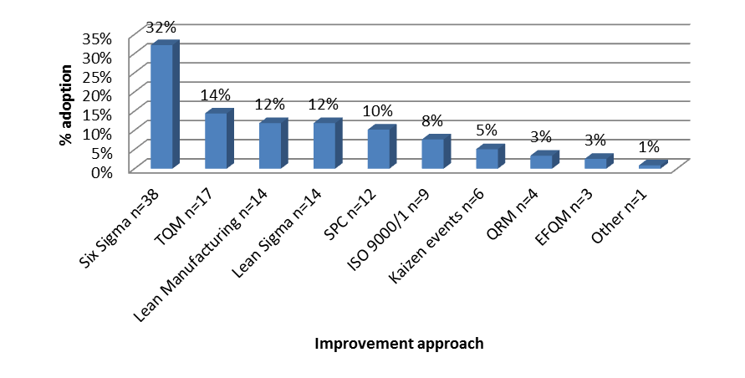

Figure 2. Relationship between improvement approaches and objective prioritisation of improvement initiatives
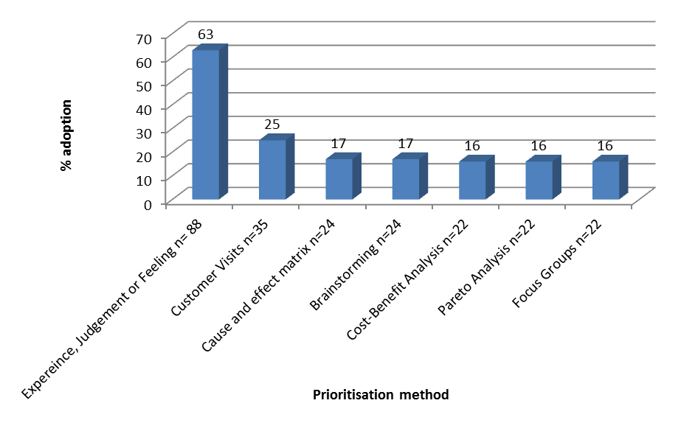
Figure 3. Common prioritisation methods used by SMEs

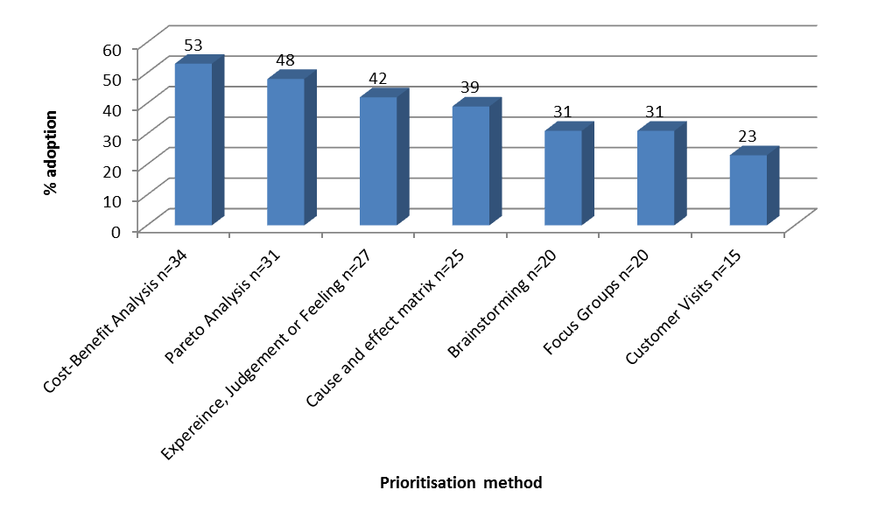 Figure 4. Large organisation project prioritisation methods

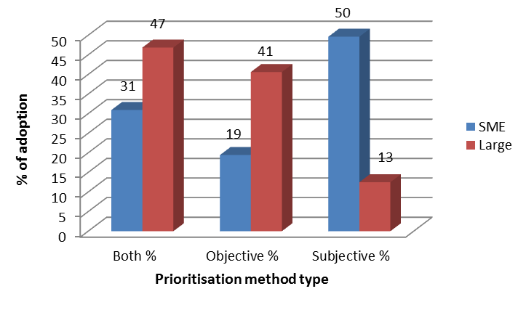
Figure 5. Subjective /objective prioritisation approaches and organisations’ size

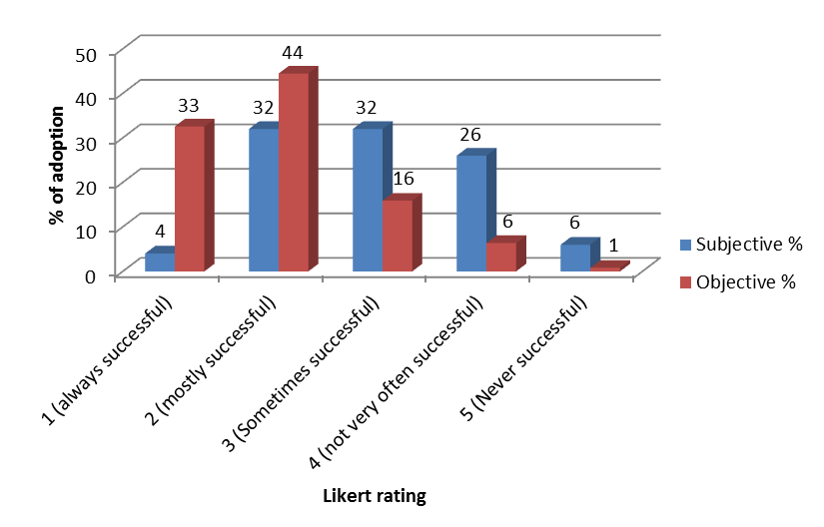

Figure 6. Success of subjective and objective prioritisation methods

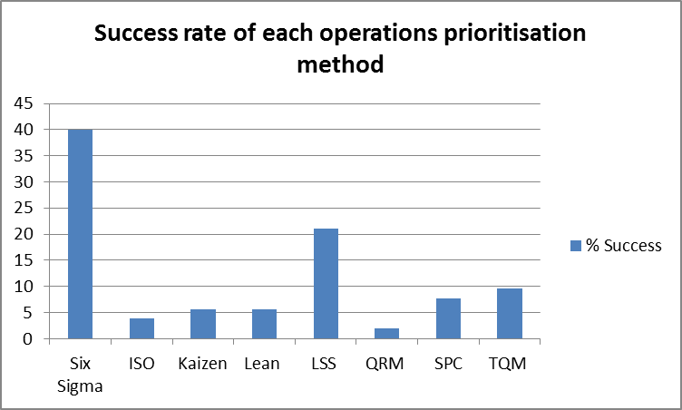
Figure 7: Comparative success rates of different operations prioritisation methods

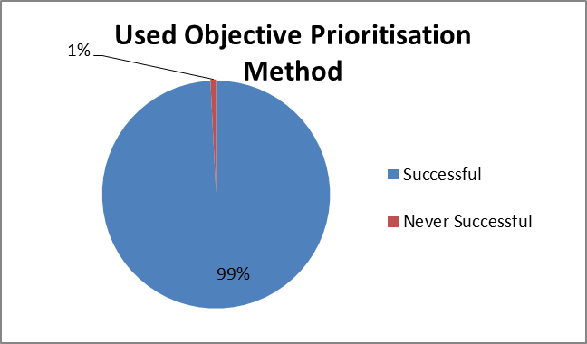

(a)
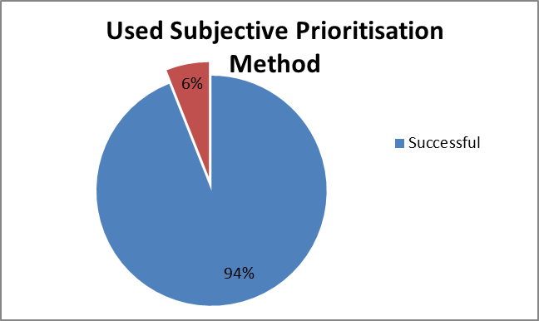

(b)
Figure 8. Comparative assessment of the success rate between objective (a) and subjective (b) prioritisation methods

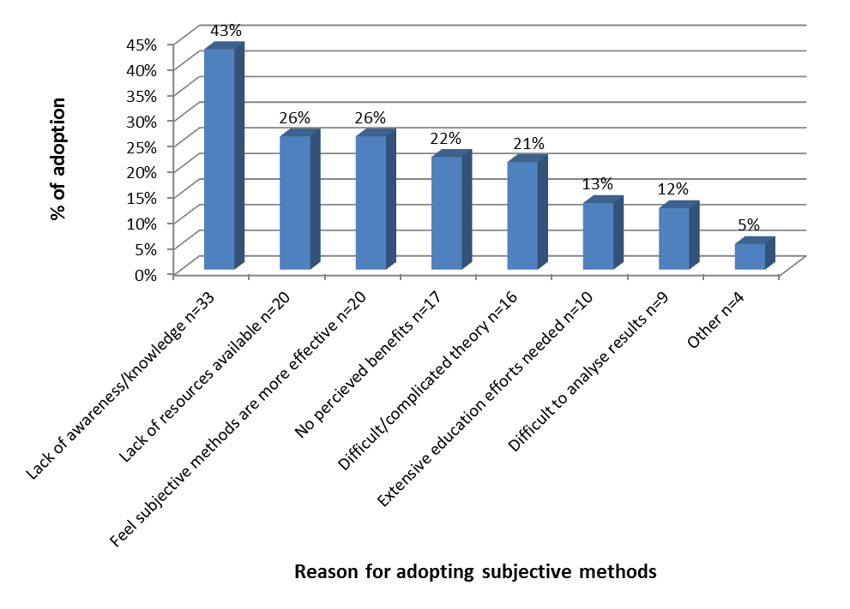 Figure 9. Reasons for adopting subjective over objective prioritisation approaches


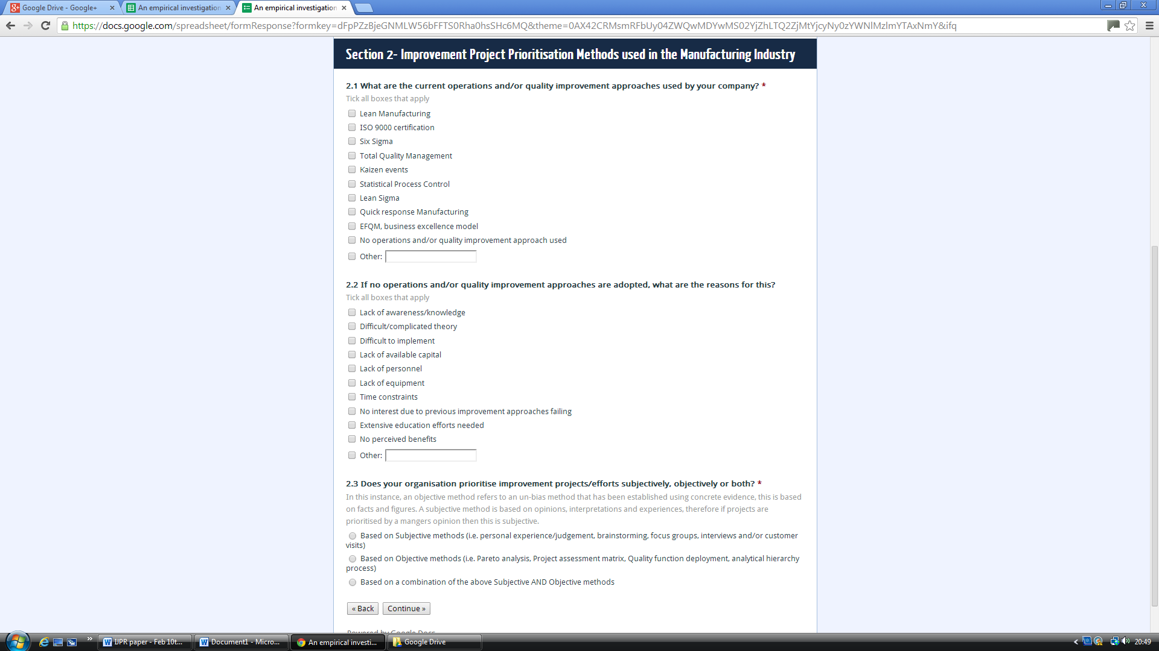
Appendix 1: Survey questionnaire


