Paper to the Working Seminar on Innovative governance patterns and grassroots activism in local contexts.

DASTU, Politecnico di Milano, 8 May 2014

Inclusive urban leadership – new ways of strengthening place-based power

Robin Hambleton

Abstract

This paper is about concepts – place, power, leadership, inclusion and public innovation. These topics are not always centre-stage in discussions of grassroots activism. It will be suggested that they deserve to be given more attention by those wishing to strengthen community empowerment and promote justice in the city. The starting point for the analysis is global. It is suggested that place-less leaders, meaning people who are not expected to care about the consequences of their decisions for particular places and communities, have seen their power increase dramatically in the last thirty years or so. The paper argues that the growth of place-less power in modern society is leading to an increase in social and economic inequality. Research for a forthcoming book on Leading the Inclusive City (2015) suggests that place-based power can be tapped to map out a different future for cities and localities than the one derived from neo-liberal ideology. The paper outlines a way of conceptualising the political space available for place-based initiatives, introduces the idea of realms of civic leadership, and suggests that the areas of overlap between these realms can be thought of as innovation zones – spaces in which people with different backgrounds can be brought together to create new possibilities.

Keywords: Power; Inclusion; Leadership; Place-based innovation

Contact details:

Robin Hambleton
Professor of City Leadership
Centre for Sustainable Planning and Environments
Faculty of Environment and Technology
University of the West of England, Bristol

E: robin.hambleton@uwe.ac.uk

Introduction

My starting point is that, during the last thirty years or so, societies across the world have become increasingly divided. Cities are the focus of attention in this paper because most people alive today live in cities and, in the thirty years ahead, demographic projections indicate, with some certainty, that we will live in an increasingly urbanised world. Despite the fact that cities are now central to the creation of prosperity, it is the case that, even in very wealthy cities – including the famous, so-called, ‘global cities’ – social and economic inequalities are on the rise.

For some scholars the increase in urban poverty arising from current approaches to urban development is unproblematic. For example, Glaeser (2011) takes the following view:

‘The presence of poverty in cities from Rio to Rotterdam reflects urban strength, not weakness. Megacities are not too big. Limiting their growth would cause significantly more hardship than gain, and urban growth is a great way to reduce poverty’ (Glaeser 2011, p70)

This is a misguided neo-liberal view. It is true to suggest, as Glaeser does, that rural poverty can trap people in isolated country areas for generations. However, it does not then follow that rapid, unplanned urban growth is a sound strategy for development. Nor is it necessary, or wise, to welcome the existence of grinding urban poverty. In the face of this complacency Thomas Piketty (2014) offers an incisive critique of the neo-liberal model, and assembles evidence to show that modern capitalism is increasing inequality at a formidable rate.

In contrast to so-called ‘free market’ thinking this paper argues that it is essential not only to guide and limit the way urban growth takes place, but also to create a just city in which all residents – established and newly arrived – can benefit and develop. Such an approach puts the search for equity, not economic growth, as the central aim of public policy. In relation to scholarship on urban inequality, I wish to highlight the valuable analysis provided by Susan Fainstein (2010) in her book, The Just City. She presents a devastating critique of modern planning theory arguing that much of it has simply ignored the reality of structural inequalities and hierarchies of power in modern society. By drawing on Rawlsian theories of liberty and justice, as well as detailed examination of the distributional impact of urban planning in Amsterdam, New York and London, she has developed an urban theory of justice.

This paper offers a contribution to this ongoing debate about city planning, community empowerment and justice in the city by focussing on civic leadership. This is because, as will be explained later, local leadership matters – it can make a difference to the quality of life in a given city. Put simply, leaders can address or ignore injustice. It is worth stressing at the outset that civic leaders are not just those ‘at the top’ – such as directly elected mayors, political leaders, city managers and the chief officers of local government departments. On the contrary, in modern systems of local governance leadership is dispersed and is multi-level. The neighbourhood activist or social entrepreneur can make a significant contribution to place-based leadership alongside the strategic efforts of, say, the city mayor.

The paper proceeds in four steps. First we examine the notion of place-less power and place-based power. Second, we consider the way a variety of forces frame the power of place. In a third section attention turns to a discussion of the changing nature of local leadership. I introduce a new way of conceptualising place-based leadership, which I call the New Civic Leadership. This approach suggests that it is helpful to distinguish between five realms of leadership in any given locality. In a rapidly changing world a key feature of effective civic leadership concerns the leadership of public service innovation. The New Civic Leadership highlights the importance of creating Innovation Zones - spaces in which different interests, who would not normally meet, are brought together. It will be suggested that progressive city leaders orchestrate the creation of Innovation Zones that can, in turn, create new possibilities for participatory forms of governance. A final section offers some reflections on the possibilities for developing inclusive approaches to urban leadership, notwithstanding the pressures of place-less power.

1) Place-less power and place-based power

For the purposes of this paper I define place as: ‘Somewhere somebody cares about’. Following Tuan (1977) and Castello (2010), I am suggesting that people imbue places with meaning, and places may often be associated with important feelings of identity. My definition is a broad one and it may be that it does not go very far in serving the needs of, for example, social geographers and environmental psychologists. But this loose definition has attractions that are consistent with the analysis presented by Tuan. It allows us, firstly, to conceive of places existing at many geographical levels; secondly, to encompass people’s fleeting engagement with places as well as deep feelings of attachment and geographical rootedness; and thirdly, it recognises that people have multiple loyalties to many places. Most important, for the purposes of this presentation, it enables us to divide decision makers into two distinct categories: place-based leaders, who care about the place they are making decisions about, and place-less leaders who don’t.

The growth of multi-national companies, and the centralisation of power in very big, remote institutions means that some of the most influential figures in the modern world are, what I call, place-less leaders. Place-less leaders are unconcerned about the impact of their decisions on particular places. They are, as often as not, driven by profit-seeking behaviour and the social costs of switching investment from one city, or country, to another do not enter their calculations. These decision-makers care little or, possibly, not at all, about whether particular places prosper or collapse. The way place-less leaders seek to play different localities off against each other is well established in the urban studies literature (Brenner et al 2012; Ranney 2003).

Without falling into the trap of romanticising place-based communities it is possible to argue that place, and more specifically place-based leaders, should be given more attention in public policy making. In a forthcoming book, Leading the Inclusive City, I gather together numerous examples of inspiring place-based leadership (Hambleton 2015). Drawn from the experiences of cities in different continents, these examples suggest that place-based actors can take on place-less forces.

A central claim in my argument is that ‘place’ is a neglected dimension in public policy. My intention, here, is not to offend those involved in geography, city and regional planning, architecture, sustainable development and related disciplines who have been striving to advance the cause of ‘place-based’ analysis and prescription for decades. Rather, my suggestion is that these disciplines are exceptional in having a concern for place. National governments tend to construct their domestic public policies around sectors - such as the economy, education, health, social care, transport, agriculture, policing, energy and so on. As a result hugely influential central government departments, bolstered by associated policy communities, professions and vested interests, have come to dominate the way public policy is conceived, developed and implemented.

But it is worse than that. The very way knowledge relating to public policy is constructed limits our understanding. This is because, as Warren Magnusson (2010) reminds us, the social sciences still bear the marks of their origins in the late nineteenth century, when the world was divided up in a new way for the purposes of academic study. The presumption was that this division of labour – between economics, sociology, geography, political science, philosophy and so on – would facilitate scientific study, and it has. However, this approach has the disadvantage that it works against other forms of analysis and, in particular, it undervalues interdisciplinary studies. Magnusson argues persuasively that urban scholars have been too hesitant in challenging restrictive disciplinary boundaries and that ‘… this timidity is bound up with an ongoing tendency to see like a state rather than a city’ (Magnusson 2010 p41).

He suggests that the traditional disciplines reflect a particular but contestable way of understanding the world, and that the social sciences, in so far as they strive to have policy relevance, tend to ‘see like a state’ – that is, to produce knowledge that is intelligible to those who seek to govern. His radical argument is that to ‘see like a city’ holds out many benefits and, in particular, it involves positioning ourselves as inhabitants, not governors. I am sympathetic to this analysis and, in my terms, ‘seeing like a city’ is consistent with adopting a place-based perspective.

2) Framing the power of place

Place-based leaders are not free agents able to do exactly as they choose. On the contrary, various powerful forces shape the context within which civic leaders operate. These forces do not disable local leadership. Rather they place limits on what urban leaders may be able to accomplish in particular places and at particular moments in time. Figure 1 provides a simplified picture of the forces that shape the world of place-based governance in any given locality.

Figure 1 Framing the political space for place-based governance

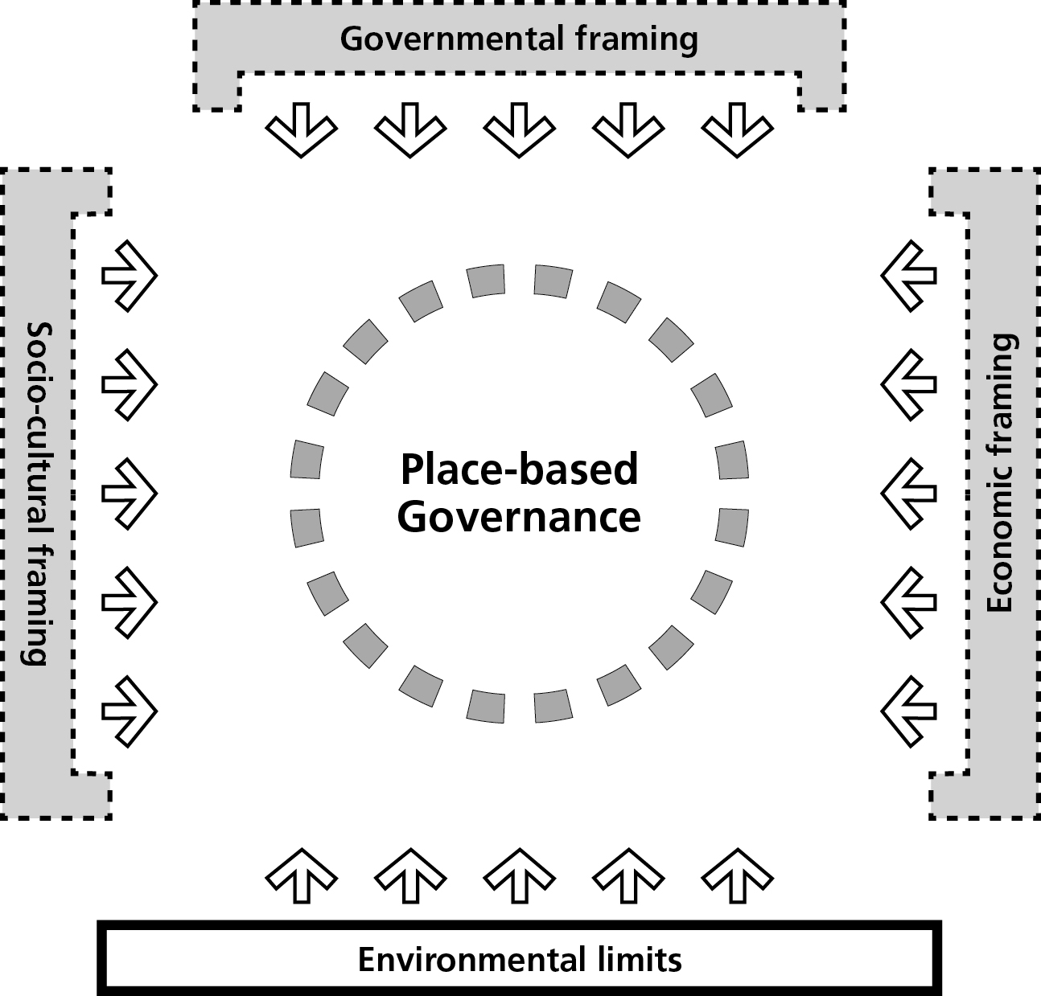

Let’s run through this figure. At the bottom of the diagram, are the non-negotiable environmental limits. Ignoring the fact that cities are part of the natural ecosystem is irresponsible, and failure to pay attention to environmental limits will store up unmanageable problems for future generations. This side of the square is drawn with a solid line because, unlike the other sides of the square, these environmental limits are non-negotiable. On the left hand side of the diagram are socio-cultural forces – these comprise a mix of people (as actors) and cultural values (that people may hold). Here we find the rich variety of voices found in any city - including the claims of activists, businesses, artists, entrepreneurs, trade unionists, religious organisations, community-based groups, citizens who vote, citizens who don’t vote, children, newly arrived immigrants, anarchists and so on. The people of the city will have different views about the kind of city they wish to live in, and they will have differential capacity to make these views known. Some, maybe many, will claim a right to the city. We can assume that, in democratic societies at least, elected leaders who pay little or no attention to these political pressures should not expect to stay in office for too long. Expression of citizen voice, to use Hirschman’s term (1970), will see them dismissed at the ballot box.

On the right hand side of the diagram are the horizontal economic forces that arise from the need for localities to compete, to some degree at least, in the wider marketplace - for inward investment and to attract talented people. Various studies have shown that, contrary to neo-liberal dogma, it is possible for civic leaders to bargain with business (Savitch and Kantor 2002). Recognising the power of economic forces, including the growth in global competition between localities, does not require civic leaders to become mere servants of private capital. For example, a detailed study of the governance of London, New York, Paris and Tokyo concluded that:

‘Global forces are not making the politics of place less important. Globalism and local governance are not mutually exclusive but are deeply entwined… important differences remain in the ways particular world city-regions are mediating international forces’ (Kantor et al 2012 p 241)

On the top of Figure 1 we find the legal and policy framework imposed by higher levels of government. In some countries this governmental framing will include legal obligations decreed by supra-national organisations. For example, local authorities in countries that are members of the European Union (EU) are required to comply with EU laws and regulations, and to take note of EU policy guidance. Individual nation states determine the legal status, fiscal power and functions of local authorities within their boundaries. These relationships are subject to negotiation and renegotiation over time.

It is clear that Figure 1 simplifies a much more complex reality. This is what conceptual frameworks do. In reality the four sets of forces framing local action do not necessarily carry equal weight, and the situation in any given city is, to some extent, fluid and changing. The space available for local agency shifts over time, and a key task of local leaders is to be alert to the opportunities for advancing the power of their place within the context of the framing forces prevailing on their area at the time.

The figure indicates that place-based governance, shown at the centre, is porous. Successful civic leaders are constantly learning from the environment in which they find themselves in order to discover new insights, co-create new solutions and advance their political objectives. Note that the four forces are not joined up at the corners to create a rigid prison within which civic leadership has to be exercised. On the contrary the boundaries of the overall arena are, themselves, malleable. Depending on the culture and context, imaginative civic leaders may be able to disrupt the pre-existing governmental frame and bring about an expansion in place-based power.

3) The New Civic Leadership

How do we define leadership? My definition draws on both the leadership literature and on my personal experience of leadership in communities, in government and in higher education in Britain and the USA: ‘Leadership involves shaping emotions and behaviour to achieve common goals’ (Hambleton 2007 p174). This definition puts emotions front of stage and also emphasises the importance of leaders adopting an inclusive approach to the identification of the aims and purposes of collective endeavour.

This definition implies a wide range of activities aimed at generating both new insights and new ways of working together. It prizes respect for the feelings and attitudes of others as well as a strong commitment to collaboration. It is imaginative, involves risk taking and involves ‘being able to put yourself in the situation of someone else’ (Keohane 2010 p89). My approach to the study of place-based leadership is informed by this perspective, and I wish to emphasise that the feelings people have for ‘their’ place have been seriously neglected in both the leadership literature and the public service innovation literature. Following Hoggett (2009 p175) I take the view that approaches to leadership need to develop a form of ‘passionate reason’. How we feel is not a distraction from reason – on the contrary: ‘Not only are our feelings essential to our capacity for thought but they are themselves a route to reason’ (Hoggett 2009 p177). This idea of emotional engagement is central to what I call the New Civic Leadership.
The realms of place-based leadership
Civic leaders are found in the public, private, and community/voluntary sectors and they operate at many geographical levels – from the street block to an entire sub region and beyond. It is helpful to distinguish five realms of place-based leadership reflecting different sources of legitimacy:
- Political leadership – referring to the work of those people elected to leadership positions by the citizenry. These are, by definition, political leaders. Thus, directly elected mayors, all elected local councillors, and Members of Parliament are political leaders. Having said that we should acknowledge that different politicians carry different roles and responsibilities and will view their political roles in different ways.
- Managerial/professional leadership – referring to the work of public servants appointed by local authorities, state and central governments, and third sector organisations to plan and manage public services, and promote community wellbeing. These officers bring professional and managerial expertise to the tasks of local governance.

- Community leadership – referring to the many civic-minded people who give their time and energy to local leadership activities in a wide variety of ways. These may be community activists, voluntary sector leaders, religious leaders, higher education leaders and so on. The potential contribution to civic leadership of an independent and engaged voluntary and community sector is important here.

- Business leadership – referring to the contribution made by local business leaders and social entrepreneurs, who have a clear stake in the long-term prosperity of the locality.

- Trade union leadership – referring to the efforts of trade union leaders striving to improve the pay and working conditions of employees in public, private and voluntary sector organisations. Elected by their members these leaders enjoy democratic legitimacy within their organisations.

Figure 2 The five realms of place-based leadership

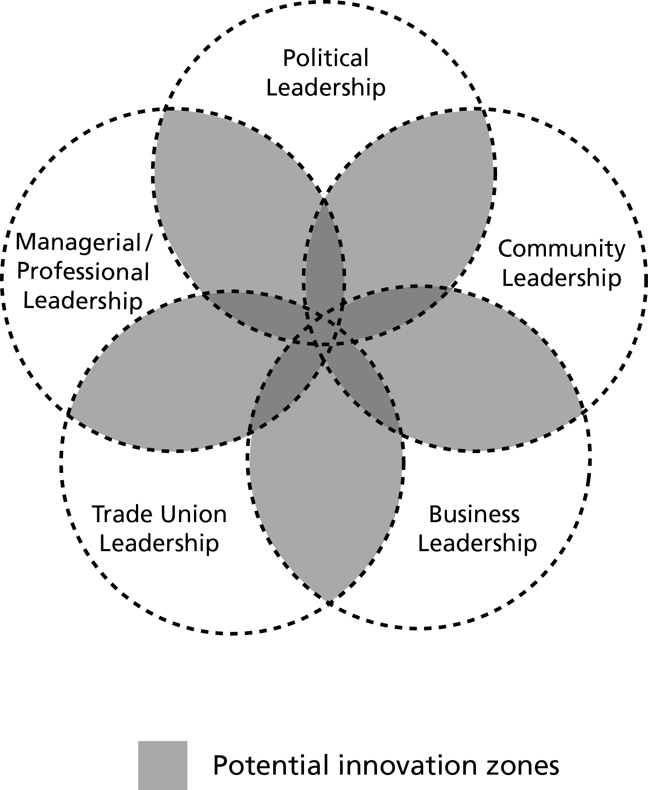

Source: Author

Innovation Zones
The five realms are all important in cultivating and encouraging public service innovation and, crucially, they overlap. I describe the areas of overlap between these different realms of leadership as Innovation Zones – areas providing many opportunities for inventive behaviour – see Figure 2. This is because different perspectives are brought together within these zones, and this can enable active questioning of established approaches. Heterogeneity is the key to fostering innovation. Civic leadership has a critical role in creating the conditions for different people to come together – people who might not normally meet – to have a creative dialogue, and then to follow through on their ideas. I present the circles in Figure 2 as dotted lines to emphasise the connectivity, or potential connectivity, across the realms of civic leadership.

It can be claimed that the areas of overlap in Figure 2 are conflict zones, not Innovation Zones. It is certainly the case that these spaces often provide settings for power struggles between competing interests and values. And it is important to acknowledge that, within these settings, power is unequally distributed.
It is possible that formalized partnership settings – administrative arrangements designed to link local stakeholders together in order to further collaboration - can operate as Innovation Zones. But in my experience this is often not the case. Recent research on public service innovation suggests that it is the more informal, open-ended, personal interactions that matter in a creative process (Hambleton and Howard 2012; 2013). This creativity can be cultivated if leaders step out of their own ‘realm’ of authority and engage with the perspectives and realities of others. This means going into what one public service leader in our Anglo-Dutch research project described as one’s ‘ZOUD’ – or Zone of Uncomfortable Debate. Here, different approaches, values and priorities collide.
Unifying the realms of civic leadership
A limitation of Figure 2 is that, while it shows clearly enough that the realms of civic leadership overlap, it gives the appearance of essentially separate fields of action. In practice the process of place-based leadership is much more dynamic than the figure implies – effective public leaders in a city are cutting across the realms of civic leadership on a day-to-day basis. Figure 3 is a reworking of the same figure. The shape of each realm is now shown, not as a contained circle, but as a petal that is inextricably linked to the other four realms. The line outlining the realms of civic leadership is a single line. This is intended to signal the importance of unifying the separate realms of civic leadership in a single purposive process. This idea of unified action resonates with the notion of ‘as one’ behaviour advocated by other writers on leadership (Baghai and Quigley 2011).
Figure 3 Unifying the realms of place-based leadership

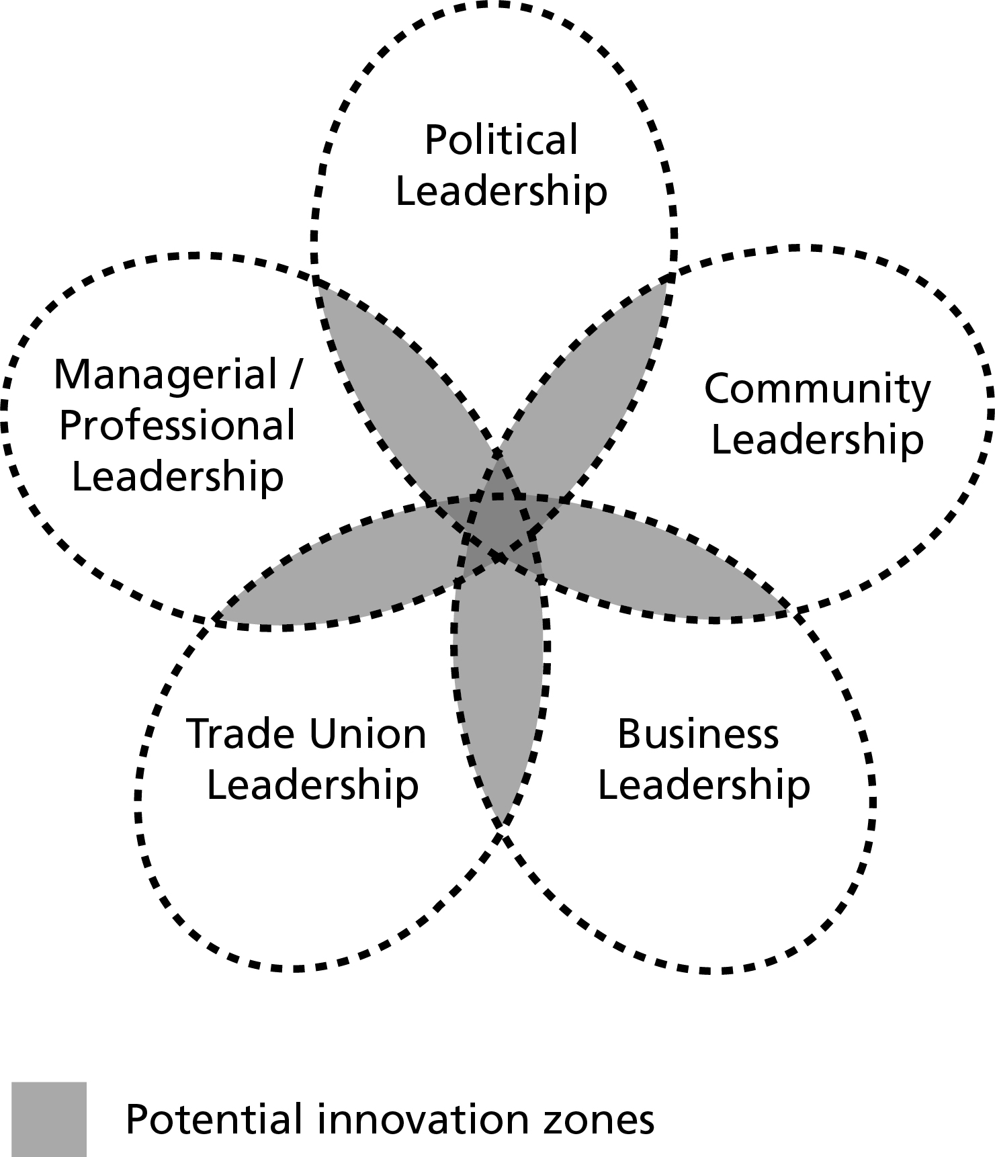

Source: Author
Wise civic leadership is critical in ensuring that the Innovation Zones – sometimes referred to as the ‘soft spaces’ of planning (Illsley et al 2010) or ‘space for dialogue’ (Oliver and Pitt 2013 pp 198-199) – are orchestrated in a way that promotes a culture of listening that can, in turn, lead to innovation (Kahane 2004). New ideas emerging in the field of urban planning resonate with the argument I am putting forward. For example, Balducci and Mantysalo (2013) suggest that successful urban planning involves the creation of ‘trading zones’, meaning arenas within which different stakeholders exchange ideas for action without necessarily developing shared agreement on core values and motives.
The point I wish to highlight from this discussion of Innovation Zones, or trading zones, is that place-based leadership can shape the quality of the exchanges that take place in these spaces. It is true that these arenas are often experienced as conflict zones – there are many clashes of values in the modern city. The role of leadership is to orchestrate a process of social discovery within these zones that is constructive and forward looking. Adam Kahane puts it this way:
‘We have to bring together the people who are co-creating the current reality to co-create new realities. We have to shift from downloading and debating to reflective and generative dialogue. We have to choose an open way over a closed way’ (Kahane 2004 p129)
In sum, leadership capacity in modern society is dispersed. Our systems of local governance need to respect and reflect that diversity if decisions taken in the public interest are going to enjoy legitimacy. Further, more decentralized approaches - both across localities and within each realm of civic leadership - can empower informal leaders to be part of the dialogue (Howard and Lever 2011). Figure 3 simplifies a more complex reality. It is not intended to show how the dynamics of local power struggles actually unfold. The relative power of the five realms varies by locality. Moreover, the realms shift in influence over time. The interactions across the realms are also complex and, of course, there are many different interests operating within each realm. Nevertheless I believe that the notion of five different realms – with leadership stemming from different sources of legitimacy within each realm – provides a helpful way of framing discussion about civic leadership.

Place-based leadership in context

Earlier in this paper I explained how various forces shape the context within which place-based leadership is exercised and I set this out in diagrammatic form in Figure 1. Having now explained the five realms of place-based leadership it is possible to advance the presentation by locating the five realms within this broader context – see Figure 4.

Figure 4 Place-based leadership in context

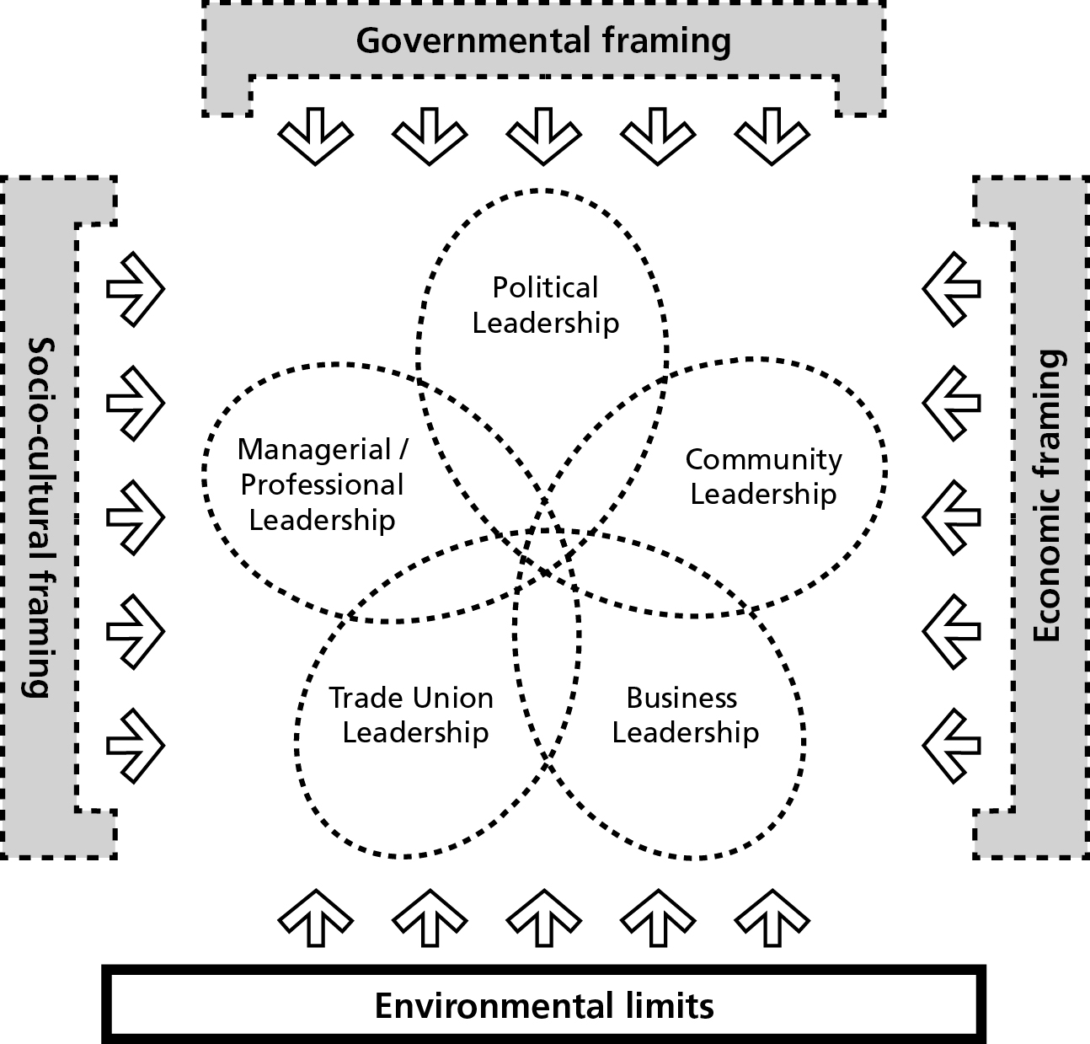

Source: Author

Skelcher et al (2013 p24) provide an interesting framework, a kind of flow chart, for the analysis of governance transitions. In their model they identify two forces shaping the agency exercised by local actors: ideational context and the institutional legacy. They argue that, aside from the imaginative agency of individuals and groups, governance change is driven by two factors – the big ideas that take hold within a community of actors (the ideational context) and the normative logics inherent in the institutions of government (the institutional legacy). An attractive feature of their model is that they show how emergent practices can, in turn, reshape the big ideas and the institutional legacy.

My own model is aligned with their approach – see Figure 5. The main differences are that I suggest that four forces, not two, shape the space for local action. My analysis suggests that environmental limits are critical, and I also try to bring out the tensions between the political and the economic drivers of local change, rather than collapsing them into one ideational driver. Figure 5 has the benefit of highlighting the dynamic possibilities for place-based leadership.

Figure 5 A process model of civic leadership

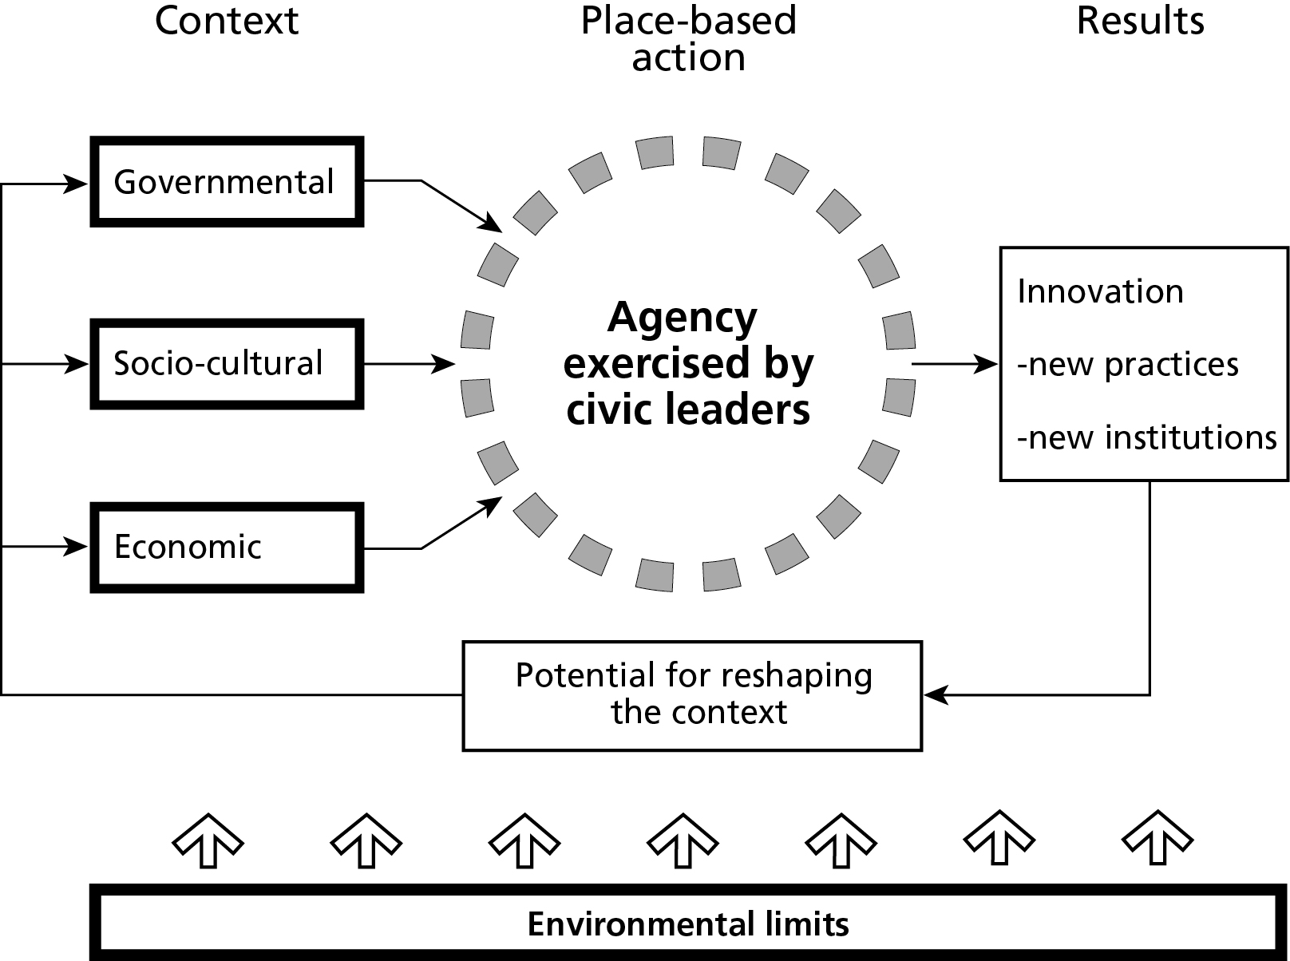

Source: Author

4) Reflections on the New Civic Leadership

The argument presented in this paper is that cities, and/or localities, are not helpless victims in a global flow of events. It has been suggested that place has meaning in modern society, possibly more so than in the past. In a forthcoming book the author presents seventeen examples of progressive civic leadership drawn from all continents (Hambleton 2015). These stories of progressive, place-based leadership demonstrate that: 1) place matters a great deal to people, even as the world becomes more globalised, 2) local civic leadership can have a significant impact on the quality of life in a given locality, and 3) alternatives to the neo-liberal, market-dominated view of the world are perfectly viable. The phrase I use to encapsulate what this approach to public leadership involves is New Civic Leadership.

In this closing section I offer five observations, or questions, about aspects of the New Civic Leadership. The aim here is to highlight key features of this way of analysing progressive change in cities, and to begin to explore how inclusive approaches to place-based leadership may be able to be even more effective in fostering effective grassroots activism.

1) Place-based power – a useful idea?

First, is it helpful to distinguish between place-less power and place-based power? Personally, I believe that it is. I recognise that place-based power can be taken too far. There is good evidence to show that deeply rooted, place-based communities can be very conservative, and, at times, can be more than ready to reject the ‘other’. This is not what I am advocating. Rather, I am suggesting, following Frederickson (2005), that local leaders need to transcend parochial perspectives and should be guided by ‘instincts of appropriateness’ and what is understood to be right and fair. Is this idea of a struggle between place-less and place-based power a helpful way of thinking about urban politics?

2) Framing place-based power

In Figure 1 I am suggesting that the political space available to local, civic leaders is constrained, to some extent, by four forces: 1) Environmental limits (inflexible and unavoidable), 2) Economic requirements (relating to competition in a globalised world), 3) Socio-cultural demands (reflecting political and social pressures), and 4) Governmental framing – the legal and policy constraints on local agency (which vary dramatically among countries). The suggestion here is that place-based leaders, provided they enjoy the support of grassroots activists, can, at times, break out of this framework and bolster local democratic power. This is, of course, why we have elected local governments today. Pressure from activists, communities and trade unions in the 19th Century led to the creation of local democracy in many western democracies.

3) Realms of place-based leadership

In Figure 3 I have suggested that it is helpful to distinguish five realms of leadership in any given locality: Political; Managerial/professional; Community; Business; and Trade union. Leadership in any given city is multi-level and is, to some extent, dispersed across different geographical levels and across these five realms. Leaders in the different realms draw on different sources of legitimacy. Evidence presented in Leading the Inclusive City suggests that progressive civic leadership draws on all five realms of leadership. The idea of a ‘city boss’ running the city is long past its ‘sell-by’ date. Effective, modern city leadership is facilitative and often relies heavily on the exercise of ‘soft’ power rather than ‘hard’ power (Nye 2004). Soft power involves winning people over by the attraction of your ideas rather than through payments (carrots) and coercion (sticks).

4) Innovation Zones

A key argument developed in Leading the Inclusive City is that successful urban leaders and managers have switched their attention from focussing on the ‘improvement’ of public services to giving much more active attention to ‘innovation’. The argument here is that, in a rapidly changing world, it is essential to engage in a deep reconsideration of the changing role and purpose of public service and the way the state relates to local communities of interest and place. Making ‘improvements’ here and there is an insufficient response to the challenges societies now face, particularly in relation to growing inequality and troubling climate change. Relationships between the state, society and markets are being rethought and place-based leaders are playing an important role in adapting public services. The suggestion has been made that it is helpful to consider the areas of overlap between the different realms of leadership in any given locality as Innovation Zones – spaces in which people with different backgrounds and experiences are brought together. These spaces may well bring together people with conflicting views – different values and ideas will collide. Creative leadership can, at times, turn conflict zones into Innovation Zones. Understanding how to lead processes of radical innovation is an area that deserves further study.

5) Grassroots innovation

Finally, I turn to consider the relationship between city leadership and grassroots activism. It is often the case that there is a high level of conflict in cities. At risk of presenting a caricature of real experience it is not difficult to find local groups fighting against city hall. Community leaders, whether they lead communities of place or interest, have a vital role to play, not just in holding senior leaders to account but also in bringing forward new ideas on how to address public concerns and challenges. Sometimes it is vital that the local community takes on city hall. A good example of this approach is provided as Innovation Story 1 in Leading the Inclusive City. This story shows how local activists in Manhattan were able to stop a proposal to demolish a disused, elevated railway, and then went on to work with others to create the High Line – a remarkable public park ‘in the sky’.

However, the suggestion I am making in this paper is that wise city leaders are highly effective in reaching out to communities of interest and place. They listen well and, by working across the realms of place-based leadership I have outlined, they enable the co-creation of new solutions to public policy problems. There are, of course, risks that radical voices will be co-opted into strategies that do not serve local communities very well. The power balances within any given city are skewed. But there is evidence to suggest that strong community leadership can co-exist with strong city leadership.

Acknowledgements

I would like to acknowledge the contributions of Jo Howard, Mirjan Oude Vrielink, Bas Denters, Pieter-Jan Klok, Jacob Norvig Larsen and Arturo Flores to the ideas presented in this paper.

References

Baghai M. and Quigley J. (2011) As One. Individual action, collective power. London: Penguin

Balducci A. and Mantysalo R. (eds) (2013) Urban Planning as a Trading Zone. New York: Springer

Brenner N., Marcuse P. and Mayer M. (eds) (2012) Cities for people, not for profit. Critical urban theory and the right to the city. Abingdon: Routledge

Castello L. (2010) Rethinking the Meaning of Place. Conceiving place in architecture-urbanism. Farnham: Ashgate

Davis M. (2006) Planet of Slums. London: Verso

Dorling D. (2011) Injustice. Why social inequality persists. Bristol: The Policy Press

Fainstein S. S. (2010) The Just City. Ithaca: Cornell University Press

Ferman B. (1985) Governing the Ungovernable City. Political skill, leadership and the modern mayor. Philadelphia: Temple University Press

Flanagan R. M. (2004) Mayors and the Challenges of Urban Leadership. Lanham MD: University Press of America

Frederickson H. G. (2005) ‘Transcending the community: Local leadership in a world of shared power’, Public Management, Vol 87, No 10

Friedmann J. (2002) The Prospect of Cities. Minneapolis: University of Minnesota Press

Glaeser E. (2011) Triumph of the City. New York: The Penguin Press

Hambleton R. (2007) ‘New leadership for democratic urban space’ pp163-176 in Hambleton R. and Gross J. S. (eds) Governing Cities in a Global Era. Urban Innovation, Competition and Democratic Reform. Basingstoke and New York: Palgrave

Hambleton R. (2009) ‘Civic Leadership for Auckland. An International Perspective’ pp 515-552 in Royal Commission on Auckland Governance. Vol 4, Part 11

Hambleton R. (2015) Leading the Inclusive City. Place-based innovation for a bounded planet. Bristol: The Policy Press

Hambleton R. and Howard J. (2012) Public Sector Innovation and Local Leadership in the UK and the Netherlands. York: Joseph Rowntree Foundation

Hambleton R. and Howard J. (2013) ‘Place-based leadership and public service innovation’, Local Government Studies, Vol 39, No 1, pp 47-70

Hambleton R., Howard J., Buser M. and Taylor M. (2009) International Insights on Civic Leadership and Public Service Innovation. Report for the Local Authority Research Council Initiative (LARCI). Swindon: LARCI

Hamnett C. (2003) Unequal City: London in the global arena. London: Routledge

Hirschman A. O. (1970) Exit, Voice and Loyalty. Cambridge, MA: Harvard University Press

Hoggett P. (2009) Politics, Emotion and Identity. Boulder, CO; Paradigm

Howard J. and Lever J. (2011) ‘New governance spaces: what generates a participatory disposition in different contexts? Voluntary Sector Review, Vol 2, No 1 pp 77-95

Illsley B., Jackson T., Curry J. and Rapaport E. (2010) ‘Community involvement in the soft spaces of planning’, International Planning Studies, Vol 15, No 4, pp303-319

Iveson K. and Fincher R. (2011) ‘”Just diversity” in the city of difference’ pp 407- 418 in Bridge G. and Watson S. (eds) (2011) The New Blackwell Companion to The City. Chichester: Blackwell

Kahane A. (2004) Solving Tough Problems. An open way of talking, listening and creating new realities. San Francisco: Berrett-Koehler Publishers

Keohane N. O. (2010) Thinking about leadership. Princeton, NJ; Princeton University Press

Kantor P., Lefevre C., Saito A., Savitch H. V. and Thornley A. (2012) Struggling Giants. City-region governance in London, New York, Paris and Tokyo. Minneapolis: University of Minnesota Press

Magnusson W. (2010) ‘Seeing like a city’ pp 41- 53 in Davies J. S. and Imbroscio D. L. (eds) Critical Urban Studies. New Directions. Albany: State University of New York Press

Nightingale C. H. (2012) Segregation. A Global History of Divided Cities. Chicago: University of Chicago Press

Nye J. S. (2004) Soft Power. The means to success in world politics. New York: PublicAffairs

Oliver B. and Pitt B. (2013) Engaging Communities and Service Users. Context, themes and methods. Basingstoke: Palgrave

Organisation for Economic Cooperation and Development (OECD) (2008) Growing Unequal: Income Distribution and Poverty in OECD Countries. Paris: OECD

Piketty T. (2014) Capital in the Twenty-First Century. Cambridge MA: Harvard University

Ranney D. (2003) Global Decisions, Local Collisions. Urban life in the new world order. Philadelphia PA: Temple University Press

Sandercock L. (1998) Towards Cosmopolis. Planning for Multicultural Cities. Chichester: John Wiley

Sandercock L. (2003) Cosmopolis II. Mongrel Cities of the 21st Century. London: Continuum

Sassen S. (2001) The Global City. New York, London, Tokyo. Second Edition. Princeton: Princeton University Press

Savitch H. V. and Kantor P. (2002) Cities in the International Marketplace. The political economy of urban development in North America and Western Europe. Princeton NJ: Princeton University Press

Scott J. C. (1998) Seeing Like a State: How Certain Schemes to Improve the Human Condition Have Failed. New Haven, CT: Yale University Press

Skelcher C., Sullivan H. and Jeffares S. (2013) Hybrid Governance in European Cities. Neighbourhood, migration and democracy. Basingstoke: Palgrave

Tuan Y. F. (1977) Space and Place. The Perspective of Experience. Minneapolis: The University of Minneapolis Press

Wilkinson R. and Picket K. (2010) The Spirit Level. Why Equality is Better for Everyone. London: Penguin

Young I. S. (2000) Inclusion and Democracy. Oxford: Oxford University Press

Endnotes The evidence to support the argument that cities and societies are becoming more unequal is substantial. See, for example: Davis 2006; Dorling 2011; Hamnett 2003; Nightingale 2012; OECD 2008; Sassen 2001; and Wilkinson and Pickett 2010.
Numerous other scholars have contributed to the discussion of social equity in cities. See, for example: Brenner et al 2012; Friedmann 2002; Iveson and Fincher 2011; Nightingale 2012; Sandercock 1998 and 2003; and Young 2000.
In this paper I am introducing themes relating to the leadership of localities. The arguments apply to rural and semi-urban areas as well as cities. At times the phrases ‘urban leadership’, ‘city leadership’, ‘civic leadership’ and ‘local leadership’ are used to refer to the same idea – they are all versions of ‘place-based leadership’.
As an aside we can note that, within both the sciences and the social sciences, there has been a remarkable growth in interdisciplinary studies in recent years. Interdisciplinarity involves combining two or more academic disciplines in a single study. Subjects such as global warming, the epidemiology of AIDS, and social inequality require insights to be drawn from different disciplines. In the sciences we see the emergence of new interdisciplinary fields, such as bioinformatics and synthetic biology.
This idea of ‘seeing like a city’ rather than ‘seeing like a state’ derives from work by Scott (1998).
Research on the performance of US city mayors lends support to this claim. For example, Ferman (1985 p197) shows how ‘…leadership strategies must be examined in the context in which they are executed’. And Flanagan (2004), in the light of his examination of the performance of nine American city mayors, highlights how timing is critical – the political space available to civic leaders, the relationship between structural forces and the power of agency, varies over time.
I recognise that leadership is a contested concept. Discussion of the nature of leaders and leadership should always take account of historical processes and the social context. Nevertheless there is, for the purposes of this book, virtue in a ten-word definition because it provides a reasonable degree of clarity about how I am using this slippery term.
The idea of realms of civic leadership was first developed in work the author carried out on leadership for the Royal Commission on Auckland Governance (Hambleton 2009). These ideas were further developed in a scoping report for the Local Authority Research Council Initiative (LARCI) (Hambleton et al 2009); and in a report the author co-authored with Jo Howard for the Joseph Rowntree Foundation (Hambleton and Howard 2012). In this earlier work we used three realms of civic leadership. In this paper I have expanded the number of realms to five as this enables a more nuanced presentation.
I am grateful to Katherine Rossiter, Managing Director of the Society of Local Authority Chief Executives and Senior Managers (SOLACE), for this insight, provided at an Anglo-Dutch Workshop on Place-based Leadership that Joanna Howard and I co-organised on 9 November 2011. SOLACE would like to acknowledge the source of this concept as The Cranfield School of Management. For further information and to read Dr Catherine Bailey’s discussion of the ‘ZOUD’, go to: http://www.som.cranfield.ac.uk/som/dinamic-content/media/knowledgeinterchange/topics/20110404/Article.pdf
In my book I discuss the nature of power in modern society in more detail and refer to the various ways in which power can be analysed and understood. This material is not included in this paper for reasons of space.
The emergence of various forms of local democracy has happened at different times in different countries. And, in some developing countries, elected local government is still very fragile.

