Paper for the Smart City: New Media, Social Participation and Urban Governance International Workshop

Shanghai University, 5-7 June 2014

From the Smart City to the Wise City: The role of universities in place-based leadership

Robin Hambleton, University of the West of England, Bristol, UK and Director of Urban Answers

For a variety of reasons the notion of the smart city has grown in popularity and some even claim that all cities now have to be ‘smart’. For example, some digital enthusiasts argue that advances in Information and Communication Technologies (ICT) are ushering in a new era in which pervasive electronic connections will inevitably lead to significant changes that make cities more liveable and more democratic. This paper will cast a critical eye over these claims. It will unpack the smart city rhetoric and show that, in fact, three competing perspectives are struggling for ascendancy within the smart cities discourse: 1) The digital city (emphasising a strong commitment to the use of ICT in governance), 2) The green city (reflecting the growing use of the US phrase smart growth, which is concerned to apply sound urban planning principles), and 3) The learning city (emphasising the way in which cities learn, network and innovate). Five digital danger zones will be identified and discussed. This analysis will suggest that scholars and policy makers who wish to improve the quality of life in cities should focus their attention on wisdom, not smartness. Civic leaders need to exercise judgement based on values if they are to create inclusive, sustainable cities. It is not enough to be clever, quick, ingenious, nor will it help if Big Data is superseded by Even Bigger Data. Universities can play a much more active role in place-based leadership in the cities where they are located. To do this effectively they need to reconsider the nature of modern scholarship. The paper will show how a growing number of universities are doing precisely this. Two respected examples will be presented to show how urban universities, if they are committed to engaged scholarship, can make a significant contribution to the creation of the wise city.

Key words: smart city, wise city, place-based leadership, engaged university

Contact details:

Robin Hambleton, Professor of City Leadership, Centre for Sustainable Planning and Environments, Faculty of Environment and Technology, University of the West of England, Bristol, UK

E: robin.hambleton@uwe.ac.uk

Also Urban Answers: http://urbananswers.co.uk
Introduction

Digital enthusiasts argue that smart cities are a panacea. They claim that the current revolution in communication technologies will transform cities in the 21st Century in the way that electricity changed them in the last. For sceptics these claims are little more than frothy hype. Many will argue that somewhere in between these extremes there is an emerging consensus. This consensus claims that advances in Information and Communication Technologies (ICT) are ushering in a new era in which pervasive electronic connections are making cities more liveable and more democratic. In this paper I want to question this emerging consensus. I do this not to be contrary for the sake of it, but because the evidence suggests that smartness, as currently conceived, is doing little to create more inclusive, sustainable and more democratic cities.

In a forthcoming book, Leading the Inclusive City, I develop an extended argument about the importance of strengthening place-based power in our rapidly globalising world and, as part of this argument, I suggest that universities could be much more active in contributing to the creation of more just cities (Hambleton 2015). The book assembles seventeen Innovation Stories, drawn from inventive cities in all continents, to underpin the argument that place-based civic leadership, when combined with radical social innovation, can help to create inclusive, sustainable cities. Since we are meeting in China I should mention that one of the Innovation Stories concerns civic leadership in Guangzhou. Here, city leaders have introduced a remarkable, high capacity Bus Rapid Transit (BRT) system, the first of its kind in Asia. Some of the Innovation Stories in my book show how cities are using ICT to improve public service responsiveness to citizens – the 311 and Open311 service in Chicago provides an example.

However, a central claim in my argument is that having super-responsive services is not enough to create an inclusive, democratic city. Smart technology, including recent advances in social media, can enhance the performance of public services, but troubling questions remain: Are these technologies strengthening local democracy and giving voice to the have-nots in society? Are they advancing equity in the city? Do they represent an adequate response to the challenges of climate change and environmental degradation?

The argument in this paper is presented in five steps. First, I try to unpack what being a ‘smart’ city might mean. Because the word smart is now used in a fairly indiscriminate way this task is more difficult than might, at first, appear. I will suggest that there are, in fact, at least three discourses competing for attention in the ongoing debate about smart cities, and I label these: 1) Digital cities, 2) Green cities and 3) Learning cities. It may be possible to unite these perspectives around a common policy agenda in a given city. But this is likely to be challenging because core values underpinning the different approaches appear to be in tension.

In the following section I identify five digital danger zones, or questions, for the digital enthusiasts to consider. It may be that these five concerns can be addressed through super-enlightened ICT strategies, but I have my doubts. In the third section I therefore outline a new way forward. The argument presented here is that we should attempt to move beyond the limiting confines of the smart city debate to develop a deeper understanding of the nature of public learning and democratic innovation in the modern city. Some of the most successful cities in the world may not use this language, but I believe that they have already embraced the idea of what I call the wise city. By this I mean a city in which values relating to justice, democracy and care of the natural environment guide the creation of the inclusive city. Leaders of wise cities recognise the value of new technology as a servant of public purpose, nothing more. They know that advocating being ‘smart’ is vacuous.

In the fourth step in the narrative I turn to examine the changing nature of scholarship. In some ways universities are the sleeping giants of civic leadership and place-based innovation. However, as the nature of modern scholarship comes to be redefined, we can see that a growing number of universities now recognise that active engagement with the politics of place has enormous two-way benefits. The intellectual and other resources of the university can be deployed to help improve the local quality of life, and engagement with the city can boost the quality of academic endeavour.

In a fifth step, in order to illustrate how forward looking universities are already contributing to place-based leadership, I present two Innovation Stories drawn from my book. The first explains how Portland State University is working closely with the City Council and other partners to make Portland, Oregon into an even more sustainable and more inclusive city. The second discusses the role of the CEPT University in working with the Ahmedabad Municipal Corporation to plan and design the Ahmedabad Bus Rapid Transit system – an effort to promote sustainable mobility and equity in the city. The two Innovation Stories illustrate ways in which universities can bring the knowledge and wisdom of scholars and students to bear on pressing public policy concerns. At the end of the paper I offer some reflections and conclusions on the analysis I have presented.

1) Unpacking smart city rhetoric

The literature on smart cities has mushroomed in recent years, and the adjective ‘smart’ is now used widely in public debates about city government, urban development, and modern architecture. Enthusiasts claim that we will all be better off if we live in smart cities, with smart buildings and smart places to loiter in and use free the Wi-Fi. But will we? What does this increasingly popular term actually mean? Does being ‘smart’ represent a breakthrough in how to understand and improve the city? Or is it just another spray-on term that has already been so misused that it is now devoid of meaning?

The adjective ‘smart’ is, it must be said, rather beguiling. Unfortunately this may, in itself, be problematic. It has the troubling effect of implying that doubters must be in favour of ignorance. It is, then, worth sparing a moment to consider what smart means. In English the word has, in fact, several meanings, not all of them flattering. On the one hand, a smart person may be seen as clever and well groomed, even stylish. But they might also be seen as slick and shallow, even obnoxious. For example, the phrase smart alec, or smart ass, refers to someone who displays ostentatious or smug cleverness. Today the phrase smart city, possible because it is rarely defined clearly, continues to divide opinion. Some believe it can provide profound insights on how to govern cities. Others take the view that it is a superficial marketing concept designed to promote the interests of the major ICT companies, who have a vested interest in selling their products and capturing personal data about citizens. The argument becomes even more complicated when the word is translated into other languages.

Lena Hatzelhoffer and her colleagues provide an introduction to the notion of the smart city in practice (Hatzelhoffer et al 2012). Their analysis suggests that the phrase smart city came into common usage in the 1990s. At that time, there was considerable excitement about the potential for using ICT to improve urban planning and city management. In those days a city could be considered smart if it actively used information technologies to improve the living and working conditions of people living in the city and the city region. With the growth of new electronic devices – PCs and tablets, simple mobile phones and high-performance smartphones – and the expansion of high-speed landline and mobile connections the availability of ICT services has become virtually ubiquitous. This expansion of availability, plus the wider growth of the digital economy, has led many city leaders to believe that improved use of ICT is essential to enhance their city’s economic competitive position.

However, over the years, this focus on technical capacities has come to be questioned. Various writers have argued that concentrating on the availability and quality of ICT was misguided, and that a city should be regarded as smart only if the urban society had learned to be adaptable and innovative. Mark Deakin and Husam Al Waer (2012) assemble a collection of essays discussing this shift in thinking. Their book focuses on the role of ICT, but, like other writers, for example, Townsend (2013), these authors suggest that it is the integration of digital technologies into everyday social life that is the most significant development. The claim is made that linking the two – the technical and the social – can create opportunities for more intelligent decision-making in cities by government and governed. Clay Shirky (2008 p196) heralded this approach when he argued that cyberspace is an out of date concept:

‘The internet augments real-world social life rather than providing an alternative to it. Instead of becoming a separate cyberspace, our electronic networks are becoming deeply embedded in real life’

At risk of oversimplification we can suggest that ICT-oriented approaches to smart cities have evolved through three main phases: 1) Provision of online information via city websites (1990s), 2) City portals for online information services and a growing number of transactions (2000s), and 3) Open data and social media initiatives creating new opportunities for government and citizens to work together to use ICT to meet community needs (2010s). Part of this most recent phase involves the use of, forgive the jargon, ‘Big Data’, meaning the capture, analysis, mapping and interpretation of truly vast amounts of data about people and their behaviour. Initiatives to take advantage of Big Data are now proliferating. For example, in 2013 the UK government launched a Future Cities Catapult, meaning a well-funded organisation set up to help UK cities become smarter and more forward thinking.

So far, so good. However, and this undoubtedly causes confusion, there are at least two other discourses vying for space in smart cities thinking. First, some commentators and practitioners use the term smart city to describe what many would prefer to call a sustainable city. For example, the ‘smart growth’ movement has gained support in North America in recent years. Smart growth involves the creation of more compact and integrated urban development. It encourages increases in urban density, mixed-use development, a variety of housing types, transit-oriented development, protection of open space and so on (Dittmar and Ohland 2004; Condon 2010).

It is, of course, perfectly possible to pursue a smart growth strategy without bothering about ICT at all. Indeed, some radical, green activists prefer to remain off-grid arguing that the hardware, cables, copper wire, telecommunications masts and all the rest of the technical equipment needed to support digital cities means that they cannot possibly be regarded as eco-friendly. However, some cities are attempting to integrate digital and green initiatives. In these cities the use of the word smart signals an effort to blend an eco-friendly approach to urban development with a commitment to making the best use of ICT.

Another major theme concerns what we might describe as the learning city. Tim Campbell (2012) has provided a helpful discussion of this perspective. The subtitle of his book headlines his focus of interest: ‘How cities network, learn and innovate’. He is critical of what might be called traditional, smart cities thinking:

‘Building up a knowledge economy of highly educated talent, high-tech industries and pervasive electronic connections are only the trappings of smartness and cannot guarantee the outcomes that policy makers hope to achieve. Though global talent and seamless connections are important, they can also amount to the dressing of a pauper in prince’s clothing.’ (Campbell 2012 p5)

Campbell argues that useful learning takes place in the heads of people who care about and take action to affect the cities where they live. Here we can note that Cambell’s analysis is consistent with the argument put forward by Zachary Neal (2013) who discusses the connected city. Neal draws on a wide literature to present a thoughtful analysis of the role of networks across a variety of geographical scales. He highlights the role of networks of communication between cities as well as within them.

This discussion suggests that the term ‘smart cities’ is both confusing and contested. Figure 1 provides a simple diagram to highlight the way three overlapping perspectives are contributing to the current smart cities discourse. I use dotted lines to signal that the approaches are porous and, as often as not, interact with each other. Some civic leaders want their cities to be digital cities, others prioritise smart growth and picture their cities as green pioneers, yet others prefer to focus on building rich networks to facilitate learning and innovation. The diagram shows how a given city may work to advance two, or even all three, agendas.

Figure 1 Perspectives on smart cities

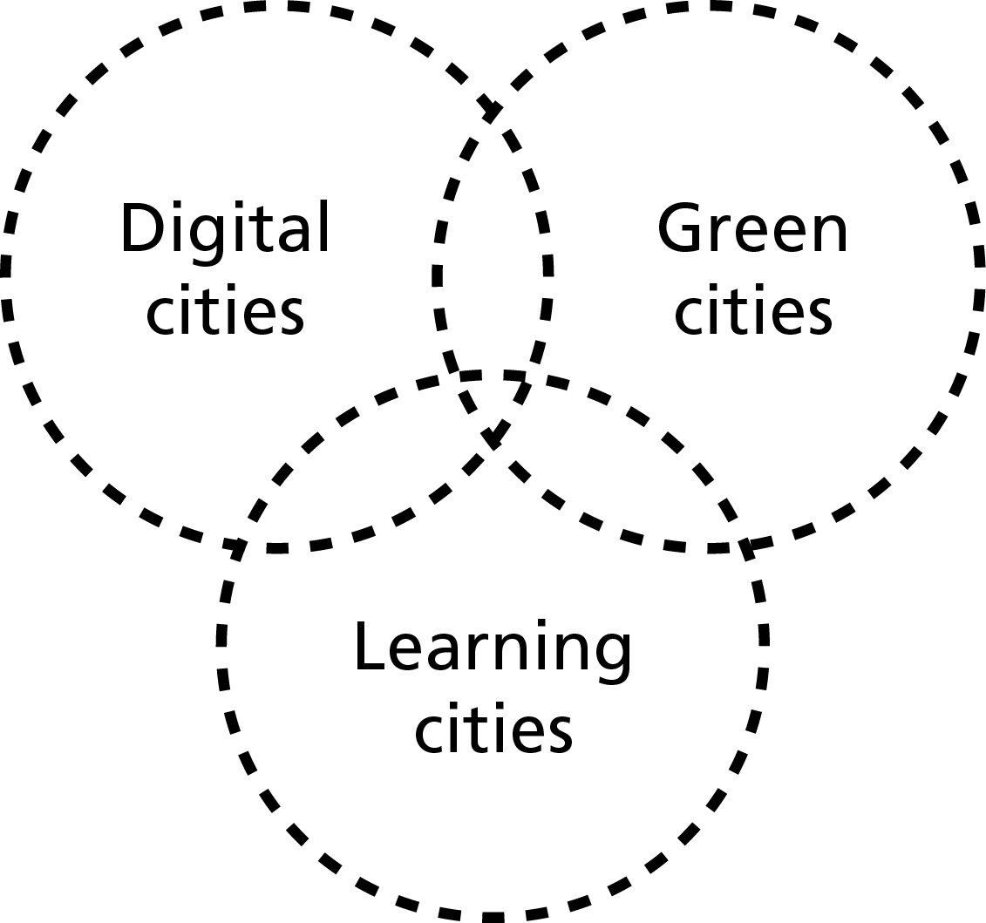

Source: Author

2) Digital danger zones

Having outlined the contours of the discourse about smart cities I want, in this section, to raise a few doubts about ICT-driven approaches to smart cities. Figure 1 could be taken to imply that the three perspectives on smart cities carry equal weight. This is not intended and this is certainly not the case. The dominant voices in the smart cities discourse are the digital enthusiasts – the big ICT companies, who have a clear vested interest, but also the civic hackers discussed by Townsend (2013). There is not space here to develop a full critique but, since the vast bulk of writing on digital cities is self-congratulatory in tone, it serves a useful purpose to raise a few concerns. My aim here is to encourage those involved in ICT-based approaches to smart cities to consider whether or not their activities are leading to the creation of more inclusive cities. Is digital power reducing inequality in the city? Are excluded voices now listened to in a way that did not happen before? If the answer to these questions is ‘No’, can ICT be employed to tackle social exclusion and bolster citizen power? I raise five points for consideration.

First, it is reasonable to ask: Where is the evidence that ICT is enhancing the quality of urban democracy? The evidence suggests, while e-government is delivering benefits – for example, improved public access to services - solid findings relating to the way e-democracy is strengthening citizen empowerment appear to be thin on the ground. It is right to celebrate ICT advances, like the electronic citizen cards introduced into cities like Zaragoza and Gijon in Spain. In these cities, with some variation in the details, a single citizen electronic card enables the owner to pay for public transport, unlock a bike-share, borrow a book from a library, access Wi-Fi, and pay for things like entry to a swimming pool and car parking. This is prize-winning, high quality e-government (or service delivery). But do these electronic cards enhance citizen power in relation to the governance of their city?

Second, we have the acute problem of the digital divide. On the whole poor families and communities suffer a double, digital disadvantage. They tend to have poor access to the Internet and, in addition, they tend to lack the skills needed to make use of online resources (Mossberger et al 2008). In a successful, democratic city all residents are able to participate fully in society. It follows that a useful test of ‘smartness’ concerns the degree to which any given innovation furthers this democratic end. The creative development of ICT to enhance the quality of life in the city for all residents is full of possibilities. But, unfortunately, the evidence suggests that online services and processes are bolstering inequality. It follows that a central question for the smart city debate is: ‘Smart for whom?’ Answering ‘Everyone’ is not a convincing response given that we know that many smart-city efforts are failing to tackle social exclusion.

A third concern relates to the fact that there is now a substantial body of evidence suggesting that digital empowerment is a myth (Hindman 2009). This is because there are, not surprisingly, powerful hierarchies shaping a medium that continues to be celebrated for its openness:

‘This hierarchy is structural, woven into the hyperlinks that make up the Web; it is economic, in the dominance of companies like Google, Yahoo! and Microsoft; and it is social, in the small group of white, highly educated, male professionals who are vastly overrepresented in online opinion’ (Hindman 2009 pp 18-19)

In an incisive analysis Hindman shows how the Internet has served to level some existing political inequalities, but it has also created new ones. He points out that true participation requires citizens to engage in direct discussion with other citizens. But ICT is not doing too well on this score. His research shows that, whilst more citizens than ever before are contributing views via the Internet, this does little to enhance democracy if hardly anyone reads these outpourings:

‘From the perspective of mass politics, we care most not about who posts but about what gets read – and there are plenty of formal and informal barriers that hinder ordinary citizens’ ability to reach an audience. Most online content receives no link, attracts no eyeballs, and has minimal political relevance’ (Hindman 2009 p18).

The fourth problem, and this was identified by Hatzelhoffer et al (2012 pp 204-205), is that many people are sceptical about the benefits of ICT. Disadvantages of ICT identified by respondents in their study of smart city policies in Friedrichshafen, Germany include: 1) It leads to less physical exercise, 2) It competes with face-to-face social and cultural activities, 3) The information provided is often perceived as false, 4) Use of the Internet can become addictive, 5) The cost of Internet and mobile usage is very high, and 6) There is too much advertising and spam. It is possible that some of these complaints are not that well founded, but it would it would be foolish to believe that they can all be dismissed out of hand.

A fifth concern relates to the invasion of privacy. The large scale sensing of data about people creates profound civil liberty concerns. The arrival of Big Data in urban management only amplifies this worry. Enthusiasts for the use of Big Data claim that sophisticated data gathering tools can provide useful information that will enable governments to advance the public good (Williams 2013). Some advocates go further and claim that: ‘Big data is poised to reshape the way we live, work and think… The ground beneath our feet is shifting… Soon big data will be able to tell whether we’re falling in love’ (Mayer-Schonberger and Cukier 2013 pp192-194). These writers betray an astonishing lack of awareness of the potential downsides of Big Data. Carried away by the possibilities of manipulating truly vast amounts of information about us, these believers fail to provide a forensic analysis of the safeguards that need to be introduced to protect our rights to privacy. To be fair, the authors just cited do refer to the risks associated with Big Data, and note that there is a ‘dark side of big data’ (p170). But, they fail to provide any clear and actionable suggestions on how to stop the dark side taking over. Vague suggestions about holding data users to account do not match the dangers we face.

What is to prevent governments from misusing the rich resources provided by smart city information systems? Stephen Graham (2010) documents the growth in the use of CCTV and electronic surveillance in many cities in recent years, and he draws attention to the erosion of civil liberties. In the past concerns about the stealthy, secret construction of an electronic police state in countries like the USA and the UK were often dismissed as alarmist. Not any more.

Edward Snowden, a former contractor to the US National Security Agency (NSA), has shown that these concerns are well founded. Following his decision to release details of the NSA mass surveillance programmes to responsible newspapers in June 2013, we now know of the existence of PRISM. This is an American, clandestine data-gathering system that has been assembling enormous amounts of data about the civilian population in the USA since 2007. This is an astonishing revelation, one that has shocked US citizens and been drawn to the attention of the judiciary. On 16 December 2013 Judge Richard Leon declared that this mass collection of so-called metadata probably violates the fourth amendment of the US Constitution, which bans unreasonable search and seizure. Leon noted the utter lack of evidence that a terrorist attack has ever been prevented because searching the NSA database was faster than other investigative tactics.

In a stinging judgement he described the NSA data gathering technology as ‘almost Orwellian’ and granted a preliminary injunction to plaintiffs Larry Klayman and Charles Strange, because he believed that a constitutional challenge was likely to be successful. The public pressure to rein in NSA use of mass surveillance was mounting and US President Obama was forced to act. On 17 January 2014 he announced important reforms, although civil liberty activists regard his statement as only a first step to restoring privacy. The Snowden revelations have stunned Americans, but citizens living in countries that share information with the NSA are equally shocked. A key question for ICT-driven smart cities initiatives that emerges from this discussion of privacy concerns is: How can smart city enthusiasts guarantee that governments will not misuse the innovative data systems they create?

3) Moving beyond the smart city

The discussion presented above is not an attempt to undermine the value of smart cities thinking or to discourage smart cities experiments. Rather I am hoping to encourage a more critical approach to the subject and, in particular, to stimulate a more penetrating consideration of the question: Who is gaining? The distributional effects of smart cities policies are not being given the attention they deserve. Unfortunately much of the literature on smart cities is dominated by case studies that appear to be little more than place-marketing literature, almost in the category of ‘Look how good we are’. Worse than that, some academic studies are overly technical in emphasis, and fail to examine how smart cities policies relate to the politics of power in the cities concerned. A current example is provided by a major European Union funded study of ‘smart cities of the future’. The international team of eight scholars carrying out this massive international study offer this evidence-free statement:

‘Smart cities are equitable cities…. We believe that… the sort of infrastructure, expertise and data that will characterise the smart city will enable equity to be easily established and such cities to improve the quality of urban life’ (Batty et al 2012 p 516)

Claims of this kind are deeply troubling. The suggestion that smart cities are equitable is, of course, pure assertion, and the belief that equity is ‘easily established’ in smart cities betrays political naivety. Granted, it is possible to imagine a future in which ICT makes a contribution to the development of inclusive, democratic cities. However, I have drawn attention to some of the significant challenges that ICT-focussed efforts at urban innovation will need to address if such aspirations are to be realised. Scholarship on digital cities that fails to deal head-on with the five danger zones I have outlined can be expected to produce findings that are of limited value.
In the rest of this paper I want to make a case for developing a deeper understanding of the nature of public learning and democratic innovation in the modern city. I will argue that we need to go well beyond the confines of the limiting smart city discourse. Spectacular advances in ICT, including revolutions in social media and crowd-sourcing, are not going save our cities. It is the exercise of judgement that matters, not technological advance. It is possible that innovations in ICT can contribute to making cities more inclusive, but only if these developments are driven by public purpose.

In my forthcoming book I argue that place-based leaders are central to the effective performance of democratic cities and that they can promote the development of inclusive cities (Hambleton 2015). Such leaders articulate public purpose and exercise well-informed, value-based judgements in their decision-making to advance it. This line of reasoning leads me to suggest that, when it comes to civic leadership, the focus of attention should be on wisdom, not smartness. Put bluntly, being smart is an inadequate response to the challenges we face. It is not enough to be clever, quick, ingenious, nor will it help even if Big Data is superseded by Even Bigger Data. Acquiring zettabytes, or even yottabytes, of data about human and technical interactions in cities is not going to enhance the quality of life in cities in the absence of judgement.

Leadership requires far more than intellectual dexterity. Following Keohane (2010), I am suggesting that leadership involves broadening your perspective to take account of the views of others affected by your judgements. It involves making an emotional connection - and effective place-based leadership depends on wisdom. What is wisdom? The simple answer is the judicious application of knowledge. The key word here is judicious. Knowing a vast amount is not, in the end, what matters – it is being able to exercise judgement that is critical. Sir Geoffrey Vickers, one of the best writers on the art of judgement, has written extensively about the application of knowledge in decision-making (Vickers 1965). He offers profound insights and returns, time and again, to the nature of values in the policy process:

‘Learning what to want is the most radical, the most painful and the most creative art of life’ (Vickers 1970 p76)

Sir Geoffrey signals an important message for modern civic leaders. Forget about data and technology for a moment and ask: What kind of city do we want to create? The idea of the city as an advanced learning system offers potential. Such a city draws insights from a range of forms of knowledge, not just data that can be captured by electronic surveillance and presented on a computer screen. Information about how people feel about living in the city is of critical importance. This more rounded social knowledge is in people’s heads.

It is helpful to make a distinction between ‘explicit’ knowledge (sometimes described as formal, scientific or professional knowledge) and ‘tacit’ knowledge (meaning knowledge stemming from personal and social experience) (McInerney and Day 2007). Tacit knowledge is often undervalued in public policy making and this is clearly misguided. Tacit knowledge embodies understanding of what it is like to live in the city and it embraces emotions – it includes an appreciation of loyalty and civic identity. Successful civic leadership pays attention to how the city feels. Wise city leaders build their understanding by drawing on both kinds of knowledge. The soft evidence derived from tacit knowledge is blended with the hard evidence presented by explicit knowledge.

4) Redefining scholarship

As part of this presentation I want to suggest that universities are a neglected resource in many cities. They can, perhaps, provide a useful corrective to ‘technological fix’ approaches to smart city thinking. Reflecting their origins, many fine universities are located in the middle of their city and, simply by virtue of their presence, they have an impact on urban and regional developments as well as the local civic culture (Goddard and Vallance 2013).

However, many universities do not see themselves as key players in improving the quality of life in their city. For example, the traditional European academic view of the university is that it stands apart. The campus is viewed as a cloistered realm that is, somehow, detached from the surrounding area – a separate reflective place devoted to learning, research and study. Increasingly, and we will return to this theme shortly, universities are recognising that this attempt to cut academic life off from society not only creates town-gown tensions, but also misses significant opportunities for student learning, practice-oriented research and innovation in theory building. The disconnected campus is an outdated view of the role of the modern university. Yes, we need critical scholars who stand aloof from the hurly burly of public policy making, who bring a fresh eye to the challenges facing the modern city and who focus on advancing urban theory. But we also need academics who can connect effectively to the world of policy and practice, who are passionate about the possibilities for local community activism and who recognise the value of tacit as well as explicit knowledge.

Engaged scholarship

At this point I would like to introduce the idea of ‘engaged scholarship’, a phrase used to describe a process in which the academic and civic cultures communicate with each other in a creative way (Boyer 1990). I define engaged scholarship as the co-creation of new knowledge by scholars and practitioners working together in a shared process of discovery. For the purposes of this definition a practitioner is anyone who is not a scholar. Figure 2 illustrates how practice and academe are brought together in engaged scholarship. In some of the most innovative cities in the world universities see themselves as place-based leaders and play an active role in, for example, the co-creation of knowledge relating to urban development (Perry and Wiewel 2005; Wiewel and Perry 2008). Later in this paper I will present two short Innovation Stories to illustrate this argument. First, however, it is helpful to reflect on the changing nature of scholarship in the modern world.

In 1862 Abraham Lincoln signed into US law the famous Morrill Act. This heralded, not just a startling expansion of higher education in the US, but also a reframing of the very purpose of a university. The Act, later called the Land Grant College Act, provided grants of federal lands to the states for the creation of public universities and colleges. Using proceeds from the sale of the land these ‘land-grant’ universities were to provide for ‘the liberal and practical education of the industrial classes in the several pursuits and professions of life’. This was a breath taking innovation that lead to the establishment in every state of a distinctively American kind of university, one that attempted to fuse scholarly inspiration with a strong commitment to practical application. Some 150 years later the US continues to benefit from the foresight shown by Representative Justin Smith Morrill and his colleagues as the vision he espoused was of an ‘engaged university’, not an ivory tower.

Ernest Boyer, in his insightful book Scholarship Reconsidered (1990), built on the land grant tradition to articulate a more rounded view of the nature of modern scholarship than the one that still prevails in many universities today. He felt that it was time:

‘… to move beyond the tired old “teaching versus research” debate and give the familiar and honorable term “scholarship” a broader, more capacious meaning, one that brings legitimacy to the full scope of academic work’ (Boyer 1990 p16)

Boyer distinguishes four overlapping kinds of scholarship:

- The scholarship of discovery comes closest to what is meant when academics speak of research. It contributes not only to the stock of human knowledge but also to the intellectual climate of a college or university

- The scholarship of integration gives meaning to isolated facts, putting them in perspective. It places discoveries into their larger scientific, social and political context. It is serious disciplined work that seeks to interpret, draw together, and bring new insights to bear on original research

- The scholarship of application applies knowledge to consequential problems. Boyer does not see this as a one-way process in which knowledge is first ‘discovered’ and then ‘applied’. He stresses that new intellectual understandings can arise from the very act of application

- The scholarship of teaching keeps the flame of scholarship alive by sharing knowledge not just with students in the lecture theatre or seminar room but also by disseminating insights and research findings in the public sphere

Boyer stresses that what we urgently need today is a more inclusive view of that it means to be a scholar: ‘… a recognition that knowledge is acquired through research, through synthesis, through practice, and through teaching’ (Boyer 1990 p24). In Figure 2 I provide a visual illustration of Ernest Boyer’s taxonomy of scholarship. This shows that all four kinds of scholarship overlap one another.

Figure 2 Enlarging the definition of scholarship

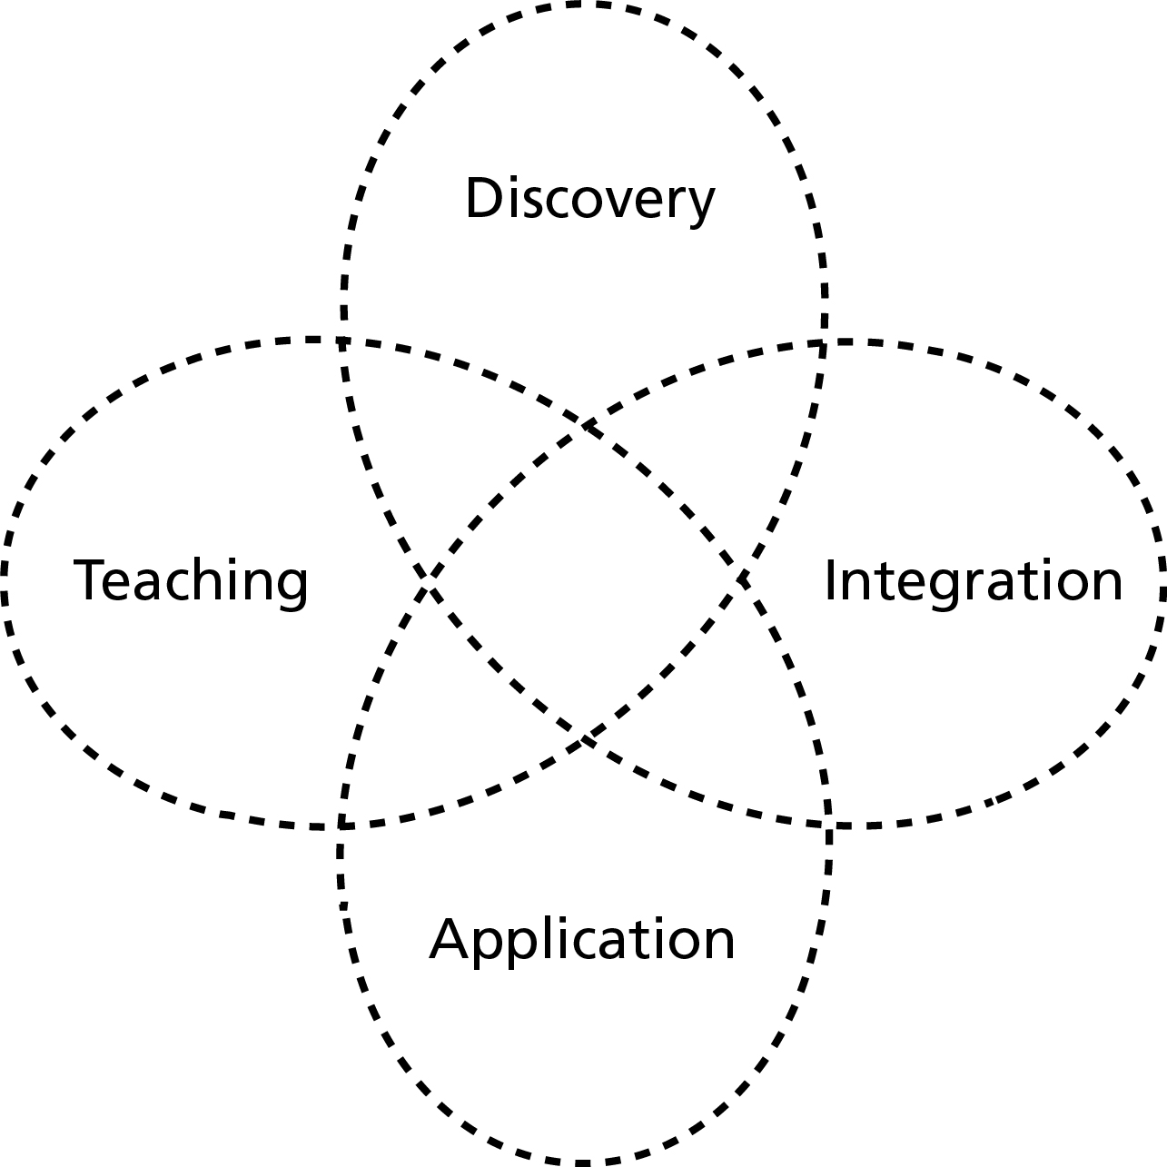

Source: Concepts – Boyer 1990 pp15-25; Diagram - Author

Boyer argues that the interactions between the different kinds of scholarship enhance the performance of the whole. In effect Boyer presents a strong argument against the disengaged university. Indeed, according to Mathew Flinders (2013 p629), he offers a ‘damning and far-reaching critique of the gradual withdrawal of academics from the public sphere’. Boyer’s ideas had a significant impact on US higher education. Many universities took account of his analysis and revised their academic promotion and evaluation criteria to take account of his wider definition of scholarship.

The triangle of engaged scholarship

By building on Boyer’s analysis, and my own experience of working in British and American universities, I have identified a ‘triangle of engaged scholarship’ (Hambleton 2007). In this model the familiar pillars of research and education, long established in the European tradition, are linked to a third pillar: policy and practice. This conceptualization is shown in Figure 3. It is my contention that it is the sides of the triangle that hold out exciting possibilities for intellectual and practical advance. The triangle suggests that the talents and resources of a university can be conjoined in a creative way with the world of policy and practice to the benefit of all stakeholders. The Innovation Stories presented in this paper provide examples of interaction on the left hand side of the triangle. In this case, the process involves researchers and practitioners co-creating plausible accounts of urban innovation. Turning to the right hand side of the triangle, well-managed student projects can benefit policy and practice in a city as well as enhance the learning experience of the students involved. This approach is well established in American urban planning programmes – see, for example, the edited collection provided by Lorlene Hoyt (2013). Along the bottom side of the triangle academics feed insights drawn from research into course content and they work with students to co-create new insights.

Figure 3 The triangle of engaged scholarship

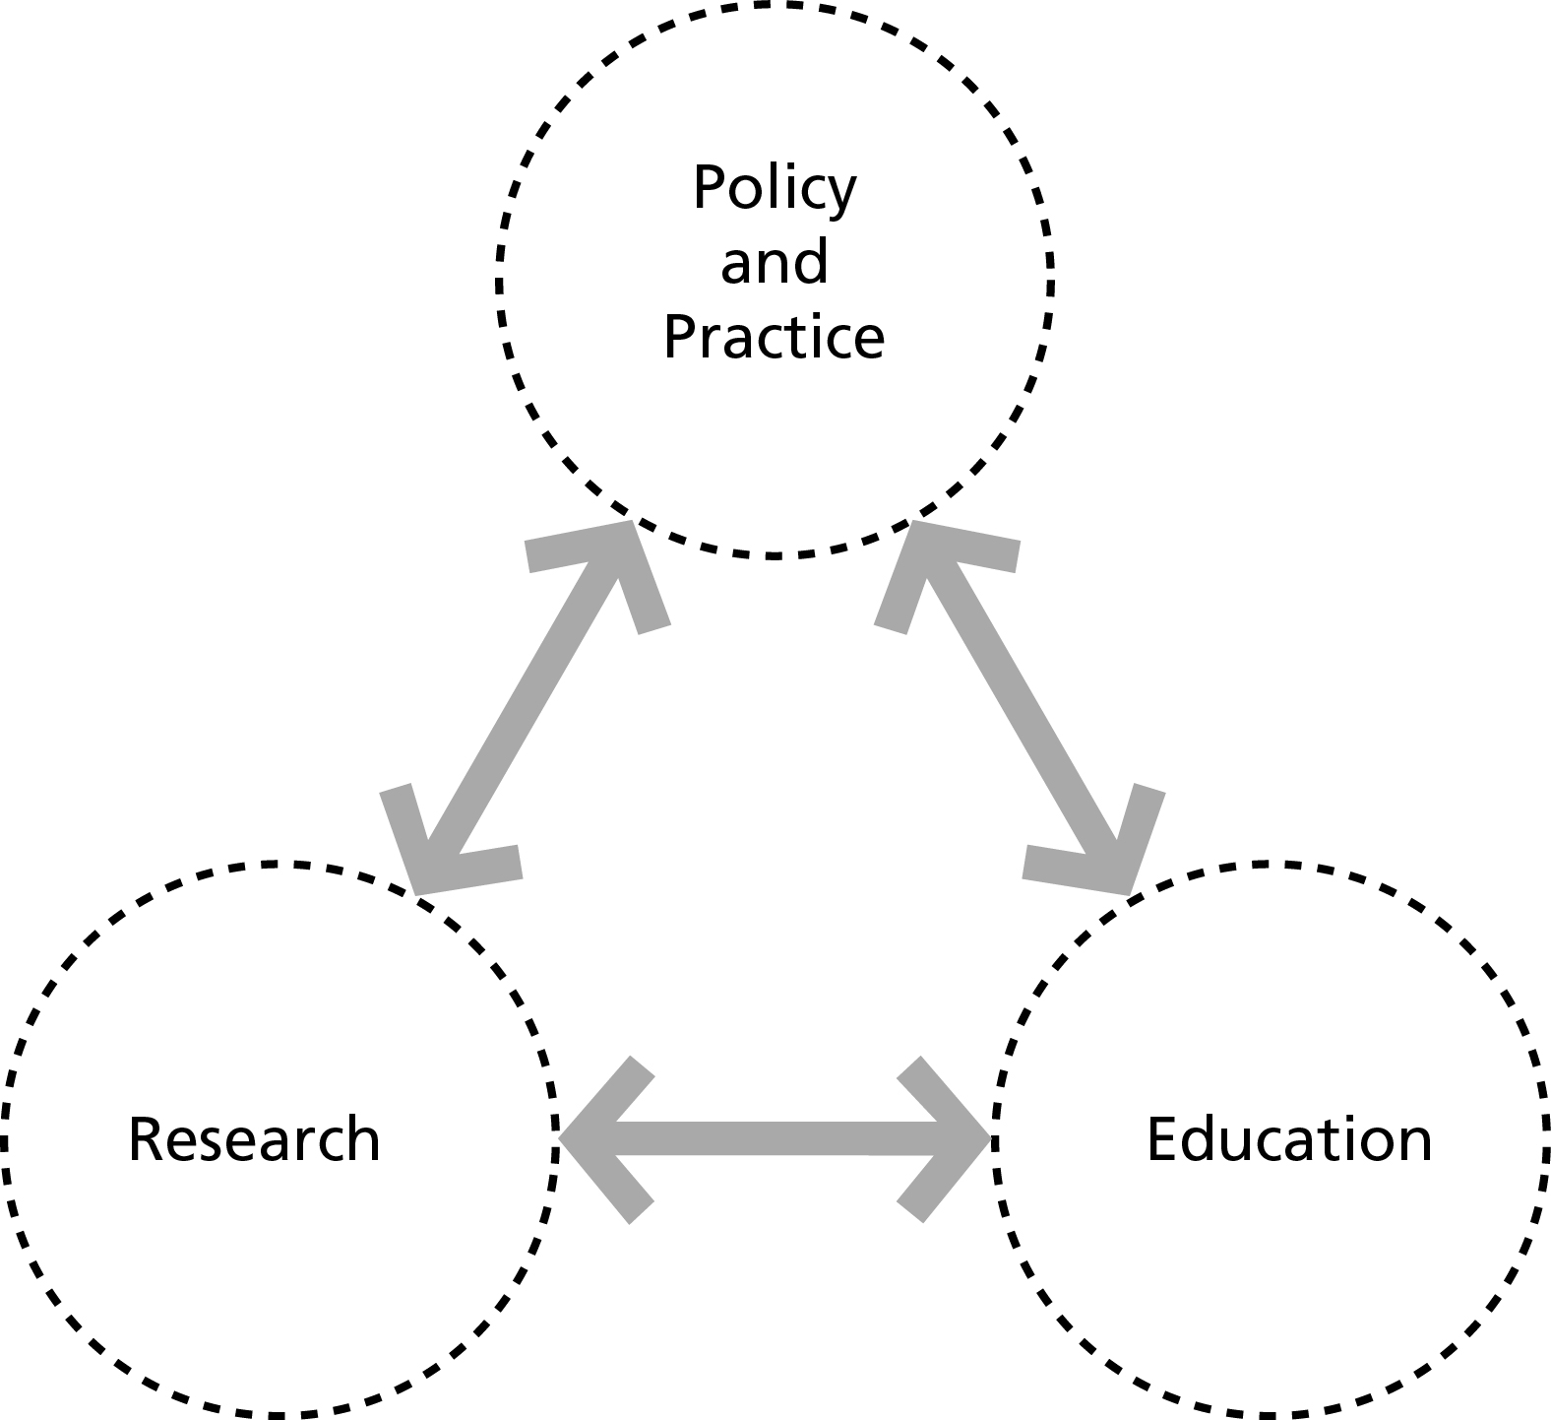

Source: Hambleton 2007 p551

Ernest Boyer was a visionary thinker and he now has a growing number of followers. Certainly the notion of ‘engaged scholarship’ has flourished in recent years. This surge of interest in strengthening the societal relevance of universities can be seen in efforts to promote ‘knowledge exchange’ and university ‘public engagement’ in many countries. Many scholars across the world are breaking new ground in changing the relationships between their university and their city. Not all of them will use the language of ‘engaged scholarship’ but the significance of their efforts for the future of higher education is difficult to over estimate.

Because of the land grant tradition the culture of civic engagement is particularly well developed in many US public universities. But, even in America, there is room for improvement. A study by the Pew Partnership notes that:

‘Many colleges and universities articulate a commitment to the public good but too often fail to bear witness to that commitment intellectually, structurally, institutionally, or behaviorally.’ (Pew Partnership 2004 p2)

The same could be said of colleges and universities in just about any country. The Pew Partnership report presents evidence from the US of university innovations in civic engagement, and concludes that higher education has a vital role to play in helping to address national and community problems, and in preparing students for engaged, responsible citizenship.

It is encouraging to note that academic interest in civic, or public, engagement has grown in recent years. For example, in the UK, the Academy of Social Sciences has set out advice on how learned societies can become more active in knowledge exchange and public engagement (Benyon and David 2008). Moreover, a National Coordinating Centre for Public Engagement (NCCPE) was created in 2008 to help inspire and support universities to engage with the public. Added to this, the Talloires Network is working hard to build up an international network of universities committed to public and civic engagement.

5) Universities as place-based leaders

In this paper I have suggested that civic leaders and their advisers might find it helpful to move beyond notions of the smart city and consider ways of creating the wise city. Universities can, in my view, make a significant contribution to this process. The ‘engaged university’ is rooted in the locality and makes a respected contribution as a place-based leader. It puts time and resources into the cultivation of a local civic culture that welcomes study, analysis and public learning. It supports research on and for the city, values community development and fosters action-oriented student learning. A growing number of urban universities see themselves in this way. They have rethought the nature of modern scholarship, taking account of ideas like those put forward by Ernest Boyer (1990), and they give serious backing to the notion of ‘engaged scholarship’ in their recruitment and promotion procedures. I was fortunate to work in one such university – the University of Illinois at Chicago (UIC) – for a period. In this instance the university as a whole is deeply committed to ‘engaged scholarship’ and this strategy is furthered through an initiative known as the Great Cities Commitment. Made by UIC in 1993 this commitment aims to promote urban research to improve the quality of life in Chicago and other cities around the world.

In this section I present two edited Innovation Stories providing illustrations of the work of two very different urban universities: Portland State University, Oregon, USA and the CEPT University in Armedabad, India. I have chosen these two universities because they illuminate, in very different settings, what ‘engaged scholarship’ can look like in practice. One is operating in a highly developed country – the USA – while the other is making an important contribution in a developing country – India.

Engaged scholarship: Portland State University

Portland, Oregon has acquired a reputation as one of the USA’s most liveable and progressive urban areas. A city of 588,000 in a metropolitan area of 1.8 million, Portland has a long-established commitment to sustainable urban development. American urban planning scholars celebrate the quality of policy-making and governance in the city not least because, over a long period, political leadership has secured an integrated approach to land use and transport planning. This brings together the state, metropolitan and local governments in a unified process. These interlocking relationships have enabled the development of farsighted policies that have succeeded in, amongst other things, restricting urban sprawl, promoting eco-friendly urban design and creating an extensive network of public parks.

In 2012 the City Council adopted a new plan for the city – The Portland Plan. This is innovative as it puts advancing equity at heart of the strategy. The City is attempting to build on its successful approach to sustainable development by building in a stronger commitment to social justice in the period through to 2035. Within this context of progressive city leadership, the city’s university – Portland State University (PSU) - is playing, in partnership with the City of Portland, other public agencies, community groups and the private sector, a key part in efforts to make Portland a more sustainable and a more inclusive city.

PSU is the only comprehensive public university in Portland, Oregon’s largest city. It has 30,000 students and is located on a campus in the heart of the Portland business district. The university is committed to tackling urban problems and to improving the quality of life for the citizens of Portland and other cities as reflected in its motto Let Knowledge Serve the City. Central to achieving this commitment is the University’s vision for engaged and innovative scholarship that ‘contributes to the economic vitality, environmental sustainability, and quality of life in the Portland region and beyond’.

Spearheading PSU’s commitment to sustainability through applied scholarship is the University’s President, Wim Wiewel. Building on the approach of previous presidents he is strongly committed to the notion of an engaged university. He believes that PSU should be seen as a community asset with a significant contribution to make to public policy and practice relating to both sustainability and equity in the city region and beyond.

For more than twenty years faculty in the university have played important civic leadership roles in the city and the city region. Here there is space only to mention two current initiatives to illustrate how PSU actively engages with the city and local partners to find innovative solutions to public policy challenges – one focussing on environmental sustainability, and one addressing equity.

Launched in 2011, Electric Avenue is a joint research and development initiative of PSU, the City of Portland and Portland General Electric, and a number of other partners. The aim of the initiative is to learn about the performance of charging stations for electric vehicles, and driver preferences relating to charging and travel patterns. This action/research project is very hands on – it has provided seven charging stations for electric vehicles on a public street in the PSU campus and is monitoring usage. This study, which is designed to throw new light on the practical aspects of providing electric charging services for vehicles, ties in well with the idea of promoting the export of green technological innovations from the region.

In 2009 PSU built on an idea, first developed in Cincinnati, to develop a comprehensive approach to supporting the success of every child from Cradle to Career – meaning from pre-school through college. Many partners are involved in this initiative – the Leaders Roundtable, the Mayor and the City, Multnomah County, social service providers, community organisations and others. The strategy has involved the development of a set of agreed educational and social performance indicators relating to a child’s readiness for kindergarten through to post-secondary education and into a career. The aim is to identify the stages at which a child needs support and then to co-ordinate efforts to deliver that support.

The initiative has led to the creation of a new crosscutting partnership known as All Hands Raised. This orchestrates the process of collaboration and shares progress and early results generated by the collaborative efforts. The underlying idea is that community leaders can achieve high collective impact if they abandon their individual agendas for change and work towards a collective approach to improving student achievement.

These examples show that, by bringing together academics, students, politicians, business people, community activists and citizens, the PSU is playing an important role in the place-based leadership of the city, the city region and the state as a whole.

Engaged scholarship: CEPT University, Ahmedabad

Ahmedabad, the largest city in Gujarat, provides an intriguing illustration, not just of the tensions that arise when a city expands rapidly, but also of the kinds of strategies that might be pursued in order to make the burgeoning metropolis more livable than might otherwise be the case. Ahmedabad established itself in the early 20th Century as the home of the expanding textile industry, and earned the nickname ‘Manchester of the East’. The population of the city grew from 274,000 in 1921, when Mahatma Gandhi moved to the city, to around 6.3 million in the metropolitan area in 2014. This figure is expected to jump to 12.5 million by 2030.

In his detailed history of the city Howard Spodek (2011) describes Ahmedabad as the ‘shock’ city of 20th Century India. He suggests that this capacity to shock has several dimensions. For example, on the upside the city made a startling economic recovery following the collapse of the textile industry in the city in the 1980s. On the downside the city acquired world notoriety for public conflict between Hindus and Muslims, with truly horrendous outbreaks of violence in 2002 (Spodek 2011 pp 248-270). CEPT University, founded in 1962, has played an active role not just in educating students who have gone on to have careers in Ahmedabad but also in contributing actively to public policy making for the city.

CEPT University has five faculties – Architecture, Planning, Technology, Design and Management. Teaching programmes focus on building professional capacities and are centred on ‘studios’ or ‘labs’. Here students engage with real problems and challenges. Practising professionals contribute to courses and the university works as a collaborative of academics and practitioners.

To illustrate the approach I refer here briefly to the role of scholars in CEPT in helping to create a path-breaking approach to public transport in the city. Professional staff from CEPT were involved in preparing the detailed plans for both Phase 1 (2006-07) and Phase 2 (2008) of the Bus Rapid Transit (BRT) system, and the Centre for Excellence in Urban Transport at CEPT is now the principal consultant to the Ahmedabad Municipal Corporation (AMC) for planning and designing BRT routes and stations. Supported by the Indian Ministry of Urban Development (MoUD) and the AMC, the Centre provides ongoing advice to Janmarg (which means ‘people’s way’), the company created to run the BRT. Recent research on BRT systems in India suggests that Ahmedabad is exceptional in that it now has in place about 45km of a rapid transit network, whereas other cities seem to have been unable to expand their initial ‘pilot’ BRT corridors. The BRT system has won several national and international awards for imaginative urban transport planning and management.

Evaluation research on BRT systems in India suggests that they are far cheaper than rail-based transport systems (Mahadevia et al 2012). For example, the Delhi Metro Rail Corridor cost $29.5 million per kilometre whereas a BRT costs $1.93 million per kilometre. Research on the impact of the Ahmedabad BRT suggests that the system has, indeed, been very cost-effective when compared with rail-based options. In the first three months of operation the system was free to use, and this resulted in a high level of positive feedback from the public and the media. BRT stations are neat and clean, the frequency of buses is maintained and support staff is always available. Survey research suggests that 12% of BRT passengers have shifted their travel from private motorised modes.

The same research suggests, however, that the BRT in Ahmedabad has, at present, some limitations. First, the original plans for well-designed walking and cycling facilities linked to the BRT stations have not been implemented. The buses run on central median lanes and are not linked adequately into urban neighbourhoods. Second, the fares are too high for low-income households with the result that the urban poor, and especially women among them, are not receiving the hoped-for benefits.

A university can contribute knowledge and expertise to urban planning and policy making in the city where it is located. CEPT University is making a research-based, influential contribution to public policy making in the city of Ahmedabad. The ethos of the university places a high value on collaboration between academics and practitioners.

Reflections and conclusions

In this paper I have suggested that the idea of ‘smart cities’ has been, and is being, oversold. It is clear that advances in communication technologies can bring benefits to service users but the gains may be more superficial than might, at first, appear. On the plus side, it is clear that innovations with ICT can enhance access to public services and improve the ability of public servants to respond to requests from citizens. Moreover open data and social media initiatives can provide exciting opportunities for social entrepreneurs to create new apps to meet social needs. Smart city initiatives that bring together digital experts with non-technical people can be expected to lead to significant improvements in public service responsiveness in the years ahead.

However, I have suggested that, when it comes to efforts to deepen democracy and strengthen citizen participation, the evidence that ICT can make a big difference is thin on the ground. The arrival of e-democracy has been underwhelming. It has certainly not led to a surge of effective innovations in citizen empowerment. While ICT can deliver vast amounts of information to citizens, it does not appear to be doing that much to advance the creation of democratic, inclusive cities.

The paper has identified five weaknesses in ICT-driven approaches to smart cities. I have called these danger zones, rather than fundamental flaws. It is possible that ICT experts can work with others to find ways of navigating safe and fruitful paths through these danger zones. At this point, however, the route maps across this minefield have yet to be constructed. It is clear, then, that technologically driven approaches to urban governance have serious limitations. This is why I have argued that we need to develop a deeper understanding of the nature of public learning and democratic innovation in the modern city. My central suggestion is that decision-making in and for cities should be led by sound judgement, not technological advance. From the point of view of public policy ICT innovations that fail to serve public purpose are a distraction. Hence my headline argument that future thinking about cities should focus not on developing smart cities but on creating wise cities.

How do we do this? There are many ways, but one possibility is to tap into the resources of local universities. In many cities, universities are the sleeping giants of place-based leadership and social innovation. However, the giant is waking up. Across the world higher education is undergoing significant change and, as part of the rethinking of the role of universities in modern society, the very nature of scholarship is being reconsidered.

In this paper I have suggested that the notion of ‘engaged scholarship’ has much to commend it. I have outlined what it means, and provided two examples to show how universities can make an important contribution to the creation of the inclusive city. Portland State University is playing an active part in the governance of the City of Portland and the wider city region. And CEPT University is contributing to public policy making in the Ahmedabad metropolitan area. These two universities are not alone in demonstrating a strong commitment to ‘engaged scholarship’. It is encouraging to note that a growing number of scholars in a wide range of disciplines now see active engagement with the city as a splendid way to advance knowledge and understanding, invent new theories as well as contribute to public purpose. Universities can, perhaps, assist in helping public policy makers and activists deepen understanding of public learning and radical innovation in the modern city.

References

Batty M., Axhausen K. W., Giannotti F., Pozdnoukhov A., Bazzani A., Wachowicz M., Ouzounis G. and Portugali Y. (2012) ‘Smart cities of the future’, The European Physical Journal Special Topics, 214, pp 481-518

Benyon J. and David M. (2008) Developing Dialogue. Learned Societies in the Social Sciences: Developing Knowledge Transfer and Public Engagement. London: Academy of Social Sciences

Boyer E. L. (1990) Scholarship Reconsidered. Priorities of the Professoriate. New Jersey: The Carnegie Foundation for the Advancement of Teaching

Campbell T. (2012) Beyond Smart Cities. How cities network, learn and innovate. London: Earthscan

Condon P. M. (2010) Seven Rules for Sustainable Communities. Design strategies for the post-carbon world. Washington DC: Island Press

Deakin M. and Al Waer H. (eds) (2012) From Intelligent to Smart Cities. Abingdon: Routledge

Dittmar H. and Ohland G. (eds) (2004) The New Transit Town. Best practices in transit-oriented development. Washington DC: Island Press

Elman S. E. and Marx Smock S. (1985) Professional Service and Faculty Rewards. Toward an integrated structure. Washington DC: National Association of State Universities and Lan-Grant Colleges

Flinders M. (2013) ‘The politics of engaged scholarship: impact, relevance and imagination’, Policy and Politics, Vol 41, No 4, pp 621-642

Goddard J. and Vallance J. (2013) The University and the City. Abingdon: Routledge

Graham S. (2010) Cities Under Siege. The new military urbanism. London: Verso

Hambleton R. (2007) ‘The triangle of engaged scholarship’ Planning Theory and Practice, Vol 8, No 4, pp 549-553

Hambleton R. (2015) Leading the Inclusive City. Place-based innovation for a bounded planet. Bristol: The Policy Press

Hambleton R. and Howard J. (2012) Public Sector Innovation and Local Leadership in the UK and the Netherlands. York: Joseph Rowntree Foundation

Hambleton R. and Howard J. (2013) ‘Place-based leadership and public service innovation’, Local Government Studies, Vol 39, No 1, pp 47-70

Hatzelhoffer L., Humboldt K., Lobeck M. and Wiegandt C. C. (2012) Smart City in Practice. Converting innovative cities into reality. Berlin: jovis Verlag GmbH

Hindman M. (2009) The Myth of Digital Democracy. Princeton NJ: Princeton University Press

Hoyt L. (ed) (2013) Transforming Cities and Minds through the Scholarship of Engagement. Economy, equity and environment. Nashville TN: Vanderbilt University Press

Keohane N. O. (2010) Thinking about leadership. Princeton, NJ; Princeton University Press

Mahadevia D., Joshi R. and Datey A. (2013) ‘Ahmedabad’s BRT system. A sustainable urban transport panacea? Economic and Political Weekly, Vol XLVIII, No 48, November, pp 56-6

Mayer-Schonberger V. and Cukier K. (2013) Big Data. A revolution that will transform how we live, work and think. London: John Murray

McInerney C. R. and Day R. E. (2007) Rethinking Knowledge Management. New York: Springer

Mossberger K., Tolbert C. J. and McNeal R. S. (2008) Digital Citizenship. The internet, society and participation. Cambridge MA: The MIT Press

Neal Z. (2013) The Connected City. How networks are shaping the modern metropolis. Abingdon: Routledge

Perry D. C. and Wiewel W. (eds) (2005) The University as Urban Developer: Case studies and analysis. Armonk: M. E. Sharpe

Pew Partnership (2004) New Directions in Civic Engagement: University avenue meets main street. Charlottesville VA: Pew Partnership for Civic Change

Shirky C. (2008) Here comes everybody. How change happens when people come together. London: Penguin

Spodek H. (2011) Ahmedabad. Shock city of 20th Century India. Bloomington IN: Indiana University Press

Townsend A. M. (2013) Smart Cities. Big data, civic hackers and the quest for a new utopia. New York: W. W. Norton and Co Inc.

Vickers G. (1965) The Art of Judgement. New York: Basic Books

Vickers G. (1970) Freedom in a Rocking Boat. Changing values in an unstable society. Harmondsworth: Penguin

Wiewel W. and Perry D. C. (eds) (2008) Global Universities and Urban Development: Case studies and analysis. Armonk: M. E. Sharpe

Williams M. (2013) Open Data or Closed Doors? Supporting research in cities. December. London: Centre for Cities

Winkler T. (2013) ‘At the Coalface: Community-University Engagements and Planning Education’, Journal of Planning Education and Research, Vol 33, No 2, pp 215-227

Endnotes An Innovation Story is a short, structured narrative describing a particular public innovation. It attempts to throw light on how change was brought about and tries to draw out leadership lessons for others. Ideally, it should be co-created by scholars and practitioners working together to generate a plausible narrative of why and how bold public innovation took place. The method was first developed and applied in an Anglo/Dutch study of public sector innovation (Hambleton and Howard 2012).
This paper draws heavily on Chapter 11 of Leading the Inclusive City (Hambleton 2015)
For more information on the work of Future Cities Catapult visit: http://futurecities.catapult.org.uk
This linkage of ecological and digital agendas is, for example, a feature of urban policy making in Bristol. Jo Howard and I have examined this digital+green initiative elsewhere (Hambleton and Howard 2013)
On 27 December 2013 US District Judge William Pauley contradicted Judge Richard Leon and ruled that the NSA’s mass surveillance programme was legal. Two different judgements from the district courts can be expected to result in the issue going to an appeal court and eventually the US Supreme Court.
The traditional university evaluates scholars according to two main criteria: research and teaching. A university committed to the scholarship of engagement adds other criteria designed to assess the societal relevance of academic efforts (Elman and Marx Smock 1985). This aspect of scholarship is often called professional service in US universities but other terms are used – for example, societal impact and/or influence on policy and practice.
This approach overlaps with educational practices that are sometimes described as community or service learning. A note of caution is needed. Tanja Winkler (2013), writing from a South African perspective, notes that community-university engagements of this kind may not always deliver sufficient benefits to the communities involved.
There is an extensive literature on US higher education engagement in public policy and practice. Two associations of universities provide valuable online resources. The Coalition of Urban Serving Universities (USU) is a network of more than 40 large, public, urban research universities: www.usucoalition.org The Coalition of Urban and Metropolitan Universities (CUMU) includes a number of smaller urban universities and publishes a quarterly journal – Metropolitan Universities Journal. More: www.cumuonline.org A small but influential research and action institute focussing on how to use analysis to advance equity and social justice is PolicyLink: www.policylink.org
The National Coordinating Centre for Public Engagement (NCCPE) defines engagement as a two-way process, involving interaction and listening, with the goal of generating mutual benefit. It has an excellent website providing useful resources and links relating to university public engagement: www.publicengagement.ac.uk
The Talloires Network, created in 2005, is an international association of institutions committed to strengthening the civic roles and social responsibilities of higher education: www.talloiresnetwork.tufts.edu
The University of Illinois at Chicago (UIC) is a leading public research university. With over 27,000 students it is the largest university in the Chicago area. I was honoured to serve as Dean of the College of Urban Planning and Public Affairs at UIC from 2002-07, and learned a great deal from students, community partners, faculty and members of UIC administrative staff about the value of engaged scholarship.

