A novel photometric stereo imaging sensor for endoscopy imaging: proof of concept studies on a porcine model
A Poullis, C Groves, G Slabaugh*, K Emrith**, M Smith**
St George’s Hospital London, *Department of Computer Science, School of Informatics, City University, London, **Centre for Machine Vision, Bristol Robotics Laboratory, University of the West of England, Bristol
Introduction: The American Society of Gastroenterology Endoscopy led Preservation and Incorporation of Valuable Endoscopy Innovations initiative has identified real time poly diagnosis as one of the next major technology driven changes in endoscopy (1). A number of imaging techniques are presently being investigated in this area. The complex and demanding nature of the imaging environment, including issues relating to operation in a confined space, the presence of surface fluids and the highly reflective nature of the mucosa areas, renders 3D surface capture and analysis for the purpose of diagnosis an extremely challenging task. A novel Photometric Stereo (PS) imaging sensor has never been previously assessed for mucosal imaging. PS imaging requires the capture of the mucosal regions while illuminated using light from differing known directions and offers the potential for the recovery of high resolution 3D shape and topographic texture data. The captured PS images are then used to recover and analyse the 3D surface geometry.
Aims and Methods: Using a porcine gut model, photometric images were captured using a six-light source PS setup. PS assumes diffuse reflectance from the illuminated surfaces. We use a least squares approximation approach to estimate the surface in the presence of the highlights. Several areas of the porcine gastrointestinal tract were scanned. For each area investigated six photometric images were captured. The data from the six photometric images was used to recover the depth information.
Results: 3D reconstruction was obtained on all mucosal areas of the gastrointestinal tract that were studied (Figure 1). We observe that the recovered 3D surface retain the surface geometry in the captured areas and important structural information at a fine level of detail even in the presence of significant high-level of highlight patches. This is highly significant for automated processing and analysis of surface abnormalities.

 | Photometric Image | 3D surface
Colon | 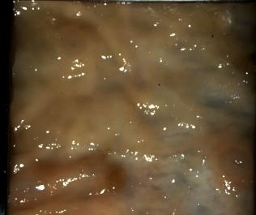 | 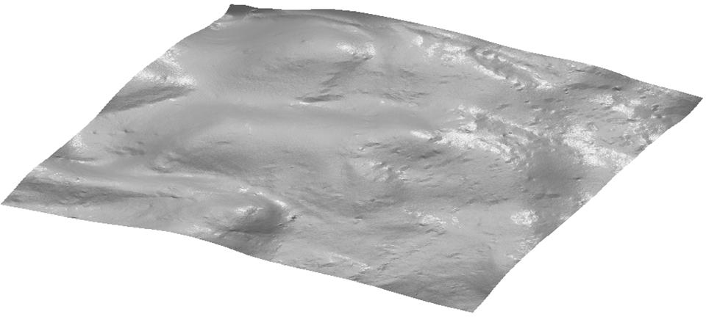
G.O.J | 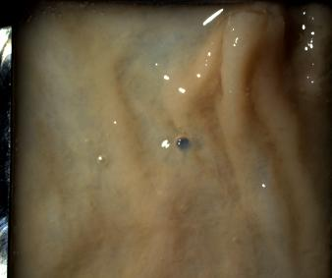 | 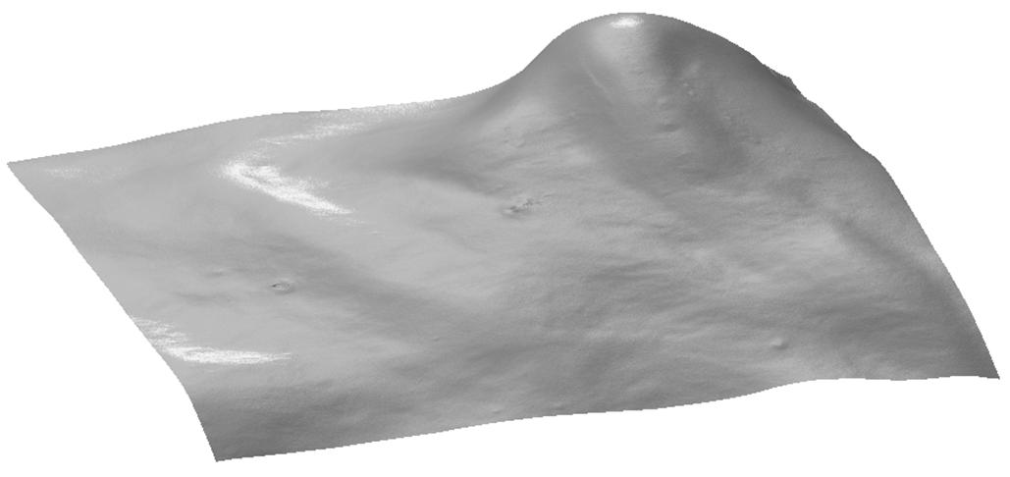
Duodenum | 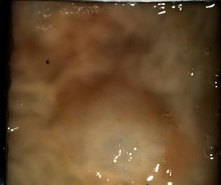 | 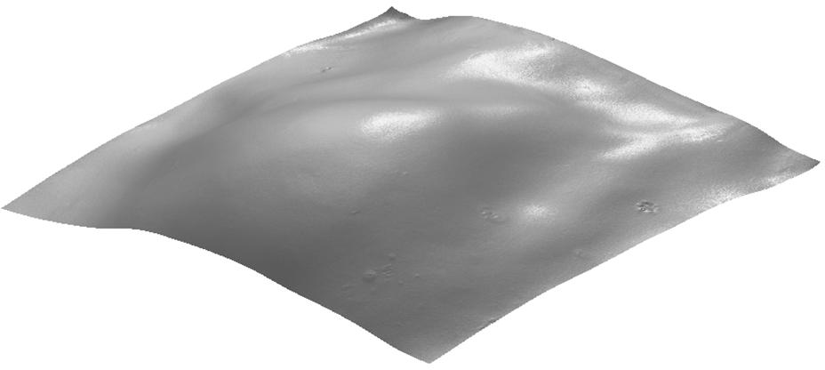
Oesophagus | 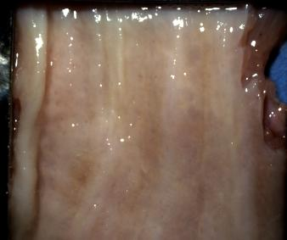 | 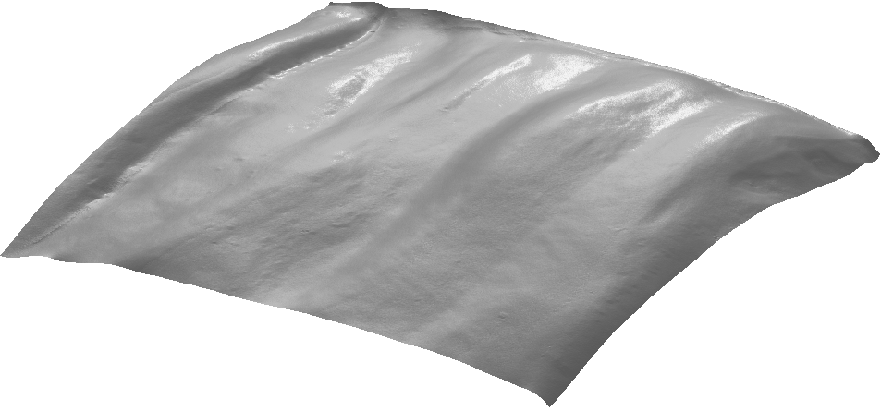
Figure 1. White light imaging and 3D surface reconstruction views.

Conclusion: Using a novel sensor technology it was possible to obtain mucosal views and 3D surface reconstruction on all areas of the gastrointestinal tract using a porcine model. 3D computer constructs of the mucosal views were obtained, raising the possibility of automated computer analysis of endoscopic images. This novel technique needs to be explored further in human studies.
1. Rex et al. Gastrointest Endosc 2011;73:419-22

