Sensors 2014, 14, 1-x manuscripts; doi:10.3390/s140x0000x
OPEN ACCESS
sensors
ISSN 1424-8220
www.mdpi.com/journal/sensors
Full paper
Development of a hydrogen peroxide sensor based on screen-printed electrodes modified with inkjet-printed Prussian blue nanoparticles
Stefano Cinti ¹ , Fabiana Arduini ¹, Danila Moscone ¹, Giuseppe Palleschi ¹, Anthony J. Killard ^{2*}
¹ Dipartimento di Scienze e Tecnologie Chimiche, Università di Roma Tor Vergata, Via della Ricerca Scientifica 1, 00133 Rome, Italy; E-Mail: Stefano.Cinti@uniroma2.it; Fabiana.Arduini@uniroma2.it; Danila.Moscone@uniroma2.it; Giuseppe.Palleschi@uniroma2.it
² Department of Biological, Biomedical and Analytical Sciences, Faculty of Health and Applied Sciences, University of the West of England, Coldharbour Lane, Bristol BS16 1QY; E-Mail: tony.killard@uwe.ac.uk
* Anthony J. Killard; E-Mail: tony.killard@uwe.ac.uk
Tel.: +44(0)117 32 82147; Fax: +44(0)117 34 42904.
Received: / Accepted: / Published:

Abstract: A sensor for the simple and sensitive measurement of hydrogen peroxide has been developed which is based on screen printed electrodes (SPEs) modified with Prussian blue nanoparticles (PBNPs), deposited using piezoelectric inkjet printing. PBNP-modified SPEs were characterized using physical and electrochemical techniques to optimize the PBNP layer thickness and electroanalytical conditions for optimum measurement of hydrogen peroxide. Sensor optimization resulted in a limit of detection of 2 x 10⁻⁷ M, a linear range from 0 to 4.5 mM and a sensitivity of 762 μA mM^{–1} cm^{–2} which was achieved using 20 layers of printed PBNPs. Sensors also demonstrated excellent reproducibility (<5% rsd).
Keywords: hydrogen peroxide; Prussian blue nanoparticles; screen-printed electrode; inkjet printing

1. Introduction
The effective measurement of hydrogen peroxide remains a critical analytical goal due to its widespread use in various fields such as food processing, textile industry, pulp and paper bleaching, pharmaceutical research, clinical chemistry, antiseptic and disinfecting agents [1-3]. H₂O₂ is also involved in several biological events and intracellular pathways and is the by-product of enzymatic processes such as those involving, for example, glucose oxidase, cholesterol oxidase and alcohol oxidase. H₂O₂ is also a substrate for the enzyme horseradish peroxidase [4]. The reliable, accurate, sensitive, rapid, and cost-effective determination of H₂O₂ continues to be widely investigated.
Several analytical techniques including spectrophotometry [5], chemiluminescence [6] and fluorescence [7] have been employed in the determination of H₂O₂. However, most of them exhibit their own technical drawbacks such as being time consuming, complicated or requiring expensive instrumentation. The area of printed electrochemical sensors has proven successful for the detection of many analytes owing to their sensitivity, selectivity, fast response, ease of use and cost-effectiveness. Together with progress in the field of nanomaterials, sensors are an excellent choice in the realization of the accurate and sensitive detection of H₂O₂. Significant effort has been expended on the design of novel H₂O₂ sensing techniques and the improvement of their analytical performances.
A wide range of materials such as redox proteins, transition metals and redox polymers have been employed to perform electrocatalytic H₂O₂ detection [8-11]. Ferric hexacyanoferrate or Prussian blue (PB) has been referred to as an "artificial peroxidase" [12]. It is electrochemically reduced to form Prussian white (PW), which is capable of catalyzing the reduction of hydrogen peroxide at low potentials (around 0 V versus Ag/AgCl), which is an excellent characteristic as it allows it to work in the presence of a wide range of interferences. There are several methods in the literature for producing PB. Almost all of the procedures adopted for deposition on electrode surfaces are based on electrochemical techniques [13] or in situ chemical deposition [14]. However, PB itself can also be fabricated into different nanostructures. Prussian blue nanoparticles (PBNPs) have received increasing attention in the electrochemical sensor field due to their enhanced surface to volume ratio and increased electrochemical properties associated with their use. The properties of nanoparticles are influenced by the type of synthesis and also by the type of chemical environment which characterizes them. For this reason, different types of PBNPs have been developed that can be produced alone [15] or in the presence of other nanomaterials in order to constitute a hybrid nanocomposite [16,17] each characterized by particular properties.
However, the fabrication of sensors can require several steps and each step introduces variability in the performance of the resulting sensors. This necessitates the development of fabrication procedures which are rapid and simple while also being highly reproducible. The use of printing techniques has been applied to the fabrication of electrochemical sensors for two decades now. In recent times, inkjet printing has become a powerful deposition technology for the fabrication of sensors. This deposition methodology has the capability to deliver precisely patterned quantities of ink at picolitre drop volumes and is now widely used as a tool for device fabrication [18-20]. The deposition of nanomaterial-based inks using inkjet printing has become a key technology for printed electronics [21].
The aim of this work was to develop an electrochemical sensor for the determination of H₂O₂ which would be simple and low cost to manufacture while also having excellent analytical performance, by depositing PBNPs onto screen printed electrodes using inkjet printing. To the best of our knowledge, Hu et al [22] reported an inkjet printing process to fabricate sensing devices for H₂O₂ based on PBNPs. However, this work reports important improvements in terms of sensitivity, detection limit, linear range and reproducibility regarding the determination of H₂O₂.
2. Experimental Section
2.1 Screen-printed electrode fabrication
Screen-printed electrodes were produced with a 245 DEK (Poole, UK) screen-printing machine [23,24] using graphite-based conductive ink (Electrodag 421) for working and counter electrode and Ag/AgCl conductive ink (Electrodag 477 SS) for pseudo-reference electrode, obtained from Acheson (Italy). The insulating layer was Vinilflat 38.101E from Argon (Italy). The substrate was a flexible polyester film (Autostat HT5) obtained from Autotype (Italy). The diameter of the working electrode was 0.3 cm resulting in an apparent geometric area of 0.07 cm².
2.2 Chemical reagents
All chemicals from commercial sources were of analytical grade. All solutions were prepared using distilled water.
2.3 Preparation of PBNPs dispersion
The PBNP dispersion was synthesized according to Chen et al. [25] by mixing equimolar amounts of potassium ferrocyanide (K₄[Fe(CN)]₆) and iron (III) chloride (FeCl₃) in presence of HCl in acidic conditions. Briefly, 2 mL of 2 mM K₄[Fe(CN)]₆ were mixed with 1 mL of 0.1 M KCl in 10 mM HCl. Subsequently, 2 mL of 2 mM FeCl₃ was poured drop-wise into K₄[Fe(CN)]₆ solution under vigorous stirring. A blue solution was gradually formed and the reaction was allowed to proceed overnight to make the reaction complete. The obtained colloid solution was stable for three weeks. A schematic of the structure of the PB crystal is shown in Fig 1.
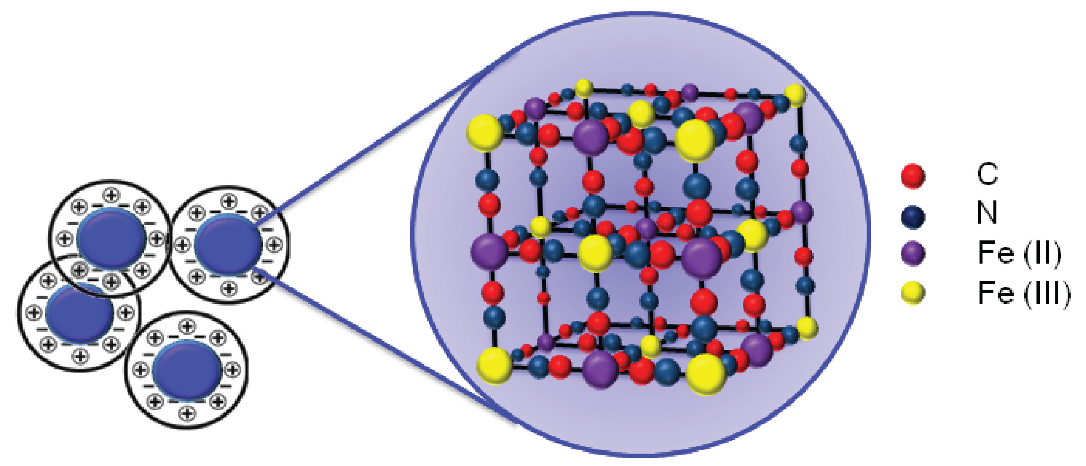
Figure 1: Schematic representation of Prussian blue nanoparticle lattice structure.
2.4 SPE modification by inkjet printing
Inkjet printing was performed using a Dimatix DMP 2831 piezoelectric printer with the Dimatix Drop Manager software (FUJIFILM Dimatix Inc., USA). PBNPs were deposited using a 10 pL printer cartridge at 25 V and a frequency of 23 kHz with a drop spacing of 20 µm using all 16 nozzles. Inkjet-printed sensors were stored dry at room temperature up to 2 months without any loss of activity towards hydrogen peroxide detection.

2.5 Apparatus
Electrochemical measurements were carried out using a Bio-Logic SP-200 potentiostat equipped with EC-Lab® software (Bio-Logic Science Instruments, France). UV-Vis measurements were obtained using a Lambda Bio spectrophotometer (Perkin Elmer, USA). Micrographs of the bare SPE and modified SPE with PBNPs were obtained by field emission scanning electron microscopy (FEG-SEM, Leo Supra 35, Germany).

3. Results and Discussion
3.1 Physical and electrochemical characterization of Prussian blue nanoparticle-modified electrodes
The dispersion of PBNPs was characterized using a UV-visible spectroscopy and scanning electron microscopy (SEM). The UV-visible spectra of the diluted PBNPs (Fig 2) yielded a broad band centered at 700 nm due to the Fe^{II} to Fe^{III} charge-transfer, characteristic of Prussian blue as seen in previous literature [26]. Synthetic precursor materials showed little distinctive absorption properties across this wavelength range. Screen printed carbon electrodes (SPEs) were also analysed by SEM before and after deposition of the PBNP ink (Fig. 3). Following deposition, the graphitic flakes were covered by a reasonably homogeneous layer of PBNPs with an average diameter of 15 nm and variation of approximately 12%.
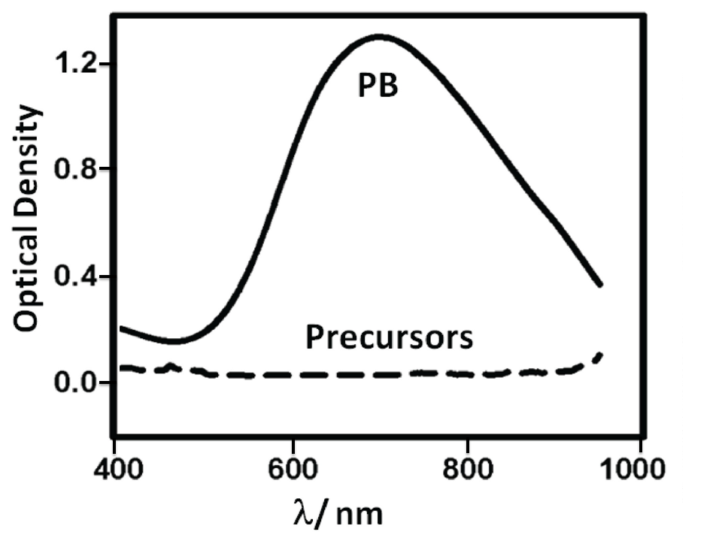
Figure 2: UV-vis spectra of the PBNP dispersion and its precursors.

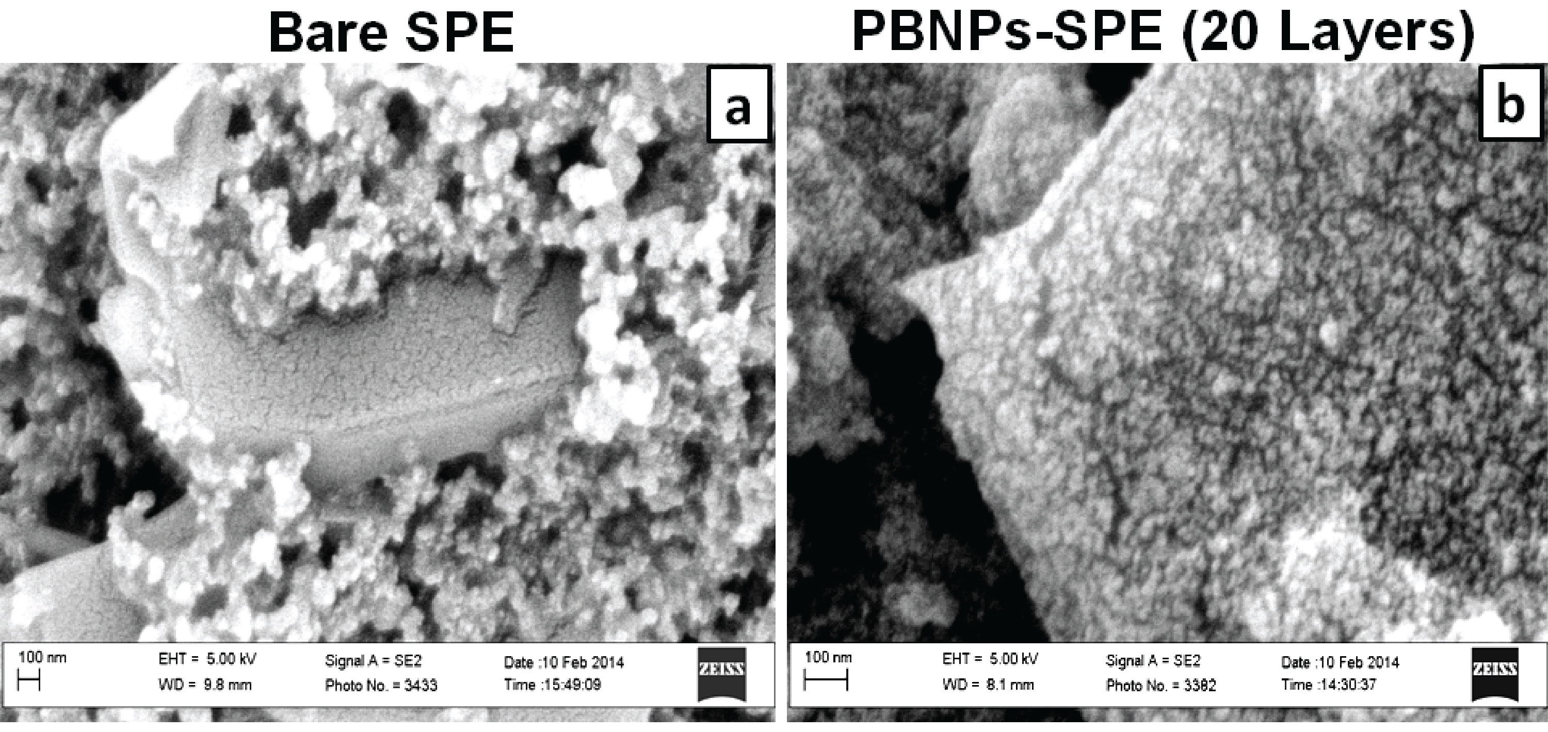
Figure 3: Scanning electron micrographs of (a) bare SPE and; (b) SPE modified with 20 inkjet printed layers of PBNPs. Acceleration voltage: 5 keV, magnification 10k.

The effect of the quantity of PBNPs deposited onto the SPEs on the electrochemical properties of the sensors was investigated by performing different numbers of prints. Electrodes were modified with 5, 10, 20 and 30 layers of the PBNP solution. Cyclic voltammetric analysis of the sensors was performed in 0.05 M phosphate buffer containing 0.1 M KCl (pH 7.4) at scan rates between 10 and 1,000 mV vs. Ag/AgCl in the potential range from -0.3 V to 0.5 V (Fig. 4). A pair of redox peaks can be seen which are due to the oxidation and reduction of Prussian blue in which the PB is reduced to PW which is re-oxidized to PB. PB is known to exist in both a soluble and insoluble form, according to the following reactions, respectively:
KFe^{III}[Fe^{II}(CN)₆] + K⁺ + e⁻  K₂Fe^{II}[Fe^{II}(CN)₆ | (1)
and
Fe₄^{III}[Fe^{II}(CN)]₆ + 4K⁺ + 4e⁻  K₄Fe₄^{II}[Fe^{II}(CN)₆]₃ | (2)

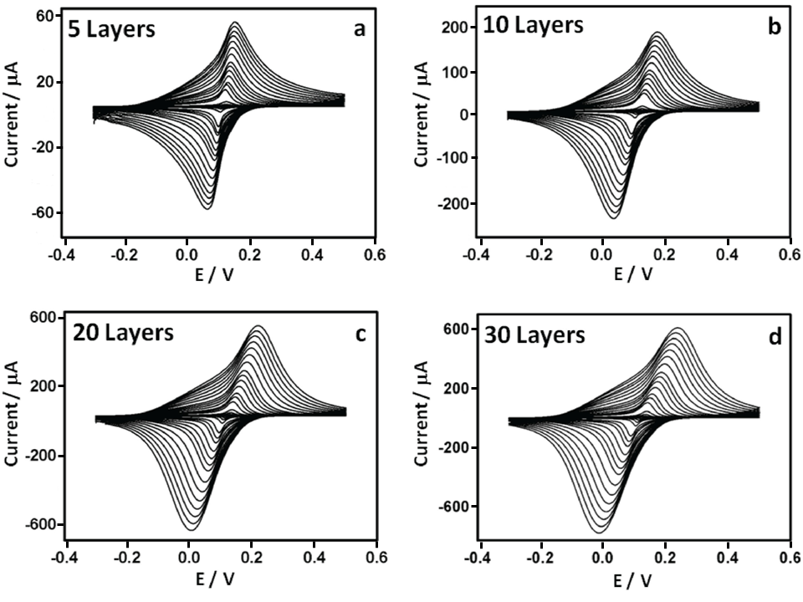
Figure 4: Cyclic voltammograms of PBNP-modified SPEs with (a) 5, (b) 10, (c) 20 and (d) 30 layers. Scan rates were from 10 to 1,000 mV s⁻¹ vs. Ag/AgCl in 0.05 M phosphate buffer, 0.1 M KCl, pH 7.4.

The solubility of PB depends on the ease with which the potassium ion enters and leaves the film. In establishing the properties of the PB film, it is important to establish whether the soluble or insoluble form has been fabricated. There are several methods with which an evaluation of the electron transfer processes involved can be achieved. One method is to employ the peak width at half height (δ_{0.5}), which tends towards 90.6/n mV when both the cathodic and anodic peaks tend to reversibility, where n is the number of electrons involved [27]. The δ_{0.5} was also calculated by taking into account the separation achieved at 10 mV s⁻¹ for the various electrodes, yielding a value of 21 ± 0.8 mV for all four sensors analysed. Peak separation at low scan rate was used to ensure operation in the reversible regime. In this case, n was found to be equal to 4.3 ± 0.3, which suggests the presence of the insoluble form of PB (Eq. 2). This reaction involves four electrons and four potassium ions which enter and leave the film in order to ensure charge neutrality of the crystal lattice during the redox process.
Anodic and cathodic peak currents were also related to the number of deposited layers. I_{p,a} values were 1.11, 7.10, 18.9 and 22.1 μA and I_{p,c} values were 0.99, 5.901, 17.8 and 18.0 μA for 5, 10, 20 and 30 layers, respectively. Anodic and cathodic currents may vary linearly with scan rate (v), or by v^{1/2}, depending on whether electron transfer processes are surface confined, or whether they depend on diffusion. Fig. 5 shows the dependency of the peak current responses of the electrodes on scan rate across the entire scan rate range, and in detail between 0 and 80 mV s⁻¹, while Fig. 6 shows the dependency of I_{p} to v^{1/2}. This demonstrates that, for fewer layers of PBNPs (5 or 10 prints) at lower scan rates, currents increase linearly with v and suggest a surface controlled process [28], while for thicker films or at higher scan rates, peak currents were proportional to v^{1/2} due to the fact that the electrochemical process was controlled by diffusion of the counter ion, K⁺, in the lattice. Table 1 shows the anodic currents and slopes at 50 mV s⁻¹ for different numbers of deposited layers of PBNPs. This data suggests that, while peak current increases with layer thickness, little gain was achieved by moving from 20 to 30 layers, between which, there was also relatively little difference in their electron transfer rates. As a consequence, sensors fabricated with 20 layers were selected for further work.
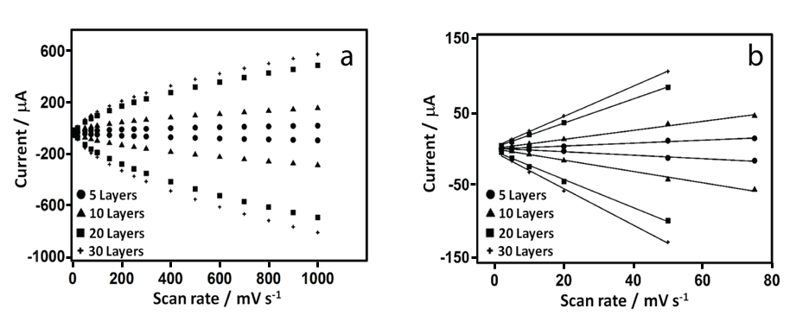
Figure 5: (a) Current vs. scan rate (10 to 1,000 mV s⁻¹ vs. Ag/AgCl) and; (b) linear correlation between current and scan rate from 0 to 80 mV s⁻¹ for PBNPs-SPEs, demonstrating thin layer behavior.

Table 1: Summary of electrochemical parameters from scan rate studies (50 mV s⁻¹ vs. Ag/AgCl) for electrodes modified with different numbers of inkjet printed layers of PBNPs in in 0.05 M phosphate buffer, 0.1 M KCl, pH 7.4.
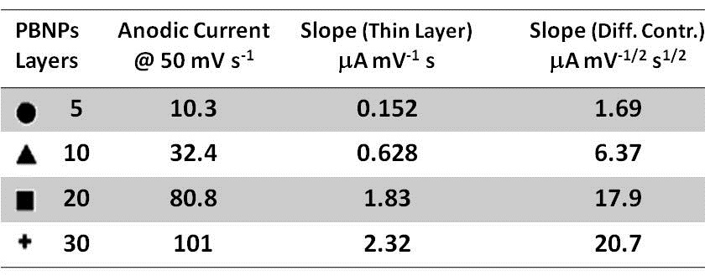
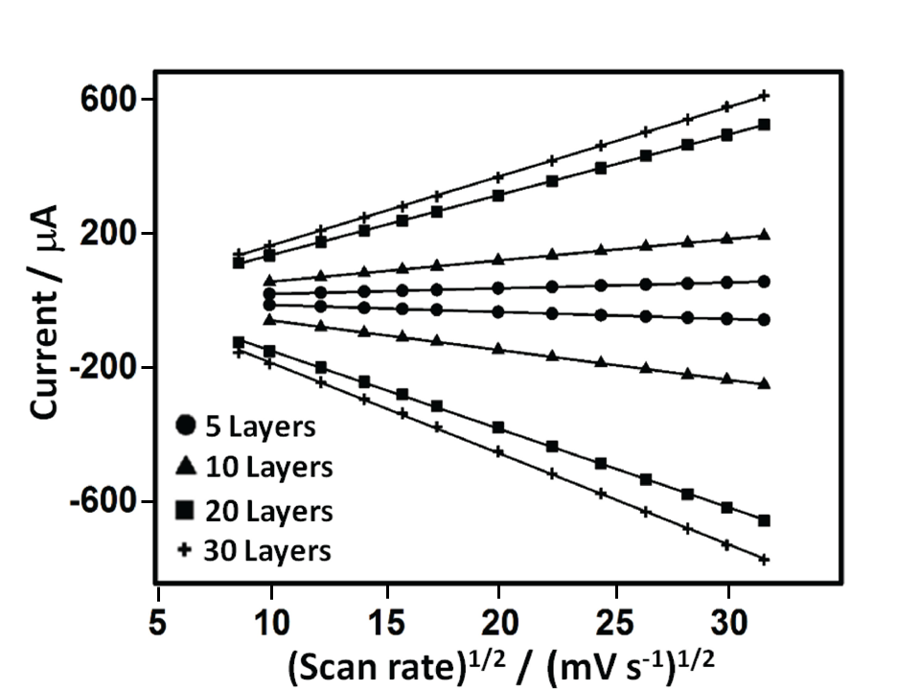
Figure 6: Current vs. square root of scan rate for PBNP-SPEs demonstrating the diffusion-controlled behavior.

3.2. Electrochemical characterization of hydrogen peroxide at a PBNP–SPE
The behavior of PBNP-SPEs toward hydrogen peroxide reduction was investigated using cyclic voltammetry in 0.05 M phosphate buffer containing 0.1 M KCl (pH 7.4) in a potential range from -0.1 V to 0.3 V (vs. Ag/AgCl) with a scan rate of 50 mV/s. Bare and PBNP-modified SPEs were studied in the presence and absence of H₂O₂ (Fig. 7). At bare SPEs, there was little or no visible reduction of H₂O₂ at the electrode. For PBNP-SPEs, the characteristic redox couple for PB could be seen, while in the presence of 3 mM H₂O₂, the cathodic peak, indicating the formation of PW was shifted to a more negative potential of 14 mV, accompanied by an increase in the cathodic current. The anodic peak was also shifted to lower potentials and was reduced in peak current, as expected for mediated, reductive reactions.
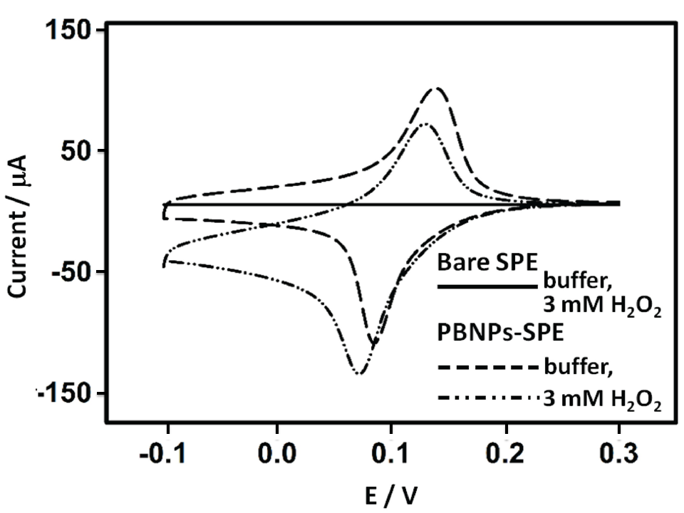
Figure 7: Cyclic voltammograms of bare SPE in 3 mM H₂O₂ (solid line), SPE modified with 20 layers of PBNP dispersion in buffer (dashed line) and 3 mM H₂O₂ (dashed-dotted line). All in 0.05 M phosphate buffer, 0.1 M KCl, pH 7.4 at 50 mV s⁻¹ vs. Ag/AgCl.

These results demonstrate that the PBNP-modified SPEs have electrocatalytic activity towards hydrogen peroxide reduction according to the scheme in Fig. 8 and equations 3 and 4 [12] and related equations (3, 4).
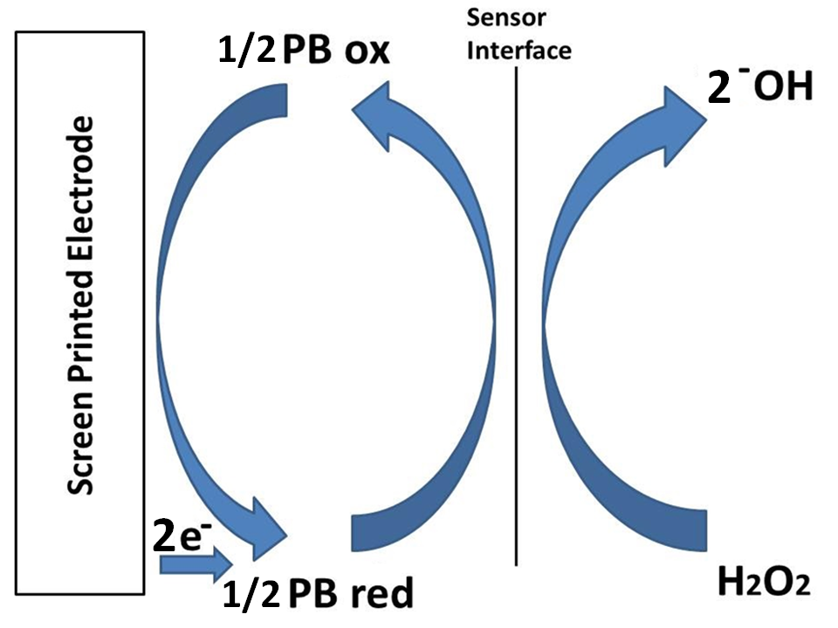
Figure 8: Mechanism of the catalytic H₂O₂ reduction mediated by PB.

K₄Fe₄^{II}[Fe^{II}(CN)₆]₃ ₊ 2 H₂O₂  Fe₄^{III}[Fe^{II}(CN)]₆ + 4OH⁻ + 4K⁺ | (3)
H₂O₂ + 2e⁻ 2OH⁻ | (4)

Further work was performed to measure the quantitative response of the sensors to H₂O₂.

3.3 Amperometric detection of hydrogen peroxide
The choice of the optimum applied potential at the working electrode is essential in achieving the lowest possible limit of detection. Several factors are relevant when making this selection. One is the signal to background ratio of the sensor at a particular potential and the non-faradaic processes that result from a potential step which contributes to the background signal and reduces achievable detection limits. However, this must be balanced against the greater levels of electrolysis that can be achieved at more extreme potentials. The other factor is the likely increase in electrochemical interference at more extreme potentials. The slope to blank ratios of the sensors at 0, -0.05, -0.1 and -0.2 V (vs. Ag/AgCl) are shown in Fig. 9. The sensors showed the greatest slope to blank ratio at 0 V, with a response ratio some ten-fold higher than at -0.2 V. This, coupled to the significant reduction in interference from a number of important reductants at this potential, as reported in a number of earlier studies resulted in a preference for operation of the sensor at 0 V vs. Ag/AgCl [29-31].

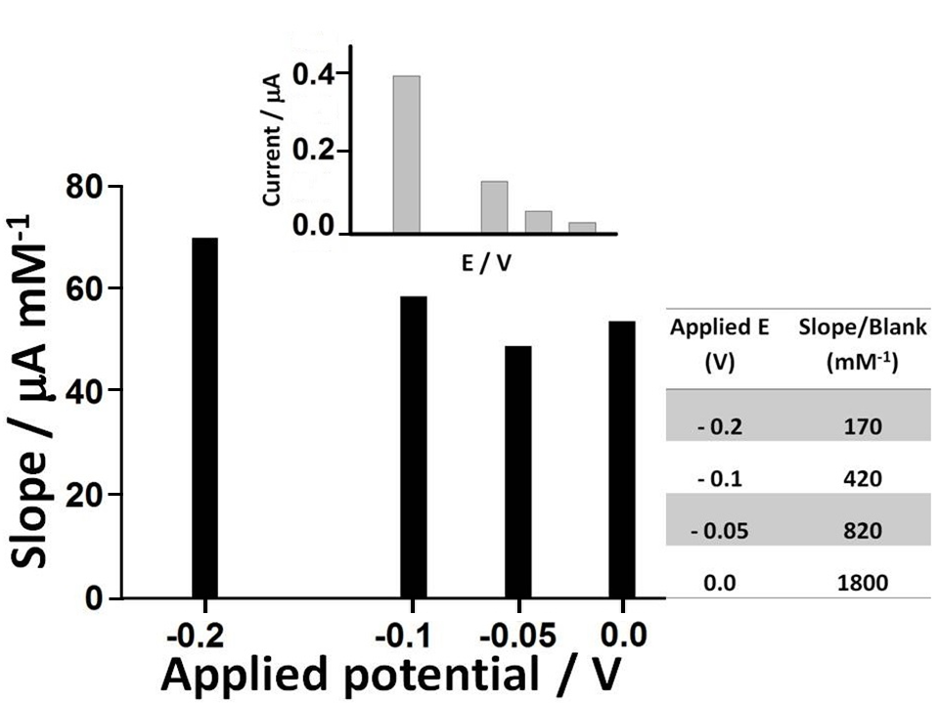
Figure 9: Selection of the optimum applied potential for the amperometric measurement of H₂O₂.

Detailed characterization of the response of the PBNP-SPEs towards H₂O₂ was performed at 0V vs. Ag/AgCl pseudoreference on electrodes modified with 20 layers of inkjet printed PBNPs. Measurements were performed in 0.05 M phosphate buffer containing 0.1 M KCl (pH 7.4) in a stirred batch reaction vessel (n=6). Limit of detection, linear range, sensitivity and reproducibility were studied (Fig. 10). Sensors showed excellent linearity between 0 and 4.5 mM with a detection limit of 0.2 μM, obtained from the formula LOD = 3·σ_{b} / slope (r²=0.9994). The sensitivity was 762 μA mM⁻¹ cm⁻². Furthermore, the sensors showed excellent inter-electrode relative standard deviation of less than 5% for all concentrations tested. As well as the excellent analytical features demonstrated by these electrodes, this is also coupled to the ease and simplicity of their fabrication and amenability to mass production. This compared favorably with several earlier works (Table 2). Hu et al. [22] achieved an LOD of 20 µM and a sensitivity of 164.82 µA M⁻¹ cm⁻². Haghighi et al. [15] achieved an analytical range from 2.1 μM to 0.14 mM by using adsorbed PBNPs covered with a layer of Nafion reaching a sensitivity of 138.6 µA mM⁻¹ cm⁻², but which was more than 5-fold less sensitive than the current sensor, also with a 5-fold higher LOD. Yang et al. [32] reported a PB-based electrochemical sensor based on chitosan functionalized with graphene nanosheets, and obtained a similar level of sensitivity to the PBNP inkjet printed device (816.4 μA mM⁻¹ cm⁻²) but with a higher LOD and narrow linear range (10 μM to 0.4 mM). In other work, Karyakin et al. [13] achieved excellent detection limits. However, this was achieved using a gold ultramicroelectrode with electrochemical modification, which requires electrochemical cleaning and deposition processes and so makes mass fabrication challenging. The approach followed by Cao et al. [17] also achieved good performance in terms of limit of detection but was also characterized by a long and complex synthesis of the electrocatalyst, while also having a relatively narrow dynamic range. In comparison to other procedures, the inkjet-printed PBNP-modified electrodes certainly represent a good balance between excellent analytical performance and low cost reproducible mass production.

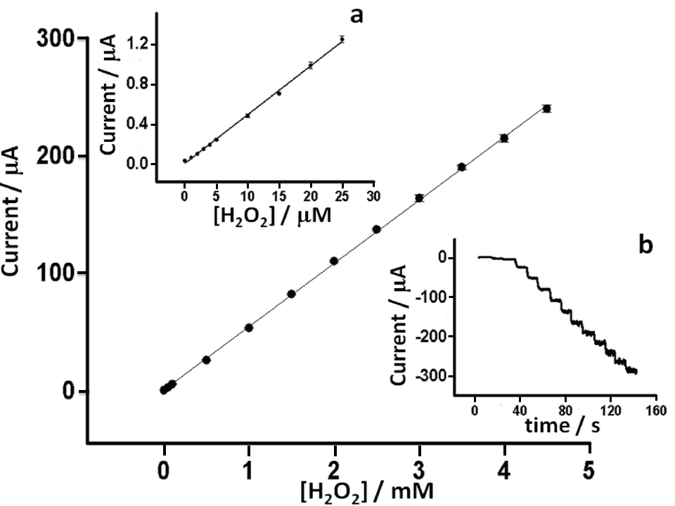
Figure 10: Calibration curve of H₂O₂ on PBNP-SPEs (n=3) in 0.05 M phosphate buffer, 0.1 M KCl, pH 7.4 at 0 V vs. Ag/AgCl. (a) Detail from 0 to 25 µM and (b) Raw amperometric data from 0 to 4.5 mM.

Table 2: Analytical performance characteristics of a number of Prussian blue-modified electrodes for H₂O₂ detection.
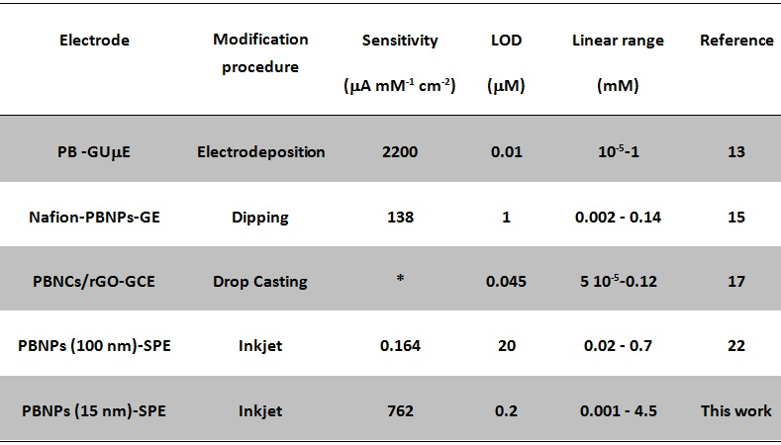
PB-GUμE: Prussian Blue gold ultramicroelectrode (125 μm); GE: Graphite Electrode; PBNCs/rGO-GCE: Prussian Blue NanoCubes on the surface of reducede Graphene Oxide adsorbed on Glassy Carbon Electrode; * Area of the working electrode has not been reported in the cited paper.

4. Conclusion
The fabrication of sensors for the measurement of H₂O₂ was achieved using screen printed electrodes modified with inkjet printed Prussian blue nanoparticles. Sensors fabricated with 20 inkjet printed layers were shown to have excellent limits of detection, linear range and reproducibility. The developed sensor represents a simple, robust and reliable means of sensing H₂O₂ which avoids long and complex multi-step sensor fabrication processes and is suitable for large scale mass production and has many potential applications in environmental, industrial and physiological monitoring, particularly where single use and disposability are advantageous.

Acknowledgments
The research leading to these results has received funding from the European Community's Seventh Framework Programme [FP7/2007-2013] under grant agreement no 257372.
Author Contributions
Main text paragraph.
Conflicts of Interest
State any potential conflicts of interest here or “The authors declare no conflict of interest”.
References and Notes
1. Chen, W.; Cai, S.; Ren, Q.-Q.; Wen, W. ; Zhao, Y.-D. Recent advances in electrochemical sensing for hydrogen peroxide: a review. Analyst 2012, 137, 49-58.
2. Hawe, A.; Wiggenhorn, M.; Van De Weert, M.; Garbe, J. H. O.; Mahler, H.-C.; Jiskoot, W.; Forced Degradation of Therapeutic Proteins. Journal of Pharmaceutical Sciences 2012, 101, 895-913.
3. Niethammer, P.; Grabher, C.; Look, A.T.; Mitchison, T.J. A tissue-scale gradient of hydrogen peroxide mediates rapid wound detection in zebrafish. Nature 2009, 459, 996-1000.
4. Wang, B.; Zhang, J.-J.; Pan, Z.-Y.; Tao, X.-Q. ; Wang, H.-S. A novel hydrogen peroxide sensor based on the direct electron transfer of horseradish peroxidase immobilized on silica–hydroxyapatite hybrid film. Biosensors and Bioelectronics 2009, 24, 1141-1145.
5. Pupo Nogueira, R. F.; Oliveira, M. C.; Paterlini, W. C. Simple and fast spectrophotometric determination of H₂O₂ in photo-Fenton reactions using metavanadate. Talanta 2005, 66, 86-91.
6. Hanaoka, S.; Lin, J.-M.; Yamada, M. Chemiluminescent flow sensor for H₂O₂ based on the decomposition of H₂O₂ catalyzed by cobalt(II)-ethanolamine complex immobilized on resin. Analytica Chimica Acta 2001, 426, 57-64.
7. Gomes, A.; Fernandes, E.; Lima, J. L. F. C. Fluorescence probes used for detection of reactive oxygen species. Journal of Biochemical and Biophysical Methods 2005, 65, 45-80.
8. Wang, Y.; Tang, M.; Lin, X.; Gao, F. Sensor for hydrogen peroxide using a hemoglobin-modified glassy carbon electrode prepared by enhanced loading of silver nanoparticle onto carbon nanospheres via spontaneous polymerization of dopamine. Microchimica Acta 2012, 176, 405-410.
9. Anjalidevi, C.; Dharuman, V.; Narayanan, J. S. Non enzymatic hydrogen peroxide detection at ruthenium oxide–gold nano particle–Nafion modified electrode. Sensors and Actuators B 2013, 182, 256-263.
10. Zhang, Z.; Gu, S.; Ding, Y.; Zhang, F.; Jin, J. Determination of hydrogen peroxide and glucose using a novel sensor platform based on Co_{0.4}Fe_{0.6}LaO₃ nanoparticles. Microchimica Acta 2013, 180, 1043-1049.
11. Anu Prathap, M. U.; Thakur, B.; Sawant, S. N.; Srivastava, R. Synthesis of mesostructured polyaniline using mixed surfactants, anionic sodium dodecylsulfate and non-ionic polymers and their applications in H₂O₂ and glucose sensing. Colloids and Surfaces B 2012, 89, 108-116.
12. Ricci, F.; Palleschi, G. Sensor and biosensor preparation, optimisation and applications of Prussian Blue modified electrodes. Biosensors and Bioelectronics 2005, 21, 389-407.
13. Karyakin, A. A.; Kuritsyna, E. A.; Karyakina, E. E.; Sukhanov, V. L. Diffusion controlled analytical performances of hydrogen peroxide sensors: Towards the sensor with the largest dynamic range. Electrochimica Acta 2009, 54, 5048-5052.
14. Arduini, F.; Ricci, F.; Tuta, C. S.; Moscone, D.; Amine, A.; Palleschi, G. Detection of carbamic and organophosphorous pesticides in water samples using a cholinesterase biosensor based on Prussian Blue-modified screen-printed electrode. Analytica Chimica Acta 2006, 580, 155-162
15. Haghighi, B.; Hamidi, H.; Gorton, L. Electrochemical behavior and application of Prussian blue nanoparticle modified graphite electrode. Sensors and Actuators B 2010, 147, 270-276.
16. Li, N.; He, B.; Xu, S.; Yuan, J.; Miao, J.; Niu, L.; Song, J. In site formation and growth of Prussian blue nanoparticles anchored to multiwalled carbon nanotubes with poly(4-vinylpyridine) linker by layer-by-layer assembly. Materials Chemistry and Physics, 2012, 133, 726-734.
17. Cao, L.; Liu, Y.; Zhang, B.; Lu, L. In situ controllable growth of Prussian Blue nanocubes on reduced graphene oxide: facile synthesis and their application as enhanced nano electrocatalyst for H₂O₂ reduction. Applied Materials Interfaces 2010, 2, 2339-2346.
18. Minemawari, H.; Yamada, T.; Matsui, H.; Tsutsumi, J.; Haas, S.; Chiba, R.; Kumai, R.; Hasegawa, T. Inkjet printing of single-crystal films. Nature 2011, 475, 364–367.
19. Huang, L.; Huang, Y.; Liang, J.; Wan, X.; Chen, Y. Graphene-based conducting inks for direct inkjet printing of flexible conductive patterns and their applications in electric circuits and chemical sensors. Nano Research 2011, 4, 675–684.
20. Hibbard, T.; Crowley, K.; Killard, A. J. Direct measurement of ammonia in simulated human breath using an inkjet-printed polyaniline nanoparticle sensor. Analytica Chimica Acta 2013, 779, 56–63.
21. Gonzalez-Macia, L.; Morrin, A.; Smyth, M. R.; Killard, A. J. Advanced printing and deposition methodologies for the fabrication of biosensors and biodevices. Analyst 2010, 135, 845-867.
22. Hu, J. -Y.; Lin, Y. -P.; Liao, Y.-C. Inkjet printed Prussian Blue films for hydrogen peroxide detection. Analytical sciences 2012, 28, 135-140.
23. Arduini, F.; Amine, A.; Moscone, D.; Ricci, F.; Palleschi, G. Fast, sensitive and cost-effective detection of nerve agents in the gas phase using a portable instrument and an electrochemical biosensor. Anal. Bioanal. Chem. 2007, 388, 1049-1057.
24. Cinti, S., Politi, S., Moscone, D., Palleschi, G., Arduini, F. Stripping analysis of As(III) by means of screen-printed electrodes modified with gold nanoparticles and carbon black nanocomposite. Electroanalysis 2014, 26, 931-939.
25. Chen, J.; Miao, Y.; Wu, X. Immobilization of Prussian Blue nanoparticles onto thiol SAM modified Au electrodes for analysis of DL-homocysteine. Colloid Journal 2007, 69, 660-665.
26. Uemura, T., Ohba, M., Kitagawa, S. Size and surface effects of Prussian blue nanoparticles protected by organic polymers. Inorganic Chemistry 2004, 43, 7339-7345.
27. Laviron, E. General expression of the linear potential sweep voltammogram in the case of diffusionless electrochemical systems. Journal of electroanalytical chemistry 1979, 101, 19-28.
28. Bard, A.J., Faulkner, L.R. Electrochemical Method Fundamentals and Applications; Wiley: New York, 1980. Chapter 12, p. 522.
29. Karyakin, A.A., Karyakina, E.E., Gorton, L. Amperometric Biosensor for Glutamate Using Prussian Blue-Based “Artificial Peroxidase” as a Transducer for Hydrogen Peroxide. Analytical Chemistry 2000, 72,1720-1723.
30. Moscone, D., D’Ottavi, D., Compagnone, D., Palleschi, G., Amine, A. Construction and Analytical Characterization of Prussian Blue-Based Carbon Paste Electrodes and Their Assembly as Oxidase Enzyme Sensors. Analytical Chemistry 2001, 73, 2529-2535.
31. Zou, Y., Sun, L.-X., Xu, F. Biosensor based on polyaniline–Prussian Blue/multi-walled carbon nanotubes hybrid composites. Biosensors and Bioelectronics 2007, 22, 2669-2674.
32. Yang, J.-H., Myoung, N., Hong, H.-G. Facile and controllable synthesis of Prussian blue on chitosan-functionalized graphene nanosheets for the electrochemical detection of hydrogen peroxide. Electrochimica Acta 2012, 81, 37-43.

Reference list: We recommend the use of reference management software to prepare the references list (e.g., Endnote, http://www.mdpi.com/files/word-templates/MDPI.ens).
© 2014 by the authors; licensee MDPI, Basel, Switzerland. This article is an open access article distributed under the terms and conditions of the Creative Commons Attribution license (http://creativecommons.org/licenses/by/3.0/).

Table caption

