Influence of road markings, lane widths and driver behaviour on proximity and speed of vehicles overtaking cyclists
Stella C. Shackel¹, John Parkin²
¹c/o Institute for Transport Studies, 36-40 University Road, University of Leeds, Leeds LS2 9JT United Kingdom scshackel@gmail.com;
²Professor of Transport Engineering, Centre for Transport and Society, University of the West of England, Frenchay Campus, Coldharbour Lane, Bristol, BS16 1QY United Kingdom john.parkin@uwe.ac.uk; (corresponding author)
Abstract
The proximity and speed of motor traffic passing cyclists in non-separated conditions may be so close and so great as to cause discomfort. A variety of road design and driver behaviour factors may affect overtaking speeds and distances. The investigation presented in this paper builds on previous research and fills gaps in that research by considering the presence of cycle lanes on 20 mph and 30 mph roads, different lane widths, different lane markings, vehicle type, vehicle platooning and oncoming traffic. Data were collected from a bicycle ridden a distance of one metre from the kerb fitted with an ultrasonic distance detector and forward and sideways facing cameras.
Reduced overtaking speeds correlate with narrower lanes, lower speed limits, and the absence of centre-line markings. Drivers passed slower if driving a long vehicle, driving in a platoon, and when approaching vehicles in the opposing carriageway were within five seconds of the passing point. Increased passing distances were found where there were wider or dual lane roads, and in situations where oncoming vehicles were further away and not in a platoon. In mixed traffic conditions, cyclists will be better accommodated by wider cross-sections, lower speed limits and the removal of the centre-line marking.
Keywords
Bicycle; lane markings; lane widths; overtaking speed; overtaking proximity
1 Introduction
Cycling offers many advantages which may be expressed as reductions of the following compared with the alternatives: journey times over short distances; access and egress times; costs to the user; motor traffic congestion; air pollution; and road maintenance costs. A cycle user also benefits from physical activity inherent in using this mode.
Pucher et al. (2010) provide a comprehensive review of infrastructure, programmes and policies to promote cycling. While factors such as hills, the weather and other social and behavioural factors influence mode choice (see Heinen et al. (2010) for a review of factors influencing bicycle commuting), features relating to infrastructure affect route choice as well as mode choice. These factors include the nature and comprehensiveness of the network of suitable routes, including provision within the highway.
A common methodology for attempting to provide space for cycle users on the highway is a delineation of a lane separate from motor traffic but within the carriageway. Pucher et al. (2010) note that aggregate cross-sectional studies have shown a positive correlation between cycle lanes and cycle use, and surveys find that cycle users and non-cycle users alike state that they would prefer to cycle within cycle lanes. However, he also notes that revealed preference studies do not show a positive correlation. No studies were convincingly able to determine whether the presence of cycle lanes caused higher levels of cycling.
Notwithstanding, the provision of cycle lanes appears to have been frequently the default approach for traffic engineers in some countries (e.g. the UK), while provision in countries with the highest levels of cycling (e.g. The Netherlands) has been based on comprehensive route networks specifically designed for cycle traffic, and generally separated from motor traffic where motor traffic volumes are large and speeds are high. These different approaches have been extensively researched and discussed in the literature in relation to the nature of the provision and responses to that provision (e.g. Akar and Clifton, 2009 (perceptions of infrastructure); Bohle, 2000 (facility attractiveness); Broach et al., 2012 (route choice); Christmas et al., 2010 (safety); Dill and Carr, 2003 (commuting and facilities); Forward, 1998 (mode choice); Gårder et al., 1998 (safety), Guthrie et al,. 2001 (‘cyclability’ index); Harkey et al., 1998 (‘compatibility’ index); Jones and Carlson, 2003 (‘compatibility’ index for rural areas); Landis et al., 1997 (level of service); McClintock and Cleary, 1996 (safety); Parkin and Koorey, 2012 (network planning); Reid and Adams, 2012 (safety); Stinson and Bhat, 2005 (route preferences); Tilahun et al. (2007) (route choice)).
While the goal may therefore be a suitably designed network of cycle paths and cycle tracks separated appropriately from motor traffic (particularly allowing cycle traffic to avoid busier roads), there remains a need to review the use of cycle lanes on less busy roads. There are developments in design thinking which are supporting a greater degree of separation within the carriageway, either through kerb separation or some other form of physical (usually intermittent) barrier, and these have been common in Denmark for example. Despite this, cycle lanes remain a widespread methodology for providing space for cycle traffic, and this may be linked with the ease of installation and the higher cost of alternatives.
At a functional level, the efficacy of cycle lanes has been called in to question in previous research on major roads (Parkin and Meyers, 2010) which showed that at posted speed limits of 40 mph and 50 mph, motor traffic gave less passing distance to cycle users with cycle lanes than without. The picture was mixed on roads with a 30 mph speed limit. In order to unravel the important issues about passing distance with and without the bicycle at these common urban speed limits, it has been necessary to collect further data. The previous research noted that in urban areas there is likely to be a greater variability in passing distance resulting from a network with more side roads, and hence turning needs, and greater variability in frontage activity, including motor vehicle parking adjacent to the kerb.
This paper presents results from comprehensive data collection of passing distances and speed by vehicle type for roads with both 20 mph and 30 mph posted speed limits. Consideration has also been given to the configuration of lanes and road markings, the presence of oncoming traffic at the point when an overtaking manoeuvre has been made, and whether the driver is in a platoon while overtaking.
Section 2 summarises the literature on overtaking behaviour in the context of motor vehicles and bicycles. Section 3 outlines the methodology and Section 4 details the results. Section 5 presents a discussion and Section 6 provides a conclusion with an exposition of the implications.
2 Review of the literature
Without a cycle lane, cycle users share the same lane as motor traffic. In this case, the passing distance will be determined by the behaviour of the driver, which in turn will be influenced by the width of the lane and road, the presence of oncoming vehicles, and the presence of parked vehicles or pinch-points. To keep themselves in the line of sight of motor traffic and to help prevent inappropriate overtaking, it is advised that cyclists position themselves at least one metre from the kerb (secondary position) and further from the kerb if the lane or road is too narrow for vehicles to pass safely (primary position) (Franklin, 2007). If a cyclist rides very close to the kerb, the driver behind may be tempted to pass when it is inappropriate to do so (Hunter et al., 2011).
Wider road lanes without bends have been found to increase vehicular speeds and probability of overtaking (Guthrie et al., 2001; Pasanen et al., 2008; Godley et al., 2004), as well as to increase the passing distance between the overtaking vehicle and the cycle user (Love et al., 2012).
Previous Dutch design guidance (CROW, 1993) helpfully identified three categories of cross-section in relation to joint cycle and motor traffic use as follows: ‘tight’ cross-sections along which it is not possible for an overtaking manoeuvre to be made without encroaching into the oncoming traffic lane; ‘spacious’ cross-sections which provide for adequate passing distance without having to cross the centre-line, and ‘critical’ cross-sections (which include the typical lane width of 3.65 m as adopted in the UK, for example). The critical cross-section provides sufficient width for drivers to overtake, but in so doing they will leave inadequate distance to the cycle user they are passing. The decision to overtake or not may be influenced by the drivers perception of the consequence of crossing a line marking, and whether oncoming vehicles are present (Goodridge, 2006; McHenry and Wallace, 1985).
The kinematic envelope of a bicycle is wider than its physical size, and a buffer zone beyond the kinematic envelope is needed for safety reasons and to limit the feelings of danger resulting from closely passing motor traffic moving at a different speed. The space recommended varies between countries (Allen et al., 1998). The UK Highway Code (UK Government, 2013) indicates that drivers overtaking cyclists should leave at least the width of a car (Rule 163).
Inadequate passing distances and vehicle speeds which are too high can cause lateral forces to be exerted on the cyclist, but turbulence problems are only estimated to start at the highest speeds and proximities. For instance, if a cyclist is passed at 0.9 m (3 ft) at 45 mph, this creates at side force of 3.75 lbs (16.7 Newton) (Federal Highway Administration, 1975).
Early work (Kroll and Ramey, 1977; McHenry and Wallace, 1985) found no change in passing distances with cycle lanes. More recent work has found slower overtaking speeds for road widths of 3.0 m to 6.4 m without a cycle lane (Wilkinson et al., 1992), and (with the exception of Chuang et al., 2013) that cycle lane markings reduce the passing distance given to a cyclist by motor vehicle drivers (Parkin and Meyers, 2010; Harkey and Stewart, 1997; Wilkinson et al., 1992). Notwithstanding, Haileyesus et al. (2007) suggest a safety benefit from cycle lanes.
The UK Traffic Signs Manual states a minimum cycle lane width of 1.5 m (DfT, 2003) although the Manual for Streets recommends 2.0 m (DfT, 2007). Cosma (2012) and Hunter et al. (2011) suggest that cycle lanes can prove reassurance for inexperienced cyclists and help to remind vehicle drivers that cyclists may be present.
Centre-line road markings have been used since 1914 (Debell, 2003). Some research suggests that speeds are reduced when centre-lines are removed (DfT, 2007; Debell, 2003; Kennedy et al., 2005). Guidelines in the Traffic Signs Manual allow omission of the centre-line if rural roads are less than 5.5 m wide (DfT, 2003), and this guidance demonstrates the way that custom and practice has developed whereby centre line marking is the default approach. There is a lack of research on the safety of centre-line road markings, particularly in relation to vulnerable road users.
Road user factors also include psychological influences caused by the environment (Jacobsen, 2003; Elliott et al., 2003; Kennedy et al., 2005). In early work on the subject of passing distances, Watts (1984) found that a spacer bar 0.5 m long halved the percentage of vehicles passing less than 0.8 m from the cyclist. Walker (2007) and Chuang et al. (2013) found that overtaking motorists gave apparently female looking cyclists more room. Walker also found that vehicles passed closer the further out he cycled (in the range 0.25 to 1.25 metres), passed closer in the morning peak hour than the evening peak hour (Walker, 2006), but that, with the exception of a high-visibility vest displaying the words ‘Police’ and ‘camera cyclist’, clothing made no difference (Walker, 2013).
Basford et al. (2002) found that professional drivers of smaller vehicles were more likely to take risks and to overtake. Sando and Moses (2011) found that smaller vehicles left less overtaking space and Parkin and Meyers (2010) found that light goods vehicle drivers overtook closer than car drivers (when cycling 0.5 m from kerb). Walker (2007) found that professional drivers of large vehicles were more likely to take risks and pass more closely. When platoon driving was defined as when vehicles were within 5 seconds of each other, no difference in overtaking proximities for cyclist positions of 0.5-0.8 m from kerb were found by Walker et al. (2013), although a tendency for the following driver to pass closer was observed. Minimal research to date has accounted for the impacts of oncoming vehicles.
The gap in the research which remains concerns lane markings and driver overtaking behaviour, measured as passing distance and speed, where the posted speed limit is 20 mph or 30 mph. Comprehensive data collection will allow for an estimation of the main effects and interactions of these dependent variables with vehicle type, road environment factors and the proximity of other vehicles both oncoming and proceeding in the same direction.
3 Methodology
A Specialized Crosstrail sport bicycle (Figure 1) with a Massa M-300/95 ultrasonic distance sensor was used. The centre of the bicycle was chosen as a datum for ease of comparison with other studies (the handlebar end was 0.315 m from the centre of the bicycle). The height of the instrument from the ground was 0.82 m. All vehicles, including sports cars were picked up, although some goods vehicles with a high clearance to the trailer were missed. Viosport POV 1.5 cameras were used both sideways-facing adjacent to the ultrasonic distance sensor for vehicle type identification and passing speed calculation, and forward-facing on the rider’s helmet with a microphone clipped under the chin for recording locality and other relevant detail. A dictaphone was used as a back-up to the sound recording, and a neck scarf hid the cables. Bicycle computers were used to provide cycling speed; verbally recorded as each overtaking vehicle passed. A laser pointer mounted on the handlebars assisted the rider in remaining one metre from the kerb (all roads in the survey had kerbed edges to the carriageway).
[Insert Figure 1 Here]
The variables of interest were as follows: passing distance, speed and type of overtaking vehicle; whether the overtaking vehicles were in a platoon; oncoming vehicle proximity and type; lane widths and lane markings.
Overtaking vehicles were assigned to defined categories based on the divisions according to the UK Department of Transport (DfT, 2004). Cars were sub-divided into private cars, private hire taxis and hackney taxi cabs. The categories of bicycle and powered two-wheelers (motorcycles or motor-scooters) were also used.
The widths were defined as being ‘tight’ (<3.10 m), ‘critical’ (3.10-3.75 m) or ‘spacious’ (>3.75 m). There were four categories for road markings as follows: single lane with no cycle lane and a centre-line marking (‘single lane’); two lanes, one of which is a cycle lane, with a centre-line (‘cycle lane’); two lanes, both of which are general traffic lanes, with a centre-line (‘dual lane’); and a single lane with no cycle lane and no centre-line (‘no centre-line’). These types are shown in Figure 2. Table 1 describes the variable categories.
[Insert Figure 2 here]
[Insert Table 1 here]
20 mph sections were a mix of 20 mph limits (without traffic calming) and zones (with traffic calming measures such as road humps or cushions).
Road sections displaying the appropriate characteristics were identified in the City of Liverpool, a relatively flat city in North West England. They were linked together to form a 31 kilometre route, as shown in Figure 3.
[Insert Figure 3 here]
To reduce data variability the route was selected to minimise the presence of the following: car parking, road narrowings, traffic refuges, road surface quality variations, bends and gradients. A summary of the traffic flows on the routes as derived from the flows observed at the time of undertaking the tests are provided in Table 2.
[Insert Table 2 here]
Three-quarters of the route was subject to a 30 mph speed limit. Average flows varied from 50 vehicles per hour (vph) to over 800 vph. 20 mph areas contained larger proportions of ‘critical’ lane widths (63%) than 30 mph areas (37%). 30 mph areas had larger percentages of ‘tight’ lane widths (11% in 20 mph; 23% in 30 mph) and ‘spacious’ lane widths (26% in 20 mph; 40% in 30 mph). There were few ‘dual lane’ sections and cycle lanes were present on 40% of the length in 20 mph sections and 8% of the length on 30 mph sections. 15% and 16% for 20 mph and 30 mph routes had ‘no centre-line’.
Pilot data runs proved the equipment, and data were collected primarily in Summer 2010. It was ensured that the cyclist’s appearance remained similar (wearing utility style clothing and hair tied back). Position and cycling according to the National Cycling Standards was applied where possible, aided by the expertise of the cyclist, a trained cycling instructor to UK Bikeability training standards. Primary positioning (middle of the traffic flow road lane) was used for safety reasons when passing parked vehicles, at road narrowings, or to go through junctions. As well as cycling speed, the dictaphone and camera microphone were used to record detail on hazards, parked cars, any change of road position of the cyclist, if eye contact was made with passing vehicle drivers, plus additional details to help with defining the vehicle type.
Whilst cycling the route, the distance sensor collected overtaking distance data, while the cameras (30 frames per second) recorded the overtaking and oncoming vehicles. Data collection times were during the morning peak (7-10am) or afternoon peak (3-6pm) periods.
To enable estimation of vehicular speed, the perpendicular camera video was annotated with a distance grid. As the wide-angle lens covered an angle of 110 degrees, it would not have been accurate to ‘place’ a regularly-spaced distance grid on the video frames. So, a series of pictures of a distance grid were prepared from a video sequence in the range of 0.3 m to 2.6 m (or 0.485 m to 2.785 m from the centre of the bicycle). The grid was then used together with vehicular features at the same distance away (at three points on the vehicle); such as the indicator light or doorframe, to measure the distance the vehicle travels between each video frame (relative to the speed of the bicycle). This distance over a defined time was then used to calculate the overtaking speed. An example of an annotated video frame is as in Figure 4.
[Insert Figure 4 here]
500 overtaking instances were collected from a total of 25 hours of usable video. Error propagation due to inherent inaccuracies in measuring speed, recording cycle speed and measuring distance each vehicle travelled between each frame were taken into account.
Traffic flow was estimated from a count from the video and the cycling time over the link. For each overtaking vehicle, proximity distances were recorded from the first to the last frame. The type, colour and other identifiable details of the vehicle were listed.
The proximity of an oncoming vehicle may affect: (a) the decision by a driver to overtake a cyclist; (b) the overtaking speed; and (c) the passing distance. Therefore, the proximity of the oncoming vehicle was calculated from the time difference between the first sight of the relevant overtaking vehicle in the sideways facing camera and the time of the first glimpse of an oncoming vehicle. Proximity was then divided into three bands as follows: alongside (≤2 seconds), mid-distance (>2 and ≤5 seconds) and far distance (>5 seconds).
If the time between the first sighting of a following vehicle and the last glimpse of the first vehicle was less than 3 seconds, then the leading vehicle and following vehicle were considered to be travelling in a platoon.
4 Results
The proximity of the overtaking vehicle to the bicycle was measured as the closest distance it came to the centre of the bicycle and the speed of overtaking was taken as the maximum speed from observations during the overtaking manoeuvre.
Factors relating to the way that drivers might behave were as follows: time of day; whether or not the speed limit was exceeded; type of overtaking vehicle; whether or not the vehicle was part of a platoon; the proximity longitudinally along the road of an oncoming vehicle on the opposite side of the road; type of oncoming vehicle; and whether or not the oncoming vehicle is within a platoon.
To satisfy the assumptions of General Linear Model (GLM) analysis of variance, dependent variables are required to be normally distributed about the mean and the variances homogeneous. In order to comply with this requirement the data distributions were normalised by square root transformation. Levene’s Test statistic was used to check for homogeneity of within-group variances. Wilks’ Lambda statistic was used to test for between-subject effects of the group means. Tukey post-hoc tests assessed whether interactions were significant. For the ‘ranking’ of each factor, back-transformed group means were used.
Preliminary analyses on the entire dataset demonstrate that being adjacent to road cushions significantly reduced (p<0.05) the maximum passing speed, but the sample size was low (only 5 cases). These data were excluded. There were too few overtaking motorcycles and bicycles to be included in the analysis. Additionally, for the same reason, the tight road sectional width category had to be excluded from the 20 mph category.
The majority of vehicles drove at approximately 45 km/h in both the 20 mph (31.2 km/h) and 30 mph (48.3 km/h) speed limits. The passing speeds ranged from 26.3 km/h to 68.8 km/h in 20 mph areas, and 18.8 km/h to 76.8 km/h in 30 mph areas. Overtaking distances were observed from 0.8 m to 2.4 m (for 20 mph areas) and 1.0 to 2.8 m for 30 mph areas. The mean passing distance for 20 mph roads was 1.6 m, and for 30 mph roads was 1.7 m.
Speed limit was found to have a strongly significant effect on overtaking speed (F=126.552, p<0.001) when in 30 mph areas (n=361) compared to 20 mph areas (n=102), but overtaking distances were not different according to the speed limit (F=0.573).
Table 3 summarises the mean speed and passing distances by speed limit, cross-section type and lane layout. Table 4 (for 20 mph speed limit roads) and Table 5 (for 30 mph speed limit roads) present results where we found significant differences in either speed or passing distance for different circumstances.
[Insert Table 3 here]
[Insert Table 4 here]
[Insert Table 5 here]
Lane widths
So far as lane widths are concerned on 20 mph roads, no significant differences in overtaking distance or overtaking speed were found for the three width categories. On roads with 30 mph speed limits, overtaking speeds were significantly greater on spacious widths compared with widths which are tight (p<0.05) or critical (p<0.001).
Road markings
No significant differences associated with road markings were found for 20 mph roads for either overtaking distance or overtaking speed. For 30 mph roads, the absence of a centre-line for an otherwise standard lane was associated with significantly reduced overtaking speeds in comparison with a single lane (p<0.001), a cycle lane (p<0.001) and dual lanes (p<0.05). In addition, the presence of a cycle lane in comparison with a standard single lane is associated with greater overtaking speeds, but these comparisons were not found to be significant.
So far as overtaking distances are concerned, dual lane markings showed greater overtaking distances than single lanes (p<0.001), cycle lanes (p<0.001) and single lanes with no centre-line (p<0.05). The mean speed without a centre-line was as low as 39.52 km/h (24.6 mph). The presence of a cycle lane in comparison with a standard single lane is associated with closer overtaking distances, but these comparisons were not found to be significant.
Overall, dual lane markings seemed to encourage greater space to be given to the cyclist, whereas overtaking speeds were reduced if there was no centre-line present.
Lane widths and road markings
Consideration now turns to comparisons of specific lane width and road marking combinations. Passing speed on spacious widths with single lanes was significantly higher than for critical widths with single lanes on both 20 mph roads (p<0.05) and 30 mph roads (p<0.001). Similarly, spacious widths with cycle lanes demonstrated significantly higher speeds than critical widths with single lanes (20 mph, p<0.05; 30 mph, p<0.001). No other comparisons for 20 mph roads were found to be significant. For 30 mph roads, however, passing speeds on spacious widths with either a single lane or a cycle lane were found to be greater than passing speeds on tight widths with no centre-line (p<0.001 and p<0.05 respectively). Also, tight widths with single lanes demonstrated significantly greater passing speeds than both tight widths with no centre-line and critical widths with a single lane (both p<0.05).
[Insert Table 5 here]
For 20 mph roads, the presence of a cycle lane for each of critical and spacious widths reduced overtaking distances, although this was not found to be significant. No other significant differences were found for 20 mph roads for overtaking distance for any lane width and road marking combination.
For 30 mph roads, overtaking distances were significantly greater for tight widths with dual lanes as compared with critical widths with a single lane (p<0.001) and spacious widths with a cycle lane (p<0.05). In addition, critical widths with dual lanes demonstrated greater overtaking distances in comparison with five other categories as follows: tight width without a centre-line (p<0.05); critical width with a single lane (p<0.001); critical width with a cycle lane (p<0.05); spacious width with a single lane (p<0.05); and spacious width with a cycle lane (p<0.001). This suggests that in dual lane situations drivers are using at least part of the offside lane to overtake cyclists, hence leaving them more room than in other situations. Finally, spacious widths with a single lane showed greater overtaking distance than critical widths with a single lane (p<0.001).
Overall, dual lanes and wider lane widths are associated with greater passing speeds and greater passing distances.
Time of day
No significant differences in either overtaking speed or overtaking distance were revealed based on the time of day.
Speed limit
Significantly (p<0.001) more overtaking incidences occurred above the speed limit than below the speed limit on both 20 mph and 30 mph roads. Group means were 43.36 km/h on 20 mph roads and 56.17 km/h on 30 mph roads. Overtaking speed on both 20 mph and 30 mph roads shows greater overtaking speeds if the speed limit is being exceeded (F=18.101 for 20 mph; F=248.207 for 30 mph, both p’s<0.001), but there were no significant results for overtaking distances (F=0.871 for 20 mph; F=0.007 for 30 mph).
Vehicle type
On 20 mph roads, the small sample of Light Goods Vehicles (LGVs) overtook at higher speeds than cars (p<0.05) on different busy roads adjacent to a 30 mph limit. It should also be noted that the three LGVs overtook just after a speed limit change from 30 mph to 20 mph, and so this result should be treated with caution. On 30 mph roads, rigid goods vehicles overtook at significantly lower speeds than cars (p<0.05), private hire taxis (p<0.05) and light goods vehicles (LGVs, p<0.001). Bus overtaking speeds were also significantly lower than those of cars (p<0.001), private hire taxis (p<0.05) and LGVs (p<0.001). Overtaking distance was not associated with vehicle type on either 20 mph roads or 30 mph roads.
Comparisons were also made by combining vehicle types into larger groupings. No significant effects were found on 20 mph roads for either overtaking speed (F=2.840) or overtaking distance (F=0.286), but on 30 mph roads all long vehicles combined showed significantly lower passing speeds (p<0.001) than cars, taxis and LGVs. The group mean speed value for long vehicles was 39.7 km/h in comparison with the mean speeds for cars, taxis and LGVs of 48.7 km/h. Again though, no significant effects of passing distances were detected.
Overtaking in a platoon
No significant differences were found on 20 mph roads between overtaking speed (F=0.866) or overtaking distance (F=0.302) for the condition that the overtaking vehicle was either a single vehicle, or part of a platoon. This lack of difference was replicated for 30 mph roads for overtaking distance (F=0.300), but overtaking speeds were found to be significantly lower when driving in a platoon (F=10.550, p<0.001).
Effect of oncoming vehicles
Overall, differences in overtaking speed were not significantly different depending on how far distant oncoming vehicles were (F=0.277 in 20 mph; F=2.103 in 30 mph). However, from Tukey tests for 30 mph roads, overtaking speeds when an oncoming vehicle was in the middle distance were significantly less than when the oncoming vehicle was in the far distance (p<0.001). Overtaking distances showed a significant between-subject effect for distance of oncoming vehicle on 20 mph roads (F=7.899, p<0.001) and 30 mph roads (F=16.558, p<0.001). For 20 mph roads, overtaking distance was found to be greater when the oncoming vehicle was far distant in comparison with the oncoming vehicle being alongside (p<0.001, alongside mean 1.35 m, far distant mean 1.75 m). No significant interactions from Tukey tests were found for 30 mph roads.
When data were separated by oncoming vehicle type, between-subject effect analyses for 30 mph roads showed significant results for overtaking speed (F=3.047, p<0.05), but not for overtaking distance (F=1.270). No significant effects were found for 20 mph roads. Although sample size was low, the data indicate overtaking speeds to be higher if an articulated lorry was approaching in comparison with a bicycle (p<0.05), a car (p<0.001), a hackney taxi (p<0.05), private hire taxi (p<0.05), LGV (p<0.001) or a bus (p<0.001). Overtaking speeds were significantly greater if a rigid lorry was oncoming in comparison with an LGV (p<0.05).
Multivariate between-subject effect analyses on whether or not oncoming vehicles were single vehicles or part of a platoon showed no significant differences between overtaking speeds (F=0.004 for 20 mph roads and F=0.056 for 30 mph roads). For overtaking distances, no significant differences were found for 20 mph roads (F=0.071), but for 30 mph roads there was a significant difference (F=6.090, p<0.05) with smaller overtaking distances being observed for oncoming vehicles as part of a platoon in comparison with oncoming single vehicles (p<0.05).
5 Discussion
Little previous research has investigated how lane widths and road markings influence the speed and distance of vehicles overtaking bicycles. The results presented here have been produced from extensive fieldwork in a range of urban road situations and the data shows a number of significant findings, some of which have policy implications.
Significantly greater passing speeds were found on roads with a 30 mph speed limit as compared with roads with a 20 mph speed limit, but the lack of significant effects for 20 mph may be due to the smaller sample size. In addition, the overtaking speed was significantly greater when the speed limit was being exceeded. Taken together, these results indicate the need for reduced traffic speeds, which is a pro-cycling policy intervention that has been called for by many for some time (for example, McClintock, 2003).
More spacious lane cross-sections lead to greater overtaking speeds, but they do not affect overtaking distances, except for the increase in lane width from critical to spacious. This contrasts with other research (Love et al., 2012). Such more spacious cross-sections may provide drivers with more opportunities for overtaking, which on average will lead to greater overtaking speeds. One result was found to contradict this general observation, and that was where a single lane with a tight cross-section was found to have greater overtaking speeds than a single lane with a critical cross-section. This may be explained by fewer overtaking opportunities being available for the tight cross-section (i.e., no possibilities of ‘squeezing’ past without encroaching over the centre-line) causing faster overtaking speeds.
It is quite striking that dual lanes were generally associated with greater passing distances, even when the nearside lane was of critical width. It is likely that drivers tended to move into the offside lane, as noted by Sando and Moses (2011). Closer passing distances were observed when oncoming vehicles approached in a platoon, and this is possibly because drivers ‘cut in’ earlier than they would otherwise do when overtaking.
The reduction of speeds observed on roads without a centre-line, which correlates with Manual for Streets (DfT, 2007) and other observations (Debell, 2003), could be the effect of an absence of a line provided to ‘drive-to’, causing drivers to consider their road position and speed more carefully. Other evidence linked with wider programmes of developing ‘self-explaining roads’, which include the removal of lane markings, have also found similar speed reducing effects of the absence of lane markings (e.g. Charlton et al., 2010)
The effect of cycle lanes was found to be inconclusive, and this corresponds with Kroll and Ramey (1977), although the group means of the data indicate reduced overtaking distances and increased overtaking speeds, particularly for wider cross-sections. This is also in contrast to work by Parkin and Meyers (2010), where significantly reduced overtaking proximities from a cyclist 0.5 m from the kerb were found when a cycle lane marking was present on a spacious cross-section on 40 mph and 50 mph roads. Many of the cycle lanes ridden as part of this study were only 1 m wide. Hence, with the cyclist in this study cycling at the recommended 1 m from the kerb, the effect of the presence of the cycle lane was negated. Further research separating out cycle lane widths and cycling at different set distances from the kerb is required.
Overall, we can say that overtaking speeds were influenced by road infrastructure factors, and tended to be greater with wider lane widths (except where speeds were found to be greater for tight than critical single lane sections), but slower if the centre-line was absent. A wider road, such as dual lanes, may help increase the distance of overtaking vehicles from cyclists, but the speeds are also more likely to increase with lane width. Measures to reduce speeds include reducing the speed limit and the removal of the centre-line marking.
The time of day at which the overtaking incidences took place was not significant, and this contrasts with Walker (2006). This lack of effect is possibly due to a limited range of destinations, absence of significant time constraints on drivers, and lack of differences by time of day in levels of congestion.
Based on the results of overtaking speed by vehicle type, and while recognising the small sample size, our results do not contradict the notion that ‘professional’ drivers of smaller vehicles may be more likely to take risks associated with faster overtaking (Basford et al., 2002). Tight time schedules for the light goods vehicle drivers could be a factor causing this effect. Long vehicles were found to pass slower, again corresponding with Basford et al. (2002) and Walker (2007). There are greater levels of driver training for drivers of long vehicles, plus an awareness that cyclists can ‘disappear’ in the blind-spot areas.
If overtaking vehicles were leading or closely following another vehicle in a platoon, lower overtaking speeds were observed. This could be due to more careful driving or due to the lead vehicle ‘forcing’ following vehicles to travel more slowly. Closer passing distances due to the second vehicle not realising the presence of the cyclist did not seem to occur.
Greater overtaking speeds were observed when an oncoming vehicle is greater than 5 seconds away (far distant) and this may indicate ‘quick decisions’ being made by putative overtaking drivers, resulting in faster overtaking. As expected, overtaking distances were closer if oncoming vehicles were alongside the overtaking vehicle. Further analyses are needed to separate out any relationships that may exist between oncoming vehicle factors and the cross-section width. The visual impact of an articulated or rigid lorry approaching, and hence reducing the overall available road space, may explain why overtaking speeds are greater in this circumstance.
6 Conclusions and implications
This study has used observed data on overtaking speed and overtaking distance of vehicles in a range of circumstances, including the following: 20 mph and 30 mph speed limits; ‘tight’, ‘critical’ and ‘spacious’ widths; circumstances with a single lane, a cycle lane, two lanes, and a single lane with no centre-line. Vehicle types were noted, and whether or not oncoming vehicles were present was also recorded. A number of significant findings have emerged; some confirm previous results, while others are contradictory. The findings provide evidence for road design and management to better accommodate cyclists.
Giving cyclists more road space has been and remains an issue in design guidance, for example UK Department of Transport guidance suggests providing 2 m wide cycle lanes (DfT, 2008), and this is recommended by other researchers (Navin, 1994). Our evidence is inconclusive however, on the effect of cycle lanes at posted speed limits of 20 mph and 30 mph. Cycle lanes have no beneficial effect on passing distances and speeds. Taking these measurements as proxies for expressions of the comfort of cycling, we might then suggest that alternatives to providing space for cycle traffic are required, such as greater degrees of separation from the carriageway. In the context of cycle traffic being mixed with motor traffic, the enforcement of lower speed limit levels or the adoption of shorter forward visibility (Elliott et al., 2003) may need to be adopted in order to prevent speeds being greater due to wider lane widths (Guthrie et al., 2001).
The introduction of lower speed limits would be effective in reducing overtaking speeds. If lanes are shared by both cycle and motor traffic, the widths need to be sufficiently wide to allow overtaking within the lane. If lane widths are insufficiently wide, then the removal of the centre-line would assist as this has the effect of creating slower overtaking speeds. Removal of centre-line markings would therefore be a very cost-effective way of increasing the level of comfort for cycle users. Driver training to encourage better overtaking techniques and cyclist training in appropriate on-road positioning may also increase safety for all road users.
Acknowledgements
Thanks are expressed to the University of Bolton for the loan of the instrumented bicycle and the majority of the equipment. Thanks are also expressed to CTC, the national cyclists’ organisation in the UK, which provided a bursary for this work to be undertaken. Special thanks go to Martin Dunschen for writing the software to annotate the videos.
References
Akar, G. And Clifton, K.J. (2009) Influence of individual perceptions and bicycle infrastructure on decision to bike. Transportation Research Record 2140, pp165-172.
Allen, D.P., Rouphail, N., Hummer, J.E. and Milazzo, J.S. (1998) Operational analysis of uninterrupted bicycle facilities. Transportation Research Record 1636, Paper No. 98-0066, pp29-36.
Basford, L., Reid, S., Lester, T., Thomson, J. and Tolmie, A, (2002) Drivers perceptions of cyclists. TRL Report 549, Transport Research Laboratory, Crowthorne.
Bohle, W. (2000) Attractiveness of bicycle-facilities for the users and evaluation of measures for the cycle-traffic. VeloMondial conference 2000.
Broach, J., Dill, J., Gliebe, J. (2012) Where do cyclists ride? A route choice model developed with revealed preference GPS data. Transportation Research Part A Policy and Practice 46 (10), 1730-1740.
Charlton, S.G., Mackie, H.W., Baas, P.H., Hay, K., Menezes, M., Dixon, C. (2010) Using endemic road features to create self-explaining roads and reduce vehicle speeds, Accident Analysis and Prevention 42 (6), pp1989-1998.
Christmas, S., Helman, S., Buttress, S., Newman, C., Hutchins, R. (2010) Cycling, safety and sharing the road: qualitative research with cyclists and other road users. Road safety Web Publication No.17. Department for Transport.
Chuang, K.-H., Hsu, C.-C., Lai, C.-H., Doong, J.-L. and Jeng, M.-C. (2013) The use of a quasi-naturalistic riding method to investigate bicyclists’ behaviors when motorists pass. Accident Analysis and Prevention 56, pp32-41.
Cosma, I. (2012) Road User Understanding of Shared Lane Pavement Markings (Sharrows) Case Study. MSc Civil Engineering Dissertation, Oregon State University.
CROW (1993) Sign up for the bike – design manual for a cycle friendly infrastructure. Centre for research and contract standardisation in civil engineering. The Netherlands.
Debell, C. (2003) White lines - study shows their absence may be a safety plus. Traffic Engineering and Control 44 (9), pp316-317.
Dill, J. and Carr, T. (2003) Bicycle commuting and facilities in major US cities. Transportation Research Record 1828 Paper No. 03-4134, pp1-9.
DfT (2003) Traffic Signs Manual: Road Markings. Chapter 5. Available: www.dft.gov.uk/pgr/roads/tss/tsmanual/ [Accessed 23/06/2011].
DfT (2004) Economic assessment of road schemes: the COBA manual. Traffic input to COBA., 13 Section 1. Available: www.dft.gov.uk/pgr/economics/software/coba11usermanual/ [Accessed 23/04/2011].
DfT (2007) Manual for Streets. Department for Transport. Available: www.dft.gov.uk [Accessed 23/06/2011].
DfT (2008) Cycle Infrastructure Design. Local Transport Note 2/08 [Online]. Available: assets.dft.gov.uk/publications/local-transport-notes/ltn-2-08.pdf [Accessed 30/10/2009].
Elliott, M.A., McColl, V.A. and Kennedy, J.V. (2003) Road design measures to reduce drivers' speed via 'psychological' processes: A literature review. TRL Report 564, Transport Research Laboratory, Crowthorne.
Federal Highway Administration (1975) Safety and locational criteria for bicycle facilities. Washington DC: Federal Highway Administration.
Forward, S. E. (1998) Behavioural factors affecting modal choice. Project ADONIS UR-96-SC.326. 4th framework. Swedish National Road Transport Research Institute. Linkoping, Sweden.
Franklin, J. (2007) Cyclecraft: The complete guide to safe and enjoyable cycling for adults and children. The Stationary Office, Norwich.
Gårder, P., Leden, L. and Pulkkinene, U. (1998) Measuring the safety effect of raised bicycle crossings using a new research methodology. Transportation Research Record 1636 Paper No. 98-1360, pp 64-70.
Godley, S., Triggs, T. and Fildes, B. (2004) Perceptual lane width, wide perceptual road centre markings and driving speeds. Ergonomics 47, pp237-256.
Goodridge, S.G. (2006) Wide Outside Through Lanes: Effective Design of Integrated Passing Facilities. Available: www.humantransport.org/bicycledriving/library/passing/ [Accessed 5/2/10].
Guthrie, N., Davies, D.G. and Gardner, G. (2001) Cyclists' assessments of road and traffic conditions: the development of a cyclability index. TRL Report 490. Transport Research Laboratory, Crowthorne.
Haileyesus, T., Annest, J.L. and Dellinger, A.M. (2007) Cyclists injured while sharing the road with motor vehicles. Injury Prevention 13, pp202-206.
Heinen, E., van Wee, B., & Maat, K. (2010) Commuting by Bicycle: An Overview of the Literature. Transport Reviews 30(1), 59-96.
Harkey, D.L. and Stewart, J.R. (1997) Evaluation of shared-use facilities for bicycles and motor vehicles. Transportation Research Record 1578, Paper No. 970840, pp111-118.
Harkey, D.L., Reinfurt, D.W., and Knuiman, M. (1998) Development of the Bicycle Compatibility Index. Transportation Research Record 1636, Paper No.98-1073, pp13-20.
Hunter, W.W., Srinivasan, R., Thomas, L., Martell, C.A. and Seiderman, C.B. (2011) Evaluation of Shared Lane Markings in Cambridge, Massachusetts. Transportation Research Record 2247, pp72-80.
Jacobsen, P. L. (2003) Safety in numbers: more walkers and bicyclists, safer walking and bicycling. Injury Prevention 9, pp205–209.
Jones, E.G. and Carlson. T.D. (2003) development of a bicycle compatibility index for rural roads in Nebraska. Transportation Research Record 1828 Paper No. 03-3911, pp124-132.
Kennedy, J., Gorell, R., Crinson, L., Wheeler, A. and Elliott, M. (2005) ‘Psychological’ traffic calming. TRL Report 641. Transport Research Laboratory, Crowthorne.
Kroll, B. and Ramey, M.R. (1977) Effects of Bike Lanes on Driver and Bicyclist Behavior. Journal of Transportation Engineering 103, pp243-256.
Landis, B.W., Vattikuti, V.R., Brannick, M.T. (1997) Real-time human perceptions toward a bicycle level of service. Transportation Research Record 1578, Paper No. 970428, pp 119-126.
Love, D.C., Beraud, A., Burnsd, S. Marguliesa, J., Romanoe, M. and Lawrence, R. (2012) Is the three-foot bicycle passing law working in Baltimore, Maryland? Accident Analysis and Prevention 48, pp451– 456.
McClintock, H. (2003) Overcoming the attitude barriers to cycle use. In: TOLLEY, R. (ed.) Sustainable transport: planning for walking and cycling in urban environments. Cambridge, England: Woodhead Publishing Ltd.
McClintock, H. and Cleary, J. (1996) Cycle facilities and cyclists’ safety. Transport Policy, Vol. 3. No. 1 / 2. pp 67-77.
McHenry, S.R. and Wallace, M.J. (1985) Evaluation of Wide Curb Lanes as Shared Lane Bicycle Facilities. Baltimore, Md.: Maryland Department of Transportation.
Navin, F. (1994) Bicycle traffic flow characteristics: experimental results and comparisons. Institution of Transportation Engineers 64(3), pp31-36.
Parkin, J. and Koorey, G. (2012) Network planning and infrastructure design. In: Parkin, J. Cycling and Sustainability. Bingley: Emerald, Chapter 6, pp131-160.
Parkin, J. and Meyers, C. (2010) The effect of cycle lanes on the proximity between motor traffic and cycle traffic. Accident Analysis and Prevention 42(1), pp159-165.
Pasanen, J., Räsänen, J., Granlund, R. and Vehmas, A. (2008) Tiegeometrian vaikutukset ajokäyttäytymiseen (Impacts of road geometry on driving behaviour). Helsinki: Finnish Road Administration.
Pucher, J., Dill, J. and Handy, S. (2010) Infrastructure, programs, and policies to increase bicycling: An international review. Preventive Medicine 50 (supplement), ppS106-S125.
Reid, S and Adams, S. (2010) Infrastructure and cyclist safety. Published project report PPR580 Transport Research Laboratory. Crowthorne, Berkshire.
Sando, T. and Moses, R. (2011) Operational and safety impacts of restriping inside lanes of urban multilane curbed roadways of 11 feet or less to create wider outside curb lanes for bicyclists. Jacksonville: University of North Florida.
Stinson, M A and Bhat C R (2005) A comparison of the route preferences of experienced and inexperienced bicycle commuters. Transportation Research Board, Paper No. 05-1434.
Tilahun, N. Y., Levinson, D. M. and Krizek, K. J. (2007) Trails, lanes, or traffic: valuing bicycle facilities with an adaptive stated preference survey. Transportation Research Part A Vol. 41, pp287-301.
UK Government (2013) The Highway Code [Online]. Available: www.gov.uk/highway-code [Accessed 31/10/2013].
Walker, I. (2006) Time of day effects in drivers' overtaking of bicycles. Philica.com [Online]. Available: philica.com [Accessed 06/04/2011].
Walker, I. (2007) Drivers overtaking bicyclists: Objective data on the effects of riding position, helmet use, vehicle type and apparent gender. Accident Analysis and Prevention 39, 417-425.
Walker, I., Garrard, I. and Jowitt, F. (2013) The influence of a bicycle commuter’s appearance on drivers’ overtaking proximities: An on-road test of bicyclist stereotypes, high-visibility clothing and safety aids in the United Kingdom. Accident Analysis and Prevention 64, 69-77.
Watts, G.R. (1984) Evaluation of pedal cycle spacers. TRRL Supplementary Report 820. Transport Research Laboratory, Crowthorne.
Wilkinson, B., Clarke, A, Epperson, B, and Knoblauch, D. (1992) The effects of bicycle accommodations on bicycle/motor vehicle safety and traffic operations. Draft report for the Federal Highways Administration. Federal Highways Administration.

Figure 1 Layout of the instruments on the bicycle
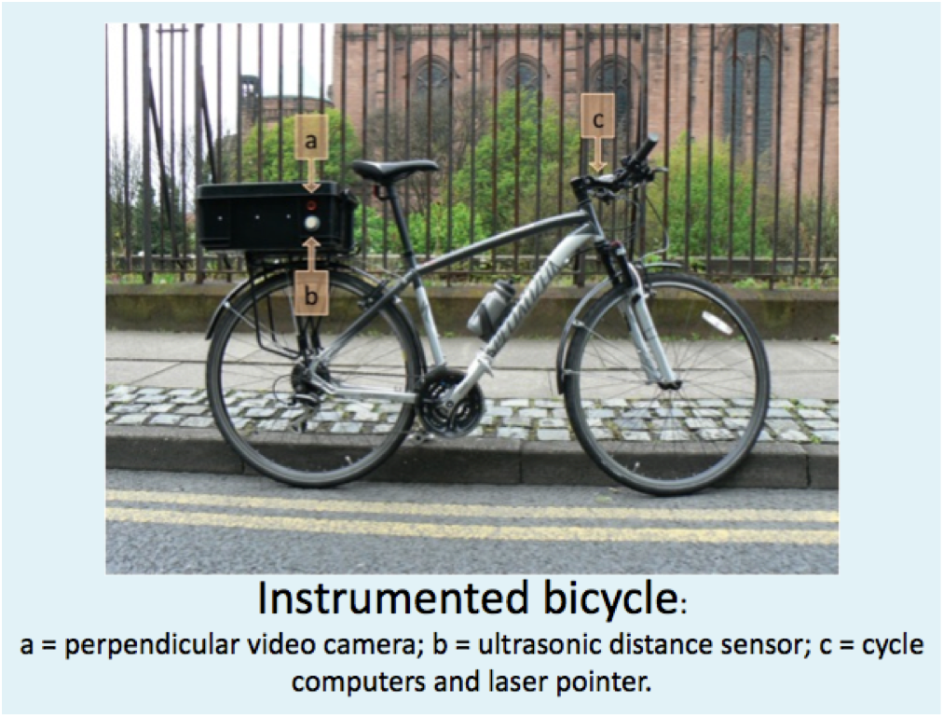

Figure 2 Types of lane marking
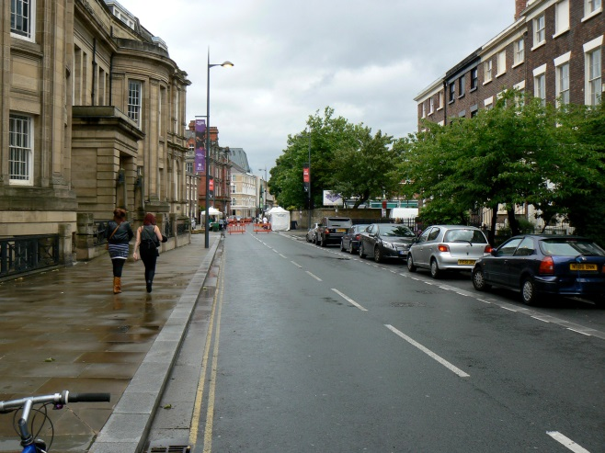  Single lane with no cycle lane and a centre-line marking (‘single lane’) | 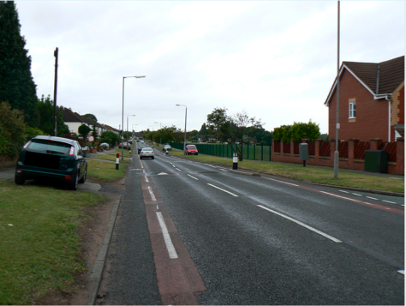  Two lanes, one of which is a cycle lane, with a centre-line (‘cycle lane’)
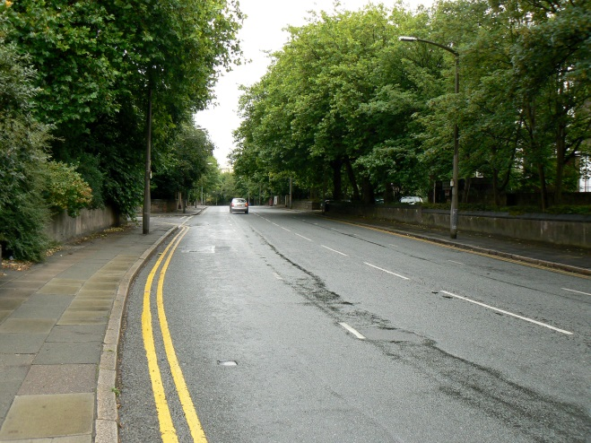  Two lanes, both of which are general traffic lanes, with a centre-line (‘dual lane’) | 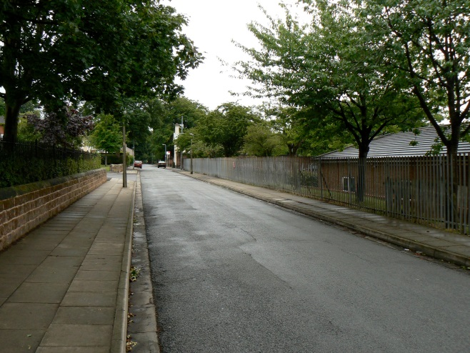  Single lane with no cycle lane and no centre-line (‘no centre-line’)

Figure 3 Satellite view of the ride route chosen
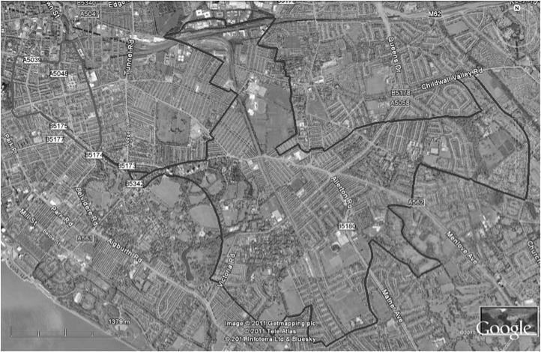

Figure 4 Annotated example of a video frame of an overtaking vehicle
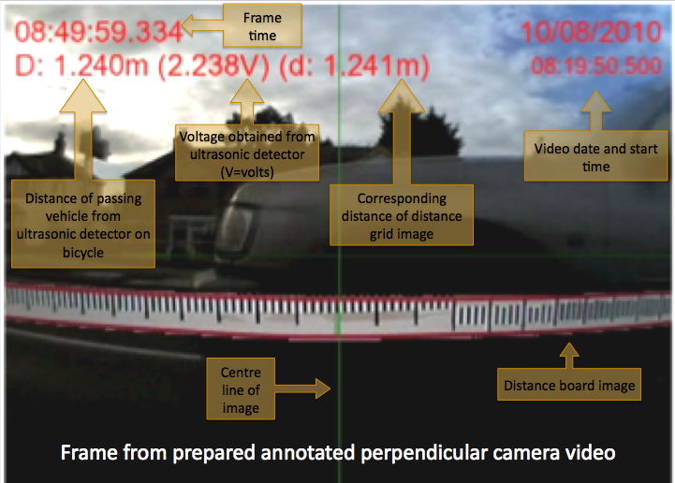

Table 1 Descriptions of each variable category
 | Variable | Description
Road layout | Lane widths | Tight <3.10 m, critical 3.10-3.75 m or spacious >3.75 m
 | Road markings | Single lane (no cycle lane and with a centre-line marking)  Cycle lane (two lanes including a cycle lane and with a centre-line marking)  Dual lane (two general traffic lanes with a centre-line)  No centre-line (single lane but no cycle lane or centre-line marking)
 | Lane widths and road markings | A combination of the above
Vehicle and driver factors | Time of day | Morning Peak (7am to 10am) or Evening peak (3pm to 6pm)
 | Exceedence of speed limit | Dummy if vehicles exceed the posted speed limit
 | Overtaking vehicle type | Bicycle, motorcycle or motor-scooter, private car, private hire taxi, hackney taxi, light goods vehicle, rigid lorry, articulated lorry, coach or bus
 | Overtaking vehicle in platoon | In platoon if time between last sight of first vehicle and first sight of following vehicle less than 3 seconds
 | Oncoming vehicle proximity | alongside (≤2 seconds), mid-distance (>2 and ≤5 seconds) and far distance (>5 seconds)
 | Oncoming vehicle type | As for overtaking vehicle type
 | Oncoming vehicle in platoon | As for overtaking vehicle in platoon

Table 2 Traffic proportions of route by type and average flows
 | 20 mph | 30 mph
 | Flow  (vehicles per hour) | Flow  (vehicles per hour)
Tight | 51 | 331
Critical | 273 | 415
Spacious | 546 | 501
Single lane | 245 | 429
Cycle lane | 72 | 827
Dual lane | 582 | 523
No centre-line | 88 | 94

Table 3 Summary of mean speeds and passing distances by speed limit, cross-section type and lane layout
 | 20 mph |  |  | 30 mph
 | Tight | Critical | Spacious | Tight | Critical | Spacious
Speed (mph) | Mean [n=] | Mean [n=] | Mean [n=] | Mean [n=] | Mean [n=] | Mean [n=]
Single lane | - | 35.05 [14] | 44.67 [19] | 53.29 [9] | 44.24 [100] | 50.08 [98]
Cycle lane | - | 41.24 [51] | 44.13 [18] | - | 45.10 [6] | 49.44 [47]
Dual lane | - | - | - | 47.69 [26] | 46.52 [47] | 49.23 [10]
No centre-line | - | - | - | 39.10 [15] | 40.35 [3] | -
Passing distance (m)
Single lane | - | 1.75 [14] | 1.58 [19] | 1.56 [9] | 1.54 [100] | 1.79 [98]
Cycle lane | - | 1.54 [51] | 1.70 [18] | - | 1.53 [6] | 1.64 [47]
Dual lane | - | - | - | 1.97 [26] | 2.17 [47] | 1.15 [10]
No centre-line | - | - | - | 1.45 [15] | 1.92 [3] | -
Key: Mean = Back-transformed group mean, [ ]= sample size

Table 3 Significant differences for roads with 20 mph speed limit
Condition | Overtaking speed | Overtaking distance
Lane widths and road markings | Spacious & single lane[19] > * critical & single lane[14]  Spacious & cycle lane [18] > * critical & single lane[14]
Exceedence of speed limit | Above limit [89] > *** below limit [13]
Overtaking vehicle type | LGV [3] > * cars [96]
Oncoming vehicle proximity |  | Far distant [33] > *** alongside [21]
Key: [ ] = sample size, * = p<=0.05, ** = p<=0.01, *** = p<=0.001.

Table 4 Significant differences for roads with 30 mph speed limit
Condition | Overtaking speed | Overtaking distance
Lane widths | Spacious [155] > * tight [50]  Spacious [155] > *** critical [156]
Road markings | Single lane [207] > *** no centre-line [18]  Cycle lane [53] > *** no centre-line [18]  Dual lane [83] > * no centre-line [18] | Dual lane [83] > *** single lane [207]  Dual lane [83] > *** cycle lane [53]  Dual lane [83] > * no centre-line [18]
Lane widths and road markings | Spacious & single lane [98] > *** critical & single lane[100]  Spacious & cycle lane [47] > *** critical & single lane[100]  Spacious & single lane [98] > *** tight & no centre-line [15]  Spacious & cycle lane [47] > * tight & no centre-line [15]  Tight & single lane [9] > * tight & no centre-line [15]  Tight & single lane [9] > * critical & single lane[100] | Tight & dual lane [26] > *** critical & single lane[100]  Tight & dual lane [26] > * spacious & cycle lane [47]  Critical & dual lane [47] > * tight & no centre-line [15]  Critical & dual lane [47] > *** critical & single lane[100]  Critical & dual lane [47] > * critical & cycle lane [6]  Critical & dual lane [47] > * spacious & single lane [98]  Critical & dual lane [47] > *** spacious & cycle lane [47]  Spacious & single lane [98] > *** critical & single lane [100]
Exceedence of speed limit | Above limit [140] > *** below limit [221]
Overtaking vehicle type | Cars [289] > * rigid lorries [6]  Private hire taxis [18] > * rigid lorries [6]  LGV [31] > *** rigid lorries [6]  Cars [289] > *** buses [10]  Private hire taxis [18] > * buses [10]  LGV [31] > *** buses [10]  Cars [289] > *** all long vehicles combined [18]  Taxis [23] > *** all long vehicles combined [18]  LGV [31] > *** all long vehicles combined [18]
Overtaking vehicle in platoon | Alone [223] > *** in platoon [138]
Oncoming vehicle proximity | Far distant [84] > *** middle distant [48]
Oncoming vehicle type | Articulated lorry [3] > * bicycle [7]  Articulated lorry [3] > *** car [159]  Articulated lorry [3] > * hackney taxi [4]  Articulated lorry [3] > * private hire taxi [3]  Articulated lorry [3] > *** LGV [22]  Articulated lorry [3] > *** bus [11]  Rigid lorry [6] > * LGV [22]
Oncoming vehicle in platoon |  | Single vehicle [127] > * in platoon [88]
Key: [ ] = sample size, * = p<=0.05, ** = p<=0.01, *** = p<=0.001.

A cycle lane is a part of the carriageway delineated by a road marking to provide space for cycle traffic. The road marking, a line, may be intermittent or solid, and the legal meaning to the space created differs between countries. In the UK, for example, it is illegal for motor traffic to cross the solid white line and enter the cycle lane, whereas this is not the case with an intermittent white line. Cycle symbols will usually be stencilled intermittently along the length of the lane. On high volume and high speed rural roads, there may sometimes exist a solid white line delineating the edge of the carriageway, with a paved shoulder beyond the carriageway. These would not usually be regarded as cycle lanes, and in fact, at least in the UK, it would also be illegal for cycle traffic to cross such a solid line unless there was a traffic regulation order in place to create a cycle lane beyond the solid line, hence creating a cycle lane.
A spacer bar is a rod protruding laterally from the bicycle in the direction of passing traffic. It may have a flag at the end of the rod. Its function is to encourage motor traffic to pass at a greater distance.

