Using Space-based Downstream Services for Urban Management in Smart Cities

Antonio Garzón, M. Palacios and Julia Pecci
Indra Sistemas
Space Unit. Earth Observation Department
Indra Sistemas S.A.
Mar Egeo, nº4, 28830 San Fernando de Henares, Madrid Spain
agarzon@indra.es, mpalacios@indra.es, jpecci@indra.es

Zaheer Khan, David Ludlow
University of the West of England, Bristol
Department of Computer Science and Creative Technologies
Faculty of Environment and Technology
Coldharbour Lane, Bristol, BS16 1QY, UK
Zaheer2.Khan@uwe.ac.uk, David.Ludlow@uwe.ac.uk

Abstract— Data collected through remote sensing (for instance geo-satellite) provides necessary stimulus for developing smart solutions for climate change & public health, energy efficiency and land monitoring in an urban environment. The velocity, variety, volume and veracity of high resolution data produced by geo-satellites provide big opportunity for planning and decision making in a smart city context. However, processing and integrating remote sensing data with auxiliary data sources require proper data management and elastic computational resources to derive necessary information intelligence (or knowledge) for decision making. This paper presents prototype of selected Decumanus services and highlights strengths & weaknesses of climate change, energy efficiency and land monitoring applications for the different European cities. The analysis of the early results indicate that the amount of computation resources required to process data for above applications make cloud computing a suitable technology but also face challenges in adopting it due to its recency, impact on green computing and reluctance to transform from legacy computing systems to new paradigms like cloud computing. We critically discuss these challenges and suggest possible solutions.
Keywords—cities, earth observation, satellite, climate change, adaptation, cloud, urban environment

Introduction
Approximately 50% of world’s population live in urban areas, a number which is expected to increase to nearly 60% by 2030 [1]. High levels of urbanisation are even more evident in Europe where today over 70% of Europeans live in urban areas, with projections that this will increase to nearly 80% by 2030 [1]. Urbanisation and its associated socio-economic and environmental impacts is one of the key drivers of change that challenges the sustainability of urban environments globally, placing significant pressure on public authorities to respond in mitigating and adapting to these challenges.
Recently, smart cities have been gaining a lot of attention from academia, scientific and ICT, government, practitioners and planning experts. Due to vibrant set of smart applications these cities can support for sustainable urban development and governance [2][3]. Apart from policy and stakeholders' specific needs, smart cities applications rely heavily on new ICT methodologies, processes, tools, technologies (e.g. sensors, cloud computing, IoTs) and hence it can be considered as common and prime driving force of smart cities initiatives. In this respect, remote sensing especially space/satellite downstream services (earth observation data) facilitate a top-down data collection approach. This top-down approach provides a unique way of collecting new data that can be used in variety of urban applications for informed decision making and better urban governance.
Smart city governance applications mostly rely on bottom-swup initiatives that offer real-time monitoring of the socio-economic dynamics of the city as inputs to land-use planning; enable environmental monitoring e.g. GHG emissions, noise pollution etc; facilitate the management of energy usage by using smart metering to support energy conservation and efficiency; offer augmented reality applications for citizens and context aware location based ubiquitous services accessible from smart phones; and provide visualisation models enhancing future planning scenarios, supporting territorial impact assessment, and thereby facilitate policy making and decision making in urban governance.
However, both these bottom-up and top-down methodologies generate huge amount of data for cities. Such data need to be properly managed, pre-processed, stored, harmonised & integrated, analysed and visualised for different city applications [4][5]. Cloud computing appears to be a suitable technology to fulfil above requirement by providing on-demand compute and storage resources. However, it is not straightforward to adopt cloud technology for some applications due to huge amount of data transfer, legacy computing models and algorithms. In this respect, we present our experiences from an European Commission Framework Programme Seven project DECUMANUS [6] which develops different space based smart cities applications for five European cities and highlight their strengths and challenges.
The remainder of this paper is structured as follows: Section II briefly introduce the DECUMANUS project and its service products. In Section III we present strengths and limitations and argue adoption of cloud computing. We critically reflect on the requirements for cloud adoption and challenges and conclude in Section IV.

Introduction to DECUMANUS Project
The DECUMANUS project [6] aims to design and develop a set of geo-spatial products and services for urban environment with a long term commercial orientation. The project has five case-study cities (Antwerp, Helsinki, Royal Borough of Kensington & Chelsea (London), Milan and Madrid) which are participating to define cities requirements and validate the service products. The objective of the project is to provide city managers with a set of sustainable decision support services that allow the deployment of geo-spatial products in the development and implementation of climate change strategies and in meeting the diverse challenges of sustainable urban development.
The project uses Copernicus (previously GMES) [7] data and experience from previous projects (e.g. BRIDGE, GUS, Geoland) for the development of city specific service products. The objective is to provide reliable, accurate and high resolution (i.e. urban scale) information to urban planners and decision-makers in making decisions for environmental changes and climate change adaptation. This requires the adaptation of climate models and GMES products to urban scales and development of innovative tools and services to meet specific needs and requirements of cities and different stakeholders. Hence, the DECUMANUS product development and assessment is fundamentally user driven.
Decumanus portfolio of information services (Fig. 1) addresses the key political concerns for Europe’s cities including climate change impacts, monitoring of land-use development and urban sprawl, assessment of urban energy efficiency and securing healthy urban environments for all citizens including the vulnerable young and increasingly ageing population of Europe, specified as follows: land monitoring, city energy efficiency, citizen health and population impact assessment.

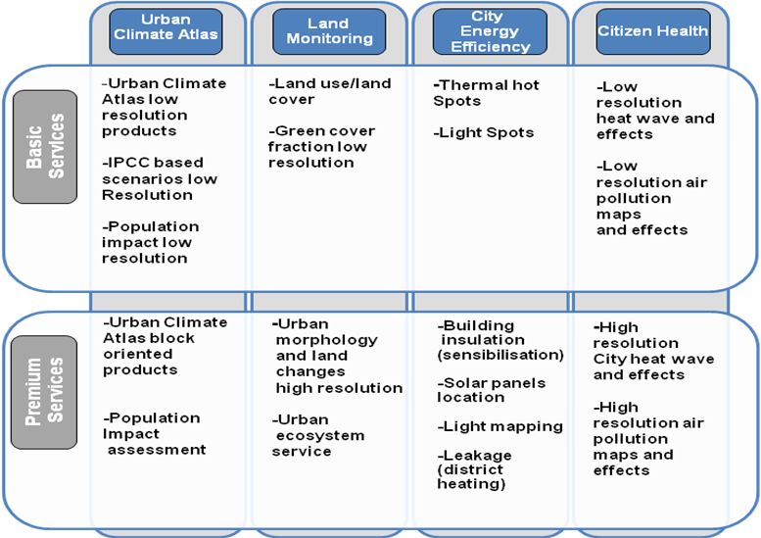
- DECUMANUS Services Portfolio

The project portfolio of products have been divided in two levels:
- Basic or Strategic Services include products that allow end-users to support the management and implementation of their climate and environmental change adaptation strategies.
- Premium or Local Services include datasets, indicators, models, etc. developed and specified according to substantial engagement with the local planning communities and/or the use of local information.

The project adopted CoReS method [8] for collecting cities requirements for the development of above services [9]. The following Fig. 2 illustrates interaction of end users (city stakeholders e.g. urban planners, decision makers, GIS experts etc) to DECUMANUS services through a web portal. End users are expected to perform certain pre-defined operations (as per requirements definition [9]) and receive corresponding response (e.g. data, image, result visualisation etc) through web/geo-portal. For instance, one common requirement is that the output of DECUMANUS services should be linkable as layer on local city Atlas and can be used for further analysis, consultation, etc. But the use of service outcome can vary from one city to another and mainly depends on the priorities of city planning and policy processes [10].
In Fig. 2, end-users mainly interact with DECUMANUS services through a web portal. All service features are covered in the background processing which actually fulfils user requirements. End users can only perform pre-defined interactive operations e.g. data export. The outcome of the service can also be linked with city atlas through service interfaces (e.g. OGC compliant services) and used for further processing. However, DECUMANUS can provide outputs in commonly used formats (e.g. shapefiles, vector/raster data, tables, JSON etc) and further transformation of data is beyond the scope of DECUMANUS services.

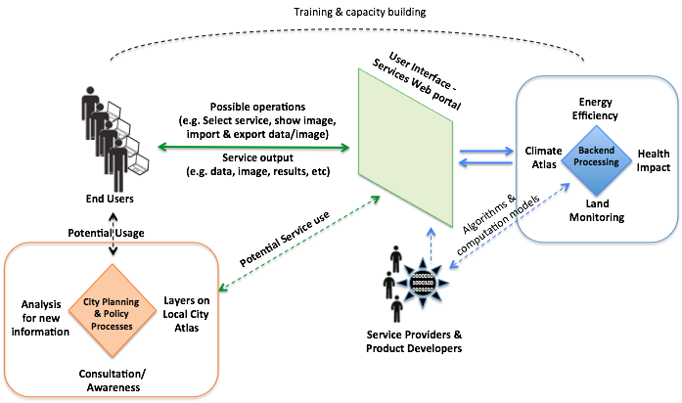

- A high level DECUMANUS user-service interaction model

In this following sections we briefly present selected DECUMANUS product services.

Land monitoring

These products are focused on the spatial characteristics of the city, which strongly influence urban climate. Area wide maps of spatial parameters such as impervious surface or vegetation fraction can provide insights into anticipated climate change scenarios because of the strong relationship between these spatial parameters and urban climate. Other products are related with Urban Environmental indexes and green roof detection (Fig. 3) are particularly useful for urban manager. Temporal analysis and appropriate exploitation of these data are a crucial factors.
- Map of potential green roof – Courtesy of DLR

City Energy efficiency
Energy efficiency is an increasing concern and drives the demand for specific products that indicate energy losses and potential savings. Light emissions and Thermography maps allow a better understanding of urban citizen behavior as well as the specific performance of buildings. These products are focus on the contribution of cities to increased atmospheric concentration of CO2 due to the inefficient use of energy within the cities, and cost reductions due to energy saving, by determining the areas that are the least energy-efficient. From space two types of energy loss can be detected: 1) thermal energy loss due to the heating or cooling of buildings (Fig. 4), and 2) excessive lighting (nighttime lights). The attribution of these energy emissions can be reached by combining this data with core mapping services (Urban Atlas, HR Layers, …), leading to an improved understanding of the emitting areas in the city (identification of hotspots).
- Thermography map of Milan – Courtesy of Eurosense

Citizen health
City authorities and in particular urban planners require cause-effect relationship assessments between territory and health outcomes in creating sustainable and healthy urban environments, e.g.:
- Number of days exceeding max 8-h concentration of ozone, carbon monoxide, PM10
- Number of hours exceeding max concentration of NO2/SO2
- Annual concentration of NO2 and PM10

These products model the influence of alternative land development and climate scenarios on meteorological and air quality variables and quantify the effects of each scenario on public health outcomes arising from high concentrations of air pollution. The services will allow the assessment of important environmental factors including heat waves, air pollution and the health impacts. City planners can assess for current as well as for future alternative climate scenario conditions, and the consequences in relation to alternative future visions for urban development and infrastructure provision.
- Air quality index example for Helsinki – Courtesy of UPM

Population impact assessment
This service allows for each of the other services generated
by the project to spatially identify and quantify its impact on
the local population. It permits hotspot analysis and is based
on city administrative units or individual building block.
- Population impact assessment (Royal Borough of Kensington & Chelsey) – Courtesy of GeoVille

Advantages And Cloudification of DECUMANUS Products
The main advantages of the DECUMANUS products/services are based on the use of earth observation (EO) data jointly with auxiliary data sources. Both these sources provide complementarity in fulfilling cities needs for the development of smart applications. More specifically, the advantages of using EO data are:
- Earth observation - satellite data are, nowadays, a affordable source of information which it is assured for a long term future. Mainly with very high resolution imagery available through EO data, now accuracy and precision and resolution scale of data suit well for cities and local citizens needs.
- With regular updates, EO data allow temporal and spatial comparison of products to measure effects of policy implementation and specific local actions e.g. land change, energy consumption and behavioural change.
- Since these products are generic and can be applied using new EO data for other cities around the world.
- Products can be easily customized according with users´ needs and requirements.
- The outcome of these products can be used for further analysis using specialized tools and new data.
- The outcome of these products can be used to validate existing information about climate, land cover, energy efficiency etc.

However, one of the major challenges of DECUMANUS project is, not only to develop all the user demanded products/services, but to made them operational and accessible to any citizen/manager in the world and for all the case study and other cities. To cope with that ambitious goal, from the technical point of view, there are several issues to resolve:
- Computational infrastructure: DECUMANUS would potentially offer services for a huge number or cities: from 5 case study cities to 500 around the world. However, this would require a cloud based scaling infrastructure to support processing and storage needs. Some of the DECUMANUS products already need supercomputer capabilities to produce data in an affordable time window (e.g. Climate Atlas). Some other products require the processing of large amount of data from heterogeneous sources, even "dynamic data", at very high resolution. These requirements cannot be satisfied without deploying DECMANUS products in a cloud based service infrastructure.
- Data storage and management: The auxiliary data needed for the development of a specific DECUMANUS service can be reused by another service. This suggests a common harmonized data repository can benefit DECUMANUS service products. Also, with the increasing amount of data, a Big Data approach (e.g. NoSQL) in a cloud infrastructure is needed to satisfy cities future needs.
- Dissemination and sharing tools: The DECUMANUS service products have to be accessible through web portal where end users should be able to visualize the service outcome and integrate services with local cities atlas using standard OGC service interfaces. Such requirements can overload DECUMANUS services at peak times and hence would need scalable cloud based infrastructure to maintain quality of service of DECUMANUS products.
- On the fly processing: DECUMANUS premium services aim to develop services with if-else scenarios where end users can change parameter values and on-the-fly see the processing results. Such a requirement necessitates use of cloud based infrastructure with elastic resources to generate processing results and visualize to end users without compromising quality of service (e.g. delay).
- Multiplatform access services: DECUMANUS products and services should potentially be accessible to different existing spatial platforms available in the market. So, data and, protocols and dissemination processes should be duly standardized, harmonized and compatible with the different user needs.

In addition to above, we found that outcome of one DECUMANUS service could be used as input to another DECUMANUS service. For instance population impact assessment can be used by all other DECUMANUS services. Similarly, 3D building model outcome of Land monitoring can be used by Energy efficiency and Climate atlas if there is no 3D building data available in cities. However, at the moment these service products are developed as stand-alone services and hence require extra efforts for sharing and integrating outputs with different services. This suggests that a cloud based integrated service model can be more beneficial for DECUMANUS products, as depicted in Fig. 7.

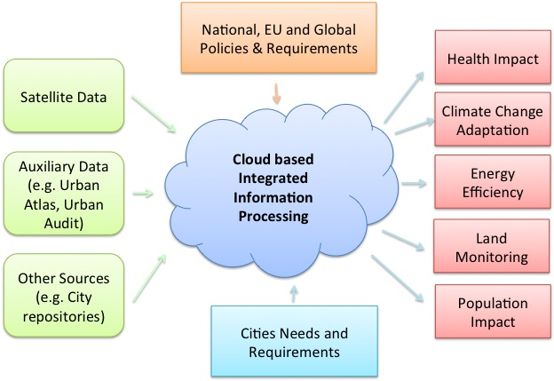
- Cloud based Integrated Processing
In Fig. 7 we present a cloud-based integrated approach to generate DECUMANUS service product specific information based on cities needs as well as other national or EU policies. The benefit of such an approach would be to reuse data and service outcomes where appropriate. Also, data storage and computational needs (as discussed above) can be fulfilled by an elastic cloud infrastructure.

Dicussion & Conclusions
In this paper we highlighted the potential of remote sensing (i.e. satellite based) data to be used for a variety of smart city applications. These new data sources provide complementary information to in-situ data that helps in gaining richer knowledge to make informed decisions. In addition, it is evident that these applications provide a unique opportunity for cities and their inhabitants to get up to date information to raise their environmental and urban awareness for better planning and decision making. The benefit of the satellite based data for smart cities applications is that new images can be used to compare and contrast the land cover/use, light emissions, energy usage, etc on regular basis. However, it is evident from the above applications that the increasing amount of such data, required pre-processing, data integration & processing and visualization to present high quality and reliable information to cities require the necessary storage and computational infrastructure. Conventional distributed computing approaches can be applied, however, with fixed infrastructure (e.g. dedicated PCs or clusters), the increasing resource needs of many cities may not be fulfilled. Therefore, the infrastructure must be scalable to meet the quality of service, storage and processing demands of different smart cities applications, e.g. cloud computing, due to its elasticity characteristic.

However, there are challenges in adopting cloud technology. For instance, climate change modeling and earth observation data processing to derive 50m resolution scale for cities need immense processing power which may result in high financial costs. In addition, the required high amount of data transfer for such an application in a cloud infrastructure may bear high environmental impact. Also, transforming existing algorithms and models to cloud based infrastructure (e.g. Hadoop) would require some extra expert efforts. In the case of the DECUMANUS Climate Atlas service, Barcelona supercomputing facility is used for climate modeling and processing to avoid the above issues. Nevertheless, there have been some efforts in literature of using cloud computing for such purposes. For instance, S. Lu et al [11] used cloud based computational resources for large scale data having complex structure and format. They demonstrated cloud based large scale data integration, management, analytics and interactive on the fly visualization for a multi-scale climate data by using RapidMiner with Hadoop on hybrid cloud model [11]. The applications presented in this paper are being applied at strategic scale (e.g. 200m pixel size for climate atlas). But in the future these services will be developed at local scale (i.e. 50m pixel) as well as provide more user-defined features such as on-the-fly if-then-analysis, which would require scalable processing power for which cloud based infrastructure is well suited.

From an end user perspective, these DECUMANUS services provide new data which otherwise is not available or too expensive to collect. This new data can be processed and analyzed for a variety of purposes and help them in decision making. After delivering the DECUMANUS strategic services, our future work will be the development of local services (which will be based on the requirements and needs coming from the five partner cities in the project). The commonalities among these requirements and needs will help in developing generic solutions which can be applied to other 500 plus medium size European or global cities.

Acknowledgement
The DECUMANUS project is partly funded by European Commission Framework Programme 7 under grant agreement number: 607183. We also thanks to different project partners for providing illustrations for this manuscript.

References
- UN Habitat report, Cities and Climate Change: Global Report on Human Settlements.United Nations Human Settlement Programme, 2011.
- B. Bach, D. Wilhelmer, P. Palensky, Smart buildings, smart cities and governing innovation in the new millennium, 8th IEEE International Conference on Industrial Informatics (INDIN). P.p. 8-14. Osaka, Japan. 2010.
- T. Nam, T. A. Pardo, Conceptualizing smart city with dimensions of technology, people and institutions, The Proceedings of the 12th Annual International Conference on Digital Government Research, 2011, p.p 282-291, College Park, MD, USA.
- Z. Khan, A. Anjum, S. L. Kiani, Cloud based big data analytics for smart future cities. Proc. ITAAC 2013 - 6th IEEE/ACM International Conference on Utility and Cloud Computing, pp. 381-386, 9th-12th December, 2013. Dresden, Germany.
- Z. Khan, D. Ludlow, R. McClatchey, A. Anjum, An architecture for integrated intelligence in urban management using cloud computing, Journal of Cloud Computing: Advances, Systems and Applications, 1:1, pg. 1-14, ISSN 2192-113X, 2012.
- DECUMANUS project: URL: http://www.decumanus-fp7.eu
- Copernicus – EU Earth Observation Programme, URL: http://www.copernicus.eu/
- Z. Khan, D. Ludlow, and W. Loibl, Applying the CoReS requirements development method for building IT tools for urban management systems: The UrbanAPI project. Theoretical and Empirical Researches in Urban Management, 8 (4). pp. 25-59. 2013. ISSN 2065-3913
- DECUMANUS project, User Requirements Definition (I), Deliverable 2.1, Feb/March 2014.
- DECUMANUS project, Service Usage Process Models (I), Deliverable D3.1, April/May 2014.
- S. Lu, M. R. Li, C. W. Tjhi, K. K. Leen, L. Wang, X. Li, D. Ma, A framework for cloud-based large-scale data analytics and visualization: Case study on multiscale climate data. In: Proceedings of the 3rd IEEE International Conference on Cloud Computing Technology and Science, Nov 29-Dec 1 2011, Divani Caravel, Athens, Greece, pp. 618–622 (2011).

