4. ‘The instinct for hero worship works blindly’: English radical democrats and the problem of memorialisation

Abstract: This essay explores a number of historical precedents for today’s debates concerning statuary memorialisation. Early-nineteenth-century radicals shared many of the same discussions and tactics that feature in modern controversies over memorial statuary, especially concerning ways of countering the triumphalism and elitism of commemorative projects. The difficulties associated in particular with memorialising progressive causes and subaltern heroes produced responses as varied and unsatisfactory in the nineteenth century as today, as the need to generate and maintain commemorative consensus often produces anodyne and uninspiring memorials.

Keywords: Cromwell; Wellington; Lincoln; chartism; monuments; progressive causes; radicalism; consensus

On a chilly October day in 1832, Thomas Hardy, founder and former secretary of the London Corresponding Society, was laid to rest in Bunhill Fields cemetery. John Thelwall, his former comrade, and fellow defendant in the 1794 treason trials, performed a 90 minute funeral oration over the grave. Hardy’s exemplary life as an unwavering reformer must never be forgotten, insisted Thelwall, but his was ‘not a grave to demand a pompous monument or colossal effigies’. Nor would he obtain one. The simple stone column erected beside it by public subscription a few months later faded quickly from public memory and was ‘going to decay’ within twenty years.
Meanwhile, George Julian Harney’s Red Republican had joined the debate, in verse, over the siting for a future statue of Oliver Cromwell. Since 1845, Conservative public opinion had been preoccupied with the question of whether Cromwell was worthy of a place in the newly rebuilt Palace of Westminster; but Chartists were more concerned with the fitness of the Palace for Cromwell.

Where shall we place his monument – the effigy sublime
Of England’s Victor Rebel, - her Worthy, for all time?
That Englishmen may worship him, with as undaunted brow
And say –Where Cromwell dared to lead, we dare to follow now.
For we do not raise our statues except to men whose worth
From out the herd of commonness stands gloriously forth;
And we build our monuments for this, that future men may say –
Those heroes were our sires, and we are worthy them today.

These two incidents illustrate a dichotomy we have yet to shake off. Is it better to counterbalance the ostentatious monuments of the elite with similar memorials to more progressive causes, or to oppose the erection of all statues as the material culture of hubris? Simply registering objection to the statue building schemes of the Establishment was straightforward enough in the 1830s, but proposing alternatives was no less complicated than it is today. ‘This is the justice to be obtained from the hereditary spoilers and slayers of mankind’, observed the Poor Man’s Guardian in 1833. ‘They will build statues to Wellington and the Duke of York but they will build none to William Tell or Robespierre’. This was the classic objection, and modern historians of the left have largely inherited it. As Raphael Samuel put it, we have ‘become accustomed to thinking of commemoration as a cheat, something which ruling elites impose on the subaltern classes. It is a weapon of social control, a means of generating consensus and legitimising the status quo with reference to a mythologized version of the past’.
And if thoughts like these have informed current attitudes to unwelcome statues like Edward Colston’s, they too are not without precedent. Just as it is argued today (see Introduction to this forum) that old statues can be challenged through reinterpretation, graffiti and guerrilla activity, so too was it argued by earlier generations. In 1817, Cobbett encouraged parents to take their children to Pitt’s statue in the London Guildhall for instance, to ‘recount to them all his deeds, from his dawn to his extinguishment, and tell them to shun that as they would the curses of their forefathers’. And the Poor Man’s Guardian was convinced that, execrable though it was by design, the new statue to the Duke of York erected in 1834 would ‘never be seen without the debts of the Duke being thought of and his recollection cursed’. If that didn’t work, like Colston they could always be toppled instead. At Bristol a statue of George III was pulled to the ground in 1813 by supporters of Henry Hunt, while in Ramsgate, a similar fate befell a statue of Wellington in 1825, and at a sculptor’s shop in Newcastle during the frantic May Days of 1832, a pro-reform crowd seized and destroyed a new statue of William IV. But attacks on the memorials of the elite were not the sole prerogative of reformers. In 1837, the Marquis of Waterford led a party of army officers to a break-in at Eton College where they pulled down the statue of the school’s founder, Henry VI, ‘which they mutilated and disfigured very much, and wrenched away the sceptre and carried it away with them as a trophy’. [Figure 2 near here]
Kings had been particularly vulnerable in earlier years when Whig and Tory rivalries were at their Jacobite peak. An equestrian statue of James II, for instance, was torn down at Newcastle in 1688 and dumped in the river Tyne. It had cost the corporation £1700 to commission and its loss was so keenly felt that nearly half a century later one enterprising local artist tried to drum up subscriptions for a commemorative engraving:
As it was a very great ornament to the town, ‘tis great pity the same is not still in being… but there are no bounds to the heady proceedings of a furious Mob who drive all before them without either Reason or Reflection and bear no regard either to things Civil or Religious. Such a Mob was that which pull’d down the same Noble statue (a few soldiers at the Revolution, as drunk with Loyalty as with Liquor, assisted by a hot-headed Crew, having provided Ropes for that Purpose, pull’d it down and dragg’d it from thence to the Key, and there threw it into the river).’
At Gloucestershire assizes in 1724, Elijah Pitt was fined £100 for damaging Gloucester’s statue of George I, a sum surely calculated to keep him in gaol for the rest of his life, while in Grosvenor Square, London in 1727, another statue to the same King was ‘defaced and partly demolished by some evil-minded persons’, his nose slit, his left leg and sword stolen and the truncheon ripped from his hand to be redisplayed at Tyburn with the inscription, ‘So Tyrants should be served’.
Statues of William III, by contrast, could inspire a rich variety of readings. On the one hand, as monuments to abstract ideas about constitutional and contractual monarchy and the (English) liberties enshrined in the 1689 Bill of Rights, memorials to William were as likely to be reinterpreted as shunned by popular democrats. Michael Rysbrack’s equestrian statue of the King in Bristol’s Queen Square was installed in 1736 by a Whig corporation anxious to display its anti-Tory and anti-Jacobite credentials. But to the plebeian democrats of the 1790s, then defending legislative attacks upon free speech and the right of public assembly, William’s statue had become a testament to betrayal. At the height of the struggle against the Pitt administration’s ‘Gagging Bills’ in 1795, the radical surgeon Thomas Beddoes urged Bristolians to turn Queen Square into a site of protest and mourning, and to ‘clothe the statue of King William in black till our liberties be secure. Then, Citizens, were our meeting held there, the scenery would be appropriate to the occasion’. Five years later, as bread prices spiralled in the city, a blood-soaked loaf was fixed to the railings around the same statue, with an anonymous note attached, ‘your Familys starving, your husbands and sons sent to foreign countrys to be murdered, and for what, why to keep Pitt and his gang in place’. In 1829, the statue formed a backdrop to the hustings at a protestant rally protesting the Catholic Emancipation Bill. But, most dramatically, while two blocks of residential housing were looted and torched in the Square during the Bristol reform riots in 1831, William’s statue was not just left undamaged but decorated with a tricolour. As if to emphasise the statue’s appropriation by the crowd, William Muller’s engraving of events that night placed a rioter on the back of the King’s horse, a plundered bottle of wine in one hand, as if raising a toast to liberty. [add second illustration here]
By contrast however, Irish Catholics regarded William III only as a repressive tyrant. William’s equestrian statue, erected on College Green, Dublin, in 1701 suffered serious physical attacks in 1710, 1714 and 1798, and in 1805 it was daubed with tar and grease. Then one April night in 1836, William was blown clean off his horse by a home-made bomb. Although repaired, reinstated and placed under police guard every night that summer, the statue continued to attract unwelcome attention and was pelted with ink in July. Finally, in 1928, the monument was blown to pieces by the IRA. Removing unwelcome statues is one thing; replacement, both then and now, is another matter. Today, Colston’s empty plinth prompts the question: If we remove old monuments because the values they represent have become outdated and abhorrent, should we propose more suitable replacements, retain and reinterpret the empty plinths so that absence itself becomes a positive and material signifier, or would it be better to design uncontested public spaces, completely free from monuments to pretended virtue?
Amongst early-nineteenth-century radicals, arguments that memorials to an approved list of reformers would be acceptable, provided they followed William Godwin’s suggestion of small and unpretentious wooden crosses, were common enough. The Chartist Circular for one, thought a ‘little green mound or grey cairn’ would suffice, since ‘the gorgeous obelisks of a Blenheim or a Waterloo can only excite a feeling of painful regret over the wickedness and ambition of man.’ If dead reformers lived on in the ‘vivid imagination of the people… no monument need they to preserve their names and perpetuate their glory and renown’. For those still wedded to conventional statues on the other hand, there was the question of placement. Harney’s statue of Cromwell should not be consigned to a landscape already tainted by the dominant ideologies of the elite and certainly, ‘Not in your new Commons house’. More appropriate places were suggested by radical sites of martyrdom; ‘some cell where Chartist “felon” waits’, or perhaps ‘where murdered Tyler fell’. The poet’s preference was for some tract of wild and natural land, free from any historical association with conservatism, ‘where the prophecy of Cromwell’s life’ might yet inspire ‘England’s Sons in thousands and in hundred thousands’ to claim their freedom.
Harney’s enthusiasm for commemorating Cromwell as a progressive republican, was more than a little compromised by his eagerness after 1847 to court the Irish Confederates, for whom Cromwell was a pariah. Yet he seems to have been little troubled by it. ‘Shall Cromwell have a statue?’, asked the Dublin Nation in 1845 after Irish MPs were urged to object. The paper was largely indifferent. ‘The omission of Cromwell out of a gallery of English rulers because of his persecutions in Ireland would be a lamentable absurdity. Why are they all Cromwell’s? In what respect was he worse than Henry… than Edward… than Richard…?’ If these monarchs were to retain their statues, reasoned the Nation, they might just as well be joined by Cromwell who, ‘if he were a knave and a hypocrite a thousand times over’, at least ‘taught Kings that they have a joint in their necks’. Some Chartist correspondents of the Northern Star took a similar line. Cromwell may have ‘far surpassed many (if not the whole) of our Governors whose names defile the pages of our history since Alfred the Great’, but ‘What is it to us, the robbed, despised, degraded and enslaved working classes, whether this or that “slaughterer of the human family” has a place in the new Houses of Parliament?’
Of course, however deep the ambivalence of some Chartists over Cromwell’s historical reputation, unless they owned property on which to build, aspirations like Harney’s were not remotely realistic. With his tongue in his cheek, in 1835 the veteran Spencean Allen Davenport urged the founding of a subscription fund to purchase land for radical memorial parks. If governments must have their ‘malls, parks and Champs de Mars’, he argued, then so too should the people. He imagined a curated space with a monument at its centre commemorating everyone convicted of selling unstamped newspapers, and flanked by memorials to Peterloo and to the more recent use of police to attack and disperse a meeting of the National Union of the Working Classes at Cold Bath Fields in 1833. ‘On one side might be represented columns of raw lobsters with bludgeons, cutting down in their drunken rage, men, women and children without mercy. On another side, Lord Melbourne, the now Prime Minister, peeping through the window of the House of Correction to inspire his bloodhounds with courage to go on with the slaughter’.
Monuments to progressive ideas or to the people associated with them have frequently been subject to criticism, and from socialists and liberals as often as conservatives. As Jonathan White and Scott Sandage have recently pointed out, the great abolitionist Frederick Douglass was one of the first to express doubts about the Lincoln Park emancipation monument, unveiled in Washington in 1876. Days later, Douglas penned a letter to the National Republican newspaper, welcoming the monument’s intention but concluded that it did not ‘tell the whole truth, and perhaps no one monument can be made to tell the whole truth of any subject which it might be designed to illustrate’. The issue here is one of body language, for it casts Lincoln as the benign emancipator, stripping agency from the half-kneeling figure of an African American, rising beneath his outstretched arm. This monument to liberty now stands incongruously behind a protective wire fence, threatened by activists of both left and right and a reminder, should we need one, that building monuments to virtuous individuals is invidious because absolute virtue does not reside in individual humans and sooner or later, somebody will call it out.
An assumed need for social consensus has frequently led to a dilution of meaning in contemporary monuments to progressive causes. In Chicago’s Haymarket for instance, the spot where a bomb exploded as police dispersed an anarchist meeting in 1886 has long been a site of contested heritage. Following a series of guerrilla attacks upon the only ‘official’ memorial at the site – a statue commemorating the seven policemen who died in the explosion – it was finally moved to a safer location and a new memorial was inaugurated in 2004. As a stylized representation of the speakers’ wagon, the memorial includes a number of anonymous human figures and a series of plaques briefly outlining what happened in as neutral a manner as possible. The site ‘has become a powerful symbol for a diverse cross-section of people, ideals and movements’, one plaque explains. ‘Its significance touches on the issues of free speech, the right of public assembly, organized labor, the fight for the eight-hour workday, law enforcement, justice, anarchy and the right of every human being to pursue an equitable and prosperous life. For all, it is a poignant lesson in the rewards and consequences inherent in such human pursuits’. In the words of Nathan Mason, from the city’s department of cultural affairs, ‘We're showing a new way to do monuments at historic sites… You make them open rather than pressing a precise meaning on people or directing them toward a specific feeling or reaction.’ Or to put it another way, if representation and interpretation are made sufficiently anodyne, a memorial will probably neither offend nor inspire, but be largely ignored. It’s an observation one might equally make of Jeremy Dellar’s family-friendly memorial in Manchester for Peterloo, which, after decades of tireless campaigning for a fitting monument, seems to have pleased nobody.
In some ways, Newport in South Wales has managed the commemoration of its subaltern histories rather more successfully than Manchester. The Chartist rising of 1839 has been marked since the centenary by the naming of the civic centre after the rising’s leader, John Frost, by a graphic public mural (controversially destroyed by the city council in 2013), and a very prominent statue group outside the Westgate Hotel where 28 Chartists were shot dead by soldiers. Like Haymarket, the ‘success’ of this memorial is difficult to separate from the dilution of its message. Rather than recall overtly the armed insurrection they commemorate, the statues are allegorical representations of ‘union’, ‘prudence’ and ‘energy’. Thanks to the Leicester Chartist, Thomas Cooper, however, we still have time to redress the balance here. Writing from prison in 1845, Cooper called for a memorial to George Shell, a nineteen-year-old insurgent from Pontypool who ‘loaded and fired his piece three times with the greatest intrepidity, before he fell in the streets of Newport. We do not write history like the glorious old Greeks, or the memory of such a hero would not be lost!’ Recalling that aristocratic Whigs had recently bankrolled a memorial to mark the bicentenary of the death in action of a more approved rebel of the civil war, John Hampden, Cooper issued a challenge to the future. ‘May not a noble be found in November 2039, to commemorate Shell’s fall at Newport with equal earnestness?’ he asked. Perhaps. But it only leaves us another eighteen years to argue over form, lettering and location.

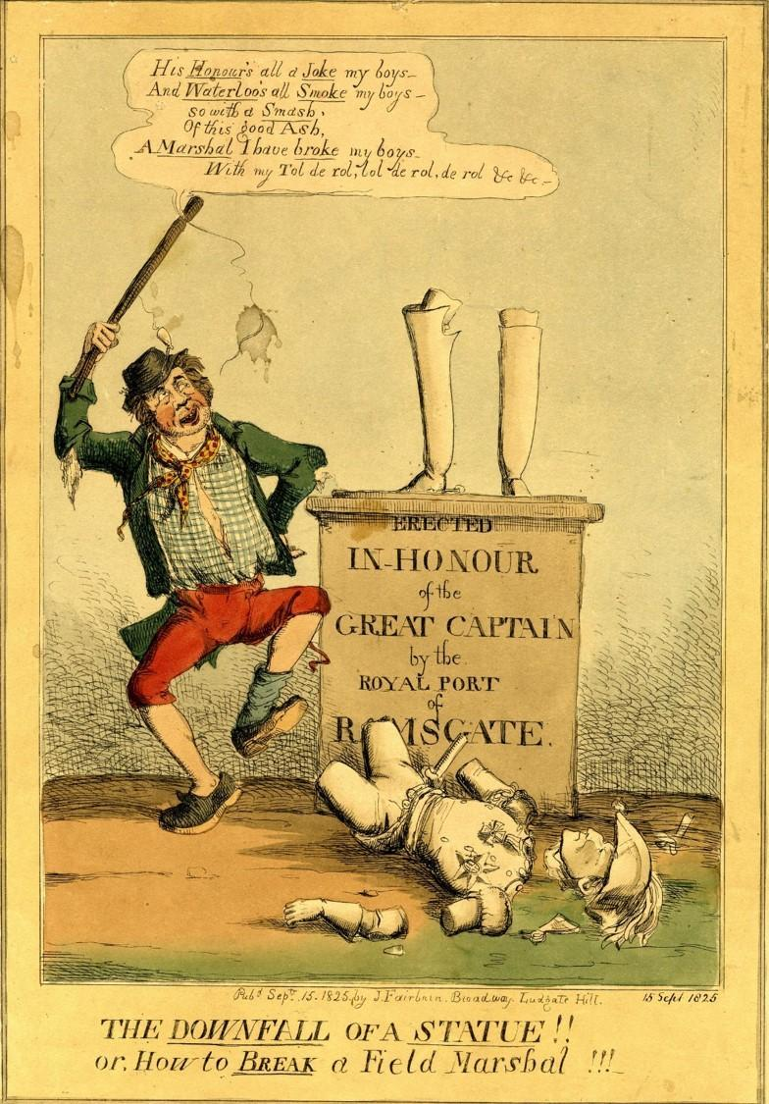
Figure 2. J. Fairburn, The Downfall of a Statue!! (1825). Engraving in response to the partial destruction of the Duke of Wellington's statue in Ramsgate on 25 August. British Museum 1868,0808.8667.

Northern Star, 14 November 1846.
The Times, 20 October 1832; Northern Star, 8 November 1851.
Spartacus, ‘The Place for Cromwell’s Statue’, Red Republican, 27 July 1850.
Poor Man’s Guardian, 17 August 1833; Northern Star, 2 October 1841.
Raphael Samuel, Theatres of Memory, Volume 1: Past and Present in Contemporary Culture (London: Verso 1994), 17.
Black Dwarf, 31 December 1817; Poor Man’s Guardian, 2 August 1834.
Bristol Mirror, 27 March 1813; Steve Poole and Nicholas Rogers, Bristol From Below: Law, Authority and Protest in a Georgian City, Woodbridge, 2017, p. 311; London Courier, 29 August 1825; Chester Chronicle, 25 May 1832; The Examiner, 18 June 1837. The chief suspect in the attack on Eton College was John Heneage Jesse, later lauded as a literary essayist and an expert on the Tudor and Stuart monarchy. He was arrested and bound over but seems never to have stood trial.
Newcastle Courant, 7 August 1742.
Daily Post, 8 August 1724; Daily Journal, 14 March 1727.
Thomas Beddoes, A Word in Defence of the Bill of Rights Against the Gagging Bills (Bristol, 1795), 7.
Bristol Archives, Town Clerk’s correspondence boxes, Duke of Portland to the Mayor of Bristol, 28 February 1800.
Bath Chronicle, 19 February 1829.
Derry Journal, 26 Apr 1836; The Pilot, 8 July 1836. For a full discussion of the impact of British royal statues in Dublin see Y. Whelan, ‘The construction and destruction of a colonial landscape: monuments to British monarchs in Dublin before and after independence’, Journal of Historical Geography, 28, 4 (2002).
Rowland Weston, ‘History, Memory, and Moral Knowledge: William Godwin’s Essay on Sepulchres (1809)’, The European Legacy, vol. 14, no. 6, 2009, 651-65.
Chartist Circular, 23 September 1839.
‘The Place for Cromwell’s Statue’, ibid.
Malcolm Chase, Chartism, A New History, Manchester, 2007, pp. 292-5; Paul A. Pickering, ‘Repeal and the Suffrage: Feargus O’Connor’s Irish Mission: 1849-50’, in Owen Ashton, Robert Fyson and Stephen Roberts, eds., The Chartist Legacy, Woodbridge, 1999, pp. 119-146.
Northern Star, 4 Oct 1845.
Northern Star 25 October 1845. For the controversy over the siting of a statue of Cromwell at Warrington in 1899, see Steve Cunliffe and Terry Wyke, ‘The curse of Cromwell: Warrington’s statue of Oliver Cromwell’, Northern History 46, 2 (2009). For Cromwell’s London statue see Melanie Unwin, ‘J’y Suis, J’y Reste: The Parliamentary Statue of Oliver Cromwell by Hamo Thornycroft’, Parliamentary History, 28, 3 (2009).
Poor Man’s Guardian, 16 May 1835.
Jonathan W. White and Scott Sandage, ‘What Frederick Douglas had to say about monuments’, Smithsonian Magazine, 30 June 2020.
Paul A. Shackel, ‘Remembering Haymarket and the Control for Public Memory’, in Laurajane Smith, Paul A. Shackel and Gary Campbell (ed.), Heritage, Labour and the Working Classes (Abingdon: Routledge 2011); New York Times, 15 Sep. 2004.
Thomas Cooper, The Purgatory of Suicides. A prison Rhyme. In Ten Books, Second Edition (J. Watson, 1858), 158-9.

