A Conceptual Framework for the Implementation of Quality Management Systems

Jose Arturo Garza-Reyes
Centre for Supply Chain Improvement
The University of Derby
Kedleston Road Campus, Derby, UK, DE22 1GB
J.Reyes@derby.ac.uk

Luis Rocha-Lona
Business School
National Polytechnic Institute of Mexico
Av. Luis Enrique Erro S/N, Unidad Profesional Adolfo López Mateos
Zacatenco, Delegación Gustavo A. Madero, C.P. 07738, México City
lrocha@ipn.mx

Vikas Kumar
Bristol Business School
University of the West of England
Coldharbour Ln, Bristol, UK, BS16 1QY
Vikas.Kumar@uwe.ac.uk

Some evidence suggests that Quality Management Systems (QMSs) have a positive contribution towards the competitiveness of organisations. However, evidence also suggests that organisations find their implementation difficult, and in many cases they are unsuccessful. This paper presents a conceptual framework that systematically guides organisations through a five stage process to effectively implement and/or improve their QMSs and core business processes. The framework can be modified or amended to be adapted to the needs of specific industries and organisations. The paper discusses some of the main issues associated with the implementation of QMSs and summarises some of the frameworks and models that have been suggested for this purpose. Then, the paper explains, in detail, all the stages and activities that the proposed conceptual framework consists of. This paper’s main contribution consists of the proposal of an alternative and novel approach for the implementation/improvement of QMS and business processes.

Keywords: Quality management systems; QMS; Total Quality Management; implementation; framework; business process improvement

1. Introduction
Global markets are characterised as being sophisticated in the way they produce, deliver, and consume products and services. They have evolved from industrialist economies and thus have specific needs to be covered considering sustainability, government legislations, technology, and social responsibility. Similarly, consumers of these markets are continuously getting more demanding as they require products of greater variety at lower prices and within shorter lead times (Godinho Filho and Veloso Saes, 2012). In this scenario, the challenge for organisations is to meet all these requirements while still producing goods of high quality. This requires from organisations a considerable amount of investments dedicated to building and developing effective Quality Management Systems (QMSs) that address those demands.
Quality Management Systems (QMSs) are an integrated business approach to plan and deploy quality management models, methods and tools across the organisation aligning to the business strategy (Rocha-Lona, Garza-Reyes & Kumar, 2013). The elements that compose a QMS can be categorised into human capital, processes, management models-methods-tools, business strategy, and information technology. QMSs have given rise to some of the most popular models, methods and quality tools such as Total Quality Management (TQM), Business Excellence Models (BEMs), ISO, Six Sigma, Lean and Business Process Reengineering (BPR), among others. Strong evidence suggests that companies that have a well-structured and developed QMS outperform their competitors as it benefits organisations in terms of increased customer satisfaction (Casadesús & de Castro, 2005), growth of revenues (McTeer & Dale, 1996), higher quality of products and services, increased productivity and efficiency (Gutiérrez, Tamayo Torres & Barrales Molina 2010), better teamwork and leadership (van der Wiele, van Iwaarden, Williams & Dale, 2005), higher profit margins, greater return on assets, and improved control of business processes and procedures (Dale, van der Wiele & van Iwaarden, 2007). Sampaio, Saraiva & Rodrigues (2009) suggest that a QMS can offer significant benefits to organisations if it is understood and implemented correctly. Thus, many companies are aiming to become world-class organisations and achieve “business excellence” through the strategic implementation of QMSs.
However, the successful implementation of some QMSs can, indeed, be a difficult task (Cândido and Santos, 2011; Yusof & Aspinall, 2000a) and one which is often unsuccessful (Dahlgaard-Park, 2006). Short (1995) comments that it is the implementation stage and not the QMS principles, the main factor that can make a QMS implementation to fail or be unsuccessful. For example, many organisations invest a considerable amount of human resources, capital, and time to build the right QMSs, but in many instances the QMSs and the adoption of specific business and quality improvement models, methods, and tools, are not adequate and/or are poorly deployed. In addition, in many cases, QMSs are not aligned with strategic quality planning and business strategies. Taylor and Wright (2003), for instance, comment that the lack of connection between QMSs and business strategy leads implementations to fail, while Sebastianelli and Tamimi (2003) found that this issue was the most significant factor which inhibits effective TQM implementations. Similarly, argue that BPR projects’ lacking of alignment with business strategy has become a major barrier to success in BPR implementation.
Due to the difficulties that organisations face when trying to implement QMSs, a vast number of frameworks have been proposed by consultants/experts, academics and professional institutions (i.e. award based) to guide organisations during this activity. Table 1 provides a summary of some of these frameworks. However, a limitation of many of these approaches, according to Yusof & Aspinwall (2000b), is that they tend to be complex and too prescriptive, rather than being a general guide. In addition, many of them have been proposed to guide implementation efforts in specific industries (i.e. local governments, manufacturing, service, healthcare, etc.) and/or for specific company sizes (i.e. large, medium, small). This paper therefore presents an alternative conceptual and generic framework that intends to guide organisations of any industrial sector and size in the implementation/improvement of their QMS and business processes.

Table 1. QMS implementation frameworks summary
Model, Methods, Tools to Implement | Author(s) | Framework/Characteristic
TQM | Deming (1986) | 14 points for management
TQM | Crosby (1980) | 14 step quality improvement programme
TQM | Juran & Gryna (1993) | 12 steps
TQM | Adams (1994) | Implementation framework for Harris Corporation
TQM | Aalbregtse, Hejka & McNeley (1991) | Total customer value (TCV) and the umbrella of TQM
TQM | Berry (1991) | Evolutionary nature of the TQM implementation process
TQM | Hakes (1991) | Management framework for TQM
TQM | Ghobadian & Gallear (1997);  Thompson & Simmons (1997) | Malcolm Baldridge and European Quality  Award (EQA) models
TQM | Oakland (1993) | 7 steps
TQM | Dale (1995) | UMIST Quality Improvement Framework
TQM | Kanji (1996) | Modified pyramid model
TQM | Mann (1992) | Mann’s model
TQM | Glover (1993) | Framework consisting of awareness,  education, structural change, necessary activities and outcomes or expected improvements
TQM | Yusof & Aspinwall (2000c) | Conceptual framework for TQM implementation for SMEs
TQM | Furterer and Elshennawy (2005) | Implementation of TQM framework for local government
Six Sigma | Kumar, Antony & Tiwari (2011) | Six Sigma implementation framework for SMEs
Six Sigma | Jones, Parast & Adams (2010) | Framework for Six Sigma implementation
Six Sigma | Jenicke, Kumar & Holmes (2008) | Framework for Six Sigma application in an academic environment
Six Sigma | Chakravorty (2009) | Implementation model for Six Sigma programmes
Lean | Singh, Garg, Sharma & Grewal (2010) | Lean implementation process in the production industry aided by value stream mapping
Lean | Hobbs (2003) | Guiding methodology for manufacturers
Lean | Zidel (2006) | Lean implementation in healthcare organisations
Lean | Locher (2011) | Lean implementation in office and service environments

2. Conceptual Framework for QMSs implementation
The conceptual framework proposed for the implementation of QMSs consists of five main stages that include a: (1) QMS and business processes diagnostic, (2) strategic planning, (3) selection of the right models, methods and tools, (4) QMS implementation, and (5) evaluation of the QMS and business processes. Subsequently, these main implementation activities (stages) are broken down into “sub-activities” that are conducted to complete every implementation stage. Figure 1 presents a detail illustration of the main implementation stages and sub-activities suggested to be carried out in every stage.

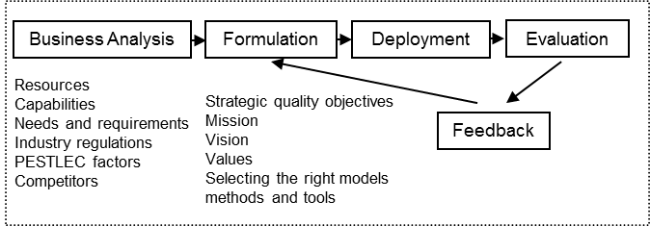
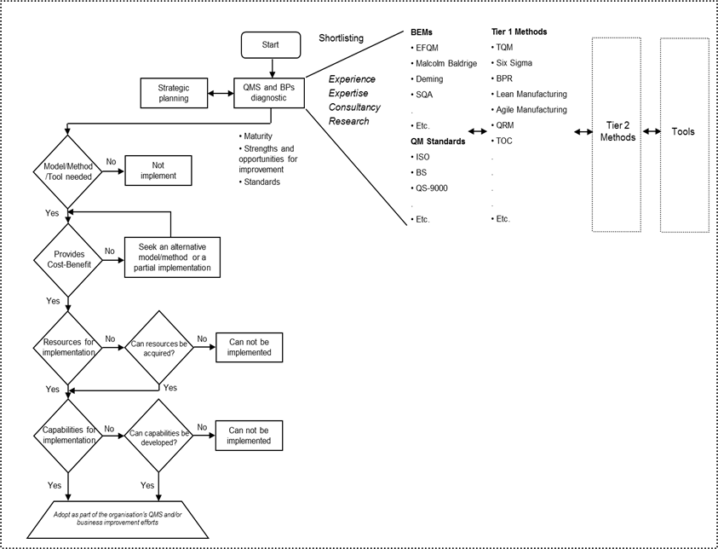
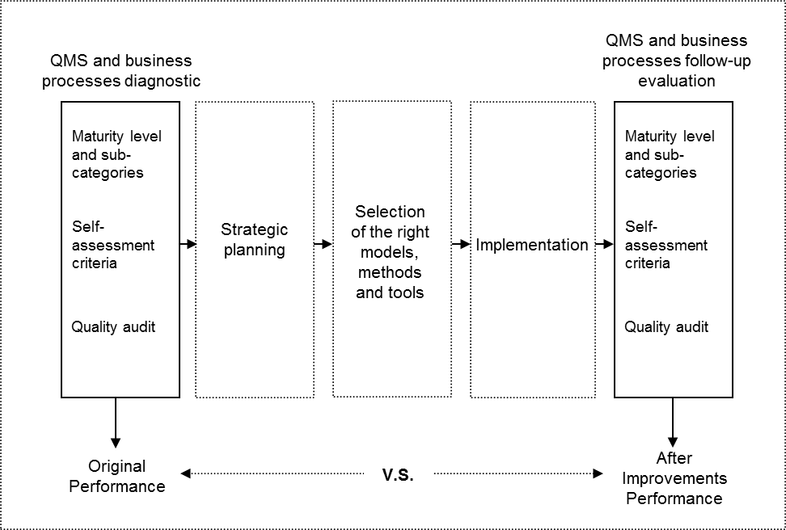
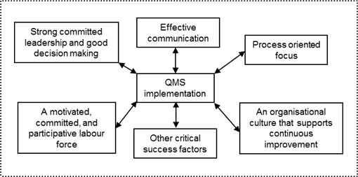
Stage 1 - QMS and Business Processes Diagnostic
Stage 2 – Strategic Planning
Stage 3 – Selection of Right Models, Methods and Tools
Stage 4 – QMS Implementation
Stage 5 – Evaluation of QMS and business processes
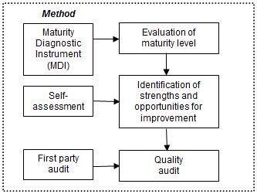

Figure 1. Illustration of the QMS implementation framework prosed
2.1 Stage 1 - QMS and Business Process Diagnostic
Understanding the current situation of an organisation’s QMS and business processes is important since it can prove instrumental in determining the quality of subsequent management decisions to effectively implement or improve a QMS and business processes. Thus, stage 1 is based on the definition and understanding of the maturity level of a company’s QMS and the assessment and identification of its strengths and opportunities for improvement in its core business processes. This stage also integrates quality audits as a means to providing further information about the QMS and its compliance with the standards of customers, suppliers, partners, collaborators, industry sector or even government (see Figure 1).

Defining the QMS Maturity Level
The diagnosis of a QMS and business processes must start by defining and understanding the maturity of the organisation’s structure, procedures, processes and resources dedicated to assure that their products and/or services satisfy their customers’ expectations. Here “maturity” refers to the degree of knowledge, use, effective deployment and concrete positive results obtained from a company’s QMS. The framework suggests the utilisations of the Dale and Lascelles’ (1997) six-level categorisation model as tool for evaluating and understanding the current organisational situation in reference to the degree of maturity of its QMS. This model identifies six levels in the adoption of Total Quality Management (TQM) principles, which can be used as a platform for performing the assessment. Based on this model, the six levels of categories an organisation may fall under are: 1) Uncommitted; 2) Drifters;
3) Tool pushers; 4) Improvers; 5) Award winners; and 6) World-class. To carry out the assessment, Rocha-Lona, Garza-Reyes & Kumar (2013) proposed a “maturity diagnostic instrument” (MDI), which these authors adapted and designed based on Dale and Lascelles’ (1997) model. Rocha-Lona, Garza-Reyes & Kumar (2013) also provide detail information to perform the QMS maturity assessment using the MDI.

Identification of Strengths and Opportunities for Improvement
Once the maturity of a company’s QMS has been defined, the next stage in diagnosing the status of its QMS and business processes is to determine the organisation’s strengths and opportunities for improvement in its core business processes. By this stage, the MDI presented in the previous section would have already provided the organisation with some insight on its strengths and opportunities for improvement. However, a more thorough measure and analysis involving different aspects of the organisation’s business activities and core processes are required to achieve this. A self-assessment approach based on the use of a business excellence model (BEM) can provide an organisation with a powerful approach to achieving this. The use of the BEMs has quickly moved from one of mere award participation to a more holistic approach employed by organisations to self-assess their operations. Some authors and experts (Gadd 1995; Porter and Tanner, 1998; Hillman 1994; Antony and Preece, 2002) have proposed several approaches to effectively carrying out a self-assessment exercise. Based on these methods, the literature and practical experience, Rocha-Lona, Garza-Reyes & Kumar (2013) have also proposed an “adaptable” approach to conduct the self- assessment exercise required in this stage.

Quality Audit
For some organisations, quality audits are a mandatory activity that needs to be performed in order to comply with requirements from their customers, suppliers, partners, collaborators, or industry sector and even to fulfil government regulations. Quality audits help organisations, and those that request them, monitor and assure that a QMS is in place and working effectively. Oakland (1993) comments, “a good quality system will not function without adequate audits and reviews”. It is for these reasons that the framework proposed suggests, as part of the QMS and business processes diagnostic methodology, the institution of quality audits. In this way, quality audits will provide further information about the QMS and organisation’s business processes, particularly whether they comply with the required standards. The framework suggests first-party audits as the easiest and most efficient type of audit to perform when this activity is integrated into the QMS and business processes diagnostic. This is because the same team involved in the maturity assessment and self-assessment process can conduct the quality audit. As this team may have been involved from the initial stage of defining the maturity of the QMS and through the self-assessment process, it would already have an in-depth knowledge of the QMS and core business processes of the organisation. In addition, by the end of the quality auditing process, the assessment team members would have acquired an overall “picture” of the status of the organisation’s QMS and business processes. This will also facilitate the reporting and debriefing of such status to top management.

2.2 Stage 2 – Strategic Planning
Once that stage one has been concluded, the organisation can then propose and deploy an action plan to address the areas for improvement highlighted in the overall diagnostic of its QMS and business improvement activities. It is therefore of major importance that the organisation integrates the diagnostic of its QMS and business processes into its business plan and strategy (i.e. Strategic Quality Planning, SQP). SQP is the set of decisions and actions that result in the formulation and implementation of quality programmes to achieve improvement objectives. This would provide the organisation with an effective mechanism by which to: 1) define adequate improvement actions; 2) transform these improvement actions into an improvement agenda; 3) implement, review and sustain the improvements; and 4) document the results obtained. SQP is carried out through the following four sub-activities (see Figure 1):

Business Analysis
Business analysis is concerned with monitoring, evaluating and disseminating information drawn from the environment in which the organisation functions. This process comprises internal and external analysis, and helps to identify the factors that support the SQP process. Some organisations have allocated this responsibility into business intelligence units which carry out internal and external evaluations of the most critical factors. These may include political, economic, social, and technological factors. The aim is to make decisions with the best information available.

Strategy Formulation – Objectives, Mission, Vision and Values
The strategy formulation stage is concerned with developing an organisation’s mission, vision, objectives, strategies, plans, policies and values (Hewlett, 1999). The aim of the formulation process for the QMS is concerned with business goals, quality management programmes, and, most importantly, with the selection of the business quality models, methods and tools. This requires full commitment and support of top management due to the financial and human resources that need to be invested in deploying the quality improvement efforts.

Deployment – Putting Plans into Action
The strategy deployment process for quality programmes is the critical stage at which the business plans must deliver results. It is frequently argued that the success of the strategic quality planning process relies on how well the plans are translated into actions. This means, how well managers execute the plans and translate models, methods and tools into effective operating terms (Kaplan and Norton, 2001).

Evaluation and Control – Setting the Metrics to Measure Performance
Evaluation is related to measuring improvements in terms of return of investments, saving operational costs, and productivity measures. At this point, frequently reviews depending on each particular project are required to adjust goals and resources. Thus, this process should be conducted on an on-going and cyclical basis to assure consistency and to sustain improvements in the medium and long terms.

2.3 Stage 3 – Selection of Right Models, Methods and Tools
Following the formulation of the SQP, stage 3 of the framework proposed consists of selecting the right models, methods and tools to be adopted to enhance the organisation’s QMS and execute its improvement plan (see Figure 1). Within the context of the framework proposed, “models” refer to those non-prescriptive standards that show organisations the criteria or characteristics of business excellence or those required in satisfying their customers’ expectations. Examples of models include the EFQM, Malcolm Baldrige, Deming, etc. or quality management standard such as ISO 9000, British Standards, QS-9000, among others. On the other hand, those approaches that provide organisations with a philosophy and a “receipt” for improving different aspects of their business operations and/or products are considered “methods”. This category includes main approaches such as lean manufacturing, Six Sigma and TQM, among others, which explicitly indicate how organisations can improve different aspects of their businesses. To assist in making the selection of the most appropriate models, methods and tools easier for organisations, this paper subdivides this classification of methods into tier 1 and tier 2 methods. Tier 1 methods represent main methods such as lean manufacturing, Six Sigma, TQM, etc., while tier 2 methods are the pillars that support the main methods by making the achievement of their objectives and implementation possible. For instance, JIT, DMAIC and quality costing are considered tier 2 methods since they complement lean manufacturing, Six Sigma and TQM respectively. See for instance Rocha-Lona, Garza-Reyes & Kumar (2013), who present a detail list of models, methods, tools and their classification. In this context, “tools” includes those enablers and techniques that support the implementation and operationalisation of tier 1 and tier 2 methods.
The framework considers organisational factors such as needs, cost-benefit, resources, and capabilities as part of the selection criteria to choose the right models, methods and tools. Figure 1 (stage 3) illustrates the steps that the proposed framework suggests to be followed in the selection of the right models, methods and tools. In general terms, the selection steps indicate that six steps have to be carried out in order to conduct the selection. These steps include:

Step 1. QMS and business processes diagnostic – alignment of action plan with an organisation’s strategic planning
The selection of the right models, methods and tools should start with the identification and understanding of the areas for improvement in the organisation’s QMS and business processes, and then by formulating and aligning an improvement plan to its strategic planning. Stages 1 and 2 of the framework proposed would help organisations in carrying out this first step.

Step 2. Models, methods and tools shortlisting
Once the QMS and business processes diagnostics have been completed (stage 1), their results will provide the organisation with a clear picture of the organisation’s actual situation. Based on this, the organisation will have to “shortlist” some of the business and/or quality improvement models and methods it believes can help it overcome the weak areas indicated by the diagnostic.

Step 3. Evaluating the need of implementing the shortlisted models, methods and tools
Once the models and/or methods have been shortlisted, the next step in the selection approach is to evaluate, in more detail, the feasible implementation of these models and tools. This is required to evaluate whether such models or methods are adequate to overcoming, or at least reducing, the problems highlighted by the QMS and business process diagnostic. In this case it is important to understand what the issues highlighted by the diagnostic are, as well as what the general objective of the models and/or methods is so that they can be matched.

Step 4. Evaluating the cost-benefit of implementing the shortlisted models, methods and tools
If in the previous step the “needs evaluation” results indicate that the objective of the shortlisted models or methods match the problem and thus are required to be implemented, the next step is to evaluate their cost-benefit. It is imperative that the organisation obtains some financial benefit from the implementation of the selected models or methods. The implementation, management, and sustainment of the shortlisted models or methods will require a financial investment, which by no means should be higher than the expected financial benefit. If this is the case, the framework indicates that such models or methods should not be implemented, but that alternative ones or a partial implementation of them should be consider (see Figure 1, stage 3).

Step 5. Evaluating whether the organisation possesses the required resources to effectively implement, manage and sustain the shortlisted models, methods and tools
In this step, the organisation must evaluate whether it has the resources needed (i.e. human, physical, financial and information resources); otherwise, the implementation of the models, methods and tools will not be possible. If it does, then the organisation can move onto the last selection step, but if it does not, then top management will have to make sure that the necessary resources are acquired.

Step 6. Evaluating whether the organisation possesses the required capabilities to effectively implement, manage and sustain the shortlisted models, methods and tools
As is the case with resources, an organisation must have certain internal capabilities in order to effectively implement, manage and sustain the shortlisted business or quality improvement models, methods and tools. It is for this reason that a capability assessment is also included as part of the selection steps. Capabilities include, among others, top management and staff commitment and involvement in continuous improvement (CI), an organisational culture that supports and aids change, strong leadership traits capable of exhibiting excellent project management styles, effective internal communication, etc.
If after the evaluations of the shortlisted models, methods and tools they have been determined to:
- Be needed by the organisation as they may solve the company’s weaknesses highlighted by the diagnostic;
- Provide a cost-benefit as their cost of implementation, management and sustainment will not exceed the financial benefit that the organisation may obtain from them;
- Be capable of being effectively implemented, managed and sustained because the organisation has, or can acquire, the resources needed;
- Be capable of being effectively implemented, managed and sustained because the organisation has, or can develop, the capabilities needed;
Then these models, methods and tools can be adopted as part of the organisation’s QMS and/or business improvement efforts.

2.4 Stage 4 – QMS Implementation
Once identified, the implementation of the models, methods and/or tools that will form the QMS is of a major importance for organisations. Regardless of how well the QMS is planned, it will not deliver any value unless it is effectively implemented. The significance of implementation is also important from an organisation’s strategy viewpoint. In the strategy-making process organisations also have to make sure that whatever strategy they are going to adapt must be well executed, as their organisational performance hinges on how well their strategy has been executed. The framework proposed addresses this issue in stage 2.
With the understanding that proper execution or implementation is a much needed requirement for the intended benefit of QMSs’ implementation, organisations often struggle at this stage. A thorough understanding of the key factors that influence the QMS implementation is necessary. There are several factors that pose substantial challenges to the management of an organisation. For example, organisations need to have an adept and decisive leadership who can take instant and effective decisions, as failure to do so can completely jeopardise the QMS implementation. Empowering employees, improving processes, instituting a quality-oriented culture, and promoting teamwork practices are also some of the other challenges that an organisation has to overcome. Organisations trying to implement a QMS continuously seek to identify factors that are believed to be critical to successful implementation and are often termed as “critical success factors” (CSFs). There are a number of critical success factors which, when aligned, will result in a successful QMS implementation in an organisation. Organisations failing to understand and minimise/eliminate these CSFs may struggle to implement a QMS and fall short of their goal of enhancing their performance. For this reason, the proposed framework emphasises organisations to develop the following CSFs to ensure an effective implementation of the QMS as the lack of these will act as implementation barriers:
- A strong committed leadership and good decision-making
- A motivated, committed, and participative labour force
- A processes oriented focus
- An organisational culture that supports continuous improvement (CI)
- An effective communication
To evaluate and select the right models, methods or tools and to perform a cost-benefit analysis, an organisation must have a strong and committed leadership who can make effective decisions. Unless leaders are good visionaries, possess honed analytical skills, and are able to sense the changes happening in the internal and external environment, it would be quite hard to choose the right approaches that can complement the organisation’s strength. Leaders alone cannot resolve all of the issues unless they have a motivated and participative labour force that is able to work as a team towards the same organisational aim and objectives. The third step in stage 3 of the framework proposed focuses on the understanding of the resources that are required to implement the shortlisted approaches. An organisation’s resources lie in their intangible and tangible assets such as production facilities, raw materials, cultures, technological knowledge, patents, and human capital. The framework proposed also identifies the importance of an organisational culture that supports CI and emphasised that the management culture should be guided by fact and not by experience or feelings. Also, it highlights the need to visualise, understand, and improve processes and suggested that an organisation should be process oriented. Finally, the last step in stage 3 was about developing the organisational capabilities needed to implement the shortlisted approaches. In this case, the framework proposed suggests organisations to focus on developing IT competence, empowering and training employees, building a participative workforce, establishing effective communication, and building a continuous improvement-focused culture. Thus, the selection steps undertaken during stage 3 are in line with these CSFs. Organisations must be able to implement QMS successfully if they recognise the importance of the CSFs as outlined and discussed previously.

2.5 Stage 5 – Evaluation of QMS and business processes
The implementation or improvement of a QMS and business processes does not stop with the selection and implementation of the right quality improvement models, methods and tools. Once integrated into the QMS or improvement plan, they have to be monitored and evaluated to determine their relevance and the benefits they provide to the organisation. Measuring the progress of QMSs and business processes is a means of conducting follow-up evaluations to determine whether they are still benefiting the organisation.
The QMS implementation framework suggests the employments of the same diagnostic approach used in stage 1 as a method for measuring the effectiveness and progress of the QMS and business processes after they have been implemented or subjected to any improvement initiatives. In this case, the diagnostic methodology can be used to present not only a “picture” of the original state of the organisation’s QMS and business processes but also an “after implementation/improvements” picture. Updating the data in the diagnostic approach after the design or improvements have taken place would allow the results to be compared against those of the organisation’s original state as illustrated in Figure 1, stage 5. This will help the organisation to determine whether any progress has been made.
In terms of performing a QMS assessment for follow-up evaluations, Rocha-Lona, Garza-Reyes & Kumar (2013) developed an adapted version of the MDI that can be used by organisations to carry out and record follow-up maturity evaluations. In addition to evaluating the maturity progress of an organisation’s QMS, it is also important for a company to focus on assessing whether its business processes have progressed after the deployment of the QMS. Diligence in following-up on this progress will provide an organisation with information about whether the strengths identified through the self-assessment process (stage 1) have been maintained and the weaknesses improved on. To do this, the framework proposed in this paper emphasises to conduct a “follow-up self-assessment”, similar to the one carried out as part of the diagnostic (stage 1). To perform a reliable evaluation, the organisations must ensure that it utilises the same BEM and evaluating criteria and sub-criteria as that followed in stage 1. Finally, having a mature QMS and effective business processes does not necessarily mean that an organisation’s products, services or processes will fully comply with the requirements of its customers, suppliers, partners, collaborators, industry sector or government regulations. Thus, quality management audits play a key role in ensuring the effectiveness of a QMS and in identifying any procedures that may not conform to specifications. Once those non-compliance procedures have been subjected to improvement initiatives, it is vital for an organisation to find out whether these initiatives have provided the expected results. If no non-compliance quality assurance procedures were highlighted, then it is still important for an organisation to know that these have not deviated and thus still comply with the corresponding regulations. It is for these reasons that in addition to the maturity and self-assessment follow-ups, the framework proposed also suggests performing “follow-up quality management audits” to validate progress actions and the effective implementation of business and quality improvement approaches. For this, the same procedure followed in stage 1 can also be followed to perform follow-up audits. The audit themselves and forms used to assess the compliance of organisational quality procedures vary greatly in industry. However, Rocha-Lona, Garza-Reyes & Kumar (2013) developed a “generic” form adapted for the purpose of comparing the results of the “initial quality audit” suggested to be conducted in stage 1 with those of subsequent follow-up audit evaluations.

3. Conclusions
Strong evidence suggests that companies that have a well-structured and developed QMS outperform their competitors as it benefits organisations (Casadesús & de Castro, 2005; McTeer & Dale, 1996; Gutiérrez, Tamayo Torres & Barrales Molina, 2010; van der Wiele, van Iwaarden, Williams & Dale, 2005; Dale, van der Wiele & van Iwaarden, 2007). The use of a QMS is fundamental to support business performance, provide a range of benefits for business improvements, and thus positively affect the organisation (Marash, Berman & Flying, 2004). However, its implementation is a difficult task that in many cases is also unsuccessful (Cândido and Santos, 2011; Yusof & Aspinall, 2000a; Dahlgaard-Park, 2006). To address this issue, this paper proposed a conceptual framework to effectively implement and/or improve an organisation’s QMS and core business processes. The framework consists of a five stage process that systematically guides an organisation through various activities to effectively achieve positive results in implementing or improving its QMS. Although the framework relies on the systematic conduction of stages and their activities, slight modifications or adjustments can be made to the framework to be adapted to the needs of specific industries or organisations; hence it should be used as a general guideline for the implementation and/or improvement of a company’s QMS, as opposed to be employed as a rigid prescriptive approach.
Further development of the framework proposed could be specifically addressed towards the incorporation of a “knowledge management approach for business excellence”. Once appropriate actions have been taken to implement and/or improve an organisation’s QMS and core business processes, and positive results have been achieved, the fundamental challenge then becomes how to sustain and constantly repeat such success. This is where an organisation has to make sure that key experiences acquired during the whole implementation/improvement process are shared through the relevant departments and members of the organisation. This will ensure that good practices are repeated and institutionalised and that the same problems do not occur again.
However, the conceptual and generic framework presented in this paper has been proposed in an anecdotal form resulting from the industrial experience of these authors as consultants, researchers, and academics, and after working on several business improvement projects for multinational organisations that wanted to design, implement, or improve their QMSs. Therefore, the necessity to validate the proposed conceptual framework is stressed, for example, by empirically testing the model through an industrial case study and seeking its statistical validation, which will also contribute in validating the economic benefits of employing such model. This is part of the further research agenda derived and proposed by this paper.

References
Aalbregtse, R.J., Hejka, J.A. & Mcneley, P.K. (1991). TQM: How do you do it?, Automation, 38(8), 30-32.
Adams, M.L. (1994). Quality first: a model for TQM implementation and planning, IEEE AES Systems Magazine, 9(2), 25-27.
Antony, J. and Preece, D. (2002). Understanding, managing and implementing quality: frameworks, techniques and cases, Routledge, London.
Berry, T.H. (1991). Managing the Total Quality transformation, McGraw-Hill, NY.
Cândido, C.J.F. & Santos, S.P. (2011). Is TQM more difficult to implement than other transformational strategies? Total Quality Management & Business Excellence, 22(11), 1139-1164.
Casadesús, M. & de Castro, R. (2005). How improving quality improves supply chain management: empirical study, The TQM Magazine, 17(4), 345-357.
Chakravorty, S.S. (2009). Six Sigma programs: an implementation model, International Journal of Production Economics, 119(1), 1-16.
Crosby, P.B. (1980). Quality is free - the art of making quality certain, McGraw-Hill, NY.
Dahlgaard-Park, S.M. (2011). The quality movement: where are you going? Total Quality Management and Business Excellence, 22(5), 493–516.
Dale, B.G. (1995). A quality improvement framework: application and comparative analysis, Total Quality Management, 6(4), 383-397.
Dale, B.G. and Lascelles, D.M. (1997). Total quality management adoption: revisiting the levels, The TQM Magazine, 9(6), 418-428.
Dale, B.G., van der Wiele, T., van Iwaarden, J. (2007). Managing quality, 5th edition, Oxford, Blackwell Publishing Ltd.
Deming, W.E. (1986). Quality, productivity, and competitive position, Center for Advance Engineering Study, MIT, Cambridge, MA.
Furterer S. & Elshennawy, A.K. (2005). Implementation of TQM and Lean Six Sigma tools in local government: a framework and a case study, Total Quality Management & Business Excellence, 16(10), 1179-1191.
Gadd, K.W. (1995). Business self-assessment: a strategic tool for building process robustness and achieving integrated management, Business Process Re-engineering & Management Journal, 1(3), 66-85.
Ghobadian, A. & Gallear, D.N. (1997). TQM and organisation size, International Journal of Operations and Production Management, 17(2), 121-163.
Glover, J. (1993). Achieving the organizational change necessary for successful TQM, International Journal of Quality & Reliability Management, 10(6), pp. 47-64.
Godinho Filho, M. & Veloso Saes, E. (2012). From time-based competition (TBC) to quick response manufacturing (QRM): the evolution of research aimed at lead time reduction, International Journal of Advanced Manufacturing Technology, 64(5-8), 1177–1191.
Gutiérrez, L.J., Tamayo Torres, I. & Barrales Molina, V. (2010). Quality management initiatives in Europe: an empirical analysis according to their structural elements, Total Quality Management & Business Excellence, 21(6), 577-601.
Hakes, C. (1991). Total Quality Management: the key to business improvement, Chapman and Hall, London.
Hewlett, C.A. (1999). Strategic planning for real estate companies, Journal of Property Management, 64(1), 26-29.
Hillman, G.P. (1994). Making self-assessment successful, The TQM Magazine, 6(3), 29-31.
Hobbs, D.P. (2003). Lean manufacturing implementation: a complete execution manual for any size manufacturer, J. Ross Publishing, US.
Jenicke, L.O., Kumar, A. & Holmes, M.C. (2008). A framework for applying Six Sigma improvement methodology in an academic environment, The TQM Journal, 20(5), 453 - 462
Jones, E.C, Parast, M.M. and Adams, S.G. (2010). A framework for effective Six Sigma implementation, Total Quality Management & Business Excellence, 21(3), 415-424.
Juran, J.M. & Gryna, F.M. (1993). Quality planning and analysis, 3rd Ed. McGraw-Hill, Singapore.
Kanji, G.K. (1996). Implementation and pitfalls of total quality management, Total Quality Management, 7(3), 331-343.
Karplan, R. S. and Norton, D.P. (2001). Building a strategy-focus organization, Ivey Business Journal, May/June, 12-19.
Kumar, K., Antony, J. & Tiwari, M.K. (2011). Six Sigma implementation framework for SMEs – a roadmap to manage and sustain the change, International Journal of Production Research, 49(18), 5449-5467.
Locher, D. (2011). Lean office and service simplified: the definitive how-to guide, CRC Press, Taylor & Francis, Boca Raton, FL.
Mann, R.S. (1992). The development of a framework to assist in the implementation of TQM, PhD Thesis, University of Liverpool.
Marash, S. A., Berman, P. and Flying, M. (2004). Fusion management, QSU Publishing Company, Virginia, US.
McTeer, M.M. & Dale, B.G. (1996). The process of ISO 9000 series registration: an examination of small companies, International Journal of Production Research, 34(9), 2379-2392.
Oakland, J. (1993). Total Quality Management, Butterworth-Heinemann, Oxford.
Porter, L.J. & Tanner, S.J. (1998). Assessing business excellence, Butterworth-Heinemann, Woburn, MA.
Rocha-Lona, L., Garza-Reyes J.A. & Kumar, V. (2013). Building quality management systems: selecting the right methods and tools, Productivity Press, CRC Press, Taylor & Francis, Boca Raton, FL.
Sampaio, P., Saraiva, P., & Rodrigues, G.A. (2009). ISO 9001 certification research: questions, answers and approaches, International Journal of Quality & Reliability Management, 26(1), 38–58.
Sebastianelli, R. & Tamimi, N. (2003). Understanding the obstacles to TQM success, Quality Management Journal, 10(3), 45-56.
Singh, B., Garg, S.K., Sharma, S.K. & Grewal, C. (2010). Lean implementation and its benefits to production industry", International Journal of Lean Six Sigma, 1(2), 157 – 168.
Short, PJRM (1995). Total quality management in hospital, Total Quality Management, 6(3), 255–263.
Taylor, W.A. & Wright, G.H. (2003). A longitudinal study of TQM implementation: factors influencing success and failure, International Journal of Management Science, 31(2), 97-111.
Terziovski, M., Fitzpatrick, P. & O'neill, P. (2003). Successful predictors of business process reengineering (BPR) in financial services, International Journal of Production Economics, 84(1), 35-50.
Thompson, J. & Simmons, P. (1997). Carving up the business excellence model in a small firm, Quality World, April, 274-277.
van der Wiele, T., van Iwaarden, J., Williams, R., Dale, B. G. (2005). Perceptions about the ISO 9000 (2000) quality system standard revision and its value: the Dutch experience, International Journal of Quality and Reliability Management, 22(2), 101-119.
Yusof, S.M., & Aspinall, E. (2000a). TQM implementation issues: review and case study, International Journal of Operations & Production Management, 20(6), 634–655.
Yusof, S.M. & Aspinall, E. (2000b). Total quality management implementation frameworks: comparison and review, Total Quality Management, 11(3), 281–294.
Yusof, S.M. & Aspinwall, E. (2000c). A conceptual framework for TQM implementation for SMEs, The TQM Magazine, 12(1), 31–37.
Zidel, T.G. (2006). A lean guide to transform healthcare: how to implement lean principles in hospitals, medical offices, clinics and other healthcare organizations, American Society for Quality, Milwaukee.

Corresponding author

