**Exploring alternative pathways towards more sustainable regional food systems by foodshed assessment – city region examples from Vienna and Bristol**

**José Luis Vicente-Vicente1*, Alexandra Doernberg1, Ingo Zasada2, David Ludlow3, Damian Staszek4, Joanna Bushell3, Ali Hainoun5, Wolfgang Loibl5 and Annette Piorr1**

1 Leibniz Centre for Agricultural Landscape Research (ZALF), Eberswalder Str. 84, 15374 Müncheberg (Germany)

2 Deutsches Zentrum für Luft- und Raumfahrt, Rosa-Luxemburg-Str. 2, 10178 Berlin (Germany)

3 Department of Architecture and the Built Environment, University of the West of England (UWE), Frenchay Campus, Coldharbour Lane Bristol, Bristol BS16 1QY (United Kingdom)

4 College of Engineering, Mathematics and Physical Sciences, University of Exeter, Harrison Building, Streatham Campus, N Park Rd, Exeter EX4 4QF (United Kingdom)

5 Austrian Institute of Technology, Giefinggasse 6, 1210 Vienna (Austria)

*Corresponding author: vicente@zalf.de

**Abstract**

Under substantial international supply disturbances (e.g. through Covid-19), resilience of the food supply system has become a vital issue for many countries. Regionalizing diets and increasing food self-sufficiency highly contribute to shortening food supply chains and, therefore, to increasing resilience of the food system. Simultaneously food supply disturbances can offer a chance for food system transition towards implementing sustainable management practices (SMPs) in agriculture (e.g. organic farming) increasing the sustainability of food production. In this study, delineating the spatial extent for such a regionalization and self-sufficiency discussion, we have proposed a foodshed for the cities of Vienna and Bristol. We used the Metropolitan Foodshed and Self-sufficiency Scenario (MFSS) model to assess the potential self-sufficiency of these areas under different pathways involving more sustainable and resilient food system scenarios, by distinguishing: i) regionalization, ii) production system, iii) food losses and wastage and iv) population growth until 2050. Furthermore, we have found the main local food policies and studies involving both cities, linking them to the current self-sufficiency levels and proposing pathways to increase them. Our results suggest that the proposed foodsheds are suitable to achieve a high degree of potential self-sufficiency when shifting consumer’s behavior towards sustainably produced regional products, and reducing food wastes in households and food losses in agriculture. In parallel, this should be accompanied by an increase in the diversification of regional crop production sustainably managed. We call for the adoption of the foodshed approach – based on the concept of sustainable city-region food systems – so that it can be integrated in the food policies, to increase food self-sufficiency sustainably.

**Keywords:** food policy;sustainable diet;self-sufficiency; resilience; city-region food system

1. **Introduction**

The interactions between the food system and the different Earth´s components have been widely studied (Alexander et al., 2016; Crippa et al., 2021; Laroche et al., 2020; Mbow et al., 2019; Ortiz et al., 2021), leading to questioning the sustainability of the globalized food systems as well as proposing venues for addressing the trade-offs (Augustin et al., 2021; Herrero et al., 2020; Rocchi et al., 2020; Sánchez et al., 2021).

On the other hand, food Self-sufficiency in food supply – generally defined as the capacity of a country to produce sufficient food to cover its own needs – is a topic known to gain increased attention in times of crises (Clapp, 2017), under the umbrella of the overarching concept of food system resilience (Puma, 2019; Savary et al., 2020). The Covid-19 crisis is a paradigmatic recent example that brought these concepts back as hotspot in the debate on the globalised food systems (Erokhin and Gao, 2020; Fan et al., 2021; Farrell et al., 2020; Fontan Sers and Mughal, 2020; Garnett et al., 2020; Guo and Tanaka, 2020; Moseley and Battersby, 2020; Nordhagen et al., 2021; Orden, 2020; Vittuari et al., 2021; Woertz, 2020).

However, not only at the country level, but at the regional and local level food self-sufficiency is assessed. Thus, feeding metropolitan areas through sustainable regional agricultural production became a local policy concern since the last years (Cardoso et al., 2017; Carey, 2011; Doernberg et al., 2019; Vicente-Vicente and Piorr, 2021; Zasada et al., 2019) as well as the creation of resilient city-region and local food systems (CRFS, LFS) (Blay-Palmer et al., 2021; Skog et al., 2018), increasingly resulting in the development of individual city-regional food strategies (Doernberg et al., 2019)

Food self-sufficiency can be achieved by implementing policies either in agricultural production and/or food consumption. (Weber et al., 2020) found that the narratives of the current literature on transitions towards sustainable food systems can be grouped in five clusters: i) alternative food movements, ii) sustainable diets, iii) sustainable agriculture, iv) health and diverse societies, and v) food as commons. According to these authors, the sustainability concept varies between the different clusters. Thus, studies on assessing transitions to sustainable diets refer to low resource consumption with low waste and adequate nutrient intake, whereas those assessing sustainable agriculture refer to environmentally-friendly production systems (e.g. organic farming, agroecology, smart farming). The sustainability impact from both sides, consumption patterns and agricultural production systems, have been widely assessed in the last years (Birney et al., 2017; Blas et al., 2018; Chaudhary, 2019; Donati et al., 2016; Esteve-Llorens et al., 2021; Falcone et al., 2020; Hallström et al., 2018; Hyland et al., 2017; Kummu et al., 2012; Mason and Lang, 2017; Mottet et al., 2020; Röös et al., 2015; Sporchia et al., 2021; Travassos et al., 2020; Vanham et al., 2015; Vicente-Vicente and Piorr, 2020; Wang et al., 2020). Transitions towards sustainable food systems have been recently assessed at the country level in Europe (Galli et al., 2020; Kugelberg et al., 2021) or the UK (Benthem de Grave et al., 2020). Furthermore, assessments on the impact of specific initiatives, like community-led local food initiatives, have been also carried out (Guzman and Reynolds, 2019) (Nicol, 2020; Prost, 2019).

However, the majority of sustainable food transition assessments are focused in the global or country scale, and the ones assessing specific interventions at the local level lack on incorporating the regional context. They are mainly focused on studying “local niche developments and discussing governance options for upscaling rather than actual regime change” (Melchior and Newig, 2021). Therefore, applying the concept of self-sufficiency to a regional context introduces the question about to what extent regional production can be adapted not only to the quantitative but also to the dietary needs of a city-region, and where the limits of such adaptation are. Regional self-sufficiency in contrast, has not been a focus of policy decision making until recently (Piorr et al., 2018; Doernberg et al., 2019).

Among the few available tools for regional self-sufficiency planning, foodshed models gain attention. They, in short, assess how much agricultural land would be needed to supply a city with food from the region. One type of foodshed approach assesses the flows (Schreiber et al., 2021) and is especially valuable to study the distribution networks (Karg et al., 2016; Moschitz and Frick, 2020; Wegerif and Wiskerke, 2017). Another type of approach is the quantitative one, assessing the production capacity of the area (Schreiber et al., 2021). In capacity assessments, the theoretical food land footprint and the potential self-sufficiency are evaluated by considering the population and current dietary patterns, farmland available, land use cover, and regional yields.

The Metropolitan Foodshed and Self-sufficiency Scenario (MFSS) model (Zasada et al., 2019) uses this approach. The result is the achievement of a theoretical self-sufficiency (Vicente-Vicente et al., 2021). The MFSS and similar tools have proven to be useful for application at regional level and to support the development of concrete urban-regional strategies (Cardoso et al., 2017; Świader et al., 2018; Zasada et al., 2019; Moschitz and Frick, 2020).

From a spatial perspective, a foodshed can be understood as the area around a metropolitan area that is required to feed its population (Peters et al., 2009; Brinkley, 2013). The foodshed has two main features: size and shape. While the size is directly related to the capacity of the foodshed, as described before, the specification of the shape is more difficult. It may be relevant in contexts where administrative boundaries are to be considered because they concern responsibilities in planning. But also landscape related features, geomorphological properties of the surrounding area or cultural and historical relationships with the nearby regions (Vicente-Vicente et al., 2021) and finally also market and supply chain organisation may make it necessary to consider the shape of the entire foodshed or subunits, e.g. for different product groups. Foodshed models like the MFSS can be furthermore used as a tool to assess the feasibility of specific political strategies (Tavakoli-Hashjini et al., 2020).

The ambition of this research is to use of the MFSS model as the basis for the policy debate on pathways towards a sustainable CRFS transformation. In specific how future diets should be, what management practices are suitable or how consumer’s behaviour affect the land footprint. We choose two case studies: Vienna, where this assessment represents the first proposing a foodshed, and Bristol, where the study uses insights from previous studies in order to improve the reliability of the foodshed assessment.

In total the objectives of this study are fourfold: i) to carry out a foodshed analysis for two cities having different land uses, population distribution and geomorphological features; ii) to demonstrate the capabilities of the MFSS model for scenario modelling regarding system change towards more sustainable diets via four pathways (i.e. regionalisation, organic farming, reduce food losses and waste, and population growth); iii) to discuss the MFSS model capabilities and concrete research outputs in the context of the emerging local sustainable development food policies; and iv) to suggest specific pathways to increase the resilience of the food system.

1. **Materials and methods**

**2.1 Foodshed model and scenarios**

The MFSS model (Zasada et al., 2019) incorporates the two dimensions driving the food self-sufficiency analysis: demand and supply. The model also distinguishes between regional and imported products. Detailed information on the calculations is shown in Data in Brief.

In this study a scenario framework from Zasada et al. (2019) was applied. The scenarios consider four key drivers: 1) organic production, 2) diet, 3) food waste and loss, and 4) population growth. By combining changes in these four key drivers we obtain eleven scenarios, plus the business-as-usual one (Table 1).

The area demand per capita for each specific food product is calculated by transforming the yields into utilisable agricultural area (UAA) demand per kg of final product, whereas the total area demand per capita results from the average diet. In the model, the aggregated area demand per district or region is spatially represented by a circle – defined by its radius – with a centroid of the administrative boundary polygon. The process can be summarized as the combination of considering the UAA inside the boundaries and the UAA outside the boundaries. The UAA for the whole region is represented as the overall agricultural area share of the region.

Together with the foodshed assessment, regional food self-sufficiency is also assessed. Food self-sufficiency as percentage arises from the relationship between the area demand and the UAA, showing the required agricultural area to meet the regional food demand. Thus, self-sufficiency values higher than 100% mean that the complete area demand for food production can be met within the boundaries. On the contrary, values lower than 100% would require food imports.

* 1. **Study area**

2.2.1. *Vienna and Bristol cities’ data on food consumption, area and population*

The average food consumption per capita for each metropolitan area amounts at total of 1,045 kg capita-1 yr-1 for Vienna, whereas this value is slightly lower for Bristol, at 961 g capita-1 yr-1 (FAO, 2013)(Data in Brief). On the other hand, Table 2 shows that the total city area of Vienna is almost four times higher compared to that of the city of Bristol, and a very similar factor is found for the total population. Accordingly, the average population density of both cities is very similar. Marked differences appear regarding the UAA, which is around 48 km2 for Vienna and 7 km2 in the case of Bristol. As expected to city regions this leads to an extremely low average UAA per capita for both cities, around 26 m2 for Vienna and 15 m2 for Bristol (Table 2). This very low UAA per capita explains the need to expand the theoretical foodshed area around the surrounding area of both cities.

2.2.2 *Vienna´s and Bristol´s foodshed selection for the study*

*a) Vienna*

The selected foodshed area for Vienna was the NUTS-2 region of Niederösterreich, and the self-sufficiency assessment was done at district, NUTS-3, level (Figure 1).

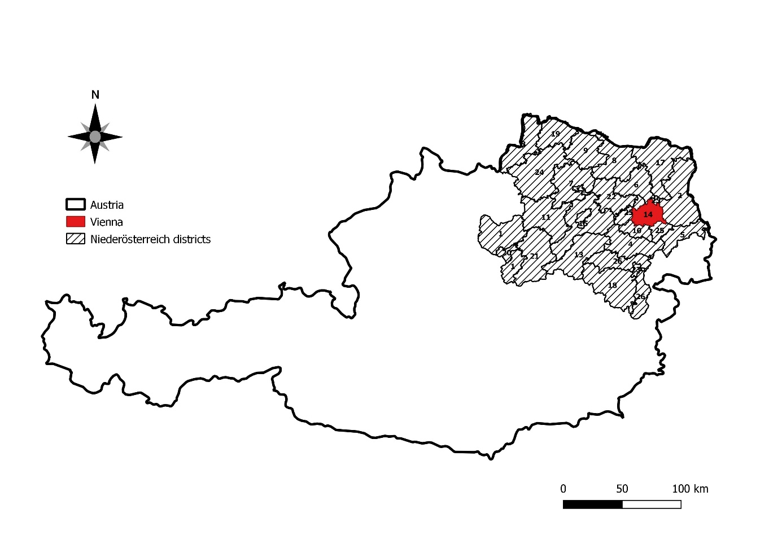

**Figure 1.** Vienna and Niederösterreich, selected as the foodshed (study area). Districts are labelled in alphabetic order. Equivalence with the corresponding names is shown in the data in brief.

*b) Bristol*

The selected foodshed area for Bristol, within the NUTS-1 region of South-West England, is comprised by two different NUTS-2 areas (Figure 2).

* Gloucestershire, Wiltshire and Bristol/Bath area. Where the following districts (NUTS-3) where selected: Bath and North East Somerset, North Somerset and South Gloucestershire.
* Dorset and Somerset area, where the districts of Sedgemoor and Mendip within the Somerset area were selected.

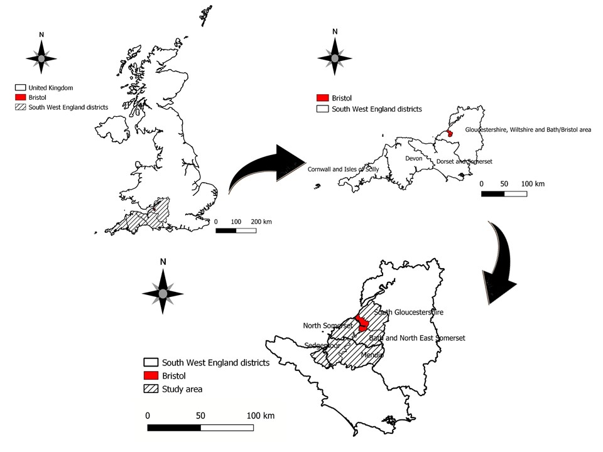

**Figure 2.** Location map of the South-West NUTS1 region (top-left), NUTS2 areas forming the South-West region (top-right), and the foodshed of Bristol formed by different counties and local authorities from the two different NUTS2 regions selected for the study (down).

* 1. **Sustainability and resilience concepts in the foodshed assessment**

Taking an environmental sustainability perspective, we understand sustainable food as a result of the sustainable production and consumption. Sustainable production is referred as the food that is produced organically (Org) and reducing food losses while harvesting, processing and handling (Org L scenarios); whereas sustainable consumption is understood as the consumption of organic products and reducing food wastes in households (Org LW scenarios) (figure 3).

The resilience component is added with the domestic scenarios (Org D), where only regionally produced food is consumed (figure 3). These scenarios imply the existence of short supply chains, the increase in the diversity of food production and the adaptation of diets to the site-specific biophysical and socio-economic conditions. After incorporating the resilience concept to the previous sustainability one, a more overarching sustainability concept (TAC/CGIAR, 1989) is adopted and adapted to the food system, referring to the way in which resources for food self-sufficiency – specially land (i.e. area demand in the MFSS model) – can be used to meet changing future food needs without undermining the natural resource base (figure3).

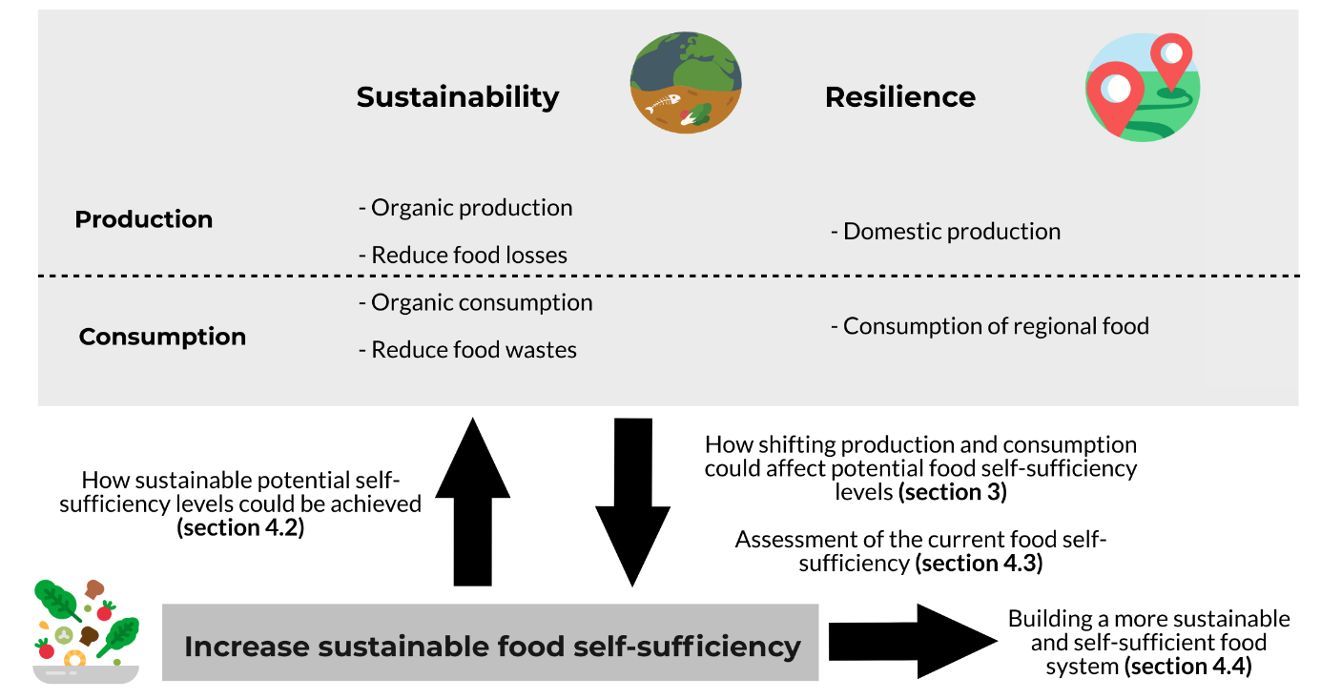

**Figure 3.** Conceptual model of the sustainability, resilience and food self-sufficiency assessments.

Thus, the assessment, methodologically, consists of two different parts: 1) analyzing the results from the MFSS, and 2) framing them within the current policy context. The local food policies and relevant studies assessing food production and consumption were selected according to our expertise and knowledge on the topic in both cities.

Thus, the analytical results on the potential food self-sufficiency under the different scenarios from the application of the MFSS model in the proposed foodsheds are shown in the Results – and as Data in Brief – and discussed in sections 4.1 and 4.2. On the other hand, the assessment of the current self-sufficiency in the context of the local and regional food policies and the city-region concept, as well as the assessment of pathways, are developed in sections 4.3 and 4.4, respectively (figure 3).

**3. Results**

* 1. **Area demand, radius and self-sufficiency of Vienna´s foodshed**

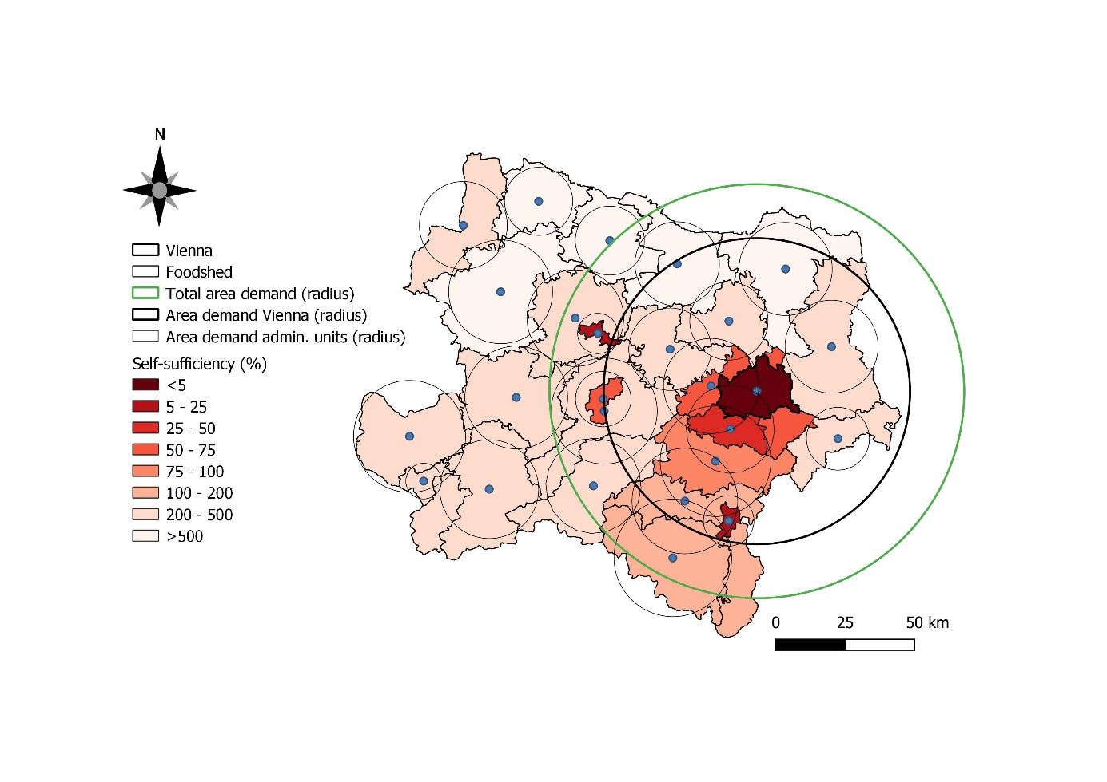

**Figure 4.** Area demand and self-sufficiency level of Vienna, the administrative units of Niederösterreich and for the whole region forming the foodshed, for the Base 15 scenario. Please, see Data in Brief for more detailed information.

3.1.1 *Base 15 scenario: business-as-usual scenario and differences between areas*

The area demand per capita, based on the average diet and average local site conditions for cropping, husbandry and related and yields estimated for the baseline scenario is 2,018 m2. The area demand for the whole region is 690,702 ha, and the potential self-sufficiency of the foodshed is around 112%. Considering the area demand and the UAA, these values can be represented by a radius of 74.71 km (Table 3).

Vienna district, due to the high population numbers and density, amounted to the highest area demand value, 362,658 ha, and radius, 55.2 km. This value represents 53% of the total area demand of the region and 74% of the total radius. The estimated area demand per capita in the baseline scenario is much higher than the calculated current available UAA per capita and, consequently, Vienna´s potential self-sufficiency is estimated to be around 1% (Figure 4)

Considering the districts surrounding Vienna mainly to the South and West, all highly densely populated, a potential self-sufficiency lower than 100% is reached, since the area demand per capita is much higher than the UAA (between 500 and 1,500 m2 capita-1). Due to the fact that the wider Vienna area is surrounded by intensive and productive agriculture, self-sufficiency ratios increase markedly when considering the western and southern hinterlands. Values of self-sufficiency between 200 and 500%, which indicate a clear market supply potential, were found in districts having very different characteristics in terms of geomorphology and population but similar values of UAA per capita (5000 – 9000 m2). For instance, these values were achieved in low populated areas in the mountainous South where the total surface of UAA is very low. However, similar values appear in flat districts to the East of Vienna, with very high total UAA, but having higher population density. Finally, the highest potential self-sufficiency (> 500%) appears in the low-populated districts placed in the very North of the region with very high UAA per capita (10,000 – 15,000 m2) (Data in Brief)

* + 1. *Differences between scenarios*

Simulating a conversion from conventional to organic farming within the spatial borders of the identified foodshed around Vienna, results in a reduction of the self-sufficiency ratio. The lowest value of the self-sufficiency (82%) is achieved in the scenario Org15, where no measures for avoiding food waste and loss are taken and only organic food is consumed. In parallel, the area demand per capita amounted the highest value (2,759 m2) and so the radius (87.4 km). Self-sufficiency values slightly lower than 100% were achieved in the Org L15 and Org D15, 95 and 98%, respectively. The rest of the scenarios for 2015 amounted values of self-sufficiency higher than 100%. The type of scenarios LW15 amounted the highest self-sufficiency values for each type of diet (conventional, organic complete and organic regional; 147%, 107% and 125%). On average, the lowest self-sufficiency values were achieved in the organic complete diets, followed by organic regional and conventional. Regarding the scenarios for 2050 in the three cases (Base 50, Org 50 and OrgD 50) self-sufficiency values were lower than 100% (95%, 69% and 83%) (Table 3). The total area demand increased according to the population growth.

* 1. **Area demand, radius and self-sufficiency of Bristol´s foodshed**

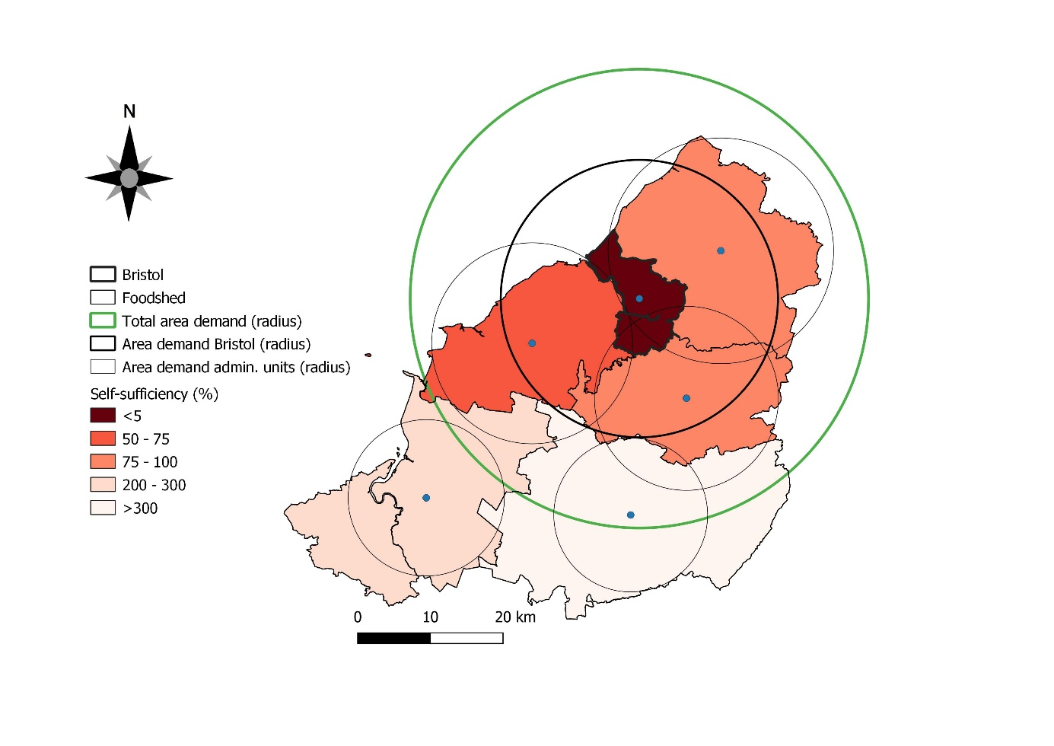

**Figure 5.** Radius of the area demand and self-sufficiency level of Bristol, the rest of the administrative units and for the whole region forming the foodshed, for the Base 15 scenario.

3.2.1 *Base 15 scenario: business-as-usual scenario and differences between areas*

The area demand per capita estimated for the base 15 scenario is 1,788 m2, whereas the area demand for the whole region is 241,508 ha, and the potential self-sufficiency is around 85% (figure 5). Considering the area demand and the UAA, these values mean a 31.5 km of area demand radius (Table 4). The highest area demand is found in the city of Bristol, 80,332 ha, representing one third of the total area demand and 19 km of radius, 60% of the radius for the whole region. The estimated area demand per capita for the city of Bristol is, thus, much higher than the UAA per capita (15.33 m2), bringing the self-sufficiency value of the city to only 1%. Lower than 100% self-sufficiency values are also found in the areas surrounding Bristol. These areas are relatively highly densely populated and have between 1,200 and 1,500 m2 capita-1 of UAA. Finally, the highest potential self-sufficiency values are achieved in areas further to the South of the city of Bristol, Mendip (South East) and Sedgemoor (South West), which have relatively low population density and have high UAA per capita (5,791 and 3,991 m2, respectively), leading to high values of self-sufficiency (>200%) (Data in Brief).

* + 1. *Differences between scenarios*

Only one scenario amounts to a value clearly higher than 100%, the Base LW15, being thus the most favorable scenario with the lowest area demand per capita (1,353m2) and radius (27.4 km). Two other scenarios, Base L15 and Org DLW15, are very close to the 100% of self-sufficiency (Table 4). Regarding Vienna, the order of the scenarios in terms of self-sufficiency for each type of diet (X = Base, Org or OrgD) is: X LW15> X L15>X 15 (inverse order for the area demand and radius). Thus, for the base scenarios values of self-sufficiency are between 85 and 112%, for the Org scenarios 60 – 80%, and 75 – 100% for the OrgD scenarios. The lowest value is achieved in the Org15 scenario, with a value of self-sufficiency around 60%. Similar trends were found for the area demand and radius. Considering the population growth until 2050, values of self-sufficiency would be reduced from 85 to 71%, from 60 to 50%, and from 77 to 64% for the Base 50, Org 50 and OrgD 50, respectively (Table 4).

**4. Discussion**

**4.1 Selection and suitability of the foodsheds**

In this study, for both of the cities, administrative boundaries have been selected as the limit of the respective foodsheds. This is due to the objective to test the capability of foodshed modelling as a tool to support regional governance processes, which typically take place within administrative responsibilities and within the corresponding spatial boundaries. For Vienna, Niederösterreich was selected as the foodshed. This NUTS-2 region surrounds the city of Vienna, and in general its districts are much less populated and have much more UAA, as they are among the most intensive agricultural locations in the country, leading to high potential self-sufficiency levels, 80-100% (Figure 4, and Data in Brief). Similarly, the city of Bristol is surrounded by the districts selected for the foodshed. However, in this case they belong to different NUTS-2 regions: three surrounding districts belong to the Gloucestershire, Wiltshire and Bristol/Bath Area region, whereas two districts to the south belong to the NUTS-2 region of Dorset and Somerset. While the selection of the first districts is very logic, as they surround the city of Bristol, the selection of the two other districts is more complex. The high population density of the surrounding districts forming the foodshed leads to a relatively low theoretical UAA per capita and, therefore, not enough UAA to satisfy the food demand of the district for the majority of the scenarios achieving a potential self-sufficiency of around 40% in average only (results not shown). Therefore, in order to define the foodshed area, two additional districts, Sedgemoor and Mendip – not far from the city of Bristol and with relatively low population density and high UAA – were included to increase the potential achievable self-sufficiency by double (around 80% in average) (Figure 5, and Data in Brief)

Crucially, the selection of a foodshed must be done without compromising the food self-sufficiency of any nearby metropolitan areas. While in the case of the city of Vienna this is not relevant since there are no other big Austrian metropolitan areas relatively near the city, when assessing Bristol´s foodshed this becomes a key issue. The city of London is just 200 km away to the East of Bristol, and according to Zasada et al. (2019), around 90 km of radius would be needed to meet 60% of London´s food self-sufficiency. Additionally, the metropolitan area of Gloucester is 60 km away to the north of Bristol. Therefore, selecting Mendip and Sedgemoor, to the south of the city of Bristol, was the only suitable solution to increase the foodshed´s potential self-sufficiency without compromising the self-sufficiency of other nearby metropolitan areas.

**4.2 Potential self-sufficiency as a starting point of the policy debate towards a more sustainable and resilient food system**

4.2.1 *Sustainability of regionalizing diets and diversifying local crop production*

In the OrgD scenarios the model estimates an increase in the potential self-sufficiency compared to the Org scenarios due to the decrease in the consumption of imported products. However, increasing food self-sufficiency by shifting to more regional diets might not be always more environmentally and health-friendly and cultural issues should be considered when proposing a shift in the diets (Johnston et al., 2014; Downs et al., 2017; Mason and Lang, 2017; Annunziata et al., 2019). Recently, Yin et al. (2020) demonstrated that a regional diet in a specific area of China was far from being environmentally friendly and also not well balanced in nutrient terms due to the tradition of consuming high amounts of mutton in meat.

On the other hand, the shift to more regional diets would only be possible when the supply is diversified. That is, when increasing crop diversification. However, this depends on the specific pedoclimatic conditions, structure of the landscape and cultural and socio-economic conditions of the area (Vicente-Vicente et al., 2021). Increasing crop diversification not only helps in the assurance of food security (Bezner Kerr et al., 2021), but also has positive environmental impacts. For instance, McDaniel et al. (2014) found, after a meta-analysis of 122 studies, that adding one or more crops in rotation to a monoculture increased total soil C and N increased sifnificantly. Furthermore, crop diversity is a key issue for increasing the resilience of agroecosystems. Crop diversification reduces economic and production risks due to the “portfolio effect”, since different crops have different responses to the same stress (Bowles et al., 2020). Bowles et al. (2020), after assessing 11 long-term studies, concluded that crop-rotation diversification increased agricultural resilience against droughts. Furthermore, not only crop diversity but also the size of the farms is a driver of food security. As (Ricciardi et al., 2021) found in a meta-analysis after assessing 118 studies, smaller farms have higher yields and provide more crop and non-crop biodiversity at the farm and landscape scales compared to larger farms and, thus, increasing the resilience at the agroecosystem scale.

However, regionalizing diets is a challenge, especially when the trend is to globalization of food trade and homogenization of crop supply (Aguiar et al., 2020), where the demand has been detached from the supply, food is often produced for exportation (Davis et al., 2021) and its delivering relies on complex supply chains having many chokepoints and vulnerabilities (Bailey and Wellesley, 2017). Thus, adopting a city-region food system (CRFS)– i.e. a foodshed approach –, which leads to an increase in crop diversification, would contribute to matching demand and supply of regional products and, therefore, to shortening the food supply chains, reduce direct CO2 emissions from transportation, refrigeration and packaging (Vicente-Vicente and Piorr, 2021) and eventually to an improvement in the resilience at the food-system scale (Blay-Palmer et al., 2021; Vittuari et al., 2021).

4.2.2 *Sustainability of increasing organic food consumption and fostering sustainable management practices (SMPs) in agriculture and livestock*

The production of organic food usually implies a reduction in yields compared to the conventional system. This is taken into consideration in our model, and the immediate effect is the increase in the area demand. Thus, for the Org15 scenarios the UAA per capita was lower than the area demand and, the self-sufficiency was lower than 100% (Tables 3 and 4). Therefore, it appears that there is a trade-off between food self-sufficiency and organic production (L. G. Smith et al., 2019). However, this higher land footprint and lower potential self-sufficiency of the organic management could be offset with an adequate land use change management and the positive impacts or synergies between the organic management and crop diversification with other ecosystem services (e.g. in agroecological systems (Rosset and Altieri, 2017)), for example, higher yields (Ricciardi et al., 2021) decrease in the GHG emissions from the transportation (Vicente-Vicente and Piorr, 2021) or the improvement of soil carbon sequestration (Schwoob et al., 2018) and overall soil fertility features (Migliorini and Wezel, 2017); in addition to social and cultural ecosystem services (Oteros-Rozas et al., 2019).

Even though crop diversity might have a relevant role on the agroecosystems’ resilience and drive many positive environmental impacts, the role of crop management practices must not be neglected (Snapp et al., 2010) and sustainable management practices (SMPs) can contribute, for instance, to increasing soil N and SOC content (McDaniel et al. 2014) and improving other soil properties (Basche et al. 2016). Fostering SOC accumulation decreases CO2 emissions from soil (Lal, 2004) and fosters different material, non-material and regulating Nature´s Contribution to People (NCP), which contribute directly to the achievement of many SDGs, especially SDG2 (food security), SDG 3 (healthy lives and well-being), SDG 6 (water and sanitation for all), SDG 12 (sustainable consumption and production), and SDG 15 (sustainable use of terrestrial ecosystems) (P. Smith et al. 2019). SMPs as substituting inorganic with organic inputs or implementing cover crops have been found to sequester relatively high amounts of SOC (Vicente-Vicente et al., 2016) and, thus, to meet international standards as the 4 per 1,000 initiative “Soils for Food Security and Climate” (<http://4p1000.org/)> (Francaviglia et al., 2019). Furthermore, the decrease in the GHG emissions due to the absence of agrochemicals application might offset the CH4 and N2O emissions in organic farming (Squalli and Adamkiewicz, 2018).

However, in order to maximize the benefits of organic farming on these ecosystem services the possible extra land needed to offset the lower yields of the organic system in the proposed foodshed should come from marginal land, where the positive effects of the SMPs on ecosystem services can be maximized (Irmler, 2018; Kazemi and Akinci, 2018; Gonzalez-Roglich et al. 2019) and to prevent and reverse land degradation (Sims et al., 2019; van Haren et al., 2019), while the conversion of highly naturalized ecosystems must be avoided. In this regard, in this study all highly naturalized ecosystems have been excluded and only pastures and non-irrigated arable lands were selected as UAA.

4.2.3 *Sustainability of reducing food losses in agriculture and processing, and food wastes in households*

The results for Vienna and Bristol cases show a decrease in the area demand when minimizing food loss and waste. The immediate effect is an estimated increase in the self-sufficiency in the L 15 and LW 15 scenarios and a decrease in the area demand (Tables 3 and 4). For instance, in the case of Bristol – and same trend was found in Vienna – in the Base 15 scenario, the total area demand for Bristol was 241,508 ha, whereas the area demand was of 289,703 and 258,401 ha in the Org L 15 and Org LW 15 scenarios, respectively. However, the area demand for the Org 15 scenario was 340,544 ha. These results suggest, therefore, that avoiding food waste and loss would be close to offset the extra land needed from shifting from conventional to organic farming.

Food losses refer mainly to food wastage in agricultural production (Augustin et al., 2020), whereas food waste refer to the behavior of the consumers in households. Regarding food waste, Chen et al. (2020)estimate a land footprint of around 131m2 capita-1 yr-1. This value is in line with our calculations, where a reduction in the area demand per capita in the scenarios reducing food waste at home in the conventional and complete diets where of 186 and 167 m2 capita-1 yr-1 for Vienna and Bristol, respectively (Tables 3 and 4). Vegetables, cereals and fruits are the products contributing the most to the overall amount of food wastage. However, cereals and meat are the most contributing in terms of land footprint, due to two facts: i) cereals are highly consumed, compared to other plant-based products, and ii) the area demand per kg of animal product is much higher than that of the plant-based ones (Data in Brief).

Food losses take place in the food supply chains during the production, postharvest, handling, agro-processing and distribution (FAO, 2016). Our results show that preventing food losses in the Base 15 diet could save around 294 and 268 m2 capita-1 yr-1 of land, in Vienna and Bristol, respectively. If total amount of food waste and loss is considered, the amount of land footprint saved would be of 480 and 435 m2 capita-1yr-1, meaning a reduction of 24% in the individual's food-related resource consumption (Tables 3 and 4). This figure is in line with the 31% estimated by Birney et al. (2017) for the US, very close to the global estimation of around 23% by Kummu et al. (2012) and higher than the 2 – 7% estimated by (Usubiaga et al., 2018) for the EU when assessing the reduce in the resource inputs in the food chain by 20% and halving the disposal of edible food waste in households based on the Resource Efficiency Roadmap targets set by the European Commission for 2020 (European Commission, 2011)

4.2.4 *Food self-sufficiency and sustainability of diets in an increasingly populated city*

The current projections of population growth for 2050 (Eurostat, 2018), and the current trend of people moving from rural to metropolitan areas (Dijkstra et al., 2020), is expected to increase the population density of Vienna and Bristol, and at the same time lead to important trade-offs because of the increase in the urbanization degree (e.g. environmental degradation, land abandonment, agricultural production, land fragmentation, deterioration in rural public services or changes in to well-being) (e.g. Liu et al., 2015; Ma et al., 2019; van Leeuwen et al., 2019; Navarro et al., 2020). Our results show that the population increase in the city of Vienna and its foodshed by 2050 would lead to a decrease in the potential self-sufficiency towards 70 – 95%, and to 50 – 70% in the case of Bristol, without considering any reduction of food waste or losses.

Furthermore, the increase in the urbanization of the peripheral areas of the cities previously occupied by crops, and the risk in the land abandonment and fragmentation of land in rural areas might jeopardize regional food production (Price et al., 2015; Terres et al., 2015; Lasanta et al., 2017; Levers et al., 2018; Schulp et al., 2019) and, thus, the achievement of the food security and food self-sufficiency goals (Chen 2007).

Although in this study we have not considered a decrease in the food consumption, some authors have already shown the need to decrease the current food consumption per capita in European urban areas (3,456 kcal capita-1 day-1) in order to adjust the current demand to the supply, and thus to achieve the “optimal demand” (2,200 kcal capita-1 day-1), defined as “balanced amount of energy from diet for a person to maintain good health, avoiding overweight and under-nutrition” (Rodríguez-Rodríguez et al., 2015). However, the final food self-sufficiency will depend on the balance between the total consumption per hectare of urbanized land – mainly dependent on the population growth – and the consumption per capita (Kroll et al., 2012). Since the population growth is expected to be slightly positive until 2050 the only way to increase the food self-sufficiency in both areas would be to decrease the food land footprint per capita.

**4.3 Current food self-sufficiency and the city-region concept in the local policy context**

4.3.1 *Bristol*

Bristol Food Policy Council was founded in 2001 as the first one in UK. From then until now, different studies and reports have assessed the state and the future of Bristol´s food system. One of the first and most important ones was the food strategy “A Sustainable Food Strategy for Bristol and Bristol Food Network” (Bristol Food Network, 2009). Later, in a policy-relevant report, Carey (2011) introduces for the first time the Bristol city´s “bioregion” (Bath and North East Somerset, Bristol, North Somerset, and South Gloucestershire). From the point of view of our research, the concept of bioregion could be used as a synonym of foodshed. In our research we have assessed this bioregion, but we extended the foodshed to include Sedgemoor and Mendip areas because of the relatively low potential self-sufficiency of the bioregion, between 30 and 50% (results not shown).

However, the reality is very different, and there is a huge gap in the demand-supply. For instance, Carey (2011) remarks that currently about the 90% of all the meat that is produced in South West England is exported to other UK regions, and just around a 10% is sold locally. The report shows that around 70% of the cereal production in the region is just for feeding animals. Therefore, currently, a huge amount of land is being used to feed animals whose meat is exported, whereas it reduces the available area to grow them for human consumption. However, the report suggests that for vegetables and fruit even more important is the incapacity of local fruit and vegetable farmers to compete with cheap imports that feed large supply chains, while there is enough knowledge and land to grow them locally.

To address these food self-sufficiency and sustainability challenges, the Bristol Food Policy Council launched specific initiatives to increase local organic food production (Bristol City Council, 2015) and to reduce food waste (Bristol City Council, 2018). These sectorial initiatives are part of an overarching strategy, the Bristol One City Plan 2020-2050 (Bristol City Council, 2019), establishing specific goals and action plans for six sectors (economy, connectivity, environment, health and well-being, homes and communities, and learning and skills). Food is included in the environmental sector, proposing that “in 2050 everyone will have access to healthy, ethical and sustainably produced food”. For this purpose, the document establishes numerous goals involving reducing food waste or increasing local food consumption from “sustainable producers in the city region”. However, there is not any specification about what regional or sustainable production means.

4.3.2 *Vienna*

In the case of Vienna approaches to food self-sufficiency and thinking comparably to foodsheds have not been developed so far. To date, the main policy debates have been focused on urban farming and smart cities (Vienna City Administration, 2019) or developing the structure of the agricultural land within Vienna´s district (Land Wien, 2017). However, as we have estimated, this amount of land would be able to satisfy just around 1% of the total demand. Nevertheless, this report shows that the current land use of the agricultural area in Vienna is mainly used for vegetables production and, thus, achieving a relatively high degree of self-sufficiency (Land Wien, 2017). This situation has been used by the city to develop public procurement initiatives with regional food, as the ÖkoKauf Wien (<https://www.wien.gv.at/english/environment/protection/oekokauf/>), where for instance food for kinder gardens has to follow specific sustainability criteria (organic, seasonal and regional).

Recently, the Vienna´s Food Policy Council published a position paper on shifting the food system towards a democratic and sustainable one in the urban district of Vienna (Ernährungsrat Wien, 2020). However, while the paper focuses on the urban area, it mentions several times the term “regional”, but without referring to specific spatial limits.

Regarding the production of animal products locally produced, considering the available data, it is possible to conclude that the current production of local animal products is negligible. However, Niederösterreich accounts for 770,000 ha of UAA. Around 77% of the land is planted by cereals and maize, and 18% with leguminous; whereas the area for vegetables and fruit is much lower (Land Niederösterreich, 2018). As such, the Niederösterreich region is one of the highest food suppliers in Austria, producing more than 80% of potatoes, 70% of rye, 57% of wheat and around 54% of vegetables. However, it only supplies 12% of the fruit and has a relative low contribution of the overall share of animal products (Land Niederösterreich, 2018).

Therefore, in light of this data it is possible to conclude that the proposed foodshed for Vienna in this study might be already food self-sufficient for some specific plant-based products (cereals and vegetables), whereas for animal products and fruit it is still far off. However, for cereals, the results suggest that part of the cereal production in the region might be exported as animal feed to other regions or to other countries (Statistik Austria, 2019).

**4.4. Pathways for building a more self-sufficient and sustainable food system**

The existing reports assessing the current situation of the food system in Vienna and Bristol suggest that both foodsheds are still very far from being self-sufficient and rely on national and international flows. As such, both national food systems are not designed to function at regional (i.e. foodshed) level.

The dependence on international food supplies due to the supply/demand unbalance makes the system non-resilient and very vulnerable to international food supply disturbances (Bailey and Wellesley, 2017; Béné, 2020; Davis et al., 2021). In order to address the demand-supply mismatch, Keating et al. (2014) identified 14 different pathways, divided into three “food wedges”: 1) pathways that target reducing the food production demand curve (reduce food waste, or over-consumption and meat consumption); 2) pathways that target filling the production gap (expanding agricultural area and efficiency in agriculture and livestock); and 3) pathways that involve avoiding losses in current or future production potential

The solution might be a combination of these three mentioned pathways, where the relative weight of each one would depend on the specific characteristics of the foodshed (e.g. degree of current land used, production efficiency, or environmental impact). As such, Alexander et al. (2019) demonstrated that a set of marginal food system changes aimed at increasing food production efficiency, decreasing food losses and shifting diets could lead to a decrease of the agricultural land use by 21%. According to this study, changes in consumer choices in developed countries might be the main driver affecting food land footprint. While in some underdeveloped countries increasing sustainable food production, efficiency and land use change is still a suitable option (Balehegn et al., 2020; Marti and Puertas, 2020), this might not be the case for developed countries, where a high degree of efficiency in production and land use is already achieved. In our study we have demonstrated that reducing food losses and wastes could increase food self-sufficiency by 20-30% because of the decrease in the land footprint (tables 3 and 4). Furthermore, the results show that even considering the potential reduction in yields, when shifting to organic and regional diets both foodsheds could be self-sufficient. As such, pathways for Bristol and Vienna should be focused on dietary changes and consumer behavior, and increasing and diversifying regional production in an environmentally-friendly way. In other words, to include the foodshed approach – based on the sustainable city-region food system (CRFS) concept – in the different food policies, decreasing the vulnerability of the food systems and adapting them to the changing conditions (Blay-Palmer et al., 2021; Vittuari et al., 2021)

**5. Conclusions**

We can conclude that the foodsheds selected for Vienna and Bristol might be suitable to achieve a high degree of potential self-sufficiency based on regional and sustainable production. However, diversification of regional crop production sustainably managed as well as shifts in consumption and food waste patterns should be fostered. We found that while the potential of achieving a high degree of self-sufficiency exists, the tools to transform this potential into reality requires further development. We believe that local food policies should explicitly consider the sustainable CRFS concept and foodshed delimitation. In this regard, we think that our results proposing specific boundaries and showing that a combination of diversifying regional food production, applying sustainable managements and changing consumer’s behavior could lead to the achievement of a high degree of self-sufficiency, could highly contribute to the debate on shifting to resilient and environmentally-friendly food systems.

**Funding**

This work has been carried out as part of the ongoing project SUNEX (Formulating sustainable urban FWE strategy by optimizing the synergies between food, water and energy systems) in the scope of the Belmont Forum and JPI Urban Europe Joint Research Programme SUGI/ FWE NEXUS (EU Horizon 2020, grant agreement No. 857160). The project SUNEX has received funding from the BMBF in Germany (grant agreement number 033WU003), from FFG in Austria (grant agreement number 730254), and from ESRC in the United Kingdom (grant agreement number ES/S002286/1).

**Author contributions**

**José Luis Vicente-Vicente:** Conceptualization, Data Curation, Formal Analysis, Investigation, Methodology, Software, Visualization, Writing. **Annette Piorr:** Conceptualization, Investigation, Methodology, Resources, Supervision, Writing. **Alexandra Doernberg:** Conceptualization, Investigation, Writing. **Ingo Zasada:** Methodology, Software, Resources, Writing. **David Ludlow:** Investigation, Validation, Writing. **Damian Staszek:** Investigation, Validation, Writing. **Joanna Bushell:** Investigation, Validation, Writing. **Ali Hainoun:** Investigation, Validation, Writing. **Wolfgang Loibl:** Project Administration, Writing.

**References**

Aguiar, S., Texeira, M., Garibaldi, L.A., Jobbágy, E.G., 2020. Global changes in crop diversity : Trade rather than production enriches supply. Glob. Food Sec. 26, 100385. https://doi.org/10.1016/j.gfs.2020.100385

Alexander, P., Brown, C., Arneth, A., Finnigan, J., Rounsevell, M.D.A., 2016. Human appropriation of land for food : The role of diet. Glob. Environ. Chang. 41, 88–98. https://doi.org/10.1016/j.gloenvcha.2016.09.005

Alexander, P., Reddy, A., Brown, C., Henry, R.C., Rounsevell, M.D.A., 2019. Transforming agricultural land use through marginal gains in the food system. Glob. Environ. Chang. 57, 101932. https://doi.org/10.1016/j.gloenvcha.2019.101932

Annunziata, A., Agovino, M., Mariani, A., 2019. Sustainability of Italian families’ food practices: Mediterranean diet adherence combined with organic and local food consumption. J. Clean. Prod. 206, 86–96. https://doi.org/10.1016/j.jclepro.2018.09.155

Augustin, M.A., Cole, M.B., Ferguson, D., Hazell, N.J.G., Morle, P., 2021. Perspective article: Towards a new venture science model for transforming food systems. Glob. Food Sec. 28, 100481. https://doi.org/10.1016/j.gfs.2020.100481

Augustin, M.A., Sanguansri, L., Fox, E.M., Cobiac, L., Cole, M.B., 2020. Recovery of wasted fruit and vegetables for improving sustainable diets. Trends Food Sci. Technol. 95, 75–85. https://doi.org/10.1016/j.tifs.2019.11.010

Bailey, R., Wellesley, L., 2017. Chokepoints and Vulnerabilities in Global Food Trade. Chatham House Rep. 124.

Balehegn, M., Duncan, A., Tolera, A., Ayantunde, A.A., Issa, S., Karimou, M., Zampaligré, N., André, K., Gnanda, I., Varijakshapanicker, P., Kebreab, E., Dubeux, J., Boote, K., Minta, M., Feyissa, F., Adesogan, A.T., 2020. Improving adoption of technologies and interventions for increasing supply of quality livestock feed in low- and middle-income countries. Glob. Food Sec. 26, 100372. https://doi.org/10.1016/j.gfs.2020.100372

Basche, A.D., Kaspar, T.C., Archontoulis, S. V., Jaynes, D.B., Sauer, T.J., Parkin, T.B., Miguez, F.E., 2016. Soil water improvements with the long-term use of a winter rye cover crop. Agric. Water Manag. 172, 40–50. https://doi.org/10.1016/j.agwat.2016.04.006

Béné, C., 2020. Resilience of local food systems and links to food security – A review of some important concepts in the context of COVID-19 and other shocks. Food Secur. 12, 805–822. https://doi.org/10.1007/s12571-020-01076-1

Benthem de Grave, R., Rust, N.A., Reynolds, C.J., Watson, A.W., Smeddinck, J.D., Souza Monteiro, D.M., 2020. A catalogue of UK household datasets to monitor transitions to sustainable diets. Glob. Food Sec. 24, 100344. https://doi.org/10.1016/j.gfs.2019.100344

Bezner Kerr, R., Madsen, S., Stuber, M., Liebert, J., Enloe, S., Noelie, B., Parros, P., Mutyambai, D.M., Prudhon, M., Wezel, A., 2021. Can agroecology improve food security and nutrition? A review. Glob. Food Sec. 29. https://doi.org/10.1016/j.gfs.2021.100540

Birney, C.I., Franklin, K.F., Davidson, F.T., Webber, M.E., 2017. An assessment of individual foodprints attributed to diets and food waste in the United States. Environ. Res. Lett. 12. https://doi.org/10.1088/1748-9326/aa8494

Blas, A., Garrido, A., Willaarts, B., 2018. Food consumption and waste in Spanish households: Water implications within and beyond national borders. Ecol. Indic. 89, 290–300. https://doi.org/10.1016/j.ecolind.2018.01.057

Blay-Palmer, A., Santini, G., Halliday, J., Malec, R., Carey, J., Keller, L., Ni, J., Taguchi, M., van Veenhuizen, R., 2021. City region food systems: Building resilience to COVID-19 and other shocks. Sustain. 13, 1–19. https://doi.org/10.3390/su13031325

Bowles, T.M., Mooshammer, M., Socolar, Y., Calderón, F., Cavigelli, M.A., Culman, S.W., Deen, W., Drury, C.F., Garcia y Garcia, A., Gaudin, A.C.M., Harkcom, W.S., Lehman, R.M., Osborne, S.L., Robertson, G.P., Salerno, J., Schmer, M.R., Strock, J., Grandy, A.S., 2020. Long-Term Evidence Shows that Crop-Rotation Diversification Increases Agricultural Resilience to Adverse Growing Conditions in North America. One Earth 2, 284–293. https://doi.org/10.1016/j.oneear.2020.02.007

Brinkley, C., 2013. Avenues into Food Planning: A Review of Scholarly Food System Research. Int. Plan. Stud. 18, 243–266. https://doi.org/10.1080/13563475.2013.774150

Bristol City Council, 2019. One City Plan.

Bristol City Council, 2018. Good Food and Catering Procurement Policy ( Framework ) 2018.

Bristol City Council, 2015. A Good Food Plan for Bristol.

Bristol Food Network, 2009. A Sustainable Food Strategy for Bristol and Bristol Food Network.

Cardoso, A.S., Domingos, T., de Magalhães, M.R., de Melo-Abreu, J., Palma, J., 2017. Mapping the lisbon potential foodshed in ribatejo e oeste: A suitability and yield model for assessing the potential for localized food production. Sustain. 9. https://doi.org/10.3390/su9112003

Carey, J., 2011. Who feeds Bristol? Towards a resilient food plan, Bristol City Council. Bristol.

Chaudhary, A., 2019. Sustainability assessment of Indian diets: a modelling study. Lancet Planet. Heal. 3, S9. https://doi.org/10.1016/s2542-5196(19)30152-4

Chen, C., Chaudhary, A., Mathys, A., 2020. Nutritional and environmental losses embedded in global food waste. Resour. Conserv. Recycl. 160, 104912. https://doi.org/10.1016/j.resconrec.2020.104912

Chen, J., 2007. Rapid urbanization in China: A real challenge to soil protection and food security. Catena 69, 1–15. https://doi.org/10.1016/j.catena.2006.04.019

Clapp, J., 2017. Food self-sufficiency: Making sense of it, and when it makes sense. Food Policy 66, 88–96. https://doi.org/10.1016/j.foodpol.2016.12.001

Crippa, M., Solazzo, E., Guizzardi, D., Monforti-Ferrario, F., Tubiello, F.N., Leip, A., 2021. Food systems are responsible for a third of global anthropogenic GHG emissions. Nat. Food. https://doi.org/10.1038/s43016-021-00225-9

Davis, K.F., Downs, S., Gephart, J.A., 2021. Towards food supply chain resilience to environmental shocks. Nat. Food 2, 54–65. https://doi.org/10.1038/s43016-020-00196-3

Dijkstra, L., Florczyk, A.J., Freire, S., Kemper, T., Melchiorri, M., Pesaresi, M., Schiavina, M., 2020. Applying the Degree of Urbanisation to the globe: A new harmonised definition reveals a different picture of global urbanisation. J. Urban Econ. 103312. https://doi.org/10.1016/j.jue.2020.103312

Doernberg, A., Horn, P., Zasada, I., Piorr, A., 2019. Urban food policies in German city regions: An overview of key players and policy instruments. Food Policy 89, 101782. https://doi.org/10.1016/j.foodpol.2019.101782

Donati, M., Menozzi, D., Zighetti, C., Rosi, A., Zinetti, A., Scazzina, F., 2016. Towards a sustainable diet combining economic, environmental and nutritional objectives. Appetite 106, 48–57. https://doi.org/10.1016/j.appet.2016.02.151

Downs, S.M., Payne, A., Fanzo, J., 2017. The development and application of a sustainable diets framework for policy analysis: A case study of Nepal. Food Policy 70, 40–49. https://doi.org/10.1016/j.foodpol.2017.05.005

Ernährungsrat Wien, 2020. Die Ernährungswende gemeinsam gestalten für ein demokratisches und zukunftsfähiges Ernährungssystem in der Stadtregion Wien.

Erokhin, V., Gao, T., 2020. Impacts of COVID-19 on trade and economic aspects of food security: Evidence from 45 developing countries. Int. J. Environ. Res. Public Health 17, 1–28. https://doi.org/10.3390/ijerph17165775

Esteve-Llorens, X., Van Dooren, C., Álvarez, M., Moreira, M.T., Feijoo, G., González-García, S., 2021. Environmental and nutritional profile of food consumption patterns in the different climatic zones of Spain. J. Clean. Prod. 279. https://doi.org/10.1016/j.jclepro.2020.123580

European Commission, 2011. Roadmap to a Resource Efﬁcient Europe. COM(2011) 571 ﬁnal. Brussels: European Commission.

Eurostat, 2018. Archive:Statistics on regional population projections [WWW Document]. URL https://ec.europa.eu/eurostat/statistics-explained/index.php?title=Statistics_on_regional_population_projections&oldid=407822

Falcone, G., Iofrida, N., Stillitano, T., De Luca, A.I., 2020. Impacts of food and diets’ life cycle: A brief review. Curr. Opin. Environ. Sci. Heal. 13, 75–79. https://doi.org/10.1016/j.coesh.2019.12.002

Fan, S., Teng, P., Chew, P., Smith, G., Copeland, L., 2021. Food system resilience and COVID-19 – Lessons from the Asian experience. Glob. Food Sec. 28, 100501.

FAO, 2016. FOOD LOSS ASSESSMENTS : Causes and Solutions. Case studies in Small-scale Agriculture and Fisheries Subsectors 85.

FAO, n.d. Food consumption per capita [WWW Document]. URL http://www.fao.org/faostat/en/#data/FBS

Farrell, P., Thow, A.M., Wate, J.T., Nonga, N., Vatucawaqa, P., Brewer, T., Sharp, M.K., Farmery, A., Trevena, H., Reeve, E., Eriksson, H., Gonzalez, I., Mulcahy, G., Eurich, J.G., Andrew, N.L., 2020. COVID-19 and Pacific food system resilience: opportunities to build a robust response. Food Secur. 12, 783–791. https://doi.org/10.1007/s12571-020-01087-y

Fontan Sers, C., Mughal, M., 2020. Covid-19 outbreak and the need for rice self-sufficiency in West Africa. World Dev. 135, 2019–2020. https://doi.org/10.1016/j.worlddev.2020.105071

Francaviglia, R., Di Bene, C., Farina, R., Salvati, L., Vicente-Vicente, J.L., 2019. Assessing “4 per 1000” soil organic carbon storage rates under Mediterranean climate: a comprehensive data analysis. Mitig. Adapt. Strateg. Glob. Chang. 24, 795–818. https://doi.org/10.1007/s11027-018-9832-x

Galli, A., Moreno Pires, S., Iha, K., Alves, A.A., Lin, D., Mancini, M.S., Teles, F., 2020. Sustainable food transition in Portugal: Assessing the Footprint of dietary choices and gaps in national and local food policies. Sci. Total Environ. 749, 141307. https://doi.org/10.1016/j.scitotenv.2020.141307

Garnett, P., Doherty, B., Heron, T., 2020. Vulnerability of the United Kingdom’s food supply chains exposed by COVID-19. Nat. Food 1, 315–318. https://doi.org/10.1038/s43016-020-0097-7

Gonzalez-Roglich, M., Zvoleff, A., Noon, M., Liniger, H., Fleiner, R., Harari, N., Garcia, C., 2019. Synergizing global tools to monitor progress towards land degradation neutrality: Trends.Earth and the World Overview of Conservation Approaches and Technologies sustainable land management database. Environ. Sci. Policy 93, 34–42. https://doi.org/10.1016/j.envsci.2018.12.019

Guo, J., Tanaka, T., 2020. The Effectiveness of Self-Sufficiency Policy: International Price Transmissions in Beef Markets. Sustainability 12, 6073. https://doi.org/10.3390/su12156073

Guzman, P., Reynolds, C., 2019. Food Hubs in the UK: Where are we and what next? Food Res. Collab.

Hallström, E., Davis, J., Woodhouse, A., Sonesson, U., 2018. Using dietary quality scores to assess sustainability of food products and human diets: A systematic review. Ecol. Indic. 93, 219–230. https://doi.org/10.1016/j.ecolind.2018.04.071

Herrero, M., Thornton, P.K., Mason-D’Croz, D., Palmer, J., Benton, T.G., Bodirsky, B.L., Bogard, J.R., Hall, A., Lee, B., Nyborg, K., Pradhan, P., Bonnett, G.D., Bryan, B.A., Campbell, B.M., Christensen, S., Clark, M., Cook, M.T., de Boer, I.J.M., Downs, C., Dizyee, K., Folberth, C., Godde, C.M., Gerber, J.S., Grundy, M., Havlik, P., Jarvis, A., King, R., Loboguerrero, A.M., Lopes, M.A., McIntyre, C.L., Naylor, R., Navarro, J., Obersteiner, M., Parodi, A., Peoples, M.B., Pikaar, I., Popp, A., Rockström, J., Robertson, M.J., Smith, P., Stehfest, E., Swain, S.M., Valin, H., van Wijk, M., van Zanten, H.H.E., Vermeulen, S., Vervoort, J., West, P.C., 2020. Innovation can accelerate the transition towards a sustainable food system. Nat. Food 1, 266–272. https://doi.org/10.1038/s43016-020-0074-1

Hyland, J.J., Henchion, M., McCarthy, M., McCarthy, S.N., 2017. The role of meat in strategies to achieve a sustainable diet lower in greenhouse gas emissions: A review. Meat Sci. 132, 189–195. https://doi.org/10.1016/j.meatsci.2017.04.014

Irmler, U., 2018. Which carabid species (Coleoptera: Carabidae) profit from organic farming after a succession of 15 years? Agric. Ecosyst. Environ. 263, 1–6. https://doi.org/10.1016/j.agee.2018.02.019

Johnston, J.L., Fanzo, J.C., Cogill, B., 2014. Understanding Sustainable Diets: A Descriptive Analysis of the Determinants and Processes That Influence Diets and Their Impact on Health, Food Security, and Environmental Sustainability. Adv. Nutr. 5, 418–429. https://doi.org/10.3945/an.113.005553

Karg, H., Drechsel, P., Akoto-Danso, E.K., Glaser, R., Nyarko, G., Buerkert, A., 2016. Foodsheds and city region food systems in two West African cities. Sustain. 8. https://doi.org/10.3390/su8121175

Kazemi, H., Akinci, H., 2018. A land use suitability model for rainfed farming by Multi-criteria Decision-making Analysis (MCDA) and Geographic Information System (GIS). Ecol. Eng. 116, 1–6. https://doi.org/10.1016/j.ecoleng.2018.02.021

Keating, B.A., Herrero, M., Carberry, P.S., Gardner, J., Cole, M.B., 2014. Food wedges: Framing the global food demand and supply challenge towards 2050. Glob. Food Sec. 3, 125–132. https://doi.org/10.1016/j.gfs.2014.08.004

Kroll, F., Müller, F., Haase, D., Fohrer, N., 2012. Rural-urban gradient analysis of ecosystem services supply and demand dynamics. Land use policy 29, 521–535. https://doi.org/10.1016/j.landusepol.2011.07.008

Kugelberg, S., Bartolini, F., Kanter, D.R., Milford, A.B., Pira, K., Sanz-Cobena, A., Leip, A., 2021. Implications of a food system approach for policy agenda-setting design. Glob. Food Sec. 28, 100451. https://doi.org/10.1016/j.gfs.2020.100451

Kummu, M., de Moel, H., Porkka, M., Siebert, S., Varis, O., Ward, P.J., 2012. Lost food, wasted resources: Global food supply chain losses and their impacts on freshwater, cropland, and fertiliser use. Sci. Total Environ. 438, 477–489. https://doi.org/10.1016/j.scitotenv.2012.08.092

Lal, R., 2004. Soil carbon sequestration impacts on global climate change and food security. Science (80-. ). 304, 1623–1627. https://doi.org/10.1126/science.1097396

Land Niederösterreich, 2018. Der Grüne Bericht 2018.

Land Wien, 2017. Landwirtschaftsbericht 2017.

Laroche, P.C.S.J., Schulp, C.J.E., Kastner, T., Verburg, P.H., 2020. Telecoupled environmental impacts of current and alternative Western diets. Glob. Environ. Chang. 62, 102066. https://doi.org/10.1016/j.gloenvcha.2020.102066

Lasanta, T., Arnáez, J., Pascual, N., Ruiz-Flaño, P., Errea, M.P., Lana-Renault, N., 2017. Space–time process and drivers of land abandonment in Europe. Catena 149, 810–823. https://doi.org/10.1016/j.catena.2016.02.024

Levers, C., Schneider, M., Prishchepov, A. V., Estel, S., Kuemmerle, T., 2018. Spatial variation in determinants of agricultural land abandonment in Europe. Sci. Total Environ. 644, 95–111. https://doi.org/10.1016/j.scitotenv.2018.06.326

Liu, Y., Luo, T., Liu, Z., Kong, X., Li, J., Tan, R., 2015. A comparative analysis of urban and rural construction land use change and driving forces: Implications for urban-rural coordination development in Wuhan, Central China. Habitat Int. 47, 113–125. https://doi.org/10.1016/j.habitatint.2015.01.012

Ma, L., Chen, M., Fang, F., Che, X., 2019. Research on the spatiotemporal variation of rural-urban transformation and its driving mechanisms in underdeveloped regions: Gansu Province in western China as an example. Sustain. Cities Soc. 50, 101675. https://doi.org/10.1016/j.scs.2019.101675

Marti, L., Puertas, R., 2020. Analysis of the efficiency of African countries through their Ecological Footprint and Biocapacity. Sci. Total Environ. 722, 137504. https://doi.org/10.1016/j.scitotenv.2020.137504

Mason, P., Lang, T., 2017. Sustainable diets: how ecological nutrition can transform consumption and the food system. London.

Mbow, C., Rosenzweig, C., Tubiello, F., Benton, T., Herrero, M., Pradhan, P., Barioni, L., Krishnapillai, M., Liwenga, E., Rivera-Ferre, M., Sapkota, T., Xu, Y., 2019. IPCC Special Report on Land and Climate Change. Chapter 5: Food Security.

McDaniel, M.D., Tiemann, L.K., Grandy, A.S., 2014. Does agricultural crop diversity enhance soil microbial biomass and organic matter dynamics? A meta-analysis. Ecol. Appl. 24, 560–570. https://doi.org/10.1890/13-0616.1

Melchior, I.C., Newig, J., 2021. Governing Transitions towards Sustainable Agriculture—Taking Stock of an Emerging Field of Research. Sustainability 13, 528. https://doi.org/10.3390/su13020528

Migliorini, P., Wezel, A., 2017. Converging and diverging principles and practices of organic agriculture regulations and agroecology. A review. Agron. Sustain. Dev. 37. https://doi.org/10.1007/s13593-017-0472-4

Moschitz, H., Frick, R., 2020. City food flow analysis. A new method to study local consumption, Renewable Agriculture and Food Systems. https://doi.org/10.1017/S1742170520000150

Moseley, W.G., Battersby, J., 2020. The Vulnerability and Resilience of African Food Systems, Food Security, and Nutrition in the Context of the COVID-19 Pandemic. Afr. Stud. Rev. 63, 449–461. https://doi.org/DOI: 10.1017/asr.2020.72

Mottet, A., Bicksler, A., Lucantoni, D., De Rosa, F., Scherf, B., Scopel, E., López-Ridaura, S., Gemmil-Herren, B., Bezner Kerr, R., Sourisseau, J.-M., Petersen, P., Chotte, J.-L., Loconto, A., Tittonell, P., 2020. Assessing Transitions to Sustainable Agricultural and Food Systems: A Tool for Agroecology Performance Evaluation (TAPE). Front. Sustain. Food Syst. 4, 579154. https://doi.org/10.3389/fsufs.2020.579154

Navarro, M., D’Agostino, A., Neri, L., 2020. The effect of urbanization on subjective well-being: Explaining cross-regional differences. Socioecon. Plann. Sci. 71, 100824. https://doi.org/10.1016/j.seps.2020.100824

Nicol, P., 2020. Pathways to scaling agroecology in the city region: Scaling out, scaling up and scaling deep through community-led trade. Sustain. 12. https://doi.org/10.3390/SU12197842

Nordhagen, S., Igbeka, U., Rowlands, H., Shine, R.S., Heneghan, E., Tench, J., 2021. COVID-19 and small enterprises in the food supply chain: Early impacts and implications for longer-term food system resilience in low- and middle-income countries. World Dev. 141. https://doi.org/10.1016/j.worlddev.2021.105405

Orden, D., 2020. Resilience and Vulnerabilities of the North American Food System during the Covid-19 Pandemic. EuroChoices 19, 13–19. https://doi.org/10.1111/1746-692X.12273

Ortiz, A.M.D., Outhwaite, C.L., Dalin, C., Newbold, T., 2021. A review of the interactions between biodiversity, agriculture, climate change, and international trade: research and policy priorities. One Earth. https://doi.org/10.1016/j.oneear.2020.12.008

Oteros-Rozas, E., Ravera, F., García-Llorente, M., 2019. How does agroecology contribute to the transitions towards social-ecological sustainability? Sustain. https://doi.org/10.3390/su11164372

Peters, C.J., Bills, N.L., Wilkins, J.L., Fick, G.W., 2009. Foodshed analysis and its relevance to sustainability. Renew. Agric. Food Syst. 24, 1–7. https://doi.org/10.1017/S1742170508002433

Piorr, A., Zasada, I., Doernberg, A., Zoll, F., Ramme, W., 2018. Research for AGRI Committee - Urban and peri-urban agriculture in the EU, European Parliament.

Price, B., Kienast, F., Seidl, I., Ginzler, C., Verburg, P.H., Bolliger, J., 2015. Future landscapes of Switzerland: Risk areas for urbanisation and land abandonment. Appl. Geogr. 57, 32–41. https://doi.org/10.1016/j.apgeog.2014.12.009

Prost, S., 2019. Food democracy for all? Developing a food hub in the context of socio-economic deprivation. Polit. Gov. 7, 142–153. https://doi.org/10.17645/pag.v7i4.2057

Puma, M.J., 2019. Resilience of the global food system. Nat. Sustain. 2, 260–261. https://doi.org/10.1038/s41893-019-0274-6

Ricciardi, V., Mehrabi, Z., Wittman, H., James, D., Ramankutty, N., 2021. Higher yields and more biodiversity on smaller farms. Nat. Sustain. https://doi.org/10.1038/s41893-021-00699-2

Rocchi, L., Boggia, A., Paolotti, L., 2020. Sustainable agricultural systems: A bibliometrics analysis of ecological modernization approach. Sustain. 12, 1–16. https://doi.org/10.3390/su12229635

Rodríguez-Rodríguez, D., Kain, J.H., Haase, D., Baró, F., Kaczorowska, A., 2015. Urban self-sufficiency through optimised ecosystem service demand. A utopian perspective from European cities. Futures 70, 13–23. https://doi.org/10.1016/j.futures.2015.03.007

Röös, E., Karlsson, H., Witthöft, C., Sundberg, C., 2015. Evaluating the sustainability of diets – combining environmental and nutritional aspects. Environ. Sci. Policy 47.

Rosset, P., Altieri, M.A., 2017. Agroecology : Science and Politics. https://doi.org/10.3362/9781780449944

Sánchez, A.C., Estrada-Carmona, N., Juventia, S.D., Jones, S.K., 2021. The impact of diversified farming practices on terrestrial biodiversity outcomes and agricultural yield worldwide: A systematic review protocol. Methods Protoc. 4, 1–24. https://doi.org/10.3390/mps4010008

Savary, S., Akter, S., Almekinders, C., Harris, J., Korsten, L., Rötter, R., Waddington, S., Watson, D., 2020. Mapping disruption and resilience mechanisms in food systems. Food Secur. 12, 695–717. https://doi.org/10.1007/s12571-020-01093-0

Schreiber, K., Hickey, G.M., Metson, G.S., Robinson, B.E., MacDonald, G.K., 2021. Quantifying the foodshed: a systematic review of urban food flow and local food self-sufficiency research. Environ. Res. Lett. 16, 023003. https://doi.org/10.1088/1748-9326/abad59

Schulp, C.J.E., Levers, C., Kuemmerle, T., Tieskens, K.F., Verburg, P.H., 2019. Mapping and modelling past and future land use change in Europe’s cultural landscapes. Land use policy 80, 332–344. https://doi.org/10.1016/j.landusepol.2018.04.030

Schwoob, M., Iddri, P.A., Asca, X.P., 2018. Agroecology and carbon neutrality in europe by 2050: what are the issues? Findings from the tyfa modelling exercise.

Sims, N.C., England, J.R., Newnham, G.J., Alexander, S., Green, C., Minelli, S., Held, A., 2019. Developing good practice guidance for estimating land degradation in the context of the United Nations Sustainable Development Goals. Environ. Sci. Policy 92, 349–355. https://doi.org/10.1016/j.envsci.2018.10.014

Skog, K.L., Eriksen, S.E., Brekken, C.A., Francis, C., 2018. Building resilience in social-ecological food systems in Vermont. Sustain. 10, 1–16. https://doi.org/10.3390/su10124813

Smith, L.G., Kirk, G.J.D., Jones, P.J., Williams, A.G., 2019. The greenhouse gas impacts of converting food production in England and Wales to organic methods. Nat. Commun. 10, 1–10. https://doi.org/10.1038/s41467-019-12622-7

Smith, P., Adams, J., Beerling, D.J., Beringer, T., Calvin, K. V., Fuss, S., Griscom, B., Hagemann, N., Kammann, C., Kraxner, F., Minx, J.C., Popp, A., Renforth, P., Vicente Vicente, J.L., Keesstra, S., 2019. Land-Management Options for Greenhouse Gas Removal and Their Impacts on Ecosystem Services and the Sustainable Development Goals. Annu. Rev. Environ. Resour. 44, 255–286. https://doi.org/10.1146/annurev-environ-101718-033129

Snapp, S.S., Gentry, L.E., Harwood, R., 2010. Management intensity - not biodiversity - the driver of ecosystem services in a long-term row crop experiment. Agric. Ecosyst. Environ. 138, 242–248. https://doi.org/10.1016/j.agee.2010.05.005

Sporchia, F., Kebreab, E., Caro, D., 2021. Assessing the multiple resource use associated with pig feed consumption in the European Union. Sci. Total Environ. 759, 144306. https://doi.org/10.1016/j.scitotenv.2020.144306

Squalli, J., Adamkiewicz, G., 2018. Organic farming and greenhouse gas emissions: A longitudinal U.S. state-level study. J. Clean. Prod. 192, 30–42. https://doi.org/10.1016/j.jclepro.2018.04.160

Statistik Austria, 2019. Versorgungsbilanzen [WWW Document]. URL https://www.statistik.at/web_de/statistiken/wirtschaft/land_und_forstwirtschaft/preise_bilanzen/versorgungsbilanzen/index.html

Świader, M., Szewrański, S., Kazak, J.K., 2018. Foodshed as an example of preliminary research for conducting environmental carrying capacity analysis. Sustain. 10. https://doi.org/10.3390/su10030882

TAC/CGIAR, 1989. Sustainable agricultural production: implications for international agricultural research, FAO research and technology paper No 4. Rome.

Tavakoli-Hashjini, E., Piorr, A., Müller, K., Vicente-Vicente, J.L., 2020. Potential bioenergy production from miscanthus x giganteus in brandenburg: Producing bioenergy and fostering other ecosystem services while ensuring food self-sufficiency in the Berlin-Brandenburg region. Sustain. 12, 1–20. https://doi.org/10.3390/su12187731

Terres, J.M., Scacchiafichi, L.N., Wania, A., Ambar, M., Anguiano, E., Buckwell, A., Coppola, A., Gocht, A., Källström, H.N., Pointereau, P., Strijker, D., Visek, L., Vranken, L., Zobena, A., 2015. Farmland abandonment in Europe: Identification of drivers and indicators, and development of a composite indicator of risk. Land use policy 49, 20–34. https://doi.org/10.1016/j.landusepol.2015.06.009

Travassos, G.F., Antônio, D., Coelho, A.B., 2020. The Environmental Impact Of Brazilian Adults’ Diet. J. Clean. Prod. 122622. https://doi.org/10.1016/j.jclepro.2020.122622

Usubiaga, A., Butnar, I., Schepelmann, P., 2018. Wasting Food, Wasting Resources: Potential Environmental Savings Through Food Waste Reductions. J. Ind. Ecol. 22, 574–584. https://doi.org/10.1111/jiec.12695

van Haren, N., Fleiner, R., Liniger, H., Harari, N., 2019. Contribution of community-based initiatives to the sustainable development goal of Land Degradation Neutrality. Environ. Sci. Policy 94, 211–219. https://doi.org/10.1016/j.envsci.2018.12.017

van Leeuwen, C.C.E., Cammeraat, E.L.H., de Vente, J., Boix-Fayos, C., 2019. The evolution of soil conservation policies targeting land abandonment and soil erosion in Spain: A review. Land use policy 83, 174–186. https://doi.org/10.1016/j.landusepol.2019.01.018

Vanham, D., Bouraoui, F., Leip, A., Grizzetti, B., Bidoglio, G., 2015. Lost water and nitrogen resources due to EU consumer food waste. Environ. Res. Lett. 10. https://doi.org/10.1088/1748-9326/10/8/084008

Vicente-Vicente, J.L., García-Ruiz, R., Francaviglia, R., Aguilera, E., Smith, P., 2016. Soil carbon sequestration rates under Mediterranean woody crops using recommended management practices: A meta-analysis. Agric. Ecosyst. Environ. 235. https://doi.org/10.1016/j.agee.2016.10.024

Vicente-Vicente, J.L., Piorr, A., 2021. Can a shift to regional and organic diets reduce greenhouse gas emissions from the food system? A case study from Qatar. Carbon Balance Manag. 16, 2. https://doi.org/10.1186/s13021-020-00167-y

Vicente-Vicente, J.L., Piorr, A., 2020. Can a shift to regional and organic diets reduce greenhouse gas emissions from the food system? A case study from Qatar. Under Rev.

Vicente-Vicente, J.L., Sanz-Sanz, E., Napoléone, C., Moulery, M., Piorr, A., 2021. Foodshed, Agricultural Diversification and Self-Sufficiency Assessment: Beyond the Isotropic Circle Foodshed—A Case Study from Avignon (France). Agriculture 11, 143. https://doi.org/10.3390/agriculture11020143

Vienna City Administration, 2019. Smart City Wien Framework.

Vittuari, M., Bazzocchi, G., Blasioli, S., Cirone, F., Maggio, A., Orsini, F., Penca, J., Petruzzelli, M., Specht, K., Amghar, S., Atanasov, A.M., Bastia, T., Bertocchi, I., Coudard, A., Crepaldi, A., Curtis, A., Fox-Kämper, R., Gheorghica, A.E., Lelièvre, A., Muñoz, P., Nolde, E., Pascual-Fernández, J., Pennisi, G., Pölling, B., Reynaud-Desmet, L., Righini, I., Rouphael, Y., Saint-Ges, V., Samoggia, A., Shaystej, S., da Silva, M., Toboso Chavero, S., Tonini, P., Trušnovec, G., Vidmar, B.L., Villalba, G., De Menna, F., 2021. Envisioning the Future of European Food Systems: Approaches and Research Priorities After COVID-19. Front. Sustain. Food Syst. 5, 1–9. https://doi.org/10.3389/fsufs.2021.642787

Wang, L., Gao, B., Hu, Y., Huang, W., Cui, S., 2020. Environmental effects of sustainability-oriented diet transition in China. Resour. Conserv. Recycl. 158, 104802. https://doi.org/10.1016/j.resconrec.2020.104802

Weber, H., Poeggel, K., Eakin, H., Fischer, D., Lang, D.J., Wehrden, H. Von, Wiek, A., 2020. What are the ingredients for food systems change towards sustainability? - Insights from the literature. Environ. Res. Lett. 15. https://doi.org/10.1088/1748-9326/ab99fd

Wegerif, M.C.A., Wiskerke, J.S.C., 2017. Exploring the staple foodscape of Dar es Salaam. Sustain. 9, 1–16. https://doi.org/10.3390/su9061081

Woertz, E., 2020. Wither the self-sufficiency illusion? Food security in Arab Gulf States and the impact of COVID-19. Food Secur. 12, 757–760. https://doi.org/10.1007/s12571-020-01081-4

Yin, J., Yang, D., Zhang, X., Zhang, Y., Cai, T., Hao, Y., Cui, S., Chen, Y., 2020. Diet shift: Considering environment, health and food culture. Sci. Total Environ. 719, 137484. https://doi.org/10.1016/j.scitotenv.2020.137484

Zasada, I., Schmutz, U., Wascher, D., Kneafsey, M., Corsi, S., Mazzocchi, C., Boyce, P., Doernberg, A., Sali, G., Piorr, A., 2019. City , Culture and Society Food beyond the city – Analysing foodsheds and self-su ffi ciency for di ff erent food system scenarios in European metropolitan regions. City, Cult. Soc. 16, 25–35. https://doi.org/10.1016/j.ccs.2017.06.002