**Impact of the Strategic Sourcing Process on the Supply Chain Response to the COVID-19 effects**

**Abstract**

**Purpose** – This research investigates the impact of the strategic sourcing process on the supply chain response to COVID-19. The paper presents practitioners’ perspectives (experts in supply chain management, especially involved in the procurement field) on the strategic sourcing process’s impact on supply chain response.

**Design, methodology/ approach** – The study follows a survey-based approach for data collection. It uses a descriptive survey methodology where questions related to the impact of the strategic sourcing process on the supply chain response in the face of the coronavirus pandemic were explored by practitioners.

**Findings –** In total, 130 valid responses were obtained. The results showed that the majority of respondents agreed or strongly agreed that strategic sourcing positively impacts supply chain response amid the COVID-19 effects. Also, for the five phases of the strategic sourcing process, the majority of respondents considered them as a high and very high impact on the supply chain response.

**Research limitations/Implications –** This paper provides timely insights for practitioners and academics especially those involved in the supply chain management area showing how the strategic sourcing process plays an important role in making supply chains more responsive amid disruption situations.

**Practical implications –** Findings of this paper clearly shows the impact of the phases of the strategic sourcing process on the responsiveness of the supply chains amid the COVID-19 Pandemic. This can encourage supply chain leadership to devote more time to strategic sourcing initiatives to generate improvements on the supply chain performance.

**Originality/value –** This paper is unique since it brings an unexplored relation in respect to strategic sourcing amid disruption situations such as the COVID-19 pandemic from a practitioner’s perspective. It also significantly contributes to developing new directions for the supply chain management domain to deal with large scale disruptions such as the coronavirus pandemic.

**Keywords:** Supply chain management, Strategic sourcing, Process, COVID-19, Responsiveness

**Paper Type:** Research Paper

## 1.Introduction

The COVID-19 pandemic has historically changed the world impacting not only human health systems but also business environments. Many disruptions have occurred at the supply chains due to this unexpected and huge event. For this reason, several academics and leadership involved in the supply chain management area are discussing the challenges caused by this pandemic and trying to learn from it and redesigning supply chain’s theories and practices to be better prepared for future sudden occurrences of this magnitude. For example, recently, Sarkis et al. (2020) and Jabbour et al. (2020) have discussed the importance of sustainability for the post-COVID-19. Ivanov and Dolgui (2020) propose a model for a more resilient supply chain. Queiroz et al. (2020) proposed a research agenda based on the COVID-19 occurrence highlighting the importance of digital supply chains. Whereas Haren and Simchi-Levi (2020) predicted that during the pandemic peak several industry segments could suffer disruptions in their supply chains evidencing the severity of this event. Linton and Vakil (2020) claimed for more resilient supply chains showing the importance of the sourcing strategy for this aim. Frederico (2020) emphasizes the importance of the maturity management of supply chains to allow more resilience to be part of strategic focus and supplier relationship management. Van Hoek (2020) has pointed out the importance of finding evidence and designing new ways of managing supply chains in order to allow them to be better prepared for future unexpected and impacting events.

Procurement, and especially strategic sourcing, is one of the main processes and decision factors in the supply chains (APICS, 2019). Çankaya (2020) states that strategic sourcing generates positive impacts on companies in terms of competitive advantage to the market. Following the same sense, Youqiong and Yifan (2021) have reported that the use of dual sources creates benefits to the supply chains. Shook et al. (2009) emphasize the importance of considering the search for multiple sources using the strategic sourcing process on a system view, especially for uncertain environments such as pandemic situations. In this line, Chen and Guo (2014) state the importance of undertaking the strategic sourcing process to mitigate risks in uncertain environments as well as improving retail competition. In the context of COVID-19 as a strong event that brought an uncertain environment for supply chains, this statement of Guo (2014) reinforces the importance of a deeper understanding of the strategic sourcing process. Boehmke et al. (2020) have studied the use of data analytics for the strategic sourcing process, which may enhance its performance. Cox (2015) suggested more research regarding the phenomenon of the strategic sourcing process on the search for a more scientific view in this regard. Yet, especially for the COVID-19 context, Van Hoek and Thomas (2021) have emphasized the need for more investigations around the strategic sourcing phenomenon amid the pandemic context Therefore, this paper aims to explore how the strategic sourcing process affects the supply chain response amid this huge ongoing disruption. Also, this study particularly investigates the impact of the strategic sourcing process on the supply chains response, which is the capacity of supply chains on keeping the continuity in delivering products and services, during the pandemic situation

Strategic sourcing plays a crucial role in the supply chain continuity, even in the non-pandemic period, by providing current sources for the downstream supply chain’s flow. But, especially in the current context of the COVID-19 pandemic, strategic sourcing is of paramount importance in maintaining supply chain continuity when compared with a non-pandemic period, mainly with regards to its process perspective which supports the implementation of sourcing strategies. Decisions around sourcing strategies play a significant role in preventing supply chain disruptions by helping supply chains to become resilient to demand variations. In that way, supply chains can rapidly react to avoid continuity interruptions.

The global COVID-19 pandemic has triggered an unexpected spike in demand for essential products that include, among many others, medical diagnostic equipment, clinical care equipment, PPE, medicines, sanitising products, food, etc. Not only the National Health Services (NHS) in the UK but also the healthcare sector and societies in general across the globe have been significantly affected by shortages of essential products due to the COVID-19 pandemic. This could be observed in various types of supply chains (e.g. foods, automotive, beauty & care). The lack of preparedness in the strategic sourcing, supported by its process, of essential and non-essential products was the primary reason for this shortage. In particular, shortages of essential products have a direct negative impact on the health and economic well-being of the population as a lack of adequate medical treatment and care, potentially results in excessive deaths. Similarly, the rest of society may suffer from surges in food prices due to shortages. According to the United Nations Industrial Development Organization (UNIDO), shortages of essential products are likely to continue to grow until a Covid-19 vaccine is found. In this sense, the strategic sourcing process could help in considering a contingency capacity strategy for PPE supply (Centers for Disease Control and Prevention, 2020). Also, CIPS (2020) has recommended a long-term vision, to enhance the strategic sourcing process on spreading companies’ sourcing across multiple suppliers in different geographies as well as looking for more local sources of supply. According to Kutzner and Rajal (2020), many sourcing issues (e.g. lack of risk management with suppliers, concentration on single-sourcing strategies, lack of reliability on delivery from suppliers and lack of transparency) have contributed to these disruptions which timely requires new ways of managing sourcing and procurement for the post-COVID-19 period. All the phases of strategic sourcing ( i.e. since planning & strategy, supplier search and selection, contract and supplier relationship), could play a crucial role by avoiding such disruptions).

This paper brings a unique contribution. First, the previous studies have not approached strategic sourcing from a process perspective which is a core element of the work herein propose, because is the strategic sourcing process that effectively supports the rollout of sourcing strategies that are essential to the supply chains’ continuity. Also, there are no approaches relating to strategic sourcing in disruption situations particularly of high magnitude such as the COVID-19 pandemic. This is another central and relevant element of this study, bringing a timely contribution. That is because the COVID-19 pandemic has brought several effects to the supply chains which in some cases have implicated disruptions due to effects including inventory shortages, delivery delays, manufacturing breaks, ripple effect. This paper is therefore guided by the following research question:

*What is the impact of the strategic sourcing process on the response of supply chains to the effects of the COVID-19 pandemic as perceived by supply chain management experts?*

The rest of the paper is organized as follows: the next section presents the gap from the literature regarding the strategic sourcing process as well as the concept of strategic sourcing process which is the basis for this empirical research. Thereafter the methodology is explained. This is followed by the main findings of the survey and discussions. Finally, conclusions are presented highlighting the key findings and main practical and theoretical implications as well as limitations and future research directions.

## 2.The Strategic Sourcing Process

**2.1 Evidencing the Gap in Strategic Sourcing Process**

The strategic sourcing process is significantly important to the performance of the supply chains as it belongs to the upstream supply chain flow then impacting to the downstream supply chain processes. Although this thematic area has been largely explored by practitioners, from the academic viewpoint, little attention has been given to the strategic sourcing theme, particularly from the process perspective. Yet, when considering the unexpected and disruptiveevents such as COVID-19, no attention has been paid to the strategic sourcing process. It is essential to address this gap as the correct understanding of the phases of the strategic sourcing processes through the lens of the COVID-19 may contribute to a better response amid disruption situations.

A search was conducted using the Web of Science (WoS) database. The search was able to identify a few papers approaching strategic sourcing as the main focus in comparison to other thematic areas related to operations and supply chain management. Using the string “Strategic Sourcing”, 55 articles were found in the WoS database. Appendix I presents the sample of the articles obtained from WoS.

We then used these 55 articles in the VOSviewer to obtain further evidence regarding strategic sourcing. Our findings show that the word “Process” doesn’t appear in any of these papers, evidencing the strong gap related to this aspect in the strategic sourcing literature. The most significant keywords appearing in the sample besides the strategic sourcing word itself are performance, management, capabilities, impact, antecedents, procurement and sourcing. This is evidenced in Table 1 that shows keywords that had more than 2 occurrences. Figure 1, presents the density graphic highlighting the most relevant keywords and Figure 2 shows the network of keywords. From Figure 1 and Table 1, it is possible to identify that the keywords which have the highest link strength (i.e. words which have more links with other words in the article's sample).

Table 1 – Keywords extracted from VOS viewer software with WoS sample

|  |  |  |  |  |  |
| --- | --- | --- | --- | --- | --- |
| **Keyword** | **Cluster** | **Links** | **Total Link Strength** | **Occurrences** | **Cumulative %** |
| strategic sourcing | 1 | 55 | 109 | 20 | 8% |
| management | 5 | 41 | 69 | 13 | 14% |
| performance | 3 | 49 | 84 | 13 | 19% |
| procurement | 2 | 28 | 41 | 7 | 22% |
| sourcing | 6 | 35 | 44 | 7 | 25% |
| antecedents | 3 | 19 | 37 | 6 | 28% |
| impact | 1 | 26 | 40 | 6 | 31% |
| capabilities | 5 | 27 | 35 | 5 | 33% |
| ervisse-dominant logic | 5 | 17 | 23 | 5 | 35% |
| supply chain management | 4 | 34 | 42 | 5 | 37% |
| buyer-supplier relationships | 5 | 18 | 24 | 4 | 39% |
| collaboration | 6 | 18 | 24 | 4 | 40% |
| competition | 2 | 18 | 19 | 4 | 42% |
| competitive advantage | 1 | 19 | 20 | 4 | 44% |
| design | 3 | 24 | 30 | 4 | 45% |
| integration | 1 | 16 | 26 | 4 | 47% |
| supplier selection | 4 | 19 | 28 | 4 | 49% |
| supply chain | 3 | 10 | 14 | 4 | 50% |
| vendor selection | 2 | 18 | 23 | 4 | 52% |
| analytic hierarchy process | 4 | 15 | 23 | 3 | 53% |
| contracts | 2 | 15 | 17 | 3 | 55% |
| decision-support-system | 4 | 15 | 23 | 3 | 56% |
| firm | 1 | 20 | 25 | 3 | 57% |
| innovation | 6 | 18 | 19 | 3 | 58% |
| methodology | 5 | 15 | 16 | 3 | 60% |
| orientation | 1 | 16 | 18 | 3 | 61% |
| power | 2 | 10 | 12 | 3 | 62% |
| product | 3 | 13 | 22 | 3 | 64% |
| resource-based view | 1 | 15 | 20 | 3 | 65% |
| structural equation modeling | 1 | 11 | 13 | 3 | 66% |
| structural equation models | 1 | 13 | 17 | 3 | 67% |
| trust | 6 | 17 | 19 | 3 | 69% |
| adoption | 3 | 11 | 15 | 2 | 69% |
| barriers | 6 | 7 | 7 | 2 | 70% |
| buyer-supplier relationship | 2 | 16 | 18 | 2 | 71% |
| buyers | 2 | 13 | 15 | 2 | 72% |
| customer requirements | 4 | 12 | 19 | 2 | 73% |
| decisions | 2 | 12 | 14 | 2 | 74% |
| dual sourcing | 3 | 6 | 8 | 2 | 75% |
| dynamic capabilities | 3 | 10 | 14 | 2 | 75% |
| economics | 2 | 8 | 9 | 2 | 76% |
| firms | 3 | 10 | 10 | 2 | 77% |
| fit | 1 | 7 | 9 | 2 | 78% |
| flexibility | 5 | 12 | 13 | 2 | 79% |
| goodness | 1 | 7 | 9 | 2 | 80% |
| importance weights | 4 | 12 | 19 | 2 | 81% |
| integrated ahp | 4 | 12 | 19 | 2 | 81% |
| inventory | 2 | 10 | 10 | 2 | 82% |
| knowledge | 6 | 13 | 14 | 2 | 83% |
| manufacturing | 4 | 20 | 20 | 2 | 84% |
| manufacturing flexibility | 1 | 11 | 12 | 2 | 85% |
| markets | 2 | 6 | 6 | 2 | 86% |
| models | 2 | 9 | 11 | 2 | 86% |
| multi-stakeholder | 4 | 16 | 16 | 2 | 87% |
| network process | 4 | 12 | 19 | 2 | 88% |
| operations | 1 | 10 | 11 | 2 | 89% |
| outsourcing | 5 | 1 | 1 | 2 | 90% |
| product development | 3 | 7 | 7 | 2 | 91% |
| purchasing | 2 | 15 | 16 | 2 | 92% |
| quality function deployment | 4 | 12 | 19 | 2 | 92% |
| resource | 1 | 15 | 15 | 2 | 93% |
| service | 5 | 16 | 16 | 2 | 94% |
| single | 3 | 6 | 8 | 2 | 95% |
| strategic sourcing decision-making | 5 | 7 | 8 | 2 | 96% |
| supplier evaluation | 5 | 12 | 14 | 2 | 97% |
| supplier relationships | 6 | 10 | 12 | 2 | 97% |
| system | 2 | 7 | 7 | 2 | 98% |
| value creation | 5 | 7 | 9 | 2 | 99% |
| vertical integration | 3 | 7 | 7 | 2 | 100% |
|  |  |  |  |  |  |
|  |  |  |  |  |  |

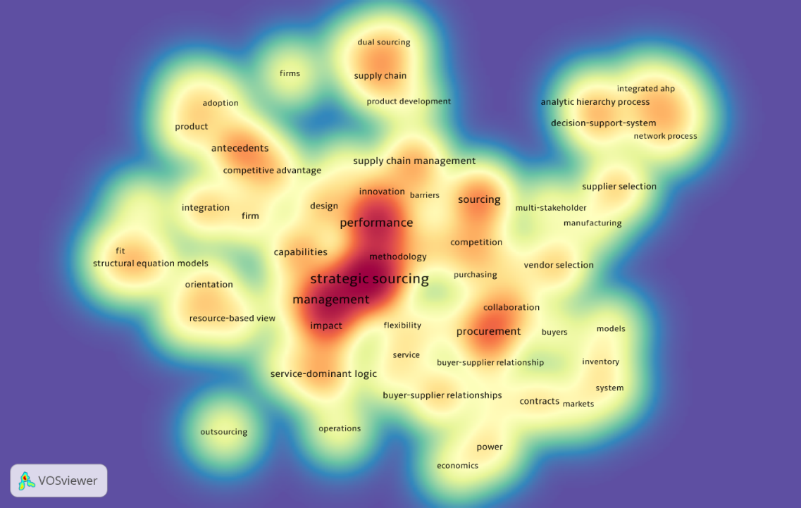

Figure 1 – Density graphic of keywords extracted from VOS viewer software with WoS sample

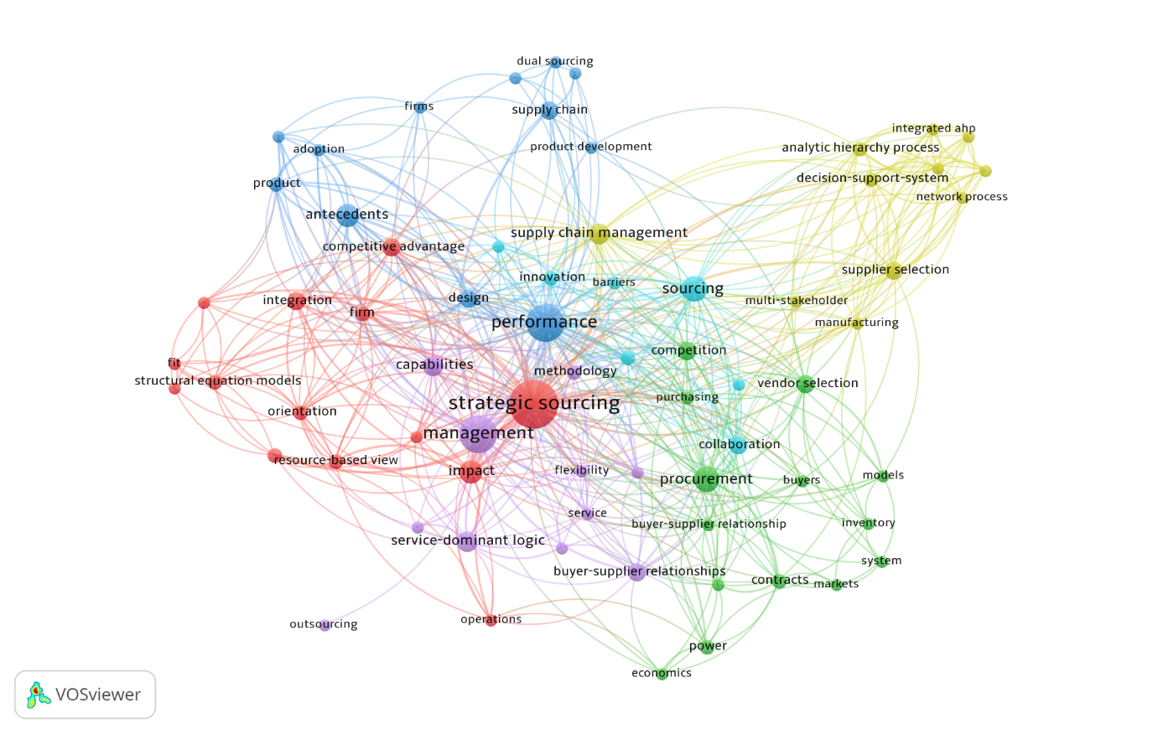

Figure 2 – Network graphic of keywords extracted from VOS viewer software with WoS sample

**2.2 Overview of Strategic Sourcing and Strategic Sourcing Process**

Strategic sourcing is implemented by a process that involves skilled, competent and knowledgeable people being a crucial part of the supply chain management (Baily et al., 2015). Strategic sourcing aims to acquire supplier capabilities aligning the needs of the functional company’s areas, seeking to reduce risks and increase the responsiveness of the supply chain (Narasimhan and Das, 1999). In performance-based strategic sourcing, sourcing decisions involve much more than only goods and service provided at a competitive cost, considering the aspects such as the ability to generate improvements and value in the relationship with suppliers as well (Vitasek, 2016). The strategic sourcing process is responsible to define the strategy regarding the places where products will be sourced and from which suppliers and how they will be sourced. Strategic sourcing aims to choose the best supplier base to organizations seeking not only the lower cost but the best supplier taking into consideration more perspectives such as quality, collaboration, responsiveness, delivery amongst other capabilities.

Concerning the purpose of this article, it is important to differentiate the following terminologies: strategic sourcing, sourcing strategy, strategic sourcing process and strategic sourcing phases. Strategic sourcing is the broad spectrum of sourcing strategies implementation. It is a philosophical approach that demystifies the myth of the operational role of the purchasing area. Moreover, it embraces the whole strategic-oriented process from the sourcing strategy conception up to the rollout of the selected source. Sourcing strategy involves a set of decisions that aims to select the best sources of supplies, according to a corporate strategy orientation (Monczka et al., 2016; Baily et al., 2015). It is the initial point and the main input for the entire strategic sourcing process (Figure 3). The strategic sourcing process is the set of phases required to effectively implement the sourcing strategy. Those phases of the whole strategic sourcing process are five, as presented and described in Figure 3 (Monczka et al., 2016).

Strategic sourcing is relatively less explored compared to other areas of supply chain management. Some research that stands out is focused on developing frameworks for strategic sourcing (Talluri and Narasimhan, 2004, Vitasek, 2016, Formentini et al., 2019) and strategic sourcing for specific industry segments (Chan and Chin, 2007; Scott, Ro and Dey, 2013; Su, 2013; Jensen, 2017; Kumar, Sharma, Singh and Matai, 2018, Mayounga, 2021). Interesting to notice that those studies do not consider strategic sourcing from a process perspective rather they are more focused on sourcing strategies. In this respect, Chan and Chin (2007) identified in their research that process improvement is one of the key success factors of strategic sourcing to be taken into consideration by supply chain decision-makers.

Especially to the theme of the strategic sourcing process, which more aligned with the purpose of this paper, some studies have related the role of strategic sourcing on supply chain performance, although they are not linked to disruption situations. For instance, Eltantawy and Giunipero (2013) have found outperformance orientation is one of the elements that drive the strategic sourcing process. Khan and Pillania (2008) have identified a strong relationship between the strategic sourcing process and the responsiveness of supply chains. According to these authors, strategic sourcing seeks to improve sourcing and purchasing activities to support the total supply chain strategy. In a similar study, Kim and Chai (2017) have also found out a positive impact of the strategic sourcing process on supply chain agility. Chiang, Kocabasoglu-Hillmer and Suresh (2012) have investigated the impact of strategic sourcing on the flexibility and agility of supply chains. In this study, they have shown that strategic sourcing influences both performance attributes, although the impact is higher for supply chain agility. Especially in the context of resilience, Mandal (2020) have reported through his findings that strategic sourcing generates a positive influence on supply chain resilience, although this study is not directly related to the process perspective.

Also, besides the impact on the supply chain performance, studies show that strategic sourcing also impacts organizational and firm performance (Braunscheidel and Suresh, 2009, Kim, Suresh and Kocabasoglu-Hillmer, 2015). Eltantawy, Giunipero and Handfield (2014), have confirmed through empirical research that strategic sourcing is oriented by a learning, performance, planning and process orientation. Moreover, these authors have confirmed that supplier management which belongs to the strategic sourcing process positively impacts the supply chain profitability. More recently, Çankaya (2020) has investigated the impact of strategic sourcing on supply chain agility, lean supply chain and competitive performance. According to his findings, strategic sourcing positively affects these three aspects.

Although these studies relating strategic sourcing to the performance elements of organizations and supply chains are insightful and relevant, a deep understanding regarding strategic sourcing from a process perspective is needed. It is paramount to understand how the phases of the strategic sourcing process and impact different aspects of the performance of supply chains. Indeed, is the strategic sourcing process that will deploy and implement a sourcing strategy. Figure 3, illustrates the strategic sourcing process with the description of all phases adapted from Monczka et al. (2016). This process is the basis for the questionnaire development for the survey data collection. This framework has been chosen as it is unique in approaching a structured step-by-step process perspective for strategic sourcing, which is linked to the main purpose of this paper. The strategic sourcing process is formed of five phases as described in Figure 3: Sourcing Strategy and Planning, Sourcing Research, Sourcing Conduction and Development, Sourcing Contract Alignment and Establishment and Supplier Relationship Management. The detailed description of each phase of the strategic sourcing process is described in Figure 3.

Figure 3 – The Strategic Sourcing Process (Based on Monczka et al., 2016)

The investigation around these phases of the strategic sourcing process is paramount taking into consideration the gap already evidenced in section 2.1 of this paper where it is demonstrated that it was not possible to find articles approaching the strategic sourcing from a process perspective. Considering the context of the COVID-19 pandemic, the research around this subject becomes even more relevant in the face of understanding the impact of the strategic sourcing process on the supply chain response amid this unexpected event.

In that regards, it is important to clarify that the meaning of supply chain response is the capacity of the organization to successfully react to a disturbing event while keeping the continuity of the supply chain flow. The supply chain response is part of the supply chain resilience concept which embraces aspects not only related to how quick a supply chain is able to respond but also how to avoid disruptive impacts and build recovery capacity after disturbing events. In this aspect, it is important to differentiate supply chain response from supply chain resilience. Supply chain response is related to how quick organisations can react against environmental changes (Santos Bernardes and Hanna, 2009). Sharma, Adhikary, and Borahn (2020) highlight that in the event of any pandemic such as Covid-19, the response given by the supply chain processes is very critical. Supply chain resilience is defined by the capacity of the supply chain in avoiding disruption and minimizing the impacts from disruptions by the development of proper readiness mechanism, response capacity and quick recovery (Chowdhury and Quaddus, 2016). The supply chain response becomes paramount due to the demand variations caused by disturbing events (Chowdhury and Quaddus, 2016; Christopher and Peck, 2004). Considering the difficulties regarding the management over the demand level, the supply of products and services become paramount to avoid disruptions in supply chains (Chowdhury and Quaddus, 2016; Christopher and Peck, 2004). Hence, in this aspect, the strategic sourcing process may play a relevant role in the supply chain response amid disruptive events.

As clearly presented in section 2.1, the majority of studies approaches strategic sourcing as a single element, linking it to the various performance attributes of organizations and supply chains, but not to the response aspect. Therefore, as illustrated in Figure 3, this study is guided by a process perspective, covering each element of the strategic sourcing process as each one of them might have a significant impact on the effectiveness of the sourcing strategy deployment and consequently influence the response of the supply chain to sudden disruptions.

## 3.Research Method

A survey method was employed to collect the data over July and August of 2020, which was the peak period of the COVID-19 pandemic in most affected countries. This survey research has an exploratory and descriptive purpose and the intention is to explore and describe the phenomenon of the impact of the strategic sourcing process on the supply chains response amid the pandemic period. A structured questionnaire was used to get the supply chain expert’s perception. This research did not aim to test and validate hypothesis using a probabilistic approach, which is considered more adequate for confirmatory surveys, but exploring and describing the phenomenon as predicted by Forza (2002) for surveys researches in operations management. According to Forza (2002), exploratory surveys are appropriate for the early stages of research when the phenomenon is still to be explored and the purpose is to get preliminary insights. Yet, this author further states that the conceptual model and constructs are not required to be measured for exploratory purposes.

Some researchers have used the descriptive survey method to study phenomena in the operations and supply chain management field (e.g. Bagchi et al., 2005; Miguel and Andrietta, 2010; Zheng et al., 2019). This study aims to provide initial insights around the phenomenon aforementioned serving as the basis for further probabilistic and explanatory surveys. This survey is also descriptive once it has a purpose to demonstrate the phenomenon and its distribution from the population studied (Malhotra and Grover, 1998; Forza, 2002).

In order to collect responses, LinkedIn was used where direct messages were sent to practitioners (e.g. managers, specialists, directors, academics) involved in the supply chain management field. LinkedIn is the most recognized platform in terms of business practitioners’ memberships, including those from the supply chain management area. In total 245 invitations were sent to specific expert profiles through LinkedIn. This resulted in 130 valid responses, i.e., a reasonable response rate of 53%. For the placement of questions as well as data consolidation, the google forms tool was used.

The survey was divided into two sections. The first set of questions were regarding the participants' profiles. The questionnaire also respected the ethical criteria, asking for consent from the participants before they could start answering questions and all information requested was non-identifiable. The next set of questions were related to the strategic process. These questions were designed according to phases of the strategic sourcing process as detailed in Figure 3. The first question was about the whole strategic sourcing process asking respondents how they would consider its impact on the improvement of the supply chain in response to the COVID-19 pandemic effects. The word improvement has been adopted with the impact in the questions in order to allow more specificity to the respondents and not allow to transparent negative impact and doubt during the act of answering the questionnaire. This was followed by questions that were linked to the phases of the strategic sourcing process according to Figure 3 (Sourcing Strategy and Planning, Sourcing Research, Sourcing Conduction and Development, Sourcing Contract Alignment and Strategy and Supplier Relationship Management). For these questions, a five-point Likert scale was used for the ranges strongly disagree to strongly agree (1-5) and very low to very high (1-5).

## 3.1 Survey Results and Discussion

The results will be presented according to the structure of the questionnaire as described in the last section of this paper.

*3.1.1 Participants’ Profile*

The respondents of this survey come from different regions of the world as demonstrated by the map in Figure 4. From the map, it is possible to realize that the responses were obtained from all regions of the world. The countries where the majority of responses were gathered are the United States, Brazil, India United Kingdom, Germany and Canada.

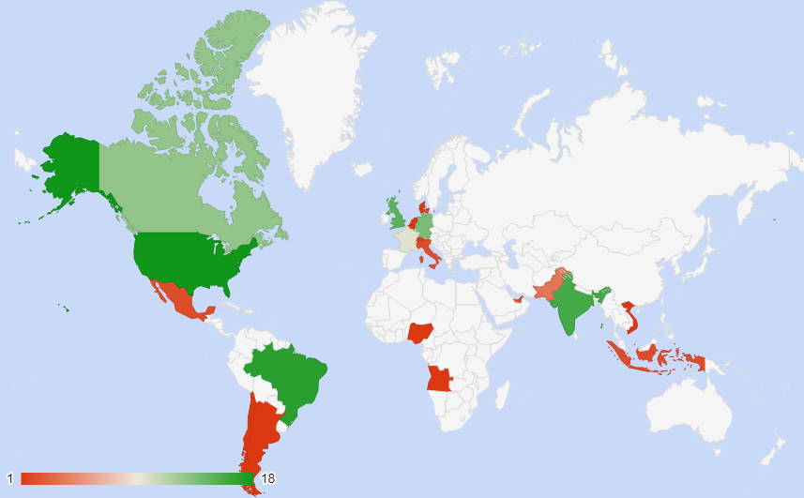

Figure 4 – Countries from survey’s respondents

Also, Figure 5 presents the detailed demographics with other characteristics of the survey participants.

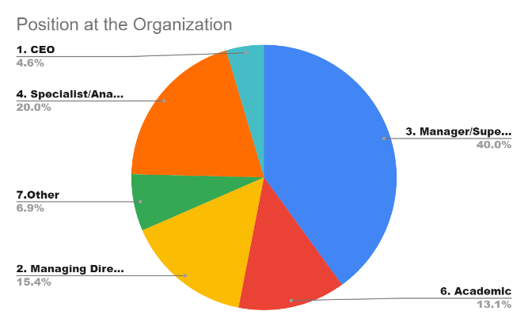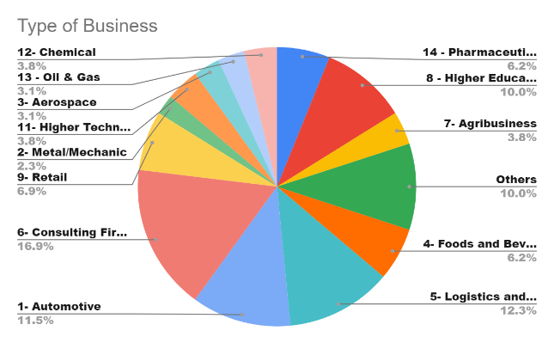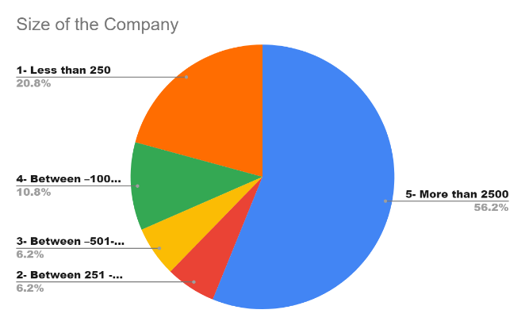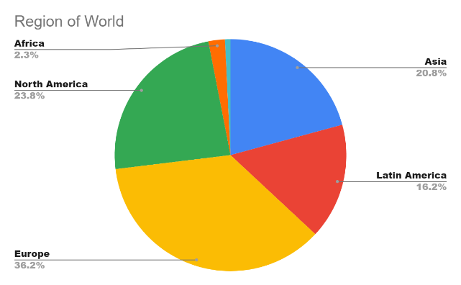

Figure 5 – Demographics of respondents

It is possible to notice that the most significant participants are from Europe (36,2%) following by North America (23.8%) and Asia (20.8%). With regards to the supply chain functions, the majority of respondents are on the Manager/Supervisor/Coordinator level (40%) followed by Specialist/Analyst/Engineer (20%).

With respect to the type of business, the results were more balanced but, stand out respondents from Consulting Firms (16.9%) following by Logistics and Supply Chain Companies (12%) and Automotive sector (11.5%). Table 2 details the number of respondents according to the region of the world and position at an organization.

Table 2 – Number of respondents according to the region of the world and position at Organization

|  |  |  |  |  |  |  |  |
| --- | --- | --- | --- | --- | --- | --- | --- |
| ***Region of World*** | **CEO** | **Managing Director** | **Manager/ Supervisor/ Coordinator** | **Specialist/Analyst/Engineer** | **Academic** | **Other** | **Grand Total** |
| *Africa* |  | 1 | 1 | 1 |  |  | 3 |
| *Asia* | 1 | 1 | 11 | 2 | 9 | 3 | 27 |
| *Europe* | 4 | 5 | 19 | 13 | 3 | 3 | 47 |
| *Latin America* | 1 | 2 | 12 | 3 | 3 |  | 21 |
| *North America* |  | 11 | 9 | 7 | 2 | 2 | 31 |
| *Oceania* |  |  |  |  |  | 1 | 1 |
| ***Grand Total*** | ***6*** | ***20*** | ***52*** | ***26*** | ***17*** | ***9*** | ***130*** |

*3.1.2 Validity and Reliability of the Questionnaire*

The aspects of reliability and validity are essential in research in order to ensure if the data collected, examined and analyzed is consistent and accurate, aiming to obtain credible findings (Saunders, Thornhill, and Lewis 2009). Robson (2011) recommends as a method for validation, the use of small groups of individuals for the run pilot study, previously to the distribution of the questionnaires to participants. In this research, this method was adopted with the purpose to guarantee the validity of the questionnaire. We have run the questionnaire to a group of 10 experts involved in procurement and supply chain management. This has ensured that possible participant errors and bias would not occur in the study. After running the pilot we have received feedback on the pilot questionnaire applied and some questions have been rectified to ensure that respondents had a common interpretation of the questions.

In terms of reliability, Cronbach’s alpha has been calculated, based on the 130 responses. As shown in Table 3, Cronbach’s alpha reached 0.803 which is higher than the minimum suggested by the literature (i.e. >0.70). This indicates the reliability of the variables which forms the strategic sourcing process construct and were the basis for the questionnaire. Those variables are: Stra_SourP: Strategic Sourcing Process; Sour_S&P: Sourcing Strategy and Planning; Sour_Res: Sourcing Research; Sour_C&D: Sourcing Conduction and Development; Sour_CAE: Sourcing Contract Alignment and Establishment; Sup_RM: Supplier Relationship Management

Table 3 – Cronbach’s alpha calculation



In the next section, each one of the questions and their responses are presented.

*3.1.3 Questions and Responses of the Strategic Sourcing Process and Discussion*

The first question that we asked concerning the **Strategic Sourcing Process** - as a whole, as follows:

*How does the Strategic Sourcing Process impact the improvement of Supply Chains response to the COVID-19 pandemic effects?*

For this question, most of the respondents strongly agreed (40.8%) and agreed (36.9%) that the strategic sourcing process impacts a better response of the supply chain process during the COVID-19 outbreak, as illustrated by Figure 6. This perception (agree and strongly agree) represents 77.7% of respondents.

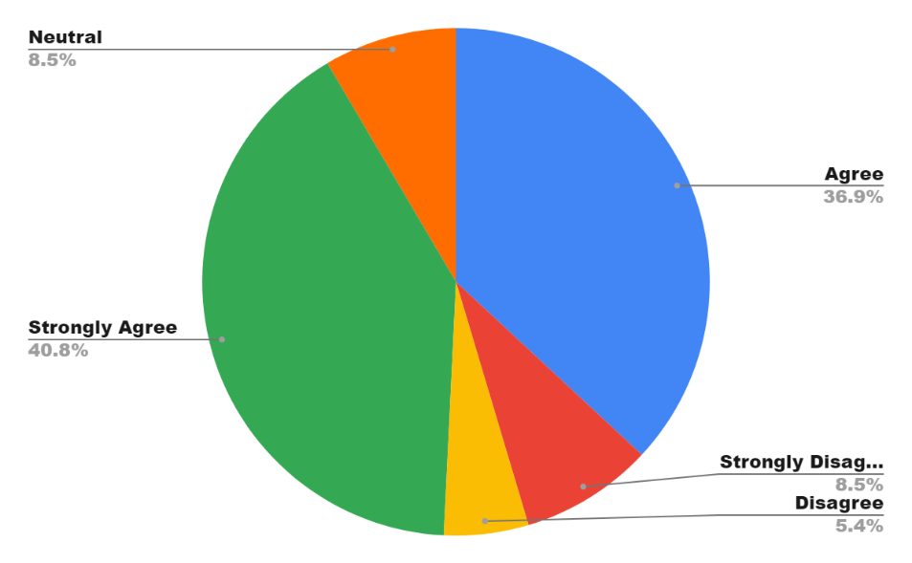

Figure 6 – Impact of the Whole Strategic Sourcing Process on Supply Chain Response Amid COVID-19 pandemic

Table 4 also presents the results deployed by type of business and countries from where the responses come from.

Table 4 – Responses about the perception regarding the impact of the strategic sourcing process on the supply chain response to the COVID-19 pandemic effects deployed by type of business and countries

|  |  |  |  |  |  |  |  |
| --- | --- | --- | --- | --- | --- | --- | --- |
| ***Type of Business*** | ***Countries*** | **Agree** | **Disagree** | **Neutral** | **Strongly Agree** | **Strongly Disagree** | **Grand Total** |
| *Automotive* | Brazil |  |  |  | 1 | 1 | 2 |
|  | France |  |  |  | 1 |  | 1 |
|  | Germany | 3 |  | 1 | 3 |  | 7 |
|  | Italy |  |  | 2 |  |  | 2 |
|  | UK |  |  |  | 1 |  | 1 |
|  | USA |  |  |  | 2 |  | 2 |
| **Automotive Total** |  | 3 |  | 3 | 8 | 1 | 15 |
| *Higher Technology* | Angola | 1 |  |  |  |  | 1 |
|  | Canada |  |  | 1 |  |  | 1 |
|  | Germany | 1 |  |  |  |  | 1 |
|  | USA |  |  |  | 2 |  | 2 |
| **Higher Technology Total** |  | 2 |  | 1 | 2 |  | 5 |
| *Chemical* | Brazil | 2 |  |  |  |  | 2 |
|  | Canada | 1 |  |  |  |  | 1 |
|  | Germany | 1 |  |  |  |  | 1 |
|  | Singapore |  |  |  | 1 |  | 1 |
| **Chemical Total** |  | 4 |  |  | 1 |  | 5 |
| *Oil & Gas* | Singapore |  |  |  |  | 1 | 1 |
|  | UAE |  |  |  | 2 |  | 2 |
|  | UK | 1 |  |  |  |  | 1 |
| **Oil & Gas Total** |  | 1 |  |  | 2 | 1 | 4 |
| *Pharmaceutical and Healthcare* | Canada | 1 |  |  |  |  | 1 |
|  | Germany | 1 |  |  |  |  | 1 |
|  | India | 2 |  |  |  |  | 2 |
|  | UK | 1 |  |  |  |  | 1 |
|  | USA | 1 | 1 |  | 1 |  | 3 |
| **Pharmaceutical and Healthcare Total** |  | 6 | 1 |  | 1 |  | 8 |
| *Metal/Mechanic* | Canada |  |  |  | 1 |  | 1 |
|  | India |  | 1 | 1 |  |  | 2 |
| **Metal/Mechanic Total** |  |  | 1 | 1 | 1 |  | 3 |
| *Aerospace* | Chile |  |  |  | 1 |  | 1 |
|  | France |  |  |  | 1 |  | 1 |
|  | Uk | 1 |  |  | 1 |  | 2 |
| **Aerospace Total** |  | 1 |  |  | 3 |  | 4 |
| *Foods and Beverages* | Brazil |  |  |  | 2 |  | 2 |
|  | Canada |  | 1 |  |  |  | 1 |
|  | India |  |  |  | 1 |  | 1 |
|  | UK |  |  |  | 1 |  | 1 |
|  | USA |  |  | 1 | 2 |  | 3 |
| **Foods and Beverages Total** |  |  | 1 | 1 | 6 |  | 8 |
| *Logistics and Supply Chain Services* | Belgium | 1 |  |  |  |  | 1 |
|  | Brazil | 2 |  |  |  | 1 | 3 |
|  | Canada |  |  | 1 |  |  | 1 |
|  | France |  |  |  | 1 |  | 1 |
|  | India |  |  |  | 2 | 1 | 3 |
|  | Mexico | 1 |  |  |  |  | 1 |
|  | Nigeria | 1 |  |  |  |  | 1 |
|  | Nigeria |  |  |  |  | 1 | 1 |
|  | Switzerland |  | 1 |  |  |  | 1 |
|  | UK | 1 |  |  |  |  | 1 |
|  | USA | 1 |  |  |  | 1 | 2 |
| **Logistics and Supply Chain Services Total** |  | 7 | 1 | 1 | 3 | 4 | 16 |
| *Consulting Firms* | Brazil |  |  |  | 1 |  | 1 |
|  | Canada | 2 |  |  | 1 |  | 3 |
|  | Denmark |  |  | 1 |  |  | 1 |
|  | France | 1 |  |  | 2 |  | 3 |
|  | Germany | 1 |  |  | 2 |  | 3 |
|  | India | 2 |  |  |  |  | 2 |
|  | Indonesia |  |  |  | 1 |  | 1 |
|  | Pakistan |  |  |  |  | 1 | 1 |
|  | UK | 2 |  |  | 2 |  | 4 |
|  | USA |  |  |  | 1 | 1 | 2 |
|  | Vietnam | 1 |  |  |  |  | 1 |
| **Consulting Firms Total** |  | 9 |  | 1 | 10 | 2 | 22 |
| Agribusiness | Argentina | 1 |  |  |  |  | 1 |
|  | Brazil | 2 |  |  |  |  | 2 |
|  | France |  |  |  | 1 |  | 1 |
|  | UK |  |  |  | 1 |  | 1 |
| **Agribusiness Total** |  | 3 |  |  | 2 |  | 5 |
| Higher Education | Brazil | 1 | 2 |  |  | 1 | 4 |
|  | Canada |  |  |  | 1 |  | 1 |
|  | India | 3 |  |  | 1 | 1 | 5 |
|  | Pakistan |  |  |  | 1 |  | 1 |
|  | UK | 1 |  |  |  |  | 1 |
|  | USA |  |  |  | 1 |  | 1 |
| **Higher Education Total** |  | 5 | 2 |  | 4 | 2 | 13 |
| Retail | Brazil |  |  |  | 1 |  | 1 |
|  | Canada | 1 |  |  | 2 |  | 3 |
|  | France | 1 |  |  |  |  | 1 |
|  | Mexico |  |  |  | 1 |  | 1 |
|  | Pakistan |  |  |  |  | 1 | 1 |
|  | Swedish |  |  |  | 1 |  | 1 |
|  | USA |  |  |  | 1 |  | 1 |
| **Retail Total** |  | 2 |  |  | 6 | 1 | 9 |
| Others | France | 2 |  |  |  |  | 2 |
|  | France | 1 |  |  |  |  | 1 |
|  | Germany |  |  | 1 |  |  | 1 |
|  | India |  | 1 |  |  |  | 1 |
|  | Indonesia |  |  | 1 |  |  | 1 |
|  | Netherlands |  |  | 1 |  |  | 1 |
|  | Pakistan |  |  |  | 1 |  | 1 |
|  | Pakistan | 1 |  |  |  |  | 1 |
|  | UK | 1 |  |  | 1 |  | 2 |
|  | USA |  |  |  | 2 |  | 2 |
| **Others Total** |  | 5 | 1 | 3 | 4 |  | 13 |
| ***Grand Total*** |  | ***48*** | ***7*** | ***11*** | ***53*** | ***11*** | ***130*** |

The second question was related to the **Sourcing Strategy and Planning** phase of the strategic sourcing process as stated below:

*How would you consider the impact of a Sourcing Strategy and Planning on the improvement of the supply chain’s response to the effect derived from the COVID-19 pandemic?*

In this case, 43.1% of respondents considered that this phase of the strategic sourcing process has a very high impact on the supply chain response amid the coronavirus pandemic. Also, 43.1% of respondents answered high impact for this phase. These results are demonstrated in Figure 7.

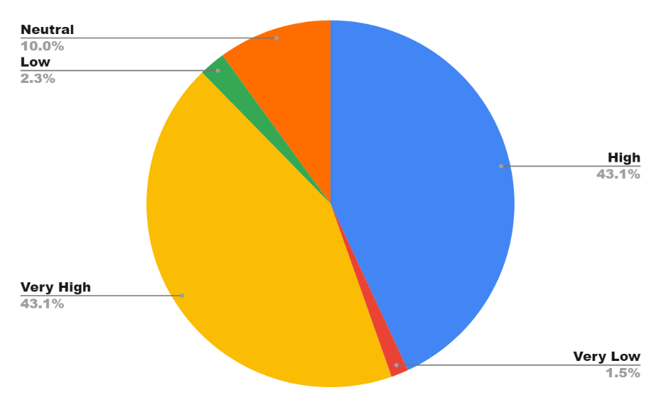

Figure 7 – Impact of the Sourcing Strategy and Planning phase on Supply Chain Response Amid COVID-19 pandemic

The third question aimed to obtain the perception from respondents concerning the phase of **Sourcing Research**. The question placed was as follow:

*How would you consider the impact of Sourcing Research on the improvement of a supply chain’s response to the effect derived from the COVID-19 pandemic?*

The majority of participants (83.1%) answered as high (50%) and very high (33.1%) impact on the supply chain response to the pandemic effects as shown by Figure 8.

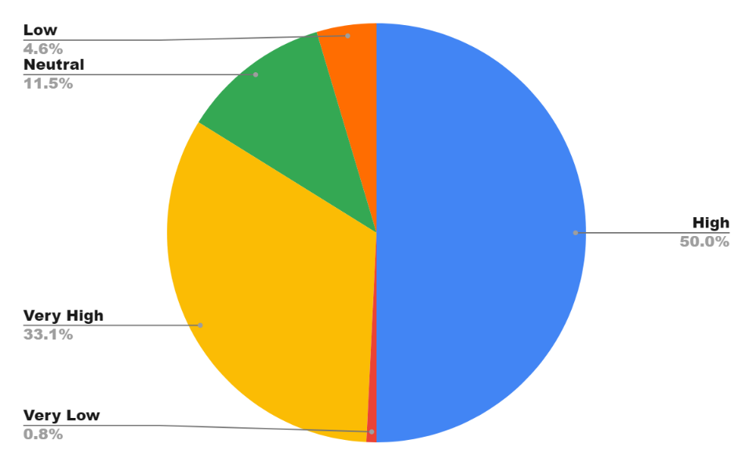

Figure 8 – Impact of the Sourcing Research phase on Supply Chain Response Amid COVID-19 pandemic

The fourth question approached the phase of **Sourcing Conduction and Development** as presented by the following question:

*How would you consider the impact of Sourcing Conduction and Development on the improvement of a supply chain’s response to the effect derived from the COVID-19 pandemic?*

Results illustrated by Figure 9, shows that a number of 86.1% of respondents considered this phase as a very high impact (31.5%) and high impact (54.6%).

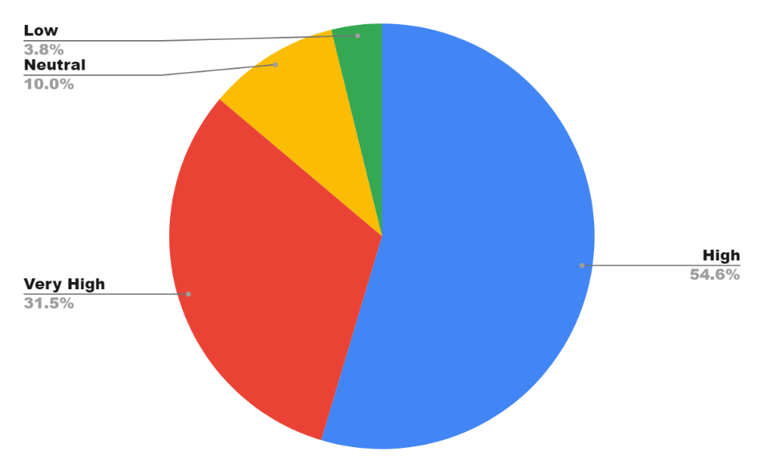

Figure 9 – Impact of the Sourcing Conduction and Development phase on Supply Chain Response Amid COVID-19 pandemic

The fifth question asked participants their perception related to the impact of the phase of **Sourcing Contract Alignment and Establishment** to the supply chain response as written in the following question.

*How would you consider the impact of the Sourcing Contract Alignment and Establishment on the improvement of a supply chain’s response to the effect derived from the COVID-19 pandemic?*

Results showed that 39.2% of respondents consider this phase as a very high impact and more 39.2% as high impact as well which represents in total 78.4% of participants. These results are evidenced in Figure 10.

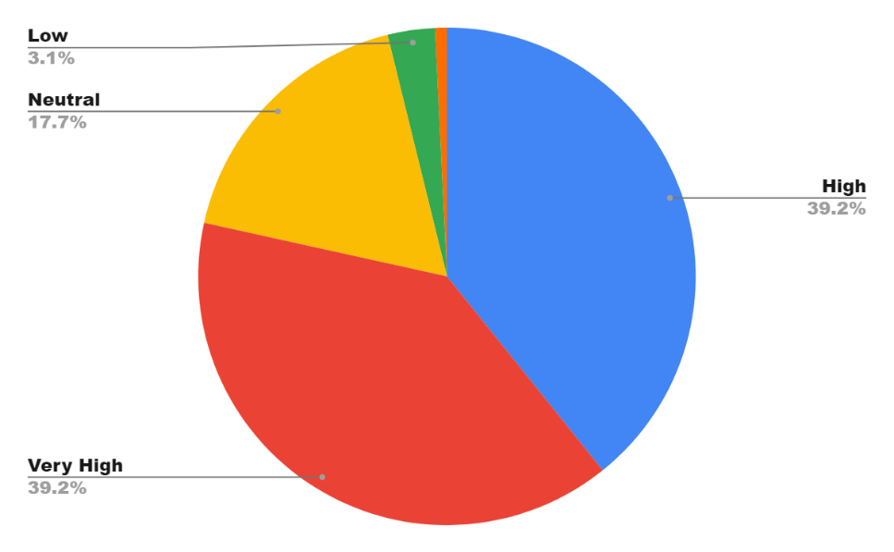

Figure 10 – Impact of the Sourcing Contract Alignment and Establishment phase on Supply Chain Response Amid COVID-19 pandemic

Lastly, a question regarding the phase of the **Supplier Relationship Management** phase was asked as described below:

*How would you consider the impact of the Management of Supplier Relations on the improvement of a supply chain’s response to the effect derived from the COVID-19 pandemic?*

As can be noticed by the results illustrated in Figure 11, this phase was considered the most important one by the participants. A number of 72.3% responded as high impact phase and more 20.8% as very high impact phase summing 93.1% of respondents.

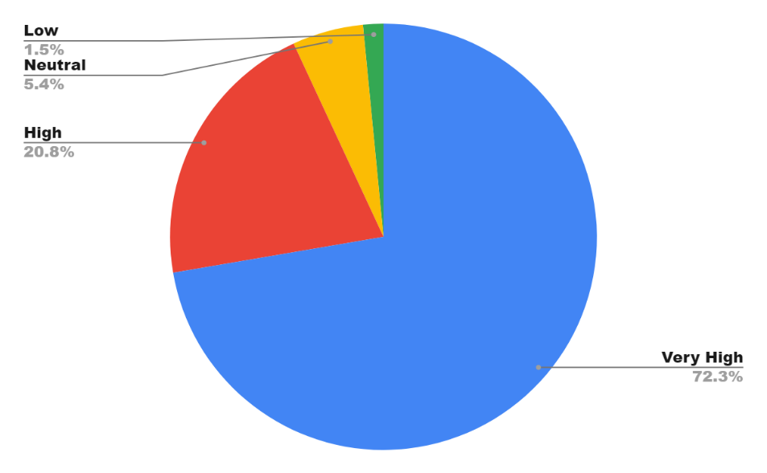

Figure 11 – Impact of the Supplier Relationship Management phase on Supply Chain Response Amid COVID-19 pandemic

It is important to emphasize that although the majority of responses for all the phases of the strategic sourcing process showed to have a high or very high impact on the supply chain response. However, there were a small number of respondents who considered these phases as a very low, low or neutral classification (i.e. 13.8% in the Sourcing Strategy and Planning, 16.9% in the Sourcing Research, 13.9% in the Sourcing Conduction and Development, 21.6% in the Sourcing Contract Alignment and Establishment, and 6.9% in the Supplier Relationship Management). This may have occurred due to some reasons. First, some businesses in which respondents work may have not significantly been affected by the COVID-19, which make this phenomenon not clear for them. Second, even though procurement and supply chain experts were chosen for this survey, some of them may not have a clear idea about how the strategic sourcing process affects the supply chain response. Further investigations to clearly understand the reasons for the scores herein obtained should be conducted to explore this phenomenon in more detail.

Table 5 brings the summarized data regarding the impact of the five phases of the strategic sourcing process. As can be noticed, the Supplier Relationship Management was considered the most impacting phase by respondents (93.1%). This phenomenon can be explained by the reason that respondents understood that during the pandemic this should be the only process that can be managed and improved once the others were performed in past strategic sourcing processes (e.g. develop jointly contingency plans during the pandemic).

However, another part of the population also considered those as very high and high impacting (above of 80% summing these 2 criteria), by the fact that although they were already undertaken in the past, they cause impacts during the term of the contract with suppliers (e.g. the way how the contract was designed predicting disruption situations on the Sourcing Contract Alignment and Establishment phase, the sourcing strategy defining the regions of suppliers during the Sourcing Strategy and Planning phase and the RFQ process evaluating and choosing the capable suppliers during the Sourcing Search and Sourcing Conduction and Development phases). This is relevant because clearly, pieces of evidence show how previous strategic sourcing phases might impact the long-term supply chain performance, and in this particular case of the COVID-19 outbreak. These insights are relevant and paramount to indicate to practitioners to devote more attention and carefully consider probable future disruption situations at the moment when the strategic sourcing process is undertaken. We also ran a correlation analysis to check the interdependencies between the strategic sourcing process phases. The findings of the correlation analysis are shown in Table 6 below. The findings show that these phases are significantly correlated with each other as all coefficients were significant at P<0.01 level.

Table 5 – Synthesis of responses regarding the impact of the strategic sourcing process’ phases on the supply chain response to the COVID-19 pandemic effects

|  |  |  |  |  |  |
| --- | --- | --- | --- | --- | --- |
|  | ***Impact Perception from Respondents (% of Participants)*** | | | | |
| ***Strategic Sourcing Process Phases*** | **Very Low** | **Low** | **Neutral** | **High** | **Very High** |
| Sourcing Strategy and Planning | *1.5%* | *2.3%* | *10.0%* | *43.1%* | *43.1%* |
| Sourcing Research | *0.8%* | *4.6* | *11.5%* | *50.0%* | *33.1%* |
| Sourcing Conduction and Development | *-* | *3.8%* | *10.0%* | *54.6%* | *31.5%* |
| Sourcing Contract Alignment and Establishment | *0.8%* | *3.1%* | *17.7%* | *39.2%* | *39.2%* |
| Supplier Relationship Management | *-* | *1.5%* | *5.4%* | *20.8%* | *72.3%* |

|  |  |  |  |  |  |  |
| --- | --- | --- | --- | --- | --- | --- |
| Table 6: Correlation analysis amongst the components of the strategic sourcing elements | | | | | | |
|  | **Stra_SourP** | **Sour_S&P** | **Sour_Res** | **Sour_C&D** | **Sour_CAE** | **Sup_RM** |
| **Stra_SourP** | 1 |  |  |  |  |  |
| **Sour_S&P** | .470** | 1 |  |  |  |  |
| **Sour_Res** | .271** | .683** | 1 |  |  |  |
| **Sour_C&D** | .237** | .577** | .727** | 1 |  |  |
| **Sour_CAE** | .233** | .424** | .497** | .645** | 1 |  |
| **Sup_RM** | .273** | .436** | .363** | .419** | .477** | 1 |
| **. Correlation is significant at the 0.01 level (2-tailed). | | | | | | |
| **Stra_SourP:** Strategic Sourcing Process; **Sour_S&P:** Sourcing Strategy and Planning; **Sour_Res:** Sourcing Research; **Sour_C&D:** Sourcing Conduction and Development; **Sour_CAE:** Sourcing Contract Alignment and Establishment; **Sup_RM:** Supplier Relationship Management; | | | | | | |

Concerning the COVID-19 pandemic, the strategic sourcing process may play a crucial role related to the supply chain response. The results herein presented from supply chain experts’ viewpoint clearly shows the importance of the strategic sourcing process and its deployed phases in response to supply chains disruption due to the COVID-19 pandemic. For instance, the *Sourcing Strategy and Planning* determines the regions from where raw materials and components will be sourced. Localizations of suppliers directly influences supply chain responsiveness. Also, this phase of the strategic sourcing process covers the decisions around make or buy. Although outsourcing and global sourcing are strong trends of contemporary supply chains, verticalization may benefit in certain situations which requires a prompt response on regards to supply needs. Once the *Sourcing Strategy and Planning* phase is concluded, the *Sourcing Search* commences. This step is crucial to effectively choose potential suppliers that will participate in the *Sourcing Conduction and Development*, which is a paramount stage taking into consideration that this is the phase when suppliers will be evaluated and chosen. Suppliers have a significant role in the supply chain response to unexpected events such as coronavirus. The supply chain performance on the responsiveness attribute will strongly depend on the ability of suppliers to effectively responding to the demand variations due to the environmental changes. Then, after the decision around contract award is made, the *Sourcing Contract Alignment and Establishment* phase is initiated. This stage is significant because the whole relationship between the supplier and the contracting company will be driven according to the clauses established in the sourcing contract. The key performance indicators will be set up at this stage. For example, performance measures that stimulate a rapid response from suppliers, as well as jointly contingency plans to solve sudden events, might contribute to better performance in terms of supply chain responsiveness. The last phase is related to *Supplier Relationship Management*. This last stage of the strategic sourcing process refers to the daily activities involving the supplier and contracting company during the term of the contract. In unexpected situations like the COVID-19 outbreak, this may be the differential aspect that will determine the success in reacting against disruption effects. Supplier’s capabilities (e.g. risk management, response plans, production flexibility) and proactiveness are aspects that make difference in face of disruption threats in the daily relationship. Those aspects must be deeply observed during *Sourcing Conduction and Development* phase.

As can be noticed from the afore discussion, the phases of the strategic sourcing process are strongly correlated one each other. The results as demonstrated by Table 5 also indicated this strong correlation among the steps of the strategic sourcing process. Some highlights are Strategic Sourcing and Planning which is significantly correlated to *Strategic Sourcing Research* (0.683) and Strategic *Sourcing Conduction and Development* (0.577). That is because of the initial phase of the strategic sourcing that will drive the following steps. Also, the *Sourcing Conduction and Development* appears to have a significant correlation with *Sourcing Contract Alignment and Establishment***.** The reason is due to the fact that in on the Sourcing Conduction and Development when the Terms & Conditions are negotiated and agreed with suppliers leaving to the following phase the basis for formalization.

Although the limited literature regarding the strategic sourcing process does not bring any evidence on the impact of each phase of the strategic sourcing process on the supply chain response as this study aims to contribute to, some authors have reported some strategic sourcing impacts on the supply chain performance. For instance, findings herein presented corroborate with Khan and Pillania (2008), who identified a strong relationship between the strategic sourcing process and the responsiveness of supply chains, although they studied the phenomenon in a normal period. More recently, Kim and Chai (2017) found out a positive impact of the strategic sourcing process on supply chain agility while Chiang, Kocabasoglu-Hillmer and Suresh (2012) demonstrated the impact of strategic sourcing on the flexibility and agility of supply chains. Also, although the study conducted by Mandal (2020) is not directly related to the process perspective of strategic sourcing, which may be implicit in it, this study proved a positive relationship between strategic sourcing and supply chain resilience. Therefore, those studies are corroborated by the findings from this research. The research herein presented differentiates from the related studies by analyzing the impact of the strategic sourcing process on supply chains during an event of high magnitude such as the COVID-19 pandemic. Moreover, it evaluates the process-orientation perspective of strategic sourcing and its impact, by considering each one of its six main phases, as it was afore discussed in this section. Table 7 summarize those related studies in relation to the findings of this research.

Table 7: Summary of related literature *versus* research findings

|  |  |
| --- | --- |
| ***Related Literature*** | ***Findings from Survey Research*** |
| Khan and Pillania (2008) | Validated |
| Chiang, Kocabasoglu-Hilmer and Suresh (2012) | Validated |
| Kim and Chai (2017) | Validated |
| Mandal (2020) | Partially Validated |

**4. Conclusion and Research Directions**

COVID-19 pandemic has brought challenging times for supply chains’ practitioners in order to ensure the responsiveness requested amid demand and supply variations. The strategic sourcing process plays an important role in the supply chain response mainly because it directly influences the whole downstream supply chain processes (i.e. manufacturing and delivery). Hence, this paper aimed to investigate the importance of strategic sourcing to the supply chain response amid the coronavirus pandemic seeking to understand the perception from supply chain management’s experts in that regards.

According to the survey results, obtained from 130 respondents from different regions of the world and different backgrounds in terms of company size, type of business and position at the organization, the strategic sourcing process impacted the responsiveness of the supply chain in face of the COVID-19 effects. Moreover, the majority of respondents have also indicated the very high and high impact of the five main phases of the strategic sourcing process (i.e. Sourcing Strategy and Planning, Sourcing Research, Sourcing Conduction and Development, Contract Alignment and Establishment and Supplier Relationship Management). This evidence helps to answer the research question placed in the introduction section of this paper. The findings show that the strategic sourcing process improves the response of the supply chain.

Although this research brings relevant insights, certain limitations must be taken into considerations. First, this research has not evaluated the difference of the strategic sourcing process’ impact on the supply chain response between normal and COVID-19 period. This analysis could bring more deep and relevant findings and may be considered as further deployments from this research. Second, in order to improve the exploratory characteristics of this study, the understanding of the reasons why respondents have scored the impact could provide a deep and sharp understanding of this phenomenon. Moreover, the understanding of, which phase of the strategic sourcing deserves prioritization in order to improve the impact on the supply chain response, is also relevant. Third, the Likert scale used in this research has considered only the positive improvement perspective of the strategic sourcing process. But one question which could arise is if there is a possibility of no improvements generation in the supply chain response from the strategic sourcing process, or if this eventually could bring any negative impact. Fourth, this study has not taken into consideration the particularities between different products involved in supply chains and even for the difference between products and services, which requires further investigations.

From a managerial perspective, this research brings relevant and timely insights when issues related to the supply chain resilience and responsiveness amid disruption situations are being discussed and rethought by practitioners and researchers. Our findings show the relevance of the strategic sourcing process as part of the supply chain management hence incentivizing supply chain leadership to devote more time on sourcing strategy and process to better prepare their supply chains for future unexpected events similar to the COVID-19. Moreover, it shows the importance of each phase of the strategic sourcing process. The study emphasizes the need for a more focus on every step that forms the whole sourcing process, due to the strong correlation between the phases, as demonstrated by the results of this empirical research.

On the theoretical side, this study encourages researchers to look for strategic sourcing as an element to be deeply investigated, providing an initial view on the relationship between the strategic sourcing process and responsiveness of the supply chains in emergency and unexpected situations. As a descriptive survey, this study had the purpose to present the perceptions of experts involved in supply chain management, more specifically in the procurement field. However, the study is limited in the sense to generalize the results herein presented which would have to be deeply investigated by an explanatory survey aiming to confirm hypotheses, with valid and tested constructs and by mean of correlation statistics analysis. We propose a set of directions for future research related to this theme which includes the following but not limited to:

* What is the impact of the sourcing strategy and planning (e.g. localization strategy, multiple and single sourcing, make or buy decisions, rapid strategic sourcing development) on the resilience and response of supply chains amid extreme disruptive situations?
* How can a quick response sourcing strategy and planning be formulated and deployed amid unexpected and emergency situations?
* How can the capabilities of suppliers be evaluated in terms of risk management to effectively respond to black swan events such as that posed by COVID-19?
* Which attributes from suppliers must be prioritized and how can these be developed to create a robust supply chain able to cope with significant and unpredictable disruptive events?
* Which types of sourcing contracts must be considered to make suppliers capable to effectively respond to unexpected and emergency occurrences?
* What is the impact of contract design with suppliers on the performance of supply chains amid disruptive situations?
* How can suppliers be more effectively engaged to proactively collaborate in the formulation and deployment of strategies aimed at reacting to sudden disruptive events? What initiatives and relationships could enhance this dimension?
* How can disruptive technologies (i.e. Industry 4.0 technologies) support the strategic sourcing process seeking to create a more responsive supply chain?
* Which steps of the strategic sourcing process should be prioritized and enhanced in disruptions and non-disruptions situations to improve the supply chain response?
* How can lean philosophy and agile methods contribute to optimizing the strategic sourcing process with the purpose the create a more responsive and effective rollout of sourcing strategies, not only during unexpected events but also in the normal environment?
* What is the impact of the strategic sourcing process on the supply chain response considering different type of products and services amid both normal and disruption situations?
* How can Supplier Relationship Management foster the supply chain response amid unexpected and impacting events?
* What are the reasons why each step of the strategic sourcing process has a lower or higher impact on the supply chain response amid impacting and disrupting occurrences?

## References

APICS (2019) *Supply Chain Operations Reference model*, APICS Supply Chain Council available at: http://www.apics.org/apics-for-business/frameworks/scor

Bagchi, P.K., Chun Ha, B., Skjoett‐Larsen, T. and Boege Soerensen, L. (2005), "Supply chain integration: a European survey", The International Journal of Logistics Management, Vol. 16 No. 2, pp. 275-294. https://doi.org/10.1108/09574090510634557

Baily, P., Farmer, D., Crocker, B., Jessop, D. and Jones, D. *Procurement Principles and Management*. 11th Ed., Pearson, Edinburgh. UK, 2015.

Boehmke B., Hazen, B., Boone, C.A. and Robinson, J. L. (2020) “A data science and open source software approach to analytics for strategic sourcing”, *International Journal of Information Management,* Vol. 54, 102167. https://doi.org/10.1016/j.ijinfomgt.2020.102167.

Braunscheidel, M.J. and Suresh, N.C. (2009), “The organizational antecedents of a firm’s supply chain agility for risk mitigation and response”, *Journal of Operations Management*, Vol. 27 No. 2, pp. 119-40. https://doi.org/10.1016/j.jom.2008.09.006

Centers for Disease Control and Prevention (2020), “*Strategies for optimizing the supply of facemasks*. Accessed September 08th, 2020. https://www.cdc.gov/coronavirus/2019-ncov/hcp/ppe-strategy/face-masks.html

Chowdhury, M.M.H. and Quaddus, M. (2016), "Supply chain readiness, response and recovery for resilience", *Supply Chain Management*, Vol. 21 No. 6, pp. 709-731. https://doi.org/10.1108/SCM-12-2015-0463

CIPS – Chartered Institute of Procurement & Supply (2020). “Coronavirus COVID-19 – More guidance for procurement and supply chain managers. Accessed September 08th, 2020. https://www.cips.org/Documents/images/Theme%20Pages/covid-long2.pdf

Çankaya, S. Y. (2020), "The effects of strategic sourcing on supply chain strategies", *Journal of Global Operations and Strategic Sourcing*, Vol. 13 No. 2, pp. 129-148. https://doi.org/10.1108/JGOSS-01-2019-0002

Chan, T.C.T. and Chin, K. (2007), "Key success factors of strategic sourcing: An empirical study of the Hong Kong toy industry", *Industrial Management & Data Systems*, Vol. 107 No. 9, pp. 1391-1416. https://doi.org/10.1108/02635570710834027

Chen, J. and Guo, Z. (2014), “Strategic Sourcing in the Presence of Uncertain Supply and Retail Competition”, *Production and Operations Management,* Vol. 23 No. 10, pp. 1748-1760. https://doi.org/10.1111/poms.12078

Chiang, C., Kocabasoglu-Hillmer, C and Suresh, N. (2012), “An empirical investigation of the impact of strategic sourcing and flexibility on firm’s supply chain agility”, *International Journal of Operations & Production Management,* Vol. 32 No. 1, pp. 49-78. https://doi.org/ 10.1108/01443571211195736

Christopher, M. and Peck, H. (2004), "Building the Resilient Supply Chain", *The International Journal of Logistics Management*, Vol. 15 No. 2, pp. 1-14. https://doi.org/10.1108/09574090410700275

Cox, A. (2015), "Sourcing portfolio analysis and power positioning: towards a “paradigm shift” in category management and strategic sourcing", *Supply Chain Management*, Vol. 20 No. 6, pp. 717-736. https://doi.org/10.1108/SCM-06-2015-0226

Eltantawy, R. A. and Giunipero, L. (2013), “An empirical examination of strategic sourcing dominant logic: Strategic sourcing centricity”, *Journal of Purchasing & Supply Management*, Vol.19 No.4, pp. 215-226. https://doi.org/10.1016/j.pursup.2013.07.001

Eltantawy, R., Giunipero, L. and Handfield, R. (2014), "Strategic sourcing management’s mindset: strategic sourcing orientation and its implications", *International Journal of Physical Distribution & Logistics Management*, Vol. 44 No. 10, pp. 768-795. https://doi.org/10.1108/IJPDLM-02-2014-0045

Formentini, M., Ellram, L. M., Boem, M. and Da Red, G. (2019), “Finding true north: Design and implementation of a strategic sourcing framework”, *Industrial Marketing Management*, Vol.77, pp. 182-197. https://doi.org/10.1016/j.indmarman.2018.09.006

Forza, C. (2002) “Survey research in operations management: a process-based perspective”, *International Journal of Operations and Production Management*, Vol.22 No.2, pp. 152-194. https://doi.org/ 10.1108/01443570210414310

Frederico, G. F. (2020), “In Times of Coronavirus, Maturity in Supply Chain Management Really Matters!”, *Supply Chain Management Review*, https://www.scmr.com/article/in_times_of_coronavirus_maturity_in_supply_chain_management_really_matters, Accessed June 2020.

Haren, P, and Simchi-Levi, D. (2020), “How Coronavirus Could Impact the Global Supply Chain by Mid-March”, *Harvard Business Review*, https://hbr.org/2020/02/how-coronavirus-could-impact-the-global-supply-chain-by-mid-march, Accessed on Feb. 2020.

Ivanov, D. and Dolgui, A. (2020) “Viability of intertwined supply networks: extending the supply chain resilience angles towards survivability. A position paper motivated by COVID-19 outbreak”, *International Journal of Production Research*, Vol.58 No.10 pp.2904-2915. https://doi.org/10.1080/00207543.2020.1750727

Jabbour, A.B. L.S., Jabbour, C.J.C., Hingley, M., Vilalta-Perdomo, E.L., Ramsden, G. and Twigg, D. (2020), "Sustainability of supply chains in the wake of the coronavirus (COVID-19/SARS-CoV-2) pandemic: lessons and trends", *Modern Supply Chain Research and Applications,* Vol. ahead-of-print No. ahead-of-print. https://doi.org/10.1108/MSCRA-05-2020-0011

Jensen, P.A. (2017), "Strategic sourcing and procurement of facilities management services", *Journal of Global Operations and Strategic Sourcing*, Vol. 10 No. 2, pp. 138-158. https://doi.org/10.1108/JGOSS-10-2016-0029

Khan K, A. and Pillania, R.K. (2008), "Strategic sourcing for supply chain agility and firms' performance: A study of Indian manufacturing sector", *Management Decision*, Vol. 46 No. 10, pp. 1508-1530. https://doi.org/10.1108/00251740810920010

Kim, M., Suresh, N.C. and Kocabasoglu-Hillmer, C. (2015), "A contextual analysis of the impact of strategic sourcing and E-procurement on performance", *Journal of Business & Industrial Marketing*, Vol. 30 No. 1, pp. 1-16. https://doi.org/10.1108/JBIM-01-2012-0010

Kim, M. and Chai, S. (2017), " The impact of supplier innovativeness, information sharing and strategic sourcing on improving supply chain agility: Global supply chain perspective", *International Journal of Production Economics*, Vol. 187, pp. 42-52. https://doi.org/10.1016/j.ijpe.2017.02.007

Kumar Sharma, S., Singh, R. and Matai, R. (2018), "Force field analysis of Indian automotive strategic sourcing risk management enablers and barriers", *Measuring Business Excellence*, Vol. 22 No. 3, pp. 258-275. https://doi.org/10.1108/MBE-09-2017-0062

Kutzner, M. and Rajal, M. (2020), "*Shaping sourcing and procurement in a post-COVID environment*", Delloite. Accessed September 08th, 2020. https://www2.deloitte.com/ch/en/pages/technology/articles/shaping-sourcing-and-procurement-in-a-post-covid-environment.html

Livingston, E., Desai, A. and Berkwits, M. (2020), “Sourcing Personal Protective Equipment During the COVID-19 Pandemic”, *JAMA,* Vol. 323 No.19, pp. 1912-1914. https://doi.org/10.1001/jama.2020.5317

Linton, T, and Vakil, B. (2020), “Coronavirus Is Proving We Need More Resilient Supply Chains”, *Harvard Business Review*, https://hbr.org/2020/03/coronavirus-is-proving-that-we-need-more-resilient-supply-chains, Accessed July 2020.

Mandal, S. (2020), "Impact of supplier innovativeness, top management support and strategic sourcing on supply chain resilience", *International Journal of Productivity and Performance Management*, Vol. ahead-of-print No. ahead-of-print. https://doi.org/10.1108/IJPPM-07-2019-0349

Malhotra, M. K. and Grover, V. (1998), “An assessment of survey research in POM: from constructs to theory”, *Journal of Operations Management,* Vol. 16 No. 17, pp. 407-425. https://doi.org/10.1016/S0272-6963(98)00021-7

Mayounga, A.T. (2021), "Strategic sourcing in Africa: the case for the labor market*", Journal of Global Operations and Strategic Sourcing*, Vol. ahead-of-print No. ahead-of-print. https://doi.org/10.1108/JGOSS-01-2020-0003

Miguel, P. A. C. and Andrietta, J. M. (2010), "Outcomes from a descriptive survey of Six Sigma management practices in Brazil", *International Journal of Lean Six Sigma*, Vol. 1 No. 4, pp. 358-377. https://doi.org.ez22.periodicos.capes.gov.br/10.1108/20401461011096104

Monczka, R.M., Handifield, R.B., Giunipero, L.C. and Patterson, J.L. *Purchasing and Supply Chain Management*. 6th Ed., Cengage Learning, Mason-OH, 2016.

Narasimhan, R. and Das, A. (1999) “An Empirical Investigation of the Contribution of Strategic Sourcing to Manufacturing Flexibilities and Performance”, *Decision Sciences*, Vol.30 No.3, pp. 683-718. https://doi.org/10.1111/j.1540-5915.1999.tb00903.x

Queiroz, M., Ivanov, D., Dolgui, A. and Wamba, S.F. (2020) “Impacts of epidemic outbreaks on supply chains: mapping a research agenda amid the COVID‑19 pandemic through a structured literature review”*, Annals of Operations Research*, In Press. https://doi.org/10.1007/s10479-020-03685-7

Robson, C. (2011), “*Real World Research”*. 3rd ed. Chichester: John Wiley.

Santos Bernardes, E. and Hanna, M.D. (2009), "A theoretical review of flexibility, agility and responsiveness in the operations management literature: Toward a conceptual definition of customer responsiveness", *International Journal of Operations & Production Management*, Vol. 29 No. 1, pp. 30-53. https://doi.org/10.1108/01443570910925352

Sarkis, J., Cohen, M.J., Dewick, P. and Schr€oder, P. (2020), “A brave new world: lessons from the COVID-19 pandemic for transitioning to sustainable supply and production”, *Resources, Conservation, and Recycling*, Vol. 159, 104894. https://doi.org/10.1016/j.resconrec.2020.104894

Saunders, M., A. Thornhill, and P. Lewis (2009) “*Research Methods for Business Studies*” 5th ed. London: Prentice-Hall.

Scott, J. A., Ho, W. and Dey, P. K. (2012), “Strategic sourcing in the UK bioenergy industry”, *International Journal of Production Economics,* Vol.146 No.2, pp. 478-490. https://doi.org/10.1016/j.ijpe.2013.01.027

Sharma, A., Adhikary, A., and Borah, S. B. (2020). “Covid-19’s Impact on Supply Chain Decisions: Strategic Insights for NASDAQ 100 Firms using Twitter Data”. *Journal of Business Research*, Vol. 117, pp. 443-449.

Shook, C.L., Adams, G.L., Ketchen, D.J. and Craighead, C.W. (2009), "Towards a “theoretical toolbox” for strategic sourcing", *Supply Chain Management*, Vol. 14 No. 1, pp. 3-10. https://doi.org/10.1108/13598540910927250

Su, J. (2013), "Strategic sourcing in the textile and apparel industry", *Industrial Management & Data Systems*, Vol. 113 No. 1, pp. 23-38. https://doi.org/10.1108/02635571311289647

Talluri, S. and Narasimhan, R, (2004), “A methodology for strategic sourcing”, *European Journal of Operational Research*, Vol.154 No.1, pp. 236-250. https://doi.org/10.1016/S0377-2217(02)00649-5

Van Hoek, R. (2020) “Research opportunities for a more resilient post-COVID-19 supply chain – closing the gap between research findings and industry practice”, *International Journal of Operations & Production Management*, Vol.40 No.4, pp. 341-355. https://doi.org/10.1108/IJOPM-03-2020-0165

Van Hoek, R. and Thomas, R. (2021) “Should merchandising and sourcing be worlds apart? The opportunity for more integrated strategic sourcing research”, *Journal of Purchasing and Supply Chain Management*, Vol.27. https://doi.org/10.1016/j.pursup.2020.100659

Vitasek, K. (2016), "Strategic sourcing business models", *Strategic Outsourcing: An International Journal*, Vol. 9 No. 2, pp. 126-138. https://doi.org/10.1108/SO-02-2016-0003

Youqiong A. and Yifan, X. (2021) “Strategic sourcing in forward and spot markets with reliable and unreliable suppliers”, *International Journal of Production Research*, Vol.59 No.3, pp. 926-941. http://doi.org/10.1080/00207543.2020.1711987

Zheng, T., Ardolino, M., Bacchetti, A., Perona, M. and Zanardini, M. (2019), "The impacts of Industry 4.0: a descriptive survey in the Italian manufacturing sector", *Journal of Manufacturing Technology Management*, Vol. ahead-of-print No. ahead-of-print. https://doi.org.ez22.periodicos.capes.gov.br/10.1108/JMTM-08-2018-0269

Appendix I – Articles Sample from Web of Science (WoS) Database

|  |  |  |  |
| --- | --- | --- | --- |
| **Authors** | **Article Title** | **Journal** | **Year** |
| Mayounga, AT | Strategic sourcing in Africa: the case for the labor market | JOURNAL OF GLOBAL OPERATIONS AND STRATEGIC SOURCING | 2021 |
| Van Hoek, R; Thomas, R | Notes and debate paper: Should merchandising and sourcing be worlds apart? The opportunity for more integrated strategic sourcing research | JOURNAL OF PURCHASING AND SUPPLY CHAIN MANAGEMENT | 2021 |
| Mubarik, MS; Kazmi, SHA; Zaman, SI | Application of gray DEMATEL-ANP in green-strategic sourcing | TECHNOLOGY IN SOCIETY | 2021 |
| Boehmke, B; Hazen, B; Boone, CA; Robinson, JL | A data science and open source software approach to analytics for strategic sourcing | INTERNATIONAL JOURNAL OF INFORMATION MANAGEMENT | 2020 |
| Mandal, S | Impact of supplier innovativeness, top management support and strategic sourcing on supply chain resilience | INTERNATIONAL JOURNAL OF PRODUCTIVITY AND PERFORMANCE MANAGEMENT | 2020 |
| Jain, T; Hazra, J; Cheng, TCE | Strategic Sourcing Under Supplier Development Investments | IEEE TRANSACTIONS ON ENGINEERING MANAGEMENT | 2020 |
| Dong, BW; Tang, WS; Zhou, C | Strategic sourcing under recall loss sharing and product quality investment | RAIRO-OPERATIONS RESEARCH | 2020 |
| Cankaya, SY | The effects of strategic sourcing on supply chain strategies | JOURNAL OF GLOBAL OPERATIONS AND STRATEGIC SOURCING | 2020 |
| Ai, YQ; Xu, YF | Strategic sourcing in forward and spot markets with reliable and unreliable suppliers | INTERNATIONAL JOURNAL OF PRODUCTION RESEARCH | 2020 |
| Serrano, RM; Gonzalez-Ramirez, R; Gasco-Gasco, J; Llopis-Taverner, J | Strategic Sourcing: Developing a Progressive Framework for Make-Or-Buy Decisions | JOURNAL OF INDUSTRIAL ENGINEERING AND MANAGEMENT-JIEM | 2020 |
| Rafati, L; Poels, G | Service-Oriented Enterprise Engineering: A Modeling Discipline Based on the Viable Systems Approach (vSa) for Strategic Sourcing Decision-Making | INTERNATIONAL JOURNAL OF INFORMATION SYSTEMS IN THE SERVICE SECTOR | 2018 |
| Rafati, L; Roelens, B; Poels, G | A Domain-specific Modeling Technique for Value-driven Strategic Sourcing | ENTERPRISE MODELLING AND INFORMATION SYSTEMS ARCHITECTURES-AN INTERNATIONAL JOURNAL | 2018 |
| Rafati, L; Poels, G | Value-Driven Strategic Sourcing Based on Service-Dominant Logic | SERVICE SCIENCE | 2017 |
| Brandon, D | Strategic sourcing & eProcurement - It's not what you buy, but how you buy it | CHEMICAL WEEK | 2002 |
| Velocci, AL | Strategic sourcing mostly a neglected opportunity | AVIATION WEEK & SPACE TECHNOLOGY | 2001 |
| Sharma, SK; Singh, R; Matai, R | Force field analysis of Indian automotive strategic sourcing risk management enablers and barriers | MEASURING BUSINESS EXCELLENCE | 2018 |
| Formentini, M; Ellram, LM; Boem, M; Da Re, G | Finding true north: Design and implementation of a strategic sourcing framework | INDUSTRIAL MARKETING MANAGEMENT | 2019 |
| Ciappini, A; Corso, M; Perego, A | From ICT outsourcing to strategic sourcing: managing customer-supplier relations for continuous innovation capabilities | INTERNATIONAL JOURNAL OF TECHNOLOGY MANAGEMENT | 2008 |
| Jensen, PA | Strategic sourcing and procurement of facilities management services | JOURNAL OF GLOBAL OPERATIONS AND STRATEGIC SOURCING | 2017 |
| Jennings, D | Building societies and strategic sourcing: Criteria and dynamics | SERVICE INDUSTRIES JOURNAL | 1997 |
| Park, WY; Ro, YK; Kim, N | Architectural innovation and the emergence of a dominant design: The effects of strategic sourcing on performance | RESEARCH POLICY | 2018 |
| Sly, N; Soderbery, A | Strategic sourcing and wage bargaining | JOURNAL OF DEVELOPMENT ECONOMICS | 2014 |
| Towers, N; Song, Y | Assessing the future challenges in strategic sourcing commodity from China: a case-study analysis | ASIA PACIFIC BUSINESS REVIEW | 2010 |
| Knight, AK; Blessner, P; Olson, BA; Blackburn, TD | Strategic sourcing and corporate social responsibility: Aligning a healthcare organization's strategic objectives | JOURNAL OF PURCHASING AND SUPPLY MANAGEMENT | 2017 |
| Shen, YL; Willems, SP | Strategic sourcing for the short-lifecycle products | INTERNATIONAL JOURNAL OF PRODUCTION ECONOMICS | 2012 |
| Apte, AU; Rendon, RG; Salmeron, J | An optimization approach to strategic sourcing: A case study of the United States Air Force | JOURNAL OF PURCHASING AND SUPPLY MANAGEMENT | 2011 |
| Vitasek, K | Strategic sourcing business models | STRATEGIC OUTSOURCING-AN INTERNATIONAL JOURNAL | 2016 |
| Eltantawy, RA; Giunipero, L | An empirical examination of strategic sourcing dominant logic: Strategic sourcing centricity | JOURNAL OF PURCHASING AND SUPPLY MANAGEMENT | 2013 |
| Chen, YT | Strategic sourcing for entry deterrence and tacit collusion | JOURNAL OF ECONOMICS | 2011 |
| Kim, M; Suresh, NC; Kocabasoglu-Hillmer, C | A contextual analysis of the impact of strategic sourcing and E-procurement on performance | JOURNAL OF BUSINESS & INDUSTRIAL MARKETING | 2015 |
| Eltantawy, R; Giunipero, L; Handfield, R | Strategic sourcing management's mindset: strategic sourcing orientation and its implications | INTERNATIONAL JOURNAL OF PHYSICAL DISTRIBUTION & LOGISTICS MANAGEMENT | 2014 |
| Su, J | Strategic sourcing in the textile and apparel industry | INDUSTRIAL MANAGEMENT & DATA SYSTEMS | 2013 |
| Yang, J; Lai, FJ | Harnessing value in knowledge acquisition and dissemination: strategic sourcing in product development | INTERNATIONAL JOURNAL OF TECHNOLOGY MANAGEMENT | 2006 |
| Cox, A | Sourcing portfolio analysis and power positioning: towards a paradigm shift in category management and strategic sourcing | SUPPLY CHAIN MANAGEMENT-AN INTERNATIONAL JOURNAL | 2015 |
| Su, J; Dyer, CL; Gargeya, VB | Strategic Sourcing and Supplier Selection in the US Textile-Apparel-Retail Supply Network | CLOTHING AND TEXTILES RESEARCH JOURNAL | 2009 |
| Chan, TCT; Chin, KS | Key success factors of strategic sourcing: An empirical study of the Hong Kong toy industry | INDUSTRIAL MANAGEMENT & DATA SYSTEMS | 2007 |
| Nudurupati, SS; Bhattacharya, A; Lascelles, D; Caton, N | Strategic sourcing with multi-stakeholders through value co-creation: An evidence from global health care company | INTERNATIONAL JOURNAL OF PRODUCTION ECONOMICS | 2015 |
| Kotula, M; Ho, W; Dey, PK; Lee, CKM | Strategic sourcing supplier selection misalignment with critical success factors: Findings from multiple case studies in Germany and the United Kingdom | INTERNATIONAL JOURNAL OF PRODUCTION ECONOMICS | 2015 |
| Chen, JQ; Guo, ZL | Strategic Sourcing in the Presence of Uncertain Supply and Retail Competition | PRODUCTION AND OPERATIONS MANAGEMENT | 2014 |
| Scott, JA; Ho, W; Dey, PK | Strategic sourcing in the UK bioenergy industry | INTERNATIONAL JOURNAL OF PRODUCTION ECONOMICS | 2013 |
| Sandholm, T; Levine, D; Concordia, M; Martyn, P; Hughes, R; Jacobs, J; Begg, D | Changing the game in strategic sourcing at Procter & Gamble: Expressive competition enabled by optimization | INTERFACES | 2006 |
| WALKER, G | Strategic Sourcing, Vertical Integration, and Transaction Costs | INTERFACES | 1988 |
| Khan, AK; Pillania, RK | Strategic sourcing for supply chain agility and firms' performance A study of Indian manufacturing sector | MANAGEMENT DECISION | 2008 |
| Tayles, M; Drury, C | Moving from make/buy to strategic sourcing: The outsource decision process | LONG RANGE PLANNING | 2001 |
| Shook, CL; Adams, GL; Ketchen, DJ; Craighead, CW | Towards a theoretical toolbox for strategic sourcing | SUPPLY CHAIN MANAGEMENT-AN INTERNATIONAL JOURNAL | 2009 |
| Kim, M; Chai, S | The impact of supplier innovativeness, information sharing and strategic sourcing on improving supply chain agility: Global supply chain perspective | INTERNATIONAL JOURNAL OF PRODUCTION ECONOMICS | 2017 |
| Ho, W; Dey, PK; Lockstrom, M | Strategic sourcing: a combined QFD and AHP approach in manufacturing | SUPPLY CHAIN MANAGEMENT-AN INTERNATIONAL JOURNAL | 2011 |
| Chiang, CY; Kocabasoglu-Hillmer, C; Suresh, N | An empirical investigation of the impact of strategic sourcing and flexibility on firm's supply chain agility | INTERNATIONAL JOURNAL OF OPERATIONS & PRODUCTION MANAGEMENT | 2012 |
| Rossetti, C; Choi, TY | On the dark side of strategic sourcing: Experiences from the aerospace industry | ACADEMY OF MANAGEMENT EXECUTIVE | 2005 |
| Hult, GTM | Managing the international strategic sourcing process as a market-driven organizational learning system | DECISION SCIENCES | 1998 |
| Talluri, S; Narasimhan, R | A methodology for strategic sourcing | EUROPEAN JOURNAL OF OPERATIONAL RESEARCH | 2004 |
| Araz, C; Ozkarahan, I | Supplier evaluation and management system for strategic sourcing based on a new multicriteria sorting procedure | INTERNATIONAL JOURNAL OF PRODUCTION ECONOMICS | 2007 |
| Gottfredson, M; Puryear, R; Phillips, S | Strategic sourcing - From periphery to the core | HARVARD BUSINESS REVIEW | 2005 |
| Narasimhan, R; Das, A | An empirical investigation of the contribution of strategic sourcing to manufacturing flexibilities and performance | DECISION SCIENCES | 1999 |
| Venkatesan, R | Strategic Sourcing – To Make or Not to Make | HARVARD BUSINESS REVIEW | 1992 |