The effect of cold atmospheric plasma and linalool nanoemulsions against Escherichia coli O157:H7 and Salmonella on ready-to-eat chicken meat.

Cid R. González-Gonzálezª, Olaoniye Labo-Popoola^{b}, Gonzalo Delgado-Pando^{c}, Katerina Theodoridou^{d}, Olena Doran^{b}, Alexandros Ch. Stratakos^{b*}
ª Tecnológico Nacional de México campus Acayucan, Department of Biochemistry Engineering, Costera del Golfo Km 216.4, Acayucan, CP 96100, México
^{b} University of the West of England, Faculty of Health and Applied Sciences, Centre for Research in Biosciences, Coldharbour Lane, Bristol, BS16 1QY, UK
^{c} Institute of Food Science, Technology and Nutrition (ICTAN-CSIC), José Antonio Novais 10, 28040 Madrid, Spain.
^{d} Institute for Global Food Security, Queen's University Belfast, Belfast, BT9 5AG, UK
* Corresponding author: alexandros.stratakos@uwe.ac.uk

Abstract
In this study, the antimicrobial efficiency of a novel low-voltage piezoelectric direct discharge generated cold plasma (CAP) and linalool-loaded nanoemulsion washing (LW) was assessed against Salmonella and Escherichia coli O157:H7 on ready-to-eat (RTE) chicken meat. The antimicrobial activity of the nanoemulsified linalool and its effect on cell membrane permeability were also determined in vitro. Nanoemulsified linalool showed similar antimicrobial activity against Salmonella and E. coli O157:H7. The antimicrobial activity of CAP (0-5 min) and LW (0-25 min) treatments were determined individually and in combination in different sequence of application on RTE chicken. Individual treatments of CAP (5 min) and LW (25 min) achieved similar reduction levels for E. coli O157:H7 and Salmonella (1.4−1.8 log CFU/g). The combination of CAP (5 min) followed by LW (25 min) showed the highest reductions, 2.76 and >3.24 log CFU/g for E. coli O157:H7 and Salmonella, respectively, without significantly affecting the lipid oxidation levels of RTE chicken meat. This is the first report on the antibacterial effect of a piezoelectric direct discharge generated cold plasma to enhance food safety. Cold plasma, alone or in combination with linalool nanoemulsions, can be adopted by the food industry for decontamination of RTE chicken meat.
ABREVIATIONS:
Atmospheric pressure plasma jet (APPJ); Cold atmospheric plasma (CAP); Corona discharge (CD); Dielectric barrier discharge (DBD); Essential oils (EO); Linalool-loaded nanoemulsion washing (LW); Reactive oxygen and nitrogen species (RONS); Ready-to-eat (RTE).

Keywords
Cold plasma; linalool nanoemulsion; Ready-to-eat chicken meat; Salmonella; E. coli O157:H7

- Introduction
Ready-to-eat (RTE) products have been gaining increasing popularity around the world during the last few years due to their convenience. RTE chicken breast is found precooked and generally already packaged in the market. It does not require further preparation before consumption, unless preheating is chosen by the consumer for enhancing palatability. At the same time, although RTE foods offer many advantages, they have been linked to foodborne disease outbreaks (Stratakos & Koidis, 2015). Surface cross-contamination of RTE chicken with foodborne pathogenic bacteria may occur during the packaging stage or post-treatment manipulation due to contact with contaminated surfaces or water (Carrasco, Morales-Rueda, & García-Gimeno, 2012). Salmonella and Escherichia coli O157:H7 are amongst the most important and common pathogenic Gram-negative bacteria responsible for foodborne diseases worldwide in meat (Koutsoumanis et al., 2019; Rouger, Tresse, & Zagorec, 2017). Several outbreaks involving these two pathogens have been reported due to the consumption of poultry meat and poultry containing products (EFSA & ECDC, 2018; Koutsoumanis et al., 2019; Niemira, Boyd, & Sites, 2018). According to the Center for Disease Control and Prevention (CDC, 2021) numerous outbreaks in the USA for the period 2011-2018 have been linked to products that contain RTE chicken meat (e.g. chicken rolls, chicken salad, and grilled chicken). Among them, E. coli was the cause of 7 outbreaks, 146 illnesses, and 26 hospitalisations whereas Salmonella has been the cause of 9 outbreaks, 698 illnesses, and 112 hospitalizations. Contamination of chicken meat in RTE products can be a result of cross-contamination from the fresh-cut vegetables that are contained with the meat, during the packaging stage or post-treatment manipulation due to contact with contaminated food contact surfaces, water or food handlers (Carrasco et al., 2012). To increase microbiological safety, food processors utilise a wide range of food treatments, including the use of organic acids (e.g., acetic, lactic, citric acid) as well as chlorine, chlorine dioxide, trisodium phosphate and acidified sodium chlorite (Keener, Bashor, Curtis, Sheldon, & Kathariou, 2004). However, the increasing consumers’ concern about the safety of chemical treatments of food has forced processors to look for alternative decontamination strategies.
The use of essential oils (EO) as a decontamination method against yeast, moulds, and bacteria has been reported (Quesada, Sendra, Navarro, & Sayas-Barberá, 2016; Zhang, Liu, Wang, Jiang, & Quek, 2016). Linalool is a monoterpenoid with a potent antimicrobial activity which has been found in EO produced from basil, rosewood, and citrus (Gao et al., 2019; Yang, Khan, & Kang, 2015). It is generally recognised as safe by the Food and Drug Administration (FDA) (Tripathi & Mishra, 2016), has shown low cytotoxicity (Politano et al., 2008) and is an approved substance under Regulation (EC) No 1907/2006 - REACH. These characteristics make linalool very promising ingredient for the food industry.
Cold atmospheric plasma (CAP) is an emerging processing technology extensively investigated for its surface decontamination capacity. CAP has shown promising antimicrobial activity against bacteria on various fruits, vegetables (Niemira et al., 2018), and meat products (Stratakos & Grant, 2018). Plasma is considered the fourth state of matter, is produced by the complete or partial ionisation of a gas by application of electric discharges. CAP is composed of electrons, ions, radicals, and UV photons (Pasquali et al., 2016), and is commonly produced with the use of the helium, argon, and oxygen (Gök, Aktop, Özkan, & Tomar, 2019). CAP can be generated by using microwaves, radio frequencies, but also using various set-ups with high voltage input such as i) dielectric barrier discharge (DBD) consisting of an electric discharge occurring between two electrodes separated by an insulating dielectric barrier; ii) atmospheric pressure plasma jet (APPJ) consisting in a pulsed electric arc generated by a high voltage discharge and a compressed gas flowing through the plasma section and then ejected through a jet head; and iii) corona discharge (CD) consisting in the ionisation of a neutral fluid, generally air, by a current flowing from an electrode with a high potential generating a region of plasma around (Tappi et al., 2016). On the other hand, the piezoelectric direct discharge (PDD), consist of a piezoelectric transformer generator that converts electric energy of low voltage AC into mechanical oscillations to produce high voltage AC. This end acts as an electrode to generate electric discharges ionising the air to produce a plasma state. This technology has the advantage of being compact, low cost operation, and has been recently proven to effectively kill bacteria on different surfaces (Gonzalez‐gonzalez, Hindle, Saad, & Stratakos, 2021; Timmermann et al., 2021).
Studies have also shown that combination of decontamination treatments (Hurdle Technology), including either a combination of physical interventions or a treatment consisting of physical, natural, and biological interventions can be a more effective tool in eliminating foodborne pathogens when compared to a single intervention (Chen et al., 2012). Stratakos, Delgado-Pando, Linton, Patterson, & Koidis (2015) demonstrated the synergistic antimicrobial effect of high-pressure processing and essential oil-based active packaging against Listeria monocytogenes on RTE chicken breast. CAP technology has strong application potential in the food industry. Thus, to accelerate its adoption the application of this non-thermal technology alone or in the combination with other interventions should be explored in depth as a means of ensuring food safety and maintain quality.
The aim of the study was to explore for the first time the efficacy of a low-voltage piezoelectric direct discharge-generated cold atmospheric plasma, and nanoemulsions loaded with linalool either alone or combined, to control the health risk from Salmonella and E. coli O157:H7 in RTE chicken breast. The two methods were also applied in different order to identify the most efficient combination. Finally, the effect of these methods on lipid oxidation was also explored in order to study the potential effects on meat quality.
- Materials and Methods
  - Linalool antimicrobial activity against E. coli O157:H7 and Salmonella.
The antimicrobial activity of linalool (Sigma-Aldrich, UK) was evaluated against S. enterica serovar Typhimurium DT104, S. enterica serovar Senftenberg, and E. coli NCTC 12900, which is a Shiga toxin negative serotype O157:H7 strain. All three strains were activated in Tryptone Soya Agar plus 0.6% yeast extract (TSAYE, Oxoid, UK) at 37 ºC for 24 h and then maintained in slopes of the same medium at 4 ºC. The antimicrobial activity of linalool was evaluated by a disc diffusion assay according to Stratakos et al. (2018) by pouring one mL of inoculum of each pathogen individually containing approximately 10⁷ CFU/mL onto TSAYE agar plates and left to dry. Sterile filter paper discs (6 mm) were impregnated with linalool solution at 8% (v/v) in DSMO and placed on the inoculated agar and then incubated at 37 ºC for 24 h. The diameter corresponding to the inhibition zone (DIZ) around the disc was measured. To determine the minimum inhibitory concentration (MIC) and the minimum bactericidal concentration (MBC) of linalool, the two-fold tube dilution method was used as described by Zhu, Du, Fox, & Zhu (2016) following the Clinical and Laboratory Standards Institute guidelines (CLSI, 2017). Linalool was diluted from 8% to 0.015625% (v/v) in Muller-Hinton broth (MHB) containing 0.15% (w/v) agar. After an overnight incubation, the bacterial cultures in MΗB were harvested by centrifugation, washed with phosphate buffer saline solution (PBS), and diluted at approximately 6 log CFU/mL in MHB with 0.15% agar. Afterwards, each tube containing linalool was inoculated with the respective bacterial suspension aiming a concentration of 5 log CFU/mL and then incubated at 37ºC for 24 h. Non-inoculated tubes containing the same growth medium were used as a negative control. Inoculated tubes without linalool were used as positive control. The tubes with no visible growth were considered as the MIC. One hundred µL aliquots were taken from the tubes that showed no visible growth and were plated onto TSAYE agar. The lowest concentration of linalool that did not show microbial growth after plating out was considered as the MBC. All the experiments were conducted in triplicate.

  - Preparation and characterisation of nanoemulsions loaded with linalool
Stable nanoemulsions loaded with linalool were prepared using the spontaneous emulsification method using food grade reagents (Chang, McLandsborough, & McClements, 2013). Briefly, 4 g of linalool (Sigma-Aldrich, UK), were added to 6 g of medium chain triglyceride oil (Miglyol 812, IOI Oleo, Germany) and mixed for 5 min (600 rpm). Subsequently, 10 g Tween 80® (Sigma-Aldrich) was added to the oil mixture and mixed for another 5 min. The Tween 80/oil mixture (20 g) was titrated (2 mL/min) into 80 g of 5.0 mmol/L sodium citrate buffer (pH 6.8) and was mixed at 600 rpm for 15 min. Subsequently, the emulsion was sterilised by passing through a sterile 0.22 μm syringe filter and stored in sterile 50 mL tubes at 4 °C. Droplet size and polydispersity index (PDI) were measured using dynamic light scattering (Zetasizer Nano ZS, Malvern Instruments, UK).
  - Bacterial time-kill assay and cell membrane permeability for nano-emulsified linalool
A time-kill assay for nano-emulsified linalool was carried out as follows. Nano-emulsified linalool was added at a concentration of 8000 ppm in sterilised meat simulation medium consisting in 20 g of bacteriological peptone, 16 g of Lab Lemco, 8 g of yeast extract, 0.2 g of MgSO₄· 7H₂O, 0.038 g of MnSO₄ · H₂O, 1 mL of Tween 80, 5 g of sterile lactic acid, and 40 g of NaCl per litre of water. Overnight cultures of E. coli O157:H7 and a cocktail (at 1:1 ratio) of S. Seftenberg and S. Typhimurium in MHB were washed twice in PBS and inoculated at 5 log CFU/mL into the meat simulation medium with nano-emulsified linalool solutions, mixed and incubated at 37 ºC. The samples were taken at 0, 2, 4, 8 and 24 h for cell enumeration by serial dilution and plated onto TSAYE agar. Cell membrane permeability for all three pathogens was indirectly measured using an electric conductivity assay to provide an insight into the antimicrobial mechanism nanoemulsified linalool according to Zhang et al. (2016). Specifically, membrane permeability was assessed by measuring changes in electric conductivity, using an electric conductivity meter (Jenway 4200, U.K.) after treatment for 6 hours. All experiments were performed in triplicate.
  - Preparation of RTE chicken samples
Commercially manufactured RTE chicken breast fillets were procured from a local retailer and transferred to the laboratory. The heat-treated (cooked) RTE samples were transferred to the lab on ice and kept under refrigeration. Whole pieces of cooked chicken (10 ± 0.2 g) were prepared and inoculated as described in section 2.5. The treatments were as follows:
- Cold atmospheric plasma treatment (CAP): RTE samples were treated with cold plasma for 0, 1, 2, 3, 4, and 5 min. These time points were chosen according to previous studies conducted on meat (Stratakos & Grant, 2018; Xiang et al., 2018). Moreover, a short time period, would make this technology more attractive to the food industry.
- Nanoemulsion wash (LW): RTE samples were treated by immersion in a 1 L solution containing nano-emulsified linalool at 8000 ppm for 0, 5, 10, 15, 20, and 25 min.
- Combination of cold plasma and nanoemulsion wash: RTE samples were treated with two different sequential combinations: CAP/LW and LW/CAP (CAP for 5 min and LW for 25 min for both sequences tested).

  - Bacterial strains used and inoculum preparation for RTE chicken breast
E. coli O157:H7 and a cocktail consisting of Salmonella (S.) enterica Typhimurium and S. Senftenberg (1:1 ratio) were used to artificially inoculate the RTE chicken breast. E. coli O157:H7 and the Salmonella cocktail were inoculated onto the cooked meat separately. For each bacterial strain individually, a loopful of a fresh Tryptone soya agar plus 0.6% yeast extract (TSAYE, Oxoid Limited, Basingstoke, UK) slope culture was inoculated into 10 mL of brain heart infusion broth (BHI, Oxoid) and incubated at 37 °C for 24 h. Subsequently, 100 μL of a 10⁻⁴ dilution of this broth culture in the maximum recovery diluent (Oxoid), was inoculated into another 10 mL of BHI broth and incubated at 37 °C for 24 h, until the stationary phase of growth was reached. The final 10 mL cultures were harvested by centrifuging at 3600×g for 30 min, washed thrice in phosphate-buffered saline (PBS), and the pellet was resuspended in a final volume of 10 mL PBS to achieve an approximately 8-9 log CFU/mL. To prepare the Salmonella cocktail, equal quantities of the 2-strain cell suspensions were mixed well in a plastic 50 mL centrifuge tube to produce the 2-strain cocktail. To emulate the surface contamination of RTE products, the suspension (100 μL) was inoculated on the surface of chicken samples (10 ± 0.2 g) (six samples per each time point), to achieve an initial inoculum level of approximately 5 log CFU/g.
  - Cold atmospheric plasma treatment of RTE chicken
The cold plasma treatment was performed using a handheld cold plasma generation device Piezobrush PZ2 (Relyon Plasma, Germany), which uses a Piezoelectric Direct Discharge (PDD®) Technology. This technology is based on the direct electrical discharge of a piezo-ceramic transformer into a working gas which is able to transform a low input voltage into a high output voltage as shown in Figure 1. The input voltage of DC power was 15 V and at a frequency of 50 kHz. The plasma was produced using atmospheric air, with the air feed being achieved by an internal axial fan. The treatments were performed in atmospheric conditions (at approximately 22 ºC and 60% of Relative Humidity) by mounting the device on a stand in a vertical position and placing the chicken meat samples on a Petri dish at 10 mm of distance from the plasma source. Independent experiments were performed in triplicate.
  - RTE chicken treatment with nanoemulsions loaded with linalool
The prepared linalool nanoemulsions were diluted 5-fold to avoid a droplet size increase. After this dilution, the concentration of linalool in the nanoemulsions was 8000 ppm. The meat samples (6 samples per each time point) were immersed individually in 1 L of antimicrobial nanoemulsion (8000 ppm) for up to 25 min and the pathogen levels were determined as described in section 2.8.

  - E. coli O157:H7 and Salmonella enumeration
A 10⁻¹ dilution of chicken meat sample was prepared by adding 90 mL of the maximum recovery diluent (MRD) (Oxoid code CM733). The dilution was homogenised for 1 min in a Seward stomacher. Further 10-fold dilutions were prepared in 9 mL MRD, as necessary. An aliquot of each of the 10-fold dilutions was poured onto the plates using Sorbitol MacConkey agar with the addition of Cefixime-Tellurite (CT-SMACK) and enumerated after incubation at 37 °C for 24 h. Each sample was plated out in duplicate. The suspected E. coli O157:H7 colonies were confirmed with the E. coli O157 Latex test kit (DR0620). For enumeration of pathogenic Salmonella, a 100 μl aliquot of each of the appropriate 10-fold dilutions was spread plated on brilliant green agar plates (Oxoid, CM0329) and incubated at 37 °C for 24 h.
  - Lipid oxidation analysis
Lipid oxidation was measured by thiobarbituric acid reactive substances value (TBARS) as described by Delgado-Pando et al., (2011). TBARS were expressed as mg of malondialdehyde (MDA) kg⁻¹ meat. The values were the means of duplicate measurements of 4 different samples from the same treatment. Briefly, 5 g samples were weighed and 35 mL of trichloroacetic acid (TCA) (7.5%) was added. Afterwards, the samples were homogenised for 30 s, centrifuged at 3000×g for 2 min and then filtered. Five millilitres of filtrate were transferred to plastic tubes, and 5 mL of 0.02 mol L⁻¹ thiobarbituric acid (TBA) (1:1, TBA: filtrate) were added. The samples were vortexed and left to stand for 20 h at 20 °C. Subsequently, the samples were vortexed again, and an aliquot was used to measure the absorbance at 532 nm, equivalent to malonaldehyde (MDA) concentration with the use of 98-well plates using a microplate reader FLUOstar Omega (BMG Labtec, UK). The blank was prepared by adding 5 mL of TCA and 5 mL of TBA. Untreated meat and chicken meat washed with distilled water only were used as negative control. The calibration curve was prepared using 1,1,3,3-tetramethoxypropane.
  - Statistical analysis
A two-way ANOVA was performed to test the levels of bacteria cell enumeration using time and strains as fixed factors when testing linalool nanoemulsion or CAP or a combination of both on chicken breast. Tukey post-hoc analysis was carried out at a significance level of P < 0.05 to compare the mean values among the groups. All experiments were carried out in three independent trials with at least two samples for each observation. Analyses were carried out using RStudio version 1.2.1335 working with R version 3.6.1 for Mac (R-Core-Team, 2019).
- Results and Discussion
  - Antimicrobial activity of linalool
In this study, we evaluated the antimicrobial activity of linalool against E. coli O157:H7 and S. Typhimurium and S. Senftenberg. The results (Table 1) for linalool, in terms of DIZ values, showed an antibacterial effect against all strains tested. E. coli O157:H7 was found to have higher MIC and MBC values, thus exhibiting a lower susceptibility when compared to the two Salmonella strains, which showed the same MIC and MBC values. Since the Salmonella strains showed the tolerance to linalool, a cocktail of both Salmonella strains (1:1 ratio) was prepared to perform subsequent experiments.
Previous studies have also shown similar linalool antimicrobial activity. DIZ values for linalool of 21.0 ± 1.0 mm and 12.5 ± 1.3 mm have been reported for S. Typhimurium and S. Senftenberg (Kisluk, Kalily, & Yaron, 2013). Zengin & Baysal (2014) reported MIC values of 0.7% & 0.6 % against S. Typhimurium and E. coli O157:H7, respectively, using linalool diluted in nutrient broth. Also, Prakash, Vadivel, Rubini, & Nithyanand (2019) reported MBC and MIC values of 1.25% for S. Typhimurium. Any differences observed between studies could be due to methodological variations (e.g. different growth media) and different bacterial strains used (Rivas et al., 2010).
Studies on the antimicrobial mechanism of monoterpenes, such as linalool, have shown their ability to damage and penetrate the cell membrane and, consequently, to interfere with cellular functions (Cristani et al., 2007). Linalool increases the membrane permeability leading to the leakage of functional cell material in Salmonella (Kalily, Hollander, Korin, Cymerman, & Yaron, 2016). Also, microscopy imaging data for L. monocytogenes and E. coli O157:H7 have also shown the lytic effect of linalool on the cell wall and cytoplasmic membrane the osmotic balance and causing the loss of ions and functional molecules (Gao et al., 2019; Zengin & Baysal, 2014). Despite advantages linked to linalool, such as its plant origin and hypo-allergenicity, it is a volatile compound with a relatively short half-life (Pereira, Severino, Santos, Silva, & Souto, 2018). Moreover, its lipophilic nature causes difficulties to its application in food systems with high water content. The encapsulation of linalool in nanoemulsions, provides different benefits: increased water solubility, longer stability, attenuated organoleptic effects, and an increased contact surface area with the bacterial cell (Pereira et al., 2018). To enhance the antimicrobial capability of linalool and circumvent possible application limitations, we employed a spontaneous emulsification process to encapsulate linalool. Dynamic light scattering analysis showed that the linalool nanoemulsions produced had an average particle size of 103.24 ± 3.31 nm and with a PDI of 0.244 ± 0.0085.
The time-kill assay results in Figure 2 show the antimicrobial activity of the nanoemulsified linalool for both pathogens. More specifically, exposure to linalool nanoemulsions reduced Salmonella and E. coli O157 counts below the detection limit after 4 h of exposure (i.e., > 4 log CFU/mL) with Salmonella showing a higher susceptibility to linalool nanoemulsion than E. coli (P = 0.022). The effect of the nanoemulsion components (Tween 80 and medium chain triglyceride oil) on all three bacterial strains was also determined by disc diffusion assay to examine if the antimicrobial effect observed could also be attributed to these components. The results exhibited no inhibition zones for all strains and concentrations used (6% and 10% for the medium chain fatty acids and Tween 80, respectively), showing these compounds do not contribute to the antimicrobial activity under the experimental conditions used. However, previous studies have suggested that the main effect of these compounds is to enhance the mass transport of EO molecules to the interstitial spaces and across the cell membrane increasing their antimicrobial effect (Yegin, Perez-Lewis, Zhang, Akbulut, & Taylor, 2015).
Additionally, to get an insight into the antimicrobial mechanism, a cell membrane permeability assay was performed by determining the changes in electrical conductivity of bacterial cultures treated with the nanoemulsified linalool. As showed in Figure A1, linalool nanoemulsions caused a pronounced increase in the electric conductivity after 6 h of treatment revealing that there was leakage of ions (e.g., Na⁺, H⁺, K⁺) compared to the untreated control linalool (P < 0.001). All three strains studied exhibited a similar trend with control samples showing no significant changes. These results suggest that increased membrane permeability is a determinant factor in the antimicrobial activity mechanism of the nanoemulsions.
Thus, the high antimicrobial effect of linalool nanoemulsions could be attributed to the following factors: i) the lower hydrophobicity of the nanoemulsified linalool and its increased solubility and easier contact with the bacterial cell, ii) nanoemulsions enhance the diffusion of essential oil particles thus facilitating penetration within the membrane causing damage (Moghimi, Ghaderi, Rafati, Aliahmadi, & Mcclements, 2016), iii) the fusion of the emulsifier itself with the cell membrane allowing the essential oil subcellular size particles to reach their target in the cytosol (Yegin et al., 2015), iv) a sustained and gradual release of bioactive molecules from the emulsified nanodrops, and v) the electrostatic interaction of positively charged nanodroplets attracted to the negatively charged microbial cells (Donsì & Ferrari, 2016). Therefore, nanoemulsified linalool is a promising technology for disinfection in the food industry.

Antimicrobial treatments on RTE chicken meat
    - Linalool nanoemulsion washing
The results from linalool nanoemulsion washing (LW) treatment on RTE chicken meat by immersion are shown in Figure 3A. Results showed a similar antimicrobial effect on both pathogens with no significant difference between them (P > 0.05). A 5 min wash reduced the pathogen counts by 0.88 and 0.76 log CFU/g for Salmonella and E. coli O157:H7, respectively. Moreover, a gradual decrease in the levels of the pathogens was observed as the washing time increased, which resulted in a 1.83 and 1.67 log CFU/g reduction for Salmonella and E. coli O157:H7, respectively. No significant difference was found between the results obtain during 15 and 25 min of exposure for both strains (P>0.05).
Washing with water as a first step is a common practice in the food industry for lowering microbial load. Previous studies reported that water washing led to a small reduction of E. coli levels (0.26 - 0.40 log CFU/mL) in beef (Stratakos & Grant, 2018). Our results demonstrate that LW applied to RTE chicken meat lowers the microbial load reducing the risk from foodborne pathogens. Similar studies have been reported of EO nanoemulsions applied on different types of meat. Stratakos and Grant (2018) reported a reduction of E. coli cells on beef after 5 min wash with carvacrol (1.13 log) and thyme EO (1.09 log) nanoemulsions. Moraes-Lovison et al. (2017) reported a reduction of approximately 1.5 log CFU/g for E. coli after 3 days of storage when oregano (Origanum vulgare) EO nanoemulsion (5g essential oil 100/g nanoemulsion) was incorporated into chicken pâté. To the best of our knowledge, this is the first report demonstrating the potential of linalool nanoemulsion wash on chicken RTE chicken meat for its antimicrobial capabilities.
    - Cold atmospheric plasma treatment
In the current study, a piezoelectric direct discharge generator was utilised to produce cold non-equilibrium plasma using ambient air. The effect of cold atmospheric plasma at different short exposure times (0 - 5 min) against E. coli O157:H7 and Salmonella on the surface of RTE chicken meat is presented in Figure 3B, The antimicrobial activity exhibited by CAP on RTE chicken breast was time dependent showing similar reduction in both pathogens. Approximately 1-log CFU/g reductions were achieved after 1 min treatment and the highest reductions were 1.8 log and 1.47 CFU/g for Salmonella and E. coli O157 respectively, after 5 min of treatment. The time dependent antmicrobial effect observed can be attributed to an accumulation of reactive oxygen and nitrogen species (RONS) (Tappi et al., 2016). No significant difference was found between the counts of the two pathogens at 2 min or longer treatments (P > 0.05). According to Timmerman et al. (2021), the air-fed cold plasma system utilised in this study has been found to produce O₃, NO₂, and NO with the temperature of the produced plasma reaching around 30 °C. When these different reactive species in cold plasma come in contact with the bacteria present on food, it leads to breaking of structural chemical bonds (e.g. C–O, C–C) in the cell membrane causing damage to it. These reactive species can also enter the bacterial cell through the compromised cell membrane and further interact with intracellular components thus leading to cell death (Pasquali et al. 2016).
Previous studies have shown the antimicrobial potential of CAP on raw chicken meat. For instance, DBD plasma treatment for 3 minutes showed a reduction of up to 2.54 log of S. enterica inoculated on skinless chicken breast, whereas reductions of 1.31 log were achieved when treating pieces without the chicken skin removed (Dirks et al., 2012). A recent study on RTE chicken meat, showed that a 39 kV DBD in package cold plasma treatment applied for 3.5 min on RTE chicken cubes resulted in a 3.9 log CFU/cube and 3.7 log CFU/cube for E. coli O157:H7 and Salmonella, respectively (Roh, Oh, Lee, Kang, & Min, 2020). Given that the RTE chicken meat is already cooked, changes in the meat structure occur under high temperature during the cooking process thus forming a new surface topography (Bertram, Engelsen, Busk, Karlsson, & Andersen, 2004). It has been reported that bacterial cell deposition into the fissures existent in chicken meat tissue may protect bacteria against reactive species thus affecting the antimicrobial effectiveness of CAP (Noriega, Shama, Laca, Díaz, & Kong, 2011). Therefore differences in the inactivation levels achieved between studies could at least partialy be attributed to different surface topographies, however, other factors such as the type and configuration of the CAP system can also influence inactivation efficiency. To the best of our knowledge, this is the first report of a low-voltage CAP system tested for meat surface decontamination achieving microbial reductions comparable to those achieved by high-voltage systems.
Based on the current results, both cold plasma and linalool nanoemulsion washing were shown to be effective against both pathogens. To facilitate adoption of cold plasma decontamination in the food industry, it is important to investigate the effect of cold plasma in combination with other interventions. Such an approach would assist with improving food safety without compromising food quality. Therefore, in this study we also investigated the efficiency of a combination of cold plasma and linalool nanoemulsion wash.

    - Combination of Cold plasma and linalool nanoemulsion washing
Figure 4 presents the effect of the combination of cold plasma and nanoemulsion washing on the inactivation of E. coli O157:H7 and Salmonella in RTE chicken meat. Cold plasma (for 5 min) and nanoemulsion washing (for 25 min) treatments were applied one after the other at two different sequences. The combined treatments significantly reduced the levels of both pathogens (P < 0.001) compared to the control. Specifically, for E. coli O157:H7, when the nanoemulsion wash was followed by CAP (LW/CAP), it resulted in a 2.38 log CFU/g reduction whereas when the CAP treatment was applied first (CAP/LW) the reduction was 2.76 log CFU/g. In addition, the LW/CAP treatment resulted in a 2.96 log CFU/g of Salmonella. When CAP/LW was applied, the pathogen levels dropped below the detection limit (>3.24 log CFU/g reduction) resulting in a more pronounced reduction compared to the reverse sequence (Fig. 4B).
Considering that washing with water may reduce the bacterial population by 0.26 – 0.40 log (Stratakos & Grant, 2018), cell reductions were calculated by taking the control wash value as baseline (washing with buffer only). The resulting reduction after the combination of both methods is comparable to the sum of the reduction of both techniques applied individually. This indicates that the two methods have an additive antimicrobial effect, with inactivation levels significantly higher than when the hurdles were applied individually.
We hypothesised that the more pronounced antimicrobial effect observed for both pathogens when CAP was applied first could be attributed to the mechanical etching effect on the cell membrane resulting in pore formation (i.e. electroporation) (Huang et al., 2020), or sub-lethal bacterial injuries (Govaert et al., 2019), making them more susceptible to linalool penetration thus increasing the killing efficiency. Future research should take into account any possible overestimation of the treatments’ efficacy due to sub-lethal injuries. Previous studies have shown that the combination of different methods with CAP may achieve increased bacterial reduction. Cui, Wu, Li, & Lin (2017) reported a synergistic effect, achieving a reduction of 2.8 log in L. monocytogenes levels when combining lemongrass essential oil (5 mg/mL, 30 min) with cold nitrogen plasma treatment (2 min) in pork loin, whereas applying these treatments individually resulted in a 0.58 log and 0.96 log reduction, respectively. Also, Lis et al., (2018) applied CAP to RTE sliced ham fillets, achieving reductions of 1.14 log in S. Typhimurium and 1.02 log in L. monocytogenes after 20 min of treatment. Higher reductions were observed after combining CAP with cold storage at 8 ºC packed in a controlled atmosphere (1.84 log for Salmonella and 2.55 log for L. monocytogenes). The results of this study demonstrate that the combination of CAP followed by LW can significantly increase food safety resulting in a very promising strategy that could be adopted by the meat industry.
  - Lipid oxidation
Application of CAP on food surfaces could result in increased lipid oxidation leading to negative effects of organoleptic properties and a reduced shelf life (Dirks et al., 2012). Lipid oxidation products confer unpleasant odours and rancid taste to meat. Malondialdehyde (MDA) is a polyunsaturated fatty acid oxidation product and is considered to be a major marker of lipid oxidation (Moutiq, Misra, Mendonça, & Keener, 2020). The RONS generated by CAP may initiate lipid oxidation on the meat surface, such as pork, beef, chicken and seafood (Gavahian, Chu, Mousavi Khaneghah, Barba, & Misra, 2018). Thus, the effect of the combined treatments on lipid oxidation, as levels of MDA in RTE chicken, was determined. The results in Figure 5 showed that although the treated samples had a slightly higher lipid oxidation level (0.36 and 0.34 mgMDA/kg for LW/CAP and CAP/LW, respectively) compared to the control samples (0.32 and 0.31 mgMDA/kg for control and control-wash, respectively), the differences were not significant (P > 0.05). The high standard deviation observed can be attributed to the high variation within meat samples. It is evident from the results that for both treatments the mean lipid oxidation values were maintained at very low levels. The mean lipid oxidation values were much lower compared to the values where oxidation starts impacting the sensory properties on meat products, which is generally 2 - 2.5 mg MDA/kg (Domínguez et al., 2019). This is in agreement with previous studies showing that chicken breast is more stable to plasma-induce oxidation than red meats due to its lower content of fat, ferric heme pigment, and myoglobin (Gavahian et al., 2018; Lee et al., 2016). Further studies are required to evaluate the organoleptic effects, including any potential effects on flavour, that CAP alone or combined with LW might cause to the RTE cooked chicken meat. Although this work has focused on Gram-negative bacteria, other relevant pathogens for the RTE-food industry, such as L. monocytogenes, will also need to be investigated in future experiments.

Conclusions
This study demonstrated that cold plasma and linalool nanoemulsion wash are effective against Salmonella and E. coli O157:H7. Also, combining the two methods can significantly enhance the decontamination effect against these pathogens on RTE cooked chicken meat without affecting lipid oxidation, an important meat quality indicator. These methods can be applied before the meat is packaged and sealed to increase the safety margin of RTE meat. Although the cost associated with the application of the two methods was beyond the scope of the study, the nanoemulsion production, and the running of the cold plasma device (low-voltage) using atmospheric air, costs are expected to be low. The use of linalool could potentially increase the cost, however since it is utilised in small quantities the cost is not anticipated to increase substantially. These results provide a strong platform for facilitating the commercial adoption of cold plasma by the food industry.

Acknowledgements
The study was supported by the University of the West of England internal funding streams.

Conflict of interest:
The authors declare that there is no conflict of interest.

References
Bertram, H. C., Engelsen, S. B., Busk, H., Karlsson, A. H., & Andersen, H. J. (2004). Water properties during cooking of pork studied by low-field NMR relaxation: Effects of curing and the RN--gene. Meat Science. https://doi.org/10.1016/S0309-1740(03)00132-3
Carrasco, E., Morales-Rueda, A., & García-Gimeno, R. M. (2012). Cross-contamination and recontamination by Salmonella in foods: A review. Food Research International, 45(2), 545–556. https://doi.org/10.1016/j.foodres.2011.11.004
CDC. (2021). Center for Disease Control and Prevention (CDC) National outbreak reporting system (2021). Retrieved April 17, 2021, from https://wwwn.cdc.gov/norsdashboard/
Chang, Y., McLandsborough, L., & McClements, D. J. (2013). Physicochemical properties and antimicrobial efficacy of carvacrol nanoemulsions formed by spontaneous emulsification. Journal of Agricultural and Food Chemistry, 61(37), 8906–8913. https://doi.org/10.1021/jf402147p
Chen, J. H., Ren, Y., Seow, J., Liu, T., Bang, W. S., & Yuk, H. G. (2012). Intervention Technologies for Ensuring Microbiological Safety of Meat: Current and Future Trends. Comprehensive Reviews in Food Science and Food Safety, 11(2), 119–132. https://doi.org/10.1111/j.1541-4337.2011.00177.x
CLSI. (2017). Performance standards for antimicrobial susceptibility testing. 27th ed. CLSI supplement M100. Wayne, PA: Clinical and Laboratory Standards Institute. Performance standards for antimicrobial susceptibility testing. 27th ed. CLSI supplement M100. Wayne, PA: Clinical and Laboratory Standards Institute. https://doi.org/10.1039/C4DT01694G
Cristani, M., D’Arrigo, M., Mandalari, G., Castelli, F., Sarpietro, M. G., Micieli, D., … Trombetta, D. (2007). Interaction of four monoterpenes contained in essential oils with model membranes: Implications for their antibacterial activity. Journal of Agricultural and Food Chemistry, 55(15), 6300–6308. https://doi.org/10.1021/jf070094x
Cui, H., Wu, J., Li, C., & Lin, L. (2017). Promoting anti-listeria activity of lemongrass oil on pork loin by cold nitrogen plasma assist. Journal of Food Safety, 37(2), 1–10. https://doi.org/10.1111/jfs.12316
Delgado-Pando, G., Cofrades, S., Ruiz-Capillas, C., Solas, M. T., Triki, M., & Jiménez-Colmenero, F. (2011). Low-fat frankfurters formulated with a healthier lipid combination as functional ingredient: Microstructure, lipid oxidation, nitrite content, microbiological changes and biogenic amine formation. Meat Science, 89(1), 65–71. https://doi.org/10.1016/j.meatsci.2011.03.022
Dirks, B. P., Dobrynin, D., Fridman, G., Mukhin, Y., Fridman, A., & Quinlan, J. J. (2012). Treatment of raw poultry with nonthermal dielectric barrier discharge plasma to reduce campylobacter jejuni and salmonella enterica. Journal of Food Protection, 75(1), 22–28. https://doi.org/10.4315/0362-028X.JFP-11-153
Domínguez, R., Pateiro, M., Gagaoua, M., Barba, F. J., Zhang, W., & Lorenzo, J. M. (2019). A comprehensive review on lipid oxidation in meat and meat products. Antioxidants, 8(10), 1–31. https://doi.org/10.3390/antiox8100429
Donsì, F., & Ferrari, G. (2016). Essential oil nanoemulsions as antimicrobial agents in food. Journal of Biotechnology, 233, 106–120. https://doi.org/10.1016/j.jbiotec.2016.07.005
EFSA, E. F. S. A., & ECDC, E. C. for D. P. and C. (2018). Multi-country outbreak of Salmonella Agona infections possibly linked to ready-to-eat food. EFSA Supporting Publications, 15(7), 1465E. https://doi.org/10.2903/sp.efsa.2018.EN-1465
Gao, Z., Nostrand, J. D. Van, Zhou, J., Zhong, W., Van Nostrand, J. D., Zhou, J., … Guo, J. (2019). Anti-listeria Activities of Linalool and Its Mechanism Revealed by Comparative Transcriptome Analysis. Frontiers in Microbiology, 10(December), 1–13. https://doi.org/10.3389/fmicb.2019.02947
Gavahian, M., Chu, Y. H., Mousavi Khaneghah, A., Barba, F. J., & Misra, N. N. (2018). A critical analysis of the cold plasma induced lipid oxidation in foods. Trends in Food Science and Technology, 77(April), 32–41. https://doi.org/10.1016/j.tifs.2018.04.009
Gök, V., Aktop, S., Özkan, M., & Tomar, O. (2019). The effects of atmospheric cold plasma on inactivation of Listeria monocytogenes and Staphylococcus aureus and some quality characteristics of pastırma—A dry-cured beef product. Innovative Food Science and Emerging Technologies, 56(November 2018), 102188. https://doi.org/10.1016/j.ifset.2019.102188
Gonzalez‐gonzalez, C. R., Hindle, B. J., Saad, S., & Stratakos, A. C. (2021). Inactivation of listeria monocytogenes and salmonella on stainless steel by a piezoelectric cold atmospheric plasma generator. Applied Sciences (Switzerland), 11(8). https://doi.org/10.3390/app11083567
Govaert, M., Smet, C., Vergauwen, L., Ećimović, B., Walsh, J. L., Baka, M., & Van Impe, J. (2019). Influence of plasma characteristics on the efficacy of Cold Atmospheric Plasma (CAP) for inactivation of Listeria monocytogenes and Salmonella Typhimurium biofilms. Innovative Food Science and Emerging Technologies, 52(January), 376–386. https://doi.org/10.1016/j.ifset.2019.01.013
Huang, M., Zhuang, H., Zhao, J., Wang, J., Yan, W., & Zhang, J. (2020). Differences in cellular damages induced by dielectric barrier discharge plasma between Salmonella typhimurium and Staphylococcus aureus. Bioelectrochemistry, 132, 107445. https://doi.org/10.1016/j.bioelechem.2019.107445
Kalily, E., Hollander, A., Korin, B., Cymerman, I., & Yaron, S. (2016). Mechanisms of resistance to linalool in Salmonella Senftenberg and their role in survival on basil. Environmental Microbiology, 18(11), 3673–3688. https://doi.org/10.1111/1462-2920.13268
Keener, K. M., Bashor, M. P., Curtis, P. A., Sheldon, B. W., & Kathariou, S. (2004). Comprehensive Review of Campylobacter and Poultry Processing. Comprehensive Reviews in Food Science and Food Safety. https://doi.org/10.1111/j.1541-4337.2004.tb00060.x
Kisluk, G., Kalily, E., & Yaron, S. (2013). Resistance to essential oils affects survival of Salmonella enterica serovars in growing and harvested basil. Environmental Microbiology. https://doi.org/10.1111/1462-2920.12139
Koutsoumanis, K., Allende, A., Alvarez‐Ordóñez, A., Bolton, D., Bover‐Cid, S., Chemaly, M., … Davies, R. (2019). Salmonella control in poultry flocks and its public health impact. EFSA Journal, 17(2), e05596. Retrieved from https://efsa.onlinelibrary.wiley.com/doi/10.2903/j.efsa.2019.5596
Lee, H., Yong, H. I., Kim, H. J., Choe, W., Yoo, S. J., Jang, E. J., & Jo, C. (2016). Evaluation of the microbiological safety, quality changes, and genotoxicity of chicken breast treated with flexible thin-layer dielectric barrier discharge plasma. Food Science and Biotechnology, 25(4), 1189–1195. https://doi.org/10.1007/s10068-016-0189-1
Lis, K. A., Boulaaba, A., Binder, S., Li, Y., Kehrenberg, C., Zimmermann, J. L., … Ahlfeld, B. (2018). Inactivation of Salmonella Typhimurium and Listeria monocytogenes on ham with nonthermal atmospheric pressure plasma. PLoS ONE, 13(5), 1–21. https://doi.org/10.1371/journal.pone.0197773
Moghimi, R., Ghaderi, L., Rafati, H., Aliahmadi, A., & Mcclements, D. J. (2016). Superior antibacterial activity of nanoemulsion of Thymus daenensis essential oil against E. coli. Food Chemistry, 194, 410–415. https://doi.org/10.1016/j.foodchem.2015.07.139
Moraes-Lovison, M., Marostegan, L. F. P., Peres, M. S., Menezes, I. F., Ghiraldi, M., Rodrigues, R. A. F., … Pinho, S. C. (2017). Nanoemulsions encapsulating oregano essential oil: Production, stability, antibacterial activity and incorporation in chicken pâté. LWT - Food Science and Technology, 77, 233–240. https://doi.org/10.1016/j.lwt.2016.11.061
Moutiq, R., Misra, N. N., Mendonça, A., & Keener, K. (2020). In-package decontamination of chicken breast using cold plasma technology: Microbial, quality and storage studies. Meat Science, 159(September 2019), 107942. https://doi.org/10.1016/j.meatsci.2019.107942
Niemira, B. A., Boyd, G., & Sites, J. (2018). Cold Plasma Inactivation of Escherichia coli O157:H7 Biofilms. Frontiers in Sustainable Food Systems, 2(August), 1–7. https://doi.org/10.3389/fsufs.2018.00047
Noriega, E., Shama, G., Laca, A., Díaz, M., & Kong, M. G. (2011). Cold atmospheric gas plasma disinfection of chicken meat and chicken skin contaminated with Listeria innocua. Food Microbiology, 28(7), 1293–1300. https://doi.org/10.1016/j.fm.2011.05.007
Pasquali, F., Stratakos, A. C., Koidis, A., Berardinelli, A., Cevoli, C., Ragni, L., … Trevisani, M. (2016). Atmospheric cold plasma process for vegetable leaf decontamination: A feasibility study on radicchio (red chicory, Cichorium intybus L.). Food Control, 60, 552–559. https://doi.org/10.1016/j.foodcont.2015.08.043
Pereira, I., Severino, P., Santos, A. C., Silva, A. M., & Souto, E. B. (2018). Linalool bioactive properties and potential applicability in drug delivery systems. Colloids and Surfaces B: Biointerfaces, 171(August), 566–578. https://doi.org/10.1016/j.colsurfb.2018.08.001
Politano, V. T., Lewis, E. M., Hoberman, A. M., Christian, M. S., Diener, R. M., & Api, A. M. (2008). Evaluation of the developmental toxicity of linalool in rats. International Journal of Toxicology, 27(2), 183–188. https://doi.org/10.1080/10915810801977948
Prakash, A., Vadivel, V., Rubini, D., & Nithyanand, P. (2019). Antibacterial and antibiofilm activities of linalool nanoemulsions against Salmonella Typhimurium. Food Bioscience, 28(January), 57–65. https://doi.org/10.1016/j.fbio.2019.01.018
Quesada, J., Sendra, E., Navarro, C., & Sayas-Barberá, E. (2016). Antimicrobial Active Packaging including Chitosan Films with Thymus vulgaris L. Essential Oil for Ready-to-Eat Meat. Foods. https://doi.org/10.3390/foods5030057
R-Core-Team. (2019). R: A Language and Environment for Statistical Computing. Vienna, Austria: R Foundation for Statistical Computing. Retrieved from https://www.r-project.org
Rivas, L., McDonnell, M. J., Burgess, C. M., O’Brien, M., Navarro-Villa, A., Fanning, S., & Duffy, G. (2010). Inhibition of verocytotoxigenic Escherichia coli in model broth and rumen systems by carvacrol and thymol. International Journal of Food Microbiology. https://doi.org/10.1016/j.ijfoodmicro.2010.01.029
Roh, S. H., Oh, Y. J., Lee, S. Y., Kang, J. H., & Min, S. C. (2020). Inactivation of Escherichia coli O157:H7, Salmonella, Listeria monocytogenes, and Tulane virus in processed chicken breast via atmospheric in-package cold plasma treatment. Lwt, 127(March), 1–7. https://doi.org/10.1016/j.lwt.2020.109429
Rouger, A., Tresse, O., & Zagorec, M. (2017). Bacterial Contaminants of Poultry Meat: Sources, Species, and Dynamics. Microorganisms, 5(3), 50. https://doi.org/10.3390/microorganisms5030050
Stratakos, A. C., Delgado-Pando, G., Linton, M., Patterson, M. F., & Koidis, A. (2015). Synergism between high-pressure processing and active packaging against Listeria monocytogenes in ready-to-eat chicken breast. Innovative Food Science and Emerging Technologies, 27, 41–47. https://doi.org/10.1016/j.ifset.2014.11.005
Stratakos, A. C., & Grant, I. R. (2018). Evaluation of the efficacy of multiple physical, biological and natural antimicrobial interventions for control of pathogenic Escherichia coli on beef. Food Microbiology, 76(January), 209–218. https://doi.org/10.1016/j.fm.2018.05.011
Stratakos, A. C., & Koidis, A. (2015). Suitability, efficiency and microbiological safety of novel physical technologies for the processing of ready-to-eat meals, meats and pumpable products. International Journal of Food Science and Technology. https://doi.org/10.1111/ijfs.12781
Tappi, S., Gozzi, G., Vannini, L., Berardinelli, A., Romani, S., Ragni, L., & Rocculi, P. (2016). Cold plasma treatment for fresh-cut melon stabilization. Innovative Food Science and Emerging Technologies. https://doi.org/10.1016/j.ifset.2015.12.022
Timmermann, E., Bansemer, R., Gerling, T., Hahn, V., Weltmann, K. D., Nettesheim, S., & Puff, M. (2021). Piezoelectric-driven plasma pen with multiple nozzles used as a medical device: Risk estimation and antimicrobial efficacy. Journal of Physics D: Applied Physics, 54(2), 025201. https://doi.org/10.1088/1361-6463/abb900
Tripathi, A. K., & Mishra, S. (2016). Chapter 16 - Plant Monoterpenoids (Prospective Pesticides). In B. T.-E. P. M. for F. S. Omkar (Ed.) (pp. 507–524). San Diego: Academic Press. https://doi.org/https://doi.org/10.1016/B978-0-12-803265-7.00016-6
Xiang, Q., Liu, X., Li, J., Ding, T., Zhang, H., Zhang, X., & Bai, Y. (2018). Influences of cold atmospheric plasma on microbial safety, physicochemical and sensorial qualities of meat products. Journal of Food Science and Technology. Springer India. https://doi.org/10.1007/s13197-017-3020-y
Yang, X. N., Khan, I., & Kang, S. C. (2015). Chemical composition, mechanism of antibacterial action and antioxidant activity of leaf essential oil of Forsythia koreana deciduous shrub. Asian Pacific Journal of Tropical Medicine. https://doi.org/10.1016/j.apjtm.2015.07.031
Yegin, Y., Perez-Lewis, K. L., Zhang, M., Akbulut, M., & Taylor, T. M. (2015). Development and characterization of geraniol-loaded polymeric nanoparticles with antimicrobial activity against foodborne bacterial pathogens. Journal of Food Engineering, 170, 64–71. https://doi.org/10.1016/j.jfoodeng.2015.09.017
Zengin, H., & Baysal, A. H. (2014). Antibacterial and antioxidant activity of essential oil terpenes against pathogenic and spoilage-forming bacteria and cell structure-activity relationships evaluated by SEM microscopy. Molecules, 19(11), 17773–17798. https://doi.org/10.3390/molecules191117773
Zhang, Y., Liu, X., Wang, Y., Jiang, P., & Quek, S. Y. (2016). Antibacterial activity and mechanism of cinnamon essential oil against Escherichia coli and Staphylococcus aureus. Food Control. https://doi.org/10.1016/j.foodcont.2015.05.032
Zhu, H., Du, M., Fox, L., & Zhu, M. J. (2016). Bactericidal effects of Cinnamon cassia oil against bovine mastitis bacterial pathogens. Food Control, 66, 291–299. https://doi.org/10.1016/j.foodcont.2016.02.013

Figure Legends
Figure 1. Schematic representation of the CAP system Piezobrush ® PZ2 utilising piezoelectric direct discharge (PDD®) technology with a standard nozzle. Adapted from Timmermann et al. (2021).
Figure 2. Killing assay comparison of the antimicrobial activity of linalool nanoemulsion against Salmonella and E. coli O157:H7. Meat simulation medium without linalool nanoemulsion was used as control. The detection limit was 1 log CFU g⁻¹. Each point represents the mean ± standard deviation (n=3).
Figure 3. A) Effect of linalool nanoemulsion washing on RTE chicken meat after 0 (control), 5, 10, 15, 20, 25 min of treatment, and B) effect of cold atmospheric plasma on RTE chicken meat after 0 (control), 1, 2, 3, 4, 5 min of treatment. The detection limit was 2 log CFU/g. Each point represents the mean ± standard deviation (n=3).
Figure 4. Comparison of combined antimicrobial treatments: cold atmospheric plasma (CAP) for 5 min followed by linalool emulsion washing (LW) for 25 min or vice versa for A) E. coli O157:H7 and B) Salmonella. * Counts for CAP/LW in Salmonella were below the detection limit represented by the dashed line. The bars represent the mean ± standard deviation (n=3).
Figure 5. Lipid oxidation value expressed as mg of malondialdehyde (MDH)/kg on RTE chicken meat after cold atmospheric plasma (CAP; 5 min) treatment followed by washing in linalool nanoemulsion (LW; 25 min) or vice versa (LW/CAP). Control = no wash, no CAP. Control = wash with only buffer and no CAP. The bars represent the mean ± standard deviation (n=4).
Figure A1. Cell permeability assay conducted by measuring relative electric conductivity in cells of Salmonella and E. coli O157:H7 exposed to control (buffer) and nanoemulsified linalool. The bars represent the mean ± standard deviation (n=3).

Figure 1
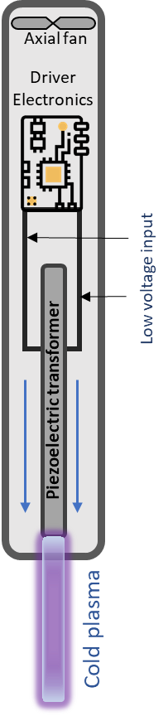

Figure 2
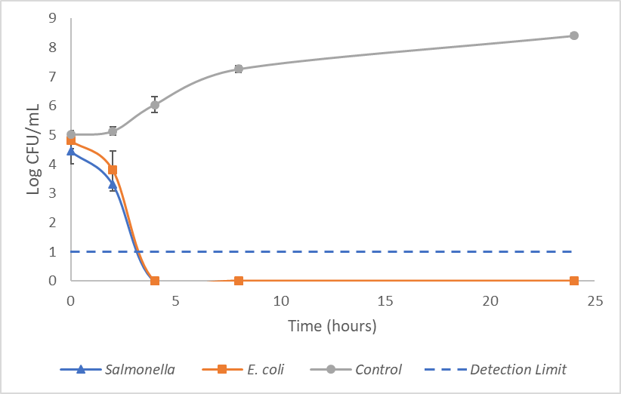

Figure 3
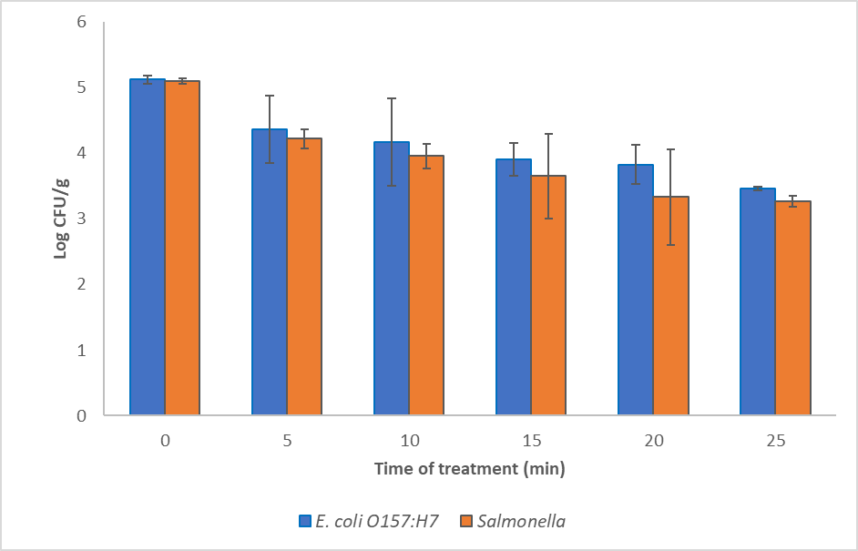
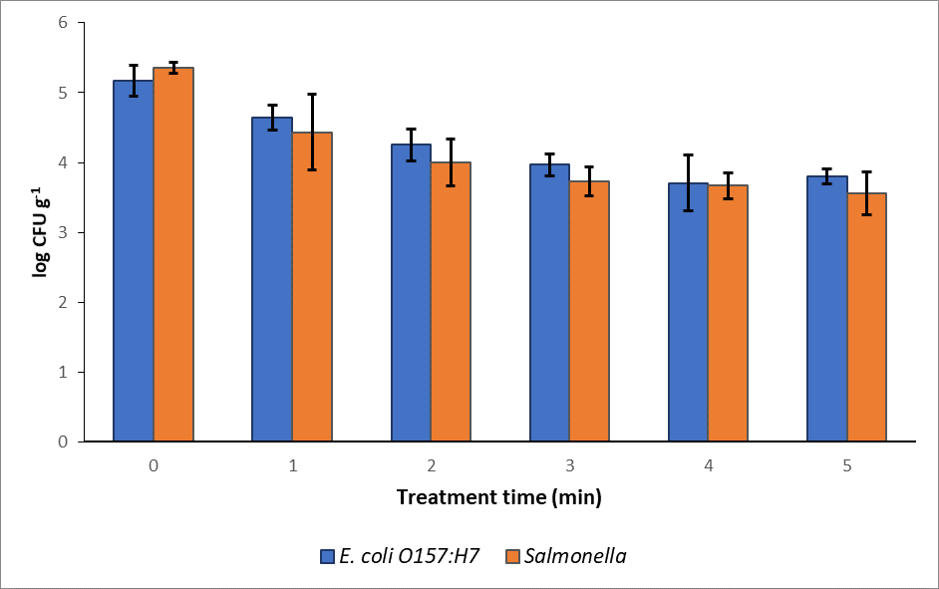
Figure 4
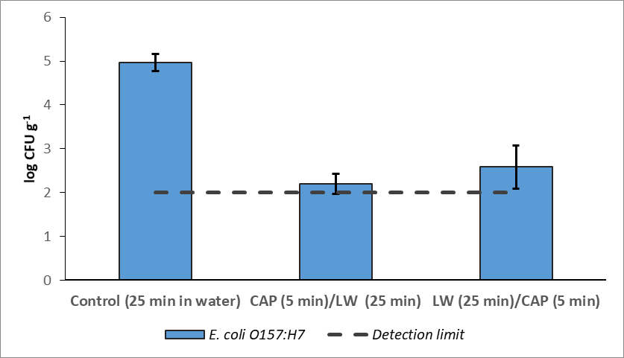
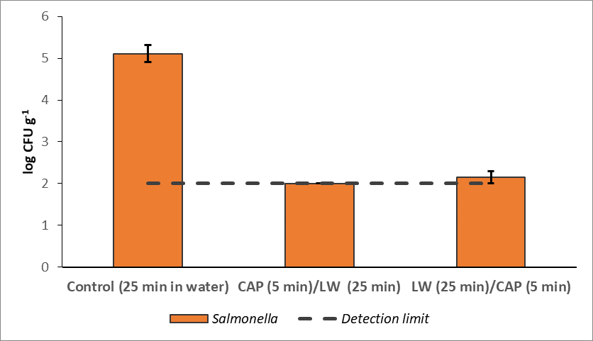

Figure 5
