Cite as: Jirapornvaree, I., Suppadit, T. and Kumar, V. (2021) Assessing the Economic and Environmental Impact of Jasmine Rice Production: Life Cycle Assessment and Life Cycle Costs Analysis, Journal of Cleaner Production (In Print)

Assessing the Economic and Environmental Impact of Jasmine Rice Production: Life Cycle Assessment and Life Cycle Costs Analysis

Abstract

Climate change is a threat to food security that has compelled government around the globe to adopt concrete measures to explore sustainable farming practices. This study, therefore, is focused on assessing the environmental and economic impacts of activities linked to jasmine rice production. The study compares organic and conventional jasmine rice production to promote sustainable farming alternatives. Purposive and snowball sampling was chosen to identify the sample and forty-nine face-to-face interviews were conducted with local farmers engaged in the rice production in Thung Kula Rong Hai, a north-eastern region in Thailand. We applied the Life Cycle Assessment (LCA) method to measure the environmental impact. In addition, Life Cycle Costs (LCC) was used to study jasmine rice production costs. The study found that even though the Green-House-Gas (GHG) emissions of organically cultivated areas was higher than the conventional cultivated areas, this was due to the higher absorption of organic matter in the soil. This is beneficial in the long run as our findings show that organic jasmine rice paddy resulted in higher yields. Therefore, economically organic rice production emerged as a better alternative than the conventional method when compared between yield, costs and profits of jasmine rice production. Our results also demonstrate how post-harvest management is an important hotspot in sustainable farming practices. Thus, our findings promote sustainable agriculture practices in Thailand that can help them to cope up with climate change issues (e.g. droughts) and ultimately contributing to the food security goals.

Keywords: Environmental Management; Jasmine Rice Production; Life Cycle Assessment;
Organic Agricultural System; Life Cycle Costs

1. Introduction
Food security has been highlighted as one of the sustainable development goals (SDGs) by the United Nations that has also been acknowledged by researchers (Van Meijl et al., 2020). Developing countries are often affected by climate change, lack natural resources, face rising production costs and have a low ability to produce sufficient food (Isvilanonda & Bunyasiri, 2009). Most people in poor countries are unable to access food to meet their own needs. Although technology is sometimes applied to increase yields, poor farming practices and excessive use of chemical fertilizers makes food products unsafe for human consumption and also negatively affect the environment. The chemical contamination of agricultural products has a long-term effect on food chains, humans and the environment (Igbedioh, 1991; Nicolopoulou-Stamati et al., 2016). Hence, in recent years there has been a greater push to adopt sustainable agricultural practices that is one of the alternative approaches for balancing food production and food security.

The conventional agricultural approach is based on a chemical method where the additional supplement is used to increase the high yield. However, these practices harm the environment as reported in many studies (Kunanuntakij et al. 2017) particularly affecting the soil quality and human health. Whereas on the other hand organic farming practices are considered as a promising solution for reducing the negative environmental impact (He et al., 2018). A study by He et al. (2018) shows that the conventional rice production system had the highest comprehensive environmental impact almost 10 times that of the organic ones. This was supported by Yodkhum et al. (2017) who also reported that organic rice production was a more environment-friendly process compared to the conventional method. This study aims to investigate whether organic farming can result in a higher yield and lower cost. Furthermore, this study also aims to explore under which conditions organic farming can be more environmentally and economically profitable than conventional farming.

Asia is the world’s largest rice-growing region with totally around 90 percent of total world output. Currently, the major rice-exporting countries in this region are India, Thailand and Vietnam. In 2019, rice cultivation areas in Thailand was approximately 11.65 million hectares (Rice Department, 2019) and rice production was nearly 25.17 million tons (Office of Agricultural Economics, 2018). In 2018, the northeastern region of Thailand was the key area where most rice cultivation was happening, approximately 5.63 million hectares (65.60 percent) (Rice Department, 2017). Even though white rice exporting Thailand is the second-largest in the world, it has a 60 percent world market share for jasmine rice, which is a high-value and high-price product much higher than India and Vietnam.

Jasmine rice production in Thailand is mainly cultivated in the northeastern and central region. The northeastern region grows rice under rainfed condition whereas, the central region focuses on irrigation. Accordingly, rice production in the central region is a stronger indication of food security than in the northeastern region (Phungpracha et al., 2016). These regions grow different types of rice, “Jasmine Rice” is preferred in the northeastern region while “Hom Phatum Rice” is chosen in the central region. However, at the moment the jasmine rice production is at risk due to climate change (Ahmed, 2020; Bocchiola et al., 2019), unsuitable cultivation methods (Qi et al., 2018) and less accessibility to infrastructures and services (Limnirankul et al., 2015). At the same time, jasmine rice production focuses on quantity rather than quality and is produced at a high production cost. There is much information about agricultural chemical utilization, impact on human health, climate change and challenges to food security at large. This study, therefore, attempts to support an alternative way of jasmine rice production. This alternative approach responds to the changing global trend focused on healthy food and food security.

1.1 Environmental Impact of Rice Production in Thailand

Rice is an important food for Thai people and is a major agricultural export product, especially jasmine rice - grown in the area "Thung Kula Rong Hai (TKRH)" located in the northeastern region. Growing rice has been the way of life for Thai farmers. Around 85 percent of Thai rice output is grown under the rainfed condition from July-September and harvested towards the end of the year. Jasmine rice 105 yields are approximately 90.72 kilograms per hectare (Rice Department, 2019). Over the years, jasmine rice has become the most famous rice in the world. Therefore, chemicals and agricultural machinery were used extensively to increase the yield. However, Sanguansermsri (2007) found that the cost of fertilizers, irrigation, cost of insecticides and pesticides, low-price grain and increasing oil prices, are the most significant issues that needed to be solved (Joshi et al., 2011). Meanwhile, factors that influence the change in jasmine rice yield are soil organic carbon (SOC) sequestration (Arunrat et al., 2018) and changes in the rainfall (Boonwichai et al., 2018). These results led to competition for production resources causing unsteady production along with increasing production costs, rice price uncertainty, and liabilities. Thai rice price downfall reflected on the future of rice-producing structure in Thailand. Alternative cultivation with high-quality rice product must replace the old traditional process, that will improve food security along with sustainable economic growth (Pintobtang, 2016). On the other hand, highlighting the barriers in jasmine rice production Chidchob (2011); Wangjai et al. (2017) found that the lack of knowledge about rice production (e.g. water management, weed management, fertilizer use, plant diseases and harvesting approach) in pre-harvesting phase and rice processing and storage (e.g. inadequate storage, Lack of quality ) issues in post-harvesting phase are major barriers. Meanwhile, information flow which is non-absolute is rice quality information such as non-compliance of organic agriculture certification and paddy contaminated from harvesting (Chidchob et al., 2014), and non-connecting data for customizing retail plans affecting forecast demand (Trongwattanawuth et al., 2018). At the same time, the risk of chemical contamination into cultivating area and lack of agricultural machine was found in the pre-harvesting phase. While in the distribution phase, lack of technology to add value to the organic rice production in the non-supporting market (Trongwattanawuth et al., 2018; Wangjai et al., 2017) and contamination occurring during transportation (Trongwattanawuth et al., 2018) was evident. Climate change is already causing a severe impact on rice production such as shortage of rainfall, droughts and natural resources (Thailand Development Research Institute, 2010; Trongwattanawuth et al., 2018). Moreover, the total direct greenhouse gas (GHG) emissions for Thailand was 242 – 459 million tons CO2eq per year. Manufacturing was the most direct contributor to GHG emissions at 28 percent. Meanwhile, according to Kunanuntakij et al. (2017), direct GHG emissions from agriculture accounted for 15 percent which was separated from rice cultivation (70 percent), enteric fermentation (25 percent), manure management (5 percent) and fuel combustion (0 percent).

It is evident that Thailand is the major rice producer, however, very few studies have paid attention to the impact assessment of rice production especially, in the northeastern region, Thailand. Most studies on the impact assessment in these fields, as noted by He et al. (2018), Mungkung et al. (2019) and Yodkhum et al. (2017) are only focused on the rice production phase and do not consider the entire rice supply chain. In addition, Peng et al. (2009) and Wang et al. (2018) highlight that global climate change and high-quality rice were the major challenges of rice production. Hence to overcome these gaps, this study will focus on identifying hotspots in the jasmine rice supply chain that adds to high emissions and costs, thus providing a more holistic approach to impact assessment. The paper will also attempt to explore ways of decreasing the emission and costs of jasmine rice production.

The literature is abundant with studies on rice production and assessing its environmental impact (Xu et al., 2019; Maraseni et al. 2018) however, very few studies (Habibi et al., 2019; Nabavi-Pelesaraei et al. 2019) have attempted to explore both the environmental and economic assessment. Moreover, studies assessing the economic and environmental impact of organic rice or providing a comparative assessment with chemical rice is scarce (He et al. 2018; Yodkhum et al. 2017). Research clearly indicates that environmental and economic assessment is necessary for achieving sustainable agricultural goals (Habibi et al., 2019). In order to assess the environmental impact of rice production and associated costs involved, this study, therefore, uses Life Cycle Assessment (LCA) and Life Cycle Costs (LCC) methods, consistent with He et al. (2018); Mungkung et al. (2019); and Wang et al. (2010) who have used this for the evaluation of the environmental impact. These two methods also help to increase understanding of the relationship between human activities and environmental impact which is useful for sustainable development.

Therefore, this study focuses on assessing the environmental and economic impacts of activities linked to jasmine rice production (both organic and conventional rice production) in TKRH, Thailand. The results of this study will help farmers and firms in jasmine rice industries to increase their competitive advantage and promote environmentally friendly production method. Furthermore, this study also creates awareness and promotes participation in all sectors. In line with the sustainable development goals following the twelfth national economic and social development plan (2017-2021) of the Thai government, this study focuses on addressing economic, social and environmentally friendly agricultural growth, by promoting green agriculture to drive the potential economy and increasing food safety and security in the future.

2. Methodology: Case Study Analysis
2.1 Life Cycle Assessment (LCA) study
Life Cycle Assessment (LCA) is necessary for decreased risk and supported the growth of rice production. It concentrates on the elimination or reduction of products that are not needed (Schaltegger, 2014). LCA is an environmental management tool that informs decision-makers other decision criteria, such as cost and performance, that should be considered in order to make a well-balanced decision (Curran, 2008). In this study, the environmental impacts between conventional and organic jasmine rice productions in TKRH, Thailand were assessed. LCA of jasmine rice production was chosen following the four steps, including goal definition and scoping, inventory analysis, impact assessment and interpretation (Scientific Applications International Corporation (SAIC), 2006). The direct GHG emissions for each of the two rice production methods are calculated using the equation suggested by Greenhouse Gas Management Organization (Greenhouse Gas Management Organization, 2015). The analysis was performed using openLCA software an open-access program.

Equation (1) below is used to calculate the indirect GHG emissions from all of the activities which causes the GHG emission. Inputs activity that was used to calculate GHG emission consists of the raw material, electricity production and fuel production which are shown in Figure 1. The emission factor is also shown in Table 1:

GHG Emission = $\sum_{i=1}{A\left(i\right)xEF(i)}$ (1)

Where: A(i) Amount of Inputs of all activities which includes raw material (unit: kg), electricity (unit: kWh) and fuel oil (unit: l) were used in jasmine rice production
EF(i) Emission Factor (kgCO₂eq/unit)

Equation (2) below is used to calculate the GHG emissions from the transport of chemical and organic jasmine rice to processors and consumers

GHG_{T} ₌ $\sum{(W(i)xD(i)xEF(T))}$ (2)

Where: GHG_{T} Amount of GHG emissions from raw material transport (kgCO₂eq/kg)
W_{i} Weight of raw material (ton)
D_{i} Transportation distance (km)
EF_{T} Emission Factor of transportation by 7-ton truck and 8.5-ton truck

Equation (3) below is used to calculate the life cycle GHG emissions:

E_{totalGHG} = E_{input} + E_{electricity} + E_{fuel production} + E_{fuel combustion} +
E_{fertilizer application} + E_{CH4 direct field emission} + GHG_{T} (3)

Where: E_{totalGHG} Total GHG Emission of organic and chemical jasmine rice life cycle (kgCO₂eq/kg)
E_{input} GHG emission from raw material production (kgCO₂eq/kg)
E_{electricity} GHG emission from electricity production (kgCO₂eq/kWh)
E_{fuel production} GHG emission from fuel production (kgCO₂eq/l)
E_{fuel combustion} GHG emission from fuel combustion (kgCO₂eq/kg)
E_{fertilizer application} N₂O emission from fertilizer application (kgCO₂eq/kg)
E_{CH4 direct field emission} CH₄ emission from rice cultivation (kgCO₂eq/kg)
GHG_{T} Amount of GHG emissions from raw material transport (kgCO₂eq/kg)
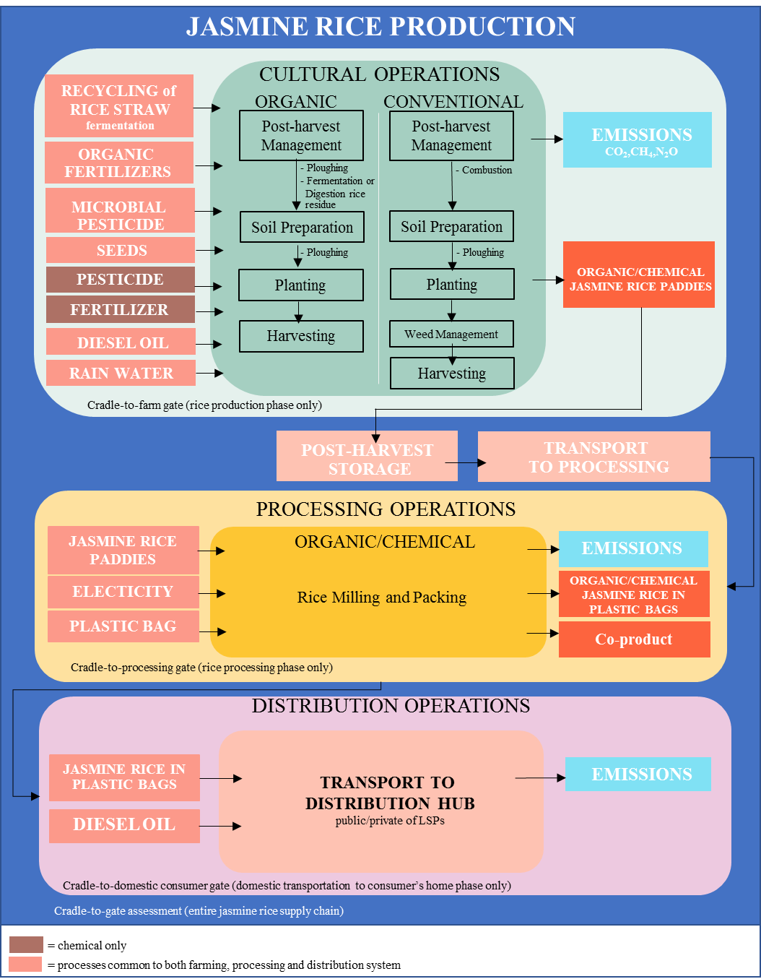
Figure 1. Conventional and Organic jasmine rice production flows (source: Authors own work)

2.1.1 Goal and Scope definition: The goal of this analysis is to determine the environmental impacts of the supply chains between conventional and organic jasmine rice production in TKRH, Thailand. The system boundary covers from Cradle-to-Gate in all phases (see Figure 1) as shown in data interpretation. Although, both supply chains are similar, but also the different operations pattern is during the distribution hub to end consumer that the transportation stage into the final destination in the domestic market. Most of the organic jasmine rice product was transported to consumers or networks by offline (face-to-face) and online (through public/private logistics) meanwhile. The conventional jasmine rice products were also sent to consumers or networks in the same way.
2.1.2 Life Cycle Inventory (LCI): Emission factors of input data consisting of all the input materials, energy consumption and all the related and output data (e.g. product, co-product and air pollution) was collected from the life cycle inventory database by Ecoinvent 2.0, Thailand Greenhouse Gas Management Organization (Public Organization) and Thai National Life Cycle Inventory (see Table 1). Before the data collection, the inventories were prepared based on the process flow diagram as shown in Figure 1. LCI data were collected from the best rice production practices of both rice patterns from forty-nine farmers through a face-to-face interview. One of the five processors was chosen and selected using Good manufacturing practices (GMP) or Hazard Analysis Critical Control Point (HACCP) and following rice mill grading as gold level from the Department of Internal Trade. All data of the inventories, including all the inputs during the whole production process, was analysed in relation to the functional unit (kg CO₂ equivalent of GHGs) by setting assumptions and calculation of CO₂ equivalent from chemical and organic jasmine rice production.

2.1.3 Life Cycle Impact Assessment (LCIA): The life cycle GHG emissions were calculated by adopting Product Category Rules of rice product based on TKRH, Thailand. The direct methane emissions from the rice cultivated are based on country-specific emission factors (Tier-2 methodology) and Nitrous oxide emissions from fertilizer application are based on Tier-1 methodology; for the GHG emissions, the Global Warming Potential (GWP)100 (100-year time horizon), of CO₂, CH₄ and N₂O are applied (IPCC, 2006). Those were converted into CO₂ equivalent, which has GWP of 1, 25 and 298, respectively.

2.1.4 Data interpretation: Finally, the results of LCI and LCIA were analysed. It was done based on the goal and scope. Overall the impact of jasmine rice production was compared between the organic and conventional process. Graphs and tables were used to interpret the results obtained in a systematic way. The impact on the environment by rice productions was identified. Finally, the recommendations are provided based on the negative impacts on the environment. The resource consumption for energy, diesel and others related in relation to the functional unit 1 kg of (organic or conventional) rice produced.

Table 1. Emission factors of parameter and input
Parameter/Inputs | Units | Data source | Emission factor
 |  |  | Chemical | Organic
Average yield | kg | Interviewing | 412.76 | 417.75
Crop period |  | Interviewing | 1st (May-November)
Rainwater |  |  | Rainfed
Land | ha | Interviewing | 0.8 – 1.6  1.6 – 7.2  > 7.2
Jasmine rice seed | kg | TGO | 0.2500
Green manure seed |  | TGO | 0.6999
Organic fertilizer production | kg | TGO | - | 0.1638
Cattle manure | kg | TGO | - | 0.1097
Bio fermentation production | l | TGO | - | 0.1638
Chemical fertilizer 21%N | kg | TGO | 3.3036
Chemical fertilizer 46%P₂O₅ | kg | TGO | 1.5716
Chemical fertilizer 60%K₂O | kg | TGO | 0.4974
Herbicides (Glyphosate) | l | TGO | 16.0000
Diesel oil production | l | TGO | 0.3522
Diesel oil combustion | l | TGO | 2.7446
Electrical power production | kWh | TGO | 0.5986
Plastic bag production (PE) | kg | Ecoinvent 2.0 | 1.5200
Broken rice | kg | TGO | 0.4700
Rice bran | kg | TGO | 0.2200
Rice hull | kg | TGO | 0.3700
transportation by 7-ton truck 100% loading | kg km | TGO | 0.1411
transportation by 8.5-ton truck 100% loading | kg km | TGO | 0.0677
Remark: TGO = Thailand Greenhouse Gas Management Organization (Public organization), 2020

Table 2 described that the co-products at the milling stage were consisting of broken rice, rice bran and rice hull. Economic values are used to allocate both. Consequently, percent allocations of both were not different which was approximately 70%, 20% 5% and 5% respectively.
Table 2. Percent allocation of average yield and price based on economic values
Product | Chemical |  |  | Organic
 | Mass  (kg/ha) | Price  (baht/kg) | %allocation | Mass  (kg/ha) | Price  (baht/kg) | %allocation
White milled rice | 1,805.25 | 35.00 | 69.98 | 2,275.00 | 50.00 | 70.00
Brocken rice | 515.95 | 15.00 | 20.00 | 650.00 | 15.00 | 20.00
Rice bran | 128.99 | 1.50 | 5.00 | 162.50 | 1.50 | 5.00
Rice hull | 128.99 | 1.50 | 5.00 | 162.50 | 1.50 | 5.00

2.2 Life Cycle Costs Assessment (LCCA) Study
Life Cycle Cost (LCC) was used to study jasmine rice production costs. LCCA is to estimate the overall costs of rice production, which consists of farming to milling and to select the production method that ensures the facility will provide the lowest overall cost of producer consistent with its quality and quantity. Purposive and snowball sampling were the chosen methods expected to provide complete and reliable information on key performance factors. Face-to-face interviews and open-ended questionnaire were chosen to collect data. Then, key performance factors were separated into two groups by their different production process as follows: Production, using topography (Thung Kula Rong Hai), jasmine rice 105, crop seasons (April - November) based on rainfed (Varinruk, 2017) and soil series factors were used as a criterion to select thirty-one chemical farmers in these studies. Due to crop activities and production cost management were separated by 0.8-1.6, 1.6-7.2 and more than 7.2 hectare which were separated from the survey of Information Technology and Communication (2017) who found that the most scale was rice cultivation of producer in Thailand. Then, eighteen organic farmers were selected using Codex Guidelines on the production, processing, labelling and marketing of organically produced foods or Good Agricultural Practice or GAP, organic Thailand or IFOAM as standard for further comparison.

The data collection was tabulated, edited and analysed using statistical techniques like averages and percentage to compare both rice production.

Equation (4) below is used to calculate the total cost of all variable input in rice production. These include five variable input costs consisting of costs for seeding, fertilizer, pesticide and herbicide, transportation and others such as maintenance machine land rental, etc.

C_{totalC} = C_{seeding} + C_{fertilizer} + C_{pesticide/herbicide} + C_{management cropping} +
C_{logistic} + C_{others} (4)

Where: C_{totalC} Total cost $of all variable inputs$ (Baht)
C_{seeding} Total cost from seeding (Baht)
C_{fertilizer} Total cost from fertilizer (Baht)
C_{pesticide/herbicide} Total cost from pesticide and herbicide (Baht)
C_{management cropping} Total cost from ploughing, labour, water pumping and harvesting (Baht)
C_{logistic} Total cost from farm gate to processing gate(Baht)
C_{others} Toal cost from maintenance machine, land rental and etc. (Baht)

Equation (5) below was used to calculate the gross margin of rice production

Gross Margin = Gross Return – Total Cost (5)

2.3 Study area
Thung Kula Rong Hai (TKRH) is one of the largest natural regions in northeastern Thailand. The area consists of five provinces and thirteen districts, Roi - Et (Kaset Wisai, Suwannaphum, Nong Hi, and Phon Sai), Maha Sarakham (Phayakkhaphum Phisai and Pathum Rat), Surin (Chumphon Buri and Tha Tum), Si Saket (Rasi Salai and Yang Chum Noi), and Yasothon (Maha Chana Chai and Kho Wang) provinces. There are approximately 320,000 hectares (320 square kilometres). Annual rainfall in TKRH is approximately 1,100 –1,400 millimetres, especially in the rainy season (March-October) the proportion of rain is 87 - 92 percent per year. Soil groups were 20, 18, 22, 24 and 7 respectively, with low soil fertility, sandy and salty soil, that cannot hold water. The land is primarily used for rice production, especially jasmine rice 105 as shown in Figure 2. This area is also protected by the Geographical Indication by Council Regulation (EC) No. 510/2006 since 2006 (Rice Department, 2006).
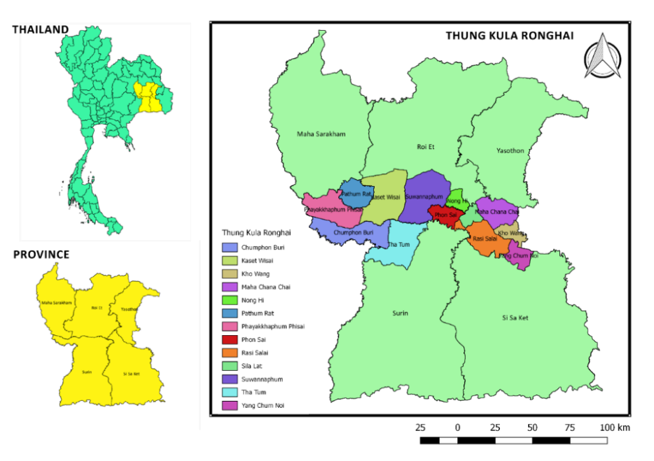
Figure 2. Area of Study TKRH, Thailand

The data from the region suggests that the rice production approach in TKRH consists of two patterns that are chemical and organic rice production. Rice cultivation in this area is based on rainfed, hence jasmine rice could only be produced one time per year as opposed to the central region where the production cycle of rice is two to four times per year. Rice production flow is simple cultivation including post-harvest management, soil preparation, planting and harvesting. Pesticide and herbicide are relatively used in small quantities in these regions as producers aim to make fallow soil after the harvesting for four to five months in order to maintain soil and eliminate the weed.

This study aims to compare the GHG emissions and cost of jasmine rice production for conventional rice vs organic rice. Therefore, two case studies were analysed as follows:

Case A: Conventional rice production is a traditional approach to produce jasmine rice in this area. Combustion or ploughing was chosen to eliminate jasmine rice straw after harvesting. To prepare the soil generally tractors are used to plough soil for helping the soil ventilate, weeding and finally growing rice. The producer also uses chemical fertilizers that include nitrogen formula during the rainy season around May to June every year. Chemical fertilizers, pesticides and herbicides are also used at the planting stage to protect the crop. It normally takes around four months to harvest jasmine rice. Harvested jasmine rice is then sent to rice storages and rice milling.

Case B: Organic rice production is an optional approach to produce jasmine rice in this area. This approach is similar to conventional rice production but different in the detail. Ploughing and rice residue fermentation is chosen for maintaining and increasing the organic matter in the soil. Organic fertilizer, manure or plant fertilizer are used to prepare the soil. Bio fermentation of hormone is selected to help for increasing yield. Figure 3 below depicts the two different approaches of rice production in TKRH.

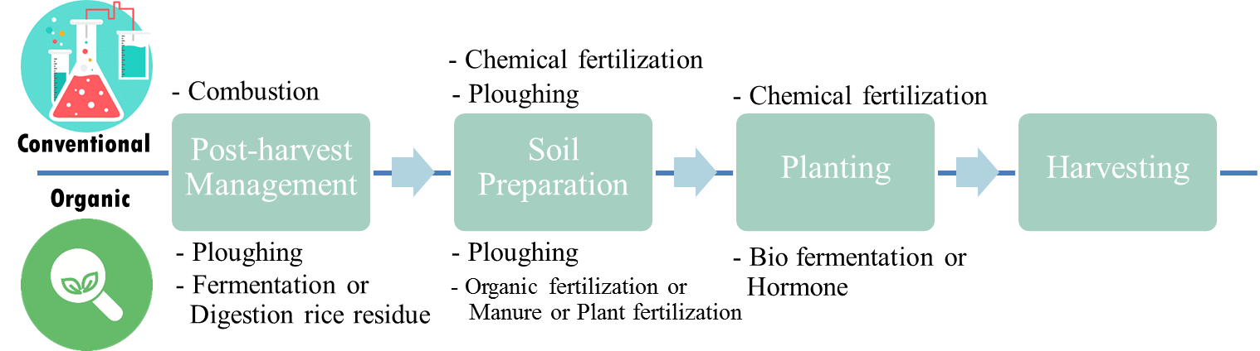
Figure 3. Conventional and Organic rice production in TKRH

3. Results and Discussion
3.1 Life Cycle Assessment
The inventory data analysis results illustrate that the organic rice supply chain required, 92.23 l of diesel, 62.50 l of bio-fermentation, 312.50 kg of organic fertilizer, 31.25 kg of green manure seeding and 75 kg of jasmine rice seeding for 3,250.00 organic rice paddies. Meanwhile, conventional rice production required, 90.60 l of diesel, 130.19 (21%N), 14.15 (46%P₂O₅) and 39.06 kg (60%K₂O) of chemical fertilizer respectively, 5.00 l of herbicides, and 75 kg of jasmine rice seeding for 2,579.75 conventional rice paddies. The energy consumption required for milling white rice was 0.22 kWh/kg white milled rice for both as seen in Table 3

This study found that jasmine rice production between organic and conventional system was different in the cultivated operation phase as illustrated by analysing the life cycle GHG emissions in the jasmine rice supply chain as shown in Fig 5. Total GHG emissions of the conventional rice supply chain were 37.42 kgCO₂eq/kg Meanwhile, the life cycle GHG emissions of the organic rice supply chain was 38.36 kgCO₂eq/kg Most GHG emissions in both supply chains were during the distribution phase, which was affected by transportation and consistent with the findings of Binh and Tuan (2016) who reported that GHG emissions of rice supply chain quickly increased by freight transport in Vietnam. However, this study did not calculate the direct emissions of methane because of the limited data availability and estimated from the work of Mungkung et al. (2019) where they note that the direct emissions of methane were 389 kgCH₄ per crop of paddy rice.

Most of the GHG emissions of jasmine rice production was different from the production phase (Mungkung et al., 2011). Conventional rice production releases less GHG emissions compared to their organic rice production and was equal to 3.0710 kgCO₂eq/kg whereas organic rice production was equal to 4.0154 kgCO₂eq/kg as seen in Figure 4. One of the reasons that increase the GHG emissions was the direct emissions of methane, which is caused by the organic matter in the soil of organically cultivated areas that are higher than the conditional cultivated areas. These findings are consistent with Pengthamkeerati (2011) who reported that methane (CH₄) of organically cultivated areas are higher than conventional cultivated areas and are caused by organic matter in soil and organic fertilizer used, which is anaerobic microbial food. Even though the direct CH₄ emission of organic rice production was higher, the carbon collecting process of organically cultivated areas is more cumulative than conventional. Therefore, organic matter which is collected in the soil would help to increase the yield in the same area as shown in Table 3.

Table 3. Input inventory of conventional and organic jasmine rice production (1 ha.)
Activities | Inputs-Outputs | Amount |  |  | Unit | References
 |  | Conventional |  | Organic
Post-harvest Management | Bio fermentation | - |  | 62.50 | l ha⁻¹
 | Diesel oil - tillage | - |  | 5.63 | l ha⁻¹
Soil Preparation | Chemical fertilizer 21%N | 130.19 |  | - | kg ha⁻¹
 | Chemical fertilizer 46%P₂O₅ | 14.15 |  | - | kg ha⁻¹
 | Chemical fertilizer 60%K₂O | 39.06 |  | - | kg ha⁻¹
 | Organic fertilizer | - |  | 312.50 | kg ha⁻¹
 | Green manure seeding | - |  | 31.25 | kg ha⁻¹
 | Diesel oil - ploughing | 5.63 |  | 5.63 | l ha⁻¹
 | Diesel oil - rotary | 5.63 |  | 5.63 | l ha⁻¹
Cultivating | Jasmine Rice seeding | 75.00 |  | 75.00 | kg ha⁻¹
 | Herbicides use | 5.00 |  | - | l ha⁻¹
 | Diesel oil - fertilizer | 2.34 |  | 2.34 | l ha⁻¹
 | Diesel oil - herbicides | 1.50 |  | - | l ha⁻¹
 | Diesel oil-water pumping | 62.50 |  | 60.50 | l ha⁻¹
Harvesting | Diesel oil - harvesting | 13.00 |  | 12.50 | l ha⁻¹
Transportation | Diesel oil – milling^{A} | 51,595.00 |  | 65,000.00 | kg km
Rice Milling | Electricity | 0.20 |  | 0.20 | kWh kg
Packing | Electricity | 0.02 |  | 0.02 | kWh kg
 | Plastic bag | 0.0096 |  | 0.0096 | kg kg
Transportation | Diesel oil – distributors/consumers^{B} | 863,003.77 |  | 1,087,222.50 | kg km
Paddy Rice | Paddy Rice | 2,579.75 |  | 3,250.00 | kg ha⁻¹
Rice | White milled rice | 1,805.25 |  | 2,275.00 | kg ha⁻¹
 | Broken rice | 515.95 |  | 650.00 | kg ha⁻¹
 | Rice bran | 128.99 |  | 162.50 | kg ha⁻¹
 | Rice hull | 128.99 |  | 162.50 | kg ha⁻¹
Air emission (fossil fuel combustion) | Carbon dioxide (CO₂) | 0.0033 |  |  | kg ha⁻¹ | (Mungkung et al., 2019)
 | Methane (CH₄) | 3.3E-06 |  |  | kg ha⁻¹ | (Mungkung et al., 2019)
 | Nitrous oxide (N₂O) | 8.0E-06 |  |  | kg ha⁻¹ | (Mungkung et al., 2019)
Air emission (residue combustion) | Carbon dioxide (CO₂) | 5.34 | - |  | kg ha⁻¹ | (Junpen et al., 2018)
 | Carbon oxide (CO) | 422.00 |  |  | kg ha⁻¹
 | Methane (CH₄) | 44.00 |  |  | kg ha⁻¹
 | NO_{x} | 2.00 |  |  | kg ha⁻¹
Remark: A = Paddy Rice * 20 km which was fixed for calculating by 7-ton truck from farm gate to processing gate
B = White milled rice * 477.90 km which was fixed for calculating by 7-ton truck from processing gate (Surin) to distributor/consumer gate (Bangkok)

Fig 4. Life cycle GHG emissions of conventional and organic jasmine rice supply chain (kgCO₂eq/kg)

Fig. 5 displays the GHG emissions of organic and conventional rice production and consists of five steps. The result shows that most of the GHG emissions in rice production for both was Post-harvest management. It was 2.6238 kgCO₂eq/kg for rice from organic production on rice paddies from straw residue fermentation and 1.4835 kgCO₂eq/kg for conventional jasmine rice paddy from straw residue combustion; respectively. Although the direct GHG emission of organic rice production was higher, the straw fermentation would help to improve the soil structure for increasing competitiveness to absorb nutrients when fertilizer was loaded in cultivated areas and also absorb humidity in the soil. Transportation GHG emissions of both were equal to 1.3540 kgCO₂eq/kg The main emissions at this stage were made from fuel combustion. The GHG emission of conventional rice production was higher than the organic in soil preparation in the cultivation and harvesting steps. Yusoff and Panchakaran (2015) confirmed that the environmental impacts of rice production were from fossil fuel consumption (1715MJ per 1MT of paddy grain harvested), and global warming (298 kgCO₂eq/1MT paddy). It was learnt that the fertilizers usage was excessive and must be looked into. Alternately, the pesticides were used in very small quantities and so, no real adverse effects were detected.

Fig 5. Life cycle GHG emissions of conventional and organic jasmine rice production phase (kgCO₂eq/kg)

To sum up, low GHG emissions were found in conventional production. Although the GHG emissions from organic production were higher than the conventional, the negative environmental impact of combustion from the post-harvest stage was higher in conventional than organic production. For example, the combustion stage generates dust and particulate matter of 10 and 2.5 micrometres which is harmful to the environment and human health alike. Hence, conventional production should change the approach from combustion to ploughing, meanwhile organic production should focus on decreasing the GHG emissions from rice straw fermentation. Hence it is important to concentrate on a post-harvest management stage in organic production.
3.2 Life Cycle Costs
Yield, Costs and Profits of jasmine rice production can be described by different size of agricultural area management. The results show that organic jasmine rice production yields were much higher than the chemical (conventional) jasmine rice production. The highest yield of organic jasmine rice production was equal to 515.90 kg/ha. Meanwhile, chemical jasmine rice production yield was equal to 406.25 kg/ha. Adhikari (2013) reported that the average productivity of organic rice was higher than conventional rice. In terms of paddy rice prices, organic paddy rice was equal to 21.50 THB per kilogram whereas chemical paddy rice was equal to 16.00 THB per kilogram. Comparing the price, it is evident that organic paddy rice was of high value as seen in Table 4.

Table 4 Yield of jasmine rice production, price of the product
Size (ha.) | Yield (2019) Kilogram/hectare |  |  |  | Prices (2019) THB/Kilogram
 | $$\overline{x}$$ |  | min - max |  | $$\overline{x}$$ |  | min - max
 | Chemical | Organic | Chemical | Organic | Chemical | Organic | Chemical | Organic
0.8-1.6 | 406.25 | 494.50 | 312.00 - 500.00 | 469.00 - 520.00 | 13.00 | 21.50 | 13.00 | 14.00 – 29.00
1.6-7.2 | 368.63 | 515.90 | 117.78 – 690.00 | 380.00 – 750.00 | 16.00 | 20.00 | 10.00 – 22.00 | 11.00 – 29.00
> 7.2 | 324.52 | 319.93 | 224.14 – 428.57 | 262.50 – 377.36 | 13.00 | 21.25 | 12.00 – 14.00 | 13.50 – 29.00

In terms of rice production, both systems have had a low quantity but a high quality as this area is a special topography which is protected geographical indication by Council Regulation (EC) No. 510/2006, since 2006 (Rice Department, 2006). This confirmed the findings of the National Science Technology and Innovation Policy Office (2019) who also found that rice production yield in Thailand was low because the cultivated areas were not well irrigated. The world’s best rice 2017 award was given to jasmine rice 105. These results show that jasmine rice was one of the most prestigious in the world.

It is evident from Table 4 that for organic farming, the yield is higher than conventional farming. These can be attributed to the nature of the soil as these areas have sandy or sandy loam soils that are unable to absorb water and fertilizer. Furthermore, some areas have saline or acidic soils that lack fertility and organic matter. However, in organic farming practices, the post-harvest management stage increases the organic matter from rice straw fermentation or ploughing and also protects the soil structure from combustion thus improving the yield. Whereas, conventional rice production follows combustion which results in reduced organic matter in soil affecting the yield. Our results thus advocate organic rice production as a better alternative to conventional production where soil quality is poor.

Table 5 Costs of jasmine rice production unit: THB/hectare
Size (hectare) | Costs of production
 | $$\overline{x}$$ |  | min - max
 | Chemical | Organic | Chemical | Organic
0.8-1.6 | 2243.75 | 1600.00 | 1,387.50 - 2,500.00 | 1,320.00 - 1,600.00
1.6-7.2 | 2270.12 | 1919.59 | 1,160.00 – 2,733.33 | 1,030.00 – 3,930.00
> 7.2 | 2277.95 | 2592.55 | 1,548.57 – 2,160.20 | 730.00 – 3,956.60

Table 5 explains that organic rice production costs in different sizes of land were equal to 1,600; 1,919.59 and 2,592.55 THB respectively. Meanwhile, chemical rice production costs were equal to 2,243.75; 2270.12 and 2,277.95 THB respectively. This result shows that the costs of organic jasmine rice production in large sizes were higher than the chemical jasmine rice production. As the cultivated areas were affected by poor rainfall, with low precipitation in 2019, thus, the use of chemical fertilizer was reduced by 50%. This is consistent with the findings of Thai Central Chemical Public Company Limited (2019) who reported that insufficiency of rain during the annual rice cultivating period in the northeast region of Thailand has decreased the demand for chemical fertilizers. When the costs were compared, it was found that organic rice production costs were lower than chemical in all different sizes. These findings are consistent with Suwanmaneepong et al. (2020) who also confirmed that the costs of chemical farming were higher than organic farming.

Moreover, this study found that management costs, which includes ploughing, labour, pumping water and harvesting were the key transaction costs of rice production in all different sizes. Chemical rice production was 56% - 59% of management costs but organic production was 69% - 82% of management costs which illustrates that these costs increase due to the soil preparation for maintaining organic matter, nutrients and soil structure to increase rice yields and reducing the need for the fertilizers, pesticides and herbicides usage. This is consistent with the study of Van der Wiel et al. (2019) who reported that residue of jasmine rice production needs to be increasingly recycled for returning the nutrients into the soil. As a result of these, the fertilizer costs for both were 24% - 27% for chemical and 10% - 17% for organic. At the same time, fertilizers usage in both rice productions were approximately 0.71 unit/hectare (chemical) and 0.75 unit/hectare (organic). Chouichom and Yamao (2010) confirmed that organic production costs were decreased by using their own organic fertilizers. This further confirms the findings of Cabasan et al. (2019) who found that rice production cost consists of fertilizers (27 percent), pesticides (24 percent) and others (49 percent). This is also consistent with Mendoza (2004) who reported that the higher cost in the conventional farms consists of 65% of fertilizer and 18.2% of pesticides. Meanwhile, Chidchob et al. (2014) found that the organic rice production supply chain is shorter than general rice production. Total logistics costs for the producer is 2.31 THB per kilogram which is accounted for 43.42 percent of production costs. Rice mill is approximately 3.55 THB per kilogram (16.06 percent of production cost).

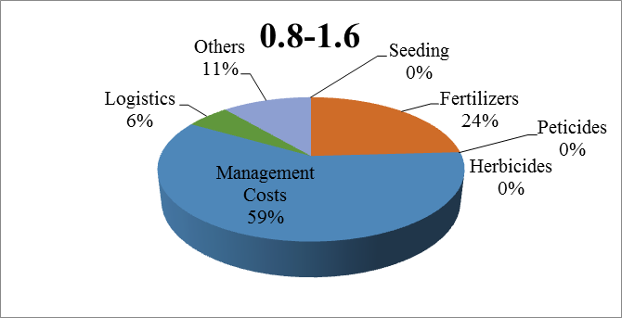 | 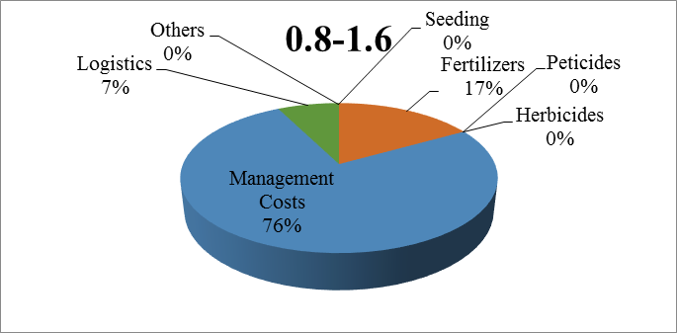
Figure 6(a) Small rice production costs; Chemical (left) and Organic (right)
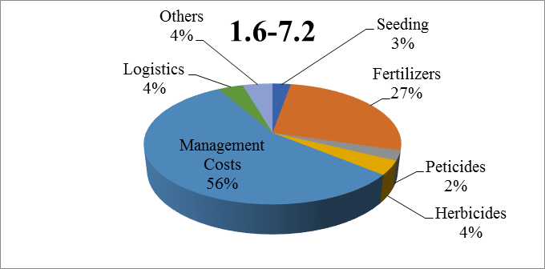 | 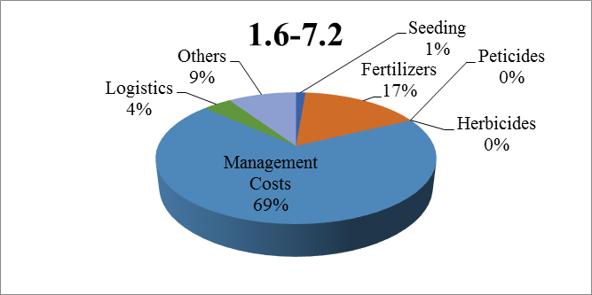
Figure 6(b) Medium rice production costs; Chemical (left) and Organic (right)
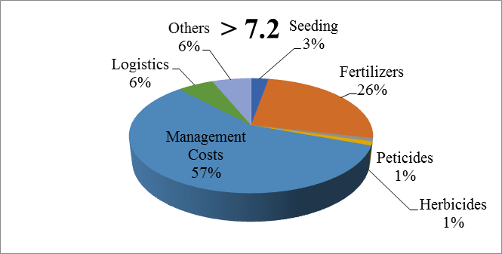 | 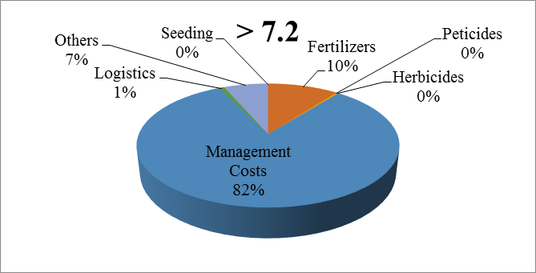
Figure 6(c) Large rice production costs; Chemical (left) and Organic (right)

Besides this rice production affects the logistic costs based on the area and demand of the market. Logistic cost in organic rice production was around 1% - 7%, while for chemical production was 4% - 6%, as most of the organic rice production in this area is a result of the demand from consumers. Hence, transportation of organic paddy rice will have a destination (specific market) which was certain. In addition, organic producers were grouped together for collecting the product for saving the logistics cost and increasing competitiveness to sell them. On the other hand, chemical paddy rice was uncertain about the market. The producer will have to find the market, which gives the best prices and paddy rice is sold after harvesting.
To sum up, chemical rice production costs were higher than the organic rice production costs as seen in Figure 6(a) to 6(c). Similarly, Mendoza (2002); Rubinos et al. (2007); Shukla et al. (2016); Tashi and Wangchuk (2015) reported that chemical rice production costs were significantly higher than organic rice, as the variable input costs were significantly higher in the chemical rice production.
In term of profits, organic paddy rice in different sizes was equal to 9,361.25; 6,015.77 and 4,900.27 THB/hectare respectively. On the other hand, chemical paddy rice was equal to 3,337.50; 2,825.89 and 2,990.28 THB/hectare respectively. This shows that the value derived from demand by healthy consumers, high quality, certification and demand of specific markets was increased. These findings are consistent with those of Mendoza (2004); Chouichom and Yamao (2010); and Mehmood et al. (2011) who confirmed that organic paddy rice prices were 2– 7 THB/kilogram, which will slightly higher than the ordinary price. Their organic paddy rice was directly sent to the department store, where they fetch higher prices, consistent with Adhikari (2013) who reported that organic farming in Nepal was profitable, where the benefit-cost ratio was 1.5. Thus, organic jasmine rice production was higher than chemical jasmine rice production. Moreover, this study found that the profits of both rice productions were decreased when cultivated areas were increased. Because 1.6 – 7.2 ha. and more than 7.2 ha. of cultivated areas will have costs of production which are higher than 0.8 – 1.6 ha as seen in Table 6.

Table 6 Profits of jasmine rice production unit: THB/hectare
Size (hectare) | Profits of production
 | $$\overline{x}$$ |  | min - max
 | Chemical | Organic | Chemical | Organic
0.8-1.6 | 3,337.50 | 9,361.25 | 2,675.00 - 4,000.00 | 5,242.50 - 13,480.00
1.6-7.2 | 2,825.89 | 6,015.77 | 700.00 – 7,102.00 | 3,900.00 – 12,470.00
> 7.2 | 2,990.28 | 4,900.27 | 1,029.31 – 4,000.00 | 2,813.75 – 6,986.79
Hobbs et al. (2008) further confirmed that conservation agriculture focuses on producing goods by minimizing the environmental impact in order to meet the growing needs of the population and was a more stable and sustainable method than chemical rice production. This is also consistent with Sarkar et al. (2020) who reported that food production security was practices based on the elimination of external input (e.g. fertilizers, herbicides, pesticides etc.) that can help to reduce the environmental impact, meanwhile improving human health and well-being. It is evident that soil degradation accelerates by unsustainable agricultural practices involving excessive heavy mechanization (Tarolli & Straffelini, 2020). Moreover, organic production was certificated and has great potential for the international market (Barrett et al., 2002; Chidchob, 2011) It could help producers by offering highly efficient production. Moreover, it has the potential to increase the competitive advantage and decrease the barriers to global trade (Garcia Martinez & Bañados, 2004; Guo et al., 2019). Similarly, Azhar et al. (2019) suggested that Eco-certification is an important tool to improve environmental and social issues caused by commercial food production.

4. Conclusions
This study presents a comparative assessment of conventional and organic rice production. Both production methods of jasmine rice production are assessed for their environmental and economic impacts in TKRH, Thailand. The findings of this study show how farmers and firms in the jasmine rice industries can increase their competitive advantage by adopting organic rice production method. Furthermore, this study also creates awareness of the benefits and challenges of different rice production methods. In line with the sustainable development goals following the twelfth national economic and social development plan (2017-2021) of the Thai government, this study suggests the adoption of the organic rice production method for sustainable agricultural growth driving the potential economy and increasing food safety and security in the future. The key findings that support the Global Strategic Framework for Food Security and Nutrition by the Committee on World Food Security (CFS) are as following:
a) Governance – The alternative agricultural approach will help to decrease inadequate state services (e.g. draught subsidies, agricultural equipment operator, etc.) in agricultural sectors. This would hence promote adaptation or self-resilience to cope up with the changing global trend and climate. Furthermore, the result of this study supports sustainable agriculture to drive the economy, promote food safety and food security.
b) Economic and production issues - This study represents a stronger emphasis on how the higher yield and low cost for organic farming can be achieved. Furthermore, the study could be applied to other areas and suggest under which conditions organic farming can be more economically profitable than conventional farming. Conventional rice production costs were higher than organic rice production costs. Moreover, organic rice production creates more profit than the conventional method by value-added which is derived from the demand from healthy consumers, high-quality expectations, certification and increasing demand from specific markets. Although organic rice trades at lower volumes, slowly organic rice consumption is increasing because of rising consumer awareness towards food safety and sustainability.
c) Demographic and social issues – Organic rice production can improve human health as it decreases the risk of exposure to chemicals and supplements in the food supply which often leads to health complications in the long run. Moreover, it also prevents the exposure of the dust and the particular matter of 10 and 2.5 micrometres to the environment that is generated during the combustion step in conventional rice production.
d) Climate/Environment - The GHG emissions hotspot should concentrate on the cultivated phase including post-harvest management. The Rice residue fermentation process, which is chosen in organic rice production, must decrease the day of residue fermentation to reduce the GHG emissions that contribute to direct emissions of methane. Whereas combustion, which is selected in conventional rice production should be eliminated at this stage for collecting the organic matter (for example, it could be changed to ploughing or rice residue fermentation) and maintaining the soil structure to help improve the jasmine rice yields.

Finally, organic rice production in this area (TKRH) can increase the rice yields as rice residue fermentation provides an ideal condition for organic rice production rather than conventional rice production. Organic rice production seems to be an alternative approach to support sustainable agriculture practices. Moreover, it is well evident that climate change affects rice cultivation every year and methane (CH₄) is emitted mainly from rice cultivation and this has become an important factor in global warming. While Carbon Dioxide (CO₂) is emitted mainly from agrochemical production. Although Nitrous Oxide (N₂O) is emitted in small quantities in rice production, the GWP contribution of N₂O is much higher than that of CO₂. Hence, organic jasmine rice production, which doesn’t need chemical fertilizer and herbicides appears to be a better alternative from an environmental perspective. However, as this study has not investigated other impact categories (such as fine particulate matter, human toxicity etc.), this needs further investigation before any strong conclusions can be drawn. Nonetheless, the key contribution of the study is a promotion of an alternative way to support food security in Thailand and globally.

4.1 Contributions
Most existing studies only focus on the rice production phase and do not consider the entire rice supply chain. This study thus adds to the limited literature that focuses on the impact assessment of the entire rice supply chain hence addressing an important research gap. In addition, this study also adds to the limited literature that provides a comparative assessment between conventional and organic rice production. Previous studies have mainly focused on the life cycle assessment of rice production, but this study assesses the environmental impact of rice production as well as the associated costs involved by using both LCA and LCC methods. This study promotes organic jasmine rice production as an alternative rice production method supporting sustainable production and advocating public policymaking to promote such practices. Our findings show that organic rice production can result in better yield compared to conventional production method in regions with poor soil properties. The adoption of organic rice production is likely to reduce environmental risk by preventing environmental contamination while simultaneously high yield would help to improve the farmer’s livelihood thus meeting the sustainability goals (economic, environmental and social).

4.2 Limitations and Future Research
As is the case with any research study, there are associated limitations. Since rice cultivation in the focused area is based on rainfed, so water consumption data used in rice processing was difficult to collect. So, the findings are based on data excluding water consumption. The study doesn’t focus on understanding the behavioural attitudes of the farmers engaged in rice production as that understanding would determine the challenges in the uptake of organic rice production by all farmers. Furthermore, the study relies on interviews with the farmers and data available from various government resources. Future studies therefore can adopt a mixed-method approach and provide triangulation of the findings through qualitative (interviews/secondary data analysis) and quantitative (survey questionnaire) data. Future studies should also focus on developing an approach that decreases CH₄ emissions in the production phase for sustainable agriculture practices. At the same time, future studies can focus on studying the social context more in detail and analyze the other impact categories (such as fine particulate matter, human toxicity etc.) to understand the full impact of rice production on the environment.

Acknowledgements
This work was supported by The Royal Golden Jubilee (RGJ) PhD programme, The Thailand Research Fund (TRF) [Grant number PhD0095, 2017].

References
Adhikari, R. (2013). Economics of organic rice production. Journal of Agriculture and Environment, 12, 97-103. doi: https://doi.org/10.3126/aej.v12i0.7569
Ahmed, S. M. (2020). Impacts of drought, food security policy and climate change on performance of irrigation schemes in Sub-saharan Africa: The case of Sudan. Agricultural Water Management, 232, 106064. doi: https://doi.org/10.1016/j.agwat.2020.106064
Arunrat, N., Pumijumnong, N., & Hatano, R. (2018). Predicting local-scale impact of climate change on rice yield and soil organic carbon sequestration: A case study in Roi Et Province, Northeast Thailand. Agricultural Systems, 164, 58-70. doi: https://doi.org/10.1016/j.agsy.2018.04.001
Azhar, B., Prideaux, M., & Razi, N. (2019). Sustainability certification of food. in P. Ferranti, E. M. Berry, & J. R. Anderson (Eds.), Encyclopedia of Food Security and Sustainability (pp. 538-544). Oxford: Elsevier.
Barrett, H. R., Browne, A. W., Harris, P. J. C., & Cadoret, K. (2002). Organic certification and the UK market: organic imports from developing countries. Food Policy, 27(4), 301-318. doi: https://doi.org/10.1016/S0306-9192(02)00036-2
Binh, N. T., & Tuan, V. A. (2016). Greenhouse gas emission from freight transport-accounting for the rice supply chain in Vietnam. Procedia CIRP, 40, 46-49. doi: https://doi.org/10.1016/j.procir.2016.01.051
Bocchiola, D., Brunetti, L., Soncini, A., Polinelli, F., & Gianinetto, M. (2019). Impact of climate change on agricultural productivity and food security in the Himalayas: A case study in Nepal. Agricultural Systems, 171, 113-125. doi: https://doi.org/10.1016/j.agsy.2019.01.008
Boonwichai, S., Shrestha, S., Babel, M. S., Weesakul, S., & Datta, A. (2018). Climate change impacts on irrigation water requirement, crop water productivity and rice yield in the Songkhram River Basin, Thailand. Journal of Cleaner Production, 198, 1157-1164. doi: https://doi.org/10.1016/j.jclepro.2018.07.146
Cabasan, M. T. N., Tabora, J. A. G., Cabatac, N. N., Jumao-as, C. M., Soberano, J. O., Turba, J. V., Barlaan, E. (2019). Economic and ecological perspectives of farmers on rice insect pest management. Global Journal of Environmental Science and Management-Gjesm, 5(1), 31-42. doi: https://doi:10.22034/gjesm.2019.01.03
Chidchob, T. (2011). The participation development form in the supply chain management for exporting organic jasmine rice of ban trasaeng organic cooperative in amphur muang Surin province. Phetchabun Rajabhat Journal, 13(2), 1-8.
Chidchob, T., Sompen, N., Yaowasakunmat, S., & Dungwak, P. (2014). Organic jasmine rice supply chain development in Thailand model. Khon Kaen Agriculture Journal, 42(243-249).
Chouichom, S., & Yamao, M. (2010). Comparing opinions and attitutes of organic and non-organic farmers towards organic rice farming system in North-Eastern Thailand. Journal of Organic Systems, 5(1), 25-35.
Curran, M. A. (2008). Life-Cycle Assessment. In S. E. Jørgensen & B. D. Fath (Eds.), Encyclopedia of Ecology (pp. 2168-2174). Oxford: Academic Press.
Garcia Martinez, M., & Bañados, F. (2004). Impact of EU organic product certification legislation on Chile organic exports. Food Policy, 29(1), 1-14. doi: https://doi.org/10.1016/j.foodpol.2004.01.001
Greenhouse Gas Management Organization. (2015). Organization Carbon Footprint Manual. BKK
Greenhouse Gas Management Organization. (2020). Organization Carbon Footprint Emission Factors. BKK
Guo, Z., Bai, L., & Gong, S. (2019). Government regulations and voluntary certifications in food safety in China: A review. Trends in Food Science & Technology. doi: https://doi.org/10.1016/j.tifs.2019.04.014
Habibi, E., Niknejad, Y., Fallah, H., Dastan, S., & Tari, D. B. (2019). Life cycle assessment of rice production systems in different paddy field size levels in north of Iran. Environmental Monitoring and Assessment, 191(4), 202. doi:10.1007/s10661-019-7344-0
He, X., Qiao, Y., Liang, L., Knudsen, M. T., & Martin, F. (2018). Environmental life cycle assessment of long-term organic rice production in subtropical China. Journal of Cleaner Production, 176, 880-888. doi: https://doi.org/10.1016/j.jclepro.2017.12.045
Hobbs, P. R., Sayre, K., & Gupta, R. (2008). The role of conservation agriculture in sustainable agriculture. Philosophical Transactions of The Royal Society B, 363, 543-555. doi:10.1098/rstb.2007.2169
Igbedioh, S. O. (1991). Effects of agricultural pesticides on humans, animals, and higher plants in developing countries. Archives of Environmental Health: An International Journal, 46(4), 218-224. doi:10.1080/00039896.1991.9937452
Information Technology and Communication. (2017). Farmer map. Retrieved from Bangkok, Thailand: http://www.ictc.doae.go.th/wp-content/uploads/2017/11/farmermap59.pdf
IPCC. (2006). 2006 IPCC Guidelines for national greenhouse gas inventories. Retrieved from https://www.ipcc-nggip.iges.or.jp/public/2006gl/vol4.html
Isvilanonda, S., & Bunyasiri, I. (2009). Food security in Thailand: Status, Rural Poor Vulnerability, and Some Policy Options. Kasetsart University, Department of Agricultural and Resource Economics, Working Papers.
Joshi, N., Maharjan, K., & Piya, L. (2011). Production economics of rice in different development regions of Nepal (Vol. 17).
Junpen, A., Pansuk, J., Kamnoet, O., Cheewaphongphan, P., & Garivait, S. (2018). Emission of air pollutants from rice residue open burning in Thailand, 2018. Atmosphere, 9(11), 449. Retrieved from https://www.mdpi.com/2073-4433/9/11/449
Kunanuntakij, K., Varabuntoonvit, V., Vorayos, N., Panjapornpon, C., & Mungcharoen, T. (2017). Thailand Green GDP assessment based on environmentally extended input-output model. Journal of Cleaner Production, 167, 970-977. doi: https://doi.org/10.1016/j.jclepro.2017.02.106
Limnirankul, B., Promburom, P., & Thongngam, K. (2015). Community participation in developing and assessing household food security in the highlands of Northern Thailand. Agriculture and Agricultural Science Procedia, 5, 52-59. doi.org/10.1016/j.aaspro.2015.08.008
Maraseni, T. N., Deo, R. C., Qu, J., Gentle, P., & Neupane, P. R. (2018). An international comparison of rice consumption behaviours and greenhouse gas emissions from rice production. Journal of Cleaner Production, 172, 2288-2300. doi:10.1016/j.jclepro.2017.11.182
Mehmood, Y., Anjum B., & Sabir, M. (2011). Benefit cost ratio analysis of organic and inorganic rice crop production; Evidence from District Sheikhipura in Punjab Pakistan. Pakistan Journal of Science, 63(3), 174-177.
Mendoza, T. C. (2002). Comparative productivity, profitability and energy use in Organic, LEISA and Conventional rice production in the Philippines. Livestock Research for Rural Development, 14(6). Retrieved from https://www.lrrd.cipav.org.co/lrrd14/6/mend146.htm
Mendoza, T. C. (2004). Evaluating the benefits of organic farming in rice agroecosystems in the Philippines. Journal of Sustainable Agriculture, 24(2), 93-115. doi:10.1300/J064v24n02_09
Mungkung, R., Gheewala, S., Poovarodom, N., & Towprayoon, S. (2011). Carbon footprinting of rice products. Kasetsart Engineering Journal, 24(75), 53-60.
Mungkung, R., Pengthamkeerati, P., Chaichana, R., Watcharothai, S., Kitpakornsanti, K., & Tapananont, S. (2019). Life cycle assessment of Thai organic hom mali rice to evaluate the climate change, water use and biodiversity impacts. Journal of Cleaner Production, 211, 687-694. doi: https://doi.org/10.1016/j.jclepro.2018.11.197
Nabavi-Pelesaraei, A., Rafiee, S., Mohtasebi, S. S., Hosseinzadeh-Bandbafha, H., & Chau, K. W. (2019). Assessment of optimized pattern in milling factories of rice production based on energy, environmental and economic objectives. Energy, 169, 1259-1273. doi: 10.1016/j.energy.2018.12.106
National Science Technology and Innovation Policy Office. (2019). Technology roadmap of rice industry "jasmine rice". BKK: Printable.
Nicolopoulou-Stamati, P., Maipas, S., Kotampasi, C., Stamatis, P., & Hens, L. (2016). Chemical pesticides and human health: The urgent need for a new concept in agriculture. Frontiers in Public Health, 4(148). doi:10.3389/fpubh.2016.00148
Office of Agricultural Economics. (2018). Rice production. Retrieved Mar 21, 2020, from Office of Agricultural Economics, http://www.oae.go.th/assets/portals/1/fileups/prcaidata/files/major%20rice%2061%20province(1).pdf
Peng, S., Tang, Q., & Zou, Y. (2009). Current status and challenges of rice production in China. Plant Production Science, 12(1), 3-8. doi:10.1626/pps.12.3
Pengthamkeerati, P. (2011). Potential on mitigating greenhouse gas emission and soil carbon sequestration by Good Agricultural Practice and water management in paddy rice field. Retrieved from BKK: http://www.tnrr.in.th/2558/?page=result_search&record_id=207443
Phungpracha, E., Kansuntisukmongkon, K., & Panya, O. (2016). Traditional ecological knowledge in Thailand: Mechanisms and contributions to food security. Kasetsart Journal of Social Sciences, 37(2), 82-87. doi: https://doi.org/10.1016/j.kjss.2015.07.001
Pintobtang, P. (2016). Thai rice still as hope. Times to create chances for "Thai native rice". Retrieved July 16, 2019, from Chulalongkorn University https://www.chula.ac.th/cuinside/5381/
Qi, X., Fu, Y., Wang, R. Y., Ng, C. N., Dang, H., & He, Y. (2018). Improving the sustainability of agricultural land use: An integrated framework for the conflict between food security and environmental deterioration. Applied Geography, 90, 214-223. doi: https://doi.org/10.1016/j.apgeog.2017.12.009
Rice Department. (2006). Rice: Geographical Indication. BKK: Rice Department.
Rice Department. (2017). Situation of rice production 2017. Retrieved from BKK, Thailand: http://www.ricethailand.go.th/web/images/pdf/situationrice/10-300960.pdf
Rice Department. (2019). Area of rice production in Thailand. Retrieved from BKK: http://www.ricethailand.go.th/web/images/Announce/point%20to%202562-63%20r1.pdf
Rubinos, R., Jalipa, A. T., & Bayacag, P. (2007). Comparative economic study of organic and conventional rice farming in Magsaysay, Davao Del Sur. Paper presented at the 10th National Convention on Statistic (NCS) EDSA Shangri-La Hotel http://citeseerx.ist.psu.edu/viewdoc/download?doi=10.1.1.561.3114&rep=rep1&type=pdf
Sanguansermsri, M. (2007). Method and problems of rice cultivation in the lower North region of Thailand. Naresuan University Engineering Journal, 2(1), 1-10.
Sarkar, D., Kar, S. K., Chattopadhyay, A., Shikha, Rakshit, A., Tripathi, V. K., Abhilash, P. C. (2020). Low input sustainable agriculture: A viable climate-smart option for boosting food production in a warming world. Ecological Indicators, 115, 106412. doi: https://doi.org/10.1016/j.ecolind.2020.106412
Schaltegger, S. (2014). Measuring and managing sustainability performance of supply chains. Supply Chain Management: An International Journal, 19(3), 232-241. doi:10.1108/SCM-02-2014-0061
Scientific Applications International Corporation (SAIC). (2006). Life Cycle Assessment: Principles and practice. Retrieved from CINCINNATI, OHIO: https://nepis.epa.gov/Exe/ZyPDF.cgi/P1000L86.PDF?Dockey=P1000L86.PDF
Shukla, S., Bloese, J., & Ray, T. (2016). Effect of yield, quality attributes and cost of rice (Oryza sativa L.) variety under System of rice intensification (SRI) Organic & Conventional methods of rice cultivation. International Journal of Scientific and Research Publications, 6(6), 313-316.
Suwanmaneepong, S., Kerdsriserm, C., Lepcha, N., Cavite, H. J., & Llones, C. A. (2020). Cost and return analysis of organic and conventional rice production in Chachoengsao Province, Thailand. Organic Agriculture. doi:10.1007/s13165-020-00280-9
Tarolli, P., & Straffelini, E. (2020). Agriculture in hilly and mountainous landscapes: Threats, Monitoring and Sustainable Management. Geography and Sustainability. doi: https://doi.org/10.1016/j.geosus.2020.03.003
Tashi, S., & Wangchuk, K. (2015). Organic vs. conventional rice production: comparative assessment under farmers’ condition in Bhutan. Organic Agriculture, 6. doi:10.1007/s13165-015-0132-4
Thai Central Chemical Public Company Limited. (2019). Annual Report 2019. Retrieved from BKK: http://www.tcccthai.com/files/download/mdna/20190222-tccc-mdna-fy2018-th.pdf
Thailand Development Research Institute. (2010). Study of supply chain and logistics management of agriculture products. Retrieved from Bangkok, Thailand:
Trongwattanawuth, S., Siriprasertsin, P., & Baimai, C. (2018). Supply chain analysis of small organic rice mills in Chiang Mai province. Using Supply Chain Operations Reference (SCOR) Model. Romphruek Journal, 36(1), 157-180.
Van der Wiel, B. Z., Weijma, J., van Middelaar, C. E., Kleinke, M., Buisman, C. J. N., & Wichern, F. (2019). Restoring nutrient circularity: A review of nutrient stock and flow analyses of local agro-food-waste systems. Resources, Conservation & Recycling: X, 3, 100014. doi: https://doi.org/10.1016/j.rcrx.2019.100014
Van Meijl, H., Shutes, L., Valin, H., Stehfest, E., van Dijk, M., Kuiper, M., Havlik, P. (2020). Modelling alternative futures of global food security: Insights from FOODSECURE. Global Food Security, 25, 100358. doi: https://doi.org/10.1016/j.gfs.2020.100358
Varinruk, B. (2017). Thailand rice production and rice research and development on climate change. Retrieved from Hanoi, Vietnam: http://mddb.apec.org/Documents/2017/PPFS/WKSP1/17_ppfs_wksp1_008.pdf
Wang, D., Hao, Y., & Wang, J. (2018). Impact of climate change on China’s rice production-an Empirical Estimation Based on Panel Data (1979–2011) from China’s Main Rice-Producing Areas. The Singapore Economic Review, 63, 535–553. doi:10.1142/S0217590817400240
Wang, M., Xia, X., Zhang, Q., & Liu, J. (2010). Life cycle assessment of a rice production system in Taihu region, China. International Journal of Sustainable Development & World Ecology, 17(2), 157-161. doi:10.1080/13504501003594224
Wangjai, W., Yooprasert, B., & Saranrom, P. (2017). Supply chain management of organic rice production of Tabthai organic cooperatives in Thamo sub-district, Prasat district, Surin province. Khon Kaen Agricultural Journal, 45, 1576-1581.
Xu, Q., Wang, X., Xiao, B., & Hu, K. (2019). Rice-crab coculture to sustain cleaner food production in Liaohe River Basin, China: An economic and environmental assessment. Journal of Cleaner Production, 208, 188-198. doi: https://doi.org/10.1016/j.jclepro.2018.10.092
Yodkhum, S., Gheewala, S. H., & Sampattagul, S. (2017). Life cycle GHG evaluation of organic rice production in northern Thailand. Journal of Environmental Management, 196, 217-223. doi: https://doi.org/10.1016/j.jenvman.2017.03.004
Yusoff, S. B., & Panchakaran, P. (2015). Life Cycle Assessment on paddy cultivation in Malaysia: A case study in Kedah. Retrieved from Malaysia: https://umexpert.um.edu.my/file/publication/00003157_122800.pdf

