**Turning points in car ownership over the life course: Contributions from biographical interviews and panel data**

**Kiron Chatterjee and Ben Clark, UWE Bristol (UK)**

**Abstract**

There is still much to learn about why people make major changes to their personal mobility. It is challenging to identify the points in time when people make major changes in their personal mobility and the circumstances in which such changes take place and the motivations for change. Some studies have used panel data from large-scale surveys while others have conducted biographical interviews with small numbers of participants. These two approaches to research stem from very different epistemological and methodological perspectives, yet provide potentially complementary insights. This chapter provides a critical examination of the contributions from the two forms of research enquiry through reviewing examples of research on car ownership. The examples demonstrate that the traditional idea of qualitative research being used to formulate theory and quantitative research being used to test theory is apparent, but it would be more accurate to describe the two types of research as being part of an iterative process of research which contributes to accumulated knowledge in a less predictable way. We advocate that common theoretical frameworks are applied to build knowledge using both qualitative and quantitative approaches. Although purely qualitative or purely quantitative longitudinal approaches can be designed to generate evidence on processes of change and causality, it will be beneficial to adopt both approaches to build a robust evidence base. Up to this point, a systematic approach has not been taken in combining research enquiry based on panel data with enquiry based on biographical interviews. We recommend researchers engage in considering the epistemological, methodological and analytical issues involved in combining the two forms of enquiry, as there is the prospect of making major strides in the understanding of personal mobility over the life course.

**Keywords** – turning points, car ownership, car sharing, panel data, biographical interviews

**Introduction**

Understanding how and why personal mobility changes over the life course is of fundamental interest to travel behaviour researchers and is also of practical value to policy makers and practitioners since it helps them identify points in people’s lives where they are most likely to be willing to alter how they travel. The major challenge in researching changes in personal mobility over the life course is to obtain suitable longitudinal data. Researchers have faced up to this challenge in the last twenty years and a considerable body of literature has accumulated. Two contrasting forms of research enquiry have been employed. On the one hand, quantitative analysis has been conducted of panel data (periodically carried out measurements of people’s lives) and, on the other hand, qualitative analysis has been conducted of biographical interviews (retrospective accounts that people give of their lives).

Reviews of the body of knowledge created in the last twenty years have been carried out by Chatterjee and Scheiner (2015) and Müggenburg et al. (2015). These papers summarise the findings of empirical studies and highlight gaps meriting further work. They also consider how the research conducted has contributed to theoretical understandings of personal mobility over the life course. Both reviews note that a central focus of the research carried out has been to look at the relationship between longer-term mobility choices (such as car ownership) and events in people’s lives (such as in the family and professional domains). Much of the research has employed the mobility biographies perspective which considers that “travel behaviour is to a large extent habitual” (Lanzendorf, 2003) and “the main objective of the mobility biographies approach is to emphasise the importance of certain stages and events in the life course for travel behaviour of individual’s and households” (Lanzendorf, 2010). Consequently, the emphasis of studies conducted has been to study how events in the life course influence a change in travel behaviour[1].

Chatterjee and Scheiner (2015) considered theoretical explanations for why life events influence travel behaviour, making the general proposition that life events disturb habitual behaviour by invoking imbalance, discrepancy, stress or role change. Müggenburg et al. (2015) proposed a broader theoretical framework which situated mobility decisions not only with respect to life events but also long-term processes (within the immediate arena of the individual but also wider society) and transport interventions. More recently, Scheiner (2018) has used theory from psychology and sociology to strengthen the theoretical framework for analysing travel behaviour change and has highlighted the role of individual psychological factors and wider societal factors in supporting change and in resisting change.

The relative strengths of quantitative and qualitative data for studying travel behaviour change are discussed by Sattlegger and Rau (2016). Quantitative analysis of panel data can be used to examine interactions between events in different domains to seek to identify patterns. Qualitative analysis of biographical interview data can be conducted to seek to understand behavioural histories as interpreted by the subjects of research themselves.

The purpose of this article is to consider the contributions made from the two contrasting types of research enquiry (quantitative analysis using panel data and qualitative analysis using biographical interviews) to understanding turning points in people’s mobility. Turning points are times when a major change occurs in the life trajectory, often associated with a life event. They represent a lasting change in travel behaviour rather than a temporary diversion. The chapter considers what has been learnt from using each of the two types of enquiry and examines whether findings are complementary or contradictory. In the next section we refer to findings from example studies to provide a basis for our discussion of the relative merits of the two approaches. We start by drawing on two of our own studies of car ownership decisions, which were conducted independently. The first is reported in Clark et al. (2016a) and involved a qualitative analysis of car ownership histories generated through biographical interviews. The second is reported in Clark et al. (2016b) and involved a quantitative analysis of a large-scale panel data set. By considering these two studies we are able to examine how the qualitative research informed the subsequent quantitative investigation. We then consider the merits of a single mixed-method study of car sharing reported in Chatterjee et al. (2013), before examining the contributions of a qualitative narrative-interpretative perspective of car ownership reported in Sattlegger and Rau (2016).

**A biographical interview study of car ownership changes**

The qualitative study of car ownership decisions (Clark et al. 2016a) was motivated by the absence of empirically supported theoretical conceptions of the process that gives rise to car ownership level changes. Previous quantitative studies had generated useful empirical findings showing changes to car ownership are more likely to occur when there are changes to the composition of households, changes in driving licence availability, changes in employment status and residential moves (Chatterjee and Scheiner, 2015). They had not revealed very much, however, about the *process* through which household car ownership changes over the life course. The qualitative study was designed to enable new conceptual understandings to emerge inductively from the data analysis, given lack of an agreed theoretical framework that could be tested deductively.

The qualitative study employed two research instruments. In the first stage of data collection, biographical interviews were conducted with 15 households located in Bristol, UK. The interviews were used to generate a timeline of life events, car ownership changes and changes to householders’ travel routines. The interviews also provided an opportunity for participants to reflect on and explain their motivations for car ownership changes. These in-depth interviews were followed by a survey of 184 households also located in Bristol, administered through a paper questionnaire and telephone call. The survey was designed to capture a wider set of open response accounts of car ownership changes.

The combined qualitative data (constituting accounts of car ownership changes) were analysed inductively in the sense that reasons for car ownership changes were not predetermined by the researchers, but were instead allowed to emerge from an examination of the data. A coding exercise was performed across the 102 car ownership changes captured by the survey to identify common reasons for car ownership changes. This revealed that nearly two thirds (65%) of car ownership changes were in some way associated with a life event such as an employment change, cohabitation or residential relocation.

The more detailed reflections and explanations provided in the smaller set of in-depth interviews were also subjected to an inductive, thematic analysis (Braun and Clarke, 2006). This analytical approach led to the development of a framework, supported by the interview accounts, depicting the key elements in a process linking life events to car ownership changes. The framework is reproduced in Figure 1 and for the purposes of discussion here is summarised as follows (from Clark et al. (2016a, p118)):

*“Life events (1) change household circumstances by altering roles, relationships, spatial contexts and lifestyle preferences. This can lead to a discrepancy between satisfaction with the current car ownership level and a desirable alternative – labelled a condition of stress (2). This then triggers processes of adaptation (3) to the new situation, and heightened consideration (4) of whether the existing car ownership state is appropriate. Households may also consider required car ownership changes in anticipation of future life events. It is through processes of consideration and adaptation that a propensity to change car ownership level (5a) may arise. It was observed that there is a tendency for households to resist acting on desirable car ownership level changes, given the effort involved in taking action – household car ownership is subject to inertia (5b). During the interviews some respondents revealed that smaller stimulus events (6) had finally prompted them into changing car ownership level (7). Lastly, following a change in car ownership state (8), the condition of stress with respect to the car ownership position is altered (it may be relieved but not always) and a process of adaptation to the new car ownership position ensues.”*

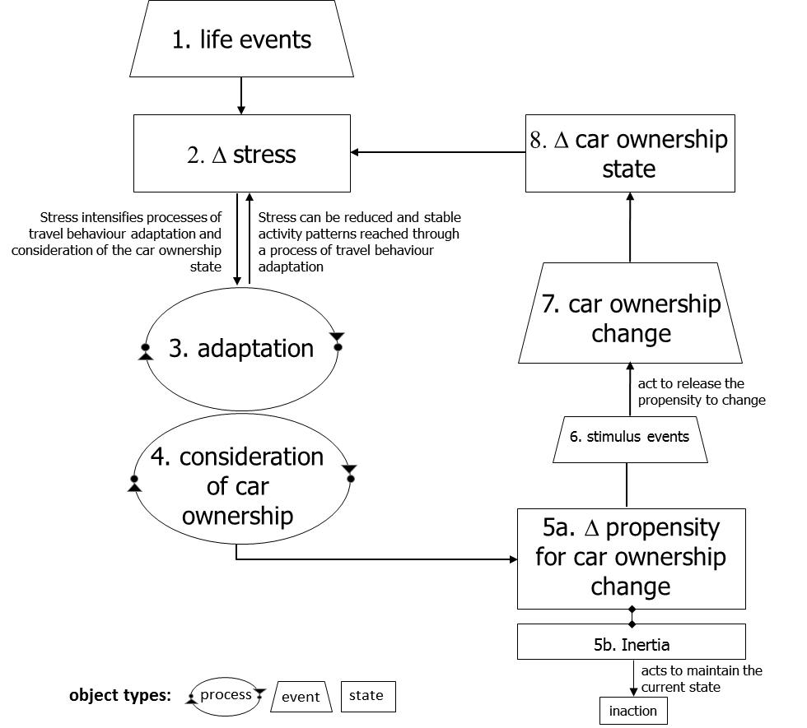

Figure 1: A framework depicting the process of household car ownership change (from Clark et al. (2016a))

Previous quantitative analyses had pointed to a household life cycle effect through which household car ownership was observed to increase as the head of the household reaches the age of 50 and thereafter declines (Dargay and Vythoulkas 1999). The open response accounts had also highlighted that the number of cars owned is related to the household size, and hence processes of household formation and dissolution. This in turn links to life-stage given that household composition and size is affected by births, partnership formation and dissolution, offspring leaving home and deaths. Figure 2 was developed to map out how different household car ownership level changes may tend to occur over the life cycle.

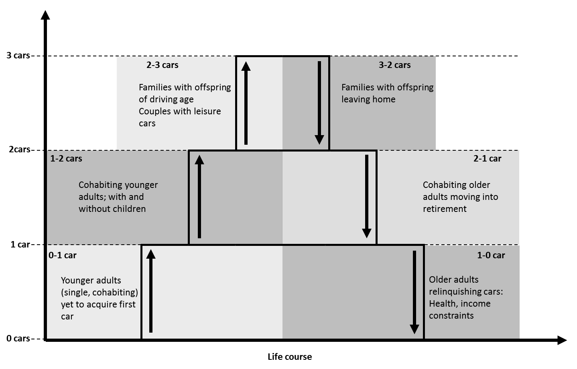

Figure 2: Car ownership level changes and the household life cycle (from Clark (2012))

On the one hand, the qualitative evidence supporting Figures 1 and 2 has strengths in providing explanatory insights into processes of change. On the other hand, there were clear evidential weaknesses in that the frameworks were based on accounts from a small sample of households. Thus it was necessary to return to quantitative approaches to examine if the processes suggested in Figures 1 and 2 hold across a wider population. In the next section, we contrast the qualitative findings with those generated through a separate analysis of a large quantitative panel data set.

**A panel data analysis of car ownership changes**

The data set prepared for analysis in the quantitative study (Clark et al. 2016b) was derived from the UK Household Longitudinal Study (UKHLS), also known as Understanding Society. Adult household members are interviewed once per year and two waves of data were available at the time of the study for 2009/10 and 2010/11[2]. This made it possible to examine *the extent* to which life events occurring between the two time points were associated with car ownership changes across the population[3].

The panel data analysis was used to identify predictors of three different car ownership states (0 car, 1 car, 2+ cars) and four different types of car ownership state change (0 to 1 car, 1 to 2+ cars, 2+ to 1 car and 1 to 0 car). The decision was made to consider each of the four types of car ownership level change separately since the previous qualitative study had shown that the characteristics of households undergoing these changes differed notably and hence it was anticipated that factors associated with these changes could also differ. The unit of analysis was the household, rather than the person, as the qualitative analysis had shown composition of households was highly important in car ownership changes.

The two-wave panel data set made it possible to firstly tabulate life events with the different car ownership state changes. This is reproduced from Clark et al. (2016b) in Table 1. This confirmed that there were indeed higher rates of car ownership state changes amongst the sub-groups experiencing life events relative to the sample averages. This provided population level evidence in support of the life event relationship presented in Figure 1.

Regression models were then estimated to examine the extent to which life events remain associated with higher likelihood of car ownership state changes after controlling for other factors. Predictors tested in the statistical models were baseline variables (measured at the first wave), describing households and the geographical context in which they lived, and change variables (measured between the first and second wave), describing changes in household circumstances (i.e. life events) and changes in geographical context (for those moving house).

The regression models once again confirmed that there was a higher likelihood of car ownership state changes occurring in association with life events (reported in full in Clark et al. (2016b)). For example, we observed in Clark et al. (2016b, p565) that *“changes to composition of households (people arriving and leaving) and to driving licence availability are the strongest predictors of car ownership level changes, followed by employment status and income changes”*. Such quantitative evidence confirmed a statistically significant association between different life events and increased likelihood of car ownership state changes occurring. The quantitative evidence has value in also revealing *by how much* the likelihood of a car ownership state change occurring increases in association with a life event. For example, the probability of a two person, zero car household[4] acquiring a first car was observed to be 5.3% in the absence of a life event, increasing to 10.9% in association with the birth of a child.

Table 1: Percentage of households changing car ownership level with life events (from Clark et al. (2016b))

|  |  |  |  |  |  |  |  |  |  |
| --- | --- | --- | --- | --- | --- | --- | --- | --- | --- |
|  | **Full sample*b*, n=19334** | **0 car sample, n=4472** | | **1 car sample, n=8449** | | | **2 car sample, n=5088** | | |
| **Life event *a*** | **Life eventfrequency *c*** | **Life event frequency *c*** | **0-1+ cars**  **%** | **Life event frequency *c*** | **1-2+ cars %** | **1-0 cars %** | **Life event frequency *c*** | **2-3+ cars %** | **2-1**  **cars**  **%** |
| Changed employer | 1647 | *170 | 24.71 | *649 | 18.34 | 4.16 | *613 | 10.44 | 12.56 |
| Entered employment from non-employment | 1525 | *332 | 20.78 | *587 | 16.18 | 4.26 | *469 | 11.09 | 16.42 |
| Residential relocation | 1426 | *399 | 21.55 | *574 | 15.51 | 16.20 | *320 | 7.19 | 42.50 |
| Lost employment (excl retirement) | 1023 | 200 | 14.00 | *409 | 10.02 | 10.76 | *319 | 5.33 | 19.44 |
| Gained a driving license | 794 | *292 | 41.44 | *301 | 26.58 | 2.99 | *146 | 37.67 | 15.75 |
| Had child | 622 | *151 | 24.50 | 232 | 11.21 | 5.17 | *210 | 1.90 | 20.48 |
| Gained a partner | 447 | *132 | 53.03 | *201 | 44.28 | 4.98 | *63 | 14.29 | 36.51 |
| Lost a partner | 372 | 81 | 13.58 | *161 | 6.83 | 31.06 | *109 | 3.67 | 82.57 |
| Retired | 355 | 33 | 3.03 | 141 | 7.80 | 4.96 | 146 | 6.16 | 17.12 |
| % households overall | | | ***10.35d*** |  | ***8.72 d*** | ***5.44 d*** |  | ***7.43 d*** | ***15.09 d*** |
| a: 33.07% of the full sample (6,394 households) experienced one or more of the life events listed in the table.  b: Note that the full sample includes 3+ car owners. This subgroup is not displayed in the table.  c: The number of households in the relevant subsample that experienced the life event. e.g. 170 of the 0 car owning households (n=4472) experienced the ‘changed employer’ event. 24.71% of these households also experienced the 0-1+ car level change.  d: % of the car ownership subgroup that experienced the relevant car ownership level change e.g. 10.35% of the 0 car sample (n=4472) overall had experienced the 0-1+ car level change.  * life event subgroup has a higher/lower prevalence of car ownership change compared to subsample average, significant at 95% level | | | | | | | | | |

The results of the panel data analysis are summarised in Figure 3 and reported in full in Clark et al. (2016b).

|  |  |  |
| --- | --- | --- |
|  | **2+ to 1 car:**  Predicted by following characteristics at wave one:  single-person household, non-couple households, in 25-29 age group, lower income, do not have educational qualification, live in London or live in area of higher deprivation  Predicted by experiencing following life events:  loss of adult (especially due to partner dissolution)  having a child  loss of employment  decrease in income  moving home (especially to area of higher population density) | **2+ cars:**  Predicted by following characteristics:  multi-person households or couple households  in middle to older age groups (45-74)  higher income, higher educational qualifications or in employment  live outside London, live in area without local amenities, live in area without rail station or live in area of lower deprivation  MCj04348180000[1]MCj04348180000[1] |
| **1 to 0 car**:  Predicted by following characteristics at wave one:  multi-person household, non-couple households, in 16-24 age group, lower income, live in inner London, live in area of higher deprivation or live in area with shorter journey times to employment by public transport  Predicted by experiencing following life events:  loss of adult (especially due to partner dissolution)  loss of employment  decrease in income  moving home (especially to area with greater access to buses) | **1 car**:  Predicted by following characteristics:  smaller households (two persons or less) or couple households  in older age groups (60+)  households with children of any age  lower income, lower educational qualifications or in employment  (not predicted by residential context)  MCj04348180000[1] | **1 to 2+ cars:**  Predicted by following characteristics at wave one:  larger households, couple households, in under-60 age groups, do not have children, in employment, higher income, do not live in London or live in area of lower deprivation  Predicted by experiencing following life events:  additional adult (especially due to partner formation)  acquisition of driving licence  gaining employment  switching employer  increase in income |
| **0 car**:  Predicted by following characteristics:  smaller households (two persons or less) or non-couple households  in under-45 age group or 75+ age group  households with very young children (aged 0-2)  lower income, no educational qualifications or not in employment  live in London or Metro area, live in area with more local services, line in area with more buses or live in area of higher deprivation | **0 to 1+ car**:  Predicted by following characteristics at wave one:  larger households, in under 60 age groups, do not have children, have higher levels of education or live in areas with longer journey times to employment by public transport  Predicted by experiencing following life events:  additional adult (especially due to partner formation)  having a child  acquisition of driving licence  gaining employment  increase in income |  |

Figure 3: Predictors of different car ownership states and transitions between them (based on results reported in Clark et al. (2016b))

The results in Figure 3 show that car ownership is strongly influenced by household composition and life-stage. This is consistent with the life-cycle conceptualisation presented in Figure 2. However, the results reveal further insights. For example, younger households are more likely to experience vehicle relinquishments (1 to 0 and 2+ to 1 car), which might be related to greater life volatility in early adulthood. We observe in Clark et al. (2016b, p594) that *“the life-cycle effect can only be considered to be a general tendency and not a normative experience”*. It is also important to acknowledge that that statistical relationships identify general tendencies and mask variations within the population. For example, the Clark et al. (2016b) study identified that 85 per cent of mid-aged households with children (with head of household aged 45-59) in the sample owned at least one car, but 15 per cent of these households did not own a car. We note in Clark et al. (2016b, p594) that variations are *“[…] partly explained by socio-economics (e.g. income) and spatial context (e.g. settlement type) but the [poor] model fits […] imply that there are other factors that play a role – for instance life-style preferences or attitudes”.*

**Complementary or contradictory findings?**

The two different types of enquiry (qualitative and quantitative) were not part of the same project. In following after the qualitative study, the quantitative analysis paid regard to its theoretical and empirical findings and was designed to add further knowledge. It was able to generate quantitative estimates of the importance of different life events to build on the indicative findings from the qualitative study. It was able to assess the role of geographical context which was not possible in the qualitative study which had recruited research participants from only one local area. The qualitative study had shown how car ownership changes are connected to life cycle development of households and the quantitative study was able to build on this and provide a stronger appreciation of this (see Figure 3). Hence the two types of study can be seen as complementary and to iteratively contribute to accumulation of knowledge.

However, there were limitations to the quantitative analysis. It was not possible to identify reasons for car ownership decisions. This was partly a consequence of the data set used (i.e. from a general-purpose survey which did not include questions seeking to explain personal mobility) and partly a consequence of the unit of analysis considered (i.e. it is not clear how to seek to explain a decision made by multiple members of a household). The panel data analysis was unable to explore the long-term dynamics of household car ownership with only two waves of data available at the time of the analysis. This was a particular limitation of the data used and other studies have had data with multiple years of data. For example, Oakil et al. (2014) found that having a child is associated with car acquisitions in anticipation of the event rather than after the event.

**An integrated quantitative and qualitative study of car sharing**

We look now at what can be learnt from a combined quantitative and qualitative study. A separate study examined the circumstances and motivations for people to join a car sharing service, changes in travel behaviour in the short and longer run and how behaviour might have changed in the event of not joining (Chatterjee et al., 2013). This was studied for members of a car sharing organisation in Bath, UK.

In the first stage of the research, all 408 members of the Bath car sharing service were invited to complete a web-based questionnaire survey with 108 responses received. From the survey 40% of respondents reported a reduction in the number of vehicles they owned after becoming a member, with 55% reporting no change in car ownership and 6% reporting a vehicle increase. These percentages were similar to figures from a UK-wide survey of car sharing members.

The second stage of the research involved qualitative telephone interviews with 16 survey respondents. In the interviews biographical information was sought on car ownership and travel behaviour history before and after joining the car sharing service. An equal number of participants who had reduced car ownership and maintained (or increased) car ownership were recruited to the interviews. In each of these groups, an equal number of members of at least 18 months membership and less than 18 months membership were recruited to enable it to be investigated how changes take place over time after joining the car share service.

The results of the interviews were interpreted with reference to the mobility biographies perspective (Lanzendorf, 2003), paying consideration to how events in the life course influenced a change in travel behaviour. The results showed that car sharing is effective at attracting those already contemplating giving up a car or triggered to consider their car ownership by life events. Once those reducing car ownership become members it was found they adapted to managing without a personal car by using a variety of transport modes, planning their activity-travel schedules in advance and paying regard to the costs and convenience of different options. Joining the car sharing service was found to prevent acquisition of cars for some members but some subsequently took opportunities to acquire cars as circumstances changed.

The qualitative research gave insights into the motivations and behavioural changes of people joining a car sharing service from different starting positions (not having a car or having a car). While it shed useful insights into situational factors and behavioural change, it is acknowledged that further research could explore in more depth the backgrounds of people joining a car sharing service and their world views. This would require life history interviews designed to encourage participants to provide full narrative accounts of their mobility histories, including major mobility decisions. It would also require analysis that focuses on narrative form (Beal, 2013), i.e. how people talk about mobility and its role in their lives and what mobility means to them. In the previous examples of biographical interview analysis discussed in this paper, the analysis has instead focused on narrative content to identify the structural nature of behaviour change occurring and themes associated with this.

**Taking a narrative-interpretative perspective**

One notable study has looked at car ownership with a focus on narrative form, taking what is referred to as a narrative-interpretative perspective. It involved open-ended narrative-biographical interviews with 15 members of carless households in the Vienna region (Sattlegger and Rau, 2016). The study’s focus was therefore not on a turning point as such, but the relatively unusual position in Vienna of not transitioning into car ownership. Nevertheless, the approach could just as easily be applied to investigate people who change their personal mobility over time.

With the narrative-interpretative perspective, the analysis shifts away from *“specific life events and their connection with mobility behaviour change to the social conditionality of mobility practices, as revealed through individuals” narrated life stories”* (Sattlegger and Rau, 2016*,* p25). The analysis identified six patterns of meaning that shape the mobility decisions and practices of individuals:

* Means to an end – rational cost-benefit calculations
* Personally meaningful – personal experience and routines
* Intrinsically social – social functions (e.g. family trips)
* Socially valued – fitting in with mobility norms and values
* Sacrificial – foregoing advantageous mobility practices
* Enjoyable and fun – mobility as a positive experience in itself

From these six patterns of meaning it was possible to identify a wide range of socio-material conditions for voluntary carlessness, as well as possible opportunities for mainstreaming carless mobility practices.

**Discussion and conclusions**

There has been very little dialogue about the value of qualitative and quantitative enquiries in travel behaviour research. There are well-rehearsed arguments for qualitative research (describing phenomena, exploring ideas and formulating a theory or hypothesis) and quantitative research (testing theories and hypotheses, establishing generalisable facts) and this chapter was concerned with comparing what quantitative and qualitative approaches have contributed to understanding turning points in personal mobility over the life course.

The examples of car ownership research considered in this chapter have shown that the traditional idea of qualitative research being used to formulate theory and quantitative research being used to test theory is partly true but it would be more accurate to describe the two types of research as being part of an iterative process of research which contributes to accumulated knowledge in a less predictable way. We draw on this experience to make recommendations on the use of qualitative research and quantitative research in travel behaviour research.

Firstly with regards to theory, we advocate that common theoretical frameworks are applied to build knowledge using both qualititative and quantitative approaches. This has the potential: (i) to strengthen the connection between what are often separate (qualitative and quantitative) bodies of research, requiring researchers to explicitly position their work against what is already known; and (ii) to increase opportunity for synergies to be drawn between qualitative and quantitative evidence, with potential to amplify their combined insight. Müggenburg et al (2015) and Scheiner (2018) provide frameworks for examining travel behaviour in general. We have developed specific frameworks for examining the effects of life events (see Clark et al. (2016c)) and processes of car ownership change (see Clark et al. (2016a)).

Secondly with regards to evidence, it has been suggested that four criteria are required to establish causal relationships (Mokhtarian and Cao, 2008). These are: (i) association (ii) non-spuriousness (iii) temporal sequence (noting that an outcome could plausibly occur before its cause, e.g. a car could be bought or relinquished in anticipation of a life event) and (iv) evidence of mechanism. By definition, research designs examining processes of behaviour change over time require longitudinal data and hence are well positioned to satisfy the temporal sequence criterion. We further suggest that, although purely qualitative or purely quantitative longitudinal approaches can be designed to meet all four criteria to a greater or lesser extent, it is advantageous to adopt both approaches to build a robust evidence base.

Taking qualitative longitudinal approaches first, biographical interviews can be analysed thematically (either inductively or deductively identifying themes, following Braun and Clarke (2006)) to examine and explain *objective* sequences of events and behavioural changes, demonstrating non-spurious association, temporality and mechanism, at the level of the individual. Underlying mechanisms explaining individual change (e.g. Figure 1) that may apply more generally to the population can also be proposed from such qualitative analyses, but quantitative evidence is then required to confirm the *prevalence, strength of association and magnitude of effect* of the phenomenon across the population of interest.

Longitudinal quantitative approaches commonly employ prospective panel data sets, although historic data can also be collected retrospectively. The familiar adage of having to walk before you can run holds with respect to the analysis of panel data. We suggest that panel data requires an incremental analytical approach via which evidence is built up incrementally:

* Step one: Cross-sectional analyses of individual panel waves are first used to identify correlations and *associations* at a single point of time. For example, in our panel data analysis of car ownership we first estimated statistical models for car ownership states (see Figure 3 which summarises detailed results from Clark et al., 2016b). It needs to be remembered that cross-sectional *associations* can always be *spurious* in being driven by a third unobserved variable.
* Step two: Behavioural change regression models can then be estimated from multiple waves of data to identify predictors of behaviour change. In our panel data analysis of car ownership we estimated statistical models for different car ownership level changes (see Figure 3 which summarises detailed results from Clark et al., 2016b). Time lagged predictor variables can be added to model specifications to examine *temporal relationships*.
* Step three: Cross-lagged structural equation models can finally be used to test hypothesised *mechanisms*. To our knowledge, few studies in the travel behaviour field have applied this method. For an example see van de Coevering et al. (2016).

Drawing connections between quantitative and qualitative approaches means that each can be used to address the weaknesses in the other. With respect to turning points, a key advantage of biographical interviews over panel data is that the interviewee has the opportunity to confirm whether a turning point has occurred (before the circumstances and motivations are discussed). With panel data there may be measurement error in recording changes in mobility between two time points or the difference may be temporary and not represent a lasting change.

It is well established that people in very similar objectively defined circumstances make very different mobility choices due to differences in their experiences, values, attitudes, preferences and other subjective factors. Biographical interviews are better suited to revealing the role of subjective influences by providing the opportunity for interviewees to explain their mobility decisions in their own words. It can be an issue that interviewees provide post-rationalisation to decisions and give a different explanation than may have prevailed at the time they made them, but post-rationalisations are of value in their own right (if interpreted with care) in revealing how people reflect on their experiences. With a narrative-interpretative perspective it is possible to go beyond seeking behavioural explanations and explore people’s experiences of mobility and the meanings they attach to mobility (as with the example of Sattlegger and Rau (2016)). This can contribute to understanding both behaviour stability and change.

Advances in knowledge have been affected by limitations of data. Panel data analysis has not been able to test the role of factors identified to be important in qualitative studies (e.g. early life experience) or examine theoretical processes suggested by qualitative studies (e.g. time dependencies). More input is needed from researchers into the data collected from panel studies if it is to be useful for testing theoretical propositions of how personal mobility changes over time. For example, initiatives should be made to capture early life experiences and subjective considerations in panel studies so that their role can be examined. Biographical interviews have been conducted with selective participants (those more easily recruited to a university research project) and this may be narrowing ideas/concepts generated.

To conclude, a systematic approach has not been taken up to this point in combining research enquiry based on panel data with enquiry based on biographical interviews. While knowledge has accumulated without this, we recommend researchers engage in considering the epistemological, methodological and analytical issues involved in combining the two forms of enquiry, as there is the prospect of making major strides in the understanding of personal mobility over the life course.

**Acknowledgements**

Kiron Chatterjee and Ben Clark give thanks to colleagues (former and current) in the Centre for Transport & Society at UWE Bristol with whom they have worked on the studies mentioned in this chapter.

**References**

Beal, C.C. (2013) Keeping the story together: a holistic approach to narrative analysis. Journal of Research in Nursing. 18(8), 692–704.

Braun, V. and Clarke, V. (2006) Using thematic analysis in psychology. Qualitative Research in Psychology. 3, 77-101.

Chatterjee, K., Andrews, G., Micci, M. and Parkhurst, G. (2013). Qualitative insights on the travel behaviour effects of joining a carshare. Transportation Research Record, 2359, 76-84.

Chatterjee, K. and Scheiner, J. (2015) Understanding changing travel behaviour over the life course: Contributions from biographical research. Resource paper presented at the 14th International Conference on Travel Behaviour Research, Windsor, UK, July 19-23.

Clark, B. (2012) Understanding how and why household car ownership changes over time. PhD. University of the West of England, Bristol.

Clark, B., Lyons, G. & Chatterjee, K. (2016a). Understanding the process that gives rise to household car ownership level changes. Journal of Transport Geography, 55, 110-120.

Clark, B., Chatterjee, K. & Melia, S. (2016b). Changes in level of household car ownership: the role of life events and spatial context. Transportation, 43, 565-599.

Clark, B., Chatterjee, K. and Melia, S., (2016c). Changes to commute mode: The role of life events, spatial context and environmental attitude. Transportation Research Part A: Policy and Practice, 89, 89-105.

Dargay, J. and Vythoulkas, P. (1999) Estimation of a dynamic car ownership model: A pseudo-panel approach. Journal of Transport Economics and Policy, 33 (3), 287-302.

Lanzendorf, M. (2003) Mobility biographies. A new perspective for understanding travel behaviour. Paper presented at the 10th International Conference on Travel Behaviour Research, Lucerne, Switzerland.

Lanzendorf, M. (2010). Key events and their effect on mobility biographies: The case of childbirth. International Journal of Sustainable Transportation, 4(5), 272-292.

Mokhtarian, P. and Cao, X. (2008) Examining the impacts of residential self-selection on travel behaviour: A focus on methodologies. Transportation Research Part B. 42 204-228.

Müggenburg, H.; Busch-Geertsema, A. and Lanzendorf, M. (2015): A review of achievements and challenges of the mobility biographies approach and a framework for further research. In: Journal of Transport Geography 46, 151–163.

Oakil, A., Ettema, D., Arentze, T., Timmermans, H. (2014). Changing household car ownership level and life cycle events: an action in anticipation or an action on occurrence. Transportation, 41, 889-904.

Sattlegger, L. and Rau, H. (2016): Carlessness in a carcentric world: a reconstructive approach to qualitative mobility biographies research. In: Journal of Transport Geography 53, 22–31.

Scheiner, J. (2007). Mobility biographies: elements of a biographical theory of travel demand. Erdkunde 61, 161–173.

Scheiner, J. (2018). Why is there change in travel behaviour? In search of a theoretical framework for mobility biographies. Erdkunde 72, 41-62.

van de Coevering, P., Maat, K., Kroesen, M. and van Wee, B., (2016). Causal effects of built environment characteristics on travel behaviour: a longitudinal approach. European Journal of Transport and Infrastructure Research, 16(4), 674-697.

1. Scheiner (2007) made the point that unidirectional causal relationships between life events and travel behaviour cannot be assumed with it possible that travel experiences influence other domains of life.
2. The data was collected shortly after the global financial crisis of 2007-08 and this may have had some influence on the results obtained.
3. Limited to the population of England in the analysis.
4. Based on a stylised household defined as a two person household, cohabiting, oldest member aged <29, no children, no qualifications, not working in the base year.