Experimental study on the use of RoadCem blended with by-product cementitious materials for stabilisation of clay soils

Samuel J. Abbeya*, Eyo U. Eyob, Chukwueloka A.U. Okekec, Samson Ngambib

(*Corresponding author Email: [samuel.abbey@uwe.ac.uk](mailto:samuel.abbey@uwe.ac.uk))

*aFaculty of Environment and Technology, Department of Geography and Environmental Management, Civil Engineering Cluster, University of the West of England.*

*bSchool of Energy, Construction and Environment, Faculty of Engineering, Environment and Computing, Coventry University, Coventry, United Kingdom.*

*cCollege of Engineering, Department of Civil Engineering, Covenant University, Ota, Ogun State, Nigeria*

**Abstract**

This work presents an experimental study on the physical, mechanical and microstructural characteristics of two clay soils treated with by-product materials (GGBS and PFA) blended with a nano technology-based additive called RC (RC). The soils were initially treated with 8% of cement in the first phase of mixing, and in the other phases of mixing, the cement content was reduced by 50%, 60% and 70% and substituted with GGBS or different combinations of GGBS and 1%RC or PFA and 1%RC. Further, the paper discusses the shear strength, stabilisation mechanism, microstructural characteristics, and swell of the treated soils based on results of series of strength, scanning electron microscope and swell test. The results show that the inclusion of 1%RC increases undrained shear strength and reduces swell of the treated soils due to encapsulation effects associated with the formation of the crystalline reaction product in the hydration process and the resulting modification of cementitious product to bind very heavy clays together. The soil treated with 1%RC combined with 4%Cem and 3%GGBS, produces the best performance in terms of undrained shear strength and microstructural characteristics and the stabilisation mechanism of cement, RC and GGBS shows that it is due to interlocking of particles and wrapping effect.

**Keywords**

Soil-Cement; shear strength; GGBS; fly ash; cement treatment; RC; swell; stabilisation; stabilisation mechanism; microstructure

1. **Introduction**

One of the key challenges that civil engineers would have to confront is the construction and execution of very intensive land developmental works on areas of the globe with serious concentration of high swelling clayey soils. This is evidently because structures that are intended on such volume-change soils would be prone to failure unless some significant measures are adopted to improve the foundation soil. Moreover, the resulting disasters and the estimated cost of rehabilitation and repairs of structures that are founded on expansive soils is a global concern. Financial losses, legal claims, cost of insurance for infrastructural failures on expansive soils have been reported in literature [1]. What has become even more worrisome is that, progressive housing and related developments on these soils seem very unavoidable especially with the continuous rise in world population figures [2–4].

Soil treatment with additives or soil stabilization is a very cost effective and well-researched technique that has been used to improve the mechanical and durability properties of expansive soils [5–14]. Traditionally, the use of calcium based stabilising agents such as lime and cement have received high attention and successfully used in improving the engineering characteristics of soft soils [15,16]. However, the significant negative environmental impacts associated with their usage besides their potential to cause sulphate heaving makes them very contemplative in recent discourse [17–19]. It has been indicated in a study carried out by CEM-Bureau [20] that in the year 2017, the global cement produced reached about 4.1 billion tonnes with an annual increase of approximately 6.3% from previous years. Van Ruijven et al. [21] also demonstrated the trends in cement production both in the past and the present with a prediction of further consumption and concluded that the global market for cement is estimated to rise at about 5% annually. Advancement in knowledge and research are presently causing a paradigm shift in the use of traditional soil stabilisation additives such as cement and lime to the production and usage of more sustainable by-product cementitious materials (such as ground granulated blast furnace slag (GGBS), cement kiln duct (CKD), silica fume, fibres and pulverised fuel ash [3,22–29]. For instance, the two industrial by-products that are widely used as partial replacements for cement mainly due to their pozzolanic property, cost effectiveness, energy saving and environmental friendliness are PFA and GGBS [30–35].

RoadCem (RC) is another fine-grained by-product additive that is based on synthetic zeolites, alkali earth metals substance (NaCl, KCl, CaCl2 and MgCl2) and complementary complex activator to enhance its unique qualities [36]. This material is mostly used in small quantities to improve the mechanical performance of cement [36,37]. There are also documented cases of the use of RC in combination with other cementitious materials and by-products such as lime, PFA, GGBS. RoadCem is manufactured majorly by PowerCem Technologies in Moerdijk and has been tested and found to possess very good environmental credentials and macro-economic prospects with over 80% reduction in CO2 emission [38,39]. According to Pengpeng [40,41], the inclusion of RC in soil-cement mixtures reduces drying shrinkage and tensile stresses (by up to 50%) of the stabilised soil after 28 days of curing. Ventura and Koloane [36] examined the addition 1% of RC to cement replaced by fly ash in both fine-grained sand and fine-grained clayey sand. The investigated engineering properties such as the California bearing ratio, UCT, durability and flexibility/stiffness) showed satisfactory performance thus complying with the standards used. The strength and free swell index of a cement-RC and cement-RC-lime-GGBS stabilised soils was studied by Ouf [42], and it was stated that while the UCT and Emod increased, the free swelling index reduced with an increase in the total binder content.

Undoubtedly, the use of cement and other calcium-based additives for soil stabilisation of similar soil types have been studied widely in literature but the use of RC as a partial replacement of cement to ascertain the effect of RC on the engineering properties of stabilised soils have received limited attention in spite of its potential merits. Therefore, with concerns about the environmental impact of the built environment becoming increasingly urgent. This research proposes that the properties of stabilised soils achieved by the partial replacement of cement with industrial by-products could be further enhanced by incorporating minimal quantities of a nanotechnology-based additive called “RC (RC)”. Therefore, the present study has investigated into the application of RC blended with GGBS, PFA and less than 4% cement content with the aim of expanding the understanding of the application of RC in combination with pozzolanic by-product materials. The originality of this work lies in the study of the physical and microstructural characteristics of a medium swelling kaolin clay and a very high swelling kaolin-bentonite mixtures treated with RC in combination with GGBS and PFA, to contribute to the understanding of sustainable and environmentally friendly approach to soil stabilisation.

**2. Materials and methods**

The materials used in this study consisted of RC, cement, ground granulated blast furnace slag (GGBS), pulverised fuel ash (PFA) and Kaolinite clay (Soil I) and a mixture of kaolinite-bentonite consisting of 25% kaolinite and 75% bentonite (Soil II). The cement (CEM I) used was sourced from the Hanson Heidelberg group in the UK and complies with the requirements of BS EN 197-1 CEM I Portland cement with a strength class of 52.5N. The GGBS used was produced and tested following the methods outlined in BS EN 196-2:2013 by the Hanson Heidelberg cement group UK. The PFA was sourced from CEMEX Cement UK and complies with the standard regulations of the BS EN 450-1 and the RC additive was supplied by PowerCem Technologies, Netherlands.

2.1 Laser diffractometric and Atterberg limit test

The untreated clays were subjected to laser diffractometric and Atterberg limit test to analyse their grain size distribution (GSD) and geotechnical properties. The grain size distribution test was performed using the Malvern Mastersizer 2000, which operates the Hydro 2000G module of sample dispersion based on laser diffraction technology for soil particle sizing, IS0 13320-1 (1999) and ASTM E1458 (1992). The Mastersizer 2000 is capable of analysing particles in the range of 0.02 μm to 2000 μm. During measurement, particles passing through a focused laser beam scatter light at an angle inversely proportional to their size [43]. A series of photosensitive detectors then measures the angular intensity of the scattered light, and following this, the map showing the scattering intensity versus angle becomes the primary source of information for calculating the particle size. In this study, the wet method of sample dispersion was used to study the particle size distribution for both kaolin clay and bentonite. The soil samples in their powdered form were first dispersed into a non-reactive liquid and then fed into the system for particle size analysis. Atterberg limits test were conducted on the samples following the procedure as outlined in ASTM D 4318-17. Table 1 and Fig. 1 show results of preliminary studies conducted on the investigated materials as used in this study, while the oxide compositions of the materials are presented in Table 2.

Table 1 shows that the liquid limit of soil II exceeded 100% as expected due to the high amount of bentonite (consisting mostly of montmorillonite) present in the soil mixture. It is well known that the bond between the layers of montmorillonite is weak and large amounts of water can easily infiltrate the spaces between the layers. While in the case of soil I (kaolinite), the layers are held relatively tightly, and water cannot easily infiltrate between the layers in comparison with soil II. Therefore, the Atterberg limits for soil I were found to be much lower than those for soil II.

**Table 1.** Geotechnical properties of the clays

|  |  |  |
| --- | --- | --- |
| Soil property | Soil types | |
| Soil I | Soil II |
| Liquid limit, wL (%) | 58 | 285 |
| Plastic limit, wp (%) | 30 | 72 |
| Plasticity index (Ip) | 28 | 213 |
| Silt content (%) | 74 | 48 |
| Clay content (%) | 26 | 52 |
| Specific gravity (G) | 2.60 | 2.76 |
| Max. dry density (MDD) (kN/m3) | 15.0 | 12.9 |
| OMC (%) | 17 | 30 |
| USCS Classification | CL | CH |
| Max swell percent (%) | 12.6 | 37.0 |

**Fig. 1.** Analysis of material grain size.

**Table 2** Chemical composition of materials used

|  |  |  |  |  |  |  |  |  |  |  |  |  |
| --- | --- | --- | --- | --- | --- | --- | --- | --- | --- | --- | --- | --- |
| Materials used |  | Oxide composition (%) | | | | | | | | | | |
| SiO2 | Al2O3 | Fe2O3 | CaO | MgO | K2O | TiO2 | Na2O | SO3 | Mn2O3 | LOI |  |
| Kaolinite | 49 | 36 | 0.75 | 0.06 | 0.3 | 1.85 | 0.02 | 0.1 | - | - | 12 |  |
| Bentonite | 57.1 | 17.79 | 4.64 | 3.98 | 3.68 | 0.9 | 0.77 | 3.27 | 0.11 | 0.06 | 7.85 |  |
| CEM I | 20.7 | 4.6 | 2.3 | 64.0 | 1.7 | 0.4 | 0.3 | 0.1 | 2.9 | 0.1 | 2.9 |  |
| GGBS | 34.1 | 13.0 | 0.51 | 39.0 | 9.5 | 0.5 | 1.3 | 0.3 | 0.3 | 0.7 | 1.9 |  |
| PFA | 52.1 | 30.1 | 4.0 | 3.0 | 1.0 | 2.1 | 1.0 | 2.1 | 1.2 | - | 4.0 |  |
| RC1 | 21.2 | 1.7 | 0.63 | 47.1 | 4.0 | 7.46 | - | - | - | - |  |  |

1. The oxide component not included in the table is H2O which is 17.9 for RC

2.2 Sample preparation

The investigated clay samples (Soil I and Soil II) were sampled in their natural state and thoroughly mixed with dry cement and different combinations of GGBS, PFA and 1% of RC. In keeping with the primary objective of this research, 8% of cement by weight of dry soil was used as the control binder content and was partially replaced and mixed with the stabilised soils in four phases. The adopted control amount of cement was selected based on some already established procedures and recommendations in literature for the enhancement of the engineering properties of soil-cement mixtures [27,44]. In phase 1, the soils were mixed with 8% cement by dry weight of soils, and in phase 2, the cement content was reduced by 50% and replaced with by-product cementitious material (BPCM) and nano technology-based additive (NTBA), RC. In phase 3 and 4, the original cement content was further reduced to 60% and 70% and replaced with combinations of BPCM and NTBA respectively. Fig. 2 shows a schematic illustration of the actual amount of cement, GGBS, PFA and RC that were mixed with each reconstituted sample of Soil I and Soil II at the different soil mixing and stabilisation phases. In order to study the influence of RC, the clay-binder mixtures were prepared by substituting either the GBBS or PFA in their respective mixes with 1% of the RC also determined by dry weight of the cement. The 1% of RC content used is what is regarded by its manufacturers as the design quantity for soil stabilisation [37,40,45,46]. All stabilised samples of Soil I and II were mixed at optimum moisture, wrapped to prevent moisture loss, and cured under moist condition for 7 and 28 days before testing.

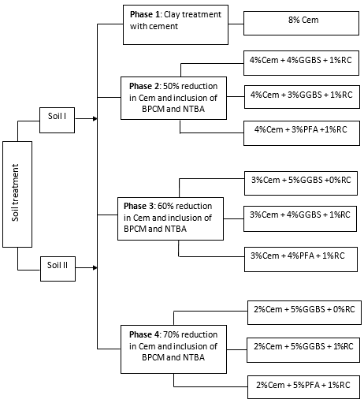

**Fig. 2.** Schematic illustration of sample preparation and stabilisation phases

**2.3 Testing methods**

2.3.1 Unconfined compression test (UCT) and swell test

The undrained shear strength of the treated soils was obtained from results of unconfined compression (UCT) test conducted according to ASTM D 2166. Two representative samples from each mix of the treated and untreated soils of height 76mmm and diameter 38mm were subject to UCT after 7 and 28 days of curing, and the average undrained shear strength value was obtained. The rate of axial deformation maintained through unconfined compression testing was 1mm/min. To study the swell potential of the treated soils, the conventional one-dimensional oedometer (1-D) testing was utilized in accordance to the ASTM D-4546 after 7 days of curing. The samples were placed in the oedometer apparatus having ring 20 mm thickness and 76 mm as dimeter and were made to sit in between two porous stones lined with filter papers. The automated load variable displacement transducer (LVDT) was set to zero after recording the initial compression under a seating load of 5kPa. Water was then gradually introduced into the oedometer and the samples inundated and then allowed to undergo free vertical swelling for a minimum time period of 24 hrs until equilibrium was reached. The swell percent was then calculated as the increase in sample height (Δh) divided by the original height (H) of the samples.

3.1 Scanning electron microscope (SEM)

The scanning electron microscope test was conducted on representative samples to study the microstructural characteristics of the treated soils. Due to cost and time constraints, the SEM test was conducted on selected mixtures of soil I and II only. Microscopic examination and measurement of soil pores has gained much interest in recent years, partly because the analysis of images of soil fabric provides a straightforward investigation and analysis of soil void and porosity including clay particle degree of arrangement [3,47,48]. The microstructural analysis allows for the examination and measurement of soil pores and orientation and to support the description of the mechanism of change occurring in the fabric of the treated and untreated soils. Scanning electron micrographs (SEMs) using the Zeiss apparatus were conducted and obtained from the cured, dry and fully vacuumed specimens working at a voltage of acceleration of up to 5.00kV, minimum distance of 2µm and minimum degree of magnification of 900x [3].

**3. Results and Discussion**

3.1 Stress-strain characteristics of treated soils

It is well known that the strength gain and stability in treated soils are due to complex chemical reactions that take place between the soil-additive systems in the presence of water, and this constitutes the ability of the treated soil to support applied load. Studies on the stress-strain behaviour of cement treated soils reveal that soil-cement mixtures show brittleness behaviour as curing time increases [49,50]. Therefore, the present study has also investigated the stress-strain behaviour of the soils treated with RC blended with GGBS and reduced amount of cement. The stress-strain characteristics of the treated soils have been captured by monitoring the stress and strain response of the treated materials through series of unconfined compression test on samples tested after 7 and 28days curing periods as shown in Fig. 3(a-f) and Fig. 4(a-f) respectively. The results show that the samples treated with 8% cement exhibits brittle failure characteristics achieving high peak stress at lower strain due to cementation effect irrespective of soil type. With reduction in cement and inclusion of GGBS, the attainment of peak deviator stress occurs at slightly higher strain levels in most cases compared to the failure strain of samples treated with 8% cement only. However, the inclusion of 1% RC in combination with 3%-4%Cem and 3%-4%GGBS increases the peak deviator stress at lower failure strain compared to the peak stress and failure strains of samples treated with combination of RC, cement and PFA. After 28days curing, all treated samples attained peak deviator stress at low strain values within 1 to 1.5% irrespective of soil type. According to Phanikumar and Vamsi Nagaraju [51], the treatment of soils with either lime or cement additives results in brittle behaviour of the treated soils associated with low strain and high strength than those of the non-treated soils.

(b)

(a)

Soil I-7days

(d)

(c)

(e)

**Fig. 3(a-f).** Stress and strain response of treated soils after 7days curing period

Soil I-28days

(b)

(a)

(d)

(c)

Soil I-28days

(e)

**Fig. 4(a-f)**. Stress and strain response of treated soils after 28days curing period

3.2 Undrained shear strength of cemented soils

The properties and change in the engineering properties of clays stabilised by cement alone and combination of cement and GGBS or cement and PFA are well established [44,52–60]. But the undrained shear strength of soils treated with 1% of RC blended with different combinations of cement, GGBS and PFA have not been looked into by many. The undrained shear strength was obtained from results of UCT conducted on representative samples of soil I and II after 7 and 28days curing period. The results obtained show variation in undrained shear strength due to physico-chemical mechanisms and microstructural characteristics as cement was partially replaced with different amounts of GGBS, PFA and 1%RC. The results show that in mixing phase 1, the undrained shear strength of soil 1 was lower than that of soil II after 7 days. Compared to samples treated with all the proportions and combinations of C/GGBS/RC for soil II for the same curing period as shown in Fig. 5(a-b). At 50% cement reduction in phase 2, the inclusion of 3%GGBS and 1%RC increases the undrained shear strength of the treated soils to 0.45MPa and 0.58MPa for soil I and II respectively after 7 days. It has been reported that the undrained shear strength and other properties of cement treated soils can be influenced by both cementation and consolidation during the early stages of strength gain due to cement hydration [61]. There is a significant increase in undrained shear strength after 28days as shown in Fig. 6(a-b), irrespective of soil type due to hydration and pozzolanic reactions. The undrained shear strength of samples treated in phase 2 increases up to a maximum value of 0.6MPa and 0.74MPa for soil I and II compared to lower strength values of samples treated in phase 3 and 4 respectively. The soils treated with cement/GGBS/RC mixtures does seem to have higher undrained shear strength values as compared with mixtures containing cement/PFA/RC. This is because the cement/GGBS mixture produces more cementation and binding effect than cement/PFA mixture. The inclusion of 1% RC causes additional particle cementation, hydration and creation of nano crystals in form of a spider web, interlocking the particles together and causing strength increase. The presence of RC causes changes in the mineralogical structure of the soil leading to a treated soil with higher strength, strong and durable crystalline structure which is fibrous in nature [56].

(b)

(a)

**Fig. 5(a-b)**. Undrained shear strength of treated soils after 7days

(a)

**Fig. 6(a-b)**. Undrained shear strength of treated soils after 28days

3.3 Microstructure and Stabilisation mechanisms

The properties of natural and stabilised soils at the macroscopic level (strength) were largely considered in the foregoing. Moreover, an adequate scientific basis involving a thorough description of the microstructural activities and mechanisms of changes occurring in the stabilised soil is very needful to justify or corroborate the claims of improvement in mechanical behaviour [57,62,63]. In the present study, the stabilisation mechanism of the additives with the incorporated RC was studied to support the understanding of the basic stabilisation mechanisms associated with the investigated additives and soils.

Chemically hydraulic binders such as Portland cement and GGBS are composed of compounds each of which can react with moist clayey soils to form complex hydration products. The process of hydration is even much more complicated when cement and GGBS are used together to stabilise the same soil [64,65]. The mechanism of reactions that ensues with the addition of GGBS to cement-soil system has two fundamental phases namely, hydration of GGBS by hydrated lime from the cement and soil-hydrated lime reactions. Firstly, the hydration of GGBS proceeds with the consumption of very little amounts of lime and commences soon after water is introduced and used to mix the soil-binder materials. This reaction tends to lead to the production of the calcium aluminosilicate hydrates (CASH) having low calcium to silicon ion ratio, aluminium to silicon ion ratio and calcium to aluminosilica ions ratio. The second phase involves the soil-cement (or hydrated lime from the cement) reaction and leads to the production of colloidal CASH again with values of the calcium to silicon ion ratio, aluminium to silicon ion ratio and calcium to aluminosilica ions ratio. Replacement of cement by a higher percentage of GGBS whereby only a small amount of cement is available to activate the hydration of GGBS may prevent the second phase of the soil-cement reaction to start. However, with the cement/GGBS ratio increased, the availability of OPC ensures the progress of the soil-cement phase and the production of more calcium alumino hydrates (CAH) and calcium aluminosilicate hydrates (CASH). This resulting crystalline products of hydration proceeds much slower than cement hydration and thus possesses some ‘pore-blocking’ effects leading further to the increase in long-term hardening of the cement paste and by extension an enhancement of the stabilised soil’s engineering properties such as strength. Soil II used in this research is an expansive flocculent clay with randomly distributed aggregates within the soil matrix, and the addition of 8%Cem (control mix) to soil II causes a gluing effect and formation of complex calcium silicate aluminate hydrate compound or mineral called “ettringite” including the cementitious compounds of hydration (CSH and CASH) as shown in Figures 7(a-d). The presence of ettringite can induce expansion of the treated soils. According to [23,34,65], ettringite formation and expansion of treated soils can be reduced by partially replacing cement with by-product materials such as GBBS. The soil stabilised by cement and GGBS or both, enables a modification of the created electrical double-diffused layer by causing a reduction of its thickness through the production of the CAH or CASH gels. It is believed that the complex hydrates formed from stabilisation with cementitious binders such as cement or GGBS or both, can result in a complete spherical barrier (Fig. 8) that could most times prevent further reaction of the binder materials as time progresses [66].

However, the ettringite formation reduces or disappears when the cement content was reduced and partially replaced with 3-5% of GGBS and 1% of RC as shown in Fig. 9(a-d) compared to Fig. 7d which clearly indicates ettringites when cement alone is used. The reduction or disappearance of ettringite formation with decrease in cement content and replacement with by-product materials such as GGBS is made possible when a substantial amount of the GGBS is used to replace cement in the stabilised soil, the percentage of GGBS being greater than approximately 50% [23,34,65]. Also, the inclusion of 1% of RC to the cementitious binders (4%Cem+3%GGBS) enabled further and deeper penetration of it and the water of hydration by breaking the CSH or CASH barrier and causing most of the cementitious materials to react in a much higher pH environment (now made possible with the RC added) due to the conversion of a larger proportion of the water of hydration into crystalline water with more nanocrystals growing into the spaces left in the hydration process. This results to the formation of a treated soil matrix with interlocking filaments (wrapping effect), a phenomenon which is only made possible by the presence of the RC additive as a nano-additive in the stabilisation process as shown in Fig. 9b. This is because the extended crystallisation process (see Fig. 10), coupled with a drastic decrease in the evolution of heat of hydration, and changes in the soil-additive stabilisation mechanism from glueing to wrapping effect. The composition of RC (mainly alkali and zeolites) may also enable other processes to occur simultaneously in the clays and probably other similar materials through ionic exchanges, modifications, charge neutralization and replacements as reported in literature [37,67].

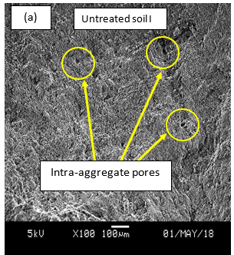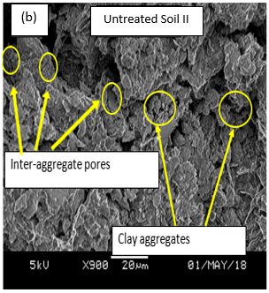

(a). SEM of untreated soil I (b). SEM of untreated soil II

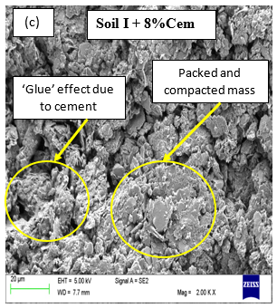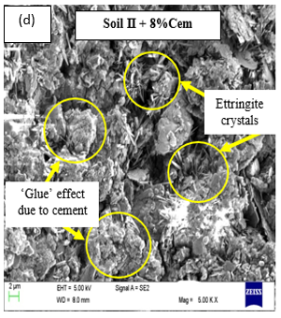

(c). SEM of untreated soil (d). SEM of soil treated with 8%Cem

**Fig. 7(a-d).** SEM of the untreated and cement treated soils

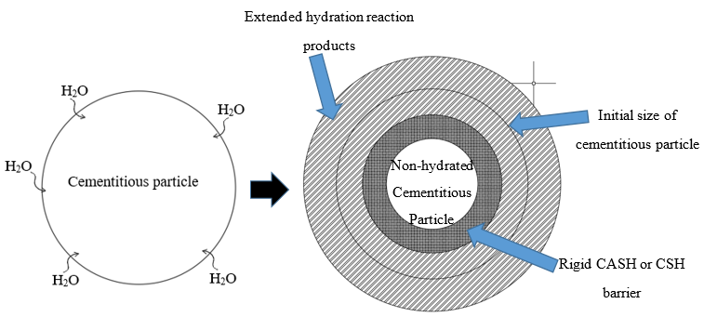

**Fig. 8.** Mechanism of stabilisation without RC

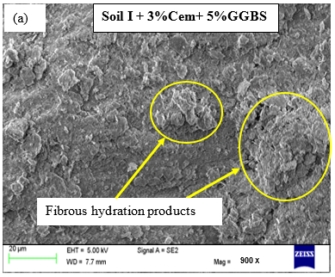 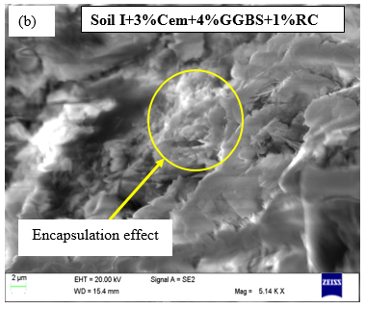

(a). SEM of soil treated with Cem/GGBS (b). SEM of soil treated with Cem/GGBS/RC

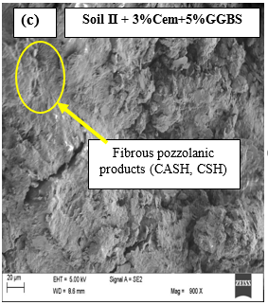 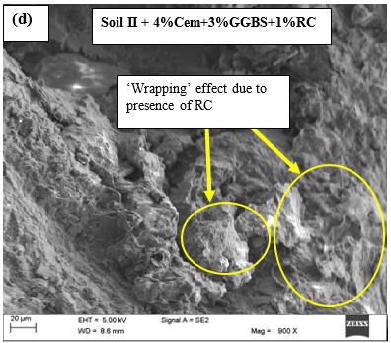

(c). SEM of soil treated with Cem/GGBS (d). SEM of soil treated with Cem/GGBS/RC

**Fig. 9(a-d).** SEM of the treated soils

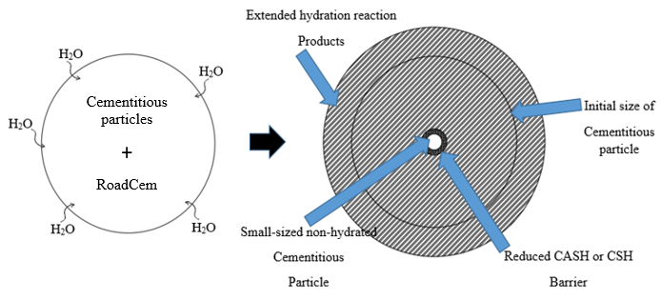

**Fig. 10.** Mechanism of stabilisation with the inclusion of RC

3.4 Swell Potential of the treated soils

The 1-D oedometer test was utilized to study the swell potential of the soil mixtures treated with cement, GGBS PFA and RC to determine the extent of swell after treatment in comparison with the recommendation of the Ohio Department of transport, U.S. The effect of reduced cement content and incorporation of GGBS, PFA and RC was investigated after 7days of curing period. The results revealed a reduction in swell for both soils compared to the untreated soils irrespective of the additive type or combinations as shown in Fig. 11(a and b). The acceptable limits of expansion for untreated and treated soils may vary depending on the country. For example, the French standard [68] suggests a minimum of 5% swell as an acceptable limit for construction while the Ohio Department of transport, U.S. [69] recommends swell of 1.5% for chemically treated soils. Soil I and soil II treated with cement meets the requirements above. However, the present study shows that for the treated soils, the replacement of cement by up to 50% in the mixes and the inclusion of by-product materials (GGBS and PFA) resulted to a significant reduction in swell potential below the recommended values for swelling of treated soils. This signifies a huge success in the application of 1% of nano additive-based material (RC) in stabilisation of clay soils in combination with 4% of cement and 3% of by-product materials (GGBS and PFA).

(a). Swell percent of treated soil I (b). Swell percent of treated soil II

**Fig. 11(a-b).** Swell potentials of the treated soils

3.5 Typical undrained shear strength requirement

In road base construction, RC additive has been mixed with in-situ soils, cement and water to increase strength and stiffness of stabilised clays to reduce the amount of swell and shrinkage of the stabilised clay, [36]. As earlier stated, the main focus of the present study was to investigate the possible reduction in the amount of cement used in combination with RC additive for stabilisation of clay soils. Following the results obtained from the present study, the undrained shear strength of the stabilised clay (soil I) stabilised with 8%cement increases from 0.24MPa to 0.55MPa after curing for 7 and 28 days respectively, but for soil II, the undrained shear strength increases from 0.57MPa to 0.81MPa. However, after 50% reduction in cement content and inclusion of 3%GGBS and 1%RC, the undrained shear strength of the treated clays increases from 0.45MPa to 0.6MPa for soil I, and 0.58MPa to 0.74MPa for soil II after 7- and 28-days curing period respectively. The standard guide for evaluation of the effectiveness of binders used in soil stabilisation as contained in ASTM D4609-08 [66], sets a minimum target of undrained shear strength of 0.17 MPa for treatment to be considered as effective. Comparing the minimum target of undrained shear strength with the values obtained from the present study, it shows that the undrained shear strength of the stabilised clays can find a range of application in civil engineering activities such as in road constructions. Table 3 presents the strength criteria for soil-cement mixtures for use in road pavement base and sub base layers according to the U. S. Army Corps of Engineers and the American Concrete Institute (ACI), [66, 67]. Table 3 shows that the mix combination comprising of 4%CEM+3%GGBS+1%RC is suitable for stabilisation of road sub-base and subgrade materials for rigid pavements under light and heavy traffic based on the 28-day undrained shear strength values of the stabilised clays. It has been said that if the selected samples strength does not meet the recommended strength values, then higher cement contents may be added to the soil and strength test may be repeated till the strength values confirm to the requirements, [66]. Therefore, following the undrained shear strength values obtained from this study, it is recommended that higher cement and GGBS contents be investigated to establish a mixture composition comprising of p%CEM+q%GGBS+1%RC to meet the 7-day strength requirements as stated in Table 3, where p and q are the required amount of cement and GGBS respectively.

According to BS EN 16907-4:2018 [70], soils can be stabilised to for use as filling in narrow places (such as earthworks close to bridges, backfill to trenches, backfill around buried pipes) and for the construction of the lower layers in high embankments built with water sensitive soils susceptible to occasional flooding. For this purpose, the undrained shear strength of the stabilised soil should be in the range of 0.25 to 0.5 MPa after 28 days of curing following equal periods of moist curing and soaking [70]. This implies that the mix combination comprising of 4%CEM+3%GGBS+1%RC can also be used in the stabilisation of the lower layers in high embankments in areas where the hydrological conditions at the site show that the lower part of the embankment may experience flooding. The investigated mixture combination can also find application in the stabilisation of soils for filling in narrow places to introduce and confer permanent cohesion in the system of compacted fill in order to compensate for any localised region of inadequate compaction caused by the tight boundaries.

Table 3. Values of undrained shear strength and typical practical requirements and application

|  |  |  |
| --- | --- | --- |
| Soil used | CL (Soil I) | CH (Soil II) |
| Typical range of cement requirement (%) | 7 to 12 | 8 to 13 |
| Cement content used in the present study blended with 3%GGBS and 1%RC | 4 | 4 |
| Typical undrained shear strength requirement in (MPa) for moist cured samples (ACI) | 0.86 to 1.72 (7-day) | 0.69 to 1.38 (7-day) |
| 1 to 3.10 (28-day) | 0.86 to 2.1 (28-day) |
| Measured values of undrained shear strength from the present study in (MPa) for moist cured samples | 0.45 (7-day) | 0.58 (7-day) |
| 0.60 (28-day) | 0.74 (28-day) |
| Minimum 7-day Undrained shear strength (MPa) | | |
| Practical application of soil-cement mixtures | Flexible Pavement | Rigid Pavement |
| Base Course | 2.58 | 1.72 |
| Subbase or subgrade material | 0.86 | 0.69 |
| Construction of lower layers in high embankments (EN 16907-4:2018)  Filling in narrow places (BS EN 16907-4:2018) | 0.25 to 0.5 MPa after 28 days curing | |
|  |  |

**4. Conclusion**

The experimental study on the use of RC blended with by-product cementitious materials for stabilisation of clay soils has been investigated in terms of mechanical and microstructural characteristics of the treated soils. The study focused on the use of reduced amount of cement with RC blended with GGBS and PFA, and possible engineering applications. The experimental testing and analysis was mainly on the stress-strain behaviour, undrained shear strength, swell potential, stabilisation mechanism and microstructural characteristics of the treated soils.

* The study on the stress-strain behaviour of the treated soils show that the inclusion of 1% of RC to the mixtures containing up to 4% of cement and up to 5% of GGBS or PFA, changes the behaviour of the treated soils from ductile to brittle response with peak stress occurring at low strain values due to increased hydration and cementation effect.
* The undrained shear strength of the treated soils after 28days, increases as the cement content in the mixtures increases from 3% to 8% as expected due to the formation of C‑S‑H gel and the binding of the material particles together.
* The partial replacement of cement from 8% to 4% in the mixtures and the inclusion of 3-5% of GGBS and 1% of RC causes deeper penetration and breakage of the CSH or CASH barrier and evokes further reaction of the cementitious materials leading to the formation of a treated soil matrix with interlocking filaments.
* The microstructural characteristics of the Cement/GGBS treated soils showed a change in stabilisation mechanism, from glue to a wrapping effect due to the extended crystallisation process caused by the presence of the nanotechnology-based additive (RC).
* The partial replacement of cement from 8% to 4% and the inclusion of 3-5% of GGBS and 1% of RC reduces the swell potential of the treated soils up to 1.5% swell due to cementation effect and the formation of fibrous pozzolanic products and hence, meeting the acceptable limit of 1.5% swell according to the Ohio Department of transport, U.S.
* This study has also revealed that cement/GGBS mixtures and 1% of RC can be incorporated in stabilisation of soils for construction purposes as an efficient and environmentally friendly approach to soil stabilisation.

**CRediT authorship contribution statement**

**Samuel J. Abbey:** Conceptualization, Methodology, Investigation, Writing - original draft, Writing - review & editing **Eyo U. Eyo:** Investigation, Writing - review & editing **Chukwueloka A.U. Okeke**: Writing - review & editing, Visualization **Samson Ngambi**: Writing - review & editing, Visualization, Supervision.

**Declaration of Competing Interest**

The authors declare that they have no known competing financial interests or personal relationships that could have appeared to influence the work reported in this paper.

**Acknowledgements**

This research did not receive any specific grant from funding agencies in the public, commercial, or not-for-profit sectors.

**Reference**

[1] J.D. Nelson, D.J. Miller, Expansive soils: Problems and practice in foundation and pavement engineering, John Wiley & Sons, Inc, 1992.

[2] G.K. Moses, A. Saminu, Cement Kiln Dust stabilization of compacted black cotton soil, Electron. J. Geotech. Eng. 17 F (2012) 825–836.

[3] S.J. Abbey, E.U. Eyo, S. Ng’ambi, Swell and microstructural characteristics of high-plasticity clay blended with cement, Bull. Eng. Geol. Environ. 79 (2019) 2119–2130. https://doi.org/https://doi.org/10.1007/s10064-019-01621-z.

[4] E.U. Eyo, S. Ng’ambi, S.J. Abbey, Effect of intrinsic microscopic properties and suction on swell characteristics of compacted expansive clays, Transp. Geotech. 18 (2019) 124–131. https://doi.org/10.1016/j.trgeo.2018.11.007.

[5] E.U. Eyo, S. Ng’ambi, S.J. Abbey, Performance of clay stabilized by cementitious materials and inclusion of zeolite/alkaline metals-based additive, Transp. Geotech. 23 (2020) 100330. https://doi.org/10.1016/j.trgeo.2020.100330.

[6] Z. Nalbantoglu, E.R. Tuncer, Compressibility and hydraulic conductivity of a chemically treated expansive clay, Can. Geotech. J. 38 (2001) 154–160.

[7] S. Horpibulsuk, N. Miura, D.T. Bergado, Undrained Shear Behavior of Cement Admixed Clay at High Water Content, J. Geotech. Geoenvironmental Eng. 130 (2004) 1096–1105. https://doi.org/10.1061/(ASCE)1090-0241(2004)130:10(1096).

[8] A.A. Al-Rawas, A.W. Hago, H. Al-Sarmi, Effect of lime, cement and sarooj (artificial pozzolan) on the swelling potential of an expansive soil from Oman, Build. Environ. 40 (2005) 681–687.

[9] A. Seco, F. Ramírez, L. Miqueleiz, B. Garci, E. Prieto, The use of non-conventional additives in Marls stabilization, Appl. Clay Sci. 51 (2011) 419–423. https://doi.org/10.1016/j.clay.2010.12.032.

[10] T.D. Tran, Y.J. Cui, A.M. Tang, M. Audiguier, R. Cojean, Effects of lime treatment on the microstructure and hydraulic conductivity of Héricourt clay, J. Rock Mech. Geotech. Eng. 6 (2014) 399–404. https://doi.org/10.1016/j.jrmge.2014.07.001.

[11] M. Khemissa, A. Mahamedi, Cement and lime mixture stabilization of an expansive overconsolidated clay, Appl. Clay Sci. 95 (2014) 104–110.

[12] S.J. Abbey, S. Ng’ambi, E. Ganjian, Development of strength models for prediction of unconfined compressive strength of cement/by-product material improved soils, Geotech. Test. J. 40 (2017) 928–935. https://doi.org/10.1520/GTJ20160138.

[13] E.U. Eyo, S. Ngambi, S.J. Abbey, Investigative modelling of behaviour of expansive soils improved using soil mixing technique., Int. J. Appl. Eng. Res. 12 (2017) 3828–3836.

[14] E.U. Eyo, S. Ngambi, S.J. Abbey, Investigative study of behaviour of treated expansive soil using empirical correlations, in: Int. Found. Congr. Equip. Expo 5-10 March, Orlando, Florida, 2018: pp. 373–384.

[15] N.C. Consoli, D. Winter, A.S. Rilho, L. Festugato, B. dos S. Teixeira, A testing procedure for predicting strength in artificially cemented soft soils, Eng. Geol. 195 (2015) 327–334. https://doi.org/10.1016/j.enggeo.2015.06.005.

[16] O. Caraşca, Soil Improvement by Mixing: Techniques and Performances, Energy Procedia. 85 (2016) 85–92. https://doi.org/10.1016/j.egypro.2015.12.277.

[17] D. Higgins, Briefing: GGBS and sustainability, Proc. Inst. Civ. Eng. - Constr. Mater. 160 (2007) 99–101. https://doi.org/10.1680/coma.2007.160.3.99.

[18] J. Olivier, J. Peters, Trendas in global CO2 and total greenhouse gas emissions, 2018. https://doi.org/https://www.pbl.nl/sites/default/files/cms/publicaties/pbl-2017-trends-in-global-co2-and-total-greenhouse-gas-emissons-2017-report_2674.pdf.

[19] European Commission, Reference Document on Best Available Techniques in Cement , Lime and Magnesium Oxide Manufacturing Industries, (2010) 459.

[20] CEM-Bureau, Worldwide percentage cement production in year 2017 by country and region, Eur. Cem. Assoc. (2017). https://cembureau.eu/media/1828/world-cement-producers-graph.png.

[21] B.J. Van Ruijven, D.P. Van Vuuren, W. Boskaljon, M.L. Neelis, D. Saygin, M.K. Patel, Long-term model-based projections of energy use and CO2 emissions from the global steel and cement industries, Resour. Conserv. Recycl. 112 (2016) 15–36. https://doi.org/10.1016/j.resconrec.2016.04.016.

[22] G.N. Obuzor, J.M. Kinuthia, R.B. Robinson, Utilisation of lime activated GGBS to reduce the deleterious effect of flooding on stabilised road structural materials: A laboratory simulation, Eng. Geol. 122 (2011) 334–338. https://doi.org/10.1016/j.enggeo.2011.06.010.

[23] E. Celik, Z. Nalbantoglu, Effects of ground granulated blastfurnace slag (GGBS) on the swelling properties of lime-stabilized sulfate-bearing soils, Eng. Geol. 163 (2013) 20–25.

[24] E. Ganjian, G. Jalull, H. Sadeghi-Pouya, Using waste materials and by-products to produce concrete paving blocks, Constr. Build. Mater. 77 (2015) 270–275. https://doi.org/10.1016/j.conbuildmat.2014.12.048.

[25] A. Al-Swaidani, I. Hammoud, A. Meziab, Effect of adding natural pozzolana on geotechnical properties of lime-stabilized clayey soil, J. Rock Mech. Geotech. Eng. 8 (2016) 714–725. https://doi.org/10.1016/j.jrmge.2016.04.002.

[26] A.K. Sharma, P. V. Sivapullaiah, Swelling behaviour of expansive soil treated with fly ash–GGBS based binder, Geomech. Geoengin. (2016) 1–10.

[27] A. Behnood, Soil and clay stabilization with calcium- and non-calcium-based additives: A state-of-the-art review of challenges, approaches and techniques, Transp. Geotech. 17 (2018) 14–32. https://doi.org/10.1016/j.trgeo.2018.08.002.

[28] K. Yao, W. Wang, N. Li, C. Zhang, L. Wang, Investigation on strength and microstructure characteristics of nano-MgO admixed with cemented soft soil, Constr. Build. Mater. 206 (2019) 160–168. https://doi.org/10.1016/j.conbuildmat.2019.01.221.

[29] O. Amini, M. Ghasemi, Laboratory study of the effects of using magnesium slag on the geotechnical properties of cement stabilized soil, Constr. Build. Mater. 223 (2019) 409–420. https://doi.org/10.1016/j.conbuildmat.2019.07.011.

[30] S.J. Abbey, A.O. Olubanwo, Strength and hydraulic conductivity of cement and by-product cementitious materials improved soil, Int. J. Appl. Eng. Res. 13 (2018) 8684–8694.

[31] R. Mohamad, I. Norsalisma, J.M. Kinuthia, Strength and environmental evaluation of stabilised Clay-PFA eco-friendly bricks, Constr. Build. Mater. 125 (2016) 964–973. https://doi.org/10.1016/j.conbuildmat.2016.08.114.

[32] D. Higgins, Soil stabilisation with ground granulated blastfurnace slag, UK Cem. Slag Makers Assoc. (2005) 1–15. http://www.ukcsma.co.uk/files/csma_report_on_soil_stabilisation.pdf.

[33] P. Ghadir, N. Ranjbar, Clayey soil stabilization using geopolymer and Portland cement, Constr. Build. Mater. 188 (2018) 361–371. https://doi.org/10.1016/j.conbuildmat.2018.07.207.

[34] S. Wild, J.M. Kinuthia, G.I. Jones, D.D. Higgins, Suppression of swelling associated with ettringite formation in lime stabilized sulphate bearing clay soils by partial substitution of lime with ground granulated blastfurnace slag, Eng. Geol. 51 (1999) 257–277. https://doi.org/10.1016/S0013-7952(98)00069-6.

[35] S.J. Abbey, S. Ngambi, A.O. Olubanwo, Effect of overlap distance and chord angle on performance of overlapping soil-cement columns, Int. J. Civ. Eng. Technol. 8 (2017) 627–637.

[36] D. Ventura, T. Koloane, Laboratory evaluation of PowerCem blend to determine its suitability as a road building material stabilizer, Zwijndrecht, The Netherlands, 2005.

[37] P. Marjanovic, C.E.. Egyed, P. de La Roij, The road to the future: Manual for working with RC, 2009. https://doi.org/10.12968/johv.2014.2.10.569.

[38] R. Montero, R. Baneros, P. Lakerveld, W. Veerbeek, Macro-economic effects of using the PowerCem technology on road infrastructure in flood risk areas, PowerCem Technologies B.V, 2012.

[39] J. Blass, Environmental impact comparison conventional road construction and RC constructions, 2017.

[40] P. Wu, Cement Stabilized Materials with Use of RC Additive, Beijing Jiaotong University, 2015. https://doi.org/10.1021/es305007w.

[41] P. Wu, Cement-bound road base materials, 2011.

[42] M.S. Ouf, Effect of using pozzolanic materials on the properties of Egyptian soils, Life Sci. J. 9 (2012) 554–560.

[43] Malvern, Mastersizer 2000 essentials user manual, (2007).

[44] Ouhadi, R. Yong, M. Amiri, M. Ouhadi, Pozzolanic consolidation of stabilized soft clays, Appl. Clay Sci. 95 (2014) 111–118. https://doi.org/10.1016/j.clay.2014.03.020.

[45] B.. PowerCem Technologies, Manual for laboratory research RCTM, (2015) 1–39.

[46] D. Faux, Stabilising the future of working platforms, University of Birmingham, 2015.

[47] A.K. Jha, P. V. Sivapullaiah, Susceptibility of strength development by lime in gypsiferous soil-A micro mechanistic study, Appl. Clay Sci. 115 (2015) 39–50. https://doi.org/10.1016/j.clay.2015.07.017.

[48] P. Jamsawang, N. Nuansrithong, P. Voottipruex, S. Songpiriyakij, Laboratory investigations on the swelling behavior of composite expansive clays stabilized with shallow and deep clay-cement mixing methods, Appl. Clay Sci. 148 (2017) 83–94. https://doi.org/10.1016/j.clay.2017.08.013.

[49] S.A.A. Khattab, J. Fleureau, Long-term stability characteristics of a lime-treated plastic soil., J. Mater. Civ. Eng. 19 (2007) 358–366.

[50] A.H.M. Kamruzzaman, S.H. Chew, F.H. Lee, Structuration and Destructuration Behavior of Cement-Treated Singapore Marine Clay, J. Geotech. Geoenvironmental Eng. 135 (2009) 573–589. https://doi.org/10.1061/(ASCE)1090-0241(2009)135:4(573).

[51] B.R. Phanikumar, T.V. Nagaraju, Engineering behaviour of expansive clays blended with cement and GGBS, Proc. Inst. Civ. Eng. Gr. Improv. 171 (2018) 167–173. https://doi.org/10.1680/jgrim.17.00054.

[52] W. lu Zhang, B.A. McCabe, Y. hui Chen, T.J. Forkan, Unsaturated behaviour of a stabilized marine sediment: A comparison of cement and GGBS binders, Eng. Geol. 246 (2018) 57–68. https://doi.org/10.1016/j.enggeo.2018.09.020.

[53] E. Mengue, H. Mroueh, L. Lancelot, R. Medjo Eko, Physicochemical and consolidation properties of compacted lateritic soil treated with cement, Soils Found. 57 (2017) 60–79. https://doi.org/10.1016/j.sandf.2017.01.005.

[54] G. Sarkar, M. Islam, Study on the Geotechnical Properties of Cement based Composite Fine-grained Soil, Int. J. Adv. Struct. Geotech. Eng. 01 (2012). http://www.basharesearch.com/IJASGE/1010202.pdf.

[55] B.S.R. Kaniraj, V.G. Havanagi, Behaviour of cement-stabilized fibre-reinforced fly ash-soil mixtures, J. Geotech. Geoenvironmental Eng. 127 (2001).

[56] Z. Wu, Y. Deng, S. Liu, Q. Liu, Y. Chen, F. Zha, Strength and micro-structure evolution of compacted soils modified by admixtures of cement and metakaolin, Appl. Clay Sci. 127–128 (2016) 44–51. https://doi.org/10.1016/j.clay.2016.03.040.

[57] S. Horpibulsuk, R. Rachan, A. Chinkulkijniwat, Y. Raksachon, A. Suddeepong, Analysis of strength development in cement-stabilized silty clay from microstructural considerations, Constr. Build. Mater. 24 (2010) 2011–2021. https://doi.org/10.1016/j.conbuildmat.2010.03.011.

[58] S. Pourakbar, A. Asadi, B.B.K. Huat, M.H. Fasihnikoutalab, Stabilization of clayey soil using ultrafine palm oil fuel ash (POFA) and cement, Transp. Geotech. 3 (2015) 24–35. https://doi.org/10.1016/j.trgeo.2015.01.002.

[59] F. Sariosseiri, B. Muhunthan, Effect of cement treatment on geotechnical properties of some Washington State soils, Eng. Geol. 104 (2009) 119–125. https://doi.org/10.1016/j.enggeo.2008.09.003.

[60] S. Por, S. Nishimura, S. Likitlersuang, Deformation characteristics and stress responses of cement-treated expnsive clay under con fi ned one-dimensional swelling, Appl. Clay Sci. 146 (2017) 316–324. https://doi.org/10.1016/j.clay.2017.06.022.

[61] M. Suzuki, T. Fujimoto, T. Taguchi, Peak and residual strength characteristics of cement-treated soil cured under different consolidation conditions, Soils Found. 54 (2014) 687–698. https://doi.org/10.1016/j.sandf.2014.06.023.

[62] N. Latifi, A.S.A. Rashid, S. Siddiqua, S. Horpibulsuk, Micro-structural analysis of strength development in low- and high swelling clays stabilized with magnesium chloride solution - A green soil stabilizer, Appl. Clay Sci. 118 (2015) 195–206. https://doi.org/10.1016/j.clay.2015.10.001.

[63] M. Mirzababaei, S. Yasrobi, Assessment of Clay Soil Fabric Using Scanning Electron Microscope, in: First Srilankan Geotech. Soc. Int. Conf. Soil Rock Eng. 7-11 August, Colombo, Sri Lanka, 2007.

[64] M.S. Ouf, Stabilisation of clay subgrade soils using ground granulated blastfurnace slag. PhD Thesis, School of Civil Engineering University of Leeds, 2001.

[65] S. Wild, Effects of Ground Granulated Blast Furnace Slag (GGBS) on the Strength and Swelling Properties of Lime-Stabilized Kaolinite in the Presence of Sulphates, Clay Miner. 31 (1996) 423–433. https://doi.org/10.1180/claymin.1996.031.3.12.

[66] S. Rahimi-Aghdam, Z.P. Bažant, M.J. Abdolhosseini Qomi, Cement hydration from hours to centuries controlled by diffusion through barrier shells of C-S-H, J. Mech. Phys. Solids. 99 (2017) 211–224. https://doi.org/10.1016/j.jmps.2016.10.010.

[67] E.U. Eyo, S. Ng’ambi, S.J. Abbey, Incorporation of a nanotechnology-based additive in cementitious products for clay stabilisation, J. Rock Mech. Geotech. Eng. (2020). https://doi.org/10.1016/j.jrmge.2019.12.018.

[68] N.P. 94–100 Association Française de Normalisation, Soils: Investigation and testing—Lime and/or hydraulic binder treated materials—Test for determining the treatment ability of soil, (1999).

[69] S. 1120 Ohio Department of transport, Mixture design for chemically stabilized soils, (2011) 1–7.

[70] CEN (European Committee for Standardization) (2018) EN 16907- 4:2018: Earthworks. Soil treatment with lime and/or hydraulic binders. CEN, Brussels, Belgium.