Network Survival Strategies of Migrant Entrepreneurs in Large Cities
Analysis of Albanian Firms in Milan

Abstract

This paper addresses the role of cultural bias (preference for what is culturally more akin) in the entrepreneurial choice regarding different types of social networks in the context of urban mixed embeddedness. We test empirically the presence and aftermaths of this cultural bias, drawing on evidence from a natural experiment with regard to Albanian ethnic entrepreneurs in the city of Milan, Italy. Namely, these entrepreneurs are exposed to the same mixed urban embeddedness and, when we control for firm characteristics, the only discriminating component explaining their success is their choice of social network. We focus on the choice over three types of social networks, classified according to varying degrees of cultural distance between the network and the entrepreneur: (a) the indigenous population, (b) the local Albanian diaspora, and (c) fellow citizens residing in the country of origin, Albania (i.e., transnational networking). We employ a novel method for reverse engineering of preferences for networking by using a Kaplan-Meier estimator and a propensity-score matching technique. We find that strategic network liaisons with locals is actually the most beneficial social network for ethnic firm performance. However, it is social networking within the culturally closer local Albanian diaspora that is the most common behavior.

Keywords: networks, social capital, mixed embeddedness, home bias, transnational networking ethnic entrepreneurship
JEL classification: Z10, D81, L26, R11

Introduction
It is often celebrated that a wealth of networking opportunities might be present for an ethnic entrepreneur in the local context. The wealth of choice opportunities however, could be a danger in disguise, as the wrong choice might easily be made (Iyengar and Lepper 2000; Frank and Lamiraud 2009). This is especially likely to happen when the choice needs to be made under time constraints and emotional pressures due to uncertainties arising from the particular cultural context (Tversky and Shafir 1992; Kahneman 2011). While the latter two insights are nowadays well-established pieces of knowledge in behavioural economics, the field of entrepreneurship has not yet fully adopted this knowledge to its domain. In particular, the entrepreneurship literature has not employed these behavioural economics insights with regard to the entrepreneurial choice of social networks in the context of mixed embeddedness in a city.
Mixed embeddedness is an entrepreneurship concept which builds on the main premise that firms operate in a state of being embedded in a rich context of institutions and networks, which they can tap on, in order to develop and grow. An extant literature has evolved on different types of social networks that entrepreneurs can exploit. First, the variety of choice options for social networks in a place was documented extensively (see Kloosterman, 2010; Kloosterman and Rath, 2001; Kloosterman et al., 1999; Kloosterman et al. 2016). Then, the field of transnational entrepreneurship highlighted the presence of networks extending beyond the immediate location of the firm, which also withholds pockets of opportunities, especially for ethnic entrepreneurs (Glick Schiller et al. 1992; Mahler 1998; Portes et al. 1999; Waldinger 2008; Ren and Liu 2015.
The study of such business networks has often paid some attention to the cultural background of the entrepreneur and the variety of networks, be it often in a partial manner. The cultural dimension has been taken into consideration either in the form of studying the effect of ethnic entrepreneurs and how they manage to integrate in a place, or how they maintain contact with the local diaspora, or how they maintain contact with their cultural roots and networks back home (Levitt et al. 2003; Gomez and Hasino 2004; Aviv and shneer 2005; Drori 2009; Pisani and Richardson 2012; Eijdenberg et al. 2019). The reasons for networking with each of these networks have also been well studied. The general findings are: the network with locals seems to provide better information about the local context (Schnell and Sofer, 2002; Ram and Jones, 2008); the diaspora may act as a safety belt and a buffer zone for threats in the foreign environment (Libertadore, 2018), and the networks abroad may provide information on opportunities which otherwise are unavailable for the recipient country of the ethnic entrepreneur (Murat et al., 2008; Barberis and Violante, 2017). In addition, the relevance of such functionally different networks has been documented in the literature leading to different outcomes for the firm (Zcan, 2006; Kariv et al., 2009; Klyver and Foley, 2012). The literature also shows that the same type of local network can be tapped on with varying success by different groups of local ethnic entrepreneurs (Fisman 2002). Thus, firms need to carefully invest their resources in networks that are most beneficial for the firm. This is the problem addressed in the present study.
A major gap in the extensive knowledgebase on options for social networking and their aftermaths is that the different options have never been studied in a comparative manner, which is only relevant to consider since the entrepreneurs must compare and choose how to use them. Mixed embeddedness rightly suggests that an ethnic entrepreneur is simultaneously embedded in all these types of networks, with their related aftermaths. However, we note that it needs to be recognized further that an entrepreneur has a limited time and resources, and can peruse in a more engaged manner only some of these networks. Therefore, a deliberate choice of a given network over another needs to be made based on comparing them on some common characteristics. Up to our knowledge, our study is the first one to address this gap in the literature by studying the strategic choice of one type of network over another in the context of mixed embeddedness.
The aim of our paper is, therefore, to study the impact of cultural bias on the strategic choice over different types of social networks in an ethnic business environment. These networks have a different degree of cultural proximity with the ethnic entrepreneur. From other strands of literature, such as the study of migration, trade and financial flows, we know that cultural proximity (or its opposite - cultural distance) causes a bias in human choice, usually termed ‘home bias’ (Parsons and Winters 2014). The essence of this bias is that people tend to choose what is culturally closer to them, indifferent of its objective advantages or disadvantages (Simon, 1955, 1956; Dodd and Patra, 2002; Andreosso-O’Callaghan and Lenihan, 2008; Webber et al., 2017; Szkudlarek and Wu, 2018). As the literature on entrepreneurship suggests that different types of networks generate a different impact on the performance of the entrepreneur, it is plausible that the presence of such a cultural bias in the choice over a social network may significantly impact the success or failure of an ethnic entrepreneur.
There already exists evidence that cultural distance,.between ethnic entrepreneurs and the indigenous population makes it harder to form successful network linkages between these two groups (Brown and Butler, 1993). We also know that ethnic entrepreneurs have certain perceptions and behaviors different from the local population, because there is a somewhat persistent cultural distance with the latter (Andreosso-O’Callaghan and Lenihan, 2008; Price and Chacko, 2009; Szkudlarek and Wu, 2018). Also, transnational networking may be hindered due to geographical distance with the original home country and the consecutive disconnections with its institutions and economic developments (Jack, Dodd and Anderson, 2008; Koning and Verver, 2013). Thus, cultural bias is likely to be present in the entrepreneurial choice of business networks of information.
Our study adds to the above literature in two important ways. Firstly, conceptually, we elaborate a theoretical explanation about the mechanisms of cultural bias behind the choice over different types of networks in the context of mixed embeddedness. Second, we device a novel methodological approach of reversely engineering the most often practiced preferences for networking by entrepreneurs, through inferring it from their revealed levels of success; we achieve this by using a unique combination of primary and secondary data and relevant statistical and econometric techniques.
To deliver these two contributions to the literature, we employ a natural experiment in which mixed embeddedness is actually a ceteris paribus state for all ethnic entrepreneurs considered. Namely, in our application, we draw on empirical evidence about Albanian ethnic entrepreneurs in the city of Milan, Italy. These entrepreneurs are exposed to the same mixed embeddedness and choose between three types of social networks, classified according to the degree of cultural distance between the network and the entrepreneur as networks with: (a) the indigenous population, (b) the local Albanian diaspora, and (c) fellow citizens residing in the country of origin, Albania (i.e., transnational networking). We introduce our novel reverse engineering procedure combining primary and secondary data about small Albanian entrepreneurs, which allows us to learn the difference between preferred and chosen social network, mapped against the aftermaths of these preferences and choice. This procedure entails three steps: (i) to identify the preferred type of network through questionnaires from the entrepreneurs and (ii) to understand the relationship between type of network and firm success (quantified alternatively in terms of turnover and number of employees), and then, (iii) by using the official city statistics, to infer from the average firm success, which is the most often used type of social network among these entrepreneurs. Statistically, this procedure employs Kaplan-Meier estimator and a propensity-score matching technique. We find that strategic network liaisons with locals is the most beneficial social network for ethnic firm performance. Nevertheless, it is social networking within the local Albanian diaspora that is the most common behavior. We interpret this finding as a case of ‘home bias’, where the ethnic entrepreneurs adopt a culturally introvert choice which causes economic underperformance. In addition, we find that cultural proximity determines the network preference, but geographical proximity rules over cultural proximity when transnational networking is compared to networking with one’s diaspora in the host country.
The structure of our study is as follows. Section 2 provides a concise overview of the literature on: (i) mixed embeddedness and ethnic entrepreneurs, (ii) social networks and ethnic entrepreneurs, and (iii) the role of home bias (i.e. cultural bonds and cultural preferences) of ethnic entrepreneurs over social networks in a mixed embeddedness context. It also offers an overview of findings from some previous case studies about Milan. Section 3 presents our research methodology, data and estimation strategy. Next, Section 4 provides the estimation results, while Section 5 contains a detailed discussion on the results. Finally, Section 5 lists some concluding remarks, outlines limitations, and suggests policy implications of our findings.

Ethnic Entrepreneurship: Mixed-Embeddedness, Social Networks and Cultural Bias

Ethnic Entrepreneurship and Mixed Embeddedness – A Complex Choice

Ethnic entrepreneurs in a foreign environment exist in a state of embeddedness in a variety of social networks, known as mixed embeddedness. The mixed embeddedness paradigm was developed in order to understand the rather complex system of networks, opportunity structures and institutions in which the (ethnic) entrepreneurial choice is situated and by which their entrepreneurial success is determined. It serves to better understand the role of the different levels of the context and the power of local demand. Thus, mixed embeddedness operates on top of the neo-classical model of profit-driven rational entrepreneurs who seize the business opportunities efficiently in a self-regulated clearing market able to achieve a balanced economic situation (Kloosterman et al. 1999; Kloosterman and Rath 2001; Kloosterman, 2010).
The relationship between such business networks and mixed embeddedness can be summarized in three groups of insights. First, it is necessary to recognize the strategic importance of knowledge transmitted through networks with regard to innovation and with regard to the information about the opportunities and institutional support for people from a non-mainstream cultural background (Lorentzen, 2008; Klyver and Foley, 2012; Cheng and Li 2012; Beckers and Blumberg 2013; Acs, Audretsch and Lehmann 2013). Second, the ethnic entrepreneurs’ social networks evolve over time (Jack, Dodd and Anderson, 2008; Koning and Verver, 2013). Third, there is a cultural heterogeneity expressed in: multiculturalism of networks, transnationalism in terms of the localities they connect to, individual heterogeneity among ethnic entrepreneurs as decision makers, and the quantitative and qualitative dimensions of the networks (in terms of density and personal sympathy between network members) (Arrighetti, Bolzani and Lasagni, 2014; Salaff et al. 2003; Kariv et al., 2009; Jones, Ram and Theodorakopoulos, 2010; Bagwell, 2015; Brown and Butler, 1993). The complex mixed embeddedness system of critical success factors demonstrates that networks cannot account for every aspect of the ethnic entrepreneurial success (Besser and Miller, 2011).
However, having so much interdependent dynamics happening simultaneously and so many important aspects of networks themselves makes it difficult to distinguish to what degree the strategic choice over a network actually plays at all a role, ceteris paribus (Nijkamp 2007). Yet, the complexity is fairly similar for the same group of ethnic entrepreneurs located at the same place. This means that the whole complexity for them can be statistically treated as a constant, and thus they can be effectively studied to understand empirically which network is indeed preferred and what is the comparative impact from choosing one network over another.
Moreover, from behavioural economics we know that complex choices represent a big challenge for human cognition. Increased number of choice options can have adverse effects, since it increases the complexity for choice, creates uncertainty as to what to choose, and thus disrupts the decision-making process (Tversky and Shafir 1992). Widely known studies in behavioural economics have documented that increased options for choice do not only make people less prone to make a decision at all, but also the decisions made often end up to be more disadvantageous for the individuals than it would have been in a simpler setting for choice. For example, an experimental study by Iyengar and Lepper (2000) shows that students invited to undertake a voluntary assignment were more likely to agree to undertake the assignment when offered 6 possible topics rather than 30 topics. Most importantly, those with the wider number of options for choice performed worse, delivering poorer essays. These findings suggest that when faced with a richer set of choice options, the students could not choose carefully enough the topic for their essay, and felt more uncertain about their choice after making it, this resulting in their poorer performance. Similarly, Frank and Lamiraud (2009) studies the Swiss health insurance market and found that the greater the choice of funds, the lower the number of people who ventured to use the funds, although the economic gain was always one and the same. There is a wealth of evidence that has amounted in behavioural economics about biases under increasing complexity of choice. But this knowledge has not yet been incorporated in the case of choice over social networks. Furthermore, the complexity of choice may trigger many different types of bias in the choice and the use of shortcuts for choice, termed heuristics (Kahneman 2011). Our main claim in this study is that the cultural bias is pivotal in the complex choice by an ethnic entrepreneur over social networks, and cultural proximity/distance is the heuristics on which it operates. The literature on which this argument is based is elaborated in the two subsections below.

2.2 Types of Networks to Choose from
Which types of social networks exist to be chosen from in a fixed (constant) mixed-embeddedness context and why do entrepreneurs choose to use them? Social networking is widely used by all individuals,is as it endows the them with social capital. Social capital is defined by Putnam (1994, 2000) as the connectivity between people and is required to form social networks. But objectively, a migrant is likely to be an individual who is less connected, is less embedded within the host country, has less local relationships and social networks, and is therefore in a more precarious position than an incumbent person (Dodd and Keles, 2015). Therefore, ethnic entrepreneurs are likely to require even more network linkages and social capital than local people in order to survive and flourish.
Specifically, it has been noted in the literature that the size of local diasporas is positively associated with the self-employment attributes of immigrants (Brown and Butler, 1993; Battisti et al., 2016). Some recent literature has also touched on the different patterns of network formation within the diaspora itself (Epstine and Heizler, 2016). A convincing illustrative insight into the importance of informal networks is provided by Kloosterman, Van Der Leun and Rath (1998, 1999) and more recently by Moyo (2014). Yet, to the best of our knowledge, there is no existing body of quantitative evidence-based literature on the immigrants’ comparative propensity for using different types of networks and on the importance of this for the success of the ethnic entrepreneur.
According to the literature, the three types of social networks most typical to be used by ethnic entrepreneurs in a modern mixed embeddedness context are: (i) local indigenous networks, (ii) local diaspora networks and (iii) networks with the homeland (transnational networks).
Local indigenous networks are supposed to be highly beneficial for the ethnic entrepreneur, since they compensate for the lack of tacit knowledge of the incoming decision maker on the local market (see for example Baycan-Levent et al. 2003; Acs, Audretsch and Lehmann 2013). Therefore, more diverse and open local milieus are likely to generate better success opportunities for ethnic entrepreneurs (see Tubadji and Nijkamp 2014, 2015).
Local diaspora networks are conceptualized and documented empirically to act as a buffer to segregation of immigrants, acting as a safety net and a self-employment alternative when faced with labour market discrimination in the host country (Salaff et al. 2003). The local diaspora is often documented to be a positive factor for the ethnic entrepreneur by facilitating the access to resources and markets, especially for producers of ethnic goods (Kitching et al. 2009). Occasionally, diasporas act as hedging mechanisms by supporting their members from the decisions of the local majority (see, for example, Liberatore 2018).
Networks with the homeland (transnational networks) are also known in the literature as a prominent type of ethnic entrepreneurship linkage that traverses national contexts. This tendency is called generally ‘transnationalism’, and is defined as the presence of migrants “who retain ties to their homeland” (Mahler, 1998:72). While initially contested in terms of its existence and frequency of occurrence (Waldinger 2008), recently various instances of transnationalism in entrepreneurial activity have been widely documented (see for example Pisani and Richardson 2012; Ren and Liu 2015). The impact from the networks with the homeland have been shown to be very helpful in contributing to the economic performance in the country of settlement. For instance, Chinese immigrants could not have contributed so significantly to the local textile industry during its decline in Italy, if it were not for their connection with China (Murat et al. 2008; Barberis and Violante 2017). Additionally, it is found that Chinese multinationals locate in places where there are higher concentrations of Chinese diaspora (Karreman, Burger and Van Oort, 2017). Similar evidence exists about international trade and FDI flows which are directed to places where local ethnic diaspora exist (Murat et al. 2008; Fassio 2015). Then, networking with a homeland can also be expected to produce a positive effect on the ethnic diaspora and on the ethnic entrepreneurs themselves due to new opportunities for business activity and opportunities for regular employment in multinationals. However, the network connecting with a homeland is clearly geographically more distant and less oriented towards the challenges in the immediate surrounding of the ethnic entrepreneur. Thus, the sign of the effect of transnational networking on ethnic entrepreneurship remains an empirical question.
We contribute to this literature by addressing the complex choice between these types of networks in a comparative manner. As a basis for comparison, we use the different cultural distance that characterizes each type of network. Namely, we argue that these three networks have a distinct cultural distance, since: (i) the diaspora is ethnically and contextually similar to the ethnic entrepreneur; (ii) the local incumbent networks share the context, but not the ethnicity; (iii) the compatriots at home share only the ethnicity, but not the immediate cultural milieu and context of the ethnic entrepreneur in Milan. The following section explains why cultural distance can be expected to act as an important basis for comparison of these choice options over type of social network.

2.3 Cultural ‘Home Bias‘ in the Entrepreneurial Choice for Networks under Mixed Embeddedness
Home bias originated as a term in the trade literature to signify the cultural-proximity driven preference for trade partners and international financial investment destinations (see, for example, Tadesse and Shukralla, 2013; Parsons and Winters, 2014). The essence of this bias is that cultural distance between the agent and the options for choice lead to the prioritization of options for choice that are culturally closer.
There is evidence that home bias does also affect the ethnic entrepreneurs’ patterns in a wide spectrum of their decisions: from choosing their trading destinations (Rauch and Trindade 2002) to their patterns of practicing social responsibility (Azmat 2010). We assume here that the same type of home bias occurs in making a strategic choice over which network is preferred, since different networks have a different cultural distance from the entrepreneur. This is the home or cultural bias we will capture in our analysis. It is likely to vary among individuals, but it is relatively predictable in its variation across countries, ethnicities or other cultural groupings (see Desmet, Ortuño-Ortín, and Wacziarg 2017).
How can we expect that home bias operates in the case of ethnic entrepreneurs and their choice over a social network in the context of mixed embeddedness? The three types of networks possess different cultural proximity with the ethnic entrepreneur and are known to contribute towards a different form of success by the firm (Abduleev et al. 2014; Karreman, Burger and Van Oort, 2017; Kloosterman et al. 1999). Therefore, we argue that the mixed embeddedness in different social networks does not represent some unlimited potential for networking. In an increased complexity of choice and under the natural pressure of a time constraint (see Brown and Butler, 1993; Kariv et al., 2009), the lack of cultural proximity with one entity and the presence of cultural proximity with another entity can result into a salient marker (or heuristics) for a fast selection for choice. Essentially, cultural proximity might be elevated to a strategic rule for choice. Such choices may be crucial for the success of the firm and the entrepreneur (Ren and Liu 2015).
Most importantly, when choosing in which network to invest one’s limited time, ethnic entrepreneurs are likely to underweight the objective usefulness of the networks, and to give priority to their bias towards the cultural characteristics of the networks. In our global world, agents live in a context of growing local cultural diversity with contested impact on local development (Alesina and La Ferrara 2005; Agera and Brückner 2013; Beugelsdijk et al. 2019) and therefore, the networks we are embedded in are also culturally different from each other. So, a clear salient cultural and geographic distance as a marker distinguishing the three types of networks provides a solid empirical foundation of the choice of the entrepreneur over the three options at stake. Due to this salient cultural difference, the strategic choice by an entrepreneur might not be rational but culturally biased, since ethnic entrepreneurs are likely to prefer culturally closer networks (Zcan, 2006; Szkudlarek and Wu, 2018). This kind of preferential weighting of the choices with higher cultural proximity corresponds to the conceptual notion of ‘home bias’.
If this home bias proves to be an important factor for the choice of type of network by an ethnic entrepreneur in mixed embededness, this finding will offer a new avenue in understanding the relationship between ethnic diversity and economic performance, as outlined by Alesina and La Ferrara (2005). The importance of this mechanism is further highlighted by previous findings about the many negative effects of polarization within countries (see Easterly and Levine 1997; Alesina et al. 2003 and Azzimonti 2011, among others).
We can frame the above issues through a Culture-Based Development (CBD) conceptual model, in which the ethnic entrepreneur situated in a mixed embeddedness chooses between culturally heterogeneous local networks and transnational networking. This choice involves a variation in cultural (and geographic) distance and therefore might experience a strong home bias. We propose that this bias might be moderated by the type of the local milieu – mainly, since a less open milieu will be more conducive to searching more culturally close networks. Figure 1 presents a summary of this conceptual CBD model.
+++ Insert Figure 1 about here +++
As seen from Figure 1, our CBD model suggests that, if we consider the three networks – local indigenous networks, local diaspora networks, and networks with the homeland (transnational networks) (as defined in the previous section) – then:
- the proximity with each of these network breaks down into geographical and cultural proximity, where the geographical proximity is the one of potentially smaller perceived value for the individual entrepreneur, due to home bias; namely, normally, the proximity experienced with local diaspora is bigger than the one with local indigenous population; the overall vector of proximity between the entrepreneur and the networks at home is smaller than the one with the local diaspora, because of the higher geographical distance; geographical distance adds immediacy and relevance, thus overall proximity with networks at home cannot rationally out-weigh the local indigenous network;
- the local milieu determines how the home bias will be fine-tuned – if the milieu is culturally neutral to the immigrants, this will suggest that ethnic entrepreneurs will anyway have access to what is close as opportunities, so they will seek transnational networks that diversify their opportunities for competing with indigenous locals; if the local cultural milieu is positively open to immigrants, this will decrease the cultural distance with local indigenous population, and the entrepreneur will more often opt for cooperating (not competing) with local indigenous people; if the local milieu is culturally closed for immigrants, it will induce the ethnic entrepreneur to seek cooperation with local diaspora in order to be able to efficiently seize the most important immediate opportunities in the surrounding context;
- the results achieved through the use of the different networks will clearly differ both in type (i.e., employment, turnover) and in magnitude, due to the different paths to success pursued. In this study, we reduce the complexity of varying firm performance through this model by examining ethnic entrepreneurs situated in one and the same milieu – the city of Milan. Thus, the remaining question under this created ceteris paribus condition is the presence of the home bias mechanism itself.

Small Ethnic Entrepreneurs in the Milan Area
Our choice to focus on the Milan region, Italy, and on the Albanian entrepreneurial population in this region, has clear economic and methodological backgrounds. These are outlined below.

3.1 Albanian Ethnic Entrepreneurs in Milan – Economic Background of the Case
Firstly, Milan is the most ethnically diverse city in Italy (Marzorati 2013, Barberis et al. 2014; Marzorati and Quassoli 2015). The policy treatment of diversity in the city can be categorised as a rather closed local cultural milieu, since the city addresses its own diversity issues through the introduction of security police instead of integrative measures stimulating inter-cultural discourse (see Andall 2010; Marzorati and Quassoli 2015). Unlike elsewhere (Basu and Altinay 2002; Cheng and Li 2012; Beckers and Blumberg 2013), relatively little is known about the motives of the different ethnic immigrants who enter into entrepreneurial activity in Milan (De Nori et al. 2013). The migrant population seems to be rather spatially segregated in Milan, and the level of segregation indeed differs across the different ethnic groups. In such a context, ethnic diasporas can be expected to play a significant role. It is also plausible that networking with locals and networking within the ethnic diaspora will have a significant but possibly opposite effect on the economic success of an ethnic entrepreneur in Milan (see Borjas 1995; Rimoldi and Terzera 2017). Next, although not the biggest group in terms of overall share of immigrants, the Albanian immigrants are among the top five most entrepreneurially-oriented ethnic minorities in Milan (see Fetahu and Bejtja 2014). Thus, focusing on them in particular is motivated by their significant ethnic entrepreneurial activity. Moreover, Albania as a country has lost almost one third of its population due to emigration, and their main destination is Italy. Therefore, in addition to the networks with locals and local diaspora, it is to be expected that the link with Albania will be intense in terms of transnational networking. This third type of network is also expected to have an impact on the decisions and activities of the Albanian migrants and entrepreneurs, such as personal remittance payments and return migration.

3.2 Data
Our study uses data from both interviews with small Albanian entrepreneurs and a secondary public dataset based on a survey containing all small ethnic Albanian entrepreneurs in Milan with information on their economic characteristics. The secondary data set was provided by the Chamber of Commerce in Milan. It surveys more than 200 small Albanian entrepreneurs with questions covering: the sector of enterprise, type of enterprise (business or personal), year the enterprise was founded, number of employees, and number of external associates and collaborators. In addition, to obtain our primary dataset, all 200 enterprises were contacted by telephone, e-mail and post by a native Albanian speaking researcher to participate in a 30 minute structured interview that focussed on the preference of entrepreneurs in using local indigenous networks, local diaspora networks or transnational networks back in Albania. The response rate of 53 from the 200 enterprises contacted represents a percentage that is in keeping with work of this nature and is representative with a 95% confidence level. We also have information about the number of employees and the sector the interviewed firms operate in. Thus, the first dataset has observed information about the success of the firms and their characteristics, while the second has self-reported utility (i.e. declared happiness to use a particular network) derived from the use of the three types of networks of interest in this study.

3.3 Methodology
Our quantitative methodological approach seeks to combine both datasets, in order to: (i) analyze separately the level of individual utility derived from the three types of networks and its impact on firm success for the 53 self-reporting firms, and (ii) to map the success of these self-reporting firms against the actual success of all firms. The latter aims to trace the transformation of the utility into revealed preferences for use of a particular type of social network in the context of mixed embeddedness. For identifying the impact and firm characteristics associated with deriving higher utility from a particular type of network, we use a classical Kaplan-Meier test; and for mapping the transformation of utility to revealed preferences we use propensity score matching between firms’ characteristics to explain firm success.
Further methodological considerations include a focus ethnic entrepreneurs from a single ethnic origin (Albanian entrepreneurs located in the Milan area of Italy) which offers a number of advantages to our analytical approach. Firstly, it provides us with a sample of people who are homogeneous with regard to their cultural origin and this means we are automatically avoiding different cultural distances between the origin of the entrepreneur and the local Italian network. Secondly, by focusing on Milan, rather than on Italy as a whole, our sample will likely be exposed to the same institutional and opportunity context. Thirdly, since 1991, Albanian migrants have been rather successful in integrating into Italy (King and Mai, 2009), but little is known about which type of network(s) in their mixed embeddedness is critical in this integration. Our approach adopted here can help to extend the literature on this front.,

3.4 Hypotheses about Ethnic Entrepreneurial Choice for Networking
Firstly, we use primary data (i.e information from our structured interviews). Thus, we are interested in addressing three alternative testable hypotheses:
H01: Albanian immigrants’ firms survive better when they choose to rely on local networks of Italians (incumbent social capital).
H02: Albanian immigrants’ firms survive better when they choose to rely on local networks of Albanians in Italy (diaspora social capital).
H03: Albanian immigrants’ firms survive better when they choose to rely on networks of Albanians in Albania (homeland social capital).
Secondly, we address the full sample of Albanian small ethnic entrepreneurial firms in Milan. Therefore, we are able to explore to what extent the characteristics of all Milanese Albanian small ethnic firms are similar to the characteristics of firms with prominent preferences for respectively incumbent networking, diaspora networking or networking with homeland. To identify which networking behavior the firms in the full population have exhibited, we compare their survival outcomes to the survival outcomes of the 53 interviewed firms that self-declared a preference for each particular type of network. Consequently, the following three hypotheses can be tested:
H04: The Albanian immigrants’ firms in the Milan area perform like the interviewed immigrant firms who declared a preference for networks of Italians.
H05: The Albanian immigrants’ firms in the Milan area perform like the interviewed immigrant firms who declared a preference for local networks of Albanians in Italy.
H06: The Albanian immigrants’ firms in the Milan area perform like the interviewed immigrant firms who declared a preference for networks with Albanians in Albania.
Thus, we seek to analyze the success (alternatively in terms of turnover and number of employees) of the same enterprise, given the likely individual utility derived from each of the three clearly distinct types of networks (where the utility is analyzed as the potential ‘treatment’ responsible for success). As long as preferences are not transitive, our hypotheses are therefore independent and the results regarding the impact of treatments will be comparable.

3.5 Estimation Strategy

Our estimation strategy contains two steps. First, we analyze the effect of the utility derived from each type of network on the success of the ethnic entrepreneur. This includes addressing our first three working hypotheses using a Kaplan-Meier test. In the second step, we use matching techniques (based on firms’ sectoral specialization and basic economic inputs) and we compare the overall population of firms to those firms that rely most heavily on a particular type of network. The aim of this matching is to compare self-reported and observed behavior of firms in order to identify which type of networking might plausibly be most widely spread across the whole population of small ethnic entrepreneurs in Milan. This approach serves to address our hypotheses 4 to 6. We present the statistical details of each estimation procedure below.
3.5.1. Kaplan-Meier for Two Groups – Testing H01, H02, H03
We use the Kaplan-Meier test by defining each type of network as a separate treatment and checking whether this treatment generates an effect on the success of the firm. The success is considered as ‘survival’ (in the spirit of Kaplan-Meier’s terminology) in the sense of ‘surviving’ to reach alternatively one discrete unit more turnover or one more employee as a firm.
The non-parametric Kaplan-Meier estimator and survivor analysis technique (see Kaplan and Meier 1958) is a statistical technique used originally to identify whether a certain medication had an effect on curing the patients who received it, as opposed to those who did not. Patients are divided into those who take the medicine and those who do not and survival of both groups is compared. Thus, we separate the firms into: (i) firms who interact with a particular type of network, and (ii) those who do not; and we compare the survival success of the two groups. We interpret survival here by looking at firm success from lowest to highest success and by defining as ‘survival’ the remaining firms among the more successful firms which have one or more degrees of income (or one or more employees) compared to the preceding groups of firms that ‘die-off’ in success (in terms of remaining as smaller firms). In other words, the survival success is measured through a decreasing step function with a jump at each discrete event (in our case, the event is one unit of difference in entrepreneurial success). This function is expressed as the Kaplan-Meier (KM) estimator, capturing “time to event”, namely:
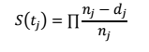 (1)
where t is a discrete unit of difference in entrepreneurial success, n is the overall number of firms, and d is those who did not survive (in our case, survivors are only those who are above a particular unit of entrepreneurial success within one discrete unit of change). The KM estimator takes the ratios of those without events over those at risk and multiplies that over time. Thus, the KM estimator is just the empirical distribution of the data. But it is possible to compare the KM estimator for two groups: treated vs. not treated – and our treatment is the preference for use of a network of a specific social capital type. So, we make three comparisons: (i) entrepreneurs who rely on networking with Italians versus those whose strategy is not to use this social capital channel; (ii) Albanian entrepreneurs who network with the local diaspora versus those who do not rely intensively on this channel; and (iii) Albanian entrepreneurs who intensively rely on networking with Albanians at home. The structured interviews contain questions about preferences for interacting with the three particular types of networks. We identify as treated those who answered above 8 on a 10-point Likert scale intensity of reliance on the particular type of network. We expect to find a difference in the ‘survival’ of the treated and non-treated group, whether the particular type of network has a significant influence on firm success among Albanian ethnic entrepreneurs in Milan.

3.5.2. Propensity Score Matching – Testing H04, H05 and H06
What the entrepreneurs would like to do, what is best for them to do and what they actually do are not necessarily the same thing (Benjamin et al. 2012). To learn to what extent these three domains coincide, we would like to examine the actual behaviour of Albanian small firms in Milan against the identified effects from certain preferences for networks (using the known characteristics of those who self-reported a certain preference as an approximation for having these preferences).
We use a propensity score matching to map the characteristics of the firms with a certain self-reported highest utility from a given type of network against the full sample of firms from the secondary dataset. This is done in order to understand whether the firms in the full sample are of a certain type of preference for networking. We then compare the economic performance of both groups of firms in order to see whether they also succeeded according to a common pattern. As the type of network predicts the type of survival, if the self-reported firms and the full sample have the same survival patterns, then the full sample of firms inclined to prefer this network has indeed managed to choose this type of network. In a sense, the revealed ‘success’ result reflects the firm’s revealed preference. It is possible however, that in spite of having the characteristics that make it likely these firms from the full sample to share the liking of a certain type of network, yet the survival of these firms is different from the survival of the self-reporting firms with the same preference. This phenomenon offers an indication that the firms have not followed in their revealed preferences the likely utility that they derive from the specific type of network. Put differently, we conclude that according to how they fared on the market, it seems the full sample firms did not make the choice to use this type of network, since they have not achieved the result typical for those who self-reportedly choose this type of network.
Thus, technically the second part of our analysis uses propensity-score matching techniques (see Austin 2011). We first match the firms on their charactersitics (size and sector specialization). We match the existing full population of firms against the interviewed firms with a preference for a specific type of social network. Put differently, we select the most similar in size and sector specialization match of firms from the full sample of firms to match the group of firms that self-reported a particular type of network preference. This means that we match alternatively the full population with the firms that preferred the strategy: (i) to network mostly with local Italian collaborators; (ii) to network mostly with Albanians in Italy and (iii) to network mostly with Albanians in Albania. Then, we use the matched groups to compare their success (in terms of number of employees).
As the treatment in our matching procedure is defined as ‘having declared a particular type of network preference’, if the matched interviewed firms are found to have the same results as the non-treated group, this will actually mean that we will find the treatment statistically non-significant and this result can be interpreted as a finding that there is a similar ability to employ workers within the firms from the full sample and the treated interviewed firms. The final rationale here is that a nonsignificant treatment effect in our propensity score matching means that the full sample has the same propensity to create employment as the firms with a chosen strategy over a particular type of networking. Indirectly, this will be an indication that the full sample has a significant similarity with this type of networking preference.
To estimate the effect of the treatment in the propensity score matching, besides a standard t-test, we perform several alternative types of matching, such as: Kernel matching (where all existing firms are used), nearest neighbour matching, radius matching and stratified matching (which uses especially defined subsamples of the control group of the full population of firms in Milan). The average-treatment-effect-on-the–treated (ATET) for all alternative tests are reported, compared and analyzed as well.

- Empirical Results
  - Descriptive Statistics
4.1.1 Main descriptive statistics
The interviewed sample of firms is generally a good representation of the full sample of Albanian small entrepreneurs in Milan (see Table 1). This regards both the size of the sample and the main characteristics of the firms.
+++ Insert Table 1 about here +++
It is noteworthy that the full population, after excluding observations which did not contain information about the years of operation of the entity, remained slightly below the original 203 observations, leaving us with an overall total of 196 firms. Therefore, the interviewed firms (amounting to 53 firms, excluding one for which no information of years of existence was available) represent about one quarter of the full population. Next, the interviewed firms were all within the first generation of ownership (below 25 years of existence as an entity). The full population contained also older firms. However, the dummy variable equal to 1 (when a firm is less than 25 years of age) shows that firms with a comparable age in the two datasets represent about 92% of the whole population. This leaves us with a potentially comparable – on the basis of common characteristics – overall total of 181 firms from the full population. The number of employees is higher for the full sample per se, and it becomes even a bit higher when we restrict the group of analyzed firms to those which are below 25 years of age.
Regarding the variables of special interest – the types of networking strategically chosen by the Albanian firm owners – it is obvious that the preference for networking with Italians is typical for 85% of the interviewed firms, while the preference for networking with Albanians in Italy is much lower, viz. about 64% of the sample of interviewed firms; the preference for transnational networking with Albanians in Albania is the lowest, amounting to 11%. With regard to the rationale of survival analysis and propensity score matching, all these percentages are sufficient for identifying the treatment effects. These first indications based on self-reported data would suggest that the Albanian ethnic entrepreneurs are free from a home bias. It remains to be cross-checked in our analysis, however, whether this self-reported preference is indeed revealed in the behavior of the full population of firms available for our analysis.
4.1.2 Distribution per sector
Table 2 below presents the distribution in the interviewed sample and the full population of small entrepreneurs with an Albanian background. Two important conclusions can be drawn based on this table.
+++ Insert Table 2 about here +++
First, the distribution per sector follows a similar pattern in both datasets. The construction sector is the leading one (with the highest number of firms, viz. 21 in the interviewed and 70 among the full population of firms). The second and third sectors are, respectively, services and restaurants. There are eight matching sector codes between the two datasets.
  - Strategic Choice on Network Type and Firm Performance: A Non-Parametric Kaplan-Meier Test
As we have managed to isolate the bias from the cultural preferences effect (since we observe entrepreneurs with the same cultural background), their self-reported reliance on a particular type of network can be considered as their preference for using this type of network, i.e. their strategic choice for a network. We define here the strategic network preference types according to the cultural bond in the network (with locals, with local diaspora or with homeland) and we regard this network preference as a treatment explaining the firm performance. There might still be a home bias driven by the differences in the cultural bond, but it will not be varying in a culturally relative manner among the entrepreneurs observed. The most interesting take from the analysis using the Kaplan-Meier estimator of treatment effect is the comparison between a treated and a non-treated group in terms of how fast the failure of the firm is happening for the two groups over the same period of time. Figures 1a-b, 2a-b and 3a-b below present the results.
+++ Insert Figures 1a-b, 2a-b and 3a-b about here +++
Both measures for failure (based on firm reaching only a certain inferior or underperforming outcome in terms of turnover and employees as previously defined) capture the adverse development of the firm. The survival is observed, given one of three treatments: networking with Italians (Figures 2a-b), with Albanians in Italy (Figures 3a-b) and with Albanians in Albania (Figures 4a-b). As seen from Figure 2a-b, when a firm chooses networking with Italians, the firm failure is slower for the firm in terms of turnover and faster in terms of employment, when a firm chooses to network with Italians in Milan. This means local Italian networks support the stability of financial capital inflow to the firm, but increase the turnover of human capital from competitive local employers. Figure 3a-b shows that when firms choose to network with the local Albanian diaspora, they tend to fail faster both in terms of turnover and in terms of size (number of employees). Figure 4a-b shows that when firms value to network with their homeland (Albania), the firm success seems to be similar to the one for the firms that did not prefer this type of network. The lack of a significant effect on the actual firm survival from this transnational type of networks can be explained by the decay in the cultural bond over time between ethnic entrepreneur and the network back in the homeland. This means that the main difference that we identify in our interviewed firms is between those who strategically prefer to network with the local Italian population and those who liaise themselves within the local diaspora. The effect of local diaspora appears to be negative on firm survival, especially distinctively with regard to the number of employed people in the firm. And this finding seems valid, even for the milieu under analysis, which as previously said, is rather characterized by a closed local cultural attitude with regard to managing cultural diversity. Furthermore, we also find that employment in the ethnic firm still seems to be far better, if the firm prefers to network with local Italians from the closed cultural milieu. This is an indication that even if resourcing to the own identity and its related cultural bonds is instinctive in hostile general contexts (see Hall 1966), employing the inter-cultural bonds prompts a positive effect on firm performance. Potential reasons for this are the tacit knowledge and access to general resources (Aldrich and Zimmer 1986; Acs, Audretsch and Lehmann 2013).
From a mixed embeddedness perspective, these results mean that under the same institutional and opportunity structure settings, a relatively homogeneous group of ethnic entrepreneurs tends to follow different networking strategies which affect significantly their entrepreneurial success. While the reasons for their choice (i.e. which network they will choose) might be a product of nudging (Sunstein and Thaler 2008) by local institutions and opportunities existing in the local context, the presence of impact from the strategic choice of the networks seems to be a generalizable fact. The finding also suggests that the known negative effects from polarization on the efficiency related to overall welfare and consumption losses (see Alesina et al. 2003; Azzimonti 2011) can occur also due to cultural polarization (closedness) harm on local entrepreneurial success.
As a next step, we will focus on the number of employed people by the interviewed firms from each category of a strategically chosen network compared to the employees (i.e. job creation achieved) among the full population of small Albanian enterprises in Milan.
  - Propensity Score Matching: Comparing Interviewed Firms to Full Population
Our propensity score matching results are presented in Table 3a&b below. The main aim of the test is to identify which type of social capital and social network dominates in the mixed embeddedness of small ethnic entrepreneurs with Albanian origin in the Milan area, based on their observed behaviour. In essence, this is a reverse engineering of their enacted preference for a network, based on our findings in the previous section about the relationship between firm characteristics and network preference, and the impact from each type of network on firm success. Table 3a presents the number of observations in treatment and control groups (i.e., the full sample of firms and group of firms with a high preference for a particular type of network) and the common support found for the matching between them. Table 3b presents the actual estimated ‘average treatment effect on the treated’ (ATET) (see Cochran and Rubin 1973 and Abadie et al. 2004) for the three types of treatment considered (i.e. the effect of preferring a particular type of network on firm success measured by employment numbers).
+++ Insert Table 3a-b about here +++
Table 3a shows that we implement several types of matching techniques (Kernel, nearest-neighbour, radius and stratified matching) to compare our treated groups on the full population of small ethnic Albanian entrepreneurs in Milan, which amounts to 181 observations with full information about their employment, size and sector specialization. The three alternative treatments considered are the preference reported during the interview with regard to: networking with Italians, with Albanians in Italy or with Albanians in Albania. To make this comparison possible, we merge the full sample of firms with the respective group of interviewed firms that reported during the interview a favourable preference for a particular type of networking. We see that the number of interviewed firms is sufficiently low, so that we have a sufficient number of observations from the full population of companies on the basis of which we can implement a meaningful propensity score matching analysis. The main result from Table 3a is the fact that the highest common support for a propensity score is found between the full sample of firms and the firms that strategically chose networking with Italians. This means that the full population of firms has a longevity and sector specialization that is most similar to the same characteristics of the firms that prefer to network with locals in the Milan area. In the second place, we find the highest statistical common support for commonality between the full sample of firms and the entrepreneurs networking with the local diaspora. And the least common support exists for matching the full population with firms like the ones that reported an interest in networking with Albanians in Albania. This means that the full sample of firms is the least similar to the firms that rely mostly on their transnational networks in their home country (Albania). Put differently, the companies with a self-reported choice for networking with Italians have the same characteristics (sector, size, age etc.) as most firms in Milan, i.e. they are structurally closest to the average small ethnic firms in Milan. It is only their actual behavior in a culturally close milieu of Milan that obviously makes the difference in their performance.
Table 3b however, reveals an additional aspect about the similarities between the full sample of firms and the interviewed firms in our database. Namely, we consider here the average effect of the treatment on the treated, i.e. we examine in Table 3b whether the interviewed firms expressing a particular preference for networking are significantly different in their propensity to employ people compared to firms with similar characteristics (in terms of sector specialization and longevity) in the full population of small Albanian entrepreneur firms in Milan. In a sense, we re-engineer the actual choice of network based on the firm success according to the knowledge about the link between success and type of network obtained from the self-reported data. We see from Table 3b, that although there was the largest common support between the full population of firms and those interviewed firms who prefer to network with Italians, these two sets of firms seem to have significant differences in their number of employed people. This means that there are significant differences in the performance between the similar interviewed and full population firms. These two sets of firms cannot be considered to be products of the same mechanisms of impact. Ultimately, this means that the full sample of firms does not really exhibit the same behaviour and preferences as the interviewed firms which expressed support for networking with Italians. The differences in number of employed people are somewhat unclear when networking with Albanians in Albania is considered. This might be also due to the very small number of interviewed firms that actually reported such a propensity.
The group that Table 3b identifies as most identical in both its characteristics and performance (in terms of number of people they manage to employ) to the full population of small ethnic Albanian firms in the Milan area is the type of firms preferring to network with Albanians in Italy. Thus, our propensity score matching reveals that Albanian entrepreneurs in Milan seem to achieve a success closest to the one of the companies that explicitly reported that they prefer to network with the local diaspora. The behavior exhibited in terms of outcome and survival shows that the results of most companies are similar to those of companies that self-reported a strategic choice in favour of networking with the Albanian diaspora. A possible explanation for this is that, as we saw in the Kaplan-Meier and survivor analysis part of our study, choosing to network with the local diaspora is actually detrimental to the development of the firm. This means that most ethnic entrepreneurs in Milan are likely to be performing below their optimal potential due to their strategic choice regarding the type of network. This finding sheds light on a novel aspect that can be added to the extant literature on the importance of the local context for the way diversity may or may not thrive depending on the local milieu (see Fisman 2002; Tubadji and Nijkamp 2015; Lee 2015; Rodríguez-Pose and Hardy 2015; Rodríguez-Pose and Berlepsch 2017; Desmet, Ortuño-Ortín, and Wacziarg 2017). Namely, we highlight here for the first time the importance of the local milieu as a factor for the strategy for social networking that ethnic entrepreneurs might be willing to undertake under mixed embeddedness. Our results show that this choice leads to important differences in firm performance and may lead to forgone local economic success.
Our results can be subject to cross-checking with other relevant methods for optimal performance of firms such as data envelopment analysis. But the reliability of our findings is already high and therefore, due attention in policy making should be paid to the question whether synergies from local networking of ethnic entrepreneurs are adequately used. If not, measures might be taken to avoid losses from forgone benefits from local externalities that these networking synergies can create. This means our findings confirm that, even in a closed cultural milieu, cross-cultural bonding is more helpful for firm survival than cultural closedness. Unfortunately, this type of networking seems to be discouraged in Milan, and most Albanian ethnic entrepreneurs seem to be closed into their diaspora.
It is possible that additional individual factors, not available in our dataset, affect and explain the differences in the preferences of this relatively homogeneous group of ethnic entrepreneurs in Milan. The exploration of the home bias factors however, is clearly demonstrated to be important, since it naturally relates to making a social networking choice (as we know from previous research as well – see for instance Szkudlarek and Wu, 2018). Moreover, our results suggest that home bias is not a mere harmless fact of life, but proves to be an element of choice of strategic importance for the success or failure of fully comparable ethnic entrepreneurs who are exposed to otherwise identical elements of their mixed embeddedness context.
5. Discussion
This study serves to explore the role of home bias in the ethnic entrepreneurs’ choice for the type of social network and the impact of this choice on the firm’s economic performance (in turnover and number of employees), in an otherwise identical mixed embeddedness context. This study of home bias in a mixed embeddedness context is statistically precise only if we are able to keep institutional and opportunity structure elements of mixed embeddedness constant, in a well-designed case study. Our results show that the success of ethnic entrepreneurship does depend on a culturally-biased strategic choice of network. The practical and conceptual implications of our findings are now offered below in detail.
Practical Implication of the Findings
Our study has demonstrated that methodologically – with a careful research design – it is possible to combine primary and secondary data to understand the behavior of the entire population by a reverse engineering procedure. Using primary data, we tested our first three operational hypotheses (H01, H02, H03) which served to test alternatively whether the three types of social networks that Albanian ethnic entrepreneurs could choose from all led to the same positive impact from social networking on the survival of the ethnic firm. We used information from interviews with Albanian ethnic entrepreneurs and analyzed the statistical effect of their reported preference to socially network with locals, with Albanian diaspora in Milan or transnationally with Albanians in Albania over their firm survival. Our results show that the strategic choice of network types seems to be very important, since the tests of our three hypotheses show evidence for completely different impacts from each type of social network. Especially the results from testing our third hypothesis show that relying too heavily on home country links with Albania has a negative relationship with employment and turnover. Moreover, in line with Waldinger (2008), we observe transnationalism as a generally most rarely singled out network among the ethnic entrepreneurs in Milan, potentially because of the high economic and legal transaction costs still present for mobility between Italy and Albania.
Next, we used available secondary urban data on the entire population of Albanian ethnic entrepreneur firms, obtained from the relevant public authorities in Milan (with information about all existing ethnic Albanian enterprises in Milan area). We tested a second set of three hypotheses (H04-H05-H06) using this dataset, suggesting alternatively that the most common type of networking among Albanian entrepreneurs in Milan is either networks with locals, or with the diaspora, or with the Albanians in Albania.
Analyzing the full sample of small Albanian entrepreneurs in the Milan area, there is clear evidence that they are oriented towards networking within their own diaspora, so that the remaining two hypotheses are not confirmed. Moreover, at first sight, the full sample of Albanian small businesses is found to have the closest structural characteristics with the interviewed firms that strategically preferred to network with local Italian collaborators. However, the ‘average effect on the treated’ from our propensity score matching estimations demonstrates that firm success is very different when a treatment is defined as being pro-network with Italians. This means that, through reverse engineering, we learned that while most firms have the same characteristics as those firms that would network with Italians, not all of these firms seem to be de facto enacting this choice.
Put differently, combining the results from analyzing our primary and secondary datasets, we find that Albanian firms in the Milan area have the characteristics of firms that can choose to network with local networks, but the majority choose to stay locked in within their ethnic diaspora. This failure to engage with Italian networks is a suboptimal choice and questions the wisdom of Albanian entrepreneurs adopting the best strategy in using their mixed embeddedness in order to survive and grow as businesses.
In short, our novel combined methodological procedure helps understand and interpret primary and behavior-related information from primary and secondary data collection. This methodology can be used to extend the use of many existing big-scale secondary datasets through additional primary data collection on a smaller scale with representative samples.
Conceptual Contribution
With regard to our conceptual mechanism of interest – the cultural home bias in the choice of type of social networks – we find that the Albanian ethnic entrepreneurs in Milan exhibit a strong home bias. These results might be to some degree dependent, of course, on the other levels in the mixed embeddedness context in Milan. While keeping institutions and opportunity structures constant, because they are the same for all ethnic entrepreneurs in Milan, the level of support and type of institutions and opportunities existing in Milan might be a conducive factor for the observed predominant preference among the ethnic entrepreneurs in this city. A more culturally open and diversity embracing (rather than diversity sanctioning) city might observe more ethnic entrepreneurs prone to strategically choose cooperation with the locals. Our results keep the type of milieu fixed by employing a natural experiment of firms located in the same mixed embeddedness context. This helps us identify clearly the social mechanism of interest. In future research, it will be interesting to extend this by empirically addressing changing cultural milieus as well.
Theoretically, our results seem to confirm in a generalizable manner that there is a behavioural significance of home bias in the strategic choice of network for an entrepreneur. And this is our main focal point (and main mechanism of interest) in this study, in which our six hypotheses converge. This CBD mechanism offers a novel conceptual blend between behavioural economics advances and entrepreneurial (and mixed embeddedness in particular) fields of study. The results of this study may be seen as a starting point for a further study into the potential boundedness in the strategic choice of networks, with the increased awareness of its importance for the success of an ethnic enterprise. In particular, our findings contribute to the growing body of literature distinguishing reasons for the different effects from diversity on local performance. More generally, our findings suggest that local cultural factors may play an important role in the home bias of ethnic entrepreneurs. The current study serves to demonstrate that these dimensions are worth exploring and paying attention to in policy and management of ethnic enterprises, when optimal economic results are pursued.
The results from testing our hypotheses added also further insights to the functioning of the home bias concept. The hypothesis regarding the preference for networking only within the local diaspora shows that this type of social network generates negative social capital for the immigrant entrepreneurs in terms of the survival and firm’s capacity to create jobs. This is an interesting result, that is supportive of our assumptions in our CBD model (Figure 1), and contains a lesson to take especially for unfriendly to ethnic entrepreneurship local milieus that instigate themselves ethnic firm development that is less beneficial for their locality. Regarding the entrepreneurs, the study underscores the benefit from remaining culturally open, even in a general milieu of cultural closedness, which is consistent with what we know from studies on cooperative behavior, social desirability, altruism and cooperation versus competition (Van Lange and Semin‐Goossens 1998). An economic mechanism behind this result could encompass the contribution of the social network to the competition between firms for accessing the existing opportunities in their shared environment. Alternatively, a social mechanism explaining the same result could be that remaining open in one’s own approach to the incumbents may enhance the chances of the ethnic entrepreneur to be perceived positively on a personal level by the incumbent population that may embrace her/him as an individual rather than as a representative of an alien ethnic group. Furthermore, the test of our hypothesis regarding the effect from a preference for networking with the local population shows that this social network contributes to the survival rates of the ethnic firms. This finding is consistent with Kloosterman et al. (1999). Yet, this means that the choice over different types of social networks seems likely to generate a different impact on firm survival. Finally, we know that immigrants are instrumental for local development by playing the role of a link for flows of trade and investments between a sending and receiving country. Our findings show that negative effects on the ethnic entrepreneurs themselves may occur in case their strategic choice focuses on remaining links mostly to their homeland. In short, testing our first three hypotheses shows that local ethnic entrepreneurs may be harmed in their development, if they rely too much on local and (transnational) homeland-bound networks. Instead, a better integration into local networks could lead to improved firm performance and can help optimize the business’ contribution to the local economy, consistent with a mixed embeddedness approach.
6. Conclusions
Our study contributes to the mixed embeddedness literature, by identifying differences between the predominantly self-reported preference for networking and the actual revealed networking preference that seems to be in place. The use of solid techniques helps ensure that this a fact beyond any potential self-reporting bias.
Our findings about Albanian ethnic entrepreneurs in Milan confirm the presence of a cultural bias mechanism. Firms whose owners self-reported preference for networking with Italians were the most successful firms. But the average firm performance in Milan seems to be the one typical for firms that network within the diaspora. We consider, that this is a true mechanism of home bias and not a case of social desirability bias, because we find a significant difference between the full sample firms and the self-reported firms in the degree of their success, which would not be present if there were no real difference in the strategy of those otherwise closely matching in their business characteristics firms. Moreover, we also find that the type of firm owners who typically self-reported a certain intention, in practice often acted towards a different actual choice. Finally, since the choice that actually dominated is prioritizing the use of culturally closer networks (the diaspora rather than the Italians), it seems a fact that in the context of mixed embeddedness ethnic entrepreneurs are likely to make an inferior (with regard to its effects on firm success (in terms of turnover and number of employees)) culturally-biased strategic choice for a type of networking. Generally, small ethnic firms in Milan seem to prefer culturally and geographically closest networks, thus avoiding the culturally distance Italian locals diaspora and the geographically distant transnational network with Albanians in Albania.
Regarding our main home bias mechanism, diversity and transnationalism motivating cultural distance differences across the networks between an ethnic entrepreneur can choose nowadays, have been confirmed as an important determinant of entrepreneurial success. It was clarified that stimulating a stronger cultural bias in the entrepreneurial strategic choice of network in a mixed embeddedness context has negative effects on firm success and consecutively also so on local development. Our assumption is that the local cultural milieu triggers the degree of this home bias, yet the question regarding the trigger still remains to be analyzed in a culturally diverse context, as the current study was focused on one type of ethnic entrepreneurs in one cultural milieu for the purpose of benefitting from ceteris paribus conditions that allow the analysis of the complex question of utilities and preferences from culturally different networks in mixed embeddedness feasible.
Reliability and validity-wise, this study uses a novel recombination of quantitative approaches for identifying a treatment effect from the choice of network and employs propensity score matching techniques to cross-check the match between stated and revealed preferences of the ethnic entrepreneurs with regard to the type of network they most often rely on in the context of a mixed embedded condition. A clear limitation of the study is the fact that our primary dataset contains 53 observations. Yet, they are representative for the group of small Albanian ethnic entrepreneurs in Milan, while the second part of our analysis uses the entire sample of small ethnic entrepreneurs in Milan, comparing and contrasting their economic behaviour to the 53 interviewed firms. Also, the necessary sufficient number from statistical point of view according to the Centre Limit Theorem amounts to be roughly above 40 observations. Therefore, clearly external validity with our small dataset may be curbed to what extent we could generalize our findings. Yet, our findings are sufficiently reliable for deriving some policy implications for the case of the city of Milan and its Albanian small ethic entrepreneurs. The city will benefit from promoting cross-ethnic business networking, as this will improve Milan’s benefit from the ethnic entrepreneurship concentrated there. On the conceptual side, our study demonstrates that home bias is present in the entrepreneurial choice for network and this is a strategic decision directly related to firm success. This cultural boundedness of the ethnic entrepreneur definitely merits further theoretical and empirical work.
In conclusion, this paper fills in a gap in the entrepreneurial literature on mixed embeddedness which so far did not examine the choice complementarity on social networks in the context of mixed embeddedness. Our study feeds on insights from behavioural economics about complex choices and from cultural economics on cultural home bias, employing the CBD paradigm to address the varying cultural proximity between ethnic entrepreneurs and different types of social networks. Our analysis contains also a methodological novelty, by extending the usability of purely economic secondary data for cultural economic questions, through a combination with primary data collected on a smaller scale and applying a reverse engineering procedure. Conceptually, we recombine the above outlined strands of literature, in order to synthesize the understanding of mechanisms of cultural bias in an ethnic entrepreneurial choice context, that has important strategic implications for ethnic firm performance. In this spirit, our study opens new pathways for further theoretical and empirical exploration of entrepreneurial behavior and its complexity.

References
Abadie, A., D. Drukker, J. Herr and G. Ibens (2004) Implementing Matching Estimator for Average Treatment Effects in Stata, The Stata Journal, 4(3): 290-311.
Abdulloev, I., G. Epstein and I. Gang (2014) Ethnic Goods and Immigrant Assimilation, IZA, DP No. 8004.
Acs, Z., D. Audretsch and E. Lehmann (2013) The Knowledge Spillover Theory of Entrepreneurship, Small Business Economics, 41(4): 757-774.
Agera, P. and Brückner, M. (2013) Cultural diversity and economic growth: Evidence from the US during the age of mass migration, European Economic Review, 64: 76-97.
Alesina, A., A. Devleeschauwer, W. Easterly, S. Kurlat, and R. Wacziarg (2003) Fractionalization, Journal of Economic Growth, 8: 155-94.
Alesina, A. and E. La Ferrara. (2005) Ethnic diversity and economic performance, Journal of Economic Literature 43(3): 762-800.
Aldrich, H. and C. Zimmer (1986) Entrepreneurship Through Social Networks: The Art and Science of Entrepreneurhip, New York: Ballinger.
Andall, J. (2010) Second-generation attitude? African-Italians in Milan, Journal of Ethnic and Migration Studies, 28(3): 389-407.
Andreosso-O’Callaghan, B. and H. Lenihan (2008) Networking: a question of firm characteristics? The case of the Shannon region in Ireland, Entrepreneurship and Regional Development, 20(6): 561-580.
Arrighetti, A., D. Bolzani and A. Lasagni (2014) Beyond the enclave? Break-outs into mainstream markets and multicultural hybridism in ethnic firms, Entrepreneurship and Regional Development, 26(9/10): 753-777.
Audretsch. D. and Lehmann, E. (2017) The Routledge Companion to the Makers of Modern Entrepreneurship, Routledge: New York.
Austin, P. (2011) An Introduction to Propensity Score Methods for Reducing the Effects of Confounding in Observational Studies, Multivariate Behavioural Research, 46(3): 399–424.
Aviv, C. and Shneer, D. (2005) New Jews: The End of the Jewish Diaspora, New York University Press: New York and London.
Axelrod, R. (1997) ‘The dissemination of culture: a model with local convergence and global polarization’, The Journal of Conflict Resolution, 41(2): 203-226.
Azmat, F. (2010) Exploring social responsibility of immigrant entrepreneurs: Do home country contextual factors play a role? European Management Journal, 28(5): 377-386.
Azzimonti, M. (2011) Barriers to Investment in Polarized Societies, American Economic Review, 101(5):2182-2204.
Bagwell, S (2015) Transnational entrepreneurship amongst Vietnamese businesses in London, Journal of Ethnic Migration Studies, 41(2):329–349.
Barberis, E., Y. Kazepov and A. Angelucci (2014) Assessment of Urban Policies in Milan, Italy, Urbino: DESP – Università di Urbino Carlo Bo.
Barberis, E., and A. Violante (2017) Chinese immigration to Italy and economic relations with the homeland. In S. Guercini, G. Dei Ottati, L. Baldassar & G. Johanson (Eds), Native and Immigrant Entrepreneurship (pp. 31-52). New York, Springer. Doi: 10.1007/978-3-319-44111-5_3.
Battisti, M., G. Peri and A. Romiti (2016) Dynamic Effects of Co-ethnic Networks on Immigrants' Economic Success, NBER, Working Paper 22389.
Baycan-Levent, T., A. Gülümser, S. Kundak, P. Nijkamp and M. Sahin (2003) ‘Diversity and ethnic entrepreneurship: dialogue through exchanges in the economic arena’, Sustainable Development in a Diverse World, Position Paper 4.4.
Bankston, C. (2014) Immigrant Networks and Social Capital, Wiley: UK.
Bielenia-Grajewska, M., E. Carayannis and D. Campbell (2013) Linguistic Dimension of Creativity, Invention, Innovation, and Entrepreneurship, in Carayannis, E. (2013) Encyclopedia of Creativity, Invention, Innovation and Entrepreneurship, Springer, New York: pp. 1206-1215.
Basu, A. and E. Altinay (2002) The Interaction between Culture and Entrepreneurship in London's Immigrant Businesses, International Small Business Journal: Researching Entrepreneurship 20(4):371-393.
Beckers, P. and B. Blumberg (2013) Immigrant entrepreneurship on the move: a longitudinal analysis of first- and second-generation immigrant entrepreneurship in the Netherlands, Entrepreneurship & Regional Development, 25(7-8): 654-691.
Benjamin, D., O. Heffetz, M. Kimball and A. Rees-Jones (2012) What Do You Think Would Make You Happir? What Do You Think You Would Choose?, American Economic Review, 102(5): 2083–2110.
Besser, T. and N. Miller (2011) The structural, social, and strategic factors associated with successful business networks, Entrepreneurship and Regional Development, 23(3/4): 113-133.
Borjas G. J. (1995) Ethnicity, neighborhood and human-capital externalities, The American Economic Review, 85(3): 365-390.
Brown, B. and J. Butler (1993) Networks and entrepreneurial development: the shadow of borders, Entrepreneurship and Regional Development, 5(2): 101-116.
Beugelsdijk, S., Klasing, M. and Milionis, P. (2019) Value Diversity and Regional Economic Development, The Scandinavian Journal of Economics, 121(1):153-181.
Cheng, S. and H. Li (2012) New firm formation facing cultural and racial diversity, Papers in Regional Science, 91(4): 759-774.
Clancey, G. (2004) Local Memory and Worldly Narrative: The Remote City in America and Japan, Urban Studies, 41(12): 2335–2355.
Cochran, W. and D. B. Rubin (1973) Controlling Bias in Observational Studies, Sankhya 35: 417-446.
Constant, A., L. Gataullina and K. Zimmermann (2009) Ethnosizing immigrants, Journal of Economic Behavior & Organization, 69(3), 274–287.
De Noni, I., A. Ganzaroli, L. Orsi and L. Pilotti (2013) Immigrant entrepreneurship in the Milan metropolitan area: results from an empirical analysis, International Journal of Economic Policy in Emerging Economies (IJEPEE), 6(2): 168 – 188.
Desmet, K, I. Ortuño-Ortín, and R. Wacziarg (2017) Culture, Ethnicity, and Diversity, American Economic Review, 107(9): 2479–2513.
Dodd, S. and J. Keles (2015) Expanding the networks of disadvantaged entrepreneurs, A Background Paper, OECD Centre for Entrepreneurship, SMEs and Local Development.
Dodd, S. and E. Patra (2002) National differences in entrepreneurial networking, Entrepreneurship and Regional Development, 14(2): 117-134.
Drori, I., Honig, B. and Wright, M. (2009) Transnational Entrepreneurship: An Emergent Field of Study, Entrepreneurship: Theory and Practice, 33(5):1001 - 1022.
Easley, D. and J. Kleinberg (2010) Overview, in: Networks, Crowds, and Markets: Reasoning about a Highly Connected World, Cambridge University Press. pp. 1–20.
Easterly, W. and R. Levine (1997) Africa ʼ s Growth Tragedy: Policies and Ethnic Divisions, Quarterly Journal of Economics, 112 (4): 1203—1250.
Eijdenberg, E., Thompson, N., Verduijn, K. and Essers, C. (2019) Entrepreneurial activities in a developing country: an institutional theory perspective, International Journal of Entrepreneurial Behavior & Research, 25(3): 414-432.
Epstein, G. and O. Heizler (2016) The formation of networks in the diaspora, International Journal of Manpower, 37(7): 1136-1153.Genc, M., M. Gheasi, P. Nijkamp and J. Poot (2011) The Impact of Immigration on International Trade: A Meta-Analysis, IZA Discussion Paper No. 6145.
Fassio, C. (2015) Export-led innovation among European firms: demand and technological learning effects, LUISS Guido Carli/ School of European Political Economy, WP 2-2015.
Fetahu, E. and I. Bejtja (2014) Immigrant entrepreneur challenges toward trade Europeanization. The dynamics of Albanian experience in the province of Milan, Italy., Fourth Euroacademia Global Conference Europe Inside-Out: Europe and Europeaness Exposed to Plural Observers , Manuscript.
Fisman,R. (2002) Ethnic Ties and the Provision of Credit: Relationship-Level Evidence from African Firms, The B.E. Journal of Economic Analysis & Policy, 3(1): 1-21.
Frank, R. and K. Lamiraud (2009) Choice, price competition and complexity in markets for health insurance. Journal of Economic Behavior and Organization 71, 550-562.
Glick Schiller, N., Basch, L. and Blanc-Szanton, C. (1992) Towards a Transnational Perspective on Migration: Race, Class, Ethnicity, and Nationalism Reconsidered. New York: New York Academy of Sciences.
Gomez, T. and Hasino, M. (2004) Chinese Enterprise, Transnationalism and Identity, Routledge: London.
Gordon, I. and P. McCann (2000) Industrial Clusters: Complexes, Agglomeration and/or Social Networks?, Urban Studies, 37(3): 513–532.
Hall, E. (1966) The Hidden Dimension, Garden City, NY: Doubleday.
Hervas-Oliver, J. and J. Albors-Garrigos (2009) The role of the firm's internal and relational capabilities in clusters: when distance and embeddedness are not enough to explain innovation, Journal of Economic Geography, 9(2): 263-283.
Iyengar, S. and M. Lepper M (2000) When choice is demotivating: Can one desire too much of a good thing? Journal of Personality and Social Psychology 79, 995-1006.
Jacobs, D. and J. Tillie (2004) Integration: Social Capital and Political Integration of Migrants, Journal of Ethnic and Migration Studies, 30(3): 419–427.
Jack,S., S. Dodd and A. Anderson (2008) Change and the development of entrepreneurial networks over time: a processual perspective, Entrepreneurship and Regional Development, 20(2): 125-159.
Jones T, M. Ram and N. Theodorakopoulos (2010) Transnationalism as a force for ethnic minority enterprise? The case of Somalis in Leicester, International Journal of Urban and Regional Research,34(3): 565-585.
Kaplan, E. and P. Meier (1958) Nonparametric Estimation from Incomplete Observations, Journal of the American Statistical Association, 53(282): 457-481.
Kariv, D., T. Menzies , G. Brenner and L. Filion (2009) Transnational networking and business performance: Ethnic entrepreneurs in Canada, Entrepreneurship and Regional Development, 21(3): 239-264.
Karreman, B., M. Burger F. van Oort (2017) Location Choices of Chinese Multinationals in Europe: The Role of Overseas Communities, Economic Geography, 93(2): 131-161.
Kesler, C. and I. Bloemraad (2010) Does Immigration Erode Social Capital? The Conditional Effects of Immigration-Generated Diversity on Trust, Membership, and Participation across 19 Countries, 1981–2000, Canadian Journal of Political Science/Revue canadienne de science politique, 43(2): 319-347.
Kahneman, D. (2011). Thinking, fast and slow. Macmillan.
King, R. and Mai. N. (2009) Italophilia meets Albanophobia: paradoxes of asymmetric assimilation and
identity processes among Albania immigrants in Italy. Ethnic and Racial Studies 32: 117-138.

Kitching, J., D. Smallbone and R. Athayde (2009) ‘Ethnic diasporas and business competitiveness: Minority-owned enterprises in London’, Journal of Ethnic and Migration Studies, 35(4): 689-705.
Kloosterman, R., K. Rusinovic and D. Yeboah (2016). Super-diverse migrants—similar trajectories? Ghanaian entrepreneurship in the Netherlands seen from a Mixed Embeddedness perspective. Journal of Ethnic and Migration Studies, 42(6), 913-932.
Kloosterman, R. (2010) “Matching opportunities with resources: a framework for analysing (migrant) entrepreneurship from a mixed embeddedness perspective”, Entrepreneurship and Regional Development, 22(1): 25–45.
Kloosterman, R. and J. Rath (2001) Immigrant entrepreneurs in advanced economies: Mixed embeddedness further explored, Journal of Ethnic and Migration Studies, 27(2): 189-201.
Kloosterman, R., J. Van Der Leun and J. Rath (1999) Mixed Embeddedness: (In)formal Economic Activities and Immigrant Businesses in the Netherlands, International Journal of Urban and Regional Research, 23(2): 252–266.
Kloosterman, R., J. Van Der Leun and J. Rath, J. (1998) Across the border: Immigrants’ economic opportunities, social capital and informal business activities. Journal of Ethnic and Migration Studies, 24(2), 249–268.
Klyver, K. and D. Foley (2012) Networking and culture in entrepreneurship, Entrepreneurship and Regional Development, 24(7/8): 561–588.
Koning, J. and M. Verver (2013) Historicizing the ‘ethnic’ in ethnic entrepreneurship: The case of the ethnic Chinese in Bangkok, Entrepreneurship and Regional Development, 25(5/6): 325-348.
Liberatore, G. (2018) Forging a ‘Good Diaspora’: Political Mobilization among Somalis in the UK, Development and Change 49(1): 146–169.
Lee, N. (2015) Migrant and ethnic diversity, cities and innovation: Firm effects or city effects? , Journal of Economic Geography, 15(4): 769–796.
Levitt, P., DeWind, J. and Vertovec, S. (2003) International Perspectives on Transnational Migration: An Introduction, International Migration Review, 37( 3): 565? 575.
Lorentzen, A. (2008) Knowledge networks in local and global space, Entrepreneurship and Regional Development, 20(6): 533-545.
Mai, N. (2001) ‘Italy is beautiful’: the role of Italian television in the Albanian migratory flow to Italy. In Media and Migration: Constructions of Mobility and Difference, King R, Wood N (eds). Routledge: London; 95-109.
Malecki, E. (2002) Hard and Soft Networks for Urban Competitiveness, Urban Studies, 39(5-6): 929-945.
Markusen, A. (2004) The Work of Forgetting and Remembering Places, Urban Studies, 41(12): 2303–2313.
Markusen, A. (1996) Sticky Places in Slippery Space: A Typology of Industrial Districts, Journal Economic Geography, 72(3): 293-313.
Marzorati, R. (2013) “Imagined Communities and Othering Processes: The Discursive Strategies of Established Italian Residents in a Milan City Neighbourhood,” Journal of Language and Politics, 12(2):251–71.
Marzorati, R. and F. Quassoli (2015) Governing diversity in Milan “città!mondo”: political discourse and policies towards 2015 Expo, , Paper presente dat RC21: International Conference on “The Ideal City: between myth and reality. Representations, policies, contradictions and challenges for tomorrow's urban life”, Urbino (Italy), August 2015, http://www.rc21.org/en/conferences/urbino2015/
McKay, D. (2013) Does the Mafia suppress entrepreneurship in Italy? World Review of Entrepreneurship, Management and Sustainable Development, 9(4): 475-517.
Moyo, I. (2014) A Case Study of Black African Immigrant Entrepreneurship in Inner City Johannesburg Using the Mixed Embeddedness Approach, Journal of Immigrant & Refugee Studies, 12(3): 250-273.
Murat, M., B. Pistoresi and A. Rinaldi (2008) Italian diaspora and foreign directinvestment: a cliometric perspective, RECent Center for Economic Research, WP13/2008.
Nijkamp, P. (2007) Ceteris paribus, spatial complexity and spatial equilibrium: An interpretative perspective, Regional Science and Urban Economics, 37: 509–516.
North, D. (1991) Institutions, The Journal of Economic Perspectives, 5(1): 97-112.
Page, J. and S. Plaza (2006) Migration Remittances and Development: A Review of Global Evidence, Journal of African Economies (2006) 15 (suppl_2): 245-336.
Parsons C.R. and L. A. Winters L.A. (2014) International migration, trade and aid: A survey, International Migration Institute, University of Oxford, WP-90-2014.
Pilati, K. (2012) “Network Resources and the Political Engagement of Migrant Organisations in Milan”, Journal of Ethnic and Migration Studies, 38(4): 671–88.
Pisani, M. and Richardson, C. (2012) Cross-border informal entrepreneurs across the South Texas?Northern Mexico boundary, Entrepreneurship & Regional Development24(3): 105-121.
Ponzini, D. and U. Rossi (2010) Becoming a Creative City: The Entrepreneurial Mayor, Network Politics and the Promise of an Urban Renaissance, Urban Studies, 47: 1037-1058.
Portes, A., L. E. Guarnizo, and P. Landolt (1999) The Study of Transnationalism: Pitfalls and Promise of an Emergent Research Field, Ethnic and Racial Studies 22( 2): 217- 237.
Portes, A. and J. Sensenbrenner (1993) Embeddedness and Immigration: Notes on the Social Determinants of Economic Action, American Journal of Sociology, 98(6): 1320-1350.
Price, M. and E. Chacko (2009) The Mixed Embeddedness of Ethnic Entrepreneurs in a New Immigrant Gateway, Journal of Immigrant & Refugee Studies, 7:328–346.
Putnam, R. (1994) Social Capital and Public Affairs, Bulletin of the American Academy of Arts and Sciences, 47(8): 5-19.
Ram, M. and T. Jones (2008) Ethnic Minorities In Business, The Small Enterprise Research Team, Open University Business School , Second Edition.
Rauch, J. and V. Trindade (2002) Ethnic Chinese networks in international trade, Review of Economics and Statistics, 84(1): 116-130.
Reggiani, A. and P. Nijkamp (eds.) (2009) Complexity and Spatial Networks, Springer-Verlag, Berlin.
Ren, N., and Liu, H. (2015) Traversing between transnationalism and integration: Dual embeddedness of new Chinese immigrant entrepreneurs in Singapore, Asian and Pacific Migration Journal, 24(3): 298–326 .
Rodríguez-Pose, A. and V. von Berlepsch, (2018) Does population diversity matter for economic development in the very long-term? Historic migration, diversity and county wealth in the US, Journal of Urban Economics. ISSN 0094-1190
Rodríguez-Pose, A. and D. Hardy (2015) Cultural Diversity and Entrepreneurship in England and Wales, Environment and Planning A: Economy and Space, 47(2): 392-411.
Salaff J.W., Greve A., Siu-Lun W., Ping L.X.L. (2003) Ethnic Entrepreneurship, Social Networks, and the Enclave. In: Yeoh B.S.A., Charney M.W., Kiong T.C. (eds) Approaching Transnationalisms. Springer, Boston, MA.
Sandercock, L. (2000) When Strangers Become Neighbours: Managing Cities of Difference, Planning Theory and Practice 1: 13–30.
Schnell, I. and M. Sofer (2002) "Unbalanced embeddedness of ethnic entrepreneurship: The Israeli Arab case", International Journal of Entrepreneurial Behavior & Research, 8(1/2): 54-68.
Simon, H. A. (1955) A behavioral model of rational choice. Quarterly Journal of Economics, 59: 99–118.
Simon, H. A. (1956) Rational choice and the structure of the environment. Psychological Review, 63: 129–138..
Szkudlarek, B. and S. Wu (2018) The culturally contingent meaning of entrepreneurship: mixed embeddedness and co-ethnic ties, Entrepreneurship and Regional Development, 30(5/6): 585-611.
Tadesse, B. and E. K. Shukralla (2013) The impact of foreign direct investment on horizontal export diversification: Empirical evidence, Applied Economics, 45: 141–59.
Rimoldi, S. and L. Terzera (2017) Neighbours and Friends? Can Residential Segregation Explain Ethnic Separation? The Case of Milan (Italy), Spatial Demography (2017) 5:193–214
Tubadji, A. and P. Nijkamp (2016) Six Degrees of Cultural Diversity and R&D Output Efficiency: Cultural Percolation of New Ideas - An Illustrative Analysis of Europe. Letters in Spatial and Resource Sciences, 9(3): 247-264.
Tubadji, A. and P. Nijkamp (2015) Cultural Gravity Effects Among Migrants: A Comparative Analysis of the EU15. Economic Geography, 91(3): 344-380.
Tubadji, A. and P. Nijkamp (2014) Altruism to Strangers for our Own Sake: Domestic Effects from Immigration, (joint with Peter Nijkamp), International Journal of Manpower, Special Issue on Culture and Labour, 35(1/2): 11-32.
Tversky, A. and E. Shafir (1992) Choice under conflict - the dynamics of deferred decision. Psychological Science 3, 358-361.
Van Lange, P. and A. Semin‐Goossens (1998). The boundaries of reciprocal cooperation. European Journal of Social Psychology, 28(5), 847-854.
Velez-Ibanez, C.G. (1983) Bonds of Mutual Trust : the Cultural Systems of Rotating Credit Associations among Urban Mexicans and Chicanos, New Brunswick : Rutgers University Press.
Waldinger, R. (2008) Between Here and There: Immigrant Cross-Border Activities and Loyalties, International Migration Review, 42(1):3-29.
Webber, D., Webber, G., Berger, S. and Bradley, P. (2017) Explaining Productivity in a Poor Productivity Region, Environment and Planning A, 50 (1): 157-174 .
Weber, M. (1905) The Protestant Ethic and the Spirit of Capitalism. New York: Routledge.
Zcan, G. (1995) Small business networks and local ties in Turkey, Entrepreneurship and Regional Development, 7(3): 265-284.

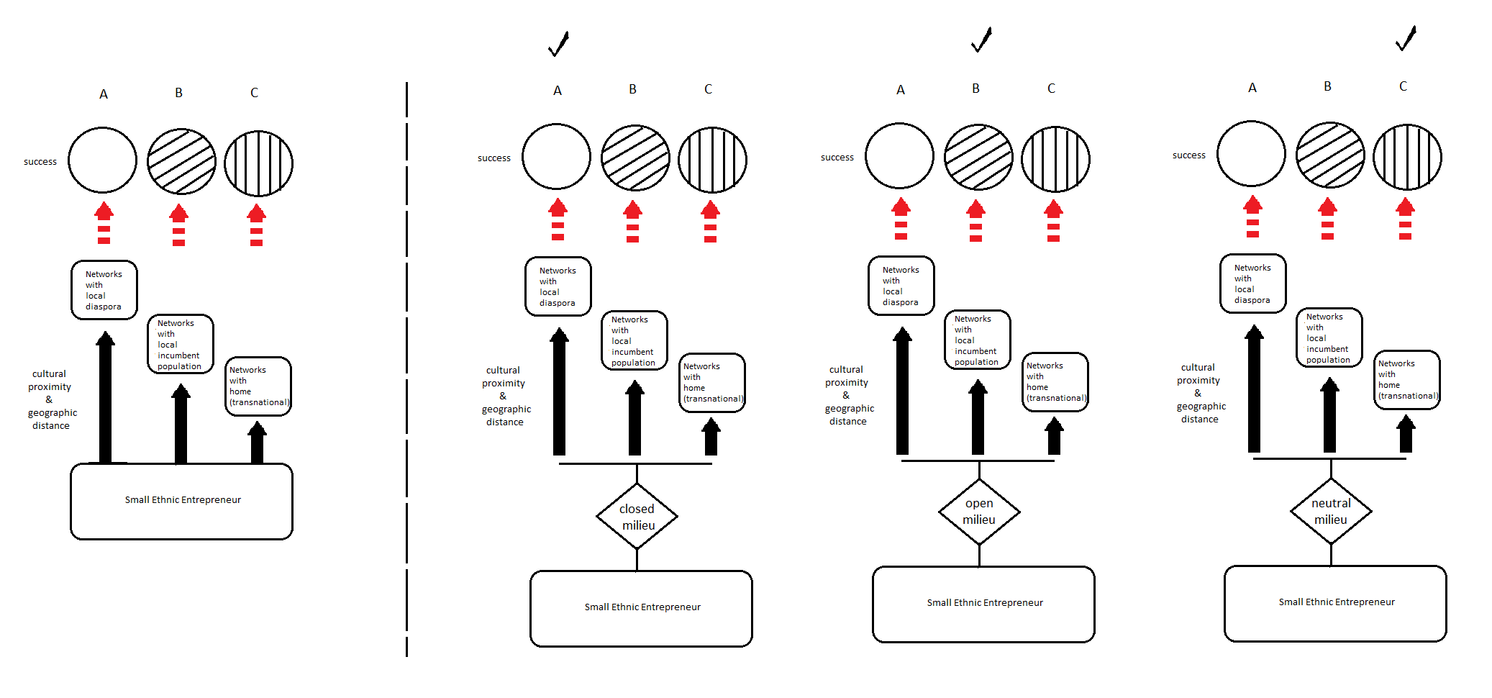

Figure 1: CBD Model of Home Bias in Ethnic Entrepreneur’s Choice for Network

Note: The figure shows the mechanism of home bias, which is driven by the vector of perceived proximity, decomposed into geographical and cultural distance. Three types of networks are visualized: with local indigenous people, with local diaspora and networks with home (transnational networks). The vector of cultural proximity is largest for culturally and geographically closest local diaspora, second for the geographically close but culturally distant local indigenous people and finally smallest for the culturally close but geographically distant networks from home. The figure enfolds from left to right, showing how the general mechanism (left figure) operates differently in different cultural milieus in the country of residence of the ethnic entrepreneur. The different cultural milieu (neutral, open or closed towards immigrants) prompts the home bias to trigger a different strategic choice by the ethnic entrepreneur (A, B or C). These choices lead also to different success (where ‘different’ can be understood either in terms of different types of success (such as profit, employment numbers etc.), or in terms of different magnitudes of success within the same type of success (such as different level of profit)), due to the different path to success that each network can offer.

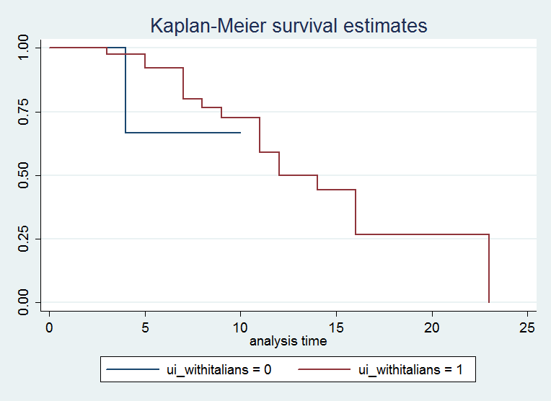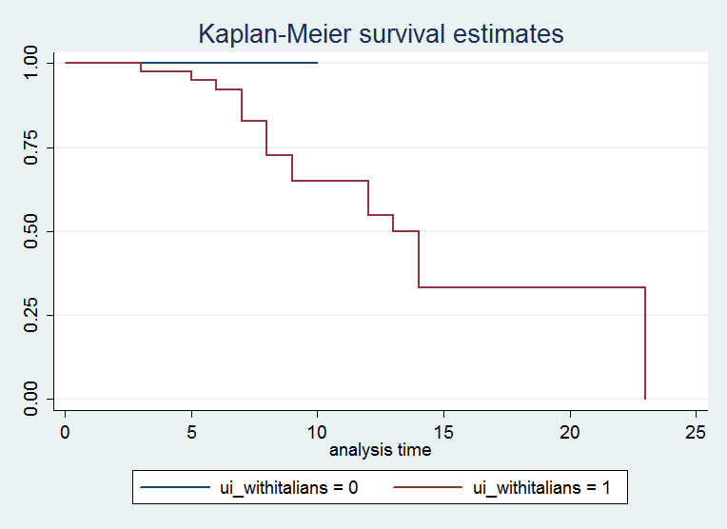

Figure2a,b: Firm Failure for Treatment – Preference for networking with Italians ((a) failure in employment and (b) failure in turnover) .

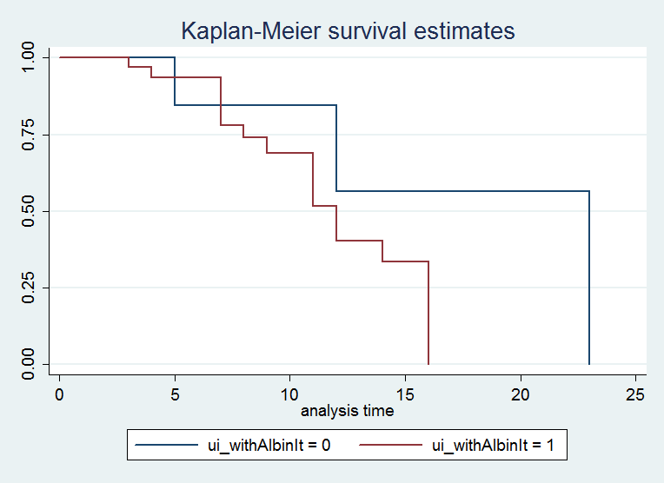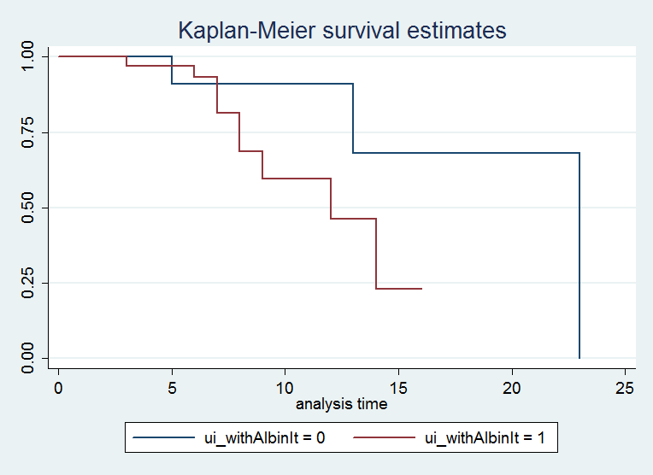

Figure3a,b: Firm Failure for Treatment – Preference for networking with Albanians in Italy ((a) failure in employment and (b) failure in turnover)

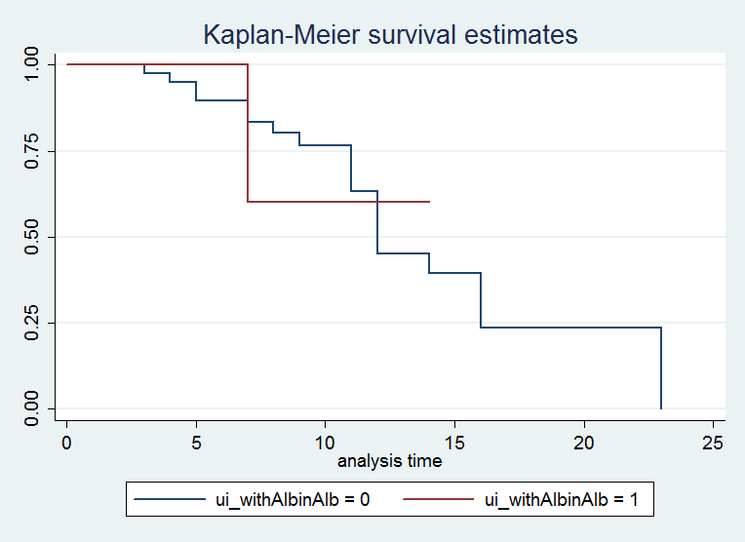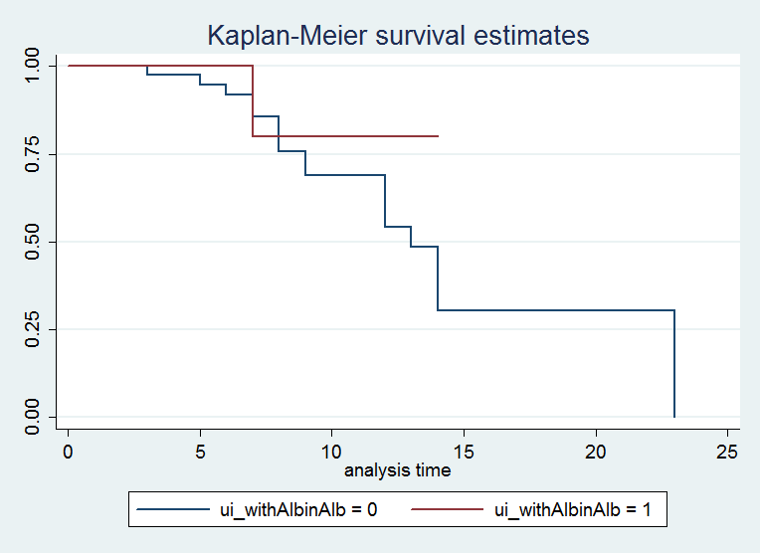

Figure4a,b: Firm Failure for Treatment – Preference for networking with Albanians in Albania ((a) failure in employment and (b) failure in turnover)

Table 1a-b: Descriptive Statistics for Interviewed Firms & Full Population of Firms in Milan, Italy

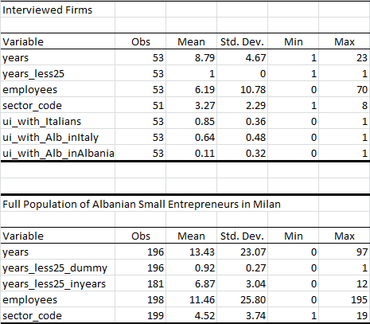

Legend: Table 1a-b presents results with omitted missings for variable year (denoting years of survival of firm since foundation year). Table 1a presents the results for the interviewed firms. Table 1b presents the data for the full population of Albanian small entrepreneurs in Milan. The variable years_less25_dummy is equal to 1 for those firms below 25 years of age, i.e. within the cycle of one (first) generation of ownership. Alternatively, variable years_less25_inyears has as values the actual number of years of a firm if it is below 25 years of existence and a missing if the firm has 25 or more than 25 years of existence. Number of employees and sectors is also indicated, as well as the three types of preferred networks for the interviewed firms: networks with Italians, with Albanians in Italy or with Albanians in Albania.
Source: Authors’ calculations.

Table 2: Sectoral Specialization of Interviewed Firms and Full Population of Firms in Milan, Italy
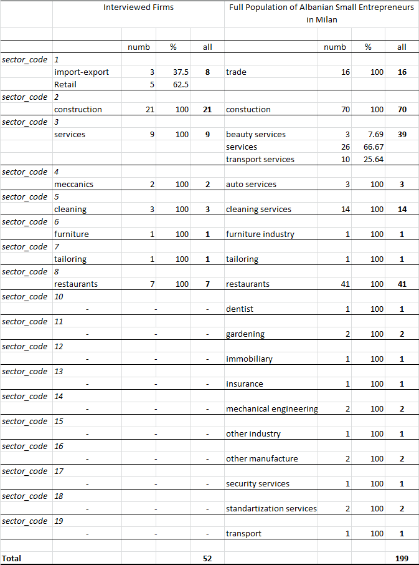
Legend: Table 2 presents the distribution per sector of the firms in our two samples(interviewed firms vs full population of Albanian small enterprises in Milan, Italy). The definition of sectors is different in the two datasets, therefore we created a sector code, where the sectors in the interviewed firms were considered the defining foundation of the sector code and all relevant and related sectors from the full sample of firms were assign to the same sector code.
Source: Authors’ calculations.

Table 3a-b: Propensity Score Matching of Interviewed Firms with Full Population of Firms
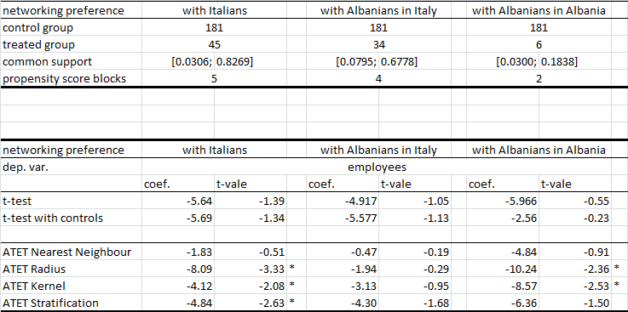

Legend: Table 3a presents the number of firms in treated and control group, as well as the common support for the propensity score and the estimated blocks of common support for the propensity scores per type of networking preferred by the firms (with Italians, with Albanians in Italy or with Albanians in Albania). Table 3b presents the t-tests (without and with control variables) and the average treatment effect on the treated coefficients and t-values. Significance of coefficients is noted with star (*).
Source: Authors’ calculations.

Annex 1: Data Gathered through Structured Interviews

The interviewed ethnic entrepreneurs were asked about their: status of employment before starting entrepreneurship; time duration of being entrepreneur in the host country‘s market; reason for being an entrepreneur; main way of starting the business; sources of capital to found the enterprise; role and status played in the enterprise; relation with employees in the enterprise; the number of the employees since the begining; the place/market segment to sell the products and services; origin of the buyers; size of the market segment; origin of the suppliers; way of communication with the market; weight of the Albanian products in the total budget; origin of the goods and services bought; number of functions of business completed within enterprise; national origin of the competitors; total competitvenes capacity; "level of ties with egos and alters (level of internal/strong ties – 1,2,5,6 – X21a) and (level of external/weak ties – 3,4,7 – X21b); origin of the intermediator for contacts, hiring employees or collaborators; origin of the loan; origin of the organization or networks of membership; impact of the economic crisis on the business; 31-33 are related to social status and social involvement of the entrepreneur; economic conditions of the family of origin compared to the average of the country; national origin of the spouse/husband; employment before immigration; immigration motive.

The most typical examples of cultural distance is the obvious linguistic distance, as well as distance in internalized norms of behavior and communication, socialization patterns and expectations (see Bielenia-Grajewska et al. 2013).
Focusing on one type of ethnic entrepreneurs, from only one ethnicity and in one specific locality (viz. Albanian small entrepreneurs in the Milan area), allows us to reduce all context-related cultural heterogeneity with regard to opportunity structures and institutions. The entrepreneurs in our dataset also share a common cultural-ethnic origin. This provides us with a group for empirical analysis that is fairly homogeneous and is situated in the same mixed embeddedness context. Therefore, we can clearly identify different effects from using (i) networks of incumbents (Italian network) (ii) networks of Albanians in Milan (diaspora networks) and (iii) Albanians in Albania (transnational networks).
A social network has been defined by Reggiani and Nijkamp (2009) and Easley and Klinberg (2010) as structures of connected people.
Markusen (1996, 2004) recognizes networks as one of the most prominent causes of a firm’s development and survival.
According to ISTAT, Milan was in 2011 the leading region in Italy in terms of share of foreigners in the regional population. Thus, Milan is only comparable to and competing with Rome, the two cities sharing or exchanging the first place in terms of diversity, depending on the measurement approach and period considered.
https://www.urbandivercities.eu/wp-content/uploads/2017/02/Divercities-City-Book-Milan.pdf https://www.rc21.org/en/wp-content/uploads/2014/12/G3-Marzorati.Quassoli.pdf https://core.ac.uk/download/pdf/6264162.pdf
The eventual social desirability bias (which would suggest that the interviewee might feel pressed to report preference for networking with the local population in order to be perceived as socially agreeable by the interviewer) is not likely in our case, since the interviewer .was of Albanian origin and we have promised full anonymity to the interviewees. Moreover, the question was phrased around ‘what is more important to you’ (addressing the affect), rather than ‘what do you perceive as the more important network for your business’ (which would address a rationally perceived merit from supporting this network). Thus, we believe to have successfully captured the social value that the entrepreneur bestows onto the three types of networks.
The interviewed 53 small entrepreneurs have been guaranteed full anonymity according to the institutional ethical requirments for data collection. Therefore, we cannot provide any revealing individual firm level information about any of the participants, as it may lead to identifying the entrepreneur. We have however, provided all the summary average characteristics of the interviewed sample, depicting in sufficient detail the heterogeneity of the firms and their mapping against the subgroups in the full sample.
Since we have data comprised of only Albanian entrepreneurs, it is difficult to claim that Albanians are typical or atypical per se in order to generalize our results. However, having the opportunity to focus on a representative sample for only one ethnic group, allows us to analyze the factors of interest here, free from the cultural relativity bias when comparing choices made by people from different ethnic groups.
In a total population of 200 firms, a sample of 53 firms is representative with confidence level 95% and margin of error 12%.
The full range of questions the interviewed answered can be seen in Annex 1.
Namely, we measure success through number of employees. The firms have between 1 and 10 employees. We code as survival having more than 1 employee, next having more than 2 employees, then having more than 3 employees, with the last survivors having only 10 employees each. The same logic can be applied when success is measured through generated turnover.
Results are robust to different cut-off points. However, choosing 8 or above for a Likert scale with 10 levels approximates choosing those people whose likelihood to really choose a particular network was above 80%.

