**Rare Earth Doped Metal Oxide Sensor for the Multimodal Detection of Volatile Organic Compounds (VOCs)**

Matteo Fois, Timothy Cox1, Norman Ratcliffe, Ben de Lacy Costello*

*Department of Applied Sciences, The University of the West of England, Bristol BS16 1QY, U.K.*

*1Institute of Biosensing Technology, The University of the West of England, Bristol BS16 1QY, UK.*

*\*Corresponding author: Ben de Lacy Costello, Ben.DeLacyCostello@uwe.ac.uk*

**Abstract**

Heated metal oxide sensors have been widely studied for their ability to give a reversible change in the electrical resistance following the interaction with a volatile compound. Another feature is their inherent cataluminescence (CTL) properties when these materials interact with specific volatiles.

This study reports for the first time a zirconium oxide nanomaterial doped with a rare earth metal which gives combined resistance and cataluminescence responses, providing enhanced sensitivity and selectivity of detection via a **multimodal response in a single sensor**. The europium-doped zirconium oxide, ZrO2:Eu3+ was studied and compared with the undoped zirconium oxide, ZrO2, and tungsten oxide, WO3. Materials were characterised structurally and tested with a series of volatiles. Both the cataluminescence light emission and the resistance response were recorded at different temperatures (starting from 180°C up to 400°C) and then combined to achieve the dual modality response. Europium-doped zirconium oxide gave a better sensitivity in terms of cataluminescence response than the undoped zirconium oxide sensor; dual modality sensing is demonstrated for ethanol and acetone which give cataluminescence and resistance responses on both the undoped and europium doped zirconia.

**Keywords**

Gas sensing; multimodal; cataluminescence; rare-earth ions; metal oxide semiconductors; zirconium dioxide.

1. **Introduction**

Interest in the selective detection of volatile organic compounds at low concentrations (VOCs) has increased over the past decade. Detecting VOCs is of crucial importance in different fields such as environmental monitoring[1,2], medical diagnosis[3–5], air quality monitoring [6–8] and industrial safety and security applications[9]. In the case of security applications, the detection of low concentrations (typically ppb levels) of explosives in air has become of increasing interest due to the heightened threat of international terrorism. [10–12]

Among the many detection techniques developed to meet this need, chemical-based sensor systems have a leading role and, in particular, semiconductor metal-oxide gas sensors[13–15]. Detection is typical via a change in their electrical resistance properties allowing high sensitivity but often with limited selectivity. However, this can be improved by doping, the temperature of operation and the use of nanostructured materials. The primary materials studied are typically oxides of yttrium, tin, zinc, tungsten, titanium, and zirconium[16–21].

Another property of a sub-class of metal oxide-based materials that have been utilized albeit, less frequently in sensing applications, is their ability to give chemiluminescence, i.e. light emission as a result of the interaction with a target compound. A particular kind of chemiluminescence, called cataluminescence (CTL) has been reported which arises from the heterogeneous catalytic reaction occurring on the surface of solid catalyst accompanied by light emission[22]. It has been reported that the doping of the metal oxides with certain rare earth metals gives an increase in the production of CTL. In particular, europium, terbium and erbium have been employed successfully to enhance the CTL sensitivity of certain metal oxides such as zirconium oxide [23].

Although these sensors display high sensitivity of detection for a range of gases, this aspect is accompanied by a lack of specificity of detection. Another practical issue exhibited by these devices is thus the high false alarm rate, especially when the sensors need to be employed in a real-life environment such as explosives detection[25,26].

A possible solution, to create a sensor with enhanced selectivity, is via a sensor which simultaneously detects both the light emission (CTL) and the electrical resistance. Another important aspect is the sign of response: (i) the change in resistance can be positive or negative depending on the target gas (oxidising /reducing) or the sensor material properties (n-type/p-type), providing further differentiation between two compounds. (ii) the light emission signal can be positive or absent.

Nanoparticle-based sensor systems have shown better performance than those fabricated with non-nano materials. These studies [27–29] have optimised the selectivity of a zinc oxide-based resistive sensor for acetone with respect to ethanol by using dumbbell like zinc oxide nanoparticles and varying the operating temperature. Whilst selective to acetone, the sensor is not able to distinguish between a low concentration of acetone or a higher concentration of ethanol. The addition of a second sensing modality, such as CTL, would facilitate such a differentiation to be made. Thus, this paper reports the tests conducted to determine the best sensitivity and selectivity conditions for detection of acetone (the target) and ethanol (the interferent) for a nano-particle europium-doped ZrO2  dual modality sensor, as compared with an undoped ZrO2 sensor and a tungsten oxide sensor, included as a standard resistance-based sensor. Different operating temperatures and different targets and interferents have also been studied. To our knowledge, this is the first report in the scientific literature of such a dual modality sensor based on combined resistance and cataluminescence measurements.

1. **Methods**

2.1 Synthesis of the mixed metal oxide ZrO2:Eu3+

The synthesis of the mixed metal-oxide ZrO2:Eu3+, (europium 5 atomic per cent with respect to zirconium) is via a wet chemical method analogous to the one reported in the previous literature[23]. The chemicals utilized for the preparation were of analytical grade and used as received from the suppliers: ZrO(NO3)2 (Aldrich); Eu(NO3)3(aq); NH4OH (aq) (5M) (Fluka).

2.5 mL of a 0.02 M Eu(NO3)3(aq) solution was added to 10 mL of a 0.1 M ZrO(NO3)2(aq) solution and stirred rapidly. 0.1M NH4OH (aq) was added in a steady stream until the reaction mixture reached pH 8. The precipitate formed was filtered and washed three times with deionised water and the pH adjusted to pH 8 with 0.1M NH4OH (aq). The precipitate was first dried in an oven at 60°C and finally calcined in a muffle furnace for 3 hours at 600°C.

2.2 Characterization

Transmission electron microscope (TEM) images were captured using a Philips CM10 TEM, 100kV, with a Gatan Orius SC100 (model 832) digital camera.

The metal-oxide nanoparticles were also characterised using a scanning electron microscope (SEM), operating at 30kV, combined with EDX using an FEI Quanta 650 field emission SEM. Three different detectors were used: Large Field Detector (LFD), Gaseous Secondary Electron Detector (GSED) and Gaseous Back Scattered Electron Detector (GBSD).

The composition of the nanoparticle materials was determined using Energy Dispersive X-Ray Microanalysis (EDX), using an Oxford Instruments AZtec Energy EDX system. The voltage used was between 7.5-20 kV.

X-Ray Powder Diffraction (XRD) patterns were recorded on a Bruker D2 Phaser in theta-theta geometry using Cu (Kα1/Kα2 λ = 0.15418 nm) radiation and a Ni Kβ filter (detector side). Additional beam optics and settings: primary and secondary axial Soller slits (2.5°), fixed 0.6mm divergence slit, 1mm anti-scatter-screen, Detector: 1D LYNXEYE with a 5° window, Generator: 30kV, 10mA. The software used for the data analysis was the DIFFRAC.SUITE COMMANDER, Bruker AXS. DIFFRAC.EVA 2.1, Bruker AXS (2010-2012).

Vibrational Raman spectra and photoluminescence spectra of sensor surfaces were recorded using a Horiba LabRAM HR Evolution Raman Microscope using an Olympus M Plan x5, NA 0.15 objective lens. For Raman scattering measurements, a 785nm laser, ~30mW, was used. For the photoluminescence spectra, excitation was with a 532nm laser, ~0.3mW.

For Cataluminescence and Photoluminescence measurements, the sensor was packaged in a dye cast box with an optical window; vapour samples were input to the sensor chamber to obtain cataluminescence spectra.

Cataluminescence spectra were recorded using an EG&G 1460 OMA system including a 0.25m Jarrell Ash 82-497 polychromator, 300 lines/mm grating, and 1254 intensified silicon detector cooled to -20O and an accumulation time of 20 seconds. The sensor was placed immediately in front of the polychromator entrance slit. The experimentally determined black body radiation (BBR) from the heated sensor was subtracted from the total emission spectrum to yield the cataluminescence spectrum.

2.3 Sensor Preparation

The sensor substrate was a 3 mm x 3mm square alumina tile. On the sensor (front) face was screen printed two gold interdigitated electrodes (four pairs of interpenetrating bars, electrode gap 100 μm). On the reverse face was a platinum heater track which also served as a temperature sensor. The sensor/heater assembly was wire bonded to a TO39 transistor can. The resistance of the platinum heater at different temperatures was determined by placing the sensor in an oven whose temperature could be varied. In operation, a feedback control loop was used to maintain the sensor at the required preset temperature.

All the sensors were fabricated using a drop-coating method to apply the sensor material to the interdigitated electrodes: a small amount (0.2g) of the metal-oxide was placed in a glass vial, and sufficient water (0.4 g) was added to produce a thick slurry by stirring. The heater resistance at room temperature was of 10 Ohms. Other resistance heather features are reported in the supplementary information. The sensor was prepared by drop coating the oxide paste on to the top surface of the sensor substrate (3 x 3 mm alumina tile) so that it completely covered the interdigitated gold electrodes. The sensor was then allowed to dry at room temperature for 12 hours before use.

2.4 Experimental

The sensor was housed in a light-tight chamber of volume 100 mL with input and output tubes (internal diameter of 3 mm). Laboratory air was flowed through the chamber using a KNF-Neuberger micro diaphragm pump at a rate of 100 mL/min.

The concentrations were validated by the volatile compounds of interest were diluted from headspace concentrations and then injected into the input air flow using a 10mL gas-tight syringe via a silicone rubber septum attached to the inlet tubing of the sensor chamber. At this constant flow rate, the volatile is input to the sensor chamber and mixed, i.e. diluted, with the flowing laboratory air in a few seconds. The concentrations quoted at the sensor are the diluted values achieved at the sensor surface. Compounds characterised by a shallow headspace concentration (under 1 ppm) were generally heated in a thermostatic oven, and the new enhanced headspace concentration was calculated using the Clausius Clapeyron equation. The concentrations in Table 1 are theoretical values based on the vapour pressure of the test substance. To establish the validity of using diluted headspace concentrations the method was tested using selected ion flow tube mass spectrometry (SIFT-MS). The results of these tests for acetone are reported in the supplementary information. The sensors were tested under ambient humidity conditions (40-60% R.H.)

A number of controls were run such as injecting air (at the appropriate temperature) or water headspace to ensure that the response is due to the target and not just due to changes in humidity, background volatiles, syringe contamination or changes in oxygen partial pressure. The dual modality responses for a given sensor were measured at different sensor operating temperatures (150°C to 450°C) and at a range of different concentrations of the target volatile compounds (low ppb to high ppm).

The light (cataluminescence) produced following the reaction occurring on the surface of the sensor was detected by a Hammamatsu photomultiplier (HP7820) used in photon counting mode; quantum efficiency ~20%. Output pulses corresponding to incident photons are counted by an ASCEL Electronic AE20401 5.8 GHz Frequency Counter. A 650 nm short-pass filter was placed between the sensor and the photomultiplier (see Fig. 8(a)) to enhance the ratio of CTL to the black body radiation (BBR) arising from the heated sensor. Generally, three injections of the same concentration of a given compound are made into the chamber, and the cataluminescence response profile was measured.

Regarding the resistance, the sensor is connected to a voltage source and the change in current in response to the presence of a volatile compound is monitored via a Keithley Electrometer model 617 and connected through a suitable Picolog: Prologix GPIB-USB (HPIB-USB) analogue to digital converter which is interfaced to a computer running bespoke sensor analysis and signal conditioning software. The applied voltage was of 5 V. For each material was made a single sensor and they have been tested singularly by the dual-modality experiments.

**3. Results and Discussion**

3.1 Materials and Cataluminescence Characterisation

Figs. 1(a) and (b) show TEM images of the (a) ZrO2 and (b) ZrO2:Eu3+(5%) nanoparticles. Regarding the europium-doped zirconium oxide (Fig. 1(b)) it is observed that some agglomerates formed, possibly caused by uncontrolled coagulation during the precipitation process. The formation of such clusters is more evident in comparison with the undoped ZrO2, shown in Fig. 1(a). The images also reveal that the nanoparticles are characterized by a narrow particle size distribution and nearly spherical morphology. Average particle size, as calculated by the ImageJ software, was 22 nm for the undoped zirconium dioxide and 15 nm for the europium doped particles. These values are in accordance with those reported in the literature [11].

**Fig. 1.a, Fig. 1.b**

SEM micrographs are shown in Fig. 2(a) (ZrO2) and 2(b) (ZrO2:Eu3+). If the ZrO2 nanoparticles, shown in Fig. 2(a) are compared with the ZrO2:Eu3+ in Fig. 2(b), the formation of clusters is again found for the europium doped material.

**Fig. 2.a, Fig. 2.b**

The XRD patterns of the undoped ZrO2 and the europium doped material are shown respectively in Fig.3 and Fig.4.

**Fig. 3**

**Fig. 4**

The Raman spectra are shown in Fig. 5 for the undoped ZrO2 and the europium doped ZrO2 materials for excitation at 785 nm.

The XRD data are fitted well to a monoclinic phase for the undoped ZrO2 and the tetragonal phase for the ZrO2:Eu3+ (5%) material.

Following the assignment of Hui *et al.* 2015 [30]given in their figure 4, the Raman peaks for the monoclinic and tetragonal phases are indicated in our Fig. 5. Reference to our Fig. 5 confirms that the undoped ZrO2 and Eu3+ doped materials are respectively comprised almost entirely of the monoclinic and tetragonal phases, in agreement with the XRD analysis.

It was also possible to calculate the average particle size through the Debye-Scherrer equation Dc = Kλ/βcosθ where Dc is the average particle size, K is the Scherrer constant taken to be equal to 0.94, the X-Ray source wavelength is 0.15418 nm, β is the full width at half-maximum of the peak at a diffraction angle of θ. The average particle size calculated for the undoped oxide was 17 nm and that for the Europium-doped was 21 nm. These values are in accordance with the values calculated from the TEM images and those reported in the previous literature [11].

The Energy Dispersive X-ray Analysis (EDX) pattern for the undoped ZrO2 is shown in Fig. 6; for this experiment, a voltage of 20kV was used.

**Fig. 6**

The pattern shown in Fig. 6 identifies the presence of only zirconium and oxygen; whereas EDX analysis of the ZrO2:Eu3+ material (Fig. 7) shows that effective doping with europium had been achieved.

**Fig. 7**

The photoluminescence (PL) spectrum for the ZrO2:Eu3+ material is shown in Fig. 8(c), recorded at a sensor temperature of 450OC. The two major PL peaks are at 592 and 607 nm. Hui et al recorded PL spectra for ZrO2 doped with Eu3+ with concentrations in the range 0.5 to 5%. Reference to figure 7 of Hui et al shows that, for PL excitation at 254 nm, they observed principal PL peaks at similar positions, i.e. 593 and 608 nm; and when their material was doped with at least 3% Eu3+, their PL lineshapes were similar to those we found for our europium doped zirconium dioxide.

Cataluminescence spectra are shown in Fig. 8 for the interaction of acetone vapour (2 parts per thousand) with (a) undoped ZrO2 and (b) ZrO2:Eu3+ also at a sensor temperature of 450OC. The cataluminescence spectrum from ZrO2:Eu3+is similar to that of the corresponding photoluminescence spectrum recorded at the same temperature (Fig. 8(c)). The cataluminescence spectrum from the undoped ZrO2 is a broad featureless response over the 400 – 700 nm region recorded.

**Fig 8**

3.2 Sensing Experiments

The following analytes were tested with the apparatus described above: acetone, ethanol, water, hydrogen peroxide, ethylene glycol dinitrate (EGDN), nitroglycerine (NG), 2,4-dinitrotoluene (DNT) and 2,3-dimethyl-2,3-dinitrobutane (DMNB). All chemicals were of analytical grade and used as received from the suppliers. Table 1 shows the gas concentration ranges tested. NG and EGDN were in a safe format: 10% by weight immobilised on diatomaceous earth, Kielselguhr (desensitised) and supplied by one of the projects sponsors DSTL. The compounds tested are a mixture of VOCs and other compounds which have been linked to explosives and possible interferents which may limit their detection in specific applications.

**Table. 1**

The data were collected as sensor response (light emission or resistance change) as a function of time. The cataluminescence response was defined by subtracting the black body radiation from the signal registered by the photomultiplier. The resistance signal is reported as relative resistance R = Rgas/Rair, where Rgas is the sensor resistance in the presence of the volatile under investigation, while Rair is the value in the presence of air.

An overview of the ZrO2:Eu3+ responses, both in terms of cataluminescence and electrical resistance, is reported in Table 2. The operating temperature was of 300°C

**Table 2**

The dual modality response profiles for the ZrO2:Eu3(5%) sensor, at an operating temperature of 275°C, are shown in Fig. 9, for three repeat injections of 296 ppm of acetone. The peak responses are seen to be highly reproducible, i.e. ~+ 5%, for both the cataluminescence and resistance responses.

**Fig. 9**

The sensor gives the response simultaneously in terms of light emission and resistance. Referring to Fig. 9, while the response time is comparable for the two different modalities (~10 seconds), the recovery time (1/e) is significantly longer (150 seconds) for the resistance measurement vs the cataluminescence response (~20 seconds).

Fig.10a shows the light emission response as a function of the concentration of acetone at an operating temperature of 300°C for the three sensor materials. The zirconium oxide sensor and europium doped zirconia sensor have high cataluminescence sensitivity to acetone at this temperature as compared to tungsten oxide sensor, which is at least an order of magnitude lower.

Fig. 10b shows more in detail the zirconium oxide and the europium-doped zirconium oxide response. The europium-doped sensor gives a cataluminescence response which is ~ 5 times that of the undoped zirconium oxide sensor. The convergence at the highest acetone concentrations could be partly due to the saturation of the photon counting system at 106 photons per second. This result is consistent with that reported by Zhang *et al*., 2005, where europium doping was seen to improve the light emission and thus the sensitivity of the zirconia cataluminescence sensor, particularly at lower temperatures.

**Fig. 10**

Fig. 11 shows the cataluminescence response at different temperatures for a high concentration of acetone (296ppm) for the tungsten oxide sensor, which does give a measurable cataluminescence response, but only at temperatures above 250°C and concentrations above 30 ppm. The maximum CTL signal is 8000, which is approximately one hundred times lower than for the undoped and europium doped zirconium oxide sensors at this concentration (see Fig. 10(b).

**Fig. 11**

The sensor performance in terms of selectivity as a function of sensor temperature was also studied. In Fig. 12 the ZrO2:Eu3+ CTL response following the interaction with ethanol (58.7ppm) and acetone (29.6ppm) at different temperatures is reported.

**Fig. 12**

Fig. 13. shows the ratio of the CTL response to acetone (29.6ppm) to that of ethanol (58.7ppm) for the ZrO2:Eu3+ sensor as a function of temperature. The relative response to acetone (29.6ppm) is higher with respect to ethanol (58.7ppm) despite the lower concentration of acetone at all temperatures. This allows the determination of the optimum operating temperature to obtain maximum selectivity for acetone with respect to ethanol to be identified as 200°C; offering a CTL selectivity for acetone over ethanol, normalized to concentration, of ~20. A low temperature of operation is desirable, and overall, this work has shown that the cataluminescence response is better at lower temperatures when compared to the resistance response.

**Fig. 13**

Fig. 14 shows the cataluminescence response to nitroglycerine for all three sensors studied. The ZrO2:Eu3+. showed the best sensing performance for 0.63 ppm nitroglycerine in the temperature range of 250-300oC. At 350oC, the cataluminsecence response is lost in the noise due to the high background signal due to the black body radiation (BBR). The BBR does limit the use of cataluminescent sensors for low concentrations at higher temperatures of operation. Whilst europium doping has significantly increased the CTL signal with respect to undoped zirconia, it has also shifted the peak cataluminescence response to a higher wavelength where the BBR signal is higher. Selective wavelength filtering could reduce BBR relative to CTL. For example, referring to Fig. 8(b), a 50nm width bandpass filter centred around 610 nm would transmit most of the CTL for ZrO2:Eu3+, whilst further reducing the BBR.

**Fig. 14**

The relative resistance response for the three sensors as a function of the concentration of acetone at an operating temperature of 300°C is reported in Fig. 15.

**Fig. 15**

In this case, the WO3 gives by far the most massive change in resistance while the zirconium-based sensors give much smaller responses. However, both the undoped and europium doped zirconia-based sensors do give measurable, albeit smaller, responses as shown in Fig. 16. This aspect indicates that the undoped zirconia sensor gives a more considerable resistance change over a wide range of concentrations of acetone when compared to the europium doped sensor. The main benefit from the perspective of multimodal sensing is that the undoped and doped sensors do give different response profiles, showing that the europium doping has affected both the cataluminescence and resistance responses when compared to the undoped sensor.

**Fig. 16**

One route to achieving selectivity of detection is to consider the ratio between the cataluminescence and the resistance responses (CTL/Resistance). In Fig. 17, this dual modality ratio response is reported for acetone (29.6 ppm) and ethanol (58.7 ppm) at different temperatures. This graph emphasises that it is possible to get a massive difference in the CTL/resistance ratio between two compounds, in this case, acetone and ethanol (target/interferent) at different temperatures. At 200°C, there is a massive difference, but, at 250°C, the acetone and ethanol ratios are similar. Thus, calculating the CTL/resistance ratio can be one method of improving selectivity in this multimodal sensor, with the temperature of operation chosen to optimise differences in this ratio.

**Fig 17**

***Discussion***

We believe that this is the first report in the scientific literature of multimodal sensing combining simultaneous resistance and cataluminescence measurements on the same heated metal oxide sensor. This work has demonstrated that the approach shows promise for enhancing the selectivity of detection. In terms of sensor recovery, this is limited by the resistance response which is much slower than the cataluminescence response. The selective wavelength of detection combined with dopants other than europium chosen to shift the CTL to shorter wavelength might offer a route to increasing the ratio of the CTL signal to BBR noise. This would be particularly useful for high sensor temperatures and low vapour concentrations, where the high BBR background limits CTL signal to noise, thereby extending the operational temperature range for multimodal sensing.

A further approach is to combine a number of multimodal sensors in a sensor array to offer additional specificity of detection. Such arrays could feature different nanomaterial sensors operated at different temperatures. Such multimodal micro-hotplate sensor arrays could be manufactured using MEMS (MicroElectroMechanical Systems) technology. An improved understanding of the CTL and resistance sensing mechanisms could also lead to enhanced sensor design.

At present, although all sensors studied gave some cataluminescence in addition to resistance changes, there were considerable differences observed between tungsten-based sensors which were better for resistance measurement and zirconium oxide-based materials which gave enhanced cataluminescence responses and smaller resistance responses

For the zirconia material, europium doping was shown to be successful in enhancing the cataluminescence response and modifying the resistance response vs the undoped material. This demonstrates the potential to dope other metal oxide materials to produce multimodal sensors with differing cataluminescence and resistance response profiles.

The work presented here represents a new type of sensor with potential to improve selectivity for detection of individual VOCs in the presence of other interfering volatiles.

There are certain limitations to the study presented. However, work was carried out at a range of sensor temperatures to find optimal response to targets for each sensing modality, more complete environmental testing such as altering ambient temperature and humidity is required. It should be noted that these tests were carried out at a typical room humidity (40-60%RH) and not under dry air conditions. Hence, the sensors show relatively good stability across this humidity range. Moreover, the cataluminescent response is not affected by humidity in the same way as resistance-based sensors. We did not observe any catalumiscent response to high levels of humidity. However, cataluminscent sensors are adversely affected by high temperature, and the baseline light emission rises as the temperature increase, especially marked above 300oC. However, it should be noted that with better filtering of background light emission vs. Cataluminescent response which are at distinct wavelengths, then this issue could be resolved.

Another limitation is the relative cost of combining two modalities compared to typical metal oxide-based sensors which are relatively cheap. The addition of the requirement to measure CTL response adds bulk and a costly photon counting PMT module. However, there are silicon technologies which are appropriate to replace the PMT module and could realise a miniaturised device in future studies. The need for a light-tight cell is also potentially more costly but we have developed field prototypes based on this sensor relatively inexpensively. The baseline resistance of the dual modality sensors giving the best cataluminescent response is relatively high compared to conventional metal oxide sensors. The need to operate at lower temperatures to negate background effects also exacerbates this. However, this paper reports the first step in developing these sensors, and we have tested a range of conventional metal oxide materials, including tungsten that have some CTL based response. Therefore, we envisage the possibility of new materials being discovered with multimodal responses inherent or being synthesised. Future work would consequently, try to identify new materials and also to better understand the sensor characteristics in order to design better and more selective sensors.

**4. Conclusions**

We have demonstrated for the first time a multimodal sensor that combines resistance and cataluminescent measurements simultaneously on a single heated metal oxide sensor. We have shown that cataluminescence and resistance measurements can be combined to enhance the selectivity of the sensors to various targets as compared to the single mode sensors.

The systematic screening was undertaken using the ZrO2, ZrO2:Eu3+ and WO3 sensors showed that it is possible to create a sensor system with increased selectivity by using the dual-modality. It is thus possible to distinguish between different targets that, even if they gave a similar response under one of the sensing modalities, they could provide a different response to the sensing modality. It is possible to exploit dual modality for enhanced sensitivity to the presence of a target as one of the modalities could be optimised for sensitivity to that target.

In particular, the europium-doped zirconia sensor has shown a better response in terms of CTL even at a relatively low operating temperature, whilst the resistance response is similar to that of the undoped zirconia.. The WO3 sensor exhibited the best resistance response even with low concentrations of the target compounds but gave limited light emission, which was only detected at high target concentrations. Therefore, it may be considered unsuitable as a multimodal sensor, but its inclusion in a sensor array could be advantageous.

**Acknowledgements**

This project was funded under the Innovative Research Call in Explosives and Weapons Detection 2016 initiative. This is a Cross-Government programme sponsored by a number of Departments and Agencies under the UK Government's CONTEST strategy in partnership with the US Department of Homeland Security, Science and Technology Directorate.

The authors wish to thank Dr Dan Wood and Mr Tony Webb from the Threat Mitigation Technologies department of the Metropolitan Police Service for their invaluable help and guidance during the project.

The authors would like to thank David Patton and Sue Hula, The University of the West of England for instruments usage and technical assistance relative to the Transmission Electron Microscopy, the Scanning Electron Microscopy and the Energy Dispersive X-ray Analysis.

We would also like to thank Dr Mark Light, University of Southampton, for the X-Ray Diffraction data analysis.

The views expressed in this publication are those of the authors and not necessarily those of the funding contributors.

**References**

[1] M.S. Kamal, S.A. Razzak, M.M. Hossain, Catalytic oxidation of volatile organic compounds (VOCs) - A review, Atmos. Environ. (2016). https://doi.org/10.1016/j.atmosenv.2016.05.031.

[2] J.E. Colman Lerner, M. de los A. Gutierrez, D. Mellado, D. Giuliani, L. Massolo, E.Y. Sanchez, A. Porta, Characterization and cancer risk assessment of VOCs in home and school environments in gran La Plata, Argentina, Environ. Sci. Pollut. Res. (2018). https://doi.org/10.1007/s11356-018-1265-2.

[3] A.D. Wilson, Application of electronic-nose technologies and VOC-biomarkers for the noninvasive early diagnosis of gastrointestinal diseases, Sensors (Switzerland). (2018). https://doi.org/10.3390/s18082613.

[4] A.M. Casas-Ferreira, M. del Nogal-Sánchez, J.L. Pérez-Pavón, B. Moreno-Cordero, Non-separative mass spectrometry methods for non-invasive medical diagnostics based on volatile organic compounds: A review, Anal. Chim. Acta. (2019). https://doi.org/10.1016/j.aca.2018.07.005.

[5] A. Pizzini, W. Filipiak, J. Wille, C. Ager, H. Wiesenhofer, R. Kubinec, J. Blaško, C. Tschurtschenthaler, C.A. Mayhew, G. Weiss, R. Bellmann-Weiler, Analysis of volatile organic compounds in the breath of patients with stable or acute exacerbation of chronic obstructive pulmonary disease, J. Breath Res. (2018). https://doi.org/10.1088/1752-7163/aaa4c5.

[6] C.S. Lee, Z. Dai, D.H. Kim, H.Y. Li, Y.M. Jo, B.Y. Kim, H.G. Byun, I. Hwang, J.H. Lee, Highly discriminative and sensitive detection of volatile organic compounds for monitoring indoor air quality using pure and Au-loaded 2D In2O3 inverse opal thin films, Sensors Actuators, B Chem. (2018). https://doi.org/10.1016/j.snb.2018.06.011.

[7] P. Arroyo, J.L. Herrero, J.I. Suárez, J. Lozano, Wireless sensor network combined with cloud computing for air quality monitoring, Sensors (Switzerland). (2019). https://doi.org/10.3390/s19030691.

[8] M.F. Yassin, A.M. Pillai, Monitoring of volatile organic compounds in different schools: a determinant of the indoor air quality, Int. J. Environ. Sci. Technol. (2019). https://doi.org/10.1007/s13762-018-1838-0.

[9] S. Öztürk, A. Kösemen, Z. Şen, N. Kılınç, M. Harbeck, Poly(3-methylthiophene) thin films deposited electrochemically on QCMs for the sensing of volatile organic compounds, Sensors (Switzerland). (2016). https://doi.org/10.3390/s16040423.

[10] C. Tudisco, A. Motta, T. Barboza, C. Massera, A.E. Giuffrida, R. Pinalli, E. Dalcanale, G.G. Condorelli, Cavitand-Decorated Silicon Columnar Nanostructures for the Surface Recognition of Volatile Nitroaromatic Compounds, ACS Omega. (2018). https://doi.org/10.1021/acsomega.8b01018.

[11] J.R. Askim, Z. Li, M.K. LaGasse, J.M. Rankin, K.S. Suslick, An optoelectronic nose for identification of explosives, Chem. Sci. (2016). https://doi.org/10.1039/c5sc02632f.

[12] K. Konstantynovski, G. Njio, F. Börner, A. Lepcha, T. Fischer, G. Holl, S. Mathur, Bulk detection of explosives and development of customized metal oxide semiconductor gas sensors for the identification of energetic materials, Sensors Actuators, B Chem. (2018). https://doi.org/10.1016/j.snb.2017.11.116.

[13] A. Dey, Semiconductor metal oxide gas sensors: A review, Mater. Sci. Eng. B Solid-State Mater. Adv. Technol. (2018). https://doi.org/10.1016/j.mseb.2017.12.036.

[14] T. Lin, X. Lv, Z. Hu, A. Xu, C. Feng, Semiconductor metal oxides as chemoresistive sensors for detecting volatile organic compounds, Sensors (Switzerland). (2019). https://doi.org/10.3390/s19020233.

[15] D. Nunes, A. Pimentel, A. Goncalves, S. Pereira, R. Branquinho, P. Barquinha, E. Fortunato, R. Martins, Metal oxide nanostructures for sensor applications, Semicond. Sci. Technol. (2019). https://doi.org/10.1088/1361-6641/ab011e.

[16] A. Staerz, T. Russ, U. Weimar, N. Barsan, Understanding the Sensing Mechanism of WO3 based Gas Sensors, in: ISOEN 2019 - 18th Int. Symp. Olfaction Electron. Nose, Proc., 2019. https://doi.org/10.1109/ISOEN.2019.8823145.

[17] J. Zheng, T. Zhang, H. Zeng, W. Guo, B. Zhao, Y. Sun, Y. Li, L. Jiang, Multishelled Hollow Structures of Yttrium Oxide for the Highly Selective and Ultrasensitive Detection of Methanol, Small. (2019). https://doi.org/10.1002/smll.201804688.

[18] B.P.J. de Lacy Costello, R.J. Ewen, N.M. Ratcliffe, M. Richards, Highly sensitive room temperature sensors based on the UV-LED activation of zinc oxide nanoparticles, Sensors Actuators, B Chem. (2008). https://doi.org/10.1016/j.snb.2008.06.055.

[19] L.E. Ocola, Y. Wang, R. Divan, J. Chen, Multifunctional UV and gas sensors based on vertically nanostructured zinc oxide: Volume versus surface effect, Sensors (Switzerland). (2019). https://doi.org/10.3390/s19092061.

[20] B. Gökdere, A. Üzer, S. Durmazel, E. Erçağ, R. Apak, Titanium dioxide nanoparticles–based colorimetric sensors for determination of hydrogen peroxide and triacetone triperoxide (TATP), Talanta. (2019). https://doi.org/10.1016/j.talanta.2019.04.071.

[21] U. Guth, H.D. Wiemhöfer, Gas sensors based on oxygen ion conducting metal oxides, in: Gas Sensors Based Conduct. Met. Oxides Basic Understanding, Technol. Appl., 2018. https://doi.org/10.1016/B978-0-12-811224-3.00002-0.

[22] J. Hu, L. Zhang, Y. Lv, Recent advances in cataluminescence gas sensor: Materials and methodologies, Appl. Spectrosc. Rev. (2019). https://doi.org/10.1080/05704928.2018.1464932.

[23] Z. Zhang, K. Xu, W.R.G. Baeyens, X. Zhang, An energy-transfer cataluminescence reaction on nanosized catalysts and its application to chemical sensors, Anal. Chim. Acta. (2005). https://doi.org/10.1016/j.aca.2004.12.025.

[24] M. Hijazi, M. Rieu, V. Stambouli, G. Tournier, J.P. Viricelle, C. Pijolat, Ambient temperature selective ammonia gas sensor based on SnO2-APTES modifications, Sensors Actuators, B Chem. (2018). https://doi.org/10.1016/j.snb.2017.10.036.

[25] N. Joshi, T. Hayasaka, Y. Liu, H. Liu, O.N. Oliveira, L. Lin, A review on chemiresistive room temperature gas sensors based on metal oxide nanostructures, graphene and 2D transition metal dichalcogenides, Microchim. Acta. (2018). https://doi.org/10.1007/s00604-018-2750-5.

[26] S. Zampolli, I. Elmi, J. Stürmann, S. Nicoletti, L. Dori, G.C. Cardinali, Selectivity enhancement of metal oxide gas sensors using a micromachined gas chromatographic column, Sensors Actuators, B Chem. (2005). https://doi.org/10.1016/j.snb.2004.06.036.

[27] M.E. Franke, T.J. Koplin, U. Simon, Metal and metal oxide nanoparticles in chemiresistors: Does the nanoscale matter?, Small. (2006). https://doi.org/10.1002/smll.200500261.

[28] J.M. George, A. Antony, B. Mathew, Metal oxide nanoparticles in electrochemical sensing and biosensing: a review, Microchim. Acta. (2018). https://doi.org/10.1007/s00604-018-2894-3.

[29] Q. Qi, T. Zhang, L. Liu, X. Zheng, Q. Yu, Y. Zeng, H. Yang, Selective acetone sensor based on dumbbell-like ZnO with rapid response and recovery, Sensors Actuators, B Chem. (2008). https://doi.org/10.1016/j.snb.2008.04.024.

[30] Y. Hui, B. Zou, S. Liu, S. Zhao, J. Xu, Y. Zhao, X. Fan, L. Zhu, Y. Wang, X. Cao, Effects of Eu3+-doping and annealing on structure and fluorescence of zirconia phosphors, Ceram. Int. (2015). https://doi.org/10.1016/j.ceramint.2014.10.091.

**Captions to Illustrations**

Fig.1 Transmission Electron Microscopy (TEM) images for (a) ZrO2 and (b) ZrO2:Eu3+ nanoparticles.

Fig. 2 Scanning Electron Microscopy (SEM) images for (a) ZrO2 and (b) ZrO2:Eu3+ nanoparticles.

Fig.3 X-Ray Diffraction (XRD) pattern of the undoped zirconium oxide and relative phase attribution fitting.

Fig. 4 X-Ray Diffraction (XRD) pattern and phase attribution fitting for the ZrO2:Eu3+ material.

Fig. 5 Raman spectrum of undoped ZrO2 nanoparticles (upper trace) and ZrO2:Eu3+ nanoparticles (lower trace). The positions of peaks are marked for the tetragonal phase (t) and monoclinic phase (m), following Hui et al., 2015; i.e. monoclinic at 179 and 190 cm-1 and tetragonal at 147, 264, 319, 462 and 642 cm-1.

Fig 6. EDX spectrum for undoped ZrO2 material. The peak positions for Zr and O are marked.

Fig. 7 EDX spectrum for ZrO2:Eu3+. The peak positions for Zr, O, and Eu are marked.

Fig. 8 Photoluminescence and cataluminescence spectra at 450OC : (a) cataluminescence from undoped ZrO2 for acetone at 2 parts per thousand (ppth). The dotted line indicates the calculated form of black body radiation (BBR). (b) cataluminescence from ZrO2:Eu3+ for acetone at 2 ppth and (c) photoluminescence from ZrO2:Eu3+ with 532 nm excitation.

Fig. 9 Resistance (upper trace) and Cataluminescence (lower trace) responses from the ZrO2:Eu3+ sensor (275°C), for three injections of 296 ppm of acetone.

Fig. 10 Cataluminescence response as a function of the concentration of acetone for (a) the three different sensors on a vertical scale and (b) detail of the ZrO2 and ZrO2:Eu3+ sensor responses on a logarithmic vertical scale.

Fig. 11 Cataluminescence response for a WO3 sensor following the interaction with 296 ppm of acetone, at different temperatures.

Fig. 12 Cataluminescence response from ZrO2:Eu3+ as a function of temperature for ethanol (58.7 ppm), lower trace, and acetone (29.6 ppm), upper trace.

Fig. 13 Ratio between acetone (29.6 ppm) and ethanol (58.7 ppm) cataluminescence signals at different temperatures for the ZrO2:Eu3+ sensor.

Fig. 14 Cataluminescence response for the three sensors studied for nitroglycerine (0.63 ppm) at different temperatures.

Fig. 15 Relative resistance (Rgas/Rair) response as a function of the concentration of acetone for the three different sensors studied at 300°C.

Fig. 16 Relative resistance (Rgas/Rair) response at 300°C for the undoped zirconium oxide sensor (upper trace) and ZrO2:Eu3+ (lower trace).

Fig. 17 Ratio between the relative CTL signal and the relative resistance signals for acetone (29.6 ppm) and ethanol (58.7 ppm), for the ZrO2:Eu3+ sensor as a function of temperature.

**Table 1 Volatile organic compounds (VOCs) tested and relative sample vapour concentration**

|  |  |
| --- | --- |
| Sample Vapour Concentrations (ppm) |  |
| Sample | Concentrations (ppm) |
| Acetone | 0.00296 – 296 |
| Ethanol | 0.005871 – 58.71 |
| Water | 312 |
| Hydrogen Peroxide | 1.92 |
| Ethylene Glycol Dinitrate (EGDN) 75°C | 0.63 |
| Nitroglycerine (NG) 75°C | 0.64 |
| 2,4-Dinitrotoluene (DNT) 75°C | 0.05 – 0.5 |
| 2,3-Dimethyl-2,3-Dinitrobutane (DMNB) 75°C | 2.76 |

**Table 2 Cataluminescence (CTL) and electric resistance response for the ZrO2:Eu3+ sensor, following the interaction with all the VOCs tested at different concentrations. Operating temperature of 300°C.**

|  |  |  |  |
| --- | --- | --- | --- |
| Compound | Concentration (ppm) | CTL Response (Hz) | Relative Resistance Response (Rgas/Rair) |
| Acetone | 296 | 1.35x106 | 133.90 |
| Acetone | 29.6 | 4.42x105 | 22.67 |
| Acetone | 2.96 | 2.80x104 | 3.99 |
| Acetone | 0.296 | 9.61x103 | 2.04 |
| Acetone | 2.96x10-2 | 1.11 x103 | 1.21 |
| Ethanol | 58.71 | 1.64x105 | 18.78 |
| Ethanol | 5.871 | 8.10x103 | 1.88 |
| Ethanol | 0.5871 | 3.17x103 | 1.35 |
| Ethanol | 5.871x10-2 | 914.18 | 1.10 |
| H2O | 312 | 0 | 1 |
| H2O2 | 1.92 | 0 | 1 |
| 2,4-DNT | 0.543 | 7.14x103 | 1.77 |
| DMNB | 2.76 | 0 | 1 |
| EGDN | 0.631 | 1.39x103 | 1.15 |
| NG | 0.632 | 1.86x103 | 1.20 |

This research did not receive any specific grant from funding agencies in the public, commercial, or not-for-profit sectors.



**Fig.1a**



**Fig.1b**

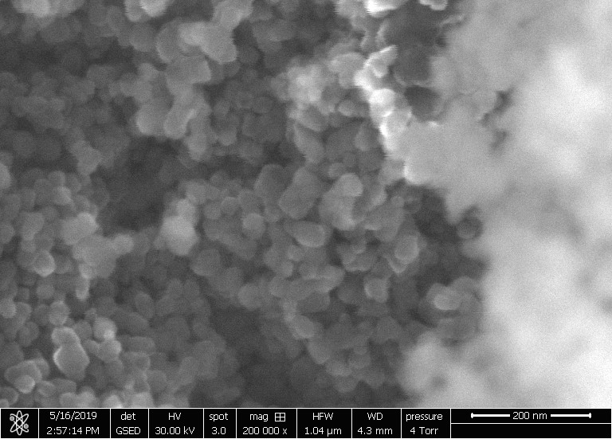

**Fig. 2a**



**Fig. 2b**

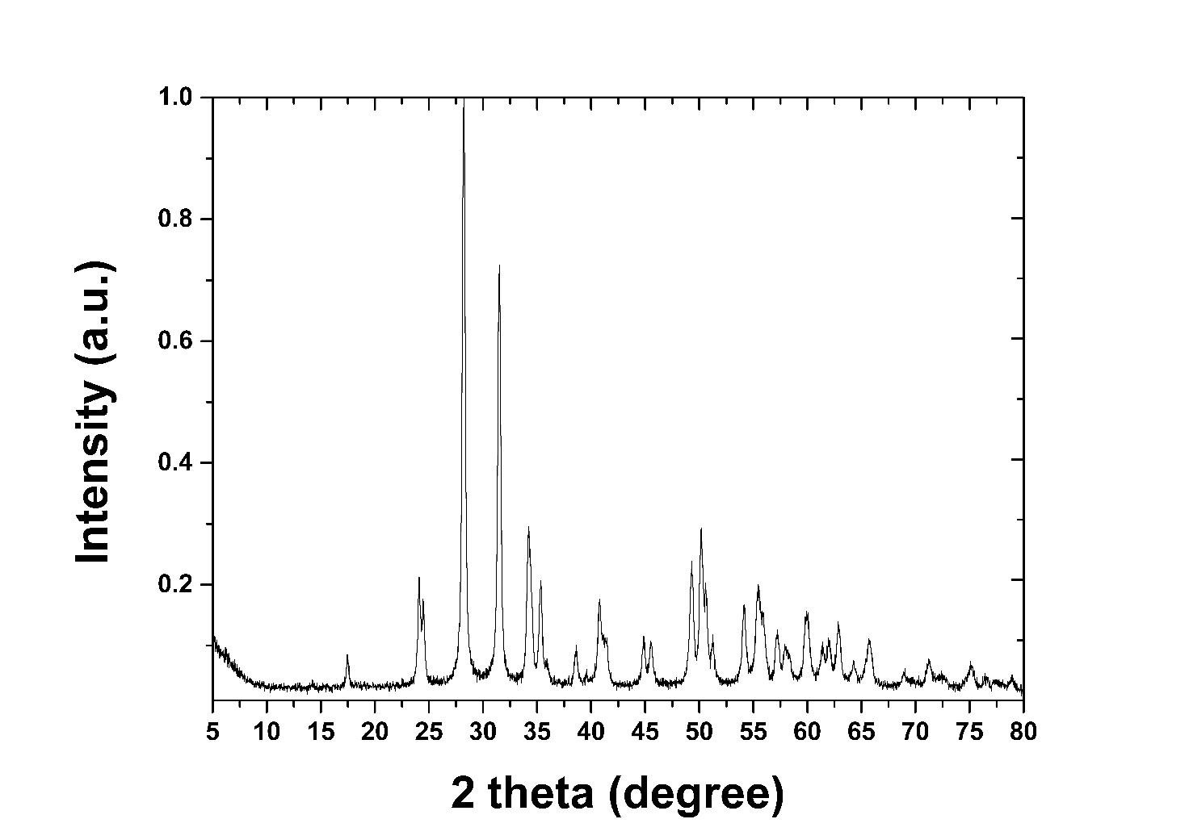

**Fig. 3a**

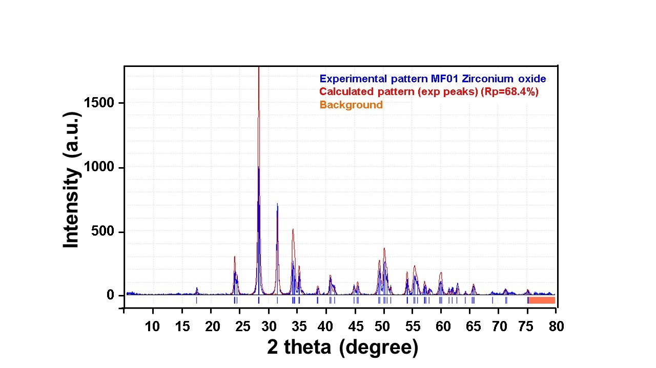

**Fig. 3b**

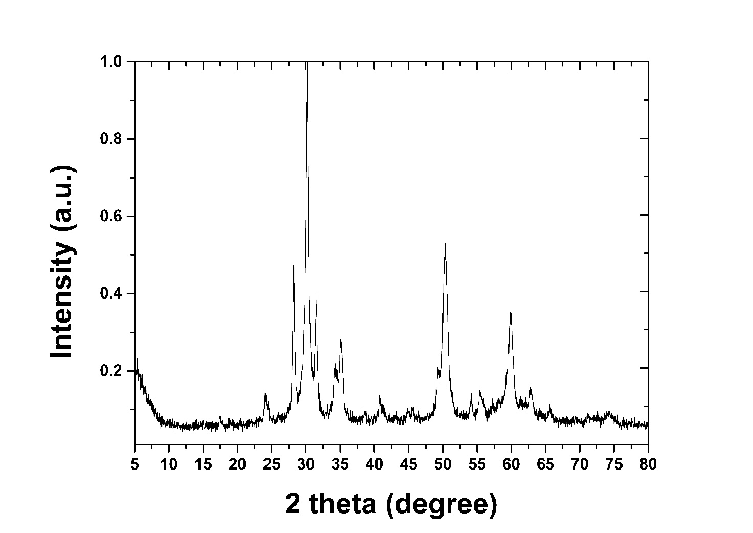

**Fig. 4a**

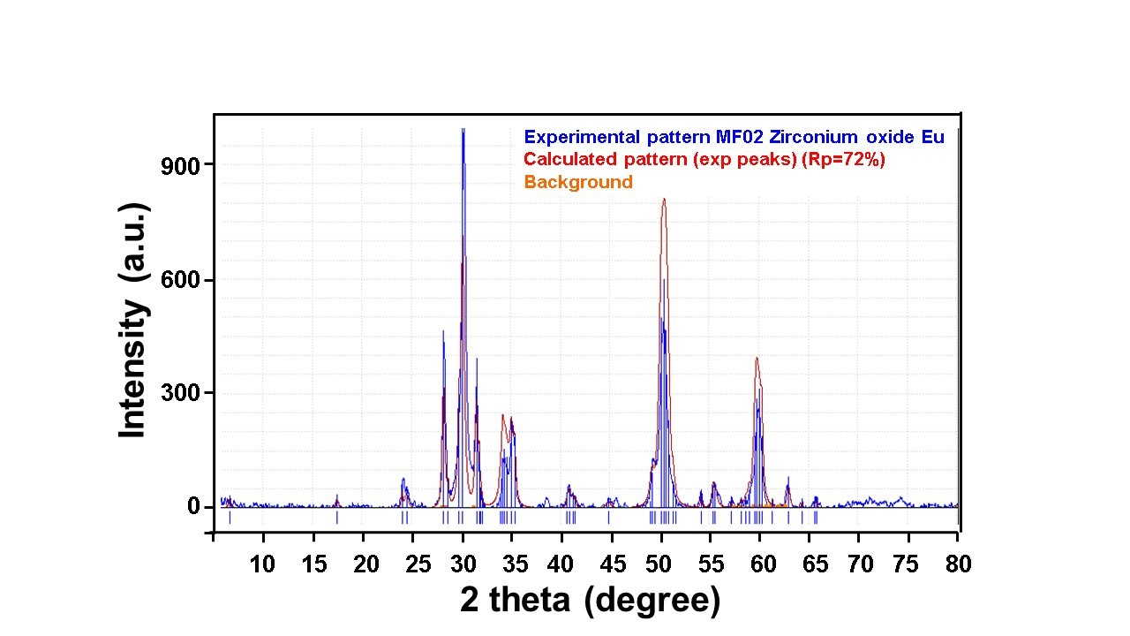

**Fig. 4b**

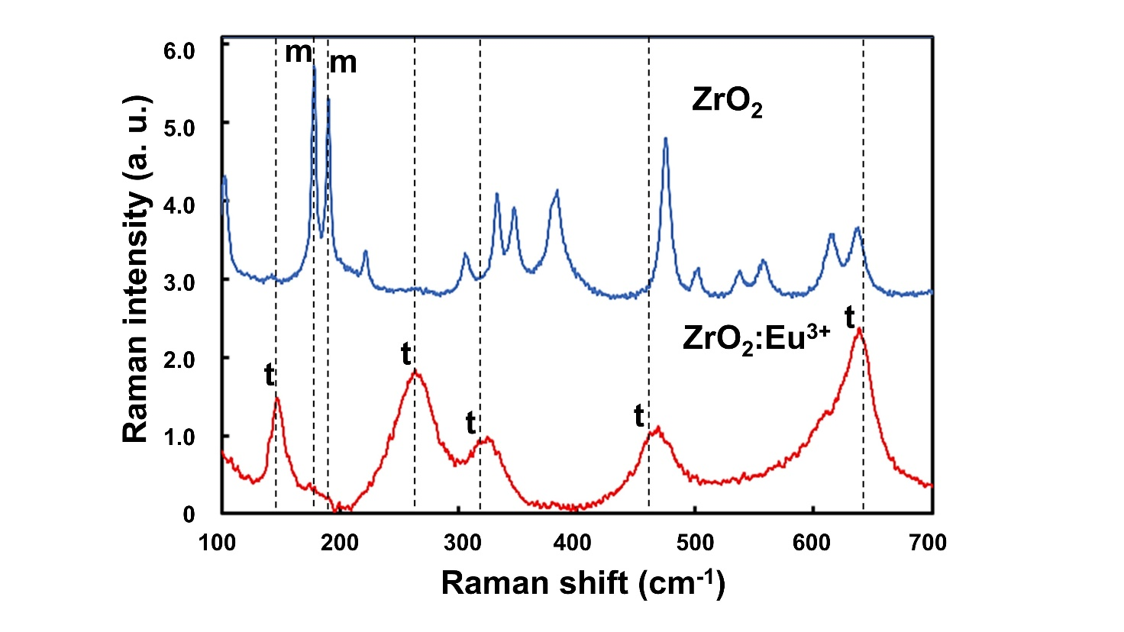

**Fig. 5**

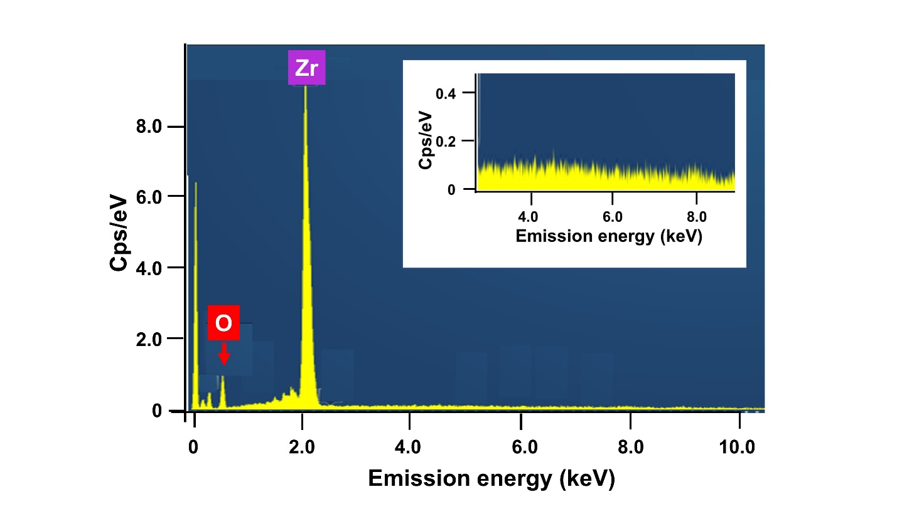

**Fig. 6**

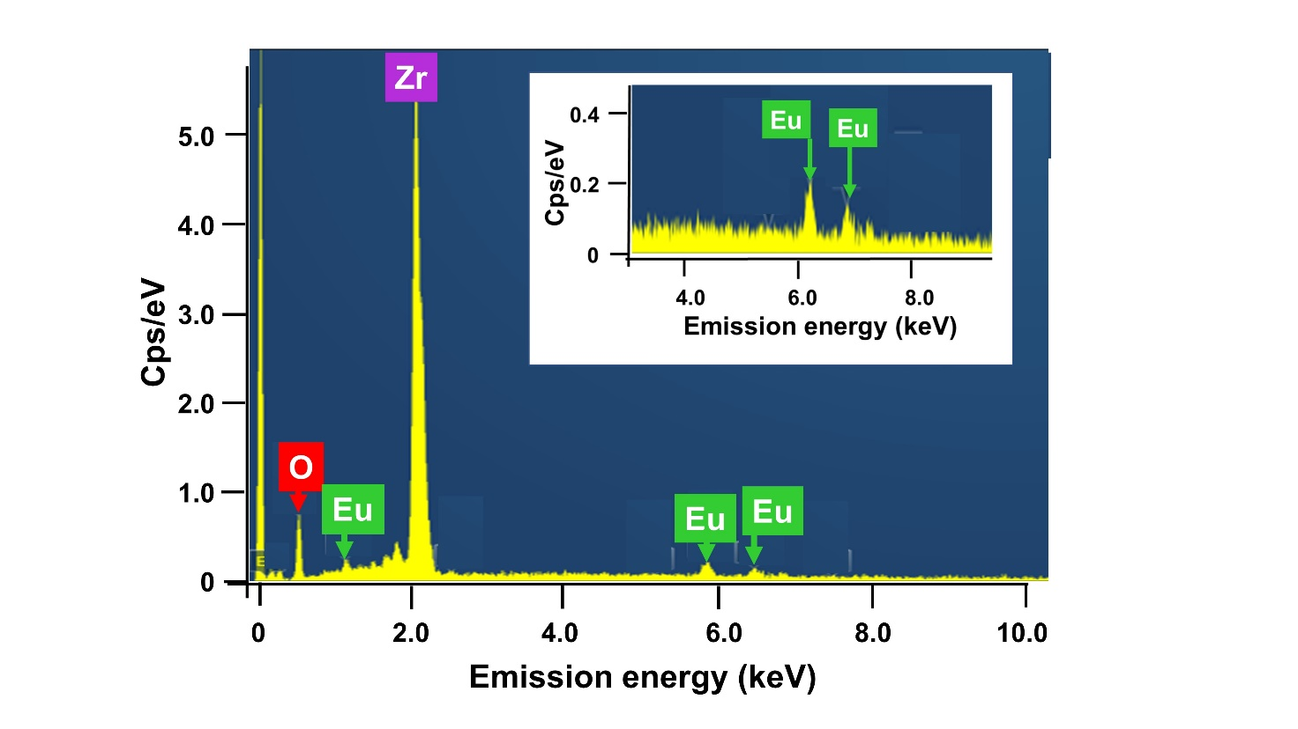

**Fig. 7**

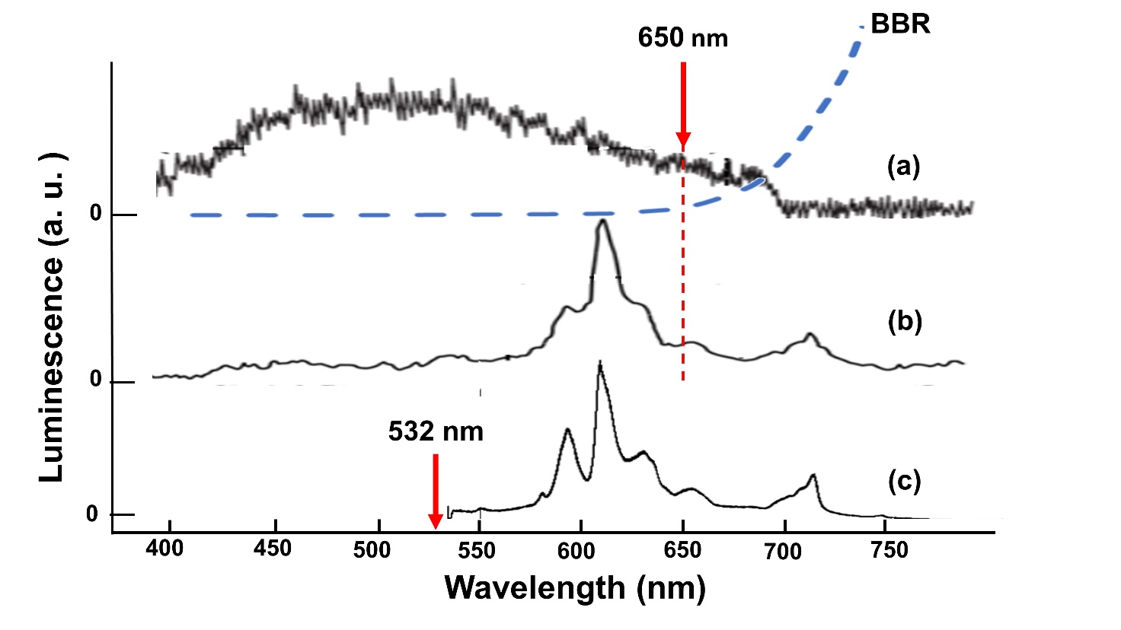

**Fig. 8**

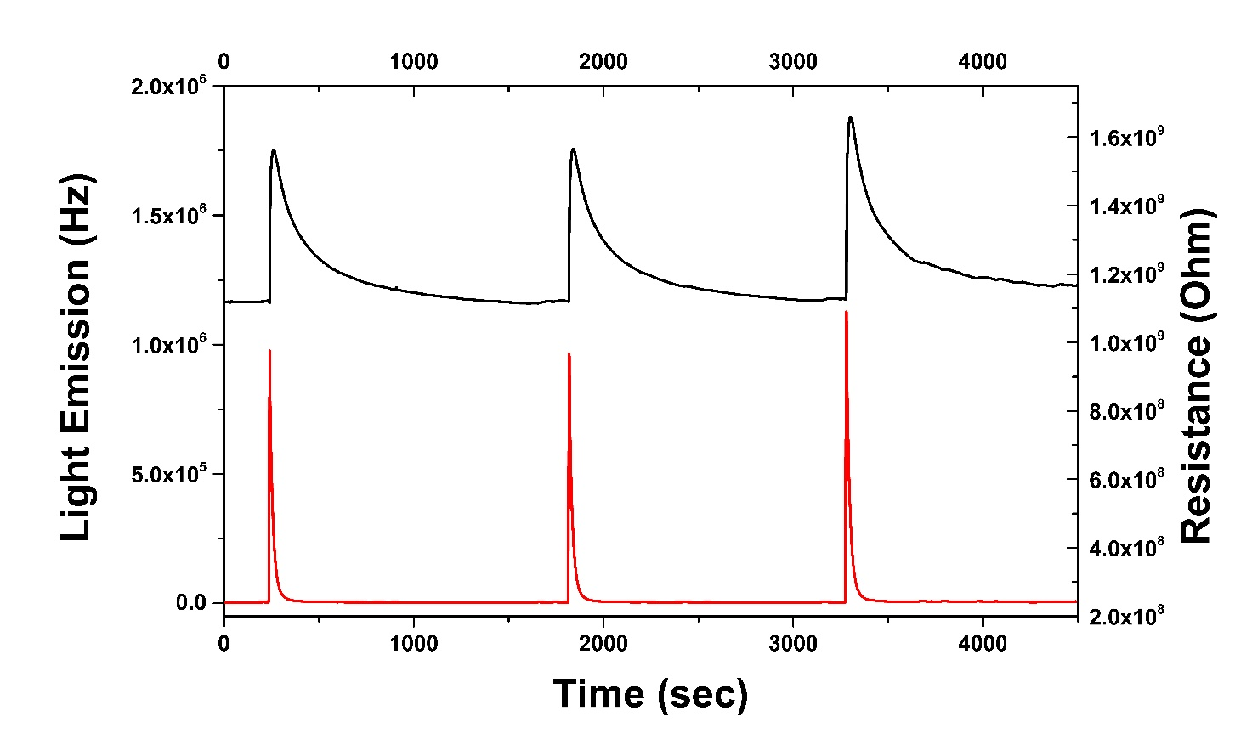

**Fig. 9**

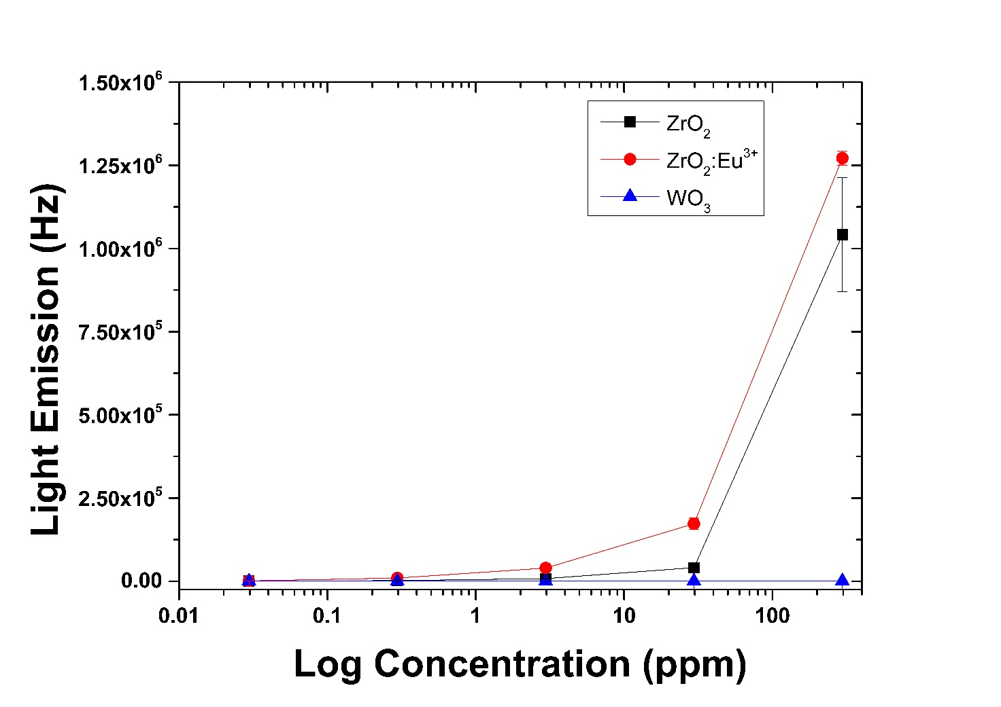

**Fig. 10a**

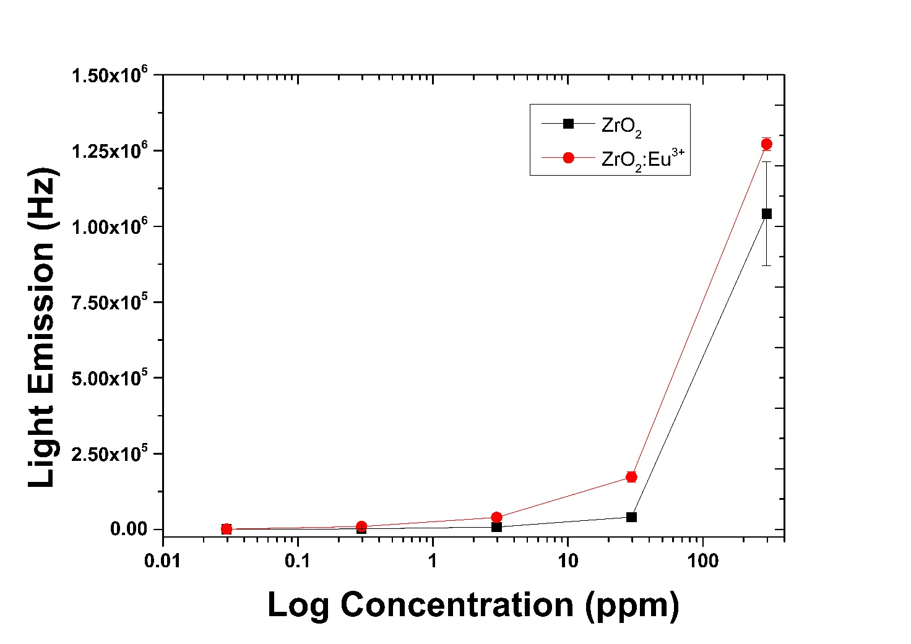

**Fig. 10b**

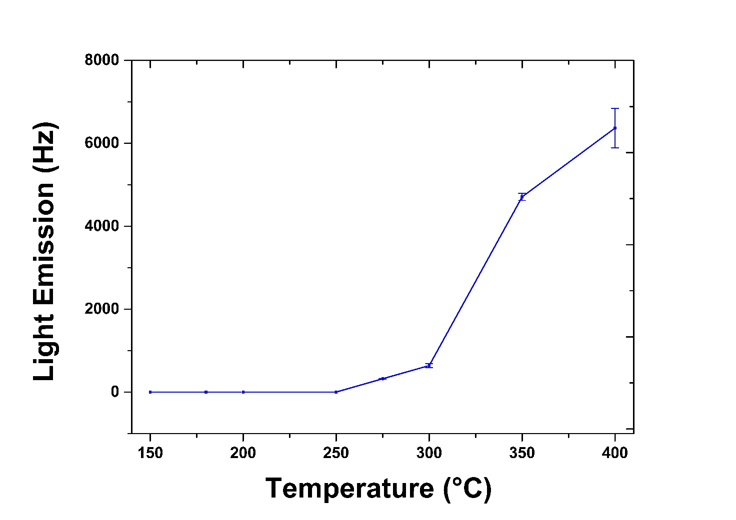

**Fig. 11**

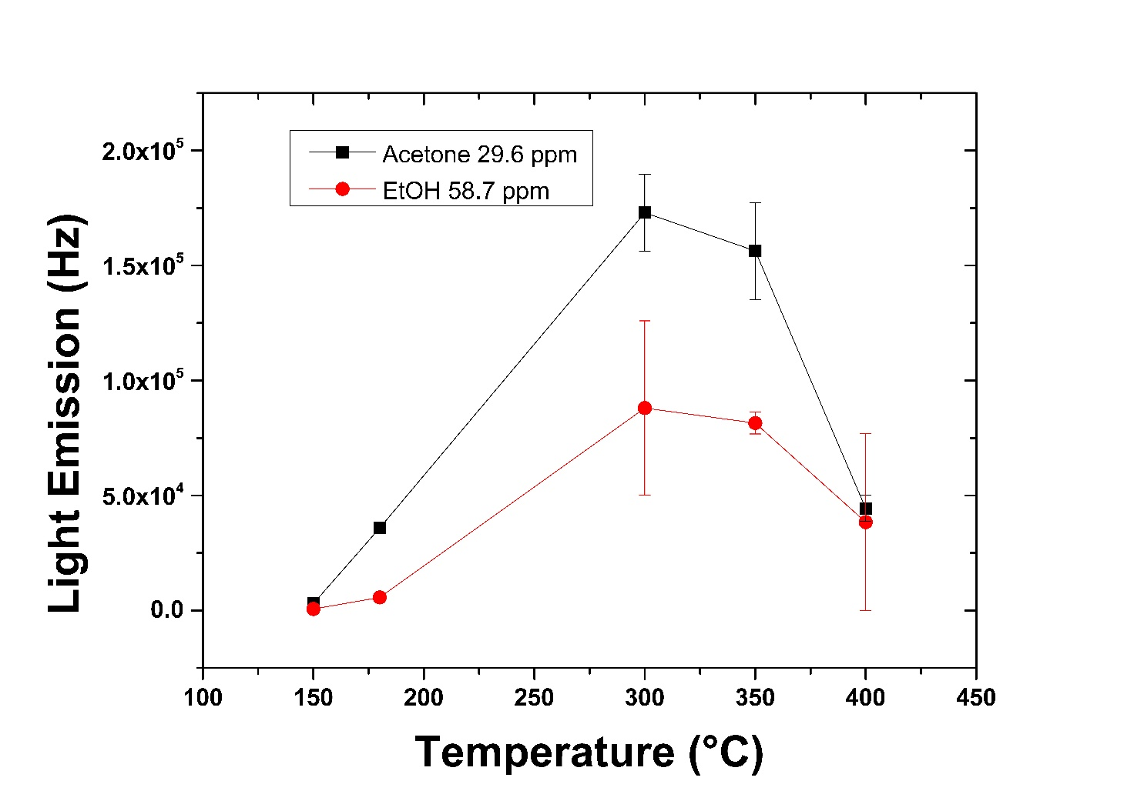

**Fig. 12**

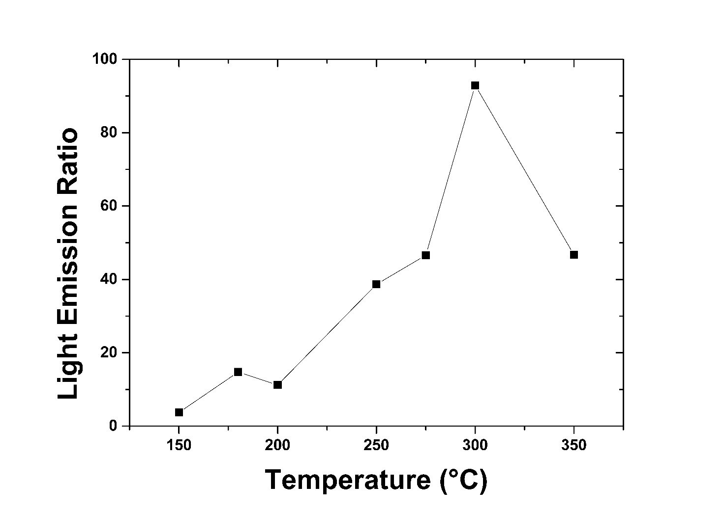

**Fig. 13**

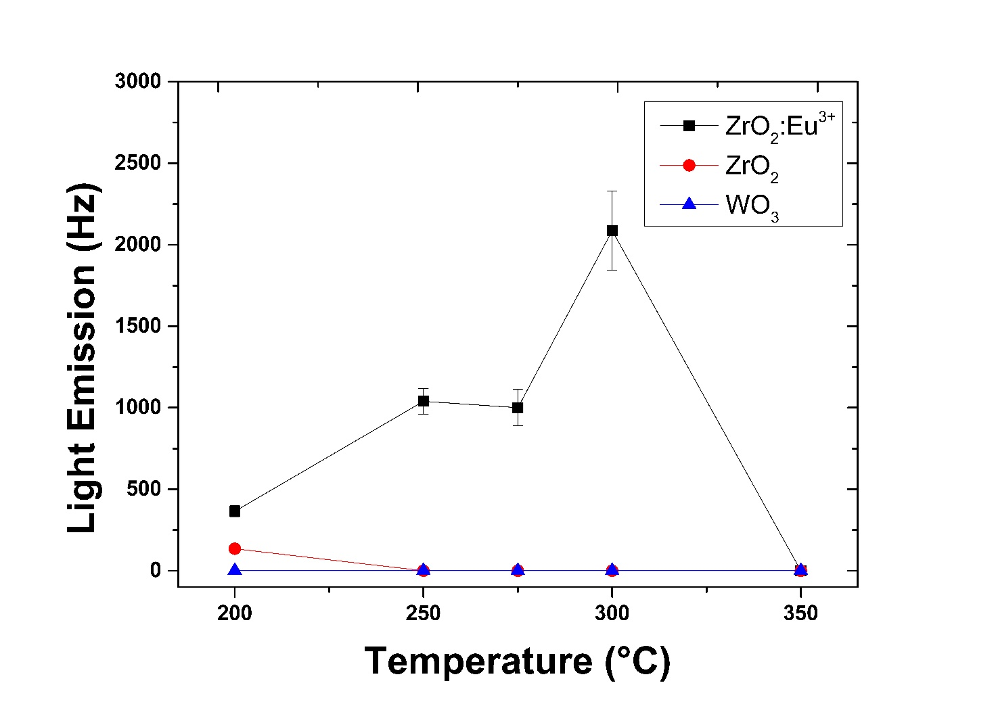

**Fig. 14**

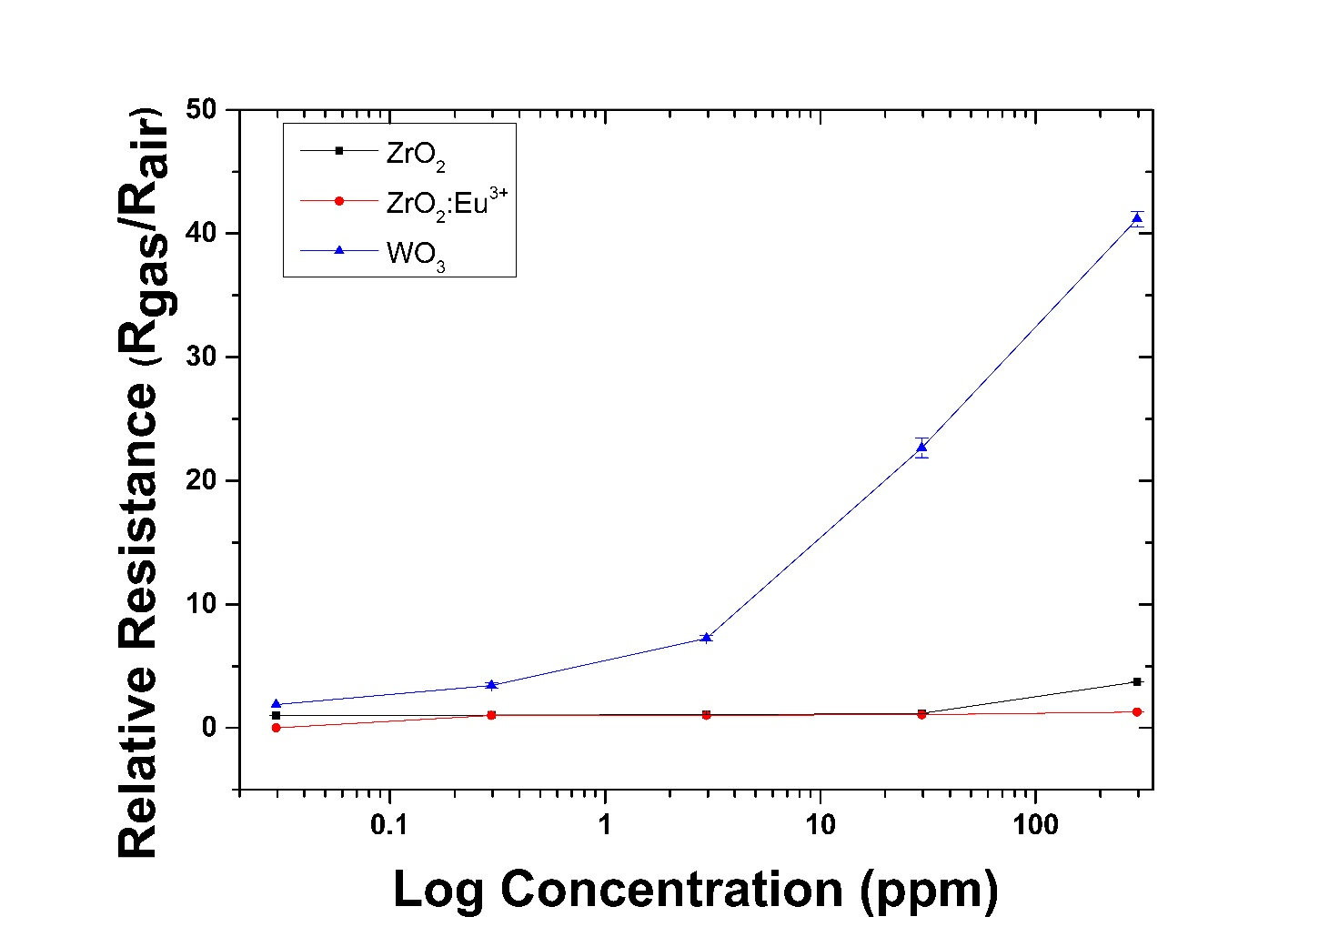

**Fig. 15**

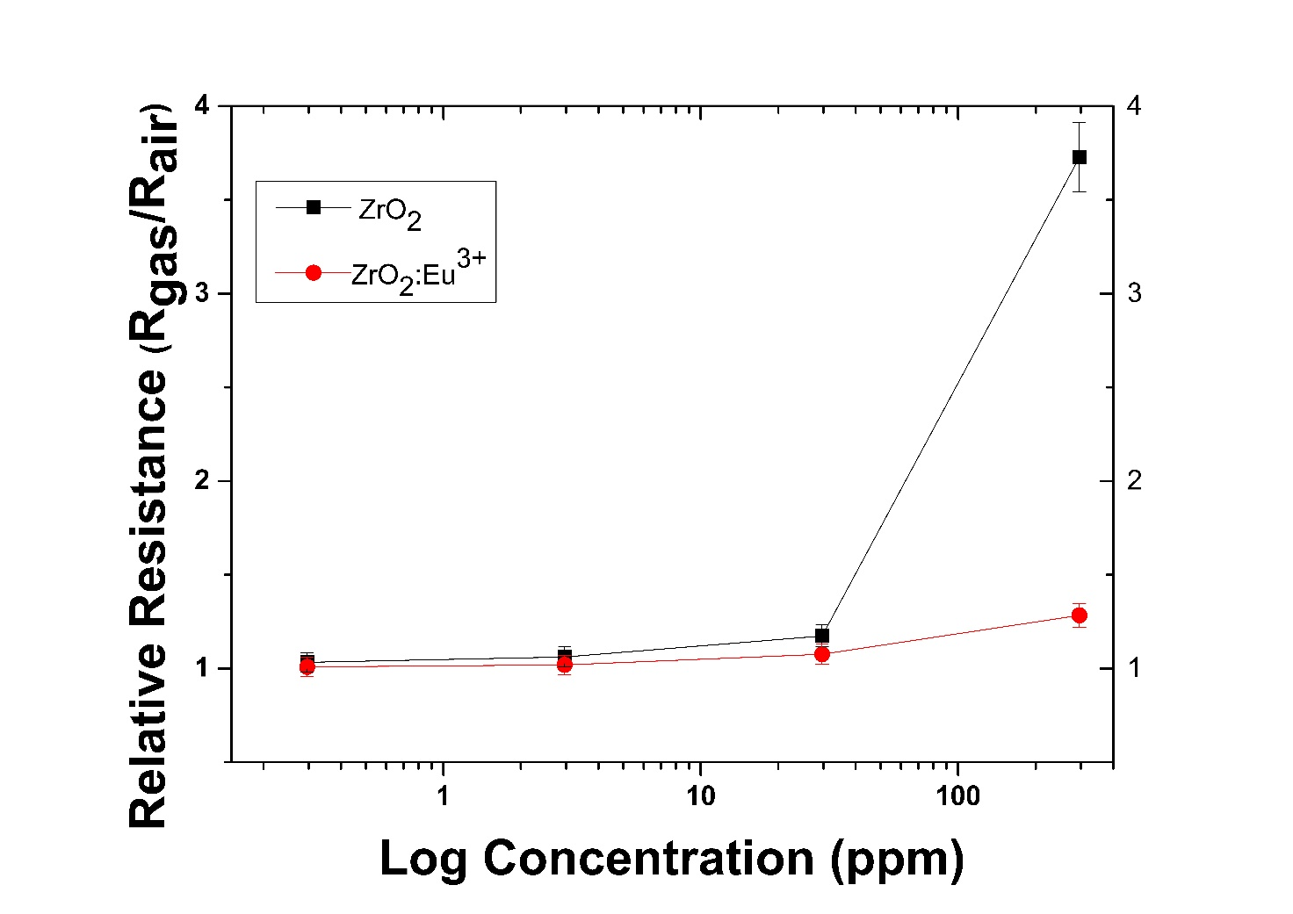

**Fig. 16**

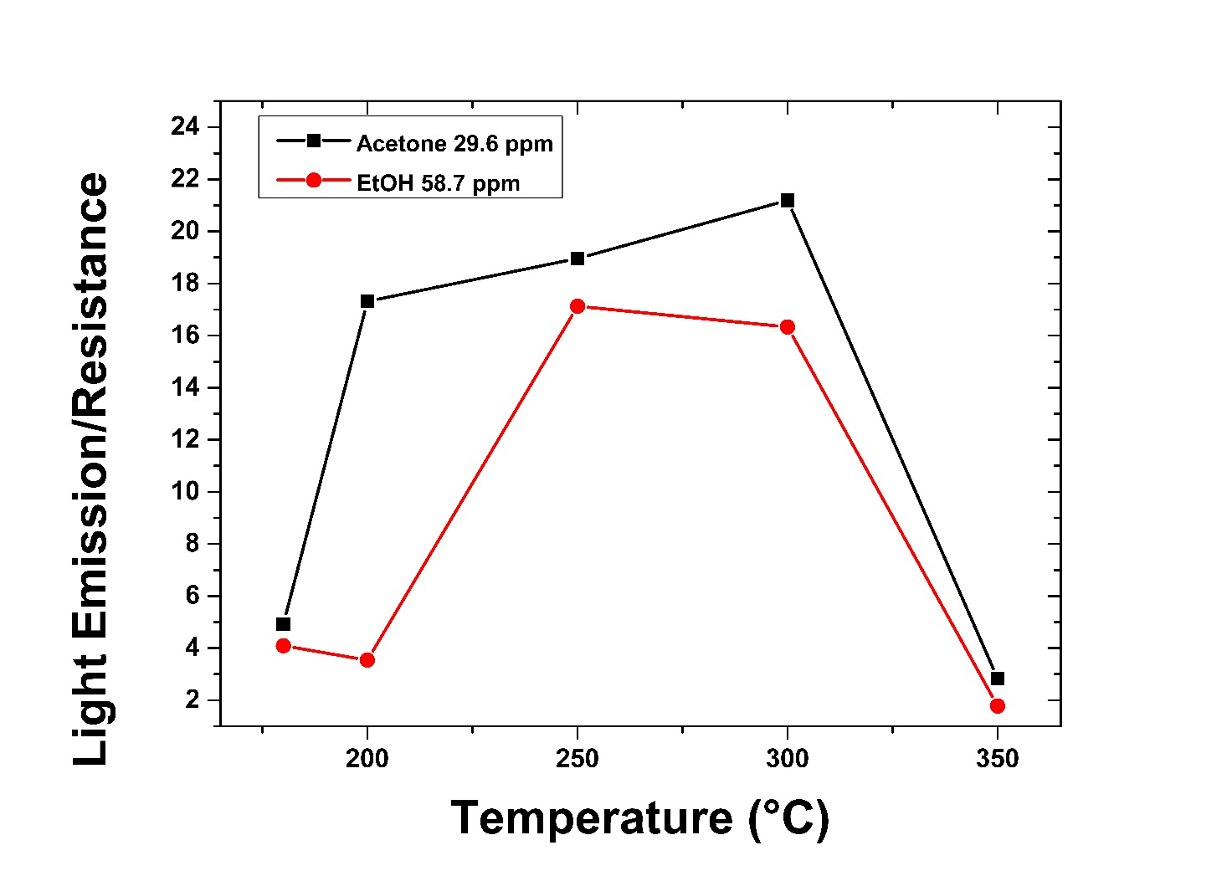

**Fig. 17**

**Supplementary Information**

**Rare Earth Doped Metal Oxide Sensor for the Multimodal Detection of Volatile Organic Compounds (VOCs)**

Matteo Fois, Timothy Cox1, Norman Ratcliffe, Ben de Lacy Costello*

*Department of Applied Sciences, The University of the West of England, Bristol BS16 1QY, UK*

*1Institute of Biosensing Technology, The University of the West of England, Bristol BS16 1QY, UK.*

*\*Corresponding author: Ben de Lacy Costello, Ben.DeLacyCostello@uwe.ac.uk*

**S1. Heater characteristics**

The basic dimensions of the heater side of the sensor are reported in Table S1. Additionally, the heater resistance at room temperature is of 10 Ohms A scheme of the heater is reported in Figure S1. The heater resistance at room temperature is of 10 Ohms.

|  |  |
| --- | --- |
| **Sensor feature** | **Dimensions** |
| Heater track width | 180µm |
| Gap between meanders | 166µm |
| Contact pad width | 1175µm |
| Contact pad length | 500µm |

Table 1: Basic dimensions of the heater side of the sensor



Figure 1 The heater employed during the eperiments

**S2. Dilution method validation: SIFT-MS**

In the sensing experiments, different volatile concentrations were obtained using a 10 mL gas-tight syringe. To check the efficiency of the method, the concentrations reported in this paperwork were validated by selected ion flow tube (SIFT) mass spectrometry.

The SIFT-MS used for all the experiments is a Voice 200 (Syft technologies, New Zealand). The sample inlet was set to the default flow rate of 30 mL/min, with the inlet capillary and base both operating at 120°C. The dwell time for each mass was set to 1000ms or 100,000 counts depending on which was achieved first. Selected compounds for this method was acetone.

Different increasing dilutions were carried out by a 10 mL gas-tight glass syringe and injected into the machine. 1 mL of acetone headspace was taken from the vial. As a matter of example, a dilution of 1/10 was obtained by taking this 1 mL to 10 mL by the syringe and then coming back to 1 mL. Repeating the operation a second time allowed getting a concentration of 1/100, repeating three times of 1/1000 and so on. The 1 mL of the obtained concentration was then injected into the spectrometer. The results are reported as raw data in Figure S2.

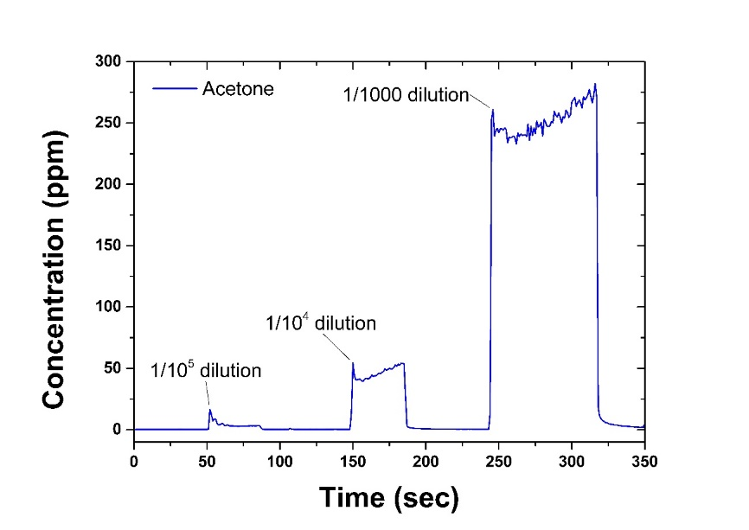

*Figure S2. Different levels of dilution, starting from the headspace concentration of acetone, registered by selected ion flow tube (SIFT) mass spectrometry.*

Also, it is possible to make a comparison between the expected values of acetone concentration expected by a given dilution, and the concentration effectively registered by the spectrometer. The slope obtained by linear regression of the SIFT-MS measured data vs the theoretical values of acetone concentration is reported in Figure S3. Four dilutions have ben taken into account, and the data registered by the SIFT-MS spectrometry are in good correlation with the theoretical values calculated.

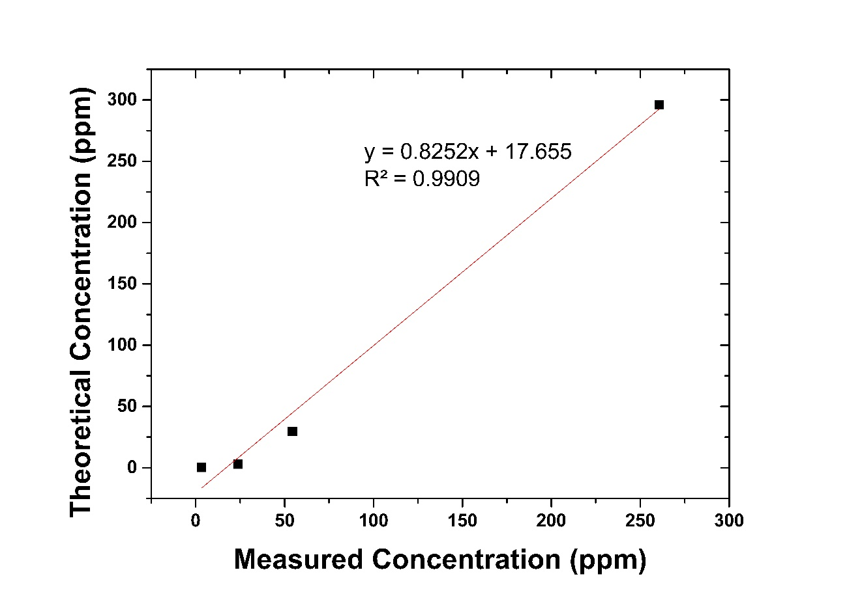

Figure S3 Theoretical acetone concentration as a function of the concentration measured by SIFT-MS and carried out with the glass syringe-dilution method.

**S3. The sensor**

The typical sensor utilized during the study is reported in Figure S3, where it is possible to observe the metal oxide nanopowder coating. In this case, a ZrO2 nanopowder was used.

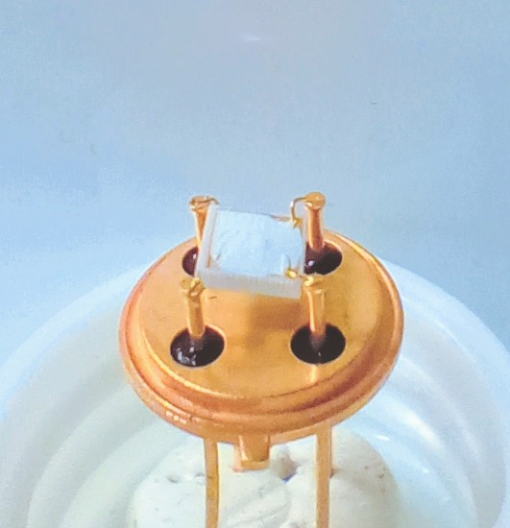

*Figure S5 Sensor substrate drop-coated with ZrO2 nanopowder.*