Cloud Computing in Construction Industry: Use Cases, Benefits and Challenges

Abstract
Cloud computing technologies have revolutionised several industries (such as aerospace, manufacturing, automobile, retail, etc.) for several years. Although the construction industry is well placed to also leverage these technologies for competitive and operational advantage, the diffusion of the technologies in the industry follows a steep curve. This study therefore highlights the current contributions and use cases of cloud computing technologies in construction practices. As such, a systematic review was carried out using ninety-two (92) peer-reviewed publications, published within a ten-year period of 2009-2019. A key highlight of the research findings is that cloud computing is an innovation delivery enabler for other emerging technologies (building information modelling, internet of things, virtual reality, augmented reality, big data analytics, mobile computing) in the construction industry. As such, this paper brings to the fore, current and future application areas of cloud computing vis-à-vis other emerging technologies in the construction industry. The paper also identifies barriers to the broader adoption of cloud computing in the construction industry and discusses strategies for overcoming these barriers.
Keywords
Cloud computing; emerging technologies; construction industry; future trends

Introduction
The construction industry is data intensive as heterogeneous data are continuously generated as the project progresses. The data from different stages of the project are usually stored in silos; team server or desktop, individual desktop, laptops, smartphones, etc. Data integration is thus required for the overall project coordination because the inability to access a holistic view of data often leads to wrong decisions that could delay the project and also impact on performance and profitability of the project [1]. The traditional Information and Communication Technologies (ICT) solution is to acquire high-end capacity system to store, process and analyse data from its subcontractors. Deploying on-site solutions require a massive overhead (power, cooling, security, availability, updates) which comes with huge operational cost burden. Therefore, it is impractical to commission on-site ICT infrastructure for all projects due to the huge initial investment requirement. Besides, in-house computing provision is static in capability and usually more expensive to upgrade to meet a sudden upsurge in computing needs. The construction industry is about 90% small and medium enterprises (SME) [2] and cannot afford to invest heavily in the state-of-the-art ICT infrastructure that is a prerequisite to benefit from the current digital innovations. Hence, construction industry is one of the least digitised industry.
Construction industry is investment intensive hence may not be too willing to experiment with new technology and thus being observed to be slow in technology adoption. While there is a huge potential for cloud computing in the construction industry, such applications are not widespread [3]. Cloud computing technology provides affordable and scalable computing facilities using a pay as you go pricing model [4]. Hence the suitability of cloud computing functionality to the SME. As cloud computing eliminates acquisition, installation and maintenance cost of computing facilities [5], which has been a significant hindrance to the adoption of ICT in the construction industry [2]. To assist the construction industry to adopt cloud computing technology, researchers need to expose the potential benefits of the cloud computing technology to the construction practitioners. The need to fill this knowledge gap led to the research question of this study.
A review of extant literature reveals that no research work provides information on the specialised applications of cloud computing in the construction industry and the future trends. Although some attempts have been made to review the existing usage of cloud computing in construction industry. In 2012, Zhang et al. [6] developed a framework for comparison of BIM-based cloud computing applications in order to aid ICT implementers’ in making informed decisions on their adoption. Wong et al. [7] reviewed existing literature on the integration of cloud computing and BIM applications (cloud-BIM) in 2014 with a special focus on the building life cycle management. In [8], Chong et al. conducted a study of the existing cloud computing applications in the built environment and developed a decision-making model to assist practitioners in the selection of suitable application for their use cases. Additionally, Almaatouk et al. [9] reviewed the potential of cloud computing to improve collaboration in the construction industry and concluded that it results in reduced cost for data storage. Furthermore, Bilal et al [10] elaborated on the applicability of cloud computing in the construction industry by detailing the several existing use cases. Though, Wong et al. [7] detailed the use of Building Information Modelling in cloud, no practical use cases of cloud computing vis-à-vis other emerging technologies was highlighted. Hence, these studies are not properly tailored to the needs of a practitioner who seek real-life guidance on cloud computing adoption. It should also be noted be noted that this review focuses purely on cloud computing and its applications in construction, which is completely different from point cloud technology. Point cloud refers to a 3-dimensional (3D) data, usually captured using light detection and ranging (LiDAR) sensors and represented as X, Y and Z points to represent the external surfaces of objects such as buildings [11]. In order to meet the expectation and needs of the construction practitioners to be aware, accept and adopt cloud computing technologies, this study provides an extensive appraisal of the state of the art in cloud computing, and brings to the fore the current benefits accruable of cloud computing application in construction. The study also discusses the underpinning technologies for cloud computing that distinguished cloud computing from earlier distributed systems. This study is carefully crafted to provide detailed and actionable guidelines about cloud computing technology, rather than the word of a salesman trying to sell a specific cloud product to construction practitioners. As such, the specific objectives of the study are:
- To review extant literature on cloud computing in the construction industry in the last decade (2009 – 2019).
- To highlight existing applications of cloud computing as being used in the construction industry with the benefits
- To identify the barriers to adoption strategies for improved and future opportunities of cloud computing in the construction industry.

Contribution of this study
Despite recent advances in cloud computing technologies, existing literature shows that there is currently no comprehensive up-to-date survey and analysis of cloud computing in the context of the construction industry. As such, this study analyses and categorises the use cases of cloud computing in construction. The study also highlights challenges militating against the broader adoption of the technology in the construction industry. Thus, channelling a path for construction practitioners and researchers.

Arrangement of the Paper
The study is organized in ten sections: section 2 contains an overview of cloud computing technology while section 3 detailed the need for cloud computing in construction. Section 4 provides step by step methods employed in carrying out the study. Section 5 discusses the statistical and the qualitative analysis of the review. Existing use cases of cloud computing in the construction industry was discussed in section 6 followed by the insights from the review exercise. The challenges for wider adoption of the technology was discussed in section 8. Section 9 discussed future opportunities for cloud adoption. The implications of the findings from the studies on the construction industry was discussed in section 10 and finally the conclusions from the study. The structure of the review is presented in Figure 1.
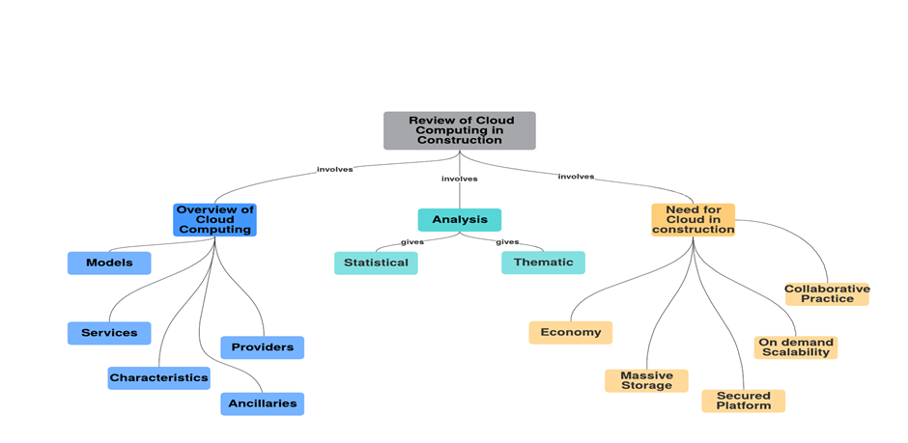
Figure 1: A Mind Map of the Review

Overview of Cloud Computing
Cloud computing is a paradigm shift in the way hardware and software resources are managed and utilized. The emergence of Service Oriented Architecture (SOA) which underpins cloud computing technologies, allows organizations to share the physical and non-physical aspects of an Information Technology (IT) infrastructure. The idea is to make computing infrastructure to be re-usable and thus distributing the computing costs. These capabilities significantly reduce the initial investment costs and reduces the operational costs of computing infrastructure. Cloud computing means different things to different people; to an e-commerce personnel, it implies shareable Information and Communication Technology [12]. Figure 2 depicts different more summarised definitions of cloud computing from different studies. The most widely used definition of cloud computing is the National Institute of Standards and Technology (NIST) definition as reported by [13];
Figure 2: Definitions of Cloud Computing
“Cloud computing is a model for enabling convenient, on-demand network access to a shared pool of configurable computing resources (for example, networks, servers, storage, applications, and services) that can be rapidly provisioned and released with minimal management effort or service provider interaction. The definition is summarised in Figure 3 and it comprises of five essential characteristics (on-demand self-service, broad network access, resource pooling, rapid elasticity, and measured service), three service models (software as a service, platform as a service, and infrastructure as a service), and four deployment models (public, private, community and hybrid).
Figure 3: A Birds Eye View of Cloud Computing

Cloud Characteristics
The five essential characteristics of cloud computing are: (1) The ubiquitous nature of cloud computing that implies a broad network access as cloud services are accessible regardless of time and location. Cloud service is accessible using any device over the internet, this is because the underlying computing infrastructure is on multiple locations (2) The shared pool feature implies a multi-tenancy infrastructure that can accommodate many users and applications. This allows many users to share the same computing infrastructure with individual privacy and security guaranteed (3) The elasticity attribute allows users to increase or decrease the request for computing resources on demand. For example, if a business suddenly starts to experience a high traffic, cloud infrastructure can easily scale up to accommodate the new demand (4) The on-demand self-service facet means computing capabilities to be provided automatically to users. In the past, users will order for computing facilities, await the arrival and do installations to prepare the system for use. This will take at least 24 hours before the system is fully functional. Nowadays, computer users will only enter credit card details on cloud providers’ website and within minutes computer resources is made accessible to them for use. Cloud users can use the web service portal to manage their services without intervention from the cloud provider and (5) the pay-as-you-go peculiarity enable users to pay only for consumed cloud services. Cloud resources usage is metered in a similar manner to electricity and water utilities, users get bill for the exact usage at the end of the month and make payment accordingly.

Cloud Service Models
Cloud has three service models from virtual hardware provisions to application domain-specific users; Infrastructure-as-a-Service, also called the technology layer, provides virtual storage and servers for data analysis. Users rent virtual storage, which are web accessible, and can scale up and scale down based on the customers’ need. A 2TB portable hard disk with a warranty of two years is selling for £58.99 at the same time, a 2TB ready-to-use cloud storage is rented for £13.90/yr. This implies the traditional procurement cost alone for the hard disk is over three times the annual cloud usage rate of the same capability. In addition to the procurement cost is still the operational (installation and security) cost for the portable disk to be usable. Whereas cloud storage apart from being easily accessible at the small price, is also highly secured. Platform-as-a-Service also called the application layer provides a development platform to build applications. A PaaS can be procured to integrate databases from different project data generated by the different professionals on site and those in the back office. Software-as-a-Service are cloud based construction software that can be purchased for use on a pay as you go basis and thus at a reduced cost of ownership. Common SaaS services are, BIM360, Primavera, Oracle Financials, Procore, SmartnetBid [21].

Cloud Deployment Models
Cloud services can be deployed as a public service, a private service, a community service or a hybrid service. The deployment models are differentiated by the method of access and also category of users eligible to access the service. In public cloud, diverse clients are accessing the cloud service via internet, it’s a multi-tenant system, meaning one user’s data is processed side by side with other user’s data. Applications running on public cloud can be hosted within a data centre or distributed across multiple data centres. The cloud provider is wholly responsible for the maintenance and control of the entire stack of facility. Public cloud is usually ideal for small businesses. Private cloud is an on-premise hosted cloud infrastructure, exclusively for the use of an organization and accessed via the intranet. Private cloud is best suited for dedicated system to store sensitive information such as national infrastructure. This model is ideal for large businesses and government institutions for storing sensitive data. The community cloud model is for several organizations closely working together to share a cloud infrastructure. The community cloud infrastructure will be accessible only to the participating organizations. The hybrid cloud deployment allows for combination of one or more deployment types. The financial reporting of a project can be on a private cloud while other high–traffic non-sensitive data like telematics can be placed on the public cloud. Hybrid cloud allows for movement of peak period requirements to the public cloud on a seasonal basis.

Cloud Service Providers
Multi-billion dollars cloud service providers create massive data centres containing hundreds of thousands of computers employed virtualisation technology fortified with redundant power, networking and connectivity [17]. These providers locate these data centres around regions all over the world to provide various services to users to solve problems involving massive and distributed data. An exposition of Cloud Providers by Bello [22] revealed the likes of Amazon, Google Inc., Microsoft Corp, Salesforce, and Oracle as pioneer service providers. Some cloud providers themselves do not own infrastructure instead acquire services from other provider to build services like PivotalCRM, a SaaS service using Amazon EC2. Cloud SaaS pricing at inception was per unit time of consumption, incorporation of market value brought about personalised pricing model [23]. Extension of the personalised price model of SaaS to other cloud service models yielded variations like, free trial, reservation, high consumption, On-Spot price offers, to create more personalised pricing [24]. Cloud services are packaged in bundles, for example an Amazon EC2 server instance has 16core virtual CPU and 32 Gibibyte of memory and choice operating systems (16 vCPU 32GiB). Table 1 illustrates some cloud providers together with the type of cloud service offered and the exact function of the service.

Table 1: Cloud Providers and Service Function
Cloud Provider | Cloud Service | Service Model | Service Function
Amazon | EC2 | IaaS | Server
Amazon | S3 | IaaS | Storage
Google | GAE | PaaS | Development Environment
Microsoft Corp | Window Azure | IaaS | Storage
Microsoft Corp | Office 365 | SaaS | Office Suite
Salesforce | Salesforce Service Cloud | SaaS | Customer  Relationship Management
CDC Software APTEAN | Pivotal CRM | SaaS | Business Customer Relationship  (Built on Amazon Service)
eBid Systems | ProcureWare | SaaS | Procurement System
Procore | Procore Construction Project Management Software | SaaS | Project Management System
e-Builder | e-Builder | SaaS | Construction Management Software
Oracle | Aconex | SaaS | Project Management System
Amazon | AWS EMR | SaaS | Hadoop Framework

2.5 Ancillaries of Cloud Computing Technology
Earlier distributed technologies are characterised with challenges ranging from performance measurement to managing portability, on-demand provisioning, hosting dissimilar applications on a single physical platform, spikes in demand for resources and adversarial behaviour by users [25] and [26]. This section discusses the cutting-edge technologies used by cloud computing to tackle these challenges, these techniques empowers the distinguishing features of cloud technologies from earlier distributed systems. These ancillaries provide supportive environment for the cloud computing technology.
- Virtualization
Virtualization provides a logical abstraction level that run application, operating systems, or system services in a logically distinct system environment that is independent of the physical computer systems. Computer resources (processors, memory and I/O devices) virtualization allows multiple operating systems and software stacks on a single physical computer platform. The hypervisor, a software layer, which is the virtual machine monitor (VMM) mediate access between each guest operating system presented as a virtual machine (VM) and the physical hardware [27]. The most notable VMMs are VMware, Xen and KVM. Workload management in a virtualised environment involves, isolation, consolidation and migration. Workload isolation ensures computer programmes are fully confined inside a VM, such that software failure in a VM does not affect other VMs; thus, improving the security and reliability. Consolidation allows heterogeneous workloads onto a single physical platform to overcome software and hardware incompatibilities, and enables several systems to run concurrently. Workload migration is responsible for application mobility to achieve hardware maintenance, load balancing and disaster recovery.
- Virtual Machine Management
Efficient management of the virtualised resource pool in cloud include mapping of VM onto physical hosts while maximising user utility. This capability considers among others number of CPUs, amount of memory, size of virtual disks and network bandwidth. Mapping policies determines when to suspend, migrate or resume a VM. Migration of VMs involves several processes, which include when to initiate migration, which VM to migrate, where to migrate to, all without significantly disrupting running services. Efforts on efficient VM Management scheme include, traffic aware algorithm [28], Software-defined Networking (SDN) based algorithm [29] and energy-efficient based algorithm [30]. Recently, Agarwal et al, [31] presented secure VM placement algorithms for the automatic enforcement of security against co-location-based attacks. Also, Xu et al, [32] proposed a balanced VM migration algorithm aiming at both reducing energy consumption and mitigating performance degradation.
- Quality of Service (QoS)
Service provisioning in the cloud is governed by Service Level Agreements (SLAs), which is a contract specifying commitment to deliver cloud services by a provider to a cloud user. SLA includes compensation to users; thus, SLA serves as warranty to cloud users. SLA signed between the customer and the service provider include non-functional requirements of the service specified as Quality of Service (QoS) [33]. QoS parameters include CPU time, network bandwidth, storage capacity [34]; provider’s profit [35]; deadline, budget, penalty ratio, size of input file from customer and request length [36]. Garg et al. [37] classified QoS requirements into quantifiable QoS attributes such as Accountability, Agility, Assurance of Service, Cost, Performance, Security, Privacy, and Usability and non-quantifiable QoS attributes such as Service Response Time, Sustainability, Suitability, Accuracy, Transparency, Interoperability, Availability, Reliability and Stability. Cloud service performance are measured using QoS parameters. Khazaei et al. [38] employed the Markov chain to model the performance of a cloud computing centre using the response time. Ding et al, [39] presented a guaranteed QoS-aware resource matching algorithm for cloud computing systems. Also, Heidari and Buyya [40] presented an algorithm which considers service level agreement (SLA) requirements and quality of service (QoS) for provisioning appropriate combination of resources in order to minimize the monetary cost of the operation.

(c) Resource Allocation
Cloud services can be located in various resources with varied QoS parameters. Thus, a cloud broker is required to select the best set of cloud services based on user’s needs and tendencies [41]. Service composition is used to select atomic services among similar available cloud services based on end-user priorities for maximum QoS. Cloud computing service composition is an NP-hard problem due to a large number of simple services consumed by the many service providers. Yu et al. [42] proposed Greedy-WSC and an ant colony optimization-based algorithm to select practical cloud combination of services using multi-cloud providers. Wang et al, [43] employed a multi-agent reinforcement learning model to achieve an optimized dynamic service composition. Naseri and Navimipour [44] improved on the cloud services composition problem using an agent-based framework and the Particle Swarm Optimization (PSO) algorithm.

(d) Job Scheduling
Job Scheduling enables cloud technology to minimise execution time and improve resource utilization that results in lower cost of resources and energy consumption [45]. The efficiency of whole cloud computing services directly relates to the performance of cloud job scheduler associated with the cloud data center. Job scheduling consider job features (job’ length, job’s execution time, job execution cost, etc) and resource properties dynamically together to achieve lower waiting time, turn-around time and energy consumption. A number of algorithms are being proposed to achieve efficient job scheduling in cloud. Kaur and Verna [46] proposed a modified Genetic Algorithm (GA) approach while Kumar and Dinesh [47] proposed the fuzzy theory for its job scheduling tasks. Shojafar et al [48] in 2015 proposed a hybrid approach called FUGE that is based on fuzzy theory and a genetic algorithm (GA) for optimal load balancing considering execution time and cost in cloud job scheduling. Ali et al. [49] employed the Grouped Task algorithms for cloud job scheduling, executing job with minimum execution time first. Aloboud and Kurdi [50] presented a Cuckoo scheduling algorithm to achieve higher CPU utilization and average turnaround time.

The Need for Cloud Computing in the Construction Industry
The application of cloud computing to construction is an emerging area, which promises a number of opportunities. While not exhaustive, some of the benefits accrued from adoption of cloud computing technology in construction are discussed in this section:

Economic Benefits
Cost is a significant barrier in the adoption of IT solutions by construction companies, because of its low-profit margin [2]. Construction companies are seeking new ways to drive down infrastructure and operational costs. As such, the industry is not buoyant for the massive IT infrastructure, which requires expert human resources and training to manage. Cloud computing technologies have therefore provided opportunity to construction businesses especially SMEs to have access to high end computing infrastructure and applications which could cost a fortune to acquire. This will also undoubtedly translate to a reduction in the total cost of a project delivery, therefore giving construction companies a competitive advantage and operational edge. Since payment will only be for actual consumption, the cloud computing technology provides increased agility for the construction by the elimination of ownership and operational costs.

On-demand Scalability of Computing Resources
Cloud computing enables a construction company to purchase IT resources as services dictated by the specific requirement at that particular period on a construction project. A short-term need for a higher capacity infrastructure that necessitates tying down of capitals on computing facilities is no more economically viable. The unexpected demand might not even give enough time for an infrastructure purchase and installation. Cloud computing offers high-performance servers with powerful CPUs, GPUs and super-fast SSD drives to construction industries at affordable prices. In particular, SMEs will be on a playing field with the larger companies without a huge initial investment. Alreshidi et al. [51] employed the scalability feature of cloud service to propose a BIM-Governance model.

Secured Platform
Cloud security has matured and popular security measures in the cloud includes; encryption, use of up-to-date security software, cyber insurance security cover, security audit, and so on. There is virtually no SME in the construction sector that can afford the level of data security found in the cloud in their in-house infrastructure. Security threats on on-premise construction data such as Cryptolocker and the associated ransom have further necessitated the use of cloud for safe keeping the construction data. It is also very costly for construction companies to implement system availability on in-house computing infrastructure that could to match up with the 99.99% SLA (Service Level Agreement) and uptime provided by cloud service providers.

Massive Storage
Massive data generation characterises construction projects, right from the design stage, that different modelling simulations are required to transform the owner's building idea into a functional design by the professionals. The use of emerging technologies like IoT, Augmented reality, 5D BIM generates continuously large data. An aerial imagery of a site that will occupy points on a cloud storage, will take hundreds of GBs on a typical computer. Storing construction data on site has been a problem as a result of the volume and the required hardware infrastructure for such on-site storage. Additionally, storing data on the site requires physical access, whereas with cloud storage, data can be remotely stored and retrieved with no limitation to space and time. Hence the availability of cloud storage is an excellent opportunity for the construction industry.

Facilitating Collaborative Practice
Construction projects are executed by several project teams, with different business reporting models [52] that are stored in different silos. The scattered data are not readily available for timely and critical decision-making process by the stakeholders in the industry. This has resulted in poor planning, delay in project delivery, and variation in project cost and reduced Return on Investment (ROI). Cloud provides a central repository for construction data for-end-to-end solution that improves the productivity and organisation of the construction industry. Access to up-to-date project data enables the construction workers higher participation and keep the project team organised and well-integrated.

Methodology
An extensive review of the literature was conducted to answer the following research questions: (1) what has been the relevance of cloud computing in the construction industry and (2) what is the future relevance of cloud computing in the construction industry. This section discusses the research methodology adopted to address the two questions.

Paper Selection Method
In selecting publications to be reviewed in the study, SCOPUS, Google Scholar and Science Direct were selected because of their popularity and to ensure a good coverage of journal articles. The steps for this systematic review is as shown in Figure 4 which was adopted from the Preferred Reporting Items for Systematic Reviews and Meta-Analyses (PRISMA) guidelines [53]. The search was limited to research articles published between 2009 and 2019. This is because “cloud computing” scheme was first declared by IBM at the end of 2007 but publications on cloud computing became active in 2009 [54]. The search from the three databases was based on “Title/Abstract/Keyword” field for Cloud Computing and Construction Industry. In considering documents that are relevant to this study, we defined the inclusion and exclusion criteria [55], we have considered two inclusion criteria and three exclusion criteria.
Inclusion Criteria 1: The study discusses scenarios, research challenges, and opportunities on the integration of cloud computing and construction industries. Inclusion Criterial 2: The study presents a strategy on how cloud computing (PaaS, IaaS or SaaS) was used in the construction industry at any work stage (preconstruction, construction and construction). Exclusion Criteria 1: The publication does not address the integration of the Cloud Computing and Construction Industry. Exclusion Criteria 2: The document is not peer reviewed. Therefore, table of contents, forewords, tutorials, editorials, keynote talks, or textbooks, book reviews, letters to editors, comments and discussions etc. are excluded. Exclusion Criteria 3: The study is not written in English, which is the most common language in scientific papers. In the systematic review, a document is considered relevant if it meets one of the inclusion criteria and does not meet any of the exclusion criteria.

Selected Papers
The search after applying the inclusion and exclusion criteria gave 3,681 publications from Science Direct, 173 publications from SCOPUS with the same filters while Google Scholar gave 2,720. The three databases gave a total of 6,574 publications, duplicates of 2,857 were removed leaving 3,628 publications. A more focused title and abstract review was carried out to remove abstracts that do not address cloud computing and construction industry. The focused review resulted in 92 publications for full text reading. A total of 92 peer reviewed academic publications consisting of 34 conference proceedings and 58 journal articles were used for the review.

Findings
The reviewed papers were analysed quantitatively and qualitatively. The quantitative analysis is on the empirical strength of the publications in the area under review. The qualitative analysis reveals the pattern of the theme discussed, in terms of the content of the publication.

Statistical Analysis
The analysed articles of the systematic review are from 18 countries and 5 continents. China has the highest publications, followed by the United Kingdom. This is closely matched by the USA, then other Europeans countries (New Zealand, Germany, Italy, Norway, Greece, Ireland, Portugal, and Belgium) as shown in Figure 5. Figure 6 illustrates the distribution of the some of the articles by publishers; Automation in Construction has the highest number of publications, closely matched by American Society of Civil Engineers (ASCE) then the Institute of Electronic and Electrical Engineering (IEEE). Figure 7 depicts the progression of the number of articles with respect to their publication years.
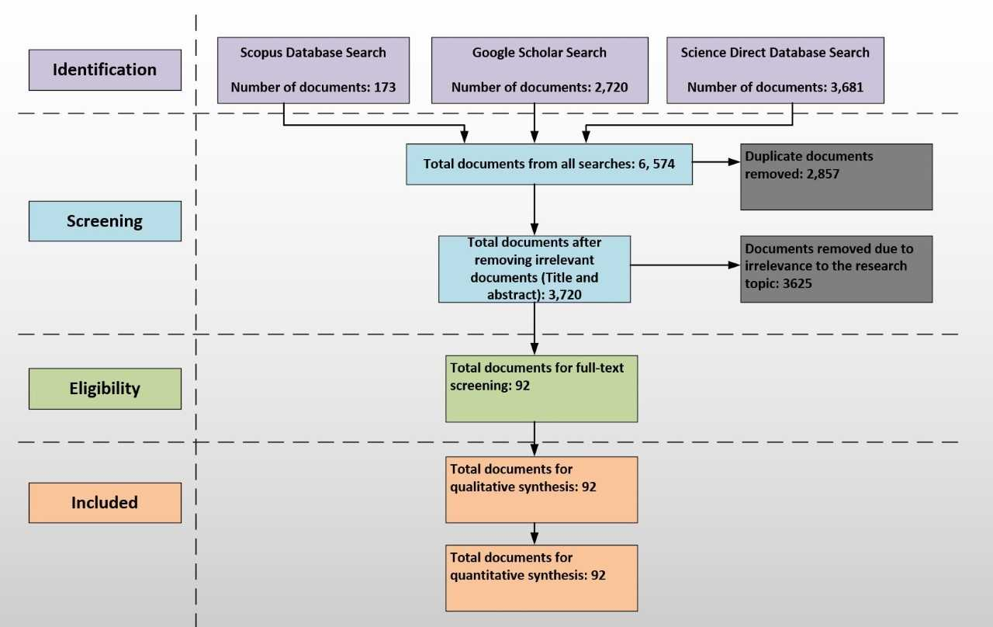

Figure 4: Flowchart of the Systematic Review Process
This review covers only the first quarter of 2019, it is highly likely that the number of published articles by the end of the year would follow the increasing trend of previous years. The papers between 2009 and 2013 are proposing ideas and models whereas 2014 and beyond are incorporating experimentation. Probably, in the early years of cloud computing, experimentation with real life projects was not feasible, hence publications were accepted without implementation, and by 2014 experimentation was expected to be reported. This account for the drop in 2014 that gradually picked again in 2015. This upward trend reflects the global interest of the research community in cloud computing and construction.
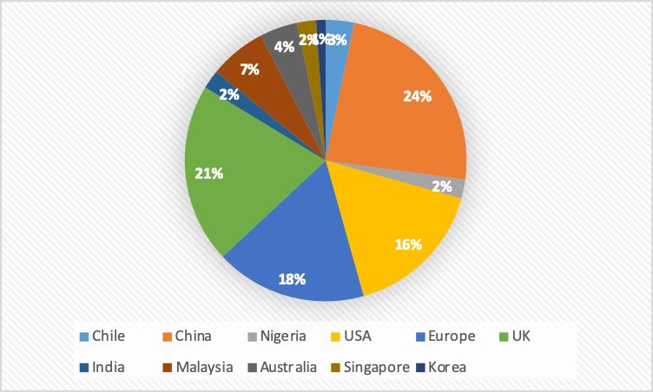

Figure 5: Publications per Territory

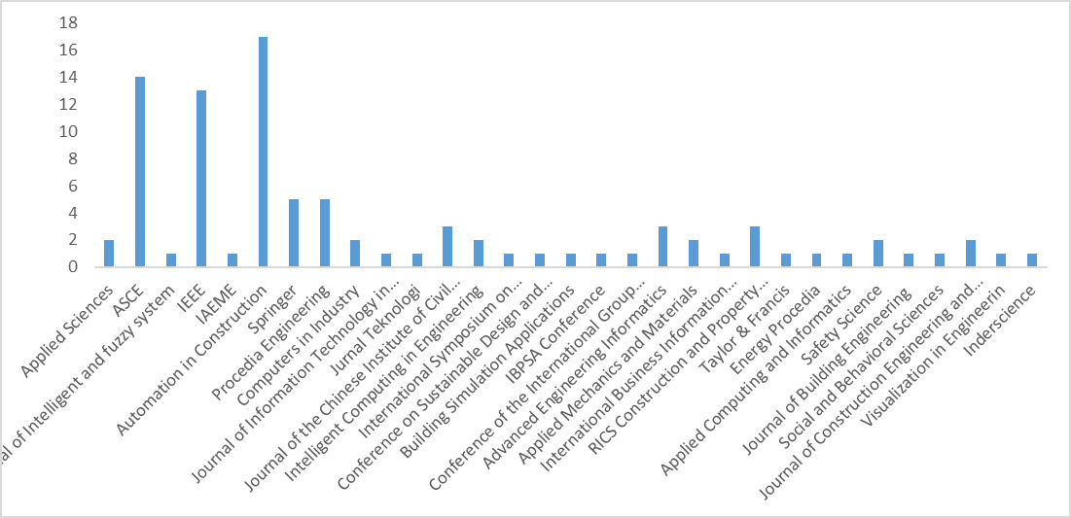

Figure 6: Articles sorted by data source
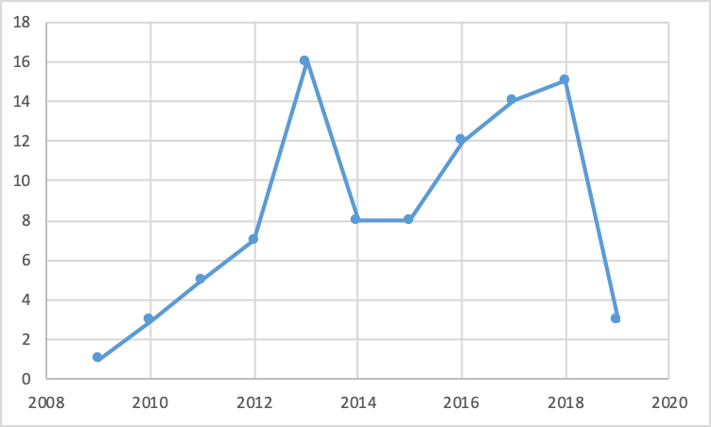

Figure 7: Articles sorted by publication year

Qualitative Analysis of the papers
The content of the papers reviewed were analysed for depth and detailed discussion on the specific applications of cloud computing in construction industries in form of use cases. The study identified that there a number of motivations for the existing studies to employ cloud in the different stages of construction. The motivation ranges from the need; (1) for computational power for data analysis, (2) to make construction data accessible to team members, (3) for an affordable system, (4) for storage or (5) for a secured platform. The analysis also reveals the bearing of cloud computing across the building work stages; feasibility study, design, construction and operations. Table 2 illustrates the use of cloud technologies together with the emergent technologies and the motivation for cloud usage. The analysis shows the relevance of cloud computing to key emerging technologies in construction [56] such as Building Information Modelling (BIM), Internet of Things (IoT), immersive technologies (virtual reality and augmented reality), mobile technology and big data analytics. Different case studies will thus be used to highlight the existing applications of cloud computing in the construction industry vis-à-vis some of the emerging technologies. Existing applications and potential benefits of cloud computing adoption in the construction industry is depicted in Figure 8.

Table 2: Cloud Usage and Motivation
Author | Cloud Service | Stage of use in Construction | Emergent Technologies in use | Motivation for use
[57] | SaaS | Design | BIM | Access
[58] | IaaS | Construction | BIM | Storage
[59] | SaaS | All stages | BIM | Access
[60] | SaaS | Design | BIM | Storage
[61] | IaaS, PaaS | All stages | BIM | Access, Computational power
[62] | IaaS | All stages | BIM | Storage, Access
[63] | SaaS | All stages | IoT | Computational power
[64] | PaaS | Construction | IoT | Cost Benefit
[65] | IaaS | Construction | IoT | Storage
[66] | IaaS, PaaS, SaaS | Operations | IoT | Storage, Computational power
[67] | IaaS, PaaS, SaaS | Construction | IoT | Access
[68] | IaaS | Construction | IoT, VR | Storage, Access
[69] | IaaS | Operations | IoT | Storage, Computational power
[70] | SaaS | Construction | IoT | Access, Cost Benefit
[71] | SaaS | Construction | AR | Access
[72] | SaaS | Construction | VR | Access
[73] | IaaS | Construction | AR | Storage
[74] | SaaS | Construction | - | Computational power
[75] | SaaS | Construction | - | Computational power
[76] | SaaS | Construction | Mobile Technology | Access
[77] | PaaS | Construction | - | Computational power, Access
[78] | SaaS | Construction | Mobile Technology | Access
[79] | IaaS | Design | - | Storage
[52] | IaaS | Design | - | Computational power
[80] | IaaS | Construction | - | Storage and Access
[81] | SaaS | Operations | - | Computational power
[82] | SaaS | Operations | IoT | Computational power, Storage
[83] | SaaS | Construction | - | Access
[84] | SaaS | Construction | - | Access
[54] | SaaS | Construction | - | Access
[85] | SaaS | Construction | - | Access
[86] | SaaS | Construction | - | Access
[87] | SaaS | Construction | - | Access
[88] | SaaS | Construction | - | Cost Benefit
[89] | SaaS | Design | - | Access
[90] | PaaS, SaaS | Design & Construction | Mobile Technology | Access
[91] | SaaS | Construction | - | Access
[92] | IaaS | All stages | Big Data Analytics | Computational power
[93] | IaaS | Construction | - | Cost Benefit
[94] | SaaS | Design | Big Data Analytics | Computational power
[95] | IaaS | Design | - | Cost Benefit, Access
[96] | SaaS | All stages | - | Cost Benefit
[97] | SaaS | Design | - | Access
[98] | SaaS | Design | - | Storage
[99] | IaaS | Construction | - | Access
[100] | IaaS | Construction | - | Access, Security
[101] | IaaS | All stages | - | Storage, Security
[58] | SaaS | Design | - | Access
[9] | IaaS | All stages | - | Cost Benefit
[102] | IaaS | All stages | - | Cost Benefit
[103] | IaaS | Feasibility study | Mobile Technology | Access
[104] | SaaS | All Stages | - | Storage, Access
[105] | SaaS | Construction | Mobile Technology | Access
[51] | SaaS | Construction | BIM | Access
[106] | SaaS | All Stages | BIM | Access
[107] | SaaS | All Stages | BIM | Storage, Access
[108] | SaaS | All Stages | Mobile Technology | Cost Benefit
[109] | SaaS | All Stages | Mobile Technology | Access
[110] | SaaS | All Stages | BIM | Access
[111] | SaaS | All Stages | BIM | Access
[112] | SaaS | All Stages | BIM | Access
[113] | SaaS | All Stages | BIM | Access
[114] | SaaS | All Stages | BIM | Access
[115] | SaaS | All Stages | BIM | Access

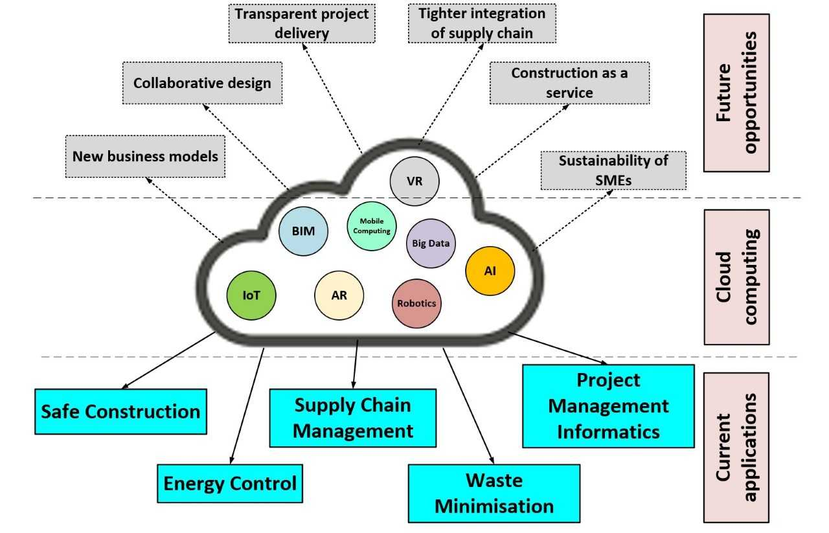
Figure 8: Existing and Future Applications of Cloud Computing in Construction Industry

Use Cases of Cloud Computing in Construction Industry
This section categorised the specific applications of cloud computing in the construction industry as discovered in the literature. The existing use cases were found for management of waste, energy, health and safety, supply chain and project communication of built assets. The identified uses cases in the eight RIBA stages of construction are depicted in Table 3. Figure 9 mapped these use cases into a broadly categorised preconstruction, construction and post-construction stages. For example, the PaaS model deployed in a public cloud was used to realise an energy management system at the construction stage of a project life cycle.

Cloud Computing for Construction Waste Minimisation
Uncoordinated construction management is characterised with untimely feedback that results in wastage of resources. Azambuja et al. [84] tackled the problem of accumulating large inventories resulting in material wastage on site by employing cloud-based technology to integrate suppliers and actual site demand. Wastage throughout the life cycle of a building must be minimised to reduce project cost and time over run [116]. Smith and Redmond [117] presented an efficient Cloud-BIM cost estimate process with simplified file structure that led to a substantial file space reduction that improves access for the design team. Redmond et al. [118] observed that limited accessibility to existing construction information has resulted in resources wastage, thus Redmond et al. [119] proposed cloud computing to reduce transaction costs and enhance online collaboration tools. Abedi et al. [54] developed a Cloud Computing Information System (CCIS) collaborative tool to ameliorate productivity deterioration arising from lack of coordination among parties involved in the precast construction. This tool also addresses the problem of inaccurate components delivery [120] and high cost of precast installation when contractor order changes [121].

Cloud Computing for Safe Construction
Construction sites are usually dangerous due to a large number of workers, materials, equipment, and dynamic/unforeseen circumstances [122]. The risk of working in the construction site is further increased by a lack of access to real time safety information to provide predictive, quantitative, and qualitative measures allowing the identification, correlation, and elimination of hazards before health and safety incidents [123]. Cloud technologies is thus being employed to provide timely access to safety information and in turn resulting in improved safety performance of construction sites. Getuli et al. [58] observed that building activities in construction sites are ineffectively monitored, thus proposed a cloud-based information system for monitoring construction sites for improved safety with location information. Li et al. [68] developed a cloud-enabled platform to provide decision support tools to site managers and workers in on-site assembly process of prefabricated construction. Park et al. [74] observed that existing manual construction-safety monitoring is labour-intensive and error-prone, thus developed a SaaS application to detect unsafe conditions and analyse the trajectories of workers with respect to potential safety hazards on construction site. Guo et al. [75] employed cloud technology to observe the behaviour of workers during a metro construction to evolve a safety system. Zou et al. [77] employed PaaS offering on a public cloud to capture, process and share on-site safety data with location information. Tang et al. [78] tackled the problem of irregular and untimely site inspection using the SaaS cloud with GPS for a Personalised Safety Instruction Method (PSIM) system.
Table 3: Cloud Use Cases in the Stages of Construction
Author | Strategic Definition | Preparation & Brief | Concept Design | Developed Design | Technical Design | Construction | Handover & Close Out | In Use
Author | PRECONSTRUCTION |  |  |  |  | CONSTRUCTION | POST CONSTRUCTION
Cloud Computing for Waste Management

[117] | ☓ | ☓ | ✓ | ✓ | ✓ | ☓ | ☓ | ☓
[84] | ☓ | ☓ | ☓ | ☓ | ☓ | ✓ | ☓ | ☓
[54] | ☓ | ☓ | ☓ | ☓ | ☓ | ✓ | ☓ | ☓
[119] | ✓ | ✓ | ✓ | ✓ | ✓ | ✓ | ☓ | ☓
Cloud Computing for Safety Management
[68] | ☓ | ☓ | ☓ | ☓ | ☓ | ✓ | ☓ | ☓
[74] | ☓ | ☓ | ☓ | ☓ | ☓ | ✓ | ☓ | ☓
[75] | ☓ | ☓ | ☓ | ☓ | ☓ | ✓ | ☓ | ☓
[77] | ☓ | ☓ | ☓ | ☓ | ☓ | ✓ | ☓ | ☓
[78] | ☓ | ☓ | ☓ | ☓ | ☓ | ✓ | ☓ | ☓
[58] | ☓ | ☓ | ☓ | ☓ | ☓ | ✓ | ☓ | ☓
[79] | ☓ | ☓ | ✓ | ✓ | ✓ | ☓ | ☓ | ☓
Cloud computing for Energy Management
[94] | ☓ | ☓ | ✓ | ✓ | ✓ | ☓ | ☓ | ☓
[124] | ☓ | ☓ | ☓ | ☓ | ☓ | ☓ | ✓ | ✓
[95] | ☓ | ☓ | ✓ | ✓ | ✓ | ☓ | ☓ | ☓
[80] | ☓ | ☓ | ☓ | ☓ | ☓ | ✓ | ☓ | ☓
[81] | ☓ | ☓ | ☓ | ☓ | ☓ | ☓ | ☓ | ✓
[66] | ☓ | ☓ | ☓ | ☓ | ☓ | ☓ | ☓ | ✓
[82] | ☓ | ☓ | ☓ | ☓ | ☓ | ☓ | ☓ | ✓
[52] | ✓ | ✓ | ✓ | ✓ | ✓ | ✓ | ✓ | ✓
Project Management Informatics
[92] | ✓ | ✓ | ✓ | ✓ | ✓ | ✓ | ✓ | ✓
[103] | ✓ | ✓ | ☓ | ☓ | ☓ | ☓ | ☓ | ☓
[89] | ☓ | ☓ | ✓ | ✓ | ✓ | ☓ | ☓ | ☓
[125] | ☓ | ☓ | ✓ | ✓ | ✓ | ☓ | ☓ | ☓
[93] | ☓ | ☓ | ☓ | ☓ | ☓ | ✓ | ☓ | ☓
[91] | ☓ | ☓ | ☓ | ☓ | ☓ | ✓ | ☓ | ☓
[98] | ☓ | ☓ | ✓ | ✓ | ✓ | ☓ | ☓ | ☓
[99] | ☓ | ☓ | ☓ | ☓ | ☓ | ✓ | ☓ | ☓
[126] | ☓ | ☓ | ☓ | ☓ | ☓ | ✓ | ☓ | ☓
[104] | ✓ | ✓ | ✓ | ✓ | ✓ | ☓ | ☓ | ☓
[90] | ☓ | ☓ | ✓ | ✓ | ✓ | ✓ | ☓ | ☓
[100] | ☓ | ☓ | ☓ | ☓ | ☓ | ✓ | ☓ | ☓
[102] | ✓ | ✓ | ✓ | ✓ | ✓ | ✓ | ✓ | ✓
[101] | ✓ | ✓ | ✓ | ✓ | ✓ | ✓ | ✓ | ✓
Cloud Computing for Supply Chain Management
[87] | ☓ | ☓ | ☓ | ☓ | ☓ | ✓ | ☓ | ☓
[86] | ☓ | ☓ | ☓ | ☓ | ☓ | ✓ | ☓ | ☓
[85] | ☓ | ☓ | ☓ | ☓ | ☓ | ✓ | ☓ | ☓
[64] | ☓ | ☓ | ☓ | ☓ | ☓ | ✓ | ☓ | ☓
[88] | ☓ | ☓ | ☓ | ☓ | ☓ | ✓ | ☓ | ☓
[70] | ☓ | ☓ | ☓ | ☓ | ☓ | ✓ | ☓ | ☓
The inaccurate collection and sharing of safety risks for underground construction was solved by Li et al. [79] using cloud storage to achieve timely and accurate recognition of safety risk at the preconstruction stage of a project. Mansouri and Akhavia [127] concludes from a survey that cloud data analytics is essential for rapid decision making on construction safety.

Cloud Computing for Energy Management in Construction
Buildings consume appreciable amount of energy during both construction and operation stages. Cloud computing has been employed to effectively manage energy in various stages of construction. Towards realising the much-desired green consumption, Li et al. [52] employed cloud computing platform to manage construction information in building life cycle. Khajenasiri et al. [66] employed IaaS, PaaS and SaaS cloud offerings to intelligently control building energy in smart cities. Rawai et al. [80] opined that using cloud computing technology during construction of buildings will reduce both energy consumption and CO₂ emissions. Cho et al. [81] employed the SaaS cloud to propose an energy management system for sustainable decision support. Wang et al. [82] employed IaaS and PaaS for hosting building data to realise Building Management Operation of green building. Naboni et al. [94] employed the SaaS cloud service to carry out the parametric simulation of the energy performance of a building within design processes of architectural and engineering practices. Balaras et al. [95] utilised the computational power of cloud computing to develop a Virtual Energy Laboratory for affordable simulations design of energy efficient buildings. A real-time energy awareness and an audit-style energy tracking system was implemented by Curry et al. [124] using the “linked data” technologies in a cloud environment. Their solution provided a unified interface for the diverse building management data integrated from disparate sources.
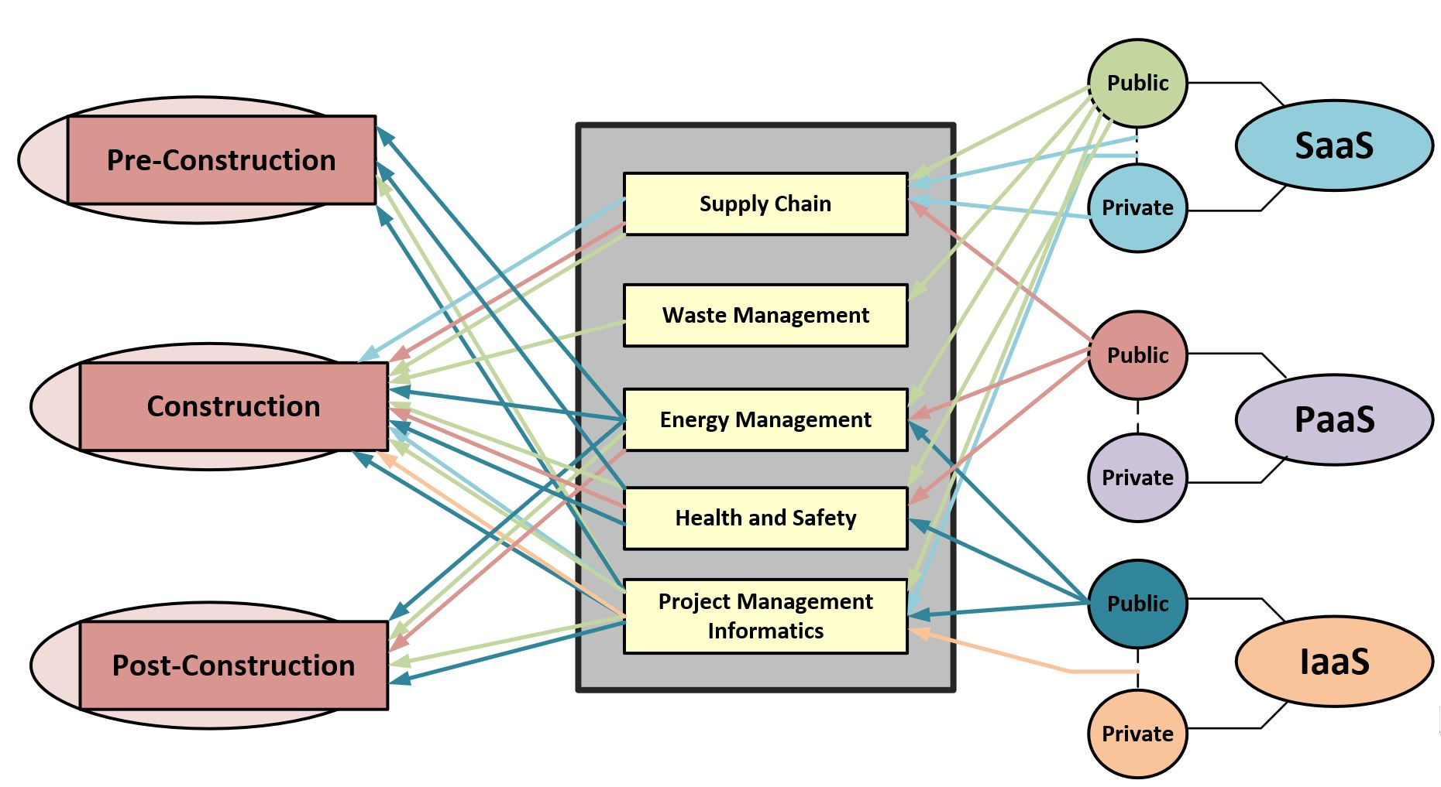
Figure 9: Existing and Future Applications of Cloud Computing in Construction Industry

Cloud Computing in Supply Chain Management in Construction
The existing uncoordinated traditional material supply in construction site usually resulted in supply gap leading to delay in projects. Ko et al. [64] employed cloud platform-as-a-service technology to track material movement on construction site in order to address the unaffordability by SMEs of existing tracking systems. Sahin et al. [70] presented a cloud-based cost-effective system integrated with RFID to increase visibility and traceability of materials and information flow in construction supply chain. Hemanth et al. [85] also used cloud-based supply management system to solve the problem of miscommunications and improper transfer of information in a precast industry. Grilo and Jardim-Gonclaves [86] employed the public and private SaaS cloud platform for interoperability to bring together different stakeholders in the procurement process for efficient construction process. Fathi et al. [87] developed the Context-Aware Cloud Computing Information Systems (CACCIS) for accurate and relevant information to parties in the construction supply chain processes. Azambuja and Gong [88] used; Google Fusion Table (GFT), Google Maps, and Google Earth to manage supply chain data in a cost-effective manner.

Cloud Computing for Project Management Informatics
The construction industry is characterised with communication and coordination problem culminating in low construction quality. Zheng [89] reported that cloud computing technology for collaborative design will result in improved design, construction and project efficiency. Ferrada et al. [90] employed the public SaaS cloud offering to formalize the transfer of knowledge among local construction companies to improve the construction project. Petri et al. [91] employed federated clouds to coordinate multi-site construction enabling varied individuals and organisations on multiple projects and in varied location to exchange information and data. Alaka et al. [92] employed cloud server instances to analyse data in order to predict failure of construction businesses. Hore et al. [93] proposed cloud computing to enhance uptake of IT by construction SMEs noting the on-site and highly customised construction services. Hore et al. [96] presented the affordability of adopting cloud computing software solution to Irish construction companies. Haymaker and Senescu [98] presented a cloud-based Design Process Communication Methodology (DPCM) for process clarity and information consistency resulting in fewer mistakes when data intensive construction processes are shared. Ahn et al. [99] employed cloud computing technology to integrate real-time on-site information from PMIS, Web Camera, RFID, PDA used on site together with office work for rapid decision making. Petri et al. [100] presented "Clouds-for-Coordination"(C4C) architecture for improved security, reliance, fault tolerance and data access during construction. Beach et al. [101] presented a data sharing capability using CometCloud (public and private) to store and manage building data, provide security during increasing demand and node failure. Polter and Scherer [102] presented an accessible hybrid environment for construction data management by SMEs using private grid and public cloud to automate complex workflows and optimise data transfer at a reduced cost. Núñez et al. [103] developed an affordable mobile cloud computing platform for construction SMEs to manage lessons from previous projects. To solve the big-data lifecycle management problem, Jiao et al. [104] built a community SaaS platform for the AEC/FM sector. This Project Data as a service application supports all phase of data collection, automatic data correlation, intra/inter organisation data sharing and diachronic data tracing in a cost effective and efficient manner. Jardim and Grilo [125] proposes a cloud service that ensures universal access to BIM in the Building and Construction Sector. Cloud storage was employed to model a shareable simulation library of some cooperative behaviours of construction workers [126]. Cheng et al. [128] developed a decision-making model to assist constructions stakeholders in selecting a suitable cloud application for the built environment. Afolabi et al. [129] studied the uniqueness of construction industry and concluded that cloud computing, though rarely used by the sampled companies, is an essential tool for collaboration in construction industries.

Insight from the Systematic Review
The findings from the review shows that cloud computing in construction industry is an active area of research evidenced by the soaring interest in the field. The territorial analysis follows the established trend of construction research activities among the countries, with China at the topmost of the ladder. Cloud computing has provided incentives ranging from computational power for data analysis, secured enormous storage to a cost–effective and convenient access for construction data. The study highlights that cloud computing is used at different stages of the project life cycle, which include feasibility, design and construction stages. Whereas, its usage in the handover and operations stages of project construction is still unpopular. The use of cloud computing technologies in post occupancy systems like facility management, users comfort management, demolition and deconstruction system etc. is not well established in the literature.
The review also shows that cloud computing, is such an enabler of the use of other emergent technologies in the construction industry. As cloud computing has successfully driven the further adoption of BIM, Immersive technologies (AR & VR), Internet of Things (IoT) and mobile technology in the construction industry. The review also reveals that the rising interest in cutting-edge trends is primarily driven by cloud computing which could drive the realization of the full potentials of these emerging technologies. Although cloud computing has ceded the spotlight to these emerging trends, cloud computing remains the foundation piece for modern collaborative IT architecture.

Challenges of Cloud Adoption by Construction Industry
Despite the relevance of cloud computing to the construction industry, there are certain challenges impending its wide adoption:

Latency
Cloud adoption in construction may not guarantee acceptable transfer rate and response time required for some time sensitive construction applications. This could either be a software issue or network problem. Proper software designing techniques have been known to prohibit latency issues, as the use of distributed cloud architecture can ensure that latency to a specific application is low. Cloud applications are recently designed to be cloud-native because cloud applications are known to scale well in cloud infrastructure. The use of hybrid cloud has also been employed by Petri et al. [100] to solve latency issues as delay-sensitive part of an application can be maintained in house while other part of the distributed application can be on the public cloud service. Construction Companies could also be linked to the service provider with dedicated link in order to prevent delay issues that could arise from the use of Internet as transport. Construction companies may also avert delay by choosing service providers with closer data centres as fewer hops between the service provider and the customer improves the network performance. There are Application Performance Monitoring (APM) tools monitoring network performance to enable early identification of the source of the latency problem and thus aid prompt solving of latency problems.

Trust, Data Privacy and Security
The anticipated vulnerability in the adoption of cloud technology is increasing due to the increasingly fluidity of the security perimeter [130]. In practice, business partners are usually unwilling to give their private and commercial information such as project cost to a third-party [131]. As Mahamadu et al. [132] has identified security and privacy concerns as threats to BIM-cloud integration. Storing construction design and financial information in shared resources understandably gives concern to construction industry. The perception is usually that some unknown set of people can access the stored data, this is more of a psychological discomfort. In reality the most sensitive part of the data chain resides with the client. Most data leakages from the cloud are from the client side, more so as employees are allowed to use own mobile devices for work. These own devices may be infected or even hacked. Hence, construction firms need to put up internal data protection strategies to block data leakage. However, in rare cases of Data Bridge from service providers, data security and privacy laws could be invoked on cloud service providers to ensure compliance [133].

Data Availability
It is not uncommon to experience down time with technologies utilising cloud resources, as a technology cannot be perpetual. A cloud provider may have cause to shut down their resources unexpectedly. The building data thus becomes unavailable, what will become of the building data? Moreover, the building project? More so if this happens at the middle of a construction project. To overcome this concern, the cloud providers are known to provide 99.999% availability as stated in the Service Level Agreement. Also, recently, Cloud technologies are committing to open-source tools to create standards and strategies in data representations to enable various cloud providers to be compatible. This is to allow exchanging data between clouds providers to avoid the issue of lock-in if a provider became unavoidably unavailable.

Data Governance
Construction projects involve many professionals, there is the need to spell out the contractual relationship between stakeholders. This is critical since the data is being contributed, it may be regarded as being owned by all. The issue of actual owner of data may arise [134], since all concerned party has access to the data and are required to update data continuously. The relationship between the building team members is also another point to consider, the information exchange requirement among the various project team members [135]. Is the Building Owner allowed to share data with the Engineer? There may be the need to define access level for the different category of stakeholders involve in the production and management of building data. The applications harnessing shall implement appropriate access control features rather than leaving them to the cloud service providers.

Poor Broadband Connectivity of Construction Sites
Access to cloud services is primarily over the internet, hence, to maximise the benefit of cloud solution in the construction site, internet connectivity must be available every time. Adedeji et al. [136] assessed the economies of cloud computing in project delivery and included poor network connect among the threats to cloud adoption by construction industry. Project sites at times might be an underdeveloped area or a rural area usually with low or no internet connectivity. The power infrastructure project such as underground cabling, overhead lines or substations are prime examples of projects that span larger geographical area with poor connectivity across the construction route. However further improvement in ICT technologies like the emergence of 5G network set to offer more speed as high as several gigabytes per second will readily overcome this problem. The 5G network will easily connects rural communities and open up underdeveloped areas and thus boost the performance of cloud technology.

Cost Implication of Long-Term Use
Accumulated cost for the use of cloud infrastructure over a long period could be daunting, depending on the type of deployment. Cloud SaaS pricing at inception was initially per unit time of consumption, further efforts by cloud researchers incorporated market value and brought about personalised pricing resulted in many pricings offers. Though assured patronage in form of reservation is currently giving a good bargain, further improvement in ICT technologies is bound to bring about a reduction in cloud service cost. Meanwhile, the cost implication is not the same for the various cloud deployments types even for the same construction company. There could be substantial high cost of renting high-end resources such as GPUs for performing project analytics and machine learning tasks. It might be necessary for individual construction company to perform personalised cost analysis of long-term use of the various cloud deployment models before moving into cloud.

High Chances for Scoring Dark Data
The cloud storage is providing an easy and inexpensive ways to store data. This has actually encouraged the storing of dark data. Dark data are data that are acquired but are not further processed or analysed for any meaningful insight. A large percentage of data generated by sensors never get used because most of the times the generation capacities is far greater than the analytics capacities. Most of the times most data collected are to satisfy regulatory policies. At times the idea that this data collected though not usable now could still be useful in future for analytics informed the storage of this data. Data value are usually time based, as an initially useful data but not processed fast enough becomes either trivial, redundant or obsolete. However, the energy consumed in storing and maintaining dark data are becoming significant, as appreciable amount of money is being spent in storing irrelevant data.

Threats of Edge Computing and Other Associated Technologies
No doubt, some construction applications characterised with fast processing and quick response time may not be able to rely on the distant and centralised cloud computing. Thus, portraying a threat for the traditional cloud computing in construction industry. The need to bring processing nearer to devices has culminated into the emergence of Edge Computing [137] and related technologies like fog computing, cloudlet, hierarchical cloud computing, mobile edge computing, mobile IoT etc. [138]. Edge computing locates processing power near the source of the data generating devices, thus bringing services and utilities of cloud computing closer to the end users. Nevertheless, Ai et al. [139] has argued that some applications are better suited for the centralised cloud while some are better carried out at the edge. This is demonstrated in uses cases found in [140], [141] and [142]. This implies that the conventional centralised cloud continues to be relevant even as other technologies emerge.

Future Opportunities of Cloud Computing in the Construction Industry
Aside of the existing benefits of cloud adoption discussed earlier, cloud computing holds a bright future for the construction industry. Some future benefits amongst others are discussed in this section.

Real Time Collaborative Construction Environment
Overcoming latency and some barriers in cloud adoption will facilitate seamless connectivity that could evolve a real-time collaborative practice leading to collaborative computing. Project designers from various locations can work on projects design using document sharing and virtual meetings facilities enabled by cloud computing. Construction designs on cloud platform will then lead to a new workflow that will allow collaboration on the construction design without uploading various versions. This will enable real time review leading to proactive identification of conflicts to be resolved timely. Collaborative design platform will reduce design space as construction designs will no more be limited by space.

Further Flexibility in Cloud Computing Upfront and Operational Costs
Cost flexibility offered by cloud computing allows construction SMEs operating on tight budget to avoid significant upfront investment and operational cost. In this way fixed costs are turned into variable costs. Avoiding this investment is imperative for the survival of SMEs which made up 90% of the construction industry. The emergence of Serverless architecture with a cost model based on execution has further reduced cost of using IT. This will allow SMEs to be able to access enterprise solution at a reduced cost. As an opportunity for SME business to use and pay only for what is actually needed reduces fixed overhead cost. This allows construction SMEs to boost margin, expand business growth and make the business more viable.

Tighter Integration of Construction Supply Chains
The construction industry is still largely fragmented despite the evidence that a tighter integration could offer several benefits [9]. Benefits accruable from a tighter and efficient integration of stakeholders include a material database using open standards. The single integrated material platform will include among others, manufacture date, prices, installation date, actual usage, end-of-life information etc. A common platform for product manufacturers, facility managers and other stakeholders in the supply chain will provide instant birds view of construction material usage and insight analytics for predictive maintenance, waste prediction, and eventually lead to a green supply chain.

More Transparency in Construction Project Delivery
A cloud based real-time project performance monitoring and reporting system will allow all stakeholders to be part of every stage of the project delivery process. Cloud adoption will allow project progress to be monitored in an open manner. The use of cloud platform to monitor project progresses will eliminate delays and block leakages arising from inaccessible information. This transparent monitoring will help in resolving disputes in a timely manner. Disputes is one of the biggest financial drains for project contractors. Disputes usually arises as a result of conflicting or unavailable evidences for a clear conclusion. Cloud storage readily makes as designed and as built evidences available for comparison, resulting in amicable settlement of disputes rather than spending money and time on litigations.

Enabling New Business Models for Construction Companies
Cloud computing will result in emergence of new business models which will enable construction companies to do business in a new way. As such cloud computing will bring about a change from the one-off on-site business models to pay as you go solutions. Cloud would afford business with new ways to use databases software and network. Intelligence on demand will be available for construction practitioners as a result of instant response from the massive power of cloud computing. Examples of new business models that could emerge include design-as-a-service, procurement–as-a-service, construction-as-a-service, facility management-as–a–service, demolition-as-a-service, retrofitting-as-a-service, waste management-as-a-service. For example, a cloud-based solution deployed for facility management will detect the number of occupants at a point in time inside a building, which will influence the rate at which facilities are consumed at that time. Facility manager will then be paid based on the measured service consumed. Construction will thus be conceived as a utility and paid for per usage.

Improved Security Assurance
Apart from the matured security features of the cloud infrastructure providing secured platform for construction data at a minimal cost. Cloud services provides excellent backup for construction data, as Construction Company no longer have to worry about running data back up on a routine basis. Cloud virtual server is hardware independent. The virtual server encapsulated the operating system, applications, patches and data. These are safely and accurately transferred from one data centre to another, by this construction data is replicated in more than one data centres on different locations. In the face of any disaster in a data centre, data can be instantly restored from other data centres and thus ensures business continuity. This is not possible with in house storage, as the cost of replicating hardware servers is enormous and may not be feasible to have them in different locations. As such, if disaster befall a server that may be the end of the data therein and may affect the continuity of the business having the data.

Implications for Practice
This study has huge implications for the construction industry especially from four key perspectives namely, (1) Skill and competency implication, (2) implication for cloud contract and agreement with service provider (3) cloud host location as well as (4) efficiency impact.
Firstly, the adoption of cloud computing has implications for employees, especially because it brings about frequent interaction between employees and machines, thus necessitating the need for workers to develop new skills or update existing skills in order to adapt to the new roles. As a result, construction organisations have responsibility to provide the right learning channels through training programmes and continuous learning models to avoid laying off staff. Construction IT personnel may also need to be optimized to ensure effective and efficient management of services and service providers rather than managing systems and components directly. Other impact of cloud adoption on skills and competencies of employees include adjustment in terms of IT talents as new roles may have to be created with new skills, staffing capacity evaluation when moving to cloud with respect to staffing requirements.
Secondly, though cloud contracts are usually in the form of a one-click agreement which in most cases are highly favourable to the provider. Nevertheless, construction organisations that are adopting cloud technology can utilise negotiation in order to address their various concerns. Oftentimes, a cloud contract will fundamentally control how, what and where cloud data are stored, exclusion for liability for natural disasters, power outages, cyber-attacks are significant. However, construction companies may request for the provider managed service insurance or rather, obtain insurance for loses due to unforeseen events. Similarly, construction companies could also assert in the cloud contract, important clauses that ensures the entire construction data is fully retractable and with the full ownership lying with Construction Company. Other clauses indicating how the data will be managed at the expiration of contract, complete deletion of data including backups after a specified period of time, could also be incorporated into the cloud contract among others.
Thirdly, laws governing data usage in the territory where the cloud storage is located will prevail over the stored data irrespective of the owner of data. For example, the EU law requires that all data stored on citizens must be either stored in the EU or in jurisdiction with similar level of protection. Hence, construction companies need to be mindful of the territory where construction data is stored. Usually cloud providers have servers located all around the world, as a result, it is incumbent on the subscriber to choose a suitable location. Construction companies might also need to anonymise personal data in order to protect such information.
Finally, cloud adoption also has huge significant impact on efficiency within organisational operations. For instance, the use of cloud computing helps to reduce the number of in-house servers thus reducing energy consumed by individual servers. Data centres are specially designed with sophisticated cooling systems and are designed to be efficient than in-house servers. This combination results in high energy saving systems. Similarly, online monitoring of construction and online collaboration using cloud computing as well as other emerging technologies greatly reduces the commuting of construction workers thus reducing carbon emission as well carbon footprint. The use of cloud computing in construction also eliminates the need for papers in the stages of construction e.g. design, tendering, procurement, etc. This in turn saves a lot of energy required for creating papers as well as energy required to discard waste papers. As such, with cloud computing adoption resulting in reduced operational cost, reduced IT spending as well as maintenance cost, the impact on RoI for the construction industry will be greatly enhanced. Thus, cloud computing adoption by Construction Company is a great move towards a green society.

Conclusion
The study has investigated the relevance of cloud computing in the last decade to the construction industry, exploring the extent to which cloud computing has been used in construction. Relevant up-to-date publications from SCOPUS, Science Direct and Google Scholar that are characterised with robustness and integrity have been reviewed. This is the first of its kind study, viewing construction industry from the inception of cloud computing technology to the present. The study provided a rundown of cloud computing including the underpinning technologies that has supported the development of cloud-native services. This study analysed the existing literature and find out that cloud computing in construction is an active area of research.
The study has revealed that the use of cloud computing in construction industry is emerging and that opportunities there in are abound. More importantly, cloud services are inevitable for SMEs in the sector to digitise their processes using BIM-enabled applications. The study has brought out the core use cases of cloud computing in construction industry, presently these are; safety system, waste minimisation system, supply chain management system, energy management system and construction informatics. The study found out that construction industry is benefitting computational power for data analysis, a secured cost–effective and convenient access to construction data by all stakeholders from the use of cloud computing. The study divulged that cloud computing is being used in the feasibility study, design and construction stages of project lifecycle. Whereas, its use in the handover and operations stages of project construction is still unpopular. The use of cloud computing technologies in post occupancy systems like facility management, users comfort management, demolition and deconstruction system etc. is not well pronounced.
The study highlighted some of the challenges militating against wider adoption of the technology and provide strategies to survive them. The study also mentioned some of the future benefits of wider adoption of cloud computing in construction industry. This work is very useful for the construction practitioners and researchers as it presents the potentiality of cloud computing in the construction industry. Future research will look into relevance of emerging Edge computing, fog computing, cloudlet, mobile edge computing, etc in the construction industry.

References

[1] C.J. Anumba, J. Pan, R.R.A. Issa, I. Mutis, Collaborative project information management in a semantic web environment, ﻿Engineering, Construction and Architectural Management, 15(1), (2008) pp. 78-94. DOI: 10.1108/09699980810842089
[2] B. Kumar, J.C.P. Cheng, L. McGibbney, Cloud Computing and its implications for construction IT, 13th International Conference on Computing and Building Engineering and 17th International European Group Workshop on Intelligent Computing in Engineering, Nottingham, UK, (2010) pp. 315-320. ISBN 978-1-907284-60-1
[3] T.D. Oesterreich, F. Teuteberg, Understanding the implications of digitisation and automation in the context of Industry 4.0: A triangulation approach and elements of a research agenda for the construction industry, Computers in Industry, 83, (2016) pp. 121–139, DOI:10.1016/j.compind.2016.09.006.
[4] J. Voas, J. Zhang, Cloud Computing: New wine or just a new bottle?, Information Technology (IT) Professional. 11(2), (2009) pp. 15–17, DOI: 10.1109/MITP.2009.23
[5] H. Erdogmus, Cloud computing: Does Nirvana hide behind the Nebula?, Institute of Electrical and Electronics Engineers (IEEE) Software. 26 (2) (2009) pp. 4–6, DOI:10.1109/MS.2009.31.
[6] L. Zhang, R.R.A. Issa, Comparison of BIM cloud computing frameworks, International Conference on Computing in Civil Engineering, Clearwater Beach, Florida, United States (2012) pp. 389–396. DOI: ﻿10.1061/9780784412343.0049
[7] J. Wong, X. Wang, H. Li, G. Chan, H. Li, A review of cloud-based bim technology in the construction sector, Journal of Information Technology in Construction. 19, (2014) pp. 281–291. ISSN: 1874-4753
[8] H.-Y. Chong, J. Wong, X. Wang, An explanatory case study on cloud computing applications in the built environment, Automation in Construction 44, (2014) pp. 152–162. DOI: 10.1016/j.autcon.2014.04.010
[9] Q. Almaatouk, M.S. Bin Othman, A. Al-Khazraji, A review on the potential of cloud-based collaboration in construction industry, 3rd Middle East College International Conference on Big Data and Smart City, Muscat, Oman, (2016) pp. 18–22. DOI:10.1109/ICBDSC.2016.7460336.
[10] M. Bilal, L.O. Oyedele, J. Qadir, K. Munir, S.O. Ajayi, O.O. Akinade, H.A. Owolabi, H.A. Alaka, M. Pasha, Big Data in the construction industry: A review of present status, opportunities, and future trends, Advanced Engineering Informatics, 30(3), (2016) pp. 500–521. DOI: 10.1016/j.aei.2016.07.001.
[11] P. Tang, D. Huber, B. Akinci, R. Lipman, A. Lytle, Automatic reconstruction of as-built building information models from laser-scanned point clouds: a review of related techniques, Automation in Construction, 19 (7), (2010) pp. 829–843. DOI:10.1016/j.autcon.2010.06.007.
[12] M. Abedi, M.S. Fathi, S. Rawai, Cloud computing technology for collaborative information system in construction industry, 18th International Business Information Management Association Conference - Innovation and Sustainable Competitive Advantage: From Regional Development to World Economies, (2012) pp. 593–602. ISBN: 978-0-9821489-7-6
[13] P. Mell, T. Grance, The NIST Definition of cloud computing, National Institute of Standards and Technology. Special Publication 800-145, National Institute of Standards and Technology, (2011). https://nvlpubs.nist.gov (accessed November, 20, 2018).
[14] A. Goscinski, M. Brock, Toward dynamic and attribute based publication, discovery and selection for cloud computing, Future Generation Computer Systems, 26(7), (2010) pp. 947–970. DOI:10.1016/j.future.2010.03.009
[15] G. Pallis, Cloud Computing: The new frontier of internet computing, Institute of Electrical and Electronics Engineers Internet Computing, 14(5), (2010) pp. 70–73. DOI:10.1109/MIC.2010.113.
[16] S.C. Misra, A. Mondal, Identification of a company’s suitability for the adoption of cloud computing and modelling its corresponding Return on Investment, Mathematical and Computer Modelling, 53(3-4), (2011) pp. 504–521. DOI:10.1016/j.mcm.2010.03.037
[17] M. Armbrust, I. Stoica, M. Zaharia, A. Fox, R. Griffith, A.D. Joseph, R. Katz, A. Konwinski, G. Lee, D. Patterson, A. Rabkin, A view of cloud computing, Communications of Association for Computing Machinery. 53(4), (2010) pp. 50–58. DOI: 10.2991/ijndc.2013.1.1.2.
[18] A.M. Sharif, It’s written in the cloud: The hype and promise of cloud computing, Journal of Enterprise Information Management, 23(2), (2010) pp. 131–134. DOI:10.1108/17410391011019732
[19] W. Voorsluys, J. Broberg, S. Venugopal, R. Buyya, Cost of virtual machine live migration in clouds: a performance evaluation, 1st International Conference on Cloud Computing, Berlin, (2009) pp. 245–265. DOI:10.1007/978-3-642-10665-1_23.
[20] N. Sultan, Cloud computing for education: A new dawn?, International Journal of Information Management, 30(2), (2010) pp. 109–116. DOI: 10.1016/j.ijinfomgt.2009.09.004.
[21] T. Liu, A. Mathrani, J. Mbachu, Hunting the popular construction Apps, 3rd Asia-Pacific World Congress on Computer Science and Engineering (APWC on CSE), Nadi, Fiji, (2016) pp. 205–211. DOI: 10.1109/APWC-on-CSE.2016.042.
[22] S. Bello, A proposed criteria for evaluating cloud based systems, ﻿International Journal of Computers & Innovative Research 13(3), (2014) pp. 4282–4290. DOI:10.24297/ijct.v13i3.2759
[23] C. Reich, S.A. Bello, Cloud utility price models, Third International Conference on Cloud Computing and Services Science, E.S. F. Desprez, D. Ferguson, E. Hadar, F. Leymann, M. Jarke, and M. Helfert (Ed.), SciTePress, Aachen Germany, (2013) pp. 317–320. DOI:10.5220/0004350503170320
[24] S.A. Bello, C. Reich, L. Luethje, Cloud resource price system, The Sixth International Conference on Emerging Network Intelligence, Rome, Italy, (2014) pp. 12–17. ISBN: 978-1-61208-357-5
[25] R. Buyya, S. Venugopal, Market oriented computing and global Grids: An introduction, in Market Oriented Grid and Utility Computing, in: Bubendorfer, K. and Buyya, R. (Ed.), John Wiley & Sons, Hoboken, NJ, (2009), pp. 1-27 DOI:10.1002/9780470455432.ch1.
[26] K. Keahey, I. Foster, T. Freeman, X. Zhang, Virtual workspaces: Achieving quality of service and quality of life in the grid, Scientific Programming, 13, (2005), pp. 265–275. DOI:10.1155/2005/351408.
[27] R. Uhlig, G. Neiger, D. Rodgers, A.L. Santoni, F.C.M. Martins, A.V. Anderson, S.M. Bennett, A. Kägi, F. H., F.H. Leung, L. Smith, Intel virtualization technology, Institute of Electrical and Electronics Engineers Computer, 38, (2005), pp. 48–56. www.cs.columbia.edu (accessed Aug 26, 2020).
[28] F.P. Tso, K. Oikonomou, E. Kavvadia, D.P. Pezaros, Scalable Traffic-Aware Virtual Machine Management for Cloud Data Centers, in: Institute of Electrical and Electronics Engineers 34th International Conference on Distributed Computing Systems, Madrid, (2014), pp. 238–247. DOI:10.1109/ICDCS.201.
[29] R. Cziva, S. Jouët, D. Stapleton, F.P. Tso, D.P. Pezaros, SDN-Based Virtual Machine Management for Cloud Data Centers, Institute of Electrical and Electronics Engineers Transactions on Network and Service Management 13, (2016), pp. 212–225. DOI:10.1109/TNSM.2016.2528220.
[30] S.A. Bello, W. Gazali, G.A. Aderounmu, Efficient Virtual Machine Placement Algorithm, International Journal of Computer Science Issues, 14, (2017), pp. 68–75. DOI:10.20943/01201705.6875.
[31] A. Agarwal, T.N. Duong, Secure virtual machine placement in cloud data centers, Future Generation Computer Systems, 100, (2019), pp. 210–222. DOI:10.1016/j.future.2019.05.005.
[32] X. Xu, X. Zhang, M. Khan, W. Dou, S. Xue, S. Yu, A balanced virtual machine scheduling method for energy-performance trade-offs in cyber-physical cloud systems, Future Generation Computer Systems, 105 (2020), pp. 789–799. https://doi.org/10.1016/j.future.2017.08.057.
[33] N.A.B. Mary, K. Jayapriya, An Extensive Survey on QoS in Cloud computing, International Journal of Computer Science and Information Technologies, 5, (2014), pp. 1–5. ISSN::0975-9646.
[34] V.C. Emeakaroha, I. Brandic, M. Maurer, I. Breskovic, SLA-Aware Application Deployment and Resource Allocation in Clouds, in: Proceedings of 35th Institute of Electrical and Electronic Engineers Annual Computer Software and Applications Conference Workshops, Munich, (2011), pp. 298–303. DOI:10.1109/COMPSACW.2011.97.
[35] S.K. Garg, S. Versteeg, R. Buyya, A framework for ranking of Cloud computing services, Future Generation Computer Systems, 29, (2013), pp. 1012–1023. DOI:10.1016/j.future.2012.06.006.
[36] N.A.B. Mary, Profit Maximization for Service Providers using Hybrid Pricing in Cloud Computing, International Journal of Computer Applications Technology and Research, 2, (2013), pp. 218–223. ISSN: 2319–8656.
[37] S.K. Garg, S. Versteeg, R. Buyya, SMICloud: A Framework for Comparing and Ranking Cloud Services, in: Fourth Institute of Electrical and Electronics Engineers International Conference on Utility and Cloud Computing, Victoria, Australia, (2011), pp. 210–218. DOI:10.1109/UCC.2011.36.
[38] H. Khazaei, J. Misic, V.B. Misic, Performance Analysis of Cloud Computing Centers Using M/G/m/m+r Queuing Systems, Institute of Electrical and Electronics Engineers Transactions on Parallel and Distributed Systems, 23, (2012), pp. 936–943. DOI:10.1109/TPDS.2011.199.
[39] S. Ding, S. Xia, C. Cai, Q. Zhou, K. Yang, QoS-aware resource matching and recommendation for cloud computing systems, Applied Mathematics and Computation 247, (2014), pp. 941–950. DOI:10.1016/j.amc.2014.09.058.
[40] S. Heidari, R. Buyya, Quality of Service (QoS)-driven resource provisioning for large-scale graph processing in cloud computing environments: Graph Processing-as-a-Service (GPaaS), Future Generation Computer Systems, 96, (2019), pp. 490–501. DOI:10.1016/j.future.2019.02.048.
[41] A. Jula, E. Sundararajan, Z. Othman, Cloud computing service composition: A systematic literature review, Expert System with Applications 41, (2014), pp. 3809–DOI:10.1016/j.eswa.2013.12.017.
[42] Q. Yu, L. Chen, B. Li, Ant colony optimization applied to web service compositions in cloud computing, Computers and Electrical Engineering, 41, (2015), pp. 18–27. DOI:10.1016/j.compeleceng.2014.12.004.
[43] H. Wang, X. Wang, H. Xingguo, X. Zhang, G. Mingzhu, A multi-agent reinforcement learning approach to dynamic service composition, Information Sciences, 363, (2016), pp. 96–119. DOI:10.1016/j.ins.2016.05.002.
[44] N. Afshin, N.N. Jafari, A new agent-based method for QoS-aware cloud service composition using particle swarm optimization algorithm, Journal of Ambient Intelligence and Humanized Computing, 10, (2019), pp. 1851–1864. DOI:10.1007/s12652-018-0773-8.
[45] D.G. do Lago, E.R.M. Madeira, L.F. Bittencourt, Power-Aware Virtual Machine Scheduling on Clouds Using Active Cooling Control and DVFS, in: Nineth International Workshop on Middleware for Grids, Clouds and e-Science, Association of Computing Machinery, Lisboa, (2011) pp. 1–6. Doi: 10.1145/2089002.2089004.
[46] S. Kaur, A. Verma, An efficient approach to genetic algorithm for job scheduling in cloud computing environment, ﻿International Journal of Information Technology and Computer Science, 4, (2012), pp. 74–79. DOI:10.5815/ijitcs.2012.10.09.
[47] V.V. Kumar, K. Dinesh, Job scheduling using fuzzy neural network algorithm in cloud environment, Bonfring International Journal of Man Machine Interface, 2 (2012), pp. 1–6. ISSN 2277 – 5064.
[48] M. Shojafar, S. Javanmardi, S. Abolfazli, N. Cordeschi, FUGE: A joint meta-heuristic approach to cloud job scheduling algorithm using fuzzy theory and a genetic method, Cluster Computing, 18, (2015), pp. 829–844. DOI:10.1007/s10586-014-0420-x.
[49] H. Gamal El Din Hassan Ali, I.A. Saroit, A.M. Kotb, Grouped tasks scheduling algorithm based on QoS in cloud computing network, Egyptian Informatics Journal, 18, (2017), pp. 11–19. DOI:10.1016/j.eij.2016.07.002.
[50] E. Aloboud, H. Kurdi, Cuckoo-inspired Job Scheduling Algorithm for Cloud Computing, Procedia Computer Science 151, (2019), pp. 1078–1083. DOI:10.1016/j.procs.2019.04.153.
[51] E. Alreshidi, M. Mourshed, Y. Rezgui, Requirements for cloud-based BIM governance solutions to facilitate team collaboration in construction projects, Requirements Engineering, 23, (2018) pp. 1–31. DOI:10.1007/s00766-016-0254-6.
[52] Y. Li, X. Ma, Research on the informatization management of green construction based on Cloud-BIM, 2016 International Conference on Construction and Real Estate Management: Building Information Modelling Application and Off-Site Construction, Edmonton, Canada, (2016) pp. 585–592. DOI: 10.1061/9780784480274.069.
[53] D. Moher, A. Liberati, J. Tetzlaff, D. Altman, The PRISMA Group, Preferred reporting items for systematic reviews and meta-analyses: The PRISMA Statement, Journal of clinical epidemiology 62(10), (2009) pp. 1006–1012. DOI: 10.1016/j.jclinepi.2009.06.005
[54] M. Abedi, N.M. Rawai, M.S. Fathi, A.K. Mirasa, Cloud computing as a construction collaboration tool for precast supply chain management, Jurnal Teknologi, 70(7), (2014) pp. 1–7. DOI: 10.11113/jt.v70.3569.
[55] F. Rowe, What literature review is not: diversity, boundaries and recommendations, European Journal of Information Systems 23(3), (2014) pp. 241–255. DOI:10.1057/ejis.2014.7
[56] E.A. Holt, J.M. Benham, B.F. Bigelo, Emerging technology in the construction industry: Perceptions from construction industry professionals, 122nd Annual Conference and Exposition of American Society for Engineering Education, Seattle, WA, (2015) pp. 26.595.1 – 26.595.10. DOI:10.18260/p.23933
[57] T.-H. Chuang, B.-C. Lee, I.-C. Wu, Applying cloud computing technology to BIM visualization and manipulation, 28th International Symposium Automation Robotic Construction, Seoul Korea, (2011) pp. 144–149. ISBN: 978-1-5108-0429-6
[58] V. Getuli, S.M. Ventura, P. Capone, A.L.C. Ciribini, A BIM-based construction supply chain framework for monitoring progress and coordination of site activities, Procedia Engineering, 164, (2016) pp. 542–549. DOI: 10.1016/j.proeng.2016.11.656
[59] Y. Jiao, Y. Wang, L. Yuan, L. Li, Cloud and SNS supported collaboration in AEC industry, Institute of Electrical Electronics Engineers 16th International Conference on Computer Supported Cooperative Work in Design (CSCWD), Wuhan, China, (2012) pp. 842–849. ﻿DOI: 10.1109/CSCWD.2012.6221919
[60] T.-H. Chen, H.-M. Chang, K.-C. Lin, A cloud-based system framework for performing online viewing, storage, and analysis on big data of massive BIMs, Automation in Construction, 71(1), (2016) pp. 34–48. DOI: 10.1016/j.autcon.2016.03.002
[61] S. Arthur, H. Li, R. Lark, A collaborative unified computing platform for building information modelling (BIM), 18th International Federation for Information Processing Working Group 5.5 Working Conference on Virtual Enterprises: Collaboration in a Data-Rich World, R. Camarinha-Matos, L.M., Afsarmanesh, H. and Fornasiero (Ed.), Springer, Italy, (2017) pp. 63–73. DOI:10.1007/978-3-319-65151-4_6
[62] E. Alreshidi, M. Mourshed, Y. Rezguia, Factors for effective BIM governance, Journal of Building Engineering, 10, (2017) pp. 89–101. DOI:10.1016/j.jobe.2017.02.006.
[63] M. Bashir, A. Gill, Towards an IoT big data analytics framework: Smart buildings systems, Institute of Electrical and Electronics Engineers 18th International Conference on High Performance Computing and Communications; Institute of Electrical and Electronics Engineers 14th International Conference on Smart City; Institute of Electrical and Electronics Engineers 2nd International Conference on Data Science and Systems, Sydney, (2016) pp. 1325–1332. DOI:10.1109/HPCC-SmartCity-DSS.2016.0188
[64] H. Ko, M. Azambuja, H. Lee, Cloud-based materials tracking system prototype integrated with radio frequency identification tagging technology, Automation in Construction 63 (1), (2016) pp. 144–154. DOI: 10.1016/j.autcon.2015.12.011
[65] Y. Fang, Y.K. Cho, S. Zhang, E. Perez, Case study of BIM and cloud–enabled real-time RFID indoor localization for construction management applications, Journal of Construction Engineering and Management, 142(7), (2016) pp. 05016003-1 – 05016003-12. DOI:10.1061/(ASCE)CO.1943-7862.0001125
[66] I. Khajenasiri, A. Estebsari, M. Verhelst, G. Gielen, A Review on internet of things solutions for intelligent energy control in buildings for smart city applications, Energy Procedia. 111, (2017) pp. 770 – 779. DOI: 10.1016/j.egypro.2017.03.239
[67] G. Xu, M. Li, C.-H. Chen, Y. Wei, Cloud asset-enabled integrated IoT platform for lean prefabricated construction, ﻿Automation in Construction, 93, (2018) pp. 123–134. DOI: 10.1016/j.autcon.2018.05.012
[68] C.Z. Li, F. Xue, X. Li, J. Hong, G. Shen, An internet of things-enabled BIM platform for on-site assembly services in prefabricated construction, Automation in Construction, 89, (2018) pp. 146–161. DOI:10.1016/j.autcon.2018.01.001
[69] M. Jia, A. Komeily, W. Wang, S. Srinivasan, Adopting internet of things for the development of smart buildings: A review of enabling technologies and applications, Automation in Construction, 101, (2019) pp. 111–126. DOI:10.1016/j.autcon.2019.01.023
[70] M. Sahin, H. Ko, H.F. Lee, M. Azambuja, A simulation case study on supply chain management of a construction firm adopting cloud computing and RFID, ﻿International Journal of Industrial and Systems Engineering, 27(2), (2017) pp. 233–254. DOI:10.1504/IJISE.2017.086269.
[71] Y. Jiao, S. Zhang, Y. Li, Y. Wang, B. Yang, Towards cloud augmented reality for construction application by BIM and SNS integration, ﻿Automation in Construction, 33, (2013) pp. 37–47. DOI:10.1016/j.autcon.2012.09.018
[72] J. Du, Y. Shi, Z. Zou, D. Zhao, CoVR: Cloud-based multiuser virtual reality headset system for project communication of remote users, Journal of Construction Engineering and Management, 144(2), (2018) pp. 04017109-1 - 04017109-19. DOI:10.1061/(ASCE)CO.1943-7862.0001426
[73] M. Chu, J. Matthews, P.E.D. Love, Integrating mobile iuilding Information modelling and augmented reality systems: An experimental study, ﻿Automation in Construction, 85, (2018) pp. 305–316. DOI:10.1016/j.autcon.2017.10.032.
[74] J. Park, K. Kim, Y. K. Cho, Framework of automated construction-safety monitoring using cloud-enabled BIM and BLE mobile tracking sensors, ﻿Journal of Construction and Engineering Management, 143(2), (2016) pp. 05016019. DOI: 10.1061/(ASCE)CO.1943-7862.0001223.
[75] S. Guo, H. Luo, L. Yong, A big data-based workers behavior observation in China metro construction, Procedia Engineering. 123, (2015) pp. 190–197. DOI: 10.1016/j.proeng.2015.10.077.
[76] F. Abanda, D. Mzyece, A. Oti, M. Manjia, A study of the potential of cloud/mobile BIM for the management of construction projects, Applied System Innovation, 1(2)(9), (2018) pp. 1-19. DOI:10.3390/asi1020009
[77] P.X.W. Zou, P. Lun, D. Cipolla, S. Mohamed, Cloud-based safety information and communication system in infrastructure construction, Safety Science, 98, (2017) pp. 50–69. DOI:10.1016/j.ssci.2017.05.006
[78] N. Tang, H. Hu, F. Xu, F. Zhu, Personalized safety instruction system for construction site based on internet technology, Safety Science, 116, (2019) pp 161–169. DOI:10.1016/j.ssci.2019.03.001.
[79] M. Li, H. Yu, P. Liu, An automated safety risk recognition mechanism for underground construction at the pre-construction stage based on BIM, Automation in Construction, 91, (2018) pp. 284–292. DOI:10.1016/j.autcon.2018.03.013.
[80] N. Rawai, M. Fathi, M. Abedi, S. Rambat, Cloud computing for green construction management, Third International conference on intelligent system design and engineering applications, Hong Kong, (2013) pp. 432–435. DOI: 10.1109/ISDEA.2012.107.
[81] Y.K. Cho, H. Li, J. Park, K. Zheng, A framework for cloud-based energy evaluation and management for sustainable decision support in the built environments, Procedia Engineering, 118, (2015) pp. 442–448. DOI:10.1016/j.proeng.2015.08.445.
[82] M. Wang, S. Qiu, H. Dong, Y. Wang, Design an IoT-based building management cloud platform for green buildings, Chinese Automation Congress, Jinan, China, (2017) pp. 5663–5667. DOI:10.1109/CAC.2017.8243793.
[83] A. Redmond, A. Hore, J. Underwood, R. West, M. Alshawi, The future of ICT in the construction industry through the use of cloud computing, Royal Institution of Chartered Surveyors (RICS) Construction Property Conference, Salford, (2011) pp. 1033–1044. ISBN: 978-1-907842-19-1
[84] M. Azambuja, T. Schnitzer, M. Sahin, F. Lee, Enabling lean supply with a cloud computing platform - An exploratory case study, Annual Conference of the International Group for Lean Construction, C. T. Formoso & P. Tzortzopoulos (Eds) Fortaleza, Brazil, (2013) pp. 815-820. ISBN 9781632660183
[85] G. Hemanth, C. Sidhartha, S. Jain, P. Saihanish, V. Rohit, AHP analysis for using cloud computing in supply chain management in the construction industry, International Conference for Convergence in Technology (I2CT), Mumbai India, (2017) pp. 1228–1233. DOI:10.1109/I2CT.2017.8226323.
[86] A. Grilo, R. Jardim-Goncalves, Cloud-marketplaces: distributed e-procurement for the AEC sector, ﻿Advanced Engineering Informatics, 27(2), (2013) pp. 160–172. DOI: 10.1016/j.aei.2012.10.004
[87] M. Fathi, M. Abedi, N. Rawai, The potential of cloud computing technology for construction collaboration, Applied Mechanics and Materials, 174-177, (2012) pp. 1931–1934. DOI: 10.4028/www.scientific.net/AMM.174-177.1931
[88] J. Gong, M. Azambuja, Visualizing construction supply chains with google cloud computing tools, International Conference on Sustainable Design, Engineering, and Construction: Developing the Frontier of Sustainable Design, Engineering, and Construction, Texas, USA, (2013) pp. 671–678. ﻿ ﻿DOI: 10.1061/9780784412688.080
[89] J. Zheng, Analysis of collaborative design and construction collaborative mechanism of cloud BIM platform construction project based on green computing technology, ﻿Journal of Intelligent and Fuzzy Systems, 34(2), (2018) pp 819–829. DOI:10.3233/JIFS-169375.
[90] X. Ferrada, D. Núñez, A. Neyem, A. Serpell, M. Sepúlveda, A cloud-based mobile system to manage lessons-learned in construction projects, Procedia Engineering, 164, (2016) pp. 135–142. DOI: 10.1016/j.proeng.2016.11.602
[91] I. Petri, T. Beach, O. Rana, Y. Rezgui, Coordinating multi-site construction projects using federated clouds, ﻿Automation in Construction. 83, (2017) pp. 273–284. DOI: 10.1016/j.autcon.2017.08.011
[92] H. Alaka, L. Oyedele, H. Owolabi, M. Bilal, S.O. Ajayi, O. Akinade, A framework for big data analytics approach to failure prediction of construction firms, Institute of Electrical and Electronics Engineers Transactions on Engineering Management, 66(4), (2019) pp. 689–698. DOI:10.1109/TEM.2018.2856376.
[93] A. Hore, R. West, A. Redmond, Creating a software marketplace for the SME community in the Irish construction industry, The Construction and Building Research Conference of the Royal Institution of Chartered Surveyors (RICS), Cape Town, South Africa, (2009) pp. 711–726. ISBN 978-1-84219-519-2
[94] E. Naboni, Y. Zhang, A. Maccarini, D. Lezzi, E. Hirsh, Extending the use of parametric simulation in practice through a cloud based online service, First Building Simulation Applications Conference, Bozen, Italy, (2013) pp. 105–112. ISBN 978-88-6046-058-5
[95] C. Balaras, S. Kontoyiannidis, E. Dascalaki, K. Droutsa, Intelligent services for building information modelling- Assesing variable input weather for building simulations, ﻿The Open Construction and Building Technology Journal, 7(7), (2013) pp. 138–145. ﻿DOI: 10.2174/1874836820131022005
[96] A. Hore, A. Redmond, R. West, Development of a cloud solution for SMEs in the Irish construction industry, Proceedings of the European Conference on Product and Process Modelling: eWork and eBusiness in Architecture, Engineering and Construction, Taylor and Francis Group, London, (2010) pp. 139–144. ISBN ﻿978-0-415-60507-6
[97] A. Redmond, A. Hore, M. Alshawi, R. West, Exploring how information changes can be enhanced through BIM, Automation in Construction 24, (2012) pp. 175–183. DOI: ﻿10.1016/j.autcon.2012.02.003
[98] J. Haymaker, R. Senescu, , Evaluating and improving the effectiveness and efficiency of design process communication, ﻿Advanced Engineering Informatics, 27(2), (2013) pp. 299–313. DOI: 10.1016/j.aei.2013.01.003
[99] J.-S. Ahn, C.-H. Park, D.-M. Lee, Y.-N. Cha, S.-Y. Chin, Development plan of individual unit PMIS using smartphone, International Symposium on Automation and Robotics in Construction, Waterloo, (2013) pp. 1110–1118. DOI: ﻿10.22260/isarc2013/0122
[100] I. Petri, O. Rana, T. Beach, Y. Rezgui, A. Sutton, Clouds4Coordination: Managing project collaboration in federated clouds, Institute of Electrical and Electronics Engineers/Association for Computing Machinery Eight International Conference on Utility and Cloud Computing, Limassol, Cyprus, (2015) pp. 494–499. DOI: ﻿10.1109/UCC.2015.88
[101] T.H. Beach, O.F. Rana, Y. Rezgui, M. Parashar, Cloud computing for the architecture, engineering & construction sector: requirements, prototype & experience, Journal of Cloud Computing: Advances, Systems and Applications, 2, (2013) Article 8. DOI: ﻿10.1186/2192-113X-2-8
[102] M. Polter, R. Scherer, Towards an adaptive civil engineering computation framework, Procedia Engineering, 196, (2017) pp. 45–51. DOI: 10.1016/j.proeng.2017.07.171.
[103] D. Núñez, X. Ferrada, A. Neyem, A. Serpell, M. Sepúlveda, A user-centered mobile cloud computing platform for improving knowledge management in small-to-medium enterprises in the chilean construction industry, Applied Sciences, 8(4), (2018) pp. 516-. DOI:10.3390/app8040516.
[104] Y. Jiao, Y. Wang, S. Zhang, Y. Li, B. Yang, L. Yuan, A cloud approach to unified lifecycle data management in architecture, engineering, construction and facilities management: Integrating BIMs and SNS, Advanced Engineering Informatics. 27(2), (2013) pp. 173–188. DOI:10.1016/j.aei.2012.11.006.
[105] F.H. Abanda, C. Vidalakis, A.H. Oti, J.H.M. Tah, A critical analysis of Building Information Modelling systems used in construction projects, Advanced Engineering Software 90, (2015) pp. 183–201. DOI: 10.1016/j.advengsoft.2015.08.009.
[106] C.B. Amarnath, A. Sawhney, J. Uma Maheswari, Cloud computing to enhance collaboration, coordination and communication in the construction industry, World Congress on Information and Communication Technologies, Mumbai India, (2011) pp. 1235–1240. DOI:10.1109/WICT.2011.6141425.
[107] M. Das, J. Cheng, S. Kumar, Social BIMCloud: a distributed cloud-based BIM platform for object-based lifecycle information exchange, Visualization in Engineering, 3, (2015) Article 8. DOI: 10.1186/s40327-015-0022-6.
[108] X. Ferrada, M. Sepúlveda, A. Serpell, D. Núñez, A. Neyem, A lessons-learned mobile system for construction companies: Motivation and design, Procedia Engineering, 85, (2014) pp. 157–165. DOI: 10.1016/j.proeng.2014.10.540
[109] X. Ferrada, D. Núñez, A. Neyem, A. Sepúlveda, M. Serpell, A lessons-learned system for construction project management: a preliminary application, Procedia-Social and Behavioural Sciences 226, (2016) pp. 302 – 309. DOI:10.1016/j.sbspro.2016.06.192
[110] D. Juan, The research to open BIM-based building information interoperability framework, Instrumentation and Measurement, Sensor Network and Automation, IMSNA, Toronto, Canada, (2013) pp. 440–443. DOI: 10.1109/IMSNA.2013.6743310
[111] R. Kuo, S. Hsieh, Y. Chen, C. Yang, T. Jean, Design and Implementation of of BIM Collaboration Cloud Platform, ﻿Journal of Chinese Institute of Civil and Hydraulic Engineering, 26 (4), (2014) pp. 309–321. ISSN: 10155856
[112] H. Li, Y. Rezgui, O.F. Rana, Editorial for special issue: Cloud computing and distributed data management in the AEC – Architecture, Engineering and Construction industry, Advanced Engineering Informatics, 27(2), (2013) pp. 158–159. DOI:10.1016/j.aei.2013.04.002
[113] C. Merschbrock, B. Munkvold, Effective digital collaboration in the construction industry – A case study of BIM deployment in a hospital construction project, Computers in Industry, 73, (2015) pp. 1–7. DOI:10.1016/j.compind.2015.07.003.
[114] J. Zhang, Q. Liu, F. Yu, Z. Hu, W. Zhao, A framework of cloud-computing-based BIM service for building lifecycle, International Conference on Computing in Civil and Building Engineering, Orlando, Florida, USA, (2014) pp. 1514–1521. DOI:10.1061/9780784413616.188.
[115] Y. Jiao, B. Yang, L. Wang, Y. Wang, FCL2-CloudBIM: Framework and applications for BIM-based collaboration platform under cloud environment, 21st European Group for Intelligent Computing in Engineering International Workshop on Intelligent Computing in Engineering, Cardiff, UK, (2014) pp. 70–79. ISBN: 978-1-63439-550-2
[116] O.J. Ameh, E.I. Daniel, Professionals’ views of material wastage on construction sites and cost overruns, Organisation, Technology and Management in Construction: An International Journal, 5(1), (2013) pp. 747-757. DOI: 10.5592/otmcj.2013.1.11
[117] B. Smith, A. Redmond, Exchanging partial BIM information through a cloud-based service: testing the efficacy of a major innovation, I﻿nnovation and the Built Environment Academy Conference: Innovation and Integration - Science, Technology and Policy in the Built Environment London, (2011) pp. 84–95. ﻿ISBN-13: 978-1898523024
[118] A. Redmond, A. Hore, R. West, J. Underwood, M. Alshawi, Developing a cloud integrated life cycle costing analysis model through BIM, Proceedings of the International Council for Research and Innovation in Building and Construction (CIB) CIB W078 – W102 Conference: Computer, Knowledge, Building, Sophia Antipolis - France, (2011) pp. 31–40. ISBN 978-90-6363-068-3
[119] A. Redmond, A. Hore, M. Alshawi, J. Underwood, R. West, Identifying cost savings for the UK building industry through cloud computing and BIM software, Proceedings of the Royal Institution of Chartered Surveyors (RICS) Construction and Property Conference, Ruddock, L and Chynoweth, P (Eds), Salford, (2011) pp. 494–504. ISBN: 978-1-907842-19-1
[120] R. Marasini, N. Dawood, Simulation, modelling and optimization of stockyard layouts for precast concrete products, Winter Simulation Conference : Simulation modeling and optimization of stockyard layouts for precast concrete products, San Diego, CA, USA, (2002) pp. 1731-1736 vol.2, doi: 10.1109/WSC.2002.1166458
[121] L. Pheng, C. Chuan, A study of the readiness of precasters for just-in-time construction, Work Study, 50(4), (2001) pp. 131–140. DOI: 10.1108/00438020110391855.
[122] C. Kim, T. Park, H. Lim, H. Kim, On-site construction management using mobile computing technology, Automation in Construction 35, (2013) pp. 415–423. DOI: 10.1016/j.autcon.2013.05.027
[123] J. Teizer, The role of automation in right-time construction safety, 33rd International Symposium on Automation and Robotics in Construction and Mining, Auburn, Alabama, USA, (2016) pp. 191-199. DOI:10.22260/isarc2016/0024
[124] E. Curry, J. O’Donnell, E. Corry, S. Hasan, M. Keane, S. O’Riain, Linking building data in the cloud: integrating cross-domain building data using linked data, ﻿Advanced Engineering Informatics, 27(2), (2013) pp. 206–219. DOI: 10.1016/j.aei.2012.10.003.
[125] R. Jardim-Goncalves, A. Grilo, Putting the building and construction industry in the single European information space, Automation in Construction 19(4), (2010) pp. 388–397. DOI: 10.1016/j.autcon.2009.11.009.
[126] J. Du, M. El-Gafy, P. Lama, A Cloud-based shareable library of cooperative behaviors for agent based modeling in construction, Automation in Construction 62, (2016) pp. 89–100. DOI: 10.1016/j.autcon.2015.11.005
[127] S. Mansouri, R. Akhavian, The status quo and future potentials of data analytics in AEC/FM: A quantitative analysis of academic research and industry outlook, Construction Research Congress (2018) Infrastructure and Facility Management, New Orleans, 2018. pp. 90-100. ﻿DOI: 10.1061/9780784481295.010
[128] J.C.P. Cheng, B. Kumar, Cloud computing support for construction collaboration, Mobile and Pervasive Computing in Construction, (2012) pp. 237–54. DOI: 10.1002/9781118422281.ch12
[129] A. Afolabi, L. Amusan, D. Owolabi, R. Ojelabi, O. Joshua, P. Tunji-Olayeni, Assessment of the linkages and leakages in a cloud-based computing collaboration among construction stakeholders, Construction Research Congress 2018: Construction Information Technology, New Orleans, USA, (2018) pp. 673–683. DOI: 10.1061/9780784481264.066
[130] B. Hay, K. Nance, M. Bishop, Storm clouds rising: Security challenges for IaaS cloud computing, ﻿44th Hawaii International Conference on System Sciences, (2011) pp. 1–7. DOI: 10.1109/HICSS.2011.386.
[131] D.H. Shin, The effects of trust, security and privacy in social networking: A security-based approach to understand the pattern of adoption, Interacting with Computers, 22(5), (2010) pp. 428–438. DOI: 10.1016/j.intcom.2010.05.001.
[132] A. Mahamadu, L. Mahdjoubi, C. Booth, Challenges to bim-cloud integration: Implication of security issues on secure collaboration, 2013 Institute of Electrical and Electronics Engineers Fifth International Conference on Cloud Computing Technology and Science, Bristol, (2013), pp. 209-214, DOI: 10.1109/CloudCom.2013.127
[133] J.N. Hoover, Compliance in the ether: Cloud computing, data security and business regulation, Journal of Business & Technology Law, 8(1), (2013) pp. 255–273. http://digitalcommons.law.umaryland.edu/jbtl/vol8/iss1/18 (accessed June 15th, 2019)
[134] W. Wu, R. Issa, Leveraging cloud-BIM for LEED automation, Journal of Information Technology in Construction, 17, (2012) pp. 367–384. ISSN 1874-4753. https://www.itcon.org/2012/24 (accessed February 20th 2019)
[135] A. Afolabi, R. Ojelabi, O. Fagbenle, T. Mosaku, The economics of cloud-based computing technologies in construction project delivery, International Journal of Civil Engineering and Technology (IJCIET), 8 (12), (2017) pp. 232-242. ISSN Print: 0976-6308 and Online: 0976-6316
[136] W.Z. Khan, E. Ahmed, S. Hakak, I. Yaqoob, A. Ahmed, Edge computing: A survey, Future Generation Computer Systems 97, (2019) pp. 219–235. DOI: 10.1016/j.future.2019.02.050
[137] H. Elazhary, Internet of Things (IoT), mobile cloud, cloudlet, mobile IoT, IoT cloud, fog, mobile edge and edge emerging computing paradigms: Disambiguation and research directions, Journal of Network and Computer Applications, 128, (2019) pp. 105–140. DOI:10.1016/j.jnca.2018.10.021.
[138] Y. Ai, M. Peng, K. Zhang, Edge Computing Technologies for Internet of Things: a primer, Digital Communications and Networks. 4(2), (2018) pp. 77–86. https://doi.org/10.1016/j.dcan.2017.07.001 (accessed August 25th, 2019).
[140] C. Zhang, Design and application of fog computing and Internet of Things service platform for smart city, Future Generation Computer Systems, 112, (2020) pp. 630–640. DOI:10.1016/j.future.2020.06.016.
[141] J. Li, Resource optimization scheduling and allocation for hierarchical distributed cloud service system in smart city, Future Generation Computer Systems, 107 (2020) pp. 247–256. DOI:10.1016/j.future.2019.12.040.
[142] R. Jin, H. Zhang, D. Liu, X. Yan, IoT-based detecting, locating and alarming of unauthorized intrusion on construction sites, Automation in Construction, 118, (2020) pp.103278. https://doi.org/10.1016/j.autcon.2020.103278 (accessed September 17th 2020).

