IoT for Predictive Assets Monitoring and Maintenance: An implementation strategy for the UK Rail Industry
Abstract
With about 100% increase in rail service usage over the last 20 years, it is pertinent that rail infrastructure continues to function at an optimal level to avoid service disruptions, cancellations or delays due to unforeseen asset breakdown. In an endeavour to propose a strategy for the implementation of Internet of Things (IoT) in rail asset maintenance, a qualitative methodology was adopted through a series of focus-group workshops to identify the priority areas and enabling digital technologies for IoT implementation. The methods of data collection included audio recording, note-taking, and concept mapping. The audio records were transcribed and used for thematic analysis, while the concept maps were integrated for conceptual modelling and analysis. This paper presents an implementation strategy for IoT for rail assets maintenance with focus on priority areas such as real-time condition monitoring using IoT sensors, predictive maintenance, remote inspection, and integrated asset data management platform.
Keywords: Internet of things, predictive maintenance, remote inspection, rail assets, augmented reality

Introduction
About 3.23% of all planned rail journeys in the UK were cancelled in 2016, resulting in over £28 million claims by unsatisfied rail service customers [1]. With a forecast of 14% increase in passenger demand and 22% increase in freight tonnage forecast by 2021, it is important to place the focus of rail assets management on the needs of passengers and customers. Reliable rail assets performance is essential for customers satisfaction, business growth and economic development [2]. The UK government plays a major role in supporting the delivery of safe, reliable and efficient rail service operation with a projected £3.74 billion support including the Passenger Transport Executive (PTE) grants between from 2018 to 2019 [3]. According to the Office of Rail Regulation (ORR), Network Rail has made up to 40% savings on the running cost of rail assets over the last 10 years [3]. However, current approaches of rail assets maintenance, such as manual routine inspection by lineside workers and corrective maintenance, are labour intensive and inefficient for the current and future challenges of the rail industry [4]. Furthermore, the routine-inspection approach is not cost-effective because it sometimes entails the searching of areas with no faults and often the detection of already failed or failing rail assets. As such, there is a need to develop ways for efficient assets monitoring and maintenance.
The motivation for this study is based on the need for more efficient ways of acquiring information about rail assets condition as well as improve the methods of asset inspection. Efficient rail assets maintenance requires timely information for proactive intervention to prevent the breakdown of rail assets and unplanned maintenance activities. Another limitation of the current maintenance approaches such as ‘find and fix’ and ‘report of asset failures by train drivers’ is the lack of timely information about the performance and condition of assets, which leads to maintenance inefficiency, rail service interruption and ultimately, poor customers’ satisfaction [5, 1]. In addition, some current approaches require the deployment of rail inspection operatives to high-risk areas of rail assets to perform routine checks, which has health and safety hazards on the workers [6, 1]. Efficient rail assets monitoring and maintenance require innovative methods of data collection, processing and analysis for timely information about the present and possible future condition of rail assets.
Internet of Things (IoT) is the network of uniquely identifiable objects that enables physical objects to connect and exchange data within the existing internet infrastructure [7]. IoT is an emerging digital technology with prospects of providing timely information and control of rail assets through IoT actuators, sensors and hardware devices [8]. Although there exist many advanced methods of monitoring rail assets and detecting defects, for example, Thaduri et al., [9] identified a potential domain for big data analytics in rail assets information management. Antony and Nasira [10] showcased a clustering approach, a technique of data mining for enabling predictive maintenance of rail assets using failure data of rail assets. There are also a number of technology-based rail asset inspection such as the use of Unmanned Autonomous Vehicle (UAV), IoT sensors, infrared and visible images registration and rail-robot based remote three-dimensional system for rail assets inspection [11, 12, 13]. Despite the existence of some IoT-related technologies and systems in the rail industry, there is still a lack of holistic implementation strategy for IoT, which has essential characteristics such as interoperable communication protocol and holistic integration into the information network, in rail asset maintenance [14].
IoT-based digital rail asset inspection, monitoring, and control have tremendous potential to improve maintenance efficiency, prevent assets breakdown, ensure rail service reliability, reduce maintenance cost and enhance workforces and passenger’s safety. Based on this premise, it can be acknowledged that IoT implementation has potential tremendous benefits for rail assets management, despite these potential benefits, the implementation of IoT for rail assets maintenance requires a sound understanding of the opportunities and risks involved in IoT implementation [15]. Also, the design and development of IoT systems for optimum effectiveness could be challenging especially for a risky industry such as rail [16]. The potential opportunities for implementing IoT technology in rail is hinged on its capability for real-time data collection and processing [17]. Hence, it is pertinent to answer the following research questions: (RQ-1) what are the problem areas in rail asset maintenance? (RQ-2) what are the priority problem areas for IoT implementation? (RQ-3) how can IoT be implemented for rail asset maintenance?
Based on the foregoing, this study aims to formulate an implementation strategy targeted at the development of an integrated solution for rail asset condition monitoring and predictive maintenance. Accordingly, the specific objectives of this study are to:
- Identify the priority areas for the implementation of the internet of things in rail assets maintenance.
- Formulate a strategy using enabling digital technologies for implementing IoT in rail assets maintenance.
This study adopts a qualitative methodology through two rounds of focus group workshops held with expert innovation engineers in rail assets maintenance, and expert researchers in digital technologies. A conceptual analysis was done to identify potential opportunities, enablers, and barriers to the implementation of IoT-based rail assets maintenance.

Internet of Things and Rail Assets Maintenance
Rail asset monitoring and maintenance remain one of the critical challenges facing railway infrastructure in terms of cost-effectiveness, workforce safety and operational efficiency [18]. A major cause of this critical challenge is the lack of adequate and timely information for planning efficient maintenance operations, which often results in late response to failing assets, unscheduled interruption of operation and train service delays [1]. Secondly, the means to data acquisition for understanding the condition of rail assets remains risky, rail assets operatives still enter danger-zones for conducting rail assets inspection and maintenance [19]. This current situation necessitates the development of new approaches to ensure a completely safe working condition for rail assets operatives and deliver reliable services to rail assets user.
In terms of priority for improvement, rail passengers voted punctuality, reliability and journey times ahead of on-train experience, at-station experience and ticketing/pricing [20]. With 1.718 billion journeys on the UK rail network in 2016 coupled with further rail network expansion projects such as High Speed 2 (HS2), punctuality and reliability of rail services are expedient to meet up with the growing need for increased capacity of rail transportation [3]. Generally, the reliability of rail services depends on the performance of rail assets such as tracks, stations, power, communication and signalling facilities [21, 22]. Understanding rail assets performance enables pre-emptive maintenance practices, however, it also requires the consistent and continuous gathering of information about the current and possible future conditions of assets [23]. Consequently, there is a need for more pervasive data acquisition, aggregation analytics and management [24, 25].

Problem Areas in Rail Assets Maintenance
As part of the efforts of developing rail technical strategy for control period 6 (CP6: 2019-2024), the Network Rail has published a number of challenge statements for research and development priority areas. Network Rail is the owner and operator of Britain’s main rail network, and it manages the railway infrastructure including about 20,000 miles of rail track, thousands of tunnels, signals, level crossing and points, about 30,000 bridges and 20 of the largest stations in England, Scotland and Wales [26, 27]. The strategic business plan of the Network Rail for CP6 is focused on achieving various targets to ensure a safe, reliable, efficient and growing railway [27].
As part of the activities for this study, several “Network Rail Challenge Statements” were reviewed to fully understand the scope and research needs of Network Rail’s problem areas. Following the review, nine problem areas were selected in a way to avoid similar problem areas and to cover as much areas as possible. A summary of the selected problem areas is given in Table 1
Table 1: Shortcomings of current maintenance approaches (Source: Network Rail)
 | Problem areas | Current approaches | Shortcomings
1 | Detection of geotechnical asset failure by means other than train drivers or lineside staff | - Manual inspection by site examiner  - Report from train drivers  - Data collection for specific projects | - Subjective and sometimes unreliable datasets  - Late identification of failing assets  - Lack of holistic understanding
2 | Intelligent assets and condition monitoring | - Find and fix approach  - Corrective maintenance | - Late mitigation of asset failure  - The high cost of maintenance
3 | Lineside asset management | - Manual inspection  - Ellipse asset inventory repository | - Lack of proactive measures  - Lack of timely information
4 | Safe and effective lineside inspections | - Manual inspection by lineside workers  - Repetitive tasks  - Partial assessment of the condition | - Unsafe working conditions for workers  - Poor quality of data  - Lack of full understanding of asset condition
5 | Enabling transition to predict and prevent maintenance regimes | - Corrective maintenance  - Non-compliance of required track access for maintenance | - Lack of data quality  - The high cost of maintenance  - Lack of predictive capabilities
6 | Automating inspection and maintenance activities to remove the workforce from high-risk areas and improved data capture | - Manual maintenance of high-risk areas by the workforce  - Manual methods of data collection | - High workforce safety risks  - Low cost-efficiency  - Unsustainable for increased train services
7 | Improved application of friction management to prevent defects, derailment and extend rail life | - Manual friction management methods  - Report by train drivers | - Wearing of track  - High risk of derailment
8 | Railhead squats | - Corrective maintenance  - Poor analysis of causes | - High-cost implication  - Risk of train accidents
9 | Re-profiling rail to remove defects and extend rail life | - Manual methods of fixing Rail Contact Fatigue (RCF) | - The high development of RCF defects  - The high cost of re-railing sites with severe RCF defects
Concisely, a common shortcoming of the current approaches is the lack of efficient ways of consistently acquiring up-to-date information about the conditions of rail assets, which affects the possibility of providing timely intervention to failing assets and subjects rail maintenance workforce to risky operations in danger zones. The opportunity of matching the current problem areas in rail asset maintenance with digital solutions in IoT-based systems was conceived as the goal of this study because of the huge transformational potentials that lie in an IoT-based system for rail assets maintenance.

IoT-based System for Rail Asset Maintenance
IoT-based applications are designed for automation of information acquisition, sense-making, and control of the physical asset [28]. As laid out in Figure 1, an IoT system typically comprises of four levels of data and control flow between physical devices and IoT applications [29]. The four levels include physical devices such as sensors and actuators for data acquisition and asset control, IoT gateway devices for data aggregation or segregation, edge/fog Information Technology (IT) and Operational Technology (OT) for data processing, analytics and control, and lastly, the cloud technology IoT application for data and control management [30, 31]. IoT systems encompass the synchronised interaction of hardware, software, networking and communication components to provide real-time intelligence and control of the physical asset and environment [32]. IoT has been used to provide context aware information for users in a manufacturing industrial setting [33]. Alexopoulos et al., [34] concluded that Industrial IoT system architectures share some common characteristics such as layered architectures, event driven and context aware approaches.
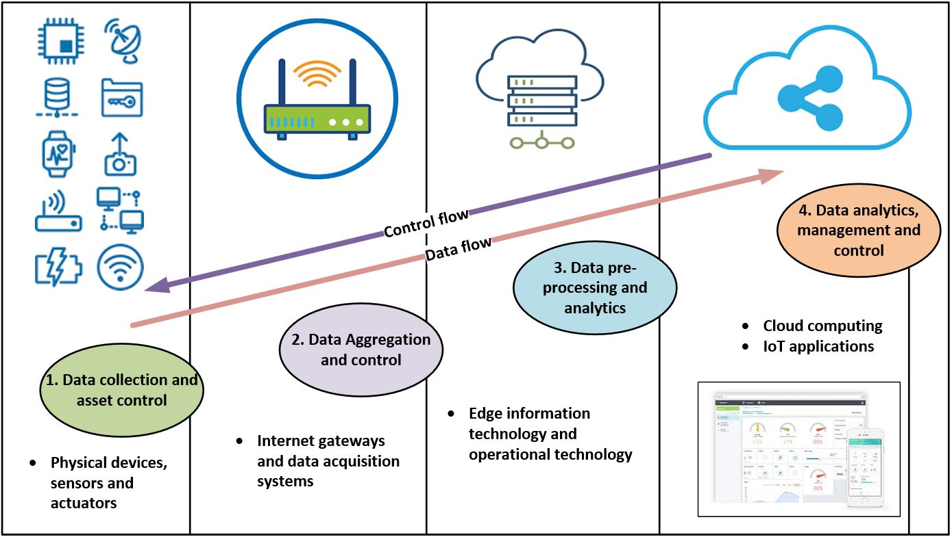
Figure 1: Data flow and control flow in IoT System architecture
A desirable goal in rail asset maintenance is the ability to capture timely information about the condition of assets and assuage the maintenance procedure of or automate the control, repair or replacement of the components of such assets. This goal is in perfect alignment with the core capabilities of IoT system, which can ensure the connectivity to billions of hardware devices such as sensors, actuators and user-tools for rail asset monitoring, management and control [35]. IoT hardware devices are connected through the software infrastructure, which is characterised by three main components viz; the cyber-model, big data analytics and the IoT application [36]. The cyber-model component is described as the virtual representation of the physical assets, while the big data analytics and software application components are responsible converting data to useful information and defining the functionality of the IoT system [37, 38].
There are many existing and potential use cases for IoT implementation in some aspects of rail asset maintenance, however, there is a lack of study, which proffers an implementation strategy for holistic IoT-based system in rail asset maintenance. This constitutes a knowledge gap which this study explores through a qualitative approach to address the problem areas in rail asset maintenance through IoT implementation.

Methodology
This study adopted a qualitative methodology, which is underpinned by the subjectivism [39]. A subjectivist philosophical stance was adopted because the process of rail asset maintenance is mainly driven by people and supported by technology. Hence, it is important consider the implementation of IoT for rail asset maintenance as a socio-technical phenomenon, which can be addressed through a qualitative methodology [40]. Qualitative methodologies rely on techniques such as interviews and focus groups, for collecting subjective data from individuals to understand the various perspectives of a phenomenon [41, 42]. Figure 2 shows the proposed methodological framework for the qualitative inquiry in this study, which involved two focus group workshops, laboratory-based research analysis and follow up meetings, and was used to develop the implementation strategy for IoT in rail asset maintenance. For the purpose of answering RQ-1, the first workshop was held to evaluate some problem areas (see section 2.1) in rail assets maintenance and to prioritize the problem areas according to the importance and interest attached to them by the focus group expert participants. Five focus groups were formed for the first workshop as well as the second workshop, which was held for the purpose of answering RQ-2. The five focus groups each comprised of four individuals with at least one rail asset operator, rail asset maintenance expert and digital technologies expert.
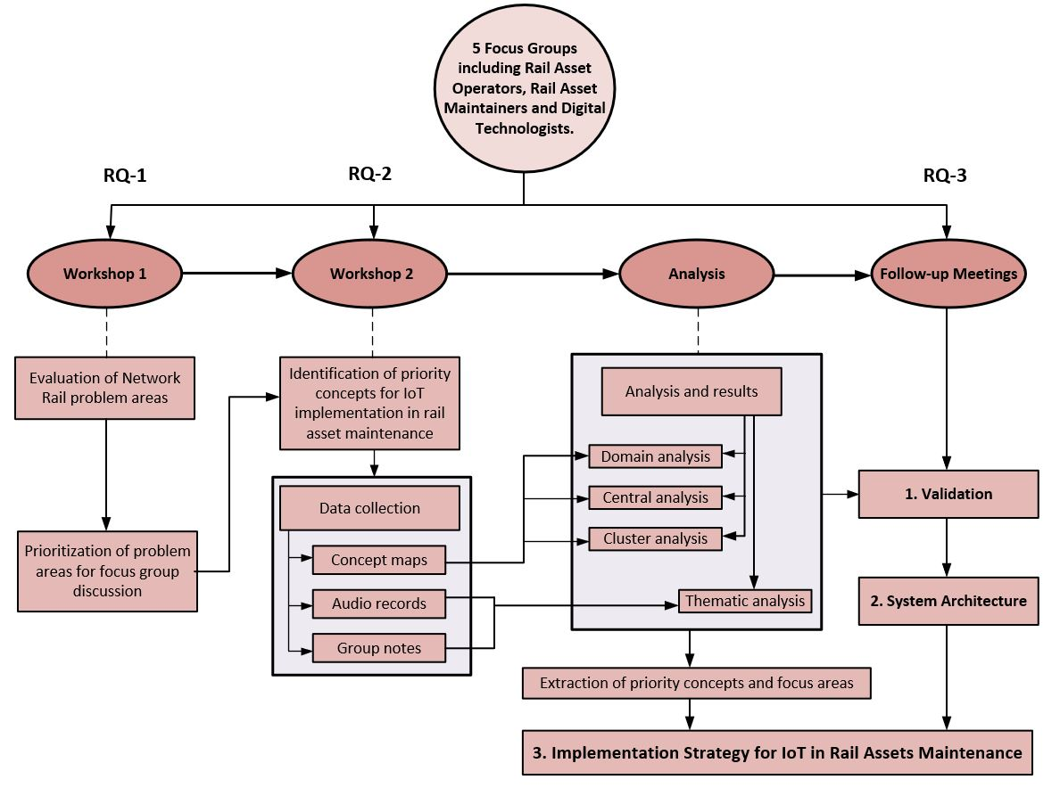
Figure 2: Proposed Methodological Framework of Qualitative Inquiry
The second workshop was used to gather spontaneous ideas and concepts of IoT implementation from the diverse perspectives of the participants. In identifying the priority concepts for IoT implementation in rail asset maintenance, a focus was placed on addressing the immediate problem areas of rail asset maintenance as well as long term benefits of IoT implementation [43]. As highlighted in section 2.1, the nine problem areas, which were selected from a pool of Network Rail’s asset maintenance challenge statements, were further streamlined to five problems areas through a simple voting activity by the participants at the first focus group workshop. RQ-3 was answered through three follow-up meetings, which were held to validate the output of the workshops, formulate an implementation strategy and develop a conceptual system architecture.

Focus Group Design
The focus groups were recruited as part of the stakeholder's engagement process for the project in which this study was conducted. The stakeholders were selected from three main groups, which included: rail asset maintenance experts, rail asset operators and digital technologies developers. Several pre-selection criteria were set to ensure that the focus group participants had the required knowledge for the purpose of this study. The pre-selection criteria included an expertise in any of the stakeholder groups, minimum of three years’ experience, and prior knowledge of rail asset maintenance. Each focus group included at least one participant from each stakeholder group to ensure heterogeneity and convergence of opinions from various perspectives.
The five selected problem areas were used to group the workshop participants into five focus groups. Although the focus group participants had prior knowledge of the rail asset maintenance problems areas, the focus group activities began with the revaluation of the problem areas for new insights and identify potential solutions within the domain of IoT implementation. Other focus group activities include the identification of IoT implementation opportunities, potential barriers and enabling technologies.

Data Collection
This study ensured triangulation in data sources in order to enhance the reliability of the acquired data and validity of the proposed methodological approach. Ensuring triangulation in data sources also transcends to triangulation in analysis and ensures overall methodological robustness in qualitative research. Three main data techniques viz concept mapping, audio recording and note taking were used to capture the technological, physical and socio-economical concepts of IoT implementation in rail assets maintenance. The focus group data were collected and used in line with the research ethics guidelines and General Data Protection Regulation (GDPR).

Concept Mapping
The concepts and links were initially formed by each focus group using multiple coloured sticky notes on wall posters. Five key questions were asked, and the concept link model shown in figure 3 was used to form the links. The five key questions include: (1) what does an ideal maintenance service mean to you; (2) what are the potential solutions to achieve this ideal situation; (3) what are the opportunities for IoT implementation to achieve this solution; (4) what are the potential barriers to implementation; (5) what are the potential enablers of this opportunity. Figure 3 shows the concept mapping model used to form the links between concepts. The conceptual modelling tool was used to execute domain, central and cluster analysis of the concept.
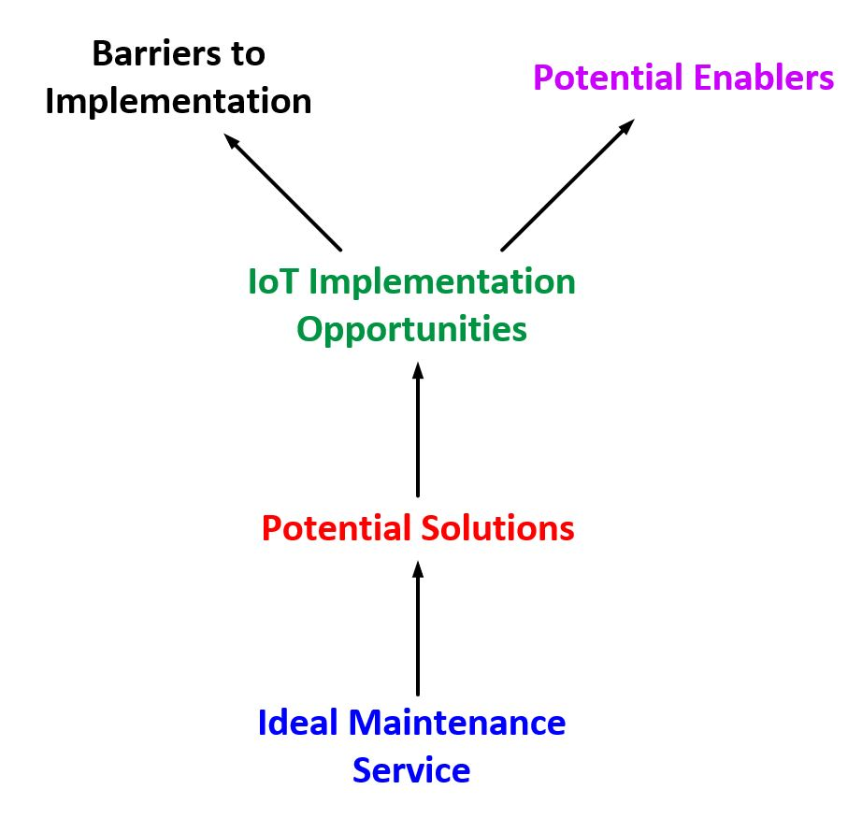
Figure 3: Technique for conceptual modelling of IoT implementation

Results and Analysis
In order to select five problem areas in rail asset maintenance for the focus group discussions, nine problem areas were compared using a simple priority exercise by the focus group participants. Figure 4 shows the five selected problem areas (green). The three problem areas shown in red were not chosen because they had two votes or less, though, item three (lineside asset management), which had 1 vote, was merged with item four because of the similarity in context.
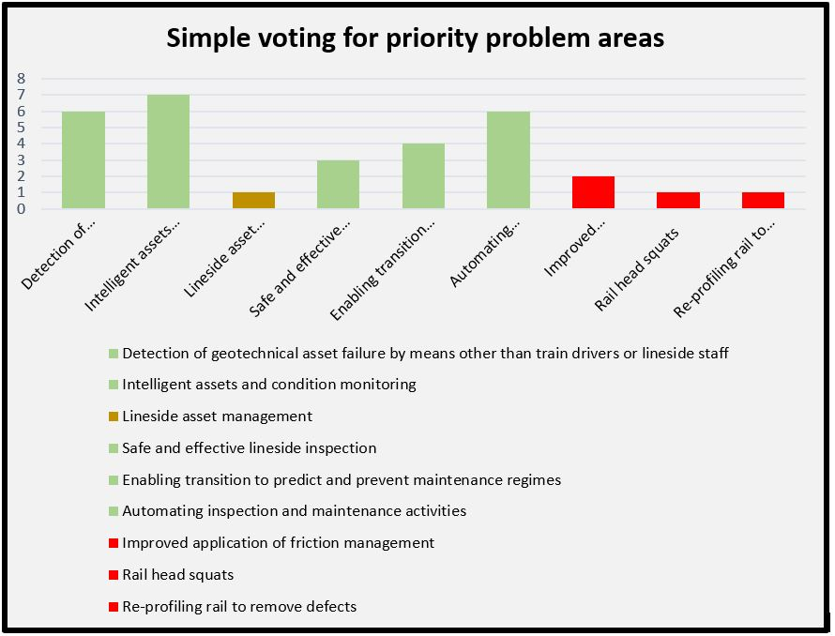
Figure 4: Priority selection of problem areas based on simple voting by participant
In this study, three types of qualitative data including concept maps, audio records, and notes were collected from the focus group workshops. The audio records were transcribed and analysed using Nvivo to identify the emerging themes while the concept maps were developed and analysed using the Banxia decision explorer tool. It includes the opportunities for IoT implementation in rail assets monitoring, the challenges of implementing IoT and the potential solutions to address these challenges.
The distribution of the participants in the five focus groups is shown in Table 2, according to the problem areas addressed at the first focus group. The problem areas and focus groups were retained for the initial sessions second focus group workshop, however, a cross-group rotation was conducted to identify consistencies, clarify and reach consensus about priority concepts of IoT implementation as discussed across the focus groups. The data collected during the focus group activities were analysed and used to formulate the IoT implementation strategy through follow up meetings with the participants.
Table 2: Description of focus problem areas and expertise of participants
FG-ID | Problem areas | Description | No of participants | Expertise of participants (ID)
FG-1 | Detection of Geotechnical Asset Failure by means other than Train drivers or lineside staff | Use of LiDAR scans to assess and monitor changes in geotechnical assets  Cross-disciplinary data usage to monitor cross-level features on embankments. | 4 | - Rail innovation manager (P1A)  - Associate professor in big data analytics and AI (P1B)  - Research associate in IoT for Rail assets management (P1C)  - Rail systems and technology engineer (P1D)
FG-2 | Intelligent Assets and Condition Monitoring | Improve asset management process and train service timetable reliability  Reduce the number of train delays/cancellation and reduce maintenance cost | 4 | - Head of IoT and data services (P2A)  - Business development lead (P2B)  - Associate professor in Big data application development (P2C)  - Research associate in immersive technologies and Big Data application development (P2D)
FG-3 | Safe and effective lineside inspection | New data sources for safe and effective inspection methods | 4 | - Head of rail assurance (P3A)  - Innovation manager (P3B)  - Associate professor in Machine learning (P3C)  - Engineering Manager (P3D)
FG-4 | Automating inspection and maintenance activities to remove the workforce from high-risk areas and improved data capture | Integration of disparate data sources and additional insights on existing data for remote condition monitoring and predictive maintenance | 4 | - Strategic development manager (P4A)  - Sustainable engineer manager (P4B)  - Head of rail engineering (P4C)  - Associate professor in Big data and artificial intelligence (P4D)  - Solutions Architect (P4E)
FG-5 | Enabling transition to predict and prevent maintenance regimes | Improved safety of inspecting high-risk areas  Develop technologies to automate and mechanise inspection processes.  Improved data collection and analytics. | 4 | - Engineering Manager (P5A)  - Research Associate in Artificial Intelligence for Construction (P5B)  - Graduate civil engineer (P5C)  - Senior carbon manager (P5D)

Conceptual Modelling
Conceptual modelling is an important means of strategy formulation between information systems analysts and end users [44]. Typically, concept maps consist of nodes and links, which signifies the concepts and the relationships between them respectively [45]. Concept mapping is a technique for strategy formulation in information systems development [46]. Emerging from the personal construct theory, concept mapping is used to conceptualise and visualise people’s perceptions and views pertaining to the research questions [47]. Specifically, for focus group data acquisition, cognitive mapping promotes a common understanding of the effect of individual ideas on the research questions, re-examine and make new connections between concepts through consensus activities [48].
The concept modelling was executed in Banxia decision explorer tool, which allows the mapping of concept data generated by the various focus groups in a comprehensive model. Figure 5 shows the comprehensive conceptual model developed from the focus group workshops. A total of 151 concepts including the ideal situations, potential solutions, implementation opportunities, potential barriers, and enablers were developed in the model. The model shows how the concepts emerged through the technique described in Figure 4. The conceptual modelling tool was used to execute domain, central and cluster analysis of the concept.

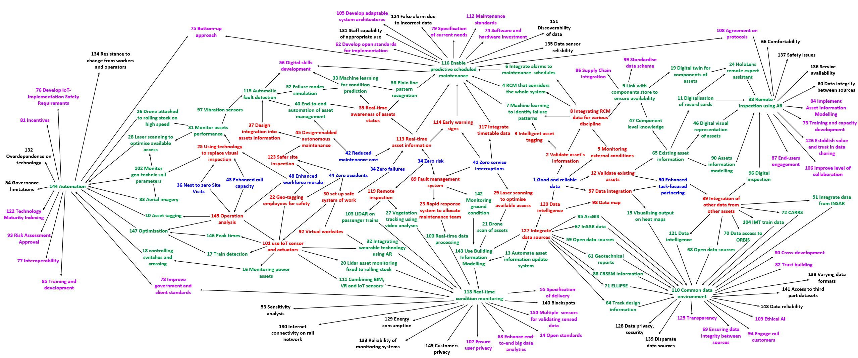
Figure 5: Comprehensive Conceptual Model (A Total Number of 151 Concepts)

Domain Analysis
Domain analysis is used to examine the importance of concepts based on the number of other concepts with a direct link to a particular concept and returns the concepts with the highest number of links [47. The domain analysis for the comprehensive concept map was executed using the analysis functionality in the Banxia decision explorer tool. A list of the top twenty priority concepts to the implementation of IoT in rail asset maintenance as well as the domain scores are presented in Table 3 according to the domain analysis.
Table 3: Top 20 Priority Concepts according to Domain Analysis
No. | Top 20 Priority Concepts according to Domain Analysis | Domain score
1 | 110 Creating a common data environment across the rail industry *** | 27 links
2 | 116 Enable predictive assets maintenance through machine learning *** | 19 links
3 | 118 Real-time condition monitoring using IoT sensors *** | 19 links
4 | 144 Automation of assets control and maintenance using robotic-IoT *** | 18 links
5 | 38 Remote inspection using IoT- wearable augmented reality *** | 15 links
6 | 9 Link maintenance data with components store | 5 links
7 | 65 Digitalize and integrate existing asset information *** | 5 links
8 | 115 Automatic fault detection using IoT sensors | 5 links
9 | 143 Adopt of Building Information Modelling *** | 5 links
10 | 31 Machine learning for condition prediction | 4 links
11 | 33 Monitor assets performance using embedded IoT sensors | 4 links
12 | 102 Monitor geotechnical soil parameters using IoT devices | 4 links
13 | 147 Optimization of service operations using IoT systems *** | 4 links
14 | 7 Identifying failure patterns through machine learning *** | 3 links
15 | 46 Digitalization of record cards | 3 links
16 | 24 Remote expert assistant using HoloLens AR | 3 links
17 | 28 Laser scanning to optimize available access | 3 links
18 | 40 End-to-end automation of asset management | 3 links
19 | 46 Digital visual representation of assets | 3 links
20 | 58 Plain line pattern recognition | 3 links
(Note: Asterisk shows Concepts that are common in both domain and central analysis)
In order to ensure the validity of this analytical approach, another approach known as the central analysis is conducted. The concepts shown in bold with asterisks are common to both the domain and central analysis, these concepts are considered a core priority for this study.

Central Analysis
In contrast to the domain analysis, which is used to examine the priority of concepts based on the number of direct links to other concepts, the central analysis is used to examine a deeper level of the importance of concepts by considering the importance of the successive layers of linked concept [47]. Table 4 shows the top 20 priority concepts according to the central analysis and reveals a 45% agreement with the domain analysis with the core priority concepts, which occurred in both domain and central analysis, shown in bold and asterisked.
Table 4: Top 20 central concepts from the conceptual model
No. | Top 20 priority areas for IoT implementation in rail service | Central score
1 | 116 Enable predictive assets maintenance through machine learning *** | 38 from 73 concepts
2 | 144 Automation of rail assets inspection and maintenance *** | 35 from 67 concepts
3 | 118 Real-time condition monitoring using IoT sensors *** | 34 from 62 concepts
4 | 110 Creating a common data environment across the rail industry *** | 31 from 39 concepts
5 | 38 Remote inspection using IoT- wearable augmented reality *** | 26 from 47 concepts
6 | 143 Adopt of Building Information Modelling *** | 22 from 44 concepts
7 | 32 Integrate wearable technology with augmented reality | 20 from 42 concepts
8 | 111 Combining BIM, VR and IoT sensors | 19 from 42 concepts
9 | 20 Fixing LiDAR assets monitor to rolling stock | 19 from 42 concepts
10 | 121 Improve data intelligence through IoT applications | 18 from 39 concepts
11 | 104 Integrate train embedded manufactured sensors into IoT system | 18 from 39 concepts
12 | 95 Integrate maintenance team data management system | 18 from 37 concepts
13 | 68 Use more open data sources | 18 from 39 concepts
14 | 67 Collect more data using interferometric synthetic aperture radar | 18 from 37 concepts
15 | 64 Integrate rail track design information | 18 from 37 concepts
16 | 61 Digitalize and integrate geotechnical reports | 18 from 37 concepts
17 | 147 Optimization of service operations using IoT systems *** | 17 from 37 concepts
18 | 65 Digitalize and integrate existing asset information *** | 17 from 37 concepts
19 | 7 Identifying failure patterns through machine learning *** | 17 from 38 concepts
20 | 6 Integrate alarms to maintenance schedules | 17 from 38 concepts
Aside from revealing 9 core priority concepts, the central analysis also placed 5 of 9 core priority concepts as the topmost core priority concepts in 100% agreement with the domain analysis, however, the order of priority of the topmost 5 core priority concepts varies between both analyses as shown in Table 3 and 4. The final analysis conducted on the conceptual model is cluster analysis.

Cluster Analysis
Cluster analysis is a technique for classifying concepts with the same or similar focus [49]. The concepts classified into focus areas based on the similarity in context and the connections drawn from the concept map [50]. Using the cluster technique, five major focus areas, which were consistent with the topmost core priority concepts from the domain and central analysis, were identified in the cluster analysis. The five focus areas thus identified include: (1) enabling predictive maintenance; (2) developing a common data environment (3) enabling remote access and inspection of assets (4) enabling real-time assets condition monitoring (5) automation of maintenance activities. Figure 7 and 8 show cluster 1 and cluster 2 respectively.
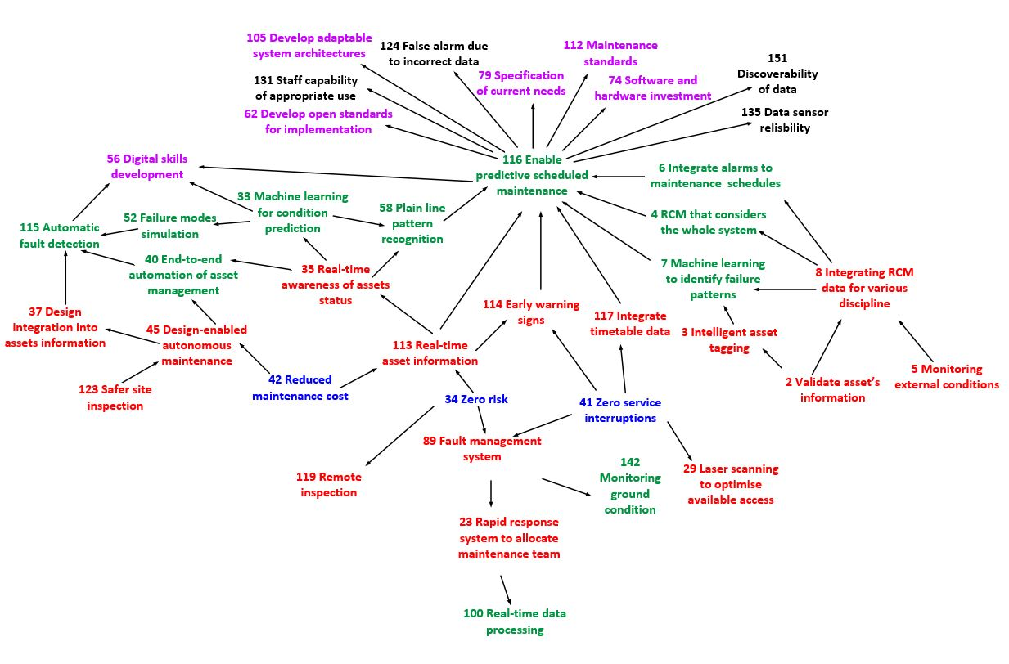

Figure 6: Cluster 1 (Enabling predictive scheduled maintenance)
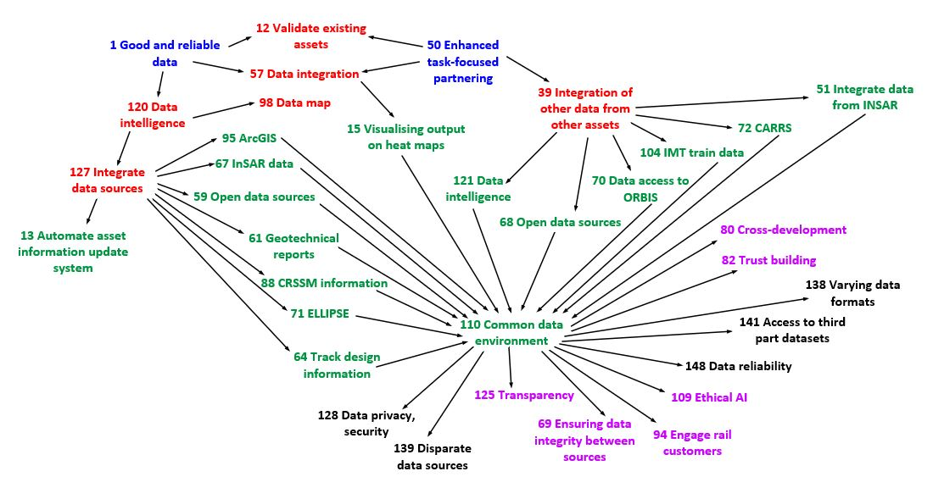

Figure 7: Cluster 2 (Developing a common data environment)

Thematic Analysis
A thematic analysis was conducted to consolidate the result obtained from the analysis of the conceptual model, gain further understanding of the context of the identified concepts and ensure the validity of the proposed qualitative approach. The audio data acquired from the focus group workshop was transcribed using NVivo 12 Software. Due to the availability of the existing five focus areas, no attempt was made to formulate new or additional themes, however, the validity of the existing focus areas was tested by attempting to find additional concepts in the transcripts which do not have any relevance to the five focus areas. No additional concept was found to be uncaptured or irrelevant to the focus areas and as a result, the conceptual model was deemed suitable as a reliable qualitative approach.
Subsequently, the transcripts were used to trace the focus groups were the concepts emerged or occurred and to consolidate the context of the concepts in developing the implementation strategy. Table 5 shows the consolidated list of concepts as well as the focus groups where the concepts came up. The following section presents the proposed implementation strategy for IoT in the UK railway industry for asset maintenance.
Table 5: Priority Concepts and Focus Areas for IoT Implementation in Rail Asset Maintenance
Themes |  | Focus Groups
 |  | 1 | 2 | 3 | 4 | 5
Enable predictive scheduled maintenance
1 | Integrate alarms to maintenance schedules
2 | Develop machine learning algorithms to identify assets failure patterns
3 | Use machine learning to predict potential assets condition |  | - V
4 | Consider an integrated whole system for predictive condition monitoring
5 | Integrate real-time sensor data for early warning signs in assets failure
6 | Plain line pattern recognition
7 | Simulation of failure modes
Develop Common Data Environment (CDE) across the rail industry
8 | Integrate assets design information into CDE
9 | Integrate train design information and train embedded sensors data into CDE
10 | Integrate data from interferometric synthetic aperture radar
11 | Integrate maintenance staff communication and information system into CDE
12 | Visualise heat maps of maintenance tasks with responsible resources in CDE
13 | Connect to open data sources for improved information system
14 | Integrate geotechnical reports into CDE
15 | Integrate Geographic Information System (GIS) data into CDE
Remote access and inspection of assets
16 | Digital visualisation of data from hardware sensors and monitors from a remote location
17 | Assets information modelling
18 | Digital inspection of assets
19 | Digitalise maintenance record cards
20 | Implementation of assets digital twin using real-time condition modelling
21 | Enable remote expert assistant using augmented reality
22 | Component level digital collaboration with components manufacturer or suppliers
Real-time assets condition monitoring
23 | Use Building Information Modelling (BIM) for real-time condition monitoring
24 | Automate asset information update system
25 | Attach LiDAR scanners on passenger trains for continuous data acquisition
26 | Integrate wearable technologies with IoT sensors and augmented reality devices
27 | Develop real-time data analytics software
28 | Vegetation tracking using video analyses
29 | Train detection and real-time assets control
30 | Combining BIM, Virtual Reality (VR) and IoT sensors for real-time asset visualisation
Automation of maintenance activities
31 | Install vibration sensors for automatic train detection
32 | Automatic drone scan of flagged assets
33 | Automatic fault detection through sensors
34 | Asset tagging using QR code/RFID for automatic identification
35 | End-to-end automation of asset management
36 | Laser scanning to optimise available access
37 | Automate real-time data analytics and simulation

The Proposed Implementation Strategy for the Internet of Things in Rail Asset Maintenance
The focus group discussion involved participants from Network Rail. Network Rail owns and operates Britain’s main rail network, and as part of its Strategic Business Plan for Control Period 6 (i.e. 2019 to 2024), network rail plans to enable intelligent infrastructure through predictive maintenance. The essence of this study is to formulate an implementation strategy for Internet of things (IoT) towards enabling the intelligent infrastructure goal. This study mainly focused on developing a long-term strategy through the engagement of the rail industry experts.
Following the data analyses, three follow up meetings were held. The first meeting was held with the purpose of validating the output of focus group data analyses. The core priority areas, which were identified from the analyses of the focus group data were validated by 5 rail asset operation experts. The second follow-up meeting involved 8 participants including 4 digital technologies innovators and 4 rail asset maintenance innovators. The meeting participants conducted a brainstorming session to link the core priority areas together as a system with enabling digital technologies. The third follow-up meeting involved the formulation of an implementation strategy by 6 participants, who were also involved in the data analyses phase of this study. The transcripts of the focus group discussions were extracted to propose an implementation strategy through the inclusion of enabling digital technologies. Figure 8 shows the implementation strategy for IoT rail asset maintenance.
The five focus areas of this proposed implementation strategy include: (i) enabling predictive maintenance; (ii) developing a common data environment; (iii) enabling remote access and maintenance of assets; (iv) enabling real-time assets condition monitoring, and (v) automating of maintenance activities. The scope of this current paper is limited to the proposition of the implementation; however, further research is currently underway for developing the system architecture and working prototype for an IoT-based system for rail asset maintenance.
The following digital technologies, which are explained with relation to the focus areas of the proposed strategy in the subsequent sections, emerged as enabling technologies of the IoT implementation strategy for rail asset maintenance: (a) artificial intelligence; (b) augmented reality (c) edge, fog and cloud computing (d) robotics, and; Asset Information Modelling (AIM). Evidently, the implementation of an integrated IoT-based system along with the listed enabling technologies in the UK railway industry requires careful investment choices massive hardware, software, and networking infrastructure.
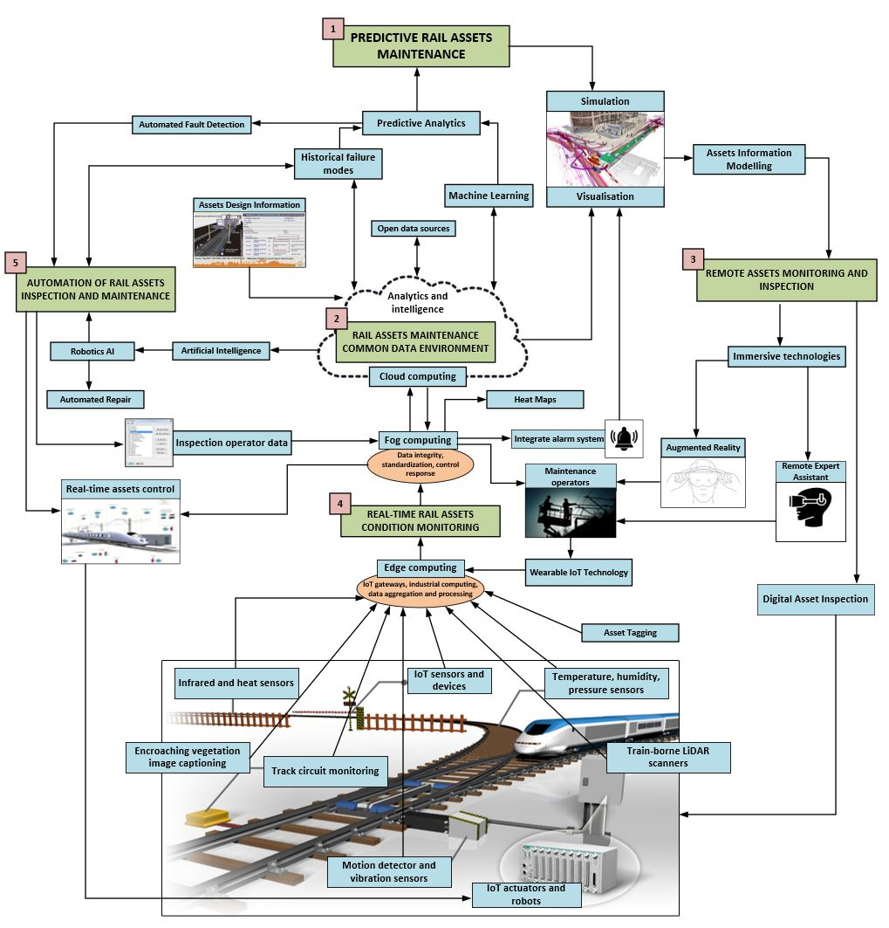
Figure 8: Implementation Strategy for IoT in Rail Assets Maintenance
Apart from the hardware IoT sensors and actuators, which have edge computing capabilities required for interfacing with rail assets for activities such as track circuit monitoring and encroaching vegetation image captioning, there are also hardware requirements for IoT gateway and storage devices to enable fog and cloud computing as well as for robotics and immersive technologies. Despite the complexities associated with the components of the implementation strategy being proposed in this study, a principled approach has been taken in this study to connect the major exploitable outputs in the proposed strategy.
The following subsection contains the discussion of the focus areas of the proposed implementation strategy in relation to the priority concepts and the enabling digital technologies.

Enabling Predictive Maintenance using IoT and Rail Asset Failure Modes
Enabling predictive maintenance of rail assets through IoT sensors and rail assets historical failure modes was the most important concept from the central analysis with 38 from 73 concepts, which makes predictive maintenance a central opportunity for the implementation of IoT in rail assets maintenance. The focus group experts identified the opportunity to revolutionise the current maintenance approach such as ‘find and fix’ to a more proactive approach such as ‘predict and prevent’ (Network Rail, 2019). Based on the availability of historical data of rail assets failure modes, it is advantageous to identify approaches that will enhance automatic detection of potential failures using a combined application of machine learning techniques and data from IoT sensors.
An expert in IoT and data services in FG-2 buttressed on the importance of digitising and exploiting existing voluminous data of rail assets failure to enabling predictive maintenance. This argument also emerged from FG-3, where a rail innovation manager argued that; “it is important to integrate the full history of rail failure data such as Fault Management System FMS-2000 and study the failure modes to examine the capabilities of IoT sensors to pick up such failures, and what IoT system requirement is needed for monitoring such failure patterns”. This means that the tendency of an asset to fail in the future can be inferred when the same variables. Historical failure data will enhance the development of IoT hardware sensors that have the capabilities to measure various parameters and compare with existing datasets to spot slight differences in the conditions of rail assets. A researcher in artificial intelligence in FG-5 added that the development of advanced machine learning techniques such as deep learning can facilitate predictive maintenance. This means that the implementation of IoT will not only automate the acquisition of data from rail physical assets but also enhance the applicability of such data to flag slight variations between datasets and identify early warning signs.
Many participants argued that predictive maintenance exists in the rail industry. For example, the Network Rail’s New Measurement Train (NMT) has the capability to identify the early warning signs in track faults such as track twist, cyclic top, and problem with gauges. The NMT can travel up to a speed of 125mph and capture about 10TB of data every 440 miles (Network Rail, 2017). The NMT enables Plain Line Pattern Recognition (PLPR), which uses image analysis to identify faults on tracks through laser sensors and cameras. Participants granted that innovations such as PLPR are important in enabling predictive maintenance in rail, however, a participant in FG-1 noted that such innovations should not be discipline-based, he stated “the application of PLPR can be extended for monitoring geotechnical assets because some track faults result from changes in geotechnical conditions...ground conditions can be monitored by integrating datasets such scanned images and soil parameters to flag potential geotechnical assets failures”. This makes a case for adopting the IoT implementation approach, which promotes data decentralisation and enables integrated predictive maintenance of the entire rail system. Participants agreed that the implementation of IoT in rail assets maintenance requires a holistic approach to ensure that the rail industry maximises all forms of acquired IoT data for an industry-wide application for predictive rail assets maintenance.

Developing Common Data Environment for Rail Assets Management
Many experts from all focus groups especially FG-2 opined that the development of a rail assets maintenance Common Data Environment (CDE), which came first with 27 links in the domain analysis, is an important opportunity for IoT implementation. The CDE, participants argued, will enable the holistic approach required for IoT-based rail assets maintenance and offer a smooth transition from the current discipline-based data silos system. An engineering manager in FG-5 opined that “the collection of data by various disciplines across the rail industry is currently not optimal… some disciplines collect and keep data for their own use although such data have relevance to other disciplines and can improve the overall rail maintenance system”
For example, the methods of collecting and storing asset design information and maintenance track record have changed over the years and many records have been lost or currently exists with the disparaged application. Typically, in executing predictive maintenance through condition monitoring and machine learning, it is important to use sufficient and necessary amount of data for decision making by various disciplines in the rail industry [15]. A research associate in big data application development in FG-2 added that the integration of datasets across the various disciplines and assets in the rail industry would be a beneficial opportunity for IoT implementation. As a means to ensure data quality, integrity and cross-disciplinary harmonized data usage, IoT applications for rail asset maintenance should integrate various datasets such as train design information, train embedded sensors data and interferometric synthetic aperture radar data. A participant in FG-4 also noted that it is important to integrate maintenance staff communication and information system into CDE to ensure that relevant data and visualization can be quickly referenced and maintenance information can be tracked in real-time. He further stated that “the CDE can facilitate optimal maintenance resource allocation and efficient visualization of maintenance heat maps through real-time data, open data sources and responsible resources” FG-4.
Evidence from the literature suggests that System Information Modelling (SIM) for rail assets maintenance requires the digitization of rail infrastructure [51]. This means that the CDE requires adequate data flow into and out of the system for adequate representation of the rail assets condition and appropriate usage of big data for assets maintenance. A participant in FG-3 asserted that the integration of service timetable will be beneficial for optimization of maintenance access by monitoring assets usage trends.
Having identified some benefits of implementing CDE for IoT-based rail assets maintenance, the focus group participants discussed the available and potential data sources that could enhance IoT-based rail assets maintenance. Participants contributed from various perspectives that, while ensuring data integrity, all relevant datasets for rail assets maintenance such as geotechnical reports, assets design information, satellite images, data from sensors, maintenance management data, timetables, components availability data and maintenance resources should be integrated into the CDE. As opposed to the data silos system of discipline-based data collection and usage, the CDE will enhance data standardization and optimal usage across board in the rail industry.

Ensuring Remote Monitoring of High-Risk Areas of Rail Assets
The concept of enabling remote inspection of high-risk areas of rail assets consistently came fifth in both domain (15 links) and central analyses (26 from 47 concepts). With a genuine concern for the safety of rail assets operatives working in high-risk areas, some experts mentioned the importance of developing digital technologies such as AI, AR, and Robotics for conducting rail assets inspection and maintenance where possible. While buttressing the point of a rail solutions architect in FG4, who opined that digital technology cannot fully replace rail assets inspectors and human intervention can sometimes be necessary, however he agreed that “although these technologies are important, they should be designed to support rail worker’s operations rather than replace the workers” FG4.
In the opinion of an expert in FG-4, an important aspect of remote inspection is Assets Information Modelling (AIM), which enables the digital representation of physical assets in the virtual digital environment for seamless access to assets information. IoT is required in combination with AIM to create a technology known as “digital twin”, which enables a simultaneous replica of physical assets through seamless data collection through physical devices such as drones and IoT sensors for automatically updating the AIM. An engineering manager in FG-5 added that “digital twin for rail assets requires the validation and modelling of existing rail assets and common data environment to enhance IoT data sources”. A digital twin requires physical agents such as IoT sensors, drones, and robots to collect information from the physical assets and automatically update the virtual replica of the rail assets.
Experts discussed the importance of IoT sensors, cameras, LiDAR scanners, drones, AR and VR hardware to act as agents for interfacing between an asset’s physical environment and the digital twin of such asset to enhance bidirectional data flow for remote inspection. A research associate in artificial intelligence affirmed the possibility of “identifying anomalies in physical assets using advanced AI techniques such as machine learning, image recognition and computer vision” FG-5. Another idea noted from FG-2 captured the “integration of GIS, InSAR, weather and train-mounted sensors rail assets virtual models to monitor earth movement and environmental effects on the assets”. An expert in FG-3 also highlighted the possibility of using AR hardware devices like IoT sensors for real-time data acquisition. This can be used for “digitalizing maintenance record cards” FG-1, and “remote digital inspection” FG-2, FG-3, FG-4. Another opportunity notable for IoT in rail assets maintenance is the “support and supervision of onsite maintenance activities by remote expert” FG-2. With the current rate of development in Augmented Reality (AR) technology and its application in other industries, experts discussed the possibility using AR to provide an immersive environment for rail assets maintenance experts to access and assess maintenance activities remotely. The key point here is to enable AR and IoT-based connectivity between onsite rail assets maintenance operatives and remote experts or supervisors in such a way that will integrate the visualisation of the real physical environment, virtual holographic models and real-time data from IoT sensors.

Facilitate Real-time Rail Asset Information System
Having a real-time rail assets condition information system was the third most important opportunity in both the domain (19 links) and central analysis (34 from 62 concepts). Aside from having the capability to integrate data of various sources and formats in a common data environment, another opportunity identified by the experts for IoT adoption in rail assets maintenance is the possibility of integrating real-time data analytics in IoT application for easy conversion of raw sensor data to useful information. From the perspective of an expert in FG-4, “automating data analytics and asset information update system is important for real-time assets condition monitoring”, this, in essence, means that there is an opportunity to leverage on the real-time data analytics capabilities of IoT applications to create assets intelligence through “alarm systems” FG-2, “just-in-time notification” FG-4 and enable the deployment of onsite maintenance operatives for “quick intervention” FG-2 as and as at when required. An associate professor in AI and machine learning opined that “to develop real-time data analytics system for a massive infrastructure with a vast amount of data can be tedious but not impossible…we just have to start from developing adaptable prototypes” FG-4.
A similar concept to digital twin surfaced from discussions in FG-4, where a solution architect mentioned the use of “Building Information Modelling with IoT sensors for real-time condition visualization”. The idea of using Building Information Modelling (BIM) in combination with Virtual Reality (VR) and IoT for real-time visualization of holographic models of rail assets was also noted in FG-2. However, the research associate in immersive technologies further highlights a major challenge that “BIM modeling tools are not currently synchronized with VR tools… some manual conversations are still needed for visualizing BIM models in VR formats” FG-2. It can be inferred from the foregoing that the development of enabling technologies that bridges the gaps between Computer-Aided-Design (CAD) models and immersive models, as well and between models and IoT real-time data would enhance the adaptability of IoT rail assets maintenance.
An associate professor with expert knowledge of machine learning also debated that, “to integrate wearable IoT sensors and augmented reality devices can be used to validate the assets or the virtual model of the assets using machine learning” FG-3. He further argued that the Convolutional Neural Network (CNN) is particularly useful for image recognition and can be used to measure variance between the conditions of assets. Another suggestion of visual data gathering from FG-2 entails “the use of LiDAR scanners attached to a passenger train to monitor any slight displacement of an asset from its original position”, however, the idea was questioned based on the ability of LiDAR scanners to record accurate data when attached to fast-moving trains with vibrations caused by the train movement and speed. An innovation manager in FG-3 stated that “interesting research would be to investigate the possibility of enhancing train-borne LiDAR scanner data using motion and vibration sensors”. The use of a train-borne LiDAR scanner can be used for tracking encroaching vegetation, displaced assets such as track and tunnels and so on.

Automation of Rail Assets Maintenance
The concept of automating rail assets maintenance activities is the second most important opportunity according to the central analysis conducted in this study with 35 from 67 concepts. The concept also came fourth in the domain analysis with 18 links. Despite the potential benefits of reducing the number of workers exposed to high-risk areas through remote assets inspection, experts further discussed the importance of enabling automated maintenance activities to optimize access for train service operations. With the idea of “automating real-time data analytics and simulation” FG-5 already existing in the debate, the argument of “establishing end-to-end automation of asset maintenance” using the actuating capability of IoT systems and robotic was established. Some experts in FG-3 and FG-4 discussed the significance of “assets tagging such as QR codes or RFID for automatic identification” such assets by digital systems.
As presented in figure 9, the idea of using machine learning in combination with rail assets historical failure modes, which was proposed to be situated in an integrated cloud-based CDE, was questioned based on the capability of the cloud system to create alert systems in good amount of response time if the maintenance activity can be quickly done by an onsite robot or an asset repair-enabled train. In response to this, a researcher in AI for construction posited that “IoT devices can have automatic fault detection ability for the assets by using edge or fog computing”. This will enable the rail assets management system maximize the benefits for CDE-based failure modes learning as well as the rule-based deployment of automatic maintenance and control systems such as “automatic drone scan of flagged assets” and initiation of emergency protocol due to “automatic fault detection” by localized IoT-systems with fog computing capability as well as capability to push data to the cloud.
Summarily, the development of robotic systems for automatic maintenance activities was classified as a desirable future that can be enabled through the holistic implementation of IoT in rail assets maintenance.

Implication for practice
As this paper is a part of ongoing research for implementing an IoT-based system for rail asset maintenance, it is important to clearly understand the potential practical implications of the study. In this paper, a rigorous qualitative approach has been taken to propose an implementation strategy for an IoT-based system in rail asset maintenance, with clear exploitable integration of other relevant digital technologies. The implementation strategy proposed in this paper is set to enable predictive maintenance, data integration, remote inspection, real-time condition monitoring and automation of maintenance operations. With further development of the proposed strategy, there are vast opportunities for the UK railway industry to transform its approach to rail asset maintenance, ensure cost-effectiveness, operational efficiency and safety. Understandably, the implementation of the IoT-based system that is proposed in this study requires circumspect decision-making, however, this paper has outlined and clearly justified the need for the five major components of the proposed system. Using these five components, this paper is expected to guide the investment for gradual and extensible implementation of the system. Some prototypes of the entire proposed system can be developed and carefully introduced to ensure the safety of implementing technological innovation.
It should be noted that many of the problems being currently witnessed in rail asset maintenance stem from the lack or ineffective methods of information acquisition about the current and possible future conditions of rail asset. By implementing the system proposed in this study, rail asset managers will ensure the smooth operation of rail asset by providing adequate digital support for maintenance operatives, who require early warning signs of potential asset damage to optimise maintenance schedule and ensure zero or minimal service interruption. Furthermore, while carrying out maintenance activities, the proposed system is capable of facilitating expert digital support, retrieve asset information and digitise maintenance records. If implemented, the proposed system will also remove the rail asset operatives from danger zones using remote inspection techniques and advancing the development of supervised robots and autonomous repair agents for activities in such zones.
The technology of the proposed system is set to revolutionise the approach the maintenance, although, there are concerns that the proposed system could replace a significant number of jobs and consequently result in risky over-dependence on technology. Furthermore, there are still ethical issues with the implementation of digital and artificial systems, which cannot be responsible for any misleading or wrong actions or decisions. These potential barriers to implementation are important considerations in the proposed strategy, which has been formulated using a bottom-up approach. Rail assets operators have been engaged in this study to ensure that only the technologies that will enhance the efficiency and accuracy of operations are included in the strategy. Though high-level automation will be achieved if the proposed strategy is accomplished, the human supervisory role has been integrated into the proposed strategy to ensure the safety of adoption, avoid ethical repercussion and deliver an efficient system for rail asset maintenance.

Conclusion
The rail industry plays an important role in sustainable economic growth through the distribution of goods and long-distance transportation of people. The UK economy will benefit from £85 billion economic growth through private and public investments in the rail industry [52]. Improvements in rail service performance will continue to increase economic activities, contribute to economic growth and further extend the demands for rail services [26]. With a forecast of 40% increase in rail service users by 2040, the challenges of rail assets management in meeting the growing demands and ensuring efficient, reliable and safe services, will continue to increase [27]. Therefore, to enhance the ‘value for money’ for rail service customers, digital innovations, including IoT can be leveraged to manage rail assets with a focus on safety, reliability and, efficiency.
For the purpose of answering the research questions, this study adopted a qualitative methodology through focus group engagements and conceptual modelling. To address RQ-1 “what are the problem areas in rail asset maintenance?”, the problem areas in rail asset maintenance were identified and classified through a review of network rails challenge statements and an initial priority voting. The priority voting was used to select the problem areas, which formed the basis of the focus group discussions. The second research question (RQ-2) “what are the priority problem areas for IoT implementation?”, was addressed through robust analyses of the concepts, which were generated through the focus group discussions and conceptual mapping. Domain, central, clusters, and thematic analysis were conducted to identify the priority concepts and focus areas for the implementation strategy. Five focus areas were identified including predictive maintenance, remote inspection, real-time condition monitoring, maintenance automation, and data integration. The third research question (RQ-3) “how can IoT be implemented for rail asset maintenance?”, was addressed through the development of a system architecture and formulation of an IoT implementation strategy. A major contribution of the research is the establishment of practicable relationships between the problem areas in rail asset maintenance and the capabilities of digital technologies in an IoT-based system. This study identifies the exploitable focus areas as well as the important enabling digital technologies for IoT implementation in rail asset maintenance.
IoT-based digital rail asset management facilitates the efficient acquisition and optimal usage of information for sustainable assets operation [51]. To continuously ensure the safety of rail service customers and workforce, it is important to leverage digital means of understanding the conditions of rail assets, monitoring degradation and digitising failure patterns to enable predictive maintenance. Monitoring rail assets through safe and remote means also ensures reliable rail service by preventing unplanned assets maintenance and service interruptions. Hence, it is important to leverage on digital innovations for rail asset monitoring to enable optimised performance by learning from past and present efficiency trends to seamlessly deliver the ideal future for rail infrastructure, minimize rail asset failure, service interruption and enhance reliability index.

Acknowledgment
This work has been funded by the Department for Transport (DfT) fund through the Innovate UK. Project number 104242.

Reference
S/N | Reference List
[1] | Network Rail, A better railway for a better Britain: strategic business plan 2019 to 2024, (2016), Retrieved on August 27, 2020 from https://www.networkrail.co.uk/wp-content/uploads/2018/02/Strategic-business-plan-high-level-summary.pdf
[2] | Department for Transport, Reforming our railways: putting the customers first. Presented to Parliament by the Secretary of State for Transport, by Command of Her Majesty. The Stationery Office Limited, UK. (2012), Retrieved on August 27, 2020 from https://assets.publishing.service.gov.uk/government/uploads/system/uploads/attachment_data/file/4216/reforming-our-railways.pdf
[3] | Office of Rail Regulation, Opportunities and challenges for the railway: ORR’s long-term regulatory statement. (2013), Retrieved on August 27, 2020 from https://orr.gov.uk/__data/assets/pdf_file/0008/2321/long-term-regulatory-statement.pdf
[4] | A.H. Tsang, Strategic dimensions of maintenance management. Journal of Quality in Maintenance Engineering, 8 (1) (2002), pp.7-39. https://doi.org/10.1108/13552510210420577
[5] | F.P.G. Marquez, R.W. Lewis, A.M. Tobias, C. Roberts, Life cycle costs for railway condition monitoring. Transportation Research Part E: Logistics and Transportation Review, 44 (6) (2008), pp. 1175-1187. https://doi.org/10.1016/j.tre.2007.12.003
[6] | B. Zimolong, G. Elke, Occupational health and safety management. Handbook of Human Factors and Ergonomics, (2006) pp. 673-707. https://psycnet.apa.org/doi/10.1002/0470048204.ch26
[7] | F. Xia, L.T. Yang, L. Wang, A. Vinel, Internet of things. International Journal of Communication Systems, 25 (9) (2012), p.1101. https://doi.org/10.1002/dac.2417
[8] | Q. Jing, A.V. Vasilakos, J. Wan, J. Lu, D. Qiu, Security of the internet of things: perspectives and challenges. Wireless Networks, 20 (8) (2014), pp.2481-2501. https://doi.org/10.1007/s11276-014-0761-7
[9] | A. Thaduri, D. Galar, U. Kumar, Railway assets: a potential domain for big data analytics. Procedia Computer Science, 53 (2015), pp. 457-467. https://doi.org/10.1016/j.procs.2015.07.323
[10] | J.J.V. Antony, G.M. Nasira, Towards predictive maintenance and management in rail sector: a clustering approach. In 2013 International Conference on Recent Trends in Information Technology (ICRTIT) (2013) pp. 502-507). IEEE. ISBN: 978-1-4799-1024-3
[11] | T. Tang, Z. Deng, S. Zhou, L. Lei, H. Zou, Fast vehicle detection in UAV images. In 2017 International Workshop on Remote Sensing with Intelligent Processing (RSIP) (2017) pp. 1-5). IEEE. https://doi.org/10.1109/RSIP.2017.7958795
[12] | C. Chellaswamy, L. Balaji, A. Vanathi, L. Saravanan, IoT based rail track health monitoring and information system. In 2017 International conference on Microelectronic Devices, Circuits and Systems (ICMDCS) (2017) pp. 1-6. IEEE. https://doi.org/10.1109/ICMDCS.2017.8211548
[13] | D. Minoli, B. Occhiogrosso, Internet of things (IoT) -based apparatus and method for rail crossing alerting of static or dynamic rail track intrusions. In ASME/IEEE Joint Rail Conference, Vol. 50718, (2017) p. V001T06A016). American Society of Mechanical Engineers. https://doi.org/10.1115/JRC2017-2304
[14] | A. Bahga, V. Madisetti, Internet of things: a hands-on approach. (2014). ISBN: 978-0996025515
[15] | Galar, D., Thaduri, A., Catelani, M. and Ciani, L., 2015. Context awareness for maintenance decision making: A diagnosis and prognosis approach. Measurement, 67, pp.137-150. https://doi.org/10.1016/j.measurement.2015.01.015
[16] | L. Atzori, A. Iera, G. Morabito, The internet of things: a survey. Computer Networks, 54 (15) (2010), pp. 2787-2805. https://doi.org/10.1016/j.comnet.2010.05.010
[17] | T. Wang, G. Zhang, A. Liu, M.Z.A. Bhuiyan, Q. Jin, A secure IoT service architecture with an efficient balance dynamic based on cloud and edge computing. IEEE Internet of Things Journal, 6 (3) (2010), pp.4831-4843. https://doi.org/10.1109/JIOT.2018.2870288
[18] | J. Carretero, J.M. Pérez, F. Garcı́a-Carballeira, A. Calderón, J. Fernández, J.D. Garcı́a, A. Lozano, L. Cardona, N. Cotaina, P. Prete, Applying RCM in large scale systems: a case study with railway networks. Reliability Engineering and System Safety, 82 (3) (2003), pp.257-273. https://doi.org/10.1016/S0951-8320(03)00167-4
[19] | British Transport Police, Policing Great Britain’s Rail Network. British Transport Police Authority. (2018), Retrieved on August 27, 2020 from https://www.btp.police.uk/pdf/8271_BTPA_National_Policing_Plan_c.pdf
[20] | Transport Focus, Rail passengers’ priorities for improvement. TU ink, (2017), Retrieved on August 27, 2020 from from: www.tuink.com/15897
[21] | R.B. Faiz, E.A. Edirisinghe, Decision making for predictive maintenance in asset information management. Interdisciplinary Journal of Information, Knowledge, and Management, 4 (1) (2009), pp.23-36. Retrieved on August 27, 2020 from: http://www.ijikm.org/Volume4/IJIKMv4p023-036Faiz422.pdf
[22] | C. Stenström, A. Parida, D. Galar, Performance indicators of railway infrastructure. The international Journal of railway technology, 1 (3) (2012), pp.1-18. https://doi.org/10.4203/ijrt.1.3.1
[23] | C. Lohman, L. Fortuin, M. Wouters, Designing a performance measurement system: a case study. European Journal of Operational Research, 156 (2) (2004), pp.267-286. https://doi.org/10.1016/S0377-2217(02)00918-9
[24] | M. Bilal, L.O. Oyedele, J. Qadir, K. Munir, S.O. Ajayi, O.O. Akinade, H.A. Owolabi, H.A. Alaka, M. Pasha, Big Data in the construction industry: a review of present status, opportunities, and future trends. Advanced Engineering Informatics, 30 (3) (2016), pp.500-521. https://doi.org/10.1016/j.aei.2016.07.001
[25] | Y. Wang, L. Kung, T.A. Byrd, Big data analytics: understanding its capabilities and potential benefits for healthcare organizations. Technological Forecasting and Social Change, 126 (2018), pp.3-13. https://doi.org/10.1016/j.techfore.2015.12.019
[26] | Office of Rail Regulation, Business plan 2017 -2018, (2013), Retrieved on August 27, 2020 from: https://orr.gov.uk/__data/assets/pdf_file/0008/24587/business-plan-2017-18.pdf
[27] | Network Rail (2019) A better railway for a better Britain: strategic business plan 2019 – 2024, Retrieved on August 27, 2020 from: https://www.networkrail.co.uk/wp-content/uploads/2018/02/Strategic-business-plan-high-level-summary.pdf
[28] | J. Gubbi, R. Buyya, S. Marusic, M. Palaniswami, Internet of things (IoT): a vision, architectural elements, and future directions. Future Generation Computer Systems, 29 (7) (2013), pp.1645-1660. https://doi.org/10.1016/j.future.2013.01.010
[29] | J. Jin, J. Gubbi, S. Marusic, M. Palaniswami, An information framework for creating a smart city through internet of things. IEEE Internet of Things journal, 1 (2) (2014), pp.112-121. https://doi.org/10.1109/JIOT.2013.2296516
[30] | X. Zheng, Z. Cai, Y. Li, Data linkage in smart internet of things systems: a consideration from a privacy perspective. IEEE Communications Magazine, 56 (9) (2018), pp.55-61. https://doi.org/10.1109/MCOM.2018.1701245
[31] | A.Q. Gbadamosi, L. Oyedele, A.M. Mahamadu, H. Kusimo, O. Olawale, The role of Internet of Things in delivering smart construction. CIB World Building Congress, 2019, 17th to 21st June 2019, Hong Kong SAR, China. Retrieved on August 27, 2020 from: https://uwe-repository.worktribe.com/preview/1492592/Gbadamosi%20et%20al_Ab0501.pdf
[32] | P. Kochovski, V. Stankovski, Supporting smart construction with dependable edge computing infrastructures and applications. Automation in Construction, 85 (2018), pp.182-192. https://doi.org/10.1016/j.autcon.2017.10.008
[33] | K. Alexopoulos, S. Makris, V. Xanthakis, K. Sipsas, G. Chryssolouris, A concept for context-aware computing in manufacturing: the white goods case. International Journal of Computer Integrated Manufacturing, 29 (8) (2016), pp.839-849. https://doi.org/10.1080/0951192X.2015.1130257
[34] | K. Alexopoulos, K. Sipsas, E. Xanthakis, S. Makris, D. Mourtzis, An industrial Internet of things-based platform for context-aware information services in manufacturing. International Journal of Computer Integrated Manufacturing, 31 (11) (2018), pp.1111-1123. https://doi.org/10.1080/0951192X.2018.1500716
[35] | I. Lee, K. Lee, The Internet of Things (IoT): applications, investments, and challenges for enterprises. Business Horizons, 58 (4) (2015), pp.431-440. https://doi.org/10.1016/j.bushor.2015.03.008
[36] | J. Lee, B. Bagheri, H.A. Kao, Recent advances and trends of cyber-physical systems and big data analytics in industrial informatics. In International proceeding of International Conference on Industrial Informatics (INDIN) (2014), pp. 1-6. Retrieved on August 27, 2020 from: https://www.researchgate.net/profile/Behrad_Bagheri/publication/266375284_Recent_Advances_and_Trends_of_Cyber-Physical_Systems_and_Big_Data_Analytics_in_Industrial_Informatics/links/542dc0100cf27e39fa948a7d.pdf
[37] | H. Li, K. Ota, M. Dong, Learning IoT in edge: deep learning for the internet of things with edge computing. IEEE Network, 32 (1) (2018), pp.96-101. https://doi.org/10.1109/MNET.2018.1700202
[38] | S. Yun, J.H. Park, H.S. Kim, W.T. Kim, Importance-aware SDN control mechanism for real-time data distribution services. In 2018 International Conference on Information and Communication Technology Convergence (ICTC) (2018) pp. 1113-1118. IEEE. https://doi.org/10.1109/ICTC.2018.8539690
[39] | M. Crotty, The Foundations of Social Research. SAGE Publications: Australia, (1998)
[40] | V. Krotov, The Internet of Things and new business opportunities. Business Horizons, 60 (6) (2017), pp.831-841. https://doi.org/10.1016/j.bushor.2017.07.009
[41] | M. Sandelowski, Reading, writing and systematic review. Journal of Advanced Nursing, 64 (1) (2008), pp.104-110. https://doi.org/10.1111/j.1365-2648.2008.04813.x
[42] | M. Saunders, P. Lewis, A. Thornhill, Understanding research philosophies and approaches. Research Methods for Business Students. 4 (2009), pp. 106-135. ISBN: 978-0-273-71686-0
[43] | J. Glova, T. Sabol, V. Vajda, Business models for the internet of things environment. Procedia Economics and Finance, 15 (2014), pp.1122-1129. https://www.researchgate.net/deref/http%3A%2F%2Fdx.doi.org%2F10.1016%2FS2212-5671(14)00566-8
[44] | K. Siau, X. Tan, Improving the quality of conceptual modeling using cognitive mapping techniques. Data and Knowledge Engineering, 55 (3) (2005), pp. 343-365. https://doi.org/10.1016/j.datak.2004.12.006
[45] | P. Giorgini, S. Rizzi, M. Garzetti, GRAnD: A goal-oriented approach to requirement analysis in data warehouses. Decision Support Systems, 45 (1) (2008), pp.4-21. https://doi.org/10.1016/j.dss.2006.12.001
[46] | J. Village, F.A. Salustri, W.P. Neumann, Cognitive mapping: revealing the links between human factors and strategic goals in organizations. International Journal of Industrial Ergonomics, 43 (4) (2013), pp.304-313. https://doi.org/10.1016/j.ergon.2013.05.001
[47] | C. Eden, Analyzing cognitive maps to help structure issues or problems. European Journal of Operational Research, 159 (3) (2004), pp.673-686. https://doi.org/10.1016/S0377-2217(03)00431-4
[48] | D. Shaw, C. Eden, F. Ackermann, Mapping causal knowledge: how managers consider their environment during meetings. International journal of management and decision making 10 (5/6) (2009), 321-340. https://doi.org/10.1504/IJMDM.2009.026681
[49] | L. Wallace, M. Keil, A. Rai, Understanding software project risk: a cluster analysis. Information and Management, 42 (1) (2004), pp.115-125. https://doi.org/10.1016/j.im.2003.12.007
[50] | T. Wagener, N. McIntyre, M.J. Lees, H.S. Wheater, H.V. Gupta, Towards reduced uncertainty in conceptual rainfall‐runoff modelling: dynamic identifiability analysis. Hydrological Processes, 17 (2) (2003), pp.455-476. https://doi.org/10.1002/hyp.1135
[51] | P.E. Love, J. Zhou, J. Matthews, M. Lavender, T. Morse, Managing rail infrastructure for a digital future: future-proofing of asset information. Transportation Research Part A: Policy and Practice, 110 (2018), pp.161-176. https://doi.org/10.1016/j.tra.2018.02.014
[52] | P. Plummer, In partnership for Britain’s prosperity: the rail industry’s plan to secure growth across the country. Rail Delivery Group (2017). Retrieved on August 27, 2020 from: https://www.raildeliverygroup.com/files/Publications/2017-10_in_partnership_for_britains_prosperity.pdf

