**Running page heading: H2S and drought stress in sunflower**

**The effects of seed priming with NaHS on drought tolerance of sunflower (*Helianthus annuus* L.) in germination and early growth**

**Ocvirk, D1., Špoljarević, M2., Kristić, M2., Hancock, J. T3., Teklić, T2., Lisjak, M2*.**

1 **Croatian Agency for Agriculture and Food, Centre for Seed and Seedlings,** Osijek, Croatia

2 Faculty of Agrobiotechnical Sciences Osijek, University of Josip Juraj Strossmayer in Osijek, Osijek, Croatia

3 Department of Applied Sciences, University of the West of England, Bristol, UK

*Correspondence: Miroslav Lisjak, Faculty of Agrobiotechnical Sciences Osijek, University of Josip Juraj Strossmayer in Osijek, Osijek, Croatia. E-mail address: [mlisjak@fazos.hr](mailto:mlisjak@fazos.hr)

**Abstract**

Sunflower seeds (hybrid Luka) were primed with water (hydropriming) or sodium hydrosulfide (NaHS) solutions (0.1, 0.5, 1.0 and 1.5 mM NaHS) and subsequently dried to initial moisture content. Un-primed (control) and primed seeds were germinated in a growth chamber on paper towels moistened with water or PEG 6000 solutions (2.5, 5.0 and 10%), mimicking different drought stress levels. To evaluate the response of the primed seeds to drought in the germination stage, the germination energy (GE), germination rate (SG), seedling fresh mass (SW), hydrogen peroxide and free proline content (PRO), as well as lipid peroxidation rate (MDA) were established. The results show strong effects of the imposed drought stress and the metabolic response to oxidative stress through lower germinability and proline accumulation in seedlings. NaHS priming showed some positive effects on seed germination depending on stress level and the concentration of NaHS. Sunflower seeds were also germinated in pots filled with soil, at optimal (70% of field water capacity; FWC 70%) and drought conditions (FWC 30%), in natural outdoors conditions. When plantlets developed the first pair of leaves, the number of plants (emergence rate, ER), shoot mass (SM) and leaves mass (LM) were determined, as well as the total activities of catalase (CAT), ascorbate peroxidase (APX), glutathione reductase (GR) and dehydroascorbate reductase (DHAR). There was a significant influence of an interaction between drought stress and priming, whereas drought stress inhibited plant emergence and early growth (SW and LW), and strong anti-oxidative enzymatic response to drought stress was clearly established in the leaves. Although seed priming showed some influence on enzyme activities it was mostly related to seed hydro-priming effects, while NaHS seed priming was less effective, influencing only DHAR. Altogether, the results imply that sunflower seed priming with NaHS may not have a prolonged impact on the anti-oxidative defence mechanism based on CAT and ascorbate/glutathione cycle during sunflower early growth in drought conditions.

**K E Y W O R D S:** anti-oxidative enzymes, drought stress, NaHS, proline, seed priming, sunflower

**Introduction**

All living organisms have a series of pathways to combat environmental stress (Capaldi et al., 2015). Regarding plant responses to environmental stresses and obvious climate changes, many scientists consider drought as the most important threat to crop production worldwide (Balestrini et al., 2018; Farook et al., 2009, 2012; Fotopoulos et al., 2013; Li et al., 2016; Paul & Roychoudhury, 2020). It has been estimated that drought causes more than 50% yield reduction in crops (Bukhari et al., 2019), and the damage exerted by water stress is translated into important loss in amount and quality of crop yield. Undoubtedly, there is an international interest in increasing yield and plant drought tolerance (Ilyas et al., 2020). The development of crops with enhanced drought resistance, according to Farooq et al. (2009), requires among other things, the knowledge of physiological mechanisms and genetic control of the contributing traits at different plant developmental stages.

The initial effect of drought on the plants is the poor germination and impaired seedling establishment (Fahad et al., 2017). If plants face drought in this stage, there is no agrotechnical measure that can enable an optimal crop stand as a pre-condition of desired yield achievement. However, Kaya et al. (2006)stated that priming techniques may be helpful in reducing the risk of poor stand establishment and permit more uniform growth under conditions of irregular rainfall and drought on saline soils. Nevertheless, considerable attention has been given to the detrimental effects of environmental extremes in plants, and their alleviating through the exogenous application of various priming agents. There is a plethora of reports dealing with chemical pre-treatment of plants, with the aim of more efficient activation of cellular defence mechanisms when challenged by abiotic stress factors (Fotopoulos et al., 2013). So, one of the short-term and most pragmatic approaches to boost plant resistance to water scarcity is seed priming. This approach has been applied to overcome the drought stress effects in a range of crop species (Farooq et al., 2009), but not exclusively related to drought stress. In recent years, seed priming has gained a lot of attention as an indispensable method to produce tolerant plants against various stresses (Jisha et al., 2013). Some chemical compounds used as priming agents may significantly enhance plant tolerance in various crop and non-crop species against a range of different individually applied abiotic stresses (Antoniou et al., 2020). As stated by Balestrini et al. (2018), the application of such priming compounds prior to stress exposure results in many transcriptional modifications which can be specific, or not, to the agent used. The authors claimed that the increased potential of priming at the seed stage should be highlighted and further explored. Briefly, seed priming is a pre-sowing technique in which seeds are treated with some aqueous solutions of priming agents whereas the seed is moderately hydrated, to the point where pre-germination metabolic processes begin, without actual germination. Thereafter, the seeds are re-dried to near their actual weight for normal handling (Farooq et al., 2019). Seed priming affects the germination rate, seed vigour, and seedling development, under different ecological conditions (Draganić & Lekić, 2012). Along with commonly seen early and uniform germination, plants raised from primed seeds mostly show fast cellular defence responses to different abiotic stresses, and the overall growth of plants is enhanced due to the seed-priming treatments (Jisha et al., 2013). It is necessary to emphasize that seed priming differs from plant priming, although both lead to improved stress-tolerance (Chen & Arora, 2012). As they involve different mechanisms, Tanou et al. (2012)suggest that it is important to characterize distinct features as well as the potential interplay between them at the proteome level.

Hydrogen sulfide (H2S) has been recently revealed as a potent priming agent (Christou et al., 2013). Savvides et al. (2015)concluded that plant priming with chemical agents such as sodium nitroprusside (which releases nitric oxide: NO), hydrogen peroxide (H2O2), sodium hydrosulfide (which releases H2S), melatonin, and polyamines enhances plant tolerance to different abiotic stresses, improving cellular homeostasis and plant growth under stress conditions. H2S has been recognized as a novel gaseous messenger (gasotransmitter), actively involved in various biological processes, such as seed germination, root development, stomatal movement, photosynthesis, senescence, and plant growth in general. Moreover, recent research shows that exogenous H2S application enhances the plant tolerance to abiotic stress conditions, such as drought, salinity, high heavy metal concentrations and temperature extremes (Fotopoulos et al., 2013; Calderwood & Kopriva, 2014; Li et al., 2017; Hancock, 2019; Singh et al., 2020). H2S interacts with the ROS-mediated oxidative stress response network at multiple levels, including the regulation of ROS-processing systems by transcriptional or posttranslational modifications (Chen et al., 2020). Apart from certain specific responses, in most cases, the application of exogenous H2S appears to improve the expression of genes encoding resistance-related enzymes, such as catalase (CAT), superoxide dismutase (SOD) isozymes, as well as enzymatic and non-enzymatic components of the ascorbate-glutathione cycle, which reduce H2O2 levels and lipid peroxidation rates in stressed plants (Xuan et al., 2020; Corpas & Palma, 2020). It was established that treatment with H2S increases the availability of reduced sulphur for synthesis of glutathione, the major player in defence against a wide range of stresses (Calderwood & Kopriva, 2014). Also, it is commonly accepted that this volatile molecule has an important signalling role in various cellular events, and plant environmental interactions (Jin & Pei, 2016; Zulfiqar & Hancock, 2020; Chen et al., 2020). This gasotransmitter has been deeply studied in recent years and the emerging data has changed the concept of H2S from toxic molecule to crucial signalling molecule as comparable to H2O2 and NO (Hancock et al., 2011; Lisjak et al., 2013; Pandey & Gautam, 2020). During certain plant processes, such as stomatal movements, which are an important response to drought stress, H2S could act upstream or downstream of NO and ABA signalling (Lisjak et al., 2011; Jin et al., 2013; Paul & Roychoudhury, 2020). Indeed, when plants are endangered by various stresses such as drought, temperature stress and salinity, an interplay of NO and H2S, among other signalling pathways, regulates growth and developmental processes. Singh et al. (2020)stated that they also trigger the formation of cross-adaptation. According to Shi et al. (2013), the activation of endogenous H2S levels after stress treatments indicates that H2S might also be an important secondary messenger of stress sensing, which in turn modulates plant physiological changes and downstream gene expression. The content of endogenous H2S increases during seed germination whereas the exogenous sodium hydrosulfide (NaHS) treatment (the most used H2S donor) enhances its accumulation, which in turn protects seed germination from damage by enhancing the activities of amylase and esterase, by reducing oxidative damage, by preventing the absorption of metal ions, and by repressing ABA signalling (Xuan et al., 2020).

Considering H2S as priming agent, the effects of its exogenous application reported so far undoubtedly showed beneficial effect on different plant species, especially those of considerable agronomic interest, under adverse environmental conditions (Corpas, 2019; Corpas & Palma, 2020). Interestingly, H2S might have both short-term and long-term effects in plant cells (Zulfiqar & Hancock, 2020). Although the concentration, exposure time, and type of H2S donor needs to be adjusted to each specific condition, plants clearly show external visual signs of recovery following treatment with H2S (Corpas, 2019). However, the detailed mechanisms of the effects of H2S on drought stress responses in plants remain unclear (Chen et al., 2016), and insufficiently studied, in general (Kolupaev et al., 2019). Therefore, the role of H2S in enhancing stress tolerance of plants facing the global climate change is immensely important, and the exogenous application of H2S seems as a promising approach to help mitigate the food security problem, especially under climatic fluctuations inducing environmental stresses (Zulfiqar & Hancock, 2020). In the opinion of Baudouin et al (2016), as treatments with H2S donors efficiently alleviated inhibition of germination by abiotic stresses, future works should be focused on deciphering whether endogenously evoked H2S participates in abiotic stress tolerance during seed germination and could therefore constitute a trait for variety selection and improvement.

Globally, the sunflower (*Helianthus annuus* L.) is ranked the fourth most important oilseed crop after soybeans, rapeseed, and safflower, as the most profitable and economic oilseed crop (Adeleke & Babalola, 2020). Sunflower is a plant with various uses, in the feeding of humans and animals but also for industrial and energy uses (Bonciu et al., 2020). The opinions on sunflower's drought resistance are different, so it was considered as tolerant crop (Markulj Kulundžić et al., 2016; Mahpara et al., 2019)as well assusceptible to drought (Hussain et al., 2014, 2015, 2018; Sarvari et al., 2016).It was reported that sunflower is particularly susceptible to water shortage at the germination stage (Ahmad et al., 2009; Amin et al., 2014), and during early vegetative stages (Vassilevska-Ivanova et al., 2014). Therefore, it has become very important to elucidate the drought tolerance mechanisms of sunflower, with aim to improve its agronomic performance and obtain more resistant sunflower cultivars (Baloǧlu et al., 2012).

Based on the above, we aimed to investigate the potential use of the H2S donor NaHS as the priming agent for sunflower seeds, expecting its beneficial effects on seed germination in PEG-induced water stress in controlled conditions of growth chamber, as well as on early growth of sunflower plants exposed to drought in natural conditions. The analysed morpho- and physiological parameters may contribute to a better understanding of sunflower drought tolerance and H2S-mediated drought response of this important crop species.

**Material and methods**

*Drought stress and seed priming treatments in the germination stage under controlled conditions*

Sunflower seeds (*Helianthus annuus* L.) of the F1 hybrid "Luka" (producer: Agricultural Institute, Osijek) were primed with water (hydro-priming) and solutions of sodium hydrosulfide (NaHS) before germination. Seeds were imbibed for 2 hours in 0.1 mM, 0.5 mM, 1 mM and 1.5 mM NaHS, after which they were dried on filter paper at room temperature for approximately 24 hours, until the initial seed moisture content was reached. After that, the filter paper sheets were moistened with 250 mL of water (control), i.e. PEG-6000 solution in concentrations of 2.5%, 5% and 10%, having the osmotic potential of -0.19 MPa, -0.499 MPa, and -1.483 MPa, respectively. 50 seeds per replication were germinated and the experiment was set up in 4 replicates. Luka is single cross hybrid with maturity period 110 – 115 days and genetic grain yield potential of 5–5.5 t ha-1 (Krizmanić et al., 2014). The hybrid is suitable for sowing on all soil types and in all areas of sunflower sowing. It has a modern head position, strong stem, extremely good fertilization of the central part of the head and a high hectoliter mass of grain.

Prepared filter papers with seeds were rolled, transferred into plastic bags and sealed to prevent moisture loss. Five days before germination, the seeds were incubated at the temperature of 7°C, according to the ISTA method (ISTA rules, 2015). Seeds were placed for germination in a growth chamber, with a photoperiod of 8 hours at 30°C and 16 hours in the dark at 20°C. Germination energy (GE) was determined on the fourth day, while standard germination rate (GR) and mass of the seedlings (SW) were determined on the tenth day after setting up the experiment. Seedling tissue samples were stored at -80 °C for the further analysis of lipid peroxidation rate, hydrogen peroxide and free proline content, after grinding the seedlings in a mortar and pestle with liquid nitrogen.

*Determination of the lipid peroxidation rate (MDA)*

Lipid peroxidation was determined by estimating the amount of thiobarbituric acid reactive substances in seedling tissues using the method described by Heath and Packer (1968). The analysis was performed spectrophotometrically, by reading the specific absorbance at 532 nm and non-specific absorbance at 600 nm. The concentration of the lipid peroxidation products (malondialdehyde, MDA) was calculated by using the molar extinction coefficient of 155 mM-1 cm-1 and expressed as nMg-1 FW.

*Determination of the hydrogen peroxide (HP)*

The concentration of hydrogen peroxide (H2O2; HP) in seedling tissues was determined indirectly by measuring the amount of titanium peroxide complex, which is deposited when the titanium (IV) oxysulphate sulfuric acid solution and 25% ammonium hydroxide solution, were added to the plant extract (Mukherjee & Choudhouri, 1983). The absorbance was measured at 415 nm against a blank sample. Concentration of H2O2 was determined using an extinction coefficient 1.878 mM-1 cm-1 and the results are expressed as nMg-1 FW.

*Free proline content (PRO)*

Free proline content in seedling tissues was determined after Bates et al. (1973). The concentration of proline in the toluene fraction was determined by measuring the absorbance at 520 nm against a toluene blank, compared with the absorbance of a range of standard proline solutions containing 0 – 5.0 µg proline mL-1. The final results were expressed as μMg-1 FW.

*Drought stress in the early growth of sunflower grown in the soil in outdoors conditions*

The same sunflower seeds as in the previous experiment under controlled conditions were used for setting up the experiment in pots filled with soil. 50 seeds per replication were sown in plastic containers measuring 20 x 20 x 7 cm, in the soil type eutric cambisol (according to WRB) which had been saturated to two levels of field water capacity (FWC) before sowing. FWC was determined according to Cassel & Nielsen (1986). Each day during the experiment the mass of containers was checked. In control treatment (70% FWC) was maintained with the addition of water lost by the evapotranspiration to the initial container mass, while in the drought stress variant, water was added up to 30% of FWC. The containers were placed outdoors, from 29th of May till 10th of June 2015. Minimal and maximal air temperatures and relative air humidity were recorded on a daily basis (Table 1). 15 days old plants, having the first pair of leaves, were counted and the emergence rate (ER, %) was calculated. The fresh mass of the above-ground parts (shoot, SM) and leaves (LM) were determined (g/plant) and leaf tissue was stored at -80°C after grinding using a mortar and pestle with liquid nitrogen, for further analysis of anti-oxidative enzymes activity.

*Catalase assay (CAT)* *(EC 1.11.1.6)*

The total activity of the enzyme catalase (CAT) was determined according to Aebi (1984). Decrease in absorbance was measured at 240 nm, every ten seconds for 120 seconds in the reaction mixture (pH 7.0) containing 0.05 mM KH2PO4, 0.05 mM K2HPO4, 0.01 mM H2O2 and 50 μL of crude protein extract. The total activity of CAT is expressed as the concentration of decomposed H2O2 as µmol min-1 g-1 FW using molar extinction coefficient ε = 81 M-1 cm-1 (Duh et al., 1999).

*Glutathione reductase assay (GR)* *(EC 1.6.4.2)*

The total activity of the enzyme glutathione reductase (GR) was determined after Dolphin et al. (1989). Decrease in absorbance was measured at 340 nm every ten seconds during 100 seconds in the reaction mixture (pH 7.0) containing 0.1 M KH2PO4, 0.1 M K2HPO4, 1 mM EDTA, 2 mM NADPH, 2 mM GSSG and 50 μL of crude protein extract. Total activity of GR is expressed as the ΔA min-1 g-1 FW using NADPH molar extinction coefficient, ԑ = 6.22 mM-1 cm-1.

*Ascorbate peroxidase assay (APX)* *(EC 1.11.1.11)*

The total activity of the enzyme ascorbate peroxidase (APX) was determined according to Nakano & Asada (1981). Decrease in absorbance was measured at 290 nm during 60 seconds in the reaction mixture (pH 7.0) containing 50 mM K2HPO4, 50 mM KH2PO4, 0.1 mM EDTA, 50 mM ascorbic acid, 12 mM H2O2 and 100 µL of crude protein extract. Total activity of APX is expressed as µmol min-1 g-1 FW using extinction coefficient ԑ = 2.8 mM-1 cm-1.

*Dehydroascorbate reductase assay (DHAR)* *(EC 1.8.5.1)*

The total activity of the enzyme dehydroascorbate reductase (DHAR) was determined according to Hossain & Asada (1984). Increase in absorbance was measured at 265 nm during 60 seconds in the reaction mixture (pH 7.0) containing 50 mM K2HPO4, 50 mM KH2PO4, 0.8 mM DHA, 10 mM GSH, 1 mM EDTA, 2 mM mercaptoethanol and 100 µL of crude protein extract. Total activity of DHAR is expressed as µmol min-1 g-1 FW using extinction coefficient ԑ = 14.6 mM-1 cm-1.

*Statistical analysis*

All obtained results were analysed by the usual methods of statistical analysis using SAS Enterprise guide 7.1 (SAS Institute Inc., Cary, USA) and Microsoft Office Excel 2016. The following statistical methods were used: analysis of variance (ANOVA) and statistical tests of significance of the treatments applied - the F test and Fisher's LSD test.

**Results**

*Seed priming and drought effects on sunflower germination under controlled conditions*

*Germination energy (GE)*

Under controlled conditions using a climate chamber, the germination energy (GE) of sunflower seeds was under significant influence of both seed priming variant (*p* = 0.001) and stress level (*p* ˂0.0001) (Table 2). The seeds primed with 1.5 mM NaHS showed the highest GE (76%), which was significantly higher when compared to the un-primed seeds (70%) and hydro-primed seeds (65%). The highest stress level (10% PEG) significantly decreased GE in general, irrespective of seed priming treatment, in comparison with control (seed germinated in water) and lower concentrations of PEG (Figure 1). Positive effects of NaHS priming in particular stress variants were mainly statistically less confirmed when particular priming variant and stress level are considered. However, in all priming variants PEG-induced drought stress diminished germination energy significantly. As for the priming effect in particular stress variants, it was significant in the un-stressed seedlings (germinated in water; *p*=0.0462) and in 5% PEG treatment (*p*=0.0444). In un-stressed seedlings the effect of priming on GE seems to be inconsistent, while in 5% PEG treatment the highest stimulative effect on GE was established with 1.5 mM NaHS seed priming, being significantly higher compared to un-primed and hydro-primed seed.

*Germination rate (SG)*

Sunflower seed germination rates (standard germination test, SG) were significantly influenced by both seed priming (*p*=0.0012) and stress treatments (*p*=0.0388) (Table 2), without an interaction effect. The highest germinability was seen with the 0.5 mM NaHS seed priming treatment (87%), which was insignificantly different from the other NaHS treatment variants. Significantly lower germinability was observed in the un-primed seeds (78%) and hydro-primed seeds (75%). Drought stress effect was the most significant when considering the differences between the germination in water (84%) and in a 10% PEG solution (58%). When analysing the obtained results of germination rate in each and every stress level, and priming variant, respectively, the above-mentioned effects were less visible, whereas only the 5% PEG variant showed some distinction among seed pre-treatment variants (Figure 2).

*Seedling mass (SW)*

Seedling mass (SW) was strongly affected by priming (*p* ˂0.0001), stress level (*p* ˂0.0001) and their interaction (*p*=0.008). Seedling mass gradually decreased with an increment in PEG concentration (stress intensity), so that the mean seedling mass in the 10% PEG variant was only half of the seedling mass obtained in the control (water) treatment (Table 2; 0.30 vs. 0.60 g). In all variants of seed priming, stress level significantly influenced seedling mass, including un-primed seed (Figure 3). The differences in SW among seed priming variants were significant (*p*≤0.05) at all stress levels, except for the highest stress level (germination in 10% PEG solution).

*Hydrogen peroxide content (HP)*

Hydrogen peroxide content (HP) was significantly influenced by the stress level (*p* ˂0,0001), and priming and stress interactions (*p* ˂0,0001), while priming itself did not have an effect on this parameter according to two-way ANOVA (Table 2). The lowest mean peroxide content was 0.083 µM g-1 FW in the 5% PEG treatment, and the highest HP was in 10% PEG (0.125 µMg-1 FW). The difference between seedlings germinated in control (water) and 2.5% PEG solution was not significant. Considering particular stress levels (Figure 4), it is obvious that the highest stress level elicited HP accumulation in sunflower seedlings, without significant differences among priming treatments, and with the lowest HP content in seedlings developed from un-primed seeds. The most effective priming effect, that is the lowest HP, occurred in seedlings germinated in 5% PEG and pre-treated with 0.5 mM NaHS. Under no-stress conditions (germination in water), all priming variants significantly decreased HP accumulation, whereas the most effective were the two in the highest concentrations of NaHS (1.0 and 1.5 mM).

*Free proline content (PRO)*

Based on the two-way ANOVA and F test, free proline content in sunflower seedlings was not influenced by seed priming, however it is strongly dependant on the applied stress level (Table 2). The lowest proline content was in seedlings germinated in water (0.544 µM g-1 FW), 2.5 times more proline was detected in the lowest stress variant (PEG 2.5%; 1.410 µM g-1 FW), 4.6 times higher content was after 5% PEG treatment (2.496 µM g-1 FW), while the highest stress level induced 8.5 times more proline in comparison with no stress conditions (10% PEG; 4.649 µM g-1 FW) (Table 2). An increment in proline accumulation is clearly visible, regarding the applied stress levels, and in particular considering the un-primed seed in severe drought conditions (5 and 10% PEG solution, respectively; Figure 5). There was no significant influence of seed priming in the highest stress treatment, whereas some significant differences occurred among the priming variants in no stress conditions and in the two lower PEG concentrations. The highest proline accumulation was found in the sunflower seedlings obtained in 10% PEG solution, from the un-primed seeds (4.649 µM g-1 FW).

*Lipid peroxidation rate (MDA)*

The amount of lipid peroxidation in sunflower seedlings germinated in a climate chamber were significantly influenced by the applied drought stress levels (*p*˂0.0001) and the interactions between priming and stress (*p*˂0.0001) (Table 2). On average for all priming variants, the lipid peroxidation rates in seedlings germinated in water and 2.5% PEG were insignificantly different. However, a significant increase of malondialdehide content (MDA) occurred at the two higher stress levels (5% and 10% PEG). Hydropriming caused the highest lipid peroxidation in sunflower seedlings developed in severe drought conditions (10% PEG), while seed priming with 0.1 mM NaHS showed the best effect on MDA lowering (Figure 6). At 5% PEG, the lowest lipid peroxidation was in the seedlings from the un-primed seed, while in mild stress conditions (2.5% PEG) priming had no effect whatsoever. Seedlings developed in water (no drought stress) and obtained from the primed seed (all priming variants), had significantly lower lipid peroxidation levels as compared to un-primed seed, in general.

*Seed priming and drought effects on soil-grown sunflower in early growth outdoors*

The effects of seed priming with H2S donor NaHS and drought stress were evaluated in young sunflower plants grown in the soil outdoors, where the seedlings emergence rate, shoot and leaves mass as well as the activity of antioxidative enzymes in the leaf tissue were determined in two leaves stage. The results are analysed by two-way ANOVA (Table 3), and one-way ANOVA (Table 4) separately for the control plants (regular watering up to the 70% of field water capacity) and drought-stressed plants (restricted watering, 30% of field water capacity).

*Emergence rate (ER)*

Emergence rate (ER) or the number of developed young plants in the outdoor experiment was significantly lower in drought conditions, across all seed treatment variants (*p***<**0.0001; Table 3). ER was 90% of initial 50 seeds per replicate in optimal water supply conditions (70% of the field water capacity) that gave the plants with full development of the first pair of true leaves, as compared to only 79% in the pots with water supply of only 30% of soil field water capacity. On average for both stress variants (Table 3), and separately for each stress level (Table 4), the seed priming did not have a significant influence on this parameter.

*Shoot mass (SM)*

The fresh mass of the above-ground plant parts (shoots) of young sunflower plants was approximately three times lower in drought stress treatments, against plants watered regularly to the 70% of FWC, so the influence of water restriction on plants' growth and development was very significant (*p***<**0.0001; Table 3). As for the effect of seed priming, there was no significant effect on SM, neither in control plants nor in the drought-stressed plants (Table 4).

*Leaves mass (LM)*

Leaves mass (LM) was strongly reduced by the water restriction during early growth outdoors (*p***<**0.0001; Table 3), and seed priming showed some effect on LM (*p*=0.0214; Table 3), for both stress variants. In this regard, seed priming resulted in plants having lower LM compared to the plants from un-primed seed, in general. The effect of seed priming in optimal water supply conditions (FWC 70%) was not significant, while in drought conditions seed priming had an influence on LM (*p*=0.0305; Table 4). Seed treatment with 0.1 mM NaHS resulted with significantly higher leaf mass than hydro-priming and seed treatment with 0.5 mM NaHS (Table 4), in drought stress conditions.

*Catalase total activity (CAT)*

Catalase activity in sunflower leaves was under significant influence of both (Table 3), seed priming (*p*=0.0422) and drought stress (*p***<**0.0001), as well as their interaction (*p*=0.0009). On average for both stress treatments, the lowest CAT was obtained in plants following 1 mM NaHS seed treatment (74.58 µmol min-1 g-1 FW). Irrespectively from the seed priming variant, drought stress strongly increased CAT. Seed treatment affected CAT only in un-stressed conditions, whereas hydropriming resulted in the highest CAT (84.14 µmol min-1 g-1 FW), while NaHS treatments did not differ from the control (no priming; Table 4).

*Ascorbate peroxidase total activity (APX)*

Ascorbate peroxidase activity was influenced by seed priming (*p*<0.0001), drought level (*p*=0.0316) and their interaction (*p*=0.0094) (Table 3). It was enhanced in drought stress conditions, and in the variant of seed primed with water. Seed hydropriming effect on APX in leaves of young sunflower plants contributed to the significance of seed priming in both control (p=0.0003) and drought stress variant (*p***<**0.0001) (Table 4). In both applied drought stress levels, seed priming with NaHS did not influence APX activity in leaves, compared to un-primed seeds.

*Glutathione reductase total activity (GR)*

Glutathione reductase activity was significantly affected by seed priming variants (*p*=0.0030, Table 3) and the interaction between seed priming and stress levels (*p*=0.0072), mostly because of strong stimulation of GR in the un-stressed plants developed from hydro-primed seed (0.055 ΔA min-1 g-1 FW). Seed priming with NaHS did not have an impact on GR activity in leaves, neither in optimal water supply, nor in a drought stress (Table 4).

*Dehydroascorbate reductase total activity (DHAR)*

Like APX activity, DHAR activity in the leaves was influenced by seed priming (*p*=0.0001), drought stress (*p*<0.0001) and their interaction (*p*=0.0208) (Table 3). Seed priming with NaHS solutions decreased DHAR in both stressed and unstressed plants as compared to no priming and the hydro-priming variant, however, this effect was significant only in drought stress conditions (Table 4).

**Discussion**

De Leonardis et al. (2012) consider that the improvement of drought tolerance represented, and still represents, one of the major objectives of plant breeding. Sunflower genotypes may perform differently under different drought levels, and genotypic differences in drought tolerance could be, at least in part, attributed to the ability of plants to acclimate and induce different defence mechanisms under severe water stress (Vassilevska-Ivanova et al., 2014). According to Ahmad et al. (2009),dry biomass, plant height and root length indicate that seedling growth is a reliable and efficient procedure for screening sunflower hybrids for moisture stress tolerance. In our research, the highest stress level (10% PEG) significantly decreased GE in general, irrespective of seed priming treatment, in comparison with control (seed germinated in water) and lower concentrations of PEG (Figure 1). The greatest difference seen with the drought stress effect was on germination rates (SG): 84% in water and 58% in 10% PEG solution. In the research of Igbal & Ashraf (2006),PEG treatment severely reduced germination percentage, fresh and dry biomass and mean germination time (days to 50% germination) in both tested sunflower cultivars. In their research the osmotic stress treatments of –1.2 and –0.6 MPa caused a 67 and 21% reduction in fresh seedling biomass, as compared with control. Fulda et al. (2011)reporteda significant growth deficit in drought-stressed plants compared to control plants in terms of hypocotyl length, shoot and root fresh mass, when sunflower seedlings were grown in PEG-amended MS medium (-0.6 MPa), up to primary leaves stage. We have observed the seedling mass gradually decreasing with an increment in PEG concentration, so that in the 10% PEG variant there was only half of the seedling mass obtained compared to control (water) treatment (Table 2; 0.30 vs. 0.60 g). Vassilevska-Ivanova et al. (2014)concluded that a number of physiological and biochemical features of sunflower plants, such as seed germination, shoot and root length, fresh and dry matter content, water content and the accumulation of proline, MDA and H2O2, are directly affected by PEG-mediated water stress. In their research, the increase of MDA content was evident under severe water stress (-1.0 MPa), and the levels of proline increased in parallel with the severity of water stress in both tested sunflower genotypes. Similarly, MDA content or lipid peroxidation rate observed in seedlings exposed to higher stress levels (5% and 10% PEG) in our research confirm oxidative stress in sunflower seedlings (Table 2; Figure 6). This was in line with H2O2 accumulation in stressed seedlings which showed lower germinability and seedling vigour (Table 2; Figure 4). Also, intensive drought stress elicited proline accumulation as an important mechanism of osmo-conditioning in sunflower seedlings to PEG-induced osmotic stress (Table 2; Figure 5). Similar responses of sunflower to drought in seedling stage was established by Khalil et al. (2016), who reported that sunflower hybrids with higher capacity of osmotic adjustment through proline accumulation had lower stress injury, showing also higher root length, shoot length and shoot weight. These authors concluded that the negative relationship with morphological traits indicates that proline concentration may not be related with enhancing growth in sunflower but could increase survivability under stress through the osmotic adjustment and could participate in rapid recovery.

Dooley et al. (2013)claimed that the application of extremely narrow concentrations (at taxon specific levels) of liquid H2S, produces two separate kinds of increased growth rates in plants: time to seed germination and absolute mass of tissue in roots, stems and leaves. In their research, positive effects of H2S on germination speed and seedling size were seen in bean, corn, wheat, and pea seeds. Here, the seed primed with 1.5 mM NaHS showed the highest GE (76%), which was significantly higher compared to the un-primed seed (70%) and hydro-primed seed (65%) (Table 2). In 5% PEG treatment the highest stimulative effect on GE was established with 1.5 mM NaHS seed priming, being significantly higher compared to un-primed and hydro-primed seed. As for the germination rate (SG), the highest value was obtained with 0.5 mM NaHS seed priming treatment (87%), insignificantly different from the other NaHS treatment variants. Significantly lower germinability was observed in the un-primed seeds (78%) and hydro-primed seeds (75%).The differences in SW among seed priming variants were significant (*p*≤0.05) at all stress levels, except for the highest stress level (germination in 10% PEG solution). In lower stress variants (2.5% and 5% PEG), the highest seedling mass was obtained from seed primed with 0.5 mM NaHS (Figure 3).

Many reports so far imply that priming for enhanced resistance to abiotic stress is functional in plants through the modifications of various pathways involved in different metabolic processes. Here, considering individual stress levels (Figure 4), it is obvious that the highest stress level elicited H2O2 accumulation in sunflower seedlings, without significant differences among priming treatments. Under no-stress conditions (germination in water), all priming variants significantly decreased H2O2 accumulation, whereas the most effective were the two highest concentrations of NaHS (1.0 and 1.5 mM). Interestingly, seed hydropriming resulted with the highest lipid peroxidation in sunflower seedlings developed in severe drought conditions (10% PEG), where seed priming with 0.1 mM NaHS showed the best effect on MDA lowering (Figure 6.). Basically, the pre-treatment of plants with chemical agents can initiate a mild stress cue, like the acclimation response that leads eventually to enhanced tolerance when the plant is exposed to an abiotic challenge (Savvides et al., 2015). Such effect could be the explanation of higher H2O2 accumulation and lipid peroxidation rate (MDA) in seedlings developed from the hydroprimed seed, compared to unprimed seed (Figures 4 and 6), therefore we assume that hydropriming can elicit a certain level of oxidative stress during seed imbibition in water, which is further reinforced by the highest drought stress applied in germination stage (10% PEG). Howecer, NaHS priming resulted with significantly lower MDA contents in seedlings exposed to the same stress level (Figure 6). Based on two-way ANOVA and F test, the free proline content in sunflower seedlings was not influenced by seed priming, however it was strongly dependant on the applied stress level (Table 2). The highest proline accumulation was found in the sunflower seedlings obtained in 10% PEG solution, from the un-primed seed (Figure 5).

Drought stress does not only influence seed germination but also on the growth and development of young plants in field conditions. Recently, in the research of Almeida et al. (2020), NaHS was among the tested substances applied by spraying of sunflower plants et R1 stage and grown under soil drought conditions in a pad greenhouse. Their results indicate the potential of the tested substances to mitigate water deficit in sunflower crop and the importance of carrying out field experiments. Here, in the second experiment, we exposed sunflower seed to severe drought (30% FWC) until the first pair of leaves development. The implied drought stress had significant effects on the ER (*p*<0.0001), and development of young sunflower plants (SW, *p*<0.0001; LW; (*p*<0.0001), so in optimal water supply ER was 90% while in the stress variant it was 79% (Table 3). In our experiment sunflowers were grown in the pots filled with soil and kept outdoors. El Midaoui et al. (2003) observed significant reduction of shoot and root growth by osmotic stress (-0.6 and -1.0 MPa) induced with PEG 6000, in young sunflower plants grown in a sand culture in greenhouse conditions. The fresh mass of the above-ground plant parts (SW) of young sunflower plants in our study was approximately three times lower in drought stress variants, against plants watered regularly to the 70% of FWC. Some prolonged effect of the seed priming with NaHS was obtained considering LW, whereas seed treatment with 1.0 mM NaHS resulted with significantly higher LW (*p*≤0.05) compared to hydropriming and seed treatment with 0.5 mM NaHS (Table 4), in drought stress conditions. However, these effects were not significantly different from the LW in plants developed from the un-primed seed. Although the seedling survival appeared to be higher in those from NaHS treated seeds, the effect of NaHS priming on the final number of plants (ER) was not significant (Table 4).

In the research of Sgherri & Navari-Izzo (1995), sunflower seedlings reached a mild, moderate and severe level of water stress after 5, 8 and 11 days of soil water depletion. In response to a minor osmotic potential and an intermediate rate of water potential decrease, glutathione level increased, and enzyme activities related to ascorbate/glutathione cycle were induced. In severe water deficit stress, the efficiency of this defence mechanism fell and oxidative processes intensified. According to Baloǧlu et al. (2012), strategies for the improvement of APX and CAT enzyme activities in sunflower tissues could provide an effective protection system for drought stress in this important oilseed crop species. In their research the sunflower shoot tissues showed an increase in APX and CAT activities under drought. Our results show that irrespectively from the seed priming variant, drought stress strongly increased CAT, APX and DHAR activities in the leaves of sunflower young plants (Table 3), as well**.** The results of Ghobadi et al. (2013) who investigated sunflower responses to drought after the start of stem elongation in field conditions, showed a drought-elicited CAT activity in the leaves, as well. On the contrary, Quartacci & Navari-Izzo (1992) observed the reduced CAT activity in sunflower leaves, in plants grown in the soil under water withholding conditions in a growth chamber.

Palma et al. (2020) stated that the growing evidence recently indicate that catalase enzyme activity is regulated by signalling events promoted by NO and derived RNS and H2S. As previously seen in *Arabidopsis* (Jin et al., 2011), wheat (Ma et al., 2016; Khan et al., 2017; Kolupaev et al., 2019; Li et al., 2015, 2017; Shan et al., 2011, 2017), strawberry (Christou et al., 2013), sweet potato (Zhang et al., 2009), soybean (Zhang et al., 2010), etc., H2S application can elicit anti-oxidative mechanisms in drought/osmotic-stressed plants. NaHS treatment may alleviate the reactive oxygen species burst and cell damage induced by abiotic stress, through the influence on metabolisms of several antioxidant enzymes such as catalase, peroxidase and glutathione reductase, as well as through stimulation of non-enzymatic glutathione pool and redox state regulation (Shi et al., 2013; Chen et al., 2020). In our study, on average for both stress treatments, 1 mM NaHS seed treatment significantly reduced CAT activity in sunflower plants (Table 3). However, taken into account only un-stressed plants, NaHS priming effect on CAT in leaves was not significant compared to variants with no seed priming, but hydro-priming resulted with the highest CAT activity (Table 4). There was no significant influence of seed priming on CAT activity in the leaves of drought-stressed plants. Similar effects of drought stress and the applied priming treatments were seen considering APX activity in the leaves, which was enhanced in drought conditions (Table 3), and with strong increment in plants developed from hydro-primed seed, in comparison with the activities obtained in un-primed variant and NaHS seed treatment. The effect of NaHS seed treatment on this enzyme activity in sunflower leaves was not significant, neither in well-watered plants, nor in drought stressed plants (Table 4). GR was also influenced by seed priming, however the stimulation of this enzyme’s activity was related only to the hydro-priming variant (Table 3), and this effect was more established in unstressed plants. Interestingly, drought stress did not influence GR significantly, which matches the results of Baloǧlu et al. (2012) who concluded that GR activity does not seem to be an essential part of the protection mechanism against drought in two tested sunflower cultivars. As for the effects of NaHS seed priming on GR in leaves, similar to the CAT and APX activities, both NaHS levels did not differ from control (no priming) (Table 4). DHAR activity analyses also showed significant effects of seed priming, drought stress and their interaction as seen in the case of CAT and APX (Table 3). However, opposite to all other enzymes, the effect of seed priming was not significant regarding this enzyme activity in un-stressed plants **(**Table 4). Under drought, NaHS seed treatment resulted with significantly lower activities of DHAR in leaves, which was the only significant prolonged effect of seed priming with NaHS on investigated enzymes’ activities obtained in this research.

**Conclusions**

An interaction of drought stress and seed priming treatments significantly affected all four investigated enzymes (CAT, APX, GR, DHAR; Table 3). In general, in young sunflower plants grown outdoors under restricted watering (30% FWC), drought stress inhibited plant emergence, shoot development and leaf mass, and a strong anti-oxidative enzymatic response to drought stress was clearly established. Although seed priming showed some significant effects on enzyme activities in leaves, it was mostly related to seed hydro-priming effects, whilst NaHS seed priming was less effective, influencing only DHAR. Altogether, these results imply that seed priming with NaHS may not be the best solution for the stimulation of anti-oxidative defence mechanism based on CAT and ascorbate/glutathione cycle in young sunflower plants growing in drought conditions. Some positive effects of NaHS seed priming on GE, SG and SW seen here suggest that this H2S-donor might be interesting as a potential sunflower seed priming agent, as the release of H2S during priming and germination in drought conditions feasibly stimulate seedling drought stress resistance, increase seed vigour and can contribute to better crop stand establishment. As stated by Zulfiqar & Hancock (2020), in many experiments so far sodium hydrosulfide (NaHS), or sodium sulphide (Na2S) as H2S donors have been used, but these release H2S very rapidly in solution and therefore give a short, not-sustained burst, and are not physiological. Much of the applied H2S would be rapidly lost to the atmosphere and such compounds would have limited use in the environment. To this end, the usage of other compounds, such as GYY4137 that release H2S at a much slower rate and could give a longer treatment of plants in the environment, may be a better option for agricultural use. Recently, Wang et al. (2019) reported the development of iron oxide-coated nanoparticles with excellent uniformity and mesoporosity, that can be used as a H2S donor with controlled and sustained release of H2S in biological systems. The investigation of such H2S donors’ application in plant science and especially environmental stress resistance in plants, is suggested.

**Acknowledgements**

The authors appreciate financial support from the Croatian Ministry of Science, Education and Sports, through the funding of the research project no.: 079‐0790494‐0559.

**ORCID**

Miroslav Lisjak  <https://orcid.org/0000-0003-2018-4903>

**References**

Adeleke, B. S., & Babalola, O. O. (2020). Oilseed crop sunflower (*Helianthus annuus*) as a source of food: Nutritional and health benefits. *Food Science & Nutrition*, *00*, 1–19. https://doi.org/10.1002/fsn3.1783

Aebi, H. (1984). Catalase *in vitro*. In L. Packer (Ed.), *Methods in Enzymology* (Vol. 105, pp. 121–126). Academic Press Inc. https://doi.org/10.1016/S0076-6879(84)05016-3

Ahmad, S., Ahmad, R., Ashraf, M. Y., Ashraf, M., & Waraich, E. A. (2009). Sunflower (*Helianthus annuus* L.) response to drought stress at germination and seedling growth stages. *Pakistan Journal of Botany*, *41*(2), 647–654.

Almeida, G. M., Silva, A. A., Batista, P. F., Moura, L. M. F., Vital, R. G., & Costa, A. C. (2020). Hydrogen sulfide, potassium phosphite and zinc sulfate as alleviators of drought stress in sunflower plants. *Ciência e Agrotecnologia*, 44, e006320. Epub August 28, 2020.https://dx.doi.org/10.1590/1413-7054202044006320

Amin, W., Malook, S., Ashraf, S., & Bibi, A. (2014). A review of screening and conventional breeding under different seed priming conditions in sunflower (*Helianthus annus* L.). *Nature and Science*, *12*(10), 7–22.

Antoniou, C., Xenofontos, R., Chatzimichail, G., Christou, A., Kashfi, K., & Fotopoulos, V. (2020). Exploring the potential of nitric oxide and hydrogen sulfide (NOSH)-releasing synthetic compounds as novel priming agents against drought stress in *Medicago sativa* plants. *Biomolecules*, *10*(120), 1–17. https://doi.org/10.3390/biom10010120

Balestrini, R., Chitarra, W., Antoniou, C., Ruocco, M., & Fotopoulos, V. (2018). Improvement of plant performance under water deficit with the employment of biological and chemical priming agents. *The Journal of Agricultural Science*, *156*(5), 680–688. https://doi.org/10.1017/S0021859618000126

Baloǧlu, M. C., Kavas, M., Aydin, G., Öktem, H. A., & Yücel, A. M. (2012). Antioxidative and physiological responses of two sunflower (*Helianthus annuus*) cultivars under PEG-mediated drought stress. *Turkish Journal of Botany*, *36*(6), 707–714. https://doi.org/10.3906/bot-1111-20

Bates, L. S., Waldren, R. P., & Teare, I. D. (1973). Rapid determination of free proline for water-stress studies. *Plant and Soil*, *39*(1), 205–207. https://doi.org/10.1007/BF00018060

Baudouin, E., Poilevey, A., Hewage, N. I., Cochet, F., Puyaubert, J., & Bailly, C. (2016). The significance of hydrogen sulfide for Arabidopsis seed germination. *Frontiers in Plant Science*, *7*(930), 1–8. https://doi.org/10.3389/fpls.2016.00930

Bonciu, E., Pandia, O., Olaru, A. L., Saracin, I., & Rosculete, E. (2020). Some aspects regarding the genetic and biotechnological progress of the *Helianthus annuus* L. *Management, Economic Engineering in Agriculture & Rural Development*, *20*(1), 105–110.

Bukhari, S. A. H., Peerzada, A. M., Javed, M. H., Dawood, M., Hussain, N., & Ahmad, S. (2019). Growth and development dynamics in agronomic crops under environmental stress. In M. Hasanuzzaman (Ed.), *Agronomic Crops* (pp. 83–114). Springer Singapore. https://doi.org/10.1007/978-981-32-9151-5_6

Calderwood, A., & Kopriva, S. (2014). Hydrogen sulfide in plants: From dissipation of excess sulfur to signaling molecule. *Nitric Oxide*, *41*, 72–78. https://doi.org/10.1016/j.niox.2014.02.005

Capaldi, F. R., Gratão, P. L., Reis, A. R., Lima, L. W., & Azevedo, R. A. (2015). Sulfur metabolism and stress defense responses in plants. *Tropical Plant Biology*, *8*(3–4), 60–73. https://doi.org/10.1007/s12042-015-9152-1

Cassel, D. K., & Nielsen, D. R. (2018). Field capacity and available water capacity. *Methods of Soil Analysis: Part 1 Physical and Mineralogical Methods*, *9*, 901–926. https://doi.org/10.2136/sssabookser5.1.2ed.c36

Chen, J., Shang, Y.-T., Wang, W.-H., Chen, X.-Y., He, E.-M., Zheng, H.-L., & Shangguan, Z. (2016). Hydrogen sulfide-mediated polyamines and sugar changes are involved in hydrogen sulfide-induced drought tolerance in Spinacia oleracea seedlings. *Frontiers in Plant Science*, *7*(1173), 1–18. https://doi.org/10.3389/fpls.2016.01173

Chen, K., & Arora, R. (2013). Priming memory invokes seed stress-tolerance. *Environmental and Experimental Botany*, *94*, 33–45. https://doi.org/10.1016/j.envexpbot.2012.03.005

Chen, T., Tian, M., & Han, Y. (2020). Hydrogen sulfide: a multi-tasking signal molecule in the regulation of oxidative stress responses. *Journal of Experimental Botany*, *71*(10), 2862–2869. https://doi.org/10.1093/jxb/eraa093

Christou, A., Manganaris, G. A., Papadopoulos, I., & Fotopoulos, V. (2013). Hydrogen sulfide induces systemic tolerance to salinity and non-ionic osmotic stress in strawberry plants through modification of reactive species biosynthesis and transcriptional regulation of multiple defence pathways. *Journal of Experimental Botany*, *64*(7), 1953–1966. https://doi.org/10.1093/jxb/ert055

Corpas, F. J. (2019). Hydrogen sulfide: a new warrior against abiotic stress. *Trends in Plant Science*, *24*(11), 983–988. https://doi.org/10.1016/j.tplants.2019.08.003

Corpas, F. J., & Palma, J. M. (2020). H2S signaling in plants and applications in agriculture. *Journal of Advanced Research*, *24*, 131–137. https://doi.org/10.1016/j.jare.2020.03.011

De Leonardis, A. M., Petrarulo, M., De Vita, P., & Mastrangelo, A. M. (2012). Genetic and molecular aspects of plant response to drought in annual crop species. In M. Giuseppe & B. Dichio (Eds.), *Advances in Selected Plant Physiology Aspects* (pp. 45–74). InTech. https://doi.org/10.5772/31352

Dolphin, D., Poulson, R., & Avramović, O. (1989). Glutathione: chemical, biochemical and medical aspects. In D. Dolphin, R. Poulson, & O. Avramovic (Eds.), *Cell Biochemistry and Function* (p. Part A and B). Wiley‐Interscience.

Dooley, F. D., Nair, S. P., & Ward, P. D. (2013). Increased growth and germination success in plants following hydrogen sulfide administration. *PLoS ONE*, *8*(4), e62048. https://doi.org/10.1371/journal.pone.0062048

Draganić, I., & Lekić, S. (2012). Seed priming with antioxidants improves sunflower seed germination and seedling growth under unfavorable germination conditions. *Turkish Journal of Agriculture and Forestry*, *36*(4), 421–428. https://doi.org/10.3906/tar-1110-16

Duh, P.-D., Du, P.-C., & Yen, G.-C. (1999). Action of methanolic extract of mung bean hulls as inhibitors of lipid peroxidation and non-lipid oxidative damage. *Food and Chemical Toxicology*, *37*(11), 1055–1061. https://doi.org/10.1016/S0278-6915(99)00096-4

El Midaoui, M., Serieys, H., Griveau, Y., Benbella, M., Talouizte, A., Bervillé, A., & Kaan, F. (2003). Effects of osmotic and water stresses on root and shoot morphology and seed yield in sunflower (*Helianthus annuus* L.) genotypes bred for Morocco or issued from introgression with H. argophyllus T. & G. and H. debilis Nutt. *Helia*, *26*(38), 1–15. https://doi.org/10.2298/HEL0338001M

Fahad, S., Bajwa, A. A., Nazir, U., Anjum, S. A., Farooq, A., Zohaib, A., Sadia, S., Nasim, W., Adkins, S., Saud, S., Ihsan, M. Z., Alharby, H., Wu, C., Wang, D., & Huang, J. (2017). Crop production under drought and heat stress: plant responses and management options. *Frontiers in Plant Science*, *8*(1147), 1–16. https://doi.org/10.3389/fpls.2017.01147

Farooq, M., Hussain, M., Wahid, A., & Siddique, K. H. M. (2012). Drought stress in plants: an overview. In R. Aroca (Ed.), *Plant responses to drought stress* (pp. 1–33). Springer Berlin Heidelberg. www.springer.com

Farooq, M., Usman, M., Nadeem, F., Rehman, H. U., Wahid, A., Basra, S. M. A., & Siddique, K. H. M. (2019). Seed priming in field crops: potential benefits, adoption and challenges. *Crop and Pasture Science*, *70*(9), 731–771. https://doi.org/10.1071/CP18604

Farooq, M., Wahid, A., Kobayashi, N., Fujita, D., & Basra, S. M. A. (2009). Plant drought stress: effects, mechanisms and management. *Agronomy for Sustainable Development*, *29*(1), 185–212. https://doi.org/10.1051/agro:2008021

Fotopoulos, V., Christou, A., & Manganaris, G. (2013). Hydrogen sulfide as a potent regulator of plant responses to abiotic stress factors. *Molecular Approaches in Plant Abiotic Stress*, 353–373. https://doi.org/10.1201/b15538-22

Fulda, S., Mikkat, S., Stegmann, H., & Horn, R. (2011). Physiology and proteomics of drought stress acclimation in sunflower (*Helianthus annuus* L.). *Plant Biology*, *13*(4), 632–642. https://doi.org/10.1111/j.1438-8677.2010.00426.x

Ghobadi, M., Taherabadi, S., Ghobadi, M.-E., Mohammadi, G.-R., & Jalali-Honarmand, S. (2013). Antioxidant capacity, photosynthetic characteristics and water relations of sunflower (*Helianthus annuus* L.) cultivars in response to drought stress. *Industrial Crops and Products*, *50*, 29–38. https://doi.org/10.1016/j.indcrop.2013.07.009

Hancock, J. T. (2019). Hydrogen sulfide and environmental stresses. *Environmental and Experimental Botany*, *161*, 50–56. https://doi.org/10.1016/j.envexpbot.2018.08.034

Hancock, J. T., Lisjak, M., Teklic, T., Wilson, I. D., & Whiteman, M. (2011). Hydrogen sulphide and signalling in plants. In *CAB Reviews: Perspectives in Agriculture, Veterinary Science, Nutrition and Natural Resources* (Vol. 6, pp. 1–7). CABI International. https://doi.org/10.1079/PAVSNNR20110012

Heath, R. L., & Packer, L. (1968). Photoperoxidation in isolated chloroplasts. I. Kinetics and stoichiometry of fatty acid peroxidation. *Archives of Biochemistry and Biophysics*, *125*(1), 189–198. https://www.sciencedirect.com/science/article/pii/0003986168906541

Hossain, M. A., & Asada, K. (1984). Purification of dehydroascorbate reductase from spinach and its characterization as a thiol enzyme. *Plant and Cell Physiology*, *25*(1), 85–92. https://doi.org/10.1093/oxfordjournals.pcp.a076700

Hussain, M., Farooq, S., Hasan, W., Ul-Allah, S., Tanveer, M., Farooq, M., & Nawaz, A. (2018). Drought stress in sunflower: Physiological effects and its management through breeding and agronomic alternatives. *Agricultural Water Management*, *201*, 152–166. https://doi.org/10.1016/j.agwat.2018.01.028

Hussain, S., Saleem, M. F., Iqbal, J., Ibrahim, M., Ahmad, M., Nadeem, S. M., Ali, A., & Atta, S. (2015). Abscisic acid mediated biochemical changes in sunflower (*Helianthus annuus* L.) grown under drought and well-watered field conditions. *Journal of Animal and Plant Sciences*, *25*(2), 406–416.

Hussain, S., Saleem, M. F., Iqbal, J., Ibrahim, M., Atta, S., Ahmed, T., & Rehmani, M. I. A. (2014). Exogenous application of abscisic acid may improve the growth and yield of sunflower hybrids under drought. *Pakistan Journal of Agricultural Sciences*, *51*(1), 49–58.

Ilyas, M., Nisar, M., Khan, N., Hazrat, A., Khan, A. H., Hayat, K., Fahad, S., Khan, A., & Ullah, A. (2020). Drought tolerance strategies in plants: a mechanistic approach. *Journal of Plant Growth Regulation*, 1–19. https://doi.org/10.1007/s00344-020-10174-5

ISTA - International Seed Testing Association. (2015). ISTA rules full issue. *International Rules for Seed Testing*, 1–276. https://doi.org/10.15258/istarules.2015.f

Jin, Z., & Pei, Y. (2016). Hydrogen sulfide: the shutter button of stomata in plants. *Science China Life Sciences*, *59*(11), 1187–1188. https://doi.org/10.1007/s11427-016-0265-3

Jin, Z., Shen, J., Qiao, Z., Yang, G., Wang, R., & Pei, Y. (2011). Hydrogen sulfide improves drought resistance in *Arabidopsis thaliana*. *Biochemical and Biophysical Research Communications*, *414*(3), 481–486. https://doi.org/10.1016/j.bbrc.2011.09.090

Jin, Z., Xue, S., Luo, Y., Tian, B., Fang, H., Li, H., & Pei, Y. (2013). Hydrogen sulfide interacting with abscisic acid in stomatal regulation responses to drought stress in *Arabidopsis*. *Plant Physiology and Biochemistry*, *62*, 41–46. https://doi.org/10.1016/j.plaphy.2012.10.017

Jisha, K. C., Vijayakumari, K., & Puthur, J. T. (2013). Seed priming for abiotic stress tolerance: an overview. *Acta Physiologiae Plantarum*, *35*(5), 1381–1396. https://doi.org/10.1007/s11738-012-1186-5

Kaya, M. D., Okçu, G., Atak, M., Çıkılı, Y., & Kolsarıcı, Ö. (2006). Seed treatments to overcome salt and drought stress during germination in sunflower (*Helianthus annuus* L.). *European Journal of Agronomy*, *24*(4), 291–295. https://doi.org/10.1016/j.eja.2005.08.001

Khalil, F., Rauf, S., Monneveux, P., Anwar, S., & Iqbal, Z. (2016). Genetic analysis of proline concentration under osmotic stress in sunflower (*Helianthus annuus* L.). *Breeding Science*, *66*(4), 463–470. https://doi.org/10.1270/jsbbs.15068

Khan, M. N., Mobin, M., Abbas, Z. K., & Siddiqui, M. H. (2017). Nitric oxide-induced synthesis of hydrogen sulfide alleviates osmotic stress in wheat seedlings through sustaining antioxidant enzymes, osmolyte accumulation and cysteine homeostasis. *Nitric Oxide*, *68*, 91–102. https://doi.org/10.1016/j.niox.2017.01.001

Kolupaev, Y. E., Firsova, E. N., Yastreb, T. O., Ryabchun, N. I., & Kirichenko, V. V. (2019). Effect of hydrogen sulfide donor on antioxidant state of wheat plants and their resistance to soil drought. *Russian Journal of Plant Physiology*, *66*(1), 59–66. https://doi.org/10.1134/S1021443719010084

Krizmanić, G., Šimić, B., Tucak, M., Popović, S., Čupić, T., Španić, V., Mijić, A., & Liović, I. (2014). Importance of storage conditions and seed treatment for sunflower hybrids seeds germination. *Poljoprivreda (Agriculture)*, *20*(2), 3-7. Available at: https://hrcak.srce.hr/index.php?show=clanak&id_clanak_jezik=194248&lang=en

Li, H., Gao, M. Q., Xue, R. L., Wang, D., & Zhao, H. J. (2015). Effect of hydrogen sulfide on D1 protein in wheat under drought stress. *Acta Physiologiae Plantarum*, *37*(225), 1–9. https://doi.org/10.1007/s11738-015-1975-8

Li, H., Li, M., Wei, X., Zhang, X., Xue, R., Zhao, Y., & Zhao, H. (2017). Transcriptome analysis of drought-responsive genes regulated by hydrogen sulfide in wheat (*Triticum aestivum* L.) leaves. *Molecular Genetics and Genomics*, *292*(5), 1091–1110. https://doi.org/10.1007/s00438-017-1330-4

Li, Z.-G., Min, X., & Zhou, Z.-H. (2016). Hydrogen sulfide: a signal molecule in plant cross-adaptation. *Frontiers in Plant Science*, *7*(1621), 1–12. https://doi.org/10.3389/fpls.2016.01621

Lisjak, M., Teklic, T., Wilson, I. D., Whiteman, M., & Hancock, J. T. (2013). Hydrogen sulfide: environmental factor or signalling molecule? *Plant, Cell & Environment*, *36*(9), 1607–1616. https://doi.org/10.1111/pce.12073

Lisjak, M., Teklic, T., Wilson, I. D., Wood, M. E., Whiteman, M., & Hancock, J. T. (2011). Hydrogen sulfide effects on stomatal apertures. *Plant Signaling and Behavior*, *6*(10), 1444–1446. https://doi.org/10.4161/psb.6.10.17104

Ma, D., Ding, H., Wang, C., Qin, H., Han, Q., Hou, J., Lu, H., Xie, Y., & Guo, T. (2016). Alleviation of drought stress by hydrogen sulfide is partially related to the abscisic acid signaling pathway in wheat. *PLoS ONE*, *11*(9), 1–16. https://doi.org/10.1371/journal.pone.0163082

Mahpara, S., Bashir, Muhammad Amjad Kamaran, S., Irfanullah, M., Salman, S., Khan, F. U., Shah, Z., Amanullah, & Shahnawaz, M. (2019). Genetic response of diverse sunflower genotypes in contrasting moisture regimes for various physiological and growth parameters at early developmental stage. *Pure and Applied Biology*, *8*(1), 820–837. https://doi.org/10.19045/bspab.2019.80024

Markulj Kulundžić, A., Kovačević, J., Viljevac Vuletić, M., Josipović, A., Liović, I., Mijić, A., Lepeduš, H., & Matoša Kočar, M. (2016). Impact of abiotic stress on photosynthetic efficiency and leaf temperature in sunflower. *Poljoprivreda*, *22*(2), 17–22. https://doi.org/10.18047/poljo.22.2.3

Mukherjee, S. P., & Choudhuri, M. A. (1983). Implications of water stress-induced changes in the levels of endogenous ascorbic acid and hydrogen peroxide in *Vigna seedlings*. *Physiologia Plantarum*, *58*(2), 166–170. https://doi.org/10.1111/j.1399-3054.1983.tb04162.x

Nakano, Y., & Asada, K. (2018). Hydrogen peroxide is scavenged by ascorbate-specific peroxidase in spinach chloroplasts. *Plant and Cell Physiology*, *22*(5), 867–880.

Palma, J. M., Mateos, R. M., López-Jaramillo, J., Rodríguez-Ruiz, M., González-Gordo, S., Lechuga-Sancho, A. M., & Corpas, F. J. (2020). Plant catalases as NO and H2S targets. *Redox Biology*, *34*(101525), 1–9. https://doi.org/10.1016/j.redox.2020.101525

Pandey, A. K., & Gautam, A. (2020). Stress responsive gene regulation in relation to hydrogen sulfide in plants under abiotic stress. *Physiologia Plantarum*, *168*(2), 511–525. https://doi.org/10.1111/ppl.13064

Paul, S., & Roychoudhury, A. (2019). Regulation of physiological aspects in plants by hydrogen sulfide and nitric oxide under challenging environment. *Physiologia Plantarum*, *168*(2), ppl.13021. https://doi.org/10.1111/ppl.13021

Quartacci, M. F., & Navari-Izzo, F. (1992). Water stress and free radical mediated changes in sunflower seedlings. *Journal of Plant Physiology*, *139*(5), 621–625. https://doi.org/10.1016/S0176-1617(11)80381-0

Sarvari, M., Darvishzadeh, R., & Najafzadeh, R. (2017). Morphological and molecular responses of sunflower (*Helianthus annuus* L.) lines to drought stress. *Iranian Journal of Genetics and Plant Breeding*, *5*(1), 40–56.

Savvides, A., Ali, S., Tester, M., & Fotopoulos, V. (2016). Chemical priming of plants against multiple abiotic stresses: mission possible? *Trends in Plant Science*, *21*(4), 329–340. https://doi.org/10.1016/j.tplants.2015.11.003

Sgherri, C. L. M., & Navari-Izzo, F. (1995). Sunflower seedlings subjected to increasing water deficit stress: oxidative stress and defence mechanisms. *Physiologia Plantarum*, *93*(1), 25–30. https://doi.org/10.1034/j.1399-3054.1995.930105.x

Shan, C., Zhang, S., & Zhou, Y. (2017). Hydrogen sulfide is involved in the regulation of ascorbate-glutathione cycle by exogenous ABA in wheat seedling leaves under osmotic stress. *Cereal Research Communications*, *45*(3), 411–420. https://doi.org/10.1556/0806.45.2017.021

Shan, Chang-juan, Zhang, S., Li, D., Zhao, Y., Tian, X., Zhao, X., Wu, Y., Wei, X., & Liu, R. (2011). Effects of exogenous hydrogen sulfide on the ascorbate and glutathione metabolism in wheat seedlings leaves under water stress. *Acta Physiologiae Plantarum*, *33*(6), 2533–2540. https://doi.org/10.1007/s11738-011-0746-4

Shi, H., Ye, T., & Chan, Z. (2013). Exogenous application of hydrogen sulfide donor sodium hydrosulfide enhanced multiple abiotic stress tolerance in bermudagrass (*Cynodon dactylon* (L). Pers.). *Plant Physiology and Biochemistry*, *71*, 226–234. https://doi.org/10.1016/j.plaphy.2013.07.021

Singh, S., Kumar, V., Kapoor, D., Kumar, S., Singh, S., Dhanjal, D. S., Datta, S., Samuel, J., Dey, P., Wang, S., Prasad, R., & Singh, J. (2020). Revealing on hydrogen sulfide and nitric oxide signals co‐ordination for plant growth under stress conditions. *Physiologia Plantarum*, *168*(2), 301–317. https://doi.org/10.1111/ppl.13002

Tanou, G., Fotopoulos, V., & Molassiotis, A. (2012). Priming against environmental challenges and proteomics in plants: Update and agricultural perspectives. *Frontiers in Plant Science*, *3*(216), 1–5. https://doi.org/10.3389/fpls.2012.00216

Vassilevska-Ivanova, R., Shtereva, L., Kraptchev, B., & Karceva, T. (2014). Response of sunflower (*Helianthus annuus* L) genotypes to PEG-mediated water stress. *Central European Journal of Biology*, *9*(12), 1206–1214. https://doi.org/10.2478/s11535-014-0355-5

Wang, W., Liu, H., Lu, Y., Wang, X., Zhang, B., Cong, S., Zhao, Y., Ji, M., Tao, H., & Wei, L. (2019). Controlled-releasing hydrogen sulfide donor based on dual-modal iron oxide nanoparticles protects myocardial tissue from ischemia– reperfusion injury. *International Journal of Nanomedicine*, *14*, 875–888. https://doi.org/10.2147/IJN.S186225

Xuan, L., Li, J., Wang, X., & Wang, C. (2020). Crosstalk between hydrogen sulfide and other signal molecules regulates plant growth and development. *International Journal of Molecular Sciences*, *21*(13), 4593. https://doi.org/10.3390/ijms21134593

Zhang, H., Jiao, H., Jiang, C.-X., Wang, S.-H., Wei, Z.-J., Luo, J.-P., & Jones, R. L. (2010). Hydrogen sulfide protects soybean seedlings against drought-induced oxidative stress. *Acta Physiologiae Plantarum*, *32*(5), 849–857. https://doi.org/10.1007/s11738-010-0469-y

Zhang, H., Ye, Y. K., Wang, S. H., Luo, J. P., Tang, J., & Ma, D. F. (2009). Hydrogen sulfide counteracts chlorophyll loss in sweetpotato seedling leaves and alleviates oxidative damage against osmotic stress. *Plant Growth Regulation*, *58*, 243–250. https://doi.org/10.1007/s10725-009-9372-1

Zulfiqar, F., & Hancock, J. T. (2020). Hydrogen sulfide in horticulture: Emerging roles in the era of climate change. *Plant Physiology and Biochemistry*, *155*, 667–675. https://doi.org/10.1016/j.plaphy.2020.08.010

Figure 1 The effects of seed priming and drought stress level on germination energy (GE) of sunflower seeds germinated under controlled conditions in a climate chamber. Bars represent means (± S.E.) of particular seed priming variants and drought stress levels (n=4); x,y,z – differences among stress levels within each priming variant; a,b,c – differences among priming variants within each stress level, according to LSD test p≤0.05.

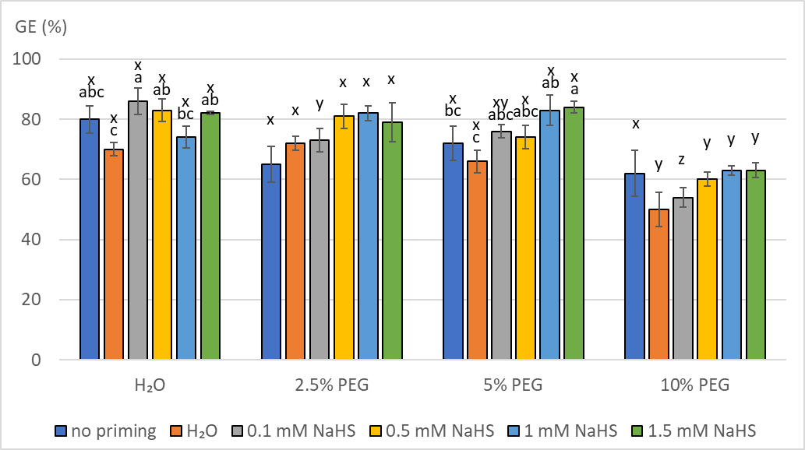

Figure 2 The effects of seed priming and drought stress levels on germination rates (SG) of sunflower seeds germinated under controlled conditions in a climate chamber. Bars represent means (± S.E.) of particular seed priming variant and drought stress levels (n=4); a,b – differences among priming variants within each stress level, according to LSD test p≤0.05

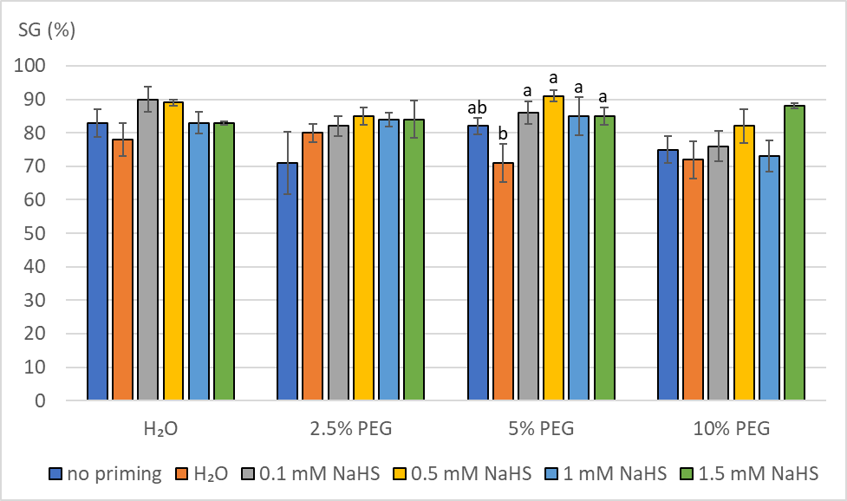

Figure 3 The effects of seed priming and drought stress levels on seedling mass (SW) of sunflower seed germinated under controlled conditions in a climate chamber. Bars represent means (± S.E.) of particular seed priming variants and drought stress levels (n=4); x,y,z,q – differences among stress levels within each priming variant; a,b,c,d – differences among priming variants within each stress level, according to LSD test *p*≤0.05

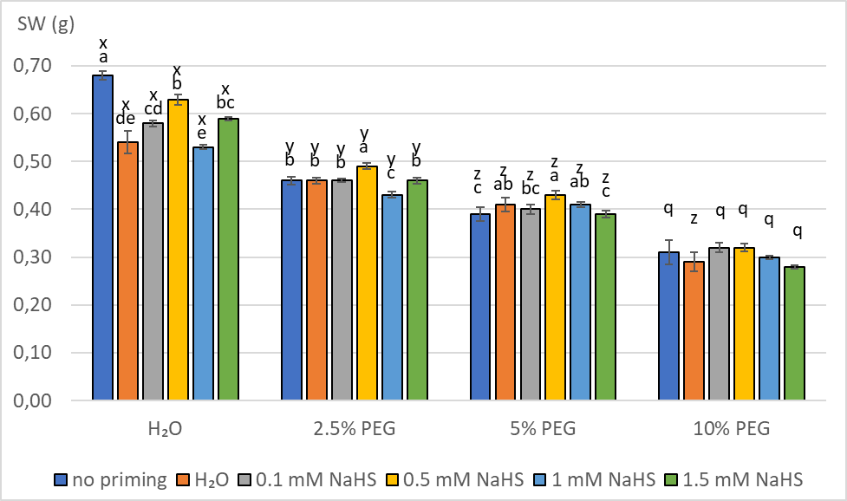

Figure 4 The effects of seed priming and drought stress levels on H2O2 content in sunflower seedlings (HP) germinated under controlled conditions in a climate chamber. Bars represent means (± S.E.) of particular seed priming variants and drought stress levels (n=4); x,y,z – differences among stress levels within each priming variant; a,b,c – differences among priming variants within each stress level, according to LSD test *p*≤0.05

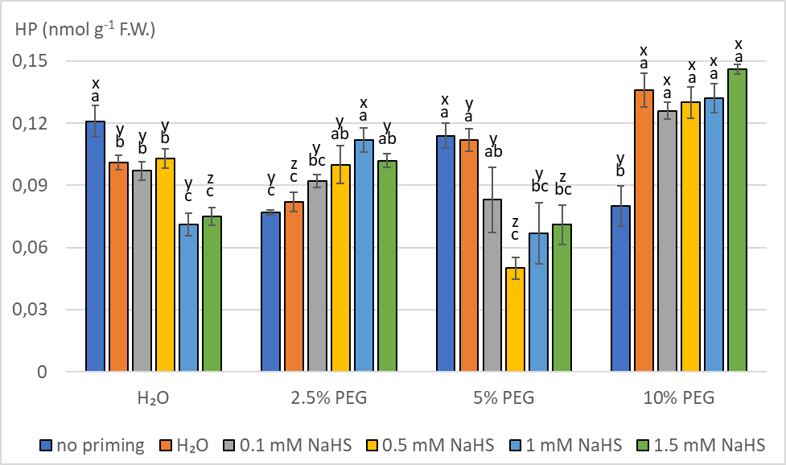

Figure 5 The effects of seed priming and drought stress levels on free proline content in sunflower seedlings (PRO) germinated under controlled conditions in a climate chamber. Bars represent means (± S.E.) of particular seed priming variants and drought stress levels (n=4); x,y,z – differences among stress levels within each priming variant; a,b,c – differences among priming variants within each stress level, according to LSD test *p*≤0.05.

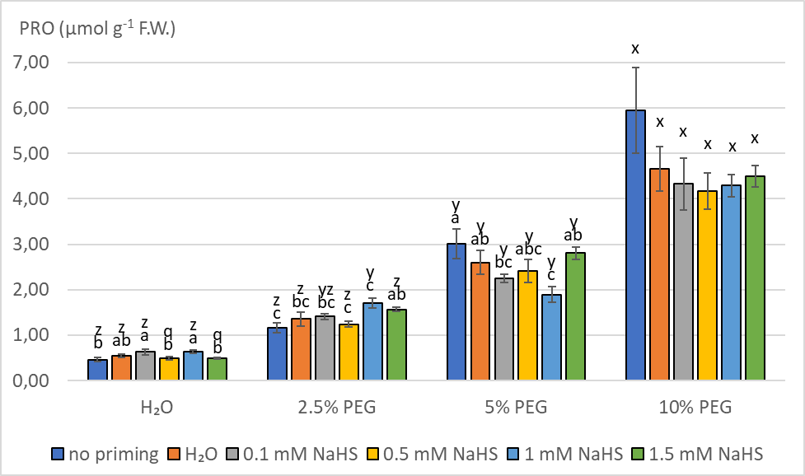

Figure 6 The effects of seed priming and drought stress level on lipid peroxidation rate (malondialdehyde content, MDA) in sunflower seedlings germinated under controlled conditions in a climate chamber. Bars represent means (± S.E.) of particular seed priming variants and drought stress level (n=4); x,y,z – differences among stress levels within each priming variant; a,b,c,d – differences among priming variants within each stress level, according to LSD test *p*≤0.05

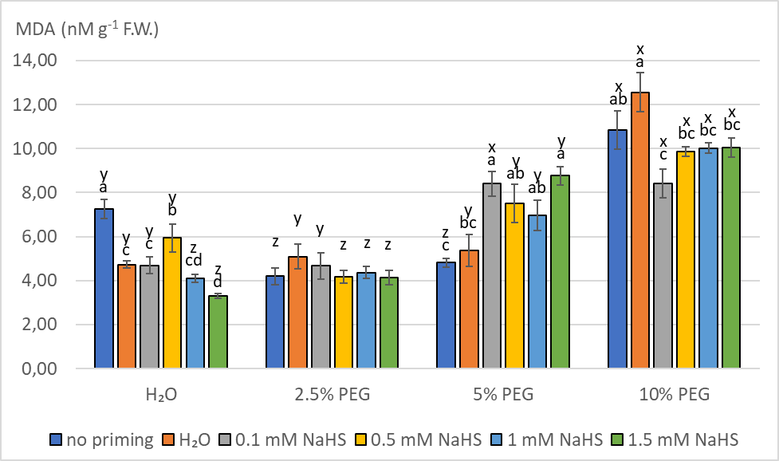

Table 1. Temperature and air humidity during the experimental period for soil-grown sunflower plants.

|  |  |  |  |
| --- | --- | --- | --- |
| **Date** | **Air temperature (oC)** | | **Air relative humidity** |
| **Min.** | **Max.** | **RH%** |
| May 26 | 6.2 | 21.5 | 54.5 |
| May 27 | 7.1 | 22.8 | 55.3 |
| May 28 | 8.0 | 25.4 | 55.3 |
| May 29 | 6.4 | 37.0 | 56.1 |
| May 30 | 9.6 | 36.9 | 58.7 |
| May 31 | 12.5 | 38.3 | 61.1 |
| June 1 | 14.0 | 37.8 | 66.8 |
| June 2 | 14.6 | 40.6 | 81.4 |
| June 3 | 15.2 | 39.0 | 61.7 |
| June 4 | 15.3 | 42.5 | 76.1 |
| June 5 | 15.8 | 40.6 | 64.8 |
| June 6 | 14.3 | 40.7 | 51.6 |
| June 7 | 16.6 | 41.6 | 48.3 |
| June 8 | 15.5 | 46.5 | 52.6 |
| June 9 | 15.7 | 39.3 | 63.7 |
| June 10 | 16.2 | 40.6 | 63.9 |

**Table 2.** The effects of seed priming, drought stress level and their interaction on germination energy (GE; %), germination rate (SG; %), seedling weight (SW; g), H2O2 content (HP; µmol g-1 FW), free proline content (PRO; µmol g-1 FW) and lipid peroxidation level (MDA; nmol g-1 FW) in sunflower seedlings germinated in climate chamber conditions (n=4). Two-way ANOVA (F test); means marked with the same letters (A,B,C,D) do not differ by LSD test (*p*≤0.05).

|  |  |  |  |  |  |  |  |
| --- | --- | --- | --- | --- | --- | --- | --- |
|  |  | **GE** | **SG** | **SW** | **HP** | **PRO** | **MDA** |
| **Priming** | no priming | 70BC | 78BC | 0.46A | 0.098 | 2.648 | 6.775 |
| H2O | 65C | 75C | 0.43BC | 0.108 | 2.289 | 6.940 |
| 0.1 mM NaHS | 72AB | 83AB | 0.44B | 0.100 | 2.156 | 6.547 |
| 0.5 mM NaHS | 74AB | 87A | 0.47A | 0.096 | 2.080 | 6.874 |
| 1.0 mM NaHS | 75AB | 81AB | 0.42C | 0.096 | 2.134 | 6.369 |
| 1.5 mM NaHS | 76A | 85A | 0.43BC | 0.098 | 2.342 | 6.569 |
| F test  *P* | 4.63 | 4.53 | 10.46 | 1.54 | 1.98 | 0.72 |
| **0.0010** | **0.0012** | **˂0.0001** | 0.1896 | 0.0918 | 0.6074 |
| **Stress** | H2O | 79A | 84A | 0.60A | 0.095B | 0.544D | 5.006C |
| 2.5% PEG | 75A | 81AB | 0.46B | 0.094B | 1.410C | 4.442C |
| 5% PEG | 76A | 83A | 0.41C | 0.083C | 2.496B | 6.974B |
| 10% PEG | 58B | 77B | 0.30D | 0.125A | 4.649A | 10.293A |
| F test  *P* | 30.25 | 2.94 | 99.63 | 36.84 | 216.44 | 157.38 |
| **˂0.0001** | **0.0388** | **˂0.0001** | **˂0.0001** | **˂0.0001** | **˂0.0001** |
| **Priming x Stress** | F test  *P* | 1.36 | 1.01 | 2.37 | 10.35 | 1.79 | 7.91 |
| 0.1888 | 0.4557 | **0.0080** | **˂0.0001** | 0.0527 | **˂0.0001** |

**Table 3.** Influence of seed priming (A), drought stress level (B) and their interaction on the development and anti-oxidative enzyme activity in young sunflower plants grown outdoors in the soil. ER - emergence rate (%), SM - shoot mass (g), LM - leaves mass (g), CAT- catalase total activity (µmol min-1 g-1 FW), APX - ascorbate peroxidase total activity (µmol min-1 g-1 FW), GR – glutathione reductase total activity (ΔA min-1 g-1 FW), DHAR - dehydroascorbate total activity (µmol min-1 g-1 FW). Two-way ANOVA, F test; A,B - treatment means marked with different letters significantly different at *p*≤0.05 (LSD test, n=4).

|  |  |  |  |  |  |  |  |  |
| --- | --- | --- | --- | --- | --- | --- | --- | --- |
|  |  | **ER** | **SM** | **LM** | **CAT** | **APX** | **GR** | **DHAR** |
| **Seed**  **priming**  **(A)** | No priming | 80 | 0.682 | 0.130A | 99.83A | 2.170B | 0.012B | 0.054A |
| H2O | 85 | 0.626 | 0.113B | 108.24A | 4.673A | 0.035A | 0.053A |
| 0.5 mM NaHS | 84 | 0.680 | 0.120AB | 86.72AB | 2.293B | 0.010B | 0.049B |
| 1.0 mM NaHS | 88 | 0.693 | 0.127A | 74.58B | 1.816B | 0.006B | 0.047B |
| F test  *P* | 2.75 | 2.12 | 3.88 | 3.18 | 25.96 | 6.15 | 10.43 |
| 0.0649 | 0.1240 | **0.0214** | **0.0422** | **<0.0001** | **0.0030** | **0.0001** |
| **Drought**  **stress**  **(B)** | FWC 70% | 90A | 0.99A | 0.172A | 35.440B | 2.4457B | 0.0183 | 0.0393A |
| FWC 30% | 79B | 0.35B | 0.073B | 149.244A | 3.0304A | 0.0134 | 0.0617B |
| F test  *P* | 27.1 | 970.83 | 665.19 | 188.34 | 5.21 | 0.83 | 477.57 |
| **<0.0001** | **<0.0001** | **<0.0001** | **<0.0001** | **0.0316** | 0.3701 | **<0.0001** |
| **Interaction**  **(AxB)** | F test | 0.24 | 1.13 | 1.01 | 7.63 | 4.84 | 5.10 | 3.92 |
| *P* | 0.8672 | 0.3566 | 0.4058 | **0.0009** | **0.0094** | **0.0072** | **0.0208** |

**Table 4.** Prolonged effects of seed priming on plant development and anti-oxidative enzyme activity in young sunflower plants grown in the soil outdoors, in optimal water supply (Control - field water capacity 70%) and drought stress conditions (field water capacity 30%). FWC – field water capacity, ER - emergence rate (%), SM - shoot mass (g), LM - leaf mass (g), CAT- catalase total activity (µmol min-1 g-1 FW), APX - ascorbate peroxidase total activity (µmol min-1 g-1 FW), GR - glutathione reductase total activity (ΔA min-1 g-1 FW), DHAR - dehydroascorbate total activity (µmol min-1 g-1 FW). One-way ANOVA, F test; A,B - treatment means marked with different letters significantly different at *p*≤0.05 (LSD test, n=4).

|  |  |  |  |  |  |  |  |  |
| --- | --- | --- | --- | --- | --- | --- | --- | --- |
|  | | **ER** | **SM** | **LM** | **CAT** | **APX** | **GR** | **DHAR** |
| **Control**  **FWC 70%** | No priming | 87 | 1.03 | 0.183 | 25.608B | 1.908B | 0.008B | 0.040 |
| H2O | 91 | 0.92 | 0.160 | 84.137A | 5.167A | 0.055A | 0.041 |
| 0.5 mM NaHS | 90 | 1.00 | 0.171 | 15.820B | 1.608B | 0.008B | 0.038 |
| 1.0 mM NaHS | 93 | 1.02 | 0.173 | 16.195B | 1.100B | 0.002B | 0.038 |
| F | 1.12 | 1.66 | 1.97 | 23.49 | 14.56 | 5.90 | 1.92 |
| *p* | 0.3798 | 0.2288 | 0.1722 | **<0.0001** | **0.0003** | **0.0103** | 0.1801 |
| **Drought stress**  **FWC 30%** | No priming | 73 | 0.34 | 0.076AB | 174.06 | 2.433B | 0.015 | 0.067A |
| H2O | 80 | 0.33 | 0.065B | 132.35 | 4.178A | 0.015 | 0.065A |
| 0.5 mM NaHS | 79 | 0.36 | 0.068B | 157.61 | 2.979B | 0.013 | 0.059B |
| 1.0 mM NaHS | 84 | 0.37 | 0.081A | 132.35 | 2.532B | 0.011 | 0.056B |
| F | 1.66 | 1.34 | 4.18 | 1.80 | 22.12 | 0.73 | 9.5 |
| *p* | 0.2281 | 0.3072 | **0.0305** | 0.2013 | **<0.0001** | 0.5562 | **0.0017** |