**Estimation of groundwater recharge in savannah aquifers along a precipitation gradient using chloride mass balance method and environmental isotopes, Namibia**

*S. Uugulua*, H. Wankea*

*a Geology Department, University of Namibia, 340 Mandume Ndemufayo Avenue, Windhoek, Namibia *Corresponding author email: suugulu@unam.na*

The quantification of groundwater resources is essential especially in water scarce countries like Namibia. The chloride mass balance (CMB) method and isotopic composition were used in determining groundwater recharge along a precipitation gradient at three sites, namely: Tsumeb (600 mm/a precipitation); Waterberg (450 mm/a precipitation) and Kuzikus/ Ebenhaezer (240 mm/a precipitation). Groundwater and rainwater were collected from year 2016 to 2017. Rainwater was collected monthly while groundwater was collected before, during and after rainy seasons. Rainwater isotopic values for δ18O and δ2H range from -10.70 to 6.10 and from -72.7 to 42.1 respectively. Groundwater isotopic values for δ18O range from -9.84 to -5.35 for Tsumeb; from -10.85 to -8.60 for Waterberg and from -8.24 to -1.56 for Kuzikus/Ebenhaezer, while that for δ2H range from -65.6 to -46.7 for Tsumeb; -69.4 to -61.2 for Waterberg and -54.2 to -22.7 for Kuzikus/Ebenhaezer. Rainwater scatters along the GMWL. Rainwater collected in January, February and March are more depleted in heavy isotopes than those in November, December, April and May. Waterberg groundwater plots on the GMWL which indicates absence of evaporation. Tsumeb groundwater plots on/close to the GMWL with an exception of groundwater from the karst Lake Otjikoto which is showing evaporation. Groundwater from Kuzikus/Ebenhaezer shows an evaporation effect, probably evaporation occurs during infiltration since it is observed in all sampling seasons. All groundwater from three sites plot in the same area with rainwater depleted in stable isotopic values, which could indicates that recharge only take place during January, February and March. CMB method revealed that Waterberg has the highest recharge rate ranging between 39.1 mm/a and 51.1 mm/a (8.7% - 11.4% of annual precipitation), Tsumeb with rates ranging from 21.1 mm/a to 48.5 mm/a (3.5% - 8.1% of annual precipitation), and lastly Kuzikus/Ebenhaezer from 3.2 mm/a to 17.5 mm/a (1.4% - 7.3% of annual precipitation). High recharge rates in Waterberg could be related to fast infiltration and absence of evaporation as indicated by the isotopic ratios. Differences in recharge rates cannot only be attributed to the precipitation gradient but also to the evaporation rates and the presence of preferential flow paths. Recharge rates estimated for these three sites can be used in managing the savannah aquifers especially at Kuzikus/Ebenhaezer where evaporation effect is observed that one can consider rain harvesting.

***Key words****: Chloride Mass Balance; Groundwater recharge; Isotopic values; Precipitation gradient*

**1 Introduction**

Namibia is a dry sub-Saharan country with limited surface water resources due to the fact that all rivers inside Namibia are ephemeral and all perennial rivers are shared with neighbouring countries. Groundwater is therefore the main source of water in the country both for domestic and agricultural purposes.

Estimating groundwater recharge in arid and semi-arid regions like Namibia can be difficult, because such regions are characterized by generally low recharge compared to the average annual rainfall or evapotranspiration, and thus making it difficult to quantify precisely (Scanlon et al., 2002). Recharge occurs to some extent in even the most arid regions and, as aridity increases, directrecharge is likely to become less important than localizedand indirectrecharge, in terms of total aquifer replenishment (Alsaaran, 2005 ) (De Vries and Simmers, 2002).

Accurate quantification of recharge rates is vital for proper management and protection of valuable groundwater resources. For proper management systems the recharge to the aquifer cannot be easily measured directly but usually estimated by indirect means (Lerner et al., 1990).

Chloride mass balance (CMB) method and environmental isotopes have been commonly used in water resource development and management (Subyani, 2004). CMB method is based on the law of conservation of mass, where chloride is considered as a conservative tracer. The input of chloride deposition by both dry and wet deposition is assumed to balance out the output of chloride concentration by infiltration and mineralisation.

CMB method has been successfully applied in several studies to estimate groundwater recharge rates in semi-arid areas. Sharma and Hughes (1985) estimated groundwater recharge using CMB method in the deep coastal sands of Western Australia, (Gieske et al., (1990) in south eastern Botswana and Subyani (2004) in Saudi Arabia with 15, 2.5 and 11 % of the average annual precipitation respectively.

Environmental isotopes are widely used as tracers to understand hydrogeological processes such as precipitation, groundwater recharge, groundwater-surface water and vegetation interaction. A comparison of the δ18O and δ2H isotopic compositions of precipitation and groundwater provides an excellent tool for evaluating the recharge mechanism (Yeh et al., 2014). This method can only be used to understand groundwater recharge processes rather than quantifying groundwater recharge, and therefore needs to be used hand in hand with other groundwater recharge estimation methods such as CMB.

Vogel and Van Urk (1975) compared δ18O content of the precipitation at Grootfontein with the δ18O content of the groundwater from the Etosha National Park, assuming a north western discharge of groundwater from the Grootfontein district. His conclusion was the recharge only takes place under exceptional circumstances, when precipitation tends to have lower heavy isotope content. Hoad (1993) considers that recharge to the confined Kalahari aquifer occurs by through flow from the unconfined Kalahari aquifer. The unconfined aquifer between Namutoni Gate and Otjikoto Lake is defined as the recharge area where direct diffuse recharge is thought to be the dominant recharge mechanism to the unconfined Kalahari aquifer. Groundwater recharge estimation using the saturated volume fluctuation approach revealed annual recharge ranging between 0.33% and 4% of the mean annual precipitation for both Kalahari and Otavi dolomite aquifers (Bäumle, 2003).

Mainardy (1999) estimated groundwater recharge rates based on the chloride method and on fracture aperture measurements. Recharge amount ranging between 3.2 to 4.8% of the mean annual precipitation were determined for bare, fractured sandstone in the western part of the Waterberg. Much lower recharge values of 0.2 to 1.8% of the mean annual rainfall in the area were derived for quartzite outcrops of the Nossib Group and for meta-sediments belonging to the Damara Sequence.

Külls (2000) estimated groundwater recharge in the north-eastern part of the Omatako Basin ranging between 0.1 to 2.5 % using a water balance model. He also used CMB method that gave recharge values ranging between 2% and 3.3% of the mean annual rainfall.

Külls (2000) observed only little isotopic enrichment by evaporation in the western part of the Waterberg area. However, the isotopic composition of groundwater from the secondary aquifers in the Damara Sequence north of the Waterberg indicates some evaporative enrichment due to shallower depths to the water table.

Taapopi (2015) estimated groundwater recharge rates in the unsaturated zone at Ebenhaezer farm in the Stampriet Basin using CMB. Her findings ranged from 0.18% to 0.71% of the mean annual precipitation. Stone and Edmunds (2012)estimated groundwater recharge rates in the Kalahari dune field, Stampriet Basin using CMB method in the unsaturated zone. Their findings indicated recharge values between 4% and 20% of the mean annual precipitation, with chloride profiles representing between 10 years and 30 years of rainfall infiltration. JICA (2002) determined groundwater recharge rates of the Auob aquifer system, Stampriet Basin and found out that the recharge is 1% of the long-term mean annual precipitation.

Although groundwater recharge studies have been carried out in Namibia, a seasonal sampling along a precipitation gradient has not been carried. This study thus aims at identifying groundwater recharge rates as well as processes using a CMB method and water stable isotopes δ2H and δ18O along a precipitation gradient in the savannah aquifers, therefore from Tsumeb area in the north, Waterberg in the central part and Kuzikus/Ebenhaezer further south of Namibia.

2 **Description of the study areas**

**2.1 Location**

The study was carried out along a precipitation gradient in the following areas: Tsumeb, Waterberg and Kuzikus/Ebenhaezer. The study areas indicate a precipitation gradient (Figure 1). Tsumeb area lies within the south-eastern part of Cuvelai-Etosha Basin, having the highest annual precipitation rate of about 600 mm/a and an annual potential evaporation rate ranging between 2000 to 3000 mm/a.Waterberg area lies within the south-western part of Omatako Basin. The area receives an annual precipitation of about 450 mm and has a potential evaporation of about 2800 mm/a. Kuzikus/Ebenhaezer area is part of the Stampriet Basin, where the annual precipitation within the basin ranges between 175 mm to 240 mm, with potential evaporation varying from 3000 mm/a to 3500 mm/a (DWA, 1988).

Both Tsumeb and Kuzikus/Ebenhaezer study areas are flat-laying areas while Waterberg area has a southern slope where springs emerge from the Etjo sandstone. All three study areas are characterized by savannah vegetation zone which is mainly dominated by thorn trees and bushes. Common vegetation species that are found at all three study area are: *Senegalia mellifera, Senegalia erioloba, Dichrostachys cineria, Boscia Albitrunca.*

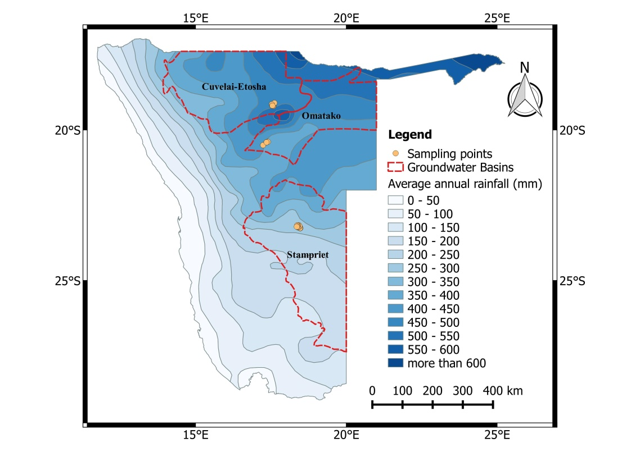  
Figure 1: Location of the study areas, Data source Acacia project E1 database.

**2.2 Geology, Hydrology and Hydrogeology**

*2.2.1 Tsumeb area*

Tsumeb area is located within the Otavi Mountain Land of northern Namibia, which forms part of the Northern Carbonate Platform of the Pan African Orogen. Rocks of the Damara Supergroup are unconformably deposited on the Grootfontein basement rocks. The oldest Damara sediments are the volcanics and clastic rocks of the Nosib Group. These are unconformably overlain by rocks of the Otavi Group which are composed of Carbonates initially deposited on a stable marine shelf (Miller, 2008). Sandstone of the young Mulden Group overlay the Otavi Group rocks (Figure 2).

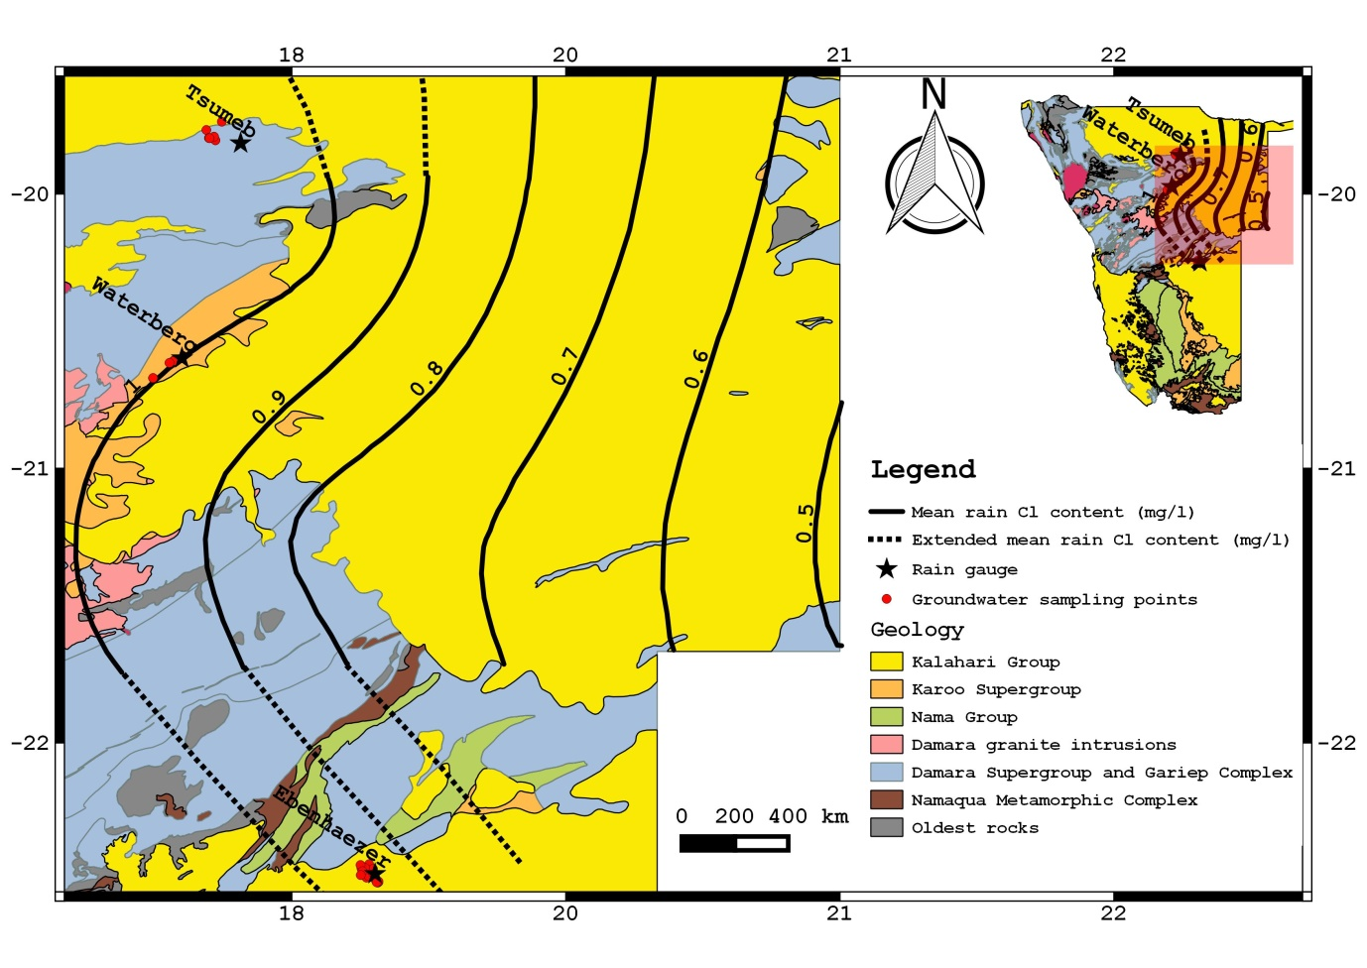

Figure 2: Geology of the study areas, Data source E1, Acacia project database overlain by the mean chloride concentration in precipitation isolines obtained from Klock (2001).

In general, the Otavi Mountain Land, within which the Tsumeb area lies, has a watershed draining westwards into the Ugab River catchment, northwards into the Etosha Pan, south and eastwards into the Omatako Omuramba, a tributary of the Okavango River (Christelis and Struckmeier, 2011).

Groundwater in the Tsumeb area is contained in two principal aquifers: the Tsumeb Karst Aquifer (TKA) in the north and the Grootfontein Karst Aquifer (GKA) in the south. According to Van Vuuren (2011) these two aquifer systems are divided by the low transmissivity rocks of the Nosib group and therefore there is little groundwater flow between them. The GKA drains water towards the south, in the direction of the Omatako Omuramba whilst the TKA drains towards the north (Van Vuuren, 2011).

Due to the karstic nature of the TKA, the groundwater potential in the study area is relatively high with a few areas that are locally having low potential probably where karstic features are not well pronounced (Figure 3).

Borehole information from the SADC Groundwater Information Portal (SADC-GIP) shows a wide range of the borehole depths in the TKA. Some boreholes are as shallow as 18 m while some are as deep as 120 m. Depth to groundwater in the study area varies, with static water level as low as 6 m and the deepest at 25 m.

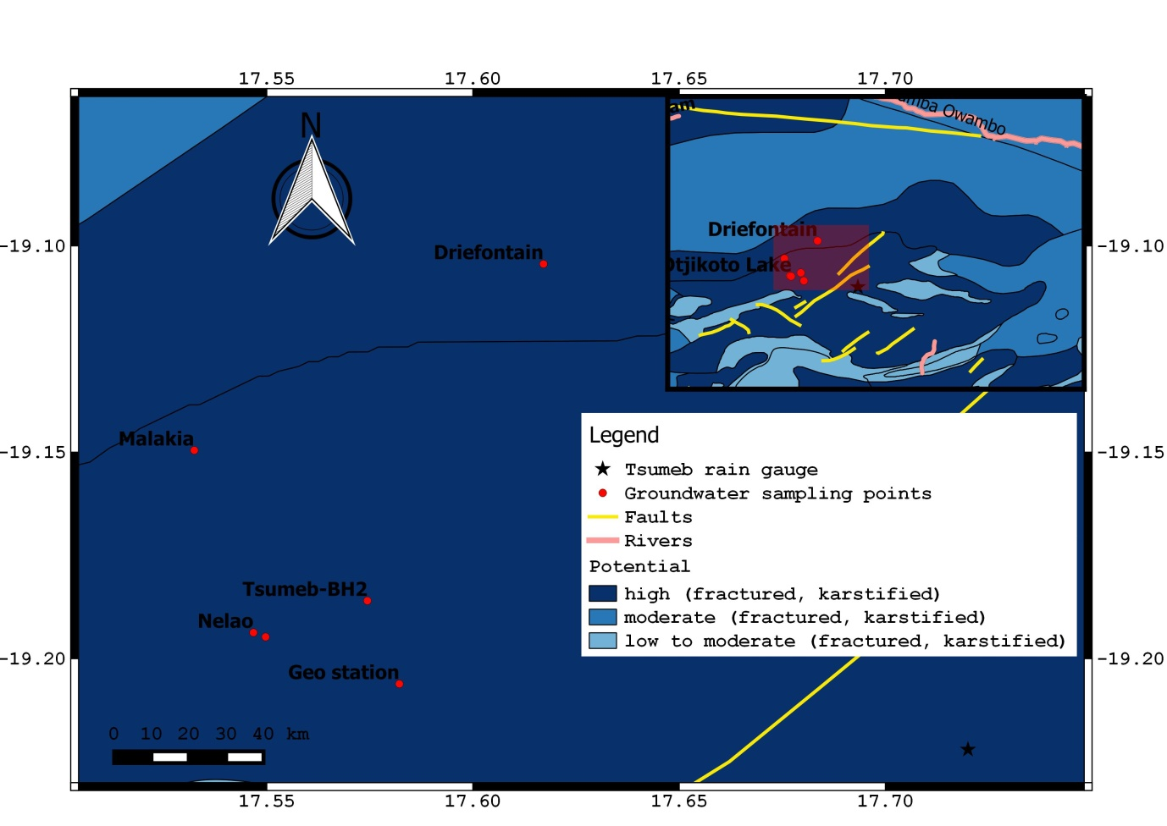Figure 3: Hydrogeological map of the Tsumeb Area, Data source Department of Water Affairs of Namibia and BGR (2001)

*2.2.2 Waterberg area*

Waterberg area is covered by Kalahari sediments of less than 10 m thick that overlay the Etjo formation (Sandstone) of the Karoo group in the western part of the area and the secondary aquifers in the Damara sequence north of the Waterberg (Külls, 2000) (Figure 2).

The Waterberg area forms part of the Brandberg, Erongo and Waterberg Hydrogeological Region of Namibia (Christellis and Struckmeier, 2011). The area has no permanent rivers, except for small ephemeral rivers which may carry water for very short periods after heavy rain. Generally, the Omatako Omuramba drains towards the east and finally to the north-east while the Ugab and several smaller rivers drain towards the west (Figure 4). Almost all water in the region comes from the underground, pumped from boreholes or via free flowing springs.

In this region, the Waterberg plateau forms a major hydrogeological structure containing a series of contact fountains that drain water from the porous sandstone layers of the Etjo Formation (Christellis and Struckmeier, 2011). In addition to that, a number of springs emerge on the southern slope of the Waterberg. Groundwater in the study area occurs predominantly in hard rock bodies and porous alluvium aquifers, as shown in Figure 4. The hard rock bodies (sandstone) and the porous alluvium aquifers (Kalahari sand) have generally low but locally moderate groundwater potential whilst in areas where the hard rock bodies are fractured or fissured, the potential for groundwater is relatively high (Figure 4).

SADC Groundwater Information portal (SADC-GIP) reveals borehole depth in the study area ranging from 50 m to 150 m and with an average depth to groundwater of 20 m.

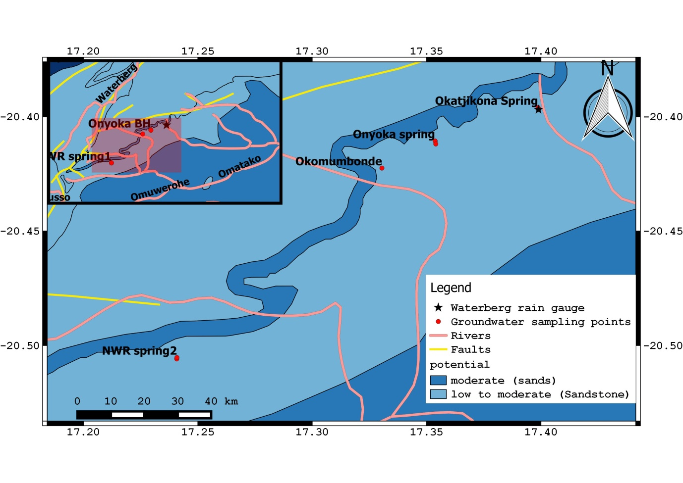Figure 4: Hydrogeological map of the Waterberg Area, Data source Department of Water Affairs of Namibia and BGR (2001)

*2.2.3 Kuzikus/Ebenhaezer area*

Kuzikus/Ebenhaezer, which lies in the north-western parts of the Stampriet Basin (Figure 1), is characterized by rocks of the Karoo Sequence, Nama group rocks as well as the Damara Sequence (Figure 2). These are overlain by young Kalahari sequence deposits (Miller, 2008).

There are no permanent rivers flowing through the basin except for the ephemeral Auob River and Nossob River, which are the only evidence of surface water flow during wetter climates in the past (Christellis and Struckmeier, 2011). The entire basin therefore relies on groundwater.

Groundwater in the basin occurs in three main aquifers (Figure 5): the Auob sandstone; the Nossob sandstone and the Kalahari beds (Alker, 2009; Christellis and Struckmeier, 2001). The Auob aquifer and the Nossob aquifer lie in the Ecca Group of the Lower Karoo Sequence. These aquifers are confined and may be free-flowing (artesian) in some parts of the basin such as in the Auob valley and downstream of the Stampriet settlement as well as in the Nossob valley around Leonardville. Elsewhere in the basin, groundwater is sub-artesian. 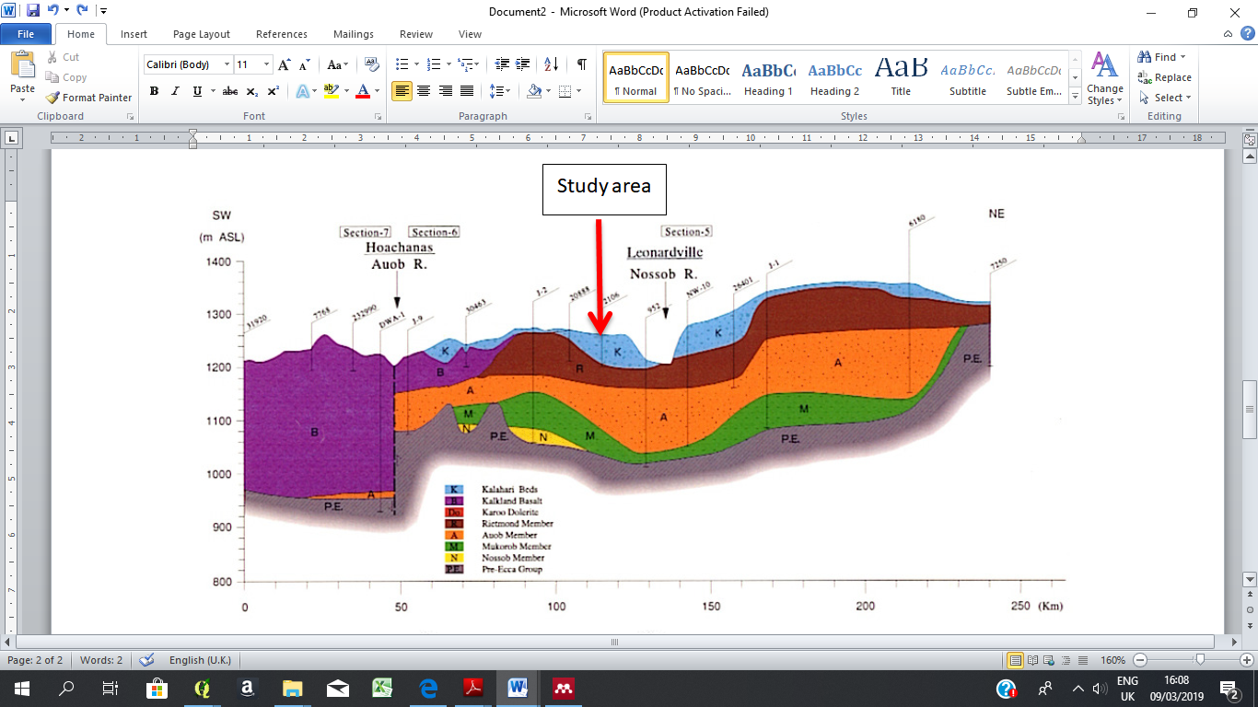

Figure 5 Geological cross section of JICA section 1 (the section closer to the sampling points) in the stampriet basin (JICA, 2002)

According to JICA (2002), small, shallow depressions caused by calcrete dissolution become karstic sinkholes where local runoff concentrates and sinks into permeable layers or structures below. Furthermore, fractures also act as preferential flow paths for groundwater recharge to these confined aquifers. Such geological features exist in the west, northwest and southwest of the basin; as a result there is low or non-existent of isotopic evaporation of the water in these aquifers. On the other hand, the water in the unconfined Kalahari layers in the central part of the basin has a very definite isotopic evaporation signal, indicating that a substantial proportion of rainfall evaporates and consequently does not recharge the aquifer (Alker, 2009).

Groundwater in the Kuzikus/Ebenhaezer area is contained in porous aquifers, thus the hard rock bodies as well as in porous alluvium layers (Figure 6). The groundwater potential in these layers ranges between low to moderate potential. An average measured depth to groundwater in the study area is 36.5 m.

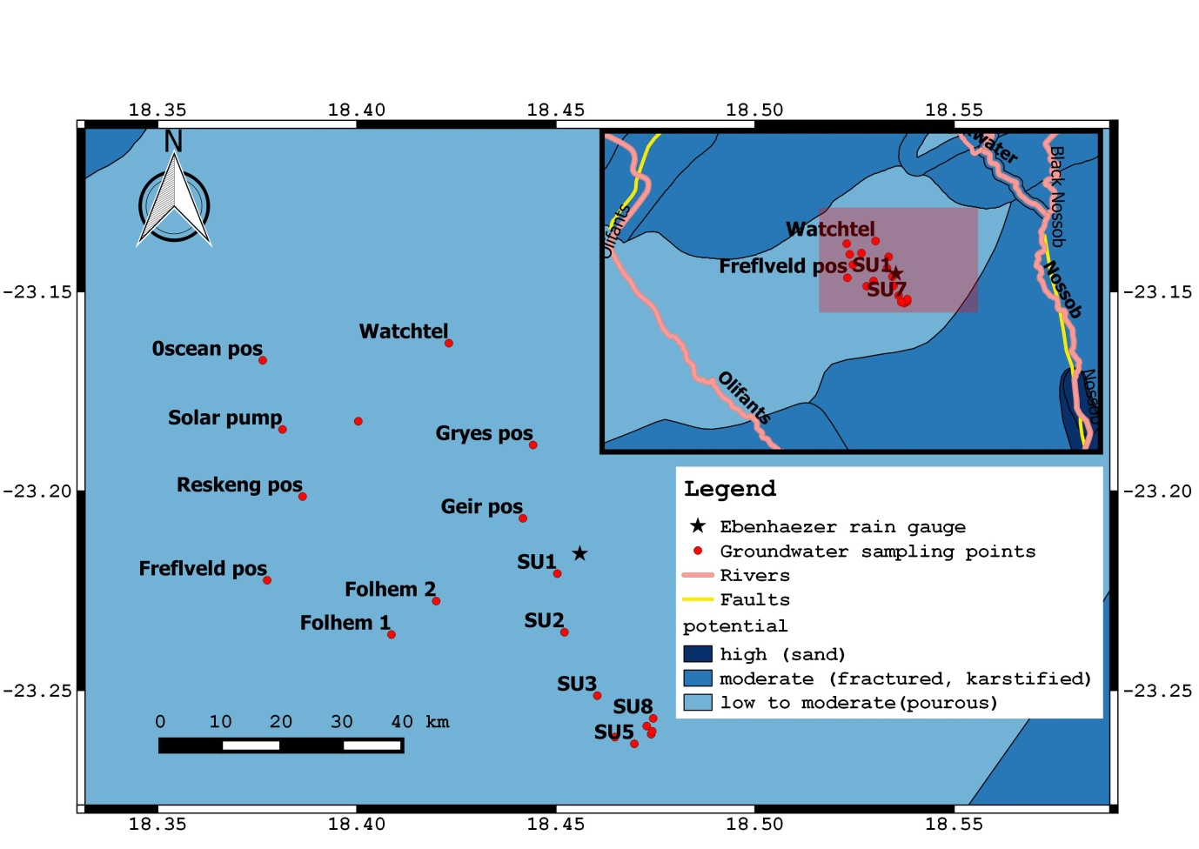 Figure 6 Hydrogeological map of the Kuzikus/Ebenhaezer Area, Data source Department of Water Affairs of Namibia and BGR (2001)

**3 Materials and Methods**

Seasonal field campaigns were carried out between 2016 and 2017 for Tsumeb, Waterberg and Kuzikus/Ebenhaezer areas. A total of 20 rainwater samples were collected monthly throughout the rainy seasons using a rain collector at all three study sites. Groundwater sampling was done before rainy season (around November), during rainy season (March), and after rainy season (June). As a result, a total of 28, 25 and 58 groundwater samples were collected from boreholes in Tsumeb Karst Aquifer, Tsumeb; boreholes and springs in the Etjo sandstone, Waterberg; and boreholes in the unconfined Kalahari sand, Kuzikus/Ebenhaezer respectively. Accessibility to boreholes in the Kuzikus/Ebenhaezer area enabled us to collect more samples compared to the other two study sites.

Onsite parameters such as electrical conductivity, pH, redox potential and temperature were measured using Hach field portable instruments (pH meter, conductivity meter, multimeter for the redox pontetial). TDS was determined from the electrical conductivity values where the conversion factors (ke) for the study areas were determined from SADC-GIP borehole data. Average ke values of 0.66 for Tsumeb, 0.71 for Waterberg and 0.64 for Kuzikus/Ebenhaezer were used.

50 ml glass bottles were used to collect groundwater samples. Chloride content for 27 groundwater samples from the three study sites was determined using an ion-selective electrode by measuring 25 ml of the sample into a beaker with a chloride ionic strength adjuster, and then placed on a magnetic stirrer to homogenous the solution.

The long term averages for annual precipitation amounts from DWA (1988) were used for each of the site to estimate groundwater recharge. An annual precipitation amount of 600 mm/a was used for Tsumeb, 450 mm/a for Waterberg and an average annual precipitation amount of 240 mm/a for the Leonardville weather station close to Kuzikus/Ebenhaezer area was used.

Average chloride concentrations in precipitation were obtained from Klock (2001). For Waterberg, the rain collector falls on the 1 mg/l average chloride concentration isoline. Furthermore, average chloride concentrations isolines were extended to obtain values for both Tsumeb and Kuzikus/Ebenhaezer as indicated in Figure 2, where a 1.05 mg/l and 0.95 mg/l were determined for Tsumeb and Kuzikus/Ebenhaezer respectively.

Groundwater recharge rates were determined using the CMB method. For CMB in Kalahari, the input by dry deposition is small when compared to the wet deposition (Gieske, 1992) and for that reason it is assumed negligible and therefore the following equation can be used to estimate groundwater recharge:

R = ((P – A)*Clp)/Clsw

Whereby P = Precipitation (mm); A = surface runoff; Clp = Chloride concentration in precipitation (mg/l); Clsw = Chloride concentration in soil water (mg/l) and R = Recharge (mm).

Both rainwater and groundwater isotopic contents were measured using the Laser Absorption Spectrometry measurements LGR DLT 100. Results are reported in ‰ versus VSMOW standard (Vienna–Standard Mean Oceanic Water). Typical analytical uncertainty of the reported isotopic values is about ±0.2 ‰ for δ18O and ±0.14‰ for δ2H. Both Chloride and isotopic content analyses were carried out at the University of Namibia hydro-laboratories.

**4 Results**

**4.1 Groundwater physio-chemical parameters**

Groundwater pH ranges between 6.0 to 7.2 for Tsumeb; 5.4 to 8.4 for Waterberg; and 6.2 to 8.0 for Kuzikus/Ebenhaezer, thus groundwater in these areas is slightly acidic to slightly alkaline in nature with an exception of Onyoka spring in the Waterberg area which is mildly acidic, covered by algae and not captured due to its low yield. With an exception of Onyoka spring in Waterberg, pH for all sites are within a range of 6 – 9 therefore, groundwater at all three study areas can be classified as of class A according to Namibian drinking water guidelines.

The electrical conductivity values for Tsumeb range from 630 to 1763 µS/cm; 17 to 311 µS/cm for Waterberg; and 347 to 994 µS/cm for Kuzikus/Ebenhaezer. Groundwater samples from Tsumeb area show elevated electric conductivities during rainy season and after rainy season in comparison to values before rainy season as indicated in Figure 7. Electrical conductivities for both Waterberg and Kuzikus/Ebenhaezer are below 1500 µS/cm and therefore the water quality is classified as of type A which is an excellent quality according to Namibian drinking water guidelines. All other groundwater points sampled in Tsumeb have class A water quality with an exception of Driefontain where the electrical conductivity is 1763 µS/cm during the rainy season, making the water quality to be of class B, hence water with acceptable quality.

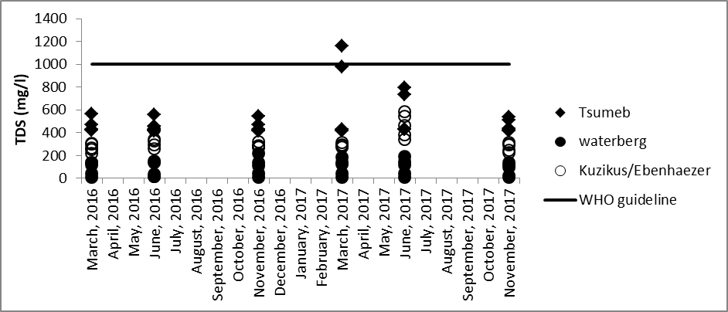Figure 7: TDS for the three sites

Total dissolved solids (TDS) at Waterberg and Kuzikus/Ebenhaezer sites are all within the World Health Organization (WHO) guidelines for safe drinking water (Figure 7). However, Tsumeb has one sampling point (Driefontain) where the TDS is above WHO guidelines during the rainy season (March 2017).

The average redox potential values for Tsumeb, Waterberg and Kuzikus/Ebenhaezer areas are 138.5 mV, 126.8 mV and 131.0 mV respectively. Such values are typical for an oxidizing environment. Groundwater sampled during rainy season has a higher redox potential especially those from Kuzikus/Ebenhaezer area (Figure 8) compared to those collected at the end of the rainy season. A summary of groundwater physical parameters is given below in Table 1.

Table1: Summary of physical parameters for all three seasons.

|  |  |  |  |  |  |  |  |  |
| --- | --- | --- | --- | --- | --- | --- | --- | --- |
|  | **Kuzikus/Ebenhaezer** | | | |  | |  | |
| Parameter | Minimum | | Maximum | | Median | | Average | |
| pH | 6.2 | | 8.0 | | 7.0 | | 7.1 | |
| EC (µS/cm) | 347.0 | | 1792.0 | | 470.5 | | 555.2 | |
| Temp (oC) | 17.2 | | 39.7 | | 26.3 | | 26.6 | |
| Eh (mV) | -3.6 | | 423.0 | | 121.0 | | 131.0 | |
|  | **Waterberg** | | |  | |  | | |
| Parameter | Minimum | Maximum | | Median | | Average | | |
| pH | 5.4 | 8.4 | | 6.6 | | 6.7 | | |
| EC (µS/cm) | 17.0 | 311.0 | | 158.2 | | 123.8 | | |
| Temp (oC) | 18.3 | 35.7 | | 23.7 | | 24.1 | | |
| Eh (mV) | 25.4 | 204.6 | | 126.4 | | 126.8 | | |
|  | **Tsumeb** | | |  | |  | |
| Parameter | Minimum | Maximum | | Median | | Average | |
| pH | 6.0 | 7.2 | | 6.6 | | 6.7 | |
| EC (µS/cm) | 630.0 | 1763.0 | | 649.0 | | 778.6 | |
| Temp (oC) | 14.9 | 31.4 | | 27.8 | | 27.1 | |
| Eh (mV) | 46.7 | 195.2 | | 136.7 | | 138.5 | |

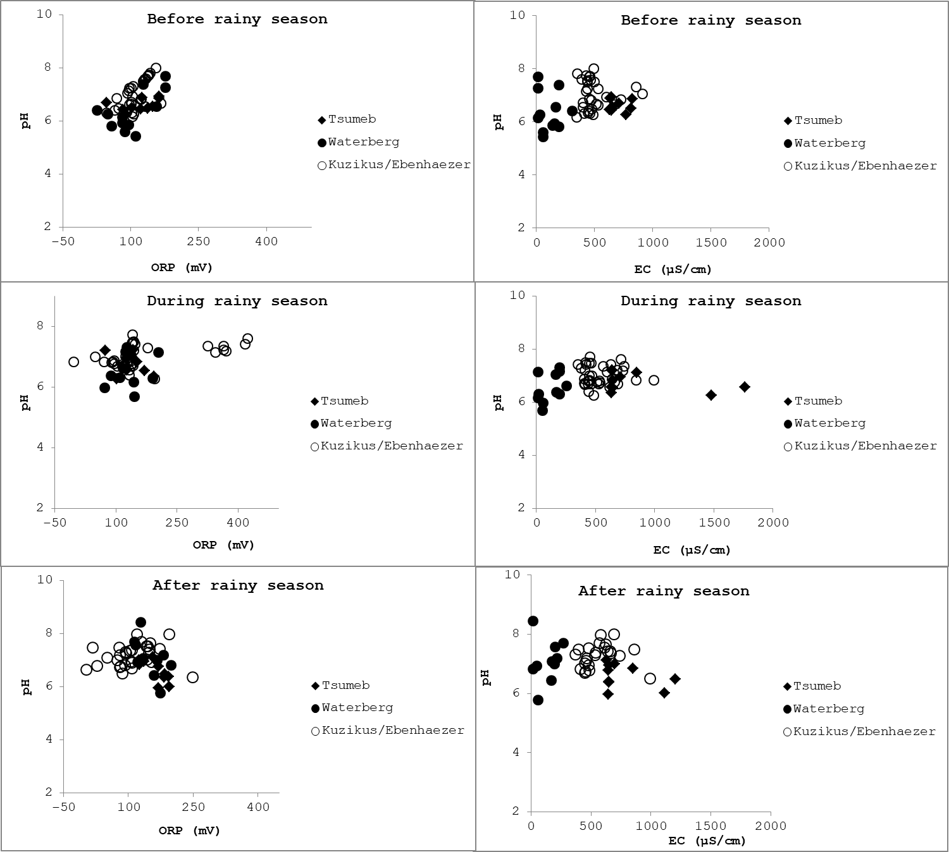

Figure 8: Redox potential (ORP), Electrical conductivity (EC) and pH for the groundwater samples from Tsumeb, Waterberg and Kuzikus/Ebenhaezer areas.

**4.2 Chloride mass balance method**

Groundwater recharge rates in Tsumeb area vary between 21.1 and 48.5 mm/a (3.5 – 8.1% of annual precipitation) (see table 2). Waterberg recharge rates range between 39.1 mm/a to 51.1 mm/a (8.7- 11.45% of annual precipitation) while rates from Kuzikus/Ebenhaezer are between 3.2 mm/a to 17.5 mm/a (1.3 – 7.3% of annual precipitation). On average, Waterberg has the highest recharge rate of 43.1 mm/a (9.6 % of annual precipitation), followed by Tsumeb with a rate of 36.4 mm/a (6.1% of annual precipitation) and lastly Kuzikus/Ebenhaezer with an average rate of 9.8 mm/a (4.1 % of annual precipitation).

Table 2: Groundwater recharge values based on chloride content

|  |  |  |  |  |
| --- | --- | --- | --- | --- |
| **Tsumeb** | Minimum | Maximum | Median | Average |
| Chloride in groundwater (mg/l) | 13.0 | 29.8 | 14.2 | 18.1 |
| Recharge values (mm/a) | 21.1 | 48.5 | 42.3 | 36.4 |
| Recharge values (%) | 3.5 | 8.1 | 7.0 | 6.1 |
| **Waterberg** | Minimum | Maximum | Median | Average |
| Chloride in groundwater (mg/l) | 8.8 | 11.5 | 10.7 | 10.5 |
| Recharge values (mm/a) | 39.1 | 51.1 | 42.3 | 43.1 |
| Recharge values (%) | 8.7 | 11.4 | 9.4 | 9.6 |
| **Kuzikus/Ebenhaezer** | Minimum | Maximum | Median | Average |
| Chloride in groundwater (mg/l) | 13.0 | 71.4 | 26.9 | 31.5 |
| Recharge values (mm/a) | 3.2 | 17.5 | 8.9 | 9.8 |
| Recharge values (%) | 1.3 | 7.3 | 3.7 | 4.1 |

**4.3 Water stable isotopes**

Rainwater samples show isotopic contents ranging from –10.70 to 6.10‰ vs. VSMOW for δ18O and –72.7 to 42.1‰ vs. V-SMOW for δ2H. Rainwater samples are scattering along the global meteoric water line (GMWL) Figure 8. A seasonal effect is indicated by more enriched samples collected in April, May, November and December while samples collected in January, February, and March are more depleted in heavy isotopes (Figure 9).

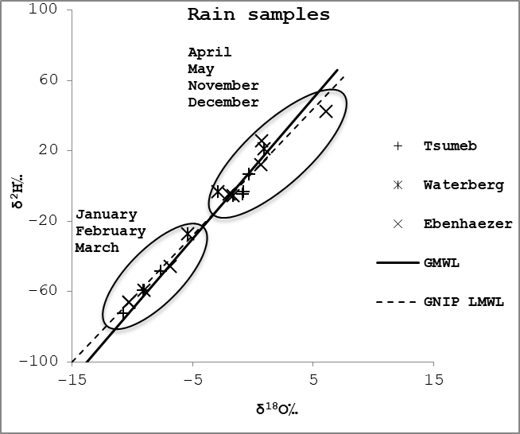

Figure 9: Isotopic values for rain samples collected at Tsumeb, Waterberg and Kuzikus/Ebenhaezer areas

Groundwater samples show isotopic values ranging from –9.9 to –1.1‰ vs. V-SMOW for δ18O and –65.6 to –32.3‰ vs. V-SMOW for δ2H for Tsumeb area; –10.9 to –8.6‰ vs. V-SMOW for δ18O and –70.7 to –61.2‰ vs. V-SMOW for δ2H for Waterberg and –8.2 to –1.3‰ vs. V-SMOW for δ18O and –59.0 to –21.3‰ vs. V-SMOW for δ2H for Kuzikus/Ebenhaezer.

Groundwater samples from Tsumeb area are plotting on the GMWL, with an exemption of a few that are plotting slightly below and above the GMWL (Figure 10). Groundwater from Waterberg area is plotting on the GMWL, with an exemption of few samples that are plotting slightly above the GMWL (Figure 10) but on the Global Network of Isotopes in Precipitation local meteoric water line for Windhoek (GNIP LMWL). Few groundwater samples collected at Kuzikus/Ebenhaezer are plotting on the GMWL while the majority of the samples are plotting below the GMWL. Samples that are plotting directly on the GMWL at Kuzikus/Ebenhaezer are mainly collected during the rainy season. In general, groundwater isotopic compositions from these three study sites are similar to that of rain water occurring in January, February and March (Figure 9 and Figure 10).

Groundwater sampled during rainy season shows a trendline of δ2H = 3.8 δ18O – 28.1 with a R2 = 0.7) for Tsumeb; δ2H = 3.2δ18O – 34.4 with a R2 = 0.6 for Waterberg; and δ2H = 5.0δ18O – 16.6 with a R2 = 1.0 for Kuzikus/Ebenhaezer. Samples taken after the rainy season has a δ2H = 4.4δ18O – 24.2 with a R2 = 0.9 for Tsumeb; δ2H = 4.5δ18O – 23.3 with a R2 = 0.5 for Waterberg; and δ2H = 5.7δ18O – 14.7 with a R2 = 0.9 for Kuzikus/Ebenhaezer. Groundwater collected before the rainy season shows a trend line of δ2H = 3.8δ18O – 28.2 with a R2 = 1.0 for Tsumeb; δ2H = 3.5δ18O – 32.1 with a R2 = 0.6 for Waterberg; and = 4.8δ18O – 17.7 with a R2 = 1 for Kuzikus/Ebenhaezer. Groundwater collected at the beginning of the rainy season at Tsumeb and Waterberg areas show trend lines of δ2H = 4.3δ18O – 23.3 with R2 = 1.0 and δ2H = 7.5δ18O + 7.1 with a R2 = 0.9 respectively.

Figure 4: Dual isotope plot of both rain water

and groundwater samples from Tsumeb,

Waterberg and Kuzikus/Ebenhaezer areas

plotted together with the GMWL and GNIP

LMWL.

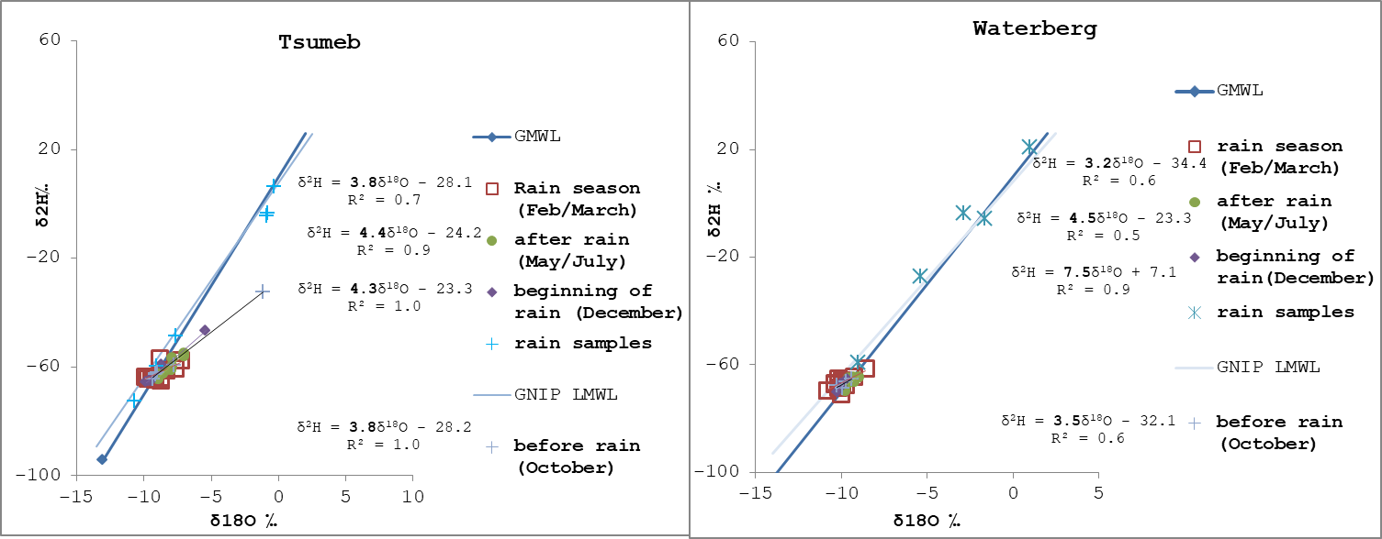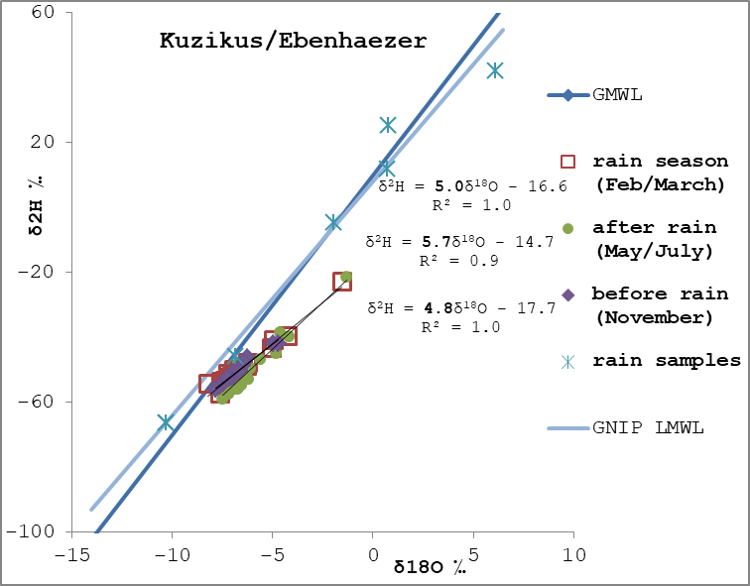

Figure 10: Dual isotope plot of both rain water and

groundwater samples from Tsumeb, Waterberg and

Kuzikus/Ebenhaezer areas plotted together with the

GMWL and GNIP LMWL.

**5. Discussion**

**5.1 Groundwater physio-chemical parameters**

Groundwater samples from Onyoka spring in the Waterberg area are mildly acidic due to the presence of algae. The presence of algae in water reduces its pH due to the fact that the pH of the water is lowered during respiration, where carbon dioxide is produced and hydroxide levels decreases (Assmy and Smetacek, 2012).

Waterberg groundwater having the lowest electrical conductivity and followed by Kuzikus/Ebenhaezer can be explained by the fact that groundwater at these two study sites are hosted in Karoo sandstone and Kalahari sand respectively where dissolution is limited in comparison to Tsumeb groundwater which is hosted in a karst aquifer (TKA). Consequently, this explains why Tsumeb area show elevated electric conductivities during rainy and after rainy seasons in comparison to values beforerainy season which is due to rock-water interaction therefore dissolution of the carbonate minerals at Tsumeb especially at the Driefontain farm where TDS exceeded WHO drinking water guideline during 2017 rainy season. This is further supported by the study carried out by Li et al. (2018) in the western part of the Cuvelai - Etosha basin where authors identified dissolution of carbonates as the main hydrochemical process responsible for an increase in total dissolved solids.

Groundwater sampled during rainy season has a higher redox potential especially at Kuzikus/Ebenhaezer area compared to other seasons due to rainwater that enters the groundwater system with a higher redox potential as a result of its exposure to atmospheric oxygen (Freeze and Cherry, 1979). This indicates that groundwater systems at all three study sites are under oxic conditions.

**5.2 Chloride mass balance method**

The chloride mass balance method revealed that Waterberg area has a higher recharge rate compared to all other study sites although Tsumeb area has the highest annual precipitation amount. This is an indication that groundwater recharge at these three study sites is not only necessarily controlled by the mean annual amount of precipitation at each site but probably by other factors too.

A synthesis on groundwater recharge in Southern Africa done by Abiye (2016) revealed that the presence of permeable geological cover plays a role to groundwater recharge in the region which however not captured by most of the recharge estimate methods. Based on Abiye (2016) study, this would mean that Waterberg has more preferential paths compared to the other savannah aquifers since the area is fractured and faulted. Our recharge rates are however slightly higher compared to the previous studies in the study areas. For example, in the Tsumeb area, Bäumle (2003) estimated the rate to range between 0.33 to 4 % of the annual precipitation. This could be an indication that groundwater recharge rates probably vary in the Tsumeb Karst Aquifer depending on the degree of karstification.

Both Stone and Edmunds (2012) and Taapopi (2015) estimated groundwater recharge rates in the Stampriet basin using the same method but in the unsaturated zone where Taapopi (2015) findings are lower compared to ours. However, our groundwater recharge rates fall under the range estimated by Stone and Edmunds (2012).

Other factors that influence groundwater recharge in an arid to semi-arid environment are vegetation cover, slope and aspect and surface runoff. However these factors play an insignificant role in groundwater recharge variations since they are relatively uniform to the study sites.

**5.3** **Water stable isotopes**

Scattering of rainwater samples along the GMWL/GNIP LMWL indicates a seasonal effect where by samples collected in April, May, November and December have more enriched isotopic values while samples collected in January, February, and March are depleted in isotopic values. April, May, November and December are generally dry months where rain amounts are small in Namibia. Gat et al. (2000) stated that dry months are associated with partially evaporated rain which is characterized by relatively higher δ18O values and hence enriched isotopic values in these months.

Groundwater isotopic values similar to isotopic values of rainwater collected in January, February and March at all three study sites, could be an indication that groundwater recharge generally occurs during those months. Külls (2000) pointed out that the potential for direct recharge is highest in February followed by January and March in the upper Omatako Basin using a daily water balance method which correlates to our findings. Moreover, our findings correlates with the conclusion made by Vogel and Van Urk (1975) that recharge in the Grootfontein only takes place when precipitation have lower heavy isotope content.

Figure 11 shows groundwater level fluctuation over the years 1987 to 2009, water levels rise generally from January and drop during June. A rise in the water level during these months could be attributed to groundwater recharge, hence supporting our findings.

Groundwater from Waterberg area plotting right on the GMWL/GNIP LMWL suggests that there is fast infiltration of rainwater with the absence of evaporation, probably via preferential path flows. Such path flows could be faults or fractures since the Etjo sandstone formation is documented to be synsedimentary faulted (Mountney et al., 1998).

Groundwater samples from Tsumeb area plotting on the GMWL/GNIP LMWL, with an exemption of a few that are plotting slightly below and above the GMWL also indicated fast infiltration of rainwater through karstific features, and probably slowed infiltration rates in areas that are not less karstified. Groundwater from Otjikoto Lake which is a karst sinkhole shows an evaporation effect due to the fact that it is open to the atmosphere.

Gibson et al. (1993) stated that meteoric waters that have undergone evaporation display systematic enrichment in both δ18O and δ2H, resulting in divergence from the meteoric water line along evaporation lines having slopes of less than 8, often in the range of 4 to 6. Groundwater samples collected from Kuzikus/Ebenhaezer area are having a slope ranging between 4.8 to 5.7 during all field campaigns, therefore indicate an evaporation effect which is observed at all field campaigns, thus during, before and after rainy seasons. It is therefore suggested that evaporation probably takes place during infiltration of rainwater to the Kalahari beds, a typical isotopic evaporation signal for the unconfined Kalahari aquifer in the study area according to Alker (2009).

Furthermore, isotopic values showing evaporation effect at Kuzikus/Ebenhaezer area compared to the other two sites corresponds to higher potential evaporation in that area in relation to potential evaporation rates at both Waterberg and Tsumeb areas (DWA, 1988).

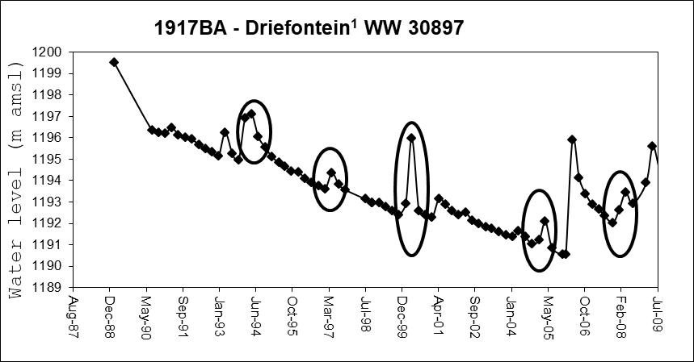

Figure 11: Water level fluctuation in Tsumeb (Driefontain) Data source Department of Water Affairs of Namibia

**6. Conclusion**

The water quality assessment based on the onsite parameters show that groundwater at all three sites is mostly safe for human consumption. Chloride Mass Balance method revealed that Waterberg area has the highest recharge rate compared to the other two study sites despite Tsumeb having a higher mean annual precipitation amount, followed by Tsumeb area and Kuzikus/Ebenhaezer area having the lowest. High recharge rates in the Waterberg can be related to the absence of evaporation as indicated by the isotopic ratios due to fast infiltration of rainwater possibly through preferential flow paths. Groundwater from Kuzikus/Ebenhaezer area indicated that evaporation takes place during infiltration of rainwater. Differences in recharge rates at these three study sites can not only be attributed to the precipitation gradient but also to the potential evaporation rates and the preferential paths at each study site. The identified groundwater recharge rates and recharge mechanisms revealed by chloride mass balance method and stable isotope composition provide useful information for groundwater management for example groundwater users in the Stampriet Basin where recharge values are very low due to evaporation during infiltration of rainwater can explore options such as roof rainwater harvesting.

**Acknowledgements**

Authors would like to thank OPTIMASS project for funding this research. We would like to also acknowledge and thank all the farmers who allowed us to sample their private boreholes. Special thanks go to the maintenance team at NWR Waterberg for field assistance in sampling their springs.

**References**

Abiye, T., 2016. Synthesis on groundwater recharge in Southern Africa_ A supporting tool for groundwater users. Groundwater for Sustainable Development 2–3, 182–189. https://doi.org/10.1016/j.gsd.2016.10.002

Alker, M., 2009. The Stampriet Artesian Aquifer Basin A case study for the research project ”Transboundary groundwater management in Africa”. Bonn.

Alsaaran, N.A., 2005. Using environmental isotopes for estimating the relative contributions of groundwater recharge mechanisms in an arid basin, central Saudi Arabia. The Arabian Journal for Science and Engineering 31.

Assmy, P., Smetacek, V., 2012. Algal Blooms. In Environmental Microbiology and Ecology. Edited by Schaechter, M 32, 435–449.

Bäumle, R., 2003. Geohydraulic Characterisation of Fractured Rock Flow Regimes. Regional Studies in Granite (Lindau, Black Forest, Germany) and Dolomite (Tsumeb Aquifers, Northern Namibia). Universität Karlsruhe (TH).

De Vries, J., Simmers, I., 2002. Groundwater recharge: an overview of processes and challenges. Hydrogeology 5–17.

DWA, 1988. Evaporation map for Namibia. Windhoek.

E1, A.P., n.d. No Title [WWW Document]. URL http://www.uni-koeln.de/sfb389/e/e1/index.htm

Freeze, R., Cherry, J., 1979. Groundwater. Prentice Hall, Englewood cliffs.

G Christelis W.Struckmeier, 2011. Groundwater in Namibia: an Explanation to the Hydrogeological Map, second. ed. HYMNAM, Windhoek.

Gat, J.R., Mook, W.G., Meijer, H.A.J., 2000. VOLUME II - Atmospheric Water. Environmental Isotopes in the Hydrological Cycle Principles and Applications 114.

Gibson, J.J., Edwards, T.W.D., Bursey, G.G., 1993. Estimating Evaporation Using Stable Isotopes : Quantitative Results and Sensitivity Analysis for Two Catchments in Northern Canada. Nordic Hydrology 24, 79–94. https://doi.org/10.2166/nh.1993.006

Gieske, A., Selaolo, E., McMullan, 1990. Groundwater recharge through the unsaturated zone of southeastern Botswana: a study of chlorides and environmental isotopes, in: Proceedings of the Ljubljana Symposium. IAHS, pp. 33–44.

Hoad, N., 1993. An overview of Groundwater Investigations in the Tsumeb and Oshivelo Areas. Windhoek.

JICA, 2002. The Study on the Groundwater Potential Evaluation and Management Plan in the Southeast Kalahari (Stampriet) Artesian Basin in the Republic of Namibia. Windhoek.

Klock, H., 2001. Hydrogeology of the Kalahari in north-eastern Namibia with special emphasis on groundwater recharge, flow modelling and hydrochemistry. Julius-Maximilians University of Würzburg.

Külls, C., 2000. Groundwater of the North-Western Kalahari, Namibia: Abschätzung der Neubildung und Quantifizierung der Fließsysteme. Julius-Maximilian University of Würzburg.

Lerner, D.N., Issar, A.S., Simmers, I., 1990. Groundwater recharge: a guide to understanding and estimating natural recharge. Heise, Hannover.

Li, Z., Wang, G., Wang, X., Wan, L., Shi, Z., Wanke, H., Uugulu, S., Uahengo, C.I., 2018. Groundwater quality and associated hydrogeochemical processes in Northwest Namibia. Journal of Geochemical Exploration 186, 202–214. https://doi.org/10.1016/j.gexplo.2017.12.015

Mainardy, H.., 1999. Grundwasserneubildung in der Übergangszone zwischen Festgesteinsrücken und Kalahari-Lockersedimentüberdeckung (Namibia). HU-Forschungsergebnisse aus dem Bereich Hydrogeologie und Umwelt 1–145.

Miller, R., 2008. The geology of Namibia. Geological Survey of Namibia 3, 16.1-28.1.

Mountney, N., Howell, J., Flint, S., Jerram, D., 1998. Aeolian and alluvial deposition within the Mesozoic Etjo Sandstone formation, northwest Namibia. Journal of African Earth Sciences 27, 175–192. https://doi.org/https://doi.org/10.1016/50899-5363(98)00056-6

SADC Grounwater Information Portal [WWW Document], n.d. URL https://www.un-igrac.org/special-project/sadc-groundwater-information-portal-gip

Scanlon, B.R., Healy, R.W., Cook, P.G., 2002. Choosing appropriate techniques for quantifying groundwater recharge. Hydrogeology Journal 10, 18–39. https://doi.org/https://doi.org/10.1007/s10040-001-0176-2

Sharma, M.L., Hughes, M.W., 1985. Groundwater recharge estimation using chloride, Deuterium and Oxygen-18 profiles in the deep coastal sands of western Australia. Journal of Hydrology 93–109.

Stone, A.E.C., Edmunds, W.M., 2012. Sand, salt and water in the Stampriet basin, Namibia: Calculating unsaturated zone (Kalahari dunefield) recharge using the chloride mass balance approach. Water SA 38, 367–378. https://doi.org/10.4314/wsa.v38i3.2

Subyani, A.M., 2004. Use of chloride-mass balance and environmental isotopes for evaluation of groundwater recharge in the alluvial aquifer, Wadi Tharad, western Saudi Arabia. Environmental Geology 741–749.

Taapopi, J., 2015. Application of the chloride mass balance method to determine groundwater recharge in the area of farm Ebenhaezer. University of Namibia.

Van Vuuren, O., 2011. Groundwater. A Namibian perspective.

Vogel, J.C., Van Urk, H., 1975. Isotopic composition of groundwater in semi-arid regions of southern Africa. Journal of Hydrology 23–36.

Yeh, H.F., Lin, H.I., Lee, C.H., Hsu, K.C., Wu, C.S., 2014. Identifying seasonal groundwater recharge using environmental stable isotopes. Water (Switzerland) 6, 2849–2861. https://doi.org/10.3390/w6102849