**A Multi-Objective Mixed-Integer Linear model for Sustainable Fruit Closed-Loop Supply Chain Network**

**Abstract**

**Purpose**: This paper presents a closed-loop supply chain (CLSC) optimization problem for a perishable agricultural product to achieve three pillars of sustainability, including minimizing total network costs and carbon dioxide (CO2) emissions from different network activities and maximizing responsiveness to demands simultaneously.

**Design/methodology/approach:** The research problem is formulated as a multi-objective (MO) mixed-integer linear programming (MILP) model, and classical approaches, including the LP-Metric and weighted Tchebycheff method have been applied to solve the optimization model. A set of test problems has been proposed to validate the model and the results are presented.

**Findings:** Computational time to find Pareto optimal solutions by using the weighted Tchebycheff method was twice as much as that of the LP-Metric method. Also, the result of the study is a mathematical model that can be applied to other products that are close to the fruit, such as vegetables.

**Research limitations/ implications:** The present study is limited to fruits supply chains and the inventory is considered at the distribution centers only. The study also considers only one type of transport.

**Practical implications:** The paper can assist supply chain managers to define strategies to achieve a sustainable CLSC network configuration for the fruits.

**Originality/ value:** This research is one of the early studies to consider environmental indicators in fruits supply chain design along with two other indicators of sustainability, namely economic and social indicators. Therefore, this can help supply chain managers to achieve sustainability by optimizing location decisions, inventory quantities, and flow between facilities.

**Keywords:** Sustainable supply chain; Multi-objective optimization; Closed-loop network; Reverse logistics.

**Paper type**: Research paper

# Introduction

In today's world, the supply of food for human consumption is one of the fundamental problems, so that food security and quality assurance have become the significant goals of governments. Therefore, agricultural production has been considered extensively to supply food (Tsolakis et al., 2014). On the other hand, agriculture is the most important driver of environmental change in the world (Godfray and Garnett, 2014). Eventually, the awareness of environmental pressure drives the demand for sustainable production in the agricultural sector. Also, the formulation of government regulations on environmental issues has prompted industries to redesign their supply chain (SC) networks to incorporate all aspects of sustainability: social, environmental, and economical called the triple bottom line (TBL). The adoption of new technologies that focus as much as possible on the use of natural resources and materials is one of the requirements of a supply chain that underscores environmental-friendly behavior.

Annual crops refer to those crops those complete their cycle within one year. Therefore, in order to make these crops available throughout the year, most of them are stored in suitable warehouses for several months, and only a small part of the production is directly sent to market after harvest. Therefore, a large volume of food crops, about 30%, gets degraded and decayed every year (FAO, 2011). Due to growing environmental concerns and stricter laws on waste generated during product development and subsequent stages, one of the most complex issues that need to be noticed is the management of these waste at both strategic and tactical levels. This issue has led to the emergence of the concept of the closed loop supply chains (CLSC) in which waste from various echelons of the forward SC is considered as a product returns (Easwaran and Uster, 2010). Waste products are precious in terms of both cost and environmental-friendliness (Krikke et al., 2013). This reduces the amount of waste that needs to be buried and since both forward and reverse SCs exist, we deal with a CLSC (Guid et al., 2003; Stindt and Sahamie, 2014).

In addition to the transportation and human resources costs of collecting and disposing rotten and waste fruits, the cost related to harvesting, processing, maintenance, and other implicit costs should be considered. Given that these costs could be significant, the necessity of reverse logistics planning in the fruit supply chains (FSCs) cannot be denied (Cheraghalipour et al., 2018). Consequently, a sustainable CLSC network can be an essential source of competitive advantage and customer satisfaction (Hatefi & Jolai, 2014). Items that are not used in the long-term and that their value is partially recoverable are taken into consideration in CLSCs (Flapper et al. 2005). SC planning, especially in the area of production and transportation planning, has been extensively studied (Catala et al., 2013; Mula et al., 2006), but is less common in the agricultural food industry.

In the recent decade, the agricultural supply chain (ASC), which refers to the chains that produce and distribute agricultural and horticultural products, has received widespread attention. Two main types of ASC are identified: fresh agri-foods and non-perishable agri-foods SCs. Fresh products are examined for their logistical complexity, limited shelf life, and public interest in their health (Ahumada and Villalobos, 2009). In the ASC products, the raw materials used for production usually diminish due to consumption or are lost due to their loss of value (e.g., spoiled foods). It should be noted that spoiled foods can be valuable in other supply chains. These spoiled products are utilized to produce materials such as organic fertilizer or the growth medium. Therefore, closed loops at ASC may need to reconceive business processes and redesign distinct logistics structures fundamentally.

The design of the integrated forward and reverse network must be carefully handled since strategic decisions (e.g., establishment of facilities) play a vital role in the performance of a supply chain and are very costly and time-consuming. That's why supply chain management is so important that it has been studied in many aspects over the past two decades and experts hope to improve the sustainability and profitability of the entire supply chain (Amoozad Mahdiraji et al., 2019). A CLSCs can provide environmental and social benefits, in addition to saving cost on perishable products. Thus a proprietary model for crops is required to investigate the objectives of an CLSC, including cost, environmental, and social objectives.

A review of the literature conducted within the context of this study has enabled the identification of gaps in mathematical modeling research on sustainable CLASCs design optimization. This paper proposes a multi-period, multi-level model of CLSC network that includes manufacturers, distribution centers, composting centers, and customer locations of products derived from forward and reverse flows. In this research, vermicompost facilities, one of the main methods of recycling organic waste, are regarded in reverse flows. The result of this process is obtaining a significant amount of organic fertilizer, in addition to maintaining human health and the environment. In this study, a mixed-integer linear programming is developed in the form of a multipurpose formula designed to address costs, carbon dioxide emissions, and customer demand for each segment (forward and reverse flows), providing optimal facility location. Moreover, it determines the optimal flow of products between facilities and the level of optimal inventory at distribution centers. The proposed CLSC model is an attempt to obtain Pareto-optimal solutions for trade-offs between the three pillars of sustainability in the supply chain network.

The remainder of this article is organized as follows. The related literature is reviewed in Section 2. In Section 3, the problem is described in detail. In Section 4, the mathematical model is formulated. Subsequently, the results of the test problem to evaluate the model performance and the comparative analysis of the two classical approaches to solve the optimization problems are discussed in Section 5. Finally, Section 6 presents the main conclusions and future research directions.

# Literature review

In recent years, ASC has gained a prominent role in supply chains due to its unique features such as the importance of product quality, supply, demand, climate change, and price changes. Agricultural products are divided into two categories of perishable and non-perishable, in terms of shelf life, and two categories of crop and horticultural items in terms of the life cycle (Ahumada and Villalobos, 2009). Recently fresh fruits have become popular across the globe that leads to increased demand for such products. Consequently, effortless access to fruits throughout the year, and its quality are paramount issues that prompt the recognition of the agricultural industry as the principal part of the industry. In recent years, the agricultural food industry and particularly the fresh fruits in general have been recognized and discussed as a critical concept for competitiveness in the SCs (Lucas and Chhajed, 2004). However, there are limited studies investigating the fresh fruits reverse logistics. The following section focuses on a brief description of studies related to agricultural SCs, sustainable and reverse logistics supply chains, and CLSCs.

## Mathematical Models in Fruit and Agricultural Food Supply Chains

Numerous research studies have been conducted in the field of perishable foods such as seafood (Brodheim et al.,1975), dairy products (Sharma et al., 2019), fruits, and vegetables (Osvald & Stirn, 2008). One of the earliest studies carried out by Ahumada and Villalobos (2009) focused on the simulation models in the ASCs of a variety of perishable and non-perishable agricultural foods as well as vegetables. In another work, Audsley and Sandars (2009) surveyed the Agricultural Research Operations Model limited to examining British developments. Subsequently, Zhang and Wilhelm (2011) presented a fascinating version of mathematical models for the crop industry, including fruits, vegetables, grapes, ornamental plants, tree nuts, berries, and dried fruits. Shukla and Jharkharia (2013), on the other hand, published a review of the literature from 1991 to 2011 on the production of fresh produce such as fruits, flowers, and vegetables. Alongside, several studies have conducted on mathematical models in the field of ASCs and the FSCs. Amorim et al. (2012) have studied the production and distribution of perishable food to optimize freshness of the fruit. Verdouw et al. (2010) elaborated a basic model for designing fresh and processed fruit SCs. A transport planning model for the FSCs, in which several storage centers provide a fruit logistics center on demand during the off-season, was developed by Nadal-Roig and Pla-Aragones (2015).

Additionally, a fresh fruit SC model was presented along with a brief review by Soto-Silva et al. (2016). Etemadnia et al. (2015), using binomial transport options, suggested the optimal location of the wholesaler facility for the fruit and vegetable SCs and suggested a heuristic approach for achieving results. Several studies, such as the product planning model developed by Sarker and Ray (2009) as a multi-objective optimization model, addressed the multi-objective analysis of ASC planning problems. Sarker and Ray’s (2009) procedure acknowledged as the ε-constrained method and some multi-objective metaheuristic algorithms. In fact, the development of meta-heuristic algorithms has resulted in finding optimal solutions to real-world problems in a reasonable computational time (Ghaffarinasab et al., 2018).

## Sustainable Supply Chain

The carbon emission index widely used as a validated indicator for quantifying environmental effects is currently being used by various researchers to evaluate the environmental impacts of SC activities. The multi-objective linear programming model proposed by Paksoy et al. (2010), deals with minimization of the CO2 emission and costs in forward logistics, as well as the minimization of SC costs only in reverse logistics. Kannan et al. (2012) considered the carbon emission rate as a decision variable in their proposed model in which the plastic logistics network is modeled as a mixed-integer linear programming problem. Pishvaee et al. (2012) developed the environmental impacts of facility construction and transportation of products alongside the objective of the total cost function in a reverse paper recycling SCs in their suggested model. They used a fuzzy programming approach to deal with the uncertainty of parameters in their model. Recently, the concepts of sustainable SC and social responsibility have been developed as interesting topics for the researchers in the field of SC design. El Korchi and Millet (2011) examined the criteria to achieve a sustainable SC that simultaneously encompasses economic, social, and environmental considerations. Dehghanian and Mansour (2009) established a sustainable rubber recovery network which takes into account the economic, environmental, and social impacts simultaneously. They used a life cycle analysis to assess end-of-life ecological effects of used tires and measure social responsibility to evaluate the social impact and profit function to determine the economic impact. They also adopted analytical hierarchy process (AHP) to calculate the social effects as well as a multi-objective Genetic Algorithm (GA) to find a Pareto-optimal solution.

## Reverse Logistics and Closed Loop Supply Chains

One of the environmental issues in SCs is the amount of waste produced, and in response, its recycling has attracted the attention of experts and researchers (Paksoy et al. , 2010; Piyathanavong et al., 2019). The goal is recovering the value of some products after they have been consumed instead of being discarded (Dekker et al., 2012). Value recovery of a product typically involves reverse logistics activities such as recycling, product upgrades and waste management (Fernandez-Gonzalez et al., 2017; Xiong et al., 2016). Therefore, reverse logistics includes all activities that start with the used product (meaning not be user requirements) until they can be reused in a market (Fleischmann et al. 1997). Furthermore, the importance of reverse logistics has resulted in economic benefits and has a positive social image for companies (Kannan et al., 2012). Therefore, a better evaluation of product return, and effective reverse logistics can provide a competitive advantage (Stock & Mulki, 2009). Over the past decade, several reverse logistics network design models have been developed as CLSCs defined as a chain in which both forward and reverse logistics are combined. In a CLSC, material flows are circular, and manufactured products are not disposed of after being used but instead dismantled, reused, recovered, or recycled as raw materials (Hassini et al., 2012; Mangla et al., 2018). Wang et al. (2011) proposed a nonlinear model for the problem of CLSC design in which the pervasive tree approach is used to model the problem. Pishvaee et al. (2010) presented a mixed-integer linear programming model to minimize transportation costs and fixed construction costs in a multi-echelon reverse logistics network using a simulated annealing algorithm.

Multi-objective optimization is currently being used to solve different decision-making problems and test the performance of different configurations and operational strategies in the SC (Aramyan et al., 2011 and Ramudhin et al., 2010). Ramezani et al. (2013) presented a multi-objective probabilistic model for the integrated logistics network design under uncertainty. In their research, the levels of decision making in the forward network include suppliers, production centers, and distribution centers and in the reverse network include collection centers and disposal centers. The objective functions (OFs) used in the model are intended to maximize profit, customer responsiveness, and quality. Özkɪr and Başlɪgil (2012) examined the critical features of CLSC creation, including product recovery processes. After defining CLSC levels including customers, collection centers, production centers, recovery centers, and distribution centers, they provide an multi-objective optimization model with the objectives of maximizing business satisfaction, customer satisfaction, and ultimately total profits. Food wastes mainly occurs in the primitive and last stages of the SC, namely agricultural production, inspection, and storage immediately after harvest and consumption (FAO, 2013). That can be utilized in a wide range of industrial applications, containing energy production, animal feed production, chemical, or pharmaceutical applications (Girotto et al., 2015). Some publications provide mathematical models for optimizing the production of biofuels in several criteria. For instance, Ziolkowska (2014) examined optimal fossil fuel production and proposed a fuzzy PROMETHEE technique to obtain coefficients for a linear programming model that incorporates fuzzy constraints associated with unresolved access to resources such as water and land use.

Whereas the above studies provide mathematical models for what is known as reverse SC for food products, these studies are not CLSC because the waste is not consumed in the same chain. Stindt and Sahamie (2014) argue that research on CLSCs in the process industries are limited, and challenges for non-integral products are not adequately addressed. In discrete manufacturing products, most of the valuable flow of material with similar original properties is dismantled and kept in stock until reused. On the other hand, in CLASCs, product rotation is significant, and crops that need to be recycled often need to be improved by adding value in processing. The need to enhance product value during specific recovery and reverse flow of waste due to sopilage, which is generated from the production process and not by customers, the models developed in the agri-food SC are different from those developed for the discrete sector industries. As far as we know, few ASC decision support models in the literature consider material flows as closed loops that utilize waste material for production in the same SC. Banasik et al. (2017) studied the CLSC of industrial mushrooms and presented the first framework for the CLASC. In the studied mushroom SC, the crop medium can be reused or recycled. As such, they have proposed a complex integer linear programming model for the CLSC design challenge to balance economic and environmental indicators. Cheraghalipour et al. (2018) developed a new mathematical model solved by some renowned meta-heuristic algorithms to reduce citrus CLSC costs and maximize meeting customer demand in forward and reverse flow. In this model, rotten citrus fruits are collected from all progressive stages in the SC and transferred to composting centers and then processed into organic fertilizer. Eventually, these fertilizers are purchased by the producers (gardeners) and are entered to the SC.

According to the research by Mirabella et al. (2014), the environmental and economic implications of CLs in the field of ASC, especially in real case studies, should be examined. Also, conventional waste recovery options (reuse, repair, recover, and recycle) do not apply to individual products, and there are challenges in reviewing recovery options for process industries. Based on the case study in our paper, we will make the first attempt to create a framework for sustainable CLASCs.

# Problem definition

In line with national and international regulatory frameworks, the concept of sustainable SC has been translated by industries into a set of strategic decisions and operational practices, some of which have indirect effects on the entire SC. Even though research on sustainable SC has long been introduced, further research developments in this area, given its expanse, are still needed. Especially in the field of sustainability research at the ASC is rarely seen. It should be noted that no study has assessed the negative environmental impacts of ASC.

In this paper, a multi-objective mathematical model to optimize the CLSC performance of fruits, which supports three sustainability pillars including economic, social, and environmental performance, is developed in the form of an SSC network scheme. In this model, in addition to minimizing the total cost in a specific CLSC scheme, social performance is evaluated based on responding to customer demand as well as environmental performance based on carbon dioxide emissions. The proposed logistics network is a multi-period and single-product, and as illustrated in Figure 1 is a five-echelon network including producers (gardeners), distribution centers, fruit customers, composting centers and compost customers. Figure 1 also shows the forward and reverse flows between supply chain echelons. This model allows decision-makers to achieve the optimal CLSC design of fruit and determine the number and location of facilities (distribution centers and composting centers) that need to be included in the network and optimizes the amount of product flow between different segments, the inventory of distribution centers and the amount of product shipping from gardens. In this model, three product forms (fresh product, rotten product and, composted product) are considered which details the product flow based on the product form as follows:

* Fresh products that have the quality needed for consumption is transferred from producer to customer and distribution center, which lasts for up to three periods (months), as the fruit harvest time. In addition, part of the customer's unsatisfied demand is satisfied with distribution centers. This part of the flow is assumed to last up to eight periods as the fruit Storage time.
* Spoiled and wasted products, collected from fruit’s customers, distribution centers, and gardens, some of which are transferred to composting centers, many of which are disposed, and transferred to landfills. These products flow from gardens for up to three months and from distribution centers and customers for up to eight months.
* Composted products that are obtained from the conversion of the waste products, through specific processes in the composting centers, to meet the compost markets and gardens demands.

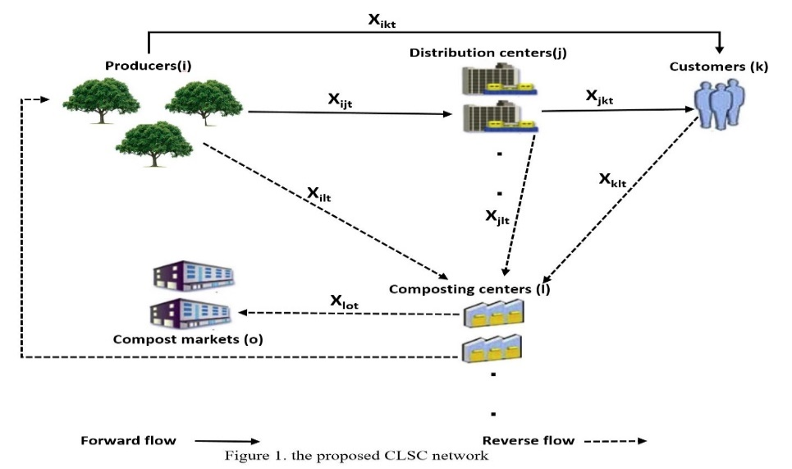

The proposed model is based on the following assumptions:

* The customers and producers (gardens) locations are predetermined and fixed.
* The initial inventory of distribution centers is zero
* In any echelon in forwarding flow, the quality of the fruits may decline and, as a result, become indespensable and can be transferred to reverse logistics.
* Customers' demands in both markets are given.
* Products shipped from gardens are considered variable because not all gardens’ products are considered on the network, and products dispatched from each of them are expected to be less than or equal to the maximum production. Other products that are not shipped from the gardens are considered to be wasteful, so they diminish financial and environmental performance.
* Disposed products are only eliminated by transferring them to landfills.

# Mathematical model

According to the problem described in the previous section, the SCLSC model includes the following indices, parameters and variables. The indices i, j, k, l, o, and t include gardens, available and candidate distribution centers, fruit customer locations, existing and candidate composting centers, compost customer locations, and periods, respectively. Model Parameters are Forward and Reverse Markets Demand, Shipping Costs, Distance between facilities, Fixed and Variable Costs, Fixed CO2 emissions due to establishing facilities, Capacity Limits of facilities, CO2 Emissions from Different echelons Activities, and CO2 Emission due to transportation. Binary and continuous decision variables are used to achieve the objectives of the mathematical model, namely determining the structure of the SSC network and the amount of product flowing along with the network.

### Indices

*i* = 1*,* 2*, . . . , I* The production locations (Gardens)

*j*1 = 1*,* 2*, . . . , J*1  The fixed points of the distribution locations

*j*2 = 1*,* 2*, . . . , J*2  The potential points of the distribution locations

*j* = 1*,* 2*, . . . ,* (*J*1+*J*2) All points of the distribution locations

*k* = 1*,* 2*, . . . ,K* The customer locations (fruit markets)

*l*1 = 1*,* 2*, . . . ,L*1  The fixed points of the compositing locations

*l*2 = 1*,* 2*, . . . ,L*2   The potential points of the compositing locations

*l* = 1*,* 2*, . . . ,* (*L*1+*L*2) All points of the composting locations

*t* = 1*,* 2*, . . . , t′, . . . , T* Time periods

*o*1 = 1*,* 2*, . . . ,O*1 The compost markets

*o*2 = 1*,* 2*, . . . ,O*2 Some of producers/ Gardens as compost customers

*o* = 1*,* 2*, . . . ,* (*O*1+*O*2) The compost customer locations

### Parameters

*fj* Fixed cost of opening a fruit distribution center *j*

*fl* Fixed cost of opening a composting center *l*

*dc* Transportation cost per unit of distance per unit of product, ($*/km.ton*)

*drr′* Distance from Location *r* to Location *r′,* (*km*)

*chjt* Holding cost per unit of inventory from distribution center *j* at Time *t,* ($*/ton*)

*cpjt* Processing and packing cost per unit of products from distribution center *j* at time *t*

*crlt* Compost manufacturing cost per unit of products from compositing center *l* at time *t*

*cp′* Production cost per unit of products

*ρ* Weight coefficient (importance) to respond to the fruit demand

*dkt* Demand for the processed product by customer *k* at time *t*

1 *− ρ* Weight coefficient (importance) to respond to the compost demand

*dot′* Demand of reprocessed product (compost) by compost market *o* at time *t*

*fej* Fixed emissions to establish (opening) distribution center *j*

*fel* Fixed emissions to establish (opening) composting center *l*

*ehj* Holding emissions in distribution center *j*

*epj* Emissions of processing and packing per unit of products from distribution center *j*

*ecl* Emission for reprocessing product in compositing center *l*

*epi′* Production emission per unit of products from producers

*de* Transportation emissions per unit of distance per unit of product

*αt* Waste percentage of the harvested product by producers at time *t*

*M* A big positive number

*λcit* Production capacity of producer *i* at time *t*

*λhj* Holding capacity of distribution center *j*

*θt* Waste percentage of the stored product by customers at time *t*

*βt* Waste percentage of the stored product by distribution centers at time *t*

*λrl* Compost manufacturing capacity of composting center *l*

*φ* Conversion rate of the fruit to compost

*wc* Destroying cost per unit of wasted fruits

*we* Destroying emissions per unit of wasted fruits

### Decision variables

*Wj* 1 If distribution center *j* is opened at the location, 0 otherwise

*Yl* 1 If composting center *l* is opened at the location, 0 otherwise

*Xrr′t* Flow of product from location *rϵ(i, j, k, l, o)* to location *r′ϵ(i, j, k, l, o)* at time *t,* (*ton*)

*Ihjt* Quantity of stored, processed products by distribution center *j* at time *t,* (*ton*)

*λit*  Quantity of production entered into the supply chain by producer *i* at time *t*

### Objective functions

The proposed mathematical model formula in SSC design is divided into two parts, namely objective functions and constraints. The proposed mathematical model has three objectives: to minimize the total cost (*Zcost*), to maximize responsiveness to customer demand (*Zresponsiveness*), and to minimize total CO2 emissions across the entire SC (*Zemission*). The mathematical formula of objective functions and constraints are described below.

#### Cost objective

Min *Zcost*= Z1 + Z2 + Z3 + Z4 + Z5



Z1 = 

Z2 = 



Z3 = 

Z4 = 

Z5 = 

 (6)

First objective function (*Zcost*) minimizes the total costs comprised of fixed costs of openning new distribution centers and composting centers at candidate locations (*Z*1), the cost of transporting the product as shown in Figure 1 (*Z*2), fruits holding cost at distribution centers (*Z*3), production cost of gardens, processing cost of distribution centers (processes related to the preparation and packaging of fruit to market) and reprocessing costs of composting centers (*Z*4), and destroying Cost of wasted fruits (*Z*5). Wasted fruits are those fruits that remain at the facility, except for inventory in distribution centers, and do not flow or be consumed in the supply chain. The mathematical formulation of the objective function is described in Eqs. (1)-(6).

#### Responsiveness objective



 (7)

The second objective function (*Zresponsiveness*) maximizes the responsiveness to customer demand in both flows which consists of two fractions that determine the percentage of demand met for the forward and reverse logistics. The first fraction dividing the amount of input flows into the customer’s areas in the forward flow by the total amount of fruit customers’ demands and the second fraction dividing the amount of input flows into the customer’s areas in the reverse flow by the total amount of compost markets demands. The maximum value of this function is when the amount of incoming streams to the customer’s areas is equal to the demands level in both streams, which is equal to 1 and is between 0 and 1. The importance of meeting customer demand in both flows (ρ and 1-ρ) can also be different. The mathematical formulation of the objective function is described in Eq. (7).

#### Carbon emission objective

Min Zemission = ZPE + ZPH + ZPR + ZPT + ZPD (8)

ZPE =  (9)

ZPH =  (10)

ZPR =  (11)

ZPT = 

 (12)

ZPD = 

 (13)

The third objective function (*Z*emission) minimizes the amount of CO2 emissions comprised fixed CO2 emissions due to establishing the new potential facilities (*ZPE*), CO2 emissions due to holding inventory (*ZPH*), CO2 emissions due to processing and reprocessing (*ZPR*), CO2 emissions due to transportation (*ZPT* ), and emission of CO2 due to destroying disposal fruits (*ZPD*). The mathematical formulation of the objective function is described in Eqs. (8)– (13).

### Constraints

The constraints of the mathematical model are given next, Eqs. (14)– (32).

 (14)

 (15)

 (16)

 (17)

 (18)

 (19)

 (20)

 (21)

 (22)

 (23)

 (24)

 (25)

 (26)

 (27)

 (28)

 (29)

 (30)

 (31)

 (32)

Constraint (14) ensures that the amount of the entered products minus the wasted amount is equal to the number of products shipped from producers to distribution centers and customers. Constraint (15) ensures that the products are shipped to a potential location only if a distribution center is opened in that location. Constraint (16) provides that the entered product of each producer is less than or equal to the anticipated maximum production rate. Constraint (17) ensures that each distribution center inventory level in each period is equivalent to the previous period inventory level plus the number of products received from producers minus the number of products shipped to customers and composting centers. Constraint (18) shows that the distribution center inventory in each period is less than or equal to the holding capacity of the distribution center. The fact that each customer’s demand in each period is greater than or equal to the number of products received from producers and distribution center is enforced by constraint (19). Constraints (20) show that the quantity of vermicompost shipped to compost markets in each period is less than or equal to the demand of each compost markets. Constraints (21) shows that the returned product shipped to composting centers from each producer is less than or equal to the waste rate of production. Constraints (22), (24), and (26) express the fact the returned products may be shipped from producers, distribution centers, and markets to a composting center only if a composting center is opened in a potential location for such facility, respectively. Similar to the constraint (21), constraint (23), and Constraint (25), confine the shipped products to the maximum capacity of the facilities. Constraint (27) ensures that all received returned product from the producers, distribution centers and customers multiplied by the conversion rate is equal to the total reprocessed product (vermicompost) sent to compost markets. Constraint (28) show that the quantity of vermicompost shipped to compost markets in each period is less than or equal to the manufacturing capacity of each compost market. Constraint (29) implies that the quantity of fruits shipped from the customer area to composting centers in each period is less than the sum of inputs to the customer area. Finally, the binary and non- negativity restrictions on the corresponding decision variables are shown in constraints (30) and (31) and (32).

# Solution method

Our problem is multi-objective, and there are various methods such as ε-constraint (Haimes et al., 1971), LP-Metric (Pasandideh et al., 2015), goal programming (Sharma et al., 2003), and evolutionary algorithms (Che and Chiang, 2010) to solve these problems. Multi-objective mathematical programming involves several conflicting objectives that must be optimized simultaneously, and there is no single optimal solution that optimizes all objective functions simultaneously. In fact, in this kind of problem, any objective can be improved without deteriorating the performance of at least one of the other objectives. These solutions are known as the Pareto optimal solutions and are obtained using a scaling methods. In this research, the LP-Metric method, known as the most popular method, and the weighted min-max (also called the weighted Tchebycheff method) are used to obtain Pareto optimal solutions. Therefore, the multi-objective problem with some parameters becomes a single-objective optimization problem. In these methods, the objective functions are combined with appropriate weights. Determining the weight of functions is a challenge. Weights (*w1*, *w2*, *w3* in this case) are determined by the decision-makers through some methods such as AHP.

The mathematical formulas of these methods for solving an multi-objective problem with three goals are shown in Eqs. (33) and (34).

* LP-Metric method

 S.t Eqs. (14)-(32) (33)

Where ,  and  are weights such that  , ,  and  are the objective functions that  and are minimizing and  is maximizing, and ,  and  are the ideal solutions. 1 *≤ p ≤ ∞*, is a norm metric that indicates the degree of emphasis on the existing deviations.

* weighted min-max method

 S.t  , , Eqs. (14)-(32) (34)

Where ,  and  are weights such that  , ,  and  are the objective functions that  and are minimizing and  is maximizing, and ,  and  are the ideal solutions or reference points.

# Results and discussion

The CLSC of fruit has been explored in a limited number of articles, such as Cheraghalipour et al. (2018). Most of the wasted fruits in the gardens, distribution centers, and fruit customers are buried and eliminated. These wasted fruits can be converted into natural fertilizer, known as compost, at the vermicomposting center, thereby reducing costs and CO2 emissions while simultaneously increasing responsiveness to compost demand. The purpose of this section is to illustrate the application of the mathematical model with a numerical example. For this purpose, a test problem is considered as follows:

Consider 9 gardens, 8 available and 5 candidate distribution centers that the best mix of them must be established to fulfill demands of the 9 fruit customers as much as possible in 8 time periods. Also, consider 8 available and 5 candidate composting centers in reverse logistics network that the best mix of them must be established to fulfill demands of the 8 compost markets that details of them are given in Table 1. The input parameters of the proposed mathematical model are obtained from the case in Cheraghalipour et al. (2018) and from Nurjanni et al. (2017), Eriksson, M., & Spångberg, J. (2017) and FAO (2015) presented in Table 2. Since it is difficult to estimate the values ​​of some parameters in the real world, the test problem assumes that some parameters follow a uniform distribution over some specific interval. The purpose of using uniform distribution is to consider a realistic model.

**Table 1. List of problem indices**

**Table 2. Model parameters tuning**

Available and potential locations of facilities were determined using the map available in Cheraghalipour et al. (2018) and distances between these locations were obtained using Google Maps are presented in Table 3, Table 4 and Table 5.

**Table 3. Distance between gardens and linked locations (km)**

**Table 4. Distance between Distribution centers and linked locations (km)**

**Table 5. Distance between composting centers and linked locations (km)**

A numerical example is solved on a computing machine with core (TM) i7, 2.60 GHz, RAM 12 GB using GAMS 24.1.2 software to validate the performance of the proposed solution methods. In Table 6, the ideal solution for each objective function was calculated before performing the computational processes using scalarization methods. The ideal (minimum) total cost is $6,38,460,while the ideal (maximum) responsiveness is 1, and also, the ideal total CO2 emission is 70,08,977kg. This ideal point is used as a reference point in solving methods. Nine different weights combinations were considered. The solutions of the test problem for different weights combinations using the LP-Metric method and the Weighted Tchebycheff method are shown in Table 7 and Table 8, respectively. Solving with the LP-metric method takes twice as long as solving with the Tchebycheff method in the problem test.

Conceptually, trade-offs between objective functions are seen as conflict relationships. This situation is in line with the solutions obtained for the test problem in which a satisfactory result in one of the objective functions results in the deterioration of the other objective functions. Also, because of the high cost and carbon dioxide emissions to establish each of the distribution centers or potential composting centers, it prefers to establish only new facilities (2 new distribution centers) if the weight of the objective function of accountability is highest (row 3 in Tables 7 and 8). The results also indicate that by increasing the weight of the environmental function, we cannot assert that the network moves towards a more green state and carbon dioxide emissions desreases. Indeed, the CO2 emission can even increase. This result may be due to the superiority of the cost-objective function over the CO2 emission function (comparing row 6 with row 8 in Tables 7 and 8).

**Table 6. Results of individual optimizations**

Two methods determined different approximations to the optimal Pareto frontier. The largest difference between the solutions from two methods are in the fourth row of Tables 7 and 8, which are: 7.5% in cost, 35% in responsiveness and 4.9% in carbon dioxide emissions. The LP-Metric method cannot obtain the optimal Pareto frontier in non-convex regions. In contrast, solutions in non-convex regions can be obtained by the Tchebycheff method. Instead, the weighted Tchebycheff method does not make sure that all the solutions found are Pareto optimal.

**Table 7. Pareto-solutions with LP-Metric method**

**Table 8. Pareto-solutions with weighted Tchebycheff method**

# Conclusions

This research has developed a mathematical model for a five echelon sustainable closed-loop fruit supply chain network consisting of gardens, distribution centers and fruit customers in forward logistics, and composting centers and compost markets in reverse logistics. The problem was first formulated as a mixed-integer mathematical model with three conflicting objectives, including minimizing supply chain network total costs, minimizing CO2 emissions from different network activities, and maximizing responsiveness to customers’ demands in each market. The proposed model was converted into a single-objective function using the LP-Metric method and weighted Tchebycheff method and solved with different weights by GAMS software. The existence of Pareto optimal solutions confirms the validity of the model.

Although both proposed methods yielded Pareto optimal solutions, the Tchebycheff method was faster than the LP-Metric method. There are also differences between the solutions of two methods up to 7.5% in cost, 35% in responsiveness, and 4.9% in carbon dioxide emissions, which can be related to the non-convex area of the Pareto frontier. Moreover, by icreasing the environmental target function weight, we can not necessarily claim that emissions decrease and it may even increase due to higher impact of the cost target function.

The present study is limited to fruits and the inventory is considered at the distribution centers only. The study also considers only one type of transport. There are some potential directions for future work. This research can be generalized to other products that are close to the fruits, such as vegetables. The model can also be solved by considering the uncertainty in demand and return rate. Other methods of solving multi-objective optimization problems such as augmented Weighted Tchebycheff and ԑ-constraint methods can also be used. Since our model is NP-hard, solving this model for large problems requires the use of specific algorithms such as genetics and Scatter Search, because it is hard to solve large problems in a reasonable time. Finally, using models in real cases and analyzing results will be very valuable.

# References

Ahumada, O., & Rene Villalobos, J. (2009), "Application of planning models in the agri-food supply chain: a review", *European Journal of Operational Research*, Vol. 195, pp. 1–20.

Amoozad Mahdiraji, H., Shateri, H., Beheshti, M., & Mokhtarzadeh, N.G. (2019). A Comparison of Buyback, Rebate and Flexible Contracts in a Seller-Buyer Supply Chain. *Transformations in Business & Economics*, Vol. 18, No 1, pp.109-127.

Amoozad Mahdiraji, H., Turskis, Z., Jafarnejad, A., & Rezayar, A. (2019). Non-cooperative two-echelon supply chains with a focus on social responsibility. *Technological and Economic Development of Economy*, *25*(6), 1162-1187.

Amorim, P., Günther, H. O., & Almada-Lobo, B. (2012), "Multi-objective integrated production and distribution planning of perishable products", *International Journal of Production Economics*, Vol. 138, pp. 89–101.

[Aramyan, L., Hoste, R., van den Broek, W., Groot, J., Soethoudt, H., Nguyen, T.L.,](http://refhub.elsevier.com/S0925-5273(16)30191-8/sbref5) [Hermansen, J., & van der Vorst, J. (2011), "Towards sustainable food production: a](http://refhub.elsevier.com/S0925-5273(16)30191-8/sbref5) [scenario study of the European pork sector", *Journal on Chain and Network Science*, Vol. 11, pp. 177–189.](http://refhub.elsevier.com/S0925-5273(16)30191-8/sbref5)

Audsley, E., & Sandars, D. L. (2009), "A review of the practice and achievements from 50 years of applying OR to agricultural systems in Britain", *OR Insight*, Vol. 22, No. 1, pp. 2–18.

Banasik, A., Kanellopoulos, A., Claassen, G. D. H., Bloemhof-Ruwaard, J. M., & van der Vorst, J. G. A. J. (2017), "Closing loops in agricultural supply chains using multi-objective optimization: A case study of an industrial mushroom supply chain", *International Journal of Production Economics*, Vol. 183, pp. 409-420.

Brodheim, E., Derman, C., & Prastacos, G. (1975), "On the Evaluation of a Class of Inventory Policies for Perishable Products Such as Blood", *Management Science*, Vol. 21, pp.1320–1325.

Catala´, L. P., Durand, G. A., Blanco, A. M., & Bandoni, J. A. (2013), "Mathematical model for strategic planning optimization in the pome fruit industry", [*Agricultural Systems*](https://www.sciencedirect.com/science/journal/0308521X), Vol. 115, pp. 63–71.

Che, Z.H., Chiang, C.J. (2010), "A modified Pareto genetic algorithm for multi-objective build-to-order supply chain planning with product assembly", *Advances in Engineering Software,* Vol. 41, No. 7–8, pp. 1011–1022.

Cheraghalipour, A., Paydar, M. M., & Hajiaghaei-Keshteli, M. (2018), "A Bi-objective Optimization for Citrus Closed-Loop Supply Chain Using Pareto-Based Algorithms", *Applied Soft Computing*, Vol. 69, pp. 33-59.

Dehghanian, F., & Mansour, S. (2009), "Designing sustainable recovery network of end-of-life products using genetic algorithm. Resources", *conservation and recycling*, Vol. 53, pp. 559-70.

[Dekker, R., Bloemhof, J., & Mallidis, I. (2012), "Operations Research for green logistics -](http://refhub.elsevier.com/S0925-5273(16)30191-8/sbref12) [an overview of aspects, issues, contributions and challenges", *European Journal of Operational Research,* Vol. 219, pp. 671](http://refhub.elsevier.com/S0925-5273(16)30191-8/sbref12)–[679.](http://refhub.elsevier.com/S0925-5273(16)30191-8/sbref12)

Easwaran, G. and Üster, H., (2010), "A closed-loop supply chain network design problem with integrated forward and reverse channel decisions", *Iie Transactions*, Vol. 42, No. 11, pp.779-792.

[El korchi](https://www.sciencedirect.com/science/article/pii/S0959652610004476#!), A., & Millet, D. (2011), "Designing a sustainable reverse logistics channel: the 18 generic structures framework", *Journal of Cleaner Production*, Vol. 19, pp. 588-597.

Eriksson, M., & Spångberg, J. (2017), "Carbon footprint and energy use of food waste management options for fresh fruit and vegetables from supermarkets", *Waste Management*, Vol. 60, pp. 786-799.

Etemadnia, H., Goetz, S. J., Canning, P., & Tavallali, M. S. (2015), "Optimal wholesale facilities location within the fruit and vegetables supply chain with bimodal transportation options: An LP-MIP heuristic approach", *European Journal of Operational Research*, Vol. 244, pp. 648–661.

FAO, (2011), "Global food losses and food waste - extent, causes and prevention", SAVE FOOD an Initiat. Food Loss Waste Reduct 37, Food and Agriculture Organization of the United Nations, Rome, available at: <https://doi.org/10.1098/rstb.2010.0126>.

FAO, (2013), "Food Wastage Footprint; Impacts on Natural Resources", Food and Agriculture Organization of the United Nations, Rome.

FAO, (2015), "Food Wastage Footprint & Climate Change", UN FAO, Rome.

Fernández-González, J.M., Grindlay, A.L., Serrano-Bernardo, F., Rodríguez-Rojas, M.I. and Zamorano, M. (2017). Economic and environmental review of Waste-to-Energy systems for municipal solid waste management in medium and small municipalities, *Waste Management*, Vol. 67, pp.360–374.

[Fleischmann, M., Bloemhof-Ruwaard, J. M., Dekker, R., van der LAAN, E., van Nunen,](http://refhub.elsevier.com/S0925-5273(16)30191-8/sbref15) [J. A. E. E., & van Wassenhove, L. N. (1997), "Quantitative models for reverse logistics: a](http://refhub.elsevier.com/S0925-5273(16)30191-8/sbref15) [review", *European Journal of Operational Research*, Vol. 103, pp. 1–17.](http://refhub.elsevier.com/S0925-5273(16)30191-8/sbref15)

Flapper, S. D. P., van Nunen, J. A. E. E., & van Wassenhove, L. N., (2005), "Managing Closed- loop Supply Chains", New York: Springer.

Ghaffarinasab, N., Motallebzadeh, A., Jabarzadeh, Y., Y. Kara, B. (2018). Efficient simulated annealing based solution approaches to the competitive single and multiple allocation hub location problems. *Computers & Operations Research*, Vol. 90, pp. 173-192.

[Girotto, F., Alibardi, L., & Cossu, R. (2015), "Food waste generation and industrial uses: a](http://refhub.elsevier.com/S0925-5273(16)30191-8/sbref16) [review", *Waste Management,* Vol. 45, pp. 32](http://refhub.elsevier.com/S0925-5273(16)30191-8/sbref16)–[41.](http://refhub.elsevier.com/S0925-5273(16)30191-8/sbref16)

Godfray, H.C.J., Garnett, T., (2014), "Food security and sustainable intensification", *Phil. Trans. R. Soc. B*., Vol 369, 1639.

Guide, V., Harrison, T., & Van Wassenhove, L. (2003), "The Challenge of Closed-Loop Supply Chains". *Interfaces*, Vol. 33, No. 6, pp. 3-6.

Haimes Y.Y, Lasdon, L.S, Wismer D.A. (1971), "On a bi-criterion formulation of the problems of integrated system identification and system optimization", *IEEE Transactions on Systems, Man, and Cybernetics*, Vol. 1, pp. 296–297.

[Hassini, E., Surti, C., & Searcy, C. (2012), "A literature review and a case study of sustainable supply chains with a focus on metrics", [*International Journal of Production Economics*,](https://www.journals.elsevier.com/international-journal-of-production-economics) Vol. 140, pp. 69](http://refhub.elsevier.com/S0925-5273(16)30191-8/sbref19)–[82.](http://refhub.elsevier.com/S0925-5273(16)30191-8/sbref19)

Hatefi, S.M. and Jolai, F. (2014), "Robust and reliable forward–reverse logistics network design under demand uncertainty and facility disruptions", *Applied Mathematical Modelling*, Vol. 38, No. 9-10, pp. 2630-2647.

[Jayaraman, V. (2006), "Production planning for closed-loop supply chains with product recovery and reuse: an analytical approach", [*International Journal of Production Research*](https://www.tandfonline.com/tprs20), Vol. 44, pp. 981](http://refhub.elsevier.com/S0925-5273(16)30191-8/sbref20)–[998.](http://refhub.elsevier.com/S0925-5273(16)30191-8/sbref20)

Kannan, D., Diabat, A., Alrefaei, M., Govindan, K., & Yong, G. (2012), "A carbon footprint based reverse logistics network design model", *Resources, conservation and recycling*, Vol. 67, No. 7, pp. 5-9.

Krikke, H., Hofenk, D., & Wang, Y. (2013), "Revealing an invisible giant: A comprehensive survey into return practices within original (closed-loop) supply chains", *Resources, Conservation and Recycling*, Vol. 73, pp. 239–250.

Lucas, M. T., & Chhajed, D. (2004), "Applications of location analysis in agriculture: a survey", *Journal of the Operational Research Society*, Vol. 55, No. 6, pp. 561–578.

Mangla, S.K., Luthra, S., Mishra, N., Singh, A., P. Rana, N., Dora, M., Dwivedi, Y. (2018). Barriers to effective circular supply chain management in a developing country context*, Production Planning & Control*, Vol. 29, No. 6, pp. 551-569.

[Mirabella, N., Castellani, V., & Sala, S. (2014), "Current options for the valorization of](http://refhub.elsevier.com/S0925-5273(16)30191-8/sbref26) [food manufacturing waste: a review", *Journal of Cleaner Production*, Vol. 65, pp. 28-41.](http://refhub.elsevier.com/S0925-5273(16)30191-8/sbref26)

Mula, J., Poler, R., Garc´ıa-Sabater, J. P., & Lario, F. C. (2006), "Models for production planning under uncertainty: a review", [*International Journal of Production Economics*,](https://www.journals.elsevier.com/international-journal-of-production-economics) Vol. 103, pp. 271-285.

Nadal-Roig, E., & Plà-Aragonés, L. M. (2015), "Optimal Transport Planning for the Supply to a Fruit Logistic Centre" In Plà-Aragonés, L. (eds). Handbook of Operations Research in Agriculture and the Agri-Food Industry, Vol. 224, pp. 163-177. New York, NY: Springer.

Nurjanni, K. P., Carvalho, M., & Costa, L. (2017), "Green supply chain design: A mathematical modeling approach based on a multi-objective optimization model", *International Journal of Production Economics*, Vol. 183, Part B, pp. 421-432.

Osvald, A., & Stirn, L. Z. (2008), "A vehicle routing algorithm for the distribution of fresh vegetables and similar perishable food", [*Journal of Food Engineering*,](https://www.journals.elsevier.com/journal-of-food-engineering) Vol. 85, pp. 285-295.

Özkɪr, V., & Başlɪgil, H. (2012), "Multi-objective optimization of closed-loop supply chains in uncertain environment", *Journal of Cleaner Production*, Vol. 41, pp. 114-125.

Ramezani, M., Bashiri, M., Tavakkoli-Moghaddam, R. (2013), "A new multi-objective stochastic model for a forward/reverse logistic network design with responsiveness and quality level", *Applied Mathematical Modelling*, Vol. 37, pp. 328-344.

[Ramudhin, A., Chaabane, A., & Paquet, M. (2010), "Carbon market sensitive sustainable](http://refhub.elsevier.com/S0925-5273(16)30191-8/sbref33) [supply chain network design", *International Journal of Management Science and Engineering Management*, Vol. 5, pp. 30-38.](http://refhub.elsevier.com/S0925-5273(16)30191-8/sbref33)

Sarker, R., & Ray, T. (2009), "An improved evolutionary algorithm for solving multiobjective crop planning models", *Computers and Electronics in Agriculture*, Vol. 68, pp. 191-199.

Sharma, D.K., Ghosh, D., Mattison, D.M. (2003), "An application of goal programming with penalty functions to transhipment problems", *International Journal of Logistics: Research and Applications*, Vol. 6, pp. 125–136.

[Sharma, Y.](https://www.emerald.com/insight/search?q=Yogesh%20Kumar%20Sharma), [Mangla, S.](https://www.emerald.com/insight/search?q=Sachin%20Kumar%20Mangla), [Patil, P.](https://www.emerald.com/insight/search?q=Pravin%20P.%20Patil) and [Liu, S.](https://www.emerald.com/insight/search?q=Shaofeng%20Liu) (2019). "When challenges impede the process: For circular economy-driven sustainability practices in food supply chain", [*Management Decision*](https://www.emerald.com/insight/publication/issn/0025-1747), Vol. 57, No. 4, pp. 995-1017.

Shukla, M., & Jharkharia, S. (2013), "Agri‐fresh produce supply chain management: a state of the art literature review", *International Journal of Operations & Production Management*, Vol. 33, No. 2, pp. 114-158.

Soto-Silva, W. E., Nadal-Roig, E., González-Araya, M. C., & Pla-Aragones, L. M. (2016), "Operational research models applied to the fresh fruit supply chain", *European Journal of Operational Research*, Vol. 251, No. 2, pp. 345–355.

[Stindt, D., & Sahamie, R. (2014), "Review of research on closed loop supply chain](http://refhub.elsevier.com/S0925-5273(16)30191-8/sbref39) [management in the process industry", [*Flexible Services and Manufacturing Journal*,](https://www.researchgate.net/journal/1936-6582_Flexible_Services_and_Manufacturing_Journal) Vol. 26, pp. 268-293.](http://refhub.elsevier.com/S0925-5273(16)30191-8/sbref39)

Stock, J. R., Mulki J. P. (2009), "Product returns processing: an examination of practices of manufactures, wholsalers/distributers, and retailers", *Journal of Business Logistics*, Vol. 30, pp. 33-62.

Tsolakis, N. K., Keramydas, C. A., Toka, A. K., Aidonis, D. A., & Iakovou, E. T. (2014), "Agrifood supply chain management: A comprehensive hierarchical decision-making framework and a critical taxonomy", [*Biosystems Engineering*](https://www.journals.elsevier.com/biosystems-engineering), Vol. 120, pp. 47–64.

Verdouw, C. N., Beulens, A. J. M., Trienekens, J. H., & Wolfert, J. (2010), "Process modelling in demand-driven supply: A reference model for the fruit industry", *Computers and Electronics in Agriculture*, Vol. 73, pp. 174–187.

Wang, F., Lai, X., & Shi, N. (2011), "A multi-objective optimization for green supply chain network design", *Decision Support Systems*, Vol. 51, No. 2, pp. 262-269.

Xiong, Y., Zhao, P., Xiong, Z., Li, G. (2016). The impact of product upgrading on the decision of entrance to a secondary market. *European Journal of Operational Research,* Vol. 252, No. 2, pp.443–454.

[Ziolkowska, J. R. (2014), "Optimizing biofuels production in an uncertain decision](http://refhub.elsevier.com/S0925-5273(16)30191-8/sbref43) [environment: conventional vs. advanced technologies", [*Applied Energy*,](https://www.journals.elsevier.com/applied-energy) Vol. 114,](http://refhub.elsevier.com/S0925-5273(16)30191-8/sbref43) pp. [366](http://refhub.elsevier.com/S0925-5273(16)30191-8/sbref43)-[376.](http://refhub.elsevier.com/S0925-5273(16)30191-8/sbref43)

Zhang, W., & Wilhelm, W. E. (2011), "OR/MS decision support models for the specialty crops industry: a literature review", *Annals of Operations Research*, Vol. 190, No. 1, pp. 131–148.

Paksoy, T., Özceylan, E., & Weber, G. W. (2010), "A multi objective model for optimization of a green supply chain network", *AIP Conference Proceedings*, Vol. 311.

Pasandideh, S.H.R., Akhavan niaki, S.T., Asadi, K. (2015), "Optimizing a bi-objective multi-product multi-period three echelon supply chain network with warehouse reliability", *Expert Systems with Applications*, Vol. 42, pp. 2615–2623.

Pishvaee, M. S., Kianfar, K., Karimi, B. (2010), "Reverse logistics network design using simulated annealing", *The International Journal of Advanced Manufacturing Technology*, Vol. 47, pp. 269-281.

Pishvaee, M. S., Jolai, F., & Razmi, J. (2012), "A stochastic optimization model for integrated forward/reverse logistics network design", *Journal of Manufacturing Systems*, Vol. 28, No. 4, pp. 107-114.

Piyathanavong, V., Garza-Reyes, J.A., Kumar, V., Maldonado-Guzm_an, G., Mangla, S.K., (2019). The adoption of operational environmental sustainability approaches in the Thai manufacturing sector. *Journal of Cleaner Production,* Vol. 220, pp. 507-528.

Table 1. List of problem indices

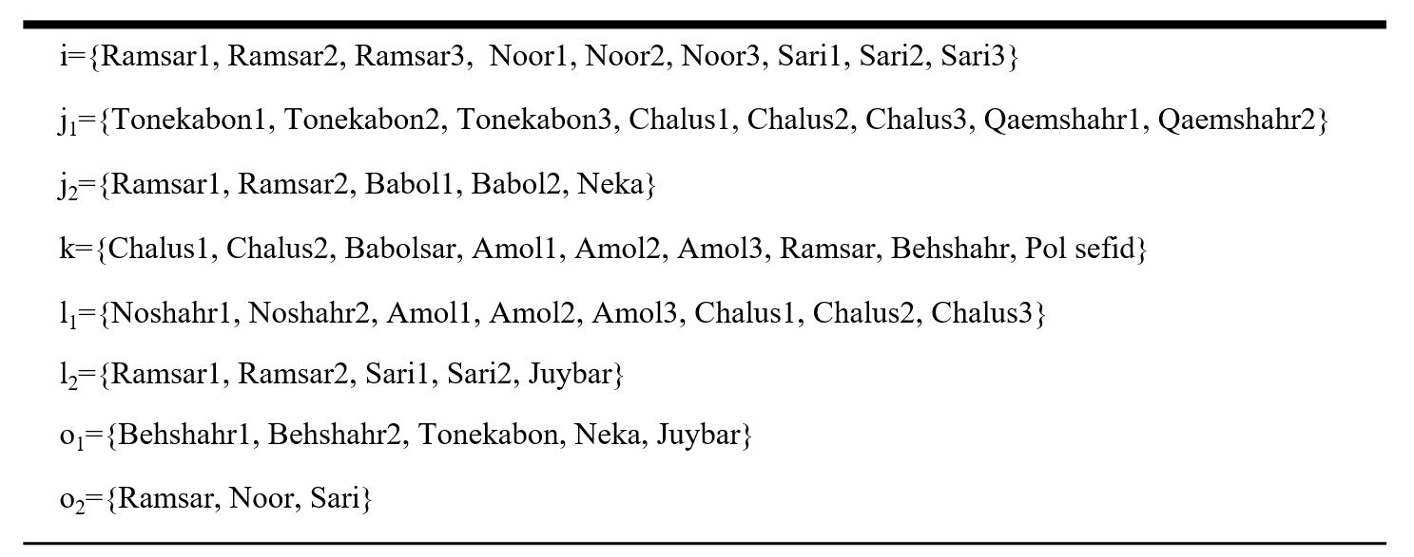

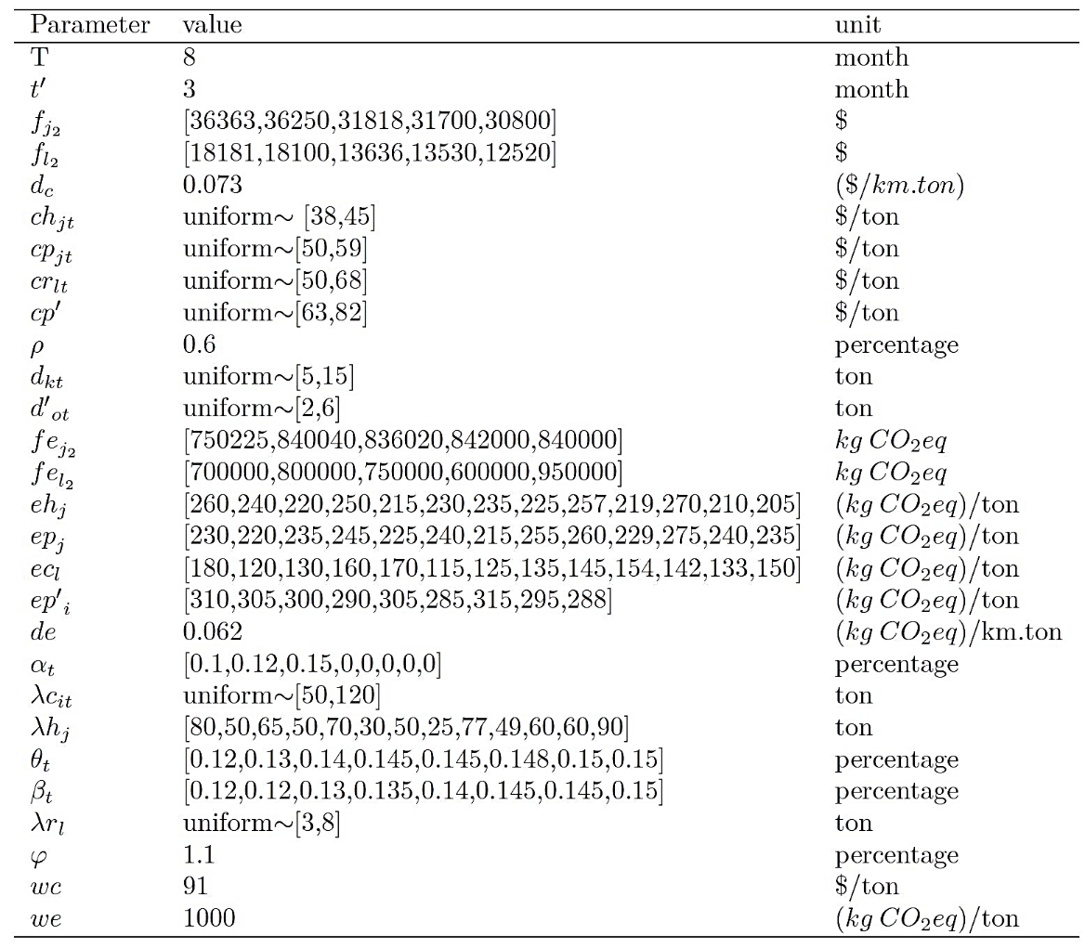

Table 2. Model parameters tuning

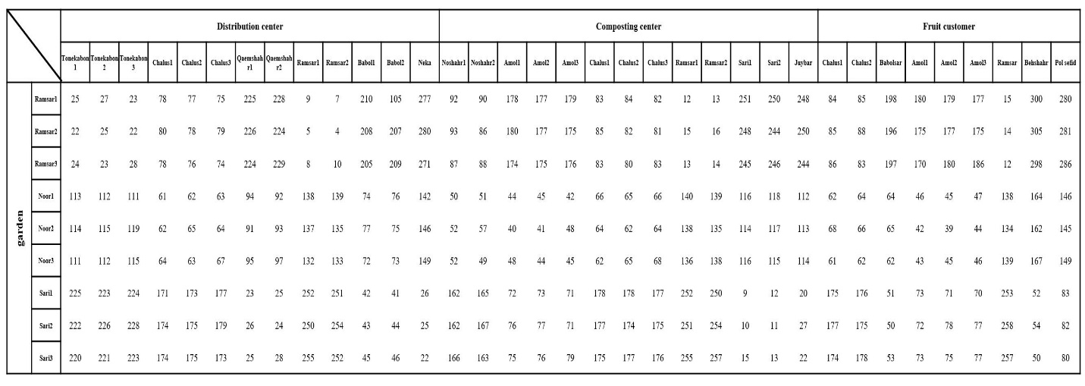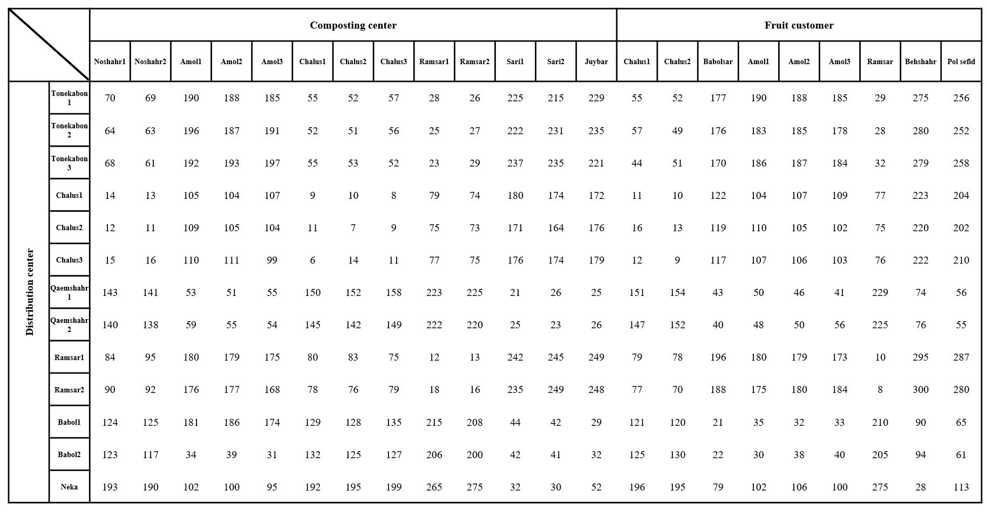

Table 3. Distance between gardens and linked locations (km)

Table 4. Distance between Distribution centers and linked locations (km)

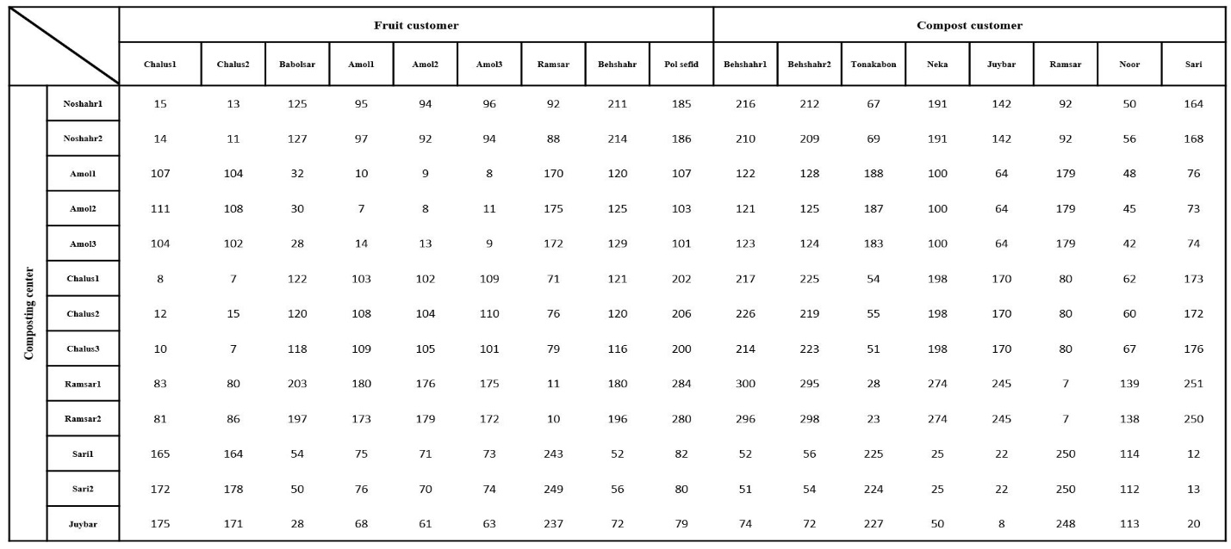

Table 5. Distance between composting centers and linked locations (km)

Table 6. Results of individual optimizations

|  |  |  |  |
| --- | --- | --- | --- |
|  | *Zcost\** ($) | *Zresponsiveness* * (Persentage) | *Zemission* * (kg CO2-eq) |
| *Zcost* | **638460** | 0.000 | 7016042 |
| *Zresponsiveness* | 1156782 | **1.000** | 16298450 |
| *Zemission* | 641878 | 0.065 | **7008977** |

Table 7. Pareto-solutions with LP-Metric method

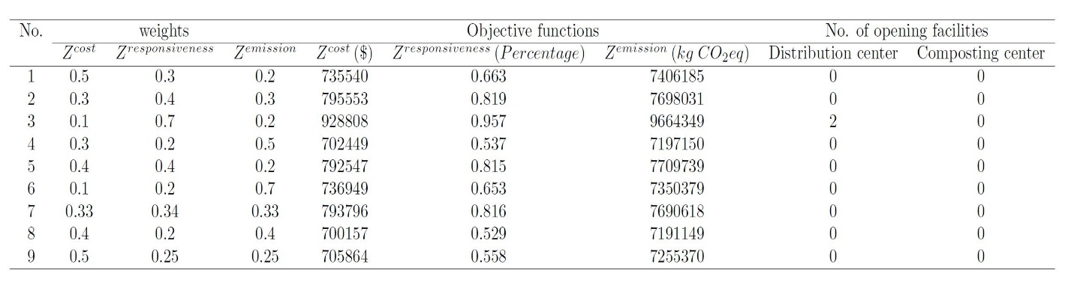

Table 8. Pareto-solutions with weighted Tchebycheff method

