BIALL Article 2019

Alive and Kicking: Reflections on the Evolving Role of Subject Support Librarians at UWE Bristol

Biography
Sue Shreeve and Julie Hamley job-share the role of Business and Law Faculty Librarian at the University of the West of England Bristol, a post-1992 university catering for approximately 3000 students. In this capacity, they manage a team of five Business and Law Librarians, supporting business and law students’ information and academic skills development by means of face-to-face teaching sessions and technology-enhanced learning resources. They also oversee the maintenance and development of a balanced collection of print and electronic materials to support law and business teaching and research. Liaison with academic colleagues ensures a responsive and integrated library service to the Faculty of Business and Law. Prior to this, Sue worked at Integreon Managed Solutions Ltd and at Osborne Clarke solicitors, having gained a professional library qualification from the University of Bristol (2003). Sue joined UWE in 2012. Julie gained a Postgraduate Diploma in librarianship from the University of Wales (1997). Starting her career as a graduate trainee working for Oxfordshire County Council, after various roles she moved to Bristol Polytechnic in 1989. In 1992 Julie was appointed Subject Librarian for Law and in 2010 Business and Law Faculty Librarian.

Abstract
In this article Sue Shreeve and Julie Hamley give an over-view of how the subject support librarian role at UWE Bristol has evolved over the last five years, broadening from subject information specialist to encompass academic skills support and English language/communication skills support. They outline how they have implemented this change in role profile by evolving the skills set of the subject librarians and share some of the student online learning materials that have been created during this evolution in role.

Article

UWE’s Regional Identity
The University of the West of England, Bristol is a large and modern university offering over six hundred undergraduate, postgraduate, professional and short courses. ​There are approximately thirty thousand students (twenty two thousand undergraduates) and nearly four thousand staff across four campuses.​
​UWE Bristol’s core purpose is ‘advancing knowledge, inspiring people and transforming futures’.​ Our focus is providing high quality teaching and research with real world impact.​
- We achieved 89% student satisfaction in the last National Student Survey which makes us the top University in the South West for student satisfaction.​
- Over 95% of our graduates are in work or further study after 1 year​
- We achieved gold rating in the Teaching Excellence Framework (TEF) 2018.

Strategic Context – Driving the Role Evolution
The evolution of the subject librarian role is very much determined from the top by UWE’s strategic priorities which include:

- Outstanding learning​
- Ready and able graduates​

One of UWE Library Services’ strategic goals that aligns with these university level priorities is ​‘to enable learners to become independent and confident and to achieve their full potential in respect of academic achievement and employment’​.

This strategic goal defines the Library Services key priorities and thus determines what we do in practical terms:
- Enable the embedding of academic, employability and enterprise skills in the curriculum, enhanced by an extra curricula offer.​
Our approach is to embed academic skills support at appropriate points in the programme, targeting key modules and aligning with skills need/assignment. We drip feed support to scaffold skills development.​ Some support is via face-to-face teaching, some online and the subject support librarian play a key role in both development and delivery.

- ‘Empower our student community to articulate and evidence their skills and expertise in relation to their future ambitions’.​
An example of how this translates into practice is our new approach to skills support for our international students with the introduction of our language and academic culture programme which we call ‘Communication Skills for International Students’ (CSIS). Again the subject support librarians are key to the success of this programme.

- Work in partnership to create and offer accessible and inclusive opportunities.​
We work in close partnership with our academic colleagues to develop, embed and promote engagement with relevant face-to-face and online skills support.​

Evolution of the Subject Support Librarian Role

​Figure 1: Evolution of Role 2015-2017
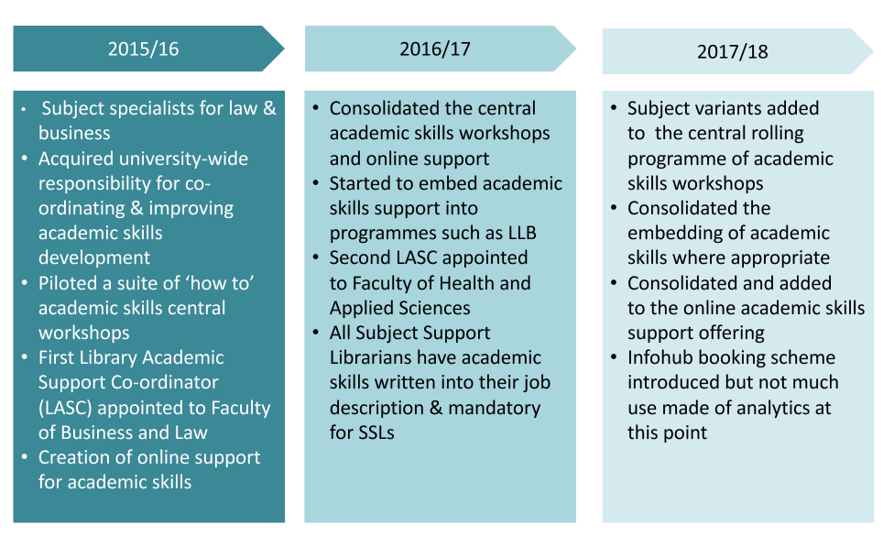

Pre-2015/16
Prior to 2015/16, the focus of UWE’s subject librarian role was as information specialists for law and business, supporting students to develop information and evaluation skills in the information literacy context​. It included face-to-face and online information skills support in addition to collection management, negotiation with suppliers and help desk duties.

2015/16
In 2015/16 UWE Library Services acquired university wide responsibility for co-ordinating and improving academic skills, in addition to information skills. Academic skills might include aspects of planning and structuring an assignment, reading and note taking, or critical thinking and writing​. It made logical sense to wrap these skills together with the information literacy skills of finding, evaluating and managing resources. Nevertheless this was a step change and a different message to the wider university​.

To facilitate this, at the same time, the University’s former English Language and Academic Support unit closed and was incorporated into Library Services, bringing two English for Academic Purposes (EAP) lecturers into the library team with their essential English language expertise.​

Working closely with the EAP lecturers, a small team of library staff (volunteers initially) began to develop a central offering of 1.5 hour face-to-face academic skills workshops which students could sign up to attend. For example:​

- How to put your reading into your writing​
- How to get started with critical writing​
- How to reference and avoid plagiarism​

Workshops were delivered by teachers working in pairs, one EAP lecturer and one subject support librarian​. The team also developed a limited amount of online support and started to promote this and embed it on UWE’s Virtual Learning Environment.
​
A new role was created within Library Services, the Library Academic Support Coordinator (LASC), following conversion of posts and a successful funding bid. The full time role was embedded within two faculty librarian teams, with an aspiration to employ one for each of the four faculty teams in the future. ​ It is perhaps important to note that the new role still sits below the Faculty Librarian within the Library Services staff structure. The Faculty Librarian role (our role) manages, co-ordinates and takes the strategic lead for embedding skills support. The person specification for the role notably had qualified librarian as desirable not essential. A teaching qualification was essential. While it was not essential to have an EAP or librarianship qualification there was an expectation that the successful candidate would be qualified in one of those two areas and would undertake qualification in the future in whichever area they were lacking. The first appointment was a librarian who went on to gain an EAP qualification in his first year.​
​

2016/17​
During this year we consolidated our central academic skills offering. More ‘How to …’ workshops were added and more online support was created​. Delivery of the central academic skills workshops was rolled out across all the subject support librarians and academic skills support delivery was written into the subject support librarian job descriptions so that delivery was mandatory for all. A lot of training and support was required to facilitate this change, which we outline a little later in this article.

We began to embed some aspects of academic skills support within the curriculum. We presented a lightening talk at the 2017 BIALL Conference in relation to our embedding of academic skills support within the undergraduate law degree programme.​

We appointed a second Library Academic Support Coordinator. She didn’t have a library qualification but was EAP qualified and had also worked in para-legal role so had a lot of information skills experience.​

Figure 2: Evolution in Role 2018-2020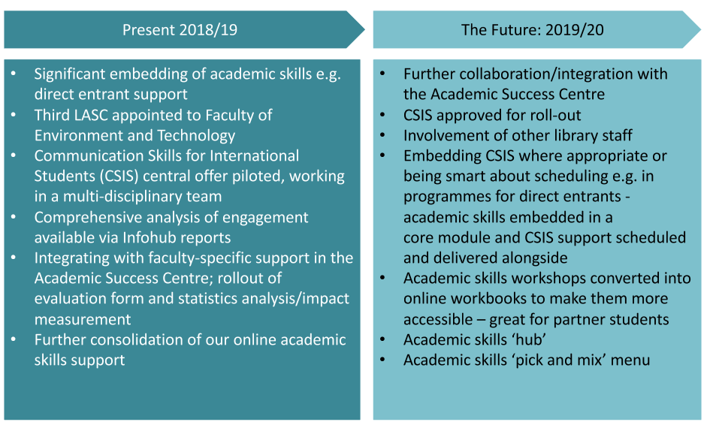

2017/18​
Subject variants of academic skills support were added to the central programme where appropriate, for example ‘Writing for law’.​ We also consolidated the embedding of academic skills support into the curriculum where appropriate. For example we run a 2 hour workshop in semester 2 for criminal law students each year and in 2017/18 some aspects of academic skills content were woven into it alongside the legal information skills elements. ​

We extended our online study skills support offer, working closely with faculty colleagues to co-create online workbook support. For example we created a Poster Presentations workbook and added faculty ‘talking heads’ to our Reflective Writing Workbook. An Assignment Planner and Prepare for Study workbook followed.

A central web based ‘Infohub’ booking scheme for the academic skills ‘How to …’ workshops was introduced, but not much use was made of the analytics at this point. This is the same booking system that is used by other university events so that UWE students have all their support and events listed in just one place.

2018/19 (The Present)​
So how do things currently stand?​ There has been significant further embedding of academic skills support within the curriculum. For example we trialled embedding information and academic skills support for Business direct entrants and for the Business and Management undergraduate students for the first time in September 2019. In both cases the support was well received.
​
In January 2019 a third Library Academic Support Coordinator was appointed, so only one of our faculties is still without this role. This time we appointed a librarian with Teaching English as a Foreign Language (TEFL) qualifications. ​
​
Communication Skills for International Students (CSIS) workshops were added to our central offer as a pilot during 2018/19, with a limited but growing number of workshops. These workshops were created and delivered in multi-disciplinary teams with subject librarians, EAP lecturers and LASCs all working together. Again the subject support librarians involved were volunteers at this point.​ Workshops include: ​
- Common Grammatical Errors
- Sentence Structure
- Using Academic Writing Style
- English for Business
​
We were concerned about our capacity to offer these increasing levels of support. By 2018/19, in theory less collection management input was required from the library subject teams. Online reading lists had been introduced and were largely driving collection management and there was increasing Patron Driven Acquisition. The Collections team were also taking more of a lead in subscription negotiations. In the longer term this should give subject teams more capacity for CSIS support. For us, as Faculty Librarians, at present during this transition phase we’ve not yet relinquished responsibility for this area and are concluding that we will always have a role. Subject team liaison with faculty colleagues over reading lists is also likely to continue as the focus shifts to improve the quality of online reading lists rather than simply to ensure that they exist. However, we are hopeful that mainstream collections matters will increasingly be picked up by Collections colleagues.​
​
Detailed analysis of student engagement with our comprehensive centralised offer is now available via Infohub reports. Detailed statistics on engagement are available, for example by programme/gender/BAME characteristics. For example, we were able to see that there has been a 26% increase in attendance at central academic skills workshops between autumn 2017 and autumn 2018. This allows us to target our promotion and informs future practice in terms of which workshops we run and when, and highlights programmes where students are less engaged with the academic skills offer. In some cases a lack of engagement with the central offer may be because we have support embedded within the programme.​

During 2018/19 we've also been integrating with, and increasing collaboration with, faculty-specific support. At UWE Bristol there is a Business and Law Academic Success Centre (ASC), wholly funded by the faculty. We're starting to work more closely with the Academic Support Lecturers (ASLs) in the ASC, at times team-teaching and ensuring that we avoiding duplication of teaching. We're also aligning our processes, for example:
​
- Promotion of our teaching sessions e.g. via social media​
- Rolling out the same evaluation/feedback form across all teaching so that we can demonstrate impact​
- Making all bookings via Infohub so that we can statistically analyse engagement across all teaching via Infohub reports ​
- Creating a central document storage area for sharing teaching material​

This will very much be a focus of our energies in 2019/20 too.​
​
There has also been further consolidation of our online academic skills support with the addition of a Literature Review Workbook.
​

Underpinning Staff Skills Development
In terms of evolving the skills set of the business and law librarians to implement this change, we’ve had to recognise that we can’t do everything all at once. There has had to be a gradual, strategic integration of skills and an incremental build of expertise commensurate with grade roles and duties.​
​
Understandably some staff have been anxious, feeling that they are information professionals and unqualified to offer support in these new areas. We’ve needed to upskill library staff, recognising that this is a huge culture change and that we are often operating outside our comfort zone. Both training and confidence-building have been necessary. ​
​
Some of the steps that we have taken to address this are:​
​
- Investment in staff upskilling by external course:​
- Teaching English for Academic Purposes (TEAP) course​
- Certificate in English Language Teaching to Adults (CELTA) - the essential TEFL qualification that’s trusted by employers, language schools and governments around the world.​
​
- Staff upskilling by compulsory internal training in academic skills, monitored as part of the annual Performance Development Review process. There is a UWE Library Services Internal Training Matrix which shows all potential internal training courses, some of which are compulsory within a certain time frame while others are desirable. Academic skills training sessions delivered by EAP lecturers are part of this matrix. e.g. ‘An Approach to Written Grammar’, ‘Classroom Management Techniques‘ and ‘Analysing Student Writing’.​
​
- Multidisciplinary teams and team teaching/buddying was essential to build confidence. Our subject librarians found team teaching with the EAP lecturers particularly helpful and that gave them the confidence to move on to teaching alone.​
​
- We’ve also been instilling a coaching approach at all levels, with staff encouraged to form coaching triads to practice this approach and to work through any issues or concerns.
​
Our ongoing recruitment now always references the need for academic skills, so that increasingly those recruited have this skills set.​ We will need to ensure that training budgets remain healthy so that we are able to offer staff the support that they need as they develop in these new areas of expertise.

The Future
Many of our present activities are signalling developments for 2019/20 such as more collaborative teaching with the ASLs in the ASC, taking an integrated approach and recognising each other’s skill sets​.
​
The CSIS programme has been approved for roll out, so it will be mainstreamed into our offer. There is now an expectation that all subject librarians will participate in delivery (previously a small team of volunteers participated in the pilot) but it is not yet mandatory/written into roles.​
​
We will also be working towards embedding CSIS where appropriate or (because of resource constraints) becoming smarter about scheduling the central workshops. For example, in the ‘top up’ programmes for our international direct entrants next year we will be embedding academic skills support in their core 'Academic and Professional Development' module and the central CSIS sessions will sit alongside, scheduled to avoid key lecture clashes with those programmes. We're also considering delivering some sessions in the Business School rather than in the library to encourage engagement.​
​
We will be developing our academic skills support offer for overseas partners via more online workbooks and webinar/conferencing technological solutions. For example, we are in the process of converting our academic skills ‘How to ...’ workshops into interactive online workbooks which will open up that support to our partners​.
​
As a senior management team we have talked about the concept of an academic skills 'hub', with the Library Service essentially being the hub. Currently we are exploring ways to make that happen virtually. It may lead to a physical space change …. or not.​
​

Conclusion
Prompted by UWE’s strategic priorities, this evolution of the UWE subject support librarian role means that we now have an excellent information and academic skills offer. There is effectively a menu (a ‘pick and mix’ approach) of embedded or central support, covering information skills, academic skills, and English language and academic culture. This forms a basis from which to negotiate with faculty colleagues when they are looking to embed support for their students and we can tailor our offer of support to meet their students’ needs. With effective training and support, the subject support librarians continue to increase in confidence and expertise in their new roles. We have no doubt that their evolving roles will continue to support the success of UWE students in the years to come.

References (OSCOLA)
UWE Bristol ‘Assignment Planner’ <https://academicskills.uwe.ac.uk/general/workbooks/assignment-planner> accessed 16 September 2019
UWE Bristol ‘Creating Academic Posters Workbook’ <https://academicskills.uwe.ac.uk/general/workbooks/creating-academic-posters> accessed 16 September 2019
UWE Bristol ‘Literature Review Workbook’ <https://academicskills.uwe.ac.uk/general/workbooks/literature-reviews> accessed 16 September 2019
UWE Bristol ‘Prepare for Study Workbook’ <https://academicskills.uwe.ac.uk/prearrival/workbooks/prepare-for-study> accessed 16 September 2019
UWE Bristol ‘Reflective Writing Workbook’ <https://academicskills.uwe.ac.uk/general/workbooks/reflective-writing> accessed 16 September 2019
UWE Bristol ‘Study Skills Advice and Support’ <https://www1.uwe.ac.uk/students/studysupport/studyskills.aspx> accessed 16 September 2019

