Urban Expansion, Road Building and Loss of Countryside – a Non-linear Relationship

Dr Steve Melia
Senior Lecturer in Transport and Planning,
University of the West of England, UK.
Coldharbour Lane,
Bristol BS16 1QY,
UK.
Steve.melia@uwe.ac.uk

Abstract
This study conducted a secondary analysis of data from a previous study of the geographical distribution of ‘undisturbed’ countryside in England. It juxtaposes the proportion of undisturbed countryside in each local authority area against the total built area including gardens. It finds a strong non-linear relationship with the proportion of undisturbed countryside tending towards zero as the proportion of land built on tends towards 20%. Since the 1960s expansion of the road network has contributed more than expansion of settlements to the loss of undisturbed countryside, although the two are interrelated. These findings challenge the inference often made in political and professional debate that incremental expansion of settlements will cause only minor environmental losses. Green belt policy in England, which encourages green field housing in small settlements around cities, whilst allowing the expansion of roads through green belts, is accelerating the loss of undisturbed countryside, and should be changed.
Keywords: road building, urbanisation, countryside, limits to growth
Introduction
This article reports on some secondary analysis of data from a previous study (Land Use Consultants, 2007) and illustrates its implications with a regional example. It sheds some new light on one of the most politically contentious issues in planning and transport planning. In 2012, the UK Planning Minister Nick Boles said:
“In the UK and England at the moment we’ve got about 9 per cent of land developed. All we need to do is build on another 2-3 per cent of land and we’ll have solved a housing problem.”
(Grice, 2012)
Similar arguments are often made by politicians, think tanks (Aldred, 2010) and recognised authorities on housing and planning (Barker, 2014). They are often made through frustration at the rate of house building or a desire to combat NIMBYism. Debates around urbanisation usually focus on housing growth, particularly in the context of green belts around cities (Melia, 2019a). The analysis below concerns all urban development, particularly including road building, which is often related to housing growth and has multiplied its environmental impacts.
It is written in a context of rising population, political pressure to accelerate home building (MHCLG, 2018a) and a five-year programme that will treble the scale of strategic road building in England (DfT, 2015, Melia, 2019b). During interviews for a forthcoming book, the author asked some former ministers and advisors whether they recalled any discussion about ultimate limits to the physical size of the road network. No-one could recall any such discussion and some expressed surprise at the question.
The question of ultimate limits to the physical growth of settlements and road networks is largely absent from debates around sustainable development. Professional debate typically concerns the type, location and speed of urban expansion – which might be slowed by densification for example (URBACT, 2019) or accelerated by expansion into green belts (Brown, 2019). Even more radical debates on the limits to economic growth tend to overlook the ultimate limits to changing land uses (see for example: Kallis et al., 2018). This constrained window of discourse effectively assumes that land is an infinite resource, or one whose supply is so great that any ultimate limits can be ignored. The above quote from the former minister invites the reader to assume that incremental urbanisation will cause only incremental impacts. The analysis that follows will shed some new light on that inference and some more fundamental questions about the ultimate limits to urbanisation.
What is ‘the Countryside’ and Why Does its Loss Matter?
The word ‘countryside’ denoting a rural landscape valued for its beauty or recreational amenity came into common use during the eighteenth century and it has remained an important element of English and British national identity ever since (Bunce and Bunce, 1994). As the first country to experience the industrial revolution, and one of the most densely populated today, England represents an extreme case in the tensions between development and attachment to the countryside.
There are two main reasons for concern about loss and/or fragmentation of countryside, relating to wildlife and people. There is a very substantial literature relating to both aspects, which this article can only briefly discuss; Di Giulio et al. (2009) provide a good overview, in the context of densely populated landscapes. For wildlife, the total area of suitable habitats and their connectivity or fragmentation are both important. Some species are able to move and adapt more easily, whilst others are less mobile and more easily fragmented into population pockets, which become unviable. The need for species to migrate is growing as climate change alters the geographical distribution of habitats (Opdam and Wascher, 2004).
Roads fragment habitats; even gravel paths can deter some species from crossing but the greatest severance is caused by wider roads with heavier volumes of traffic (Underhill and Angold, 1999). There have been many attempts to mitigate the severance caused by roads (with tunnels or bridges, for example) but evidence on their effectiveness is weak and incomplete (Ward et al., 2015).
Farming practices are often identified as the biggest single contributor to loss of habitats and biodiversity (State of Nature Partnership, 2019). Those issues lie outside the scope of this study, but it may be noted that damaging farming practices may be reversed. Indeed, incentivising farmers to help repair damage to habitats is now a government objective in designing a new agricultural policy following the UK’s withdrawal from the EU Common Agricultural Policy (DEFRA, 2018). Fragmentation caused by roads and urbanisation is much more difficult to reverse. Current policies are increasing that fragmentation, with no plan even to halt the process, hence the focus on those issues in this article.
A second reason for concern about the countryside relates to its benefits for people. Leaving aside issues related to food production, access to nature is important for mental wellbeing (Maller et al., 2005 summarise this evidence). The calmness of undisturbed nature has powerful restorative properties. People visit green spaces to recover from stress; spending time in green spaces reduces susceptibility to stress-related illnesses. People particularly value calm green areas near to where they live; the restorative effects are stronger if people are able to walk to them. High traffic densities and traffic noise reduce the restorative effects of green areas (Gidlöf-Gunnarsson and Öhrström, 2007).
Much of that literature focusses on localised access to green spaces in or near to urban areas but there is also evidence that visits to countryside further afield can have similar impacts. One study of visitors to the Lake District found the experience stimulated a range of feelings including: oneness and connection to the world, timelessness, renewal and even euphoria (Sharpley and Jepson, 2011). Other studies have found strong attachments to the countryside, even amongst people who rarely visit it (Walton, 2013).
So although other environmental problems, particularly climate change, are more pressing, (relatively) undisturbed countryside is valuable in its own right. It is also important because physical fragmentation of the countryside will reduce the resilience of a territory to the effects of climate change and other environmental shocks. The rest of this paper will review a study of growing intrusions into the countryside and conduct some secondary analysis of the relationship between urbanisation, road building and loss of (relatively) undisturbed countryside.
The Changing Intrusion Map of England
Land Use Consultants’ work on mapping intrusion (2007) was written for CPRE the countryside charity (formerly known as the Campaign to Protect Rural England), as part of their ongoing interest in tranquil rural areas. Its purpose was to measure intrusions into the English countryside and how these have changed over time. It aimed to map “areas which are sufficiently far away from the visual or noise intrusion of development or traffic to be considered unspoilt by urban influences” (Land Use Consultants, 2007 p.3). Land Use Consultants’ criteria for measuring visual or noise intrusion were based on earlier research for the UK Department of Transport and took the form of distance bands around built-up areas, mineral works, electrical installations, wind farms and roads. Table 1 shows the most important of these bands.
Intrusion | Band of Intrusion
Settlement over 270,000 people | 3km
Settlement 4,000 to 270,000 people | 2km
Settlement 2,500 to 4,000 people | 0.5km
Road with over 75,000 movements per day | 3km
Road with 25,000 to 75,000 movements per day | 2km
Road with 10,000 to 25,000 movements per day | 1km
Road with 5,000 to 10,000 movements per day | 0.5km
Table 1 –Thresholds Used to Map Intrusion by Land Use Consultants (2007)
The distance bands may be considered rather arbitrary (and some later research sought to refine the criteria: Jackson et al., 2009) so the estimated size of the undisturbed areas should be treated with some caution. However, the principles that larger settlements and heavier traffic create more noise and visual intrusion are indisputable. For this paper, the absolute size of the areas is less important than the nature of the relationships and the direction of change.
The authors' use of the word ‘undisturbed’ is arguably misleading, as the study did not attempt to measure all sources of disturbance. Indeed, the ‘undisturbed’ area could be described more simply as ‘countryside’ since undeveloped land disturbed by traffic or proximity to settlements would not satisfy the definition of countryside above. The rest of this article will continue to use the term ‘undisturbed countryside’ for consistency with the original study, whilst recognising its narrow definition.

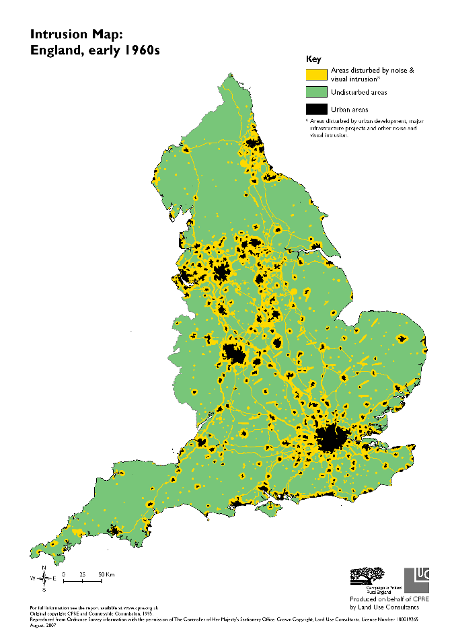 | 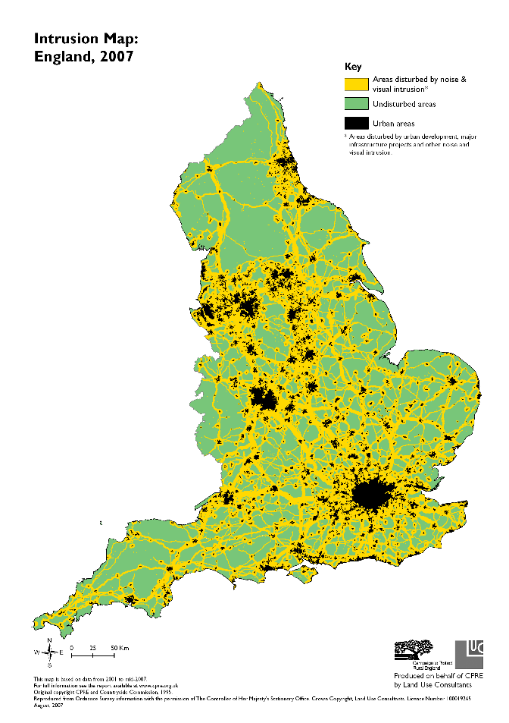
Figure 1 – Extent of Intrusion and Undisturbed Areas (in Green) from Land Use Consultants (2007)
Figure 1 illustrates the extent of intrusion in the early 1960s and in 2007. Based on GIS mapping, the authors estimated that undisturbed countryside reduced from 75% to 50% of the surface area of England over that time. They also provided the same information by local authority area, which was used in the analysis below. The published data did not differentiate between the different types of intrusion but the two maps clearly show that most of the additional intrusion, which occurred after the 1960s, was due to expansion of the road network – both its physical expansion and the associated increase in the volume of traffic.

Secondary Analysis – the Relationship Between Built Area and Undisturbed Countryside
Figure 2 juxtaposes the measures of undisturbed countryside from Land Use Consultants (2007) for each local authority in 2007 against the proportion of land classified as ‘built up’, including gardens, from the Generalised Land Use Database for 2005 (ONS, 2010).

Figure 2 – Built Area (2005) and Undisturbed Countryside (2007) by Local Authority Area

In a few cases, the relationship is distorted by the geographical accident of local authority boundaries. The most notable outlier, Sheffield, is highlighted; its boundaries incorporate some land within the Peak District National Park. For the vast majority of the authorities, the relationship is strong and non-linear. The proportion of undisturbed countryside declines rapidly as the built area increases. Excluding a few outliers, the proportion of undisturbed countryside approaches zero as the built area approaches 20%.
No statistical analysis has been performed, because the key finding is one of principle, rather than mathematical exactness. If the width of the intrusion bands were adjusted to reflect the findings of other research, some of the data points would shift left or right along the horizontal axis but a strong non-linear relationship would remain.
This relationship has some important implications for the debate around urbanisation of the countryside. The inference in the statement by the former minister in the introduction is clearly misleading. Based on current and recent practice in England, small incremental increases in urban intrusion are associated with a disproportionately large loss in undisturbed countryside. The biggest part of this loss appears to come from expansion of the road network, although more research would be needed to understand how this interacts with other elements of urbanisation.
So, would it be possible to expand the population of urban areas without a disproportionate loss of undisturbed country? A thought experiment can help to illustrate the principle. If all of the population of England were concentrated in one city, with no roads crossing the rest of the country, expansion of that city would have only marginal impacts on the area of undisturbed countryside. More realistically, incremental expansion of larger settlements will have much less impact than urban development that fragments the spatial pattern of conurbations. The disproportionate impact of fragmented development will be magnified where roads are built or widened between the new fragments and surrounding towns and cities.

Green Belts and Loss of Countryside – the Example of the West of England
That scenario was illustrated by the recently rejected Joint Spatial Plan and associated Joint Transport Strategy for the West of England (West of England Authorities, 2017b, 2017a) as discussed by Melia (2019a). Figure 3 is the Key Diagram, which appears in both of those reports (with a more detailed key than the one below). The area in green is the green belt, which surrounds Bristol and Bath. The ‘strategic development sites’ were the proposals for the residual housing development, which would be additional to the densification of Bristol, Bath and some of the other towns. The light blue lines indicate new roads with the darker blue showing new or improved bus routes. One of the new roads, which passes through Nailsea and Backwell, would bisect a Site of Special Scientific Interest (Melia, 2019a).

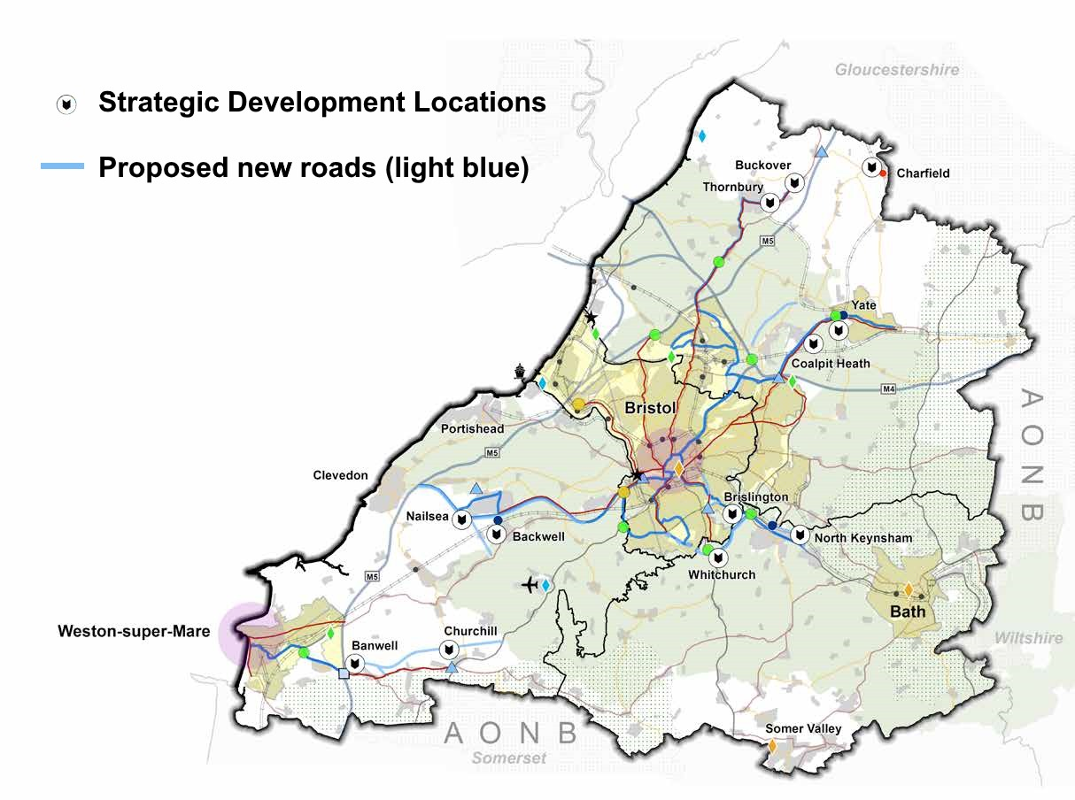
Figure 3 – Key Diagram, Showing Planned Developments and New Roads from WoE Authorities (2017a p. 51)

Green belts around (some) cities have been an important element of planning policy in the UK since 1947. Current national planning policy has a strong presumption against most forms of development within green belts, particularly housing development, but with an exemption for transport and some other forms of infrastructure (MHCLG, 2018b). Following that presumption, and a consultation exercise, Figure 3 shows housing development distributed around villages and small towns immediately outside the green belt. Several new roads, and road widening schemes, were planned to link the new housing to Bristol and the motorway network. The Spatial Plan was recently rejected by planning inspectors following an Examination in Public. Their grounds were mainly procedural, although some of their comments hint at concerns about the strategic development locations (Rivett and Lee S., 2019). The authorities are now reconsidering their strategy.

Conclusions
These conclusions have implications for planning policy and for CPRE, who commissioned Land Use Consultants to do the original study. CPRE have strongly supported green belt policy (CPRE, 2005) and have also opposed large-scale road building (CPRE, 2017). Green belts can slow down the loss of undisturbed countryside to the extent that they encourage urban densification but expansion in multiple locations around the fringes of green belts as illustrated above will reduce the quantity of undisturbed countryside more rapidly than the alternative of expanding cities within green belts. This is particularly true where new or widened roads are planned to support greenfield development in ex-urban locations. As ex-urban developments generate high levels of car use (Headicar and Curtis, 1994, Melia, 2015), they increase pressure on authorities to expand road capacity to accommodate them. The two issues, of housing location and road building, are closely linked in the example above.
One of the aims of green belt policy is: “to assist in safeguarding the countryside from encroachment” (MHCLG, 2018b para. 134). The strategy illustrated above would achieve the opposite outcome. The policy invites authorities to “consider the consequences for sustainable development” of expanding urban areas compared to developing beyond the green belt, but gives no suggestion of which option is likely to be more or less sustainable (MHCLG, 2018b para. 138). To achieve the ‘safeguarding’ aim, national planning policy would need to be amended in two ways. Firstly, the presumption against development in green belts should be applied in the same way to housing development and to road building or widening. Secondly, the policy should make clear that expanding larger settlements will usually be more sustainable than expanding small settlements (for transport reasons as well as countryside protection reasons: Melia, 2015, Chapter 9).
This analysis also has some implications for the long-running dispute on the relationship between population growth and environmental degradation (see for example: Weber and Sciubba, 2018). Although it might be theoretically possible to house a growing population with no expansion of settlements or road networks, at least for a while, it is difficult to imagine any such scenario occurring in reality. In practice, incremental urban expansion always entails both expansion of urban areas and road networks. ‘Sustainability’ in that context usually implies slowing the process down rather than stopping or reversing it.
The ultimate limits to the expansion of urban areas and road networks are missing elements in the debate around the limits to growth, initiated by the Club of Rome over 40 years ago (Meadows et al., 1972). Although the concept of limits to economic growth is now more widely acknowledged, the ultimate limits to the physical growth of settlements and roads has not entered the window of discourse, partly due to political sensitivities and practical challenges around population growth and how to restrain it. If sustainability is to have any meaning over the long-term, then the window of discourse will need to expand to encompass those fundamental questions.

References:
Aldred, T., (2010) Arrested Development: Are we Building Houses in the Right Places. London: Centre for Cities.
Barker, K. (2014) Housing: Where's the Plan?. London: London Publishing Group.
Brown, R. (2019) Is it Time to Review London’s Green Belt? Available from: www.centreforlondon.org/blog/green-belt/ [Accessed November 2019].
Bunce, M.F. and Bunce, M. (1994) The Countryside Ideal: Anglo-American Images of Landscape. Psychology Press.
CPRE, (2017) The End of the Road - Challenging the Road Building Consensus. London: Campaign to Protect Rural England.
CPRE, (2005) Green Belts 50 Years On. London: Campaign to Protect Rural England.
DEFRA, (2018) A Green Future: Our 25 Year Plan to Improve the Environment. www.gov.uk: Department for the Environment Farming and Rural Affairs.
DfT, (2015) Road Investment Strategy: For the 2015/16 – 2019/20 Road Period [online]. www.gov.uk: Department for Transport. [Accessed July 2017].
Di Giulio, M., Holderegger, R. and Tobias, S. (2009) Effects of habitat and landscape fragmentation on humans and biodiversity in densely populated landscapes. Journal of Environmental Management. 90(10), pp. 2959-2968.
Gidlöf-Gunnarsson, A. and Öhrström, E. (2007) Noise and well-being in urban residential environments: The potential role of perceived availability to nearby green areas. Landscape and Urban Planning. 83 (2), pp. 115-126.
Grice, A. (2012) Planning Minister - We Need to Build More Homes on the Countryside. The Independent.
Headicar, P. and Curtis, C. (1994) Residential development and car-based travel: does location make a difference. In: Anon. (1994) Seminar C:Environment Issues. September. PTRC European Transport Forum.
Jackson, S., Fuller, D., Dunsford, H., Mowbray, R., Hext, S., MacFarlane, R. and Haggett, C., (2009) Tranquillity Mapping: Developing a Robust Methodology for Planning Support, Report to the Campaign to Protect Rural England. Centre for Environmental & Spatial Analysis, Northumbria University, Bluespace environments and the University of Newcastle upon on Tyne.
Kallis, G., Kostakis, V., Lange, S., Muraca, B., Paulson, S. and Schmelzer, M. (2018) Research on Degrowth. Annual Review of Environment and Resources. 43 .
Land Use Consultants, (2007) Developing an Intrusion Map of England. London: Campaign to Protect Rural England.
Maller, C., Townsend, M., Pryor, A., Brown, P. and St Leger, L. (2005) Healthy nature healthy people: ‘contact with nature’ as an upstream health promotion intervention for populations. Health Promotion International. 21 (1), pp. 45-54.
Meadows, D.H., Meadows, D.L., Randers, J. and Behrens, W.W.,III (1972) The Limits to Growth: A Report for the Club of Rome's Project on the Predicament of Mankind. Pan Books.
Melia, S., (2019a) How Green Belt Policy could be Adapted to Promote Sustainability [online]. Bristol: University of the West of England. [Accessed 2019].
Melia, S. (2019b) Why did UK governments cut road building in the 1990s and expand it after 2010? Transport Policy. 81 pp. 242-253.
Melia, S. (2015) Urban Transport without the Hot Air. Cambridge: UIT Cambridge.
MHCLG (2018a) Government Announces New Housing Measures Available from: www.gov.uk/government/news/government-announces-new-housing-measures [Accessed December 2018].
MHCLG, (2018b) National Planning Policy Framework. London: Ministry of Housing Communities and Local Government.
ONS (2010) Land use Statistics (Generalised Land use Database). Available from: https://data.gov.uk [Accessed December 2016].
Opdam, P. and Wascher, D. (2004) Climate change meets habitat fragmentation: linking landscape and biogeographical scale levels in research and conservation. Biological Conservation. 117 (3), pp. 285-297.
Rivett, M. and Lee S., (2019) Examination of the West of England Joint Spatial Plan - Letter to the West of England Authorities [online]. [Accessed October 2019].
Sharpley, R. and Jepson, D. (2011) Rural tourism: A spiritual experience? Annals of Tourism Research. 38 (1), pp. 52-71.
State of Nature Partnership, (2019) State of Nature Report [online]. www.nbn.org: [Accessed December 2019].
Underhill, J.E. and Angold, P.G. (1999) Effects of roads on wildlife in an intensively modified landscape. Environmental Reviews. 8 (1), pp. 21-39.
URBACT (2019) Densification Beyond the City Centre: Urban Transformation Against Sprawl. Available from: https://urbact.eu/densification-beyond-city-centre-urban-transformation-against-sprawl [Accessed November 2019].
Walton, J. (2013) The Northern Rambler: Recreational Walking and the Popular Politics of Industrial England, from Peterloo to the 1930s. Labour History Review. 78 (3), pp. 243-268.
Ward, A.I., Dendy, J. and Cowan, D.P. (2015) Mitigating impacts of roads on wildlife: an agenda for the conservation of priority European protected species in Great Britain. European Journal of Wildlife Research. 61 (2), pp. 199-211.
Weber, H. and Sciubba, J.D. (2018) The Effect of Population Growth on the Environment: Evidence from European Regions. European Journal of Population = Revue Europeenne De Demographie. 35 (2), pp. 379-402.
West of England Authorities, (2017a) Joint Spatial Plan Publication Document [online]. www.jointplanningwofe.org.uk: [Accessed January 2018].
West of England Authorities, (2017b) Joint Transport Study Final Report [online]. www.jointplanningwofe.org.uk: [Accessed January 2018].

Reproduced from Ordnance Survey information with the permission of The Controller of Her Majesty's Stationery Office. Crown Copyright. Land Use Consultants. Licence Number I 00019265 August. 2007
Two outlier authorities, Bristol and Wirral, have been removed from the dataset; in those cases, the proportion of undisturbed countryside appears to have been inflated by estuarine areas.

